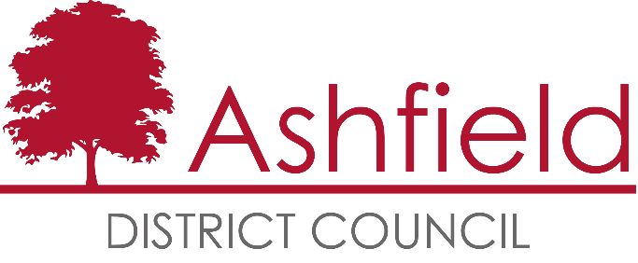

Markets and Events

Fees and Charges Policy

Version 1 – January 2024

Contents Page
- Introduction 3
- Scope 3
- Background 3
- Idlewells Markets 4
- Outdoor Markets 4
- Event Fees 4
- Changes to Agreed Licence Fees/Stall Fees/Event Fees 5
- Review 5

1. Introduction

  - This policy document sets out the Council’s approach to the setting of fees and charges for indoor and outdoor markets and events.
  - The aim of the Policy is to identify where variation from the agreed fees and charges is permissible for markets and events.
2. Scope
2.1 This policy includes but is not limited to, the setting of fees and charges relating to:
- Idlewells Indoor market
- Ashfield District Council’s outdoor markets
- Events held on Ashfield District Council land
- Commercial Market Licence Fees

3. Background

  - Fees and charges are reviewed and set at Cabinet each year, however flexibility is sometimes required for the following reasons:

- Recognition of the Council’s social responsibility, to support specific events free of charge or at a reduced rate
- To ensure charges are fair and equitable and support the Council’s objective to promote equality of opportunity
- Allocate appropriate refunds due to cancellations through force majeure etc.
- To ensure specific concessionary rates for defined groupings are applied consistently
- To increase the number of third-party events to support the visitor economy
- To ensure that the Council can charge at commercial rates.

  - Where fees and charges are increased in comparison to regular market fees the income will be used for:
- running an efficient waste, street cleansing and on-site market service
- Market promotion both within the District and beyond
- Improving the markets environment to be modern, safe secure and attractive
- Road Closures and traffic management
- Market team staff costs

4. Idlewells Market

4.1 The Council is committed to ensuring the market continues to be a key attraction for the town centre creating jobs and supporting the vitality of the town centre.

4.2 Individual stall fees are based on the size, location and amenities of each stall to cover operating costs and a return on borrowing incurred by investment in the building balanced with ensuring they are attractive to new start-ups and competitive with the local retail offer.

4.3 When a tenant takes on a new unit, there is a period where they will be fitting out their stall prior to commencement of trading, during which they are liable for their licence fees but are not generating income. Significant sums can be invested by the tenant in the design, fit out and equipment. It is in the interest of the Markets Service to encourage licensees to invest in their unit as this enhances the overall offer in the market. Therefore, a licence fee free period, or a period of time where this is reduced on a sliding scale may be offered to a prospective tenant.

This is standard practice between commercial landlords and their licensees and depends on the level of investment in the unit, the time taken to fit out and establish the business, and the level of investment the landlord has had to make to accommodate the tenant. Any agreement will always take account of the need for the Authority to earn income which will as a minimum cover the costs of implementing that tenancy during the period of lease agreed.

4.4 Occasionally, licensees may approach the Markets management to request temporary assistance with fees and charges; each application is considered individually, and any such arrangement is made confidentially.

4.5 Any proposed change to agreed fees and charges must take into account any previous discounts; increases; incentives or similar, arrears and the impact on the markets budget.

5.0 Outdoor Markets

5.1 Ashfield’s outdoor market traders are casual and are therefore under no obligation to turn up and trade and the Council is under no obligation to offer compensation when a market is cancelled. The Council will seek to give as much notice as possible when cancelling a market.

5.2 Markets management have the discretion to waive or reduce fees in these circumstances for example; adverse weather, environmental conditions (flooding, ice, etc.), and minimum trader numbers (less than 5 traders).

6.0 Event Fees

6.1 The fees applied depend on whether an event is:
• Commercial
• Charity (National)
• Charity (Local)
• Community

6.2 Commercial
These events provide a commercial benefit to a profit-making business or operation including product launches, corporate events and other marketing and promotional activities for profit making organisations. Events organised by commercial organisations that are aimed primarily at improving public health and wellbeing will be considered separately to purely commercial events.

6.3 Charity
Events organised by registered national or local charities and are predominantly fund-raising events for the benefit of the charity. Locally based charities will be exempt from the majority of fees outlined in this policy. National Charities will need to make a case to the Council for any exemption to be applied to the fees and the primary consideration for waiving any fee will be on the contribution of the event to local priorities and outcomes.

6.4 Community
Any event organised by not for profit, community, or voluntary groups that directly benefits residents and visitors. The classification of the event type is subject to officer discretion and may affect any of the following:
• Whether an application is accepted
• The application and hire fees charged or waived
• The length of time needed for an application to be considered
• The nature and duration of the consultation to be undertaken

  - For Council organised events such as Food Festivals etc, rates for stall holders will be set at the time as to be commercially competitive and attractive.

  - The Council reserves the right to negotiate the commercial event fee for large scale events and for markets operated on behalf of the Council.
- Changes to Agreed Licence Fees/ Stall Fees / Event Fees
7.1 Any changes or deviations from the existing fees and charges agreed at Cabinet require authorisation through form FC1 whereby requests for changes to fees and charges can be proposed, reviewed by the Finance Section, and authorised by a Chief Officer.

8.0 Review

8.1 We will continue to evaluate the policy and may update it as and when required.

