PORTLAND PARK

MANAGEMENT PLAN

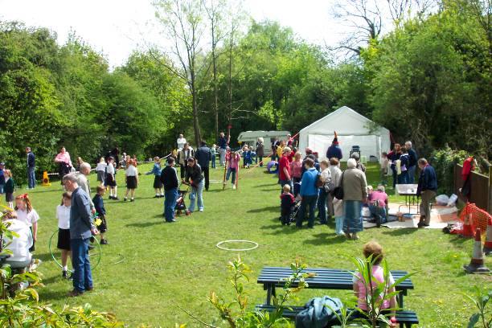

January 2017 – December 2021
(Refreshed April 2018)

Disclaimer

This document or some parts of it may not be accessible when using adaptive technology.

If you require assistance with accessing the content of the document, please contact:

email: place@ashfield.gov.uk and quote the document name and web page you found it on.

Portland Park Location Plan

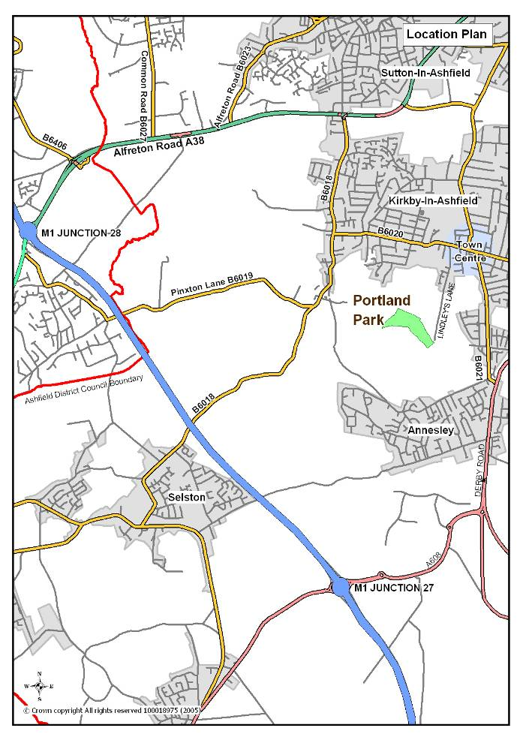

Portland Park Aerial Photograph indicating park boundary

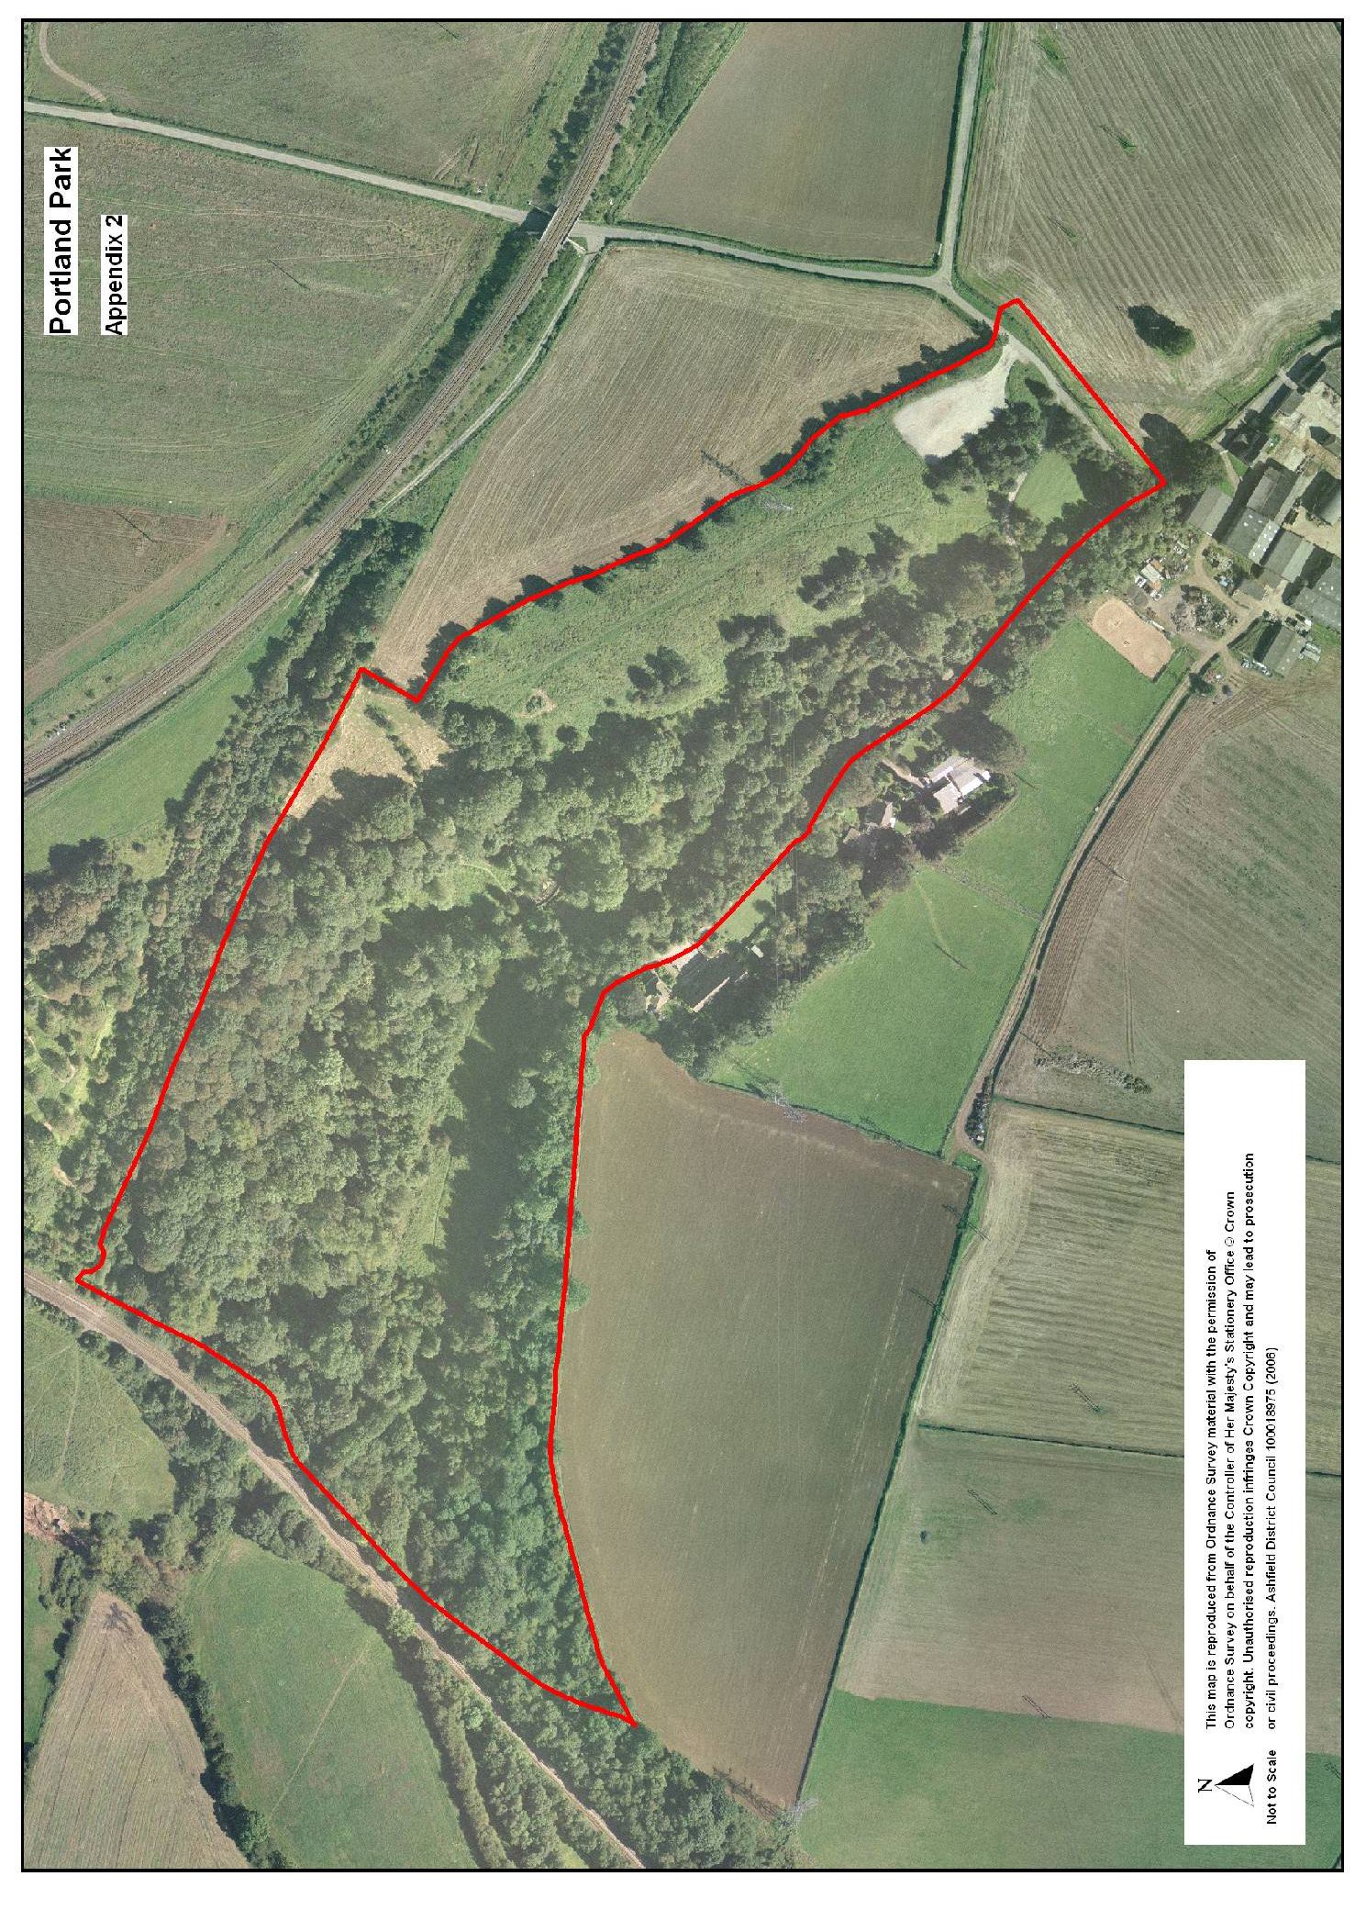

Portland Park - Site Layout Plan indicating features and designations

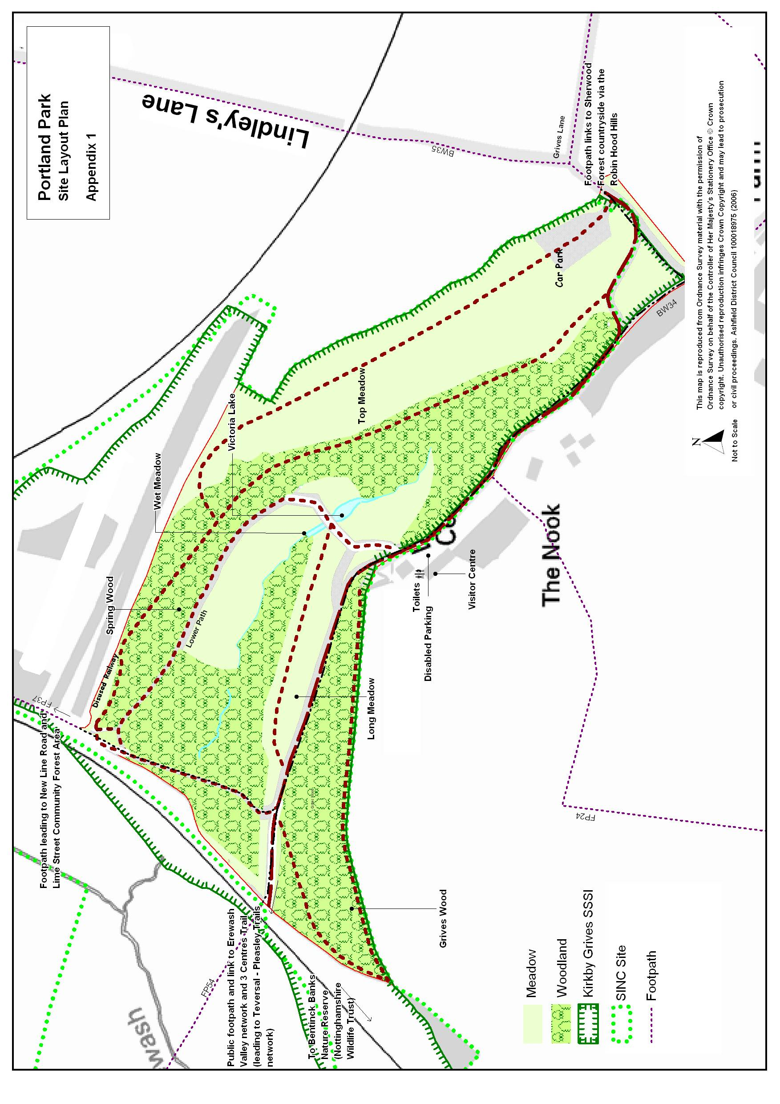

CONTENTS PAGE

- OVERVIEW

1.1 Introduction 5

1.2 Park Facilities 6

1.3 Investment 8

1.4 Heritage 9

1.5 Community Involvement 10

1.6 Landscape and Ecology 13

1.7 Evaluation of Features 19

1.8 Green Flag Criteria 20

- DELIVERY/ IMPLEMENTATION

2.1 Action Plan 25

3 MONITORING/ REVIEW

3.1 Monitoring and Review 29

3.2 Contacts 29

OVERVIEW

1.1 Introduction

This management plan has been developed by Ashfield District Council and revised following public consultation. It is intended that the plan will help to improve general maintenance of the site, plan for the future and as part of this process retain the Green Flag Award, which the park has held from 2002 – 2004 and then from 2006 to present. Details of the Council’s policies and procedures for green space management are contained within the Management Plan Overview and Supporting Information documents.

Portland Park is situated directly to the south west of Kirkby-in-Ashfield town centre, less than 1km to the south is the small urban area of Annesley Woodhouse / Nuncargate / Kirkby Woodhouse and Annesley. The former Bentinck Colliery lies to the west.

Portland Park covers 15.2 hectares of informal open space, including 10 hectares of woodland in the valley of a tributary of the River Erewash together with several areas of species-rich grassland and a number of wetland areas. The site is partly bounded by used and disused railway lines that form part of a once extensive local and regional network. The meadow area to the north west of the main car park was once a limestone quarry which was infilled during the 1950s. Parts of the woodland are thought to date back to at least 1600. Some areas have been quarried for limestone and the park is known locally as ‘The Quarries’.

The site is unique in Nottinghamshire, being located on a band of magnesium limestone, part of a narrow band running northwards up the west side of the county. This enables many rare plant species to grow, creating an area which is abundant with fascinating natural history and making it a Site of Special Scientific Interest. The limestone supports important 'calcareous' vegetation that is rare in Nottinghamshire and uncommon in Britain generally.
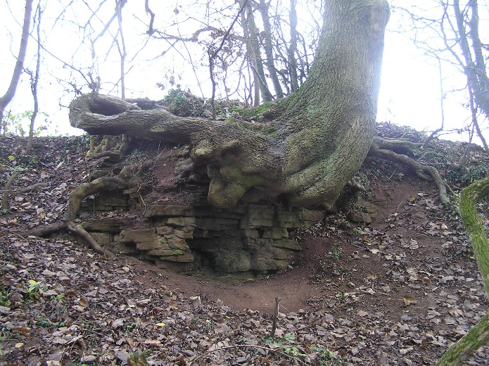
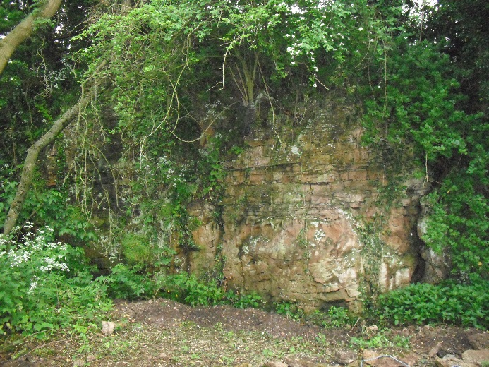
Photograph 1: Limestone behind visitors’ centre
Photograph 2: Limestone outcrop in the park

The site contains a network of pathways with picnic areas; a Visitor Centre is located in the centre of the park, providing information, refreshments, public toilets and educational resources. A series of three ponds receive water from a spring which is then directed into the stream flowing through the site.

1.2 Park Facilities

The park contains the following facilities:

A visitor centre, 3 pond areas, a main car park, 3 disabled parking bays in front of the visitor centre and a secondary smaller car park adjacent to the lawn area to the side of the visitor centre. A tenanted bungalow lies adjacent to the centre.

The visitor centre provides a café, toilets, display areas and tea room facilities on the first floor.

A garden area has been created at the rear of the centre, which has a lawn area, woodland edge and paths. At the rear of the garden an old limestone quarry face can be seen. In 2013 Nottinghamshire Wildlife Trust carried out some improvement works in the garden.

Access improvements were undertaken as a series of phased projects from 2012 to 2014. These included all of the parks footpaths being improved and new footpaths created. These works have improved, as far as is practicable due to the park’s topography, access around the park for disabled users. The construction of a ramp provides access for visitors using wheelchairs from the disabled parking bays to the visitor centre via the lawn area. As well as the walks within the park, the centre is an ideal starting point for the Three Centre’s Trail (leading to Teversal-Pleasley Trails network) and many other adjoining walks.

Photograph 3: Visitor Centre Ramp, constructed in 2014

The park is well served by a network of definitive footpaths, permissive routes and bridleways. Vehicle access is from the centre of Kirkby-in-Ashfield, where a brown tourism sign directs road traffic southwards, along Lindleys Lane. The park is approximately 15 minutes’ walk from the town centre.

The park is bounded by railway lines to the north and west and by Lindleys Lane in the east. The main vehicular and pedestrian entrance to the park is via Lindleys Lane, which is unadopted but which the Council has a right of access over. There is car parking for approximately 40 cars off Lindley’s Lane from where the visitor centre can be accessed via the main access road or via the footpath through the meadow and woodland.

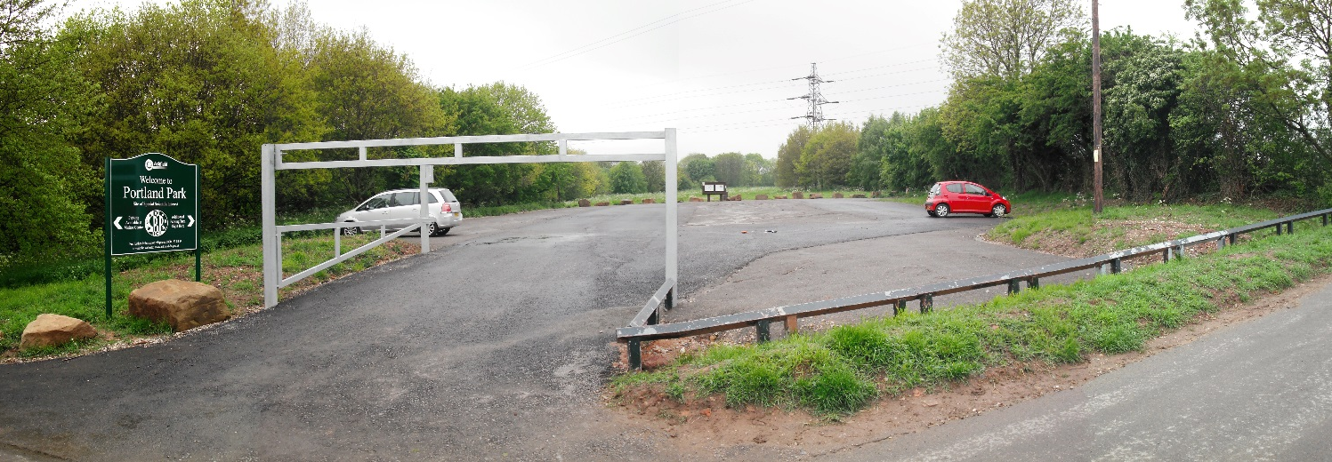

Photograph 4: Main visitors’ car park on Lindleys Lane

Public footpath (fp) no. 24 gives access from the south, a combination of fp no. 56 and fp no. 37 from the north, fp no. 54 from the west and a combination of fp no. 33, bridleway (bw) no. 34, bw no. 35, bw no. 36 and bw no. 55 from the east. Works have been undertaken to improve pedestrian access and links to Portland Park and other sites, including an informal nature area at nearby Lane End, Kingsway Park, Nuncargate Recreation Ground and west Kirkby.

An information board giving details of the site’s status as a Local Nature Reserve is provided near the picnic area. Information boards are provided around the park, giving details about the park and its history.

The bottom meadow is a rare example of neutral grassland habitat in Nottinghamshire. Over the course of the previous 5 year management plan woodland and scrub encroachment into the meadow has been removed thereby increasing its size by 10-15%. This has substantially improved the botanically-rich grassland. Green hay from the species rich central areas have been used to spread seed into the recently cleared woodland/scrub areas.
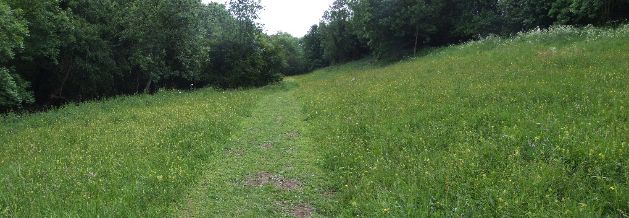

Photograph 5: View of the bottom meadow in bloom

1.3 Investment during previous 5 year Action Plan

Capital Works | Cost (£) | Funding | Date
Boulders for access barriers | 1,000 | s106 | 2010/11
Notice boards | 580 | s106 | 2011/12
Footpath Improvements (incl signage) | 60,000 | s106 | 2012/13
Main Car Park Improvements (incl signage) | 28,475 | s106 | 2012/13
Garden Area | 14,775  4,430 | WREN  s106 | 2013/14
Disabled access ramp | 35,000  7,735 | SLC  s106 | 2013/14
Works to make doors automatic | 6,570 | ADC | 2013/14
Revenue Works | Cost (£) | Funding | Date
Plants | 215 | s106 | 2011/12
Tree Works | 1,500 | s106 | 2011/12
Drainage Improvements | 10,000  4,470 | ADC  s106 | 2012/13
Works to top patio | 4,705 | ADC budget | 2013/14
Tree survey | 300 | ADC budget | 2013/14
Tree works | 3,400 | ADC budget | 2014/15
TOTAL | £183,155 |  | 2010-15
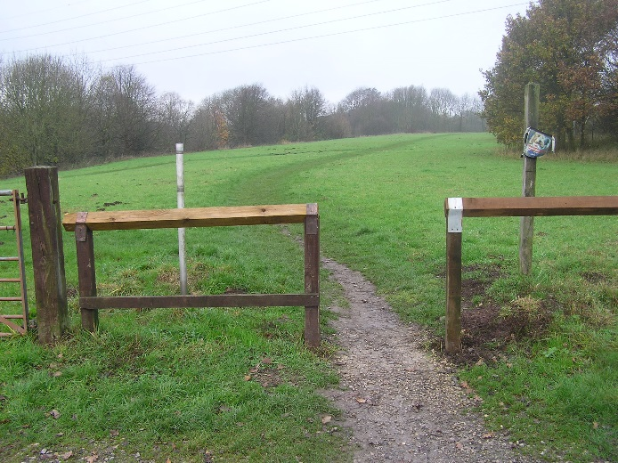
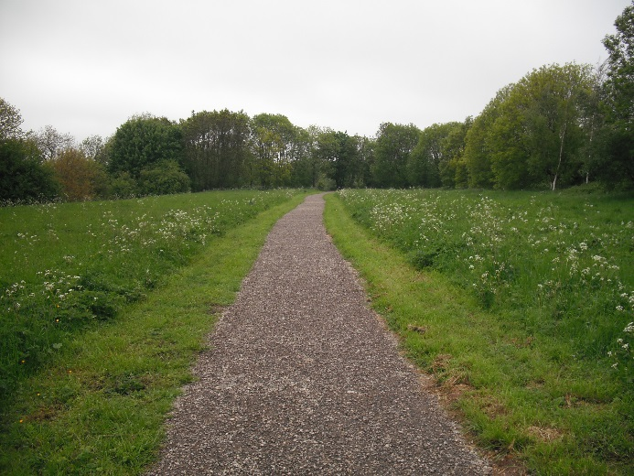

Photograph 6: Top meadow path before works
Photograph 7: Top meadow path after works
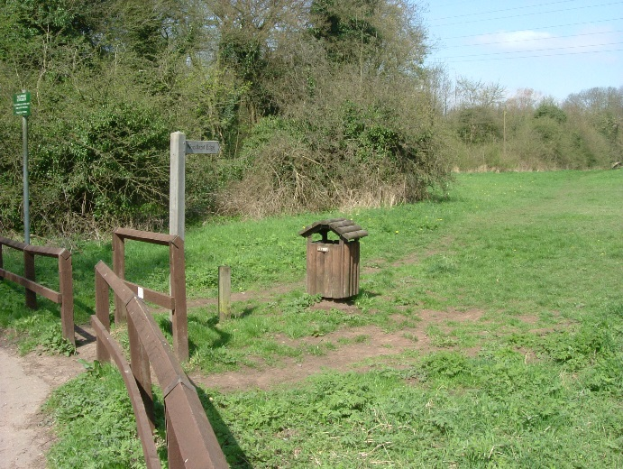
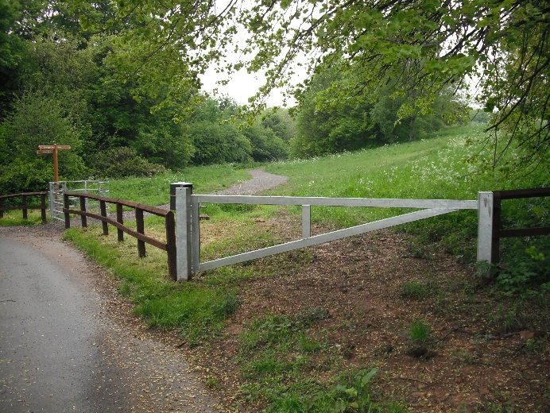

Photograph 9: Top meadow path after works
Photograph 8: Top meadow path before works

1.4 Heritage

Portland Park was donated to the people of Kirkby by the 6th Duke of Portland as a series of gifts dating from 1910. A small area of what is now the park was leased to Kirkby Urban Council from this date and in 1914 the Duke and Duchess of Portland celebrated their Silver Wedding Anniversary and the 21st birthday of their son, William Arthur Henry Cavendish-Bentinck, (7th Duke of Portland) by gifting the remainder of the land. The Council developed 'Portland Park' as a formal recreational area for local people and the park was a popular rendezvous on a Sunday, for church services, family walks and picnics, listening to the bands in concert, tennis and playing on the swings. Other features included formal gardens, paddling pools (now ponds) and a bowling green. The main pond known as Victoria Lake, named after the Duke and Duchess’s daughter Lady Victoria Alexandrina Violet Cavendish-Bentinck, was created in 1914 as part of the original development of the park as a formal pleasure ground.
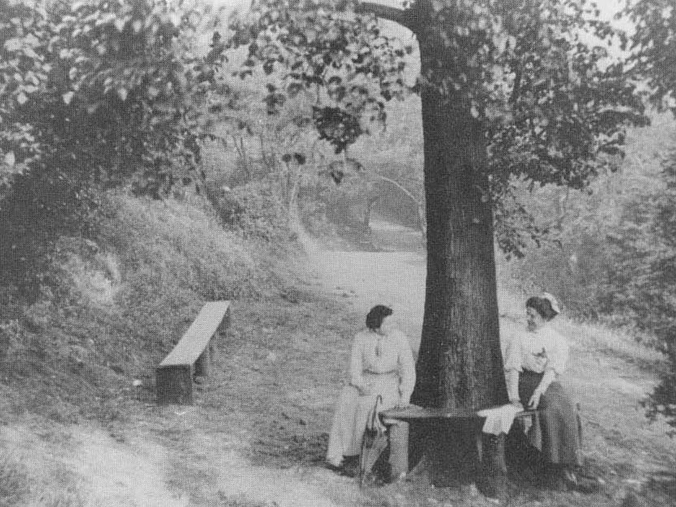
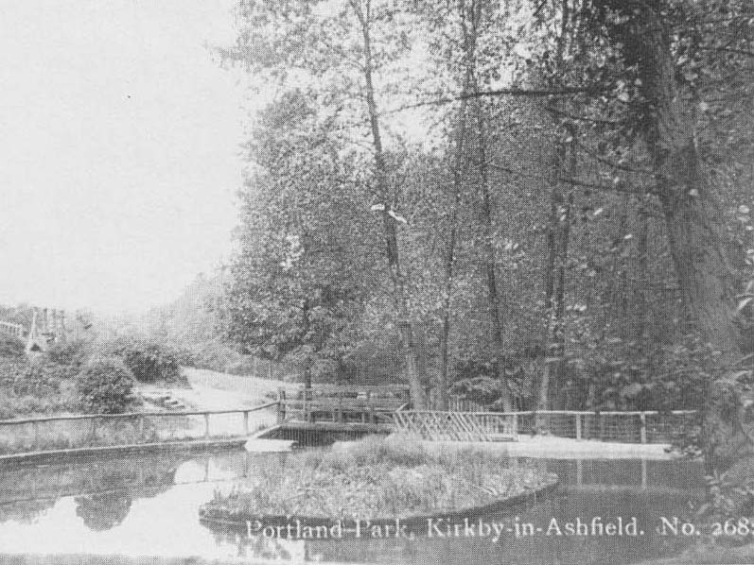

Photograph 10: Victoria Lake c.1930
Photograph 11: Leafy glade; early 19th Century

In 2001 the main pond was renovated, by the removal of the concrete base and replacement with a Butyl liner. Other works included the rebuilding of the stone walls around the lake, new seating and repairs to the weir, which takes water from the main pond to the lower pond. The main pond is fed from a smaller pond above it, which is fed from a natural spring. The ponds are the only significant remaining feature of the formal pleasure grounds.

Up until the 1960's all the paths within the park crossed over or under railway bridges. The main pathway to the west of the park was originally an embankment built to carry the first railway within the district, which was one of the first pre-steam railways in the country. The railway lines were built to serve the former local coal mining industry and the majority are now disused.

A shortage of staff after the Second World War led to less intensive management and areas of the park became less formal. Over time all of the more formal features of the park were removed, such as the bandstand, bowling green and play area. Following designation of the park as a Site of Special Scientific Interest in 1974, the park was transformed over time into a country park.

The park will eventually extend into an additional area of land known locally as the ‘Humps and Hollows’ up to the edge of the Robin Hood Railway cutting following the completion of the adjacent housing development. This transfer of land from the developer to the Council forms a condition of the planning permission to build the housing development.

1.5 Community Involvement

Nottinghamshire Wildlife Trust, working with the Council secured funding for improvements to the garden area at the rear of the centre. The works included clearing areas of scrub to make better use of the space, creating natural bark mulch and crushed stone pathways, replacing timber boundary fencing and interpretation of the natural features including the limestone rock face at the rear of the garden.

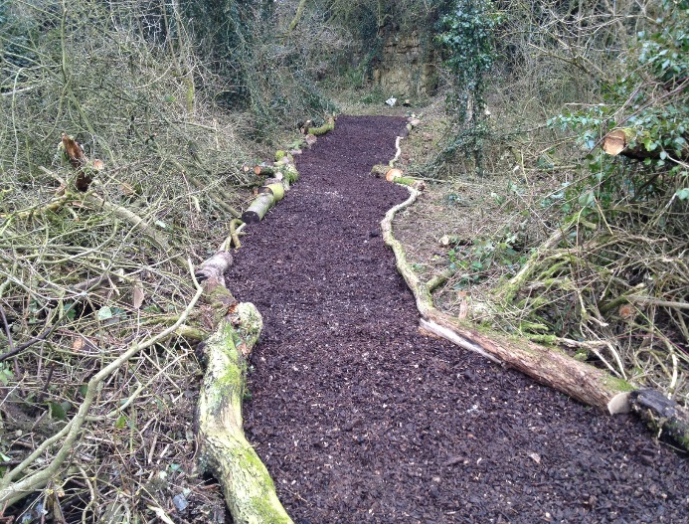
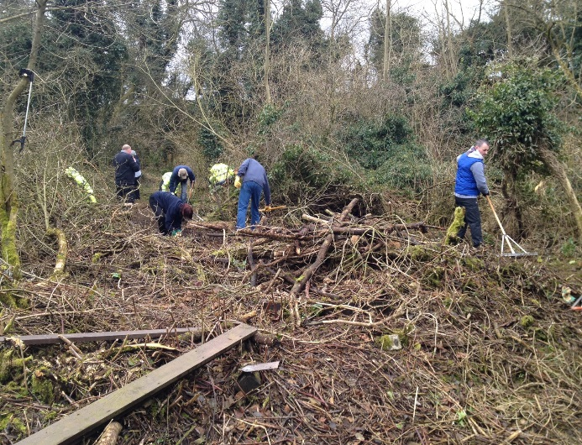
Photograph 13: Garden Pathway - After

Photograph 12: Garden Pathway - Before

The friends group entered into a Partnership Protocol Agreement with the Council in September of 2015 acknowledging both organisations shared interest in the site and demonstrating a commitment to work together during its future development.

Orchard Primary School took part in an environmental day in April 2016 exploring various aspects of the park, including flora and fauna, geography and geology and local heritage. Pupils worked with the Council to clear an area and plant approximately 2,000 snow drop and bluebell bulbs. The schools have registered with the Council’s Green Buddies scheme and will be continuing visits and activities in the longer term.
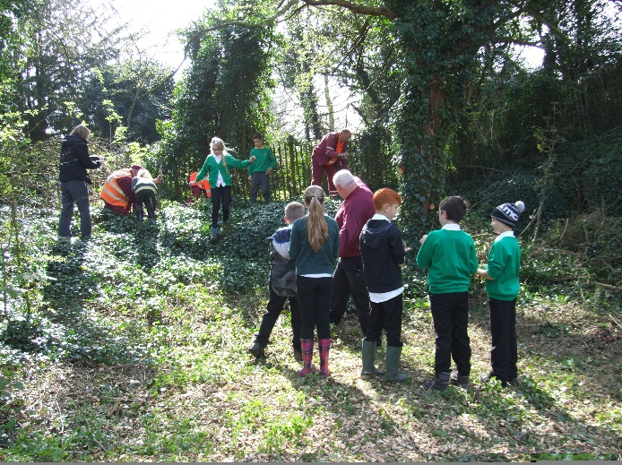
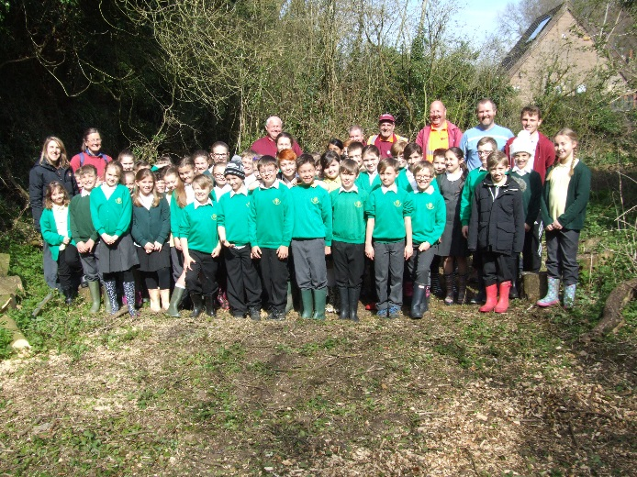
Photograph 15: Bulb planting gang

Photograph 14: Bulb planting in action
In October 2016 the 1st Kirkby Girl Guides created a volunteer workforce and undertook a litter pick as part of their environmental badge. As part of the badge project they looked at the problems of litter in the countryside, the potential effects on local wildlife and came up with possible solutions to solve the problem.
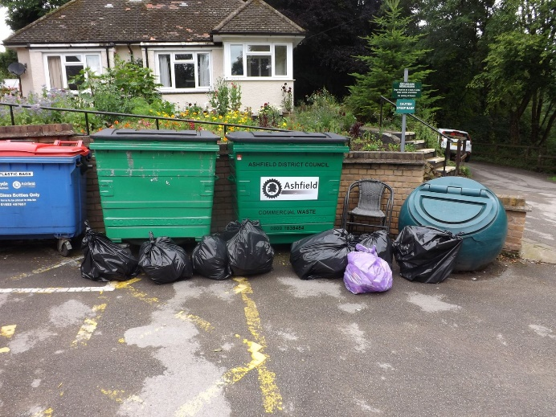
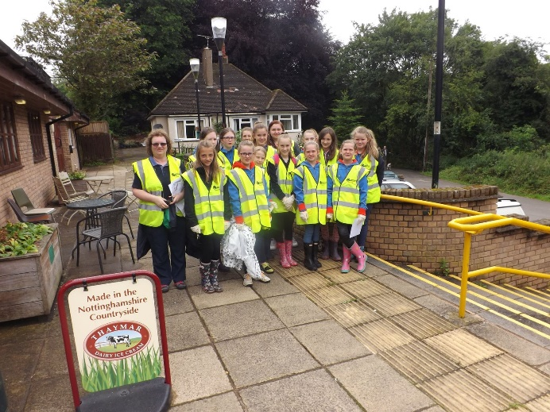
Photograph 17: 8 Bags of litter collected

Photograph 16: 1st Kirkby Girls Guides

In September 2016 and 2017 pupils from Orchard Primary School took part in environmental activities as part of the Green Flag Raising Celebration making bird feeders to hang in the garden to the rear of the visitor centre.
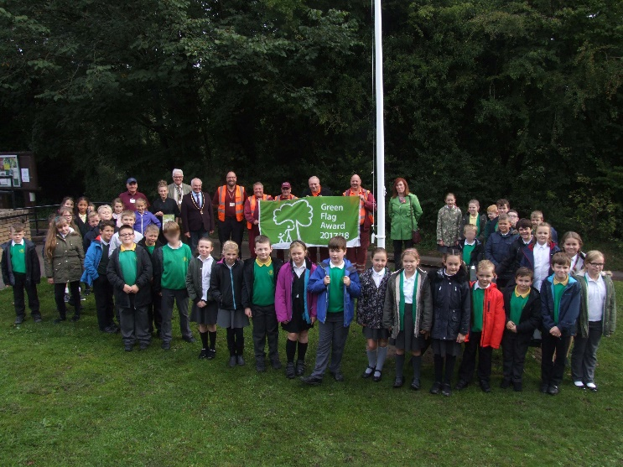
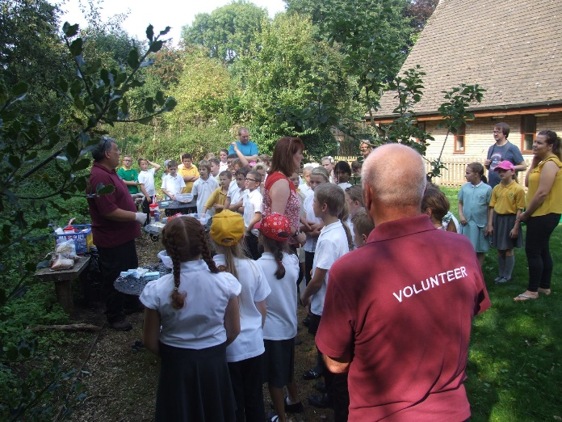

Photograph 18: 2017 Green Flag ceremony
Photograph 19: Bird feeder workshop

Both the 1st Kirkby Girl Guides and Orchard Primary School signed up to the Council’s ‘Green Buddy’ environmental volunteer programme for young people promoting the importance of keeping public open spaces clean and well looked after amongst their peer groups.

The ‘Green Buddy’ environmental volunteer programme was part of a larger ‘Even Cleaner Streets’ initiative across the District which the Council won the Community Engagement Award category in Keep Britain Tidy’s prestigious National Network Awards in 2017.
The award recognised and acknowledged the Council’s achievement in working with local community groups and organisations in improving local environmental quality.

As part of a wider Wetland Landscapes For All project to improve the Trent & Leen catchment areas works to clear debris and overgrown vegetation from the stream took place in winter 2017. The aim was to improve flow whilst creating riffles and pools for improved habitat to attract water voles back into the area that had previously been eradicated by mink. It is envisaged that this would be the first phase of works concerning the stream. A potential second phase identified is to improve water quality removing contaminants from the source of the River Erewash at the head of the catchment.

Opening up the woodland canopy improved foraging areas and opportunities for native birds and bat species. As part of the RSPBs ‘Big Bird Watch’ pupils from Orchard Primary School made bird and bat nest boxes that have been installed in the park in time for the 2018 nesting season.

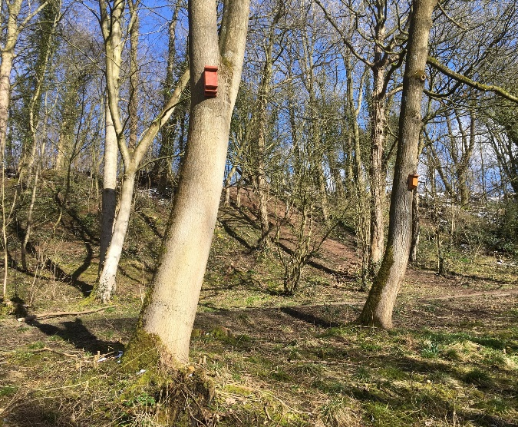
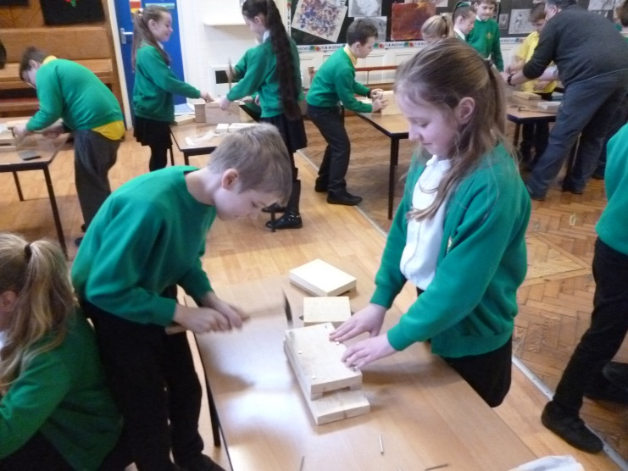
Photograph 20: Nest box making workshop
Photograph 21: Nest boxes installed in the park

The clearance works to the stream captured the public’s imagination and inspired people to come forward expressing an interest in volunteering within the park. As part of Keep Britain Tidy’s first ever Great British Spring Clean campaign registered volunteers cleared vegetation encroachment from paths, swept the steps and also cleared the edges of the heritage paddling pool so it could be seen from the bridge over the weir.
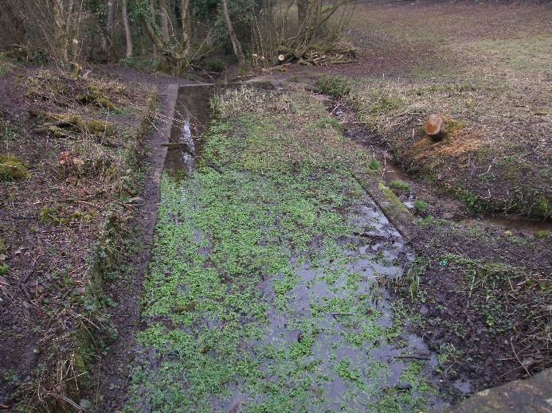
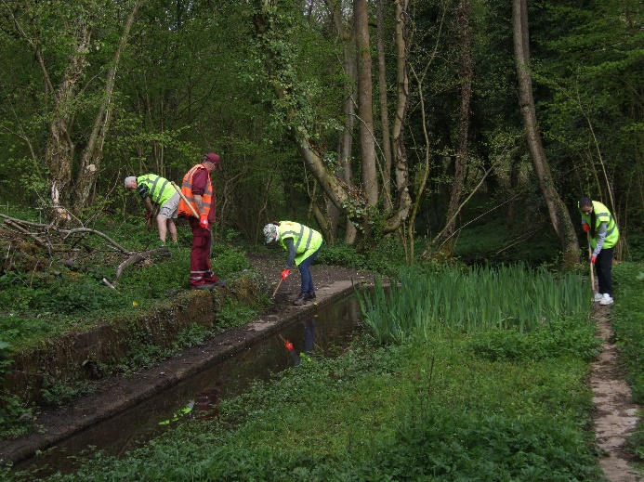
Photograph 23: Volunteer clearance works

Photograph 22: Heritage Paddling Pool (before)
1.6 Landscape and Ecology

Statutory Designations

As a country park, with SSSI, LWS and LNR designations, one of the most important aspects is its ecological and educational value. The most extensive habitat type at Portland Park is woodland, but there are also grassland, wetland and tall herb communities.

1.6.1 Site of Special Scientific Interest (SSSI)

Portland Park forms a major part of the Kirkby Grives SSSI, which was designated under Section 16 of the 1949 National Parks and Access to the Countryside Act. SSSI status is applied to sites of national or international importance for their wildlife and/or geological interest. The designation confers a significant degree of statutory protection for the special interest.

The site description from the SSSI citation describes the site as ‘one of the finest remaining limestone plant communities in Nottinghamshire and is of regional importance.’ The Council is required to obtain a licence from Natural England for any works to be carried out within the SSSI area. Natural England carries out two inspections of the site during the year; once a year with Council officers (usually in June) to check the site’s management and again for an independent visit on one other occasion during the year. The inspection sheet is made available to view on the Natural England website.

1.6.2 Local Nature Reserve Status (LNR)

The Council designated the park as a Local Nature Reserve, under Sections 19 and 21 of the National Parks and Access to the Countryside Act in 1997. LNR status applies to land of at least local wildlife interest, and allows the local authority to protect that interest through the creation of special bye-laws.
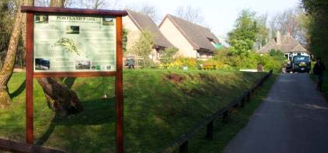

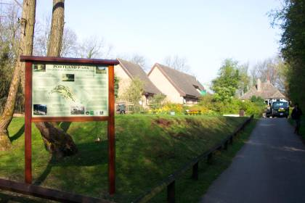
Photograph 24: Signage at main entrance regarding LNR status
Non-statutory Designations

Portland Park LNR is part of a larger Site of Interest for Nature Conservation – SINC No. 1/9 (Nottinghamshire Biological & Geological Records Centre, 2004).

The park itself is within the Southern Magnesian Limestone National Character Area profile No. 38. The limestone creates a ridge, or narrow belt of elevated land, running north–south through the NCA forming a prominent landscape feature. The geology has influenced many aspects of the landscape, from use of its limestone resource as a local building material to the specialised limestone grasslands associated with limestone areas (Natural England, 2014).

In terms of the Nottinghamshire Regional Character Areas, it is within ML019 Kirkby Quarry, Portland Park and Rise Hill which is defined by woodland comprising of large irregular blocks of predominantly broadleaved species, infrequent in the landscape, although where present it is a prominent and a defining feature (TEP Consultants, 2009).

The Ashfield Biodiversity Opportunity Mapping defines the park as being part of the Erewash Catchment. This is an area with great potential for improving the wetland and grassland habitats (and to a lesser extent the woodland network) offering opportunities to improve existing core areas of habitat; to create new areas of habitat; and to improve habitat connectivity along the valley by creating linking pieces of habitat between the existing habitat blocks. (Notts BAG, 2016).

1.6.3 Calcareous Grassland

High quality calcareous grassland occurs at the 'Humps and Hollows', which is a hummocky area separated from the northern edge of the park by a disused railway cutting. In contrast, the calcareous grassland within the park is mostly of much lower quality which includes a large area abutting the main car park which, during the latter part of the 20th century, was re-sown landfill. However, a few quite valuable patches occur elsewhere, particularly on slopes or close to boundaries. One of these supports ant-hills frequented by the ant-eating green woodpecker. Plants present include tor-grass, quaking grass, narrow-leaved meadow-grass, meadow oat-grass, greater knapweed and burnet-saxifrage. There are also some remaining patches of the highly invasive, non-native, Japanese knotweed, on the top meadow, still present following eradication treatment. These continue to be monitored and treated. A substantial part of a young ash plantation also intrudes into the botanically-rich grassland. The grassland is mown in the autumn to allow an uninterrupted show of flowering plants for as long as possible.
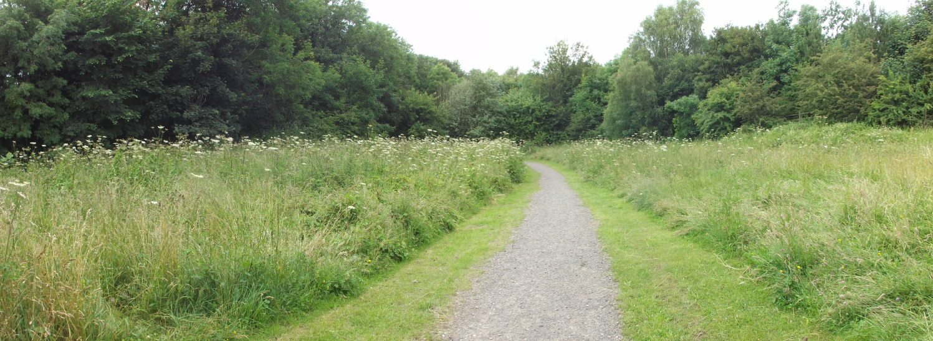
Photograph 25: View of the calcareous grassland in bloom
1.6.4 Neutral grassland (bottom meadow)

On marl, close to the valley bottom, is an elongated meadow that supports a range of plants indicative of high quality neutral grassland such as devil's-bit scabious, betony, great burnet, salad burnet and lady's bedstraw. Other species recorded in 2003 by the Nottinghamshire Botanical Recorder in this or other small neutral grassland glades include common dog-violet, lady's-mantle, water avens, twayblade and yellow rattle.

This meadow forms Unit 7 of the wider Kirkby Grives SSSI which is important for its lowland meadow habitat (MG5 Cynosurus cristatus-Centaurea nigra).

In order to achieve the MG5 standard for ‘Favourable Condition’, the SSSI meadow must achieve a number of attributes including maintaining its size, cover, quality of grasses and wildflowers and not carrying too much weed or scrub burden.

Unfortunately due to a number of years of incorrect management, several of these attributes were starting to fail and the whole area of MG5 was becoming squeezed by encroaching scrub, weeds and coarser species.

In 2013 the Council signed up to a 10 year Higher Level Environmental Stewardship agreement with Natural England to support the restoration of the meadow. In the winter of 2014/15 works were undertaken in line with the new agreement to remove woodland and scrub encroachment into the meadow area thereby increasing its size by 10-15%. This has substantially improved the botanically-rich grassland.

Following a site inspection visit in 2016 Natural England’s Lead Adviser for Nottinghamshire, stated,

“Although it’s still early days, the area has already been opened up providing increased levels of light; the meadow species are improving for the wildlife and visitors to enjoy.”

The records have established a baseline to monitor further improvement in species richness and diversity for future years.

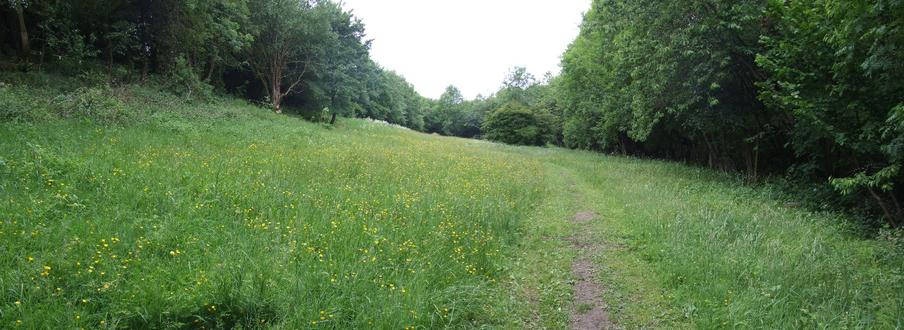

Photograph 26: View of the neutral grassland in bloom
1.6.5 Tall Herb Communities

Another fairly extensive area, and some smaller patches elsewhere, are dominated by taller and coarser species on damper ground, including great horsetail, meadowsweet, great willow herb and hogweed. Some rotational cutting and removal of invading scrub and coarse vegetation is beneficial in these areas (See Action Plan).

1.6.6 Woodland

The woodland is predominantly a mixed broad-leaved lowland woodland type. There are many variations of this type but in Portland Park they broadly correspond to the W8 ash-maple-dog’s mercury woodland under the National Vegetation Classification (Rodwell, 1991).

W8 woodlands occur on alkaline and neutral soils with dog’s mercury as the dominant plant in the field layer and other associates also common such as bluebell and wood anemone. Ash tends to be the main canopy tree (along with oak) but, as in the case of many W8-type woodlands, sycamore has invaded and is now the predominant canopy tree in most parts. There are some small areas of woodland that approach the W10 oak-bramble-bracken type particularly where birch is locally frequent (such as the northern part of Studfold Wood). W7-type wet woodland, characterised by frequent willow and alder, occurs along the stream. Secondary woodland dominated by young or semi-mature ash and sycamore occurs in some areas of disturbed ground along with scrub dominating areas at the northern end of the park.

The south-western part of the site, on a substantial north-facing slope, is an interesting combination of silver birch canopy and a grassy ground flora. Elsewhere in the compartment, the woodland is clearly long-established and diverse, with a canopy of mostly ash. Other trees present include elm, sycamore, hornbeam, beech field maple and rowan. Amongst the many shrubs are hawthorn, blackthorn, guelder rose, spindle hazel and holly. Typical woodland ground flora species include hairy-brome, false brome, wood melick, bearded couch and greater stitchwort. The damper conditions towards the foot of the slope are marked by the presence of such species as wood-sedge, male fern, broad-buckler-fern and tufted hair-grass.

The wet, valley-bottom woodland is dominated by crack willow and sallow, with a ground flora including wavy bitter-cress, creeping buttercup, and various ferns. Alder is present in low numbers, but their seeds are a favourite food of winter-visiting siskins and redpolls.

One large poplar tree is of particular interest, as its roots support a colony of the parasitic plant toothwort.

The non-native sycamore is a prominent tree towards the centre of the site, away from the wettest areas. Under normal circumstances it would be preferable to remove non-natives. However there are a large number of mature sycamores within the park, whose felling would create a detrimental visual impact, and deplete the site of valuable standing deadwood potential. Therefore the trees are left, especially as they might support toothwort.

A detailed woodland management plan was completed in 2009. The management prescriptions recommended within the plan have been incorporated into the Management Action Plan. For more details please refer to the Woodland Management Plan.

1.6.7 Wetland

Woodland occupying the southwest part of the nature reserve is the location of the head of the stream of the River Erewash. From here it runs in a northwest direction to exit from the SSSI at a point along the western boundary (via a culvert).

Water from springs and seepages occurring at the eastern end of the former railway cutting have contributed to the creation of a small wetland area with standing water. Seepages and springs occur in other areas of the park most notably along woodland / scrub edge of the compartments making up the southern end of Studfold Wood. To the north of the visitor centre, the stream is crossed by a stone bridge and weir, forming three shallow ponds.

Several wetland plants occur in this area, including branched bur-reed, fool's-water-cress and water-cress, all of which appear to have colonised naturally in the lower pond. Important communities of liverworts, mosses and lichens characterise the stream banks and other damp, shaded areas, including the bridge stonework.

Victoria Lake has undergone relatively recent management to increase its nature conservation interest. The stream and most other wetland habitats are unlikely to need management in the foreseeable future, the ponds are cleaned on a rotational circle no more than once every 5 years.

1.6.8 Fauna

Birds
A range of typical bird species occur in the woodland including great spotted woodpecker, tawny owl, nuthatch, chaffinch and treecreeper. A bird box scheme operates in the core area of woodland and there have been records of boxes utilised by pied flycatcher (owl nest boxes have also been erected). Other birds include summer migrants such as blackcap, chiffchaff and willow warbler, the latter largely present in the northern part in and around Studfold Wood and Humps and Hollows. Surveys carried out for the management plan also recorded bullfinch and male yellowhammer, both red listed birds of conservation concern.

Mammals
Evidence of badgers has been found within the woodland with foxes also suspected to be present; grey squirrel are also commonly observed. Grassland woodland habitats are likely to support a range of small mammals such as wood mouse and voles. Woodland edge and glades also provide potentially good foraging habitats to a small range of bat species. In addition there are many mature trees with features that provide potential roosting sites for bats.

Amphibians and reptiles
The nature reserve has potentially good habitat for the presence of reptiles such as grass snake and common lizard, the latter especially to the north on land between two railway lines. The ponds provide potential for the presence of amphibians such as frogs and toads. There are no existing records for newt species within the site and very few in the wider area (up to a distance of 10km).

Invertebrates
The park has very few published records of invertebrates however marbled white, orange tip and speckled wood butterflies have been observed in various areas throughout the park.

1.6.9 Pedology (soils)
These are essentially alkaline in nature due to the park being located on or near limestone bedrock. However, much of the park has been modified and it is unclear what type or amount of soil has been imported into the site over time. The soil map for England and Wales shows the park to have two main soil types – stagnogleyic brown earths (in the predominant) and Cambic stagnogley soils.

1.6.10 Geology

Portland Park occupies the head of a valley which begins close to the site's south-eastern corner and then progresses downstream in a north-westerly direction. A small stream within the valley has cut through Lower Magnesian Limestone strata into Lower Permian Marl below. As a result, much of the higher land at the eastern end of the site (and to a lesser extent in the north and south) has a limestone cover, while most of the remaining land surface is on marl. The vegetation to some extent reflects this situation, but it is further influenced by the greater dampness of soils close to the course of the stream. Middle Coal Measures rocks underlay the Lower Permian Marl, and are exposed in the very lowest section of valley. Slopes are predominantly gentle, within an altitudinal range of 125 to 150m.

1.7 Evaluation of Features

Categories in the table below are arranged in descending order of significance: 'national', 'regional', 'county' and 'district'. Data in the table reflect current knowledge, so lack of certain species may either mean they are truly absent or present but not recorded. There is likely to be a significant bias towards recording the more noticeable and best studied species-groups, e.g. flowering plants, birds and butterflies. Conversely, many invertebrate groups, fungi, lichens and bryophytes are probably vastly under-recorded, as a general rule. Much of the plant data has been supplied by the Nottinghamshire Botanical Recorder (Wood, 2003).

 | Site Features | Importance
 |  | National | Regional | County | District
Vegetation Types:
 | Magnesian Limestone Grassland | *
 | Mixed Ash-dominated Woodland |  |  | *
 | Ponds |  |  |  | *
 | Running Water |  |  | *
 | Tall Herb Communities |  |  |  | *
 | Unimproved Neutral Grassland | *
 | Wet Broad-leaved Woodland |  |  | *
Flora – higher plants:
 | Betony |  |  | *
 | Common Twayblade |  |  |  | *
 | Devil's-bit Scabious |  |  | *
 | Frog Orchid (old record) |  | *
 | Great Burnet |  |  | *
 | Great Horsetail |  |  | *
 | Lady's Mantle |  |  | *
 | Toothwort |  |  | *
 | Water Avens |  |  | *
 | Yellow Rattle |  |  |  | *
Flora – lower plants:
 | Bryophyte/lichen assemblage |  |  | *
Vertebrates:
 | Pied Flycatcher |  |  | *
 | Woodcock |  |  |  | *

1.8 Green Flag Criteria

The Green Flag Award is the benchmark national standard for parks and green spaces in the UK. In order to achieve the award green spaces need to meet eight key criteria. The table below shows how the park meets the criteria.

1. A Welcoming Place
Good and safe access | - Vehicular & pedestrian access to the centre  - Welcoming, friendly environment with enthusiastic owner and staff  - Meeting rooms available for hire  - Function space available for hire  - Garden area accessible through the centre  - Paths around the park recently upgraded  - 6 pedestrian access points into the park  - Well link to surrounding footpath network including 5 ROW & 4 BW
Good signage to and in the park/green space | - Brown tourism signs installed at Kirkby Cross, Diamond Ave, Urban Rd and Lindleys Ln  - Entrance signs/directional signage within park  - Historical/geological interpretation provision in place around the park
Equal access for all members of the community | - Disabled parking in front of visitor centre  - Disabled access ramp to visitor centre  - Centre has automatic doors  - Not all paths area fully accessible due to the topography of the park

2. Healthy, Safe and Secure
Equipment and facilities must be safe to use | - Comprehensive inspection regime is detailed in the Management Overview
It must be a secure place for all members of the community to use or traverse | - Lighting is provided outside the visitor centre  - Council staff undertake regular maintenance  - Visitor Centre lease holder is on site daily (during summer and Thurs-Sun in winter)  - Park is patrolled by the Council’s Community Protection Officers as necessary  - During the summer the visitor centre is open until 9pm
Dog fouling must be adequately addressed | - Policy information is within the Management Overview
Health and safety policies should be in place, in practice and regularly reviewed | - The Council has up to date policies which are regularly reviewed, further information is within the Management Overview
Toilets, drinking water, first aid, public telephones and emergency equipment where relevant should be available in or near the park/green space, and be clearly signposted | - Toilets are provided within the visitor centre  - There is a phone for emergency use

3. Well maintained and Clean
Litter and other waste management | - Green waste is composted locally at Kingsway Park  - Further policy information is within the Management Plan Overview
The maintenance of grounds, buildings, equipment and other features | - Policy information on asset management is provided within the Management Plan Overview
A policy on litter, vandalism and maintenance should be in place, in practice and regularly reviewed | - Policy information on asset management is provided within the Management Plan Overview

4. Environmental Management
An environmental policy or charter and management strategy in place, which is in practice and regularly reviewed | - The Council has a policy in place within the Management Plan Overview
Minimise and justify pesticide use | - Pesticides are only used on the control and eradication of non-native invasive species within the SSSI
Eliminate horticultural peat use | - Horticultural peat is not used on the park
Recycle waste plant material | - Green waste is composted locally at Kingsway Park
Demonstrate high horticultural and arboricultural standards | - The park is maintained to the Council’s standards, details are provided within the Management Plan Overview
Have energy conservation, pollution reduction, waste recycling, and resource conservation measures | - The Council actively seeks to reduce the environmental impact of green space management in Ashfield  - The visitor centre has a number of energy conservation features, further details are within the Management Plan Overview  - All energy consumption is recorded and compared against targets. This programme is undertaken by the Asset Management team within the Council

5. Biodiversity Landscape and Heritage
Particular attention should be paid to the conservation and appropriate management of:  Natural features, wildlife and fauna | - Bird boxes have been provided in the park  - Records of flora were recorded in 2003  - Records of birds, bats, invertebrates and flora require up dating.
Landscapes | - No records of the original park planting design have been found  - Woodland management plan in place  - Maintenance regime in place for neutral and calcareous grassland
Buildings and structural features | - Ponds, stone walls and bridges form main heritage features within the park  - Unfortunately none of the other original features within the park survive

6. Community Involvement
The park/green space management should actively pursue the involvement of members of the community who represent as many park/green space user groups as possible | - Friends group set up for the park  - Local groups and schools use the park  - Volunteers carry out environmental tasks such as litter picking  - The café within the visitor centre supports community use of the park
Knowledge of user community and levels and patterns of use | - Public consultation has been carried out as part of the revision of the new 5 year action plan
Evidence of community involvement in management and/or developments and results achieved | - Café operator involved in the annual review of the action plan. The Friends group and environmental volunteers are invited to make comments  - Public consultation carried out bi-annually to inform the review and update of the action plan  - All comments and ideas are considered and where appropriate incorporated into the plan
Appropriate levels of provision of recreational facilities for all sectors of the community | - The park is popular with walkers and nature lovers  - The garden to the rear of the visitor centre provides opportunities for education visits from local schools  - The garden also provides future potential for natural play opportunities

7. Marketing and Communication
A marketing strategy should be in place, which is in practice and regularly reviewed | - The Council has a parks and green spaces marketing strategy in place which can be found within the Management Plan Overview
There should be good provision of information to users, e.g. about management strategies, activities, features, ways to get involved | - Information is available on the Council’s website
The park/green space should be promoted as a community resource | - Information is available on the Council’s website

8. Management
A management plan or strategy should be in place | - The action plan is reviewed annually and the management plan is revised every 5 years
The plan must be actively implemented and regularly reviewed | - The action plan is reviewed annually and the management plan is revised every 5 years
A financially sound management of the park/green space must also be demonstrated | - The park is managed as part of the Council’s green space assets and does not have separate budgets

  - Portland Park Action Plan
KEY:
PT: Place Team AI: Assets & Investments S106: Developer Contributions ● To be completed
NE: Neighbourhoods & Environment CS: Community Safety Complete Incomplete/ in progress
VOL: Volunteers

VOL: Volunteers TBI To be identified

AIM 1: CREATE A WELCOMING PARK

Objectives | Action | Delivery |  |  |  |  | Resources | Lead
A Welcoming Place |  | 22 | 23 | 24 | 25 | 26
Welcoming | Develop scheme to improve appearance of main car park including resurfacing, marking out parking bays, directional signage into the park and notice board improvements |  |  | ● |  |  | S106 | PT
 | Improve visitor centre car park by scraping off weed encroachment to kerbs |  |  | ●
 | Explore options to install additional picnic table seating on the lawn / patio area |  | ● |  |  |  | S106 | PT
Good and safe access | Refresh parking bays and cross hatching in car park on a 5-year cycle |  | ● |  |  |  | Revenue | NE
 | Improve vehicle approach to visitor centre by constructing a defined edge to the roadway, resurfacing, improved signage and replacing the timber fencing |  | ● |  |  |  | S106 | PT
 | Undertake a conditions survey of the footpaths around the park and develop a 10-year cycle of repair, maintenance and resurfacing as required |  | ● |  |  |  | S106 | PT
Signage | Carry out signage and interpretation audit across the park, undertake necessary improvement works – to include additional interpretation when humps and hollows is adopted by the Council |  |  | ● |  |  | S106 | PT
 | Explore options for installing park notice boards providing a park map and information regarding facilities, events and pitch locations |  | ● |  |  |  | S106 | PT
 | Explore options for installing vehicle speed limit signs / vehicle priority signs / pedestrian warning signs on road to visitor centre |  | ● |  |  |  | Revenue | NE
Equal access for all | Refresh access audit for the park and implement recommendations where appropriate | ● |  |  |  |  | S106 | PT

AIM 2: ENSURE THAT THE PARK HAS GOOD FACILITIES THAT ARE SAFE AND SECURE

Objectives | Action | Delivery |  |  |  |  | Resources | Lead
Healthy, Safe & Secure |  | 22 | 23 | 24 | 25 | 26
Appropriate provision of quality facilities and activities | Work with café operator to develop plans for improving garden area behind visitor centre, lawn areas around the visitor centre building and patio (explore options for play, sculptures, paths etc.) |  | ● | ● |  |  | S106 / Revenue | PT / NE
 | Upgrade existing lighting outside visitor centre for LEDs |  |  | ● |  |  | Revenue | AI
Safe equipment and facilities | Carry out inspection of drainage ditches and de-silt where necessary (including outfalls) every 5 years | ● |  |  |  |  | Revenue | NE
Personal Security | Continue to liaise with police, community protection officers regarding issues that arise | ● | ● | ● | ● | ● | n/a | NE / CS
 | Continue to improve and maintain sight lines across the park to increase natural surveillance | ● | ● | ● | ● | ● | Revenue | NE
Control of dogs / dog fouling | Ensure current Public Space Protection Orders are in place and signage displayed | ● | ● | ● | ● | ● | Revenue | NE
 | Continue regular patrols and issue fines to offenders | ● | ● | ● | ● | ● | n/a | CS
 | Continue to monitor dog fouling and continue to top up free dog poo bags on site | ● | ● | ● | ● | ● | Revenue | NE

AIM 3: ENSURE THAT THE PARK IS WELL MAINTAINED AND CLEAN

Objectives | Action | Delivery |  |  |  |  | Resources | Lead
Well Maintained and Clean |  | 22 | 23 | 24 | 25 | 26
Litter and waste management | Review the number and condition of the bins on site |  | ● |  |  |  | n/a | NE
 | Develop and implement a bin replacement strategy for the park |  |  | ● |  |  | Revenue | NE
Arboricultural maintenance | Undertake a detailed arboricultural survey of all trees on the park complete with management recommendations for 6mths / 1 yr / 2 yrs paying particular attention to Ash die back | ● |  | ● |  | ● | Revenue | NE
Building and infrastructure maintenance | Inspect building, existing lighting outside visitor centre, patio area, steps and ramps (incl handrails) to disabled parking area every 12 months as a minimum and undertake repairs as and when necessary | ● | ● | ● | ● | ● | Revenue | AI
 | Inspect steps and handrail down to ponds every 12 months as a minimum and undertake repairs as and when necessary | ● | ● | ● | ● | ● | Revenue | AI
 | Number footpaths on park map and physically on site with timber posts to aid visitor location in case of accidents / emergencies |  |  | ● |  |  | S106 / Revenue | PT / NE

AIM 4: ENSURE APPROPRIATE MANAGEMENT OF BIODIVERSITY, LANDSCAPE AND HERITAGE FEATURES
Objectives | Action | Delivery |  |  |  |  | Resources | Lead
Biodiversity, Landscape & Heritage |  | 22 | 23 | 24 | 25 | 26
Management of natural features, wild fauna and flora | Calcareous and neutral grassland communities  Mow neutral grassland and remove arisings in August and October (compartment K) | ● | ● | ● | ● | ● | Environmental  Stewardship | NE
 | Remove brash pile & tree stump from neutral grassland  (compartment K) |  | ● |  |  |  | Revenue | NE
 | Consider using green hay to expand areas of high quality grassland / improve existing areas of similar type |  |  | ● |  |  | Revenue | NE
 | Mow calcareous grassland for hay followed by prompt removal of bales/loose arisings in Autumn  (compartment H, Q, S) | ● | ● | ● | ● | ● | Revenue | NE
 | Remove hay from around anthills by hand  (northern boundary Compartment: H3) | ● | ● | ● | ● | ● | Revenue | NE
 | Consider removal of young planted / self-set trees where they intrude on botanically-rich grassland  (Compartment: H1, H2 & H3) |  | ● |  |  | ● | n/a | NE/ VOL
 | Wetland and tall herb communities  Undertake rotational pond management, no more than once every 5 years, and involve clearance of vegetation/silt from less than one third of the pond area |  | ● |  |  |  | Revenue | NE
 | Cut and remove coarse vegetation from the main tall herb area on a five-year rotation (compartment N) | ● |  |  |  |  | Revenue | NE
 | Woodland Management  Refresh and update existing woodland management plan and implement recommendations | ● |  |  |  |  | S106 | PT
Conservation of buildings & structures | Survey existing heritage items every 12 months as a minimum and undertake repairs as and when necessary | ● | ● | ● | ● | ● | Revenue | AI
 | Explore options for improving the biodiversity, habitat and wildlife potential of the stream by creating new and improved channels to replace existing culverts and bypass channels | ● |  |  |  |  | Trent Rivers Trust | PT / NE
AIM 5: ENCOURAGE AND SUSTAIN COMMUNITY USE AND INVOLVEMENT

Objectives | Action | Delivery |  |  |  |  | Resources | Lead
Community Involvement |  | 22 | 23 | 24 | 25 | 26
Community involvement  in management & development | Volunteers  Attract new volunteers to the park, identify volunteer activities and carry out practical tasks | ● | ● | ● | ● | ● | n/a | PT / NE
 | Continue to work with established groups such as Notts County Foundation a develop an annual programme of task days | ● | ● | ● | ● | ● | n/a | PT / NE
Appropriate provision for community | Undertake a user survey to gain valuable insight in community provision and use to help inform future works | ● |  | ● |  |  | n/a | PT

AIM 6: ENSURE THE PARK IS MARKETED AS A DESTINATION SITE

Objectives | Action | Delivery |  |  |  |  | Resources | Lead
Marketing and Communication |  | 22 | 23 | 24 | 25 | 26
Marketing and promotion | Develop a marketing and promotional strategy for the park – to be included in the District wide digital information offer | ● | ● | ● | ● | ● | n/a | PT / NE
Educational and interpretational information | Liaise with café operator regarding displaying historical and interpretational displays within the visitor centre |  |  | ● |  |  | n/a | PT
 | Continue to promote the site for educational use with local schools and community groups | ● | ● | ● | ● | ● | n/a | PT / NE

3 MONITORING/ REVIEW

3.1 Monitoring and Review

The management plan will be reviewed every two years with a review of the action plan carried out annually to monitor progress. This process will be carried out in September to feed into the Council’s business plan cycle. The results of the process will give the opportunity to assess the overall success of the management plan and whether additional funding and resources are required. A site inspection will be carried out during August/ September to check whether any additional works are required, which will then be added to the work programme/ Action plan, as appropriate.

3.2 Contacts

Portland Park
Off Lindleys Lane
Kirkby-in-Ashfield
Nottinghamshire
NG17 9AL

Email: environment@ashfield.gov.uk
0800 183 8484 / 01623 457 857

www.ashfield.gov.uk

Café – The Wild Rabbit Cafe
Telephone: 01623 753577
www.wildrabbitcafe.co.uk

via facebook

Friends of Portland Park
For information about the Friends of Portland Park, please contact
the council on 01623 457 091.

To find out more about Environmental Volunteering opportunities, please contact the Community Engagement Officer:

Donna Mellar: 01623 457 448 / donna.mellar@ashfield.gov.uk

