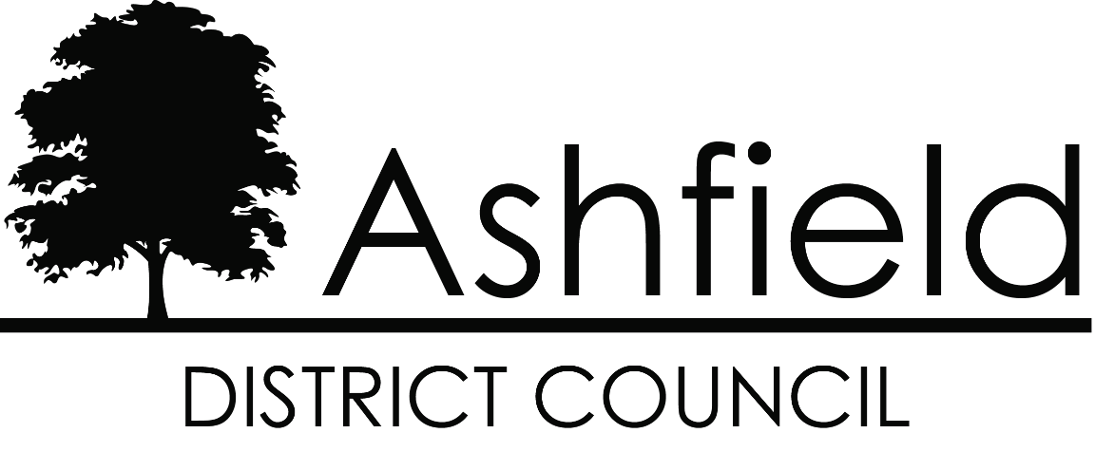

Waste Collection Policy

REVISED 2023

Introduction
Ashfield District Council is committed to delivering excellence in its provision of waste services to its residents. Through understanding what matters to residents we have determined that the purpose of our service is to help people dispose of their waste responsibly and in a sustainable way. In fulfilling this purpose Waste Services contributes to the Council’s wider corporate priority of ‘increasing community responsibility for an attractive and safe environment’.
For further information or to apply for any of the services outlined in this policy residents can:
- email environment@ashfield.gov.uk
- call 0800 183 8484

Contents

Contents 2
1. Presenting Bins for Collection 3
2. Support for Health Conditions 4
Assisted Collections 4
Medical Waste 4
3. Waste Bins 4
Additional waste receptacles 4
Replacement waste bins 4
4. Bin Provision 5
General Waste 5
Bins Not Required 5
5. Missed Collections 6
What exactly can go in the ‘green lidded’ recycling bins? 7

- Presenting Bins for Collection
Bins must be presented at the property boundary by 6am on the scheduled collection day.
Although rounds are generally undertaken in a similar order from week to week, bins may be collected at any time from 6am. Collection times can be influenced by breakdowns, traffic flow, adverse weather, etc.
Waste must be presented in the correct receptacle as set out in the table below;

Green Lidded Bin | Red Lidded Bin | Black/Brown Lidded Bin | Blue Lidded Bin
Dry recyclables | General waste/non-recyclable waste | Garden waste  (No food) | Mixed glass bottles and jars only
Where recyclables are not presented in the correct bin crews will not collect the waste and will notify the resident by placing a hanger on the bin. The non-compliant waste should be completely removed and the bin presented for collection on the next scheduled collection day. Persistent contamination may result in enforcement action being taken. Residents can request support from a Waste Advisor to help them manage their waste more effectively.
Waste must be contained within the bin with the lids closed.
Additional general (red-lidded bin) waste will not be collected, except on the first general waste collection after Christmas and during special projects delivered at specific times, such as Spring Clean. One standard bin bag of side waste will be collected.
Additional dry recyclable (green-lidded bin) waste will be collected throughout the year where it is safe to do so and where it is contained appropriately (e.g. in a cardboard box). Additional green-lidded bins may be requested if this is a regular occurrence.
Additional garden (brown-lidded bin) waste will not be collected. Extra garden waste bins can be supplied at a discount and a quotation can be provided for additional one-off collections of garden waste.
Additional glass bottles placed at side of the blue lidded bin will be collected so long as they are presented in a suitable, robust container. Additional bins will be supplied on request.

- Support for Health Conditions

Assisted Collections
Residents who have health or mobility restrictions can apply for assisted collections. Applications will be assessed, and where granted, arrangements will be made for crews to collect and return bins to the resident’s property.
Residents with assisted collections are required to ensure the crews have access to the bins, e.g., leaving gates unlocked on collection day.

Medical Waste
Residents with medical conditions that generate additional general, or recycling waste may apply for extra capacity. Where the waste is infectious a separate clinical waste collection will be provided. An on-demand sharps collection service is also provided.
- Waste Bins

Additional waste receptacles
Should residents repeatedly generate additional recyclable waste, an additional recycling bin may be requested. If collection crews recognise that residents are frequently leaving recyclable side waste, they will request that a Waste Advisor contacts the resident to offer an additional recycling bin.
Residents may contact Waste Services at any time to discuss additional general waste capacity needs. An advisor will consider each case and help to find the best solution to their issue. The Council currently provides a chargeable bulky waste collection service for additional general waste items and will continue to do so.

Replacement waste bins
Any defective bins will be repaired where possible. Bins that cannot be repaired or are beyond use through fair wear and tear will be replaced free of charge.
Missing, stolen or wilfully damaged general waste bins will be replaced at a charge of £26 (This charge will be reviewed annually). This is to cover the costs of purchasing and delivering a new bin.
The Council is committed to recycling and provides replacement recycling bins free of charge.

- Bin Provision

General Waste
In normal circumstances households with 4 or less permanent occupants will be provided with one red lidded bin of 180 litres capacity for disposal of general waste.
Households may apply for additional general waste capacity subject to the number of occupants detailed in the table below. Proof of occupancy will be required, and a waste audit may be carried out at any time to ensure full participation in all recycling schemes. Failure to comply may result in additional capacity being withdrawn.
The following table sets out the maximum general waste capacity available to households with 5 or more permanent occupants.
Number of residents in household | Bin capacity (litres)
5 | 1 x 240
6 | 2 x 180
7 | 2 x 180
8 | 1 x 240 + 1 x 180
9 | 1 x 240 + 1 x 180
10 | 2 x 240

Bins Not Required
Residents should contact Waste Services to arrange collection of any unwanted additional bins.

The Council reserves the right to remove any additional bins from households whose circumstances have changed so that they no longer qualify for additional capacity.
The Council always seeks to ensure that all Ashfield residents have the correct capacity for their waste. Where additional bins are being utilised by a particular property which have not been authorised, they will be removed.
- Missed Collections
No return will be made to bins that have been reported as ‘not out’ by the collection crew.
Where a resident reports a bin as ‘missed’ and no report has been made by the crew we will endeavour to return to empty the bin within 3 working days.

What exactly can go in the ‘green lidded’ recycling bins?
No other metal items are accepted at the Materials Recycling Facility.
No other plastic items are accepted at the Materials Recycling Facility.
Please ignore the recycling symbols on other plastic items. Whilst they may be recyclable, unfortunately no facilities or end markets exist locally for us to use.

