KINGSWAY PARK

MANAGEMENT PLAN

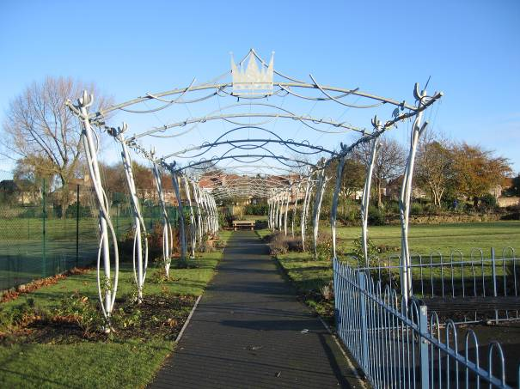

January 2017 – December 2021
(Refreshed March 2021)

Disclaimer
This document or some parts of it may not be accessible when using adaptive technology.
If you require assistance with accessing the content of the document, please contact:
email: place@ashfield.gov.uk and quote the document name and web page you found it on.

Site Location Plan

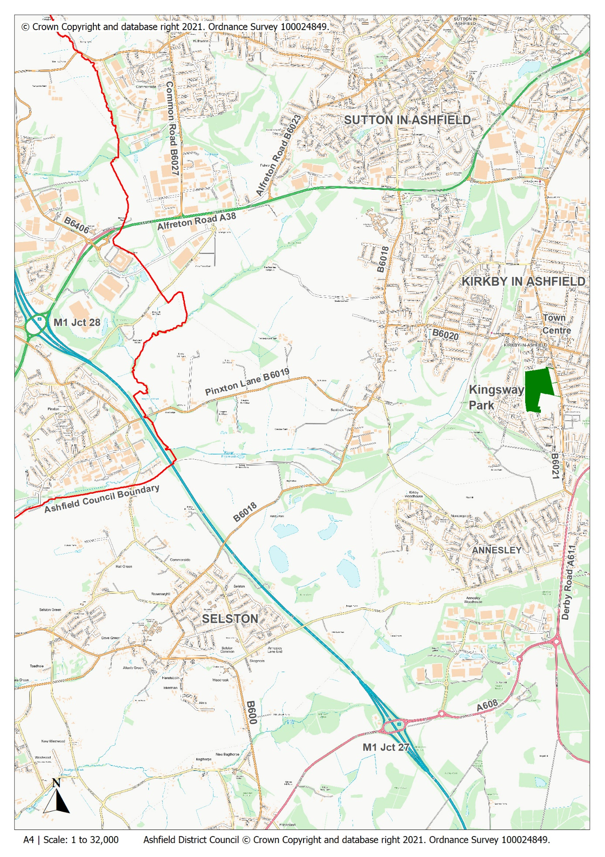

Site plan

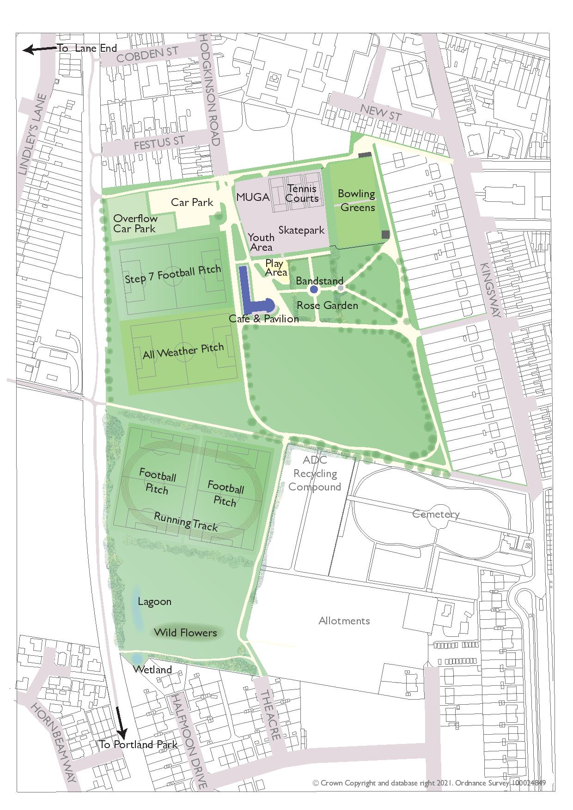

Aerial Photograph
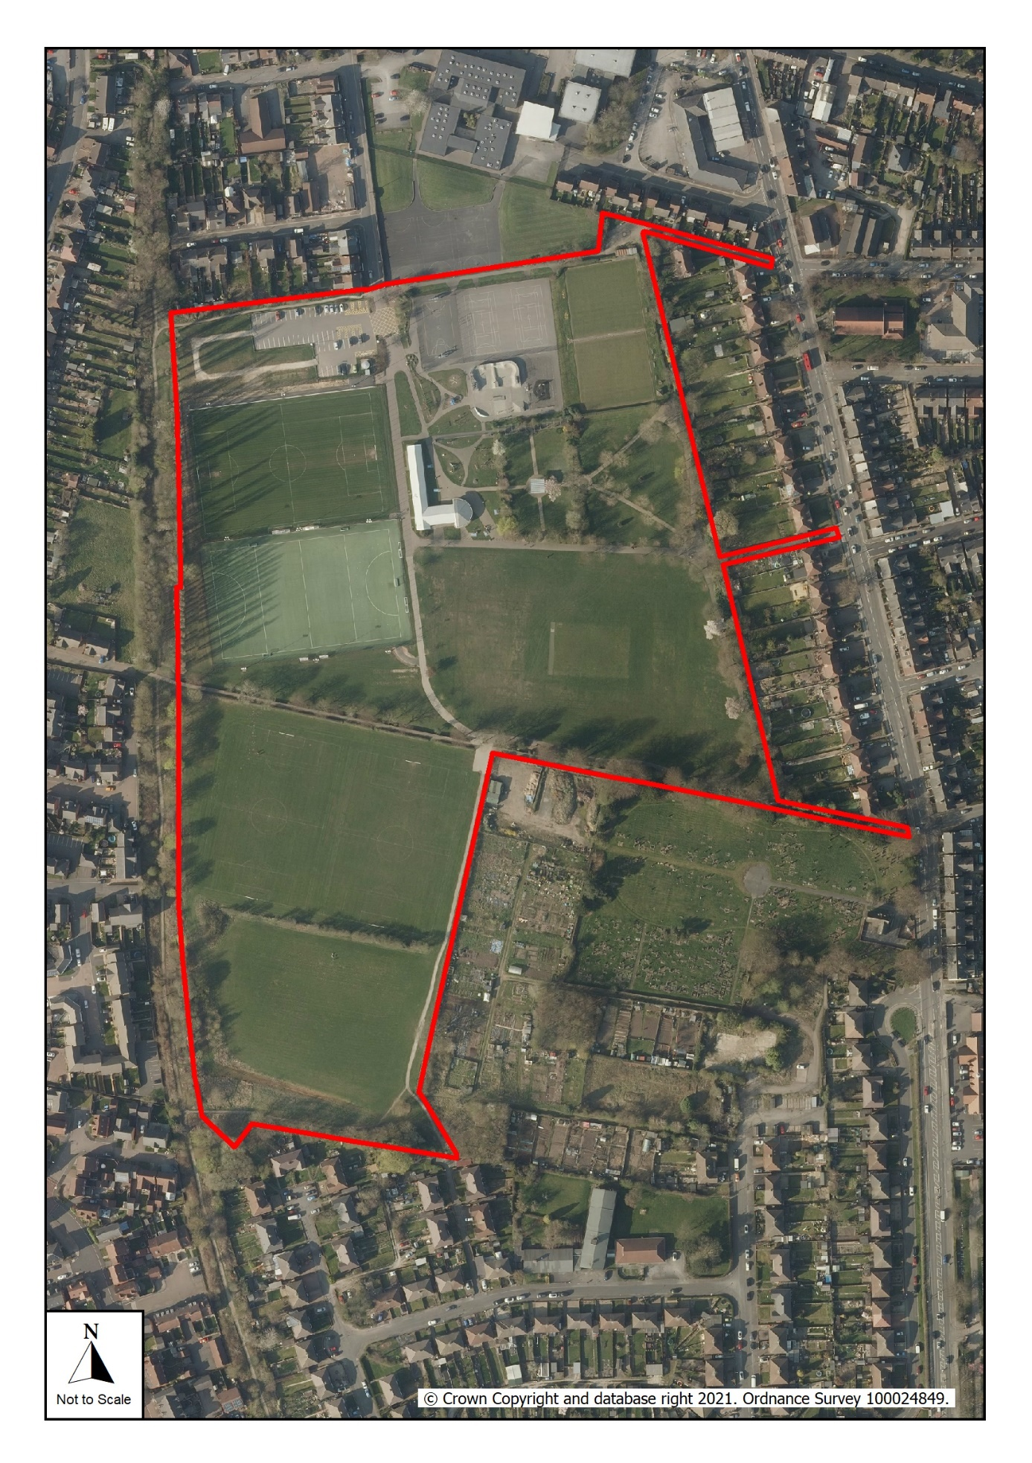

CONTENTS PAGE

- OVERVIEW

1.1 Introduction 1

1.2 Park Facilities 2

1.3 Investment 3

1.4 Heritage 4

1.5 Community Involvement 5

1.6 Landscape and Ecology 6

1.7 Green Flag Criteria 7

- DELIVERY/ IMPLEMENTATION

2.1 Action Plan 12-14

3 MONITORING/ REVIEW

3.1 Monitoring and Review 15

3.2 Contacts 15

OVERVIEW

1.1 Introduction

This management plan has been developed by Ashfield District Council in partnership with the Friends group, Acre View Café and the local community and is intended to cover the period from January 2017 – December 2021. A steering group involving all relevant sections from the Council has been set up to manage the process and carry out ongoing monitoring and review. It is intended that the plan will help to improve general maintenance of the site, plan for the future and as part of this process retain the Green Flag Award, which the park has held from 2008 to present. Details of the Council’s policies and procedures for green space management are contained within the Management Plan Overview and Supporting Information documents.

Kingsway Park, covering nearly 9 hectares, lies close to the centre of Kirkby-in-Ashfield and is the main park within the town, providing important sports and recreational facilities for local residents. The park has been subject to extensive re-development over the course of the previous 5 year management plan. The developments have included improvements to the existing play area (including the hard surfacing around the café), a new youth area, new skate park and parkour area, improvements to the existing tennis courts and MUGA, relaying of the synthetic sports pitch including new boundary fencing, improvements to the grass football pitches and upgrades to the park’s footpath network.

The housing development that is located to the west and south west of the park, (on either side of Lindleys Lane - See Context plan) which began in March 2006 and is currently nearing completion, has provided a total of £480,000 of Section 106 monies for projects across Kirkby in Ashfield.

Approximately £459,496 of Section 106 funding, together with £203,644 of external grant funding has been used to undertake improvement works to the park over the previous 5-year action plan cycle (2012 – 2016).

An additional £95,755 of both Section 106 and external grant funding has been invested into the park so far during the current 5-year action plan cycle from 2017 – 2020. Additional funding will be invested in 2021, the final year of the current cycle.

These improvements have resulted in increased visitor numbers from new residents who have moved into the adjacent housing development and from the wider Kirkby area and across the district for days out or to attend events held on the park.

Kingsway Park is one of numerous green spaces which have been progressively upgraded during the last few years, which have been funded mainly by Section 106 monies and external grant funding and is one of three main town parks within the District serving the three main urban areas, the Lawn in Sutton in Ashfield and Titchfield Park in Hucknall are the others.

1.2 Park Facilities

The park contains the following facilities:

Pavilion including a café, toilets and changing rooms
Bandstand
Rose Garden
Bowls Club House
Tennis Courts x 2
Netball Courts x 2
5-aside Football Courts x 2
Bowling Greens x 2
Multi Use Games Area
Play Area
Youth Area
Skate Park
Parkour Area
Synthetic Pitch
Football Pitches x 4
Car Park (including overflow capacity)
Grounds Maintenance Compound Area (including storage cabins and composting areas)

The park is well used by the local community, for sports and play. Kirkby College Academy, which is located adjacent to the main entrance on Hodgkinson Road use the park facilities for school sports and contribute to the maintenance of the facilities that they use.

Sports facilities include football pitches, a floodlit all-weather pitch (used for football and hockey), two tennis/netball/5-aside football courts and two bowling greens (used by 2 bowls clubs) with a club house.

It’s a Knockout – An inflatable obstacle team building course (adults only) is held over two weeknights in July providing workplace competition as part of Active Ashfield Games Programme. Unfortunately, due to the pandemic this popular event was not able to take place in 2020; it is hoped that it will return in 2021.

More informal facilities are provided such as a skate park, parkour area, multi-use games area (basketball/football), children’s play area, youth area and balance trail together with picnic tables and seating areas. The play and youth equipment is inspected by RoSPA qualified council officers and annually by an independent RoSPA qualified playground inspector.

The bandstand forms the focal point within the rose garden and is often hired out for community events. Other features include entrance archways and additional seating around the edge, recessed into the stone walls and herbaceous borders.

The park is very accessible for local residents. Pedestrian access is available from Kingsway via the three heritage archways to the east, the main heritage entrance archway from Hodgkinson Road to the north, numerous points along the reclaimed railway line which runs along the west side of the park (providing a popular route for walkers to Portland Park and Titchfield Park) and residential areas to the south and west.

The Acre View Café is open to the public, for current opening times please check the cafés Facebook Page, details can be found in the contacts section of this management plan. The café is currently leased to a local, independent business woman serving drinks, hot and cold food and a variety of homemade cakes.

The following sports clubs use the park for training/ matches:

Bowls Clubs  Kirkby Investment Bowls Club  Sutton and Kirkby Bowls Club | Cricket Clubs  Mansfield Hosiery CC
Football Clubs  Ashland Rovers FC  Beaufort United FC  Kirkby Cobras  Kirkby Colts FC | Hockey Clubs  Ashfield Aztecs  Mansfield Hockey Club  Meridian Hockey Club  Other  Kirkby College – Summer and winter sports and athletics

1.3 Investment during previous 5 year Action Plan

Capital Works | Cost (£) | Funding | Date
Entrance to Grounds Maintenance Compound | 13,720 | s106 | 2011/12
Skate Park and Parkour Area | 89,961  49,999  40,000 | s106  Lottery  WREN | 2011/12
Café Gardens improvements to the paving and grass areas | 29,690  12,000 | s106  NCC LIS | 2012/13
Footpaths | 30,500 | s106 | 2012/13
Overflow Car Park | 16,600 | s106 | 2012/13
Tennis Courts | 61,220 | s106 | 2012/13
Bandstand including electrical connection | 51,645  3,390 | NCC LIS  s106 | 2012/13
Rose Garden improvements including stone wall repairs, seating and Memorial Bench | 4,415 | s106 | 2012/13
Play and Youth Area | 60,000  50,000 | s106  WREN | 2014/15
Synthetic Pitch – New carpet and fencing | 150,000 |  | 2014/15
Sub-total | 459,496 | s106 | 2011-16
Sub-total | 203,644 | Grant Funding | 2011-16
TOTAL | £663,140 |  | 2011-16

1.4 Heritage

The park was laid out in 1930 on land sold to Kirkby in Ashfield District Council by a Miss Catherine Hodgkinson of Kirkby House. The land was to be used and maintained as a public playing field for the community. Prior to this the site was used as grazing land for horses and was known locally as ‘16 Acre Field.’ The Acre - the street at the southern end of the park takes its name from this and the park is often referred to locally as ‘the Acre’. Local knowledge confirms that the layout of the park changed very little between 1938 and 1976. Poplars were an important landscape feature, lining the drive from the main entrance on the east side of the park, the western perimeter with the LMS railway line (many survive to this day), and to the north as far as the Hodgkinson Road entrance. A mixed row of oak and ash and other native trees bordered the remainder of the northern perimeter. Ornamental trees formed avenues within the park. A feature of the park (no longer present) was the eight timber shelters which provided seating for visitors, one of the shelters was turned into a pavilion for cricketers.

As part of the original layout there were eight tennis courts, two large bowling greens, putting greens, areas for netball and hockey, two football fields, a kick about area and a large aviary. There was a large play area and a paddling pool/sand pit, children’s toilets and changing rooms. A central building provided refreshments, showers, toilets and a ticket office for equipment hire. Sunday band concerts were held. The garden area was laid out as a rose garden with a small pond. World War II saw a reduction in staff and the gradual decline of the park, by the 1970’s the play area was run down and staff cuts during government reorganisation in 1974 led to further problems. In 1971 there were 8 men based on the park, but this number reduced significantly during the 1970s and 80s.

In 1977 the northern end of the park was given over to the school, the play area which had been sited here was relocated on four of the tennis courts. A new all-weather pitch for the school was also developed within the park. The pond within the rose garden was replaced by a rose pergola, which itself was removed several years later. The timber shelters were removed in the late 1990s/early 2000s after falling into disrepair and suffering from vandalism.

The main important heritage features that remain, which are recorded on the Local Heritage Asset List, are the main shared vehicular and pedestrian access gates and archway on Hodgkinson Road, the smaller shared vehicular and pedestrian access gates and archway and the two sets of pedestrian access gates and archways on Kingsway.
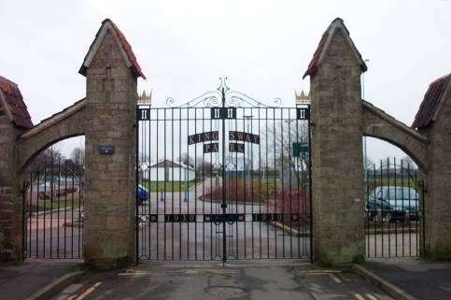
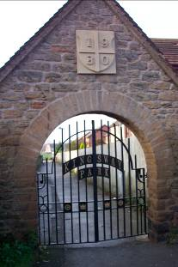

Entrance from Kingsway
Main entrance gates off Hodgkinson Road
1.5 Community Involvement

The Friends of Kingsway Park were constituted in 2004 and have played a varied and active role in supporting the development of the park. They have supported funding applications submitted to external grant funding organisations by acting as a third party funder. This has assisted the council to access over £200,000 of external grant funding during the previous five year action plan (2012 – 2016) with an additional £41,000 secured so far during the current 5-year action plan cycle (2017 – 2020) .

Both the local schools, Kingsway Primary School and Kirkby College Academy, have taken part in consultation sessions held to establish what new facilities children and young people wanted to have on the park. Their involvement proved invaluable in securing external grant funding for the new skate park/parkour area and new play and youth areas demonstrating community support for the applications.

Pupils from Kingsway Primary School have previously participated in bulb planting sessions on the park; they assisted the Kirkby Branch of the Rotary Club plant purple crocus bulbs to form the Rotary Logo as part of the club’s ‘End Polio Now’ campaign.

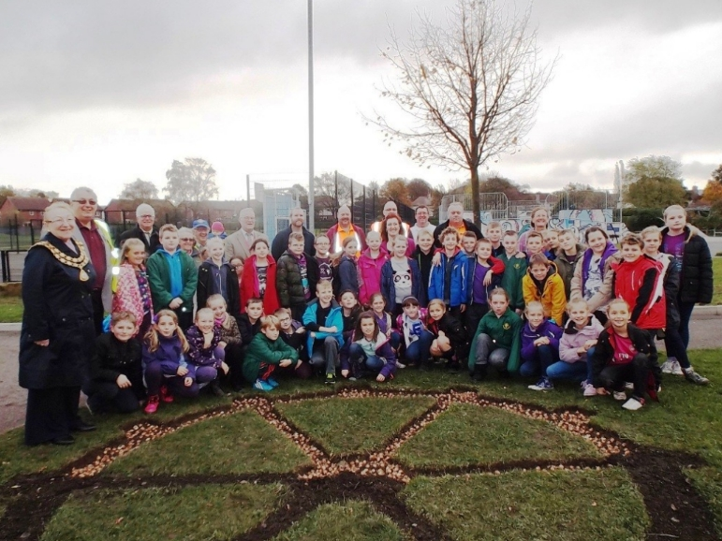

Pupils from Kingsway Primary School planting crocus bulbs – part of the End Polio Now campaign

‘Green Buddies’ from Morven Park, Abbey Hill and Orchard Primary Schools took part in a park awareness event combined with the Green Flag Raising Celebration. The event included tidying flower beds, litter picking and park appreciation activities.

1.6 Landscape and Ecology

To date there have been no habitat/species surveys undertaken at the site and therefore thee aim of undertaking a survey is included within the Action Plan. Although the site does have some wildlife interest at present, one of the aims of the plan is to increase this interest and value.

The major known habitat types present at the site are: mixed and broadleaved planted trees, hedgerows, standing water (run off retention). There are a number of planting compartments which were planted as part of the improvement works to the park in the early 2000’s which are now reaching maturity. In addition there is a block of trees between the former railway line and the west side of the park. Around the edges of the original park area there are broad shrub beds containing a variety of ornamental species and specimen trees.

A water retention area and small pond have been created at the south west corner of the park to prevent the flooding of adjacent housing; the pond is dry in summer. Drainage of the football pitches runs into this area where a soakaway was constructed as part of the works to improve the drainage of the football pitches. However the effectiveness of the soakaway has been limited, hence the creation of the pond and retention area. A drainage ditch runs adjacent to the pond.
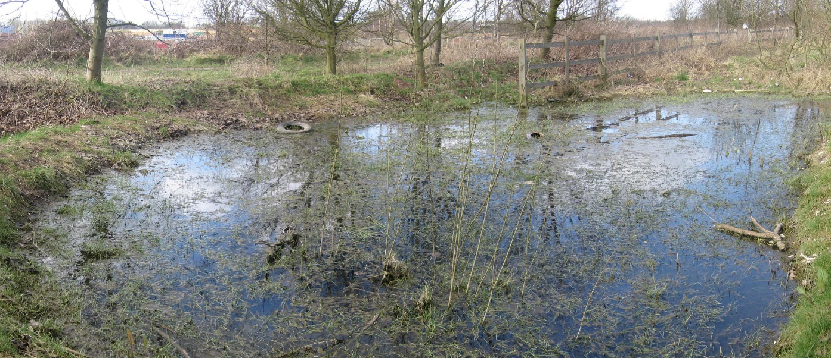

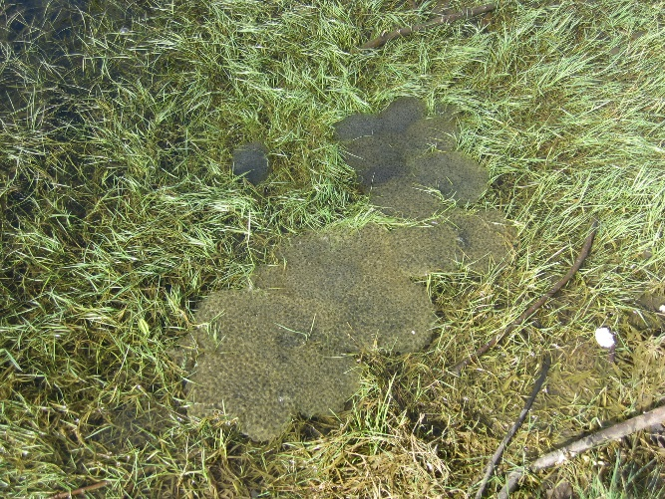
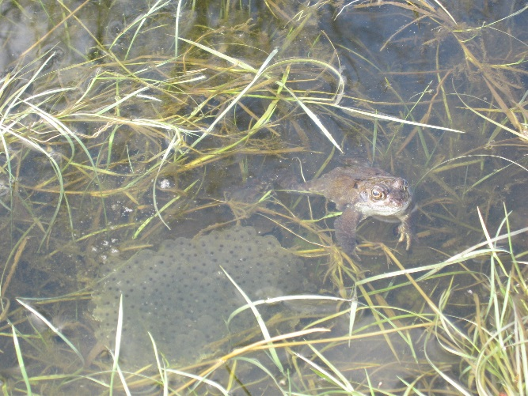
Frog spawn laid in the wetland
Frogs in the wetland
Wetland area in south west corner of the park
1.7 Green Flag Criteria

The Green Flag Award is the benchmark national standard for parks and green spaces in the UK. In order to achieve the award green spaces need to meet eight key criteria. The table below shows how the park meets the criteria.

1. A welcoming place
Good and safe access | - Vehicular via main entrance (if required via Kingsway)  - 3nr pedestrian access points from Kingsway, 1nr from The Acre, via the main entrance and via numerous points along the former railway line including Ronchin Gardens  - Disabled parking in car park  - Disabled access to cafe  - Welcoming, friendly environment with enthusiastic staff  - Drinks, snacks, hot and cold food served daily  - Café Garden area contains 4nr picnic benches  - Paths around the park upgraded during the previous 5 year action plan  - Well linked to surrounding footpath network via former railway line and ROW Kirkby FP 57
Good signage to and in the park/green space | - Brown tourism signs installed at junction of Station Street and Hodgkinson Road  - Entrance signs/directional signage within park
Equal access for all members of the community | - Disabled parking in the car park  - Disabled access to café  - Picnic benches provide access for wheelchairs  - Inclusive play equipment included  - All paths are fully accessible

2. Healthy, Safe and secure
Equipment and facilities must be safe to use | - Comprehensive inspection regime is detailed in the Management Overview
It must be a secure place for all members of the community to use or traverse | - Lighting is provided outside the café and around the formal areas of the park  - Council staff undertake regular maintenance  - Café lease holder is on site daily  - Park is patrolled by the Council’s Community Protection Officers as necessary  - CCTV situated at main entrance  - Park Keeper on site every day (Mon – Fri)
Dog fouling must be adequately addressed | - Policy information is within the Management Overview
Health and safety policies should be in place, in practice and regularly reviewed | - The Council has up to date policies which are regularly reviewed, further information is within the Management Overview
Toilets, drinking water, first aid, public telephones and emergency equipment where relevant should be available in or near the park/green space, and be clearly signposted | - Toilets are provided within the café  - There is a phone for emergency use

3. Well maintained and Clean
Litter and other waste management | - Green waste is composted onsite within the grounds maintenance compound  - Further policy information is within the Management Plan Overview
The maintenance of grounds, buildings, equipment and other features | - Policy information on asset management is provided within the Management Plan Overview
A policy on litter, vandalism and maintenance should be in place, in practice and regularly reviewed | - Policy information on asset management is provided within the Management Plan Overview

4. Environmental Management
An environmental policy or charter and management strategy in place, which is in practice and regularly reviewed | - The Council has a policy in place within the Management Plan Overview
Minimise and justify pesticide use | - Pesticide use is kept to a minimum within the park
Eliminate horticultural peat use | - Horticultural peat is not used on the park
Recycle waste plant material | - Green waste is composted on site within the grounds maintenance compound
Demonstrate high horticultural and arboricultural standards | - The park is maintained to the Council’s standards, details are provided within the Management Plan Overview
Have energy conservation, pollution reduction, waste recycling, and resource conservation measures | - The Council actively seeks to reduce the environmental impact of green space management in Ashfield  - All energy consumption is recorded and compared against targets. This programme is undertaken by the Asset Management team within the Council

5. Biodiversity, Landscape & Heritage
Particular attention should be paid to the conservation and appropriate management of:  Natural features, wildlife and fauna | - Bird boxes have been provided in the park  - Records of birds, bats, invertebrates and flora require updating.
Landscapes | - No records of the original park planting design have been found  - Tree management plan in place
Buildings and structural features | - Stone Archways and stone walls form the main heritage features within the park  - Unfortunately none of the other original features within the park survive

6. Community Involvement
The park/green space management should actively pursue the involvement of members of the community who represent as many park/green space user groups as possible | - Friends group supports the park  - Local groups and schools use the park  - Volunteer opportunities are being explored  - The café supports community use of the park
Knowledge of user community and levels and patterns of use | - Public consultation has been carried out as part of the revision of the new 5 year action plan  - A user survey undertaken annually
Evidence of community involvement in management and/or developments and results achieved | - Friends group and Café are involved in the annual review of the action plan  - Public consultation carried out annually to inform annual review and update of the action plan.  - All comments and ideas are considered and where appropriate incorporated into the plan
Appropriate levels of provision of recreational facilities for all sectors of the community | - The park is popular with sports enthusiasts (football, hockey & bowls), families, children and young people, (dog) walkers and nature lovers  - The park as a whole provides opportunities for educational visits from local schools

7. Marketing and Communication
A marketing strategy should be in place, which is in practice and regularly reviewed | - The Council has a parks and green spaces marketing strategy in place which can be found within the Management Plan Overview
There should be good provision of information to users, e.g. about management strategies, activities, features, ways to get involved | - Information is available on the Council’s website
The park/green space should be promoted as a community resource | - Information is available on the Council’s website

8. Management
A management plan or strategy should be in place | - The action plan is reviewed annually and the management plan is revised every 5 years
The plan must be actively implemented and regularly reviewed | - The action plan is reviewed annually and the management plan is revised every 5 years
A financially sound management of the park/green space must also be demonstrated | - The park is managed as part of the Council’s green space assets and does not have separate budgets

  - Kingsway Park Action Plan
KEY:
PT: Place Team AI: Assets & Investments S106: Developer Contributions ● To be completed
NE: Neighbourhoods & Environment CS: Community Safety Complete Incomplete/ in progress

VOL: Volunteers TBI To be identified

AIM 1: CREATE A WELCOMING PARK

Objectives | Action | Delivery |  |  |  |  | Resources | Lead
A Welcoming Place |  | 22 | 23 | 24 | 25 | 26
Welcoming | Improve floral displays at all entrances into the park and formal garden areas on a 5-year cycle | ● |  |  |  |  | Revenue | NE
 | Reduce use of seasonal bedding plants, replace with perennial planting and bulb planting where appropriate | ● | ● | ● | ● | ● | Revenue | NE
 | Re-paint school railings on a five-year cycle | ● |  |  |  |  | Revenue | NE
 | Paint access gates to overflow car park and from Ronchin Gardens on a 5-year cycle | ● |  |  |  |  | Revenue | NE
 | Improve the entrance into the park from Hodgkinson Road to reduce conflict between vehicles and pedestrians |  |  | ● |  |  | S106 | PT
Good and safe access – improvements to be made to co-inside with completion of Towns Fund project proposals | Refresh parking bays and cross hatching in car park on a 5-year cycle |  | ● |  |  |  | Revenue | NE
 | Upgrade crushed stone roadway through overflow car park to tarmac |  | ● |  |  |  | S106 | PT
 | Upgrade overflow car park from grass reinforcing mesh to eco-grid so car park can be used year-round |  |  | ● |  |  | S106 | PT
 | Undertake a conditions survey of the footpaths around the park and develop a five-year cycle of repair, maintenance and resurfacing as required |  |  | ● |  |  | S106 / Revenue | PT / NE
Signage | Explore options for installing park notice boards providing a park map and information regarding facilities, events and pitch locations |  | ● |  |  |  | S106 | PT
 | Explore options for installing vehicle speed limit signs at main entrance |  | ● |  |  |  | Revenue | NE
Equal access for all | Replace A-frame motorcycle barriers with chicane style access improvement at The Acre & Ronchin Gardens entrances | ● |  |  |  |  | S106 | PT
 | Refresh access audit for the park and implement recommendations where appropriate | ● |  |  |  |  | S106 | PT

AIM 2: ENSURE THAT THE PARK HAS GOOD FACILITIES THAT ARE SAFE AND SECURE

Objectives | Action | Delivery |  |  |  |  | Resources | Lead
Healthy, Safe & Secure |  | 22 | 23 | 24 | 25 | 26
Appropriate provision of quality facilities and activities | Bowls Pavilion  Build a new energy efficient bowls pavilion to accommodate relocated teams from other sites, provide new accessible facilities and relocate to a more prominent location providing improved access to the bowling greens |  | ● |  |  |  | Towns Funding | PT
 | Changing Rooms  Replace the existing with a new energy efficient building providing adequately sized and accessible facilities as required by sports teams |  | ● |  |  |  | Towns Funding | PT
 | Pitch Lighting  Upgrade the floodlighting on the synthetic pitch and adjacent grass pitch to LED to reduce carbon emissions, running costs and improve the playing experience |  | ● |  |  |  | Towns Funding | PT
 | Court Lighting  Explore options for installing lighting to tennis/netball courts and skate park |  |  |  |  | ● | S106 | PT
 | Youth Area  Explore options for improving the parkour area behind skate park – change to scoot park |  |  |  | ● |  | S106 | PT
 | Play & Youth Area  Replace old equipment with new as current equipment comes to the end of its life expectancy |  |  | ● | ● | ● | S106 | PT
Safe equipment and facilities | Sports Pitches  Continue to improve the quality of the sward and drainage of the football pitches | ● | ● | ● | ● | ● | Revenue | NE
 | Improve drainage at the southern end of the park and create 2nr full-size football pitches |  | ● |  |  |  | Towns Funding | PT
 | Work with local community football team to attract further investment and continue to improve the stadia around pitch 1 | ● | ● | ● | ● | ● | S106 / external funding | PT
Personal Security | Continue to liaise with police, community protection officers regarding issues that arise | ● | ● | ● | ● | ● | n/a | NE / CS
 | Continue to improve and maintain sight lines across the park to increase natural surveillance | ● | ● | ● | ● | ● | Revenue | NE
Control of dogs / dog fouling | Ensure current Public Space Protection Orders are in place and signage displayed | ● | ● | ● | ● | ● | Revenue | NE
 | Continue regular patrols and issue fines to offenders | ● | ● | ● | ● | ● | n/a | CS
 | Continue to monitor dog fouling and continue to top up free dog poo bags on site | ● | ● | ● | ● | ● | Revenue | NE

AIM 3: ENSURE THAT THE PARK IS WELL MAINTAINED AND CLEAN

Objectives | Action | Delivery |  |  |  |  | Resources | Lead
Well Maintained and Clean |  | 22 | 23 | 24 | 25 | 26
Litter and waste management | Review the number and condition of the bins on site |  | ● |  |  |  | n/a | NE
 | Develop and implement a bin replacement strategy for the park |  |  | ● |  |  | Revenue | NE
Horticulture maintenance | Review the condition, quality and age of planting throughout the park | ● |  |  |  |  | n/a | NE
 | Develop and implement a horticulture strategy for the park prioritising key, visual impact areas |  | ● |  |  |  | Revenue | NE
Arboricultural maintenance | Undertake a detailed arboricultural survey of all trees on the park complete with management recommendations for 6mths / 1 yr / 2 yrs | ● |  | ● |  | ● | Revenue | NE
Building and infrastructure maintenance | Continue essential building maintenance whilst detailed plans are developed for new bowls pavilion and changing rooms | ● | ● | ● | ● | ● | Revenue | AI
Equipment maintenance | Continue with annual independent / fortnightly in-house inspections of play and youth facilities | ● | ● | ● | ● | ● | Revenue | NE
 | Inspect, maintain and repair sports equipment such as football goals, hockey nets, tennis nets and sports fencing | ● | ● | ● | ● | ● | Revenue | NE

AIM 4: ENSURE APPROPRIATE MANAGEMENT OF BIODIVERSITY, LANDSCAPE AND HERITAGE FEATURES

Objectives | Action | Delivery |  |  |  |  | Resources | Lead
Biodiversity, Landscape & Heritage |  | 22 | 23 | 24 | 25 | 26
Management of natural features, wild fauna and flora | Wetland  Continue to improve wetland areas creating valuable wildlife habitat to include rotational coppice of willows and additional planting | ● |  | ● |  | ● | Revenue | NE
 | Wildflowers  Improve the quality of wildflower areas by treating and eradicating perennial weeds and re-seed with wildflowers | ● | ● | ● | ● | ● | Revenue | NE
 | Nest boxes  Explore options for installing bird / owl / bat boxes around the park; encourage involvement from local schools and community groups | ● |  |  |  | ● | S106 | PT
 | Hedgerows and plantation blocks  Produce a maintenance plan for trees, hedgerow and woodland areas on a 5-year cycle |  |  | ● |  |  | Revenue | NE
Conservation of buildings & structures | Heritage archways and stone walls  Inspect the archways and stone walls to the perimeter of the park and rose garden a minimum of 1x per year and carry out any necessary repairs | ● | ● | ● | ● | ● | Revenue | NE / AI
 | Re-paint the heritage gates on a 5-year cycle |  |  |  |  | ● | Revenue | NE / AI
 | Feature Structures  Carry out an annual inspection of the bandstand, arches and pergola within the rose garden and carry out any necessary repairs | ● | ● | ● | ● | ● | Revenue | AI

AIM 5: ENCOURAGE AND SUSTAIN COMMUNITY USE AND INVOLVEMENT

Objectives | Action | Delivery |  |  |  |  | Resources | Lead
Community Involvement |  | 22 | 23 | 24 | 25 | 26
Community involvement  in management & development | Volunteers  Attract new volunteers to the park, identify volunteer activities and carry out practical tasks | ● | ● | ● | ● | ● | n/a | PT / NE
Appropriate provision for community | Undertake a user survey before and after the sports hub has been developed to gain valuable insight in community provision and use | ● |  | ● |  |  | n/a | PT

AIM 6: ENSURE THE PARK IS MARKETED AS A DESTINATION SITE

Objectives | Action | Delivery |  |  |  |  | Resources | Lead
Marketing and Communication |  | 22 | 23 | 24 | 25 | 26
Marketing and promotion | Develop a marketing and promotional strategy for the park – to be included in the District wide digital information offer | ● | ● | ● | ● | ● | n/a | PT / NE
Educational and interpretational information | Refresh the historical and interpretational displays for the park and display within the new building |  |  | ● |  |  | n/a | PT

3 MONITORING/ REVIEW

3.1 Monitoring and Review

The management plan will be reviewed and updated every five years; the action plan will be reviewed annually to monitor progress. This process will be carried out in September to feed into the Council’s business plan cycle. The results of the process will give the opportunity to assess the overall success of the management plan and whether additional funding and resources are required. A site inspection will be carried out during August / September to check whether any additional works are required, which will then be added to the work programme / Action plan, as appropriate.

3.2 Contacts

Kingsway Park
Hodgkinson Road
Kirkby in Ashfield
Nottinghamshire
NG17 7DJ

Email: environment@ashfield.gov.uk
0800 183 8484

www.ashfield.gov.uk

Café - The Acre View Cafe
Telephone: 07957 710 801 (contact Angie)
via facebook - The Acre View Cafe Kingsway Park

Friends of Kingsway Park

via facebook – Friends of Kingsway Park, Kirkby-in-Ashfield

To find out more about Environmental Volunteering opportunities, please contact the Community Engagement Officer:

Donna Mellar: 01623 457 448 / donna.mellar@ashfield.gov.uk

