# Ashfield District Council Logo

# Annual Monitoring Report

# 2023 to 2024

# CONTENTS Page

District Background **1**

Figure 1 – Map of the District 1

Census 2021 2

Table 1 – Population Change 3

The Index of Multiple Deprivation 4

Figure 2 - Ashfield Map of deprivation 4

Health and Happiness **6**

Table 2 – Health **6**

HOMES AND HOUSING **7**

Table 3 – Housing **7**

Affordable Home Acquisitions and Losses **7**

Table 4 – Affordable Housing **7**

# ECONOMIC GROWTH AND PLACE 8

## Flood Risk 8

## Planning Application 8

## Table 5 – Planning Application 8

## Table 6 – Major Application 9

## Table 7 -Minor Applications 9

## **Planning Appeals** 9

## Table 8 – Planning Appeals 9

## **Regeneration** 11

Table 9 – External funding for regeneration **11**

Developer Contributions **12**

Table 10 – Developer Contributions **12**

Table 11 – The Economy **12**

# Employment 13

# NEIGHBOURHOOD 14

Table 12-Recorded Crime **14**

Ashfield’s Local Plan 15

Ashfield Local Plan Review 2002 15

Planning Contributions **14**

## Statement of Community Involvement (SCI) 15

## The Emerging Local Plan 16

## Ashfield Social Value Policy 17

# District Background

Ashfield is ideally situated in the heart of the country, situated on the M1 directly between the cities of Nottingham, Derby and Sheffield. Nestled on the edge of beautiful countryside, with three towns and a number of rural villages it is renowned for its welcoming, supportive and passionate communities. The area is complemented by a wide variety of award-winning parks and outdoor spaces, a range of sporting facilities, educational activities, cafes and natural environments to relax and enjoy.

The three town centres in Ashfield; Hucknall, Kirkby and Sutton provide a great variety of shops and services. With low cost, easy to access parking and well served by public transport links. Hucknall is on the NET Nottingham tram network and is the most northerly stop on the green line. There are three railway stations in the district, along the Robin Hood line, connecting with Worksop (to the North) and Nottingham (to the South).

Rich in natural, cultural and industrial heritage, Ashfield is the home of a number of historical and cultural/ literary figures, most notably Lord Byron and his daughter Ada Lovelace, regarded as being the first ever computer programmer. The area has miles of way-marked rural walks, cycle paths and bridleways nestled amongst wooded areas and open countryside. Areas of countryside within the district are much of what D. H. Lawrence referred to as “The country of my heart” and based many of his novels around the places and families of the area. The villages of Jacksdale, Underwood, Bagthorpe, Lower Bagthorpe, Selston, Annesley, Ravenshead, Newstead, Linby and Papplewick are set within the Hidden Valleys landscape.

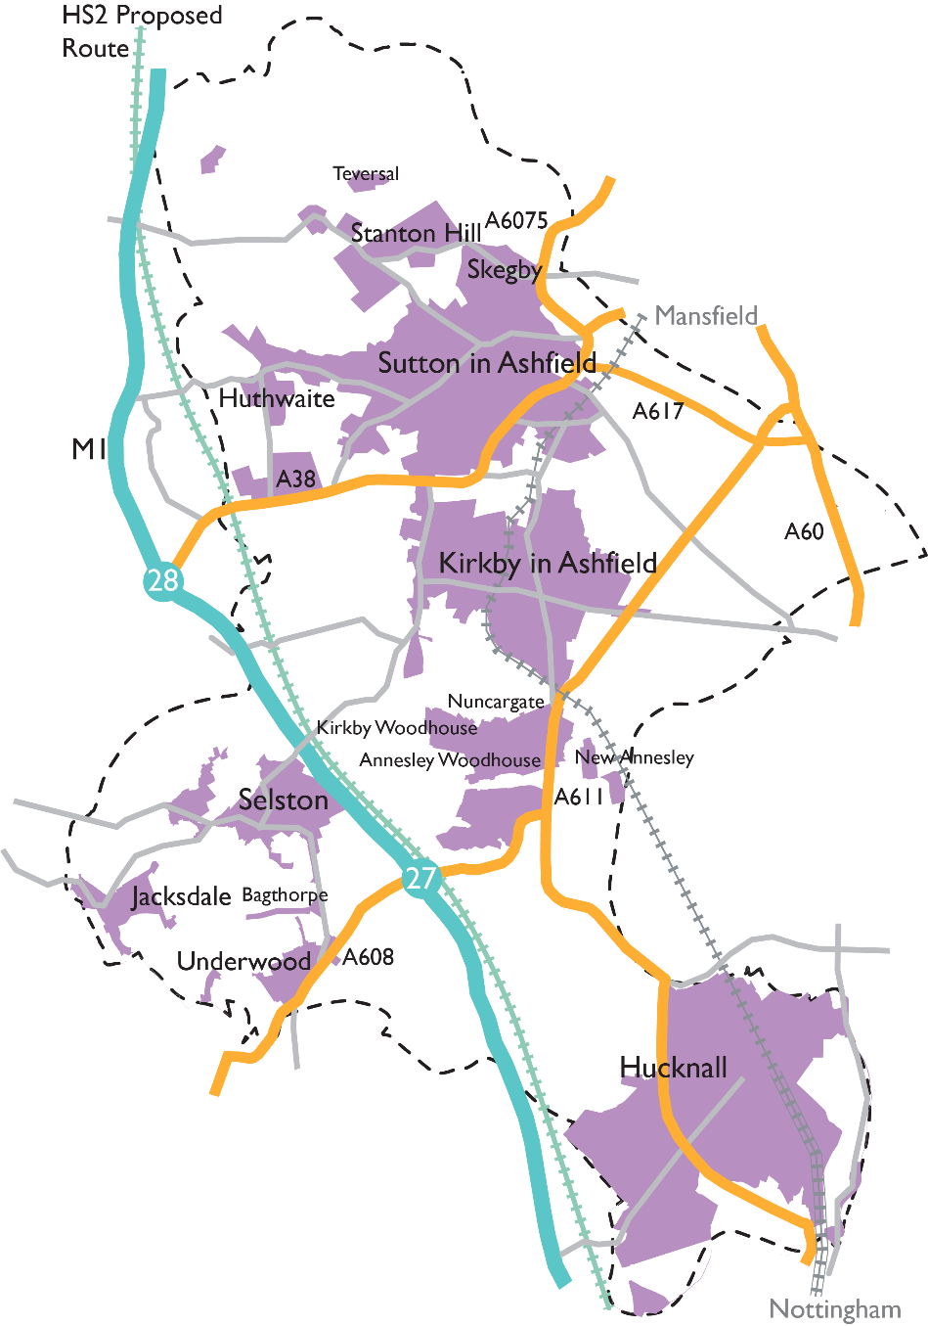

Figure 1 Map of the district

## 

# CENSUS 2021

In Ashfield, the population size has increased by 5.7%, from 119,497 in 2011 to 126,305 in 2021. This is lower than the overall increase for England with a 6.6% increase. The increase for the East Midlands is 7.7%.

There were 54,500 households with at least one resident, an increase of 3,600 since 2011.

There are 1,153 people per square kilometre, 1,091 in 2011

## Age

The median age on Census day was 42 years, 41 in 2011

61.7% of the population are aged 16-65, an increase of 1.8% from 2011

19.7% of the population are over 65 an increase of 22.5% from 2011

18.6% are 15 years or younger, an increase of 4% from 2011

The United Kingdom was the place of birth of 94.3% of the resident population.

## Households

66.3% are single family households

29.4% are one person households

4.3% are other household types

43.6% of people aged over 16 are living as a couple (47.9% in 2011)

17.6% are co-habiting (14.5% in 2011)

23.1% not living as a couple: single (21.3% in 2011)

## Ethnicity

95.1% of the population identified as White (97.7% in 2011)

1.6% identified as Asian or Asian British (0.9% in 2011)

1.2% identified as Black, Black British, Caribbean, or African (0.4% in 2011

1.6% identified as Mixed or Multiple ethnic groups (0.9% in 2011)

0.4% identified as other ethnic group (0.1% in 2011)

## Religion

50.3% have no religion (33.8% in 2011)

42% identified as Christian (58.2% in 2011)

## Language

96.4% of households had English as their main language

1.9% of households had had no people who have English as a main language

Table 1 The Population of Ashfield Census 2011 and Census 2021

## Population 2023

|  |  |  |  |  |
| --- | --- | --- | --- | --- |
|  | All People | Aged 0-15 | Aged 16-64 | Aged 65+ |
| Ashfield | 128,360 | 18.5% | 61.6% | 19.9% |
| East Midlands | 4,934,900 | 18.1% | 62.2% | 19.8% |
| East Midlands Combined Authority | 2,251,679 | 17.8% | 62.4% | 19.8% |

## The Index of Multiple Deprivation

A revised Index of Deprivation was released in 2019.

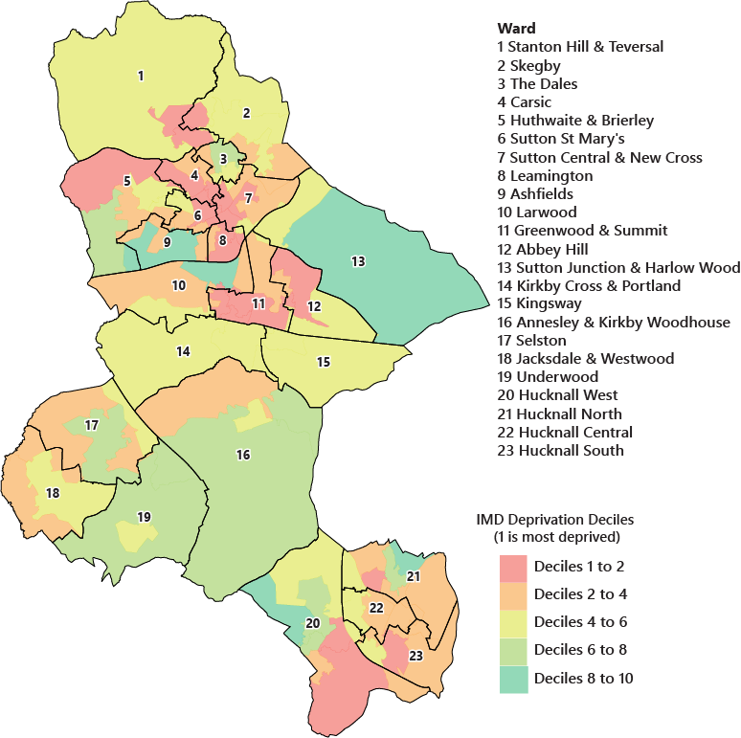The index measures the overall prevalence of deprivation in Local Authorities and small areas (Lower Super Output Area’s) based on 7 domains.

Figure 2 Map showing the Index of Multiple Deprivation 2019

* Health
* Income
* Employment
* Education
* Crime
* Living environment
* Barriers to housing and Services

There are also two sub-groups concerning older people and children.

Based on the domain scores each area is given an overall score. These scores are then ranked nationally. 1 is the most deprived. The district of Ashfield is ranked 63rd out of 317 local authorities. As a comparison, Rushcliffe Borough Council in the south of Nottinghamshire is ranked 314.

The most deprived area in the district is the Leamington Estate in Sutton in Ashfield and the least deprived the Ashfields Estate also in Sutton in Ashfield. However, this description does not apply to every person living in these areas. Many non-deprived people live in deprived areas, and many deprived people live in non-deprived areas. It is important to note that the IoD2019 is designed to identify and measure specific aspects of deprivation, rather than measures of affluence.

To explore the Index of Multiple Deprivation further, click this link here.

# Health and Happiness

The picture of the health of Ashfield is not overall positive, but trends of life expectancy, adult obesity, children in poverty, and smoking prevalence have improved over recent years.

|  |  |  |  |  |  |
| --- | --- | --- | --- | --- | --- |
| Health Data | Period | Ashfield | | East Midlands | |
| Obesity Aged 10-11** | 2023-2024 | **26.2%** | é | **19.8%** | ê |
| Overweight or obese adults | 2022-2023 | **73.3%** | é | **66.8%** | ê |
| Children in low-income families* | 2022-2023 | **28.4%** | é | **21%** | é |
| Life expectancy at birth – male *** | 2021-22 | **76.4** | ê | **79.6** | é |
| Life expectancy at birth – female*** | 2021-22 | **82.2** | é | **83** | é |
| Life expectancy at age 65 – male *** | 2021-22 | **17.8** | é | **18.9** | é |
| Life expectancy at age 65 – female *** | 2021-22 | **20.6** | é | **20.9** | é |
| Percentage adults who are active**** | 2022-2023 | **63.7%** | é | **67.1%** | é |
| Percentage adults who are inactive**** | 2022-2023 | **24.2%** | é | **22.1%** | ê |
| Smoking prevalence in adults (18+) (2020 definition)** | 2023 | **6.9%** | ê | **10.7%** | ê |
| Winter mortality index** | 2020-2021  * Relative poverty, below 60% of the average income *** Office for National Statistics  ** Public Health England **** Sport England | **6.8** |  | **6.6** |  |

**Table 2 - Health**

The District and our communities are changing, and we recognise the need to build stronger, more resilient communities that can come together to provide help and support to each other. It also means focusing on some of our most deprived neighbourhoods to make sure that everyone has the same opportunities to achieve their goals and lead happy and healthy lives.

# HOMES AND HOUSING

Many homes in the district are owner occupied and in good condition. The Council is proactive in supporting owners to return empty properties back to occupation and fixing signs of disrepair.

* Ashfield has 58,059 homes (from Council Tax). 7% of these properties are in Band D and 54% in Band A. Across the East Midlands band D contains 10.8% of properties and Band A 37%

|  |  |  |  |  |  |
| --- | --- | --- | --- | --- | --- |
| Housing Data | Period | Ashfield | | East Midlands | |
| Average house price | 2024 Q2 | £195,271 | ê | £245,232 | ê |
| Mean monthly private rent | 2022-2023 | £627 | é | £694 | ê |
| Affordability ratio* | 2023 | 1:6.04 | é | 1:7.14 | ê |

**Table 3 - Housing**

*Median house price to median earnings

## Affordable Home Acquisitions and Losses

|  |  |  |
| --- | --- | --- |
| 2023-24 | Loss | Gain |
| Right to Buy scheme | 21 ê | - |
| New build owned & built by Ashfield District Council | **-** | 62 é |
| New build from developer contributions transferred to Ashfield District Council | - | 0 é |
| Acquisitions from the private sector | - | 15 é |

* In the private sector there were 451 net housing completions in 2023-2024, a increase in 100 homes from 2022-2
* 104 affordable homes were delivered by developer contributions, up from 46 in 2022-23
* Further information on housing development in the district can be found in the Annual Housing Monitoring Report 2023-24

**Table 4 – Affordable Housing**

# ECONOMIC GROWTH AND PLACE

## Planning and Development Management

Ashfield handles planning applications for home improvements and large-scale commercial projects in the Ashfield area.

There are many types of application ranging from householder questionnaires to find if permission is required and permission for work to trees, to large commercial applications such as the recent Amazon warehouse development in Sutton in Ashfield. Each one must be considered on its economic, environmental, community and legal merit. In 2022-23 Ashfield received 1,095  
valid applications.

## Planning Applications 2023-24

|  |  |  |
| --- | --- | --- |
| **Application Type** | **Applications Received** | **Applications Decided** |
| Full Planning Application | 395 ê | 434 ê |
| Householder Questionnaire | 55 é | 54 ê |
| Pre-Application Enquiry | 113 ê | 122 ê |
| Approval of details | 104 ê | 130 é |
| Trees | 38 ê | 41 ê |
| Prior Approval | 34 ê | 35 ê |
| Telecoms | 32 ê | 34 ê |
| Advertisements | 12 ê | 13 ê |
| Other Applications | 110 ê | 109 ê |
| **TOTAL** | **893**  ê | **972** |

**Table 5 – Planning Applications**

**Flood Risk**

Planning applications are referred to the Environment Agency if they are in Flood Zones. In 2023-2024 Planning received objections from the Environment Agency regarding flood risks in 3 applications:

|  |
| --- |
| V/2021/0777– Environment Agency advice followed; Withdrawn |
| V/2023/0113– Environment Agency advice followed: Refused |
| V/2023/0563– Environment Agency advice followed: Consent |

|  |  |  |
| --- | --- | --- |
| **Application Type** | **Decision** | **Granted** |
| Major Dwelling* | 32 é | 14 é |
| Major Office or Light Industry | 1 ê | 0 |
| Major General Industry | 0 ê | 0 ê |
| Major Retail or Services | 2 é | 2 é  **Table 6 – Major Applications** |

*10 or more dwellings

|  |  |  |
| --- | --- | --- |
| **Application Type** | **Decision** | **Granted** |
| Minor Dwelling | 104 ê | 51 ê |
| Minor Office or Light Industry | 3 ê | 2 ê |
| Minor General Industry | 14 ê | 10 ê |
| Minor Retail or Services | 24 é | 16 é |

## Planning Appeals

In 2023-24 there were 17 appeals against planning decisions, of which 4 were allowed.

|  |  |  |
| --- | --- | --- |
| Application Reference | Proposal | Decision |
| V/2022/0682 | Application for Consent to Display an Advertisement - To Display a Hanging Sign | DISMISSED |
| V/2022/0842 | Remove Ground Floor Window and Replace with Garage Door. Build Two Canopies over Front Doors and Replace Existing Doors. | DISMISSED |
| V/2022/0910 | Proposed Garden Room | DISMISSED |
| V/2022/0623 | Single Pitch Traveller Site | WITHDRAWN |
| V/2023/0262 | Conversion and Extension to Garage to Form Dwelling | DISMISSED |
| V/2022/0404 | Demolition of Existing Commercial Building and Construction of a Three Storey Apartment Block and Nine Dwellings | DISMISSED |
| V/2022/0324 | Certificate of Lawfulness for a Proposed Use - Siting of Mobile Home for Use Ancillary to the Main Dwelling | DISMISSED |
| V/2022/0654 | Flat Within Roof Space at Second Floor Level | DISMISSED |

**Table 7 – Minor Applications**

**Table 8 – Planning Appeals**

**Table 8 – Planning Appeals continued**

|  |  |  |
| --- | --- | --- |
| Application Reference | **Proposal** | Decision |
| HIH/2021/0001 | High Hedge Complaint | ALLOWED |
| V/2023/0394 | Flat Within Roof Space at Second Floor Level | ALLOWED |
| V/2023/0521 | Balcony to Rear | DISMISSED |
| V/2022/0730 | Application for Variation of Details Reserved by Condition 6 of Planning Permission V/2020/0241 - Works to Property Including Removal of the Garage Structure | DISMISSED |
| V/2022/0002 | Erection of 2 Two Storey Dwellings with Single Garage and 2 Parking Bays | DISMISSED |
| V/2023/0054 | Outline Planning Application with all Matters Reserved Except Access for up to 9 Dwellings | ALLOWED |
| V/2022/0147 | Application for Outline Planning Permission with All Matters Reserved for a Maximum of 4 Dwellings | DISMISSED |
| V/2022/0391 | Change of Use From Paddock to Residential for Static Caravans and Associated Parking of Touring and Domestic Vehicles For Use By One Family Group, Plus Utility Blocks | ALLOWED |
| V/2022/0864 | Detached Bungalow | DISMISSED |

## Regeneration

The Council with its partners has developed a business case for the reopening of the freight-only line between the Robin Hood Line in Nottinghamshire and the Erewash Valley Line in Derbyshire (between Kirkby Lane End and Ironville Junctions) and convert it to carry passenger train.

The business case is supported by Ashfield and Mansfield Station Masterplans which identify development and place making improvement opportunities arising from locations near Kirkby-in-Ashfield and Sutton Parkway Stations.

Additional work is being undertaken to investigate the economic, social, and environmental benefits of providing additional station platforms at both Kingsmill and Selston (Jubilee), building on recent Maid Marian Line studies by AECOM and Systra on behalf of Nottinghamshire Councils.

An Ashfield Economic Recovery Plan was commissioned by the Council to inform how town centres and employment are supported post pandemic.

## Ashfield District Council Towns Fund

Kirkby in Ashfield and Sutton in Ashfield were chosen by the government in Autumn 2019, as two of the towns in the UK to receive the governments Towns Fund. The Government set out the three areas of regeneration the Towns Fund will focus on:

* urban regeneration, planning and land use,
* skills and enterprise infrastructure, and
* digital and transport connectivity.

Since then, the Council, together with the Discover Ashfield Board have been working closely with stakeholders including business, education, health, transport, and local elected Members to develop the Kirkby and Sutton Town Investment Plan.

For further information on the Towns Fund click this link

## Sherwood Observatory funding success

An additional £3.1 million of funding has been secured for Sherwood Observatory from the Levelling Up Fund.

Mansfield and Sutton Astronomical Society have developed plans to create a unique experience with a new planetarium and educational centre at the Observatory site in Sutton. Funding was previously secured for the project through the Towns Fund, from the £62.6 million secured for Ashfield.

On 8 June 2021 the government announced that it was awarding the Kirkby and Sutton Town Deal £62.6 million. Together with funding secured from the Towns Fund Accelerator Fund (£1.5m) and the Future High Streets Fund, over £70 million has now been secured for Ashfield.

## Developer Contributions

Developer contributions, also known as Section 106 payments, are made by a developer to the council to mitigate against additional pressures from development, for example, for education, health care, or transport.

|  |  |
| --- | --- |
| **Infrastructure Type** | **Contributions Received 2022-23** |
| Public Open Space | £5,749.88 |
| Transport | £154,475.97 |
| Interest | £133,378.76 |
| **TOTAL** | **£293,604.61** |

## The Ashfield Economy

The table below shows how the economy of Ashfield compares with that of the wider East Midlands

|  |  |  |
| --- | --- | --- |
| **Economic Data** | **Ashfield** | **East Midlands** |
| Median Gross Weekly Pay 2024 | £652 é | £687 é |
| Job Density 2022* | 0.79 é | 0.74 ê |
| NVQ Level 3 or above 2023 | 53.5% é | 64.1% é |
| Economic Activity Rate 2021-23 | 77.8% é | 79.3% é |
| Unemployment Rate ** | 5.3% é | 5.7% é |

*1 would mean 1 job for every person of working age   
**Jan 2023 – Dec 2023

The table below shows the money received by the council in 2023-24 and what it is ringfenced for.

**Table 10 – Developer Contributions**

**Table 11 – The Economy**

# EMPLOYMENT

Ashfield District Council and its partners are committed to increasing the number of higher skilled/higher paid jobs in Ashfield. Doing this will benefit the local economy, as people spend their greater disposable income in shops and with other local services. This will also assist the reputation of Ashfield as a location of choice for investors, where all of their employment and supply chain needs can be met.

For an in depth understanding of Ashfield’s economy in the East Midlands context follow this link.

## Ashfield Local Plan Review 2002

The Council’s Employment Land Monitoring Report details change in the business space landscape over time. Land is available in Ashfield through sites allocated for employment purposes in the Ashfield Local Plan Review 2002 or through planning permissions for new development sites. The employment land position is set out in the Employment Land Monitoring Report 2023 which can be viewed here.

Land is available in Ashfield through sites allocated for employment purposes in the ALPR 2002 or through planning permissions for new development sites.

The following land has been developed on employment allocations during the year:

* Castlewood Grange Business Park, Plot 1, for a B8 use, comprising an area of 5.0 ha
* Castlewood Grange Business Park, Plot 8, for a B2/B8 use, comprising an area of 2.94 ha
* Butlers Hill, Hucknall (0.72 ha) has implemented planning permission for open storage.
* In relation to other significantly sized units on allocated sites:
* Castlewood Grange Business Park, Plot 10 consent granted for E (g) (iii), B2 and B8 comprising 7,124 sq m on a plot of 2.375 ha. (V/2021/0621). The unit is under construction.
* West of Fulwood has permission on Plot 4, Export Drive, Huthwaite has planning consent for the construction of a warehouse including ancillary offices, totalling 17,706.5 sq m.
* The employment land allocation of Midland Road/ Station Road (Maun Valley) Sutton in Ashfield (ALPR Policy EM1Sj) has been developed for residential purposes.

Further information on the local economy is set out in the following:

* Nottingham Core HMA And Nottingham Outer HMA Employment Land Needs Study 2021.
* Strategic distribution and logistics background paper 2023.
* The Nottinghamshire Core & Outer HMA Logistics Study Final Report 2022.

These studies are available on the Council’s website under ‘emerging local plan’ under the Draft Local Plan Consultation or the evidence base.

# NEIGHBOURHOOD

**Recorded Crime 2021 to 2024**

Ashfield is pro-active in encouraging more recycling, tackling environmental crime and finding innovative ways of delivering services that are responsive to the needs of our residents, visitors and businesses.

By working with our communities and businesses the Council is better able to understand what matters and to shape services to help people enjoy living, visiting and working in Ashfield. We will work with our partners to ensure people feel safe and are safe by reducing levels of crime and disorder and anti-social behaviour.

|  |  |  |  |
| --- | --- | --- | --- |
| **Category** | **2021-2022** | **2022-2023** | **2023-2024** |
| Anti-social behaviour | 3378 | 2018 | 1940 |
| Violent crime | 4469 | 4604 | 4169 |
| Criminal damage arson | 1354 | 1348 | 1299 |
| Shoplifting | 1105 | 1361 | 1778 |
| Public order | 958 | 945 | 834 |
| Burglary | 565 | 490 | 527 |
| Other theft | 650 | 738 | 821 |
| Vehicle crime | 525 | 565 | 546 |
| Drugs | 318 | 282 | 361 |
| Other crime | 292 | 336 | 346 |
| Possession of weapons | 101 | 133 | 157 |
| Robbery | 79 | 90 | 124 |
| Bicycle theft | 94 | 108 | 82 |
| Theft from the person | 51 | 67 | 68 |

The Ashfield recycling rate has fallen to 35% in 2022-23 (37% in 2020-21) is lower than that for the East Midlands with 39.7% (42.2% in 2020-21).

Ashfield also has 8.9 reported fly tipping incidents per 1000 population, an increase from last year. This is compared to 6.6 reported per 1000 population in the East midlands.

Overall crime has remained about the same as 2022-2023. The recorded crime has declined in most categories, with the rise in shoplifting the main exception. The table opposite shows the change from 2021-2022.

In 2022-23 there were 102.8 reported crimes per 1000 population in Ashfield in 2023-24, 101.6, the decrease caused largely by increased population.

The district boasts 5 Green Flag parks, a number maintained for several years, and Neighbourhood Services maintain over 3 km² of land, much of which is grass.

**Table 12 – Recorded Crime**

# **Ashfield’s Local Plan**

## **Development Plan**

The Development Plan for Ashfield comprises the Ashfield Local Plan Review (November 2002) saved policies, together with the Teversal, Stanton Hill and Skegby Neighbourhood Plan and the Jacksdale, Selston, Underwood, tomorrow (JUSt) Neighbourhood Plan. Therefore, the starting point for decision making on planning applications are the development plan policies set out in the following:

* Ashfield Local Plan Review 2002
* Teversal, Stanton Hill and Skegby Neighbourhood Plan where applicable
* Jacksdale, Selston, Underwood tomorrow (JUSt) Neighbourhood Plan where applicable.

The neighbourhood plan policies will only apply to applications within the relevant neighbourhood plan areas.

The National Planning Policy Framework (NPPF) is a material consideration and may provide reasons why an application for planning permission should be granted notwithstanding the Development Plan. When considering the weight to be given to development plan policies, it is necessary to consider the degree of consistency of policies with the NPPF.

The Waste Local Plan and the Minerals Local Plan are brought forward by Nottinghamshire County Council.

## Planning Contributions

The Ashfield Local Plan Review 2002 Policies HG4 Affordable Housing, HG6 Public open space, and TR6 Developer Contribution to Transport Improvements together with policies in the Neighbourhood Plans are the Council’s key policies on planning obligations in the context of negotiations on planning applications. However, they must be seen alongside the NPPF priorities, including changes to the affordable housing requirements and requirements for education, health, and community facilities.

The policies are supplemented by a number of adopted strategies which are available on the Council website under the emerging local plan evidence base.

Further information on planning contributions and the Infrastructure Funding Statement is available on the Council website under Section 106.

## Statement of Community Involvement (SCI)

The SCI sets out how the local community can help to shaping the Local Plan, to taking forward a Neighbourhood Plan or be involvement in planning applications and permission in principle. It is available at Statement of Community Involvement.

The Statement of Community Involvement (SCI) was adopted in 2020. At this time, it is not anticipated that any amendments will be required to the SCI.

## The Emerging Local Plan - The Local Plan 2020 to 2038

(Information on the emerging Local Plan is up to 23rd December 2024)

## Emerging Local Plan

Ashfield District Council submitted its Draft Local Plan to The Planning Inspectorate (PINS) on 29th April 2024. The Secretary of State has appointed Planning Inspectors, Mr Philip Mileham BA(Hons) MA MRTPI and Mr Graham Wyatt BA (Hons) MRTPI, to conduct an independent examination into the soundness and legal compliance of the Plan. The Examination in Public for Ashfield District Council’s submitted Draft Local Plan commenced in November 2024 and is programmed to conclude in 2025.

The Council continues to work proactively with infrastructure and service providers.

Further information on the draft Local Plan, its supporting background papers and evidence base is available on the Council’s website at Emerging Local Plan.

In relation to the evidence base the following studies/assessments have been completed:

* Ashfield Town Centre / Local Centre Study 2023
* Brownfield Land Capacity Assessment reviews the supply of brownfield land within the district that could potentially be brought forward for development.
* Infrastructure delivery plan sets out the infrastructure required to support the growth proposed in the emerging Ashfield Local Plan 2023 - 2040.

Additional studies have been commission including a Whole Plan Viability Assessment, Heritage Impact Asset and Habitat Regulations Assessment

The Council continues to work proactively with infrastructure and service providers.

Further information on the draft Local Plan, its supporting background papers and evidence base is available on the Council’s website at Emerging Local Plan.

## Ashfield Social Value Policy

The Council’s Corporate Social Value Policy sets out the Council’s commitment to social value and the added benefits that can be gained from projects and public procurement, specifically for the social, economic and environmental benefit of local people living in the local area.

The Policy identifies that it is important for Ashfield District Council to know and understand what is being delivered so that we can understand where we need to concentrate improvement on. The draft Local Plan consultation document included a social value policy and the Council has been involved with the Social Value Task Force in the development of the policy approach.

## Queries

If you have any queries regarding the emerging Local Plan officers in Forward Planning Team can be contacted by:

* email: localplan@ashfield.gov.uk
* Telephone: 01623 457381 or 457382 or 457383