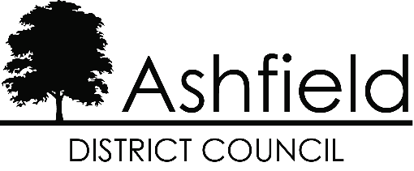

# Business Recovery Grant (BRG) and business rates relief scheme APPLICATION FORM

|  |  |
| --- | --- |
| Business Name |  |
| Full Business Address including  Postcode |  |
| Contact name |  |
| Position in business |  |
| Email address |  |
| Telephone number |  |
| Business Website |  |
| Bank account name |  |
| Bank sort code |  |
| Bank account number |  |

A SME (Small and Medium-sized Enterprise) is defined as a business which has fewer than 250 employees AND has a turnover of less than €50M or a balance sheet total of less than €43M. A business that is part of a larger group will need to include staff headcount / turnover / balance sheet data from that group too.

|  |  |
| --- | --- |
| I confirm that the business is a SME as defined above |  |
| If the company is part of a bigger group, please provide details: |  |
| Company Status |  |
| If a Limited Company, please provide the company registration number |  |
| If a Limited Company, please provide the registered office address |  |
| Business Rates Reference |  |
| VAT registration number |  |
| In respect of the business property claimed for are you a landlord, owner-occupier or tenant? |  |

Flood Details

|  |  |
| --- | --- |
| Date of the flooding |  |
| How was your business impacted by the flooding: |  |
| Please explain what loss of trade, loss of income or damage your business has experienced: |  |

Insurance Details

|  |  |
| --- | --- |
| Have you insured your business premises against flood damage |  |
| If yes, please provide insurer details / policy number / expiry date:  (A copy of the policy may be required and must be submitted to the Local Authority immediately on request) |  |
| If no, have you made attempts to insure your business premises against flood damage since 1 January 2023 |  |
| If yes, please provide a copy of the declined insurance / correspondence with the insurer  If no, please confirm why not: |  |

Declaration

|  |  |
| --- | --- |
| The statements and information provided in support of this application are accurate and true. If found to be false, this may result in full recovery of grant and/or prosecution action for fraud / suspected fraud | |
| The business was trading at and/or from the premises before and at the point the premises were impacted by Storm Babet | |
| The premises are not empty, a warehouse or storage facility | |
| The business is not in liquidation, dissolved, struck off or subject to a striking off notice | |
| The business is able to receive the grant in line with UK Subsidy Control Rules | |
| I confirm that:  • I am authorised to act on behalf of the business  • I have read and agree the declaration.  • I am content for personal data included in this application to be shared by the Local Authority with the Department for Business and Trade in line with the Privacy Notice published at: https://www.ashfield.gov.uk/your-council/legal-information-public-data/privacy-notice/ | |
| Name |  |
| Signature |  |
| Position in the business |  |
| Date |  |

## Data Protection Privacy Notice

**Data may be shared with the Department for Business and Trade (DBT). The DBT privacy notice, setting out how DBT will handle personal data and can be found here on GOV.UK @ https://www.gov.uk/government/publications/business-recovery-grant-brg-for-storm-babet-privacy-notice**

**Data may be shared with other enforcement agencies for the prevention and detection of crime.**

If form was completed on a visit, Visiting Officer signature:

|  |  |
| --- | --- |
| Visiting Officer Signature | Date |