Graph one – Stage one complaints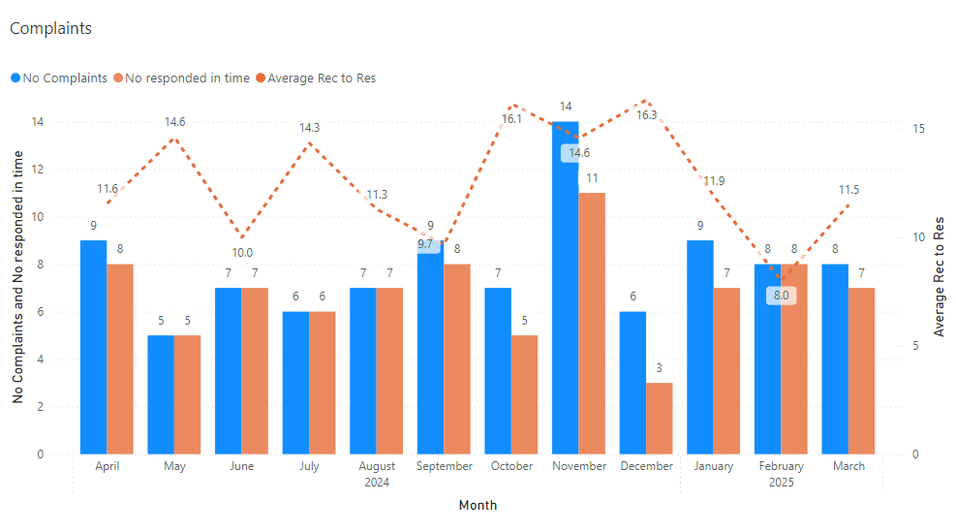
Shown below is a bar chart of the stage one complaints received during 2024 to 2025 by month (blue bar), number responded (orange bar) to in time and the average time taken to respond shown with an orange dotted line.

