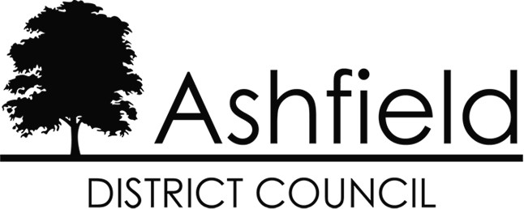

# NOTTINGHAMSHIRE COUNTY COUNCIL ACT 1985 (PART IV)

## APPLICATION TO RENEW A LICENCE FOR AN ESTABLISHMENT TO PROVIDE MASSAGE OR SPECIAL TREATMENTS

**PLEASE COMPLETE IN BLACK INK AND BLOCK CAPITALS**

**All Sections (1 & 2) must be completed *(if not applicable please state N/A)***

**SECTION 1: To be completed by the applicant**

|  |  |  |
| --- | --- | --- |
| **1.** | **Applicant’s full name:** |  |
| **2.** | **Any Maiden / Former name(s):** |  |
| **3.** | **Date of Birth:** |  |
| **4.** | **Place of Birth:** |  |
| **5.** | **Applicant’s Home Address:** |  |
|  |
|  |
|  |
|  |
| **6.** | **Contact Telephone Number:** |  |
| **7.** | **Contact Email Address:** |  |
| **8.** | **In the cases of a company, society, association or other body, give the registered office (and principal office if different) and names and private address of the directors or other persons responsible directly or indirectly for the management of the establishment:** |  |
|  |
|  |
|  |
|  |
|  |
|  |
| **9.** | **Trading Name of the Premises:** |  |
| **10.** | **Address of the Premises:** |  |
|  |
|  |
|  |
|  |
|  |
| **11.** | **Premises Telephone Number:** |  |
| **12.** | **Premises Email Address:** |  |

|  |  |  |
| --- | --- | --- |
| **13.** | **Please state which activities will be undertaken:** | **Full Body Massage** □  **Massage of a Single Body Part** □  **Special Treatments** □ |
|  | **If “Special Treatments” please describe which treatments will be provided:** |  |
|  |
|  |
|  |
|  |
|  |
| **14.** | **Do you have any connection to any other Massage or Special Treatments establishment in the United Kingdom:** | **YES / NO** (delete as applicable) |
|  | **If “Yes”, please provide the name and address of the establishment(s):**  (Please continue on a separate sheet if more than one establishment): |  |
|  |
|  |
|  |
|  |
|  |
| **15.** | **Have you ever been convicted of an offence under the Sexual Offences Act (1956 to 1985) or the Street Offences Act 1959:** | **YES / NO** (delete as applicable) |
|  | **If “Yes”, please provide details:** (Please continue on a separate sheet if more space is required) |  |
|  |
|  |
|  |
| **16.** | **Have you ever been convicted or cautioned for any other criminal offence:** | **YES / NO** (delete as applicable) |
|  | **If “Yes”, please provide details:** (Please continue on a separate sheet if more space is required) **Note:** Matters declared will not necessarily lead to refusal. |  |
|  |
|  |
|  |
| **17.** | **Has the owner of the premises or the business changed since your last application:** | **YES / NO** (delete as applicable) |

**If you have answered “YES” to Question 17, please contact the Licensing Team on 01623 457589 or by email:** [**licensing@ashfield.gov.uk**](mailto:licensing@ashfield.gov.uk) **to request the necessary “Transfer of a Massage & Special Treatments Licence” application form.**

**General Data Protection Regulation 2016 (GDPR) / Data Protection Act 2018 (DPA)**

**- Privacy Notice.**

Under the GDPR and DPA, Ashfield District Council, Urban Road, Kirkby in Ashfield, Nottingham. NG17 8DA is a Data Controller for the information it holds about you. The Council will hold the information above provided by you for assessing your application. The lawful basis under which the Council uses personal data for this purpose is Public Task.

The information provided by you includes the following special categories of personal data:

* **Physical or Mental Health**
* **Genetic / Biometric data**
* **Criminal History (including motoring offences)**

Information in these categories is used by the Council on the basis that such use is necessary for reasons of substantial public interest, and in accordance with the provisions of the Data Protection Act 2018.

Your data will be held for a period of 6 years. Subject to some legal exceptions, you have the right to request a copy of the personal information the Council holds about you; to have any inaccuracies corrected; to have your personal data erased; to place a restriction on our processing of your data; to object to processing; and to request your data to be ported (data portability). The information provided by you may also be used for other functions carried out by the Council in accordance with GDPR and DPA. For more information about how the Council may use your data and to learn more about your rights please see the Council’s Privacy Statement: [**www.ashfield.gov.uk/privacy**](http://www.ashfield.gov.uk/privacy)

If you have any concerns or questions about how your personal data is processed, please contact the Council’s Data Protection Officer at the address at the bottom of this form or by email to [**dpo@ashfield.gov.uk**](mailto:dpo@ashfield.gov.uk). If you are dissatisfied with the Council’s response you can complain to the Information Commissioner's Office in writing to: Information Commissioner's Office, Wycliffe House, Water Lane, Wilmslow, Cheshire SK9 5AF or by telephone 0303 123 1113 (local rate) or 01625 545 745.

**Declaration**

I, the undersigned, hereby declare that the information contained in this application is true and accurate to the best of my knowledge.

I understand that if I knowingly or recklessly make a false statement or omit any material particularly in giving information as part of this application I shall be committing an offence and will be liable for prosecution.

I confirm I have read the General Data Protection Regulation 2016 (GDPR) / Data Protection Act 2018 (DPA) - Privacy Notice above.

**Signature of Applicant: Date:**

# Please now continue to Section 2 of this application.

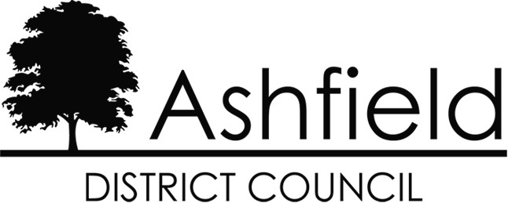

**NOTTINGHAMSHIRE COUNTY COUNCIL ACT 1985 (PART IV)**

**PLEASE COMPLETE IN BLACK INK AND BLOCK CAPITALS**

**SECTION 2: To be completed by all Practitioners (person engaged in providing “hands on” treatments i.e. Massage, Aromatherapy, etc.)**

## You are advised to take copies of this Section 2 form before it is completed, in order that for every Practitioner who works at your premises, each person is accounted for within your application.

**PLEASE NOTE: Each Practitioner must sign to confirm his / her details**

|  |  |  |
| --- | --- | --- |
| **1.** | **Practitioners full name:** |  |
| **2.** | **Any Maiden / Former name(s):** |  |
| **3.** | **Date of Birth:** |  |
| **4.** | **Place of Birth:** |  |
| **5.** | **Practitioners Home Address:** |  |
|  |  |  |
|  |  |  |
|  |  |  |
|  |  |  |
| **6.** | **Contact Telephone Number:** |  |
| **7.** | **Contact Email Address:** |  |
| **8.** | **Trading Name of the Premises:** |  |
| **9.** | **Address of the Premises:** |  |
|  |
|  |
|  |
|  |
|  |
| **10.** | **Provide details of any new qualifications since last application (and submit original certificates with this application):** |  |
|  |
|  |
|  |

|  |  |  |  |  |  |
| --- | --- | --- | --- | --- | --- |
| **11.** | **Has the Practitioner ever been convicted of an offence under the Sexual Offences Act (1956 to 1985) or the Street Offences Act 1959:** | **YES** | **/ NO** | (delete as applicable) | |
|  | **If “Yes”, please provide details:** (Please continue in the space provided below should you need to make additional comments) |  | | | |
|  | | | |
|  | | | |
|  | | | |
| **12.** | **Has the Practitioner ever been convicted or cautioned for any other criminal offence:** | **YES** | **/ NO** | (delete as applicable) | |
|  | **If “Yes”, please provide details:** (Please continue in the space provided below should you need to make additional comments) |  | | | |
|  | | | |
|  | | | |
|  | | | |
| **13.** | **Please attached a passport sized photograph of the Practitioner** (the reverse of the photograph must be signed and dated by the Practitioner): | | | | **ATTACH PHOTOGRAPH HERE** |
| **14.** | **Additional Comments in relation to matters declared at Question 11 and / or Question 12. (Note: the declaration of a caution or conviction may not automatically result in the refusal of the application).** | | | | |
|  | | | | | |
|  | | | | | |
|  | | | | | |
|  | | | | | |
|  | | | | | |
|  | | | | | |
|  | | | | | |
|  | | | | | |
|  | | | | | |
|  | | | | | |
|  | | | | | |
|  | | | | | |
|  | | | | | |
|  | | | | | |
|  | | | | | |
|  | | | | | |

**General Data Protection Regulation 2016 (GDPR) / Data Protection Act 2018 (DPA)**

**- Privacy Notice.**

Under the GDPR and DPA, Ashfield District Council, Urban Road, Kirkby in Ashfield, Nottingham. NG17 8DA is a Data Controller for the information it holds about you. The Council will hold the information above provided by you for assessing your application. The lawful basis under which the Council uses personal data for this purpose is Public Task.

The information provided by you includes the following special categories of personal data:

* **Physical or Mental Health**
* **Genetic / Biometric data**
* **Criminal History (including motoring offences)**

Information in these categories is used by the Council on the basis that such use is necessary for reasons of substantial public interest, and in accordance with the provisions of the Data Protection Act 2018.

Your data will be held for a period of 6 years. Subject to some legal exceptions, you have the right to request a copy of the personal information the Council holds about you; to have any inaccuracies corrected; to have your personal data erased; to place a restriction on our processing of your data; to object to processing; and to request your data to be ported (data portability). The information provided by you may also be used for other functions carried out by the Council in accordance with GDPR and DPA. For more information about how the Council may use your data and to learn more about your rights please see the Council’s Privacy Statement: [**www.ashfield.gov.uk/privacy**](http://www.ashfield.gov.uk/privacy)

If you have any concerns or questions about how your personal data is processed, please contact the Council’s Data Protection Officer at the address at the bottom of this form or by email to [**dpo@ashfield.gov.uk**](mailto:dpo@ashfield.gov.uk). If you are dissatisfied with the Council’s response you can complain to the Information Commissioner's Office in writing to: Information Commissioner's Office, Wycliffe House, Water Lane, Wilmslow, Cheshire SK9 5AF or by telephone 0303 123 1113 (local rate) or 01625 545 745.

**Declaration**

I, the undersigned, hereby declare that the information contained in this application is true and accurate to the best of my knowledge.

I understand that if I knowingly or recklessly make a false statement or omit any material particularly in giving information as part of this application I shall be committing an offence and will be liable for prosecution.

I confirm I have read the General Data Protection Regulation 2016 (GDPR) / Data Protection Act 2018 (DPA) - Privacy Notice.

**Signature of Practitioner: Date:**

**Please return your completed application and additional documents to: Licensing Team, Ashfield District Council, Urban Road,**

**Kirkby in Ashfield, Nottinghamshire, NG17 8DA.**