# Ashfield District Council logo

# Disclaimer

This document or some parts of it may not be accessible when using adaptive technology.

If you require assistance with accessing the content of the document, please contact us and quote the document name and the web page you found it on:

* email: Planning – [planning.admin@ashfield.gov.uk](mailto:planning.admin@ashfield.gov.uk)

1 – Alongside the Public Footpath entrance into the ppSPA, looking north

up the A611 towards Site H1Ka beyond the housing on the left.

Alongside the Public Footpath entrance into the ppSPA, looking north up the A611 towards Site H1Ka beyond the housing on the left


2 – The signposted Public Footpath into the ppSPA

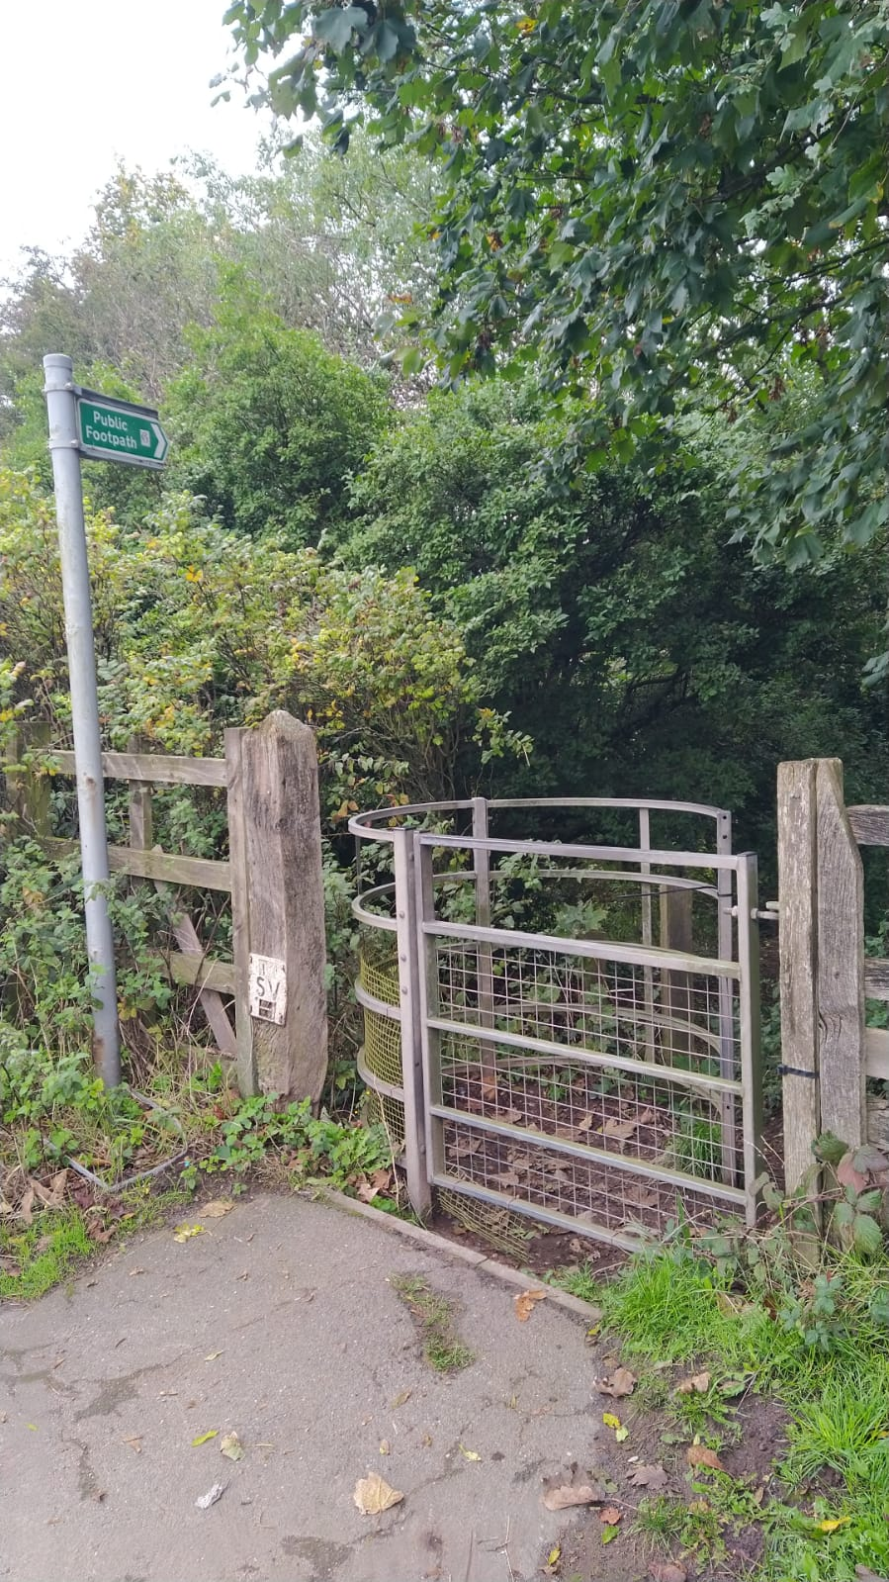

3 – The well-used Public Footpath within the ppSPA

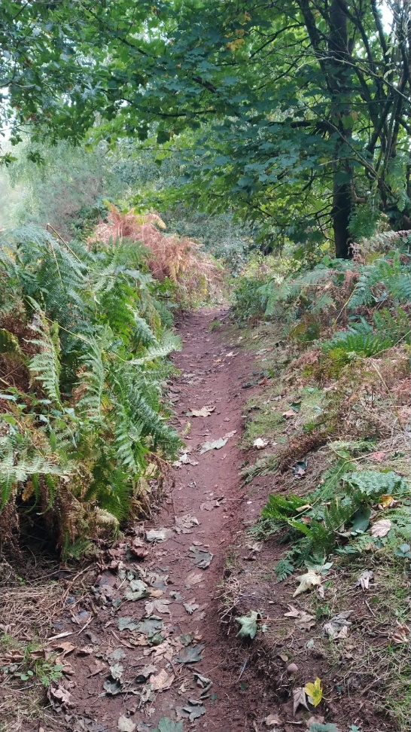

4 – Moving closer to Site H1Ka, immediately beyond existing housing on the left.

The A611 is always busy.

Moving closer to Site H1Ka, immediately beyond existing housing on the left. T
he A611 is always busy.


5 – Within Site H1Ka looking north. Balls Lane and the wider Green Belt beyond

cannot be seen through the well-established woodland

Within Site H1Ka looking north.  Balls Lane and the wider Green Belt beyond
cannot be seen through the well established woodland


6 – The Premier Store, ‘open-all-hours’ convenience store within 400m

walking distance of Site H1Ka

The Premier Store, ‘open-all-hours’ convenience store within 400m walking distance of Site H1Ka


Photo 7 –

The Premier Store, ‘open-all-hours’ convenience store within 400m walking distance of Site H1Ka


8 – Disused former compound looking south to adjacent housing

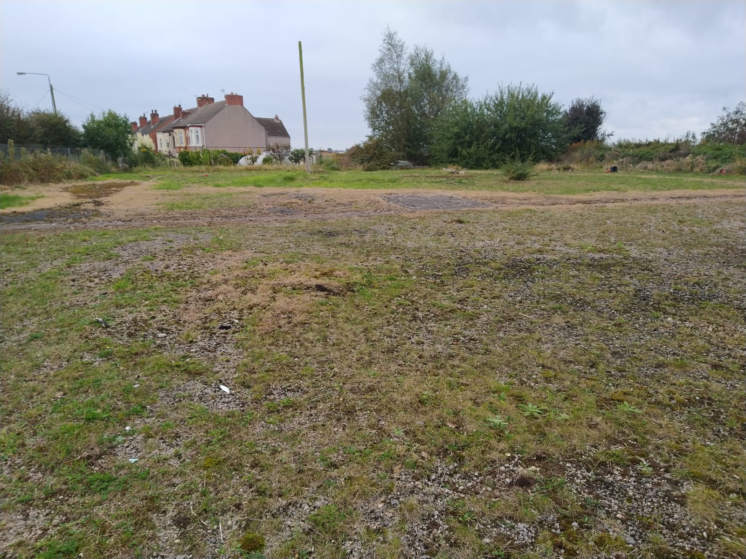

9 – Close-up view of one of the foundations where compound buildings formerly stood

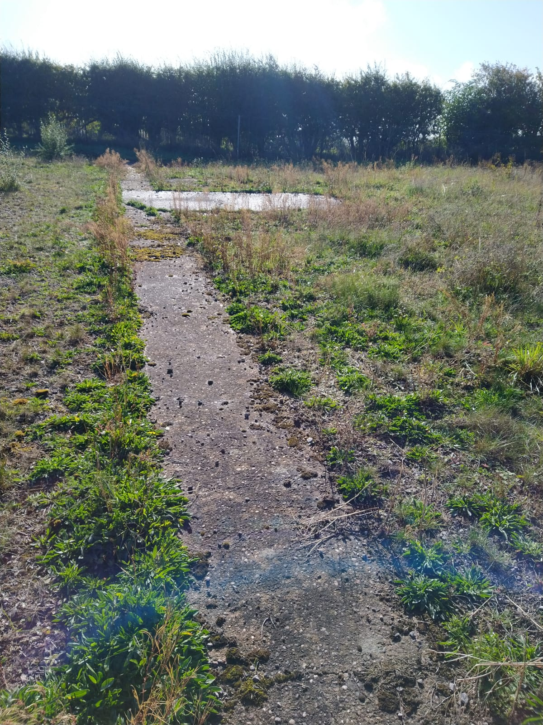

10-18 – All within the main buildings, showing they are still littered with remnants

of the former building materials storage and sales use. The extensive areas of

reinforced concrete flooring and deteriorating condition of the buildings is clearly

evident.

10

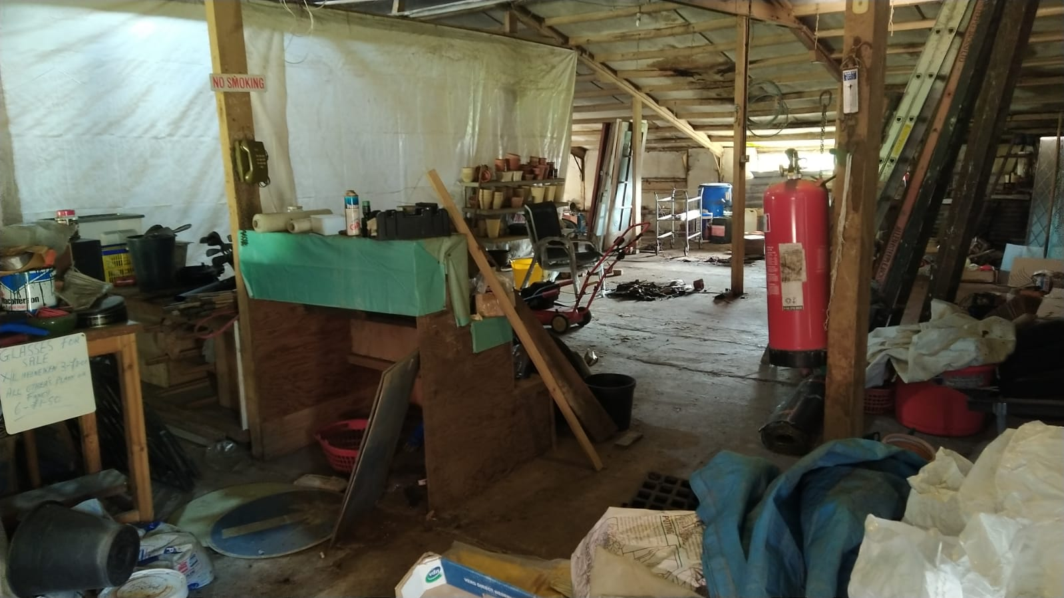

11

–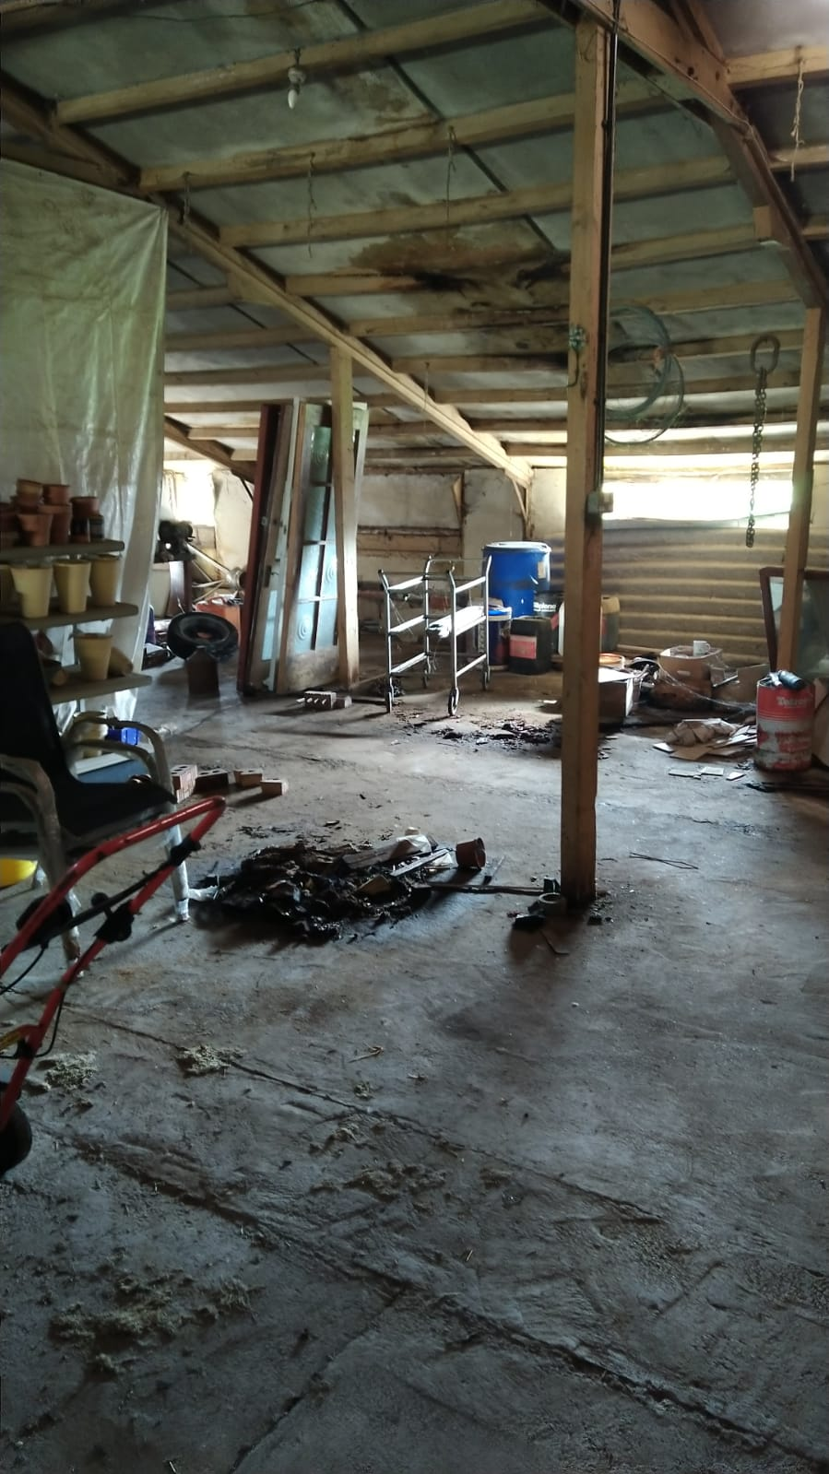

12

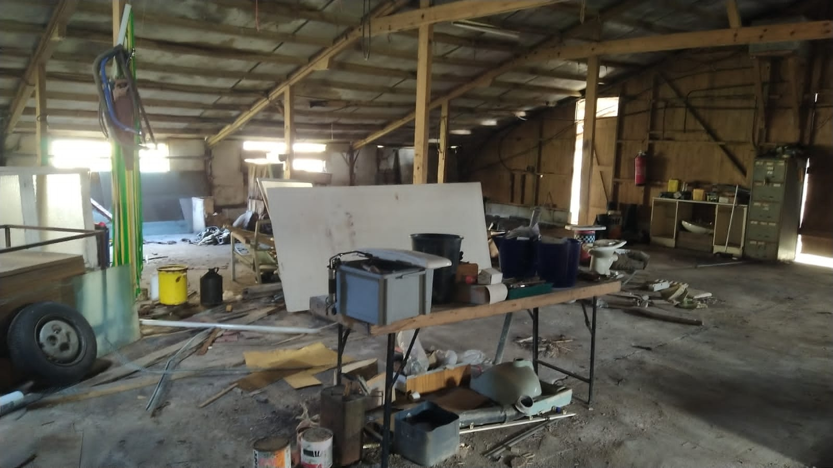

13

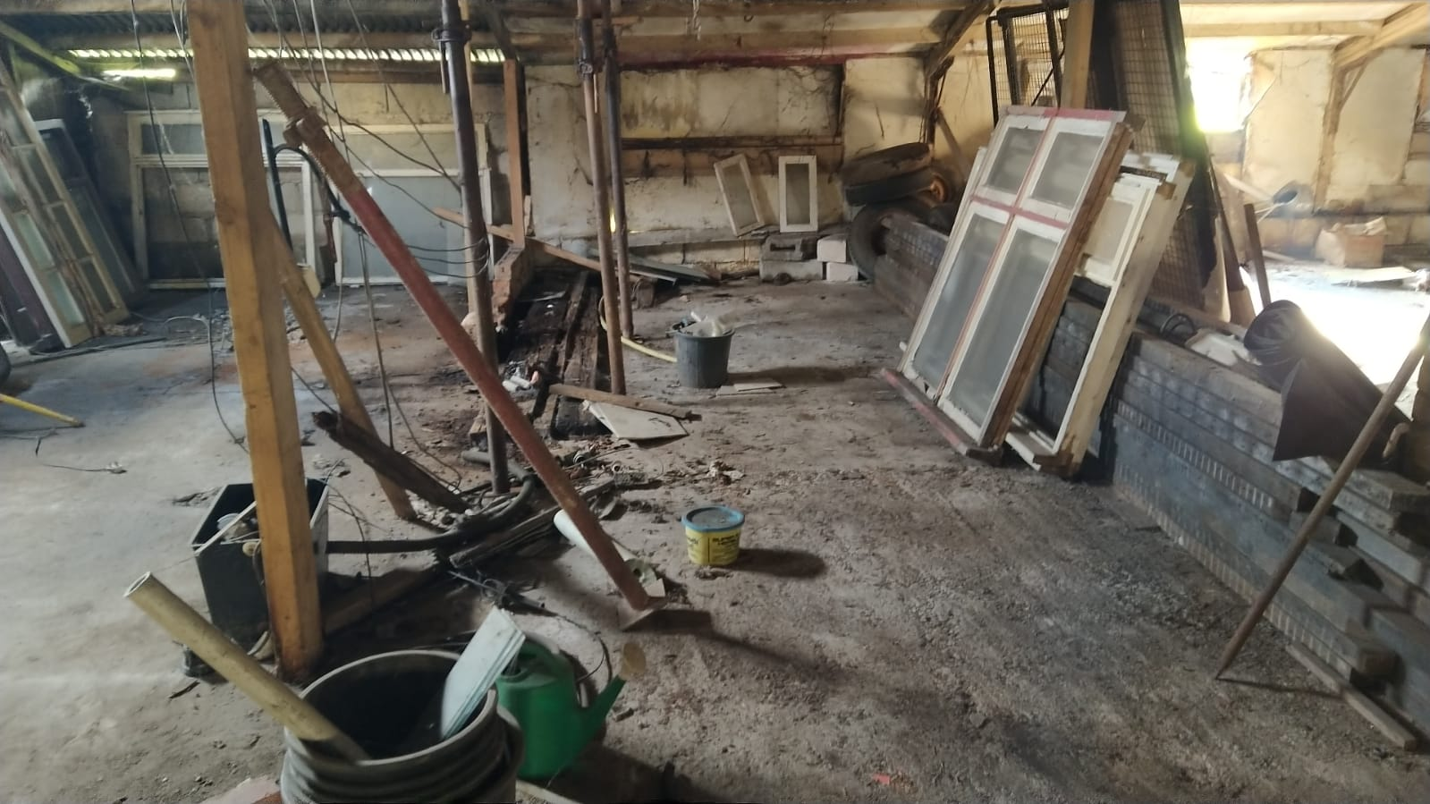

14

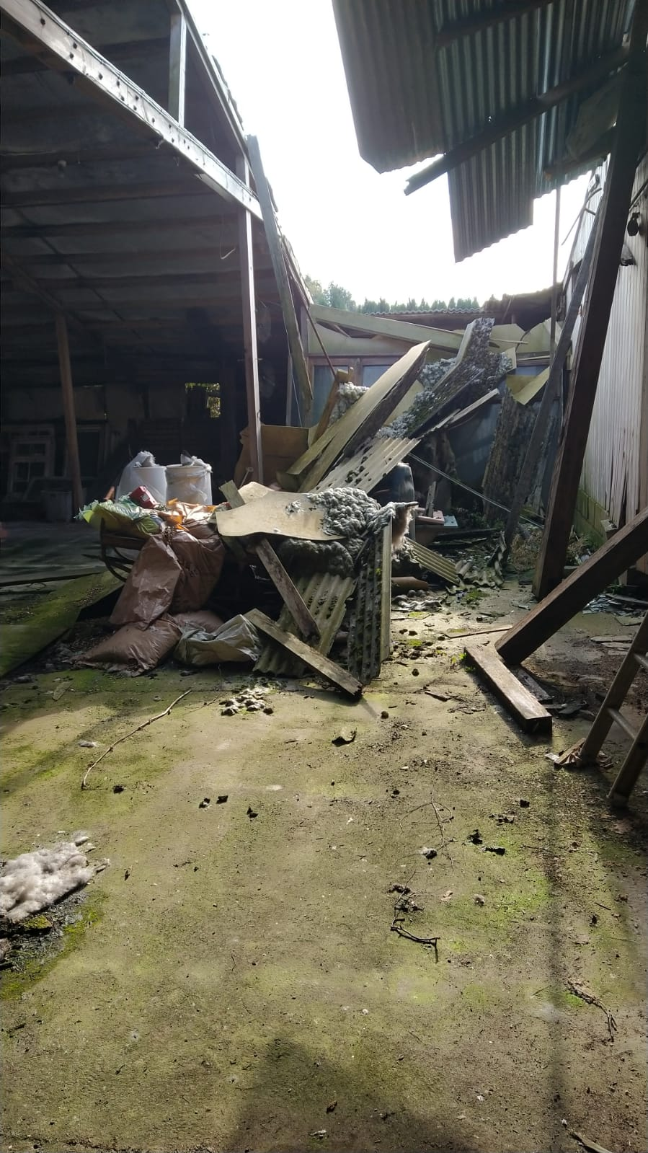

15

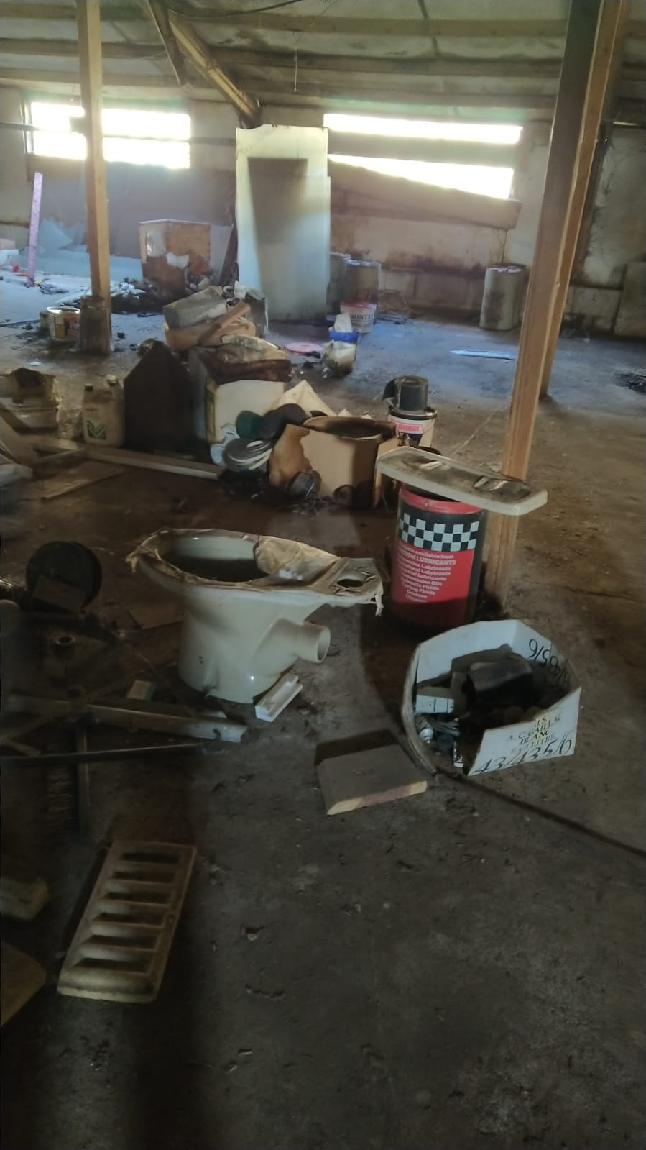

16

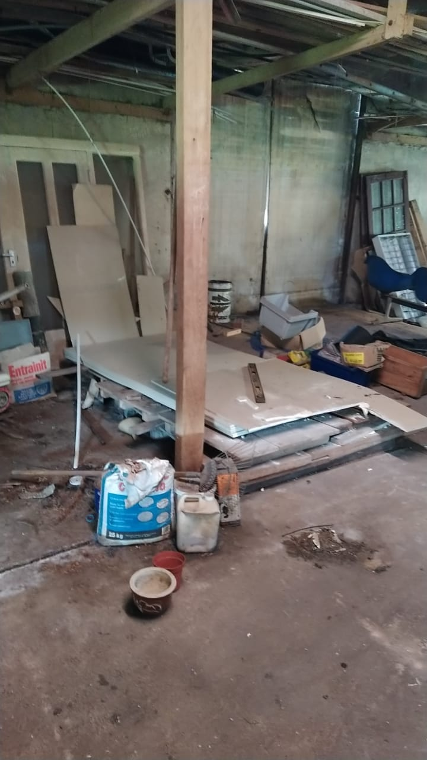

17

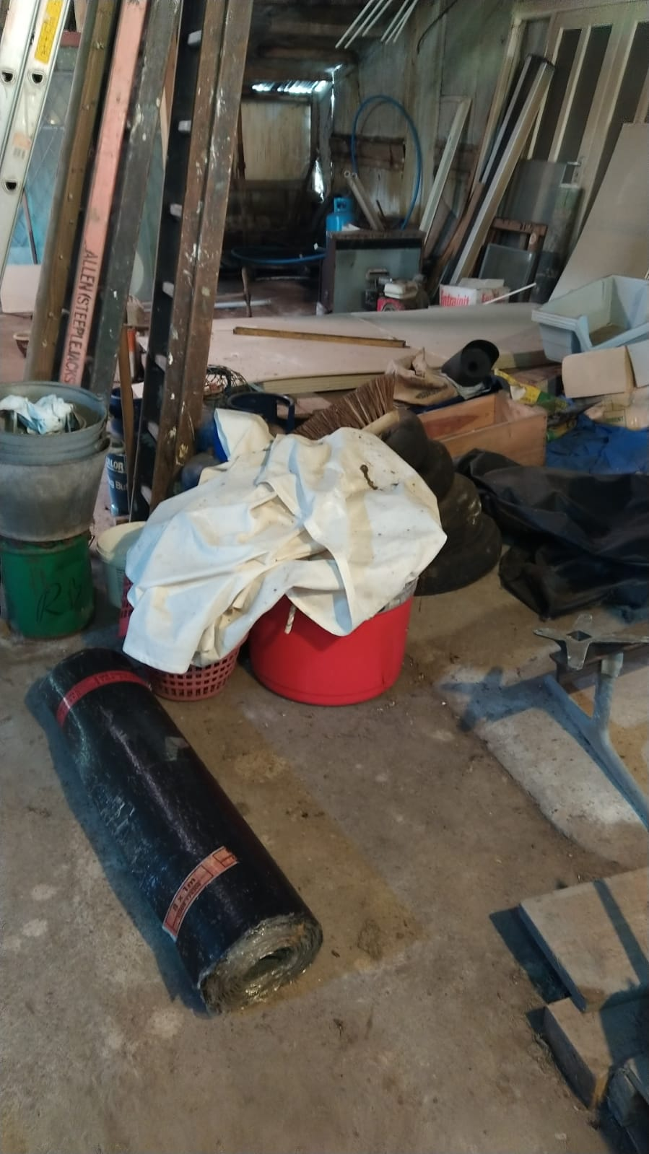

18

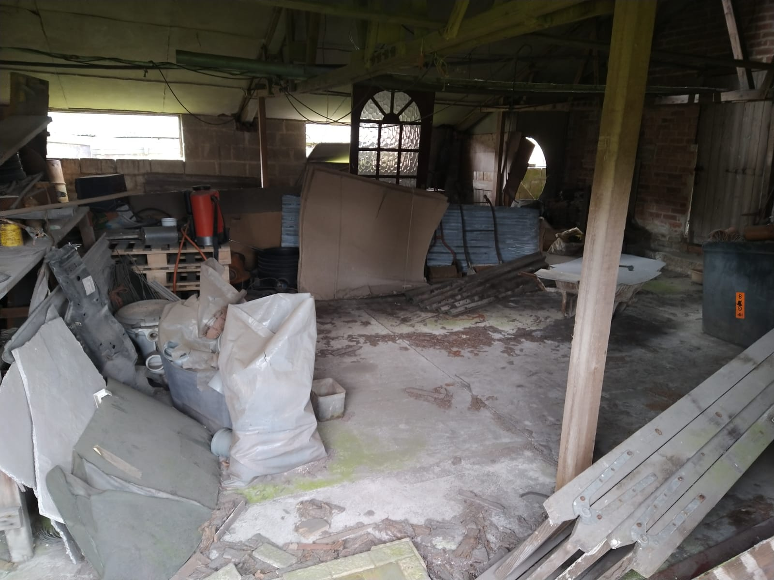

19 – One of the main redundant, semi-derelict problem buildings on site, last used for the storage

and sales of building materials, 1990-2005

One of the main redundant, semi-derelict problem buildings on site, last used for the storage  and sales of building materials, 1990-2005


20-26 - Some of the other disused/derelict buildings on site

20 -

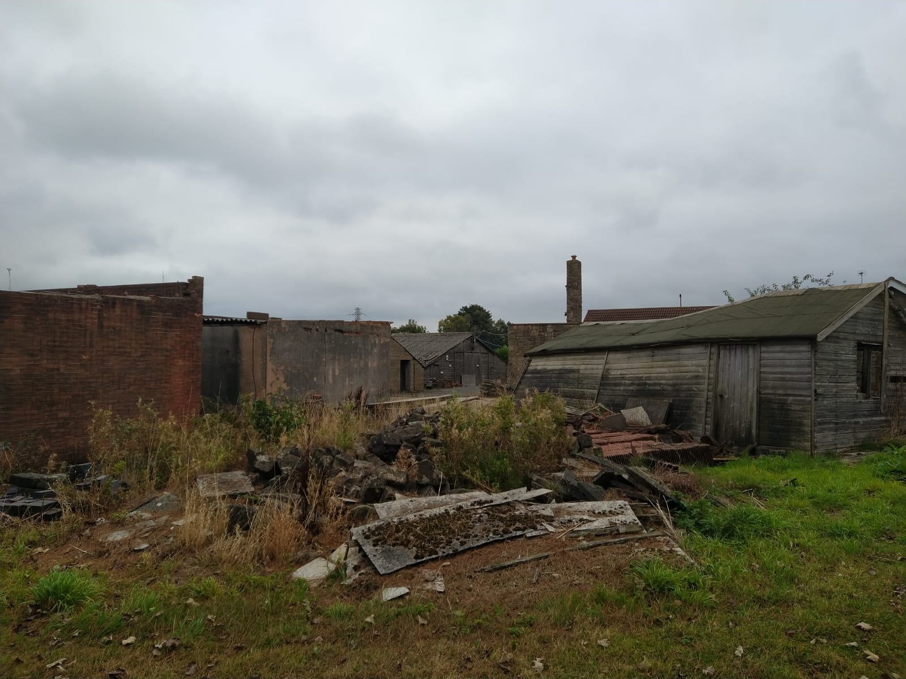

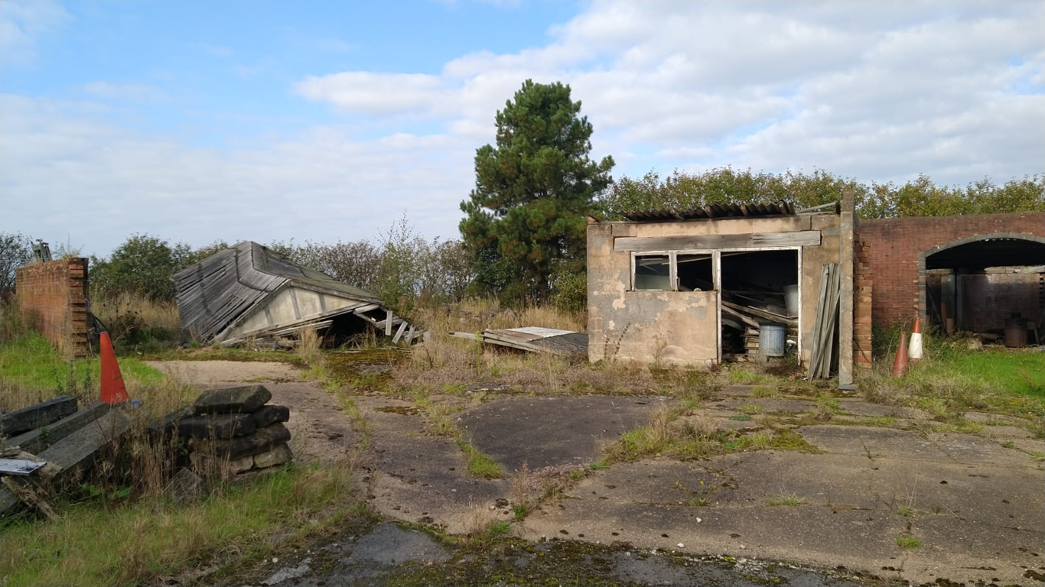21

22

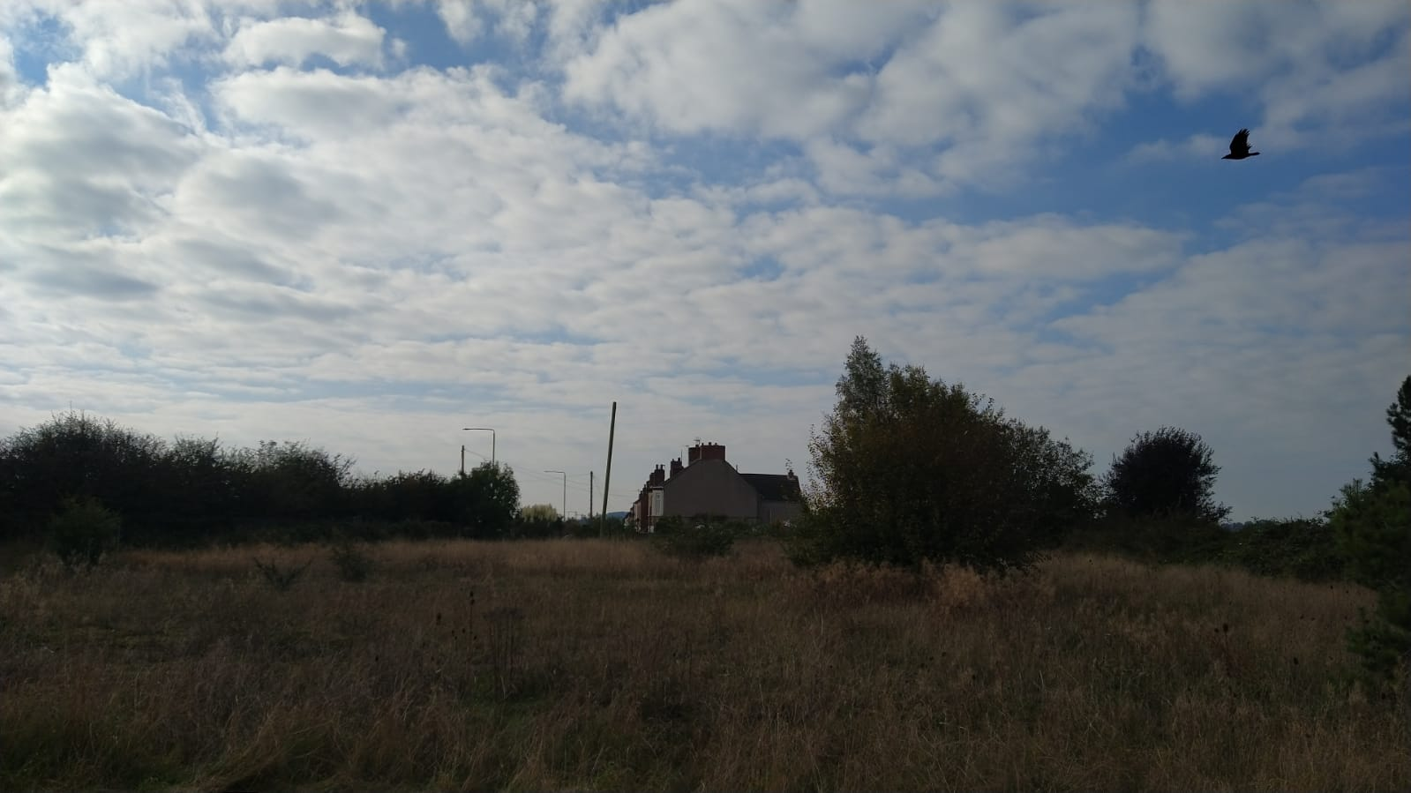

23

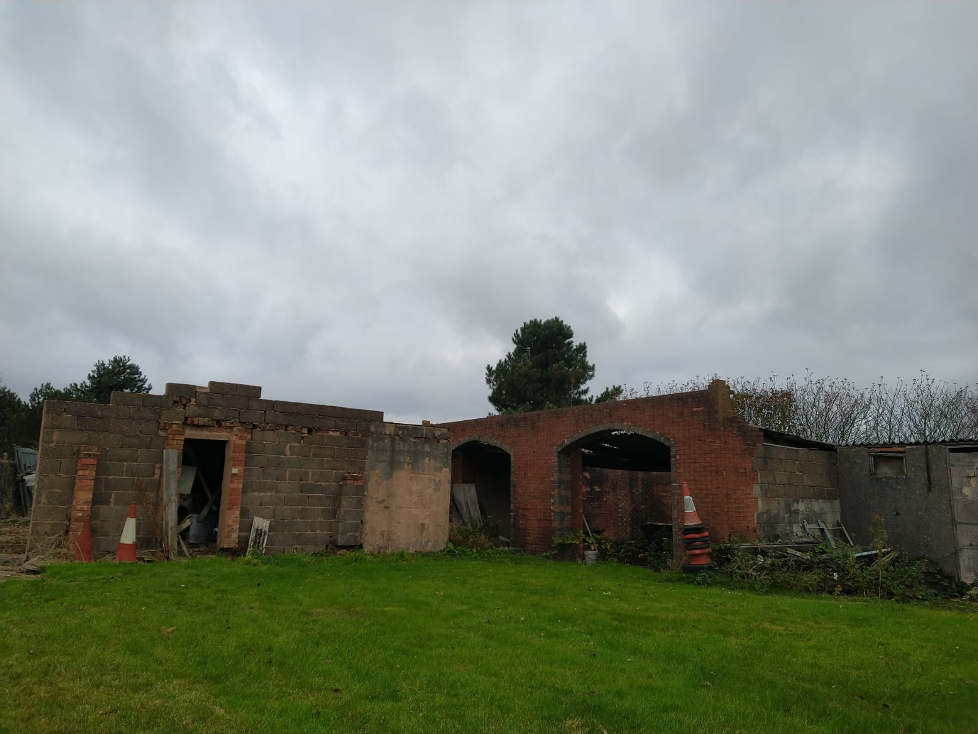

24

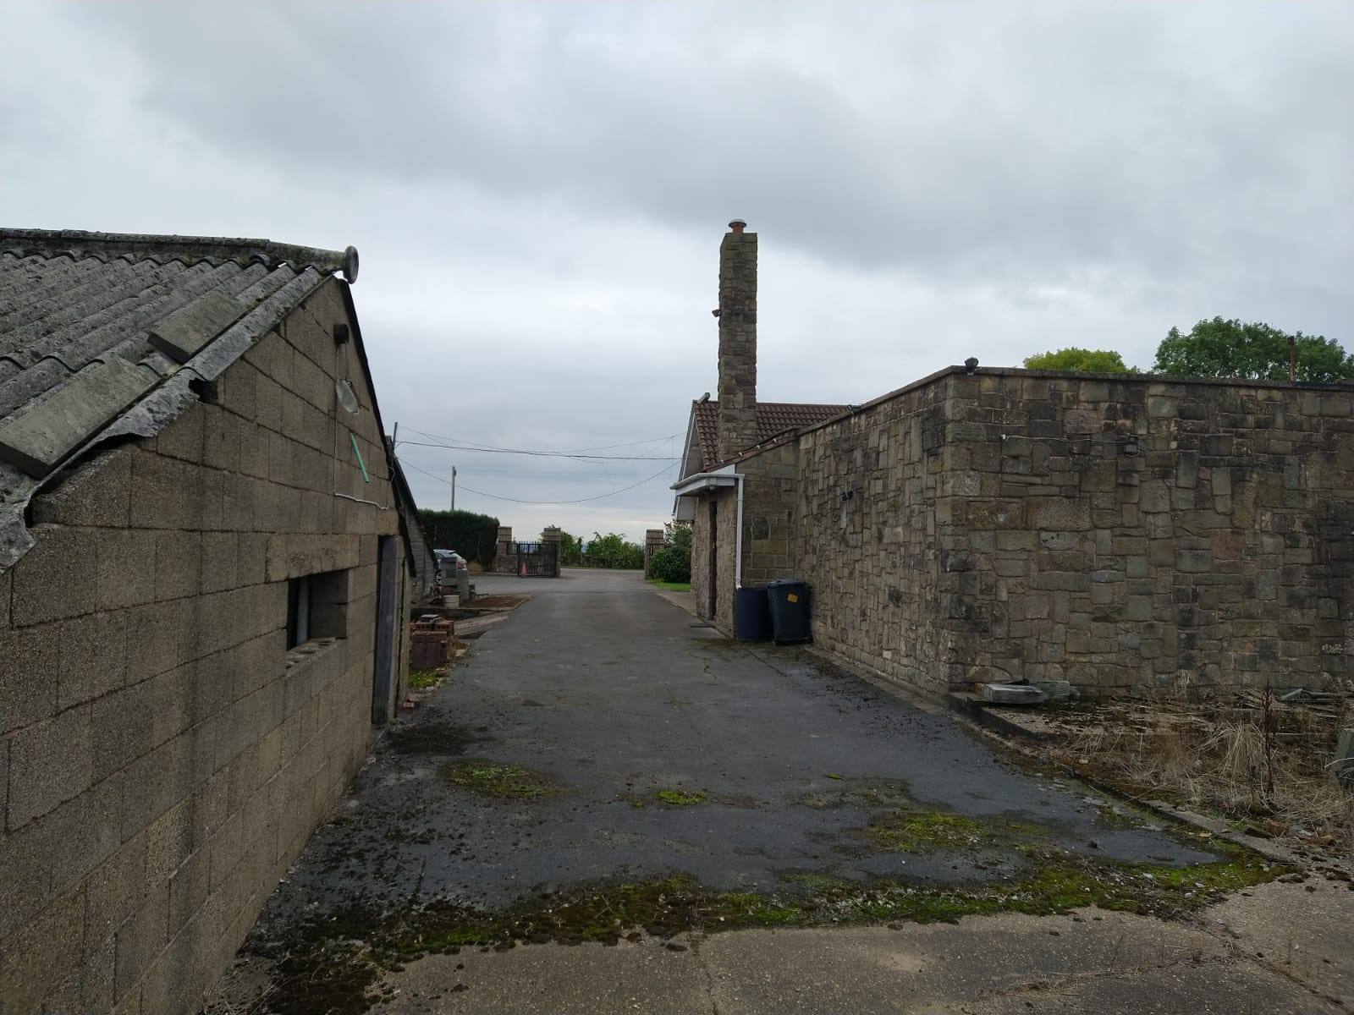

25

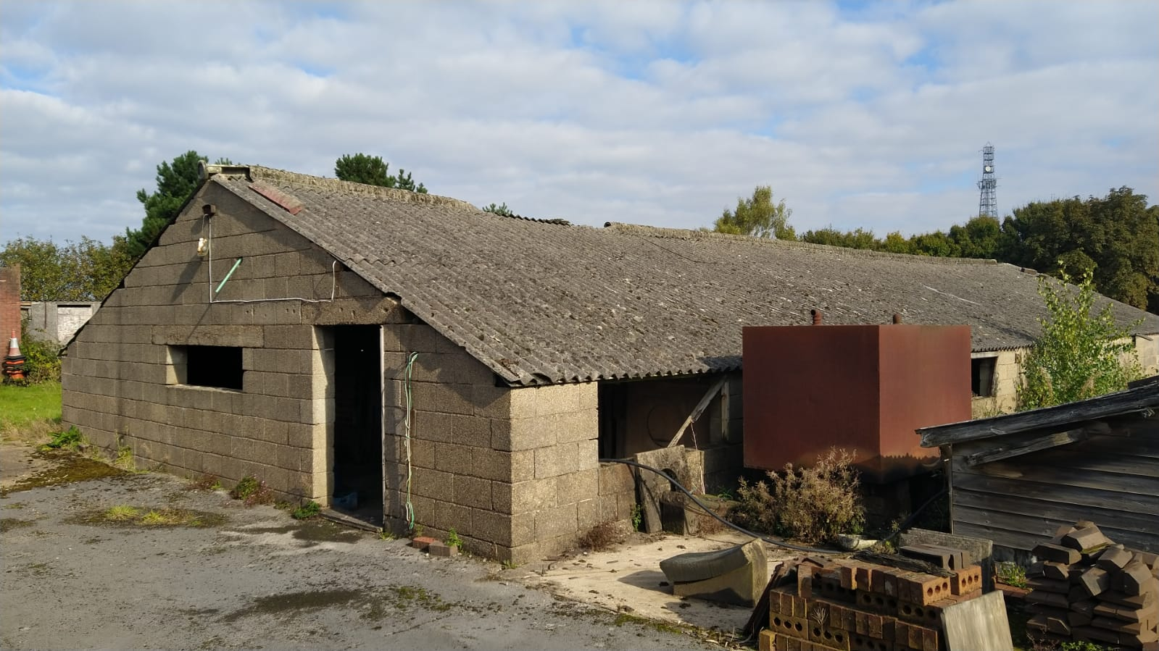

26

