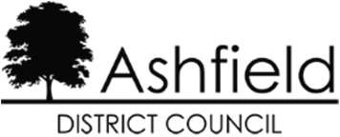

DISCLAIMER

This document or some parts of it may not be accessible when using adaptive technology.

If you require assistance with accessing the content of the document, please contact us and quote the document name and the web page you found it on:
- email: Forward planning – localplan@ashfield.gov.uk

- telephone: 01623 457381

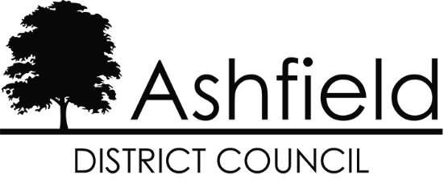

ASHFIELD DISTRICT COUNCIL

Background Paper No 5 Infrastructure Delivery

July 2021

Contents

Section |  | Page
1 | Plan Purpose and Background | 1
2 | Education | 8
3 | Transport | 12
4 | Health | 18
5 | Electricity and Gas Utilities | 21
6 | Water Supply, Treatment and Quality | 23
7 | Flooding | 26
8 | Telecommunications | 28
9 | Green Infrastructure | 30
10 | Leisure and Cultural Services | 38
11 | Waste Management | 41

Plan Purpose and Background

  - Planning for the District should be supported by evidence of what physical, social and environmental infrastructure is needed to enable the development to progress. This Background Paper provides a summary of the current position regarding infrastructure.

  - It is anticipated that at the next state of the Plan infrastructure will be considered through an Infrastructure Delivery Plan (IDP). The IDP has a number of roles but its main function is to identify the infrastructure that is required to support the level of growth anticipated in Ashfield District over the plan period 2020 to 2038.

Potential Roles of an Infrastructure Delivery Plan:
- To assess the baseline infrastructure capacity and needs in Ashfield.
- To identify the infrastructure needs and costs arising as a result of development set out in the Local Plan where this is feasible;
- To align the implementation of the IDP with the aims and objectives of other local and sub regional strategies;
- To provide an evidence base to support the Local Plan.
- As a means to achieve community benefits and deliver service efficiencies and improvements.
- To identify the lead organisations to deliver and manage infrastructure in partnership between the Council and other public service delivery organisations.
- As a method of working with the private, voluntary and community sector on their investment proposals and delivery.
- To provide an evidence for an aggregate funding gap over the plan period and a basis to carry out viability analysis.

What is Infrastructure?
  - The Planning Inspectorate (PINS) advice distinguishes between ‘critical’ and ‘non-critical’ infrastructure. Critical infrastructure is infrastructure without which the development could not physically be delivered or accessed. This includes:

    - Flooding and flood risk mitigation.
    - Transport infrastructure on which the delivery of the site is clearly dependant.
    - Utilities (Water/Energy/IT).

  - Greater levels of prosperity have been accompanied by a greater range of services, which are now included in the term “non critical’ infrastructure. That is infrastructure without which the development could still physically proceed but may be important in terms of the quality and sustainability of the development. This potentially includes education, health and community facilities, leisure facilities, provisions for emergency services, and for green space. The provision of ‘non critical’ infrastructure is important to support the objectives of increased housing requirements, economic growth, mitigate climate change and creating sustainable communities.

  - The scale, scope, phasing and overall balance of this infrastructure may determine whether the development is acceptable in policy terms and ultimately whether planning permission will be granted.

BROAD FORMS OF INFRASTRUCTURE PHYSICAL
- Transport - Strategic & local highway networks, bus rail, airports, travel management, cycle and pedestrian facilities, car parking.
- Energy - Gas and electricity generation and distribution, renewable energy projects.
- Water - Water supply, water treatment, drainage, flood defences, water quality.
- Information and communications technology (ICT) – Including Broadband and wireless connections.
- Waste - Collection and disposal, recycling.
- Minerals – Reserves.
SOCIAL
- Education - Primary, secondary, further education, and adult education.
- Health - Health centres, GP and dental surgeries, hospitals.
- Emergency Services - Police, Fire, Ambulance, community support.
- Community Services - Community centres and centres for children, young people, elderly and those with special needs. Cemeteries, post offices, etc.
- Culture and Leisure - Museums, theatres, cinemas, sport centres, swimming pools, libraries, public art and realm, heritage assets
- Community Projects - It can include community groups, and local community led projects, training and volunteering.
GREEN
- Open Space - Parks and country parks, children’s play areas, sport pitches and grounds, allotments.
- Forestry - Urban forest, woodland.
- Biodiversity - Local wildlife sites, local nature reserves, private nature reserves, SSSIs, geological sites.
- Waterways - Main rivers, small watercourses, canals.

Delivery of Infrastructure
  - Developers are required to meet infrastructure requirements which specifically related to a site such as gas and electricity provisions.

  - Developers are also required to contribute to the wider infrastructure, which looks to achieve the planning objective of sustainable development. Ashfield District Council as the local planning authority has a key role to play in securing developer contributions to deliver the necessary infrastructure to support sustainable development. The Council currently secures monies through section 106 agreements. However, this has to be seen in the context of:
    - The Community Infrastructure Levy regulations (CIL) - Under the CIL Regulations a planning obligation may only constitute a reason for granting planning permission for the development if the obligation is:
      - necessary to make the development acceptable in planning terms,
      - directly related to the development, and
      - fairly and reasonably related in scale and kind to the development.

    - The viability of any development -The NPPF stresses that viability and deliverability are key tests of all aspects of decision making1.

  - The Council utilised Section 106 contributions to ensure the provision of infrastructure where need arises from a development2. A Section 106 (S106) Agreement is a legal agreement between a local authority and a developer, linked to planning permissions (Also known as planning obligations). Section 106 agreements are drafted when it is considered that a development will have significant impacts on the local area. When a planning application is submitted to the Council, we will assess the application as to whether the development would cause a significant impact to the area and community. The S.106 will vary depending on the nature of the development and based on the needs of the District.
  - The Planning Act, 2008 identifies the types of infrastructure that should be considered for funding through CIL, although the list is not definitive. These are:

- roads and other transport facilities,
- flood defences,
- schools and other educational facilities,
- medical facilities,
- sporting and recreational facilities, and
- open spaces.

1 NPPF 2021 Paragraphs 58, 62, 77, 124 & Planning Practice Guidance Viability
2 Ashfield Infrastructure Funding Statement 2019/20, December 2020. https://www.ashfield.gov.uk/media/8d8a597125a4e4d/adc-ifs-19_20-final.pdf

  - There are a number of infrastructure providers that have statutory obligations in specific areas and this includes responding to growth in terms of the provision of infrastructure. Therefore, other funding can arise from a number of sources including public sector funding from national, regional, strategic and local grants as well as the normal capital and revenue funding streams for public service and statutory infrastructure providers.

  - A two tier system of local government operates in Nottinghamshire. Consequently, joint working between the District Council and Nottinghamshire County Council is critical as the County Council has a pivotal role in providing infrastructure as the:

    - Highways Authority.
    - Education Authority.
    - Waste and Minerals Authority.
    - Social Care service provider.
    - Lead Local Flood Authority.
  - It should be noted that the IDP and the Local Plan do not operate in isolation in respect of creating and maintaining these types of infrastructure. Rather they sit within a wider framework of plans, policies and programmes of the Authority, the County Council and a wide range of other infrastructure and service providers and regulators.

The Policy Context
  - The NPPF highlights through the importance of the provision of physical, social and green infrastructure. This has a number of implications:

    - Councils and providers should assess capacity of infrastructure and its ability to meet forecast demands. The constraints on infrastructure such as road capacity and limited funding for the foreseeable future means that more creative ways of making better use of existing capacity and facilities will be needed.

    - There is a need to assess ‘quality’ as well as capacity. This may mean looking to improve the quality of existing provision before spending on increasing capacity.
    - Based on the requirement for infrastructure being able to meet forecast demand, this means considering changes in technology, demographics, and preventative policy measures.

  - Section 110 of the Localism Act sets out the ‘duty to co-operate’. This is reflected in the NPPF, paragraph 26 which highlights the need for joint working to meet development requirements that cannot be wholly met within a single local planning area, through either joint planning policies or informal strategies such as infrastructure and investment plans. In these circumstances, meeting transport,

educational, waste management and other infrastructure requirements across council boundaries is crucial.

  - Infrastructure will need to be considered as part of the Local Plan as it moves forward. The Local Plan is the Council’s key planning document and sets out:

    - a spatial vision for growth in Ashfield;
    - a number of sustainable development principles to achieve the vision;
    - key strategic policies for the District including the provision of New Settlements and strategic employment areas around Junction 27 of the M1;
    - defining the numbers and locations of new homes and the location of employment sites over the plan period; and
    - providing policies which will guide the determination of planning applications in the District.
The purpose of the Local Plan is to strike a balance between providing for housing needs and economic growth whilst protecting and enhancing the District’s green infrastructure.

Neighbourhood Plans
  - There are two neighbourhood plans in Ashfield, the JUS-t Neighbourhood Plan (Selston Parish Council) and the Teversal, Stanton Hill and Skegby Neighbourhood Plan (Neighbourhood Forum). Neither Plan proposes to identify sites for development. However, specific policies will impact on infrastructure requirements.

Neighbouring Authorities
  - Nottingham Housing Market Area consists of the following:

Housing Market Area | Districts within Housing Market Area
Nottingham Core | Nottingham, Rushcliffe, Gedling, Erewash*, Broxtowe
Nottingham Outer | Ashfield*, Mansfield, Newark & Sherwood*

Table 1- Nottingham Housing Market Area
* Districts which are likely to be under the influence of more than one HMA area.

  - However, it should be recognised that housing markets will fall across administrative boundaries. In Ashfield there is a more complex position as it is widely recognised that Hucknall is strongly linked to Greater Nottingham3. In relation to the Greater Nottingham Area, Ashfield is working closely with the councils of Broxtowe,

3 Nottingham Outer 2015 Strategic Housing Market Assessment GL Hearn, Employment Land Forecasting Study, 2015 Nathaniel Litchfield & partners.

Erewash, Gedling, Nottingham City and Rushcliffe to produce a consistent planning strategy for Greater Nottingham. The Greater Nottingham Authorities are advised by the Greater Nottingham Joint Planning Advisory Board, which is made up of the lead planning and transport councillors from each of the councils. The Joint Board meets regularly and has overseen the coordination of all the Core Strategies and Local Plans within Greater Nottingham. The Councils collaborate on strategic policy and planning issues and work together on joint commissions and evidence base documents.
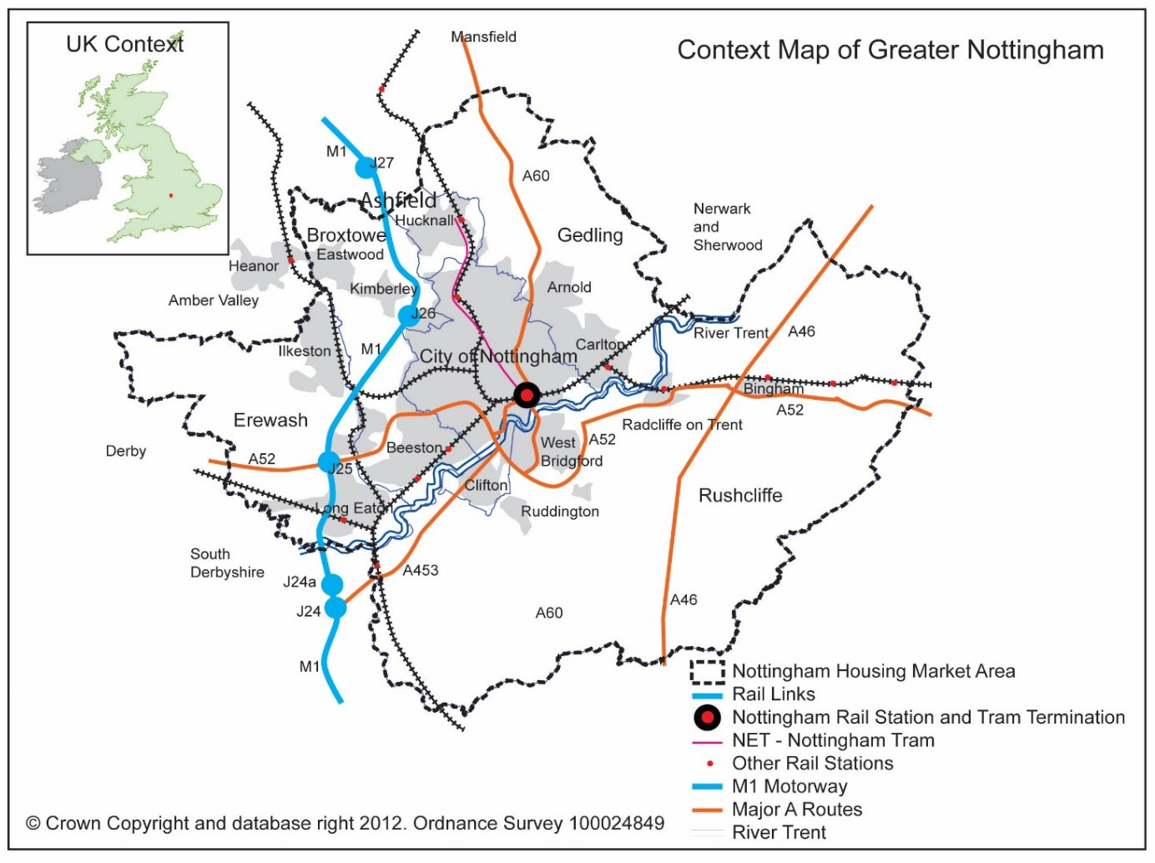

Map 1: Greater Nottingham
Source Ashfield District Council

  - Ashfield District is bounded by a further four Local Authorities; Newark and Sherwood, Mansfield, Bolsover and Amber Valley (see Map 2). Discussions with these councils have taken place on a regular basis to ensure a similar joined up approach to planning across boundaries. There are also a number of studies which provide a shared evidence base.

  - In addition to the Ashfield housing and employment sites, there are a number of proposed developments outside the administrative area of Ashfield District but may have an impact in terms of local infrastructure, Table 2.

 | Employment | Approx. dwellings
Mansfield District Council
The Lindhurst Group outline planning permission applied for. (Planning application number 2010/0089/ST). Development  has commenced. | 23.5 ha | 1,700
Land at Penniment Farm, Abbott Road, Mansfield. (Planning application number 2010/0805/ST). | 12 ha  (39,216 sq  m) | 430
Abbot Road/Brick Lane and Hall Barn Lane |  | 250
Broxtowe Borough Council
Brinsley. Aligned Core Strategy 2014 - Policy 2 & Part 2  Local Plan 2018-2028, Adopted 2019 Policy 5: Brinsley Site Allocation |  | 110
Gedling Borough Council
Land North of Papplewick Lane (adjacent to Hucknall). Aligned Core Strategy 2014 - Policy 2 as amended by the Local Plan Part 2 Publication - Policy FPD 63 Housing Distribution. (Identifies 1,265 homes around Hucknall).  Development of North of Papplewick Lane has commenced. |  | 300
Top Wighay Farm (adjacent to Hucknall). Aligned Core Strategy 2014 – Policy 2 as amended by the Local Plan Part 2 Publication Policy FPD 63 Housing Distribution. (Identifies  1,265 homes around Hucknall). A small area off Wighay Road has been developed. | 8.5 ha | 845
Bestwood Village (Aligned Core Strategy 2014 – Policy 2 as amended by the Local Plan Part 2 Publication - Policy FPD 63 Housing Distribution. Development has commenced. |  | 525
Hayden Lane, (adjacent to Hucknall) Local Plan Part 2 Publication Policy FPD 64 Urban Area. |  | 120

Table 2: Neighbouring Authority Potential Development Sites
Notes
    - Lindhurst - The development is proposed to be either side of Sherwood Way A617 (the Mansfield Ashfield Regeneration Route) and to the east of Nottingham Road, A60

    - Land at Penniment Farm, Abbott Road, Mansfield. Outline permission was granted for a mixed use development. The development is to the north east of the West of Beck Lane, Skegby (HG1Ss).

Section 2 - Education

  - Nottinghamshire County Council, as the Local Education Authority, and Ashfield District Council are working together to identify the impact of future housing requirements on educational places and local schools. The proposed growth planned in Ashfield District, has to take account of the potential educational requirements arising from the development.

  - Local Education Authorities have a statutory obligation to ensure there are sufficient primary and secondary school places within their area to meet the requirement for pupil places under the Education Act 1996. In order to carry out this statutory duty, the County Council undertakes school place planning and forecasting. This entails undertake a rolling programme of pupil projection based in part on census data, ONS mid-year population estimates and school catchment information to try to match demand for school places with physical supply.

  - The County Council has prepared estimates of pupil places generated by Local Plan allocations and added them to its forecasts of future demand for places in the existing population. Estimates of pupil places are undertaken over a 5-year period for primary school places and over a 10-year period for secondary school places. Pupil place forecasts are not undertaken for a 15-year period.

  - For the purpose of forecasting and place planning, the County Council groups primary schools across the County into primary planning areas. Ashfield comprises a number of Primary Planning Areas, which are identified in Table 3. Secondary schools are also grouped in planning areas, the majority of which do not precisely correlate to their primary counterparts. These planning areas are identified in Table 4.

Nottinghamshire County Council Primary Planning Area
- Hucknall Primary Planning area
- Annesley Primary Planning Area
- Kirkby Primary Planning Area
- Sutton Town Primary Planning Area
- Huthwaite Primary Planning Area
- Selston Primary Planning Area

Table 3 - Education Primary Planning Areas in Ashfield
Source: Nottinghamshire County Council

Nottinghamshire County Council Secondary Planning Areas
- Hucknall Secondary Planning Area
- Kirkby/Sutton Secondary Planning Area
- Selston Secondary Planning Area

Table 4 - Education Secondary Planning Areas in Ashfield
Source: Nottinghamshire County Council

Assessing the impact of new development on capacity
  - The need for development to provide additional primary and secondary school places is guided by the County Council’s assessment of total net capacity of schools within the locality and forecast future demands for school places. In determining the number of school places likely to be generated by a new development the County Council currently calculates requirements based on the following:

    - 21 primary places required per 100 dwellings
    - 16 secondary places per 100 dwellings.
Thus 1,000 new dwellings would generate a need for a ‘one form entry’ primary school (210 pupils from the ages of 4 to 11 with 30 pupils in a form). The County Council’s Planning Obligation Strategy, January 20214 identifies the requirements for educational contributions and sets out forecast costs of new schools. This formula provides a standard approach to take account of the average pupil yield from housing of different kinds and has been accepted by planning authorities, developers and Inspectors.
  - In relation to new development within Ashfield, the housing trajectory published as part of the draft Local Plan, Appendix 2, has been utilised to inform the estimated phasing of housing developments. The likely number of pupils that will arise from a development and require an additional place at the local school is based on the trajectory using the formula above. From this, the County Council assesses out how these places fit into current capacity and any extra places are identified to establish the need for new classrooms and schools.

  - The established practice has been to support sustainable expansion of existing schools. Decisions on expansion take account of factors including the availability of resources for new buildings, the infrastructure of the school (halls, specialist facilities and services such as gas and electricity supply capacity), the size of the site, and any transport implications. The quality of education and its sustainability are key considerations. Other important strategic factors are the availability of places locally, set in the context of the likely pattern of future demand, modified where appropriate through plans for known housing developments and migration.

4 Nottinghamshire Planning Obligations Strategy, January 2021 https://www.nottinghamshire.gov.uk/planning-and-environment/general-planning/planning-obligations-strategy

Provisional Requirements
  - It is stressed that at this stage of the Plan the figures set out below are at the provisional stage. Further, the consultations may result in changes to the plan and housing allocation which could not be reflected in these initial estimates of educational requirements. Ashfield will continue to work with the County Council as the Plan progresses to identify more specific requirements.

    - Hucknall Primary and Secondary Planning Areas - The Trajectory displays total growth of approximately 5,000 dwellings, of which 3,000 will be delivered during plan period (to 2035). Wyburn Farm, which is identified for 3,000 dwellings with 1,600 dwellings during the plan period would sustain its own primary school relative to the size of development (i.e. 3 Form Entry). Demand from other sites is anticipated to be met through projected surplus or, if necessary, expansion of existing school estate. The level of proposed growth requires additional secondary provision. This could be from an expansion of The Holgate School, but this would result in a substantial school and may not be able to facilitate the total growth. Alternatively, it may require a new school in relation to the proposals at Top Wighay Farm and Whyburn Farm.
    - Kirkby-in-Ashfield Primary Planning Areas– The housing trajectory displays growth of approximately 500 dwellings within plan period. The emerging pupil projections for primary schools show a potential surplus of 300 places by 2026; this could accommodate the 100 pupils generated with margin for error.
    - Sutton in Ashfield Primary Planning Area - In terms of primary schools the proposed New Settlement at Cauldwell Road will ultimately provide for approximately 1,000 dwellings but 315 dwellings in the Plan period. Therefore, a site for a one form entry primary school should be safeguarded. With the Cauldwell housing deducted, the housing trajectory displays 2,300 dwellings within the Plan period. However, there are several pending applications that are not yet commitments and are not proposed to be allocated in the Local Plan; these total around 900 dwellings, thereby increasing possible growth to circa 3000 dwellings. Emerging projections show increase in projected surplus; by end of the projection period there is forecast to be circa 510 places available, which already includes the pupil numbers arising from the 500 dwellings in the housing commitments. Based on projection data alone there would be sufficient provision. However, given the plan period is 15 years, it is not possible to rule out needing extra provision altogether.
    - Huthwaite – Primary Planning Area - The housing trajectory shows 500 dwellings s to be built during plan period. Emerging forecasts display no available places at Woodland View / All Saints schools. There is the possibility of a site adjacent to All Saints Infants which could create an additional 120 places which would meet demand from new housing.
    - Kirkby-in-Ashfield and Sutton in Ashfield Secondary Planning Area. - The Kirkby/Sutton Planning Area would need to meet demand from Sutton & Kirkby (total 2800 dwellings) plus potentially Huthwaite (500 dwellings) and Cauldwell

(315 dwellings) – though demand from the latter may be met in part through Mansfield Schools. The total 3,600 dwellings would result in a requirement for 575 pupils. Based on emerging projection data and revised school capacities, there is forecast to be a surplus of approximately 500 places by 2030 meaning the majority of demand could be met. This is subject to change given the timescales involved and the uncertainty over the details of Department for Education’s rebuilding of Kirkby College and Ashfield School.

    - Selston Primary and Secondary Planning Areas - The housing trajectory shows growth of 500 dwellings dispersed across Selston. - The emerging projections show a surplus of 200 primary places by the end of the projection period which would be sufficient to accommodate the additional demand with some margin for change. The emerging projections show a surplus of 100 secondary places by the end of the projection period which would just about accommodate the 80 pupils generated.
  - There are cross boundary implications for schools located in Ashfield as Gedling Borough Council has development sites at Top Wighay and North of Papplewick Lane. In addition, it is anticipated that the housing allocation at South of West Notts College, Cauldwell Road and Potentially the New Settlement at Cauldwell Road may require contributions towards schools in the District of Mansfield.

Section 3 - Transport Highways
  - The local highway network in Ashfield is managed by Nottinghamshire County Council, acting in its statutory duty as the Highway Authority. However, transport issues cross administrative boundaries and Ashfield also borders onto Derbyshire and Nottingham City. These three highway authorities work together with a joint agreement that identifies the transport areas of common importance that cross administrative boundaries.

  - Local Transport Plans set out the strategy and implementations adopted by highway authorities to transport. The Nottinghamshire Local Transport Plan (known as the third Local Transport Plan) runs from 1 April 2011 to 31 March 2026 but is reviewed every five years. It has two parts Strategy and Implementation. In terms of the strategy, the primary objectives of the Local Transport Plan aligns with the Ashfield Local Plan in relations to:

    - Encouraging sustainable alternatives, tackling climate change, reducing carbon emissions and pollution;
    - Supporting economic growth and regeneration;
    - Improving quality of life, safety and better health.
  - Within Ashfield the principle roads are the M1, A38, A617, A611, and the A608. Ashfield is connected to Nottingham by the A611 which runs through the District , the M1 and outside the district the A60, Mansfield Road. The A611 and the A608 provide access to Junction 27 of the M1. The A38 connects Ashfield to
Derby to the south west and is also the principle access route to Junction 28 of the M1 motorway. The A617 Sherwood Way (Mansfield to Ashfield Regeneration Route) was completed in 2004 effective providing a bypass to the south west and south of Mansfield connecting the A38 at its western end to the A617/A6191 at its eastern end. From here the A617 continues south-east to Newark-on-Trent.

  - Highways England (HE) is responsible for the Strategic Road Network (SRN) comprising motorways and trunk road. In Ashfield this comprises the M1 motorway. Nottinghamshire County Council is response for all other adopted road in Nottinghamshire. The County Council keeps under review schemes for improvements to the primary road system.

  - The M1 between Junction 25 and Junction 31 has been widened to four lanes and forms part of Highway England’s Smart Motorway Network. The Council will engage with Highways England as necessary to establish any future works.

SHELAA
  - In relation to the Strategic Housing and Economic Land Availability Study (SHELAA) the Council has worked closely with the Highway Authority to identify issues in relations to sites and come to conclusions on accessibility. However, if these conclusions are disputed it is open to the developer, landowner to obtain their own

highway evidence to demonstrate the impact on access and the wider highway network.

Transport Study
  - Based on the provisions of the draft Local Plan the Council has commission a Transport Study. The study is intended to provide an assessment of all the transport related implications of growth within the District to 2038 and prepared a series of transport infrastructure and service interventions aimed at mitigating these impacts. This included the development of a database transport model of the area which produced outputs on traffic flows, congestion, mode splits and other transport indices in a GIS format to provide evidence on the impacts of the Local Plan scenarios, develop mitigation strategies and identify the outcomes of those strategies and the residual impacts on the areas transport networks. It will provide an indication of whether the development proposals are feasible in transport terms and, if so, what mitigation is required to accommodate the Local Plan developments.

Bus Services

  - The County Council has a duty (Transport Act 1985) to consider local needs and which supported bus services are necessary where there are no commercial services available. Local bus services across the county are provided in two ways:

- Commercial services which operate without funding support;
- Supported services which are subsidised by the Council

  - Information on local bus services is available on Nottinghamshire County Council’s website. Kirkby-in-Ashfield, Sutton-in-Ashfield and Hucknall have a number of bus services at regular intervals. The rural areas of Selston, Underwood and Jacksdale have an hourly bus service. (See Map 2).

  - The LTP identify that access to bus services is good across most of the county, although there are fewer services in some of the more rural parts of the county, especially in the evenings and on Sundays.

  - The County Council is intending to draft a Bus Service Improvement Plans (BSIP) for Nottinghamshire in collaboration with the local bus operators. This stems from the government’s National Bus Strategy5, which requires all English local transport authorities to work with bus operators to come up with plans for improving their local bus services and encouraging more people to use them. Government has pledged £3 billion in funding across the country to help deliver these plans, and Nottinghamshire and Nottingham are aiming to secure a fair share of the funding.

5 Bus Back Better National Bus Strategy for England, 2021. Department for Transport.

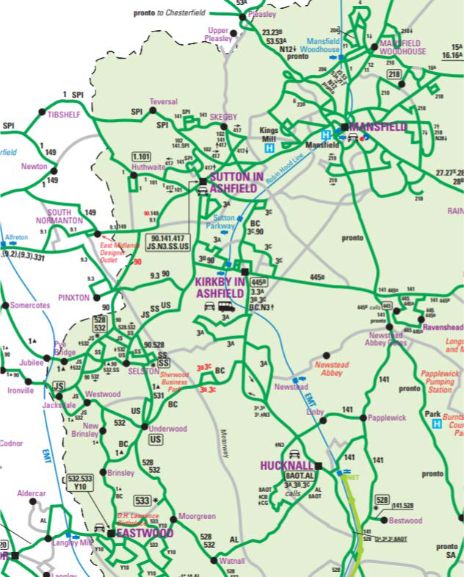

Map 2: Nottinghamshire County Bus Network Map
Source Nottinghamshire County Council website (Updated to 21st September 2021).

Nottingham Express Transit (NET)
  - Nottingham Express Transit (NET) currently runs from/to Hucknall to Nottingham City Centre serving town and local centres, employment sites and Park & Ride facilities. Two stops are located in the District:

    - Hucknall Station with 439 car park spaces, and
    - Butlers Hill.

The Moor Bridge stop is located just outside the District boundary on Nottingham Road and provides 119 car parking spaces.

  - As part of the proposals at Whyburn Farm discussions have been held regarding the possible extension of the NET to the north of Hucknall.

Railways

  - The District is served by the Robin Hood line which runs from Worksop to Nottingham. Three stations are located within Ashfield:

    - Hucknall located adjacent to the town centre
    - Kirkby-in-Ashfield located close to the town centre
    - Sutton Parkway located at Kirkby Hardwick off Penny Emma Way between Kirkby-in-Ashfield and Sutton-in-Ashfield
  - The number of train services will vary with the hours of operation but typically there are two services per hour between Mansfield and Nottingham during the day, and a more limited service at night and from Worksop. The integration with the wider railway is identified in Map 3.

HS2
  - HS2 aims to link London and the north of England via the midlands to overcome capacity constraints on the existing rail network and improve connectivity between the north and south of the country. Safeguarding Directions have been made by the Secretary of State for Transport for the route of HS2 phase 2B (Birmingham to Leeds) through the District.

  - The government, working with HS2 Ltd on an Integrated Rail Plan for the Midlands and the North, which will consider the best way to develop and deliver HS2 north of Birmingham, Northern Powerhouse Rail, the Midlands Rail Hub, and major Network Rail Projects. As yet the IRP has not been published.

Maid Marian Line
  - The potential upgrading of the freight-only line between the Robin Hood Line in Nottinghamshire and the Pye Bridge junction of the Erewash Valley Line in Derbyshire to carry passenger trains on a regular basis has the potential for positive economic impacts by enhancing the viability and attractiveness of key locations and sites along the corridor to developers and investors. It is also anticipated to benefit employees by allowing them to access a wider range of job opportunities and housing choices and employers by giving them access to a wider labour pool and more accessible locations. The potential for funding the project is being taken forward by the Council with the support of local Members of Parliament. If HS2 Phase 2b proceeds the Main Marian Line would also facilitate connections to the proposed East Midland Station at Toton.

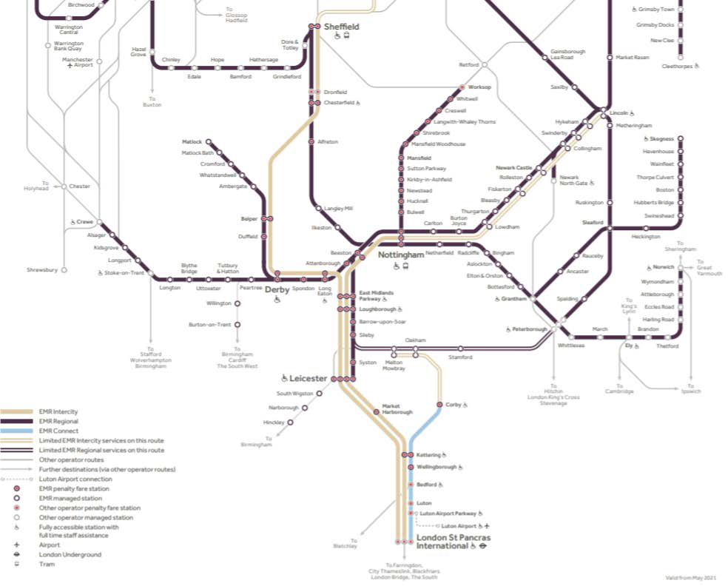

Map 3: Route Map East Midlands
Source East Midlands Railways6

Cycling & Walking

  - Nottinghamshire has more than 650 miles of countryside and urban cycle routes which together with the extensive public rights of way network provides access to substantial opportunities for walking or cycling. Part of the National Cycle Route Network (Route 6) runs through Annesley and Hucknall.

  - Nottinghamshire Cycling Strategy Delivery Plan sets out how the County Council, working with partners, aim to make cycling improvements that will deliver the strategy

6
https://www.eastmidlandsrailway.co.uk/sites/default/files/assets/download_ct/20210518/M5z6UiVeATNIa0yo mYynrJr6ru335L0DOQOLkv_w_JA/emr_website_750px_x_1134px_system_map_may_2021_rgb.pdf

in the Local Transport Plan, its goals and objectives; particularly those relating to improving access to jobs and reducing the impacts of congestion on the economy. The Delivery Plan details Nottinghamshire’s cycling vision and the actions the County Council, working with partners, will undertake to deliver the vision.
  - National planning policy7 place an emphasis on walking and cycling. The Government’s “Gear change” strategy identifies a Vision whereby cycling and walking will be the natural first choice for many journeys with half of all journeys in towns and cities being cycled or walked by 2030.

  - The Council’s Green Infrastructure and Biodiversity Technical Paper sets out information on existing routes and identifies where improvements will be necessary. The Town Fund includes the opportunity to upgrade or create new routes which are identified on the draft Local Plan Policies Map and include:

    - Hucknall - Kirkby – Sutton – Mansfield
    - Sutton – Derbyshire
    - Huthwaite – Sutton
    - Sutton - Sherwood Observatory

Air Quality

  - Air quality is a significant issue as the evidence identifies that air pollution cause both short term and long term effects on the health of children and adults.

  - Air pollution is defined as a mix of gases and particles emitted by man-made processes into the atmosphere. Concerns are particularly related to particles (PM or particulate matter) and nitrogen dioxide. Diesel vehicles are identified as making a significant contributions towards air pollution. While Ashfield does not have any Air Quality Management Areas it is important that negative impacts on air quality are reduced for the benefit of people’s health and the wider environment.

7 National Planning Policy Framework 2021, paragraphs 104 c) and 112 a)

Section 4 - Health

  - Primary care is the first point of contact for most people and is delivered by a wide range of independent contractors, including GPs, dentists, pharmacists and optometrists. NHS walk-in centres, NHS 111 and the NHS Direct telephone service are also part of primary care.

  - The planning and purchasing of NHS services is undertaken by organisations (or individuals) known as commissioners. They are responsible for assessing the reasonable needs of their populations and using their buying power as purchasers to secure services that are affordable and of the highest quality. They can buy services from any provider that meets NHS standards of care and prices.

  - Commissioning happens on an individual level every day in a GP practice. For example, when a GP refers a patient to a particular hospital for further investigation or treatment, the GP is effectively buying care for that patient from the hospital through that referral. This ‘secondary’ provider is paid to treat the patient through the NHS payment system. What care the GP can buy for their patient is determined by the commissioning organisation.

  - All GP practices are required to be a member of a clinical commissioning group (CCG). CCGs provide the organisational infrastructure to enable GPs, working with other health professionals, to commission services for their local community. The services that CCGs commission include planned hospital care, rehabilitative care, urgent and emergency care (including out-of-hours and accident and emergency services), most community health services, maternity services, mental health and learning disability services.

  - The CCG cover all GP practices in their area, and there is a governing Board who is responsible for making decisions about healthcare in the area. The Board includes GPs, nurses, hospital doctors, other healthcare professionals such as physiotherapists and patient representatives. The CCG commissions most services on behalf of patients, including emergency care, community care, planned hospital care, and mental health and learning disability services in their local areas, ambulance service and community services providers.

  - Prior to 1 April 2020 there were six CCG organisations in the city and county: Mansfield and Ashfield CCG, Newark and Sherwood CCG, Nottingham City CCG, Nottingham North and East CCG, Nottingham West CCG and Rushcliffe CCG. These organisations have now merged to form a single CCG, NHS Nottingham and Nottinghamshire Clinical Commissioning Group (CCG).

  - The Nottingham University Hospitals NHS Trust provides general hospital services to the population of Nottingham and a range of specialist care to a population of approximately 2.5 million through both the Queen’s Medical Centre and City Hospitals in Nottingham. The Sherwood Forest Hospitals NHS Trust, provides hospital services the people in and around Mansfield, Ashfield, Newark, Sherwood and parts of Derbyshire and Lincolnshire. The Trust operates two hospitals within the Ashfield

which are the Kings Mill Hospital and Ashfield Community Hospital. They are also responsible for Newark Hospital and Mansfield Community Hospital.

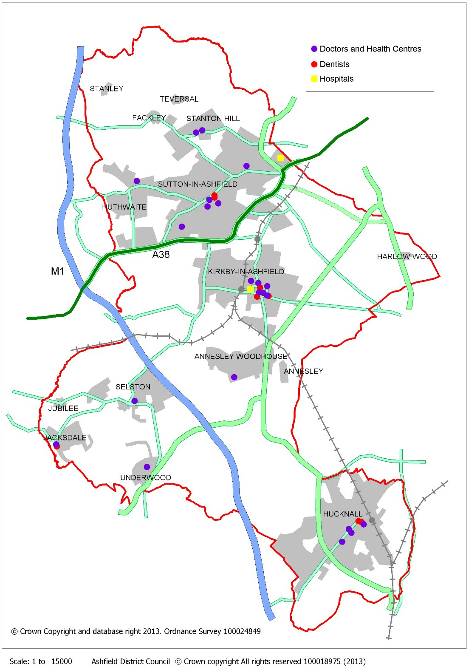

Map 4: Health Facilities in Ashfield District Council
Source: Ashfield District Council

N.B. The Underwood Surgery is closed.

  - Discussions with the CCG have indicated that they will be seeking contributions from new housing development to meet the additional requirements generated by the increased population. For planning applications contributions are based on a formula to arrive at a contribution towards expanding existing services or providing new facilities/services. On-going engagement with the CV G is required to determine the full implications of the development proposals in relation to health services.

  - National funding is available for making improvements but this is on a bidding process.

  - Elsewhere in the NHS, responsibility for public health - which focuses on, for example, promoting good dental health, vaccinations and lowering obesity, are now managed by Nottinghamshire County Council in The Nottinghamshire Health and Wellbeing Board. The Nottinghamshire Health and Wellbeing Board promotes close co-operation between the health service, local government and providers of services. Their strategy sets out the ambitions and priorities to improve the health and wellbeing of people in Nottinghamshire and a series of action plans identified how this will be achieved. A number of these aspects link into the policies and proposals within the Local Plan. However, it does not, as such, identify specific infrastructure requirements in terms of land or premises.

Section 5 - Electricity and Gas Utilities Electricity
  - Electricity is transmitted through:

    - National Grid operating a National Transmission Network;
    - Local distribution companies then supply electricity at progressively lower voltages to homes and businesses.
  - National Grid operates, owns and maintains the national electricity transmission network in England providing electricity supplies from generating stations to local distribution companies. This transmission system which operates at 400,000 and 275,000 volts (400kV and 275kV) is known as the “national grid” and covers some 4,500 route miles of overhead line, 420 route miles of underground cable and more than 335 substations. The company has a statutory duty to develop and maintain an efficient, coordinated and economical transmission system of electricity and to facilitate competition in the supply and generation of electricity.

  - Separate regional companies own and operate the electricity distribution networks that comprise overhead lines and cables at 132,000 volts and below. It is the role of these local distribution companies to distribute electricity to homes and businesses. Western Power Distribution (East Midlands) plc's operate the distribution network in Ashfield.

  - Western Power Distribution distributes power to 8 million homes and business covering the East and West Midlands, South Wales, and South West England. They are currently developing their business plan for 2023 – 2028 “ RIIO-ED2”8. Councils, including Ashfield, have been working with Western Power Distribution in terms of proposals from the developing local plan both in terms of development and the changes introduce to mitigate climate change. A series of workshops have been undertaken to facilitate Western Power Distribution’s approach to understanding future requirements. There will be more specific consultation with Western Power Distributions as the Local Plan progresses.

  - Western Power Distribution has a capital programme for reinforcement which is not attributable to individual developments. However, they may recover costs of reinforcement works required to meet the needs of specific developments. Developers may be required to pay for two main elements: the full costs of local infrastructure for the sole purpose of serving a development site and a proportion of any higher voltage reinforcement required to make the local connection (based on the proportion to be used by the development). Where adequate capacity exists ‘upstream’ reinforcement works may not be necessary. Smaller developments will probably be accommodated without additional cost.

8 Revenue = Incentives + innovation + Outputs (Electricity Distribution2)

Gas Transmission
  - National Transmission System - The high-pressure transmission pipelines transport gas from import terminals to major centres of population and some large industrial users, such as power stations. These pipelines are known as the National Transmission System (NTS). National Grid owns and operates the high pressure gas transmission system in England, Scotland and Wales. New gas transmission infrastructure developments (for example pipelines and associated installations) are periodically required to meet increases in regional demand and changes in patterns of supply. Developments to the network occur as a result of specific connection requests, for example power stations, and requests for additional capacity on the network from gas shippers. Generally, network developments to provide supplies to the local gas distribution network are as a result of overall regional demand growth rather than site specific developments. National Grid, Gas Ten Year Statement, 2019 does not identify any planned capital investment schemes for the strategic high pressure gas infrastructure within the East Midlands.

  - Local Transmission System - The gas distribution network (to homes and businesses) is not part of the National Transmission System. The gas distributer for Ashfield is Cadent Gas9. Cadent Gas’s Long-Term Development Plan 202010 and The East of England mains replacement heat map highlights that for north Nottinghamshire there are limited works. This implies that no strategic capacity issues are expected within Ashfield.
  - A range of companies are able to supply gas to homes and businesses. These companies have to be licensed by Ofgem (Office of Gas and Electricity Markets)

9 Formerly National Grid Gas Distribution Ltd
10 https://cadentgas.com/about-us/our-company/long-term-development-plan

Section 6 - Water Supply, Treatment and Quality Water Supply
  - The Environment Agency’s Water Resources Strategy Regional Action Plan for the Midlands Region 2009 recognises that there is increased pressure on water resources over the next 30 years. This reflecting an increase in population, changes in lifestyle, climate change, the development of new technologies, and changes in the use of land. These pose significant challenges to the way water resources are managed, and as a result, the way water is valued will become more important.

  - Ashfield falls entirely within the remit of one Water Company, Severn Trent Water Ltd which has responsibility for providing clean water and sewerage services. Severn Trent Water has advised that the water supply to the Ashfield area comes from 3 main sources: -

    - The Derwent Valley (North Derbyshire) - surface water source
    - Ogston Reservoir – surface water source
    - Borehole sites in North Nottinghamshire – ground water source

  - The water supply into different areas of Ashfield comes from a variety of sources:

- Hucknall and its surrounds – 100% Surface Water, Derwent Valley
- Kirkby-in-Ashfield and its surrounds – 70% Groundwater sources, 30% Surface Water, Ogston Reservoir
- Sutton-in-Ashfield and its surrounds – 50% Groundwater Sources, 50% Surface Water, Ogston Reservoir
- The villages of Selston, Jacksdale and Underwood - 100% Surface Water, Derwent Valley
  - Severn Trent Water Resources Management Plan (WRMP, 2019 sets out how they intend to provide supplies of water to our customers over the next 25 years and beyond. It consists of several elements, including:

- A 25 year demand forecast. This describes how much water customers will need in the future, considering factors such as climate change and population.
- A 25 year supply forecast. This sets out how much water is available for use now and how this may change in the future. Severn Trent consider the impact of climate change and potential reductions in the volume of water that they are allowed to take from rivers and groundwater.
For the purposes of water resources planning, Severn Trent divide the supply area up into 15 water resources zones. Ashfield is located in Nottinghamshire Zone.

  - The Environment Agency is responsible for managing water resources in England. They make sure there is:

- enough water for people - public water supply, industry and agriculture
- a healthy environment.
The Environment Agency controls how much water is taken with a permitting system. The Environment Agency regulate existing licences and grant new ones. To do this they use:

- the catchment abstraction management strategy (CAMS) process
- abstraction licensing strategies.

  - Information on the abstraction licensing strategies for Ashfield are set out in the following:

- Idle & Torne Abstraction Licencing Strategy. This covers parts of Sutton in Ashfield, particularly to the north of the town. It indicated that water is not available for extraction.
- The Lower Trent and Erewash Abstraction Licencing Strategy. This covers the area to the west of Kirkby–in-Ashfield and Hucknall (River Erewash & River Leen). In general terms, the indications are that water is not available in Hucknall Ravenshead South.
- The Don and Rother Abstraction Licencing Strategy. A small area forming part of the catchment to the River Doe Lee to the north east of the District falls within this area where generally water is available.
- The Derbyshire Derwent Abstraction Licencing Strategy. This covers Huthwaite (Nunn Brook).
  - The Watercycle Study for Greater Nottingham and Ashfield (2010) indicated water resources in the East Midlands are significantly constrained with little opportunity to develop new water resource schemes. The shortfall identified in the Watercycle Study (of water supply) is also identified in the Severn Trent WRMP, 2019 within the Nottinghamshire Water Resource Zone but the WRMP proposes a range of demand and supply measures to ensure sufficient water resources can be maintained up to 2025 (and in outline up to 2030).

Waste Water Treatment and Sewerage
  - Severn Trent Water is responsible for treating waste water so that the cleaned sewage can be returned into rivers or streams to continue its journey through the water cycle. Waste water enters the public sewer system, and is transports to one of the water treatment plans in the region.
  - The Council has worked with Severn Trent with regard to the SHELAA sites submitted to the Council. Some sites have been identified as Red (High Risk). However, this does not prevent development but highlights sites where Severn Trent require network improvements to facilitate development and this could impact on delivery Timescales.

  - The key aspect from Severn Trent Water Ltd aspect is sufficient time to upgrade water supply facilities where necessary. However, capacity improvement construction works would not normally commence until there is more certainty that a development will take place, which is usually when outline planning permission is granted. The time frame for design and eventual construction of capacity improvement work will be dependent on the certainty of planning permission being granted, development size/phasing and the extent of the anticipated capacity improvements. If capacity improvements are required, it is indicated that this can usually be completed by Severn Trent Water in 18-24 months.

Water Quality
  - The Environment Agency is the Competent Authority under the Water Framework Directive (WFD), which means that the EA co-ordinate activity to improve and maintain water quality, quantity and morphology (channel shape) through river basin management. Ashfield District along with all other public bodies must have regard to River Basin Management Plan (RBMP) and any supplementary plans in exercising their functions.

  - The head waters of the Rivers Leen, Maun, Meden and Erewash rise or run through Ashfield District and each of these watercourses are not yet at good ecological status or potential. Further information on the status of rivers in Ashfield is set in the River Basin Management Plan Humber River Basin District, 2015. Under the Water Framework Directive, the watercourses must achieve Good Ecological and Chemical Status by 2027.

  - The implication for planning is that development should not cause a deterioration to water bodies or to their tributaries and where possible proposes an improvement to the water bodies ecological status or potential. This reinforces the importance of utilising SuDS, which reduces pollution reaching adjacent watercourses.

  - The Council will continue to work with Severn Trent Water Ltd, The Environment Agency and neighbouring authorities to maximise opportunities to improve water quality.

Section 7 - Flooding

  - Flooding arises where the capacity of natural or man-made drainage systems is exceeded by heavy rainfall or high sea levels. There are various forms of flooding, which potentially could occur in Ashfield including:

    - Fluvial (from watercourses)
    - Pluvial (from surface water)
    - Sewer Flooding
    - Groundwater
  - Flooding may arise from a combination of these sources depending on circumstances. The impacts of flooding vary according to factors such as scale and duration of the flood, the velocity and volume of flood water, the speed at which the flood occurs and the type of flood water. The nature of land use and the population level in the area that is flooded also influence the scale of the impact of flood events.

  - The Environment Agency sets out an overview of flood risk through catchment flood management plans (CFMPs). These are set out under Humber River Basin District11. The River Trent Catchment Flood Management Plan gives an overview of the flood risk in the River Trent catchment and sets out our preferred plan for sustainable flood risk management over the next 50 to 100 years. Ashfield falls into to two sub-areas within the CFMP, ‘Nottingham’ and ‘Sherwood’. The Environment Agency has identified that:
    - One of the policies in the CFMP that specifically can be considered in parts of Ashfield includes, identify opportunities to maximise the use and benefits of sustainable drainage systems (SuDS), particularly in areas where the sandstone geology will support extensive use, and where a strategy for retro-fitting SuDS may be developed;
    - Surface water management is important in Ashfield, due to the receiving catchments being recognised as rapid response due to historical urbanisation, for example the River Leen;
    - To put the CFMP into action, the Environment Agency Flood Risk Management produce a Medium Term Plan (MTP) on which they manage future flood risk management works. This does not identify any future flood defence infrastructure in Ashfield.
  - Ashfield is located upstream of the Trent valley with a number of the River Trent’s tributaries rising in Ashfield. Consequently, the flood zones from water courses are not as extensive and less of a constraint to development as in other local authority districts. This is reflected in the Strategic Flood Risk Assessment (SFRA) conclusion that the risk of flooding from watercourse in Ashfield is relatively low, nevertheless

11 https://www.gov.uk/government/collections/catchment-flood-management-plans#humber-river-basin-district

flood risk is an issue. A number of properties in the District have flooded in the past with significant consequences for the wellbeing of the occupiers of those properties. Properties in parts of Hucknall are at risk of flooding from the Baker Lane Brook and a number of properties at Jacksdale are at risk from flooding from the River Erewash and the Bagthorpe Brook. Only minor parts of Sutton in Ashfield, Kirkby in Ashfield and Annesley Woodhouse are identified as being medium to high probability of flooding from watercourses. However, flood risk extends well beyond the District.
Additional water from development into the River Leen and its tributary streams has significant implications for flooding downstream in the City of Nottingham. Similarly, additional water into the River Erewash has the potential to flood Pinxton and other areas outside the District of Ashfield. This is reflected in the necessity in Hucknall to keep runoff to Greenfield rates or lower if possible.

  - The Environment Agency’s reservoir flood map indicates those areas which could be at risk of inundation should a reservoir fail. The Environment Agency’s reservoir information relates only to large raised reservoirs of a capacity of 25,000 cubic metres of water or more and is given for guidance only. Two reservoirs are identified in Ashfield;

- Sutton Lawn Dam, Sutton-in-Ashfield
- Kings Mill Reservoir, Sutton-in-Ashfield

In addition, there is a potential risk to Hucknall from the Newstead Abbey Upper Lake and Barracks Farm Reservoir which falls within the Borough of Gedling.

  - Nottinghamshire County Council, as the Lead Local Flood Authority is a consultee for surface water flooding, as the government identified that they have the appropriate technical knowledge and expertise to assess surface water drainage proposals including sustainable drainage.

  - The SHELAA has taken account of Flood Zones identified in the Environment Agency’s Flood Maps for Planning. Sites have not been taken forward where a risk of flooding has been identified (Flood Zones 2 and 3). It also considered surface water flooding identified by the Environment Agencies Flood Maps.

Section 8 - Telecommunications

  - Telecommunications covers a wide area including telephones with land lines, broadband, Mobile G2, Mobile G3, Mobile G4, G5, Digital television and digital radio.

  - The provision of high speed broadband services is important to support the growth of knowledge based economies and has an increasing role in enabling sustainable home working patterns and supporting residents to be part of digital community with easy access to online information and services.

  - IT and telecommunications such as broadband can be supplied by a number of companies but the infrastructure in this area is provided by Open Reach (BT) and Virgin Media.

  - Open Reach (part of the BT Group) operates the local loop in most of the UK. The local loop network (including ducts, poles, cables and exchange buildings) is used to deliver both the Public Switched Telephone Service (PSTN) and broadband services (and other data services).

  - Virgin Media is the largest operator of HFC networks. HFC networks are used to deliver television and broadband services. Essentially, Virgin Media owns and operates its own fibre optic cable network. This network consists of fibre optic cables to the cabinet, with the final link to the home provided by coaxial cable.

  - The strategic BT network comprises a series of telephone exchanges, with a network of cables providing services to residential and commercial properties. There are three telephone exchanges within the District, Sutton-in-Ashfield, Kirkby-in-Ashfield and Hucknall. The exchanges are SDSL enabled (symmetric digital subscriber line), therefore, as a whole, broadband speeds within the District are likely to be responsive. Table 7 sets out the position on Fibre to the Cabinet in Ashfield.

  - It is understood from BT Openreach that there are unlikely to be any limitations to broad band and telephone services for new developments and that the company is currently obliged to service new developments. Openreach will provide the infrastructure to any new residential or commercial development on an as and when needed basis, but only when full planning permission has been granted.

Exchange | Form | Available
Kirkby in Ashfield | Fibre to the Cabinet | Current
Sutton in Ashfield | Fibre to the Cabinet | Current
Hucknall | Fibre to the Cabinet | Current
Leabrooks | Fibre to the Cabinet | Current
Pinxton | Fibre to the Cabinet | Current
Langley Mill | Fibre to the Cabinet | Current

Table 7: Availability of Superfast Broadband in Ashfield
Source: BT Open reach website October 2016

Section 9 - Green Infrastructure

  - Green Infrastructure planning therefore involves the creation of strategically planned networks that link existing and proposed green spaces together and with the communities around them12. Through the maintenance, enhancement and extension of these networks multi-functional benefits can be realised for local communities, businesses, visitors and the environment. It provides opportunity to plan for a healthier environment and communities alongside other infrastructure. It also seeks to ensure the delivery, protection, enhancement and creation of recreational and environmental resources, e.g. green corridors, landscape features and habitat networks.
  - Any future development within Ashfield should aim for net social, environmental and economic gains, with no net loss to biodiversity. Strategic Green Infrastructure is identified in the evidence base to the Local Plan and the Greater Nottingham Aligned Core Strategies. The Ashfield District Council Green Infrastructure & Biodiversity Technical Paper (GI&BTP) identifies:

    - Strategic corridors which connect key Green Infrastructure resources and/or run between settlements and across district boundaries.
    - Local corridors connect small green space and/or link neighbourhoods to the strategic network.
  - Additional work has been undertaken through The Nottinghamshire Biodiversity Opportunity Mapping Projects for Ashfield 2016. This provides a better understanding of the distribution of biodiversity and identifies the habitat networks and opportunities for enhancement.

  - Spaces and places in Ashfield are categorised in the Ashfield District Public Open Space Strategy 2016. These include:
    - Parks and green spaces - There are nearly a hundred parks and green spaces within Ashfield, providing a range of facilities for residents to enjoy. To assist in setting the strategic direction across the range of spaces, Ashfield’s parks and green spaces are grouped in 2 categories:
      - Neighbourhood parks and green spaces- these smaller parks provide a focal point for the immediate community and may include one or a combination of some of the following; a play area, sports facilities, grassed areas. Examples include: Nabbs Lane Park, Morven Park, Green Well Park and Huthwaite Welfare Park

12 The NPPF 2021 Annex 2 defines Green Infrastructure as ”A network of multi-functional green and blue spaces and other natural features, urban and rural, which is capable of delivering a wide range of environmental, economic, health and wellbeing benefits for nature, climate, local and wider communities and prosperity”.

      - Destination parks- sites that provide a wider range of facilities and visitor attractions including events, examples include Titchfield Park, Hucknall, Sutton Lawn, Brierley Forest Park and Kingsway Park.

As well as Ashfield District Council a number of areas are in the County Council’s ownership/control such as Dobb Park, Hucknall and Rookery Park, Sutton which tend to be larger often restored sites, managed as country parks. There are two Parish Councils within the district; Annesley & Felley and Selston, which own the majority of green spaces within their areas.

    - Play and young people’s areas - There are currently 49 play areas and 14 young people’s areas across the district. 13 of the play areas are within sites owned by Selston Parish Council, one within a site owned by Annesley Parish Council.
    - Sports facilities on green spaces - There are a number of sports facilities within green spaces, with 36 sites across the district (not including school grounds). The majority of these sites provide adult and/or junior football pitches and changing rooms. There are also eight cricket pitches, 13 bowling greens and 13 tennis courts, some of which are marked out for netball.
    - Allotments - Ashfield District Council and the parish councils provide 23 allotment sites with approximately 904 plots, 87% are used as allotments. There are 12 private allotments sites, providing approximately 544 plots, 83% are used as allotments.
    - Cemeteries - There are 6 cemeteries and 7 closed churchyards in Ashfield. The district council maintains the sites and all buildings and infrastructure (except churches).
    - Green links - Green links are referred to in this strategy but are covered fully in the Green Infrastructure and Biodiversity Technical Paper. The technical paper identifies strategic green
  - There are a number of protected sites in the District these include:
    - Sites of Special Scientific Interest (SSSI), these are of national importance and provide legal protection for the rarest habitats and species. (There are 9 sites in Ashfield as at 2016)
    - Ancient Woodland Sites13 which are of national importance.
    - Local Nature Reserves.
    - Local Wildlife Sites formerly known as Sites of importance for Nature Conservation (SINC sites) which are locally important sites.
  - These protected sites are identified in the Ashfield draft Local Plan and on the Proposals Map. Although not protected in itself, Ashfield is within the Greenwood

13 Including Ancient Semi-Natural Woodlands (ASNW) and Plantations on Ancient Woodlands Sites (Paws).

Community Forest, which covers 161 square miles of Nottinghamshire, from Mansfield in the north to Nottingham in the south. The Greenwood is one of twelve Community Forests established in the early 1990s to demonstrate the contribution of environmental improvement to economic and social regeneration.
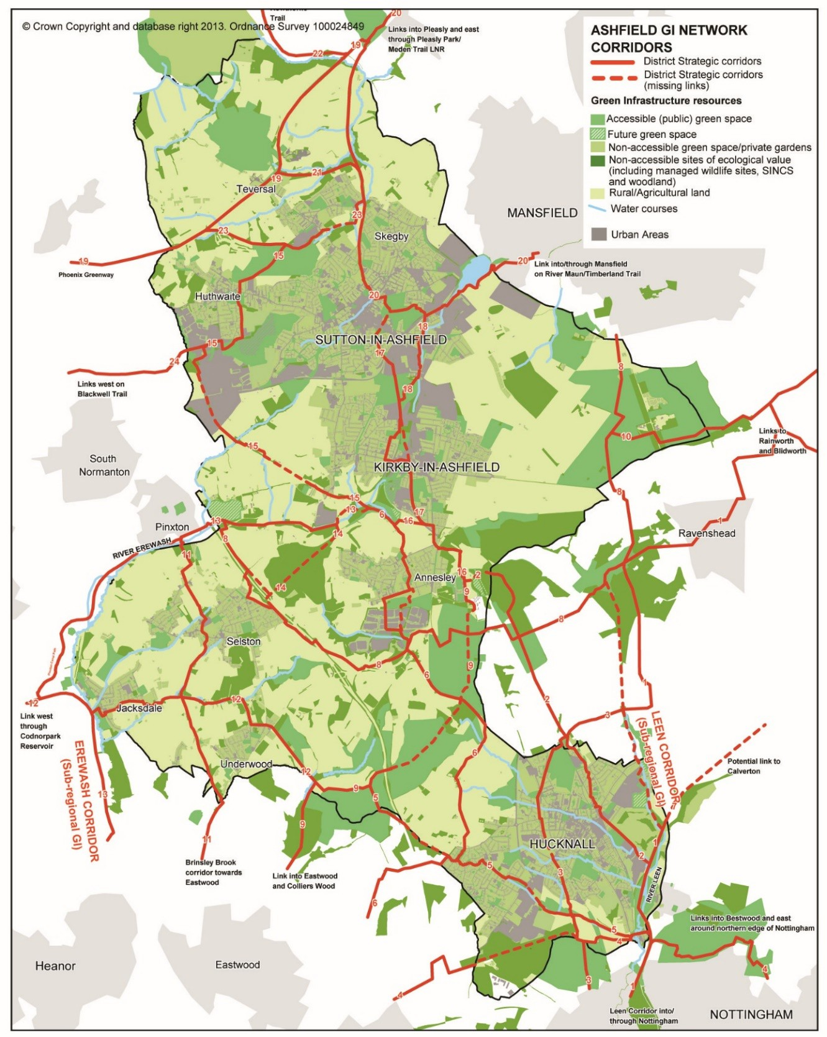

Map 5: Green infrastructure in Ashfield
Source: Ashfield District Council

  - There are a number of strategic and local footpath routes which provide good cycling and walking opportunities for the local population. The provision of a comprehensive footpath network is limited by gaps in the network and by barriers to movement, such as major ‘A’ roads, other fast roads and river corridors. Overcoming these barriers and bridging gaps in the network is a priority. The Nottinghamshire Rights of Way Improvement Plan, prepared by Nottinghamshire County Council, identifies where significant improvements are required in order to make footpaths attractive to users. The Ashfield’s GI&BS also provides additional information on “Accessibility and Sustainable Transport“.

  - Ashfield District is split into three Regional Landscape Character Areas, defined below, which are subdivided in Landscape Character Type. These types are described in more detail in the Landscape Character Assessment for Greater Nottingham and Ashfield (2009). It sets out the character, landscape analysis and actions, which will be taken into account when considering any planning application.

Landscape Character  Area | Policy Zones
Magnesian Limestone Ridge | - MLO 16 Nutha ll Wooded Farm land;  - MLO17 Linby Wooded Farm land;  - MLO18 River Leen Co rrid or;  - MLO19 Kirkby Quarry, Portla nd Park and Ris e Hill;  - MLO20 Kirkby Plateau;  - MLO21 Brie rle y Forest Park;  - MLO22 Sutton Plateau;  - MLO23 Skegby Upland Plateau.
Nottinghamshire Coalfields | - NC01 Erewash River Corridor  - NC03 Selston & Eastwoo d Urban Fringe Farm land;  - NC04 Moorg reen Rolling Woodland;  - NC05 Kirkb y Coa lfie ld Farm la nds /Kirkb y Va le s ;  - NC06 Fulwood Restored Works;  - NC07 Stan le y & S ilve rh ill;  - NC08 River Med en Va lle y.
Sherwood | - SH05 Newstead Wooded Estate la nds (SPZ 05);  - SH11 Lindhurst Wooded Farm lands (SPZ 11);  - SH16 Annesley Wooded Estatelands (SPZ 16);  - SH45 Kirkby Fo rest Wood ed Farm lands (SPZ 45);  - SH47 Coxm oor Wooded Farm lands (SPZ47)  - SH52 Watnall Coppice Wooded Estatelands (SPZ 52)

Table 8: Landscape Character Area
Source: Greater Nottingham Landscape Character Assessment 2009

  - An increase in the number of dwellings with limited spaces in the urban area means that some urban extensions will be required and additional pressure will be imposed on green infrastructure. Green infrastructure will need to be an integral part of this planned development to help to achieve sustainable growth in these areas. Enhancements and costs associated with green infrastructure will need to be developed on a case by case basis as developer proposals emerge and many schemes are likely to be provided on site as part of the overall offer of the development.

Ashfield Standards 2016 (Source: Public Open Space Strategy 2016. Ashfield District Council).

  - The Public Open Space Strategy examines standards for open spaces based on the quantity of sites which is closely linked to accessibility and at the quality using the recognised national standard for quality green space, the Green Flag Award. A standard catchment area is not provided for sports facilities. User surveys found that participants generally travelled to facilities using vehicular transport and catchment areas were therefore less important. The objective is to concentrate sports facilities on a smaller number of sites in order to provide better quality facilities. This approach is advocated by Sport England which favours multi use site funding applications.

  - The Catchments Areas are reflected in the assessments of housing sites in the SHELAA.

GREEN SPACE
Catchment areas
No person should live more than:
- 480 metres (6 minute walk) from their nearest neighbourhood park/ green space
- 1000m (12- 13 minute walk) from their nearest destination park/ green space
- 480m from their nearest area of natural green space
Quantity
- Development sites: 10% of the developable area to be designated for open space on sites of 2 hectares and above (if the site is not within the catchment area of an existing appropriate park or green space)
- New green space needs to be a minimum of 2000m2 and contain the following features: surfaced paths, trees, bulbs, litter bins, seating, cycle racks and entrance signage. If drainage features are incorporated into the green space these will be additional to the 2000m2
Destination green space definition
Provides a destination standard play area and young people’s area, as well as the requirements
stated above in ‘quantity’
Neighbourhood green space definition

Provides a neighbourhood standard play area and young people’s area and contains the following
features: surfaced paths, trees, litter bins, seating and entrance signage.
PLAY AND YOUNG PEOPLE’S AREAS
Catchment areas
No child should live more than:  - 480m from their nearest neighbourhood play area  - 1000m from their nearest destination play area | No young person should live more than:  - 700m from their nearest neighbourhood young people’s area  - 1000m from their nearest destination young people’s area
Quantity
Neighbourhood play area Neighbourhood Young People’s area
- 6-11 different pieces of equipment  - 2 seats and a litter bin  - Under 5’s area with fencing and 2no. self-closing gates, to be a minimum of 320m2  - Equipment for over 5’s provided in safer surfacing adjacent to the fenced area, including at least 4 dynamic/ challenging pieces of equipment for over 12 years | - Grass kick about area with five a side goalposts, minimum area 42 x 33m  - plus one of the following with a minimum dimension equivalent to 40 x 20 m:  - Concrete ramp skate/BMX/scooter park- with a minimum of 3 ramps  - Multi-use games area  - Bike dirt track  - Outdoor gym equipment
Destination play area Destination Young People’s area
- At least 12 different pieces of equipment  - 3 Seats, picnic benches and 2 litter bins  - Under 5’s area with fencing and 2no. self-closing gates, to be a minimum of 320m2  - Equipment for over 5’s provided in safer surfacing adjacent to the fenced area, including at least 6 dynamic/ challenging pieces of equipment for over 12 years | - Grass kick about area with nine a side goalposts, minimum area 79m x 51.2m  - plus two of the following with a minimum overall dimension equivalent to 40 x 40 m:  - Concrete ramp skate/BMX/scooter park- with a minimum of 6 ramps  - Multi-use games area  - Bike dirt track  - Outdoor gym equipment

  - An assessment of the catchment areas for green space was undertaken to assess where there are any gaps in provision and any overprovision. No oversupply of green

space was identified in the District. A number of areas were identified where there was a deficiency in green space provision.

 | Green Space under provision | Opportunities to address gap in provision
HUCKNALL | Watnall Road, south west edge of Hucknall | Within catchment area of new green space to be provided at Rolls Royce  development site
HUCKNALL | West Hucknall- Hazelwood Drive area –park/ recreation ground | Edge of settlement, houses in area have fairly large gardens and are in the vicinity  of Common Farm (natural green space)
KIRKBY | No under provision identified
RURAL | East Selston | Edge of settlement
SUTTON | Fackley Village –park/ recreation  ground | Close to Silverhill Country Park
SUTTON | Beck Lane/ Penniment Lane area-north east of Sutton (approx. 30  houses) | New park/ recreation ground to be provided as part of housing site SKA3h to  the south west
SUTTON | Fulwood- Cuttings Avenue, Rookery Lane and Alfreton Road | Would be within the catchment area for Ashfield Park if the site was upgraded to a destination site. Potential for green space provision to the north through housing  sites SKA3g, SKA3ac and SKA3l

  - Allotment standards - The National Allotment Society suggests a national standard of 20 standard plots per 1,000 households (1 plot per 50 households, equivalent to 20 plots per 2,200 people (based on 2.2 people per house) or 1 plot per 110 people). In 2016 provision in Hucknall, Kirkby and the Rural area was within the standard, however in Sutton the standard was not being met where the households per plot ratio was 1:62. The population of the district is due to increase by approximately 13,000 people (approximately 5,909 households) by 2032 with a significant proportion in Sutton. Based on the current usage of allotment plots, the District will have a total undersupply of 50 plots by 2032, and a district wide household to plot ratio of 1 plot per 52 households. The District undersupply and standard can be met if the 128 plots in public ownership are brought back into use, reducing the household to plot ratio to 1 plot per 47 households. Whilst the overall district wide undersupply could be met there will remain a deficit of 136 plots within the Sutton area. This undersupply could be addressed through housing developments in Sutton where additional plots could be provided, where appropriate.

  - The Strategy includes an Action Plan in relation to a series of priorities over varying timescale up to 2025.

  - The Ashfield Playing Pitch Strategy relates to a period from 2017 – 2020. The Strategy is anticipated to be reviewed in the near future.

Section 10 - Leisure and Cultural Services Library Services
  - The County Council has a statutory responsibility under the terms of the 1964 Public Libraries and Museums Act, to provide “a comprehensive and efficient library service for all persons desiring to make use thereof”. All libraries (excluding mobile) within the District provide books for loan by children and adults, computers including free internet and e-mail, CD Roms and a range of information services.

  - Nottinghamshire County Council Planning Obligations Strategy, January 2021 includes the anticipated developer contributions toward libraries with developments of over 50 dwellings potentially triggering a requirement for contributions.

Culture, Leisure and Community
  - ‘Culture’ has a vital role to play in the regeneration and re-building of local communities, given the wide range of activities and opportunities embraced by the term culture. The Council sees cultural activities as a catalyst for the transformation process within the District, given the important role they play in contributing to the overall quality of life, and the health (physical, mental, social and emotional) of local communities.

  - Ashfield District Council runs a wide range of leisure and community services/programmes/activities across the District. In addition, there are also some commercially provided facilities such as health and fitness centres, bingo, snooker and sports provision.

  - The Council’s focus is to ensure equality of access to all cultural opportunities in the District, working with a wide range of partners, to deliver these benefits within the local communities.

    - Community Empowerment: provides support for local people to become more involved in community life, enabling them to take part in consultations and local decision making and take action, for example through participation in community/voluntary groups and through volunteering opportunities. The provision of facilities, events, and activities supports and empowers groups and individuals to deliver quality of life improvements through their own actions, contributing to civic pride.
    - Tourism and Heritage: to enhance the District and increase the appeal of Ashfield as a destination for tourism with credible visitor attractions; to research, preserve and interpret heritage and develop infrastructure and to maintain the physical structures of industrial heritage, encouraging community and school projects and promotion of heritage to a wider market;
    - Arts: to increase opportunities for local people to participate in a wide variety of arts experiences. The arts play a vital role in regenerating communities by combating exclusion and raising aspirations.

Leisure Facilities
  - Ashfield District Council provides a comprehensive range of leisure facilities. There are leisure centres at Festival Hall Leisure Centre (Kirkby), Hucknall Leisure Centre, Lammas Leisure Centre (Sutton) and Selston Leisure Centre. A new leisure centre is currently being constructed, which will replace the aging Festival Hall Leisure Centre.

Facility | Location | Summary Provision
Lammas Leisure Centre | Sutton in Ashfield | Fitness suite; Group exercise studios; Competition main pool and teaching pool; Spin studio; 2 Squash courts 4 Court sports hall; Crèche; 6 lane Indoor Bowls Hall; 32 x 18m Ice rink; Café.
Festival Hall Leisure Centre | Kirkby-in-Ashfield | Group exercise studio; Spin Studio; 2 x Fitness suite; Fully equipped meeting room; Function bar; Sports hall; Squash court; Crèche
Selston Leisure Centre | Selston | Outdoor football pitch; Fitness suite; Group exercise studio; 4 Court sports hall.
Hucknall Leisure Centre | Hucknall | 2 x Fitness suites; Swimming pool with moveable floor; Group exercise studio; Spin studio; 2 squash courts; 4 court sports halls; Crèche; Café; Meeting room

Community Centres
  - Community facilities including community centres, religious institutions and meeting space play an important role providing focus for cultural, leisure and community activities at a local level and contributing towards education and community vibrancy. Community halls are multipurpose buildings which provide space and facilities for a range of local activities and increasingly for community services, such as: social activities, sports and recreation activities, arts activities, educational activities and local services, such as libraries. They are regarded as playing a substantial role in providing facilities for the local community, particularly in rural areas.

  - Ashfield District Council operate community centres and meeting rooms, which are available for hire, However, a significant number of community centres and meeting spaces are run within the urban areas by churches, miners’ welfares, churches, community groups or charities. Commercial interests may also provide meeting space, such as pubs and nightclubs. The villages in Ashfield will have at least one village or community hall run either by the local community, Selston Parish Council or Annesley and Felley Parish Council. These facilities can typically be booked for meetings or recreational activities.
  - It is difficult to draw conclusions as to the overall capacity of community facilities due to a lack of information on the total available space and the level of demand for that space. Therefore, no phasing or dependencies have been identified, in relation to

cultural and leisure facilities. This area covers a wide range of facilities and in a number of cases, for example, community halls, no standards have been identified.

Section 11 - Waste Management

  - The National Planning Policy for Waste (2014) document highlights the requirement for Local Authorities to identify sufficient opportunities to meet the identified needs of their area for the management of waste streams. The Local Authority should drive waste management up the waste hierarchy (below), recognising the need for a mix of types and scale of facilities, and that adequate provision must be made for waste disposal. There is a requirement for Ashfield to work collaboratively in groups with other waste planning authorities, and in two-tier areas with district authorities, through the statutory duty to cooperate, to provide a suitable network of facilities to deliver sustainable waste management.
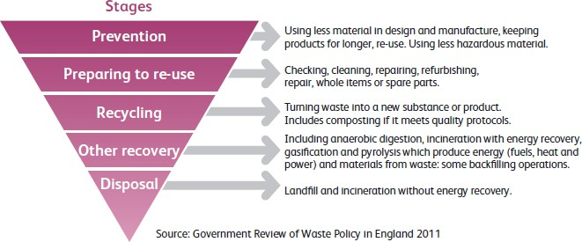

  - Waste is generated from many sources including local authority collected waste (waste from households, trade premises, litter and street sweepings collected by Waste Collection Authorities), Municipal Waste (waste similar in nature to local authority collected waste) industrial/commercial activities, and construction/demolition waste. Nottinghamshire County Council’s as the Waste Disposal Authority is responsible for the disposal of the local authority collected waste. Ashfield District Council along with other district/borough councils is responsible for the collection of waste from households and from some commercial/retail premises. However, commercial and other forms of waste will be largely collected by the private sector.

  - The District Council has separate collections for some recyclable items and operates recycling sites at various points throughout the District, collecting glass, paper, cans and shoes. The County Council’s waste management contract includes existing waste transfer and Household Waste Recycling Centres (HWRC) with sites in Ashfield being located at:

    - Sidings Road, Lowmoor Road Industrial Estates, Kirkby-in-Ashfield;
    - Wigwam Lane, Baker Brook Industrial Estates, Hucknall.
  - How waste is managed is currently set out in the Nottingham and Nottinghamshire Replacement Waste Local Plan Part 1: Core Strategy. The Core Strategy was

adopted in December 2013. The main issues arising from the Core Strategy’s growth proposals relate to the sustainable management of waste in terms of:

    - reducing the generation of waste;
    - increasing the re-use and recycling of materials;
    - securing sustainable energy from waste where appropriate;
    - minimising waste destined for landfill and ensuring that disposal is the last resort once all other options have been exhausted;
    - ensuring sufficient capacity and sites for future waste management needs; and,
    - balancing the impacts of waste management on the environment, wildlife, landscape, heritage, residential amenity and quality of life.
  - The Waste Core Strategy aims to promote a pattern of appropriately sized waste facilities in the areas where they are most needed – i.e. the main urban areas where most waste is produced. Main urban concentration will be focused on the Ashfield towns of Sutton-in-Ashfield, Kirkby-in-Ashfield and Hucknall. Functionally these main urban areas are closely linked and the availability and concentration of suitable employment land and transport links make these the most appropriate locations for the development of major waste infrastructure. However, there may also be a need for other, small or medium sized, facilities within these areas.

.Ashfield
DISTRICT COUNCIL
Ashfield District Council

Urban Road, Kirkby in Ashfield, Nottingham, NG17 BDA Tel: (01623) 450000 Fax: (01623) 457585 Website: www.ashfield.gov.uk

