# Ashfield District Council

# Cemeteries and Memorials Strategy

# 2025 - 2035

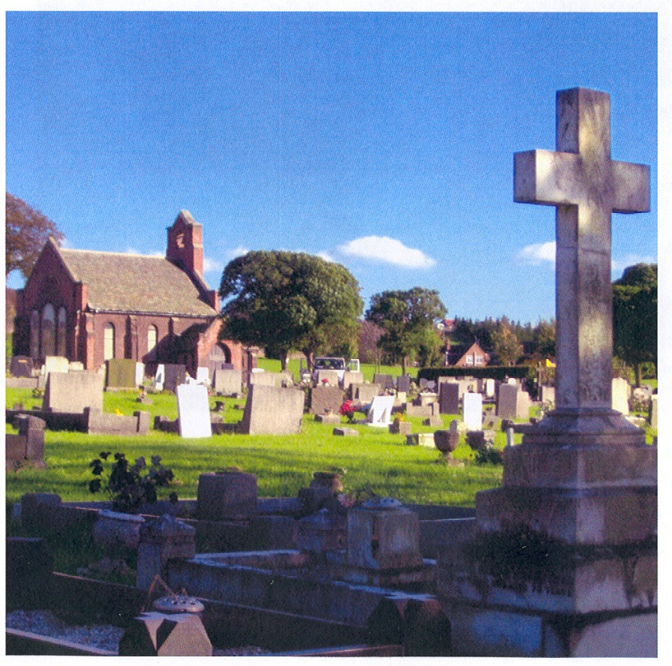

Kingsway New Cemetery, Kirkby in Ashfield

## Contents

1. Executive Summary 3

2. Introduction 4

3. Vision and Objectives 5

4. Policy Context 6

5. Cemeteries and Churchyards 8

6. Current Provision 12

7. Demographics 15

8. Looking Forward 17

9. Quality of Standards 20

10. Closed Churchyards and the Re-Use of Graves 22

11. Fees and Charges 24

12. Consultation and Liaison 25

13. Summary 26

14. Action Plan 27

Appendix A: Cemetery Rules and Regulations 28

Appendix B: Cemetery Fees and Charges 49

## 1. Executive Summary

1.1 The Cemeteries and Memorials Strategy 2025-2035 aims to ensure that cemeteries across the Ashfield district provide long term, viable, and sustainable solutions to cater for growth and demand. There are currently six cemeteries in the district of Ashfield, of which five are still open, and seven closed churchyards.

1.2 This strategy covers the current cemetery provision, demographic statistics, and the maintenance quality standards, alongside future opportunities for Ashfield District Council (ADC) to increase capacity and expand upon the burial options available. The strategy will also make certain that the cemeteries across the district are a space for reflection and remembrance, serving the needs of the community.

1.3 Whilst this strategy does not cover the process of cremation, is does provide options for ashes burial and further interment opportunities, including urns stored in a columbarium, urn headstone, interment walls, and memorial gardens. Additionally, it explores woodland burial opportunities in line with growing environmental awareness.

## 2. Introduction

2.1 Cemetery space is finite; therefore, The Cemeteries and Memorials Strategy 2025-2035 contains ADC’s vision on how to provide sustainable solutions to cater for growth and demand, alongside varying needs, across the short, medium, and long term. This strategy is separate from the pricing and maintenance policies that govern the management of cemeteries.

2.2 Maintaining the Council’s cemeteries requires regular planning for the future of the service. As such, this strategy promotes the provision of space across the district for respectful contemplation and reflection with memorial options that cater to the expectations and requirements of the residents.

2.3 This strategy is a dynamic document and subject to review every two years, or upon legislative, societal, and environmental changes that impact the Council as a Local Authority in providing cemetery provision.

## 3. Vision and Objectives

3.1 This strategy aims to ensure that cemeteries and churchyards across Ashfield meet the current and future needs and demand. As well as making certain these open spaces are adequately maintained, easily accessible, and are spaces for reflection and remembrance, serving the needs of the community.

3.2 The strategy aims to support a diverse range of memorial types, meeting cultural and individual needs, and is upheld by clear and consistent policies to support this difficult period with compassion.

3.3 This strategy presents several opportunities for:

* Assessing the condition and financial sustainability of re-opening the chapels closed during the Covid-19 Pandemic.
* Inclusion of wider cremated remains, including promession and resomation
* Expansion of eco burial options, including woodland burials, tree planting and memorial gardens.
* Extended options for ash interment, including columbarium and urn headstones.
* Improved and consistent maintenance through standardisation and designated areas for kerb sets.

## 4. Policy Context

4.1 Ashfield District Council (ADC) is a Burial Authority by virtue of S214 of the Local Government Act (1972) and operates its cemeteries in accordance with the Local Authority Cemetery Order (1977).

4.2 Article 4 of the Local Authority Cemetery Order (LACO) states:

**4(1)** “A burial authority may enclose, lay out and embellish a cemetery in such manner as they think fit, and from time to time improve it, and shall keep the cemetery in good order and repair, together with all buildings, walls and fences thereon and other buildings provided for use therewith.”

4.3 This legislation empowers local authorities like ADC to manage and maintain the cemeteries under their control, granting authority to regulate areas such as:

* Maintenance of graves
* Provision of chapels
* Plan and record cemetery plot allocation
* Burial rights and memorial erection
* Registration of burials and disinterment
* Storage of records
* Setting fees and charges for services such as burial and memorials
* Setting penalties for the disturbance of cemetery space

4.4 The Public Health Act 1984 ensures local authorities such as ADC provide funerals for individuals that have passed away with no direct next of kin, or where the next of kin, family, and friends are unwilling to make funeral arrangements. This Act provides flexibility in how the funeral is delivered, covering both burial and cremation.

4.5 ADC’s Cemetery Rules and Regulations [Appendix A] are the basis for the management and operation of cemeteries across the district. These rules cover:

* General details
* Interment
* Requirements of Funeral Directors or Companies
* Monuments, memorials, and vaults
* Conduct in Cemeteries

4.6 There are several ADC strategic documents that influence or impose upon cemetery maintenance and potential expansion. The pinnacle of these is the Corporate Plan which outlines the authorities' corporate priorities including, Cleaner and Greener, which promotes the Council’s work to battle climate change and protect the environment. A key ambition is to ensure the required infrastructure and investment in our cemeteries aligns to this strategy, promoting and delivering well maintained green spaces. Additionally, there is the Public Open Space Strategy (2016-2026), which provides the vision for sustainable long-term management and continued improvement of public open spaces. This strategy will also recognise the emerging Local Plan, currently in development, which will guide and shape any expansion of cemetery land in the district.

## 5. Cemeteries and Churchyards

5.1 Ashfield District Council owns and maintains six cemeteries across the district, where interments and memorials are facilitated. These are:

* 1. Sutton Cemetery – 63,217 sqm
  2. Kingsway Old Cemetery – 12,561 sqm
  3. Kingsway New Cemetery – 30,936 sqm
  4. Hucknall Cemetery, Broomhill – 47,458 sqm
  5. Annesley Woodhouse Cemetery – 10,343 sqm
  6. Huthwaite Cemetery – 16,236 sqm

5.2 The Council is also responsible for maintaining the closed sections of the following churchyards. These are:

1. St. Mary’s Hucknall – 5,339 sqm
2. St. Andrew’s Skegby – 15,079 sqm
3. St. Mary’s, Sutton – 11,814 sqm
4. St. Wilfred’s, Kirkby – 2,982 sqm
5. St. Mary’s, Westwood – 5,637 sqm
6. St. Helens, Selston – 12,250 sqm
7. St. Michael’s, Underwood – 6,582 sqm

5.3 The total area of land under maintenance is approximately 240,434 square metres.

5.4 Alongside carrying out burials and reopening of graves across all sites, the Council maintains all the existing buildings (except churches) along with the trees, paths, roads, site boundaries, drainage, water services, waste management, formal grounds maintenance and the grass cutting.

5.5 The total maintenance costs of the existing cemeteries for the year 2024-25, including closed sites, was £503,271.

5.6.1 FIG 1: Aerial view of Sutton Cemetery

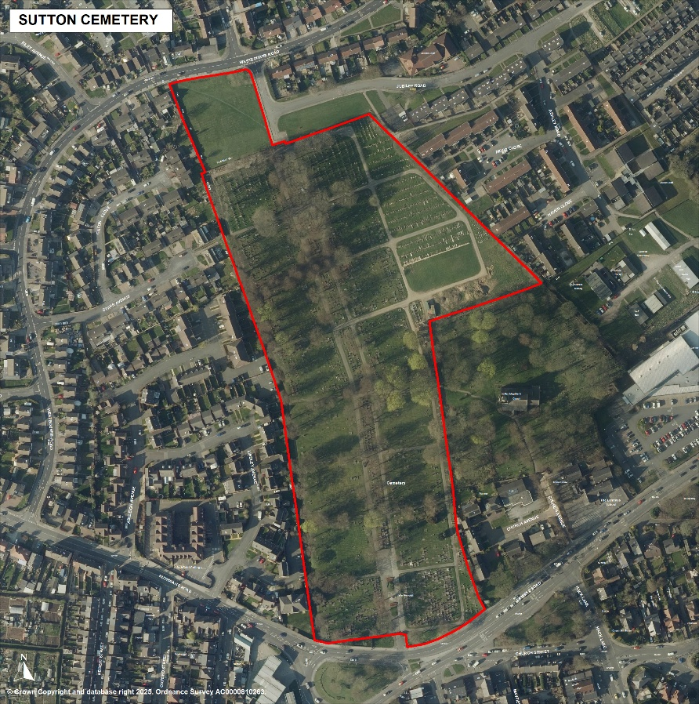

5.6.2 FIG 2: Aerial view of Kingsway New Cemetery

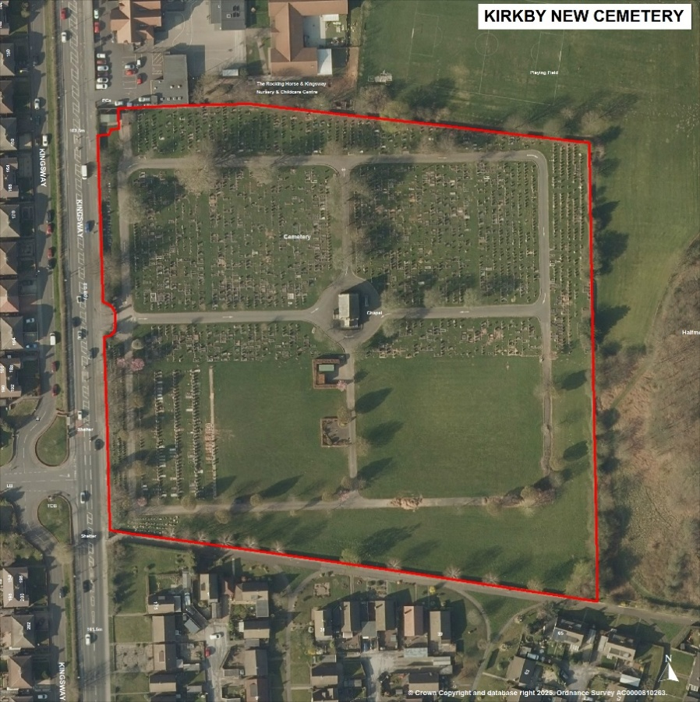

5.6.3 FIG 3: Aerial view of Hucknall Cemetery

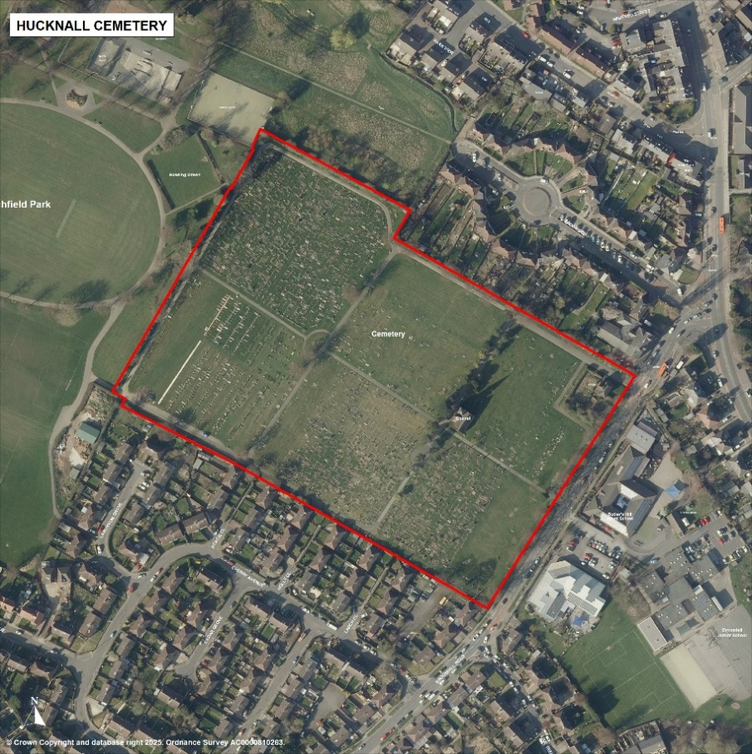

5.6.4 FIG 4: Aerial view of Annesley Woodhouse Cemetery

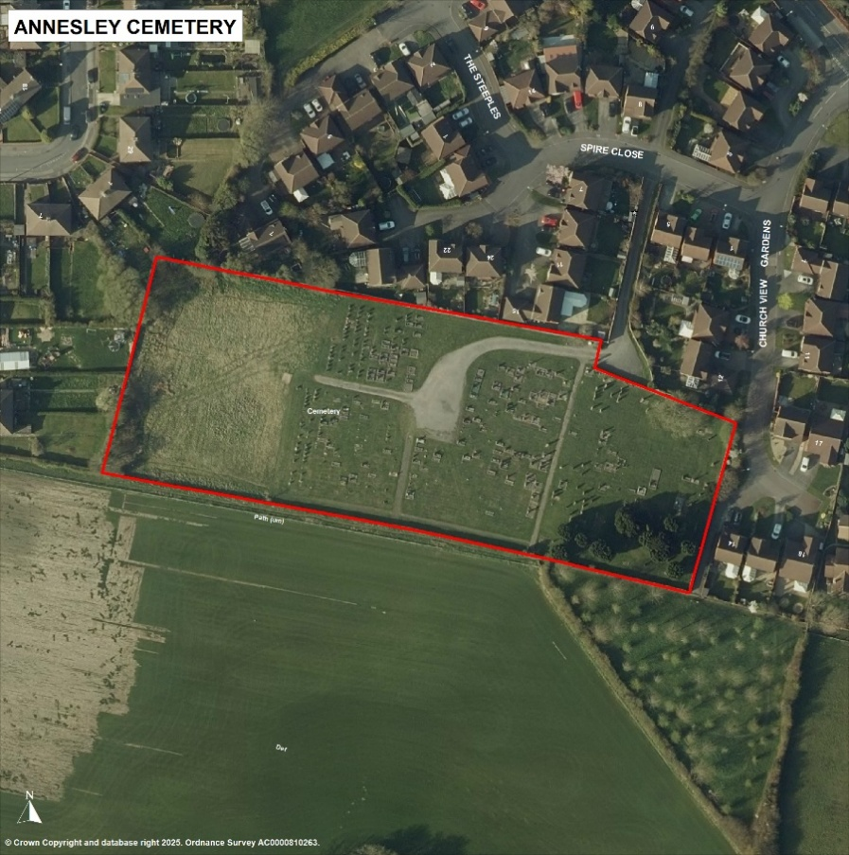

5.6.5 FIG 5: Aerial view of Huthwaite Cemetery

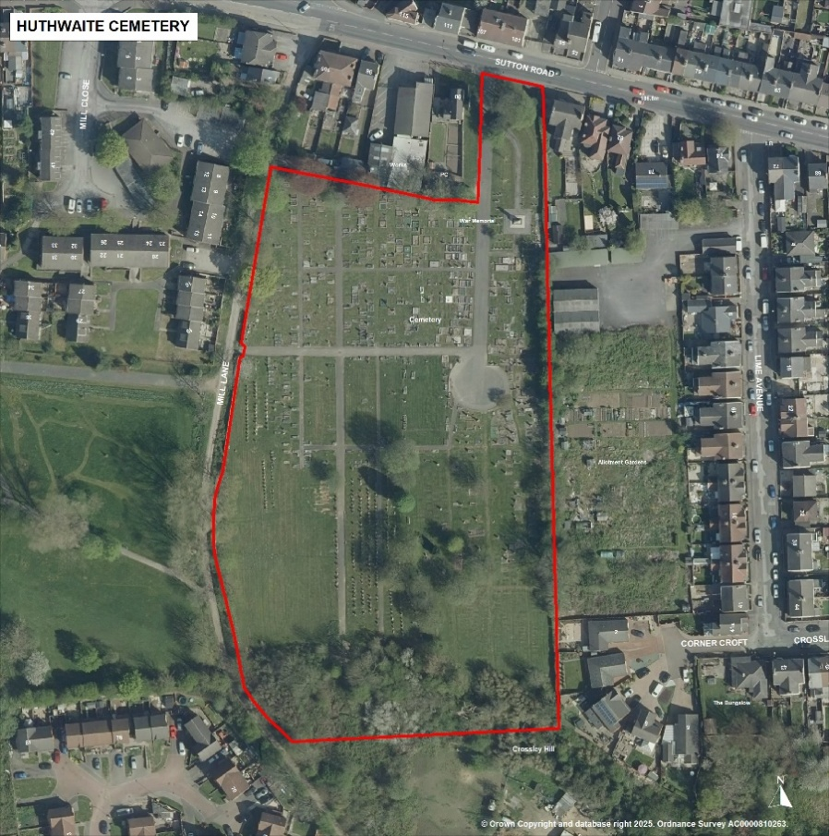

## 6. Current Provision

6.1 Graph 1 below presents the total demand for cemeteries owned by ADC for financial years 2020-21 to 2024-25. The graph captures the impact of the Covid-19 pandemic with spiking mortality rates; however, these have begun to plateau.

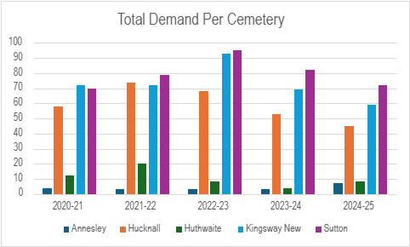Graph 1

6.2 Table 1 below captures the rate of demand by interment type across the same period as Graph 1.

Table 1:

|  |  |  |  |  |  |  |  |  |  |  |  |  |  |  |  |
| --- | --- | --- | --- | --- | --- | --- | --- | --- | --- | --- | --- | --- | --- | --- | --- |
|  |  | 2020 - 2021 |  |  | 2021 - 2022 |  |  | 2022 - 2023 |  |  | 2023 - 2024 |  |  | 2024 - 2025 |  |
| Annesley | Burial | Cremated | Other | Burial | Cremated | Other | Burial | Cremated | Other | Burial | Cremated | Other | Burial | Cremated | Other |
| Hucknall | 2 | 2 | 0 | 2 | 1 | 0 | 3 | 0 | 0 | 3 | 0 | 0 | 5 | 2 | 0 |
| Huthwaite | 34 | 24 | 0 | 33 | 37 | 4 | 30 | 38 | 0 | 28 | 25 | 0 | 21 | 19 | 5 |
| Kingsway New | 47 | 24 | 1 | 47 | 25 | 0 | 58 | 35 | 0 | 41 | 28 | 0 | 34 | 24 | 1 |
| Sutton | 49 | 20 | 1 | 42 | 37 | 0 | 57 | 34 | 4 | 47 | 35 | 0 | 42 | 28 | 2 |
| Sub total | 140 | 74 | 2 | 138 | 106 | 4 | 153 | 110 | 4 | 122 | 89 | 0 | 103 | 80 | 8 |
| Total |  | 216 |  |  | 248 |  |  | 267 |  |  | 211 |  |  | 191 |  |

6.3 The figures of Table 1 provide an average of 227 deaths per annum for the period of April 2020 – April 2025, of which an average 131 were buried per annum. The standard grave size for burial is 8 feet long by 4 feet wide, or just under 3 sqm. Therefore, on average, 393 sqm of land is required a year for burials.

6.4 Cemetery space is finite, and based upon current rate of demand for burials, not factoring in population growth and further potential pandemics, ADC will need to secure additional cemetery provision in Hucknall and Sutton within the next 10 years.

6.5 Table 2 below captures the current rate of demand against the remaining burial spaces to give a projected cemetery life. This does not include the interment of cremated remains.

Table 2

|  |  |  |  |
| --- | --- | --- | --- |
| **Location** | **Average Burial Rate (per annum)** | **Remaining Burial Spaces** | **Projected Cemetery Life (years)** |
| Annesley | 3 | 392 | 130.1 |
| Hucknall | 29 | 126 | 4.3 |
| Huthwaite | 6 | 341 | 56.8 |
| Kingsway New | 45 | 2783 | 61.8 |
| Sutton | 47 | 407 | 8.7 |

6.6 These figures do not holistically capture the death rate of Ashfield, due to the rise in private crematoria and the crematorium in Mansfield, of which Ashfield, Mansfield, and Newark and Sherwood District Council’s share joint management.

6.7 To ensure cemetery provision remains available across the district, these figures are monitored quarterly, with any cemetery life falling beneath 10 years being placed on the corporate risk register and an options appraisal drafted on future land considerations.

## 7. Demographics

7.1 In serving the residents of Ashfield, and those who choose to be buried here from outside the district, it is important to highlight the demographics of the local area to ensure the provision provided meets demand and need.

This includes:

* Population growth
* Aging population
* Religious preferences
* Socio-economic factors

7.2 According to the Office of National Statistics (ONS), there are circa 59.6 million people living in England and Wales as of 2021, an increase of 6.3% 2011. In Ashfield, the population has increased by 5.7% from 2011 to 2021, growing from 119,500 to 126,600, similar to neighbouring Nottingham at 5.9%, and Newark and Sherwood at 7%. Ashfield’s growth is shown below in Graph 2.

Graph 2

7.3 The death rates for Ashfield have increased in line with growing populations, as shown by Graph 3 below, with the spike increase of 2019-2021 capturing the impact of the Covid-19 pandemic.

7.4 The increasing population, and subsequent death rates, have an impact on cemetery provision. The age demographics for Ashfield project an increase in demand, as there was a 22.5% increase in residents aged over 65, reflecting the post-war ‘baby boom’ era of 1946-1964. Additionally, the number of residents aged between 50 and 64 years increased by 15.9%, while the number of residents aged between 35 and 49 decreased by 11.7%.

7.5 2023 statistics capture a gradual decline in the number of children born per woman of childbearing age, with the fertility rate at 1.44 children per woman. Additionally, there has been a shift to women becoming pregnant in their 30s instead of their 20s, impacting upon any future demand predictions.

7.6 A primary shift in cemetery demand is the transition from traditional Christian burial to alternate burials to meet religious, economic, and environmental requirements. Whilst the statics of the 2011 and 2021 census captured that residents who identified as Sikh, Buddhist, Muslim, Hindu, or Jewish were respectively under 1% of the district population, the percentage of residents who identified as Christian decreased from 58.2% to 42. Whereas those who identified as no religion increased from 33.8% to 50.3%.

7.7 Thus these statistics capture a shift in the needs of the district, and ADC must therefore adapt its provision where possible to cater to the demand.

## 8. Looking Forward

8.1 Cemetery provision is depleting UK wide; therefore, opportunities must be explored to enhance cemetery capacity to provide a viable service for future generations and the varying needs of the community.

8.2 Currently, ADC offers the following services:

* **Standard graves:** A plot of land which is allocated for the burial of full body remains. The depth of the grave permitted depends on the cemetery due to water table restrictions.
  + 1. Kingsway New, a depth of 8ft
    2. Sutton, Annesley, and Huthwaite, a depth of 6ft 6 inches
    3. Hucknall, a depth of 5ft
* **Ashes plots:** A plot of land allocated to the burial of ashes
* **Scattering of ashes:** Scattering of ashes in a burial or memorial ground.
* **Child graves:** A dedicated section of the cemetery dedicated to interment.
* **Non-Christian Burials:** There are no dedicated areas or consecrated grounds across ADC cemeteries, however adjustments to cater to religious adherence are facilitated, where possible, upon request. When ADC is unable to accommodate, relatives of the deceased will be directed to neighbouring authorities who can provide the alternative burials.

8.3 The following memorials are currently permitted

* **Memorial headstone:** Typical stone memorial which is offered alongside burial and ashes interments.
* **Memorial vase:** This is an alternative to a burial headstone
* **Memorial bench:** A bench placed in the cemetery with an inscription dedicated to the memory of the deceased.

8.4 To deliver long term viable and sustainable solutions to cater for growth and demand, whilst meeting the needs of the local community, ADC will explore the following considerations, with any implementation subject to relevant allocation of funding. Images of these proposals can be found in Appendix D.

8.5 **Eco-burials**

The Authority recognises the increasing demand for environmentally friendly burials, where the deceased can be memorialised with minimal impact on the environment, in line with their personal commitment to the environment and sustainability. As such, the following will be permitted:

* **Alternate coffins:** The Council will continue to allow the use of wicker or cardboard coffins.
* **Alternate cremation:** Acceptance of remains that have undergone promession or resomation, environmentally friendly alternates to cremation
* **Woodland burial:** The interment of the deceased in a biodegradable coffin in a woodland area. Viable woodland areas would be decided upon based on environmental impact and health and safety factors, as well as public consultation. These areas would be cordoned to avoid disruptions from ramblers and dog walkers.
* **Tree planting:** An alternative to ashes interment, this involves mixing the ashes of the deceased with fertiliser, and a tree seed or young tree is grown using the material. These trees are later planted into open spaces at designated sites or locations. To have one of these trees planted starts at £200 in line with the Tree and Woodland Strategy. This fee covers the cost of planting, first-year watering, and any necessary maintenance throughout the tree's life. The cost of the tree itself is not covered in this fee.

8.6 **Ashes interments**

There has been a cultural shift to cremation over conventional burial, with statics from The Cremation Society showing a 18.57% increase in cremations UK wide from 436,280 in 2013, to 535,750 in 2023. To reflect this demand, the following interment opportunities are being explored:

* **Columbarium:** A columbarium is an above ground room, building, wall, or other structure that is designed to hold cremation urns.
* **Urn Headstones:** A memorial headstone placed upon buried urns to serve as a place of remembrance
* **Memorial garden:** A place where urns can be buried in a tranquil garden within or separate to a cemetery. The landscape is designed to also house memorial benches and provide areas for scattering ashes. The space is designed to offer comfort and reflection during the grieving process.

8.7 **Chapel Services**

During the Covid-19 pandemic, the Council took the decision to close the existing on-site Chapel(s) for use by the families of the bereaved to hold small local services. Future use of these chapels would require a business case to be developed to undertake a viability study.

8.8 **Non-Christian and Traveller Burials**

Religion and ethnicity play a significant role in burial requirements. As such, where possible, ADC will designate space in new cemetery provision to cater to the religious and ethnic requirements of the district. When this cannot be facilitated, the Council is committed to supporting the relatives of the deceased by directing them to neighbouring authorities who can provide the services required.

## 9. Quality of Standards

9.1 The Council will ensure its cemeteries meet a high standard of quality, are regularly and well maintained, and are accessible to visitors. The below information shows how the Council will ensure cleanliness and safety within its cemeteries and closed churchyards.

9.2 **Monuments, Memorials, Stones, and Tablets**

* These may only be placed or erected over vaults or graves where an Exclusive Right of Burial has been purchased.
* They shall not be placed or erected without the prior written consent of the owner of the Exclusive Right of Burial, and without the express approval of the Council.
* Any monument, memorial, stone, shrub, plant or items such as kerb edgings, erected or placed in the cemetery in contravention of this strategy may be removed by the Council.
* All memorials including monuments, headstones and stone vases over 200 millimetres (8 inches) in height shall be fixed in accordance with the National Association of Memorial Masons Code of Working Practice (NAMM) 2018, complying with British Standard 8415
  + All work undertaken by stonemasons must be approved by the Council’s Cemetery Officer.
  + If the work is not deemed satisfactory, the responsible stonemason will be notified, and the work must be rectified.
  + If this time limit is lapsed the Council will remove the monument, memorial, or stone vase, and the responsible stonemason or deed owner will be charged for this work.

9.3 **Grave Decoration**

* We restrict the types of grave decoration cemetery visitors are allowed to leave on graves to ensure our cemetery officers can maintain the cleanliness of our cemeteries
* Flowers and bulbs are permitted within a 1sq/ft area in front of the headstones.
* Ornaments, wind chimes, bell glasses, and kerb sets outside of designated areas, and other such decorations are prohibited.

9.4 **Testing Damaged Graves**

In the case of a headstone or memorial which appears to be unsafe, we will:

* Conduct a visual check for obvious signs that it is likely to be unstable.
* Where a visual check suggests stability defects, a hand test will be used to assess the stability further
  1. At this time the Council will make safe the headstone by lying the headstone flat whilst further checks are explored
* Where there is significant risk from large headstones and memorials, arrangements for more detailed inspections by a structural engineer or memorial mason will be undertaken. The findings of this check will be recorded by the cemeteries office.
* Ultimate liability for the costs incurred to maintain the safety of the public from unstable headstones and memorials rests with the grave owner. Efforts will be taken to identify the grave owner and work in conjunction with them to maintain the safety of the cemetery

9.5 **Repairing Damaged Graves**

* If a headstone is found to be unstable but not imminently dangerous, the Council will notify the grave owner to rectify the situation
* If no action has been taken after 12 months, or no grave owner can be found, the Council will make safe the headstone by burying it up to one third its height or by lying the headstone flat, as appropriate.
* If a headstone is found to be unstable and imminently dangerous, the headstone will be laid flat immediately to ensure public safety
  1. The owner of such a grave will be contacted where possible, and may choose to leave the headstone lying flat, repair at their cost, or request that the Council bury the headstone up to one third of its height, for a fee.

9.6 **Crime and Vandalism**

* The Council will actively pursue by legal means any person caught wilfully damaging, committing vandalism or conducting anti-social behaviour within cemeteries and closed churchyards, and enforce the law or seek other agencies to enforce laws against perpetrators
* The Council will work in partnership with the police, fire service, youth offending teams, probation services and other partners to highlight and raise awareness of the need for respect within its cemeteries and closed churchyards.

## 10. Closed Churchyards and the Re-Use of Graves

1. By virtue of the Local Government Act 1972, where a churchyard has been formally closed under the Burial Act 1853 by His Majesty by Order in Privy Council, the duty to maintain the churchyard automatically falls upon the Parochial Church Council.
2. However, under subsection (3), the Parochial Church Council (PCC) may serve a written request upon a relevant local authority, normally the Parish Council, to take over the maintenance of the churchyard. The parish council may in turn pass the responsibility to maintain the churchyard to the next relevant level of local government, including district and borough councils, and unitary authorities, within 3 months of the service of the original request.
3. Where, under s.215(2), the PCC serve a request on the relevant local authority to take over the maintenance of the churchyard there is a duty imposed that ‘… the maintenance of the churchyard shall be taken over by the authority on whom the request is served …’. The local authority becomes responsible in lieu of the parochial church council for the maintenance of the closed churchyard and thus the local authority is under a statutory duty to maintain the closed churchyard to the same standard as that required by s.215(1) of the PCC, i.e. ‘in decent order and its walls and fences in good repair’.
4. The historical practice of granting burial rights in perpetuity and the introduction of laws preventing the disturbance of human remains and reuse of graves have contributed to lack of burial space in the modern day. The term ‘re-use’ refers to the disturbance of old graves in order to make space for new burials. It requires specific legal permission, without which it is illegal.
5. S.25 of the Burial Act 1857 makes it an offence to remove buried human remains without a licence from the Secretary of State or, in relation to ground consecrated according to the rites of the Church of England, a Bishop’s faculty (permission from the Church).

* It is important to note that the faculty jurisdiction of the Church of England does not override statute law and separate statutory powers are required to enable exclusive rights of burial to be extinguished. Such powers do not currently exist for local authorities outside of London.

1. Under the Local Authorities Cemeteries Order 1977, burial authorities may “reclaim rights in reserved graves purchased at least 75 years ago if the rights have not been exercised and the relevant notice has been given.”

10.7 Currently only a handful of local authorities outside of London have received permission to reuse graves by obtaining their own acts of parliament, such as The Bishop’s Stortford Cemetery Act 2024. The Council will monitor any developments in this regard from Government.

10.8 Exhumations

* It is an offence at law to exhume any human remains or cremated remains without first obtaining the necessary lawful permission.
  + There are three categories of legal exhumation:
    - under a Ministry of Justice licence;
    - ecclesiastical faculty (where remains are exhumed from consecrated ground);
    - a coroner's order.
* The person requesting the exhumation should be advised to contact a Funeral Director to assist them.
  + A licence must be obtained from the Ministry of Justice.
  + The application completed by the next-of-kin should be submitted to the Burial Authority for authorisation.
  + If the person is currently interred in ground consecrated in accordance with the canon law of the Church of England, a Bishop's Faculty must be obtained.
* On receipt of lawful permission to exhume the body of a deceased person the Burial Authority will notify the Council’s Environmental Health Officer so that he can be present at the exhumation site.
  + An Environmental Health Officer, Cemeteries Officer, and possibly a representative of the authority's health and safety team, will be present at the exhumation to ensure that respect for the deceased is maintained and that public health, and health and safety regulations, are observed and protected.

## 11. Fees and Charges

11.1 The fees and charges for ADC cemetery provision are set annually by the Council, unless there are extenuating circumstances. The full breakdown is in Appendix B.

11.2 Purchase of plots within one of the cemeteries provides exclusive right of burial for 75 years.

11.3 No burial or interment plots can be pre-purchased in any ADC cemetery after April 2007.

11.4 All fees and charges are determined by balancing expenditure for managing and operating the cemeteries and closed churchyards, and benchmarking against other local authorities.

11.5 Per 2024-2025 figures, the gross cost of maintaining the existing sites, land and assets, is £2.09p and net £0.98p per square metre. These costs increase annually due to inflation, the volume of land maintained, and the cost of maintenance.

11.6 Burial or interment of remains for stillborn, non-viable foetus or children from birth to under 16 is free of charge, within the children’s section only.

## 12. Consultation and Liaison

12.1 This strategy will go through the mandatory consultation process of 4 weeks, following which any amendments will be considered and implemented where appropriate.

These consultees will be:

* All councillors for Ashfield District Council
* Senior Leadership Team
* The public
* The Diocese
* Local churches
* Local funeral directors
* Local memorial masons
* Any other agency identified during the consultation period.

## 13. Summary

This strategy aims to:

* Ensure that cemeteries and churchyards across Ashfield meet the current and future needs and demand of the district.
* Ensure these open spaces and assets are adequately maintained, easily accessible, and are spaces for reflection and remembrance, serving the needs of the community.
* Support current legislation and local practice regarding burial types, internments, and closed churchyards, and ensure its services reflect this.

This action plan lays out how Ashfield will achieve its ambitions to:

* Provide adequate cemetery provision in Hucknall and Sutton.
* Assess the condition and financial sustainability of re-opening the chapels closed during the Covid-19 Pandemic.
* Widen its offer to include a more diverse range of cremated remains, including promession and resomation
* Expand upon eco burial options, including woodland burials, tree planting and memorial gardens.
* Extend its options for ash interment, including columbarium and urn headstones.

## 14. Action Plan

The action plan below gives indicative actions and timeframes for how Ashfield is going to achieve these goals.

|  |  |  |
| --- | --- | --- |
| **Action** | **Outcome** | **Timeframe** |
| Identify a site for cemetery expansion in Hucknall | Additional burial space to meet demand | December 2025 |
| Consider future land allocation or funding as developer contributions within the emerging local plan | Ensure required infrastructure and investment in our cemeteries. | December 2025 |
| Update the website to reflect updated burial options | Improved promotion of bereavement choices, including ecological options | January 2026 |
| Procure a new cemetery management system | New cemetery management system | March 2026 |
| Identify woodland land to be utilised for Woodland burials | Space to fulfil burial demands | June 2026 |
| Identify land to be utilised as a memorial garden | Space to fulfil burial demands | June 2026 |
| Conduct feasibility studies on Chapels | Options appraisal on re-opening | 2027 |
| Identify sites for a new cemetery in Sutton | Secure land to meet demand | 2027 |
| Open a new cemetery in Hucknall | Additional burial space to meet demand | 2029 |
|  |  |  |

## Appendix A: Cemetery Rules and Regulations

**Cemetery Rules and Regulations**

**

Kingsway New Cemetery, Kirkby-in-Ashfield

**Aim**

|  |
| --- |
| Ashfield District Council is committed to providing the best possible service to everyone at a time of sadness and change in their lives  The Authority strives to be recognised as a Council providing services and outcomes as expected and necessary from a good Council.  Our cemeteries are managed within regulation and resources to maintain dignified and welcoming places as befits their purpose. |

## Contents

Aim 2

1. General 4

* + - 1. Addresses and Contact 4
      2. Opening and Closing Times 4

2. Interments 6

2.1 Burial Procedure 6

2.2 Exclusive Right of Burial 7

2.3 Transfer of Deed Ownership 8

2.4 Cremated Remains 8

2.5 Fees and Payments 9

2.6 Requirements of Funeral Directors and Companies 9

3. Monuments, Memorials and Vaults 10

3.1 Monuments and Memorials – General 10

3.2 Duty of Care 13

3.3 Requirements of Monumental Masons 14

3.4 Vault Construction 15

3.5 Floral Tributes 15

4. Conduct in Cemeteries 15

4.1 General Conduct 15

4.2 Vehicles Access 16

5. Definitions 16

Contact Details 18

## General

**1.** **Cemeteries and Burial Grounds Regulations for:**

**Annesley Woodhouse**

**Hucknall**

**Huthwaite**

**Kirkby in Ashfield (Kingsway New and Old Cemeteries)**

**Sutton in Ashfield**

**1.1 Addresses and Contacts**

The Cemeteries and Allotments Coordinator

Ashfield District Council

Northern Depot

Sutton in Ashfield

Nottinghamshire

NG17 5HB

**Telephone: 01623 457462 between 08.30 - 16.30 Monday to Thursday and 08.30 -16.00 Friday (out of hours answerphone)**

**E-mail: cemeteries@ashfield.gov.uk or telephone 0800 183 8484 to register any questions or comments about our service. Complaints must be in writing and sent to the contact at the above address.**

Website for the Authority: [www.ashfield.gov.uk](http://www.ashfield.gov.uk)

**In order to help inform the public of these regulations, funeral directors and monumental masons are asked to assist the Council by talking to the public, if possible, when giving them this leaflet and help them to understand the procedures. A summary sheet is available from the Cemetery Office.**

* 1. **1.2 Opening and Closing Times**

The cemeteries will be open to the public during the following hours:

|  |  |  |
| --- | --- | --- |
|  | **Open** | **Closed** |
|  | | |
| **November - February** | **6.00am** | **6.00pm** |
| **March - April** | **6.00am** | **8.00pm** |
| **May - August** | **6.00am** | **10.00pm** |
| **September - October** | **6.00am** | **8.00pm** |

**Open every day including Sundays and Bank Holidays at the above stated times.**

**Funerals may take place between Monday and Friday from 9am - 2.30pm, excluding bank holidays and the Tuesday following a bank holiday Monday.**

**Stonemason’s may carry out works from 8-30am – 3-30pm Monday to Friday excluding bank holidays and the Tuesday following a bank holiday Monday.**

1. **Interments**

**2.1 Burial Procedure**

2.1.1 Notices of interment including scattering of ashes and all associated works orders must be forwarded to the Cemetery Officer on the Council’s official forms provided by the undertaker when a funeral is booked. These forms must be received 2 clear working days prior to any interment. In the case of vault construction, five clear working days notice is required.

2.1.2 All bookings are provisional until the Cemetery Officer receives the appropriate forms as described in 2.1.1. Telephone messages must be confirmed with the appropriate paperwork. The Council will not accept responsibility for information that has not been forwarded on the appropriate forms. The Council will not accept responsibility for paperwork lost in the post. Documents sent by fax or e-mail will only be accepted as temporary notifications and must be confirmed by the submission of the original paperwork.

2.1.3 The notice of interment, as described in 2.1.1, must be completed and contain the following details:

* Name of cemetery
* Grave number where known
* Day and hour of funeral service
* Full name and home address of the deceased
* Date of death and age of the deceased
* Full particulars and description of the grave to be used
* Overall length and width of coffin including handles and other additions
* Name of clergyman or other person officiating
* Full name and address of the funeral director
* Full name and address of the applicant

2.1.4 **NB**: Funerals will not be allowed to proceed if the Registrar’s Certificate of Disposal or a Coroner’s Order for Burial or the Cremation Certificate is not presented to the Council’s representative at the time of interment.

2.1.5 The Council’s workforce or their nominated contractor will undertake all excavation work at the Cemeteries. Back filling of graves is permitted with the Cemetery Officer’s consent.

2.1.6 Turfing or seeding a grave, as appropriate, will take place as soon as practicable after the interment, by the Council’s workforce.

2.1.7 **No** kerb sets, trenches or means of marking the boundary of a grave are permitted.

2.1.8 **Only** coffins of wood, other environmentally friendly materials and of traditional type (no glass or metal) are to be used in all graves, name plates and handles must be provided for all coffins. Any special detail must be approved by the Cemetery Officer at the time when the initial request for service is made.

2.1.9 The responsibility for making the necessary arrangements for the attendance of priests, ministers, or other persons to officiate at a service rests upon the Funeral Director or the person(s) arranging the burial.

2.1.10 The time fixed for a funeral must be the time when the procession is to arrive at the Cemetery. It is requested that the time be strictly adhered to, in order to prevent inconvenience and one funeral interfering with another. In the event of a funeral arriving late the cortege must wait as and where directed by the Cemetery Officer or a delegated representative. The service will take place as soon as possible thereafter at the direction of the Cemetery Officer or a delegated representative.

2.1.11 In the case of a public or military funeral, or one at which in excess of 50 mourners may be expected, notice must be given at the time of the booking.

2.1.12 The time allowed for a service in the Cemetery Chapel shall not exceed 30 minutes unless prior approval has been obtained from the Cemetery Officer.

2.1.13 Generally no coffin shall be opened within the Cemetery Chapel or grounds for any purpose whatsoever, however requests will be considered on an individual basis.

2.1.14 Memorials including headstones and monuments will be removed by a nominated stonemason in all cases where a grave is to be re-opened. This will be organised by the funeral director booking the funeral and arranged within one hour of the booking being confirmed. Removal of memorials requires the prior approval of the grave deed owner.

**2.2 Exclusive Right of Burial**

2.2.1 Whilst ownership of an Exclusive Right of Burial for a grave does not give any ownership whatsoever in respect of actual land, it does give the owner of the Deed the right to:-

Be buried in the grave.

Authorise further burial(s) in that grave (where space is available), or the interment or scattering of cremated remains in or over that grave.

Erect or place a memorial on that grave subject to the Rules and Regulations of the Council relating to memorials.

Have inscriptions/additional inscriptions placed on a memorial on that grave subject to the Rules and Regulations of the Council relating to this matter, see 3.1.6

2.2.2 Possession of a Deed does not necessarily give the person in possession ownership of Exclusive Right of Burial. Where the owner is deceased, subsequent ownership depends upon whether or not the deceased person left a valid Will. The law concerning this matter can be very complex. It is strongly advised that a solicitor be consulted to establish new ownership.

2.2.3 Where the Deed is lost or mislaid, a person entitled to open the grave, may do so, as long as they have made a statutory declaration giving indemnity to Ashfield District Council. It is advised that a solicitor should be consulted in this case.

2.2.4 On the purchase of the Exclusive Right of Burial in a grave, a Deed of Grant shall be issued to the purchaser whose name shall be registered on the form. The Exclusive Right of Burial shall extend 75 years from the date of purchase. Owners of a Deed may not select the position of a grave or vault, except in exceptional circumstances, when the owner’s wishes will be considered as far as is practicable by the Cemetery Officer.

* + 1. Persons arranging for a burial in a non-private grave, (where the right to bury has not been purchased), acquire no rights other than that of making a single interment in the grave. The Cemetery Officer will determine the location of non-private graves.
  1. **Transfer of Deed Ownership**

2.3.1 Ownership of a Deed may be transferred or assigned by use of the form of Declaration, Indemnity and Application in respect of the transfer or Assignment of an Exclusive Right of Burial. See 2.2.2 above.

* + 1. The Cemetery Officer must be notified of any transfer or assignment in order to update the Purchase Register.
    2. Where no interment has taken place in a purchased grave the Council may agree to repurchase the grave. In such cases the Council will pay the original purchase price.
  1. **Cremated Remains**

2.4.1 A cremated remains plot will be 1350mm (4ft) x 1350mm (4ft), to accommodate up to four caskets. Notice for the interment and the Certificate issued by the Crematorium where the cremation took place must accompany the burial and or scattering of cremated remains.

* + 1. Scattering of Cremated Remains is not permitted without the prior consent of the Deed Owner and Cemetery Officer.

2.4.3 The interment or scattering of cremated remains in or over a grave is not permitted without the prior consent of the grave deed owner. This requires the owner to complete and sign a Notice of Interment Form, see 2.4.1

* 1. **Fees and Payment** 
     1. No grave spaces or cremation plots can be pre-purchased in any of the Authority’s cemeteries after April 2007.
     2. Normal fees and charges will be paid by those who live within Ashfield District as set out in the annual review as undertaken by the Portfolio for Environment and Service Lead - Waste and Environment
     3. All burial fees shall be tripled or as applicable at the time of interment, where the person to be interred was not an inhabitant of the District of Ashfield at the time of death
     4. All purchase fees shall be tripled or as applicable at the time of interment, where the person who wishes to purchase a grave space for exclusive right of burial is not an inhabitant of the District of Ashfield at the time of purchase
     5. Multiple fees do not apply to headstones or additional inscription charges. Ashfield District Council’s decision in these matters is final.
     6. Any person who dies in a state aided hospital, care or nursing home outside the District of Ashfield but who was an Ashfield resident immediately prior to this move will be charged at single fees irrespective of how long they have lived outside the district when they died. The Ashfield District Council decision is final.
     7. At the time of death, anyone who lived in Ashfield and then moved into a residential home outside of the district will be able to receive a burial at single fees within two years after they moved out. After this time, triple fees will be applied or as applicable at the time. The Ashfield District Council decision is final.
     8. Deeds will not be released to the purchaser until full payment is received.
     9. Funeral directors/companies normally will be permitted to make payment after the Council has provided services and the payment must be made within 28 days from the date when the invoice was issued.
  2. **Requirements of Funeral Directors or Companies**
     1. Initially every funeral director or company will be required if asked, to provide to the Council the following documentation:-

1. A copy of their Health and Safety policy and codes of practice.
2. A copy of up to date Public and Employee Liability insurance certificate with at least £5 million cover. Copies to be provided to the Council upon the annual policy renewal.

Guidance on the completion of a) can be obtained from The Association of Burial Authorities, The National Association of Funeral Directors (NAFD), Independent Funeral Directors (SAIF), the Ashfield District Council’s Safety Officer or the Health and Safety Executive (HSE).

**Failure to provide the documentation will result in access to the cemeteries being denied till the matter is resolved between the funeral director or company and the Authority.**

1. **Monuments, Memorials and Vaults**

3.1Monuments and Memorials – General

* + 1. Prior permission to place or erect any form of memorial in any of the Cemetery grounds must be obtained from the Cemetery Officer. All graves in new sections will have headstones fixed to a raft where applicable.
    2. Monuments, memorials, stones or tablets may only be placed or erected over vaults or graves where an Exclusive Right of Burial has been purchased. Monuments, memorials, stones or tablets shall not be placed or erected without the prior written consent of the owner of the Exclusive Right of Burial, and without the express approval of the Council.
    3. Any monument, memorial, stone, shrub, plant or items such as kerb edgings erected or placed in the cemetery in contravention of these Regulations may be removed by the Council at any time without notice.
    4. All memorials including monuments, headstones and stone vases over 200mm (8ins) in height shall be fixed in accordance with the National Association of Memorial Masons Code of Working Practice (NAMM). All work will be undertaken to the absolute satisfaction of the Cemetery Officer. If this is not the case the stonemason will be notified and the work will be rectified within one working day of the notification. If this time limit is lapsed the Council will remove the monument, memorial or stone vase and the stonemason or deed owner will be charged for this work. At this point the responsible stonemason may be refused future entry into the Council’s cemeteries for breach of these regulations.
    5. **Memorials must be of a material approved by the Cemetery Officer**.
    6. Before the erection of a monument, memorial, or stone vase, a drawing with any proposed inscription must be sent to the Cemetery Officer for approval. The drawing and inscription must be in duplicate on the Council’s forms, which are provided by the monumental mason. The type(s) of material to be used shall be stated, together with exact dimensions and all associated details, please see 3.1.11, 3.1.13 and 3.1.14. The application forms must be duly signed and dated by the registered owner of the Exclusive Right of Burial or, in the event of the death of the owner, an indemnity must be fully completed and submitted.

**NB**: The following materials are not acceptable: wood, metal, glass, concrete and shall not be painted.

* + 1. No memorial may be fixed until the Council gives formal written approval see Appendix 10 handout leaflet.
    2. No monument or other memorial shall be altered or interfered with after it has been erected in the cemetery in accordance with the designs submitted to and approved by the Council.
    3. No inscription may be cut or work of any kind undertaken to any monument or memorial within the cemetery without the prior written consent of the Cemetery Officer, see 3.1.6.
    4. In the circumstance of a memorial requiring additional inscriptions, the application form is obtained from the monumental mason, see 3.1.6 No memorial shall be removed from a cemetery for the purpose of cutting an additional inscription until the formal written approval of the Cemetery Officer has been given in respect of the proposed addition(s). Any person contravening this Regulation will not be allowed to carry out any further work within a cemetery.
    5. Vases of a material approved by the Cemetery Officer up to a height of 200mm (8ins) are permitted. Only two vases are permitted at the head end of a grave space, next to the headstone.
    6. All work shall be subject to the directions of the Cemetery Officer and any person carrying out works must adequately protect grass, borders and adjoining memorials. On completion of works all surplus materials and resulting debris must be removed and the whole site cleaned and left in a satisfactory condition.
    7. No headstone placed in the traditional section of a cemetery shall exceed 900mm (3ft) in height, 900mm (3ft in the lawn section) or 750mm (2ft 6ins) in width. The headstones for babies and cremated remains, 600mm (2ft) in height and 750mm (2ft 6ins) in width. A technical drawing of all memorials and fixings must be submitted to the Cemetery Officer for prior approval and the name and specification of the material proposed, height, breadth and thickness will be described on the headstone application form, see 3.1.6.
    8. The name of the stonemason must be discreetly inscribed on the back of the memorial, 50mm (2ins) above ground level, along with, the year the stone was erected, the stonemason’s town of residence and the grave section and number i.e. **Section A Row G No. 235**

ACE MASONS LTD. Kirkby 2005

* + 1. All monuments and materials must be conveyed into the cemetery in such a manner as not to cause any damage to roads, walks or turf. Any resulting reinstatement costs for damage, will be assessed by the Senior Grounds Maintenance Supervisor on behalf of the Cemeteries Officer and the stonemason will be informed and invoiced on the completion of the work.
    2. No monuments, memorials or materials may be taken into a cemetery before 8.30am on any working day or on Good Friday, Christmas Day, Saturdays and Sundays or bank holidays and the Tuesday following a bank holiday Monday without the prior consent of the Cemetery Officer. All persons employed in fixing, painting or restoring memorials, etc. must leave the cemetery 30 minutes prior to the cemetery closing time, see 1.2.
    3. All dressing or working of stone or other materials to be used in or about any grave, vault, monument or memorial shall be undertaken outside the cemetery, except such work which cannot be carried out elsewhere, then the consent of the Cemeteries Officer will be required.
    4. All materials shall be carefully removed from the vehicles conveying them and neatly piled or placed in or near the place where they are to be used. No working is permitted on roads, walks or adjoining graves and all surplus materials must be removed from the cemetery.
    5. A memorial removed for the purpose of a further interment shall be transported from the cemetery grounds, otherwise the Council, may dispose of any memorial left in the Cemetery grounds.
    6. Every coffin interred in a vault shall be covered in an appropriate manner. Vaults shall not be opened otherwise than from the top except with the prior consent of the Cemetery Officer.
    7. A 300mm (1ft) area in front of headstones will be allowed for the planting of flowers and bulbs only, no shrubs.
    8. No shrubs shall be cut down or carried away without the consent of the Cemetery Officer. The Council reserves the right to prune, cut down or remove any shrub, plant or flowers where, in their opinion, they have become unsightly, overgrown or dangerous.
    9. **No** kerb sets, bell glasses, ornaments, wind chimes nor decorations of any kind will be permitted from April 2007.
    10. Memorials in the form of donation of seats will be allocated in a location designated by Ashfield District Council. The Council will accept no responsibility for the upkeep of the seats installed, including dilapidations caused by wear and tear, vandalism and age.
  1. **Duty of Care**
     1. Ashfield District Council takes its responsibility for health and safety very seriously and this is combined with its aim of ensuring that all the cemeteries are welcoming and maintained to a high standard.

* + 1. Responsibility for safe conditions in the cemeteries rests upon four main

parties:-

1. Ashfield District Council – This Council has a responsibility to ensure the cemeteries are safe for all users and Council employees. This includes the inspection of memorials to ensure they are safe. A programme of memorial inspections was begun by the Council in 2004 and is ongoing.
2. Funeral Directors - Have a duty of care for their employees and bereaved families attending funerals.
3. Monumental Masons – Stonemasons have a duty to ensure all work on memorials is carried out in a safe manner and that memorials are left secure and safe at the time of and after installation.
4. Owners of Memorials – In the case of memorials the primary responsibility for ensuring they are safe rests upon the owner of the grave or memorial. It is their responsibility to ensure the memorials are maintained to a safe standard. (see 3.2.3 and 3.2.4)
   * 1. If a memorial is found to be unsafe the Council has a duty to minimise the risk to cemetery users and its employees by:
5. Lying down of imminently dangerous memorials. This action may be taken immediately following inspection.
6. If not imminently dangerous but unstable we will inform the grave owner to make safe the memorial or after 12 months the council will bury up to one third or lay flat whichever is most suitable.
7. To take detailed records and photos of our actions. In each instance a warning note will be fixed to the memorial with a Council contact number.
   * 1. **NB**: Concern is expressed by the Council about children’s graves found to be unsafe. Therefore any child’s grave created after 1960 that is found to be unsafe, will be reinstated at the Council’s expense in the event of the owner not coming forward for whatever reason.
     2. Only approved test methods are used by the Council to establish memorial safety. This duty also applies to kerbs, vaults and any other memorial within the cemeteries. Safety tests for memorials will be carried out every year or five years dependant upon if the areas are deemed High or Low risk (see Council Strategy Document)
     3. The Council is not responsible for repairs to any monument or memorial due to storm damage or vandalism; this is the responsibility of the owner. Insurance can be obtained to cover the event of these occurrences.

**3.3 Requirements of Monumental Mason**

Initially every Monumental Mason will be required to provide to the Council the following documentation, see 2.6.1:

1. Required to be a member of BRAMM.
2. A detailed method statement showing how work will be undertaken and what measures will be taken to minimise the risk of personal injury or damage to property. This must cover every aspect of work the Monumental Mason is likely to undertake in the Cemetery during the forthcoming year, including vehicle access and movement within the Cemeteries.
3. A copy of their Health and Safety policy and codes of practice.
4. A copy of up to date Public and Employee Liability insurance with at least £5 million cover. Copies to be provided for the Council upon the policy renewal.
5. A copy of their incident reporting mechanisms and procedures in accordance with The Reporting of Injuries, Diseases and Dangerous Occurrence Regulations 1995 (RIDDOR).

Guidance on the completion of b) can be obtained from The Association of Burial Authorities (ABA), The National Association of Memorial Masons (NAMM), Ashfield District Council’s Safety Officer or the Health and Safety Executive (HSE).

**Failure to provide the documentation will result in permits being withheld and access to the Cemeteries being denied.**

3.3.1 All stonemasons will adhere to all requirements of section 4 of these regulations, in addition they will be required to:-

1. Inform the Cemetery Officer when they require entry into the cemeteries giving two clear working days notice.
2. When written approval is given for the acceptance of the memorial into the cemetery, **a permit will be issued in the form of an invoice from the Authority to the stone mason. Work may take place between 08.30 and 15.30, please see 1.2 and 3.1.16.**
3. Stonemasons are reminded that failure to comply with these regulations may result in future entry being denied to the Council’s cemeteries.

**3.4 Vault Construction**

3.4.1 Vaults may be constructed from brick, pre-cast concrete units or cast on site in concrete.

* + 1. Memorials can be fixed without delay for ground settlement if a headstone containment box is used as a foundation. See 3.1.6, approval will be required rom the Cemetery Officer.
  1. **Floral Tribute**

**Christmas wreaths will be removed by the end of February.**

**Dead flowers in vases will be removed at the discretion of the Cemetery Officer to enhance the appearance of the cemetery.**

**Artificial flowers that have been affected by the weather will be removed at the discretion of the Cemetery Officer to enhance the appearance of the cemetery.**

1. **Conduct in Cemeteries**

**4.1 General Conduct**

* + 1. All visitors must conduct themselves in a quiet and orderly manner at all times Council representatives have the right to exclude any member of the public at their discretion.
    2. Under the provision of the Local Authorities Cemeteries Order 1977, it is an offence for a person to wilfully:-

1. Create any disturbance in a cemetery.
2. Commit a nuisance in a cemetery.
3. Interfere with any burial taking place in a cemetery.
4. Interfere with any grave or vault, any tombstone or other memorial or any flowers or plants in any such manner.
5. Play at any game or sport in a cemetery.
6. Enter or remain in a cemetery when it is closed to the public, unless authorised by the Council to do so.
   * 1. No pedal bicycles, skateboards, skates, scooters may be ridden in the cemeteries.

4.1.4 **Smoking in the cemetery buildings is not permitted.**

4.1.5 **No animals will be allowed in the cemeteries (excluding guide dogs or hearing dogs) without prior permission of the Cemetery Officer.**

* + 1. Children under the age of 12 years shall not be permitted to enter the cemeteries unless accompanied by an adult.
    2. No religious services or ceremonies are allowed other than the service at the time of interment.
    3. No musical instrument or other sound-producing device will be allowed into the cemeteries except when used as an integral part of a funeral service.

Persons who contravene these provisions will be liable upon conviction to a fine; the cost of rectifying any damages caused which incur Council costs.

* 1. **Vehicle Access**

4.2.1 Vehicle access is not permitted without the consent of the Cemetery Officer. Vehicles are permitted for those attending funerals or interments at the discretion of the Cemetery Officer.

4.2.2 Disabled vehicle access is permitted with as much notice as possible forwarded to the Cemeteries Officer.

4.2.3 No vehicle access will be allowed 30 minutes prior to or during a funeral or interment.

1. **Definitions**

The following are defined in this document as:-

**The Cemetery or Cemeteries**

Kingsway (Old and New), Hucknall, Sutton, Huthwaite, Annesley Woodhouse

**The Council or Council’s**

Ashfield District Council

**The Cemetery Officer**

The Council’s Officer or their deputy responsible for Cemetery Administration.

**Stonemason or Mason**

Monumental Masons

**Cremation Plot**

Which will hold up to four interments, or cremated remains scattering.

**Lawn Section Grave Plot**

Which will accommodate three interments (with the exception of Hucknall) and three cremated remains caskets. The installation of an approved headstone, vase or memorial is also permitted.

**Cemeteries Team**

**Tel: 01623 457462**

Email: cemeteries@ashfield.gov.uk

If you require translation or interpretation into sign language, Braille, other languages or large print please telephone 01623 457462 between 8.30am – 4pm Monday to Friday (Answerphone out of hours)

## Appendix B: Cemetery Fees and Charges

**CEMETERY CHARGES : FROM 1ST APRIL 2025**

**INTERMENT FEES:**

Stillborn and up to 1 month old……. also Non-Viable Foetus 4’6” depth…. F.O.C.

Child’s grave over 1 month to 16 years …………………………………………. F.O.C.

Cremated Remains ……….. 24in. ………………………………………… £269.00

Scattering of Ashes ……….. ………………………………………………. £108.00

Adult Grave digging out for 1 5ft. 0in. ……………………………………… £942.00

Adult Grave digging out for 2 6ft. 6in. (Except Hucknall)…………….…... £981.00

Adult Grave digging out for 3 8ft. 0in. (Kingsway New only) …………….. £1075.00

PURCHASE OF EXCLUSIVE RIGHT OF BURIAL FEES (75 YEARS):

Adult Grave ……………………………………………………………………… £1210.00

Child’s Grave (Child Section only)…………………………………………….. F.O.C.

Cremated Remains Area ………………………………………………………. £672.00

MISCELLANEOUS FEES:

Use of Chapel …………………………………………………………… £269.00

Double Fees are applicable on the above charges for non-residents of ASHFIELD

Late arrival at cemetery (after first 30 min.) NEW FOR 2020……………… £135.00

Late arrival of paperwork (after first 30min.) NEW FOR 2020…………….. £36.00

(No later than 10am 2 working days before the date of the interment)

Transfer of Exclusive Right of Burial without interment NEW FOR 2020…. £36.00

Family tree & genealogy searches (per name/per grave) NEW FOR 2020… £36.00

**MONUMENTAL FEES:**

Headstone (Not exceeding 3ft. x 2ft. 6in) ……………………………. ……. £311.00

Headstone (Not exceeding 2ft. x 2ft. 6in. – (CR. REMAINS AREA) ……... £311.00

8in. x 8in. Vase ………………………………………………………….. …… £190.00

Vase over 8” ……………………………………………………………………. £234.00

Additional Inscription …………………………………………………………... £121.00

Memorial tree …………………………………………………………… ………. £206.00

Cemetery Office, Northern Depot, Station Road, Sutton in Ashfield, Notts, NG17 5HB

Mrs P Jacques/Miss R Collis

Tel: Mansfield (01623) 457462