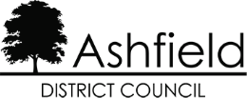

Disclaimer
This document or some parts of it may not be accessible when using adaptive technology.

If you require assistance with accessing the content of the document, please contact us and quote the document name and the web page you found it on:

- email: Regeneration – place@ashfield.gov.uk

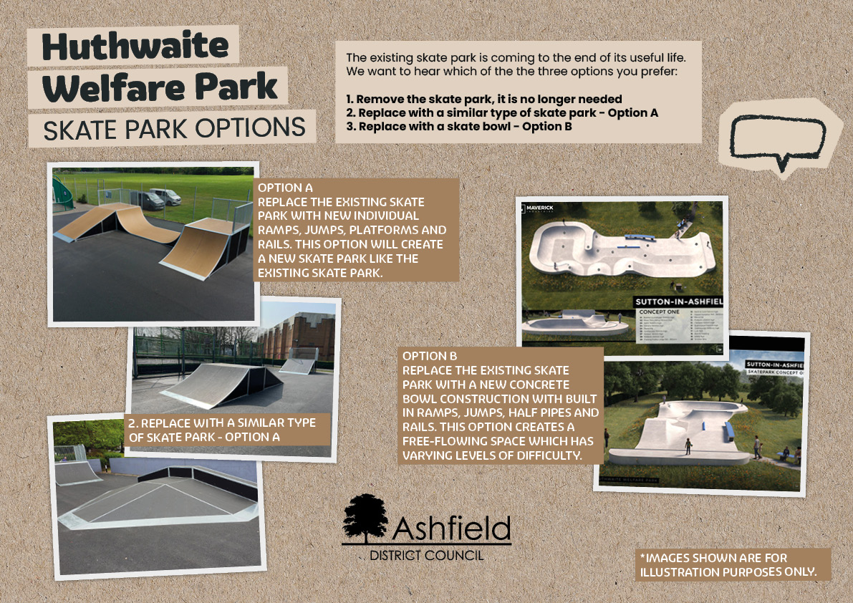
Images of skate park replacement options for Huthwaite Welfare Park. The existing skate park is nearing the end of its life there are three choices:
- remove it,
- replace it with a similar skate park (Option A), or
- replace it with a skate bowl (Option B).

Images illustrate ramps and platforms for Option A, and a concrete bowl design for Option B. These images are for illustration purposes only.

