

Disclaimer
This document or some parts of it may not be accessible when using adaptive technology.

If you require assistance with accessing the content of the document, please contact us and quote the document name and the web page you found it on:

- email: Regeneration – place@ashfield.gov.uk

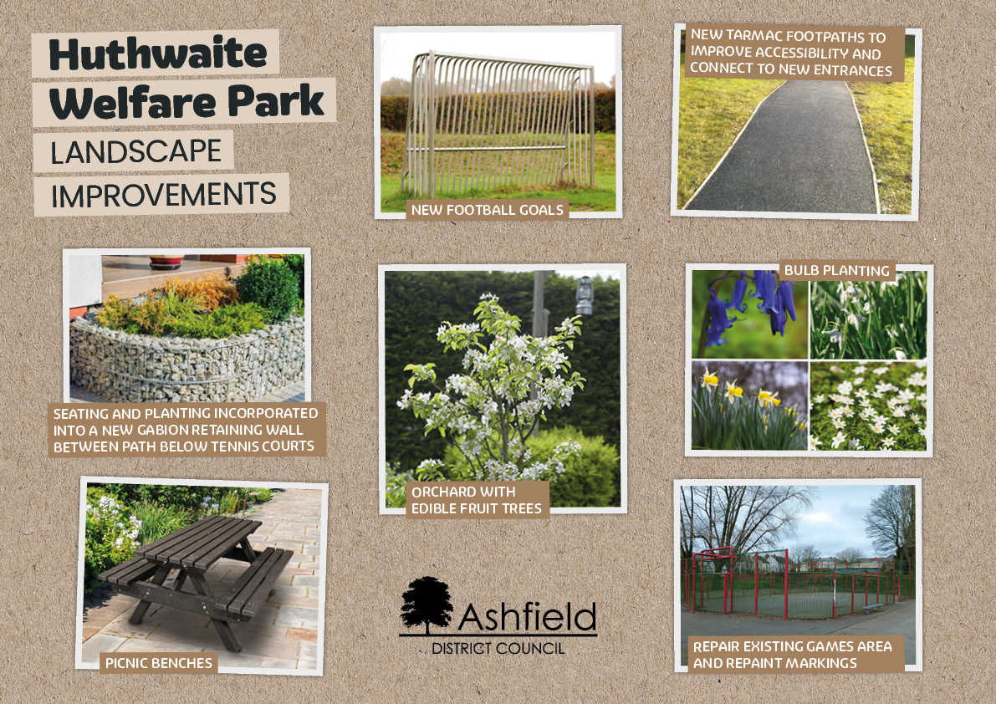

A collage of landscape improvement photos for Huthwaite Welfare Park, showing examples of new football goals, new tarmac footpaths, bulb planting, repaired games area markings, an orchard with edible fruit trees, picnic benches, and seating with planting built into a gabion retaining wall.

