

Kirkby Town Centre Spatial Masterplan

Shaping Kirkby’s Future
February 2021

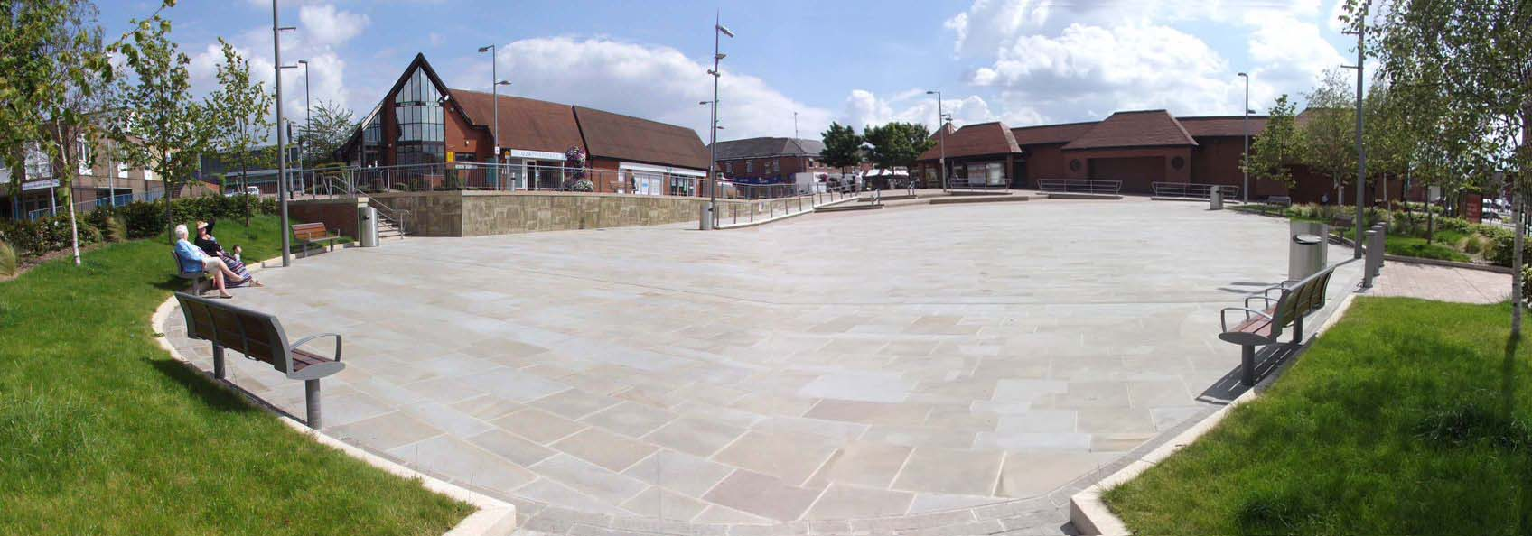
- Contents
Page
PREFACE 1

Chapter 1. Introduction
1.1 Economic Overview 2
1.2 Purpose of the Spatial Masterplan 6
1.3 Kirkby and its Geographical Context 7
1.4 Study Area 9
1.5 Vision Statement 10
1.6 Concept Plan 11

Chapter 2. Planning Policy
2.1 National Planning Policy Framework 12
2.2 National Planning Policy Guidance 12
2.3 Local Development Documents 13

Chapter 3. Baseline Summary
3.1 Historical Evolution 14
3.2 Retail Provision 15
3.3 Employment Provision 16
3.4 Housing Provision 17
3.5 Transport and Accessibility 17
3.6 Public Realm, Community Services and Leisure 19

Chapter 4. Principal Challenges

4.1 Principal Challenges 20

Chapter 5. Spatial Masterplan Principles

5.1 Maintain and Enhance Character and Identity 22
5.2 Improve the Quality of the Public Realm 22
5.3 Promote Ease of movement 23
5.4 Improve Legibility 23
5.5 Ensure Adaptability 24
5.6 Maintain and Improve Diversity 24
5.7 Support Sustainability 25

Chapter 6. Town Centre Masterplan

Masterplan drawing 28
6.1 The Town Centre Core 29
6.2 Civic/Health Hub 35
6.3 Gateways 38

Chapter 7. Masterplan Delivery

Priority Projects 42
7.1 Delivery Partners 44
7.2 Funding Masterplan Delivery 45
7.3 Delivery Mechanisms 45
7.4 Next Steps 46

Appendix 1

SWOT Analysis 47

PREFACE

“Our priority is to build community pride and aspiration across Ashfield. We want residents to be proud of where they live and see our town centres as a safe place to shop and visit. Increasing visitors and inward investment into the town centre is also important. The Kirkby Town Centre Masterplan will be a key document in achieving this.”

Councillor Jason Zadrozny
Leader of the Council


The Council has a Place Enhancement Programme, part of which is to create the ‘Ashfield Story’ identifying what makes the area distinctive to build community pride and encourage inward investment.
The Discover Ashfield brand has been developed by private and public sector bodies to promote Ashfield, increase pride and aspirations in our communities, improve the vibrancy of our town centres, encourage and promote inward investment and support tourism and the visitor economy in the Ashfield area.
This Spatial Masterplan forms one strand of the Place Enhancement Programme.
“As someone who not only lives in Ashfield but chooses to run their business from Ashfield, I am very excited to be involved with the Discover Ashfield initiative and the development of the Kirkby Town Centre Masterplan.
Whilst the demise of our traditional industries had a huge impact on our community, it is time to look to the diverse range of sectors our local businesses now serve and review how we equip ourselves to maximise the benefits now and into the future. To me Discover Ashfield and the Kirkby Town Centre Masterplan will provide the necessary framework for our community and businesses to look ahead and seize the opportunities we have, so we can really make this a fantastic place to grow your business, to live, and visit.”

Martin Rigley
Board Chair for Discover Ashfield


Chapter 1. Introduction
  - Economic Overview
This is an exciting time for our towns, with 101 places across the country being supported by the Government’s £3.6 billion Towns Fund, including Kirkby-in-Ashfield. The objective of the fund is to drive the economic regeneration of towns to deliver long term economic and productivity growth through Skills and Enterprise Infrastructure, Urban Regeneration and Connectivity.
This initiative will help to address the challenges of dramatic structural change in our town centres, brought about by external factors such as:
- Out of town retail parks with free parking, and which offer a broad mix of retail and leisure, continue to create new destinations to the detriment of traditional centres;
- Technological changes have over the past few years, seen a major shift to on-line shopping, in many cases, negating the need for bricks and mortar. This is likely to continue;
- The national business rates regime has hampered start-ups and has driven other retailers from the high street;
- Prevailing economic conditions since 2008 have led to many high profile national retailers either going into administration or undertaking financial restructuring at a cost of thousands of jobs;
- The number and type of shops being occupied in town centres has continued to decline and/or change at a faster rate than ever before. The structure of town centres has changed from a simple goods transaction to a more complex mix of retail, leisure, food and drink, events, commercial, residential, health and education.

What does this mean for Kirkby?
Kirkby is a traditional small town centre dominated by independent retailers, with a small number of national operators and a market operating Tuesday, Thursday, Friday, and Saturday. It is the smallest town centre within the Ashfield District and is generally used by the local resident population and workers. It has convenient and cost-effective car parking and is surrounded by residential areas.
Ashfield District Council has prioritised investment into Kirkby with:
- £1.1m public realm improvements on Lowmoor Road and creating a new civic square
- Investment in a shop front improvement grant scheme.
The development of a civic square and public realm improvements along Lowmoor Road in 2014 have significantly enhanced the quality of the shopping environment in Kirkby. These public realm improvements include new street furniture and public art.
The shop front grants scheme recognised the key function that shop fronts play in the town centre’s character and quality. The preservation and enhancement of traditional architectural details help to define the character of the town and provide an enhanced shopping experience and street scene. While these recent schemes have significantly improved the townscape quality of Kirkby, the Council recognises that further public realm improvements are required on the other key roads and gateways within the town centre boundary.
The variety of the goods and services available in the town support its role as an important destination for local residents to purchase basic goods and services. Most notably, the opening of the Morrison’s store in 2015 as part of the redevelopment of the old Co-op precinct has proved a successful catalyst for attracting in other national operators such as Wetherspoons (conversion of derelict cinema building), Subway, Domino’s and B&M Bargains.
Despite the improvements that have resulted from the significant investment in Kirkby, the centre remains vulnerable to edge-of-centre and out-of-centre retail developments. In October 2019 the ground floor unit vacancy rate stood at 13.7%, which is above the regional average of 9% and the national average of 10%. Its retail spreads out beyond the core centre on to Kingsway and Urban Road and this dilutes the offer.
Many of the independent retailers in Kirkby still operate historic reduced hours of opening on Wednesday afternoons. Although the more recently opened national retailers open for the full day mid-week, footfall is significantly reduced at this time – the same applies to Saturday afternoon when businesses close early, possibly as a result of losing weekend visitors to nearby centres. There is also little night-time economy with a limited number of activities (e.g. bars, restaurants, events or entertainment space) that attract visitors to the centre after 5pm. This means that the town is largely deserted after the shops have closed.
The town centre needs to diversify and enhance its vitality in order to ensure future viability and remain an important centre for the local population.

Place Shaping - Re-thinking Kirkby Town Centre
We want Kirkby town centre to have a bright and successful future. For this to happen, there is a need to proactively rethink its purpose, both physically and economically. The Spatial Masterplan sets out the framework for future investment and development by identifying a common understanding of Kirkby Town Centre as a physical ‘Place’. In addition to the Masterplan, a range of supplementary economic initiatives are considered to be essential in bringing a new purpose to Kirkby Town Centre.
Discover Ashfield is a private sector led partnership, facilitated by Ashfield District Council which is leading on the repurposing of the district and its town centres. This work provides a great opportunity to develop a true and sustainable partnership approach to Kirkby’s future.
The following list sets out some high-level ideas to make Kirkby Town Centre fit for the future. Most of these ideas cannot be delivered by the Council working alone. They (and any others subsequently proposed) will need a broad mix of other public, private, voluntary and community sector partners to shape and lead on delivery including landowners, proprietors, funders, and statutory agencies.
- Consideration of the appropriate mix of retail: nationals, local boutique style independents, markets, incentives for start-ups
- Other leisure uses to encourage more footfall and a greater length of stay: choice of food and beverage (for a variety of budgets), health and beauty, leisure and community facilities
- More events to draw people in
- Digital connectivity and investment into Smart town/city concepts - Free Wi-Fi
- A vibrant and safe night-time economy, which links to a greater choice of food and beverage, events and leisure activities. This will need to be linked to measures to reduce perceived fear of crime and combat any threat of anti-social behaviour
- The Council will follow its enforcement policies to deal with dereliction and blight in retail, commercial and industrial premises
- The Council will utilise Supplementary Planning Guidance on conversions of vacant retail units into residential properties (where appropriate) and work with owners of other vacant premises to bring them back into productive use
- The Council will encourage repurposing long-term vacant retail premises in secondary or tertiary locations in order to protect the integrity of the Town Centre
- The Council will develop (through the LEP or Towns Fund) opportunities for future grants for: shop front improvements; conversions to other purposes, and to bring derelict properties back into productive use. This will require an element of match funding by proprietors
- The Council will pursue more opportunities for residential developments to boost town centre living.
Through the Council’s ‘Place’ agenda:
- Work with all proprietors to facilitate a great customer experience, which will give Kirkby Town Centre a positive reputation
- Capitalise on the benefits of the potential Maid Marion line link to HS2
- Support the Kirkby Town Team to develop and deliver a high standard of customer care, attractive shop fronts and windows, use of IT and social media. They will build on existing initiatives in Ashfield in terms of Dementia Friendly and the Have a Seat campaigns
- Consider the development of a Business Improvement District (BID) - if this is required by businesses
- Consider what community aspirations exist with regard to town centre facilities, in particular making use of vacant sites or buildings
- Ensure high levels of public safety and usage of Public Space Protection Orders (PSPOs) where required to deter anti-social behaviour

  - Purpose of the Spatial Masterplan
The Spatial Masterplan replaces part of the 2007 Masterplan for Sutton in Ashfield & Kirkby in Ashfield, undertaken by ARUP. A new masterplan for the Sutton Town Centre element of this document was adopted by the District Council in March 2019.
This new Spatial Masterplan for Kirkby will help to realise the Council’s key priorities:
“to ensure the economy, and community pride and aspiration are key areas for development for the District” and “to enhance the identity of Ashfield and raise its profile as a place to live, visit and work”
The 2019-23 Council Corporate Plan specifically sets out the ambition to:
- Re-invigorate and re-purpose town centres by bringing empty buildings back into use, enhancing our town teams and diversifying the town centre economy.
- Make the most of external funding to improve our town centres
- Use our town centre events, including specialist markets to attract visitors to our town centres
The Spatial Masterplan aims to provide a framework for future investment and development which maximises the opportunities for Kirkby and capitalises on its existing assets. In particular it:
- Provides a consensus and common understanding of Kirkby Town Centre as a place - its character and identity.
- Establishes a clear Vision for Kirkby Town Centre to guide its development and improvement to 2029.
- Provides clear design principles for subsequent new development/projects with an emphasis on sustainability.
- Identifies sites and buildings where redevelopment and improvements will be encouraged.
- Aims to improve links to and within the Town Centre for pedestrians, cyclists and public transport users.
- Sets out how projects and initiatives could be delivered, who would be involved in delivery, how they might be funded and by what mechanism.
- Provides an evidence base for the emerging Local Plan.
The Masterplan is not inflexible or prescriptive, and it is not intended to provide detailed projects or design solutions. Nor does it represent a commitment to funding by the District Council.
  - Kirkby and its Geographical Context
Kirkby-in-Ashfield (or Kirkby) is the smallest of Ashfield’s three town centres in Ashfield and is identified as a ‘District Centre’ in the adopted Local Plan (2002).
The town is located approximately 5 km to the south of Sutton, 11 km to the north-west of Hucknall, 9 km to the south-west of Mansfield, and 22 km to the north-west of Nottingham. The town is easily accessed from the A38 which connects Derby to Mansfield, and from Junction 28 of the M1 motorway. Figure 1 shows the geographical context of the town.
Kirkby can be described as a linear town centre with one pedestrianised street. Recent improvements to create a civic square have created an attractive public realm environment. The Kirkby Outdoor Market runs four days a week in the fully pedestrianised part of Lowmoor Road. There is a single large anchor – the new large Morrison’s situated on the former Ashfield Precinct site in the north eastern corner of the centre. A smaller Aldi store provides a draw to the edge of centre in the west, close to Kirkby Railway Station.
The town performs an important role as a retail and service destination for the local area. Office for National Statistics Mid-year populations estimates 2018 set out that Kirkby (including Annesley) has a population of circa 29,500 people, an increase on the census 2011 identified population of 27, 811.
Whilst Kirkby cannot directly compete with its adjacent competitors; Sutton, Mansfield and Nottingham, it is important that the town centre continues to provide an attractive environment and retail/leisure offer that appeals to a more local catchment.

Figure 1: Context Map – Ashfield District

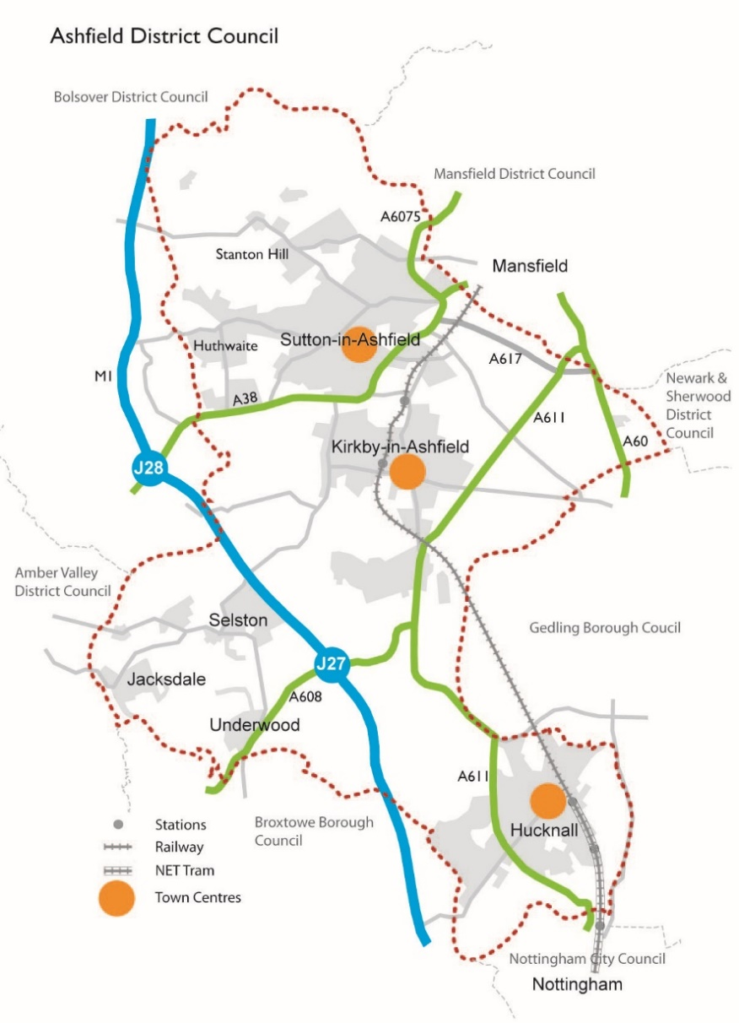

  - Study Area
The boundary of the study area is shown in figure 2 below and reflects the Town Centre boundary as identified in the 2016 Ashfield Retail and Leisure Study (Nexus).
Figure 2: Kirkby in Ashfield – Boundary of Study Area
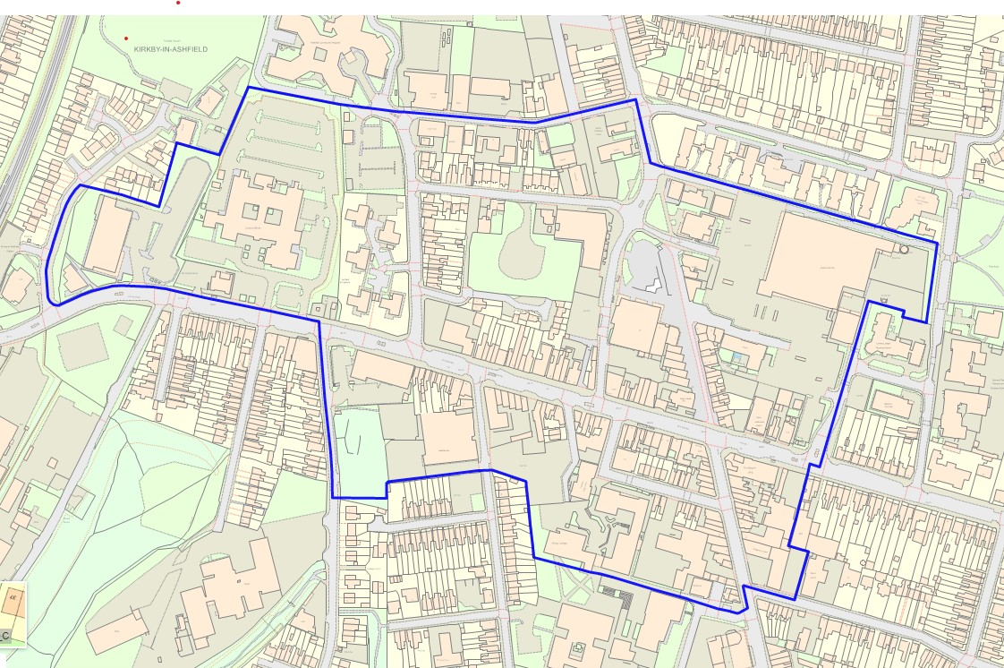Ordnance Survey Copyright 100024849
The retail focus of Kirkby is concentrated along Station Street and the pedestrianised section of Lowmoor Road and Kingsway, however, the District Shopping Centre boundary extends to include several outlying streets; the southern part of Ellis Street, the western part of Diamond Avenue; the northern section of Hodgkinson Road; the large Morrison’s store; and the Aldi store to the west.

  - Vision Statement
The vision statement below has developed from a combination of relevant matters taken from recent work undertaken by consultants, workshops, officer walkabouts and SWOT analysis (Appendix 1). This vision has guided the development of the Masterplan.
A Vision for Kirkby Town Centre

“To create an active and vibrant town centre that will make Kirkby in Ashfield a vibrant local centre of choice for its catchment population.”

To strengthen connections across the town centre linking
key destinations and promoting activity.

To enhance the townscape by ensuring that new development
offers high quality design, focuses appropriate uses in the town centre core, and maximises opportunities for the civic square.

To promote the town’s brand, attract visitors and
enliven the town centre through events and activities.”

  - Concept Plan
The Concept Plan shown on the next page has evolved through the master planning process and shows key opportunity for improvements, pedestrian linkages, key intersections and barriers to the town centre. It is from this Concept Plan that the Illustrative Masterplan in Chapter 6 has been developed.
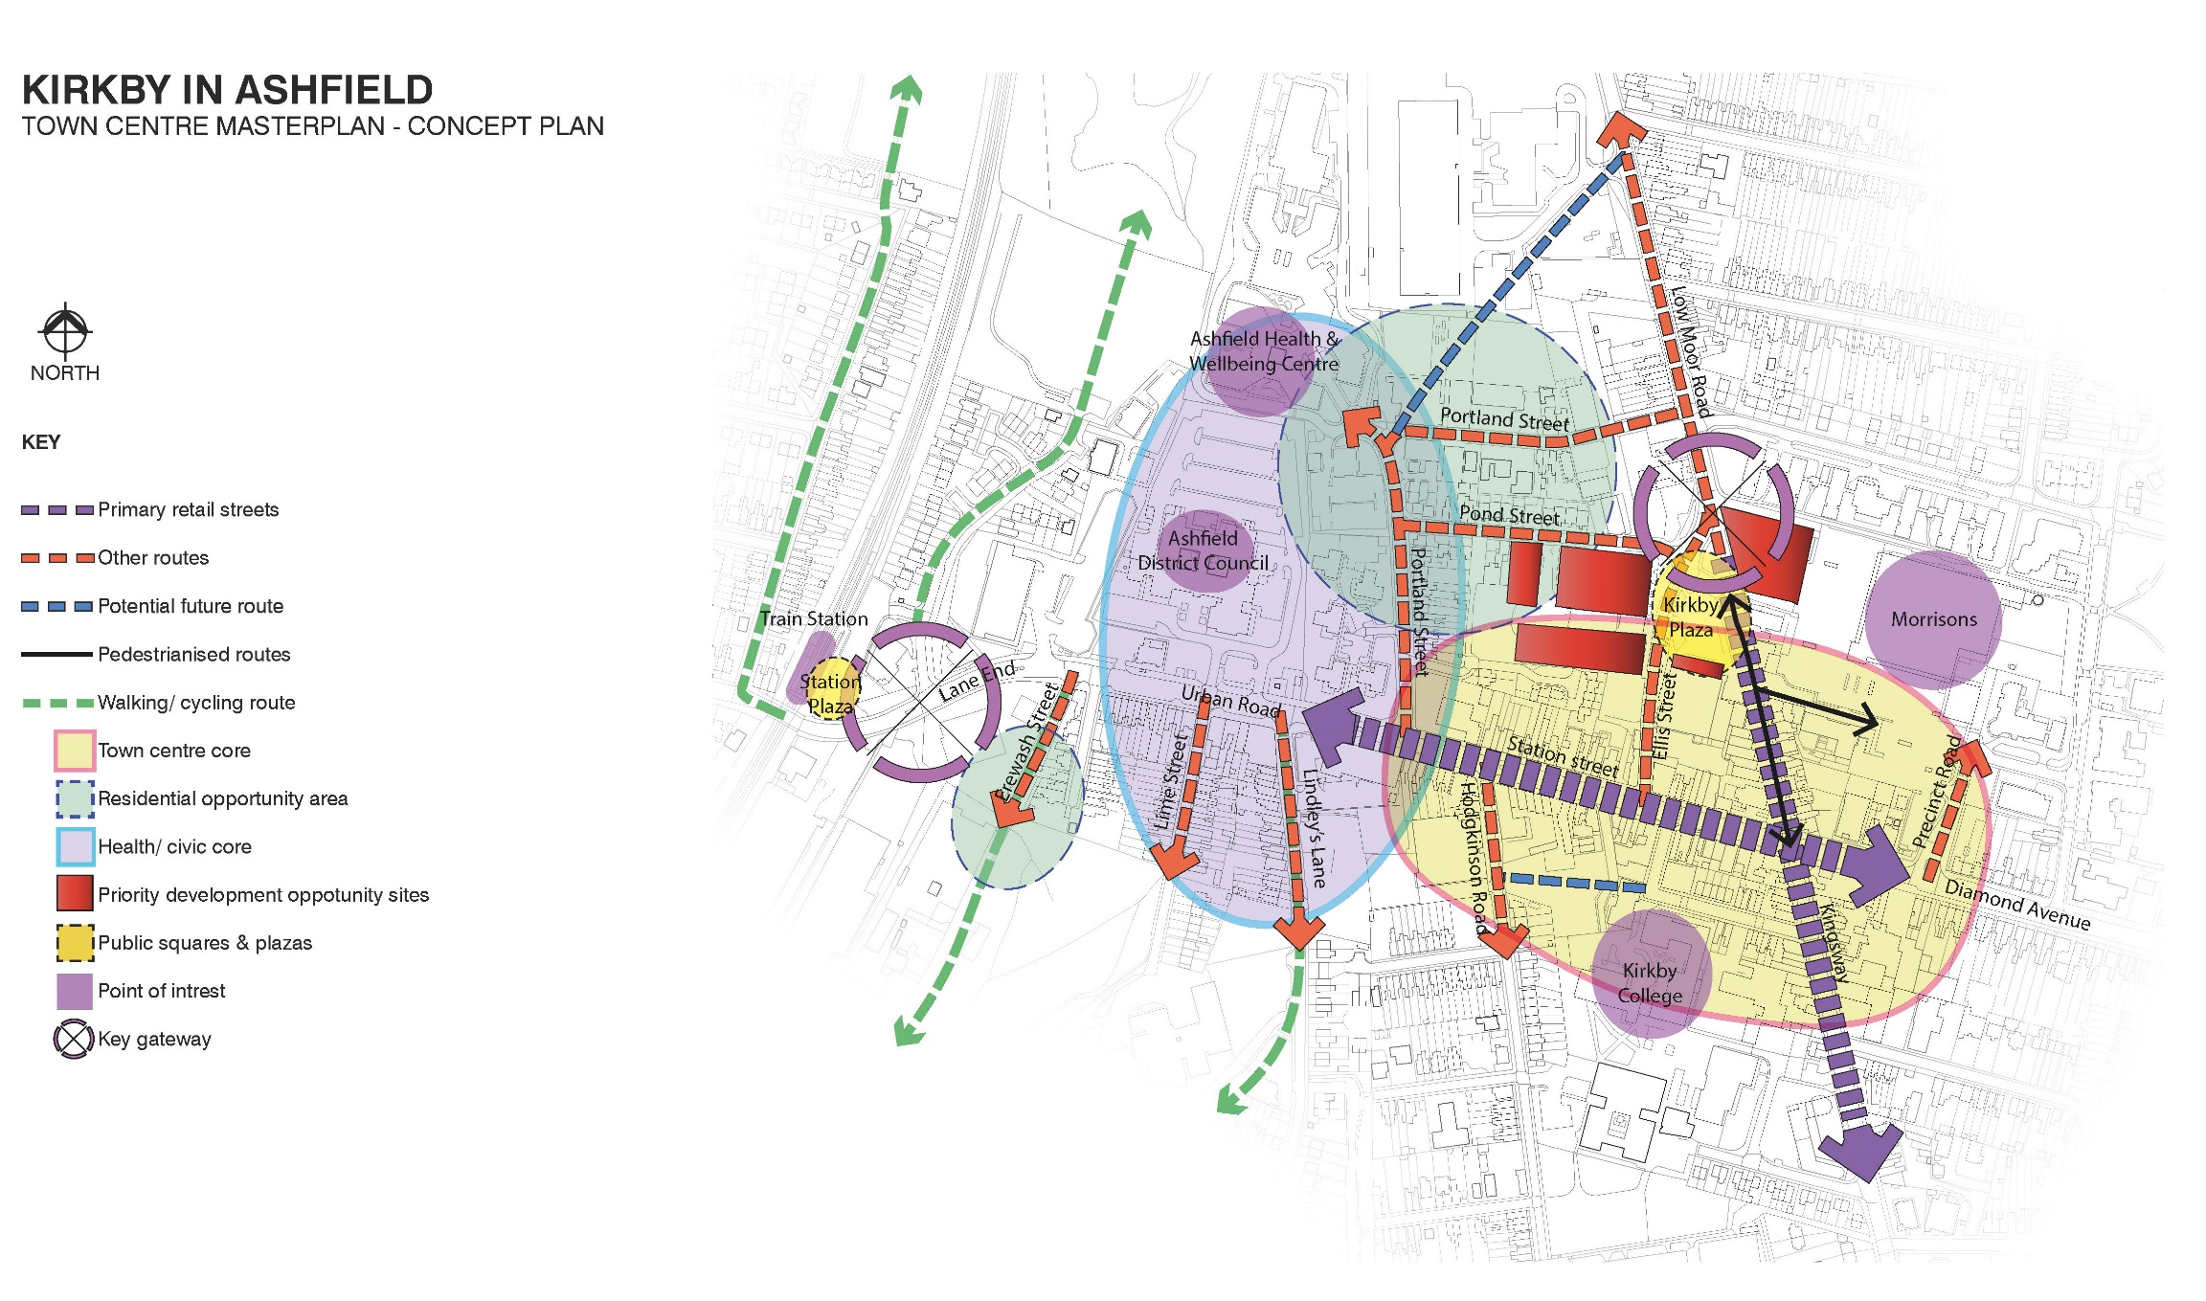

Chapter 2. Planning Policy

  - National Planning Policy Framework

The National Planning Policy Framework (NPPF) sets out the Government’s planning policies for England and how these should be applied.
The Framework recognises and stresses the importance of promoting the vitality and viability of town centres. It identifies that planning policies and decisions should support the role that town centres play at the heart of local communities, by taking a positive approach to their growth, management, and adaptation.
  - National Planning Policy Guidance
National Planning Policy Guidance (NPPG) adds further context to the NPPF and, as such, the two documents should be read together.
The NPPG entitled ‘Town Centres and Retail’ was published in July 2019. The NPPG supports councils in planning effectively for new development supporting town centres and states that:
“Local planning authorities can take a leading role in promoting a positive vision for these areas, bringing together stakeholders and supporting sustainable economic and employment growth……
A wide range of complementary uses can, if suitably located, help to support the vitality of town centres, including residential, employment, office, commercial, leisure/entertainment, healthcare and educational development.”

  - Local Development Documents
Ashfield Local Plan Review, 2002 (ALPR)
The Council’s current Local Plan was adopted in 2002, prior to the enactment of the NPPF. Despite its age, the Local Plan still includes a number of planning policies that are largely compliant with guidance set out NPPF and NPPG in that they encourage the promotion of town centres. Notably, the adopted Local Plan identifies and sets out a hierarchy of the District’s centres, identifies the boundaries of primary shopping areas, and includes policies that seek to promote its town centres competitive performance.
Emerging Ashfield Local Plan
At the time of writing, the Council is taking the preliminary steps necessary to prepare a new Local Plan consistent with the requirements of the NPPF. Housing growth, the local economy and the health of town centres, are amongst the issues to be addressed through the new Local Plan.

Chapter 3. Baseline Summary

  - Historical Evolution
The settlement of Kirkby-in-Ashfield developed in the area which has come to be known as ‘Kirkby Cross’ at the west end of the town and took its name from the Danes. Kirkby means 'village with a church', while the Ashfield suffix comes from open land, or "feld", with ash trees. Mentioned as ‘Chirchebi’ in the Domesday Book (1086), Kirkby was recorded as having a church, a priest and two mills.
In 1261 the village of Kirkby was granted a market and the market cross was constructed. The monument came to symbolise the early settlement, becoming the focal point for local people as well as the centre of early commercial and social activity. The steps and shaft of the market cross still stand on Sutton Road.
By the start of the 18th Century, Framework knitting had been introduced to Kirkby. In 1743 the population as counted by one of the rectors sent by the Archbishop of York was ‘around’ 600 people. The population had risen by the end of the 18th century to 891 people. The framework knitting industry continued to grow in status alongside the diverse range of tradesmen that traded in Kirkby.
During the 19th century, Kirkby changed from a fairly small agricultural based community to an industrial township. The area called East Kirkby - sometimes known as Kirkby Folly - developed and provided housing for the increased population. The first school was built in the parish in 1826, along with a house for the Master. By 1832 the school was attended by forty scholars and by 1900 a total of six schools could be found within the parish of Kirkby.
The sinking of the collieries in the 19th Century introduced the coal mining industry to Kirkby and created a need for new housing and brought greater economic prosperity. The Butterley Company opened the Portland Colliery in 1821, building 47 houses on Portland Row (Now demolished) in 1823 to house its workers. The company then bought further land at East Kirkby in 1887 and the Summit Colliery was sunk. Houses for the workers were built nearby off Lowmoor Road. At the time the Summit Colliery was one of the largest in the country but closed in 1969. The New Hucknall Colliery Co. acquired land at Kirkby, and Bentinck Colliery was sunk in 1894. By 1907 both Bentinck Colliery and the Summit Colliery had 1,300 men working there.
The growth of industry in the town is reflected in the population figures. In 1831, the population of Kirkby was 2,032, which was made up from farmers, tradesmen, framework knitters and a small number of miners, working at the Portland Colliery. The town rapidly expanded during the Victorian era. In 1861, the population had jumped to 2,886. This last increase was caused by the further growth of mining in the area. By 1900, the miners living in the town had pushed the population to over 7,000. By 1921, the figure was 17,236.
By the end of the 19th century, East Kirkby had become larger than the old village itself, and in 1901 it was formed into a separate ecclesiastical parish. On 23rd May 1903, the new parish church for East Kirkby, St Thomas' was consecrated by the Bishop of Southwell.
The 20th Century witnessed the continued growth and development of Kirkby but also saw the closure of the coal mines in the 1980s and early 1990s that led to a major slump in the local economy, and the area suffered a high level of socio-economic depression.
During the 20th Century the railways were closed during the Beeching era of the early 1960s, leaving the town without a link to central Nottingham and nearby Mansfield. Kirkby-in-Ashfield was once an important centre of coal mining and railways in west Nottinghamshire, with three active coal mines and several railway junctions. The former Mansfield and Pinxton Railway from the Erewash Valley Line was joined here by the later Midland Railway line from Nottingham. The Great Central Railway main line passed to the south-west side of the town and had a double junction with the Great Northern Railway Leen Valley Extension line to Langwith Junction and the Mansfield Railway to Clipstone. The railway tracks were re-opened to passengers in the 1990s as part of the Robin Hood Line project, providing links to other North Nottinghamshire towns and to Nottingham where a transport interchange allows transfer to the trams of Nottingham Express Transit system.
In recent years work to revitalise the town centre and restore pride and confidence in the town has commenced, with the demolition of the old Kirkby Precinct and re-development for a new Morrison’s foodstore, and creation of a Civic Square.

  - Retail Provision
Kirkby is the least visited centre in Ashfield, however, this is expected given it is the smallest of the main town centres in the District. The retail offer in Kirkby is dominated by sole traders rather than national operators.
The variety of the goods and services available in the town support its role as an important destination for local residents to purchase basic goods and services.The level of convenience retail stores in Kirkby is below the national average level of provision although the opening of the Morrison’s (3700 sqm unit) in 2014 has had a significant impact on the level of convenience representation in the town centre. The popularity of the supermarket is evident when reviewing the results of the NEMS Household Survey; in which 10% of respondents identified the strength of the supermarket as the main reason for visiting Kirkby. The 650 sqm Aldi, which is located between the main District Council Offices and the railway station, is considered to be an ‘edge-of-centre’ location.
Comparison units are approximately aligned with national averages at a representation of around 32%. Only a small number of “high street” comparison retailers have a presence in the town centre – these are Boots, Superdrug and Boyes (all on Lowmoor Road) and B&M bargains (Station Street).
The most dominant service retailers in Kirkby are Health and Beauty providers, accounting for 11 of the 26 retail units. The majority of the Health and Beauty units are situated on or around the pedestrianised area of Lowmoor Road.
The Post Office on the pedestrianised part of Lowmoor Road has recently closed and is now provided in a convenience store (McColl’s) located on Kingsway, south of the town centre boundary. There is a risk that the impact of this move will contribute to reduced footfall in the main retail core.

  - Employment Provision
Ashfield is well represented in manufacturing sectors, which accounts for 18.5% of jobs within Ashfield at 2018.
Kirkby-in-Ashfield has large clusters of manufacturing and distribution businesses located principally to the north of the town centre where there is good access to the A38 and Junction 28 of the M1 Motorway. These include Oddicroft Land, Lowmoor Road Business Park, and estates off Southwell Lane and Lowmoor Road. Smaller industrial estates are located on the fringe of the Town Centre at Lane End and Wheatley’s Yard, servicing a more local market.
The Council’s Employment Land Forecasting Study sets out that commercial agents identified a limited demand for office space, particularly in the Town Centres. However, this may result from existing office premises, which do not meet occupier requirements in terms of size, specification and location. There has been little speculative office development in the Town Centre, which is typically held back by rental levels that offices could currently command in the area.
Sherwood Business Park is located to the south of Kirkby-in-Ashfield, off Junction 27 of the M1. A former Enterprise Zone, Sherwood Park has substantial concentrations of both office and distribution space, accommodating internationally recognised multi-national companies. While the Business Park does provide local jobs, it is not anticipated to have a significant impact on the Town Centre employment opportunities.

  - Housing Provision
Average house prices in Kirkby are substantially lower than the national average, however, this is a common factor across the midlands and northern regions, with national averages influenced heavily by southern markets. Whilst the cost of market housing in Ashfield generally is comparatively low compared with some neighbouring Districts, lower than average earnings means there is still a demand for affordable housing, in particular for newly forming households. Consequently, there may be a level of demand for low cost housing in the most sustainable locations for those on low incomes and younger members of population for whom entry on to the housing market as a first-time buyer is becoming increasingly delayed.
It is widely acknowledged that the improvement of retail zones within a town centre location has a direct correlation with increased pedestrian flow, and therefore improves with an influx of population. Consequently, residential development within the locality of the town centre could be considered for higher density schemes and is particularly suitable for housing for those with access needs. Good access to services/employment opportunities within walking distance will not only assist with the cost of living for occupiers, but also reduce reliance on motor vehicles (hence an environmental benefit) and ultimately help to boost the town centre economy.
Whilst there are limited opportunities for medium-large scale residential schemes in the town centre, there has been some recent small-scale provision of apartments in Kirkby. Any proposed future residential scheme within the town centre will need to help strike the right balance in terms of land use, i.e., to complement but not dominate over other town centre uses such as retail and leisure.

  - Transport and Accessibility
Kirkby experiences some problems with traffic congestion on Station Street, which local people attribute to the pedestrianisation of Lowmoor Road. Many of the town centre roads are comparatively narrow due to an outdated road network, and different road users are forced to contest for space – such as businesses, through-traffic, visitors, shoppers and residents.
A number of schemes have been implemented in an attempt to address congestion issues. In February 2016, the County Council finished the Kirkby town centre traffic improvement scheme aimed at improving traffic flows along Station Street. This involved highway changes by re-routing traffic in the town centre, namely along Pond Street, Ellis Street and Station Street. It included the activation of a new signal system at the Ellis Street/Station Street junction, with Ellis Street operating a new one-way arrangement allowing traffic to flow southbound to the Station Street junction.
Kirkby railway station is located on the fringe of centre and offers good access to Nottingham. The station is served by the East Midlands Trains and connects Worksop with Nottingham. A train journey from Kirkby to Nottingham takes less than 25 minutes. Furthermore, to travel by train from Kirkby to Hucknall takes less than ten minutes, and Kirkby to Sutton Parkway involves a train journey of no more than five minutes.
The centre is well served by bus services, but is not a ‘timed stopping point / terminus’.
The town centre has historically enjoyed ample car parking for visitors. However, a review of car parking spaces is currently being undertaken with regards to long stay provision and the new leisure centre which will require dedicated parking. The town centre has also recently seen a significant increase in office-based employees, and needs arising from the railway station.
In addition to the 332 car park spaces provided by the Morrison’s foodstore, other spaces are found in the following locations:
- Ellis Street Car Park – 29 short stay spaces
- Hodgkinson Road Car Park – 66 long stay spaces
- Festival Hall Car Park – 71 long stay spaces
- Central Council Offices – 45 free spaces (for Council visitors only)
- Kirkby Station – 45 free spaces (for train users only)

All Council car parking spaces are provided with the first hour free (as of November 2015).
The availability of car parking in the town centre is reflective of the most popular mode of transport used by visitors to the centre. A high percentage of shoppers who live very close to the town centre, still drive to the town centre (59.3%). A total of 30.5% of shoppers in this area stated they typically walk into the town centre. Again, this is representative of the town centre’s role and function as an easily accessible local centre offering basic goods and services to the local community
  - Public Realm, Community Services and Leisure
The main area of public realm within Kirkby Town Centre is the civic square, Kirkby Plaza, along with the adjacent pedestrianised section of Lowmoor Road which has been subject to improvements including new street furniture, surfacing and public art in 2015. The civic square is occasionally used for events, but is not utilised to its full advantage due primarily to a lack of active frontage. Part of Lowmoor Road is occupied by market traders every Tuesday, Thursday, Friday and Saturday.
The Festival Hall Leisure centre is located to the south of the town centre, providing a range of activities including a sports hall, fitness studio and a gym. A new leisure centre will replace Festival Hall which will provide additional facilities such as swimming pool, splash pad, climbing wall and adventure play, as well as events in the sports hall.
The town is well represented by numerous healthcare facilities and NHS properties which are dispersed throughout the centre.
The main District Council offices, which incorporate the Department of Work and Pensions (DWP) and the Police are also located to the west of the main town centre core.
Civic Square, Kirkby

Chapter 4. Principal Challenges

  - Principal Challenges
Drawing on the SWOT analysis (summarised in Appendix 1), it is clear that Kirkby Town Centre is currently facing challenges that must be addressed if it is to be sustainable in the long term. Principal challenges include:
- Competition from nearby town and city centres, and out of town retail areas
- Town centre perception – the range of uses and services, the quality of shop frontages and public realm, access to the town centres, safety in the town centre and physical environment can strongly influence success
- Socio economic profile – the indicators for education, health and income point to the need to integrate the Masterplan with socio-economic regeneration strategies and initiatives to improve educational attainment, reduce crime and improve the health and wealth of the local community
- Accessibility and movement - efficient and safe movement to, through and around the town centre from a range of transport modes is crucial to ensuring regular patronage
- Complementary roles - because of the close proximity of the town centre to neighbouring towns, such as Sutton in Ashfield, they will inevitably have overlapping catchments. It will be essential to ensure that their future roles are complementary, not competing
- Attract new public / private investment funding
- Support local businesses.

Chapter 5. Spatial Masterplan Principles
Seven broad principles have been identified to achieve the vision for Kirkby Town Centre. The principles are interrelated and in combination, they will help guide development and contribute to realising the vision for Kirkby Town Centre. The opportunities identified in chapter 7 will need to take account of these principles.

Maintain and Enhance Character and Identity | Respond to and reinforce locally distinctive patterns of development and landscape, and create a sense of place.
Improve the Quality of the Public Realm | Create public spaces and routes that are lively and pleasant to use.
Promote Ease of Movement | Develop a town centre which is easy to get to and move through.
Improve Legibility | Develop a clear image and a place that is easy to understand.
Ensure Adaptability | Achieve a place that can change easily.
Maintain and Improve and Diversity | Create a place with variety and mixed uses.
Support Sustainability | Achieve a place designed to minimise required inputs of energy, water, food, waste, and outputs of heat, air and water pollution.

  - Maintain and Enhance Character and Identity
The character of a place is formed by the pattern of development, its scale and massing, by the mix of uses, architectural styles and details, and by the underlying topography. Kirkby’s character is what makes it unique and has evolved through time, shaped by the people who have lived and worked in the town. In creating a sense of place, new development and public realm projects should take account of:
- Distinctive townscapes/landscapes
- Natural features such a water courses, topography, distinctive soft landscaping and trees
- Locally distinctive buildings, including listed buildings and those of local heritage value
- Special spaces, both public and private where they are visible and contribute to the character of the area
- Skylines and roofscapes
- Good quality design
- Good quality and sustainable building materials to ensure longevity and environmental responsibility
- Respect and acknowledge local culture and traditions, and incorporate into scheme design where appropriate
- Avoid standard solutions

  - Improve the Quality of the Public Realm
Further improvements to the public realm are essential to improving the image and attractiveness of Kirkby town centre, creating a sense of wellbeing and amenity.
In order to create a place with lively and pleasant to use public spaces and routes, schemes should:
- Undertake a town centre-wide approach to public realm
- Achieve a sense of safety and security
- Create uncluttered and easily maintained surroundings
- Pay careful attention to detailing, with integrated well-designed public art
- Be inclusive - suited to the needs of everyone, including young families, disabled and older people
- Include well-designed lighting which accentuates key buildings and vistas, and assists with the sense of safety and security, whist minimising light pollution
- Include well-designed street furniture which assists in creating and enhancing identity
- Where appropriate include attractive and robust planting

  - Promote Ease of Movement
When considering movement within the town centre, there is a need to take account of the primary users of a particular space. The town centre needs to be a place that is easy to get to and move through.
To create a connective and permeable town centre, development should ensure that:
- Roads, footpaths, cycleways and public services are connected into well-used routes and connect proposed and existing nodes of activity
- Public areas are easily accessible for all users, including mobility scooter/wheelchair/pushchair users and cyclists where appropriate
- Designs incorporate direct routes that lead to where people want to go
- Schemes provide a choice of safe, high quality routes to assist with permeability

  - Improve Legibility
The town centre needs to provide a welcoming image, and be easy to understand for all users. Visitors should be able to orientate themselves and establish a clear direction, achieved through the use of effective signage.
In order to help create a place that is easy to understand development and public realm schemes should:
- Create new or capitalise on existing landmarks and focal points and vistas
- Incorporate clear and easily navigable routes, utilising appropriate and distinguishable hard surfacing
- Create new or enhance existing ‘gateways’ to key areas which enable users to identify with that particular area
- Include well-designed lighting which accentuates key buildings and vistas, assists with the sense of safety and security, and leads the user to legible routes
- Incorporate legible signage and way markers for all users whilst minimising highway/public realm clutter

  - Ensure Adaptability
The function of town centres has changed markedly in recent years with technological advances and the emergence of internet shopping. It is anticipated that the role of town centres will continue to evolve and as such Kirkby town centre needs to be a place that can respond to change.
In creating an adaptable town centre, development and public realm schemes should:
- Incorporate flexible areas which support a variety of uses
- Incorporate buildings adaptable to a variety of present and future uses
- Promote the re-use of important historic buildings and other heritage assets, whist conserving their historic importance

  - Maintain and Improve Diversity
Kirkby town centre is, at present, a predominantly retail area, with limited office, leisure (restaurants, café, cultural uses) and residential accommodation. There is an opportunity to improve and diversify the town centre offer. This can be realised through changes to the activities undertaken within existing premises, but more significantly from the development of sites that will arise over the next 10 years. There is a need to provide a broader mix of uses in the town centre (beyond shopping) to create areas that are active throughout the day and night, generating additional footfall, and therefore expenditure.
In order to create a place with a variety and mix of uses development (and public realm schemes where appropriate) should:
- Plan for a mix of compatible uses and tenures
- Provide a variety of layout and building form
- Aim to achieve diverse communities and cultures
- Explore a variety of architectural styles whilst respecting the local character, vernacular and neighbouring uses
- Increase and protect biodiversity

  - Support Sustainability
New development should seek to raise the environmental performance of buildings through the incorporation of high-quality designs that encourage behavioural changes with regard to energy use and conservation. Higher density development within town centres, high standards of construction, and requirements for the use of renewables, will be pursued.
In order to achieve a sustainable town centre for Kirkby, development should include:
- Efficient use of resources
- Utilise local materials to reduce transport and hence, carbon emissions. This also has the benefit of supporting the local economy
- Minimising energy and waste consumption through high quality design
- Encourage higher densities (in respect of housing development) in the town centre. Good access to a wide range of services and employment opportunities will reduce the need to travel
- Incorporate electric vehicle charging points, including for electric buses
- Utilise sustainable urban drainage systems (SUDs)

Chapter 6. Town Centre Spatial Masterplan
The Town Centre Masterplan for Kirkby has been developed taking into account the Masterplan Principles identified in Chapter 5 and considering how they can be best utilised to realise the Vision (see page 10) for the town centre.

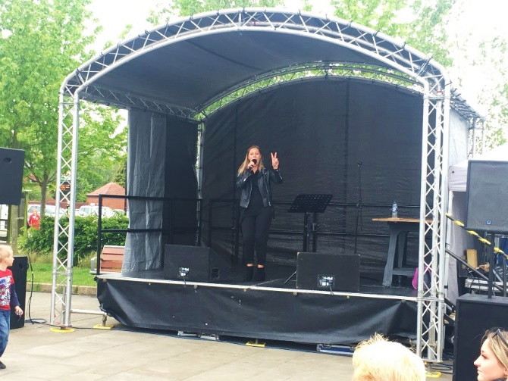 Community events,
Lowmoor Road/Civic Square
“To promote the town’s brand, attract visitors and enliven the town centre through events and activities.”



In order to realise the Vision it is important to look at different areas of the town in terms of how they function, what their role is, and how these areas can be improved in order to support and enhance the overall vitality and viability of the town centre. Taking lead from the Concept Plan in Chapter 1, this has been broken down into three topic areas:
- The Town Centre Core;
- The Civic/Health hub
- Gateways.
These topic areas are illustrated on the Spatial Masterplan overleaf. They provide a number of key opportunities for potential areas of improvement, from which more detailed schemes can be developed. The opportunities identified do not provide an exhaustive list and additional improvements may be identified in the future.

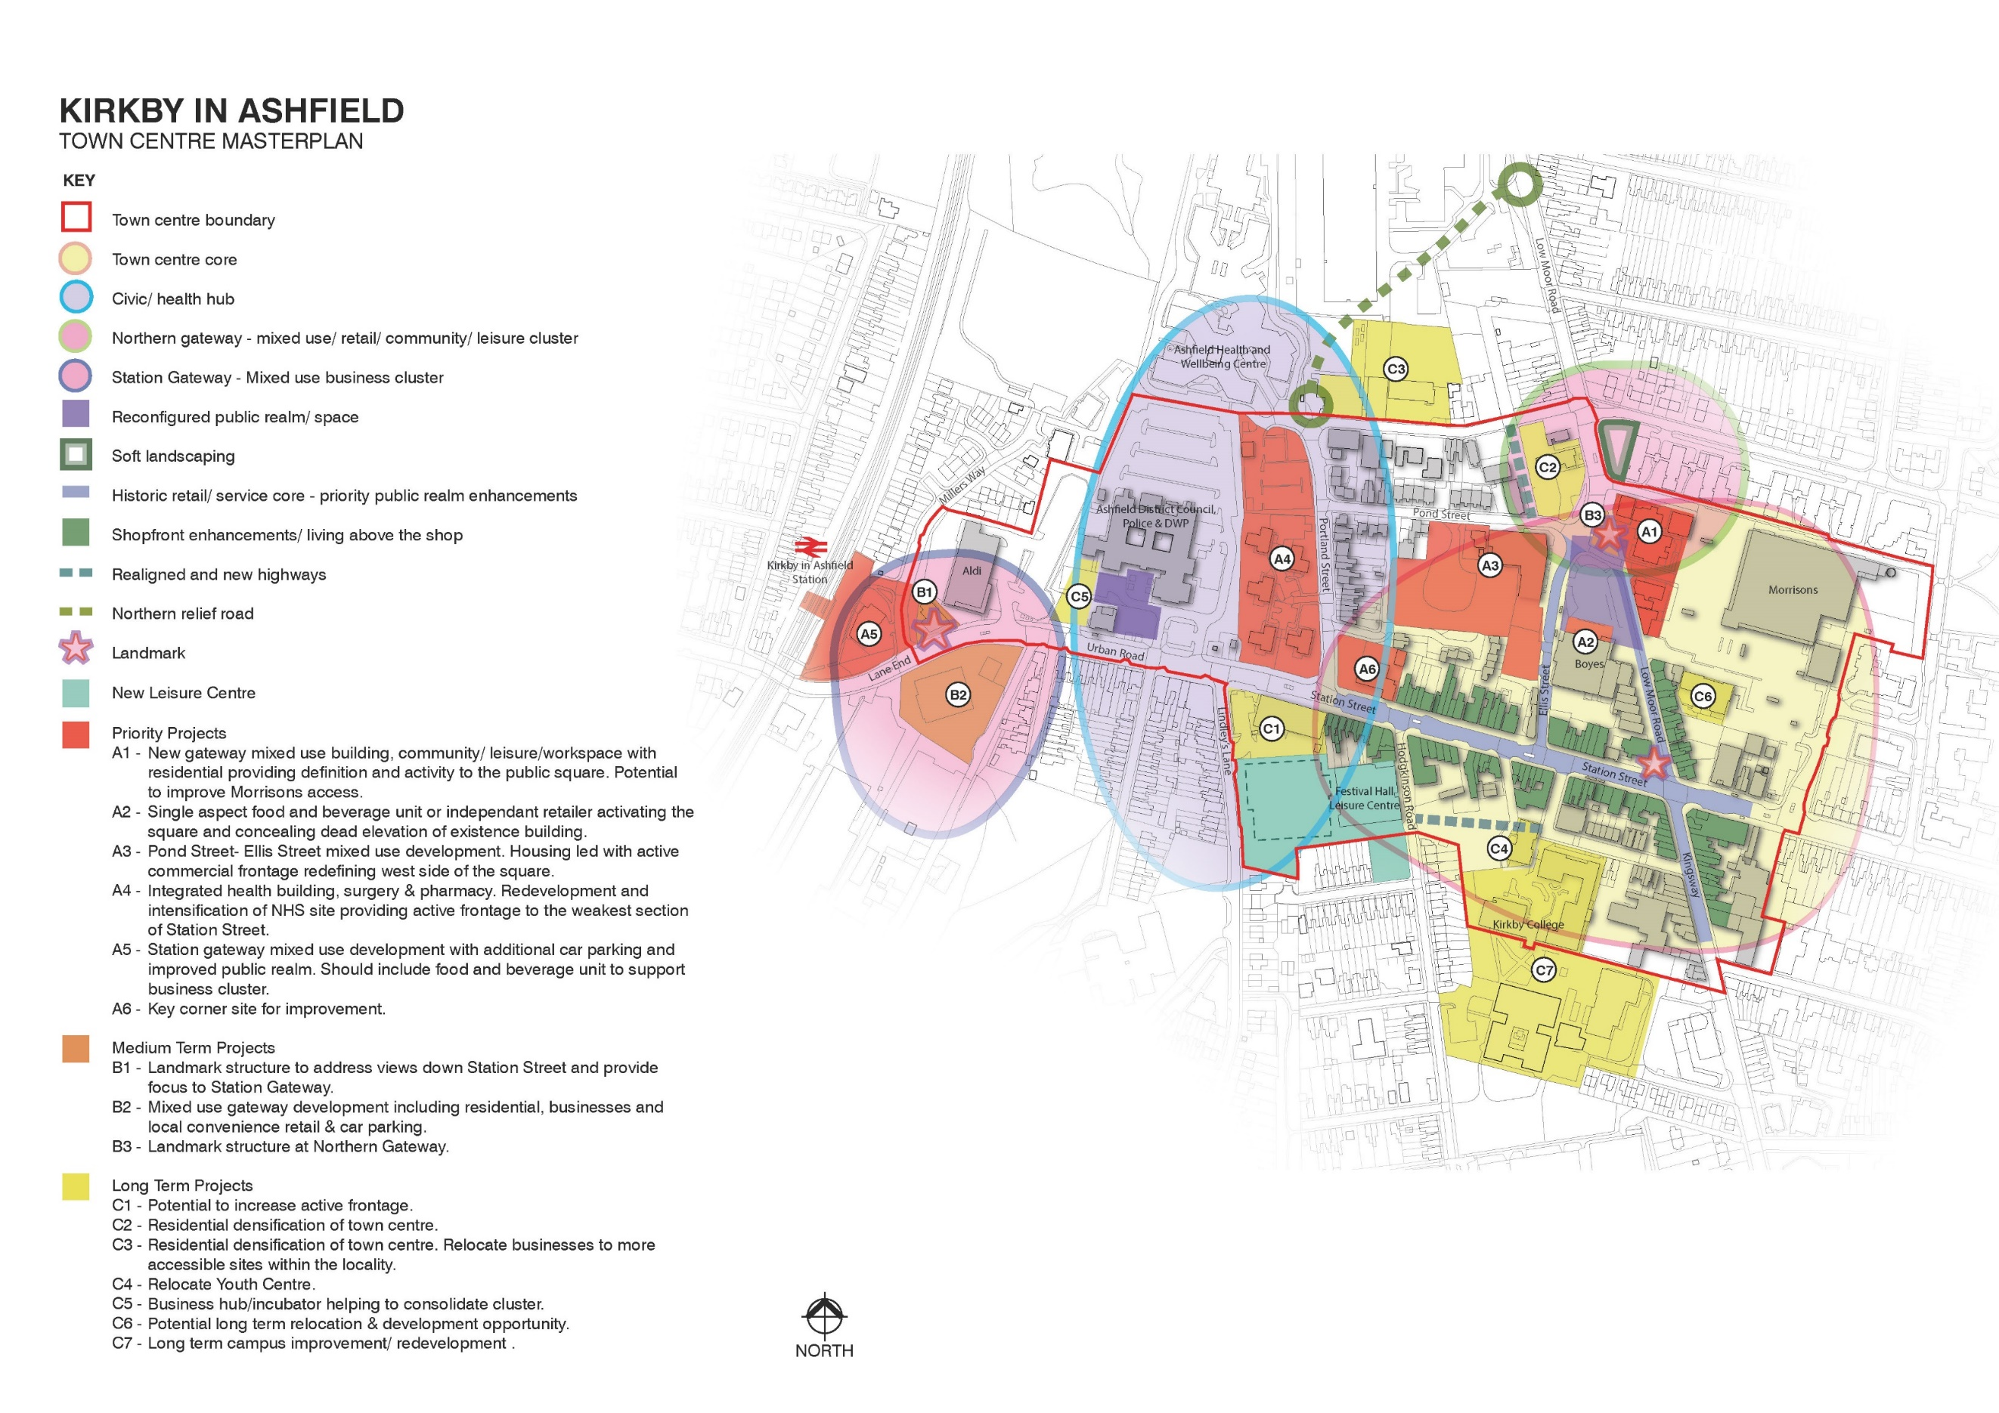
and station.

  - The Town Centre Core
The core is the heart of the existing town centre. Place making improvements will be focused to consolidate the commercial/leisure offer and reinvigorate this central area to maximise opportunities for regeneration and external investment. Ensuring a strong and vibrant core is the foundation for safeguarding the town centre as a local destination.

Civic Square Area (A1, A2, A3, B3, C2)
The vision for the Civic Square/Plaza area is to maximise its potential for activity, bringing a new level of vibrancy into the town centre. This space presents a relatively new area of public realm and is reliant on further intervention in order to realise its full potential. The key issues mainly arise from the lack of active frontage and destination points to encourage movement across and activity within the Square. The buildings which do have a frontage onto this area are either currently vacant and/or poor quality which detract from the street scene, or are occupied by uses which do not encourage significant amounts of activity, e.g. pharmacies, health centre and a vacant factory shop.
Use of the Square for public events/activities is infrequent, as it is dependent on available funding, community involvement and interest.
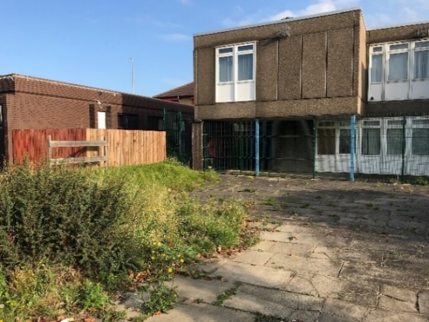 | 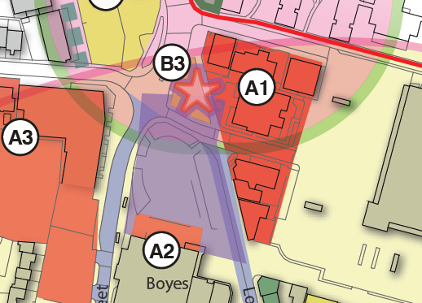
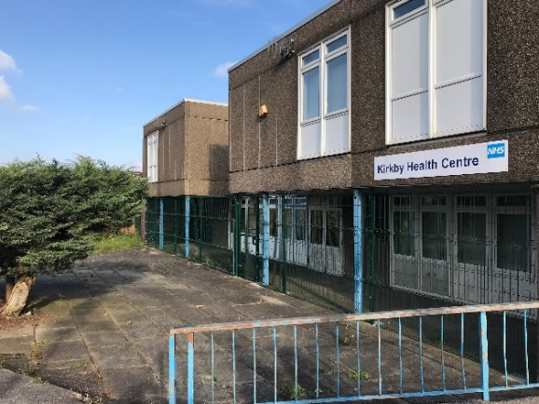 | 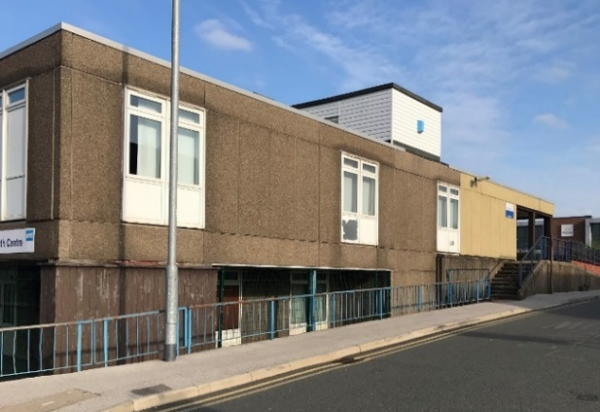

NHS Health Centre detracts from street scene occupying a prominent position close to the Lowmoor Road gateway – no active frontage in a prime retail/leisure location

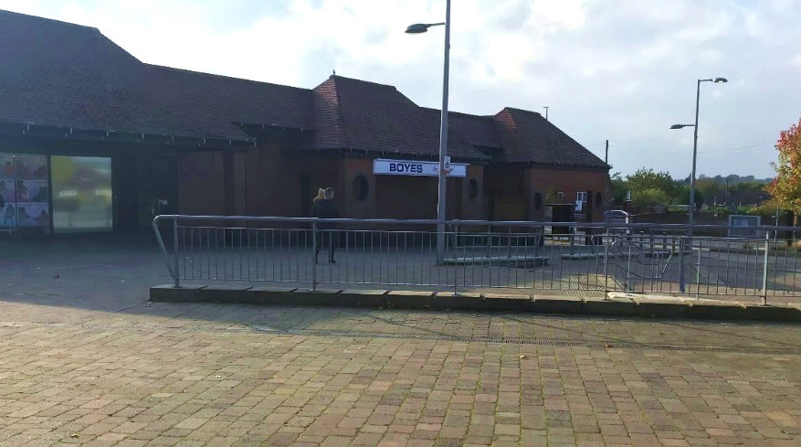 | 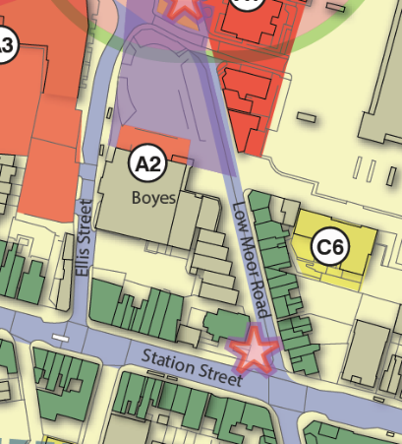

Civic Square (South): Inactive elevation at Boyes comparison store

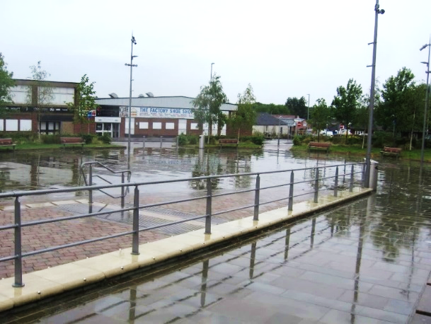 | 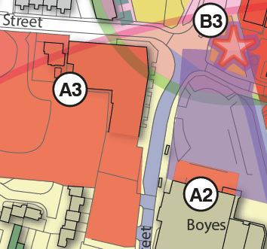

Civic Square (West): Lack of active frontage does not encourage footfall - Vacant factory shop (industrial appearance of building)

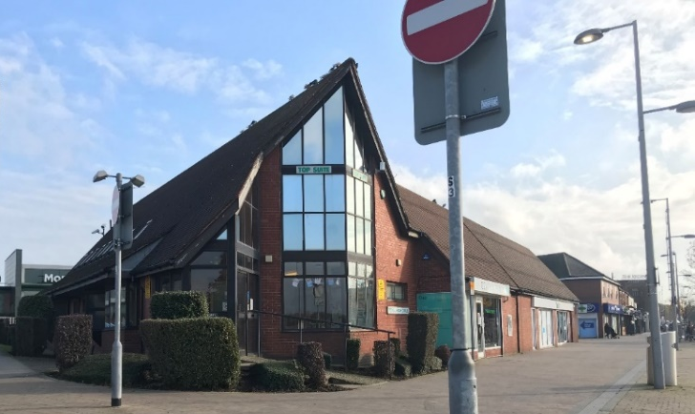 | 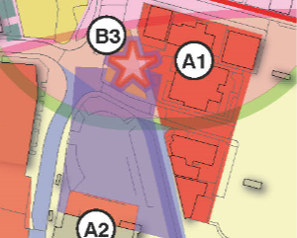

Civic Square: GP surgery and pharmacies occupy frontage to the east

Key opportunities:
- Rationalise and consolidate healthcare facilities.
- Redevelop A1 with a new landmark mixed-use building(s), potential uses may include commercial, community/leisure facilities and residential to provide definition and increase activity at the Civic Square.
- Develop single aspect unit(s) to conceal the inactive elevation south of the Civic Square at A2. This could include an opportunity for a food and beverage outlet, or for small independent niche retailers.
- Redevelop ‘Pond Hole’ site and adjacent factory shop building at A3 for residential led use. This should have an appropriate town centre use which promotes an active frontage on to Ellis Street in order to redefine the west side of the square.
- Continue to support and encourage shop front improvements.
- The under-utilised land at C2 provides an opportunity for residential densification of the town centre.
- Provide a new landmark feature to create a focal point at the northern end of the Civic Square (B3).
- Improve legibility, e.g., improved signage and navigable routes.
- Maximise opportunities to recognise/conserve Kirkby’s heritage

Pond Street, Portland Street, Ellis Street (A3)
This area, locally known as ‘Pond Hole’, is currently under-utilised and contributes little to the town centre. There is an opportunity to secure its redevelopment for mixed uses and capture potential funding contributions, through Section 106 agreement.
The Ellis Street frontage has the potential to make a significant contribution to the attractiveness and activity levels surrounding the Civic Square. Together with the fairground storage land to the rear, this site provides an opportunity to support a new mixed-use development, which would deliver the additional spending power local businesses need to support their continued future.

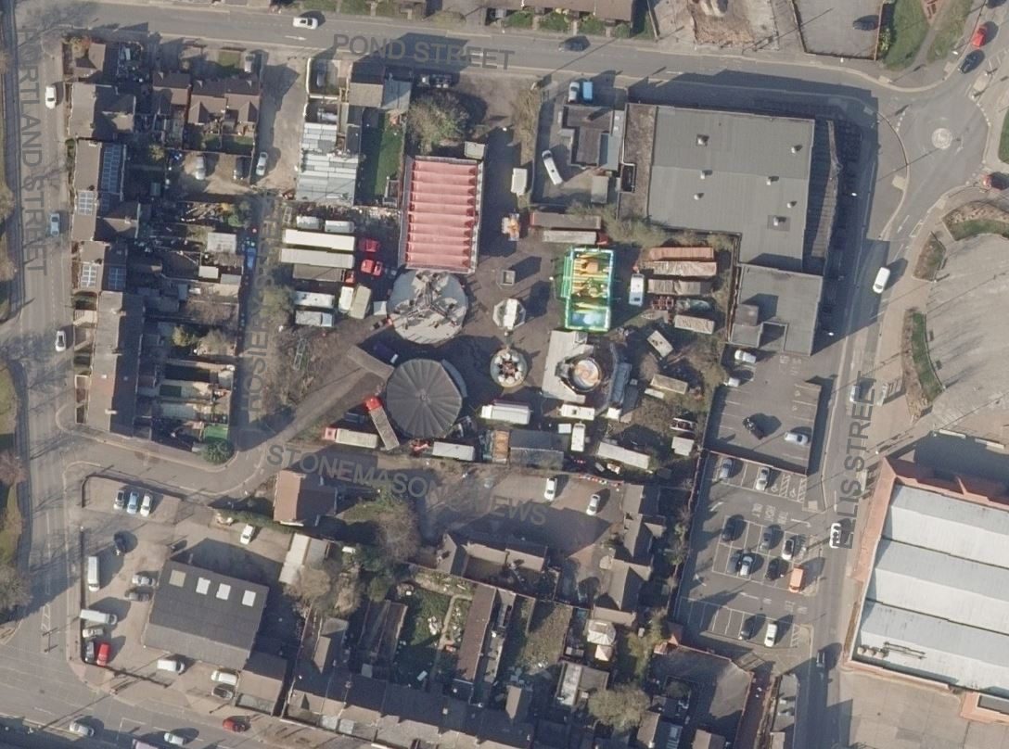 | 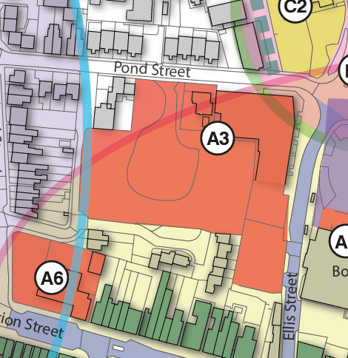
Pond Hole: Land used on a seasonal basis for fairground ride/equipment storage

Key opportunities:
- Redevelop ‘Pond Hole’ site and adjacent factory shop building at A3 to capitalise on the town centre location. Potential for residential led use, with an active frontage to redefine the west side of the square, for example, service, commercial, community/leisure uses appropriate to a town centre location.
- Locate any car parking/service area to the rear to minimise visual impact.
- Integrate safe and attractive pedestrian routes linking with the surrounding area.

Station Street, Lowmoor Road (pedestrianised part), Kingsway (A6, C4, C6, C7)
Morrison’s store is a key anchor and a main attractor to Kirkby town centre. However, the pedestrian link from Lowmoor Road is currently hindered by the poor car park configuration and fencing. As such, this area has the potential for improved linkages in the medium to long term.
Part of Lowmoor Road is occupied by market traders on certain days of the week, however, recent uptake of stalls has been in decline.
Station Street and Kingsway represent the more historic retail/service core of the town centre and have benefitted to some extent from shopfront improvement grants. This has directly increased the attractiveness of the area and is beginning to act as a catalyst for improvements to surrounding privately owned properties. The vision for this area is to maintain and enhance the historic street scene.
The site A6 is currently occupied by a motor garage and is particularly prominent in the street scene. Whilst there is a clear role for this service, the quality of the existing use contributes little to the environment of the centre. As such it is considered that there is potential for refurbishment or redevelopment/relocation, and environmental improvements at this location.
The existing youth centre (The Acre) currently occupies a site at Tennyson Street with poor visibility and connection to the town centre. This provision could potentially be relocated elsewhere in the town to improve visibility and usage.
Kirkby experiences problems with traffic congestion on Station Street, which local people attribute to the pedestrianisation of Lowmoor Road. Many of the town centre roads are comparatively narrow due to an outdated road network, and different road users are forced to compete for space – such as businesses, through-traffic, visitors, shoppers and residents. A number of schemes have been implemented in the past in an attempt to address congestion issues, although problems still occur at peak times.
There may be an opportunity to increase permeability of traffic and assist traffic flow through measures such as modelling to optimise traffic signals, and through the provision of new access routes as part of a long-term potential redevelopment area at Patco, and on the approach to the proposed new leisure centre (Kingsley Street to Hodgkinson Road). The latter would also assist in enhancing prominence of the new centre.
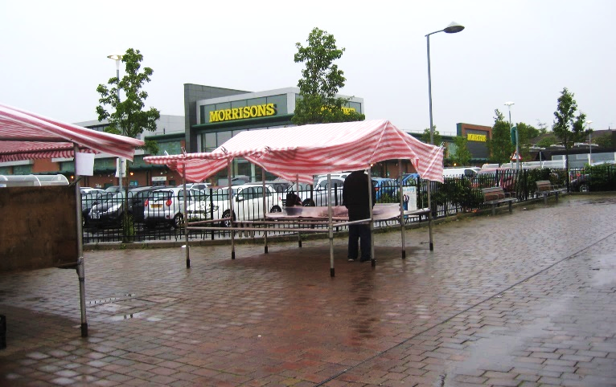 | 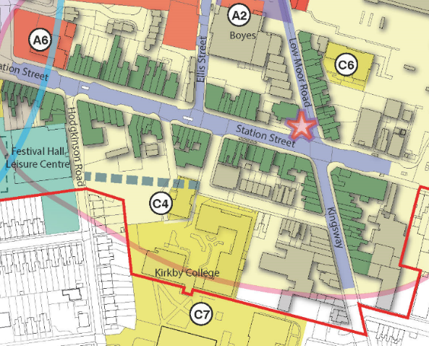

Poor pedestrian link with Morrison’s due to car park configuration

Key opportunities:
- Improve pedestrian links between Lowmoor Road and Morrison’s store.
- Rationalise the market layout and encourage a more diverse offer, including specialist and seasonal markets, e.g., Farmers Markets, Christmas markets.
- Continue to support and encourage shop front improvements.
- Enhance public realm, e.g., lighting, signage/way marking.
- Improve legibility, e.g., improved signage and navigable routes.
- Investigate potential for improvements to the highway network, without compromising the visibility of the main town centre core. There is an opportunity for improved access which would open up the Patco site to the north of the town centre for more intensive re-development, whilst assisting in wider permeability for the centre.
- Potential for refurbishment or redevelopment /relocation, and environmental improvements at A6 (Kirkby Motors site).
- Potential to relocate Youth Centre to increase visibility and usage.
- Potential for a new access route on the approach to the proposed new leisure centre (Kingsley Street to Hodgkinson Road).
- Long-term potential for campus improvements and re-development of Kirkby College, including potential for improved highway access.
- Long term development opportunity at Kirkby library site.
- Maximise opportunities to recognise/conserve Kirkby’s heritage

  - The Civic/Health Hub
This area of the town centre is primarily occupied by the main District Council Offices, which also incorporate the Department of Work and Pensions (DWP) and the Police; several NHS properties including Ashfield Health and Wellbeing Centre; and home to the new leisure centre. It is considered that this area should become the focus for civic and health/wellbeing facilities, providing a central hub of easily accessible services and optimising potential from under-utilised land at Portland Street.

Urban Road (C5, A4, C1)
The land to the front of the Main Council offices/adjacent to Ada Lovelace House occupies a prominent position on one of the main routes into the town centre and has good accessibility from the railway station and cycle routes to the west. Currently used for car parking, this area does not contribute to the attractiveness of the town centre and could be redeveloped for a well-designed building which maximises this accessible and edge of centre location.
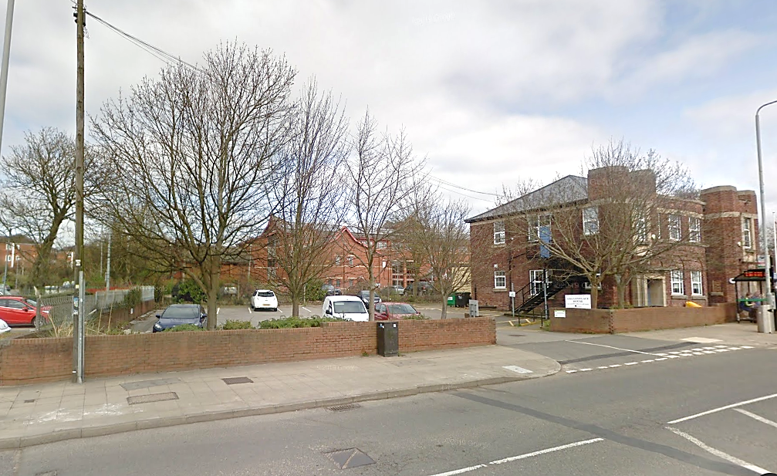 | 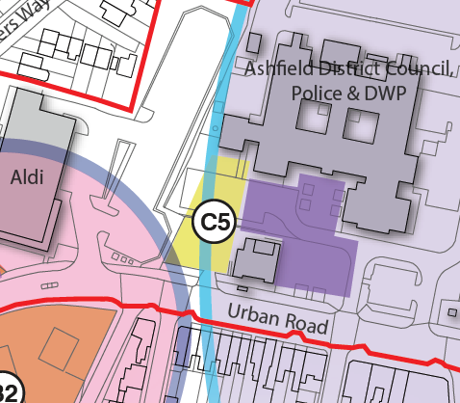
Car parking occupying a prominent edge of centre position – potential re-development site

The land to the west of Portland Street is occupied largely by very low-density development owned by the NHS. This comprises 5 single storey buildings and associated car park. As a prime town centre location, this area is significantly under-utilised. There is an opportunity to intensify use of this site and re-locate dispersed facilities into a central hub. This could take the form of a mixed-use development, including residential use

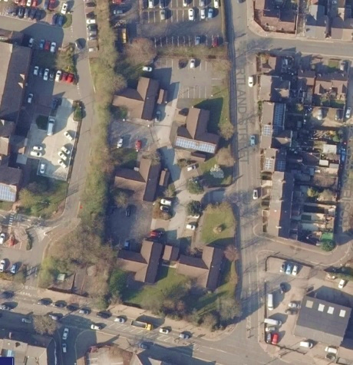 | 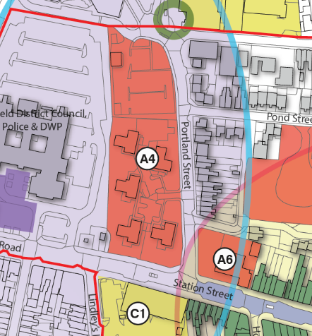

NHS site, west of Portland Street – low density, under-used land.
The existing Festival Hall Leisure Centre is situated to the south of the civic/ health hub. A new leisure centre will replace Festival Hall, providing additional facilities such as swimming pool, splash pad, climbing wall and adventure play, as well as events in the sports hall. It is envisaged that the new centre will provide a greater draw for the town and increase activity.
A comparison food store is located to the north of the new leisure centre site, which currently has an inactive elevation fronting on to Station Street. A more active frontage in this area would be beneficial to the street scene and help to present a more cohesive town centre, along with potential redevelopment of the site on the opposite side of the road (A4).
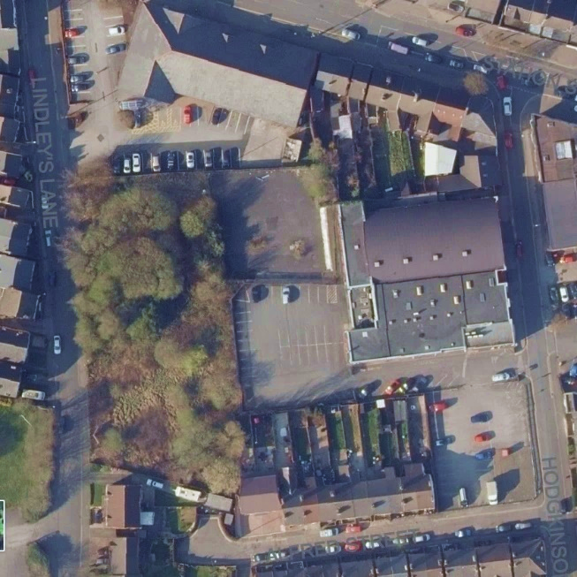 | 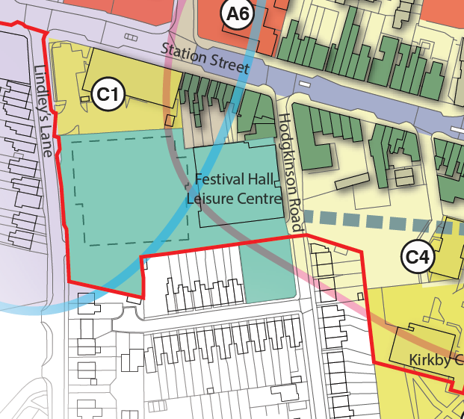
Land adjacent to Festival Hall, Hodgkinson Road – to be developed for a new leisure centre
Key opportunities:
- Redevelop car park to front of Council offices and adjacent Ada Lovelace house. Potential for business incubator units, well located for the railway station/green routes, and consolidating the cluster of office space.
- Improve legibility, e.g., improved signage and navigable routes.
- Rationalise healthcare facilities at underused NHS site - potential for active frontage on to Station Street with mixed use, including residential, to optimise site usage at this town centre location.
- Increase active frontage on to Station Street at B&M Bargains site.
- Maximise opportunities to recognise/conserve Kirkby’s heritage

  - Gateways

Northern Gateway – Lowmoor Road (A1, B3, C2)
Lowmoor Road is a key route connecting Kirkby with the A38 and Sutton. The approach to the town centre in this location offers little definition and does not provide an attractive arrival point with under-utilised land, unattractive buildings (such as apartment blocks and the NHS health centre), and a busy road network.
There is an opportunity to improve this key gateway through enhancements such as soft landscaping adjacent to Sherwood Court; relocation and redevelopment of the Health Centre site; residential densification which will contribute to the vitality of the centre; and provision of a new gateway landmark to announce arrival to the town centre and to help enclose the Civic Square.
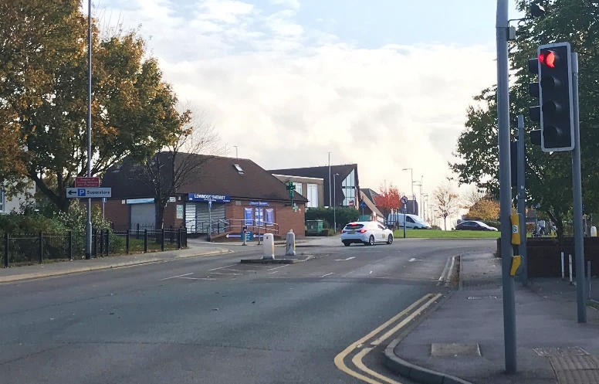 | 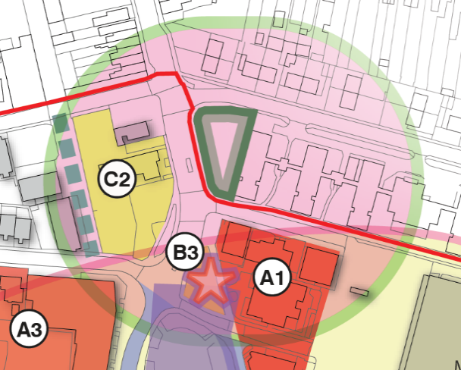

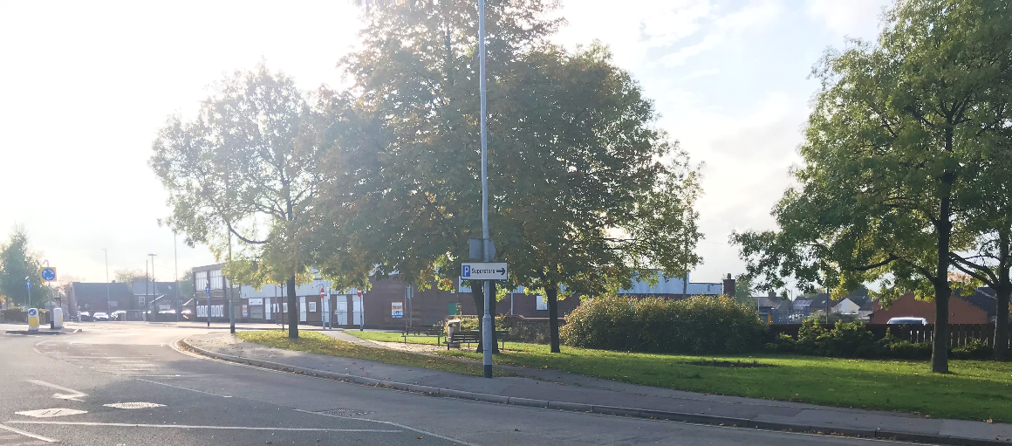
Poor approach to town centre – lack of visibility of town centre core/Civic Square

Key opportunities:
- Residential densification/ redevelopment at junction of Lowmoor Road/Pond Street (C2)
- New/improved soft landscaping
- Improve legibility, e.g., improved signage and navigable routes.
- Provide a landmark structure to address views from the town centre core and provide a focus to the northern gateway (B1).
- Rationalise and re-locate healthcare facilities.
- Redevelop A1 with a new landmark mixed-use building(s), including commercial, community/leisure facilities and residential to provide definition and increase activity at the Civic Square.

Station Gateway – Lane End (A5, B1, B2)

This is the western gateway to the town centre where people enter by road and from the railway station. The vision here is to enhance connectivity between the station and the main town centre core and to increase legibility with improved signage and navigable routes.
Wider connectivity to green routes to encourage walking and cycling in and around the town and to/from the railway station should be explored.
The two community buildings (British Railways club and Ashfield Evergreen Centre) are poor quality and hinder visibility of the railway station from the centre, whilst the vacant land south of Lane End (B2) presents an unwelcoming arrival to the town. Car parking is currently restricted at the station, resulting in increased on-street parking.
There is an opportunity to redevelop and reconfigure this gateway area to enhance access to/from the station, to provide a focus to the gateway, and to develop vacant land on the edge of the town centre.

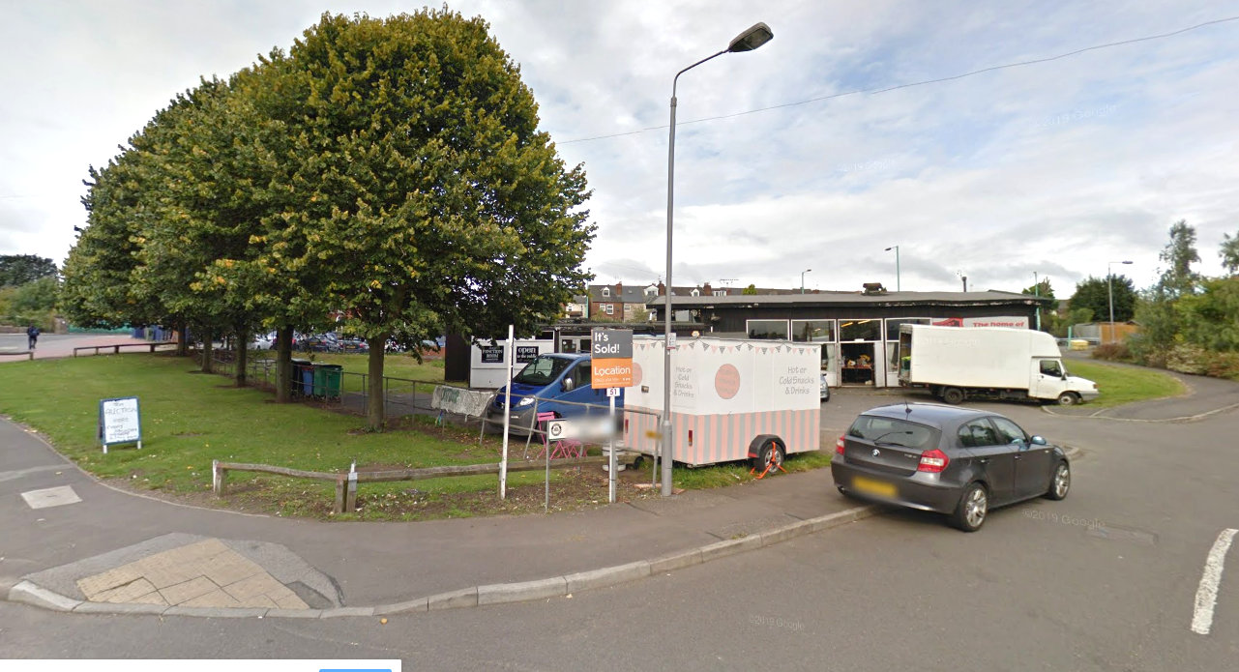 | 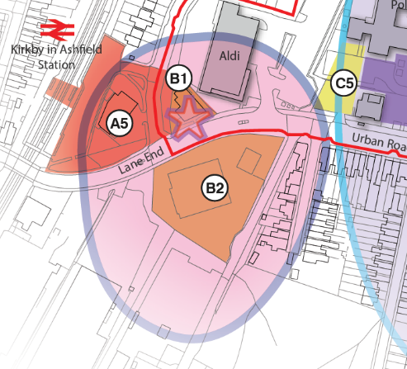
View towards Kirkby railway station - British Railways Club in the foreground

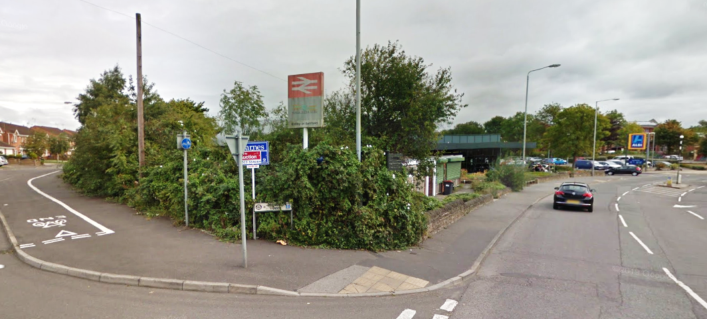
Vehicular access to Kirkby railway station – poor signage and lack of legibility

Key opportunities:
- Develop vacant land to south of Lane End (B2) for mixed use gateway development, including residential, and potentially business/service uses, local convenience store, and car parking. It should be noted that part of this site falls within Floodzone 3, and as such, any proposed development scheme must be designed to take this into account.
- Re-locate community buildings British Railways club and Ashfield Evergreen Centre
- Redevelop land between the railway platform and Aldi supermarket A5 for mixed use development, to include a food and beverage outlet and car parking.
- Enhance/create connectivity to green routes to encourage cycling and walking.
- Improve legibility, e.g., improved signage and navigable routes.
- Provide a landmark structure to address views from the town centre core and provide a focus to the station gateway (B1).
- Maximise opportunities to recognise/conserve Kirkby’s heritage.

Chapter 7. Masterplan Delivery
The masterplan illustrates the vision for Kirkby Town Centre and potential for change over the next 10 years. The table below illustrates what the Council anticipate to be short, medium, and long-term projects. It should be noted that the reference numbering of these projects does not imply any particular order of priority, as delivery will be dependent on funding and re-development opportunities as they arise.

Priority projects
Map Ref. | Project
A1 | New gateway mixed use building – community/leisure with residential, providing definition and activity to the Civic Square. Potential to improve access/egress at Morrison’s food store.
A2 | Address inactive frontage at side of Boyes (south of Civic Square) through creation of a new food and beverage or small independent retailer unit(s).
A3 | Pond Street/Ellis Street – Housing led mixed-use development with active frontage to Civic Square, for example service, commercial/leisure
A4 | Rationalise and consolidate healthcare provision at the NHS site on Portland Road, intensifying use and providing an active frontage on to Station Road.
A5 | New Station gateway mixed use development – to include (but not limited to) improved public realm, food and beverage unit to support the station and business cluster, and car parking.
A6 | Key corner site for improvement at Portland Street/Station Street junction.
All areas | Priority public realm improvements – in particular signage, including green route way marking, and lighting.
All areas | Shopfront enhancements.

Medium Term Projects
Map Ref. | Project
B1 | New landmark structure to address views towards railway station gateway
B2 | Mixed-use gateway development south of the railway station at Lane End – to include residential and potentially, business/service uses, local convenience retail and car parking.
B3 | New landmark structure at northern gateway, announcing arrival to town centre and providing a focal point at the edge of the Civic Square.

Long Term Projects
Map Ref. | Project
C1 | Potential to increase active frontage on south side of Station Street.
C2 | Residential densification of town centre at Pond Street/Lowmoor Road.
C3 | Residential densification of town centre north of Portland Street – relocation of businesses to easily accessible sites within the locality.
C4 | Relocate Youth Centre to a more visible location
C5 | New Business hub/incubator units adjacent to Ada Lovelace House
C6 | Potential long-term development opportunity within town centre core.
C7 | Campus improvement/redevelopment.

To be an effective masterplan there needs to be a clear understanding of how projects and initiatives could be delivered, who would be involved in delivery, how they might be funded and by what mechanism.

  - Delivery Partners
The delivery of the masterplan will need to be supported by activity from a wide range of stakeholders, delivery partners and agencies – both public and private. While the Council is expected to perform a key role, other agencies will be involved with enabling, funding and delivering projects which may include:
- Discover Ashfield Board
- Kirkby Town Team
- Mansfield and Ashfield 2020
- D2N2 Partnership/ LEP
- Nottinghamshire County Council
- Integrated Care Partnership
- Community organisations
- Registered social landlords
- Landowners
- Developers
- Businesses
- Utility suppliers
- Kirkby College secondary school and other education bodies
- Private and philanthropic sponsors
- Other public sector organisations - including the police, NHS and English Heritage
- Transport bodies - such as bus operators

Other organisations may also be identified, or be founded during the lifetime of the masterplan, which may be able to assist in the delivery of projects.

  - Funding Masterplan Delivery
Whilst the Masterplan does not identify costed projects, it is important to recognise that funding sources should be examined at an early stage in the development process.
Not all of the proposals contained in the masterplan are commercial in nature. Project delivery is fully expected to be secured using a combination of public and private sector investment, with the balance of need for funding varying depending on the type, nature, cost and commercial viability of the project. These funds might include:
- LEP administered grants and funding streams
- Government funding, such as the Towns Fund
- Section 106 Agreements / Community Infrastructure Levy (CIL) / developer contributions
- Housing revenue
- Rolling Investment Funds
- Ashfield District Council’s Capital Programme; Prudential borrowing
- Lottery funding
- Transport funds
Crucially, funding opportunities continue to evolve and will undoubtedly do so over the lifetime of the masterplan. Funding opportunities must be refreshed and reviewed as time progresses.
  - Delivery Mechanisms
A number of delivery mechanisms could potentially be used to deliver areas for improvement identified in the masterplan. Once fully detailed schemes have been prepared these can be delivered through three core approaches:
- Private sector delivery - where a private sector company delivers a scheme without the need to enter into a property or development agreement with a Council. This typically occurs where the developer controls all the land needed, and the Council does not have land or property interest;

- Public sector delivery - where the Council (or other public sector body) owns the land, has fully specified the development and procures a construction firm to undertake the development to that specification; and
- Public / private development partnerships the most common form of delivery mechanism used to procure more complex urban regeneration schemes by Councils. The key characteristic is some form of ‘core’ development agreement in place between a developer and Council (or other public sector body). The development agreement is a legal document which sets out what the scheme will comprise, the roles and responsibilities of the parties, preconditions which must be discharged to enable the development and the financial return to each party on completion of the scheme.
The delivery of the masterplan will also require support through planning mechanisms, such as:
- Local Development Plan Policies
- Supplementary Planning Guidance
- Development and Design Briefs
- Action Plans
  - Next Steps
There will be further consultations on individual projects as they come forward and we will review the Spatial Masterplan after the first five years.
We will pursue feasibility studies, design and planning work for individual projects and bid for funding to enable delivery.
For further information about the Spatial Masterplan, project delivery or governance arrangements:
- visit our website: www.ashfield.gov.uk
- call the Forward Planning Team
  - 01623 457381
  - 01623 457382
  - 01623 457383
- email localplan@ashfield.gov.uk

Appendix 1
This SWOT analysis draws on the information from a combination of relevant matters taken from recent work undertaken by consultants, workshops and officer walkabouts.

SWOT Analysis of the Town Centre
STRENGTHS | WEAKNESSES
- The town centre is level/accessible to all  - Customer service in the shops is welcoming  - Independent/sole traders  - Well served by public transport – railway station and bus services  - An hour free parking in Council owned car parks  - Anchor stores – Aldi (west) and Morrison’s (east)  - Redevelopment of Regent cinema building into Wetherspoon’s  - Café culture in the day  - Niche with the provision of micro-pubs – interest from CAMRA  - Civic Square/ public realm improvements have enhanced the quality of the shopping environment  - Improved/new shop fronts (some grant funded) have enhanced the street scene on Station Street/Lowmoor Rd  - Library in town centre  - Proximity to major arterial roads i.e. A38 & M1 junctions 27 & 28  - Green Flag park within 500m of town centre  - Electric Vehicle charging provided in Hodgkinson Road car park.  - Major employers located in town centre – Morrison’s, Aldi, ADC, NHS, DWP, Police, Leisure centre  - Varied mix of smaller employers – vehicle repairs/ building supplies/ furniture fitters/ undertakers  - Leisure Centre | - Lack of legible purpose of public areas/ activity in and around civic square  - Lack of legible ‘gateways’ to the town  - Pedestrian disconnect between Morrison’s and Lowmoor Road  - Traffic circulation and congestion  - A number of vacant units (including large factory shop)  - External roller shutters and appearance of shop frontages  - Traditional operating hours – Wednesday closures  - Poor town centre gateway at Lowmoor Road and Station Street approaches – underused land and poor pedestrian environment  - Hidden carparks - lack of visibility/signage  - Poor signage  - Few national brands  - Perception as a socially and economically challenged area limits high spend  - Condition of some shop fronts, particularly on Station Street  - Tenant mix and wider perception of a high number of charity shops/ takeaways  - Limited leisure offer (restaurants etc.)  - Anti-social behaviour prevalent at certain times, and limited availability of local police  - Dispersal of health offer throughout the town
OPPORTUNITIES | THREATS
- Discover Ashfield – district place making strategy  - Development opportunities – land opposite the station, Ellis Street and Pond Street  - Improve links to wider green routes – contribute to improving air quality and healthy lifestyles  - Intensification/re-development of underused land, including consolidating health offer.  - Define and enhance gateways on main routes into the town centre - identity and sense of place  - Continue with shop front grants to target key areas and unkempt gateway buildings.  - Transform dead frontages and provide a ‘destination’ to encourage activity around the civic square  - Emphasise links to railway station  - Local history  - Possible link road through Pacto site to assist with traffic flow/ unlock potential land for re-development  - Leisure centre to include new facilities including swimming pool – visitor numbers predicted to increase three-fold  - Long term: Entry to The Great British High Street/ other town centre awards  - Primary catchment = 48,000, secondary catchment = 69,372 (excluding Mansfield)  - Develop maker-seller offer  - 5G technological advances  - Introduce services in place of retail  - Maximise appropriate residential opportunities in the town centre  - HS2 rail investment.  - Use of social media for promotion.  - Potential to re-configure roads between Kirkby college site and new leisure centre to provide improved access and visibility. | - Traditional retail decline/ impact of growth of online shopping  - Future out of town retail proposals, e.g. at M1 junction 28  - Lack of funding for maintenance of new projects  - Landownership constraints  - Lack of ‘local people pride’ in their town centre  - Stability of independent retailers  - Local competition i.e. Sutton Town Centre, Shopping Centre at Mansfield - need to have a ‘complementary’ offer  - Changes in business rates/ benefits caps  - Reduced footfall on Low Street as a result of Post office re-location

NEMS Household Survey, January 2016
2016 Nexus Retail Survey
Office for National Statistics NOMIS – Labour Market Profile Ashfield Employee Jobs (2018)
Nottingham Core HMA and Nottingham Outer HMA Employment Land Forecasting Study 2015 Nathaniel Litchfield and Partners
NEMS Household Survey, January 2016

