Broomhill and Butler’s Hill

Action Plan

2026 - 2035

Be Healthy Be Happy


Map of Ashfield

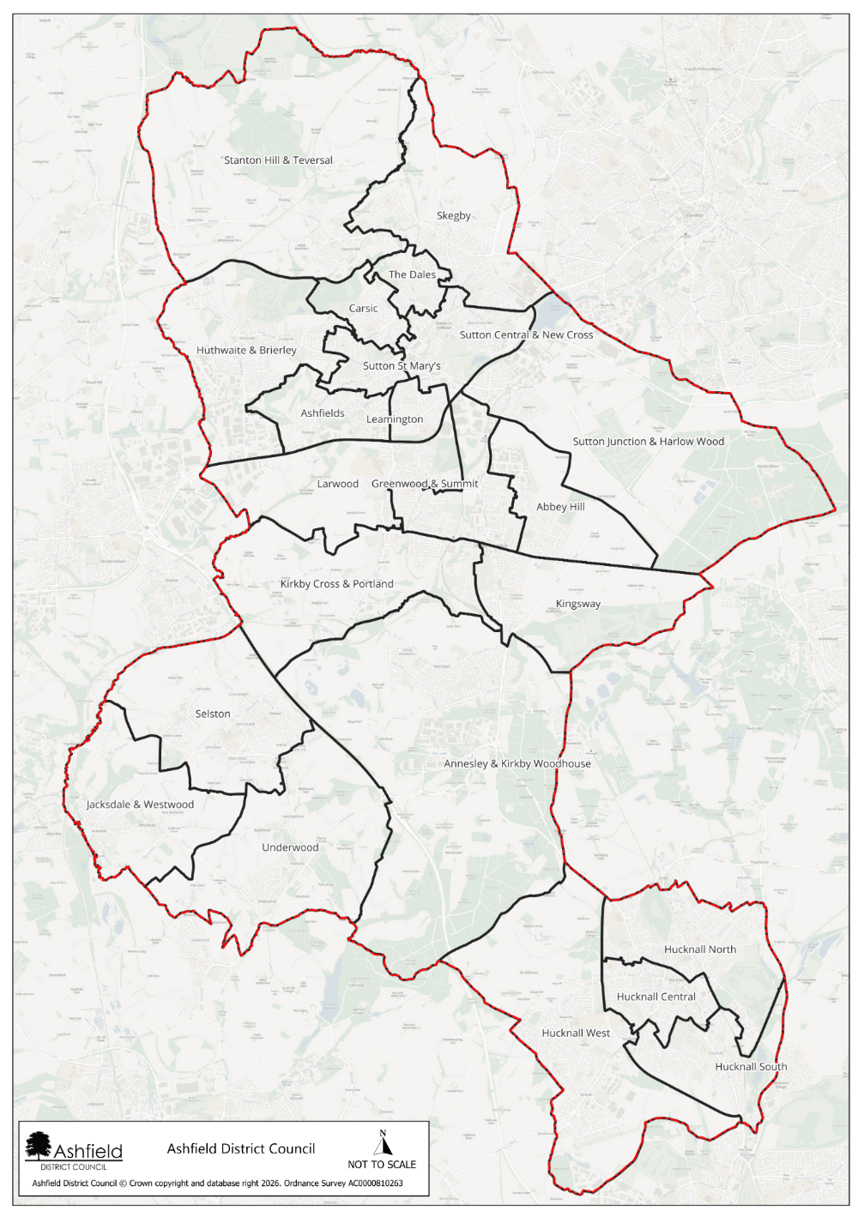

Introduction and background
Ashfield is a district within the county of Nottinghamshire. Ashfield is home to just under 130,000 residents, with a population that has grown steadily since 2011. The district has a relatively balanced age structure, though it is ageing, with one in five residents now over 65. Levels of disability are significant, affecting more than 27,000 people, including nearly one in five children. Many households’ face vulnerability, reflected in high proportions of single-person households, lone parent families, and a large share of homes in Council Tax Band A. Digital exclusion is above the national average, and access to green space is limited for most households.
Children and young people in Ashfield experience some of the most notable inequalities. Over 40% live in income deprived families, childhood obesity rates exceed national levels, and participation in higher education is considerably lower than the England average, with nearly a quarter of adults having no qualifications. Older people also experience notable health challenges, with high numbers of lone pensioner households and continued demand for support to age well. The district also faces higher than average fuel poverty and ranks as a high-risk area for food insecurity due to pressures such as low incomes, limited retail diversity, and rising living costs. Together, these factors create a community with pronounced economic challenges and health inequalities, shaping clear priorities for targeted support and investment.

Despite these challenges, Ashfield is a resilient community with a strong sense of identity and clear opportunities for improvement. While some communities experience greater pressures, there is significant potential for targeted investment to deliver meaningful change—particularly in strengthening health, financial security, and opportunities for residents. Many people in Ashfield demonstrate remarkable adaptability and tenacity, and with the right support, the district is well positioned to build on its existing strengths to improve quality of life and reduce inequalities.
Broomhill and Butler’s Hill is part of the Hucknall South ward and has been identified as a community with significant opportunities for targeted investment that can deliver strong social impact, including widening opportunities for young people, supporting older adults to live well, reducing inequalities experienced by people living with disabilities, and developing community connection that fosters greater wellbeing, a stronger sense of belonging, and improved economic security, enabling more residents to thrive.
Broomhill and Butler’s Hill is a community characterised by its largely urban environment whilst also benefitting with access to nearby green spaces. The area has a distinctive identity shaped by community pride and nearby access to the hight street, giving it a strong sense of place.
Local housing includes both council and privately owned properties. There is a mixture of older terraces and newer houses, which contributes to the area’s mix of character and need. Key features that define the community include Titchfield Park, Butler’s Hill Infant School and Broomhill Junior School supported by notable landmarks or community hubs such as Hucknall Family Hub and St John the Evangelist Church and Community Hall.
Two positive indicators in Broomhill and Butler’s Hill highlight the community’s strengths. There are multiple established community groups within the area including wildlife, litter picking and walking groups. These groups help to combat social isolation within the area and highlights the strong sense of community spirit locally. The community partnership also continues to grow and is made up of professionals working within, as well as residents of Butler’ Hill and Broomhill. This is particularly important as it demonstrates the commitment to local organisations and residents working collaboratively on the local issues that are highlighted as priorities by themselves and those they live and work with. These strengths reflect the opportunities that already exist within the area.
At the same time, two important challenges present opportunities for targeted investment and improvement. 40.2% of adults within Hucknall South are economically inactive, which may be linked to the lack of adult education opportunities and accessible pathways into work highlighted within the Butler’s Hill and Broomhill Community Partnership. Being economically inactive can also have knock on effects, leading to issues such as mental and diet related ill health and an increased number of families living in absolute low income. Hucknall South also has a higher crime rate compared to the rest of Ashfield, resulting in an increased number of residents reporting feeling unsafe. These indicators help explain why focused action is needed to support residents and strengthen long term wellbeing.
There are 23 wards in Ashfield. Broomhill and Butler’s Hill is the 7th most deprived ward within Ashfield. It is made up of 3 Lower Super Output areas, that are ranked in deciles 1-6.

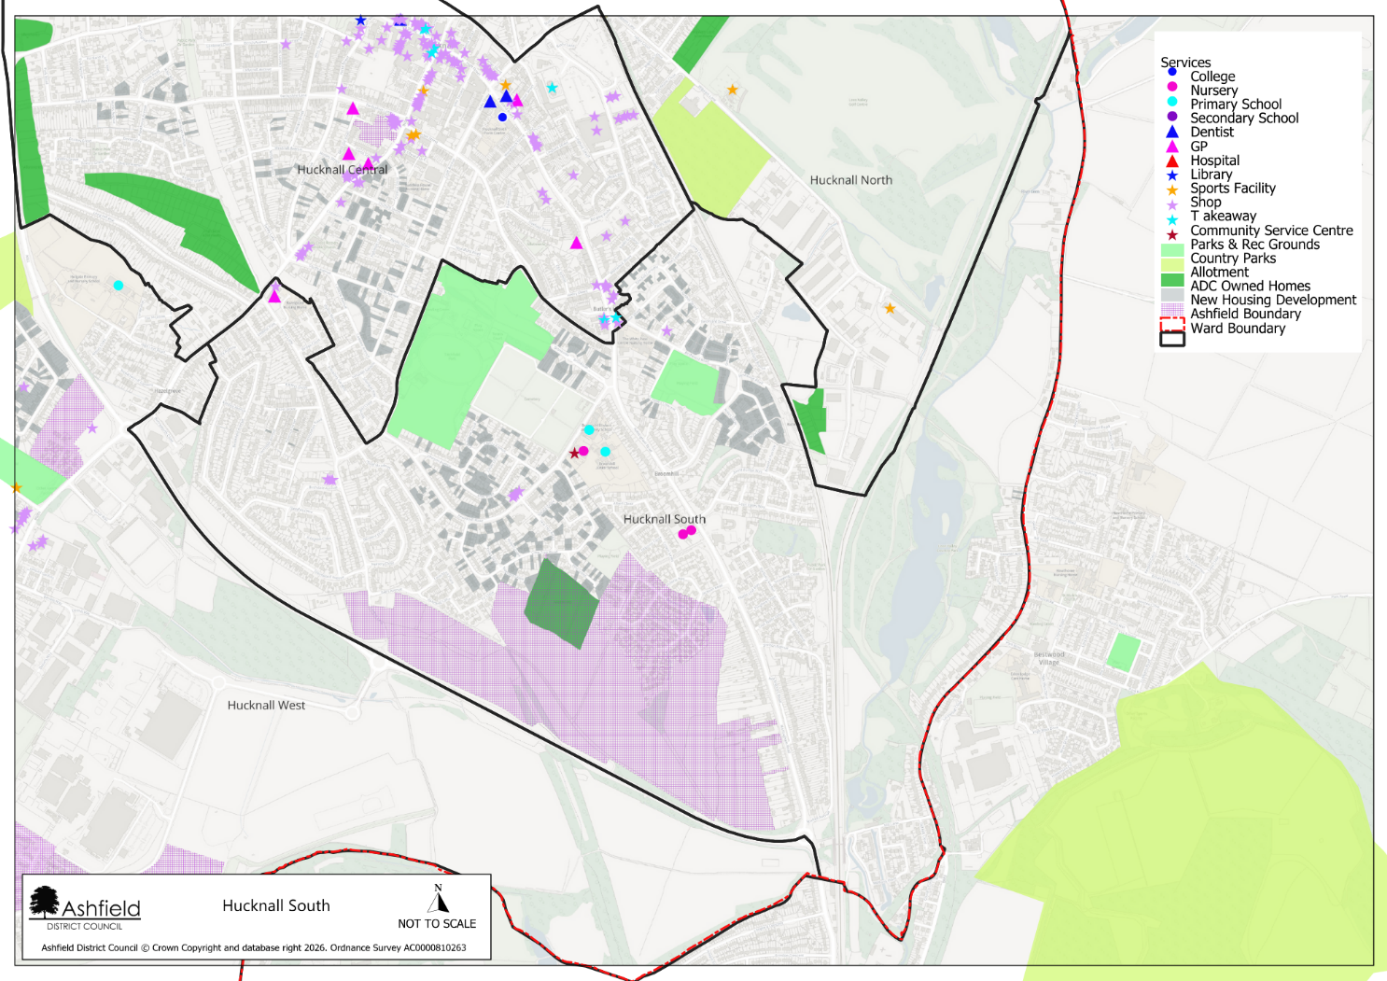
Map of Hucknall South including Broomhill and Butlers Hill

Data and Insight

Population

Area | Total population | 0 – 14 years | 15 – 64 years | 65 or over years | Female | Male
Hucknall South | 7240 | 19.1% | 64% | 16.9% | 51% | 49%
Underwood* | 2881 | 13.4% | 57.6% | 29.1% | 51.9% | 48.1%
Ashfield | 129,572 | 18.5% | 61.5% | 20.1% | 51.1% | 48.9%
The population of Hucknall South is 7240. Its age profile is similar to the Ashfield average with a slightly higher percentage of residents aged 15-54 years a lower percentage of residents aged 65+ years.

Health
Area | Self reported poor health | Long term health condition or disability | Day to day activities limited a lot | Children overweight or obese (Reception) | Children overweight or obese (Year 6)
Hucknall South | 7.2% | 21.8% | 9.7% | 24% | 47.1%
Underwood* | 6.7% | 20.9% | 8.8% | 23.1% | 42.9%
Ashfield | 7.1% | 22% | 10.1% | 25.6% | 40.4%
Self-reported poor health is similar in Hucknall South when compared to Underwood and Ashfield. This trend is repeated for the long-term health conditions/disability and limited day-to-day activities. The prevalence of overweight/obese children at year 6 is higher in Hucknall South than the Underwood and the Ashfield average

Disease prevalence
Data table: Disease - percentage prevalence within the population area
Ward area | Severe Multiple Disadvantage | Diabetes Type 1 | Diabetes Type 2 | Stroke | Coronary Heart Disease | Heart Failure | Hypertension | Chronic Obstructive Pulmonary Disease | Cancer | Serious Mental Illness | Substance Misuse
Hucknall South | 0.7% | 0.7% | 6.1% | 1.2% | 3.2% | 1.3% | 17.2% | 2.6% | 4.6% | 0.6% | 2.2%
Underwood* | 0.3% | 0.8% | 6.8% | 2.4% | 4.8% | 2.1% | 22.0% | 3.0% | 7.1% | 0.3% | 1.4%
Ashfield | 0.6% | 0.7% | 6.9% | 1.5% | 3.6% | 1.6% | 17.4% | 2.7% | 5.1% | 0.7% | 2.2%
Disease prevalence for Hucknall South is similar to the Ashfield average across all diseases reported in the table above.

Economy
Area | Provide 50 hours of unpaid care per week | Economically inactive | Out of work Benefits claimant count | Universal credit claimants  16 to 65 years old | People in Universal Credit  3 years plus | No qualifications  16 years plus | Children under 16 in families with absolute low income
Hucknall South | 3.7% | 40.2% | 4.6% | 26.1% | 12.5% | 23.4% | 22%
Underwood* | 3.7% | 45.9% | 2.1% | 11.8% | 4% | 22.3% | 11.9%
Ashfield | 3.8% | 41.6% | 4.0% | 22.8% | 9.9% | 23.6% | 24.5%
Hucknall South has a significantly higher percentage of universal credit claimants than Underwood and Ashfield, with 12.5% of people claiming universal credit for three or more years.

Housing

Area | Council rented | Owned outright | 1 person households | Household in fuel poverty | No cars or vans within household
Hucknall South | 20.9% | 31.9% | 32.1% | 9.7% | 23.8%
Underwood* | 5.3% | 50.7% | 30.9% | 10.7% | 10.8%
Ashfield | 14.90% | 35.7% | 29.4% | 12.3% | 20.6%
Hucknall South has a significantly higher proportion of council rented homes than Underwood and Ashfield and therefore, a lower proportion of homes owned outright. Hucknall South has a lower percentage of household in fuel poverty than Ashfield, however more household with no cars or vans.

Crime

Area | Crime rate per 1000 | Anti-social behaviour rate per 1000
Hucknall South | 87.6 | 18.2
Underwood* | 29.2 | 17
Ashfield | 80.4 | 19.9
Hucknall South has a significantly higher proportion of council rented homes than Underwood and Ashfield and therefore, a lower proportion of homes owned outright. Hucknall South has a lower percentage of household in fuel poverty than Ashfield, however more household with no cars or vans
.

Key messages from partners and residents

There are trusted professional and community organisations locally that residents feel comfortable accessing and asking for support.
There is not enough support available for local families experiencing Special Educational Needs and Disabilities (SEND).
There is not enough support available for local families experiencing Special Educational Needs and Disabilities (SEND).
We have noticed that there are not many opportunities for young people in the area, meaning many of them are not currently in education, employment or training.
Antisocial behaviour is a big problem – this is not just young people causing issues, older residents have been known to cause just as much trouble, if not more.
Our nearest job centre is in Bulwell which
can be hard to reach for those who rely on public transport.

There is good community spirit within Hucknall with lots of opportunities for residents to get involved in community activities throughout the week.
It’s great that Hucknall is connected to the city via the tram network. However, the buses on the estate are not very reliable, often resulting in residents being late for work or appointments.
People often forget that Hucknall is part of Ashfield – many people assume that it is part of the city.

Broomhill/Butler’s Hill Community Partnership
The Broomhill and Butler’s Hill Community Partnership was established in 2019. The Partnership forms part of a network set up in Ashfield to deliver the vision of:
‘Healthy, happy lives for all who live in Ashfield’
The partnership is made up of a wide range of organisations, including but not limited to community partners, education providers, healthcare workers and residents, who work together to achieve this vision, aligned to a set of core values, that underpin a collaborative, action and person centre-focussed approach.
The partnership has achieved several key successes since its inception

Successes to date

Growth of the Community Partnership
The Butler’s Hill and Broomhill Community Partnership continues to grow. Partnership meetings occur every 8 weeks are well attended by both professionals and residents. Within the Community Partnership, members collaborate to support residents and each other as well as to share insights and resources based on priorities highlighted by those living and working within the area. The work of the Community Partnership is also regularly fed into wider work across the district, including the Ashfield Health and Wellbeing and the Discover Ashfield boards. Regular updates, training and funding opportunities are also shared with community partners through a monthly online newsletter.

Community action subgroups


Hucknall Careers Fair Poster
Within the Butler’s Hill are Broomhill Partnership, several subgroups have been formed enabling focused action to be taken within areas highlighted by the wider community partnership. Subgroups previously formed include an employability group, youth engagement and special educational needs and disabilities (SEND). In early 2025, a lack of opportunities for young people along with a high number of individuals not in education, employment or training (NEETS) was identified within the area. As a result of this, the employability subgroup was formed and together hosted a jobs fair later in the year which received positive feedback from both employers and job seekers attending. Following this, the youth engagement subgroup formed including representatives from youth workers and the police amongst others. This group aimed to offer further opportunities for young people, whilst also combatting a rise in antisocial behaviour that had been reported by residents. Together, the subgroup organised a detached youth engagement offer that began in December 2025. This work has been relatively successful in engaging local young people, with focus now shifting onto opportunities to continue this offer sustainably going forward.

Family Activities
Since the creation of the Butler’s Hill and Broomhill Community Partnership, several family activities have been offered locally. These include free family fun days on local green spaces offering face painting, games, craft activities and more. These events have been popular within the community. The community partnership has also supported with the Hucknall Family Wellbeing Roadshow over recent years, offering more free activities to families along with information of and access to local services they may benefit from.

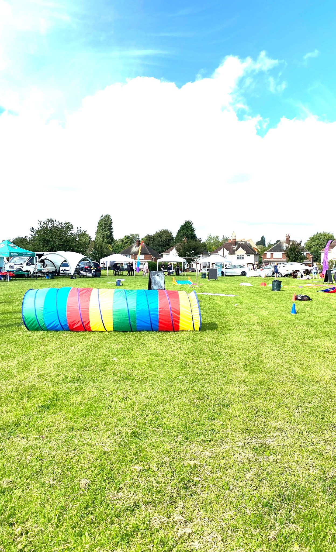
Activities in a field
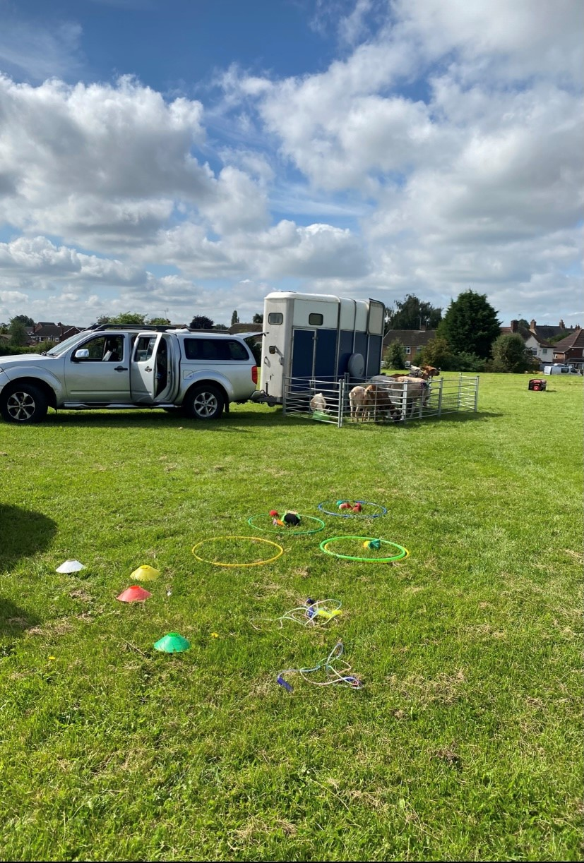
Animals for petting
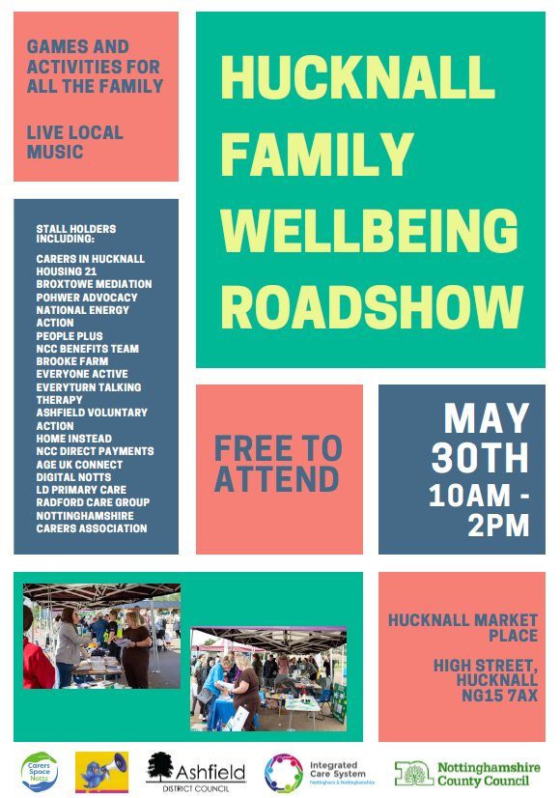
Hucknall Family Wellbeing Roadshow
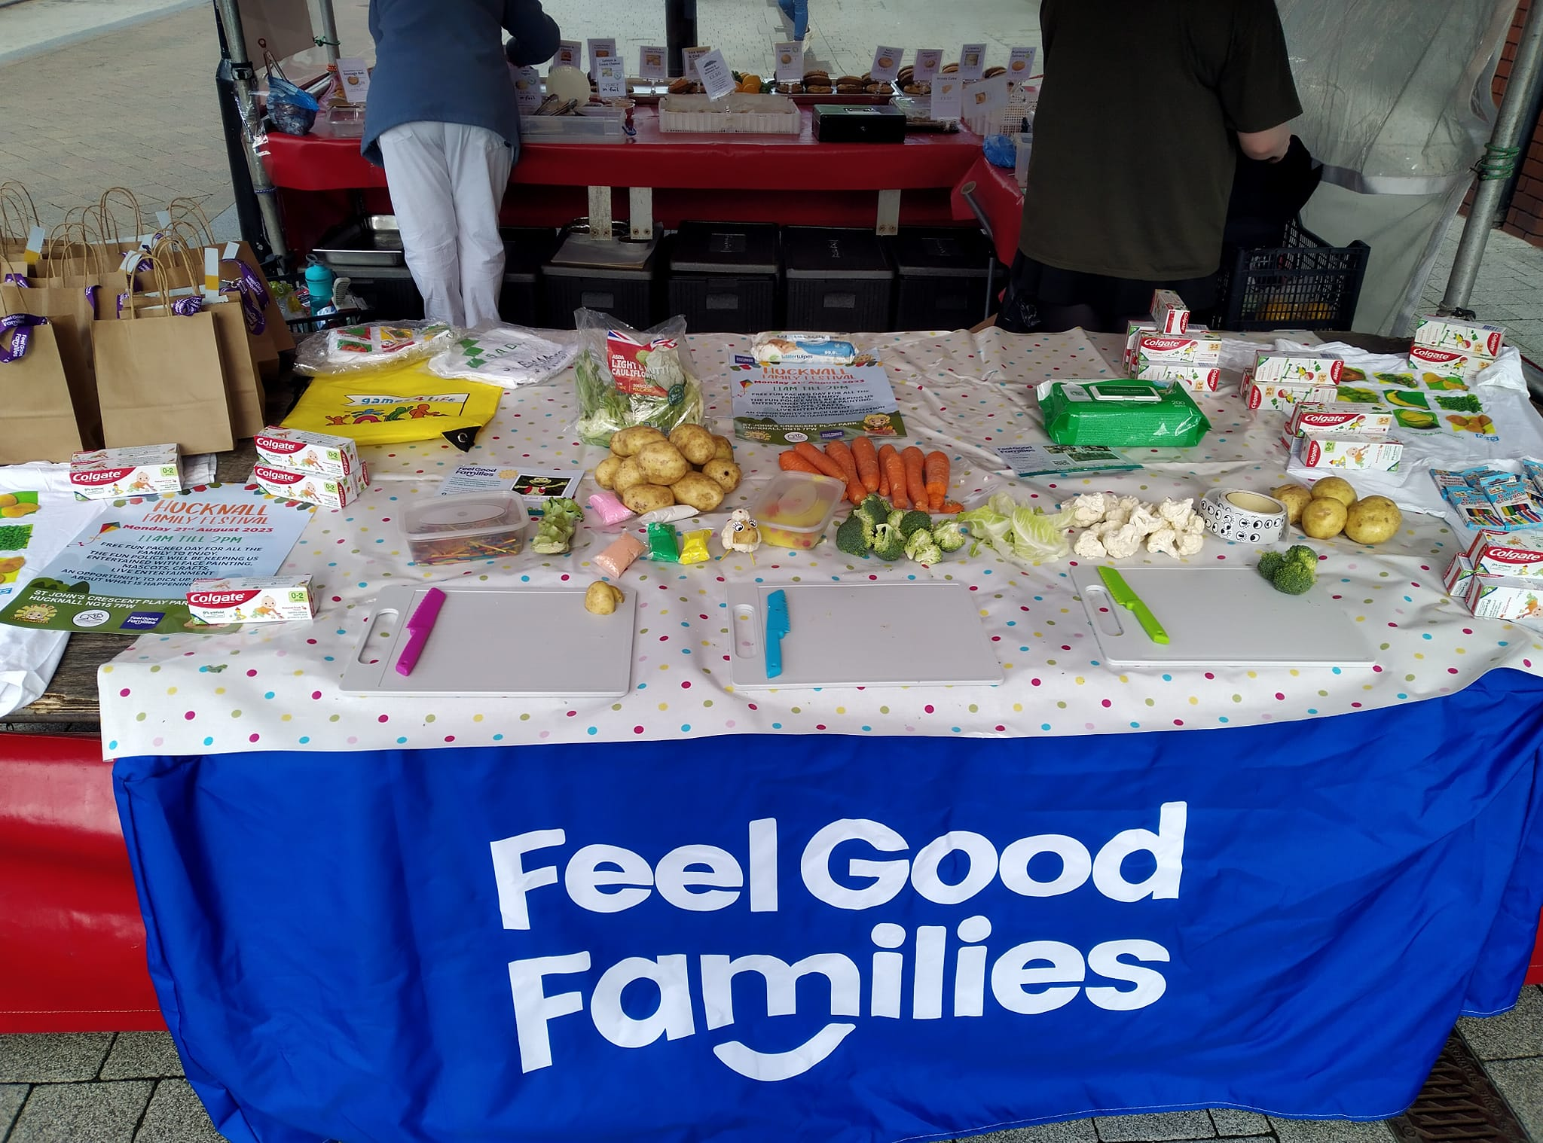
Feel good families activity

Healthy Hearts for Hucknall

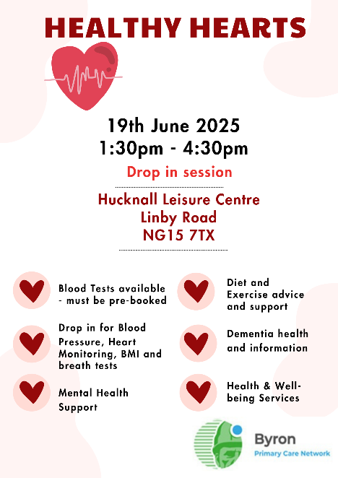
Healthy hearts poster
The Community Partnership has supported health professionals with the creation of a series of Healthy Hearts events across Hucknall. These events invited individuals registered with GPs within Byron Primary Care Network to attend events hosted in accessible community spaces such as leisure centres, churches and community halls. Whilst attending these events, those invited were able to access various health tests including blood tests, heart monitoring and breath tests along with general health and wellbeing advice and information. These events were very well attended and resulted in several individuals being referred onto further services including mental health, weight management and exercise referral schemes. In addition to this, results from health tests were shared with GPs and feedback has highlighted that these tests have led to the diagnosis of various conditions including cancers and heart conditions. As a result, attending these events has potentially been life saving for a small number of individuals.

Broomhill/Butler’s Hill Action Plan 2026 - 2035

This action plan has been developed by the Broomhill/Butler’s Hill Community Partnership following a series of workshops held throughout 2025. These sessions shaped the objectives, actions, and expected outcomes, all of which are organised using the Building Blocks of Health framework.

A wide range of factors influence people’s wellbeing.

These include:
- Socioeconomic factors such as education, employment, income, family support, and community safety.
- The physical environment, including access to green spaces and exposure to pollution.
- Health behaviours like diet, physical activity, smoking, alcohol use, and other lifestyle choices.
- Access to and the quality of health care services
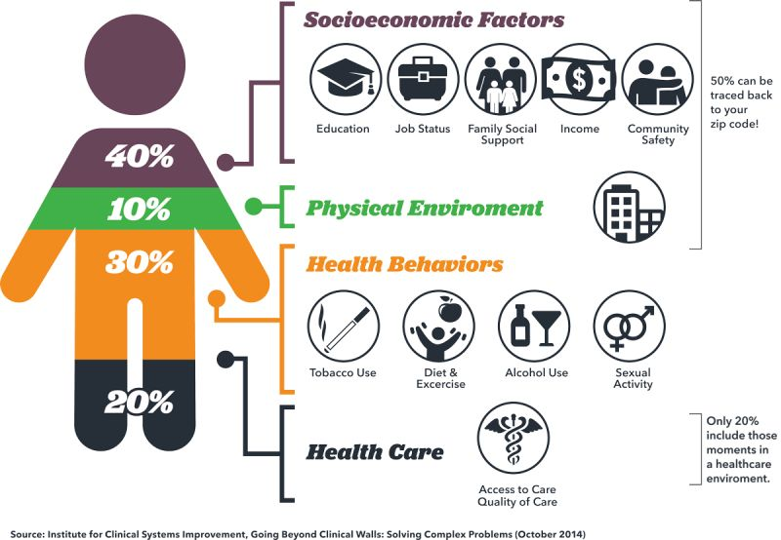.

THE HEALTH FOUNDATION - WHAT BUILDS GOOD HEALTH?
The Health Foundation developed the Building Blocks of Health to help communities understand how these factors interact and what needs to be addressed to reduce inequalities and support thriving, healthy neighbourhoods.
In Ashfield, ‘system development’ has been added as a 9th building block, recognising the importance of collaborative working between organisations and communities.
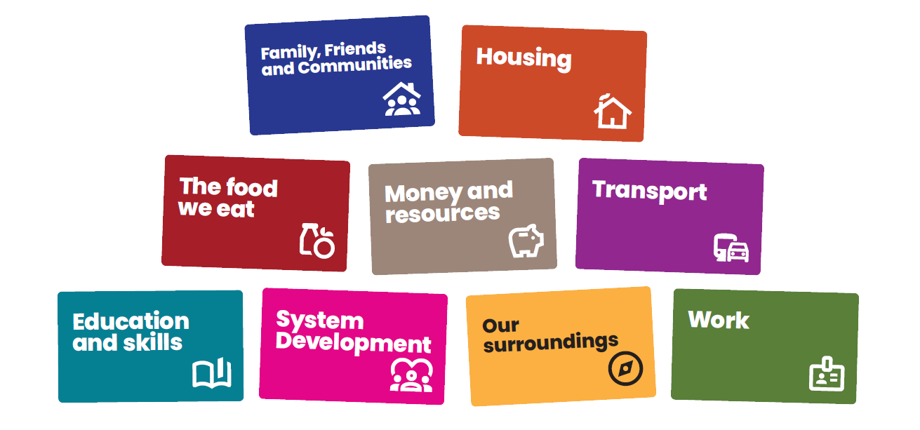
Link: What builds good heath – The Health Foundation
Education
and skills
Housing
Transport
The food
we eat
Work
System
Development
Family, Friends
and Communities

Our values

INCLUSIVE

AND

RESPECTFUL
We want everyone to feel that they are involved and that their views are heard.
We will acknowledge and embrace difference, encouraging different perspectives.
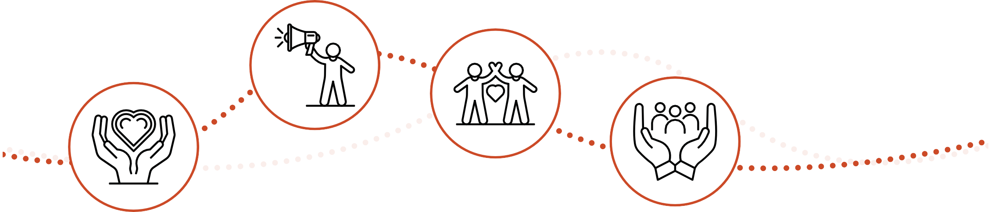
In doing this we will seek to understand, not challenge, and use this as a strength to build a shared understanding. We will use data and lived experience to help identify where to focus our energies and work with residents to enable inclusivity.

AMBITIOUS

AND

COMMITTED
We are ambitious in our desire to create a culture of collaboration across all sectors and communities where we work towards shared goals and learn together.
We will be brave and committed to working in this way, shifting our individual and collective behaviours to enable this way of working to happen.

COLLABORATION
Individuals and organisations are connected, and relationships are important. We will develop shared goals and an understanding of the work we want to do together.
In doing this we will recognise the role we can play individually and collectively, working beyond organisational boundaries to explore how to create change together.

PERSON

CENTRED
We will put people at the centre of everything we do, recognising that everyone and every community is different and what matters to them is what matters to us.
We will spend time understanding and reaching those who do not usually have a voice and have ongoing authentic conversations to understand what is important to them.

INNOVATION
We will be led by insight to focus our energies and think creatively as to how we engage with residents to understand what is important to them.
We will encourage ‘trying new’ and testing different approaches to help us understand what creates change, what doesn’t and most importantly, why.
We will create a culture of learning where to celebrate innovation, encouraging people to be creative and test ideas, by putting them into practice so that we can learn from them to inform what needs to happen next.

Broomhill and Butlers Action Plans

Family, Friends and Communities

10-year vision:
Broomhill and Butler’s Hill will be a connected and supportive community where people feel they belong. Community hubs will be vibrant spaces that bring residents together, reduce isolation, and offer activities for all ages. Strong relationships between neighbours, organisations, and volunteers will create a resilient network of support. Residents will play an active role in shaping local priorities, leading initiatives, and building a confident, empowered community where everyone has opportunities to connect, contribute, and thrive.

Focus areas and themes:
Community Spaces Creating welcoming, inclusive spaces where residents can meet, access services, and take part in local activities. Hubs will act as central points for connection, information, and community support.
Social Connection Strengthening relationships across the community through activities that reduce isolation, promote wellbeing, and bring people of all ages together. This includes befriending, peer-support groups, and intergenerational programmes.
Resident Leadership Empowering residents to shape local priorities, lead groups, and co-produce community initiatives. Building confidence, skills, and opportunities for local people to take ownership of what happens in their area.
Objective | 1-year actions | 3-year actions | Expected Outcomes | Lead
Creation of three community hubs. | Ensure hubs are promoted as spaces that residents can find information of and access to community services and activities.  Consult residents on priorities for hub offer and accessibility needs. | Ensure hubs are well-resourced, supported and promoted.  Expand the activity offer based on resident feedback | Three operational community hubs providing consistent, accessible support for all ages.  Stronger partnership working and improved visibility of local services. | Community Hubs
Encourage the creation of and engagement in social activities for all ages. | Promote coffee mornings, warm spaces, and clubs for all ages through hubs, noticeboards, and partner networks.  Map existing activities and identify gaps (e.g., youth groups, men’s groups, parent meet ups).  Support community groups to start regular sessions as required. | Develop a calendar of regular, sustainable social activities across the three hubs and wider community spaces.  Expand intergenerational activities and peer support groups based on resident feedback. | Increased participation in community activities across all age groups.  Reduced social isolation and strengthened community relationships.  More resident led social opportunities embedded within the community.  Clear, accessible communitywide information about activities. | Community Hubs / Local Community Organisations
Build resident-led groups | Identify and encourage interested residents to take part in shaping local activities | Establish a sustainable resident action group with clear roles and regular meetings.  Support the group to lead on local initiatives and influence wider partnership activity. | A confident and active resident action group providing leadership within the community.  Stronger collaboration between residents and local organisations. | Community Partnership/residents

The food we eat

10-year vision:
Broomhill and Butler’s Hill will have a coordinated, sustainable local food system where every resident can access healthy, affordable food. Community food clubs, food banks, and growing groups will work together to provide joined-up support, while residents build confidence in cooking, nutrition, and growing their own produce. A stronger, more resilient food network will help reduce inequalities and support the wellbeing of the whole community.

Focus areas and themes:
Coordinated Food Support Strengthening partnerships between food clubs, food banks, community food projects, and wraparound support services to ensure consistent, joined up services for residents.
Healthy Eating and Food Literacy Promoting healthier eating habits by providing simple, affordable recipes, practical cooking skills, nutrition awareness, and community led workshops delivered through hubs and local partners.
Community Growing and Sustainability Supporting residents, schools, and community groups to grow their own produce, build confidence in food growing, and donate surplus harvests to local food provision networks to improve access to fresh food.
Objective | 1-year actions | 3-year actions | Expected Outcomes | Lead
Align work with the Feeding Ashfield Action Plan. | Strengthen partnerships between food clubs, food banks, and other wrap around support services within Hucknall and the wider Feeding Ashfield Network. | Develop a coordinated local food pathway that connects food hubs, community allotments, and wrap around support services, allowing for shared resources, knowledge and skills where appropriate across the district. | Better coordination of food support services; improved access to healthy, affordable food; stronger links between local partners and the Feeding Ashfield Network. | Feeding Ashfield Network
Promote healthier eating and food literacy skills amongst residents. | Share simple, affordable recipes through community hubs, noticeboards and online platforms. | Embed healthy eating campaigns and workshops through community hubs, focusing on diabetes, heart health, and low-cost cooking. | Increased awareness of healthy eating; more residents using low-cost recipes; improved confidence in cooking and reduced food waste. | Feeding Ashfield Network/ Local Community Organisations/ Education providers.
Support residents and community groups to grow their own produce and donate surplus to food provision organisations. | Support community allotment and growing groups already established. Link groups up with food provision if not already connected. | Support additional residents and community groups to begin or continue to grow produce. Expand opportunities to donate surplus harvests into local food networks. | Increased access to fresh produce; stronger community involvement in growing schemes; more surplus food redistributed to support residents; greater sustainability in community food systems. | Community Allotments / Local Growing Groups / Feeding Ashfield Network

Work
10-year vision:
Broomhill and Butler’s Hill will have a clear, joined up employment and skills system that supports residents of all ages into good quality work. Community hubs, employers, colleges, and local partners will work together to offer accessible job pathways, volunteering opportunities, and future focused skills such as digital and Science, Technology, Engineering and Maths (STEM). Young people will be supported early, and more adults will gain the confidence, training, and opportunities needed to progress into secure, meaningful employment.
Focus areas and themes:
Employment Pathways and Local Opportunities Creating clear, accessible pathways into jobs, apprenticeships, volunteering, and training. Ensuring residents can easily find and navigate local opportunities through hubs, partners, and a coordinated employment system.
Youth Employment and NEET Prevention Supporting young people early to build confidence, aspirations, and skills. Strengthening links with schools, colleges, and youth services to reduce the number of young people who become NEET and improve long-term career prospects.
Volunteering as a Route to Work Promoting volunteering to build confidence, gain experience, develop skills, and move closer to employment. Supporting residents to become community champions and recognising the value of volunteering in pathways to paid work.
Objective | 1-year actions | 3-year actions | Expected Outcomes | Lead
Create a local job board and promote local employment pathways. | Map existing employment support, mentoring, volunteering, and training offers - Use noticeboards, community hubs, schools, and digital platforms to share existing offers.  Identify gaps (e.g., confidence building, digital skills). | Develop a centralised digital job board linked to partners. Update regularly and promote through hubs and resident networks.  Support residents to access employment pathways, offering coordinated support from skills development through to job placement, including mentoring and follow-up support. | Clear, accessible information on job and training opportunities, increasing awareness and engagement across the community.  Residents experience a smoother, more supported journey into work. Increased job readiness and more successful job outcomes. | Employability partners.
Support Young People Not in Education, Employment or Training (NEETs) into work. | Identify young people not in education, employment or training through local networks, schools, and youth groups. Offer signposting and outreach support. | Develop targeted programmes with partners including work experience, STEM/AI career sessions, confidence-building, and job readiness workshops. | Reduced number of young people who are NEET. Increased participation in training, volunteering, or employment programmes. | Education Providers / Youth Workers / Employability Partners.
Promote volunteering as a pathway to work. | Promote volunteering opportunities and how to get involved through noticeboards, hubs, social media, and partner organisations. | Support volunteers to gain skill development, qualifications, and employment support. | Increased confidence, skills, and progression from volunteering into paid work or training. More residents involved in the community. | Community Partnership / Voluntary Sector Organisations / Education and Employability providers.

Transport

10-year vision:
Over the next decade, Broomhill and Butler’s Hill will have a transport system that is more accessible, reliable, and supportive of healthy, active living. Residents will find it easier to move around their community, whether travelling to work, school, appointments, or local activities.
By working together, residents, partners, and transport providers will create a travel environment that reduces barriers, improves wellbeing, increases access to opportunities, and makes Broomhill and Butler’s Hill a more connected and inclusive place for everyone.

Focus areas and themes:
Active Travel and Safe Routes Improving the safety, accessibility, and visibility of walking and cycling routes. This includes auditing paths, identifying barriers, and creating clearly promoted active travel networks that link residents to green spaces, schools, and community hubs.
Public and Community Transport Access Strengthening relationships with bus and community transport providers to improve reliability and ensure residents are aware of available routes.
Community Led Travel Initiatives Encouraging walking groups, wellbeing routes, and active travel events led by residents and partners to promote healthier, greener, and more sociable ways of moving around the community.
Objective | 1-year actions | 3-year actions | Expected Outcomes | Lead
Conduct walking and cycling audits / Promote and encourage active travel routes. | Identify safe routes and barriers to active travel, including footpaths, cycle paths, school routes, and access to green spaces. | Where possible, install signage, benches, and lighting along key walking and cycling paths. Develop clearly promoted active travel routes, including nature trails, walking groups, and community led walking activity. | Improved safety and accessibility of walking and cycling routes. Increased confidence and participation in active travel. Stronger links between green spaces and community activity. | Ashfield District Council (ADC) / Community Partnership
Engage with public and community transport providers with the aim of improving access and reliability. | Promote bus timetables and available community transport options through hubs, noticeboards, and digital channels.  Collect resident feedback on transport including cost, reliability issues and the positives of the current offer. | Begin discussions with transport providers to address reliability, explore timetable improvements, and promote affordable travel schemes.  Strengthen links with community transport providers. | Better awareness of local transport options.  Increased resident confidence in using buses for work, appointments, and social activities. | Transport Providers / Community Partnership

Our Surroundings

10-year vision:
Broomhill and Butler’s Hill will have safe, welcoming, and well-maintained public spaces that encourage residents to spend time outdoors and take pride in their neighbourhood. Cleaner streets, attractive planting, and community led environmental projects will help create a greener, more vibrant place to live. Strong partnerships and resident involvement will reduce antisocial behaviour and make the area feel safer and more connected for everyone.

Focus areas and themes:
Cleaner, Greener Public Spaces Strengthening community led litter picking, planting schemes, and the maintenance of shared spaces to create a cleaner, more attractive environment that residents can take pride in.
Community Information and Visibility Improving how information is shared across the community through well-maintained noticeboards and digital options, helping residents stay informed about local services, activities, and initiatives.
Safe and Welcoming Places Addressing safety concerns and increasing positive activity in public areas.
Objective | 1-year actions | 3-year actions | Expected Outcomes | Lead
Expand community litter picking and planting schemes. | Provide equipment and promote volunteer sign up through hubs, schools, and community groups. | Support resident‑led environmental groups with the promotion of regular litter picking events and maintenance of community planters. | Cleaner, more attractive public spaces. Increased local pride and ongoing resident involvement in improving the environment. | ADC/ Resident-led environmental groups.
Improve use of community noticeboards | Ensure noticeboards are maintained and regularly updated with local news, activities, and information. | Introduce a digital noticeboard accessed through a QR Code where appropriate. | Safer, more welcoming environments. Reduced ASB and increased participation in community activities. | Community Hubs/ ADC
Create safer spaces. | Identify areas with concerns about safety through resident feedback. | Improve access to activities such as warm spaces, social groups, or youth sessions to reduce anti social behaviour and increase positive community presence. | Safer, more welcoming environments. Reduced ASB and increased participation in community activities. | ADC / Police / Youth Workers

Housing

10-year vision:
Broomhill and Butler’s Hill will have safer, healthier, and well-maintained homes where residents feel secure and supported. Stronger links with housing and tenancy teams will ensure people can easily access advice on damp, mould, fire safety, falls prevention, and tenancy issues. Improved reporting and partnership working will reduce antisocial behaviour, while early intervention and clear pathways to support will help residents maintain safe, stable homes long-term.

Focus areas and themes:
Safe, Healthy Homes Ensuring residents live in homes that are free from damp, mould, hazards and fire risks. Providing clear guidance, early intervention, and accessible home safety support to help people maintain safe living environments.
Antisocial Behaviour Awareness and Reporting Improving knowledge of how to report ASB and strengthening joint working between residents, housing teams, and police. Increasing confidence in reporting and helping to reduce ASB in the community.
Stronger Partnership Working with ADC Housing and Tenancy Teams Building clearer, more consistent communication between community partnerships and ADC housing services. Aligning local work with district wide housing strategies.
Objective | 1-year actions | 3-year actions | Expected Outcomes | Lead
Strengthen links with ADC Housing and Tenancy Teams | Begin regular communication between community partnership and ADC housing/tenancy services. | Support and link into ADC Housing and Tenancy teams with their work/strategy going forward. | Better alignment with district wide housing priorities, improved access to housing clinics, and clearer pathways for residents needing housing advice or support. | Community Partnership / ADC Housing
Support residents to access housing advice and support | Build relationships with organisations offering housing advice and support with a focus on aspects such as damp, fire safety, and falls prevention. Have information of these services available at community hubs. | Work with these organisations to develop home safety workshops/events. | Improved home safety, reduced issues related to damp and mould, and increased resident awareness of how to maintain healthy homes. | Housing advice organisations / Community Partnership.
Improve ASB reporting awareness. | Distribute flyers and promote police surgeries/ drop-in sessions. | Strengthen joint working with Community Partnership, Police and ADC ASB teams. | Increased confidence in reporting ASB. | Community Safety Teams

Money and Resources

10-year vision:
Residents will have access to benefits advice, budgeting guidance, and debt support through trusted local hubs and partner organisations. Financial support partners will ensure help is simple to navigate, while regular benefits checks and early intervention will aim to reduce hardship. By monitoring local financial pressures and adapting support, the community will become more resilient.

Focus areas and themes:
Access to Benefits and Financial Support Ensuring residents can easily access benefits advice, checks, and guidance on what they’re entitled to. Strengthening links with trusted partners so support is simple, timely, and accessible through the community.
Financial Literacy and Confidence Building residents’ confidence in managing money through practical support on budgeting, banking, savings, loans, and household bills. Providing workshops, drop-ins, and clear guidance.
Monitoring Local Financial Pressures Using data, local insight, and resident feedback to understand financial challenges in the community. Adapting services based on trends such as rising living costs or fuel poverty to ensure support remains relevant and responsive.
Objective | 1-year actions | 3-year actions | Expected Outcomes | Lead
Promote access to citizens advice and other services that can support with benefits etc. | Promote awareness of benefit checks and support available to residents and share information of how residents can book appointments with support services. | Increase access to face-to-face appointments and proactive outreach in community settings, including warm spaces, hubs, and local groups. | More residents accessing the financial support they are entitled to, improved financial stability for households. | Citizens Advice Bureau (CAB) / Department of Work and Pensions (DWP) / Community Hubs
Support financial literacy and develop a local financial support network. | Partner with local and national organisations to advise on banking, budgeting, savings, and managing bills. Share simple guidance through hubs and noticeboards. | Coordinate services offering debt advice, budgeting support, and emergency assistance.  Explore community-based offers such as budgeting workshops and confidence building sessions.. | Improved confidence in managing household finances; reduced financial stress; increased awareness of financial tools and support available within the community. | CAB / Financial Support Providers
Monitor poverty indicators | Collect local insight and work with partners to identify emerging financial pressures affecting residents. | Use data to target support where it’s most needed and adjust local provision based on trends and community feedback. | Better targeted support; improved understanding of local financial challenges; more responsive community services. | Community Partnership

Education and Skills

10-year vision:
Broomhill and Butler’s Hill will be a place where residents of all ages can access high quality learning opportunities that build confidence, skills, and aspirations. Strong partnerships between schools, community organisations, and employers will support children, young people, and adults into learning and future careers. Digital inclusion, adult learning, and SEND support will be strengthened, ensuring everyone has the skills they need to thrive in education, work, and daily life.

Focus areas and themes:
Adult Learning and Lifelong Skills Expanding access to local adult learning opportunities. Ensuring residents can gain skills that support employment, wellbeing, and independence.
School Engagement and Family Learning Strengthening relationships between schools, families, and community partners. Improving communication, creating joint projects, and increasing awareness of local support to help families feel connected and engaged in learning.
Support for SEND Learners and Families Working closely with schools, families, and SEND organisations to improve access to SEND support, peer groups, information, and local services.
Objective | 1-year actions | 3-year actions | Expected Outcomes | Lead
Expand local adult learning offer. | Work with education providers to offer more local courses such as ESOL, digital basics, budgeting, and confidence building sessions. | Develop a regular programme of adult learning delivered within the community, including accredited training, employability skills, and family learning sessions. | Increased participation in adult learning; improved confidence, skills, and progression into further training or employment. | Education Providers
Improve engagement with local schools. | Share updates through school platforms (e.g., Class Dojo). Strengthen relationships with local schools to raise awareness of community programmes and family support. | Co-develop joint projects with schools, such as family learning, careers sessions, and community events. Expand communication channels to ensure families stay connected and informed. | Improved collaboration between schools and the community; families more aware of local support and activities. | Schools / Community Partnership
Improve digital inclusion within the community. | Promote access to basic IT support within the community. Identify residents who need support with online forms, benefits, and digital skills. | Expand access to refurbished tech and digital skills training through partners. | Increased digital confidence; reduced barriers to accessing online services; more residents equipped with essential digital skills for work and daily life. | Digital Skills Providers / Community Hubs
Support families with Special Educational Needs and Disabilities. | Strengthen relationships with SEND support organisations; identify gaps in local provision through parent, school and community feedback. | Develop tailored programmes and support groups for SEND learners and their families, including workshops, peer support, and improved access to specialist services. | Improved support for SEND learners and families; better access to guidance and specialist provision; increased confidence and inclusion. | Nottinghamshire County Council (NCC) SEND Co-production officers / Family Hub

System development

10-year vision:
Broomhill and Butler’s Hill will have a strong, collaborative local system where partners work seamlessly together with clear roles, shared priorities, and open communication. Resident voice will shape decisions through ongoing “You Said, We Did” feedback, and a culture of shared learning will ensure services continually improve. Sustainable funding and coordinated partnership working will create a resilient system that delivers consistent, effective support for the community.

Focus areas and themes:
Clear Roles and Shared Responsibilities Ensuring all partners understand their roles, strengths, and contributions within the partnership.
Resident Voice and “You Said, We Did” Embedding ongoing feedback into decision making. Strengthening accountability through regular updates that show how resident insight directly shapes local action, priorities, and improvements.
Objective | 1-year actions | 3-year actions | Expected Outcomes | Lead
Clarify partner roles | Confirm who is actively involved in the partnership and what each organisation contributes. Map strengths, resources, and delivery capacity. Establish clear expectations for communication and attendance.. | Maintain an updated partnership structure with defined leads for each workstream, refreshed annually. Embed clear roles within community hubs, sub groups, and system wide projects | A clear, confident partnership with well defined roles. Reduced duplication, improved communication, and stronger collaboration across organisations. | Community Partnership
Implement “You Said, We Did” | Begin collecting resident feedback through hubs, events, surveys, and outreach. Share simple “You Said, We Did” updates via noticeboards, social media, and meetings. | Produce regular community feedback reports to drive continuous improvement. | Increased resident trust and engagement. Decisions shaped by local voice. Stronger link between local insight and wider strategic planning. | Community Partnership
Strengthen communication and shared learning across partners | Identify existing funding streams and short-term pots that can support early activity. Begin mapping future opportunities for sustainability. | Develop a long-term funding strategy, including joint bids, investment proposals, and exploration of multiyear funding to sustain community hubs, programmes, and partnership infrastructure. | Increased financial sustainability. Ability to deliver long-term projects and maintain core partnership functions. | Community Partnership

Measuring success
Each year, the Broomhill and Butler’s Hill Community Partnership will produce a detailed annual review that clearly sets out the work undertaken, the successes achieved, and the challenges faced over the previous 12 months. This review will be grounded in the same data sources that informed the original priorities, enabling partners to assess what has changed and why.
Alongside this, project level information—such as participation numbers, reflections, observations, and case studies—will be gathered to ensure every action is evidenced and accountable
The review will also assess the insight gained throughout the year, how learning has been shared across partners, the
stories that demonstrate impact, and the new or strengthened connections that have developed. Crucially, it will outline how each action has made a measurable difference, making clear where progress has been strong and where further improvement is required
The completed annual review will be presented to the Be Healthy, Be Happy Management Group. Each lead organisation is directly accountable for the actions they committed to, including delivering progress, monitoring outcomes, and providing timely and accurate contributions to the review
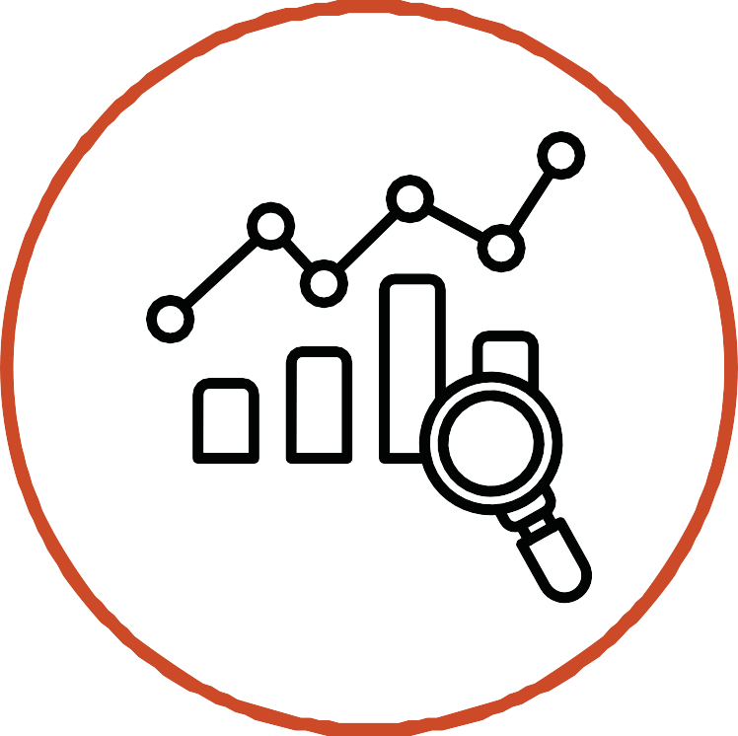

Call to action

Achieving our vision of a healthier and happier Ashfield requires everyone—residents, organisations, businesses, and community groups—to play their part. Here are six key actions you can take:

COLLABORATE

FOR CHANGE
Work together—whether you’re a resident, business, or organisation.
Pool resources, share expertise, and commit to joint action to tackle inequalities and create lasting impact. Align strategies, plans and policies to the priorities within
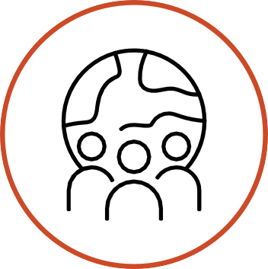
this strategy and share insight, ideas, solutions and challenges.

PROMOTE

HEALTH

AND

LIFESTYLE
Promote healthy lifestyles by sharing local wellbeing opportunities, encouraging others to join, and taking part yourself. Raise awareness of healthy habits, support proactive health management and foster movement and balance at work.

STRENGTHEN

RESIDENT

VOICE
Enable and support residents to create the change, they wish to see. Join or create local resident groups. Share your ideas, co-design solutions, and influence decisions that shape each community.

SHARE

INFORMATION

AND

RESOURCES
Help improve communication by sharing updates about services, events, and support. Use noticeboards, social media, and word of mouth to keep each community informed

.
CHAMPION

COMMUNITY

ASSETS
Support and use local hubs,
community centres, and green spaces. Encourage others to get involved and help make these spaces vibrant, inclusive, and sustainable.

VOLUNTEER

AND LEAD
Become a Community Champion or volunteer for local projects. Your time and skills can make a real difference in reducing inequalities and building stronger network.

