Coxmoor

Action Plan

2026 - 2035

Be Healthy Be Happy


Map of Ashfield

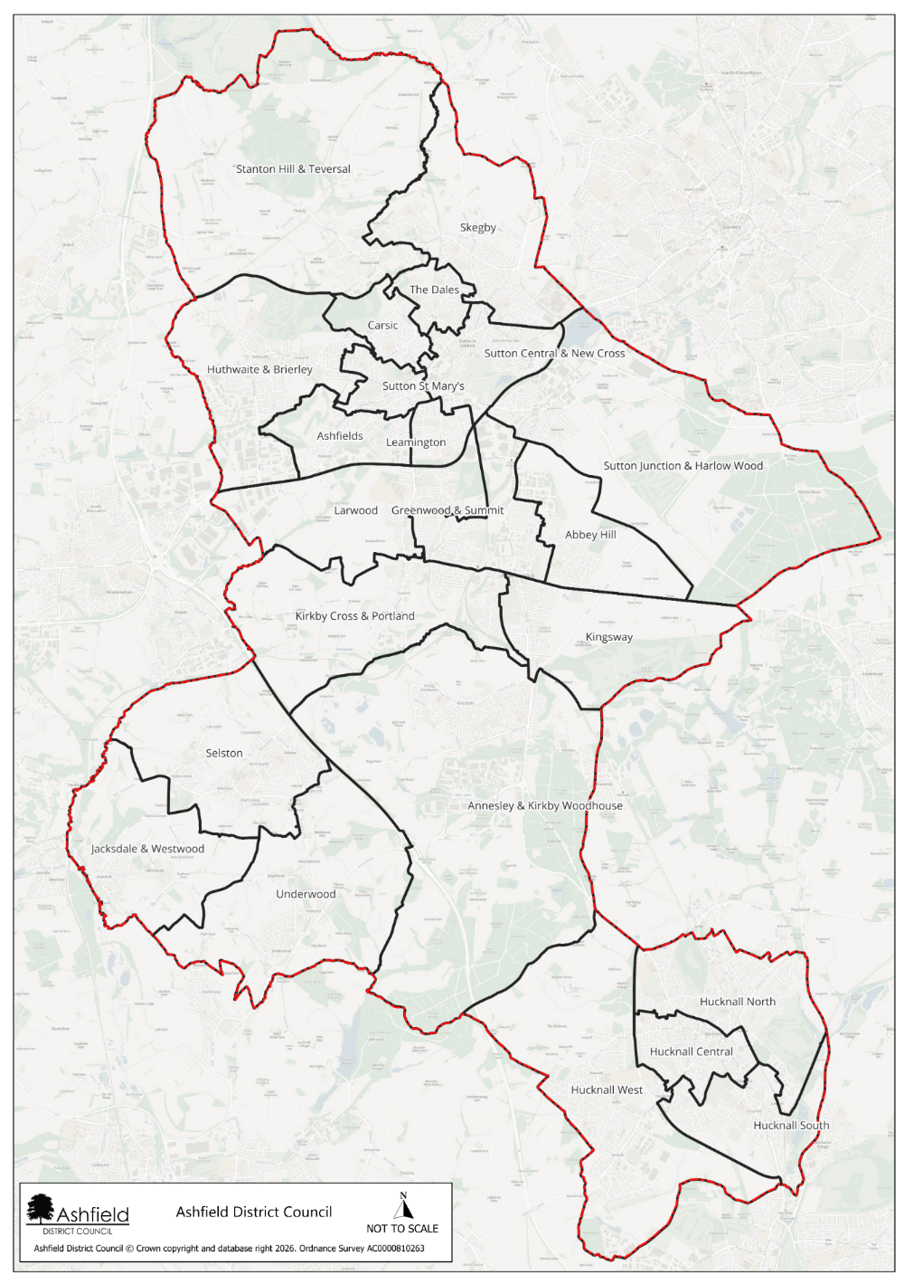

Introduction and background
Ashfield is a district within the county of Nottinghamshire. Ashfield is home to just under 130,000 residents, with a population that has grown steadily since 2011. The district has a relatively balanced age structure, though it is ageing, with one in five residents now over 65. Levels of disability are significant, affecting more than 27,000 people, including nearly one in five children. Many households’ face vulnerability, reflected in high proportions of single person households, lone parent families, and a large share of homes in Council Tax Band A. Digital exclusion is above the national average, and access to green space is limited for most households.
Children and young people in Ashfield experience some of the most notable inequalities. Over 40% live in income deprived families, childhood obesity rates exceed national levels, and participation in higher education is considerably lower than the England average, with nearly a quarter of adults having no qualifications. Older people also experience notable health challenges, with high numbers of lone pensioner households and continued demand for support to age well. The district also faces higher than average fuel poverty and ranks as a high-risk area for food insecurity due to pressures such as low incomes, limited retail diversity, and rising living costs. Together, these factors create a community with pronounced economic challenges and health inequalities, shaping clear priorities for targeted support and investment.

Despite these challenges, Ashfield is a resilient community with a strong sense of identity and clear opportunities for improvement. While some communities experience greater pressures, there is significant potential for targeted investment to deliver meaningful change—particularly in strengthening health, financial security, and opportunities for residents. Many people in Ashfield demonstrate remarkable adaptability and tenacity, and with the right support, the district is well positioned to build on its existing strengths to improve quality of life and reduce inequalities.
Coxmoor has been identified as a community with significant opportunities for targeted investment that can deliver strong social impact, including widening opportunities for young people, supporting older adults to live well, reducing inequalities experienced by people living with disabilities, and developing community connection that fosters greater wellbeing, a stronger sense of belonging, and improved economic security, enabling more residents to thrive.
Coxmoor is a predominantly residential estate with a strong community identity, shaped by a mixture of long‑standing local families and newer regeneration activity. The area is known for being community‑driven, with active resident groups (such as the Coxmoor Residents Action Group, CRAG) working to improve local spaces and social cohesion. This gives the estate a close‑knit, grassroots feel, supported by ongoing consultation and community‑led initiatives.
The identity of Coxmoor is influenced by a steady pace of neighbourhood life, strong resident involvement, and a history of local regeneration efforts responding to community needs. Issues such as redevelopment of land, housing proposals, and infrastructure concerns have driven a sense of local pride and advocacy, with residents actively voicing views on developments that affect the estate.
Coxmoor contains a mix of social housing, council properties, and newer regeneration developments. Overall, the housing landscape is defined by social housing provision, regeneration, and mixed‑size family homes.
Two positive indicators in Coxmoor highlight the community’s strengths. One positive statistic is the recent increase in community safety infrastructure, including seven new CCTV cameras and two upgraded cameras installed in Kirkby town centre and on the Coxmoor Estate, as part of the Safer Streets investment. This matters because enhanced surveillance and rapid‑response capability help deter crime, improve feelings of safety, and support vulnerable residents.
A second positive indicator is the growth in community‑led support and safeguarding schemes, such as the Vulnerable Adult Support Scheme (VASS), which brings together specialists in domestic abuse, substance misuse, vulnerability and crime prevention to support residents. This demonstrates strong multi‑agency collaboration and an existing foundation of protective community assets that can be built upon.
At the same time, two important challenges present opportunities for targeted investment and improvement. One challenging statistic is the level of deprivation affecting parts of Kirkby‑in‑Ashfield, where several nearby LSOAs rank in the top 20–40% most deprived in England according to
the Index of Multiple Deprivation. Such deprivation is significant because it links to poorer health outcomes, reduced economic opportunity, and greater long‑term inequality.
Another challenge is the persistently high levels of anti social behaviour (ASB) and neighbourhood crime, which the Community Safety Partnership continues to prioritise. Issues such as anti‑social behaviour, burglary, and neighbourhood crime remain community concerns, creating pressure on local policing, reducing residents’ sense of security, and contributing to reduced wellbeing.

These indicators help explain why focused action is needed to support local residents and strengthen long‑term wellbeing.
There are 23 wards in Ashfield. Coxmoor is the 5th most deprived ward within Ashfield. It is made up of 2 Lower Super Output areas, that are ranked in deciles 1-2.

Map of Abbey Hill including Coxmoor
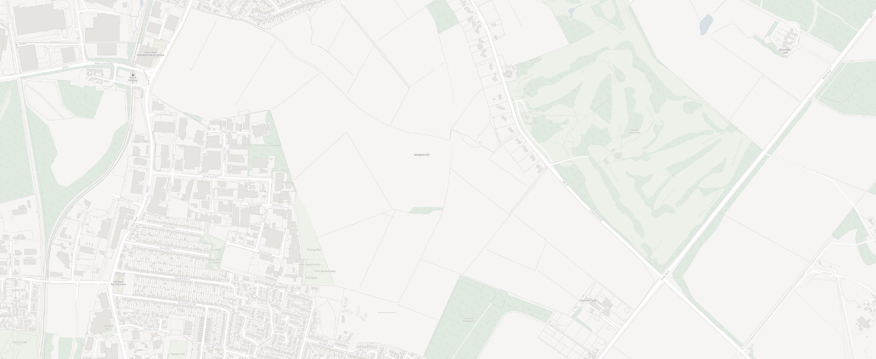
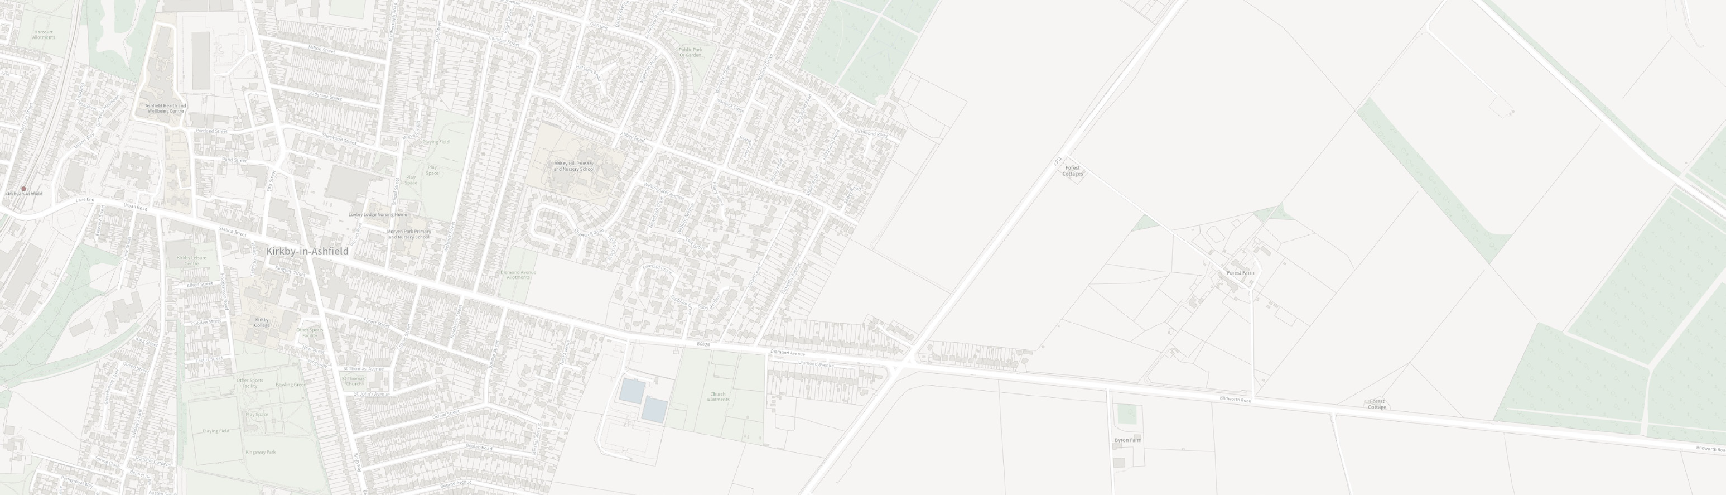






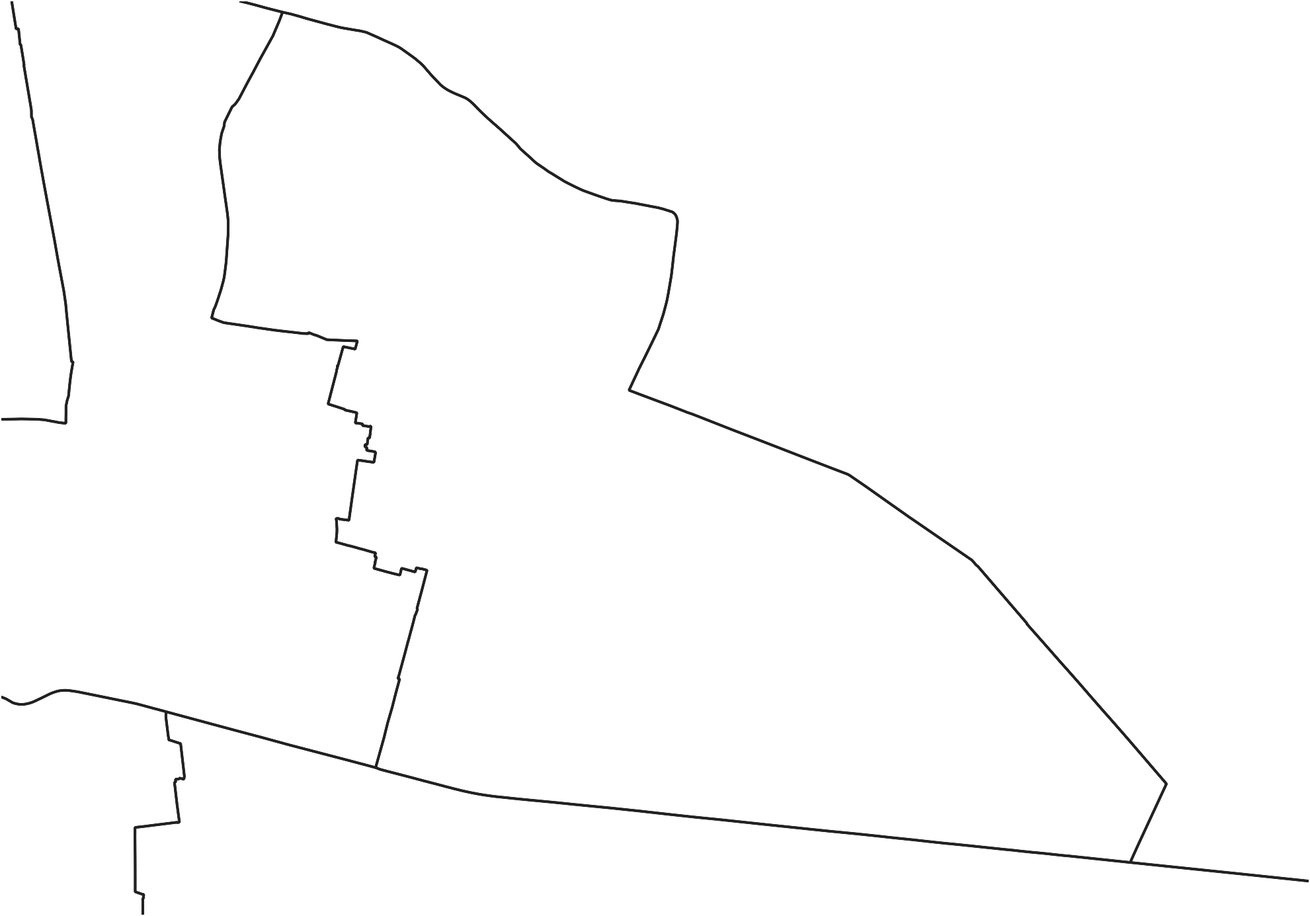




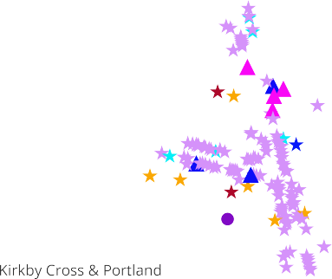




Data and Insight

Population
Area | Total population | 0 – 14 years | 15 – 64 years | 65 or over years | Female | Male
Coxmoor | 3201 | 21% | 57.1% | 21.9% | 51.7% | 48.3%
Underwood* | 2881 | 13.4% | 57.6% | 29.1% | 51.9% | 48.1%
Ashfield | 129,572 | 18.5% | 61.5% | 20.1% | 51.1% | 48.9%
The population of Coxmoor is 3201. Its age and gender profile is similar to the Ashfield average.

Health

Area | Self reported poor health | Long term health condition or disability | Day to day activities limited a lot | Children overweight or obese (Reception) | Children overweight or obese (Year 6)
Coxmoor | 9.3% | 26.1% | 12.3% | 26.9% | 42.4%
Underwood | 6.7% | 20.9% | 8.8% | 23.1% | 42.9%
Ashfield | 7.1% | 22% | 10.1% | 25.6% | 40.4%
The population of Coxmoor has a much higher percentage with a long-term health condition/disability when compared to Underwood or the Ashfield average. This trend is repeated for self-reported poor health, and limited day-to-day activities. The prevalence of overweight/obese children in reception and year 6 is like that of the Ashfield average.

Disease prevalence
Disease - percentage prevalence within the population area:

Ward area | Severe multiple disadvantages | Diabetes Type 1 | Diabetes Type 2 | Stroke | Coronary Heart Disease | Heart Failure | Hypertension | Chronic Obstructive  Pulmonary  Disease | Cancer | Serious Mental Illness | Substance abuse
Abbey Hill | 0.6% | 0.6% | 7.5% | 1.4% | 4.3% | 1.4% | 16.2% | 3.1% | 4.8% | 0.5% | 2.4%
Ashfield | 0.6% | 0.7% | 6.9% | 1.5% | 3.6% | 1.6% | 17.4% | 2.7% | 5.1% | 0.7% | 2.2%
Disease prevalence in Coxmoor is very similar to that of Ashfield as a whole.

Economy
Area | Provide 50 hours of unpaid care per week | Economically inactive | Out of work Benefits claimant count | Universal credit claimants  16 to 65 years old | People in Universal Credit  3 years plus | No qualifications  16 years plus | Children under 16 in families with absolute low income
Coxmoor | 5.1% | 50.6% | 7.4% | 44.1% | 20.6% | 26.7% | 39.8%
Underwood* | 3.7% | 45.9% | 2.1% | 11.8% | 4% | 22.3% | 11.9%
Ashfield | 3.8% | 41.6% | 4.0% | 22.8% | 9.9% | 23.6% | 24.5%
The population of Coxmoor has nearly four times the percentage of 16 to 65 year olds who claim universal credit than Underwood,
and double that of Ashfield.

Housing
Area | Council rented | Owned outright | 1 person households | Household in fuel poverty | No cars or vans within household
Coxmoor | 32% | 33% | 27.5% | 12.3% | 27.6%
Underwood* | 5.3% | 50.7% | 30.9% | 10.7% | 10.8%
Ashfield | 14.90% | 35.7% | 29.4% | 12.3% | 20.6%

Coxmoor has a much higher percentage of council rented properties when compared to Underwood; with numbers being nearly double of that as Ashfield as a district.

Crime
Area | Crime rate per 1000 | Anti-social behaviour rate per 1000
Coxmoor | 71.5 | 14.4
Underwood* | 29.2 | 17
Ashfield | 80.4 | 19.9

The crime rate in Coxmoor is significantly higher than that in Underwood but when ASB rate is compared, the rate per 1,000 is very similar.

*Underwood has been used as a comparator, as it is the least deprived ward within Ashfield (ONS Data)

Key messages from partners and residents
The natural gradient of the estate can cause issues for people accessing services – most alleyways have been closed due to ‘drug running’ and transport (buses) are often cancelled if there is a shortage of drivers.
Plans are in place to develop community spaces – Abbey Hill Primary is in the process of developing a community space
to build community connections and increase opportunities
for families. Plans are also in place to build a new community centre on the estate.
There is a lack of local amenities on the estate – the high cost of taxis and cancelled bus services can prevent residents getting to the shops, accessing local support and attending medical appointments.


Community cohesion is continuing to grow. The Coxmoor Residents Action Group (CRAG) organise and deliver community events, meeting monthly to share and discuss – for the community by the communityy. Supported by Ashfield Voluntary Action (AVA) and CLEO other examples include
volunteering and an increase in neighbours helping neighbours.
There are lots of drug issues on the estate – dealing and/or using.
We’ve experienced lots of anti-social behaviour from young people in the area. They are often riding e-bikes/e-scooters unsafely and/or vandalising property. This makes being out in the community feel unsafe for some residents.
The Coxmoor Network is valued by partners – strong and collaborative trusted relationships are being built, and this is positively impacting families in the community.
There is currently a lack of community space for events, activities etc. on the estate – this negatively impacts the number and range of activities for Children and Young People and families to access locally.
Poverty levels are high on the estate – poor housing conditions or education on how to maintain a healthy well-conditioned home, fuel and food struggles and digital
exclusion all impacts the health and wellbeing of the community.

Coxmoor Community Network
The Coxmoor community Partnership was established in January 2021. The Partnership forms part of a network set up in Ashfield to deliver the vision of:
‘Healthy, happy lives for all who live in Ashfield’
Ashfield Children and Young People Network Meeting
The partnership is made up of a wide range of organisations, including but not limited to Everyone Active, Ashfield Health Network, Active Notts, National Energy Action, Family Hubs, Early Help, Neighbourhood Coordinators, Ashfield Citizens Advice, Ashfield Voluntary Action, Primary Integrated Services, Notts Integrated Care Board, Nottinghamshire MIND, ATT Further Education College, Your Health Notts/A Better Life, Inspire, Nottinghamshire County Council, Youth Justice, Schools, Tenant Engagement, Standguide, Nonsuch Studios/Ashfield Creates, who work together to achieve this vision, aligned to a set of core values, that underpin a collaborative, action and person centre-focussed approach.
The partnership has achieved several key successes since its inception.

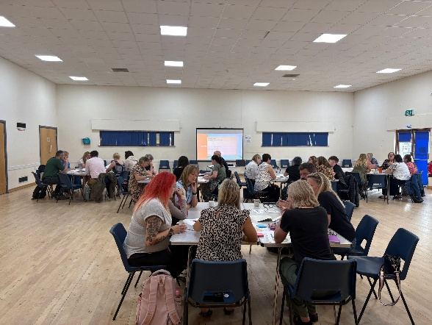
Coxmoor Network Meeting 1
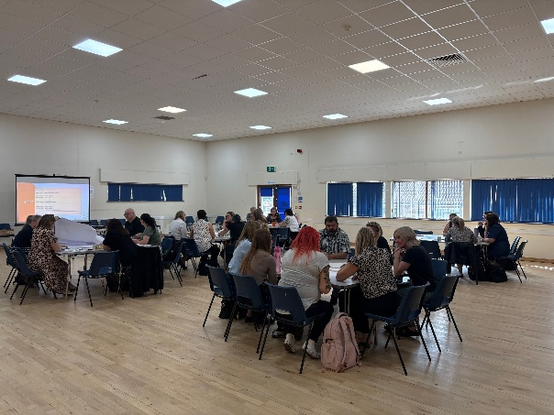
Coxmoor Network Meeting 2

Successes to date
- The Coxmoor network has, and continues to, build and grow in strength and numbers; partners are regularly coming together to meet and share their work and opportunities, building trusted relationships by working collaboratively with other partners and services in the area. This in turn is having a positive impact on our Coxmoor community. This action plan has been shaped by the Coxmoor network with a wide array of partners having an input and having their say, ensuring we are all working towards shared aims and a common purpose.
- Within the Coxmoor network and wider there are a range of other networks and teams who widen the reach to our community in Coxmoor, offering specific support and sharing key information between partners and organisations to provide the most appropriate support to the children, young people and families in the area – some of these include Project KIA, Pride in Place, the Discover Ashfield Primary School Network and Secondary School network.
- In 2025 Ashfield District Council implemented sharing with partners a regular news update via email – this enabled partners to share information and opportunities with other partners and wider within Ashfield. In 2026 the news update progressed on to a new platform called SWAY. Feedback from partners about the news update has always been positive and it has proven to be of value to many, but since using SWAY more partners have expressed how useful, clear and enjoyable the news updates are to read.

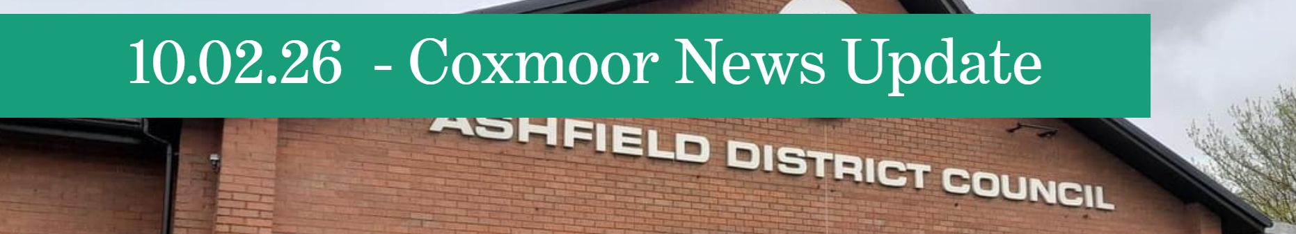
Coxmore news update 1 – SWAY news update header

Coxmore news update 2 – SWAY news update introduction

- As part of Pride in Place funding The Kirkby Neighbourhood Board have gained vital community insight via a range of community engagement methods. One success has been with the Pride in Place surveys in which we had approx. 1,500 completed. This has provided important insight from the community and local business and services which is now being used to help shape work, projects and regeneration projects in the area.
- The CRAG (Coxmoor Residents Action Group) has continued to go from strength to strength. With support from the team at AVA (Ashfield Voluntary Action) residents meet regularly working together to improve their local community, developing activity and support sessions, delivering community events and coming together to increase opportunities. The CRAG is now very much self-sufficient with light-touch support from staff at AVA (something to be extremely proud of) - the group is very much by the community, for the community.

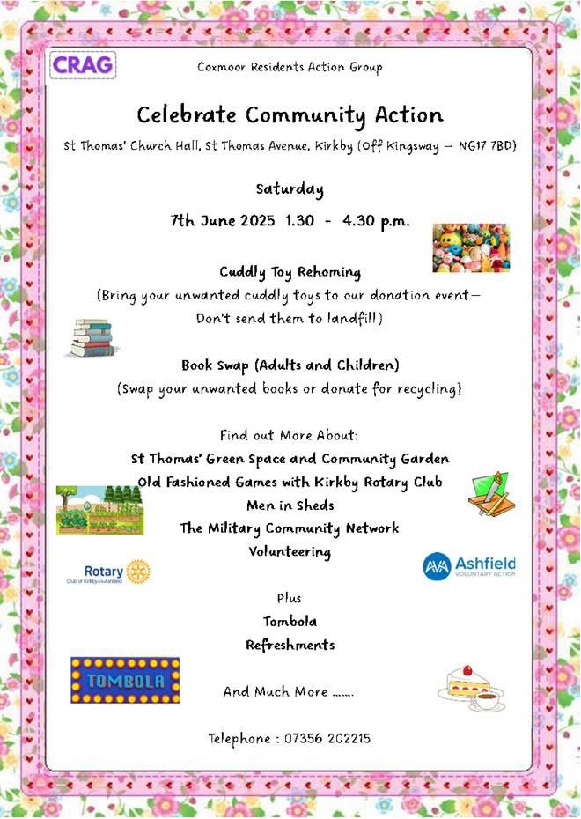
Celebrate community action poster

Family fun day poster

Christmas party poster

Coxmoor Action Plan 2026 - 2035

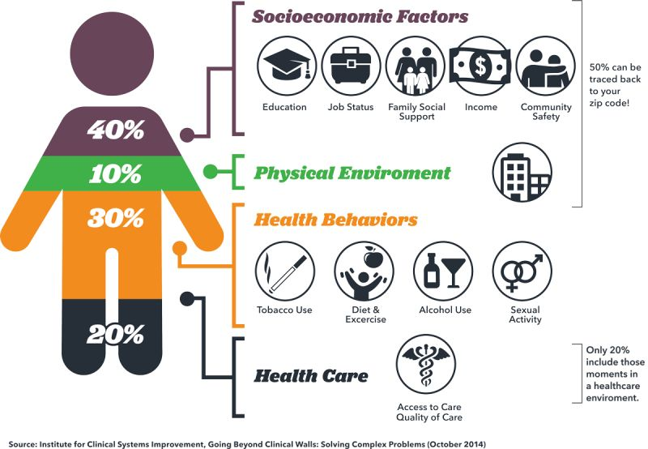
This action plan has been developed by the Coxmoor Community Partnership following a series of workshops held throughout 2025. These sessions shaped the objectives, actions, and expected outcomes, all of which are organised using the Building Blocks of Health framework.

A wide range of factors influence people’s wellbeing.

These include:
- Socioeconomic factors such as education, employment, income, family support, and community safety.
- The physical environment, including access to green spaces and exposure to pollution.
- Health behaviours like diet, physical activity, smoking, alcohol use, and other lifestyle choices.
- Access to and the quality of health care services.

THE HEALTH FOUNDATION - WHAT BUILDS GOOD HEALTH?
The Health Foundation developed the Building Blocks of Health to help communities understand how these factors interact and what needs to be addressed to reduce inequalities and support thriving, healthy neighbourhoods.
In Ashfield, ‘system development’ has been added as a 9th building block, recognising the importance of collaborative working between organisations and communities.
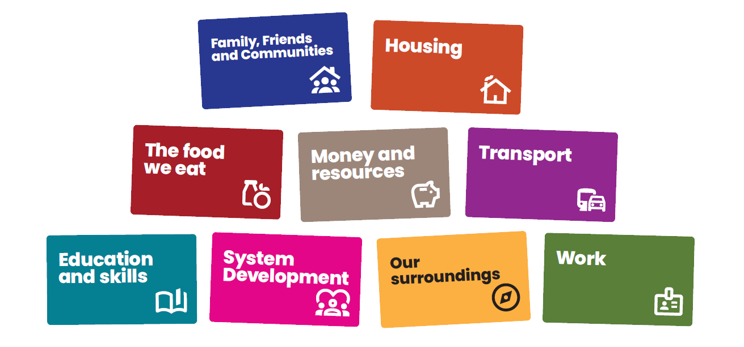
Link: What builds good heath – The Health Foundation
Education
and skills
Housing
Transport
The food
we eat
Work
System
Development
Family, Friends
and Communities

Our values

INCLUSIVE

AND

RESPECTFUL
We want everyone to feel that they are involved and that their views are heard.
We will acknowledge and embrace difference, encouraging different perspectives.

In doing this we will seek to understand, not challenge, and use this as a strength to build a shared understanding. We will use data and lived experience to help identify where to focus our energies and work with residents to enable inclusivity.

AMBITIOUS

AND

COMMITTED
We are ambitious in our desire to create a culture of collaboration across all sectors and communities where we work towards shared goals and learn together.
We will be brave and committed to working in this way, shifting our individual and collective behaviours to enable this way of working to happen.

COLLABORATION
Individuals and organisations are connected, and relationships are important. We will develop shared goals and an understanding of the work we want to do together.
In doing this we will recognise the role we can play individually and collectively, working beyond organisational boundaries to explore how to create change together.

PERSON

CENTRED
We will put people at the centre of everything we do, recognising that everyone and every community is different and what matters to them is what matters to us.
We will spend time understanding and reaching those who do not usually have a voice and have ongoing authentic conversations to understand what is important to them.

INNOVATION
We will be led by insight to focus our energies and think creatively as to how we engage with residents to understand what is important to them.
We will encourage ‘trying new’ and testing different approaches to help us understand what creates change, what doesn’t and most importantly, why.
We will create a culture of learning where to celebrate innovation, encouraging people to be creative and test ideas, by putting them into practice so that we can learn from them to inform what needs to happen next.

The Action Plans

Family, Friends and Communities

10-year vision:
Coxmoor is a vibrant, welcoming estate with a permanent, resident‑shaped community hub and a rich, inclusive programme of activities that reduce isolation and build belonging across all ages.

Focus areas and themes:
Community spaces and participation. Belonging and Safe Places — creating accessible places and programmes that residents use, trust, and co‑lead.
Objective | 1-year actions | 3-year actions | Expected Outcomes | Lead
Establish a sustainable Coxmoor Community Centre model with multi‑partner use and resident co‑design. | Run quarterly Community Living Rooms to capture insight and support delivery of resident‑led ideas | Open and operate the Coxmoor Community Centre with a shared partner calendar and resident programming board. | Operational community centre, broader age‑range programming
Expand Doorstep Activities (youth + adults/families) and make full use of Bracken Hill Community Centre and Abbey Hill School. | Work with partners to share current opportunities, building on the offer shaped from insight gathered from residents. | Scale Doorstep Activities (e.g., complement Ashfield Spartans with adult/family offers).  Leverage PlayZone – Morven Park (build initiated 2026) as an anchor for community sport and family sessions. | Increased participation at Bracken Hill, Abbey Hill and community living rooms; more consistent ASB engagement touchpoints.
Reduce anti‑social behaviour through Police/ASB clinics, Safer Streets drop‑ins, and more positive local activity options. | Schedule Police clinics/ASB surgeries; share local support links across partners. | Embed Project KIA multi‑agency collaboration (complex families/SMD) with information‑sharing and regular meetings. | A stronger trust and multi‑agency response to ASB.  A self‑sustaining community ecosystem where residents co‑design, co‑deliver and report safer, more connected neighbourhoods.
Build trusted communication channels (community living rooms, noticeboards, social media, word of mouth). | Keep noticeboards current. Work with partners to grow and develop communication channels e.g. Coxmoor news update, comms/social media and word of mouth through partners working with the community directly. |  | Improved visibility of “what’s on.” and increased resident participation.

The food we eat

10-year vision:
Healthy, affordable food is the easy choice: residents access local support, know how to cook on a budget/low energy, and grow some of their own produce.

Focus areas and themes:
Food access, food skills, and growing. Eat Well, Spend Less — practical food help that fits budgets and households.
Objective | 1-year actions | 3-year actions | Expected Outcomes | Lead
Share information on food banks/clubs/social supermarkets and Too Good To Go style apps. | Publish CRAG recipes and a local “where to get food help” guide; include NEA fuel vouchers info. | Formalise community supermarket links for referrals/insight and targeted support. | Normalised family food confidence and stronger local food network.
Run Cook & Eat education (NEA low‑energy cooking; ATTFE/ABL cookery; CRAG/community sessions). | Deliver low‑energy cooking workshops (slow cookers/air fryers) and link to white‑goods support. | Expand cookery to family cohorts and schools (HAF/ATTFE/ABL). | More households accessing affordable options and cooking skills.  Normalised low‑cost cooking.
Enable grow‑your‑own | Distribute Grow Packs and run spring planting sessions; promote library/community gardens. | More families starting to grow their own. | More households accessing first harvests from grow‑your‑own.
Offer family food support (weaning, picky eaters, breastfeeding friendly spaces. | Run weaning/picky eaters groups and normalise breastfeeding access. | More families preparing and eating healthier foods – cooking from scratch and batch cooking. | A resilient local food ecosystem improving diet and budgets.

Work
10-year vision:
Residents access stable, meaningful work through local upskilling, life‑skills education, and employer partnerships — with volunteers and Community Champions bridging trust.
Focus areas and themes:
Community capacity, employer links, and practical work skills. Pathways to Good Work — demystify routes into jobs, apprenticeships, and training.
Objective | 1-year actions | 3-year actions | Expected Outcomes | Lead
Grow Community Champions to connect residents and professionals; host regular on‑estate drop‑ins. | Recruit/train Champions; rotate partner drop‑ins at estate venues; promote via noticeboards and Network news updates. | Community Champions in role and connecting residents and professionals.. | Strong employer pipelines and community‑led employment support.
Promote upskilling offers and overcome data/tech barriers. | Map placements/apprenticeships with local businesses; publish a simple “routes to work” guide. | Provide device/connectivity solutions for job search and online learning where needed. | More residents accessing advice and first experiences; improved confidence.
Increase work experience and careers opportunities; include SEND and reduce gender stereotyping. |  | Secure a steady flow of placements, apprenticeships, and short work tasters; measure retention and progression. | Increased job stability and positive credit/insurance behaviours.
Deliver Life Skills (work/life balance, credit rating, “job hopping,” insurance) with trusted partners. | Co‑design Life Skills curriculum and start monthly workshops. | Residents are more empowered and knowledgeable in life skills and work.

Transport

10-year vision:
Coxmoor residents travel affordably and safely using a combination of reliable transport and active travel, with activities within walking distance and low barriers for young people, carers, and older adults.

Focus areas and themes:
Transport affordability, access, and safety. Move More, Reach More — combine community transport, training, and localised activities.
Objective | 1-year actions | 3-year actions | Expected Outcomes | Lead
Influence and improve transport accessibility and costs with County/Place Based Partnership/Ashfield District Council engagement. | Maintain partner meetings with Notts CC/Mid Notts PBP/ADC to escalate bus concerns and ticketing issues. | Scale Independent Travel Training (Yr9+) and a buddy approach for YP; explore a bike/ scooter refurb scheme. | A balanced, low‑cost local mobility ecosystem supporting health and participation.
Systematically promote local travel services (e.g. Our Centre, Butterfly Project, Best Years, Young Carers Travel Cards, and E1 travel support.) | Push Coxmoor Network News Update and partner channels to publicise local services.  Promote Everyone Active E1 travel support for sessions/appointments. | Improved travel service messaging for residents. | More awareness and uptake of transport schemes.
Make wheeled travel safer (bikes/scooters): security, etiquette, routes, and storage with Police/Safer Streets/Schools. | Work with partners to deliver more active travel activities; audit and improve school bike/scooter storage; deliver bike security advice. | Improved safety messaging and storage in schools/local facilities. | Reduced travel barriers to health/activities; higher rates of safe active travel.
Increase activities within walking distance and make Kirkby town a more attractive walking destination. |  | Bring more services on‑estate (benefits, library, tenancy, etc.) to reduce travel needs further.

Our Surroundings

10-year vision:
Residents can access essential health, social, digital, and wellbeing services on‑estate or within a short walk, with simple routes to support and learning.

Focus areas and themes:
Local delivery of services and social connections. Right Support, Right Here — reduce travel and costs by bringing services closer.
Objective | 1-year actions | 3-year actions | Expected Outcomes | Lead
Deliver health services locally (pop‑ups, social prescribing, community champions). | Use existing community groups e.g. Wednesday Welcome Group for partner talks (advice/support on scams, referrals, sexual health C‑card, etc.). | Regular health pop‑ups (ICB/Everyone Active CVD events; Public Health/Sexual Health outreach). | Routine on‑estate health and activity timetable.  A “local by default” service pattern with resilient community groups.
Expand activity and wellbeing sessions using a mapping tool that’s user‑friendly (venues, access, contacts, transport). |  | Develop new or improve existing mapping tool (to include fields such as provider, access, first visit info, parking/ transport etc.). | Improved access to information; more residents connected to local food support and community projects. | Primary Care Networks (PCN), Social Prescribers
Lift digital confidence and access to digital equipment to increase access to themed apps like GP/NHS online. | Run intro digital sessions on estate (ATTFE/AVA/CRAG digital team); combine with existing events to reduce intimidation. | Keep AVA’s group spreadsheet current; expand device‑loan or drop‑in digital help in community venues. | More first‑time users of digital/health outreach.  Better digital access and increased confidence of digital users.
Reduce isolation through group offers, friendly connectors, and practical support (e.g. NEA, Citizens Advice, local businesses). | Host NEA (National Energy Action) community energy sessions and promote the helpline. | Extend social groups and befriending connectors; integrate with transport offers to improve attendance. | Reduced reports of isolation.

Housing

10-year vision:
Warm, safe, affordable homes with fewer damp/mould issues and clear routes to timely housing support.

Focus areas and themes:
Housing access, conditions, and health. Warm, Safe & Sound — tackling quality, knowledge, and early action.
Objective | 1-year actions | 3-year actions | Expected Outcomes | Lead
Work with housing associations and partners to increase rental availability locally. | More families in safe, clean, warm and well-maintained homes. | Families taking ownership over maintaining their own homes – learning how to do this and where to find support when they need to. | Consistently healthy housing standards and empowered tenants.
Deliver regular on‑estate Housing Clinics (e.g. ADC Housing, Citizens Advice, NEA, Severn Trent, Nottingham Law Centre). | Launch Housing Clinics schedule and communications (include water/energy debt, repairs routes). | Maintain quarterly clinics, manage housing concerns and track resolutions and time to fix. | Clearer pathways; earlier reporting; first installations of preventative measures.  Improved resident knowledge.
Raise awareness on healthy homes and act on damp & mould (NEA sessions, Housing Ombudsman spotlight, Green Doctor). | Pilot moisture‑detection fans and staff training; run Warm Homes Healthy Futures referrals. | Damp/mould education with Ombudsman spotlight sessions. | First installations of preventative measures.  Fewer repeat damp/mould cases.  Improved resident knowledge.
Promote smoke‑free homes education (Your Health Notts/ABL/Health Visitors/Schools). | Deliver local Stop Smoking (including pregnancy) referrals and school workshops. | Decreased rates of smoking in homes. | Reduced second‑hand smoke exposure at home.

Money and Resources

10-year vision:
Households experience less financial stress through early support, simple routes to help, and practical education — especially for families and young people.

Focus areas and themes:
Early advice, financial capability, and strong partner communications. Money Confidence & Early Help — reduce crisis by making support visible and accessible.
Objective | 1-year actions | 3-year actions | Expected Outcomes | Lead
Maintain and grow the Coxmoor Network News Update as the central “offer” to share with residents. | Issue the monthly News Update; partners feed content (A‑Z of services, out‑of‑hours, events). |  | Higher visibility of support.
Provide face‑to‑face and virtual advice/drop‑ins (e.g. Citizens Advice, Social Prescribers, Family Hubs). | Schedule Citizens Advice bus and appointments; NEA helpline and community sessions; Social Prescriber referral routes. | Regular community events (health, finance, employment) delivered locally. | More residents reach advice earlier.  Reduced crisis presentations.  Community‑normed financial capability and reliable early‑help pathways.
Help residents apply for funding (HSF, white goods, clothing, IT refurb) and improve digital skills for applications. | Progress ShareWear referrals; scope local clothes swap storage/venues. | Broaden equipment/ digital support offers.  Embed application support appointments and track successful awards. | Initial clothing and essentials pathways established.
Deliver financial education for C&YP (e.g. Barclays Life Skills, Futures, DWP) and family learning. | Start school‑age money skills sessions with partners; pilot weekend family learning. |  | More stable budgeting behaviours among YP/families.

Education and Skills

10-year vision:
Lifelong learning is normal in Coxmoor: adults and families access flexible provision, and schools partner to strengthen life, work, and health skills.

Focus areas and themes:
Adult and family learning, school partnerships, and health literacy. Learn Here, Thrive Everywhere — flexible, relevant learning on residents’ terms.
Objective | 1-year actions | 3-year actions | Expected Outcomes | Lead
Provide local adult/family learning including evenings/weekends, with childcare and transport solutions. | Stand up evening/weekend learning blocks; pilot childcare support for attendance. | Expand functional skills/skills for employment. | More adults enrolled.  Higher completions.  A culture of local learning with robust pathways into meaningful employment
Integrate health and food education (e.g. FAB roadshows, cooking at Abbey Hill, lunch clubs). | Deliver FAB School Roadshows/cooking at local venue; promote FAB Lunch Clubs. |  | Family food literacy.  Stronger school links.
Maintain school networks and youth leadership opportunities (e.g. School Games, Everyone Active). | Agree a schools comms rhythm (primary and secondary networks) and work with partners to support School Games events. | Co‑deliver/support careers fairs. | Stronger school links.  Higher transitions to work or further study; youth leadership embedded.
Support employment pathways for people with health conditions (e.g. Standguide, IWorks, Futures, DWP, Portland, ATTFE, Inspire). |  | Co‑deliver/support adjustments training for employers/ employees. | A culture of local learning with robust pathways into meaningful employment.

System development

10-year vision:
A collaborative, resident‑led local system with shared outcomes, transparent funding, and a “You said, we did” culture that consistently reduces inequalities.

Focus areas and themes:
Collaboration, insight, and funding. One System, One Story — align partners behind clear goals and resident voice.
Objective | 1-year actions | 3-year actions | Expected Outcomes | Lead
Clarify shared outcomes and expectations across partners; maintain momentum through regular network meetings. | Publish a one‑page partner charter with shared outcomes and meeting cadence. | Evidence partner contributions with outcome dashboards.  Refresh shared outcomes. | Clearer roles, fewer duplications.
Confirm who’s “in” and how each contributes; showcase venues and capabilities. | Confirm with partners.  Rotate meeting venues to showcase assets. |  | A learning system that continually adapts and delivers for Coxmoor.
Influence wider commissioning via ground‑up insight and a transparent “You said, we did” loop. | Map influence meetings across the system and schedule regular insight feeds from residents. | Start a “You said, we did” tracker and share quick wins in the Network News. | Joined‑up commissioning with resident insight at the centre.  Visible “wins” to residents.
Manage funding pipeline (Kirkby Pride in Place Fund, UKSPF, transport, regeneration, safety etc.). | Run quarterly funding briefings and bid‑writing support sessions. | Secure multi‑year funding for key strands. | More stable funding.

Measuring success
Each year, the Coxmoor Community Partnership will produce a detailed annual review that clearly sets out the work undertaken, the successes achieved, and the challenges faced over the previous 12 months. This review will be grounded in the same data sources that informed the original priorities, enabling partners to assess what has changed and why.
Alongside this, project level information—such as participation numbers, reflections, observations, and case studies—will be gathered to ensure every action is evidenced and accountable.
The review will also assess the insight gained throughout the year, how learning has been shared across partners, the
stories that demonstrate impact, and the new or strengthened connections that have developed. Crucially, it will outline how each action has made a measurable difference, making clear where progress has been strong and where further improvement is required
The completed annual review will be presented to the Be Healthy, Be Happy Management Group. Each lead organisation is directly accountable for the actions they committed to, including delivering progress, monitoring outcomes, and providing timely and accurate contributions to the review



Call to action

Achieving our vision of a healthier and happier Ashfield requires everyone—residents, organisations, businesses, and community groups—to play their part. Here are six key actions you can take:

COLLABORATE

FOR CHANGE
Work together—whether you’re a resident, business, or organisation.
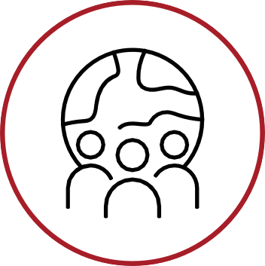
Pool resources, share expertise, and commit to joint action to tackle inequalities and create lasting impact. Align strategies, plans and policies to the priorities within
this strategy and share insight, ideas, solutions and challenges.

PROMOTE

HEALTH

AND

LIFESTYLE
Promote healthy lifestyles by sharing local wellbeing opportunities, encouraging others to join, and taking part yourself. Raise awareness of healthy habits, support proactive health management and foster movement and balance at work.

STRENGTHEN

RESIDENT

VOICE
Enable and support residents to create the change, they wish to see. Join or create local resident groups. Share your ideas, co-design solutions, and influence decisions that shape each community.

SHARE

INFORMATION

AND

RESOURCES
Help improve communication by sharing updates about services, events, and support. Use noticeboards, social media, and word of mouth to keep each community informed

.
CHAMPION

COMMUNITY

ASSETS
Support and use local hubs,
community centres, and green spaces. Encourage others to get involved and help make these spaces vibrant, inclusive, and sustainable.

VOLUNTEER

AND LEAD
Become a Community Champion or volunteer for local projects. Your time and skills can make a real difference in reducing inequalities and building stronger network.

