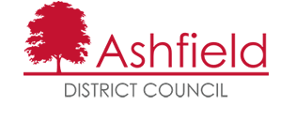
Results of Portland Park Stream Restoration Proposals Survey,
October –November 2020
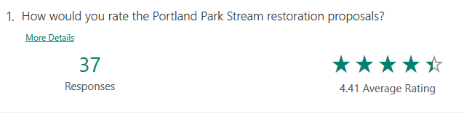
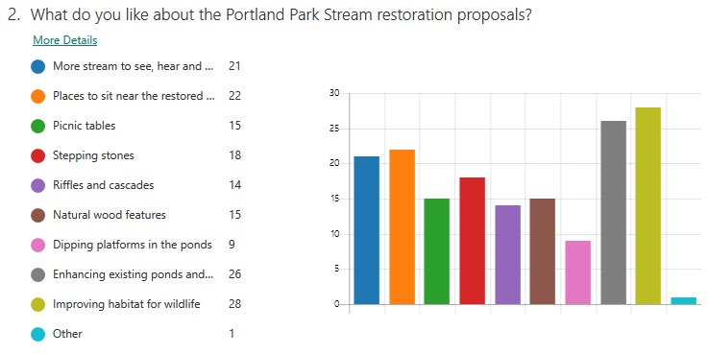
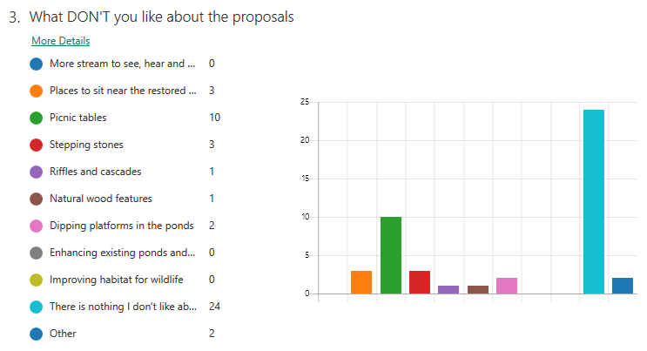
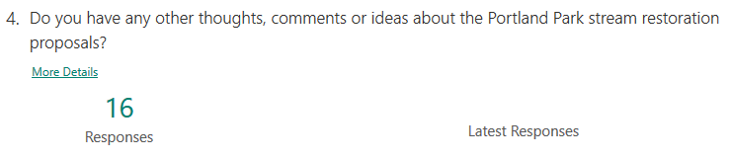
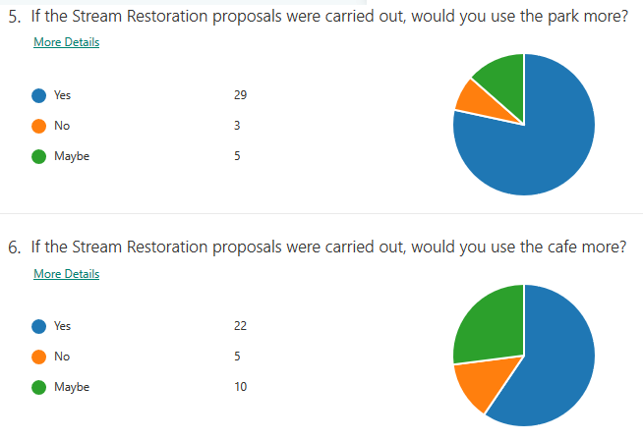
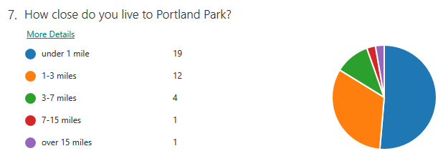
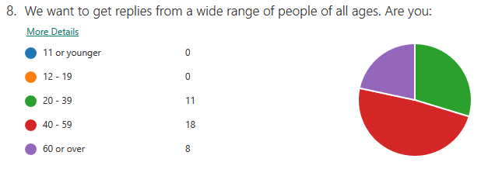

12 people said they would like to be involved in this project in the future.

Many thanks to everyone who responded. The next steps are applying for Planning Permission and other consents, and applying for funding to carry out the work. We hope to restore the stream in Autumn 2021, after bird nesting season. We’ll keep you posted!

Donna Mellar  Ashfield District Council | Julie Wozniczka  Trent Rivers Trust

