Children and Young People

Action Plan

2026 - 2035

Be Healthy Be Happy
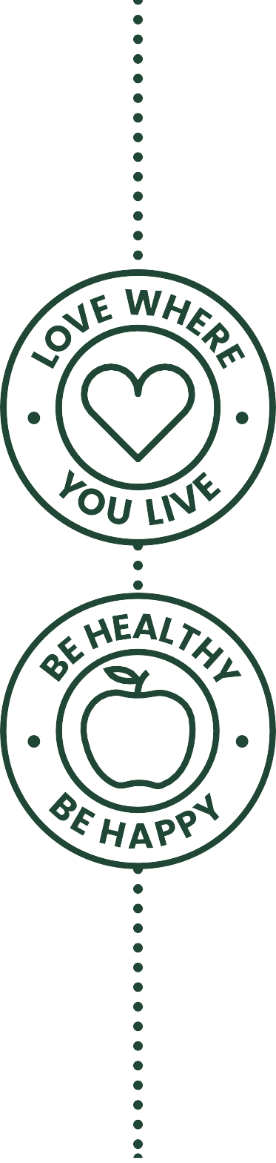

Map of Ashfield

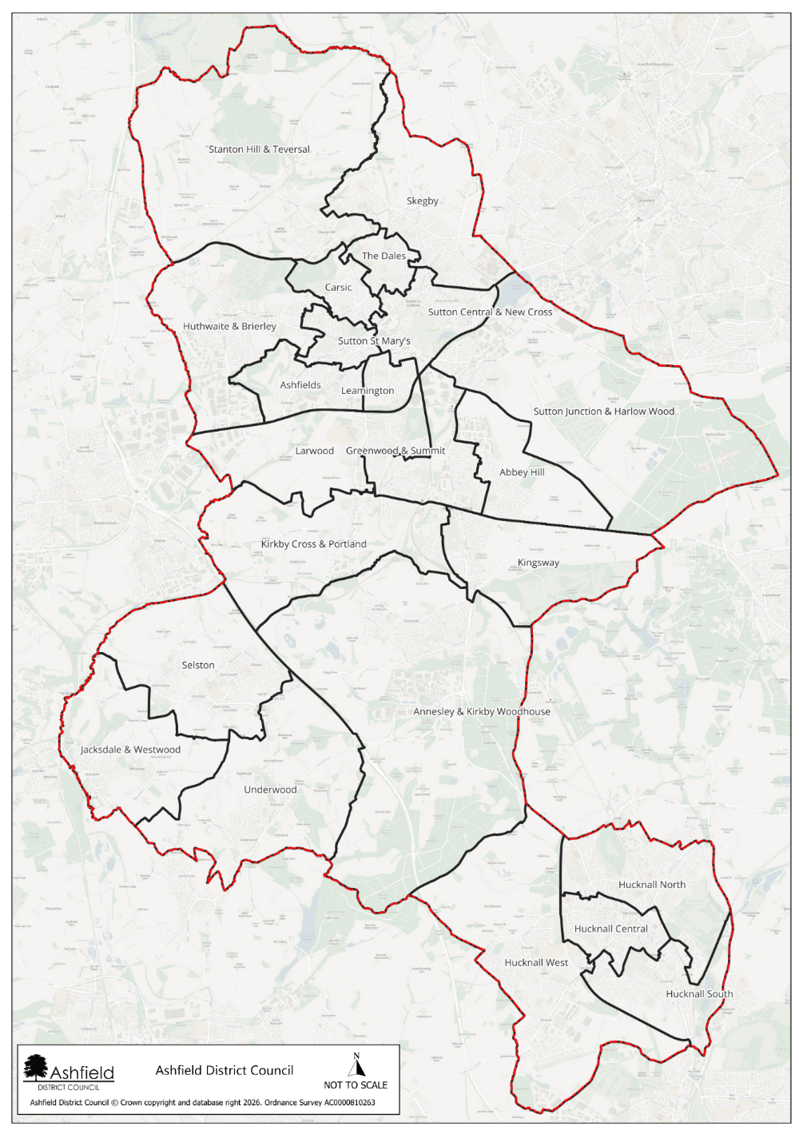

Introduction and background
Ashfield is a district within the county of Nottinghamshire. Ashfield is home to just under 130,000 residents, with a population that has grown steadily since 2011. The district has a relatively balanced age structure, though it is ageing, with one in five residents now over 65. Levels of disability are significant, affecting more than 27,000 people, including nearly one in five children. Many households’ face vulnerability, reflected in high proportions of single-person households, lone parent families, and a large share of homes in Council Tax Band A. Digital exclusion is above the national average, and access to green space is limited for most households.
Children and young people in Ashfield experience some of the most notable inequalities. Over 40% live in income deprived families, childhood obesity rates exceed national levels, and participation in higher education is considerably lower than the England average, with nearly a quarter of adults having no qualifications. Older people also experience notable health challenges, with high numbers of lone pensioner households and continued demand for support to age well. The district also faces higher than average fuel poverty and ranks as a high-risk area for food insecurity due to pressures such as low incomes, limited retail diversity, and rising living costs. Together, these factors create a community with pronounced economic challenges and health inequalities, shaping clear priorities for targeted support and investment.
Despite these challenges, Ashfield is a resilient community with a strong sense of identity and clear opportunities for improvement. While some communities experience greater pressures, there is significant potential for targeted investment to deliver meaningful change—particularly in strengthening health, financial security, and opportunities for residents. Many people in Ashfield demonstrate
remarkable adaptability and tenacity, and with the right support, the district is well positioned to build on its existing strengths to improve quality of life and reduce inequalities.
Children and young people in Ashfield bring energy, creativity, and enormous potential, offering a powerful opportunity to build a brighter future for the whole community. By strengthening access to enriching activities, supportive relationships, high quality education, and safe, inspiring spaces to learn and grow, Ashfield can turn existing challenges into a catalyst for greater opportunity. Investing in young people’s wellbeing, aspirations, and sense of belonging helps create confident, skilled, and connected future citizens who can thrive and contribute meaningfully to the district’s long-term success
.

Data and Insight

Population

Area | Total population | 0 – 14 years | 15 – 64 years | 65 or over years | Female | Male
Ashfield | 129,572 | 18.5% | 61.5% | 20.1% | 51.1% | 48.9%
Nottinghamshire | 857,013 | Nearest published:  0–17 = 20.0% | Nearest published:  18–64 = 58.4% | 21.5% | 51.0% | 49.0%
On average population data for Ashfield is very similar to that of Nottinghamshire as a whole.

Health

Area | Self reported poor health | Long term health condition or disability | Day to day activities limited a lot | Children overweight or obese (Reception) | Children overweight or obese (Year 6)
Ashfield | 7.1% | 22% | 10.1% | 25.6% | 40.4%
Nottinghamshire | 5.8% |  |  | 25.5% | 37.4%
When comparing health in Ashfield to that of Nottinghamshire, self-reported health and children overweight/obese in year 6 rates are higher, whereas children overweight/obese at reception age is very similar.

Economy
Area | Provide 50 hours of unpaid care per week | Economically inactive | Out of work Benefits claimant count | Universal credit claimants  16 to 65 years old | People in Universal Credit  3 years plus | No qualifications  16 years plus | Children under 16 in families with absolute low income
Ashfield | 3.8% | 41.6% | 4.0% | 22.8% | 9.9% | 23.6% | 24.5%
Nottinghamshire | 3.1% | 22.0% | 3.0% | 18.3% | 7.9% | 19.4% | 18.8%
Economy rates in Ashfield are very similar to that of Nottinghamshire as a whole except for the economically inactive where Ashfield is nearly double that of Nottinghamshire.

Housing

Area | Council rented | Owned outright | 1 person households | Household in fuel poverty | No cars or vans within household
Ashfield | 14.90% | 35.7% |  | 12.3% | 20.6%
Nottinghamshire | 8.4% | 38.2% |  | 11.4% | 23.4%

The number of households in fuel poverty in Ashfield are just above that of Nottinghamshire averages with less homes having a car/van.

Crime

Area | Crime rate per 1000 | Anti-social behaviour rate per 1000
Ashfield | 80.4 | 19.9
Nottinghamshire | 110.8 | 19.4
When comparing crime rates, Ashfield falls below the Nottinghamshire average with anti-social behaviour (ASB) rates being pretty much the same.

Key messages from partners and residents

We’ve experienced lots of issues around anti-social behaviour from young people in the area. They are often riding e-bikes/e-scooters unsafely and/or vandalising property.
This makes being out in the community feel unsafe for other young people and residents.
Many of our Children and Young People are lacking aspiration – this is often due to the environment and surroundings in which they live, learn and grow.

Our Children and Young People Network continues to grow in strength and size. Partners are building trusted relationships and working collaboratively towards a shared purpose – positively impacting the Children and Young People we work with.
There are recurring issues with children and young people smoking/vaping and consuming energy drinks underage.
There is a lack of Children and Young People attending activities outside of school time – even if activities are on offer, Children and Young People do not attend – why? Are we meeting their needs?
Poverty levels are high – poor housing conditions or education on how to maintain a healthy well-conditioned home, fuel and food struggles
and digital exclusion all impact the health and wellbeing of our Children and Young People.
Partner links and connections are increasing insight capture, youth voice and opportunities wanted/ needed by Children and Young People.
Gaps remain in our offers of support, opportunities and activities and for Children and Young People with Special Education Needs and Disabilities (SEND) – we are positively working to improve and meet these needs, but we still have lots of work to do.
Our Discover Ashfield Primary School Network and Secondary School Network continues to grow, strength and trust – insight gained through these has increased our offer of activities and support for Children and Young People.

The Ashfield Children and Young People’s Network (C&YP Network)
The C&YP Partnership was established in November 2022. The Partnership forms part of a network set up in Ashfield to deliver the vision of:
‘Healthy, happy lives for all who live in Ashfield’

Ashfield Children and Young People’s Network Meeting
The partnership is made up of a wide range of organisations, including but not limited to Everyone Active, Ashfield Health Network, Active Notts, National Energy Action, Family Hubs, Early Help, Neighbourhood Coordinators, Ashfield Citizens Advice, Ashfield Voluntary Action (AVA), Primary Integrated Services, Notts ICB, Nottinghamshire MIND, ATTFE, Your Health Notts/ABL, Inspire, Nottinghamshire County Council, Youth Justice, Schools, Nottingham Carers Association, Futures, NHS, Sexual Health, DWP, NIDAS, and Nonsuch Studios/Ashfield Creates, who work together to achieve this vision, aligned to a set of core values, that underpin a collaborative, action and person centre-focussed approach.
The partnership has achieved several key successes since its inception.

Successes to date

Ashfield Children and Young People’s Network Meeting
- The C&YP network has, and continues to, build and grow in strength and numbers; partners are regularly coming together to meet and share their work and opportunities, building trusted relationships by working collaboratively with other partners and services across Ashfield. This in turn is having a positive impact on our C&YP. This action plan has been shaped by the C&YP network with a wide array of partners having an input and having their say, ensuring we are all working towards shared aims and a common purpose.
- Within the C&YP network and wider there are a range of other networks and teams who widen the reach to our young people across Ashfield, offering specific support and sharing key information between partners and organisations to provide the most appropriate support – some of these include Project Kirkby in Ashfield (KIA), Pride in Place, the Discover Ashfield Primary School Network and Secondary School network, Mid Notts PBP, and Nottinghamshire Smoking (C&YP).
- In 2025 Ashfield District Council implemented sharing with partners a regular news update via email – this enabled partners to share information and opportunities with other partners and wider within Ashfield. In 2026 the news update progressed on to a new platform called SWAY. Feedback from partners about the news update has always been positive and it has proven to be of value to many, but since using SWAY more partners have expressed how useful, clear and enjoyable the news updates are to read.
- As part of our new action plan development, we delivered our first Ashfield C&YP Wellbeing Event at Kirkby Leisure Centre. The day was a great success with over 35 partners attending – sharing their services with C&YP and families, educating on how to access support and offering a wide array of fun and inclusive activities on the day. As part of the day, we also shared the draft version of our action plan with the community and captured insight to shape the plan further.
- Alongside involvement with Nottinghamshire County Council (NCC) to develop a Summer 2025 and October 2025 Half Term Activity Timetable for C&YP and families across Ashfield, throughout 2025 we offered 6 half term sessions at Asylum Skate Park for C&YP and families to access FREE of charge. All sessions included 3 hours in the park, hire of equipment, a meal and a free return visit to the park for all children attending. Sessions have been really popular; with all 65 spaces for each date being booked within a few hours of the tickets going live. Going into 2026, we will continue to offer the Skate and Bouldering sessions at Asylum Skatepark but have started to widen the offer across Ashfield to different locations and to include a variety of other activities; at present this includes Nordic Walking (being trialled in Feb Half Term). We then look to work with The Mill and Adventures at Kingsmill Reservoir to offer some outdoor activities later in the year.

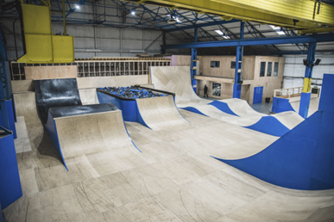
Asylum Skatepark
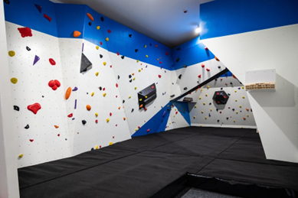
Asylum Bouldering
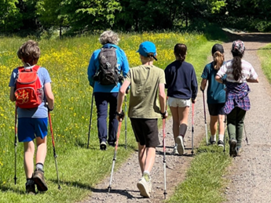
Nordic Walking

Ashfield Children and Young People’s Action Plan 2026 - 2035
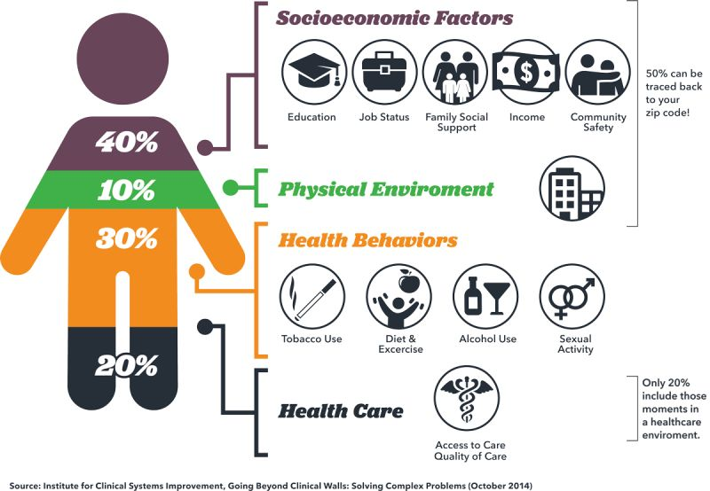
This action plan has been developed by the C&YP Partnership following a series of workshops held throughout 2025. These sessions shaped the objectives, actions, and expected outcomes, all of which are organised using the Building Blocks of Health framework.

A wide range of factors influence people’s wellbeing.

These include:
- Socioeconomic factors such as education, employment, income, family support, and community safety.
- The physical environment, including access to green spaces and exposure to pollution.
- Health behaviours like diet, physical activity, smoking, alcohol use, and other lifestyle choices.
- Access to and the quality of health care services.

THE HEALTH FOUNDATION - WHAT BUILDS GOOD HEALTH?
The Health Foundation developed the Building Blocks of Health to help communities understand how these factors interact and what needs to be addressed to reduce inequalities and support thriving, healthy neighbourhoods.
In Ashfield, ‘system development’ has been added as a 9th building block, recognising the importance of collaborative working between organisations and communities.
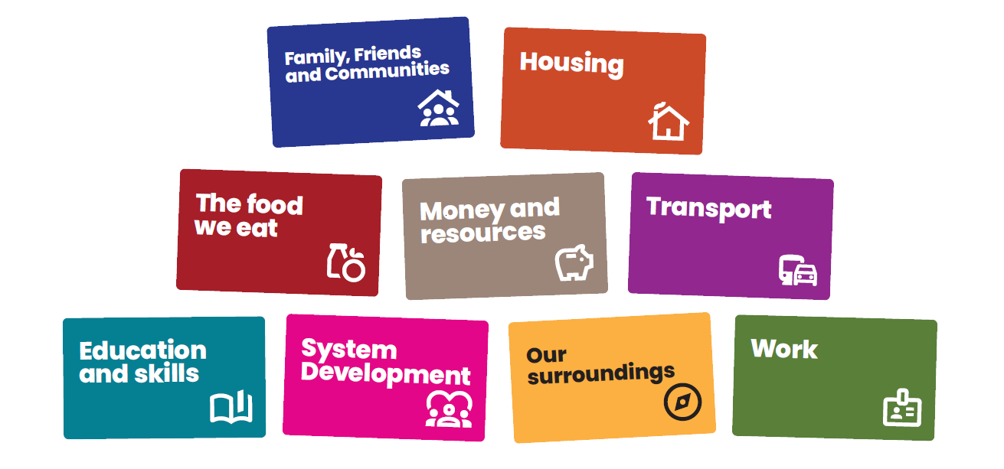
Link: What builds good heath – The Health Foundation
Education
and skills
Housing
Transport
The food
we eat
Work
System
Development
Family, Friends
and Communities

Our values

INCLUSIVE

AND

RESPECTFUL
We want everyone to feel that they are involved and that their views are heard.
We will acknowledge and embrace difference, encouraging different perspectives.
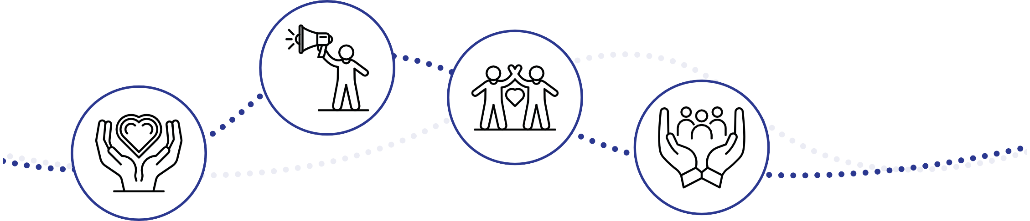
In doing this we will seek to understand, not challenge, and use this as a strength to build a shared understanding. We will use data and lived experience to help identify where to focus our energies and work with residents to enable inclusivity.

AMBITIOUS

AND

COMMITTED
We are ambitious in our desire to create a culture of collaboration across all sectors and communities where we work towards shared goals and learn together.
We will be brave and committed to working in this way, shifting our individual and collective behaviours to enable this way of working to happen.

COLLABORATION
Individuals and organisations are connected, and relationships are important. We will develop shared goals and an understanding of the work we want to do together.

PERSON

CENTRED
We will put people at the centre of everything we do, recognising that everyone and every community is different and what matters to them is what matters to us.
We will spend time understanding and reaching those who do not usually have a voice and have ongoing authentic conversations to understand what is important to them.

INNOVATION
We will be led by insight to focus our energies and think creatively as to how we engage with residents to understand what is important to them.
We will encourage ‘trying new’ and testing different approaches to help us understand what creates change, what doesn’t and most importantly, why.
We will create a culture of learning where to celebrate innovation, encouraging people to be creative and test ideas, by putting them into practice so that we can learn from them to inform what needs to happen next.

Ashfield Children and Young People’s Action Plan Action Plans

Family, Friends and Communities

10-year vision:
Every child and young person (C&YP) in Ashfield has equitable access to inclusive physical activity, mental health support, sexual health services, and creative cultural participation — with sustainable, community based provision that proactively closes gaps for Special Educational Needs and Disabilities (SEND) and vulnerable groups, aligned to Core20PLUS5 priorities.

Focus areas and themes:
Holistic, equitable wellbeing — “Healthy bodies, healthy minds, healthy relationships, for all.”
Objective | 1-year actions | 3-year actions | Expected Outcomes | Lead
Increase inclusive physical activity and “doorstep” participation (PlayZones, youth/community centres, school offers etc.). | Launch PlayZones and community sessions (including equipment‑free options) across estates and youth centres. | Scale doorstep provision and priority swim/tennis schemes with junior memberships and activator pathways; deepen school‑embedded offers via School Games and curriculum enrichment. | Increased participation in local physical activities.
Strengthen mental health (MH) literacy, early support, and timely access (schools, MH Support Teams, CAHMS, community partners). | Deliver MH workshops for students and parents/carers; extend MH Support Team reach; promote Notts Alone, Young Minds, Nottinghamshire MIND pathways. | Establish multi‑agency MH pathways (CAHMS, Healthy Family Teams, Public Health) with shared referral protocols and data flows; expand ELSA/play therapy capacity. | MH workshops delivered in ≥60% schools.
Improve sexual health knowledge and access; reduce STI and teenage pregnancy rates through trusted outreach and clinics | Expand sexual health clinics and outreach (school‑time/after‑school/weekend slots; C‑Card access; healthy relationships education), prioritising SEND‑friendly formats. | Implement a sexual health awareness campaign with trusted messengers; review rural/estate clinic accessibility; and co‑produce materials with C&YP. | Expanded C‑Card access points.  Measurable reduction in STI and. teenage pregnancy rates
Embed a person‑centred, SEND‑inclusive, holistic offer (physical, psychological, social), co‑produced with C&YP. | Stand up a central communications hub and regular network cadence (C&YP Network; primary/secondary networks) to capture insight, coordinate community‑based activities, and sign‑post C&YP |  | Create a unified comms hub in place.  Community‑led, sustainable holistic support.

The food we eat

10-year vision:
Healthy, affordable food is the easy choice: C&YP and families access local support, know how to cook on a budget/low energy, and grow some of their own produce.

Focus areas and themes:
Food access, food skills, and growing. Eat Well, Spend Less — practical food help that fits budgets and households.
Objective | 1-year actions | 3-year actions | Expected Outcomes | Lead
Share information on food banks/clubs/social supermarkets and Too Good To Go style apps. | Publish Coxmoor Residents Action Group (CRAG) recipes and a local “where to get food help” guide; include National Energy Action (NEA) fuel vouchers info. | Formalise community supermarket links for referrals/insight and targeted support. | Normalised family food confidence and stronger local food network..
Run family Cook and Eat education (NEA low‑energy cooking; ATTFE/ABL cookery; CRAG/community sessions). | Deliver low‑energy cooking workshops (slow cookers/air fryers) and link to white‑goods support | Expand cookery to family cohorts and schools (HAF/ATTFE/ABL). | More residents will feel comfortable accessing affordable food provision and amount of food waste reduced.
Enable grow‑your‑own | Distribute Grow Packs and run spring planting sessions; promote library/community gardens. |  | More households accessing first harvests from grow‑your‑own.
Offer family food support (weaning, picky eaters, breastfeeding friendly spaces. | Run weaning/picky eaters groups and normalise breastfeeding access. |  | A resilient local food ecosystem improving diet and budgets.

Work
10-year vision:
C&YP actively shape decisions, build resilience, develop leadership and work experience (inclusive of SEND), and volunteer meaningfully in their communities
Focus areas and themes:
Youth voice and leadership — “Co‑produce, lead, and give back.”
Objective | 1-year actions | 3-year actions | Expected Outcomes | Lead
Embed C&YP decision‑making and community/environmental action (Youth Parliament, Youth Forums, schools). | Set a youth co‑production calendar (awareness weeks; school forums; CV/IT skills workshops); publish opportunities hub. | Formalise youth governance roles (advisory panels linked to networks; publish annual youth insights report and “you said, we did.” | Co‑produced initiatives with C&YP.  Youth voice embedded in decisions.
Develop resilience & positive relationships (MIND programs, health promotion/outreach, 1:1 interventions). | Roll out MIND Resilience and Stability programs; targeted 1:1 interventions for aspiration/confidence. | Grow clinical and community resilience pathways. | Resilience sessions delivered
Expand leadership pathways (School Games; SEND leadership; Young Carers; work experience). | Connect/support School Games leadership (including SEND) and Young Carers panel inputs; broker initial work experience placements. | Scale leadership and work experience, including Enterprising Ashfield community roles and sports leaders. | Initial leadership cohorts assigned.  Wider leadership/work experience participation including SEND.  A self‑sustaining youth leadership and volunteering culture improving local social capital and cohesion.
Create volunteering routes (litter‑picking, planters, peer support, “not the norm” careers). | Host volunteering taster days; support/plan Careers Fairs highlighting creative/skate/music (not the norm) sectors. | Establish volunteer pipelines with progression (peer mentor → community champion). | Volunteer pool formed.  Regular volunteering contributing to local improvement. A self‑sustaining youth leadership and volunteering culture improving local social capital and cohesion.

Transport

10-year vision:
C&YP travel affordably and safely using a combination of reliable transport and active travel, with activities within walking distance.

Focus areas and themes:
Transport affordability, access, and safety. Move More, Reach More — combine community transport, training, and localised activities.
Objective | 1-year actions | 3-year actions | Expected Outcomes | Lead
Influence and improve transport accessibility and costs with County/Place Based Partnership/Ashfield District Council engagement. | Maintain partner meetings with Notts CC/Mid Notts PBP/ADC to escalate bus concerns and ticketing issues. | Scale Independent Travel Training (Yr9+) and a buddy approach for YP; explore a bike/scooter refurb scheme with partners | A balanced, low‑cost local mobility ecosystem supporting health and participation.
Systematically promote local travel services | Push C&YP Network News Update and partner channels to publicise local services.. |  | More awareness and uptake of transport schemes
Make wheeled travel safer (bikes/scooters): security, etiquette, routes, and storage with Police/Safer Streets/Schools. | Work with partners e.g. Walk Notts to deliver more active travel activities; audit and improve school bike/scooter storage; deliver bike security advice. | Improved safety messaging and storage in schools/local facilities. | Reduced travel barriers to health/activities; higher rates of safe active travel.
Increase activities within walking distance and make Kirkby town a more attractive walking destination. |  | Bring more services and activities for C&YP on‑estate to reduce travel needs further.

Our Surroundings

10-year vision:
C&YP feel safe across community assets, digital spaces, and travel; bullying, ASB, and violence are reduced through partnership action; safeguarding is seamless and multi‑agency.

Focus areas and themes:
Safe places and trusted routes — “Accessible spaces, safer journeys, strong safeguarding.”
Objective | 1-year actions | 3-year actions | Expected Outcomes | Lead
Develop and utilise inclusive community assets (libraries, leisure centres, parks/greenspaces, youth centres, community cafés, churches, schools). | Map and promote local assets; run open/taster sessions with low/no cost entry; build a shared directory. | Co‑design community spaces (lighting, warm/dry, trusted adults, SEND‑friendly) and youth digital groups; develop local ownership via training/upskilling volunteers. | Accessible sessions launched.  A resilient, youth‑friendly estate network with safe routes and spaces; sustained reductions in bullying, ASB, and exploitation.
Improve travel experiences and affordability. | Expand safe travel offers (Ring & Ride, volunteer car schemes) and train young people on travel confidence; amplify Young Carers’ free cards. | Embed travel resilience programs with feedback loops; integrate transport support into event planning. | Increased travel uptake among YP reporting prior anxieties.
Reduce ASB/violence via youth activities, mentoring, and community policing links. | Coordinate ASB/violence reduction activities with PCSOs/Community Wardens, Youth Workers, VRP; link to youth mentoring/education. | Scale youth activities and mentoring tied to hotspots data; deepen Project KIA collaborations. | Joint ASB tasking meetings underway.  Decreased ASB incidents in targeted areas and improved perceptions of safety.
Strengthen safeguarding against maltreatment, exploitation, accidental injury/death, and ensure family stability. | Align multi‑agency safeguarding (Family Hubs, Social Care, Schools, Healthy Family Team, Tackling Emerging Threats etc.). | Build safeguarding dashboards (referrals, NAI trends) for shared learning and rapid response. | Stronger multi‑agency safeguarding outcomes (referral timeliness, NAI reduction).

Housing

10-year vision:
Warm, safe, affordable homes with fewer damp/mould issues and clear routes to timely housing support.

Focus areas and themes:
Housing access, conditions, and health. Warm, Safe and Sound — tackling quality, knowledge, and early action.
Objective | 1-year actions | 3-year actions | Expected Outcomes | Lead
Work with housing associations and partners to increase rental availability locally for families. | More families in safe, clean, warm and well-maintained homes. | Families taking ownership over maintaining their own homes – learning how to do this and where to find support when they need to. | Consistently healthy housing standards and empowered tenants.
Deliver regular on‑estate Housing Clinics (e.g. ADC Housing, Citizens Advice, NEA, Severn Trent, Nottingham Law Centre) for parents | Launch Housing Clinics schedule and communications (include water/energy debt, repairs routes). | Maintain quarterly clinics, manage housing concerns and track resolutions and time‑to‑fix. | Clearer pathways; earlier reporting; first installations of preventative measures.  Improved resident knowledge.
Raise awareness on healthy homes and act on damp & mould (NEA sessions, Housing Ombudsman spotlight, Green Doctor). | Pilot moisture‑detection fans and staff training; run Warm Homes Healthy Futures referrals. | Damp/mould education with Ombudsman spotlight sessions. | First installations of preventative measures.  Fewer repeat damp/mould cases and less health issues for C&YP.  Improved resident knowledge.
Promote smoke‑free homes education for parents (Your Health Notts/ABL/Health Visitors/Schools). | Deliver local Stop Smoking (including pregnancy) referrals and school workshops. | Decreased rates of smoking in homes. | Reduced second‑hand smoke exposure at home.

Money and Resources

10-year vision:
Families have stable housing and basics met; C&YP understand money and career pathways; communities access help easily; transport is affordable and events are accessible.

Focus areas and themes:
Foundations and skills for economic stability — “Secure homes, smart money, accessible transport.”
Objective | 1-year actions | 3-year actions | Expected Outcomes | Lead
Support decent homes and sustainable communities with cross‑agency help (housing, poverty, childcare, advice). | Coordinate housing/basic needs sign‑posting (Citizens Advice, ADC Feeding Ashfield, community groceries, baby banks); streamline childcare support info. | Implement poverty review mechanisms and case‑coordination with DWP/Family Services; integrate MIND family unit support. | Increased uptake of advice/food/baby banks.  Better coordination across housing/basic needs support.  Communities experience stable foundations.
Improve financial capability and careers (Barclays LifeSkills, Futures, Inspire & Achieve). | Run/deliver Barclays LifeSkills and careers guidance sessions in schools/APs; pilot evening family‑learning on budgeting. | Scale financial education (after‑school/weekend, fun incentives, trusted delivery), and Futures pathways to training/employment. | First wave of LifeSkills workshops delivered.  Improved financial confidence among YP.  C&YP navigate money and careers confidently.
Increase transport affordability and access | Promote Our Centre membership, Ring & Ride, volunteer car schemes; increase Young Carers card uptake and work with NCC to improve local travel services. | Embed transport planning in event approvals; partner on bike training/maintenance; improve local bike/scooter routes. | Transport support.  Fewer transport barriers reported.  Transport access is a routine consideration.
Ensure events and activities are delivered in accessible, local venues with good public transport links (and bike/scooter routes). | Publish an accessible events checklist (transport, routes, outreach pick‑up options, exclusivity‑to‑be‑inclusive where needed). | Standardise venue accessibility checks and publish transport information in all comms/promotions. | Venue access is a routine consideration

Education and Skills

10-year vision:
Children enter school ready; attendance and engagement improve; inclusive leisure and community learning enrich achievement, especially for SEND and vulnerable groups.

Focus areas and themes:
Belonging and enjoyment in learning — “Start well, attend well, thrive.”
Objective | 1-year actions | 3-year actions | Expected Outcomes | Lead
Boost early school readiness through Family Hub core offers, social/play development, and nursery take‑up | Coordinate early years interventions (Healthy Family Team, Health Visitors, Family Hubs, Homestart) with clear sign‑posting in community venues (tear‑off posters, supermarkets, cafés). | Embed school‑community pipelines (School Games, after‑school clubs, creative CPD); deepen nursery uptake campaigns. | Increased early years engagement.  Improved FSP/early development indicators;  A culture where enjoyment, creativity, and learning are routine.
Strengthen family support for learning and celebration of achievements (awards events, joint activities). | Launch celebration events and parent‑child activities; connect Inspire Culture’s “Help your child…” courses into primary schools | Institutionalise a family celebration calendar with cross‑partner events (Ashfield Creates; Libraries/Mill Waters). | Visible celebration culture.  Stronger attendance.  Community experiences with equitable participation.
Expand inclusive leisure/doorstep activities (FREE Wild Sessions, nature trails, swim/tennis priorities, clubs). | Deliver FREE Wild Sessions, Nature Trails, Priority Swim, FREE Tennis; co‑produce club menus with YP insight. | Scale doorstep provision based on YP co‑production and participation data; address SEND enrichment gaps beyond sport. | Increase in variety and number of sessions that address C&YP need and identified gaps in SEND offer.  Diversified inclusive leisure offers.  Community experiences with equitable participation.
Grow adult and family community learning (Cook & Eat, IT/tech, closed‑group courses, Mini Adventure). | Start community learning timetable (Family Hubs, Inspire, ATTFE, West Notts, Nottinghamshire MIND). | Expand adult learning (evening/weekend slots). | Baseline adult learning cohorts established.  Expanded adult learning completion rates.

System development

10-year vision:
A confident, adaptive local system where partners co‑produce, share data and stories, align funding, and continuously improve based on community and C&YP insight.

Focus areas and themes:
Collaborative, insight‑led system — “Shared purpose, continuous learning, sustainable investment.”
Objective | 1-year actions | 3-year actions | Expected Outcomes | Lead
Establish continuous insight mechanisms (CRAG, estate meetings, mapping tools; regular community voice). | Stand up insight capture (community and partner progress/actions/next steps) with simple mapping tools; publish feedback loops (“you said, we did”). | Embed community connector roles; scale volunteer capacity; maintain continuity despite external policy changes. | Routine insight cycles established.  A resilient, insight‑led system that sustains equitable services and adapts quickly to emerging needs.
Clarify shared purpose and outcomes across networks; set governance and “what’s next” cycles. | Define shared outcomes in Health & Wellbeing and C&YP network meetings; circulate regular news updates; agree flexible, adaptive working norms. | Publish an annual system learning report; feed insights into ADC/NCC/wider system planning. | Shared outcomes documented.  Stronger community networks.
Strengthen collaboration and knowledge‑sharing (data/info sharing, cross‑network learning, reduce gaps). | Launch cross‑network exchanges and data‑sharing arrangements; spotlight best practice and problem‑solving early. | Mature data dashboards mixing quantitative and qualitative narratives (stories alongside numbers). | Improved partner visibility.
Ensure smart, sustainable investment (connected funding, collective resourcing, legacy clauses, less red tape). | Pilot connected funding approaches and collective resourcing. | Expand longer‑term funding and reduce administrative friction where permissible. | Initial connected‑funding pilots.  Better resourcing alignment across gaps.

Measuring success
Each year, the Ashfield Children and Young People’s Network will produce a detailed annual review that clearly sets out the work undertaken, the successes achieved, and the challenges faced over the previous 12 months. This review will be grounded in the same data sources that informed the original priorities, enabling partners to assess what has changed and why.
Alongside this, project level information—such as participation numbers, reflections, observations, and case studies—will be gathered to ensure every action is evidenced and accountable.
The review will also assess the insight gained throughout the year, how learning has been shared across partners, the stories that demonstrate impact, and the new or strengthened connections that have developed. Crucially, it will outline how each action has made a measurable difference, making clear where progress has been strong and where further improvement is required.
The completed annual review will be presented to the Be Healthy, Be Happy Management Group. Each lead organisation is directly accountable for the actions they committed to, including delivering progress, monitoring outcomes, and providing timely and accurate contributions to the review.



Call to action

Achieving our vision of a healthier and happier Ashfield requires everyone—residents, organisations, businesses, and community groups—to play their part. Here are six key actions you can take:

COLLABORATE

FOR CHANGE
Work together—whether you’re a resident, business, or organisation.
Pool resources, share expertise, and commit to joint action to tackle inequalities and create lasting impact. Align strategies, plans and policies to the priorities within
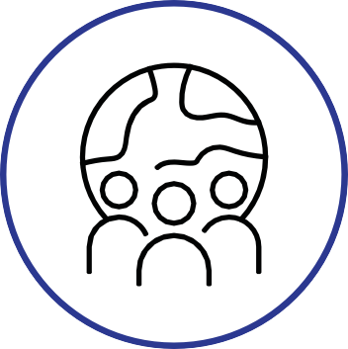
this strategy and share insight, ideas, solutions and challenges.

PROMOTE

HEALTH

AND

LIFESTYLE
Promote healthy lifestyles by sharing local wellbeing opportunities, encouraging others to join, and taking part yourself. Raise awareness of healthy habits, support proactive health management and foster movement and balance at work.

STRENGTHEN

RESIDENT

VOICE
Enable and support residents to create the change, they wish to see. Join or create local resident groups. Share your ideas, co-design solutions, and influence decisions that shape each community.

SHARE

INFORMATION

AND

RESOURCES
Help improve communication by sharing updates about services, events, and support. Use noticeboards, social media, and word of mouth to keep each community informed

.
CHAMPION

COMMUNITY

ASSETS
Support and use local hubs,
community centres, and green spaces. Encourage others to get involved and help make these spaces vibrant, inclusive, and sustainable.

VOLUNTEER

AND LEAD
Become a Community Champion or volunteer for local projects. Your time and skills can make a real difference in reducing inequalities and building stronger network.

