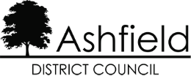

DISCLAIMER

This document or some parts of it may not be accessible when using adaptive technology.

If you require assistance with accessing the content of the document, please contact:

- Email: selectivelicensing@ashfield.gov.uk
- Telephone: 01623 450000 and ask for Selective licensing

Quote the document name and web page you found it on.

