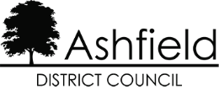

Disclaimer

This document or some parts of it may not be accessible when using adaptive technology.
If you require assistance with accessing the content of the document, please contact Us and quote the document name, website and web page you found it on:
- email: improvement@ashfield.gov.uk
- telephone: 01623 450000




Thank you to everyone who joined our first virtual panel meeting on the 25th February 2026. During the panel, we discussed the new Be Happy Be Healthy Strategy and Community Safety. Please see below the questions
you asked and the answers regarding both topics.
BE HAPPY BE HEALTHY STRATEGY
Are there any other key areas to
focus on?
- Other key areas have been identified and will slowly be added, due to this kind of change taking so long this isn’t a quick process.
What other organisations are involved?
- NHS, Your Health Notts, Active Notts, Social Care and many more.
Is there enough support for mental health? And do people know how to access this?
- Unfortunately, you can’t say if there is enough, however the Council is always happy to guide residents to the available support.
What are the outcomes from the work completed in these key areas?
- We measure outcomes by comparing census data (which only occurs every 10 years) and by gathering our own information and case studies. Also, any work which is externally funded will have its own sets of outcomes that need to be measured and reported on.
Are the road show events allowed to be attended by everyone?
- Yes, anyone can attend.
COMMUNITY SAFETY
Are you looking at enforcement for companies that keep
advertising car boots?
- This is called fly posting. Posters will be removed and the company will be contacted. If it is continued enforcement action can take place.
- If seen placing fly posting a Fixed Penalty Notice of £75 can be issued.
How do CPOs interface with the police?
- There is a very strong relationship between the council and police, we work directly together within a HUB setting, which allows joint working and joint enforcement.
Are the issues in Sutton town centre being ignored?
- Police Dispersal Orders are issued and put in place by and signed off by the Chief Inspector, this normally covers the weekend economy and any periods of high level ASB covering 48 hours.
- Public Space Protection Order (PSPO) provides the Council powers to issue a Direction to Leave Notice, banning a person/s from a location for up to 48 hours.
- Under the same powers (PSPO) Fixed Penalty Notice can be issued for dogs which aren’t under control.
- Rough sleepers and street drinkers are being supported, however there is also enforcement to the most problematic. Injunctions have been gained, banning the individual from the area for up to 2 years. Breaches carry a power of arrest. Works continue.
What’s the difference between fly tipping and littering
- Fly tipping has a fine of £1000 and cases can go to court. Littering carries a £150 fine. Duty of Care offences also come under fly tipping, this being if you arrange removal and disposal which results in the waste being fly tipped, you could be liable for a fine of £400. It is always advisable to ensure the contractor is licenced and registered to carry and dispose of the waste.
Are there regular litter pickers?
- There is a team who litter pick across the district. There is a scheme which is free of charge and lets you sign up to be a local litter picker, and this can be done via our website. There are currently 200 litter pickers.
Are there any plans to have better lighting across the district?
- Lighting is the responsibility of Nottinghamshire County Council however, through partnership and project work it allows the Community Protection Officers and Community Safety team to have a say and give input.
- CCTV- The Community Safety team have over 58 cameras in the district which we manage and fund (the Police also have access). CCTV on new developments will again be subject to costings and partnership working in the same way as the street lighting, this is to secure suitable CCTV Columns so re-deployable cameras can be placed as and when needed, targeting ASB Hot Spots.

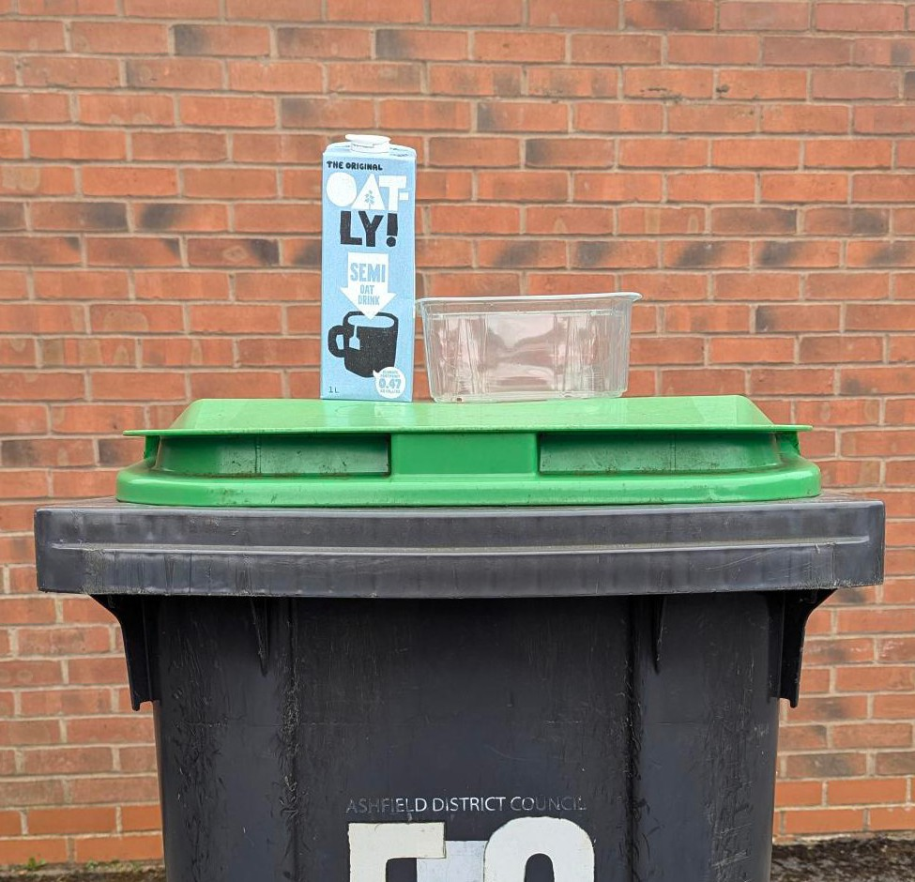


CHANGES TO YOUR RECYCLING
New national rules mean more of your everyday packaging can now be recycled at home, making it simpler to do the right thing.
You’ll be able to recycle a wider range of items, including more plastics, cartons, paper, card and metal packaging, so less of your waste needs to go in the general bin. These changes are designed to remove confusion and make recycling simple.
So, from 31 March, check the updated guidance and start adding those newly accepted items. Together we can keep Ashfield cleaner, greener, and recycling more than ever.
WHAT’S COMING UP?
- We are holding our next panel meeting this September.
- We want your feedback on how to hold this meeting, either via Teams (online), hybrid or in person.
- What topics would you like to
be discussed?
Thank you all for being part of our Citizens’ Panel. Your participation will help us to strengthen the voices of our communities across Ashfield. If you have any questions or topics you would like us to consider, please feel free to contact us.
KEY TOPICS RAISED
From our engagement activities across the District, you have told us what you would like more information on, the key topics were: -.
- Environment
- Regeneration projects
- Keeping updated on recycling changes
- Keeping updated on Local Government Reorganisation
Post – The Policy and Performance Team, Ashfield District Council, Urban Road, Kirkby in Ashfield, Nottingham NG17 8DA
Email - Improvement@ashfield.gov.uk Call - 01623 450000 - quote ‘Citizens Panel’
YOU SAID WE DID
You said you want to hear from the Community Safety team as community safety is a big priority for the community

We invited them to the meeting and allowed panel members to ask questions to ensure they have a full understanding of their role.

You said sometimes getting to in person events can
be difficult due to other commitments

We trialled an online meeting

