Background Paper 4: Green Belt Harm Assessment Addendum
This addendum should be read as a supplementary addition to Appendix 5 [Ashfield Local Plan Examination Library Ref: BP.04a].

Overview
Ashfield District Councill submitted the Ashfield Local Plan 2023 to 2040: Regulation 19 Pre-Submission Draft (Local Plan Pre-Submission Draft) for examination in April 2024.
The Local Plan Pre-Submission Draft was supported by Background Paper 4: Green Belt Harm Assessment (September 2023) [BP.04a].
The Green Belt Harm Assessment provides a robust and transparent assessment of the potential harm of releasing Green Belt land in line with national policy, guidance and case law. It also considers potential mitigation measures to minimise harm (see Chapter 4 of BP.04a).
Appendix 5 of the Green Belt Harm Assessment provides an assessment table and map showing harm rating for each assessed parcel of land within the rural villages in Ashfield.

Purpose of this Addendum
This addendum provides a green belt harm assessment for housing site allocation H1Vj: Land off Main Road, Jacksdale, which has a resolution to approve full planning permission for 81 dwellings subject to the signing of a s106 legal agreement for agreed developer contributions.
The site was not previously assessed as part of the September 2023 Green Belt Harm Assessment and therefore for clarity, and at the request of the Inspectors, this addendum seeks to address this.

Strategic Green Belt Review - Appendix 5: Jacksdale Green Belt Assessment - Site J01 / Site 4 [SEV.07e]
Purpose / Impact | Score (1 – 5) | Justification/Notes  Based on Assessment Matrix and Assessment Criteria (Figures 1 and 2)
Check the unrestricted sprawl of settlements | 5 | - Small part of the western boundary adjoins the existing settlement of Jacksdale.  - Development of this site in isolation would not ‘round off’ the existing settlement.  - The site is well contained. Boundaries are formed by mature hedgerows to the north, east and west (boundaries shown on the 1835 Sanderson’s Map) and Main Road to the south.  - The site has limited visual connection to the existing settlement.  - The land is slopes down from the north towards Main Road in the south.
Prevent neighbouring settlements from merging into one another | 1 | - Development would not extend beyond the existing urban area and would therefore not reduce the size of the gap between settlements.
Assist in safeguarding countryside from encroachment | 5 | - No inappropriate development.  - The site comprises agricultural field.  - The site is open countryside in character.
Preserve the setting and special character of historic settlements | 1 | - Development of the site will have no adverse impact on the setting and special character of a historic settlement.
Assist in urban  regeneration | N/A | It is considered that all sites in the Green Belt assist in urban regeneration. This is not considered to be a matter of difference between Green Belt sites and therefore this Green Belt purpose is not scored as part of the Framework.
TOTAL SCORE | 12 | The score indicates how an area/site performs as a whole when assessed against the 5 purposes of Green Belt (as set out in Greater Nottingham and Ashfield Green Belt Assessment Framework). In general terms a higher score indicates a stronger performing parcel of land.

Background Paper 4: Green Belt Harm Assessment [BP.04a]
Addendum to Appendix 5: Rural Villages – Assessment Table and Map showing harm rating for each parcel of land
Site Address | Site Area (ha) | Release Scenario | Purpose 1 (Unrestricted Sprawl) | Purpose 2 (Prevent Settlements Merging) | Purpose 3 (Safeguard from Encroach-ment) | Purpose 4 (Preserve Historic Settlements) | Purpose 5 (Urban Regeneration) | Overall Harm Score | Overall Harm Rating | Green Belt Assessment Area (* Please refer to Stage 1: SGBR)
Land off Main Road, Jacksdale | 4.19 | Release of H1Vj as an expansion of Jacksdale | High | Low | High | Low | N/A | 10 | Moderate | J01 / Site 4*

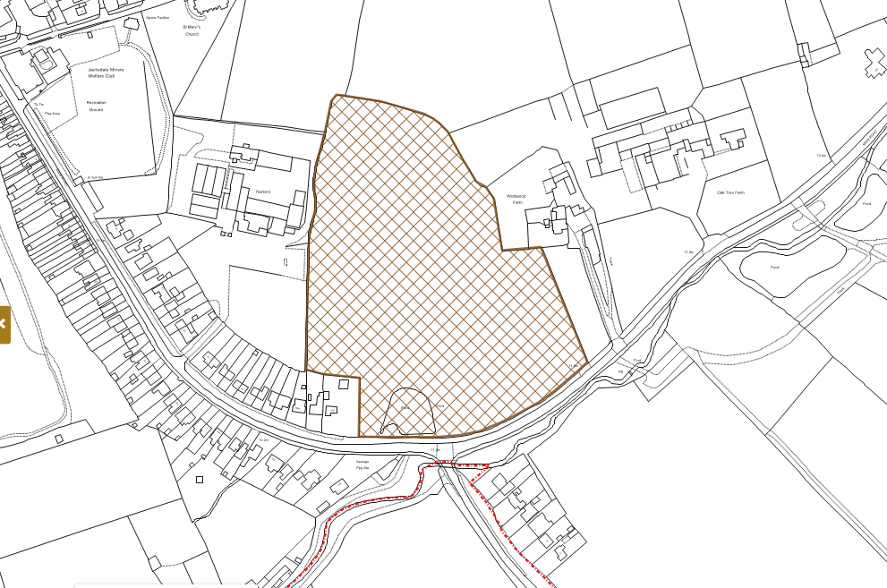
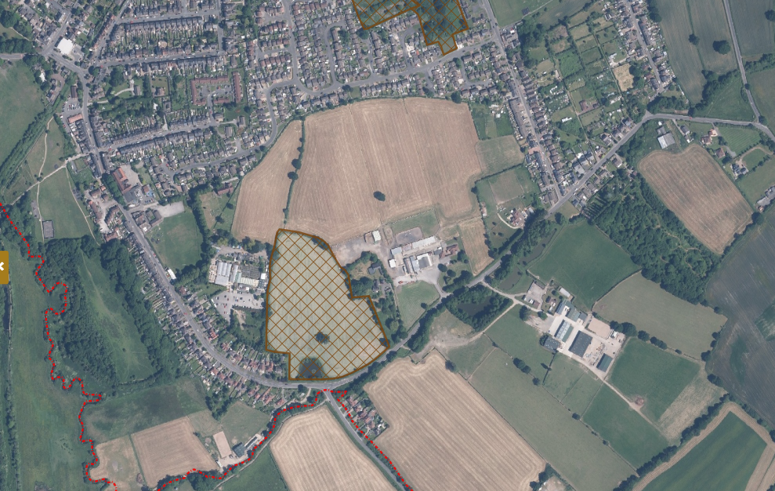
Site Location Maps

