

DISCLAIMER

This document or some parts of it may not be accessible when using adaptive technology.

If you require assistance with accessing the content of the document, please contact us and quote the document name and the web page you found it on:

- email: Regeneration – place@ashfield.gov.uk

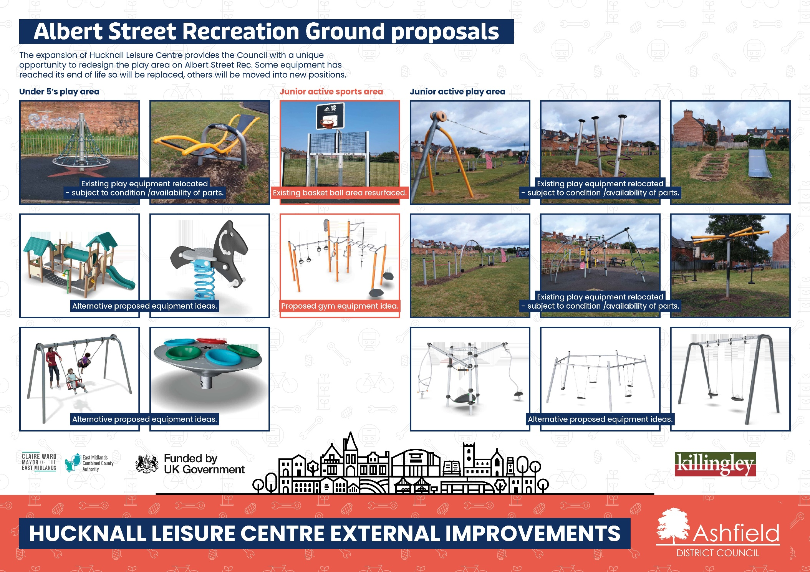

Albert Street Play Area Play and Sports Equipment
The expansion of Hucknall Leisure Centre provides the Council with a unique opportunity to redesign the play area on Albert Street Rec. Some equipment has reached its end of life so will be replaced, others will be moved into new positions. This is your chance to shape what you would like to see here for your family and children to enjoy for years to come.
The plans show a variety of existing and proposed. It shows:

Under 5’s play area:
Existing play equipment relocated - subject to condition /availability of parts:
- Net rotator
- See saw
Alternative proposed equipment ideas:
- Proposed play unit
- Proposed horse springie
- Proposed toddler swings
- Proposed toddler spinner

Junior active sports area:
Existing basketball area resurfaced - subject to condition /availability of parts:
- Ball court - resurfaced
Alternative proposed equipment ideas:
- Proposed gym station

Junior active play area:
Existing play equipment relocated - subject to condition /availability of parts:
- Cableway
- Climbing poles
- Titan rotator
- Trim Trail
- Embankment Slide
- Junior Climbing, existing and proposed
Alternative proposed equipment ideas:
- Proposed Junior swing options

