



Tenant Handbook February 2025



Contents
Welcome to your new home 3
Moving in 4
Rent 6
Repairs and Maintenance 8
Recharges 14
Major improvement works 18
Looking after your home 20
Health and Safety 21
Frequently asked questions (FAQ) 22
Anti-Social Behaviour (ASB) 23
Getting involved 24
Moving on 25
Housing complaints 27
How to contact us 30

Welcome to your new home
We want you to enjoy living in your home and we strive to provide you with the best service possible.
Ashfield District Council is constantly looking at ways to improve services and we welcome any comments or feedback on the services you receive. Details of how you can do this can be found within this handbook. This handbook contains information about your tenancy and the services you will receive as a tenant. It also contains useful advice and information. If you need any information that is not covered in this handbook or you do not have access to the internet, please contact our Tenant Engagement Officer on 01623 457590.

Your tenancy
When you signed for your tenancy, you will have a signed a legal contract, a ‘Tenancy Agreement’. This is the contract between you and the Council when you occupy a Council property and sets out your rights and responsibilities as a tenant and the Council’s rights and responsibilities to you as a landlord. For more detailed information, please refer to your Tenancy Agreement.

If you require any clarification on anything in your Tenancy Agreement, please contact your Housing Officer on Tel - 01623 450000.

Reporting a repair
If you need to report a repair, please report this online at
- www.ashfield.gov.uk
- email adcrepairs@ashfield.gov.uk
- telephone 01623 457999.
See pages 8 to 13 for more information on priority repairs and timescales and how to report emergency repairs.

What standard of service can I expect?
For each of the housing departments, there is a service standard. The service standards outline the services we will provide to tenants. To see all the service standards, please look on our website at
www.ashfield.gov.uk. These can be provided in other formats upon request by emailing coin@ashfield.gov.uk or by contacting our Tenant Engagement Officer on 01623 457590.

How do I make a complaint?
We aim to provide a quality service for all our tenants, however there will be times when things go wrong. You have the right to complain when you are dissatisfied with the service that you have received. Details of how to make a complaint can be found on pages 27 and 28.

Right to view information
Under the General Data Protection Regulations 2016 (GDPR) you have the right to see information that the Council holds about you. You can request information on data held about you by submitting a subject access request form. The form can be downloaded from our website at www.ashfield.gov.uk. For further details please email foi@ashfield.gov.uk.

3 Tenant Handbook 2025

Moving in

Your keys
We do not keep a spare set of keys for your home. If you lose them, it is your responsibility to replace them and pay for any lock changes. If you want to fit extra locks to your doors or windows, you will need to apply for written permission first.

Contents Insurance
We will insure the cost of rebuilding your home, but you are responsible for insuring your possessions including furniture, carpets, curtains, flooring and decoration.
Remember it is important that you arrange contents insurance for your new home to cover your belongings in the event of any unforeseen emergencies such as accidental damage,
a break-in, fire, or flood. Most insurance companies will give you a free quote.

Gas and Electricity Supply – when you move in
The heating system and electrical supply in your new home may have been capped off or isolated and may not be working, our Lettings Team will advise you if this is the case when you sign for your tenancy. In these circumstances, an engineer(s) will need to visit your home and get the services working for you.

You will need to contact the existing utility suppliers (gas - if applicable, electricity, and water) for the property with the following information:
- A meter reading
- The date your tenancy starts
- Your name and address

Your supplier will want to discuss your payment method with you e.g., Direct Debit, Card meter etc. The supplier will then register the accounts in your name.

If you have previously been responsible for the payment of utility supplies at your previous address, you will also need to provide details of your new address and a final meter reading at that property, to the utility company that was providing these services.

Useful links and numbers to find out the current gas and electricity suppliers to the property include:

Cadent (National Gas Transporter)
Tel - 0800 389 8000
- Find my Supplier websites – online
- National Grid Tel - 0800 096 3080

Please note, if you are going to be using a card meter for gas, an engineer from the gas
company will usually need to meet you at your new home to download the previous supply.
This will be arranged when you contact the new supplier.

If you are going to be using a card meter for electricity, your supplier may send you a
plastic payment card or key through the post, along with a list of agents for you to purchase further electricity from in the future. This can take a number of days. While you are waiting for these cards to arrive, you will be given a customer reference number to quote when purchasing electricity.

Once the accounts are set up and running in your name, please contact our Repairs Call Handling Centre on 01623 457999 to make an appointment for an engineer to visit you at your new home to get your services working. This is called a ‘recommission’. Once the account is set up there must be sufficient credit on your meters (where applicable) for the recommission to take place. The engineer(s) will also show you how to work your heating system efficiently.

Moving in

Installation of Gas/Electric Cookers
Ashfield District Council can connect cookers for new tenants of Council properties*. This is a discretionary free of charge service, subject to certain conditions. Your home must have the appropriate cooker point and relevant cooker installation manuals available for the work to be carried out. This means that we can only fit a gas cooker to an existing gas point, and an electric cooker to an existing electric cooker point. Ashfield District Council will not make any kitchen alterations to accommodate your cooker. We recommend that you check the manufacturer’s instructions to ensure your chosen appliance specification is compatible with the space provided. * This could be subject to change at any time.

Please note it is the tenant responsibility to arrange for the maintenance and servicing of the cooking appliances in accordance with the manufacturer instructions.

Ashfield District Council accept no responsibility for any maintenance and servicing of tenant’s own appliances.

Any new cookers installed within a multi occupancy building will require an appliance with a Flame Safety Device (FSD) incorporated.

Please contact the Repairs Call Handling Centre on Telephone – 01623 457999 to arrange for this work
to be done. If you do not have a point already
fitted, then you will have to have the cooker fitted by a gas or electric registered contractor and this will have to be done at your own expense. You will need to apply to us for written permission first and comply with any conditions that we tell you about.

Sheltered Housing Courts with Lifts
When you move into your home, we will undertake
an evacuation ability assessment. Tenants will be
expected to advise us of any changes to
personal circumstances after this initial assessment.

Decoration Voucher Scheme
You may be given decoration vouchers when you sign up for your tenancy. Decoration vouchers can be used to purchase decorating materials and associated decorating tools such as paint, wallpaper, paste, paintbrushes, rollers, scrapers, etc. Details of how to spend your decoration vouchers and the expiry date they should be used by will be provided by the lettings team when the vouchers are issued.

Repairs When Let
All electrical and gas fittings will have been checked before you move into your new home.
Occasionally there may be some repairs awaiting completion until you have moved in, we will notify you of these, we call these ‘repairs when let’.

New Tenancy Visit
Within the first six weeks of you moving into your new home, a Housing Officer or Tenancy Sustainment Officer will visit you to check that you have settled in. It is important to ensure you are available for the visit as the officer will be able to answer any queries you may have about your tenancy and the services provided by the Council.

Rent

When you accepted your tenancy, you signed a legal agreement to abide by the terms and conditions laid out in your Tenancy Agreement. This included ensuring that your rent is paid on time every week.

When to pay your rent
Your rent and service charges are due every Monday for the forthcoming week. If you want to pay your rent fortnightly or monthly, payments must be made in advance.

Paying your rent must be your first financial priority. If you do not keep your rent payments up to date, you could lose your home.

Rent Statements
We will normally send you a rent statement twice a year. These show you when you rent is due, how much you have paid and the balance on your rent account. You can view your rent balance and payments made at any time via the Tenants Portal, which you can register for. Please see https://www.ashfield.gov.uk/housing/your-tenancy/tenant-portal/ for further details.
If you have any queries or need a statement at any other time, please contact us.

Rent Calendar
A rent calendar shows the dates that you need to pay your rent and the rent ‘catch up weeks’ which are weeks where no rent charged, but
if you have rent arrears, you will be expected to pay during these weeks to clear your rent account.

The rent calendar is available on our website at https://www.ashfield.gov.uk/housing/your-tenancy/pay-your-rent/.. If you would like a paper copy, please contact the Income Team on 01623 450000 via email at income@ashfield.gov.uk.

Rent increases
Any rent increases (this includes service charges) will normally take place in April of each year. The Council will write to you at least four weeks in advance to advise of any changes to the amount of rent and service charges you will need to pay.

How to pay your rent
You can pay your rent for your home by:
- Direct Debit - taken in weekly, fortnightly or monthly instalments; whichever suits you. Setting up your payment is quick and easy, please contact the Income Team on Tel - 01623 450000
- Paying online – via our e-store. To make your payment you’ll need your rent account reference number and paying online will take less than 5 minutes. Your rent account reference number can be found on any correspondence sent to you regarding your rent account, including rent statements and
annual rent variation letters. If you are unable to locate this information, please contact the Income Team on Tel - 01623 450000. Remember when you pay online to make a record of the transaction reference number.
- Telephone - using a debit or credit card on our 24-hour automated payment system
(freephone) Tel - 0800 0902223
- Standing Order – We can send a Standing Order form for you to complete, which you can then take to your Bank or Building Society. You can also set up standing orders or make ad-hoc payments directly with your bank or via your online banking service, using the bank account details below. Our details are:

Account name: Ashfield District Council Sort code: 20-55-70
Account number: 03619389

Please ensure that you use your rent account reference number only, as your payment reference to help us process your payment
- Pay Point Card – at any Post Office branch or at selected shops and garages displaying the Pay Point symbol. You will need a swipe card to pay this way.

For further details of how to pay or to set up direct debit payments, please contact the Income Team on Tel – 01623 450000 or email: income@ashfield.gov.uk

Rent

Accessing your tenancy details online via the Tenant Portal
The Tenant Portal is a quick and easy way to view information regarding your rent account, including generating rent statements and making payments. The Tenant Portal can be accessed online 24 hours a day, 7 days a week via our website on a smartphone or computer. You can also use the Portal to report repairs, view repairs history and contact officers within the housing team regarding your tenancy.

To register for this service visit https://www.ashfield.gov.uk/housing/your-tenancy/tenant-portal/. You’ll need to know your rent account reference number and have provided the Housing department with your email address to create a log in.

Your rent account reference number can be found on any correspondence sent to you regarding your rent account, including rent statements and annual rent variation letters. If you are unable to locate this information, please contact the Income Team on 01623 450000.

Difficulties in paying your rent?
We understand that sometimes people experience financial difficulties. If for any reason you are unable to pay your rent and/or service charges, you must contact your Income Officer immediately. It is an obligation of your Tenancy Agreement that you pay your rent when it
is due. The longer you leave it, the worse the situation will get.

We have money management advisors who can offer you support, and advice and we will try and reach a repayment agreement so that you catch up with payments. Most problems can
be resolved easily and quickly, without the need for legal action.

If you do not contact us or fail to keep to any arrangements, we will take legal action against you.

What happens if you refuse to pay or cannot pay?
If you do not pay your rent on time, you will be in rent arears. We will take action to recover arrears.

Please get in touch with us before this situation is likely to occur as we do not want you to fall into arrears and we are here to help.

If we have to take action to recover these arrears we may:-
- Write to you – to tell you how much you owe and to ask you to pay or contact your Income Officer to make a repayment agreement.
- Call you or visit you – to discuss the arrears and the way forward.
- Serve a ‘Notice of Seeking Possession’ or ‘Notice of Possession Proceedings’ - This is the first stage of court action and if it gets to this stage, you may be at risk of losing your home. You may be able to still stop further action by contacting us to pay the arrears in full or making a repayment agreement.
- Take you to Court - Failure to pay or make a repayment agreement will result in us taking you to court. We may request a suspended possession order or an eviction. You will still be responsible for the arrears and any court costs.

We will always give you a chance to pay your arrears. Income Officers will be able to provide you with the support you need to resolve the issue. They can also make an appointment with a Money Management Advisor.

Please remember it is best to speak to us as soon as you can, so we can help resolve any issues.

How do I report a repair?
If you need a repair, please report this as soon as possible to our Repairs and Maintenance Section. Please try and give us as many details
as possible. We may ask you several questions to find out as much information as we can.
You can contact us in the following ways:
- Online via the Tenants Portal. Please see page 7 for details how to register for the portal
- By completing an online ‘request a repair form’ www.ashfield.gov.uk
- By telephoning 01623 457999
- By e-mail to adcrepairs@ashfield.gov.uk

If you are not sure who is responsible for the repair i.e., yourself or Ashfield District Council, please contact us and we will advise you.

When are we open?
The Repairs Call Handling Centre is open Monday to Friday 8.00am to 5.00pm for the reporting of all repairs and maintenance issues.

The Repairs and Maintenance service operates Monday to Thursday 8.30am to 4.30pm and Friday 8.30am to 4.00pm.

Outside of normal working hours we offer a ‘make safe’ repair service. (see page 11 for what repairs are considered an emergency priority). Emergency
repairs can be reported in the normal way by contacting Tel – 01623 457999.

How will we diagnose the repair?
If the repair is straightforward or an emergency, we may be able to diagnose the required repair over the telephone by asking you a series of questions or refer you to our ‘guide to videos’ which can be found on our website.
If we cannot diagnose the required repair with you over the telephone, we will arrange to send a Repairs Technician to your home.

If your repair request is complex or you require advice of a technical nature, a Housing Surveyor will visit you first so that the correct diagnosis can be made, and the relevant works order raised. The Surveyor can visit your home at your convenience, by appointment.

Any repair appointments can be arranged by contacting the Repairs Call Handling Centre on Tel - 01623 457999.

Who will carry out the repair?
Most repairs conducted within your home will be completed by our Repairs Technicians, but for some specialist repair work or during busier periods, it may be necessary for an approved contractor to conduct the work on our behalf.

All our employees and contractors always carry ID cards, therefore if you are in any doubt about the identity of the caller to your home, please do not hesitate to contact our Repairs Call Handling Centre on Tel - 01623 457999 to check this.

PLEASE REMEMBER - “IF YOU’RE IN DOUBT, SHUT THEM OUT”.

Our Repairs Technicians will also provide dust sheets when needed and wear overshoes if necessary. Please be aware that our Repairs Technicians will not be able to remove their shoes when entering your home due to Health and Safety Reasons.

Appointments
If our Repair Technicians need to get access into your home to complete repair work, you will be offered an appointment at your convenience (subject to availability). Unfortunately, we cannot provide you with a specific time when we will be visiting your home.

Our appointments are scheduled all-day between 8.30am – 4.30pm Monday to Thursday and 8.30am – 4.00pm Friday. However, on request we may be able offer morning/afternoon and school run appointments (9.30am and 2.30pm).

All appointment requests are subject to the type of repair and availability.

For urgent and routine repairs, we will send a text message to confirm your appointment
has been scheduled, and then an appointment reminder the day before your appointment.

Please keep your appointment
Once an appointment has been made, it is important that you are at home on the arranged date and time when one of our Housing Surveyor/Repairs Technicians visits. If you are not at home at the time of the visit, a visiting card will be left indicating that we were unable to complete the necessary repairs, as arranged and the work order will be cancelled.

If you still require the repair to be completed, please contact the Repairs Call Handling Centre on Tel - 01623 457999 to arrange another appointment.

What if I cannot be at home as arranged?
If the appointment is not convenient, you may change it by contacting the Repairs Call Handling Centre on Tel- 01623 457999, or by using any of the other methods of contact outlined earlier.

Emergency repairs
If you have a genuine emergency outside of office hours, you can contact the council’s emergency repairs team. They can only help in an emergency. The telephone number is 01623 457999.
If you provide us with false information or the repair is not an emergency, you may be re- charged.

Please note it may not be possible to complete a full repair, and a temporary or make safe repair will be completed.

What do I do if I smell gas or my CO alarm sounds?
Gas leaks are initially dealt with by National Gas Emergency Helpline0800 111 999. If you think you can smell gas, please take the following steps:
- Turn gas off at the mains (do not turn back on until engineer has visited and has confirmed it is safe to do so)
- Turn off all gas appliances
- Extinguish all naked flames
- Do not turn electrical switches on or off or use any electrical appliances.
- Open doors and windows to ventilate the property
- If you have a door entry / intercom system, open the door manually.
- Do not smoke
- Do not use anything that may be a source of ignition such as matches or lighter etc.
- Keep pets and animals safely contained
- A National Gas Transporter Emergency Service Engineer should attend within two hours to make your home safe and advise you what to do next.
- Immediately call Ashfield District Council once the Engineer has visited to enable us to arrange the relevant follow up work.

If you inform us of any suspected gas leaks, we will immediately inform the National Gas Transporter on your behalf before proceeding with any repairs.

What do I do if my CO alarm sounds?
If your Carbon Monoxide (CO) alarm activates, contact the National Gas Emergency Helpline on 0800 111 999.

Please contact the Repairs Call Handling Centre on 01623 457999 after the National Gas Transporter has visited your home.

If you suspect you have carbon monoxide poisoning:
- get fresh air immediately
- open all doors and windows to ventilate the area
- switch off any appliances and leave the house
- get medical attention and make sure you tell them you think you have carbon monoxide (CO) poisoning so they can give you the right tests and treatment.

If there is an immediate danger from a gas appliance telephone 0800 111 999.

What do I do if I have no electricity?
Before you contact the Repairs Call Handling Centre, please first check your electrical consumer unit to ensure that none of the circuits have tripped and require resetting. If you have a prepayment meter, please check credit has been topped up.

Before resetting the trip or reset switch, unplug any appliance that might be faulty. Usual problem appliances include kettles, Irons, toasters and washing machines.

If you still have no electricity supply after completing the above steps, please ring the Repairs Call Handling Centre on Tel - 01623 457999.

For advice on area power cuts please contact National Grid Telephone - 0800 6783105 or visit their Live Power Cut Maps on their website.

How long will I have to wait for a repair?
The time taken to complete repairs depends on the sort of problem you have. We have different categories ranging from emergencies where there could be a danger to life or property,
to non-urgent repairs like cleaning your gutters. We always try to work flexibly with our customers and in some circumstances, we may attend to your repair sooner than the priority target.

Please advise us of any circumstances or vulnerabilities you consider we should be aware of, in order for us to offer you a service suitable to meet your individual needs.

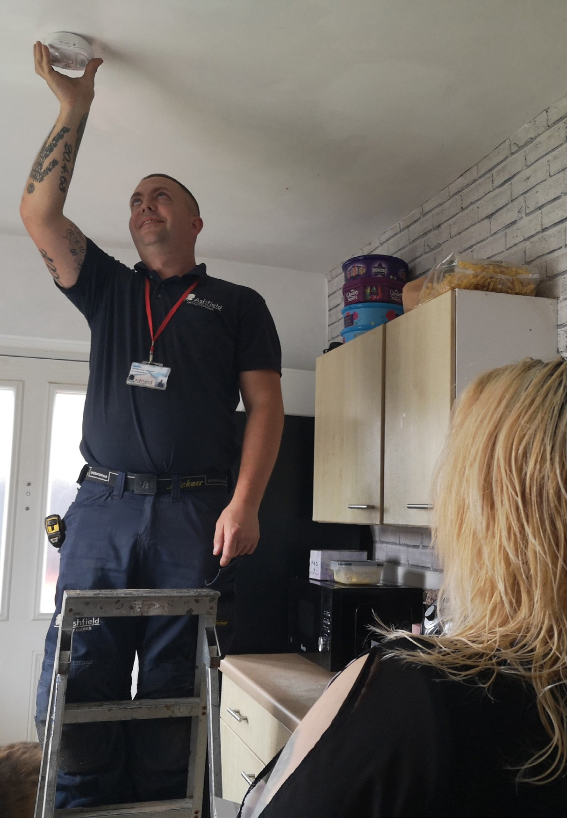
The priority of repairs is shown below (lists are for example only and not exhaustive): -

Priority 1 – Emergencies Where We Will Visit Your Home Within 24 Hours
This is where there is likely to be a danger to life or major damage to the property or surrounding homes. We will try to get to you as quickly
as possible to make the situation safe. The complete repair might take longer to carry out. Examples of Priority 1 repairs include:

- Total or partial loss of gas supply (where there is currently a working supply)
- Total loss of water supply (where there is currently a working supply)
- Total loss of heating between dates 1st November to 30th April
- Blocked flue or chimney to an open flued appliance
- Blocked or leaking drain or sewer (not gully’s) (please note you may be asked to refer this to Severn Trent Water in the first instance)
- A toilet that cannot be used – but only if there is no other working toilet in your home
- Severe leaking water or heating pipe, tank, cistern or toilet
- Tap or overflow running full bore
- Make safe insecure window, external door or external locks. Lost keys are the responsibility of the tenant
- Rotten timber flooring or stair tread causing potential health and safety hazard (our initial action will be to make safe and secure)
- Faulty staircase and corridor lighting in blocks of flats or sheltered accommodation (unless adequately lit by other sources)
- Dangerous structures such as loose cast iron rainwater gutters, unsafe chimney stacks or roofs
- Dangerous electrical wiring, sockets or switches
- Total loss of electric power (where there is currently a working supply)

Priority 3 Where We Will Visit Your Home Within 3 Working Days
This is for urgent repairs that do not fall into priority 1. These include:

- Total loss of heating between dates 1st May to 31st October
- Partial loss of heating between dates 1st November to 30th April (partial loss of heating is considered to be more than one radiator not working on the same level within your home or more than two in total).
- Partial loss of hot water (one tap left working only)
- Leaking water or heating pipe, tank, cistern, toilet (dripping or slight)
- Blocked bath or shower waste
- Repair or replace smoke or CO alarms
- Loose or detached banister or handrail for stairs
- Electric shower or shower pump not working - and this is the only form of bathing

Priority 7 Where We Will Visit Your Home Within 7 Working Days
These are for urgent repairs that do not fall into priority 1 or 3. These include:

- Electrical fitting not working but it is not a danger to health or safety
- Leaking hot water tanks and other sanitary or water appliances, not dealt with under priority 1 or 3 – i.e. a leaking tap which can be contained
- Partial loss of water, one tap not working
- Taps dripping
- Blocked sink or basin
- Overflow dripping
- A toilet that cannot be used – where there is another working toilet in your home
- Holes in a roof where rain is coming in (weather permitting for health and safety reasons)
- Partial loss of heating between dates 1st May to 31st October
- Extractor fan is not working
- Door entry system is not working

Priority 30 Where We Will Visit Your Home Within 30 Working Days
These are non-urgent repairs, which include:

  - Sanitary or water appliances that need replacing but are not leaking
  - Re-hanging easing or replacing internal doors and fittings if effected by rot or woodworm, or due to fair wear and tear
  - Letterboxes
  - Weatherboards
  - Window repairs including broken glass in windows and doors where we are responsible for the repair (our initial action will be to make safe and secure)
  - Kitchen units – replacement and repairs (individual units)
  - Repair garage doors and frames
  - Non-urgent floor repairs
  - Non-urgent roof tiling (small areas)
  - Skirting boards
  - Rainwater gutters and fall pipes that are leaking
  - Non-urgent electrical works

Priority 90 Where We Will Visit Your Home Within 90 Working Days
This is for non-urgent routine maintenance work or other specialist work, which include:
  - Major joinery repairs
  - Complete replacement of garage doors
  - Replacement gates that are the Council’s responsibility
  - Repointing works or rendering brickwork (small areas)
  - Washing line posts
  - Plastering Repairs
  - Garden walls and fencing (small areas)
  - Concrete footpaths and drives (small areas)

Priority 249 Where We Will Visit Your Home Within 249 Working Days
This is for annual planned maintenance, large works, or other specialist work. These include:
- Maintaining common areas
- Outhouse store doors
- Large scale fencing, pointing and brickwork, Roofing, paths and paved areas etc.
- Complete overhaul of rainwater gutters and pipes
- Chimney stack pointing

Aids and Adaptations

We may undertake a range of aids and adaptation works at your home, but these will be subject to finance and resources. In the vast majority of cases these works will only be considered following receipt of an Occupational Therapy referral.

If you have a disability or have serious health issues, we may be able to adapt your home so you can live safely and independently. We may require specialist advice or a referral from an Occupational Therapist at Nottinghamshire County Council. They can be contacted on 0300 500 8080.

Works include:

Minor adaptations
- Grab rails
- Additional stair rails
- Half steps
- Key safes

Large scale adaptations
- Access ramps
- level entry showers
- Stairlift installations

Major adaptations

Property extensions / alterations

What Happens if the Repair is Not Done Within the Timescale?
You should telephone our Repairs Call Handling Centre on Tel 01623 457999 if the repair is still outstanding, unless you have been provided with an appointment.

Your Right to Repair
You have a legal right to arrange your own repairs under the Right to Repair Scheme – but only if we fail to repair something within set time periods. You must have also allowed us reasonable time to gain access into your home to complete the work.

In general, the Right to Repair Scheme ensures that small urgent repairs which might affect your health, safety or security are carried out quickly and easily. Not all repairs ‘qualify’ under the scheme.

What is a Qualifying Repair?
A repair only qualifies for the Right to Repair Scheme if the cost is less than £250.
When a repair is reported, if you request the information, we will advise you:
- How long the repair will take
- If the repair qualifies under the scheme
- What to do if the repair is not completed within the time stated
- The name of the contractor if one is to be used
- The arrangements made with you to carry out the repair
- Any other details relating to the repair

The rules in relation to the Right to Repair Scheme are complex so please contact our Repairs Call Handling Centre first on 01623 457999 - otherwise we might not pay the bill.

I want to make alterations or Improvements to my home. What do I do?
You must obtain our written permission before making any alterations to the property. You will need to provide us with the details of the work that you want to do and who will be doing the work. The work must be carried out at your own expense.

We will offer you technical advice regarding health and safety and the standards of work that we expect.
Please also be aware that your proposed work to your home may also need planning and building control permission before you begin.

We also offer a home improvement scheme whereby we can undertake certain works on your behalf at a cost to yourself.

Permission may be withheld when there is the likelihood to invalidate existing warranties or guarantees. This includes properties with external insulated render, with an associated
25-year guarantee, which would be invalidated if work is not carried out by an approved contractor. Also, if your home has previously benefitted from an adaptation, for example, a level access shower, permission to remove these items may be refused.

We are not responsible for carrying out repairs to your alterations or improvements which are required because of faulty fittings, substandard workmanship or defective materials, unless required by law.

Inspecting your alterations and improvements
Whether you have received our written permission to undertake alterations or you have completed repairs as part of your Right to improve, we may need to inspect the repair, alterations or improvements once completed to ensure that these are of a satisfactory standard. Please let us know when the work has finished. Subject to obtaining written permission for improving your home you may be entitled to compensation for costs incurred if you leave your home.

Recharges & Responsibilities

Recharges when vacating your home
Where it has been identified that a tenant has caused damage to their home or neglected their garden, undertaken unauthorised alterations without prior permission, alterations that are not to a satisfactory standard or left possessions and/ or rubbish behind when vacating, we will seek to recover from the tenant, the costs incurred/ needed to rectify the damage/and or issues identified.

What if I have applied to buy the property?
Once you have submitted a Right to Buy application, we will continue to carry out essential repairs to your home during the application period. Your home is valued following receipt of your Right to Buy application form and the valuation reflects your homes condition at this time. Consequently, once you have applied to buy your home no improvements or non-urgent repair work will be undertaken to your home and your home will be withdrawn from any planned maintenance programme.

We will not undertake major works such as replacing the roof covering, replacing windows, bathrooms or kitchens while the property is subject to the Right to Buy application. Please note that once you have purchased your
home, all outstanding repairs will be cancelled, even those which were requested before you commenced the Right to Buy process.

If you decide not to purchase your home, please ensure you contact our Right to Buy Officer on Tel – 01623 457500.

Once your withdrawal has been confirmed, you will also need to contact our Repairs Call Handling Centre on 01623 457999, with regards to any potential repairs that you may need to
report or to discuss any previous planned works that may have been cancelled following your application.

What are we responsible for?
We have a duty to maintain and repair:
- The structure and outside of your home; and
- The fittings inside that we have installed, Including the water supply, sanitary fittings, gas, electricity and heating appliances

What are you responsible for?
You must take care of your home and replace/ repair any damage caused by you, your family, visitors or even your pets. In some cases, we are willing to carry out repairs and charge you the cost. Before you undertaken any alterations, to the fittings, build extensions, undertake DIY repairs (however minor), you must request prior permission.

Depending on what works you are requesting you may receive a visit from one of our Officers who may be able to provide you with advice and guidance on what you would like to do to your home. We will always confirm permission in writing and make clear what will be your responsibility. If you do not have our written permission before undertaking any alterations, you will be responsible for them and may need to put any alterations back to standard at your own expense.
In General, you are responsible for:
- Promptly reporting repairs when they are needed and taking reasonable precautions to prevent further damage. For example, you should place a bucket under leaks or remove any personal belongings to prevent further damage. You can contact the Repairs Call Handling Centre on Tel 01623 457999.
- Allowing our employees to promptly complete their work, for example, keeping children and pets out of their way and by removing furniture or belongings from the area they are working in. Employees may assist, but we will not accept responsibility for any damage caused in this process.
- Ensuring that you protect and cover furniture or carpets before work starts. Employees may assist in some circumstances, but Ashfield District Council accept no responsibility for damage. We will not accept responsibility for any damage caused during this process.
- Take responsibility for appliances or fittings that you have installed including maintaining any improvements or alterations you have made.
- The repair of any damage, accidental or not, which you, or members of the household, pets or visitors, cause.
- Heating and ventilating your home to reduce high levels of humidity than can lead to condensation and mould growth (please see page 20 for further information on the control of condensation).

As a Tenant, you should be aware that it is your responsibility to arrange for home contents insurance for your possessions.

Responsibilities

Outside of Your Home - Your Responsibilities:
  - Glazing (unless a crime number is obtained)
  - Non-standard gates
  - Lost or broken keys
  - Gully grids
  - Keeping Gullies free from debris and fats (you may be recharged for the visit if such items are found to be causing the blockage, this list is not exhaustive)
  - All garden maintenance

Inside Your Home - Your Responsibilities:
  - Internal timber such as skirting board, picture rail, Wooden airing cupboard panels, frames and shelving and internal doors (unless affected by rot or woodworm)
  - UPVC or tile windowsills
  - Ironmongery and threshold strips
  - Minor repairs to plasterwork, such as cracks and small holes (under 6 inches or 150 mm square)
  - All decorating inside your home
  - Bath panels
  - Plugs and chains to washbasins, sinks and baths
  - Chains to toilets and toilet seats
  - Internal pipework boxing
  - Replacement shower curtains
  - Sweeping chimneys and cleaning flues if you have solid fuel appliances. These should be done regularly once or twice a year.
In addition, only use appropriate fuel as defined within the Clean Air Act 1993 (further information can be located on our website)
  - Cookers / appliances
  - Electric plugs and light bulbs – including strip lights and bulbs to electric fires
  - Independent battery-operated smoke alarms
  - Plugs to appliances
  - Electric meter and supply of electricity
  - Supply of gas and gas meter
  - Monthly testing of smoke and carbon monoxide alarms (You must report defective alarms promptly to our Repairs Call Handling Centre)
  - Utilise the installed heating appliances within your home

Please do not drill holes in UPVC windows, they can cause serious damage.

If you consider you require any support or advice regarding your responsibilities or if there are
any vulnerabilities that we need to be aware of, please contact the Repairs Call Handling Centre on Tel 01623 457999 and we will try and resolve any difficulties you may have.

Will you move my furniture or carpets when carrying out a repair?
We may make arrangements for moving furniture and carpets (but not fitted carpets) for elderly tenants and tenants with disabilities where there is no other support available, i.e. family members etc. We may also help move heavy items for other households; however, we will not accept responsibility for any damage caused during this process. We will also provide you with reasonable notice of repair appointments so that you can clear areas of
your home of your belongings and fitted carpets before works start.

Am I responsible for decorating the property?
You are responsible for decorating the inside of your home and we expect you to keep it in a
reasonable condition. If you remove any fittings such as radiators or doors during the course of your re-decoration, then it is your responsibility to ensure that these are re-fitted correctly
and to rectify any repair issues that may have occurred as a consequence.

If you are about to remove wallpaper and the plaster beneath appears loose, contact the Repairs Call Handling Centre on 01623 457999, before it comes away from the wall. If you use a wallpaper steamer, we recommend that you do so with care as if you remove the plaster totally you may be responsible for its replacement.

We advise tenants not to Artex walls or ceilings, as removing it later can mean having to re- plaster walls which you may be responsible for, or for which we may re-charge you the costs. If you plan to remove Artex or textured finishes
from your ceilings or walls, please contact us first so we can check it doesn’t contain any hazardous substances.

Tips and Advice

What do I do if any pipes freeze?
If a pipe freezes, turn off the main stop tap or sure stop switch, if one is fitted to your home. This is usually under the kitchen sink or near to where the mains water supply enters your home.
Turn on all cold taps throughout your home.
As long as you have been using your heating boiler every day, it is quite safe to continue to do so. It will help to defrost the affected area.
If you know where the pipe is frozen, you can put hot water bottles on it. You can also use a fan heater or hairdryer to try and thaw the pipe. Never use a naked flame

For further advice or help, contact our Repairs Call Handling Centre on 01623 457999.

What do I do if a pipe bursts?
Turn off the main stop tap or sure stop switch.

Contact our Repairs Call Centre Handling Centre on 01623 457999.

If the burst is on a pipe leading from a storage tank, try to stop the water flowing out of the tank, or catch the water in buckets.

If you cannot stop the flow of water, open all taps to drain the system.

Remember to collect water in the bath for washing and flushing the toilet.

Electrical Safety - tips
Water and electricity or electrical appliances are dangerous together, do not use switches with wet hands.

Regularly check electric cables and flexes to make sure they are not worn or damaged.

Do not carry out any DIY wiring which can lead to electrical parts overheating, causing fires, shocks and or even death.

Do not overload sockets by plugging too many devices into one socket and over-using extension leads as this can lead to overheating and potential fires.

All new electrical appliances are supplied with a new sealed plug, where possible do not break
the seal. We would recommend only purchasing electrical goods from reputable suppliers that meet the correct safety standard. If you have children use plugs with part insulated pins and place plug blanks into sockets when they are not in use.

If one of your circuit breakers ‘trips’ and you are left without power or lighting, switch off the light you may have just tried turning on or in the case of losing power, unplug any appliance that may be faulty before resetting the trip switch.

Please allow us to carry out electrical inspections to ensure your home remains electrically safe, if you are unsure or require advice, call our Repairs Call Handling Centre on 01623 457999.

Visit our website for more advice and tips.

Planned and Cyclical Maintenance

Planned and Cyclical Maintenance
To ensure value for money, non-urgent repairs, especially larger work and the complete replacement of elements (external doors and
frames, concrete footpaths, large fences, etc.) will be collected together and completed in batches.

Such work is placed into a relevant planned and cyclical maintenance programme of works so that it can then be completed as a batch.

This reduces the cost of repairs and maintenance and allows us to complete more repairs for the same amount of money.

If you have any queries regarding this type of maintenance, please contact our Repairs Call Handling Centre on Tel - 01623 457999.

Annual servicing and inspections
Ashfield District Council is committed to the health, safety, and welfare of Ashfield District Council Tenants. As a Gas Safe Register and NICEIC (or a registered accreditation scheme), all domestic dwellings benefit from our Annual Property Health and Safety Check/Service (PHSC/S).

Every tenant’s home is visited annually by a specialist qualified engineer who will complete, by appointment, a full Property Health, and Safety Check/Service.

FAULTY GAS OR SOLID FUEL APPLIANCES CAN GIVE OFF CARBON MONOXIDE. THIS GAS CANNOT BE SEEN, TASTED, OR SMELT BUT
IT CAN KILL YOU! FAULTY APPLIANCES CAN ALSO CAUSE EXPLOSIONS!

The Property Health and Safety Check/Service includes (if applicable):
- Gas service/safety check
- Solid fuel service/safety check
- Smoke / Carbon Monoxide Alarm service/test
- A Domestic Electrical Installation Condition Report (Electrical Test)
- Unvented Hot Water Cylinders, Storage Heaters, Heat Recover Unit, or Heat Pump
- Any necessary remedial works discovered during the visit

You will be contacted in writing, with plenty of notice, to allow you to make a convenient appointment with our Property Health and
Safety Check/Service provider. It is important that an appointment for this essential maintenance is made and kept. Please ensure that you respond to the letters you receive. By doing so you reduce the chances of putting yourself, your family, friends and neighbour’s health and life at risk. Either through Carbon Monoxide Poisoning (CO) or explosion from a leaking gas supply.

We are legally obligated to undertake these works, and we must gain access to your home to complete the check. We will make every effort to visit annually to complete this range of work. The check is there to help keep you safe, please help us to help you by making and keeping your appointment.

Failure to allow us access to undertake the check, as per our request, will result in increased action being taken to gain access into your home. Failure to allow us access may ultimately result in legal action being taken against you and should this be the case you may also incur the costs associated with this legal process.

If you are unable to be at home during normal working hours or have difficulties arranging access due to work or family commitments, please call our Repairs Call Handling Centre on Tel - 01623 457999. We will make every attempt to work flexibly around your commitments, to ensure this service is successfully completed.

Decent Homes
The council is committed to ensuring all tenants have a well-maintained home. Each year we prioritise improvement works to ensure that council homes meet the Governments ‘Decent Home Standard’.

To be considered ‘decent’ your home must:

- Meet the minimum standard for housing. This is the Housing Health and Safety Rating System. For your home to fail this standard there must be a hazard present that is likely to cause extreme or severe harm. An example would be no heating system or no handrail or banister on your staircase
- Be in a reasonable state of repair
- Have reasonably appropriate and modern facilities and services, such as kitchens and bathrooms.
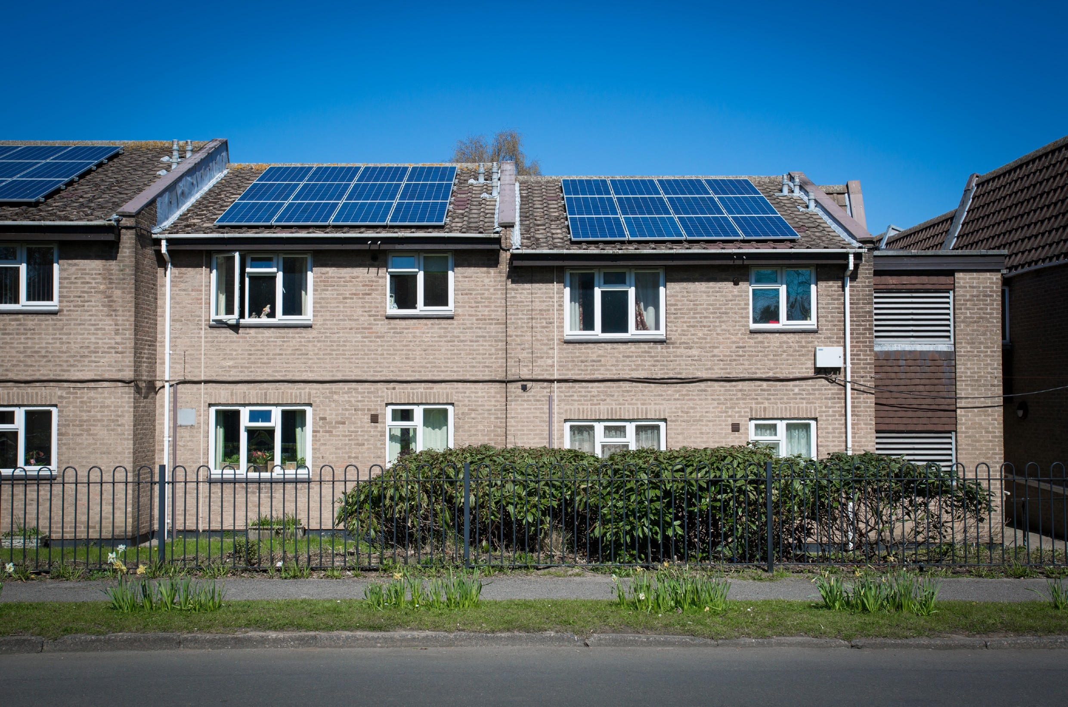
- Provide a reasonable degree of thermal comfort

Building Surveys
Ongoing building surveys provide us with important information to allow us to plan and prioritise works, and decide which homes, are to be included in forthcoming major works programmes. We will contact you to notify you when a surveyor will be in the area and will be looking to access your home to carry out a building survey, or we will contact you, or ask you to arrange a specific appointment. It is essential that any appointment is made and kept, and that access is granted. Please ensure that you respond to any correspondence e.g. letters, texts you receive. By doing so you greatly reduce the chances of your home falling below the standards we wish to maintain. If we cannot contact you or cannot arrange a building survey, your home may miss out on the opportunity to receive improvement works.

Failure to allow us access to your home will result in increased action being taken to gain such access. Failure to allow us access may ultimately result in legal action being taken against you and should this be the case you may also incur the costs associated with this legal process.

If you are unable to be at home during normal working hours or have difficulties arranging access due to work or family commitments, please call us. We will make every attempt
to work flexibly around your commitments, to ensure this essential survey is successfully completed.

Types of improvement works
Work programmes include the replacement of ‘building elements’ such as kitchens, bathrooms, central heating boilers and systems, electrical installations, roof coverings, windows, external doors and rendering. We also carry out improvements such as making homes more thermally efficient to reduce carbon emissions and assist in the reduction of fuel poverty.

Essential Works
Please note that you will not be able to decline works which we consider are essential to maintain your home in good and safe condition, reduce carbon emissions, and which relate to tenants’ health and safety.

Tenants Choice
Depending upon the nature of works due to be carried out within your home, you may be offered several choices e.g., kitchen unit colour, worktop, wall/floor tiles.

Disturbance to Decorations
When the work is finished, we will visit your home to check whether any of your decorations have been disturbed as a consequence of the works. If so, we will provide you with decoration vouchers to assist with the re-decoration of the affected areas. We will provide you with a list of local hardware stores where you can redeem the vouchers for decorating materials. You can also use the vouchers as payment or part payment to any registered decorator who is willing to accept the vouchers in return for decoration works. We reserve the right to change the decoration voucher process in terms of how and where decorating materials and services can be sourced.

Further Information
Should you have any queries relating to any works we have carried out or we are planning to carry out, or any queries in general,
please do not hesitate to contact our Tenant Liaison Officer on: Tel - 01623 608860 or our Administration Officer (Assets) on 01623 608873, or email assets@ashfield.gov.uk

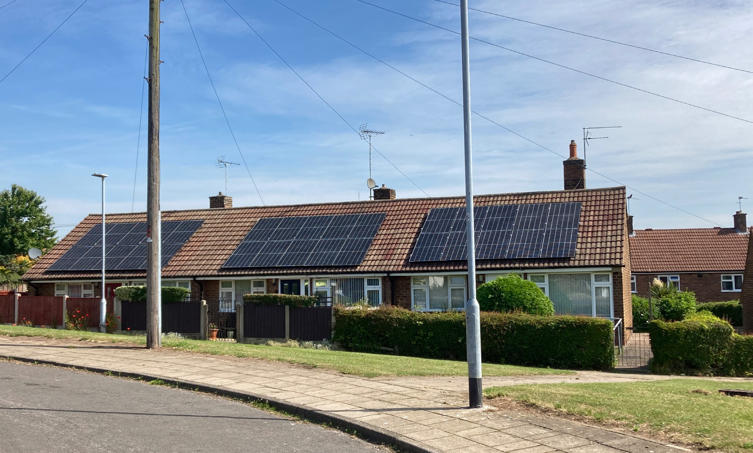

Looking after your home

Gardens

Individual gardens
For those tenants who have individual gardens, both front and/or back, it is your responsibility to cut the grass, prune any trees and keep the borders tidy. If you are responsible for a hedge next to a footpath or walkway you must maintain both sides and ensure that any walkway is not obstructed by the hedge. Housing Officers will inspect all gardens periodically and if any gardens are found to be in an unacceptable standard, we will contact you to advise what you need to do to bring it up to an acceptable standard. If you do not co-operate with us, then we may consider this a breach of your tenancy agreement and take enforcement action against you.

Shared gardens
Communal gardens are the responsibility of both tenants and the Council. We will maintain the grass and gardens; however, tenants must ensure that is it kept free of dog and cat faeces and rubbish. We do not use machinery that picks up grass clippings.

Please note we will not grant permission for any alterations or improvement works, including putting up a shed on any shared land.

Bird Protection
All wild bird species, their eggs and nests are protected by law. You must always try to avoid harming birds or to use measures which do not kill or injure them before considering taking harmful action.
In most cases you should be able to avoid harming wild birds by:

• timing your work to avoid the breeding season
• using a range of methods that deter but do not harm them

You are breaking the law if you:

• intentionally kill, injure, or take wild birds
• intentionally take, damage, or destroy a wild bird’s nest while it’s being used or built
• intentionally take or destroy a wild bird’s egg
• possess, control or transport live or dead wild birds, or parts of them, or their eggs
• sell wild birds or put them on display for sale
• use prohibited methods to kill or take wild birds

Decorating your home
You are allowed to decorate your home in a style of your choice. However, if you leave your home with an extreme decoration, for example very dark colours, you may be asked to tone this down or redecorate when you leave or you may be recharged. If you have any queries about decoration, please contact your Housing Officer.

Condensation and mould
Condensation often occurs when air carrying water vapour comes into contact with a cold surface. This can be seen, for example on the bathroom mirror, when you have had a bath or shower.

Condensation may show up as patches of black mould. This grows in the moisture soaked up by the wall. Black mould will usually grow on an outside wall or behind a piece of furniture.

What can I do to avoid condensation?
To prevent mould (black and green substance) your home needs to be heated and ventilated properly.
Top tips for prevention include: -
- Allow plenty of circulation regularly i.e. if it’s a dry day, open the windows.
- Keep your home warm. It is recommended to keep your home between 18C and 24C when you are at home.
- Keep saucepan lids on when cooking.
- Do not use bottled gas or paraffin heaters inside (this is a condition within your Tenancy Agreement).
- Avoid drying clothes indoors, especially on radiators.
- Use extractor fans where fitted.
- Ensure appliances such as a tumble dryer are externally vented.
- Leave a 2-inch gap between the wall and any cupboards and wardrobes.
- Do not cover airbricks or vents.
- Open vents on windows (if fitted).
- Wipe down a bath or shower after use.
- Keep kitchen and bathroom doors closed (to prevent moist air flowing through the home).

If you find mould, you can treat it by washing down the surfaces and window frames with an anti-fungal solution. There are also anti-fungal paints that can be used. If you continue to have problems, please call the repairs team on 01623 457999.

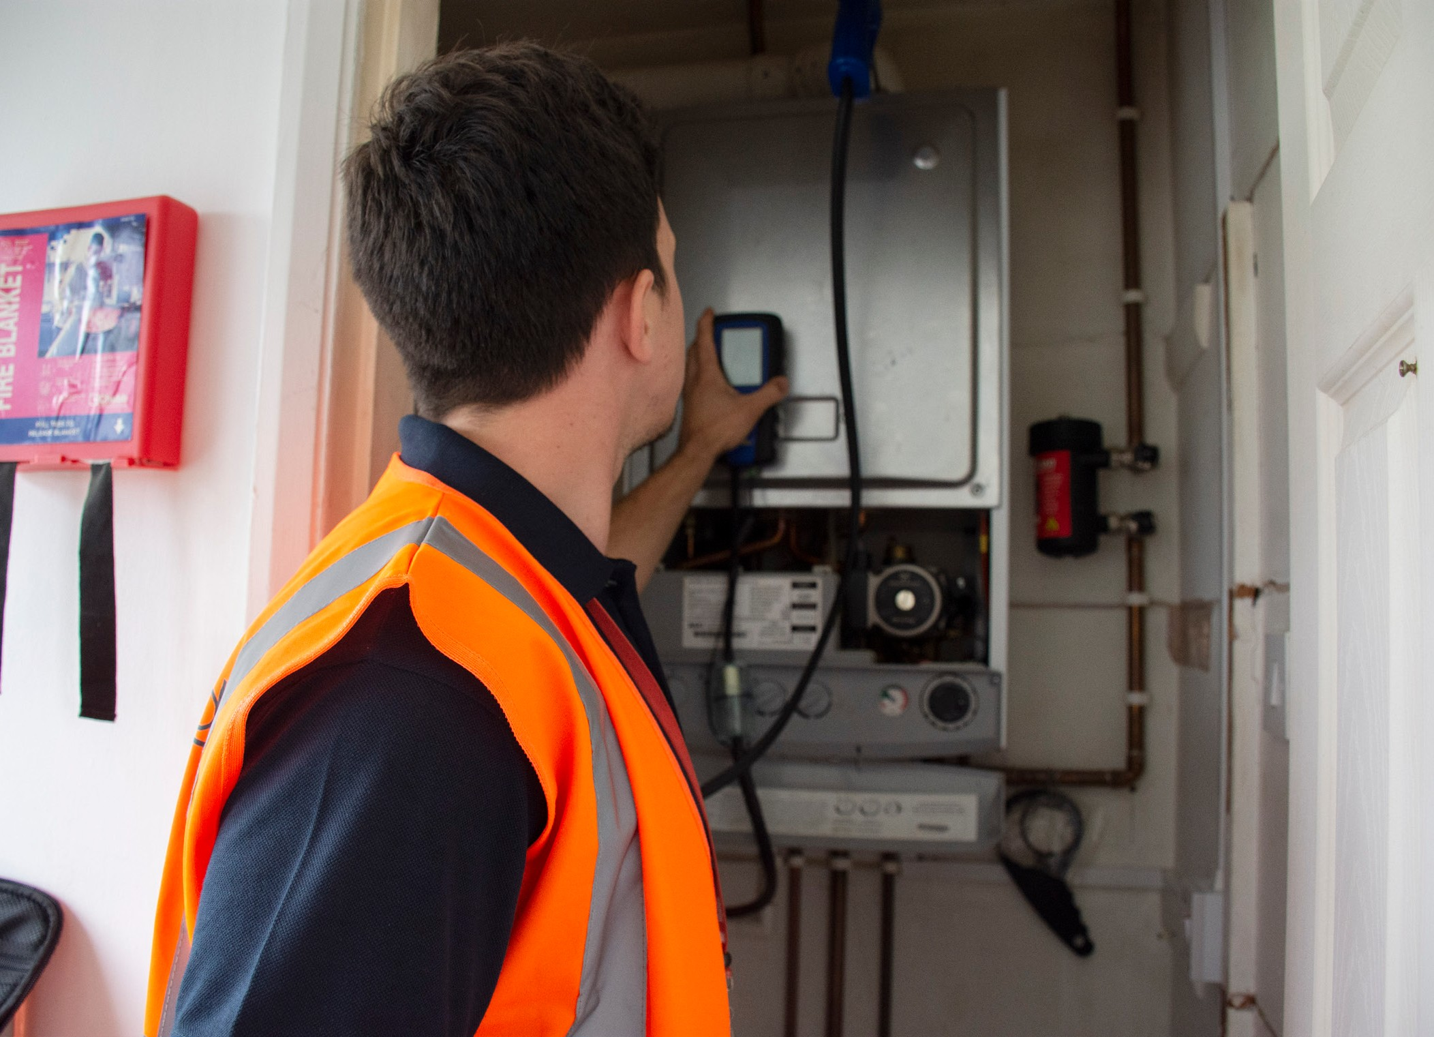
Health and Safety

Ashfield District Council is committed to and understands the importance of providing for the health, safety, and welfare of all tenants.

As such, we have produced a series of tenant safety information guides which cover the following key health and safety themes for domestic premises, including sheltered accommodation and general needs blocks of flats:
- Gas safety (including carbon monoxide)
- Electrical safety
- Fire safety (including smoke alarms)
- Asbestos safety
- Water safety (legionella control)
- Damp and Mould

The guides can be found on the Council’s website at www.ashfield.gov.uk. The specific themes are also aligned to the Regulator of Social Housing’s ‘Building Safety’ Tenant Satisfaction Measures and Consumer Standards, which are designed to help keep tenants safe in their homes.

Frequently asked questions

I have lost my keys. What do I do?
If you lose your keys or have locked yourself out, it is your responsibility for any work needed to break into your home, such as repairing broken doors or changing the existing lock.

If we agree to carry out the work on your behalf, you will have to pay for all the costs. You may choose to break in yourself or seek assistance
from a trades person or associate, but you will be responsible for any damage, and you must always tell your Housing Officer.

If you lose communal keys, we may change the communal locks (for safety). This may incur a charge.

The glass in the window or doors is broken. What do I do?
If the external glass in your windows or doors is broken, we will board them up or re-glaze to maintain the security of your home.

We will only replace broken glass free of charge, where a crime reference number is provided by you. The Police will provide you with this when you report a crime.

How can I resolve parking problems with my neighbour?
Parking may be limited where you live and there may be insufficient parking for you and your visitors. Parking can cause disputes between neighbours’.

Unless you have your own allocated parking space or driveway, you will have to accept that you might not be able to park outside your property. Please show consideration to

your neighbour’s when parking your car and remember that inconsiderate parking could block access for emergency vehicles.

If you have a dispute with your neighbour about parking, you should contact your Housing Officer for advice on how the council can help. Often parking disputes are best resolved by reaching an agreement with your neighbours as who should have priority to park.

I want to keep a pet, is this allowed?
You may need permission to keep a pet. Check your Tenancy Agreement conditions first.
If you choose to get a pet without written permission first, you may be in breach of your tenancy agreement and you could be asked to re-home the animal (s).

I have found pests in my home, what should I do?
You may occasionally get problems caused by animals or insects, for example rats, wasps, bees etc. As per the Tenancy Agreement you are responsible for the treatment of pests and
for payment of this. The Council does offer pest control treatments at a charge. Please contact Customer Services on 01623 450000 for details on treatments and charges.

You can approach an external pest control company if you wish at your own cost.

How can I get rid of bulky items?
The council may be able to remove larger items of furniture as well as safely disposing of old fridges and freezers. For more information contact Customer Services on 01623 450000.


Anti-Social Behaviour (ASB)

The Council believes every tenant has the right to live peacefully and safely in their homes, unaffected by the unacceptable behaviour of others.

Tackling and preventing anti-social behaviour within our communities is an important priority for the Council and any reports of nuisance and ASB will be taken seriously and investigated thoroughly, and the appropriate action taken.

Tenants of Ashfield District Council have signed a tenancy agreement which is a legal contract, agreeing to not commit acts of anti-social behaviour and to be responsible for the behaviour of everyone who lives in or visits their home.

If you abuse, threaten or assault anyone working for the Council or on its behalf, we will take action against you, which could result in you being evicted.
We will tackle anti-social behaviour by:
- Prevention – Initiatives will be used to try and stop the problem from arising in the first place and from continuing and escalating, should a problem develop.
- Intervention – We will aim to intervene and offer support and advice, if preventative measures have been unsuccessful. This option gives tenants another chance, before enforcement measures are considered.
- Enforcement – Will be used when necessary and when other options have been unsuccessful.

Reporting Anti-Social Behaviour
If you are having problems with a neighbour, we can offer help and advice, and work with you your neighbour’s and other agencies to sort out the problem.
If you are being threatened in any way you should first contact the Police and then let your Housing Officer know.

We take all reports of ASB seriously. We will investigate your allegations and try to
resolve the situation. We will, however, need your help and this may involve making a statement about what has happened and keeping records of what happens to you. In some cases, we may ask you to go to court with us to tell the judge what happened.

Please contact the Housing Management Department on 01623 450000 or email tenancy@ashfield.gov.uk to report any issues.

23 Tenant Handbook 2025


Getting involved

Ashfield District Council recognise that involving tenants is an essential part of our decision-making process and we are committed to making sure that there are
opportunities for all tenants to participate in the design and delivery of our Housing Service.

Our Tenants Charter is a three-year plan that sets out the various ways in which tenants may be involved with other tenants and the Council. The aims of the Charter which can be found on our website at www.ashfield.gov.uk are to:

- Enable tenants to get actively involved in improving and developing high quality housing services.
- Develop effective communication with tenants.
- Facilitate joint working between tenants, staff, Elected Members and communities to achieve effective community involvement and actions.

How can I get involved at Ashfield District Council?
There are three main ways to get involved in reviewing, developing and improving our homes and services:

Become a Tenant Gateway Member
The Tenants Gateway is a group of tenants who meet with Senior Housing Managers to discuss issues, policies and procedures about the management and delivery of landlord services. The Gateway meets every 2 months for a couple of hours.

Become a Tenant Scrutiny Panel Member
The Tenant Scrutiny Panel is a group of trained volunteer council tenants who review the services delivered by us. The panel work as a team to review our services and suggests improvements to the way we do things in the form of an action plan.

We’re looking for new members for the Tenant Scrutiny Panel. If you are interested in getting involved get in touch. Full training and support will be provided.

Join COIN
COIN is our Customer Opinion Influencing Network. COIN members can tell us about their experience of the housing services they have received and give their opinion on how things could be improved. This may include giving feedback via our website, email, face to face or by telephone.

If you are interested in getting involved or would like more information, please get in touch with our Tenant Engagement Officer by:
- Email: coin@ashfield.gov.uk
- Telephone: 01623 457590

Ending your tenancy
If you wish to end your tenancy, you must give us at least four weeks’ notice in writing. You can complete a termination form or write to us.
Please note that you are required to pay your rent until the end of your tenancy; however, you can move out earlier if you wish.
You must:
- Return all keys before or on the date stated in the letter or termination form which has been agreed by us. Late return of keys will result in rent being charged on a weekly basis until the keys are returned.
- Leave the property in a clean, empty and in reasonable condition. This includes sheds, outbuildings and stores.
- Leave your garden in a maintainable condition, including, grass, shrubs, trees and hedges.
- Ensure that any damage that you are responsible for is repaired. If you leave your property in a poor condition or fail to clear it, we may recharge you for the cost of repairs or rubbish removal.

We strongly advise you to:
- Leave us details of your forwarding address.
- Advise all services that you are moving and read your meters on the final day.

If you have any queries about ending your tenancy, please email:
housingadmin@ashfield.gov.uk or contact us on 01623 450000 (ask for the Lettings Team).

Succession of tenancy
Succession is where a tenant dies and someone in occupation of the property is entitled to succeed to the tenancy.

Please note that succession is to the tenancy and not necessarily the same property. Where successors would be under-occupying a property or the property is not considered suitable for their needs, wherever possible we would look to move them to a more suitable home. For more information about succession, contact your Housing Officer. Further details can also be found in our Tenancy Policy which is available on our website at: www.ashfield.gov.uk or upon request.

Assignment of tenancy
Depending on the type of tenancy you have, in certain circumstances, you may be able to assign it to another person. For more
information about assignments, contact your Housing Officer. Further details can also be found in our Tenancy Policy which is available on our website at: www.ashfield.gov.uk or upon request.

Exchanges
With our written permission you can swap tenancies with another local authority or housing association tenant in any part of the country. The Council subscribes to a mutual exchange advertising service where you search for a suitable exchange partner. For details
of our current service provide please email: housingadmin@ashfield.gov.uk or contact us on 01623 450000 (ask for the Lettings Team).

Once you have found a property that you consider may be suitable, it is up to you to contact the tenant directly and discuss the potential exchange. You will then both need to complete a Mutual Exchange Application Form and return them to your Housing Officer who will assess both parties’ eligibility, as there are certain grounds in law for refusing an exchange. We will also need to inspect both properties and ensure both tenants have clear rent accounts.

Transfers
If you are already a Council tenant and want to move to another Council property, this is called a transfer.

You cannot apply for a transfer during the first 2 years of your tenancy unless you have a particular need to move.

To apply for a transfer, you will need to complete a Housing Application Form online at www. amhomefinder.co.uk Your application will be assessed. Applicants with a high level of housing need will be prioritised above those with a low level of need.

Information on how your application is assessed and how the lettings process works is also available on our website at www.amhomefinder. co.uk.

Inspecting Your Current Home
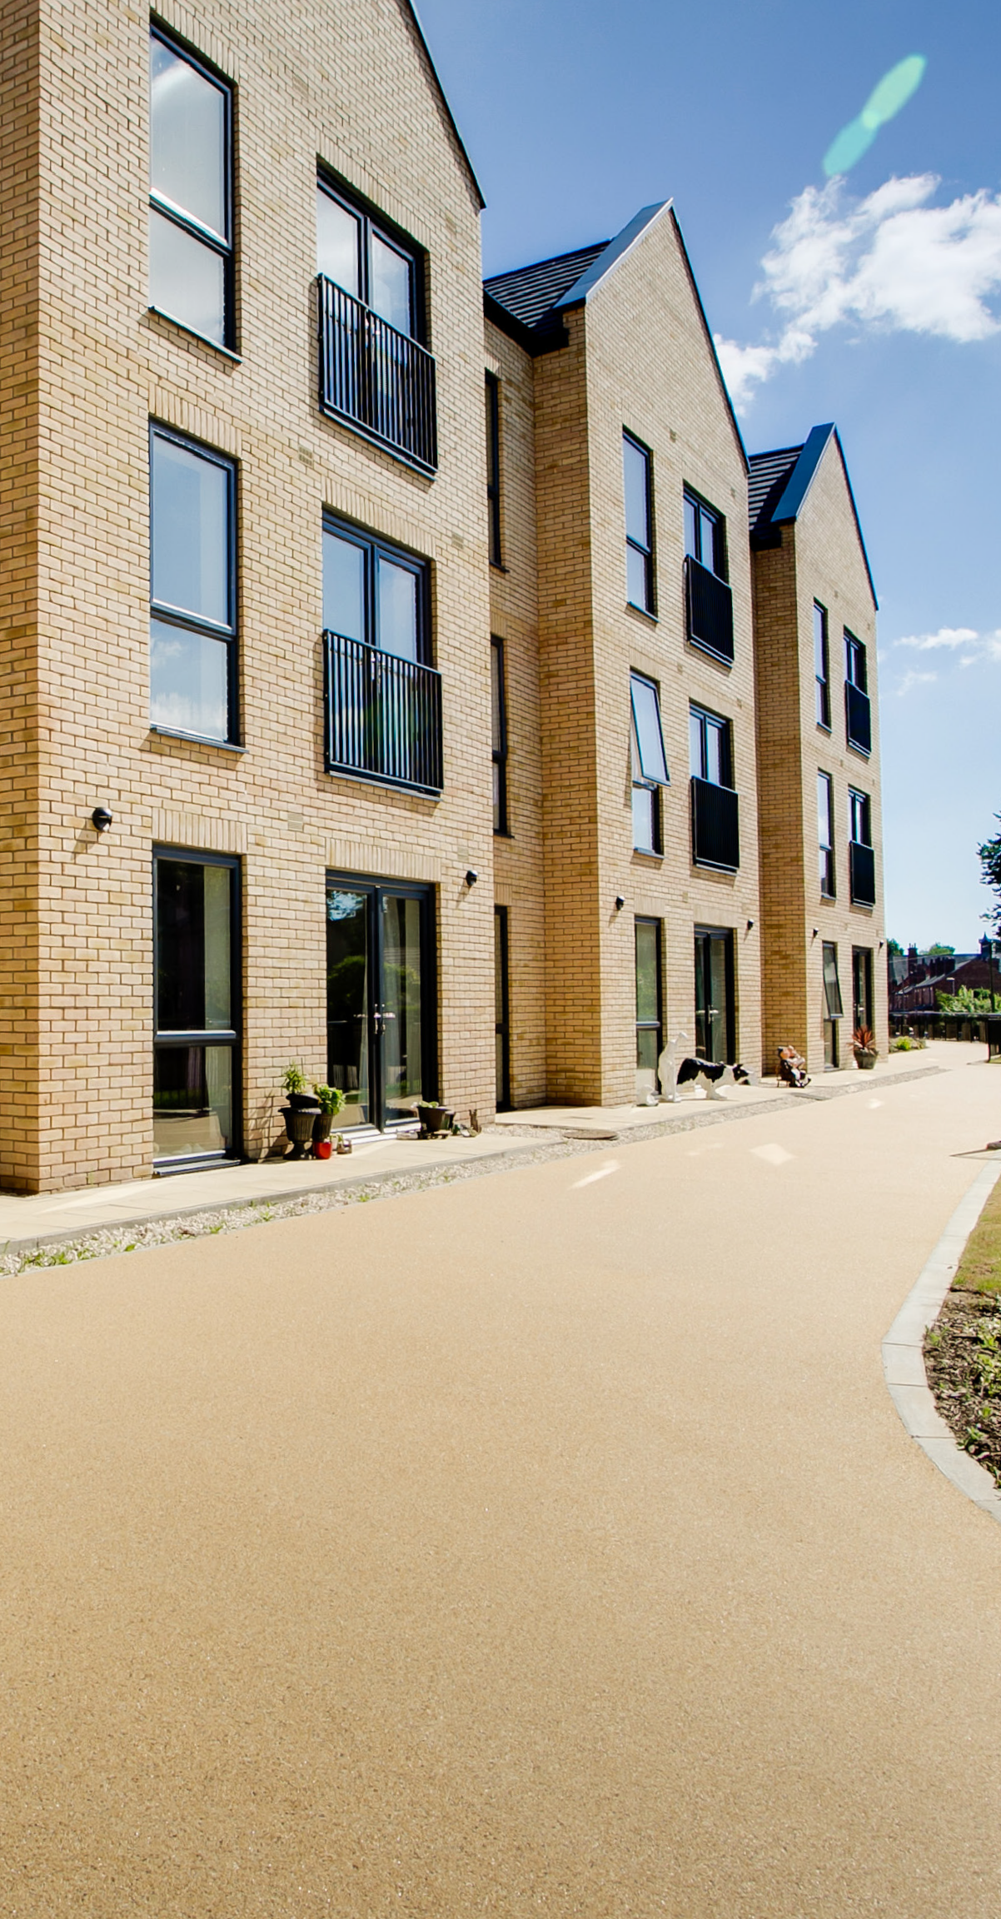
Before you will be allowed to move, we will inspect your current home to make sure that it has been kept in a satisfactory condition, that you have the correct permissions for any alterations or improvements that you have made, and that these have been carried out to an acceptable standard. You will also need a clear rent account.

Housing complaints

Our Housing Department is regulated by the Regulator of Social Housing and falls under the remit of the Housing Ombudsman for complaints. This is different to the rest of
the council which is overseen by the Local Government and Social Care Ombudsman.

The Housing Team is committed to delivering an excellent housing service.
Whilst we always strive to meet your needs, we understand that on rare occasions we may fall short of your expectations. In these circumstances we would always encourage you to contact us at the earliest opportunity as we may be able to simply resolve or put the issue right for you.

If, however, you do feel that a complaint is appropriate, the ‘housing complaints – a guide for tenants and leaseholders’ page of our website and the Council’s Complaints and Compliments Policy sets out how the council will deal with complaints relating to its social (council) housing services. By this we mean those services delivered to council tenants in council homes, as their landlord.

All complaints (housing specific and non- housing) will be dealt with under our Complaints and compliments policy, which sets out how the council will deal with complaints.

The Council defines complaints as any expression of dissatisfaction, however made, about the standard of service, actions or lack of action by the Council, its own staff, or those acting on its behalf, affecting a resident or group of residents.

Our investigations will:
- review the history of the situation and examine relevant documentation.
- carry out interviews with employees and/or relevant people.
- comply with the Housing Ombudsman Service’s Complaint Handling Code.

Our decision making will be:
- within stipulated time scales.
- effectively communicated.
- proportionate - if a complainant makes unreasonable demands, which are outside the boundaries of our service delivery this will be communicated to the complainant as early as possible.

Putting things right
We are committed to using the complaints process as a learning experience and where appropriate we will put things right. This can be done in a variety of ways including re-attending a repair job, reviewing a decision, offering an apology or explanation, and/or arriving at a solution which may prevent issues reoccurring.

We will also make amendments to policies or procedures or to the way a service is provided, if it is found these are leading to dissatisfaction with the service. We will always seek to rectify the situation where possible.

We will share learning outcomes from complaints internally and with our tenants.

Making a complaint
You can make a complaint through:

online form
- email: housingcomplaints@ashfield.gov.uk
- telephone: 01623 450000

by post or by visiting our office:
Ashfield District Council Urban Road
Kirkby in Ashfield Nottingham NG17 8DA.
- or in person - to a Council officer conducting their duties on the district

If you do feel that it is necessary to make a complaint about our housing service, it is extremely helpful if you can explain what you are concerned about and how you would like it resolved, as this may mean we can rectify the issue for you in a much quicker timescale and to your satisfaction.

Housing complaints

Complaint process
Complaints managed will be investigated in 2 stages, as set out within the Housing Ombudsman Housing Complaints Code.

Stage One: Formal response from the Head of Service or Manager

The complainant submits the complaint which will be acknowledged, in writing, within 5 days and be investigated by the appropriate Head of Service or Manager.
Time Scale:

The complainant will receive a written response to their complaint within 10 working days the date of the complaint acknowledgment. The response will confirm the outcome of the investigation and what action, if any, will be taken.

If the complainant remains dissatisfied with the stage one response, they can request that the complaint is escalated to stage two. The request should contain new or additional information that is relevant to their continued dissatisfaction.

Stage Two: Review and response from the Assistant Director or Executive Director

The complainant can request their complaint to be reviewed by the relevant Assistant Director or Director.

The complaint will be acknowledged, in writing, within 5 days and then investigated by the Director.
Time Scale:

A full review of the case will be undertaken, and a written response will be provided within 20 working days of the complaint acknowledgement.

Stage two concludes our complaints process and once complete will have exhausted our internal process. If a complainant remains dissatisfied with the response and findings at stage two, they can refer the matter to the Housing Ombudsman Service for investigation.

Housing complaints

Housing Ombudsman Service
Our tenants can contact the Housing Ombudsman for support and advice regarding our landlord functions or existing complaints at any stage of the process, including prior to submitting a complaint.

However, the Housing Ombudsman will normally only commence formal investigation into a
complaint if the complainant has exhausted our complaints process.

Once a complaint is received by the Housing Ombudsman a decision will be made on whether to investigate the complaint.

Should the Housing Ombudsman decide to undertake an investigation into a complaint, they will liaise with us to request any information they require to support their investigations. This will typically include any copies of documents, policies and information that supported the decision making at each stage of the process. Once the Housing Ombudsman has completed their investigation, they will communicate their decision to both the complainant and the Council in order that any recommendations can be actioned or implemented.

The Housing Ombudsman Service contact details:
- telephone: 0300 111 3000
- fax: 0207 831 1942
- email: info@housing-ombudsman.org.uk

post:
Housing Ombudsman Service PO Box 1484
Unit D
Preston PR2 OET

You can find out more information about the Housing Ombudsman on their website:
- website: www.housing-ombudsman.org.uk

Housing Ombudsman complaint handling code: Self-assessment
The Housing Ombudsman have a Complaint Handling Code, which sets out their expectations of how member landlords will manage complaints received.

To demonstrate compliance with the code, the Housing Ombudsman requires all member landlords to complete and publish an annual self-assessment against the code.

Our self-assessment is available in the related documents section of the Housing Complaints section of our website, the outcome of which has been reviewed by our engaged tenants, senior managers and elected members.

The Council are also required to publish an annual housing complaints performance and service improvement report, which can be found on our website.

Housing complaints satisfaction
Once we have responded to a stage one complaint, we’d like to know how satisfied the complainant is with how their complaint was handled and the outcome.

When we respond to a stage one complaint, we will include information on how we have fully considered the complaint in line with our complaints policy. We will also include details of how the complainant can complete a short satisfaction survey.

To assist with improving our services we are grateful for complainants taking the time to provide feedback on their satisfaction with the complainant process.

The satisfaction survey can be completed via an online form or by post.

Contacting us regarding Housing complaints
If you have any questions regarding the Housing complaints process, you can contact the Consumer Standards Lead Officer:
- email: housingcomplaints@ashfield.gov.uk
- telephone: 01623 450000

How to contact us

Post:
Ashfield District Council Urban Road
Kirkby in Ashfield Nottinghamshire NG17 8DA
Telephone: - 01623 450000
Email - info@ashfield.gov.uk
Website – www.ashfield.gov.uk
Twitter - @ADCAshfield

Further information
We will always publish the most up-to-date information for tenants on our website.

It also has useful links to repairs advice, how to make a suggestion or complaints, where to go for advice and how to get help if needed.

