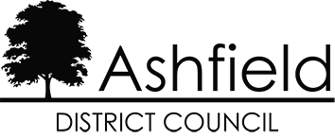

Ashfield Workforce Report 2021



Table of Contents
Page

Ashfield Workforce Report 2021 1
Table of Contents 2
Executive Summary 3
Actions for 2020 3
Ashfield Workforce 5
Workforce Diversity 7
Maternity/Paternity 9
Pay 10
Training 10
Recruitment 11
Ashfield District Council – 15
Gender Pay Gap Information – 2020 15
1. Introduction 15
2. Summary of data 15
3. Analysis of data 15
4. Action to be undertaken to address the gender pay gap 16

The Equality Act 2010 and the Public Sector Equality Duty requires all public authorities to publish equality information on their workforce to demonstrate that they are compliant and transparent in their practices. This report builds on the previous year’s reporting and forms part of the information that we collate, monitor and publish to help us ensure that equality considerations are embedded within our employment policies and practices and they meet our responsibilities under the duty.

Executive Summary
Ashfield District Council workforce has remained constant over the past year, at January 2021 there were 595 employees at the council, compared to 598 in 2020, in January 2019
there were 578.
58.2% of the workforce is male and 41.8% female, the same ratio as in 2020. Part time working is predominately female.
Just under half of the work force, 46.4%, falls within the age range 45 – 59, a small decrease on last year, although, thanks to increased availability and appointment of apprentices and trainees positions, the 16 -24 age group has remained the same as in 20120 at 5.7%. The Covid-19 Pandemic has proven challenging throughout 2020/21 for delivering the Council’s programme of apprenticeships, trainees and graduate schemes due to the imposed restrictions affecting higher education an dreduced opportunities.
The proportion of the workforce who consider themselves disabled has decreased over the past 3 years, the proportion of the working age in receipt of disability benefits has risen sharply across 2020.
The working age ethnic profile of Ashfield from the Census 2011 is predominately White British, 97.8% and Christian, 56.1% or no religion, 36.1%. At 96% White British the Ashfield workforce profile has become more ethnically diverse. It still does not, however, adequately represent the BME profile of the district which will have become more diverse since 2011.
The Council is aware that the recruitment process should continue to encourage and enable employees from minority ethnic and religious belief groups to join the workforce.
In comparison with other similar organisations, the gender pay gaps identified do not appear to be large and are therefore not significantly concerning. Although the median gender pay gap has increased, there is a mean pay gap which suggests that ranges of pay are spread fairly equally across the organisation but that the average pay for women is higher. In comparison to last year, this figure has changed slightly from 0.45% to -0.46% suggesting that measures implemented to reduce this have had an effect. The mean gender pay gap is likely to be due to the change in the organisational profile as there is a reduction in number of employees with a higher reduction of men to women and in addition there has been an increase in the percentage of men in the lower middle quartile.

Actions for 2020
Continue the implementation of our Recruitment & Selection Strategy and our work towards becoming a more attractive employer for young people.
Continue to use on line adverts and jobs boards to advertise vacancies as widely as possible so that they are accessible to all possible candidates and therefore not advertise via routes that could attract traditional genders.
To actively encourage a more diverse workforce within the organisation and ensure BME representation across all levels of the organisation.

Ashfield Workforce
In January 2021 there were 595 employees at the council, in 2018 there were 612 employees, a decrease of 2.8% from 2018.
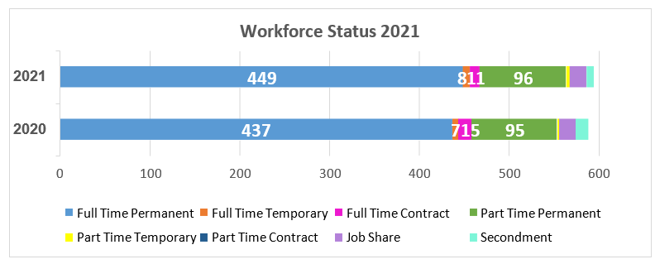

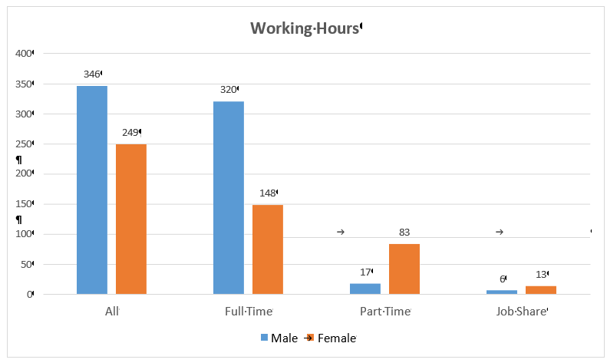
The proportion of males and females working for the council has remained relatively static with males at 58.2%, females 41.8%.

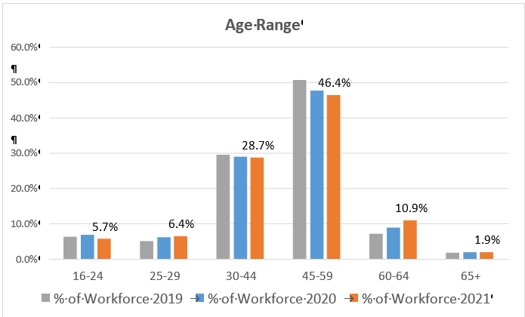
The majority of people working for the council fall within the 45 – 59 age range. The proportion of employees 25-29 continues to increase, there has also been an increase in the 60-65+ age range.
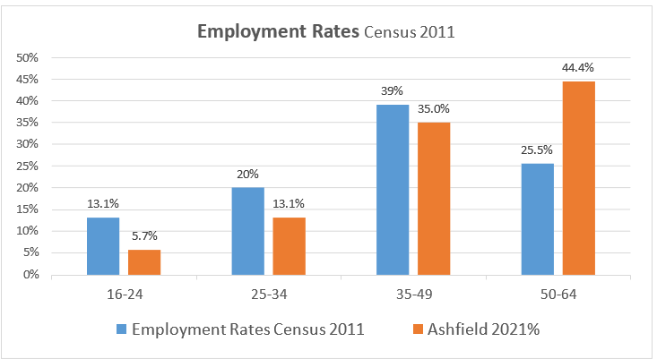
The number of people in each age band resident in Ashfield who were in employment at the time of the census and Ashfield Council 2021 employment figures

Workforce Diversity

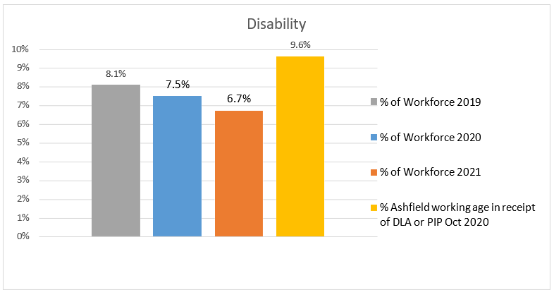
The DLA figure refers to Ashfield working age residents in receipt of a Disability Living Allowance or a Personal Independence Payment.
The proportion of people claiming these benefits has significantly risen across 2020 from 6.1%.
Ethnicity | % of Workforce 2021 | % of Workforce 2020 | % of Workforce 2019 | Ethnicity working age Census 2011
White | 95.9% | 97.8% | 98.1% | 97.8%
Asian | 0.50% | 0.2% | 0.2% | 1.9%
Black | 0.67% | 0.5% | 0.7% | 1.1%
Mixed | 1.68% | 1.4% | 1.0% | 0.6%
Chinese | 0.17% | 0.2% | 0.0% | 0.5%
Ashfield’s population is predominately white British. The BME working age population of the district from the Census 2011 was 4.1%, this is likely to have increased since then. The BME proportion of the council’s workforce is 3%, and increasing over the previous years.
This will continue to be a key action; encourage applications from minority ethnic groups.
Since the 2011 Census there has been an increasing number of Eastern European migrants moving into the area, predominantly in Sutton in Ashfield and Hucknall. However, the number of new registrations have declined over the past three years overall, but risen again in the past year. The table below shows National Insurance Registrations of Nationals from Overseas (NiNO).

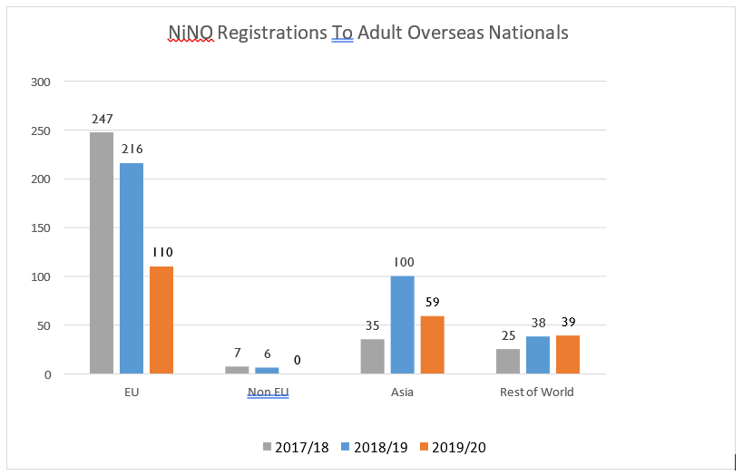
DWP

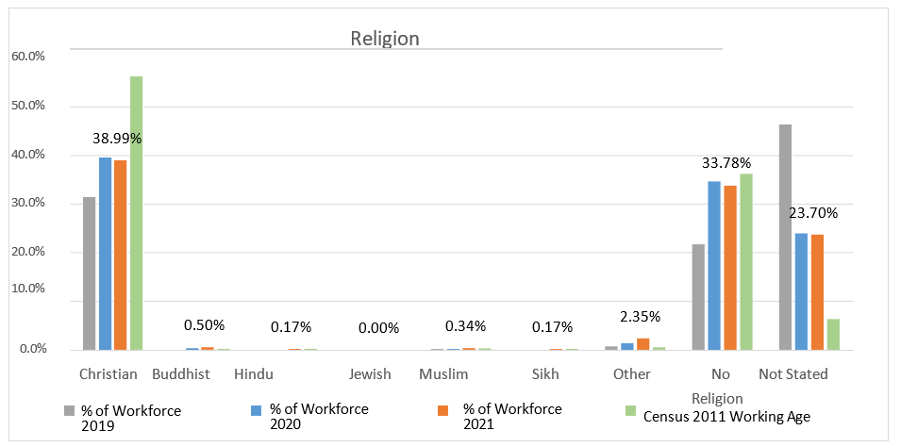
The number of employees who do not state their religions or specify ‘no religion’ has declined slightly in the past year. The number or employees who identify as or ‘Christian’ has fallen with an increase in Hindu, Muslim, and Sikh religions.

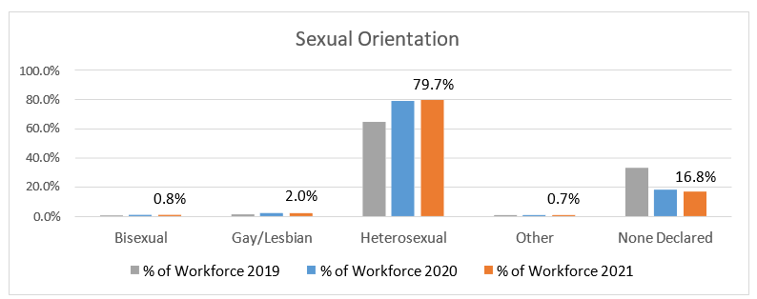
There is no district wide data available for sexual orientation but the proportion of the workforce stating that they are lesbian, gay or bisexual has remained similar on the previous year. The number of people who do not declare their sexual orientation have fallen, and those declaring themselves heterosexual has risen.

Maternity/Paternity
In 2020 six employees were on maternity leave, one employee was on paternity leave.

Pay

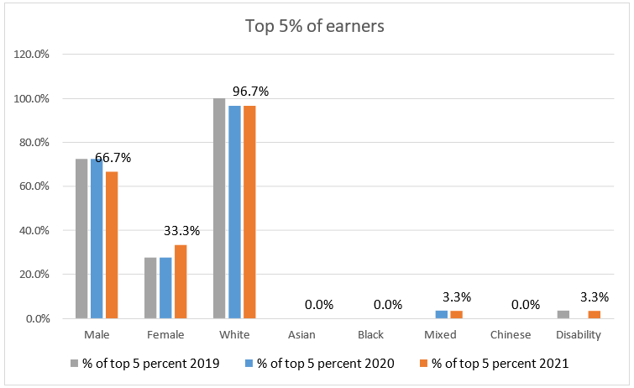
The proportion of female top 5% has increased. 3.3% of the top 5% are BME and 3.3% disabled.
The above figures of the top 5% of earners excludes CEO, Directors and Assistant Directors, they are NJC posts only. For JNC posts including CEO, Directors and Assistant Directors; 61.5% are female, a decrease from 67% in 2020.

Training

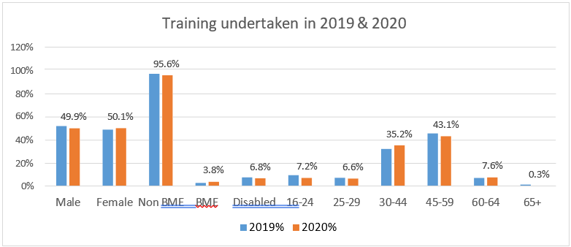
Ashfield has embedded an online training portal containing a wide variety of training opportunities, this is making access to training more accessible for all employees resulting in a significant increase in participation across all monitored protected characteristics.

Recruitment
The Authority is committed to creating a diverse workforce that is fair and free from discrimination. Reasonable adjustments are made to support disabled people throughout the recruitment process and continue into their role if they are successful. The Authority retains its accreditation to the Disability Confident Scheme and the Mindful Employer Charter in 2019.
Turnover of staff across the year was 7.6% a decrease on 2020 (8.4 %).
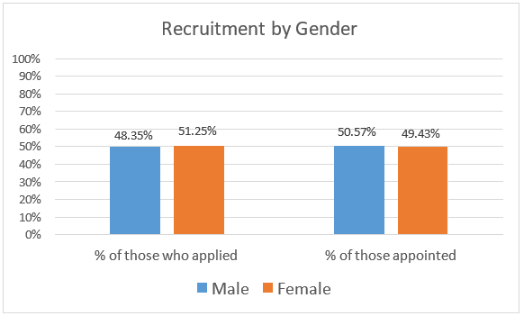
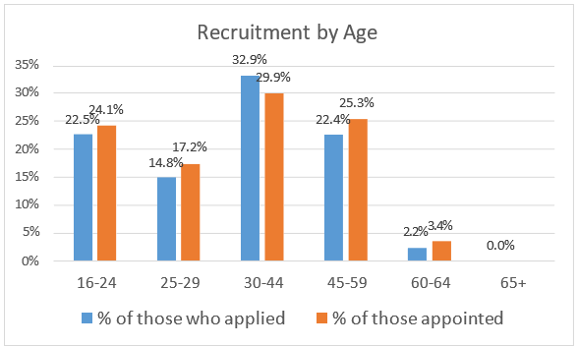
The % of overall applications from under 30’s continues to increase as does the appointments. This recognises work undertaken to increase awareness, availability and attractiveness of vacancies and the Council as an Employer of Choice, to young people such as apprenticeships and traineeships.
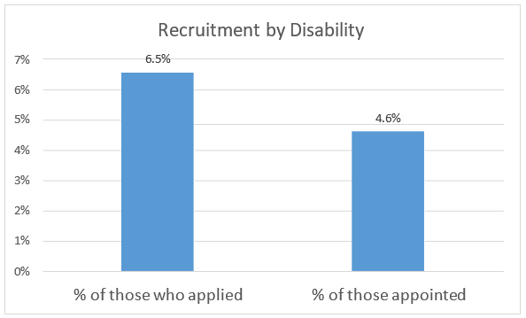
The % of applications from candidates stating a disability continue to increase; from 5.7% (2019) to 6.5% (2020), this increase continues amongst those appointed from.2.2% (2019) to 4.6% (2020).
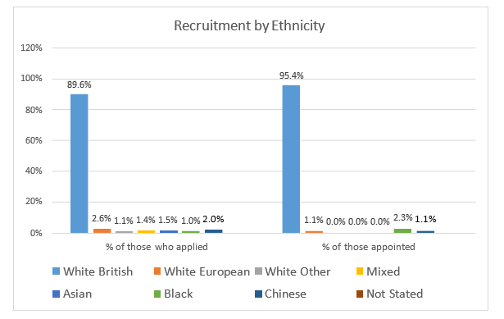

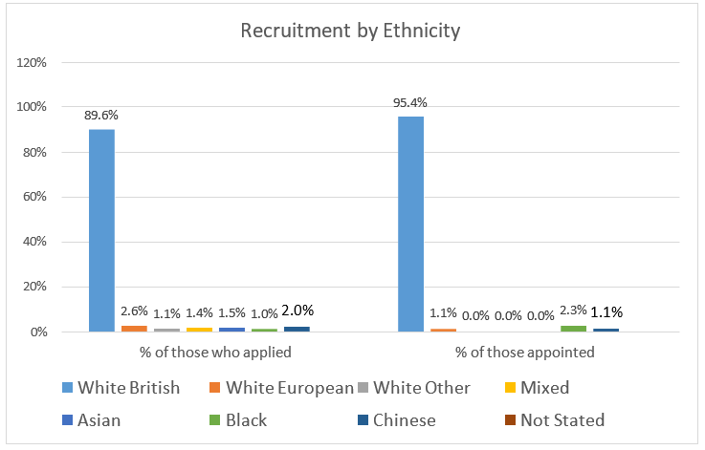
Recruitment has seen a slight increase within the White British cohort (88.9% to 89.6%) and percentage of those appointed (92.3% to 95.4%) with a corresponding decrease in other ethnicities.
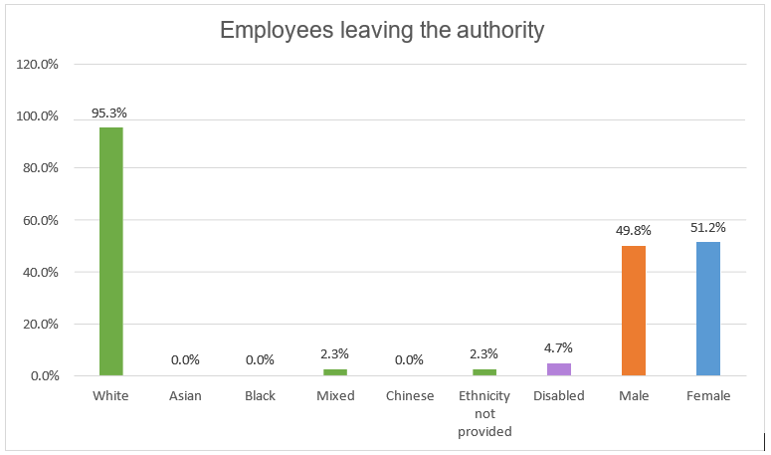
Figures based on permanent staff voluntarily leaving the Authority
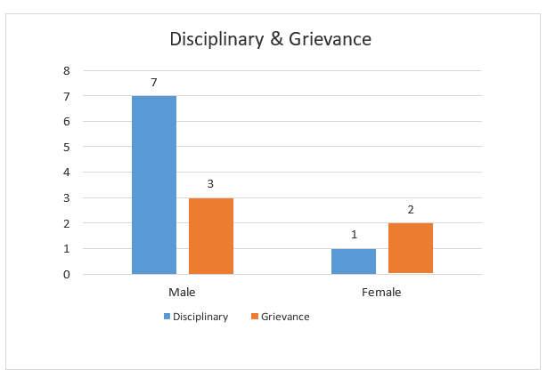
Whilst we would monitor and address any concerns with grievances that were related to the protected characteristics, we will not report on these cases as the small number may identify individual employees and same for disciplinary cases.

Ashfield District Council –

Gender Pay Gap Information – 2020

Introduction
Under the Equality Act 2010 (Gender Pay Gap Information) Regulations 2017 the Council is required by law to publish an annual gender pay gap report. The information contained within this report is for the snapshot date of 31 March 2020.

Summary of data
  - The mean gender pay gap is -1.69%
  - The median gender pay gap is -4.04%
Quartile | Females | Males | Salary range
Lower | 44.9% | 55.1% | £18426 - £20344
Lower Middle | 30.6% | 69.4% | £20344 - £23836
Upper Middle | 49.7% | 50.3% | £23836 - £29518
Upper | 39.9% | 60.1% | £29518 and above
The mean is defined as the average of the figures and is calculated by adding up all the figures and diving by the number there are. The median is defined as the salary that lies at the midpoint and is calculated by ordering all salaries from highest to lowest and the median is the central figure. The quartile information is calculated by listing all salaries from highest to lowest and the splitting that information into four equal quarters to determine the percentage of male / female employees in each quartile.
All the figures set out above have been calculated using the standard methodologies used in the Equality Act 2010 (Gender Pay Gap Information) Regulations 2017. Although reporting of the salary ranges for the quartiles is not required, this has been provided for additional information.

Analysis of data
In comparison with other similar organisations, the gender pay gaps identified do not appear to be large and are therefore not significantly concerning. Although the median gender pay gap has increased, there is a mean pay gap which suggests that ranges of pay are spread fairly equally across the organisation but that the average pay for women is higher. In comparison to last year, this figure has changed slightly from 0.45% to -0.46% suggesting that measures implemented to reduce this have had an effect. The mean gender pay gap is likely to be due to the change in the organisational profile as there is a reduction in number of employees with a higher reduction of men to women and in addition there has been an increase in the percentage of men in the lower middle quartile.
The quartile data also outlines that there is an increase in the percentage of females in both the lower quartile and the upper middle quartile, increasing by 1.44% and 3.14% respectively.
Further analysis of the data indicates that the lower middle quartile which has seen a the greatest increase for males with 70.3% in this quartile being male, one of the key reasons for this is that it contains a high proportion of trade posts such as joiners, painters etc as well as Refuse Drivers. This would suggest that the disparity continues to be due to employment of men and women in posts that traditionally attract specific genders. The Council recognises that although actions are in place to try to address this, it will take time to change these social and historical norms.
The Council remains committed to the principle of equal opportunities and equal treatment for all employees and has a clear procedure to ensure employees are paid equally for the same or equivalent work, regardless of their sex or any other protected characteristic. In 2014 the Council implemented job evaluation and undertook a comprehensive review of pay and allowances to address a number of factors which significantly improved the gender pay gap position. As part of that scheme the Council also evaluates job roles as necessary to ensure a fair structure. In 2016 the Council brought the ALMO back into the Council which included the transfer of a large number of craftworkers. Service reviews are still ongoing, and as these progress all employees, including craftworkers, are likely to transfer onto Council terms and conditions. Although a number have transferred onto the Councils terms and conditions, the impact of this on the gender pay gap is yet to be fully determined.

Action to be undertaken to address the gender pay gap
Although the gender pay gap is not significant enough to be a cause for concern the organisation will continue to implement actions as detailed below to address the disparities.
- Continue to use on line adverts and jobs boards to advertise vacancies as widely as possible so that they are accessible to all possible candidates and therefore not advertise via routes that could attract traditional genders.
- The Council is still involved in an initiative to promote flexible working, particularly in more senior posts / professional posts, and will continue build on the work of this initiative to ensure that all vacancies are advertised as flexible and encourage applicants to approach managers to discuss flexible working requirements at appointment stage. As part of promotion of flexible working managers undertook training in 2018 to encourage them to analyse vacancies before appointment to determine if the post could be redesigned more flexibly, in addition vacancies are reviewed at CLT to challenge managers when reviewing vacancies.
- The competency framework has been embedded which looks at values and behaviours. This is supported by selection exercises in recruitment, and in combination these aim to reduce any in built bias to recruit people from a specific gender into traditional gender dominated posts. In 2018 managers have received training about using selection exercises in recruitment and selecting appropriate exercises depending on the vacancy being advertised.
- Engaging young people early on (for example via apprenticeships) to try and encourage applications from under-represented groups in traditional gender dominated posts.

