

DISCLAIMER

This document or some parts of it may not be accessible when using adaptive technology.

If you require assistance with accessing the content of the document, please contact us and quote the document name and the web page you found it on:

Email: Forward planning – localplan@ashfield.gov.uk .

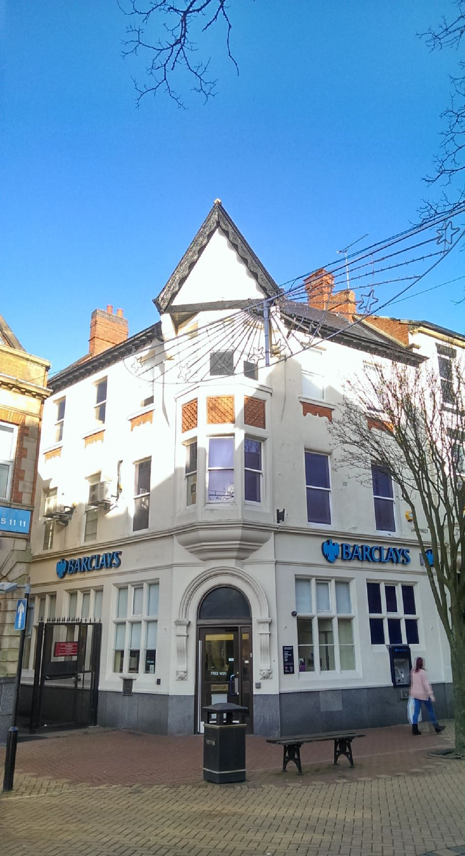

Administrator
Bassetlaw District Council
[Pick the date]

Sutton in Ashfield Church and Market Place Conservation Area Appraisal &

Management Plan
March 2015

Document details

Title: Ashfield District Council: Sutton in Ashfield Church and Market Place Conservation Area Appraisal and Management Plan.
Summary: This document is the Council’s appraisal of the special architectural and historic interest of the Sutton in Ashfield Church and Market Pace conservation area and a management plan with the proposals for management, preservation and enhancement of the area.
Approved: This document is in draft form and will be submitted for public consultation. Subject to outcomes from public consultation, the appraisal will then be presented to Councillors for approval.

Consultation summary.
The Council has undertake public consultation with local residents and property owners, English Heritage, local history societies, Nottinghamshire County Council and other relevant consultees.

Document availability.
Copies of the appraisal are available at Ashfield District Council’s Planning Services and on the Council’s website http://www.ashfield.gov.uk/

Table of Contents

Document details 2
- Introduction 5
- What is a conservation area? 6
- What is an appraisal? 6
- Geographic and historic context 9
Prehistoric & Roman 10
Medieval. 11
Post Medieval (16th – 19th century) 12
- Character appraisal. 22
Layout and plan form 22
Architectural quality and built form 24
Open spaces, boundaries, public realm, gardens and trees 58
Significant views and vistas 70
1 Management Plan 72
- Management Plan 73
Application of policy 73
Policy and Design Guidance 75
Development briefs 75
Application of an Article 4 Direction 77
Application of Section 215 Notices 77
Litter Abatement Notices 78
Monitoring change. 78
Boundary changes 78
Appraising the condition of significant buildings. 78
Enforcement proceedings 80
Enhancement schemes and grants 80
Appendices 82
- Appendices 83
Appendix A: Planning Controls in Conservation Areas. 83
Appendix B: Positive buildings in the conservation area. 85
Appendix C: Useful contacts and advisory bodies. 86
Conservation Accreditation Register for Engineers 87
Appendix D: Historic and local information 88
Appendix D: Contact us. 89

Introduction
  - Sutton in Ashfield is an historic settlement located 3.5 miles south of Mansfield and 14 miles north of Nottingham at the extreme west of mid-Nottinghamshire. The town is in an area of the highest hills in the County and drained by the River Maun whilst the River Idle is culverted through the town centre. Today Sutton in Ashfield is a large urban conurbation far removed from its earlier surroundings of Sherwood Forest. It was this forest that gives the town its suffix ‘Ashfield’. The geological formation of the Magnesian limestone so near to the surface enabled trees to thrive and in this part of the Sherwood Forest it was the ash tree that was prolific. The name of the town also suggests that it was an Anglo-Saxon settlement as its name suggests, ‘ton’ meaning an enclosure or fenced in area.
  - The conservation area is focussed on the Church and Market Place and the connecting residential area in the town centre and was identified as an area of special architectural and historic interest in 2013 by Ashfield District Council. This appraisal outlines the area’s special architectural and historic interest and is a material consideration in determining planning applications within the conservation area.
  - The conservation area was formally adopted by Ashfield District Council on (date to be inserted if adopted).
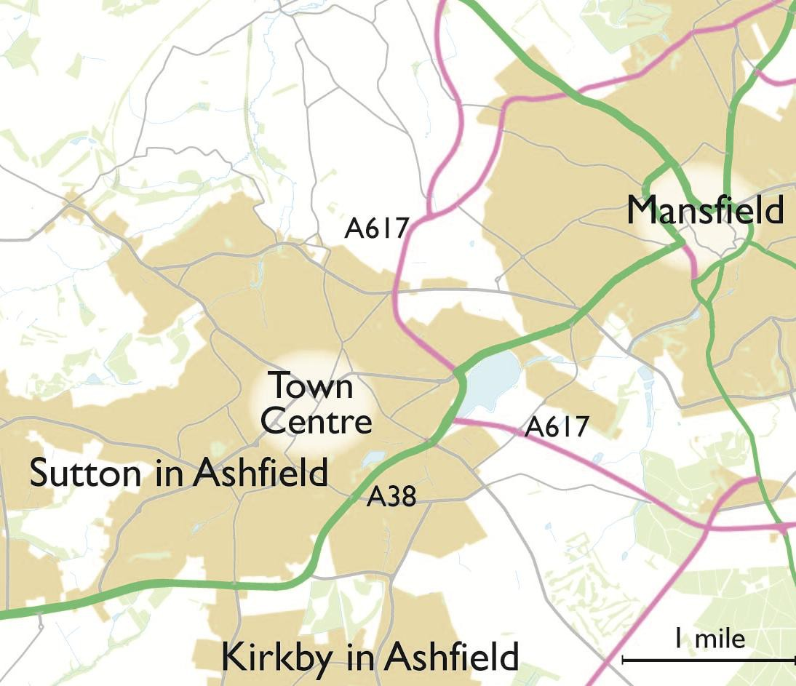
Figure 1: Sutton in Ashfield in relation to neighbouring towns.

What is a conservation area?
  - Conservation Areas were first introduced by the Civic Amenities Act 1967. Since then, over 9033 Conservation Areas have been designated across England. The various heritage-related acts were consolidated under the Planning (Listed Buildings and Conservation Areas) Act 1990. The Act defines Conservation Areas as:
“areas of special architectural or historic interest the character or appearance of which it is desirable to preserve or enhance” (section 69 (1))¹
  - Unlike listed buildings, which are designated by central government, Councils designate Conservation Areas locally. The Local Planning Authority has a duty to designate Conservation Areas where it identifies places of special architectural or historic interest. An area may warrant designation if, for example, it has an historic layout of streets, or a grouping of historic buildings that reflect the materials and style of the region. It may also be an area reflective of a particular historical time period, or it could be that the relationships between buildings and spaces create a unique historic environment. Designation does not prevent change, but enables the Local Planning Authority to positively manage and protect areas from neglect, decay or inappropriate development.

  - Conservation Areas are classified as designated heritage assets and are afforded statutory protection. Along with other types of designated heritage asset, Conservation Areas require a special level of consideration in the planning process. Designation results in special duties and controls for the Local Planning Authority. Designation brings certain duties and controls to the Local Planning Authority:
    - Proposals will need to be formulated from time to time for the preservation and enhancement of Conservation Areas in the form of a management plan;
    - In exercising their planning powers, the local planning authority must pay special attention to the desirability of preserving or enhancing the character or appearance of Conservation Areas;
    - The local planning authority is able to carry out urgent works to preserve unoccupied unlisted buildings in a Conservation Area;
    - The Local Planning Authority has a duty to review existing Conservation Areas from time to time, extending and designating where appropriate².

What is an appraisal?
  - This document is an assessment of the character and appearance of the Market Place area in Sutton in Ashfield. It clearly defines and records the special interest of the area.

¹ From Section 69 (1) of the 1990 Act.
² As discussed in Section 66 (2) of the 1990 Act.

This will ensure that there is an understanding of what is worthy of preservation. The appraisal will be used to formulate policies for the preservation and enhancement of the area as a whole and to provide material information for decision makers regarding future development.
  - Conservation Area Appraisals are based upon guidelines set out in the English Heritage publication Understanding Place: Conservation Area Designation, Appraisal and Management (2011).
  - The following themes have been explored in the preparation of this appraisal:
    - Archaeological and historical sites/monuments/buildings
    - Social, economic and demographic background
    - Current and past land use
    - Geological and topographical mapping
    - Building types, groups of buildings, density of buildings
    - Place names and historical references (e.g. road and transport evolution)
    - Aerial photos
    - Important views, vistas and landscapes
    - Historic environment record (HER) data
    - Plot layout/building orientation and the importance of gaps between buildings and any wider open spaces
  - Within the Conservation Area Appraisal, important buildings, structures and topographical features have been identified because they contribute positively to the character and appearance of the Conservation Area³. The exclusion of any building or feature within the appraisal does not necessarily indicate that it makes no positive contribution to the character and appearance of the Conservation Area. Advice should always be sought from the Council’s Conservation Officer to enable an early assessment of significance. Positive buildings, structures and features are identified within the appraisal and listed in the appendix

³ As advised in English Heritage’s Understanding Place: Conservation Area Designation, Appraisal and Management (2011).

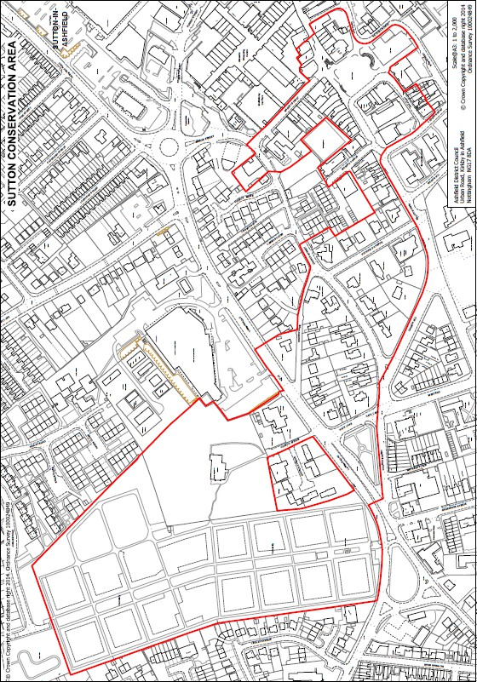

Figure 2: The proposed conservation area boundary.

Geographic and historic context.
  - Sutton in Ashfield is a town of approximately 43,000 people and is situated in the west of mid-Nottinghamshire at one of the highest areas of the county at around 150-170 metres above sea level with the town centre sitting in small valley. The town is 3.5 miles south of Mansfield and 14 miles to the north of Nottingham. The town is easily accessed from the A38 which connects Derby to Mansfield. Sutton in Ashfield sits at the head of the River Idle which runs as no more than a brook through the town before it is joined by the River Maun and enters the Kings Mill Reservoir.
  - The town lies in a geological landscape known as the magnesian limestone ridge. This is a narrow belt of Permian rock which outcrop along the western edge of the County. Magnesian limestone is a compact, partially crystalline rock which provides good building stone. Sutton in Ashfield is situated on a pronounced dip slope of a limestone escarpment which forms a series of rolling summits in the immediate region. The brown earth soils of the limestone ridge are fertile, free draining, calcareous with a fine loamy texture. The soils support a wide range of crops.⁴

⁴ Further information on the geology and landscape can be found in the Nottinghamshire Landscape Character Appraisal.

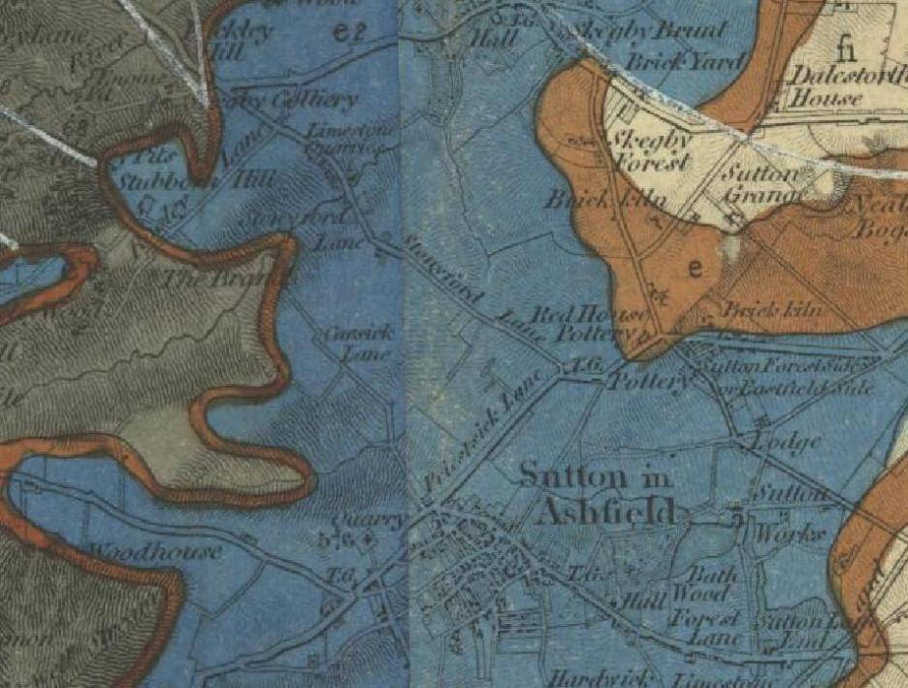

Figure 3: Extract from ‘Geological Survey of England 7 Wales (Sheet 82: Sheffield, Tickhill, Chesterfield, Mansfield) surveyed 1858. Map source: www.bgs.ac.uk, accessed March 2014).

Prehistoric & Roman.
  - Historically the area is considered to have been a remote wooded area of little interest to early settlers and little can be said about the pre-historic and Roman landscape. There is however evidence of early human activity in the area. It is recorded that in 1892 whilst foundations were being dug at St Michael’s Street eight skeletons were discovered. Sketches of the graves and a skull were submitted at this time to the British Museum and declared to have been Neolithic in date⁵. Neolithic flints have also been found in the vicinity⁶. The scheduled monument at Hamilton Hill to the east of the town has been described as a Bronze Age barrow although there is doubt over the original function of this earthwork⁷. As such there is no conclusive evidence of the impact of human activity on the area from these times but it is expected that there would be some clearances made in the forest for agriculture and the grazing of domesticated livestock after 5000BC. Modern land uses in and around Sutton in Ashfield have resulted in no visible evidence of early settlement and underground archaeological finds have been few and it is reasonable to assume that the area was not favoured by for settlement during the later

⁵ Bonser G G. 1949. A history of Sutton in Ashfield. Nottinghamshire County Council.
⁶ .English Heritage National Monuments Record.
⁷ Stroud, G. 2000. Nottinghamshire Extensive Urban Survey – Archaeological Assessment. Sutton in Ashfield

pre-historic and Roman period. There was however some Roman settlement on the magnesian limestone ridge but other than isolated finds, including hoard discovered in 1849 if 300-400 Roman silver coins⁸ there is little evidence of substantial Roman occupation.

Medieval.
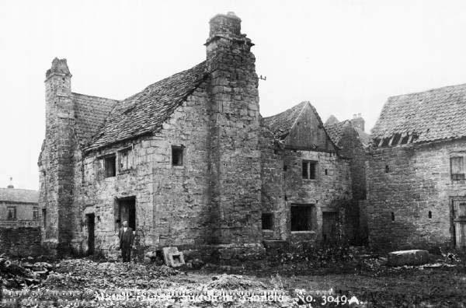
  - The name ‘Sutton’ certainly suggests that there was a settlement during the Anglo-Saxon period, ‘ton’ is an Anglo-Saxon suffix meaning a place fenced around or an enclosure. This enclosure was no doubt within the forest which the additional name ‘Ashfield’ infers. The underlying geology of magnesian limestone allows trees to grow well and ash

trees were prolific in this part of the country.
Figure 4: Sutton Manor in the early 1900s The house was demolished in 1925

  - Recorded evidence of Sutton in Ashfield being a settlement occurs in the Domesday Survey of 1086 although Sutton in Ashfield does not have a separate entry but is included in with Mansfield in the lands belonging to the king.
‘In Mansfield and the outliers Skegby and Sutton King Edward has 3 carucats and 6 bovats of land taxable. Land for 9 ploughs. The King has 2 ploughs in lordship. 5 Freemen with 3 bovats of this land; 35 villagers and 20 smallholders with 19 ½ ploughs. 1 mill and 1 fishery, 21s; meadow, 24 acres; woodland pasture 2 leagues long and 2 wide; 2 churches and 2 priests’.
  - By 1295 manorial surveys suggest that the population was about 400 and while surnames were not common names were often suffixed by a person’s trade. William the clerke, Thomas the Taylleur and Peter the smith provide an insight into workings of the village. At this time Sutton in Ashfield was free from the payment of taxes due to the fact that it was in part the personal property of the King, the King was the Lord of the Manor. Since 1170, or perhaps earlier part of the Manor became under the ownership of Walter de Sutton. Part of the Manor remained with the Sutton family until the early 16th century when it passes to Greenhalgh of Teversal. The manor eventually passes to the Countess of Shrewsbury and the Cavendish family who exchanged it for other estates with the Duke of Portland in the 18th century.
  - Sutton, being an ancient demesne of the crown at the perambulation of the forest in 1232 was to remain forest meaning that it came under the forest law⁹. By 1332 records suggest that parts had been given to waste and by 1358 the land was referred to as

⁸Stroud, G. 2000. Nottinghamshire Extensive Urban Survey – Archaeological Assessment. Sutton in Ashfield ⁹ Forest laws provided a long period of protection from timber felling and land division, and contributed to the preservation of the ancient Sherwood Forest landscape.

meadow¹⁰suggesting relaxation of the law. Maps from the 17th century show field strip farming of at least 6 fields. When these fields were established is not known.
  - With exception of the church nothing is known of the settlement from the early medieval period. There is however reference to a ‘green’ and possibly two boundary crosses but there is no evidence of markets for which a charter would have been required. The proximity of Sutton to Mansfield (charter 1227) and to Kirkby (charter (c1260) makes it unlikely that Sutton was a market town at this

Post Medieval (16th – 19th century)
  - By the early 17th century the main roads that are shown around Sutton on the enclosure map are already in existence but by the end of the century they are in such poor condition that turnpiking is introduced with the Mansfield to Alfreton Road turnpiked in 1764, resulting in three toll bars, later abolished in 1872.
  - The forest land increasingly becomes turned over for farming in the 17th century through the process of enclosure with the Enclosure Act of 1810 leading to full enclosure of the land.
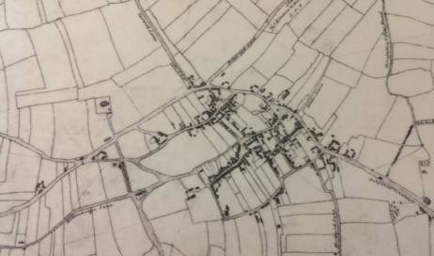

Figure 5: The 1801 Enclosure map.
  - During the 17th century the town becomes identified with the textile and hosiery industry when looms and frames were introduced into houses, these stocking frames were often left in wills. These frames and looms were the turning point in the character of Sutton in Ashfield although it was the Unwin family who settled here in 1705 who can be accredited for taking Sutton from an agricultural village to an industrial town. The Unwins and their mills (first being on Mount Street, followed by Sutton Old Mill in 1740 together with a mill at Tansley near Matlock) produced gingham and nankeen cloth that became famous country wide. Other industries of this period included pottery, making red coarse ware, corn milling with two windmills erected in the town, one at the corner of Church Street and West End and

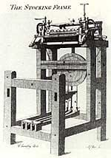
Figure 6: Example of 18th century stocking frame.

¹⁰ Stroud, G. 2000. Nottinghamshire Extensive Urban Survey – Archaeological Assessment. Sutton in Ashfield

tanning.

  - Unwin’s mill attracted people to the town in search of work as a result houses sprang up everywhere under little or no control creating areas of slum housing which was cleared from the 1930s. The industrial revolution was not welcomed by all, a visit from the Luddites of Derby and Nottingham in 1811 is reported to have
broken between 70 and 200 stocking frames in the town¹¹. The grisly tale of Jeremiah Brandreth (1790-1817) is closely associated with the town too. Jeremiah was a resident of Sutton in Ashfield and an out of work stocking maker. He is understood to have taken part in the 1811 activities but he is best remembered for his failed uprising against the Government in 1817. He and his fellow Luddite conspirators were the last people to be beheaded by an

axe in Britain in 1817. Figures recorded in 1844 suggest that the industry continued to flourish despite the rebellions with 1702 frames in employment in the town.
  - The growth of industry in the town is reflected by the population
Figure 7: A contemporary and somewhat gruesome drawing of Jeremiah Brandreth c.1817

figures. In 1295 the population was estimated at approximately 400 people¹², by the beginning of the 18th century it was approximately 500 people. A hundred years later the Parliamentary Census of 1801 recorded a total of 2801 people living in the town.
  - The population steadily increased through the 1800s and by 1891 it was recorded at 10,552 residents, a five-fold increase. Today the population is approximately 40,000.¹³
  - The industrial heritage of the town was overshadowed during the period 1837 – 1848 by the prevalent Chartists. One of the prominent leaders of the movement, Feargus O’connor visited Sutton and delivered an address to a large crowd. The Chartist Movement resulted in the Unwin family falling out of favour with many in the town and with Mr E Unwin’s death in 1841 the family closed the Old Mill and the industry of the Unwin’s left Sutton for good.
  - The loss of the Unwins certainly was not the end of the textile and hosiery industry in the town. Throughout the 19th century it continued to be a principal employer with firms such as H. W. Cooke established in 1836 and Messrs I & R Morley established 1880 employing over 350 people to name but two firms¹⁴. The well known hosiery firm ‘Pretty Polly’ was established in Sutton in Ashfield in 1919, but the raw material of limestone, sandstone and clays in the region saw the growth of other industries including lime kilns, quarries and potteries, as well as a mineral water factory to the south of the town¹⁵

¹¹ Sources vary on the number of frames broken.
¹² Bonser, G.C. 1949. A history of Sutton-in-Ashfield.
¹³ Clay-Dove, W. 1978.
¹⁴ Lindley, L. 1907. History of Sutton in Ashfield or past links with the present.
¹⁵ Whites Directory 1894.

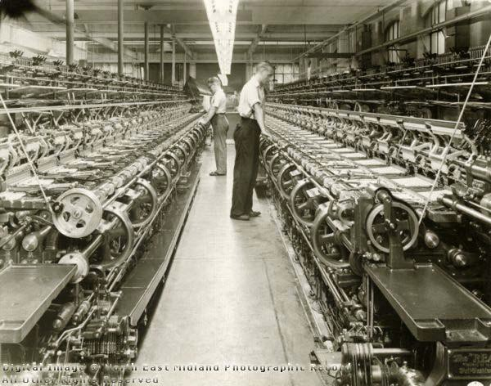
Figure 8: I.R Morley factory in the mid 20th century.
  - By the end of the century the sinking of the collieries introduced a new industry, that of coal mining to the area with each colliery employing up to 1500 people. The first colliery was sunk in 1867 at Teversal (sometimes referred to as Butcherwood Colliery) with the same company, the Stanton Ironworks Company replacing the old Skegby Colliery in 1873. This pit later became known as Sutton Colliery but also known as Brierley Pit probably after the influx of new workers that came from Brierley Hill area of Staffordshire to work. A new colliery shaft was also sunk c1875 at Teversal by the Stanton Ironworks Company, this became Silverhill Colliery. The pits created a need for new housing and brought greater economic prosperity to the area during the 20th century until their closure in the 1980s and 1990s.

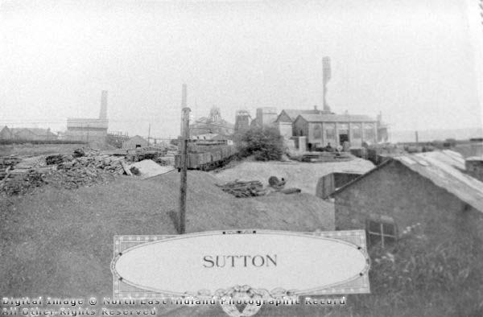
Figure 9: Sutton colliery in the early 1900s.
  - Sutton’s industrial heritage brought many new people to the town it was however the forming of the Local Board that resulted in new infrastructure and civic spaces being created. For many years matters of ‘governing’ the town was conducted by the Vestry at the parish church later replaced by the Highway Board in 1850. The adoption of the Local Government Act in 1866 saw first the Local Board which later became the Urban District Council in 1894. The Local Board and District Council introduced, together with private enterprise and implemented many changes to the town including;
    - Opening of Junction Station 1850.
    - Introducing gas lighting in 1852.
    - First public library established in 1857.
    - Establishment of markets in 1868.
    - Approval of plans for the laying out of the district around New Cross in 1869.
    - Removal of Toll Bars to the roads in 1872.
    - Purchase of the Gas Works in 1877 and approval of the new Outram Street.
    - ‘Fast trains’ began stopping in Sutton in 1883.
    - New water works to supply the town opened in 1884.
    - 1887 plans for Victoria Street approved.
    - Formation of a town fire brigade in 1887.
    - Building of Town Hall, 1888.
    - Opening of town cemetery on Hucknall Road in 1892.
    - Opening of Midland Railway Station, Forest Street, 1893.
    - Systematic renaming of streets and numbering of properties, c.1894.
    - Opening of Great Northern Railway Station, Outram Street, 1898.
    - Opening up and redevelopment of the Market Place, 1905.
    - Telephone Exchange established in 1908.

  - The 20th century witnessed the continued growth and development of the town, new commercial premises were built throughout the town notably so along Outram Street during the 1920s and 1930s. Much new development occurred during the 1960s and 70s with the most notable change happening in the 1970s with the building of the Sutton Centre (community college) which provided educational and recreational facilities for the town and the construction of the Idlewells shopping centre, built on the site of former slum housing. This provided the town with a new shopping area, library, indoor market and bus station. New investment followed shortly such as the new Fine Fare supermarket (now ASDA) however frequently new development has resulted in the loss of both architecturally and historically significant buildings in the town. The closure of the pits in the 1980s and 1990s impacted the economy of the town and its surrounding landscape, however new industries have risen to take the place of the collieries in recent
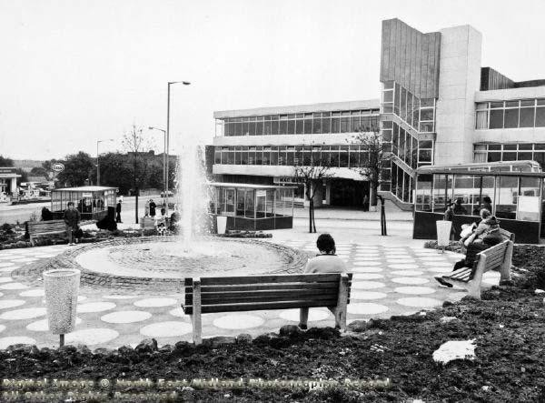
Figure 10: The Idlewells Centre in 1971
years.

Chronological development
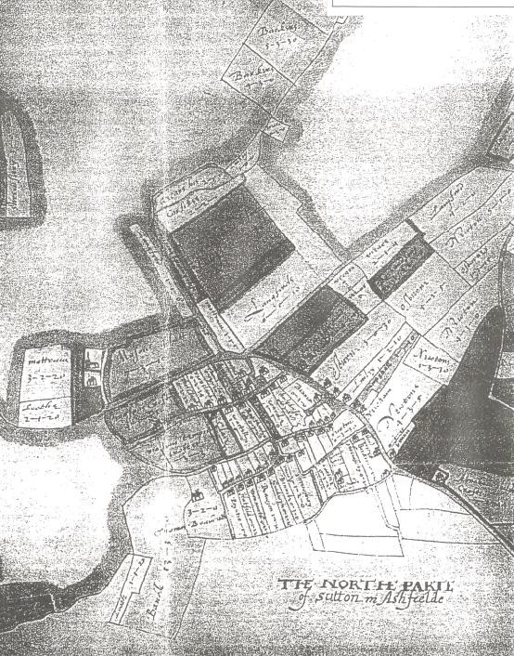
Figure 11: Part of Senior’s map of 1610.
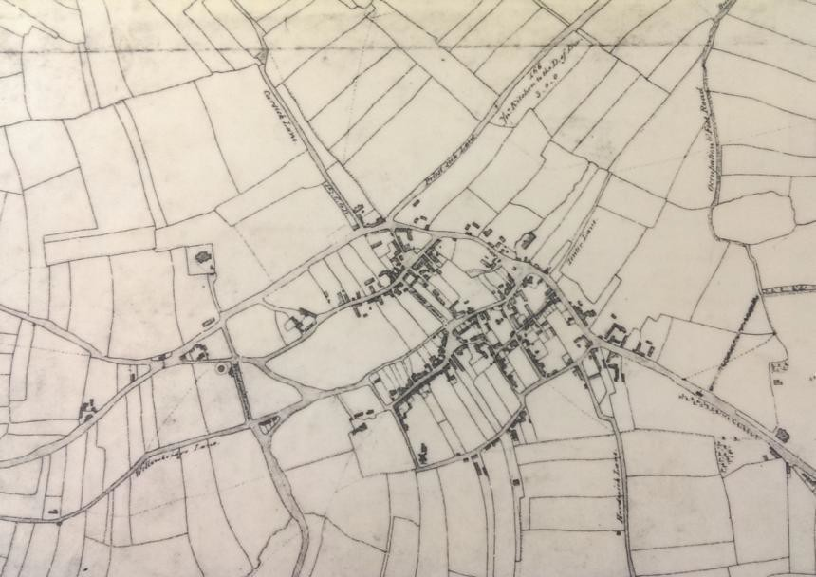

Figure 12: 1801 Enclosure map.

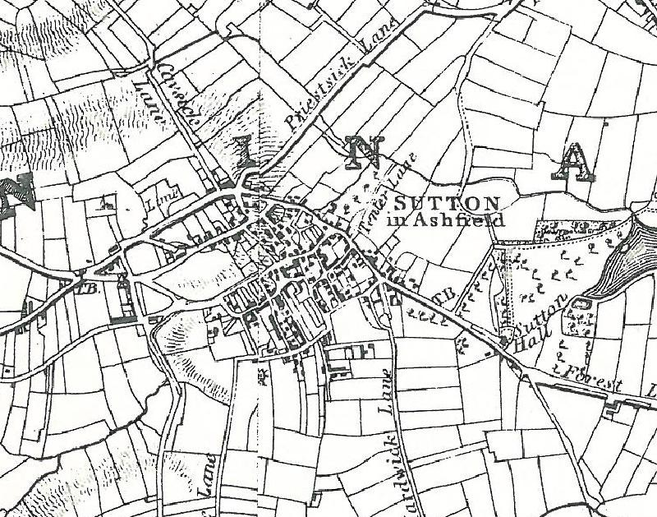
Figure 13: Sanderson map 1835.
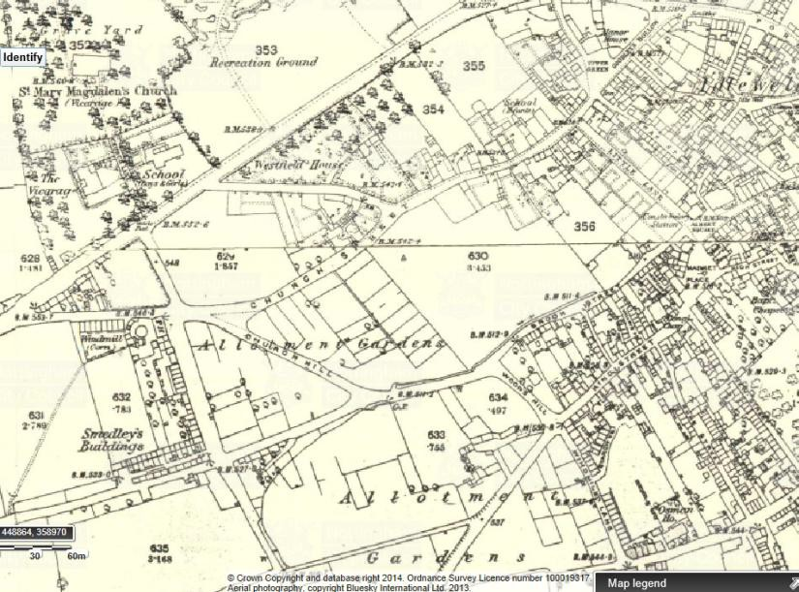

Figure 13: 1875-1885 series Ordnance Survey map.

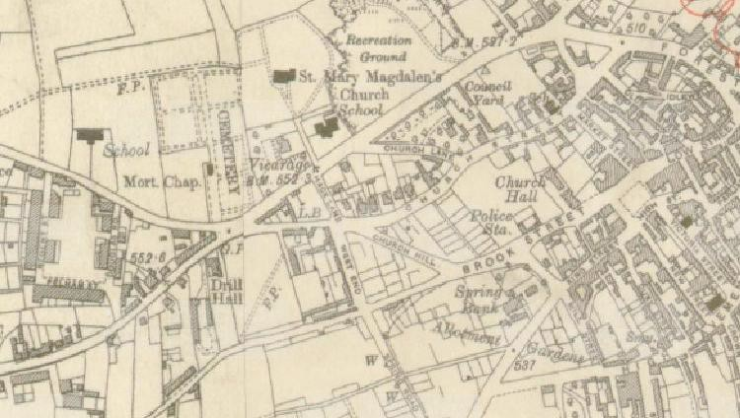

Figure 14: 1912-1919 series Ordnance Survey map

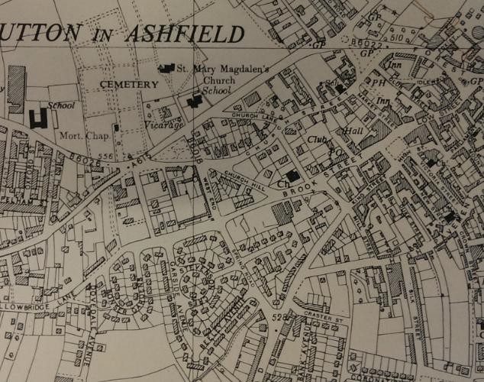

Figure 15: 1955 Ordnance Survey map.

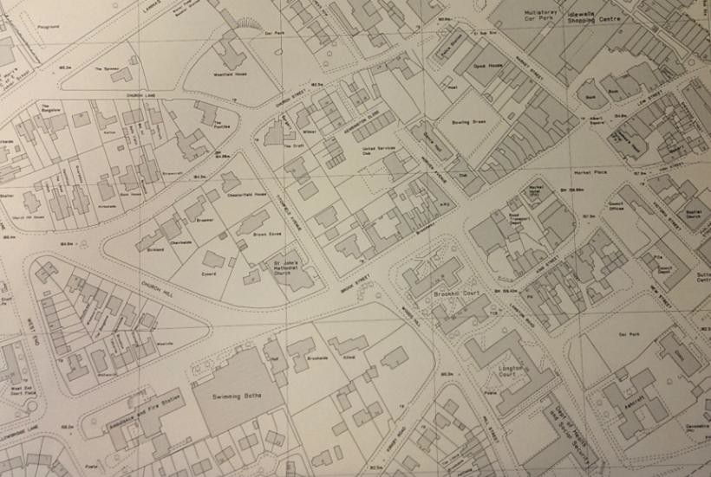

Figure 16: 1976 Ordnance Survey map.

Character appraisal.
  - The Sutton in Ashfield Market Place Conservation Area has two distinct areas. That to the north which includes the medieval parish church and the residential area of Church Street and the Market Place to the south with its commercial and civic buildings. With exception of the church the built form is predominantly late Victorian and early 20th century although the street pattern undoubtedly has much older origins.

Layout and plan form.
  - The layout of Sutton in Ashfield consists of several roads that run parallel to each other on two sides of a valley, the valley being formed by the River Idle. The Idle flowed alongside Brook Street and to the north of Low Street crossing Forest Street (where there was stepping stones) until the mid-19th century when it was culverted and hidden from view.
  - Plans from the 17th century show how the town was divided into blocks by roads that run north-south, individual plots or burgages being clearly defined within these plots.
  - The plan of 1610 shows the position of the church being peripheral to the town at a greater distance than would normally be expected¹⁶. Although it is possible that in earlier times there were buildings in the vicinity of the church the town has developed around a number of foci, particularly Church Street and Top or Upper Green (now Devonshire Square) and King Street (formerly Beggar or Begga Street) including the area known now as the Market Place.
  - Despite the growth of industry during the 18th century the town did not expand. Comparison between the plan of 1610 and the Enclosure Act plan of 1801 show that it was pre-existing plots that were being built up, the town was becoming denser.
  - During the 19th century the eastern and southern areas of the town, away from the church became increasingly denser cumulating in the slum area of Idlewells. By the end of the century with the new opportunities for work the town expanded beyond its 18th century extent, the development of the New Cross area and Forest Side.
  - The need for a larger market place became evident at the start of the 20th century when in 1905 part of King Street was pulled down to create a large square.
  - The massive 20th century redevelopment of the Idlewells Shopping Centre dramatically changed the ‘historic core’ of the town sweeping away some of the earlier street pattern although retaining key open spaces of the market place, Devonshire Green and Engine Green (Portland Place). The laying out of both the cemetery and recreation ground helped retain the isolated character of the church from the town centre. The conservation area despite having been part of the earliest settlement, as mapped, has retained its historic street pattern and lower density giving it a distinctive character amid the massive expansion and growth of the town over the past century.

¹⁶ Stroud, G. 2000. Nottinghamshire Extensive Urban Survey – Archaeological Assessment. Sutton in Ashfield

  - The conservation area contains an eclectic mix of architectural styles distinctly reflecting the periods of construction. The majority of buildings that form the general interest and character of the area were built between 1887 and 1940, unsurprisingly at a time of economic and population growth of the town.

Layout and plan form – Summary of special interest
The layout and plan form of the conservation area derives from being built around a small valley.
The town has not developed around the Church but other foci including Church Street, Devonshire Square, King Street and the Market Place.
During the 18th century the town did not expand, only becoming denser. Real expansion came in the 19th and 20th centuries following the sinking of the pits.
Large areas of the town have developed through conscious planning and Council intervention such as the cemetery at the end of the 19th century and the Idlewells Centre and the Market Place in the 20th century.
The residential streets of Church Street, Church Lane and Titchfield Avenue is defined by its low density with most properties occupying large plots with front gardens.
The commercial areas of Brook Street, King Street, Market Street, Albert Square and the Market Place is a denser and tighter urban grain with most properties occupying back of pavement positions.

Architectural quality and built form.
  - ​

Church of St Mary Magdalene is a Grade II* listed building and the oldest surviving building in the conservation area. Dating from the 12th century with the tower and spire constructed c1395. The chancel was rebuilt in 1854 with the church undergoing restoration in 1867 under the Rev. Charles Bellairs, vicar, at this time the aisles were also enlarged by the removal of pews and galleries and a wall and palisade were erected around the greater part of the churchyard. The east window was replaced in 1907. The church is built from coursed and squared rubble and dressed stone with gable and lean to slate roofs. The church benefits from a battlemented square tower topped by an octagonal spire totalling and height of 95ft. | 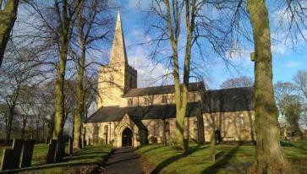  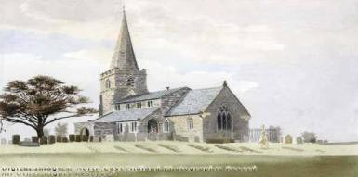
The treed churchyard is a tranquil area and forms part of the setting of the adjacent cemetery laid out in 1892, the churchyard also contains a Grade II listed headstone from 1628 inscribed ‘Here lyeth the body of Elizabeth Wright Widow who departed this life July ye 14th 1628’. The churchyard is an important open space within the conservation area and for the setting of the church itself.  The entrance gates to the churchyard from Church Walk consist of iron gates and railings. The stone gates piers original were topped with lamps whilst each pier had metal plaques attached. These plaques are understood to have read “These gates were erected by Public Subscription in grateful memory of those men and women of this town who laid down their lives in the World War 1939-1945”. ¹⁷ The plaques have been replaced with stone versions during 2014. | Figure 18: The church as painted in 1868.  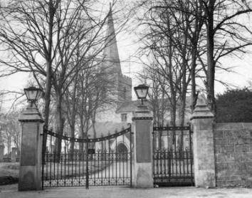  Figure 19: The entrance gates in the mid 20th century.
Condition: Good

¹⁷ Source: Picture the Past www.picturethepast.org.uk

Lammas Road
Lammas Road is one of the main thoroughfares of Sutton in Ashfield, clearly identifiable on plans of 1801 the road connects Alfreton Road to the southwest to Priestsic Road to the northeast. The road formed part of the Alfreton to Mansfield turnpike established in 1764. The toll bar was positioned close to where the cemetery gates are today.
The National School occupies an elevated position overlooking Lammas Road. It was built in 1845 in a Tudor-Gothic style to replace the earlier National school that was founded in the old Tithe Barn, which stood to the west of the present school in 1919. The new school originally provided for upwards of 200 children, later classroom additions in 1867 and an infant’s room in 1882 enabled the school to provide education for over 400 children. The school originally had a teacher’s residence too.  The school is built from stone with a decorative fish scale plain clay tile roof. Regrettably the school has lost its original stone mullion windows and belcot however the front gables does still retain stone cut lettering with the inscription “National School, 1845” although badly weathered. The irregular coursed stone wall to the playground and trees alongside Church Walk maintain much of the original appearance and enhance the “villagey” character as so described by Sir Nikolaus Pevsner in 1951¹⁸  Condition: Fair. | 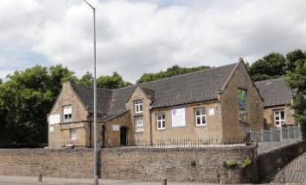  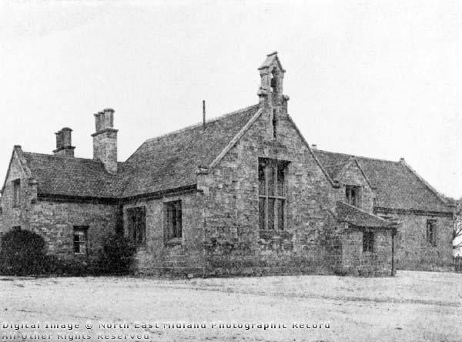  Figure 20: The National School. Date unknown.

¹⁸ Sir Nikolaus Pevsner, 1951. The buildings of England. Nottinghamshire. Yale University. New Haven & London.

2 Lammas Road (Winsford), is a two story detached house with built between 1919 and 1937. It is brick and render with slate roof and single chimney stack. The building is embellished by brick quoins to the first floor and canted bay window to ground floor. PVC-U windows and doors throughout. As an individual building it offers little to the special architectural character of the area but does have group value when considering the buildings that surround it date from the first half of the 20th century. Restoring original elements back to the building would increase its value architecturally.  Condition: Good | 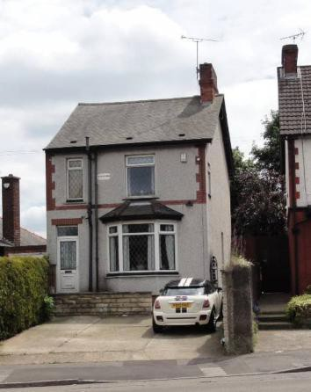
4 & 6 Lammas Road, is a 2 storey semi detached house built between 1885 and 1899. A concrete tile roof with exposed rafters at the eaves. The original chimney stacks have been retained. The first floor is rendered and has a small central gable. The building is embellished with brick detailing seen with the quoins and window lintels. The ground floor is brick with square bay windows. While and attractive building its greatest value to the conservation area is its group value when considering the buildings that surround it date from the first half of the 20th century. Restoring original elements back to the building would increase its value architecturally.  Condition: Good | 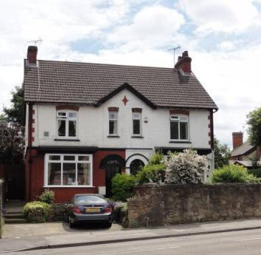
Church Lane is a narrow leafy tree lined road that links the church in a south east direction to Church Street and the town centre. The lane is now capped at the Lammas Road end not allowing through traffic but still provides a link for pedestrians to the church and school. Until the 1930s Church Lane was largely undeveloped with the exception of The Pantiles at the corner of Church Street and Westfield House to the north side of the lane which was constructed in 1853 but since demolished. The stone boundary walls to Westfield House still remain along the roadside. Historic maps suggest that Church Lane has always been a leafy approach to the church from the town centre as many of the trees pre-date or have replaced earlier trees.
Church Lane is primarily a residential street and due to the short period in which the

houses were built gives the lane a strong 1920/30s character. Despite only a small number of properties being built they are individually designed.
Number 15 Church Lane is a brick built bungalow built between 1940 and 1959, and occupies an elevated position over the lane. It has a hipped pyramidal slate roof with two very high chimney stacks and bow windows which are PVC-u. The property does however retain its original timber and leaded glass door with art deco motifs.  Condition: Good | 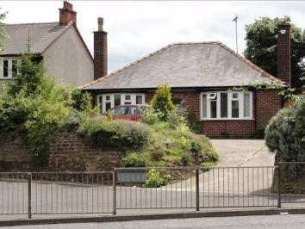
Number 11 Church Lane is a detached house built between 1919 and 1940. It has a simple ridge slate roof and roughcast render. The garage appears to be a later addition to the original building. The original steel frame leaded casements have been replaced with UPVC.  Condition: Good | 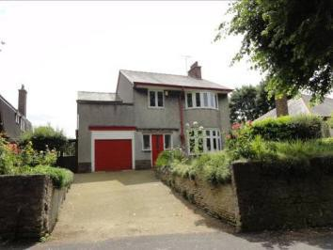
Number 9 Church Lane is again constructed between 1919 and 1940. Architecturally the building is very distinct due to its plain tile covered gambrel roof. The use of feather boarding, half timbering, render, brick and stone create a unique and aesthetically pleasing property. The property also benefits from the retention of its original steel casement windows.  Condition: Good | 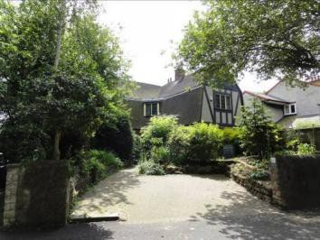
Numbers 5 and 7 Church Lane is a semi- detached house built between 1919 and 1940. Architecturally it is typical of the many semidetached houses built nationally during the 1930s with its plain clay tile hipped roof with finial details, central chimney stack, half- timber gables, bay windows and roughcast render finish. Number 7 has maintained more of its original appearance with its unpainted render and leaded windows. Whilst not  architecturally unique in a wider sense | 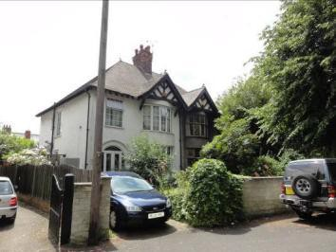

numbers 5 and 7 contribute to the group value to the lane and stand as a unique pair of houses within Church Lane itself.
Condition: Good
Number 3 Church Lane (The Chantry) is a brick and roughcast rendered detached house with a sweeping plain clay tile roof andhalf-timbered gable to the front. The property benefits from well detailed chimney stacks. The property dates from between 1919-1940 but its strong Arts and Crafts influence in the design suggests it was built to the earlier years of this date range.  Condition: Good | 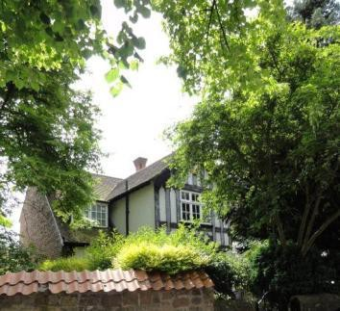
The Spinney Church Lane is, like number 9 a very distinct detached house due again to its gambrel roof but this time covered with Roman clay tiles. Its roof shape, and colour contrast of white rendered walls against the red clay roof ensure its prominence in the lane. The building was again constructed between 1919 and 1940 on the site of the former grounds of Westfield House.  Condition: Good | 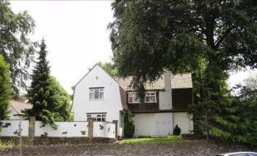
Church Street, before the growth and expansion of the town during the 19th and 20th centuries Church Street was one of the principal streets in the town, the main houses, farms and cottages were found along this street. Those on the south side of course benefitting from the stream that once ran openly along Brook Street.
Devonshire Infants School is now a commercial premise but was opened in 1873 under the newly formed school Board, a result of the recent Education Act. Stone built with prominent artificial slate roofs with both Gothic arch and square headed windows openings Windows are a combination of PVC-U and timber. Two chimneys one of which is very tall and prominent. This building together with the National School on Lammas Road represents the changes of the education system in the 19th  century of particular interest in both | 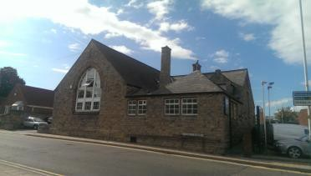

architectural and social history.
Condition: Good
The Pantiles, Church Street is an attractive H- plan stone built house with plain clay tile roof. The property is at a canted angle to both Church Lane and Church Street but positioned well off the road in a large garden plot. Whilst the current building has many elements of 17th century design such as metal casement windows and drip hoods the building is understood to be an early 20th century albeit an extension and adaptation of an earlier 18th building as the photograph from the early 1900s suggests.  Condition: Good | 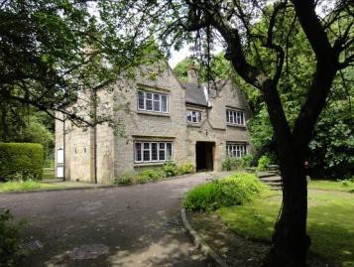  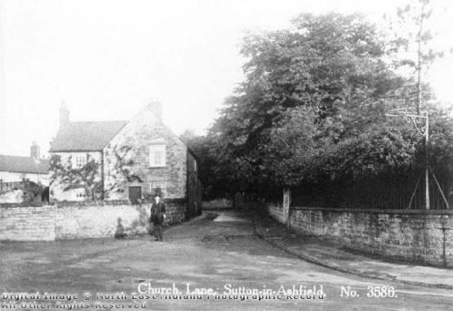  Figure 21: The junction of Church Lane and Church Street in the early 1900s.
28 Church Street is a stone built property with rendered areas under a concrete tile roof. The property is probably 18th century although could be earlier. All windows are PVC-u with timber soffits and fascias. The porch to underneath a timber cross has a stone inscribed with “W.B.S 1850”.  Condition: Good | 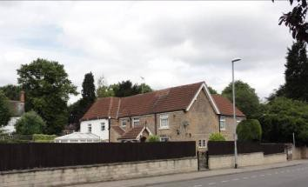
Strawcroft and Brookhill, Church Street. Large semi-detached house built between 1899 and 1919. Slate ridge roof with gable, red brick and render, canted bay windows. Clay finials and cresting to roof. Upper bay window to Brookhill has been removed. Both properties have lost their original windows, PVC-u throughout.  Condition: Good | 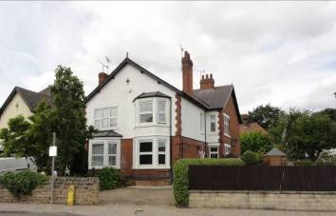

Bank House, Church Street. Formerly known as The Lindens and again built between 1899 and 1919 this large detached house is now a residential home for the elderly. Red brick and render with hipped roof, half timbering and canted corner bay with pyramidal roof. Although the original roof covering and windows have been replaced and a conservatory attached to the front the building is recognisable as an Edwardian house and contributes to the group value of this part of the conservation area.  Condition: Good | 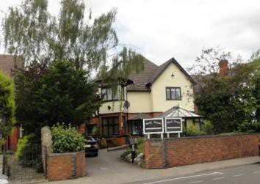
Kirkstede, Church Street is again a large detached house in generous grounds built between 1899 and 1919.. Red brick, half rendered with half timbering. Under a plain clay tile roof and finials with lead roofs to the canted bays. The property has lost its original windows now with PVC-u throughout but the property benefits from retaining its original front boundary wall. Kirkstede was once the home of George Gershom Bonser (d. 1947) an eminent local historian and Councillor.  Condition: Good | 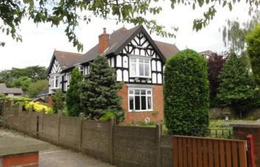
Riversdale and Heathfield, Church Street, semi- detached house, red brick and plain clay tile roof with tall chimney stacks. Built in 1906 according to the date stone set in the front gable. It has a symmetrical frontage with most of the original style timber sash windows retained. Square bays to ground floor with leaded roofs. The building using brick and terracotta decoratively as can be seen with the egg and dart patterning at the eaves, decorative ridge tiles and finials. The building also retains its original arcaded boundary wall with half round copings and gate piers which are particularly attractive. The building is largely original in appearance.  Condition: Good | 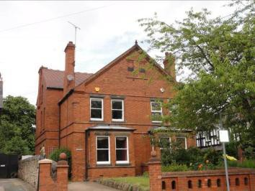

The Limes and Lindum, Church Street, semi- detached house, red brick with slate roof and tall chimney stacks. Plain barge boards, symmetrical frontage with square bays to ground floor with hipped roofs covered with plain clay tiles. Bisected diamond pattern detail to front gable. All original windows have been replaced with PVC-u however the property has retained its original front boundary wall. The building is likely to have been built in 1905 along with its neighbour.  Condition: Good | 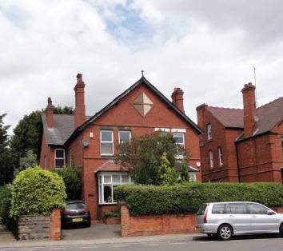
Church Hill House, Church Street is a 2 storey house that occupies a prominent corner position at the junction of Church Street and Hack Lane. The house is brick built in notable Flemish bond under a slate roof. Stone set in the gable is inscribed with “Church Hill House 1908”. The prominent gables are finished with timer barge boards whilst the ground floor bay windows are under plain clay tile roofs. The original iron railings are retained above the porch, the building has lost its original windows now all PVC-u. The building benefits from an attracted stone boundary wall which appears to have once had iron railings long since removed.  Condition: Good | 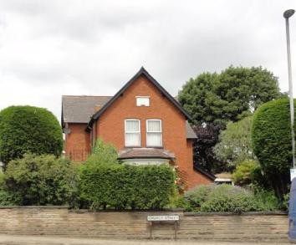
Birkland, Chevinside, Braemar, Church Street are three mid-20th century properties. They are large properties that sit in good sized plots however their contribution to the character of the conservation area is considered to be neutral.
Condition: Good

Chesterfield House, Church Street is a large 2 storey house that occupies a corner plot set behind a stone boundary wall. Built between 1919 and 1940 it has a plain clay tile hipped roof with 4 tall brick chimneys at each corner and a central stack. The building is roughcast render above a brick plinth. Its principal elevation faces south overlooking a large garden. Central to the south elevation is a half timbered gable whilst to either side are bay windows to both floors with notable tile hanging between the windows. The building retains its original wooden leaded windows many with leaded coloured glass.  Condition: Good | 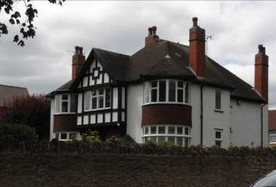
The Croft, Church Street is again a large 2 storey house that occupies a corner plot set behind a stone boundary wall. Built between 1919 and 1940 with a brick ground floor and roughcast rendered first floor under a plain clay M-plan roof with sprocketed exposed eaves. All windows are PVC-U, those at the first floor are under tile creased lintels with ground floor windows having simple stone lintels. The building is reflective of the Arts and Crafts period.
Condition: Good
Wilmar, Church Street is a 2 storey brick house set behind stone boundary wall. Built between 1919 and 1940., L-plan with bay windows to the front. Plain clay tile hipped roof with two tall chimneys. The house has a distinctive canted entrance and hall across both floors with parapet roof. All windows are PVC-U.  Condition: Good | 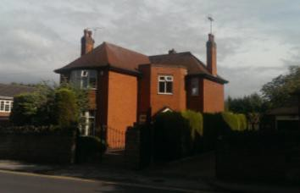
Titchfield Avenue is a modern street in the town laid out in the 1920s/30s which connects Brook Street to Church Street. It is primarily a residential street with good examples of housing from this period. Its hillside position helps to add to the interest of the area.

Brown Eaves, Titchfield Avenue is a dormer bungalow set within a large plot facing south overlooking garden behind high stone walls. Built between 1919 and 1940 the building is half timbered and roughcast render under a plain clay tile roof containing a single flat roof dormer. Prominent tall chimney stack to the front. PVC-U leaded windows. Good example of bungalow architecture of the period.  Condition: Good | 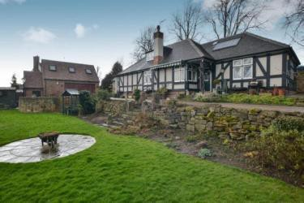
St John’s Methodist Church, Titchfield Avenue see Pevsner  Condition: Good | 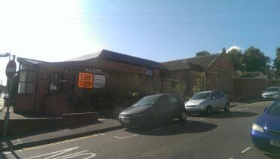
10, Titchfield Avenue is a bungalow built from buff brick. Built between 1959 and 1976 it is typical of the period. Simple architectural style, horizontal large glazed windows and shallow pitch to the roof. The building contributes little to the architectural or historic interest of the conservation area and is considered be a neutral building in this regard.  Condition: Good | 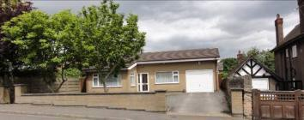
8 Titchfield Avenue is a handsome detached two storey house built between 1919 and 1940. Rough cast render to ground floor with half timbered gable to front. The building has a large sweeping plain clay tile roof with decorative ridge tiles, high chimney stacks and sprocketed exposed eaves along with a gabled dormer. The building retains its timber and metal windows with leaded upper lights. The building has interest from many angles but has a particularly visible southern elevation together with its roadside elevation.  Condition: Good | 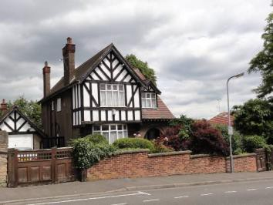

6 Titchfield Avenue is a usual house built between 1959 and 1976 with asymmetric roof and built to reflect its sloping plot. Light coloured brick, stone cladding and PVC-U bow windows and porch. Its frontage is entirely tarmac. The building contributes little to the architectural or historic interest of the conservation area and is considered be a neutral building in this regard.  Condition: Good | 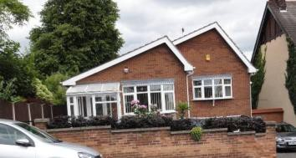
4 Titchfield Avenue was built between 1919 and 1940; it is s standard plan type 2 storey detached house of this period. Pit has a plain clay tile roof with chimney stack and projecting bays with gable to the front. It is possible that front gable has been over clad with vertical timber boarding in latter part of the 20th century. The building is part painted render part brick with PVC-u windows and doorts. The side elevations contain attractive brick detailing in the form of block and herringbone pattern brickwork set within a timber frame. The property retains its front garden although front boundary wall and gate are not original to the property.  Condition: Good | 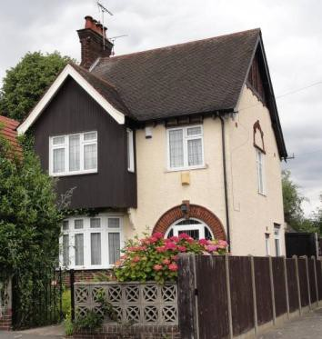
2 Titchfield Avenue (Verton) is a half timbered with render bungalow to the front and 2 storeys to the rear reflecting the sloping site. It was built between 1919 and 1940. It has a pyramidal plain clay tile roof to front with hipped roof to rear with prominent part render and brick chimney stacks. The property has lost its original windows; windows are now PVC-U. The property is set behind a random coursed stone boundary wall with random coping stones reminiscent of dry stone walls, although set in mortar.  Condition: Good | 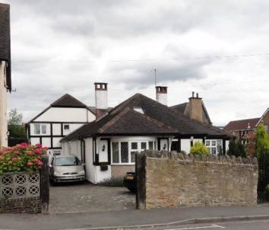
Church Hill is a historic street in the town, clearly identifiable on the 1801 plans. While
providing a north-south link for the western side of the town enabling access for the

church the street did not see development until the early 20th century. During the 19th century the road simply ran through allotment gardens.
5 Church Hill is a large 2 storey detached house built between 1940 and 1959 although now much modernised. The building is very well screened set behind a stone wall and conifer hedge. The building is considered to have a neutral contrition to the character and appearance of the conservation area.
Condition: Good
Eynord, Church Hill is an attractive 2 storey brick and rendered house built between 1919 and 1940. It has a plain clay tile roof with prominent chimney stacks and a half timbered steeply pitched gable to the front. The decorative arch to the porch is particularly notable. All windows are PVC-U with the exception of the centre dormer which retains its original metal casement with leaded glass.  Condition: Good | 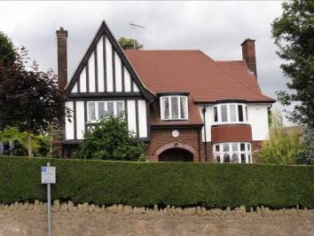
Hack Lane is a historic street in the town, clearly identifiable on the 1801 plans. While providing a north-south link for the western side of the town enabling access for the church the street did not see development until the early 20th century. During the 19th century the road formed the boundary to the quarry at Wright’s Hollow later to become St Mary’s Gardens.
Kirkside, Hack Lane occupies a corner plot and is a 2 storey detached house built between 1919 and 1940. The house is roughcast render set on a brick plinth under a plain clay tile roof with chimneys retained. To the front the building has a half timbered gable and lead roof curved bay window at ground floor. The building benefits from its retention of its original leaded casements with coloured glass. Lintels to windows and doors are tile creases providing a decorative element. To the side is a 1930s garage.  Condition: Good | 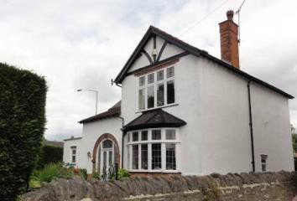

2 & 4 Hack Lane (Capesthorne Cottages) is a semi detached house with brick ground floor with roughcast rendered gable walls. The first floor to the front is also rendered but scored to appear as ashlar stone blocks. The roof is slate, with timber barge boards and soffits and all four chimneys are retained. To the front above the first floor windows are half timbered gables. The windows at number 4 have all been replaced with PVC-U, while number 2 has timber leaded casements in an original style. The name “Capesthorne Cottages” is set in a stone centrally between the first floor front windows.  Condition: Good | 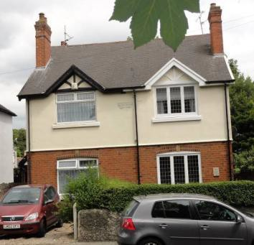
Brook Street is an historic street in the town and again is clearly identifiable on the 1801 plan. The name Brook Street is taken from the stream that ran along its length which was crossed by stepping stones until it was culverted in around 1880. Brook Street was devoid of development until the late 19th century, prior to which it formed the rear boundaries of plots akin to burgage plots along King Street.
Opticians, Brook Street is a single storey square plan building with notable plain clay tiles pyramidal roof with central chimney stack. The building was built between 1919 and 1940. The building was originally brick but is now painted render. Its frontage is symmetrical with central doorway under an eyebrow pediment flanked by two windows set on painted stone cills that extend to the ground. The building appears to have always been occupied by an optician. The building was occupied an optician in photographs from the 1930s.  Condition: Good | 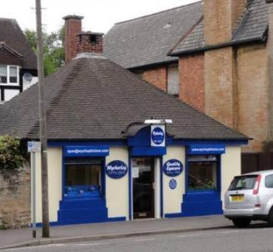  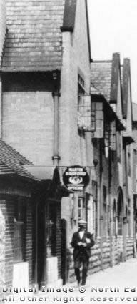  Figure 22: The opticians and the Old Police Station in the 1930s.

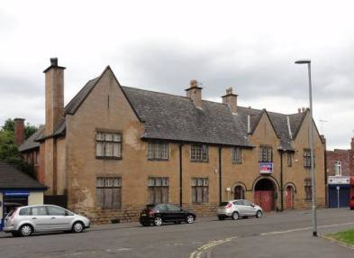
The Old Police Station, Brook Street was built in 1915 to replace the original police station that was built in 1861 on Albert Square. The building is neo-tudor in style with ashlar and rusticated stone frontage and brick to the rear. Its steeply pitched slate roof with deep exposed eaves rafters and three stone coped gables to the front ensure that the building is highly promiment on the street scene. The building retains its stone mullioned windows to the front with metal casements and carriage entrance. The building has high aesthetic value to the conservation area.
Condition: Fair & vulnerable.
Broadway (1-4) Brook Street is a stark contrast architecturally when compared to the Old Police Station adjacent. Broadway was constructed between 1919 and 1940 (although number 4 appears to have been rebuilt) and is a brick built two storey commercial premise. It has a tile creased steeped parapet which were commonly used in the first half of the 20th century. Some of the original retail units at ground floor have been lost and infilled with brick. The building has lost its orginal windows which were likely to have been timber sash windows and the original shopfronts have been lost. The applied cut lettering “BROADWAY” below the parapet is not beleived to be original to the building however the typeface is consistent with that of the 1950s and 60s. The building is considered to be a neutral building with regards to what it conributes architecturally to the character and appearance of the conservaiton area but the reinstatement of original windows and shopfronts would greatly enhance this building.  Condition: Good | 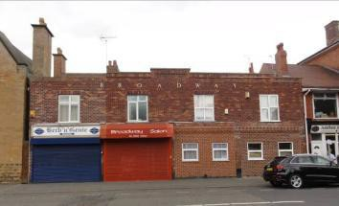

20 Brook Street is a two storey retail property. It is brick built with plain clay tile roof with sprocketed eaves and a prominent chimney stack to the front. The building was built between 1919-1940 and retains an early 20th century shopfront cornice, corbels and awning attached to brick quoins. Original joinery and rainwater goods have been lost, now all PVC-U. The building is considered to be a neutral building with regards to what it conributes architecturally to the character and appearance of the conservaiton area but the reinstatement of original windows and shopfront would greatly enhance this building.  Condition: Good | 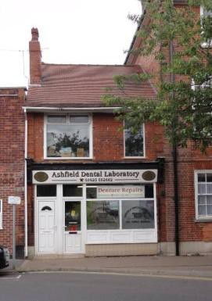
The Old Post Office, Brook Street is a 3 storey building built to reflect an 18th century (Georgian) town house. The building was built between 1919 and 1940. The building has a hipped slate roof. Original timber sash windows replaced in 2014 with PVC-U, all windows set under flat arch gauged brick lintels. The building is designed to face both Brook Street and Morwen Avenue although its principal elevation is considered to be Brook Street where the central door with decorative timber doorcase, hood and fanlight can be found.  Condition: Good | 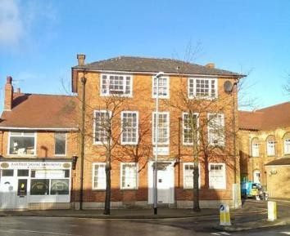
The Old Welcome Institute and Cafe, Brook Street is a prominent building just off the Market Place, 3 storeys, brick built with plain clay tile roof, two decorative chimney stacks, strong central gable and side parapets. The facade is symmetrical with two entrance doors with stone cut lettering above “Public Hall” in distinctive art nouveau typeface. The side elevation to Morven Street is defined by two bookend gables sandwiching the central hall with full height buttresses. The building contains much architectural but subtle detailing for example the stone geometric key stones,  brick drip hoods and decorative rainwater | 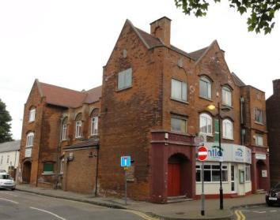

hoppers. Regrettably the building has lost its curved central entrance and balcony railings, original doors and leaded windows.  The building was designed by a local architect of some standing, Percy Bond Houfton¹⁹ and was opened in 1906 by the Duke of Portland. The building cost £4000 to construct. Its original use was effectively a temperance hall and was set up by Mr W Read, the Secretary of the Band of Hope and Adult Temperance Movement. The basement houses kitchens, stoves, boilers etc with the ground floor containing a shop, cafe, billiard room, committee room and reading room. The first floor had a hall that could seat 1100 people, a stage, retiring rooms and a girl’s club room. The second floor houses two committee rooms and the caretaker’s house. The building when built was luxuriously furnished.²⁰To the rear was a bowling green.  Restoration of the building is needed nonetheless the building positively contributes to both the architectural and social history of the town.  Condition: Fair | 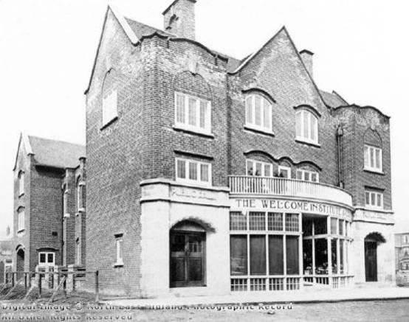  Figure 23: The Welcome Institute shortly after completion.
6a-16a Brook Street is a 3 storey building with a concrete tile roof set behind a parapet. The street facade has aspects of 1950s /60s design, particularly the stone window surrounds. The building is considered to offer a neutral contribution to the character and appearance of the conservation area.  Condition: Good | 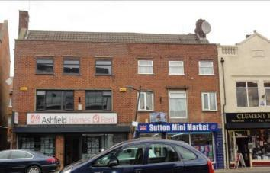

¹⁹ Percy Bond Houfton (1873-1926) Alfreton born with his architect’s practice based in Chesterfield. Houfton was responsible for designing Cresswell Model Village in 1895 and colliery villages in South Yorkshire. Along with designing many buildings locally Houfton he also designed houses as Letchworth Garden City. Houfton applied garden village principles in designing houses in an Arts and Crafts style.
²⁰ Lindley, L. 1907. History of Sutton in Ashfield or past links with the present.

6 Brook Street (Clement Taylor) is a two storey building with rendered facade and slate roof with balustrade parapet and central pediment. The date “1922” is inscribed within the pediment. The balustrade and parapet are adorned with ball finials, some of which have been lost. The ground floor contains a timber shop front with recessed terrazzo lobby or 1960s appearance.  Condition: Good | 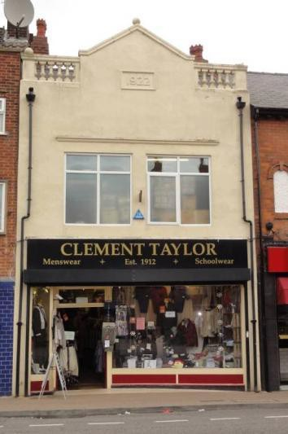
4 Brook Street (Market Plaice Fish & Chips) is a two storey building brick built with slate roof and prominent chimney stack. The frontage has a central gable emphasising the timber soffits with exposed rafter detailing. The central PVC- U window at first floor has a large timber lintel with decorative brick arch above with roughcast render beneath. This central window is flanked by two render infill arches. The ground floor has a modern tiles shopfront and signage.  Condition: Good | 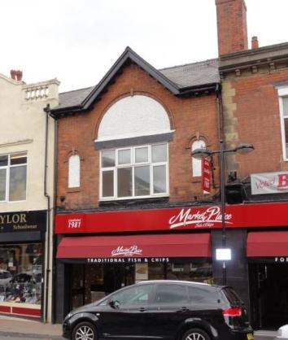

4 Brook Street (Market Plaice Fish & Chips) is a two storey building with notable stone decorative parapet and cornice and quoins set within a brick facade. The large central window is PVC-U no doubt having replaced a timber casement window. The ground floor retains original shopfront corbels although the rest of the ground floor is a modern tiled shopfront.  Condition: Good | 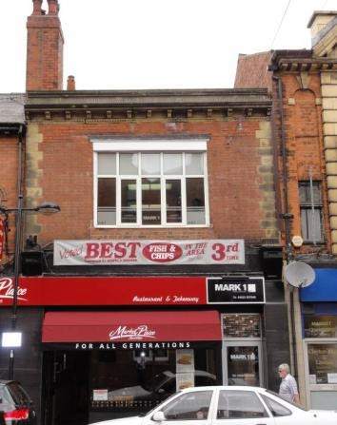
Market Place, Albert Square & Low Street. The history of Sutton in Ashfield is understood to have had its beginnings with a cleared enclosure within the forest; the concept of an open space is thereby paramount to the history and development of the town. The market place has for a long period been a place for trade and while originally it was triangular in shape it was enlarged by the Urban District Council in 1905 resulting in many of the buildings surrounding it being built at that time. The market place today is the result of development works that were carried out in the 1990s.
The market place and Albert Square today appear to form one space although the spaces were no doubt separated by the brook when it flowed through the place. Albert Square is believed to be the site of the town stocks.
Low Street is also an historic street of the town and again is identifiable on the 1801 plan. Taking its name from its position the street connects the area that was known as ‘Engine Green’ (Portland Square) to the ‘Market Place’. It forms the heart of the commercial and retail provision in the town.
Coral & Midlands Mobility, Market Place is a three storey building of brick and stone with a highly decorative facade. Stone rusticated pilasters appear to support two front gables with dentilated cornice and eaves. Set within the gables are two decorative shields with the building’s construction date of 1906 in Roman numerals.  C A  MCMVI MCMVI | 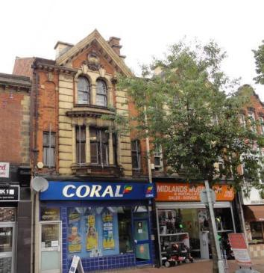

The facade is not symmetrical as evidenced by the left hand bay which has a projecting bay window at first floor. The use of Tuscan columns at the first floor provides a very classical element to the facade. There is a combination of timber sash windows and casement windows, some with leaded and coloured glass which again emphasises the lack of symmetry across the facade. The building retains its decorative rainwater goods and the right hand shopfront retains its original curved glass, lobby and entrance door although all set behind a modern roller shutter.  Condition: Fair | 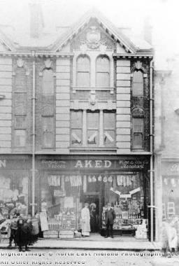  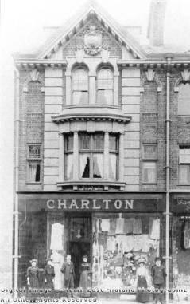  Figure 24: The former Charlton and Aked shops at the Market Place c.1900
Cafe Expresso & Spice World, Market Place is a three storey brick building with stone detailing in the form of copings and quoins. The building dates from 1905; the date is cast in the central rainwater hopper. The building is notable for its two decorative Dutch gable behind which is a slate roof with single chimney stack. The third floor has retained its original timber sash windows. The first floor has lost its original windows and apertures, it is understood that six individual sash windows occupied where the two large windows are seen at the first floor. The original shop front has been lost from the ground floor and the extensive signage, lighting and pipe work across the facade currently undermines the quality of the architecture, nonetheless this building does positively contribute to the character and appearance of the area.  Condition: Good | 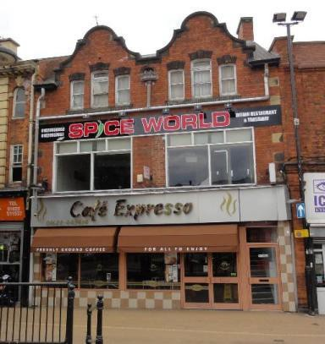

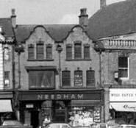
Figure 25: The former Needham building, Market Place in 1962.
Town Hall, Market Place is a three storey brick building with slate roof which occupies a commanding position overlooking the market place on the corner of Market Street. Although called the Town Hall the building has never been an administrative centre instead was built as a public hall that could accommodate 1000 people. The building was designed by local architect J.P Adlington of High Pavement, Sutton in Ashfield and commissioned by a limited liability company. The foundation stone was laid on 10th December 1888 and was opened the following year.  Originally the hall was accessed by a flight of steps from Market Street but in1906 when the new market place was created the hall was extended with a large shop at the ground floor and hall above with the roof becoming a balcony. With the removal of the original entrance a new but rather unassuming entrance was created off the market place and is still identifiable today by the stone lettering above the door.  Both the 1888 and 1906 phases of the building have lost a number of key architectural features; these include the clock tower, the circular window to the gable, the stone | 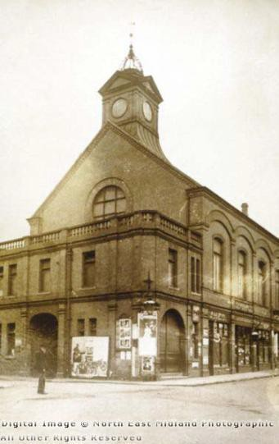  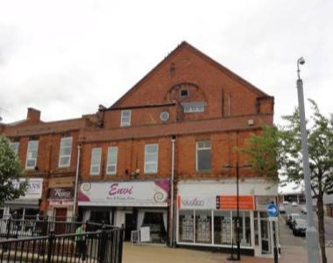

balustrade to the balcony and its original shop fronts. Nonetheless the overall form, mass and scale together with its historic use still contribute positively to the special architectural and historic interest of the town.
Condition: Good
Number 1 Low Street /Albert Square (Fidler and Pepper Solicitors is a prominent canted corner building overlooking Albert Square and the Market Place on the site of a former police station. Built between 1875 and 1899 from brick and stone it is 2.5 storeys high with slate roof punctuated by six flat roofed dormers and three chimney stacks. The façade has a number of decorative elements including a parapet, stone quoins, dentilated cornice, and central pediment. The ground floor sits atop a granite stone plinth and is a rusticated stone façade where all timber windows sit within decorative arches with prominent key stones. The central door is particularly ornate sitting between Tuscan columns. Windows to upper floors have been replaced with PVC-U.  Condition: Good | 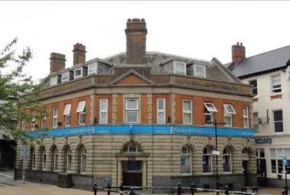
3 Low Street (Barclays Bank), is also a prominent canted corner building that overlooks Albert Square and the Market Place. It was built between 1875 and 1899 as the Nottinghamshire Bank. At 3 storeys high the building has a slate roof and rendered façade to the upper floors with decorative brick detailing. The rendering is understood to have been carried out during the later 20th century; the building originally had a brick façade. The bay windows to the 1st and 2nd floor are set under a bracketed gable with decorative barge boards. The ground floor is painted stone on a granite plinth. The central door under the bay windows if framed by a decorative arch and flanked either side by stone mullioned windows. Windows throughout are timber, those to the  1st and 2nd floor appear to be original sash | 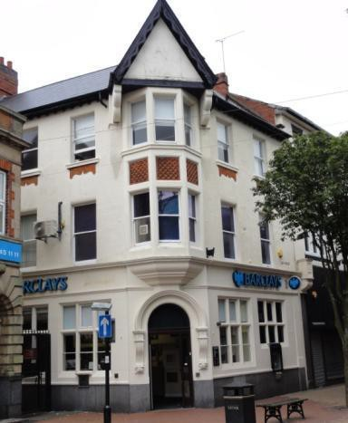

windows.
Condition: Good
5-7 Low Street, is a mid 19th century 3 storey painted brick building. The roof covering is not visible from Low street but the chimneys are retained. The front facade retains all its original  1 over 1 timber sash windows although the ground floor contains a large modern shopfront of no architectural interest.  Condition: Good | 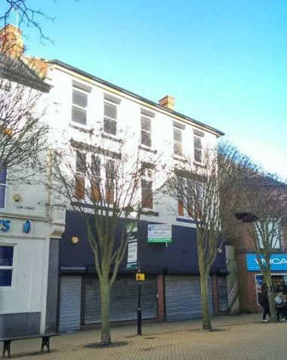
8-12 Low Street, is a 3 storeys and brick built. The ground floor has been rebuilt to accommodate modern shopfronts but the upper floors retain decorative broickwork to facade. All windows are PVC-U set under stone lintels.  Condition: Good | 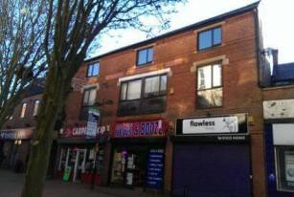
6 Low Street, is a late 19th century 2.5 storey building, brick built with hipped slate roof. The ground floor has a modern tiled shopfront, the upper floors are original in appearance. First floor retains 19th century 2 over 2 timber sash windows atop stone sill and under stone lintels. Attic floor has an eaves dormer with timber lancet window. The eaves is notable for its polychrome sawtooth detailing. | 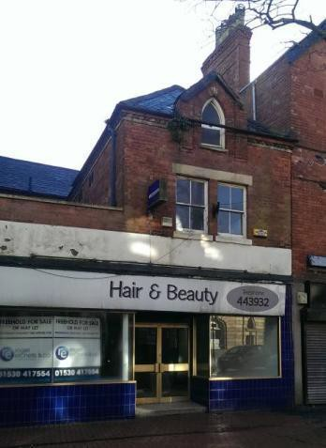

4 Low Street, is a late 19th century 3 storey brick built building with slate roof. The ground floor has a modern shopfront but the upper floors have retained their original canted bays. The second floor bay has attractive leaded windows. The bays are topped with a half timbered gable. To the left the building has retained its large chimney stack.  Condition: Fair (currently being renovated). | 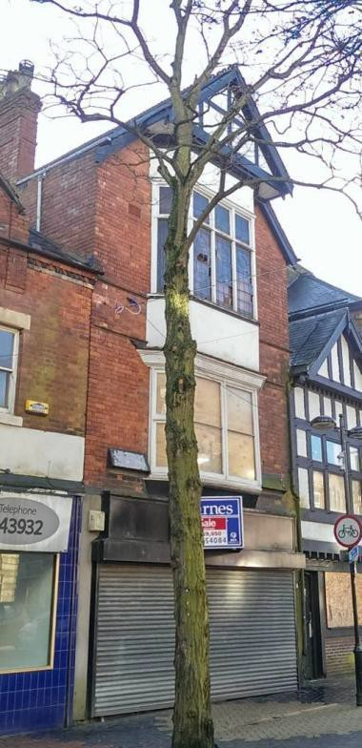
2 Low Street, is an early 20th century that appears to have been constructed in an in fill plot. The building is 2 storey, half timber and smooth render with slate roof. The first floor is jettied providing a mock Elizabethan appearance. The ground floor has a timber and brick shopfront consisting simply of a door and windows. The first floor retains steel casement windows.  Condition: Fair (currently being renovated). | 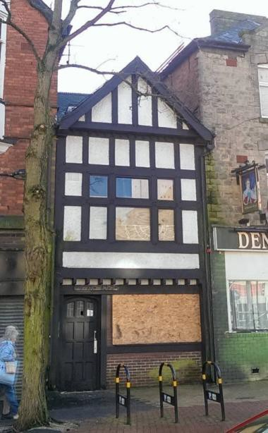

Denman’s Head Hotel, is a 3.5 storey building occupying a prominent corner location overlooking the market place. Coursed stone built with distinctive slate roof due to is conical shaped corner the building was a public house and hotel until recent years. The pub frontage at the ground floor is not original to the building which dates from the late 19th century however is early 20th century green glazed brick with timber tracery windows. The building retains many of its timber casement and sash windows under stone lintels.  The Denman’s Head Hotel occupies the site of a former inn which until 1820 was known as the ‘King’s Head’²¹. The existing building is the result of much remodelling, demolition and new development the overall appearance of the building is late 19th century.  Condition: Fair (currently being renovated). | 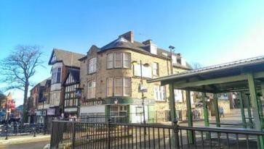  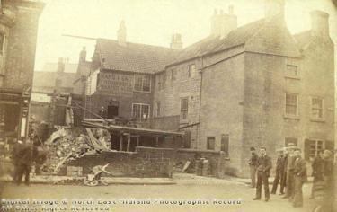  Figure 17 The Denman’s Head during rebuilding.  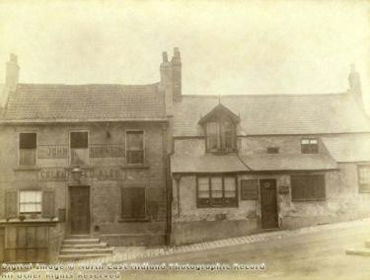  Figure 28: The Denman’s Head and Durham Ox before rebuilding, view from the Market Place.

²¹ The name was changed following the trial of Queen Caroline, the landlord was delighted with her defence by Mr Denman (later Lord Justice Denman) he changed the name to the Denman’s Head in his honour (according to Lindley, 1907).

Market Tavern, Market Place, was built in 1905 following the creation on the new market place. The building at 2.5 storeys occupies a corner position and is prominent on the Market Place. The building is constructed from brick with stone detailing which includes windows surrounds and door jambs, coping to the decorative gables, date stone atop the gables which states “1905” dentilated string course and fluted door case to the main door. The roof is slate and adorned with decorative ridge tiles and prominent chimney stacks. Whilst the corner door has been blocked the building does retain all its original timber windows.  Condition: Good. | 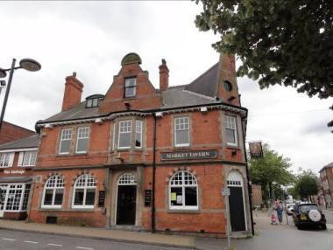  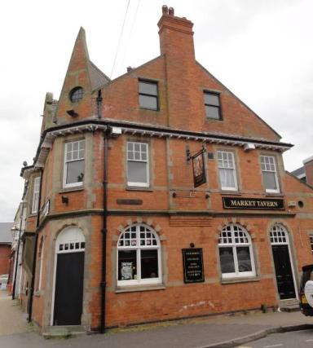
The Cottage, Market Place, is a 2 storey building built of brick with slate roof. It building is late 20th century typical of the late 1970s and early 1980s. The building is of no architectural or historic value to the conservation area.  Condition: Good. | 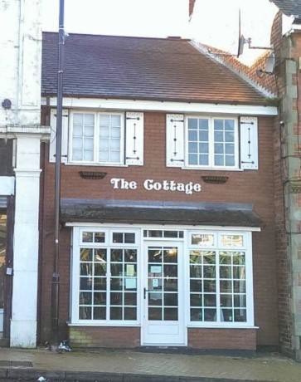

4a Market Place, is an early to mid 20th century brick and stone 2 storey flat roofed building with painted brick facade and stone pilasters to shop front. Shopfront is modern aluminium. The building is loosely influenced by the Moderne style popular at the time.  Condition: Good. | 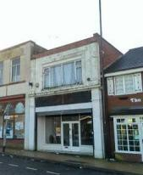
Units 3 & 4 Market Place/King Street, Was built between 1899 and 1919. Originally the building was 1 shop unit and had a brick façade interrupted by stone pilasters with timber sash windows the first floor. At ground floor were Edwardian/Moderne styles shopfronts with low stallrisers and pull out awnings. The majority of this original fabric has now been lost only the quadrant shape of the building provides any architectural interest of the conservation area.  Condition: Good. | 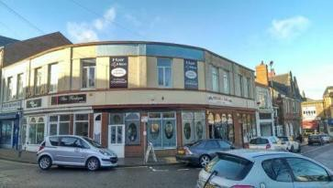  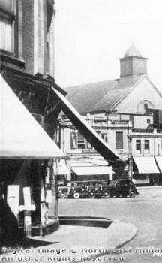  Figure 29: The buildings shortly after completion showing the shopfronts and pilasters.
King Street was one of the main streets in the town for centuries until the mid 20th century when the street was shortened for new development. The precise origin of the street is uncertain with some claims stating it was started in 1661 following the restoration of the king while others claim it was in this year the street was renamed from “Beggar Street”.

12 King Street is a 3 storey brick building with an artificial slate roof. Although the ground floor has been rebuilt with new shopfronts the earlier cornice has been retained. The upper floors are largely original with large arched timber windows at first floor under tile crease lintels. The second floor has a different window arrangement but dominated by the front stone coped gable which appears supported by the decorative brick pilasters. Between first and second floors are four brick corbels similar to to those used to support flag pole bases.  Condition: Good. | 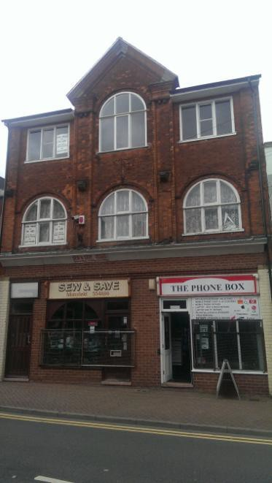
11 King Street, is an early 20th century c1905 3 storey building. Brick with slate roof with decorative use of stone and terracotta as can be seen with the rusticated pilasters, window mullions and general façade of the building and the ridge tiles and pinnacle to the roof. The 1st and 2nd floors retain their original timber sash windows. At the ground floor is a timber shop front of unknown date but has traditional features including the split stable style door once common to butcher shops and inscribed marble slabs affixed to the stallrisers advertising the shop as a butcher. The building also has a prominent chimney stack that served 6 fireplaces which makes it especially large.  Condition: Good. | 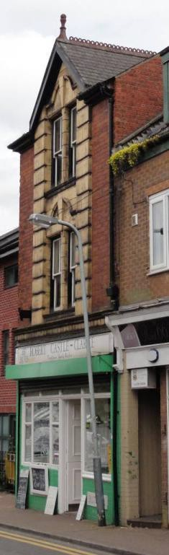

13 King Street, is a 2 storey building with large dormer to roof. The building is of unknown date without further investigation but appears to have a late 20th century brick façade. At ground floor an early 20th century cornice and corbels from a shopfront have been retained together with the glazed brick pilasters. Other than the remains of this earlier shopfront the building contributes little to the special architectural character of the conservation area.  Condition: Fair. | 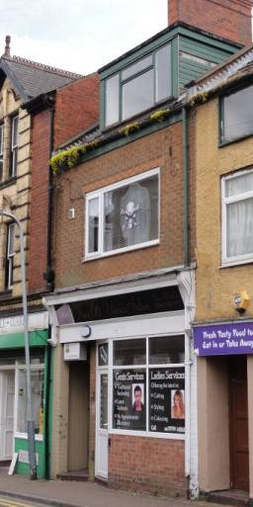
13d-15 King Street, is a 3 storey building of unknown date but could possibly be 18th century. The façade is roughcast rendered with modern windows throughout. The ground floor appears to have been rebuilt in the 20th century. The building in its current appearance contributes little to the special architectural character of the conservation area however a survey or stripping back of the building could reveal features of significance.  Condition: Good | 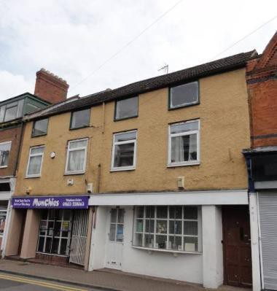
17-17a King Street, is a 3 storey building built in 1906 as per the date stone in its gable. The building is brick with a slate roof and uses brick decoration to embellish the façade. PVC-U windows are installed but the original centre mullion has been retained. The original shopfront survives at the ground floor but does require restoration.  Condition: Good. | 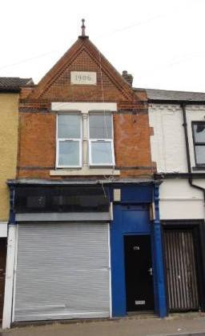

19 King Street (Café Ilachi),was originally two buildings, perhaps late 18th, early 19th century albeit much altered and was formerly a public house. One of the buildings was brick the other stone, but now painted over. The ground floor is rendered with stone mullioned windows which unify the building. The main entrance door has a stone canopy which provided interest to the façade. The timber windows are modern. The demolition of buildings along King Street to create Langton Road has meant the gable to Langton Road has been rebuilt in modern brick.  Condition: Good. | 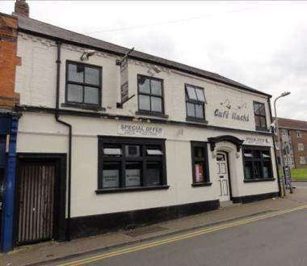
Market Street, appears to have been laid out in the early 19th century (between 1801 and 1835) and connects the market place to Church Street. The street was formerly known as Little Lane prior to the 1894 re-naming of many streets in the town. Market Street today still retains a number of its late 19th and early 20th century retail properties together with substantial 20th century developments including a multi-storey car park.
18 Market Street, 2 storeys, brick built, brick rusticated quoins with slate roof. Prominent front gable with date stone ‘1903’. First floor windows appear to be late 20th century timber replacements. At ground floor the original shop front layout with lobby entrance and remnants of original shopfront.  Condition: Good. | 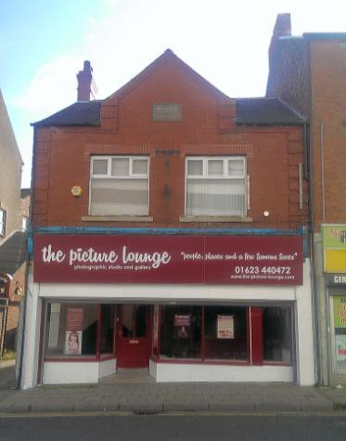

20 Market Street, is a 3 storey brick building with slate roof. Positioned between first floor windows is date and name stone inscribed ‘Leeds House, 1923’. The building retains decorative brick work to the eaves but all windows and shopfront are modern.  Condition: Good. | 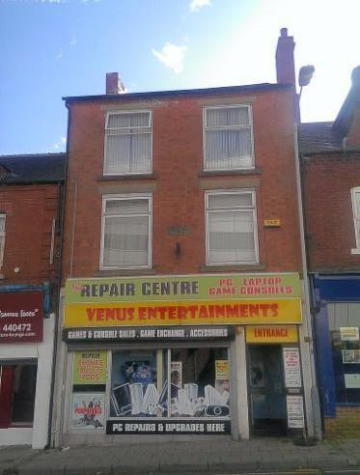
22-24 Market Street, is a 2.5 storey building built between 1900 -1919. Roof is covering in artificial slate. Roof benefits from unusual shaped Dutch gable style dormers. Modern uPVC windows but remnants of original shopfront survive at ground floor.  Condition: Good. | 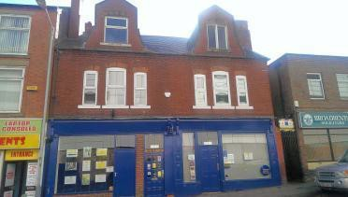
Sutton in Ashfied Cemetery was opened in 1892 and consists of unconsecrated burial ground adjacnent to teh ancient churchyard. The cemetery is formed by s series of tree- lined avenues with is principal entrance at the Hutwaite Road, Lammas Road Juntion. A focus of the cemetery is the Grade II listed war memorial. The cemetery is also a war grave cemetery with 65 graves of servicemen.

War Memorial, is grade II listed c.1920. The memorial is marble of a full sized soldier atop a square pedestal. The memorial is within a paved area with obelisk boundary posts linked by chains. The memorial commemorates the fallen from both WWI and WWII. | 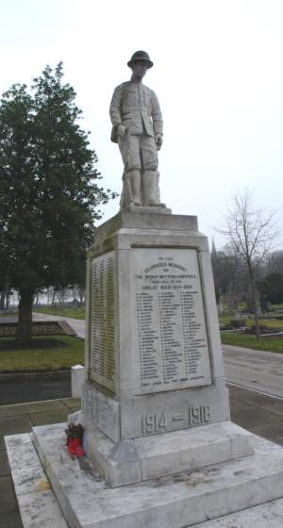
Headstone and memorials, more memorials were produced in the 19th and 20th century than in any other period for marking graves. Headstone and memorials would lend emphasis to Victorian cemetery design, the layout design and headstones therefore work as a whole. While it is not practicable to list every headstone of architectural or historic interest the cemetery does reflect the historical development of headstones with many having particular meanings associated to them, e.g. teh angel dropping an open rose often represented the guarding of the tomb of one who died in the prime of life. Within the cemetery are a number of war graves commission headstones too. | 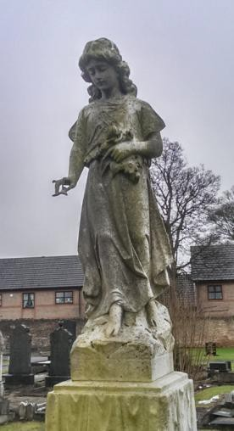

Architectural quality and built form – Summary of special interest.
The Church and Market Place Conservation Area contain numerous buildings that are considered to positively contribute to the character and appearance of the area.
The majority of buildings that contribute positively to the character and appearance of the conservation area were built during the late 19th and early 20th century.
Residential properties are usually 2 storeys high and commercial properties being 3 storeys high.
Residential properties mostly occupy large plots with substantial front gardens. Commercial properties are positioned predominantly at the back of the pavement.
A variety of building materials are used in the area. Traditional materials include brick, stone, slate and plain clay tiles. Roughcast and smooth render are used often in conjunction with brick or half timbering.
Original materials and architectural features such as original windows, chimneys, decorative bricks, date stones, bargeboards, half timbering help create and attractive and electric grouping of buildings worthy or preservation.
The use of modern materials such as concrete tiles and PVC-U windows and doors along with additions such as external roller shutters has a detrimental impact on the special architectural interest of many buildings in the area.
The loss of original shopfront features and addition of modern inappropriate commercial signage is having a detrimental effect on the character and appearance of the area.

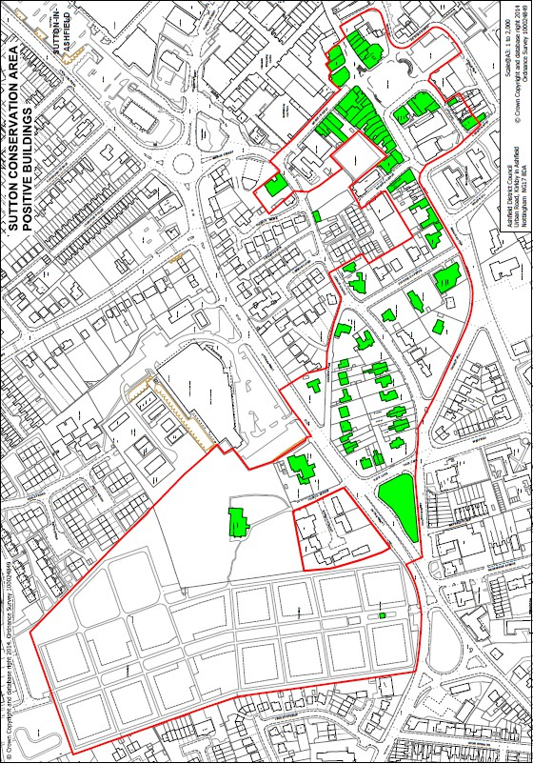

Figure 30: Buildings that positively contribute to the character and appearance of the conservation area. *
*The absence of any building on this map does not necessarily mean that it is on no interest or that it makes no positive contribution to the character and appearance of the area or its setting. Advice should always be sought from the local planning authority.

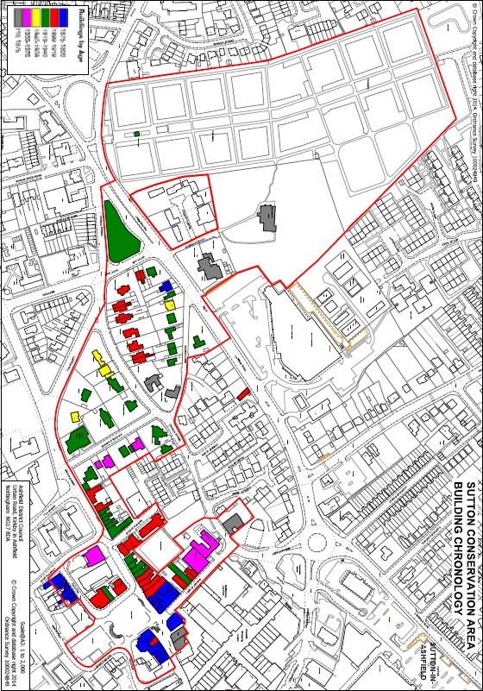

Figure 31: The chronology of buildings in the conservation area.

Open spaces, boundaries, public realm, gardens and trees.
  - The character of the conservation area consists of more than simply the architectural quality or the historic interest of the buildings. The spaces between in the form of gardens and open spaces, boundary treatments and the amenity value of trees all add to the richness and the distinct character of the area. Within the conservation area there are three distinct open spaces worthy of mention these are the churchyard to St Mary Magdalene Church, St Mary’s Gardens and the Market Place.
Churchyard at St Mary Magdalene Church
  - The churchyard at St Mary Magdalene Church is the oldest open space within the conservation area. Forming the burial ground to the 12th century church. The churchyard is accessed from Lammas Road along Church Avenue, a tree lined avenue, up to the decorative iron gates which form a war memorial. The churchyard is bound on all sides by stone walls to form a distinct space with the church standing at the centre and the focus of all views. The churchyard is predominantly grass with many standing and laid flat headstones. The headstones themselves are of significant interest historically and aesthetically. The number of trees in the churchyard provides areas of shade in the summer months with dappled light whilst in the autumn they create a woodland character with the high level of fallen leaves. The churchyard provides a tranquil retreat from the traffic and noise of the town centre.

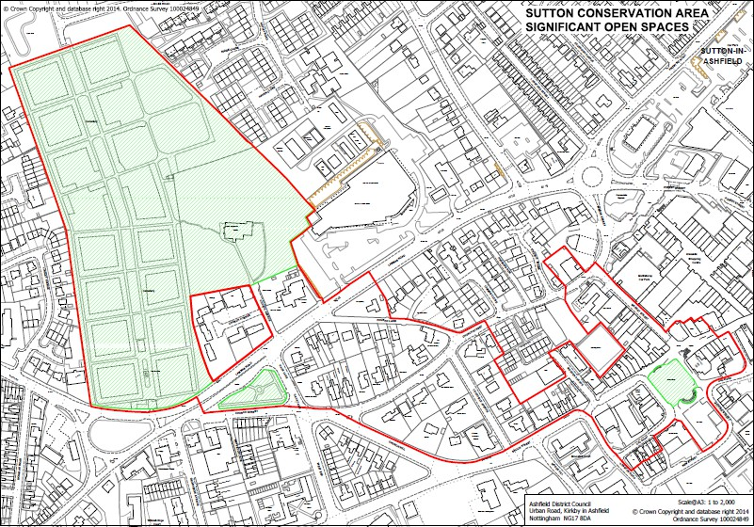

Figure 32: Significant open spaces in the conservation area.

  - The churchyard at St Mary Magdalene Church is the oldest open space within the conservation area. Forming the burial ground to the 12th century church. The churchyard is accessed from Lammas Road along Church Avenue, a tree lined avenue, up to the decorative iron gates which form a war memorial. The churchyard is bound on all sides by stone walls to form a distinct space with the church standing at the centre and the focus of all views. The churchyard is predominantly grass with many standing and laid flat headstones. The headstones themselves are of significant interest historically and aesthetically. The number of trees in the churchyard provides areas of shade in the summer months with dappled light whilst in the autumn they create a woodland character with the high level of fallen leaves. The churchyard provides a tranquil retreat from the traffic and noise of the town centre.
5.15 In contrast to the churchyard St Mary’s Gardens is a modern area of open space. The
garden was laid out in the 1930s in what was an area that was known as Wrights Hollow
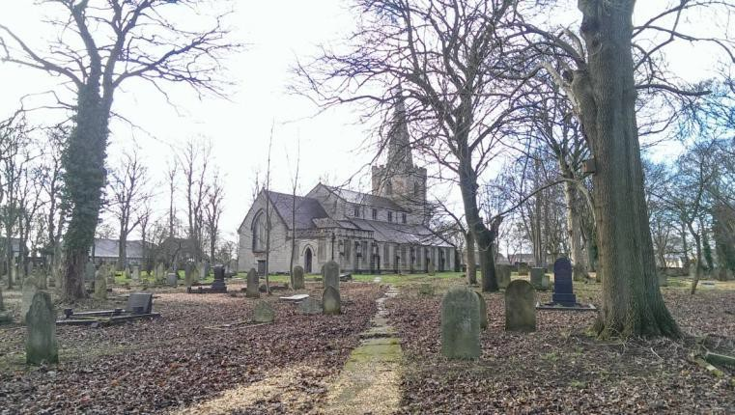
Figure 33: St Mary Magdalene Church and churchyard.
St Mary’s Gardens
  - This public garden occupies a triangular piece of land at the junction of Lammas Road, Church Street and Hack Lane. This triangular shape of the gardens emphasise this historic junction as can be seen with the historic maps below.
5.15
5.16
5.17
5.18
5.19
5.20
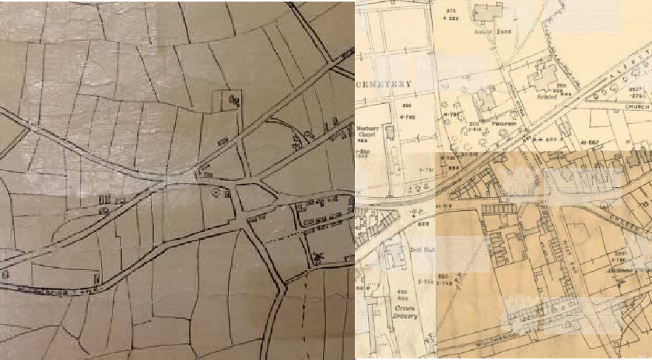
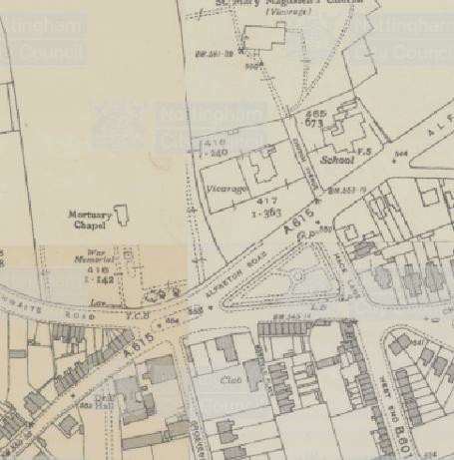

Figure 34: Left 100 Enclosure map. Centre; 1912-1919 series Ordnance Survey map. Right; 1937-1940 Ordnance survey.

which contained houses and a small quarry. The gardens were opened in June 1935 by the Mr C Brown MP and dedicated by the vicar of St Mary Magdalene church the Reverend R.P Tinsley
  - St Mary’s Gardens today is a small grass and treed park with tarmac pathways formally laid out. The gardens are not as peaceful as the churchyard due to its location but the area does provide an important amenity space within the urban environment.
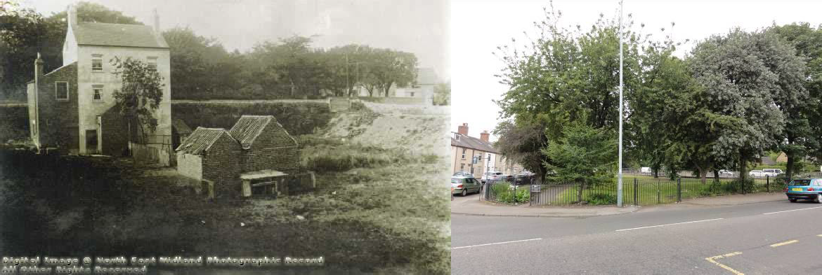
Figure 35: Left Wrights Hollow in late 19th century . Right; St Mary’s Gardens in 2014.

Market Place and Albert Square

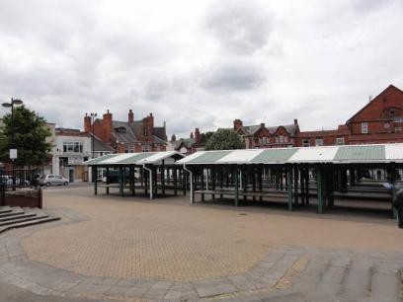
  - The Market Place and Albert Square is the commercial heart of the conservation area. The current area has not naturally evolved but is the result of the Urban District Council as known at the time in 1905 redesigning the area. With a loan of
£13,978²² and despite the impracticality of the sloping site the Council undertook a series of demolitions to increase the market
place from 760 sq yards (645 sqm) to 2500 sq yards (2090sqm) to create a market
‘square’ as opposed to its earlier triangular shape.

Figure 36: The market place in 2014.

  - Being predominantly a trading space the market place has always been hard surfaced since its creation in 1905 and with the lack of trees and vegetation within the space its character could only be described as ‘open’. A number of buildings have been demolished since the 1960s and 70s on the south side of the place which has resulted in a sense of loss of enclosure but the quality of the Edwardian architecture to the north is still retained providing a pleasing architectural background to the market place.
  - Historically when not trading the market place would have been fully open space and was in fact used for car parking for much of the mid to late 20th century. Market stalls were movable structures, only replaced by fixed stalls in the 1990s. The fixed stalls do undermine the quality and openness of the market place however the place has retained

²² Lindley, L. 1907. History of Sutton in Ashfield or past links with the present.

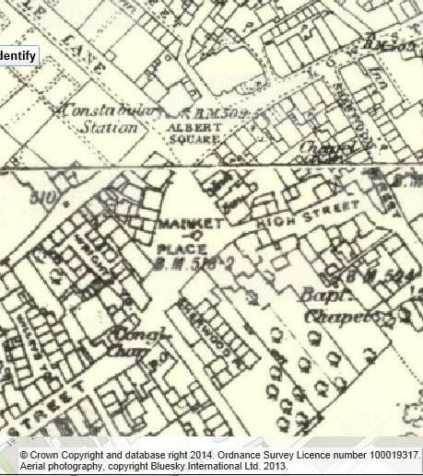
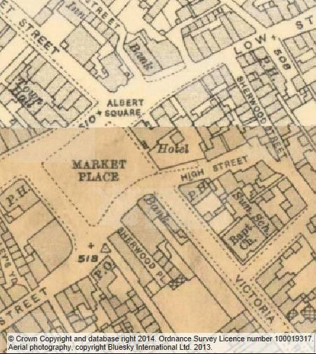
the use for which it was created and is large significant open space in the town that reflects the importance of commerce and trade to the town.
utton in Ashfield Cemetery²³
Figure 37; Left. the Market Place 1875-1885. Right, the Market Place 1912-1919 following its enlargement.

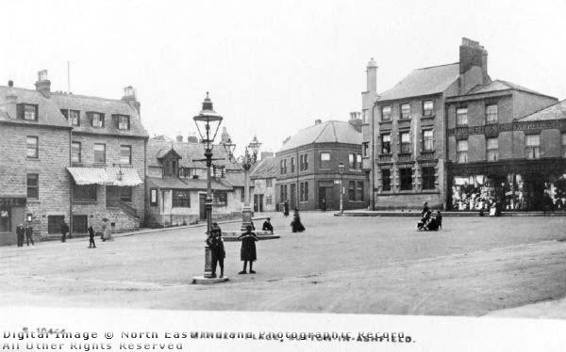
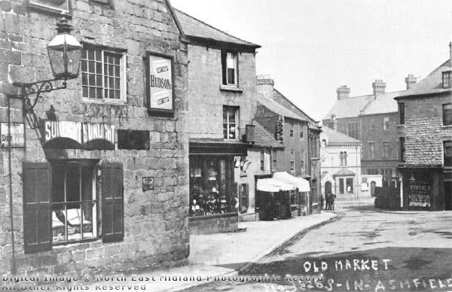
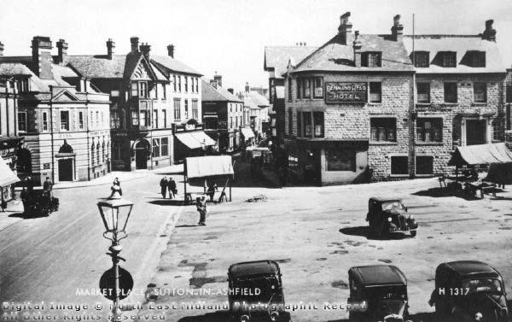
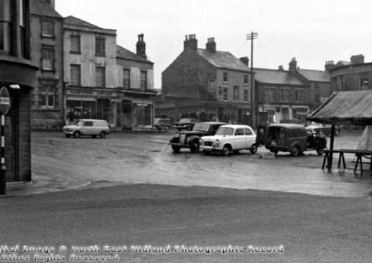
Figure38: Top left, the Market Place c 1900 before the demolition of buildings on King Street. Top right, the new Market Place shortly after 1905. Bottom left; Market Place 1930s, note the defined carriageway of the road and Sthe moveable stalls. Bottom right; Market Place in the 1960s still being used for car parking as well as trading.

²³ English Heritage have produced a series of documents on the history and management of cemeteries.

The cemetery was opened on 24th May 1892 on land adjacent to the ancient churchyard. Victorian cemeteries were conceived and designed as both gardens and memorials of the dead with interweaving of landscape, trees and memorials. While Sutton cemetery is a large open space and used as a place as quiet reflection it is also used as a thoroughfare for pedestrians linking residential areas to the town centre.

The cemetery is laid out with tree lined avenues with the oldest graves near the entrance surrounding the war memorial. The cemetery is a record of the social history and community of the town since 1874 and reflects the changing trends in memorial design over the past 100 years and more.

As expected memorials and headstones from most eras survive but with many in poor condition, sadly however the mortuary chapel which stood behind the war memorial was demolished after the 1955 (precise date unknown).

The war memorial was unveiled in October 1921 as a memorial to the fallen of the First World War. Further names were subsequently added to the memorial following the Second World War. The memorial is Grade II listed and is the focal point of the cemetery and its entrance.

The cemetery is bound on all sides by walls and fences, the stone walls are particularly attractive. The original brick entrance wall, now rendered has survived although the original iron railings have long been lost and replaced with heavy weight steel railings. There is much scope for enhancement to the entrance and repairs across the cemetery.

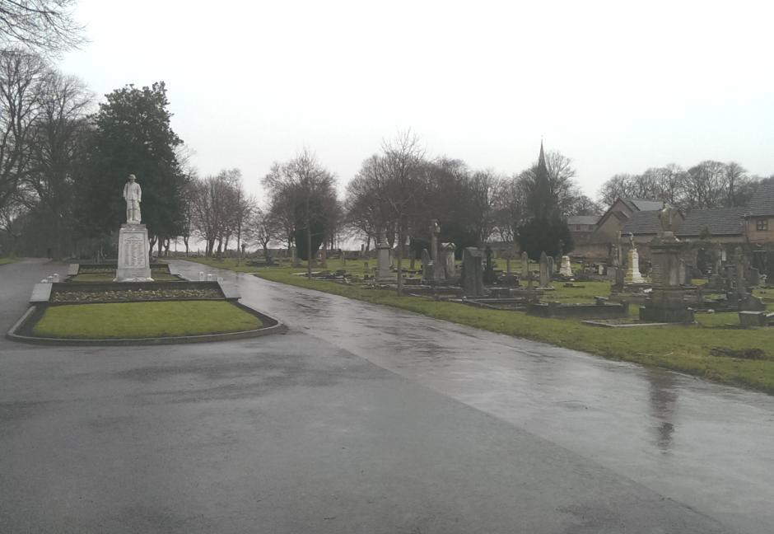

Boundaries
  - Unsurprisingly property boundaries are contained to the residential part of the conservation area. Properties in the commercial area sit back of pavement with no discernible plot definition.
  - Stone is the most widely used boundary material in the area, usually laid in courses forming walls between 1 and 2 metres in height. The stone copings used vary from roughly cut half round, angular saddle backs or random copings similar to that seen with dry stone walls. Some of the stone walls were boundaries to properties that have since been demolished. This can be seen with the stone gate piers that formed a pedestrian access to Westfield House on Church Lane.
  - Boundary walls built from brick are few in the conservation area however those of note are found along Church Street. The front boundary walls to Lindum, The Limes, Heathfield and Riversdale are good examples reflective of these quality 19th century properties. The boundary to Heathfield and Riversdale is particularly unusual with its brick arcade topped with half round brick copings. Some of the boundaries between properties along Church Street are also noteworthy either reflecting the front boundary brick walls or are high stone walls.

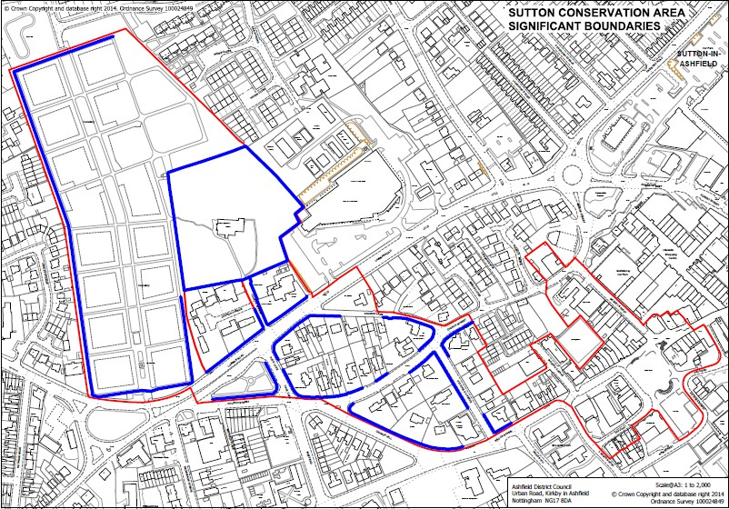

Figure 39: Significant boundaries within the conservation area.
  - Many of the original gates to the properties have been lost. Historic photographs of the area show that many gates were quite decorative timber or timber and iron/steel. Historic iron gates associated with the former National School on Lammas Road and those for the Church, especially at Church Avenue are noteworthy.
  - Whilst timber fencing is not regarded to form significant boundaries in the conservation area historic photographs from the early 1900s show the type of timber fencing that was used in this period. A close boarded fence with a crenulated top was certainly used along Church Street.
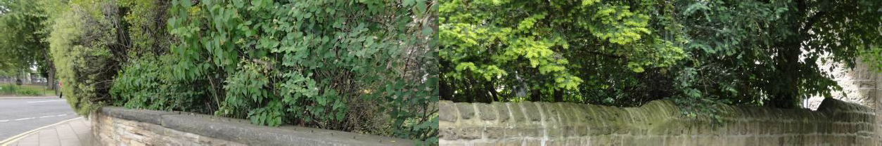
  - Metal railings are not widely used in the conservation area and are the preserve of the old National School, where a short length of early 20th century railings has been retained along Lammas Road and St Mary’s Gardens. A good proportion of the early 20th century steel railings with bent spike finial have been retained. This type of railing was common for public realm and park schemes of this period and is worthy of retention or reinstatement. Regrettably it appears that the length alongside Lammas Road have been replaced with modern railings not reflecting the original style.

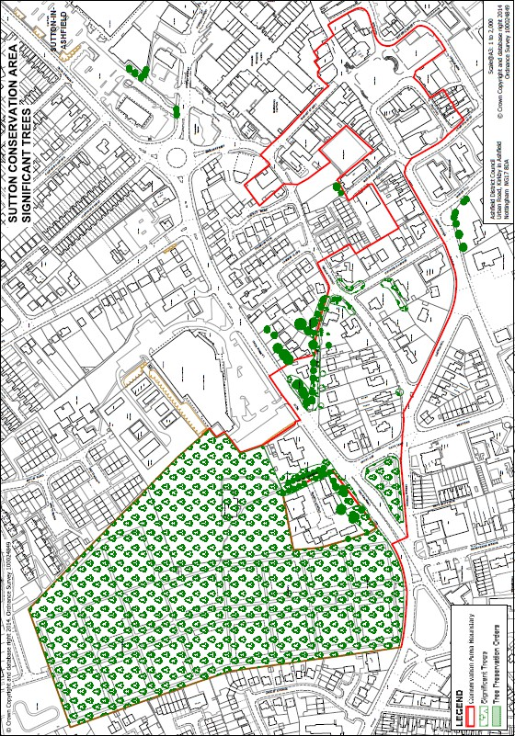

Figure 40: Examples of traditional stone walls and copings in the conservation area.

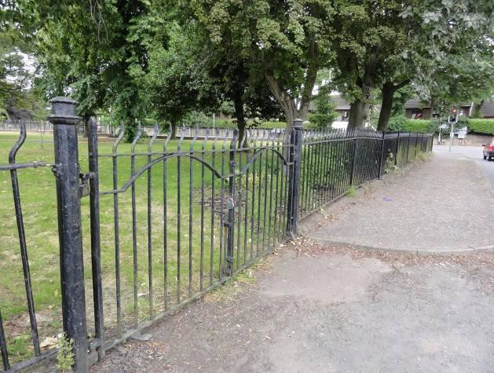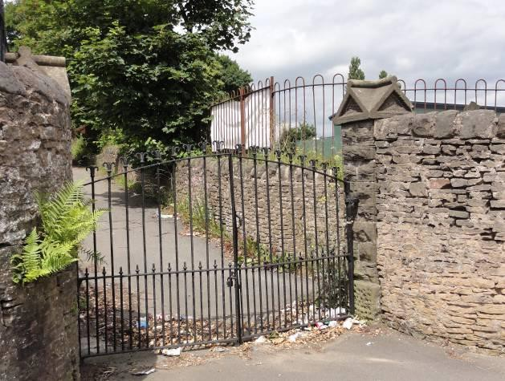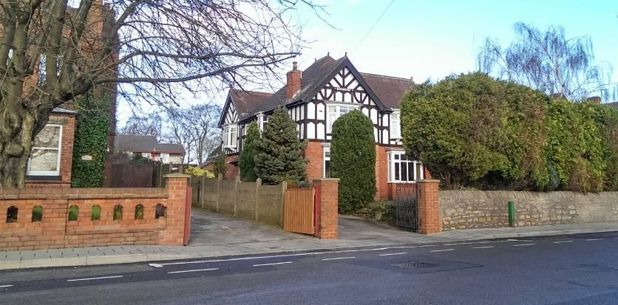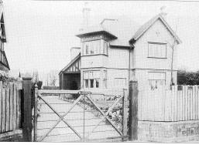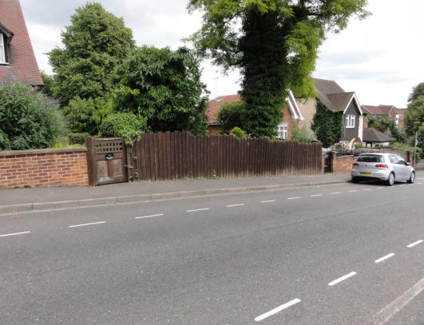

Figure 41: Examples of traditional boundaries in the conservation area.
Public realm
  - Much of the public realm in the conservation area dates from the late 20th century being standard highway and pavement treatments of black top tarmac, concrete pavers and kerbs. During the late 19th century many street names changed their names, few names plaques from period have survived although evidence of where they were located can be found. These name plaques were usually pressed steel/cast iron and are features worthy of preservation or reinstatement. The market place is surfaced in a variety of materials, most notably the brick pavers laid in the 1990s when the market place was revamped.

Few features in the public realm can be considered of historic interest. It is considered that the public realm could be greatly enhanced across the conservation area.
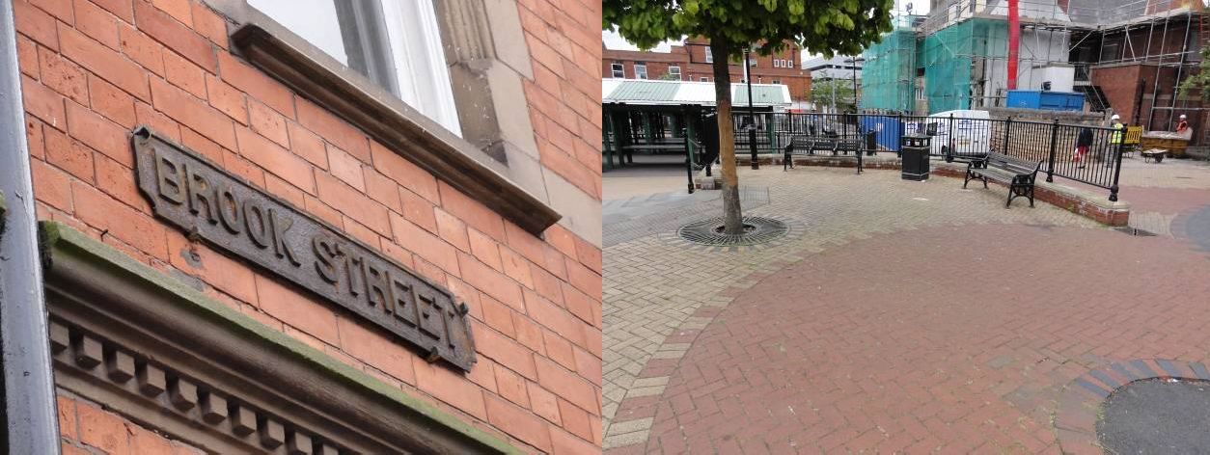
Figure 42: Left: Examples of traditional cast street name sign. Right: modern brick paviours at the market place.
Trees
  - Trees are a significant feature of the conservation area especially at St Mary’s Gardens, the churchyard, the cemetery and in the residential area along Church Lane and along the junction with Church Street. The trees contribute to the leafy suburban character of these areas providing shade, height, movement and colour (there is a variety of species of varying leaf colours) to the area.
  - Many of the trees along Church Lane and Lammas Road (formerly Alfreton Road) appear to have been formerly planted no doubt to have provided screening to create private garden spaces to both the vicarage and Westfield House, both now demolished, as can be seen on the Ordnance Survey plan below..

  - The commercial areas of the conservation area of Brook Street and the Market Place benefit from a number of street trees, unlike the trees mentioned above these have been introduced to the townscape by the Council during the late 20th century. Historic photographs and plans suggest that the commercial parts of the town were free from trees no doubt to enable trading and passage of transport. The environment and amenity benefit of street trees in the commercial areas of the conservation area has to be balanced against the preservation of buildings and ensuring that positive buildings play a visible role on the streetscape of the town. Some trees in the
commercial area interrupt the views of a number of positive buildings.

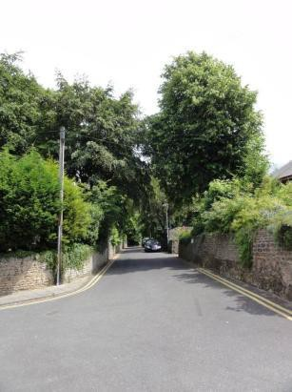
Figure 43: Tree lined Church Lane

  - The majority of the residential properties benefit from large gardens many of which contribute to the character of the area creating an area of relative low density. Many of

the gardens, either due to front gardens, properties occupying corner plots or properties positioned 90º degrees to the road are publically visible despite being private land. Many properties have managed to accommodate the need for additional car parking whilst retaining garden space and greenery.
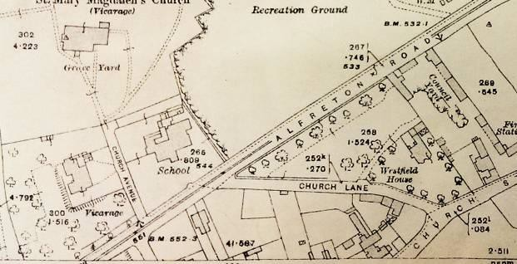
Figure 44: Ordnance Plan from 1919 showing trees at the Vicarage and Westfield House

Open spaces, boundaries, public realm, gardens and trees – Summary of special interest.
The conservation area contains a variety of open spaces, boundaries, public realm, gardens and trees that contribute to the area’s special character and appearance. Open spaces, boundaries and trees of significance are indicated on the maps above.
Open spaces include;
- The churchyard to St Mary Magdalene.
- Sutton in Ashfield Cemetery.
- St Mary’s Gardens.
- The Market Place and Albert Square
Boundaries in the area are predominantly stone with a variety of coping styles. The use of brick walls, metal railings or timber fencing is not so common although good historic examples still exist in the area.
Much of the historic public realm has been lost. Surfacing and street furniture is mostly late 20th century.
Trees and garden spaces contribute very positively to the character of the area and ensure the residential streets retain a ‘villagey’ character within the predominantly urban commercial character of the town centre.

Figure 45: Areas of significant trees in the conservation area including those covered by tree preservation orders.

Significant views and vistas
  - There are a number of views and vistas within and outside of the conservation area that contribute to the character of the area and help to define it as an area of special interest. These views are not necessarily planned views where the townscape and road layout has been purposefully designed to take account of a view or vista instead they have developed from the organic growth of the town.
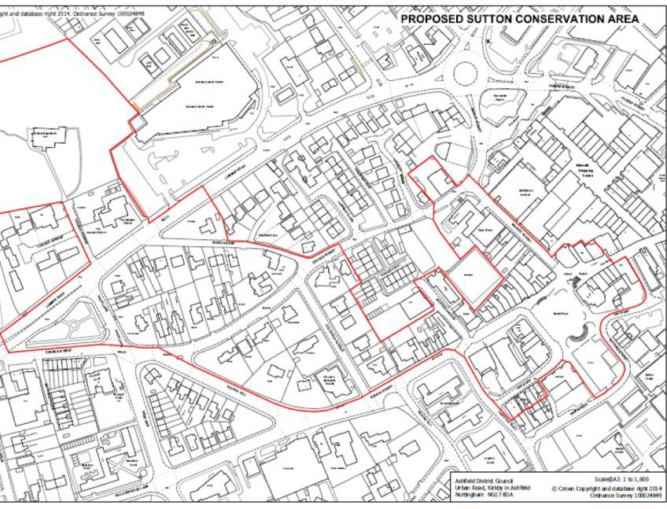

Figure 46: Significant views in the conservation area.

  - Despite the size and height of St Mary Magdalene Church it is relatively well hidden from view with few opportunities to glimpse even the spire. One such opportunity is from West End and Hack Lane looking northwards. The opportunity for view is greater in the winter when the trees are not in leaf; however continued growth of trees is likely to result in the loss of this view during summer months in the future. The church is best appreciated from within the churchyard or cemetery.
  - The approach to the church along Church Avenue is considered to be a significant vista framed by the stone boundary walls and trees along the avenue. The construction of the school in the 19th century and more modern development opposite on the site of the former vicarage has ensured that this vista has been protected.

  - Brook Street offers a fine architectural frontage of early 20th century buildings of varied styles to form an attractive streetscape. Views along Brook Street from the west help to create a sense of arrival to the Market Place and define the start of the commercial area.
  - As to be expected the openness of the Market Place provides opportunity for views across the space from all directions. Views from the south, southeast and southwest side of the Market Place focus on the public houses of the Denmans Head and the Market Tavern which frame the commercial buildings that extends from the former Town Hall. Views from the southwest corners also focus on the Fidler & Pepper Solicitors building (former police station) and Barclays bank building, both are positively contribute to the character of the conservation area. Views across the Market Place are somewhat interrupted by the permanent market stalls and some of the street trees, reducing the sense of openness that can be seen with historic photographs (see above).
  - The topography of the conservation area with the Market Place gradually rising to the south allows for glimpse views from Market Street looking southwards to the spire of the United Reformed Church at High Pavement. Although outside of the conservation area the United Reformed Church is one of Sutton in Ashfield’s most significant buildings, designed by G Baines and Son of London and built in 1905 the building is Grade II listed.
  - Looking back across the floor of the valley that is Brook Street to the north from Mill Street the combination of buildings that is the Old Police Station and opticians on Brook Street and residential properties along Titchfield Avenue creates a pleasing grouping of buildings with an interesting roofscape and half timbering rising up the hillside to the tree canopies of Church Lane.
Significant views and vistas – Summary of special interest.
Significant views and vistas are limited within the conservation area, those of particular significance are identified on the map above. Significant views and vistas include;
- Those that focus on the Church of St Mary Magdalene and the United Reformed Church on High Pavement.
- Views across the Market Place and Albert Square.
- Views of groupings of buildings that contribute positively to the special architectural interest of the area such as those along Brook Street and Brook Street and Titchfield Avenue.
- Views across the cemetery towards St Mary Magdalene Church.

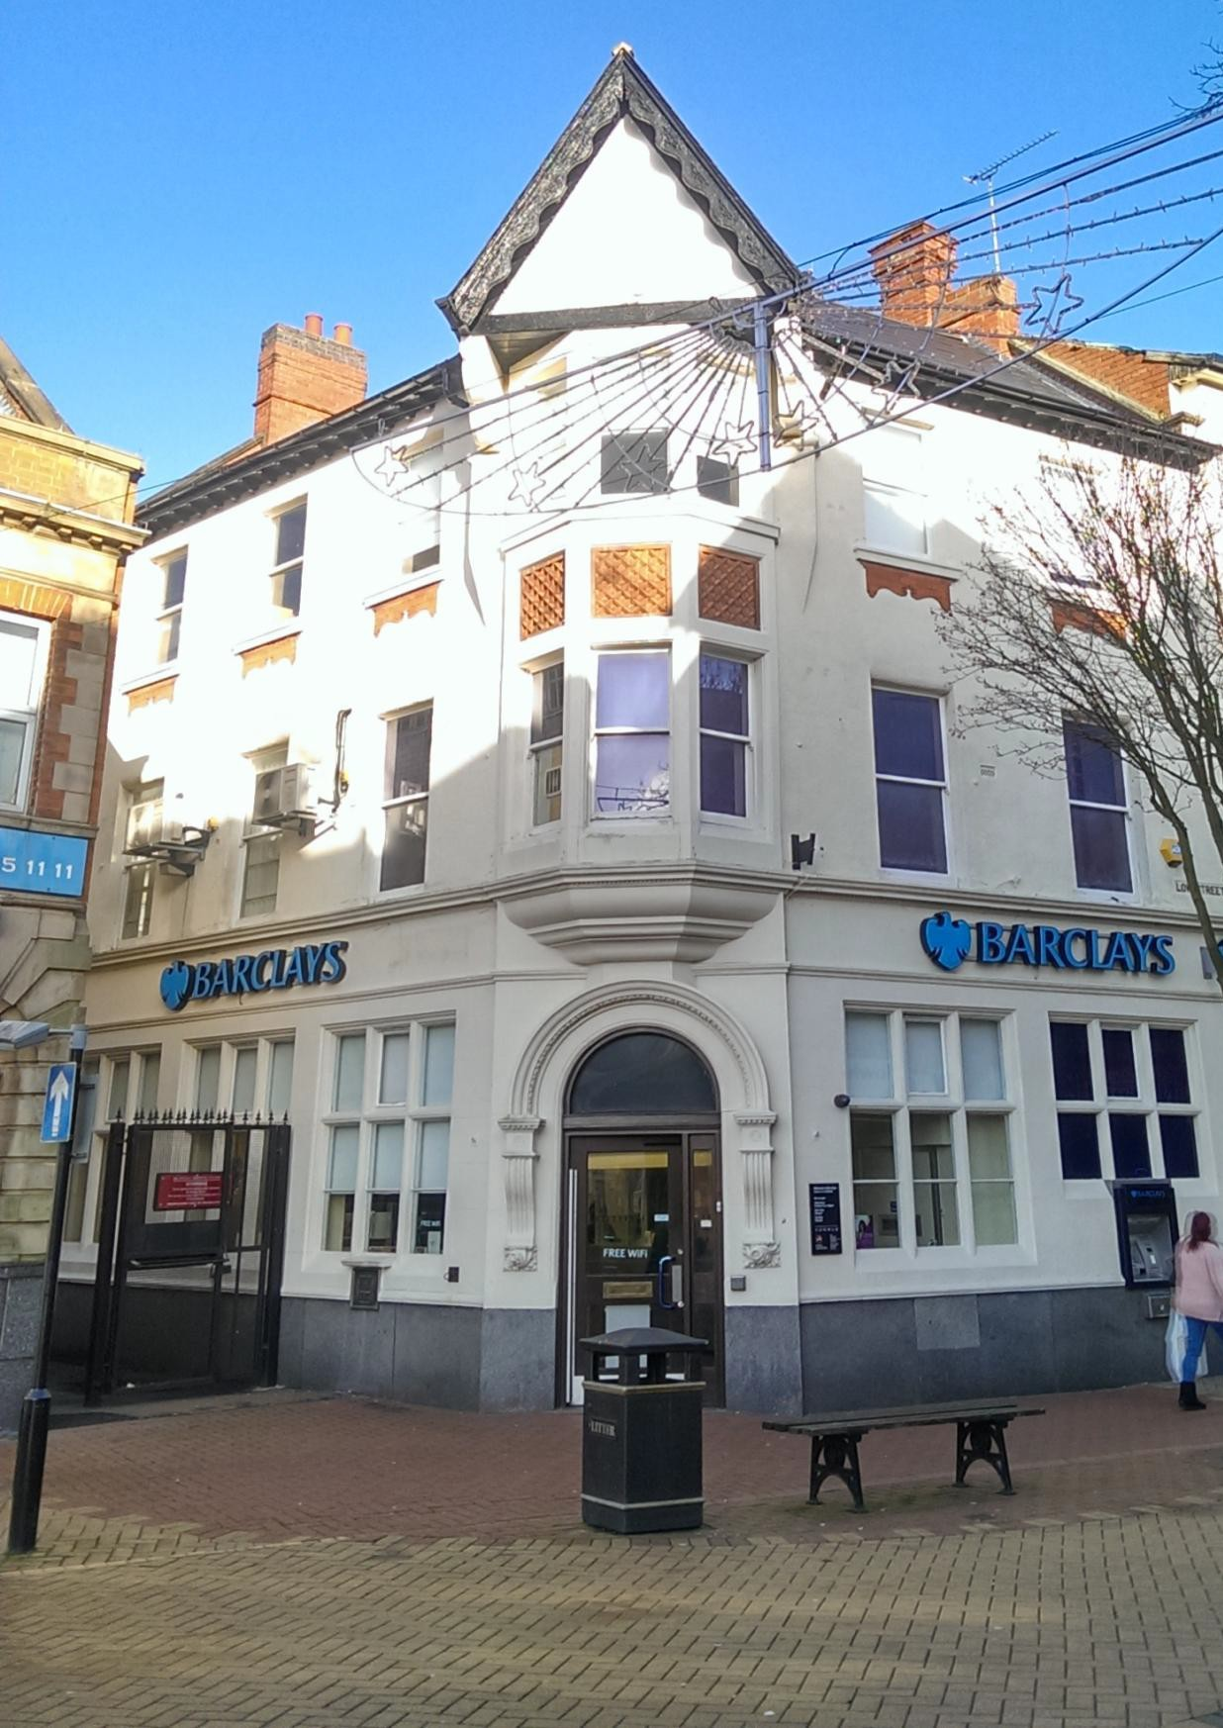

Management Plan

Management Plan
  - The special character and appearance of the conservation area has been defined in the Conservation Area Appraisal. The local planning authority however also has a duty to formulate and publish proposals for its preservation and enhancement²⁴. These proposals are detailed in the Management Plan. The Management Plan will be reviewed every five years and updated and modified where appropriate²⁵

  - There are several mechanisms through which the Council can manage the future of the Conservation Area:

    - Application of policy and design guidance
    - Development briefs
    - Application of an Article 4 Direction
    - Monitoring change
    - Boundary changes
    - Appraising the condition of significant buildings that contribute positively to the conservation area and developing a strategy for repair
    - Enforcement proceedings
    - Proposed enhancement schemes
    - Proposals for economic development and regeneration (including grants)
    - Identification and designation of Heritage Assets

Application of policy
  - Conservation areas are classified as designated heritage assets and are afforded a high level of protection, notably in the control of demolition and the requirement to ensure that new development conserves or enhances the character and appearance of the area.²⁶

  - Planning law requires that applications for planning permission must be determined in accordance with the development plan unless material considerations indicate otherwise.²⁷

  - Ashfield District Council is currently writing a new development plan (the Local Plan) for the period until 2024. This will contain new policies for conserving the historic environment. At

²⁴ Section 71 (Planning Listed Buildings and Conservation Areas) Act 1990.
²⁵ Subject to resources.
²⁶ Section 72 (Planning Listed Buildings and Conservation Areas) Act 1990.
²⁷ Section 38 (6) of the Planning and Compulsory Purchase Act 2004 and section 70 (2) of the Town and Country Planning Act 1990.

present the current local policy for conservation areas is the saved Ashfield Local Plan review Policy EV10.
Conservation Areas Policy EV10
Development in conservation areas will only be permitted where:
- It preserves or enhances the character or appearance of the area, or its setting.
- In the case of demolition or partial demolition it can also e demonstrated that the building is beyond economic repair, viable alternative uses cannot be found, or redevelopment would produce substantial benefits for the community that would outweigh the building’s loss.
- Redevelopment following demolition is undertaken within an agreed timescale

  - Nationally the Government has set out policies for the conserving and enhancing the historic environment in the National Planning Policy Framework. These policies are set out in Section 12 of the NPPF²⁸and requires local planning authorities to set out in their Local Plan a positive strategy for the conservation and enjoyment of the historic environment. To support decision making the National Planning Practice Guide²⁹and the Planning for the Historic Environment Practice Guide³⁰ provide relevant guidance.

  - The final and Council approved version of the Conservation Area Appraisal is a material consideration in any planning decision. It is anticipated that the appraisal document will help inform decision making made in line with this policy framework, which will be one of the most direct and effective means of managing the conservation area in the long term. For example, the Appraisal helps define the plan form, scale of building, materials, traditional detailing, important views and trees etc. These elements should be considered when looking at any development proposal. The appraisal identifies buildings and features that contribute positively to the character and appearance of the conservation area, often referred to as heritage assets. There should be a presumption against demolition or loss of any feature that is identified as contributing positively to the significance of the conservation area. The exclusion of any building or feature within the Appraisal does not necessarily indicate that it makes no positive contribution to the character and appearance

²⁸ The NPPF is available to read at; https://www.gov.uk/government/uploads/system/uploads/attachment_data/file/6077/2116950.pdf

²⁹ The Planning Practice Guidance is available to read at http://planningguidance.planningportal.gov.uk/
³⁰ The Planning for the Historic Environment Practice Guide is available to read at http://www.english- heritage.org.uk/publications/pps-practice-guide/pps5practiceguide.pdf

of the conservation area. Further advice should be sought from the Conservation and Planning Officers.

Policy and Design Guidance
  - The conservation area appraisal has outlined the historic and architectural interest of the area which makes the area significant. Additional guidance for householders, businesses and developers in the conservation area on specific topics would help assist in ensuring that decisions about altering buildings or designing new development is well informed to avoid harmful choices. Guidance may be written and adopted by the local planning authority as Supplementary Planning Documents (SPD) or as general guidance on relevant topics that do not necessarily require planning permission. Section 5.10 of the appraisal reveals that while many on the buildings in the area are of historic and architectural interest their architectural interest for some has been undermined by unsympathetic alterations and additions. Specific guidance to assist in enhancing the area may therefore include;
    - Shopfront design.
    - Commercial signage.
    - Window and door replacement.
    - Repointing of buildings.
    - Suitable boundary treatments.

Development briefs
  - The Management Plan can be used to identify any sites that would benefit from a development brief. A development brief is an outline of what might be expected or acceptable in principle on an identified development site prior to a formal development proposal. For example, this might be a gap site, or a site under pressure for demolition and re-development, or perhaps areas that have a neutral impact on the Conservation Area where redevelopment might readily be accommodated. The definition and characterisation of the Conservation Area can be expanded to form a detailed design brief in order to help promote appropriate form of development on the site.

  - At the time of writing this appraisal, there is one area in the conservation area that could benefit from a development brief. This would be land to the south of the Market Place. This site is currently a car park but was in the past developed. Demolition of the buildings that occupied this site has created a loss of a sense of enclosure to the Market Place. While currently there are no plans to develop this land, any future development has potential to impact on how the Market Place is experienced, and would need to careful consideration if it is not to adversely affect this significance open space.

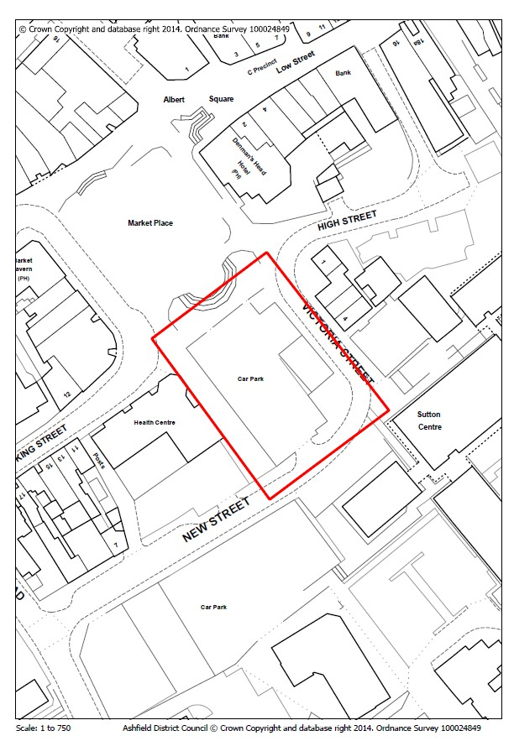
I
N
S E R T

P L A N

O F

A R E A

F O R

D E V E L O P M E N T

B R

E

I

Figure 47: Area of land which could benefit from a development brief.
F

Application of an Article 4 Direction.
  - The historic environment regularly suffers from the cumulative effect of piecemeal erosion and unsympathetic alterations to the architectural features of properties that contribute positively to a conservation area. Some of these alterations do not require planning permission and are regarded as permitted development³¹. Good examples of this include the replacement of traditional timber windows on non-listed buildings with PVC-U of different style and profile, or when historic chimney stacks are demolished. Alterations like this can be very harmful to the character and appearance of a conservation area.

  - It is possible to bring such alterations into planning control through the implementation of an Article 4 Direction.

  - The Order sets out classes of development for which a grant of planning permission is automatically given, provided that no restrictive condition is attached or that the development is exempt from the permitted development rights.

  - An Article 4 Direction can provide a positive framework for helping manage the character and appearance of a conservation area. The implementation of an Article 4 Direction, however, requires a strong justification for proposing the Direction as well as appropriate community support.

  - Sutton in Ashfield Church and Market Place Conservation Area is characterised by a large number of historic buildings. Architectural features, such as timber windows and chimney stacks are an important facet of the special interest of the historic environment. The Council must give consideration to the implementation of an Article 4 Direction.

  - If an Article 4 Direction is considered the Council must consult affected residents and property owners for a period of at least 21 days (in which period comments can be submitted) and must have regard for public views.

Application of Section 215 Notices
  - The local authority may use its general planning powers to serve a Section 215 notice³² on the owner (or occupier) of any land or building whose condition is adversely affecting the amenity of the conservation area. Such a notice requires the person responsible to clean up the site or building, or the authority can carry out the work itself and reclaim the cost from the owner. Section 215 is a relatively straightforward power that can deliver important, tangible and lasting improvements to amenity

³¹ The Town and Country Planning (General Permitted Development)Order 1995 sets out permitted development rights. The Order has been subject to a number of subsequent amendments.
³² Section 215 of the Town and Country Planning Act 1990.

Litter Abatement Notices
  - Under Section 91 of the Environmental Protection Act 1990 anyone concerned with litter on road verges or public land can apply to the Magistrate’s Court for a Litter Abatement Notice. Local amenity groups may find this a useful tool for encouraging landowners to clean up neglected roadsides where litter has become a damaging eyesore.

Monitoring change.
  - Monitoring change, both positive and negative, is very important for the long-term management of a conservation area. Regular surveys can, for example, help highlight problems that can be best tackled through an Article 4 Direction (see above). Similarly, the effectiveness of planning policies can be measured by appraising new development. Monitoring change can also assist in identifying where more resources are required and in modifying Council priorities.

  - A conservation area is thoroughly surveyed and described when first designated or when modified. Local Planning Authorities should seek to review Conservation Areas from time to time and update appraisals and management plans. The Council will review all Conservation Areas on a rolling basis, ideally within five-year cycles. The review process the Sutton in Ashfield Church and Market Place Conservation Area began in 2014. It is, therefore, envisaged that a further review will take place five years after the formal adoption of the final version of this Appraisal³³.

Boundary changes
  - An important function of this Conservation Area Appraisal is to assess whether the boundary of the Conservation Area is appropriate. Boundary changes might include reduction or extension to an area. Specific justification should be given for proposed changes. For example, an extension to the boundary might be proposed to incorporate the wider setting of a Conservation Area. Thought should be given to the appropriateness of the boundary.

  - The public consultation on this Conservation Area Appraisal and Management Plan asks specific questions on the appropriateness of the boundary. Public comments on the boundary will be taken into full consideration and will be amended if deemed necessary before final adoption.

Appraising the condition of significant buildings.
  - A survey is carried out from time to time at both a national and local level to assess the condition of significant heritage assets. This survey includes the identification of buildings that have fallen into disuse, dereliction or disrepair, commonly referred to as ‘Buildings at

³³ Reviews will always be subject of resources available at the District Council.

Risk’. This survey can provide a useful means of monitoring many significant historic buildings within conservation areas. Historic Buildings at Risk in Nottinghamshire focuses on Grade II historic buildings at risk. It is available online through www.nottinghamshire.gov.uk. The national Heritage at Risk Register focuses on Grade I and II* buildings at risk and includes conservation areas that are deemed to be at risk and is available through the English Heritage website: www.english-heritage.org.uk. This survey is updated annually and should the conservation area be deemed to be at risk will be included in this register maintained by English Heritage.

  - Historic Buildings at Risk in Nottinghamshire was produced and completed in 2004. This document provides a baseline for monitoring change in our buildings at risk within conservation areas. It can be used to identify specific problems or issues that may benefit from targeted resources. These resources could be streamed through the grant aiding of target buildings, or through the use of legislation such as Repairs Notices or Urgent Works Notices, to bring about works to a building to either repair it or make it secure or weather tight.

  - At the time of writing there are no listed buildings at risk in the conservation area. Section 5.10 of the appraisal records the buildings that are considered to contribute positively to the special architectural or historic interest of the area and opinion is offered on their condition. There are buildings considered to be at risk currently but this can often and frequently change through lack of repair of occupation and therefore needs monitoring regularly.

  - Condition is not based on a detailed structural survey of each building only a visual inspection from public vantage points. Condition is assessed against the matrix below.
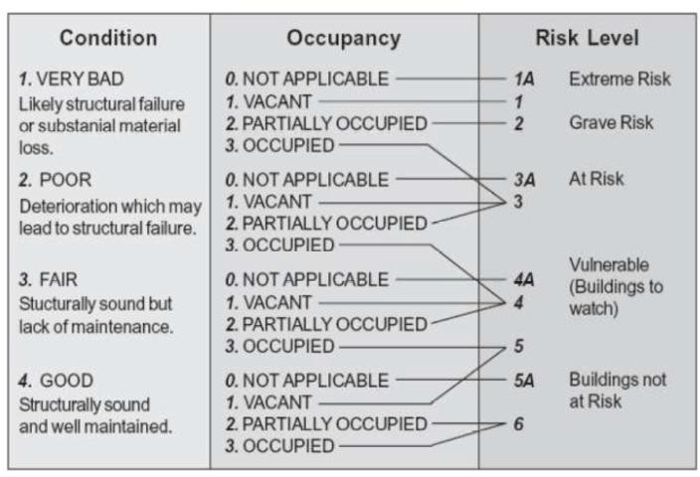

Figure 48: Matrix to assist in identifying condition, model adapted from English Heritage, Buildings at Risk- a Sample Survey (English Heritage, 1992).

Enforcement proceedings
  - Unauthorised works and breaches of planning control can cumulatively harm the quality of both the built environment and surrounding spaces within a conservation area.

  - An obvious example of this sort of damage could be unauthorised works to a listed building. A listed building is a building of special architectural or historic interest and is protected in law under the Planning (Listed Buildings and Conservation Areas) Act 1990. Listed Building Consent is required for any works to a listed building considered to affect its special interest. It is a criminal offence to carry out unauthorised works. The removal of traditional timber windows and doors, for example, and their replacement with UPVC or poor modern imitations, can be detrimental to the building’s intrinsic special interest.

  - It is not only alterations to listed buildings that can damage the character and appearance of conservation areas. The unauthorised demolition of buildings, or detrimental alterations to unlisted buildings, can all erode the special character of a conservation area. The use of non-approved materials, for example, can be particularly harmful (e.g. modern cladding).

  - It is important, therefore, that the Council investigates breaches of planning law within conservation areas, as this can help preserve the quality of the historic environment. The survey process utilised in the production of an Appraisal may highlight planning breaches and unlawful alterations to listed buildings. In response to this survey, the Council will take appropriate action with owners on an individual basis. Anyone can report a suspected planning breach by contacting the Council’s Enforcement Team. The District Council regularly follows up reports of unauthorised work and may take enforcement action.

Enhancement schemes and grants
  - A priority for enhancement in the Conservation Area is the repair and conservation of historic structures, the restoration/reinstatement of architectural features and materials and enhancement to the public realm. The following ideas would form a good basis for an enhancement strategy:
    - The retention and enhancement of historic buildings and their historic architectural features, including brick detailing, traditional timber windows/doors, cast iron rainwater goods, chimney stacks, etc;
    - The reintroduction of appropriate historic or architectural features to the conservation area’s historic buildings such as timber or steel windows, natural slate or clay pantile or rosemaries to roofs.
    - The reintroduction of surfacing, lamps, benches, street furniture appropriate to an area of architectural and historic significance to enhance the public realm.
    - The rationalisation of street furniture, including signage.

    - The removal of excessive clutter from buildings including signage and satellite dishes for example.
    - The introduction and repair of traditionally styles shopfronts that reflect the period and architecture of the building.
    - An audit of trees in the commercial area of the conservation area to assess whether they are in appropriate locations, of appropriate species and do not detract from the architectural quality of the townscape.
    - The sympathetic redevelopment of sites that currently detract from the character or appearance of the area.
    - An assessment of the Market Place as a trading area and appearance and develop a strategy to improve appearance and trade to become a focal area of the town centre.
    - The enhancement of the entrance to the cemetery and repair of memorials and headstones.
    - The introduction of Heritage Interpretation panels/ boards across the area.
  - The conservation area has potential to be the centre of a regeneration grant project subject to applications to relevant bodies and where appropriate match funding from the Council and private investors. The heritage benefits of this area being a conservation area has the potential to release grant funding from heritage bodies such as the Heritage Lottery Fund and English Heritage. Conservation led grants and regeneration schemes are often able to deliver many of the aims highlighted above.

  - Enhancement and regeneration grant schemes will often include professionals from the District Council’s Planning, Regeneration and Conservation Teams, and when within the conservation area will be subject to public consultation.³⁴

  - Grants for enhancement of buildings and areas can also be sought by business owners, charities and organisations in the conservation area too. The Heritage Lottery Fund, http://www.hlf.org.uk/, The Heritage Alliance http://www.theheritagealliance.org.uk/.The Architectural Heritage Fund http://www.ahfund.org.uk/ and Fund for Historic Buildings http://www.ffhb.org.uk/ are good sources of funding. It is advisable to contact the Council if considering a private project for further advice and assistance.

³⁴ In some cases works may be carried without public consultation.

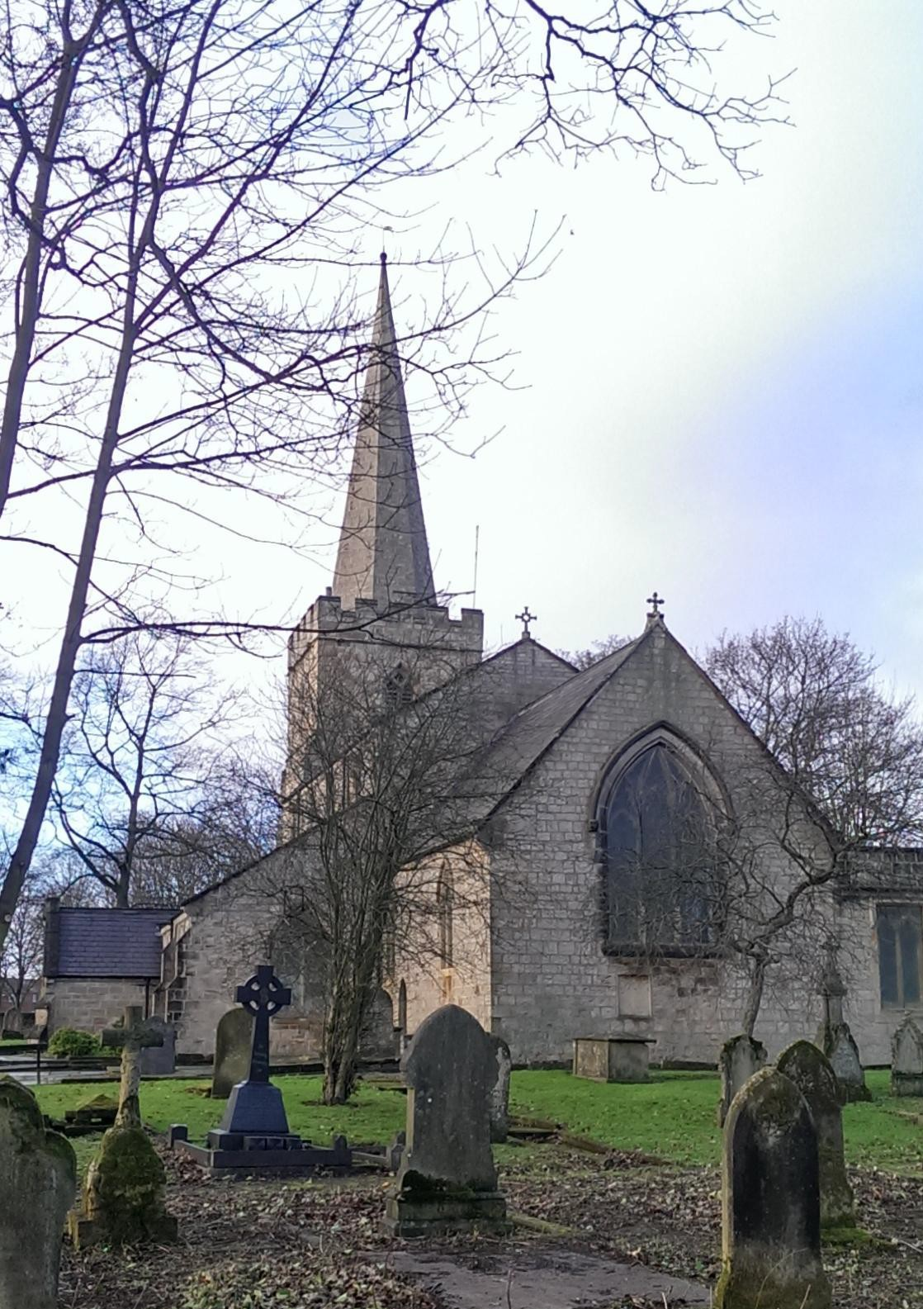

Appendices

Appendices
Appendix A: Planning Controls in Conservation Areas³⁵.
  - There are a number of planning controls that specifically relate to conservation areas.³⁶
  - Property alterations: If you live in or run a business from a property in he a conservation area you may need permission from the Council before making alterations such as cladding, inserting windows, installing , installing satellite dishes and solar panels, adding conservatories or other extensions, laying paving or building walls. As the Council can change the types of alterations that need permission by making Article 4 Directions it is advisable to contact the Council before making arrangements to starting any work.

  - Trees: If you are thinking of cutting down a tree or doing any pruning work you must notify the Council 6 weeks in advance. This is to give the Council time to assess the contribution the tree makes to the character of the conservation area and decide whether to make a Tree Preservation Order.
  - Demolition or substantial demolition: of a building within conservation area will usually require permission from the Council.

  - Special planning controls: Planning authorities have the power to introduce more strict planning controls in conservation areas by means of an Article 4 Direction. An Article 4 Direction further removes permitted development rights where it is considered that such rights would have a damaging effect on the character of an area. They can ensure that traditional details such as windows, timber doors, chimneys etc are not removed or altered without permission.
  - Currently there is no Article 4 Direction in place in the Sutton in Ashfield Church and Market Place Conservation Area. This situation could change in the future (see the Management Plan section above).

Listed Buildings: Listed buildings are recognised in statute as being of special architectural or historic interest. Under the Planning (Listed Buildings and Conservation Areas) Act 1990, it is a criminal offence to demolish or alter a listed building in a manner that affects its special architectural or historic interest without first gaining approval from the District Planning Authority³⁷. There are three types of listed building: Grade I and II* (considered to be the most special listed buildings); and Grade II buildings. There is 1 listed within the Conservation Area.

Under the Act, the listing refers to the whole of the building, inside and out. Any building, structure or feature attached to a listed building, or any structure within the grounds that has formed part of the land since before 1948 may also be protected.

³⁵ This advice is intended to be a general guide and does not purport to be a definitive guide to the legislation covering conservation areas. For specific proposals you should seek advice from the local planning authority.
³⁶ Please note that these controls are in addition to the general restrictions to permitted development for householders.
³⁷ Unless the building is a church where the Ecclesiastical Exemption applies.

Advice should always be sought from the local planning authority as to the extent of listing.

Scheduled Ancient Monuments: Certain important archaeological sites and monuments enjoy special protection under the Scheduled Ancient Monuments and Archaeological Areas Act 1979.

There are no Scheduled Ancient Monuments within the Conservation Area.

Tree Preservation Orders: A tree preservation order (referred to as a TPO) is an order made by a local planning authority in respect of trees or woodlands, the principal effect of which is to prohibit the cutting down, uprooting, topping, lopping or damaging of those trees without local authority approval. Where the Council believes that a tree or group of trees contributes positively to public amenity, it will designate a TPO.

There are a number of TPOs within the Conservation Area.

It is worth noting that regardless of whether a tree is covered by a TPO or not, it is likely to be protected if it lies within the conservation area boundary. Advice should always be sought from the local planning authority on any proposed works.

Enforcement of unauthorised works: Where work has been carried out without the relevant consent and it is considered that such works are harmful to the character and appearance of the conservation area then an enforcement notice may be served requiring remedial measures to be taken.

Appendix B: Positive buildings in the conservation area.

When assessing the contribution made by buildings and structures that are not listed, consideration is given to their individual and group contribution to the special architectural or historic interest of the conservation area. For example, if a building is the work of a particular noteworthy local architect, it may carry historic significance. Other reasons to consider the significance of unlisted buildings might include:

Qualities of age, style, materials or other characteristics that reflect those of a substantial number of the buildings in the conservation area;

Age, materials or other historic characteristics that relate strongly to adjacent listed buildings or the character area as a whole;

Group value of buildings;

Relationship to historic roads and layouts;

Landmark qualities or contribution to recognised spaces and amenity;

Usage where this reflects the historic nature of an area;

Association with past events or people.

The chief question is whether or not the building in question contributes to the character and appearance of the conservation area and whether the loss or substantial alteration of it would be harmful to the intrinsic special interest of the conservation area.

Any building meeting any of these key criteria should be considered as a locally significant and positive building. In the conservation area these are identified on the maps within the appraisal document and section 5.01. This list is by no means exhaustive. The absence of any structure on this list does not necessarily mean that it is of no interest or that it makes no positive contribution to the character and appearance of the conservation area. Advice should always be sought from the Planning Department at the District Council.

A number of buildings and structures considered being positive for age, group value, layout or other relevant factors might otherwise have individual features considered not to be positive, including for example, unsympathetic later alterations or use of inappropriate materials. Two common examples of this are UPVC windows in place of timber joinery or concrete tiles in place slate. In assessing the relative significance of these buildings, consideration will be given to the potential reversibility or transience of such features. This issue is discussed in the Management Plan because it is the Council’s aspiration to support the reinstatement of traditional features/materials, as well as promoting positive new development. Such opportunities will be seen as ways of enhancing the character and appearance of the conservation area. Enhancement of the conservation area is desirable under the Planning (Listed Buildings and Conservation Areas) Act 1990.

Appendix C: Useful contacts and advisory bodies.
English Heritage 44 Derngate Northampton

NN1 1UH
Telephone: 01604 735400

Email: eastmidlands@english-heritage.org.uk

Website: www.english-heritage.org.uk

Conservation Team (Historic Buildings and Archaeology) Nottinghamshire County Council
Telephone: 0300 500 80 80

Website: https://www.nottinghamshire.gov.uk/learning/history/

The Society for the Protection of Ancient Buildings

37 Spital Square London

E1 6DY
Telephone: 020 7377 1644 Email: info@spab.org.uk Website: www.spab.org.uk
The Georgian Group 6 Fitzroy Square London

W1T 5DX
Telephone: 087 1750 2936

Email: info@georgiangroup.org.uk

Website: www.georgiangroup.org.uk/docs/home/

The Victorian Society

1 Priory Gardens London

W4 1TT
Telephone: 0208 994 1019

Email: admin@victoriansociety.org.uk

Website: www.victoriansociety.org.uk

The Twentieth Century Society

70 Cowcross Street London

EC1M 6EJ

Telephone: 020 7250 3857 Website: www.c20society.org.uk

AABC Register (Architects accredited in building conservation)

No. 5 The Parsonage Manchester

M3 2HS
Telephone: 0161 832 0666

Email: registrar@aabc-register.co.uk
Website: www.aabc-register.co.uk

Conservation Accreditation Register for Engineers
Website: www.careregister.org.uk

Appendix D: Historic and local information.

Ashfield District Council
Public services for the District including Planning http://www.ashfield.gov.uk/

Picture the Past
Local historic photographs www.picturethepast.org.uk/

The Thoroton Society of Nottinghamshire Historical and archaeological society http://www.thorotonsociety.org.uk/
The Nottinghamshire Heritage Gateway Heritage resource http://www.nottsheritagegateway.org.uk/

National Heritage List for England Information on designated heritage assets http://list.english-heritage.org.uk/

County Buildings at Risk Register
County database of buildings at risk http://www.nottinghamshire.gov.uk/home/environment/heritage/historicbuiltenvir onment/buildingsatrisk.htm

Historic Directories
Database of historic directories and gazetteers www.historicaldirectories.org/hd/index.asp

Nottingham Insight
Local mapping data including historic maps. http://info.nottinghamcity.gov.uk/

Sutton in Ashfield Library and Local Studies.
Idlewells Shopping Centre Sutton-in-Ashfield Nottinghamshire
NG17 1BP
http://www.nottinghamshire.gov.uk/learning/libraries/

Appendix D: Contact us.

For further advice relating to conservation areas:

Planning
Ashfield District Council Urban Road
Kirkby-in-Ashfield Nottingham NG17 8DA
Telephone: 01623 457388
Email: mailto:dutyplanner@ashfield.gov.uk

