Contents
Contents 2
Chairman’s Foreword 3
Scrutiny Chairs and Vice Chairs 4
Overview and Scrutiny Committee 5
Scrutiny Review: Universal Credit 5
LGA Peer Challenge 2020 8
Scrutiny Review: Play Park Accessibility 10
Crime & Disorder Scrutiny 12
Additional Overview & Scrutiny Activity 14
Performance 14
Budget Scrutiny 14
Petitions 16
Covid-19 Response and Recovery Scrutiny Committee 17
Key Stakeholders Providing Evidence to the Panel 18
SCRUTINY PANEL A 21
Scrutiny Review: Unauthorised Encampment Protocol 21
Scrutiny Review: Veterans and Service Personnel 23
Scrutiny Review: Bus Provision in Ashfield 25
Scrutiny Review: Community Engagement 27
SCRUTINY PANEL B 29
Scrutiny Review: CCTV 29
Scrutiny Review: War Memorials 31
Scrutiny Review: Community Protection Service 34
Scrutiny Review: Town Centre Regeneration 38



Chairman’s Foreword
The global spread of the COVID-19 Pandemic has seen an unprecedented time for all in Ashfield. As a Council, our primary objective was to ensure that all our core services could still be delivered to the community and that we could assist in as much humanitarian work as possible.
To ensure that the effects of and recovery from the pandemic remained at the core of business, in July 2020 we established a COVID-19 Response and Recovery Scrutiny Committee. The work of the Committee was focused on maintaining core services, listening to the concerns of local people, communities, and businesses, and developing a long-term recovery strategy.
At the beginning of the Pandemic, we took full use of the opportunity to hold our meetings virtually in order to consider and review those topics that became even more prominent as a result of the Pandemic. We reached out to members of the community, partners and local businesses and engaged them fully in the scrutiny process, streaming the live meetings through YouTube.
This report contains a culmination of the last 2 years of Scrutiny work and provides an overview of all the reviews carried out, topics considered, and outcomes provided to Cabinet for their approval.
I would like to take the opportunity to thank all Members of Scrutiny who took part in process in order to review areas of concern, raise issues from their constituents and put forward thought provoking recommendations to Cabinet, most of which were accepted in full.
I would also like to thank my Vice-Chairman, Councillor Dale Grounds and the Chairs and Vice Chairs of the Covid-19 Recovery Scrutiny Panel and Scrutiny Panels A & B for their ongoing commitment in representing the local community and pushing forward change through the work of the Panels.
Special thanks also go to those former Chairs and Vice Chairs who have played a pivotal role in the Scrutiny Process including Councillor David Hennigan (Former Chairman of the Covid-19 Response & Recovery Scrutiny Panel), Councillor Sarah Madigan (Former Chairman of the Overview & Scrutiny Committee), Councillor Melanie Darrington (Former Chair
Councillor Andrew Harding, Chairman

Scrutiny Chairs and Vice Chairs


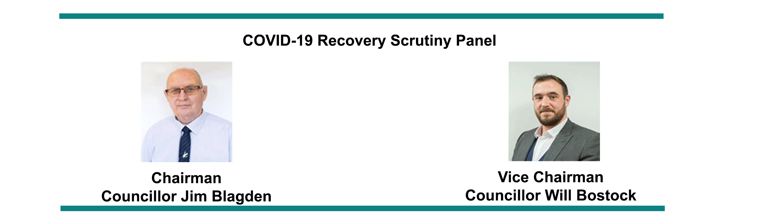
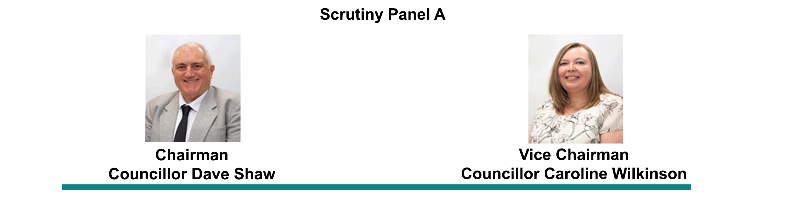
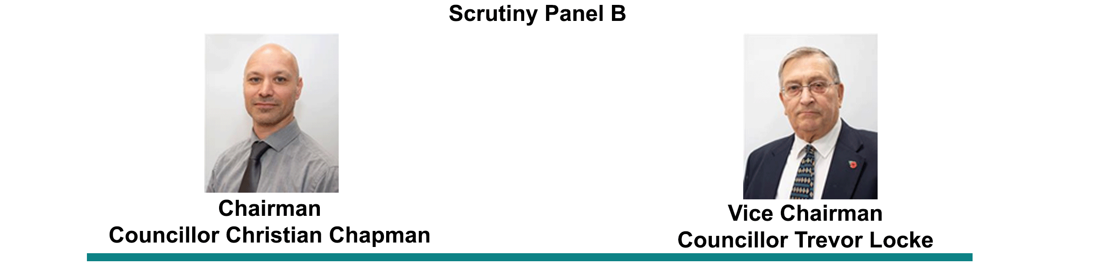

Overview and Scrutiny Committee

Scrutiny Review: Universal Credit
The Overview and Scrutiny Committee carried out a review on Universal to gain an understanding of the impact on individuals, families and communities following the implementation of welfare reforms and introduction of Universal Credit.
The Committee acknowledged the introduction of Universal Credit as a cause of significant community concern both nationally and in Ashfield and set its objective to review the measures that Ashfield District Council had taken to support impacted claimants in the District. Members also wanted to understand how the introduction of Universal Credit might have affected Ashfield District Council financially.

During the review, Members researched the following:
Welfare reforms introduced in the past decade
a. How Ashfield District Council has prepared and reacted to welfare reforms
b. The impact of Universal Credit in Ashfield
c. How Ashfield District Council is mitigating against these impacts
d. How the introduction of Universal Credit has and will impact Ashfield District Council finances
An essential part of the review was to also hear from claimants that were directly affected by the welfare reforms. This was achieved through online testimonials, which initiated an online discussion on personal experiences of Universal Credit that recognised both positive and negative experiences.
The testimonials highlighted several experiences including struggles with advanced payments, Food bank usage, change of circumstances, rent arrears and Initial claim waiting times and its implications on debt.
The testimonials provided Members of the Overview and Scrutiny Committee with firsthand accounts, detailing the real impact of Universal Credit on claimants, the long-term hardships faced through utilising advanced payments, and the impact Universal Credit has on mental health and well-being. Members of the Committee also heard evidence from the Council (Housing Management and Tenancy Services, Revenues and Benefits), partner agencies (DWP and Citizens Advice, and the Salvation Army)
The Committee concluded that the introduction of Universal Credit has negatively affected many members of the community, particularly those with financial difficulties, mental health or learning disabilities, single parent families, part time workers and family carers. Many have struggled in both applying for Universal Credit, managing debt, and dealing with delays in payment. Many have also resorted to the use of loan sharks and food banks, a fact that gravely concerned the Committee.
The Committee were encouraged by the work of the Council’s Housing Management and Tenancy Services and partner agencies such as Citizens Advice in supporting claimants. The recommendations detailed below reflected areas of service delivery and support regarding Universal Credit that the Committee agreed could generate improvements and increased knowledge to further assist supporting claimants.
Recommendation(s):
a. Cabinet should note the hardship being experienced by Ashfield residents, and the current and anticipated financial impact to the Council, as a result of the introduction of Universal Credit welfare scheme.
b. A mandatory seminar be organised for all Councillors to equip them with the necessary knowledge and skills to support residents raising issues concerning Universal Credit.
c. A letter be sent to local MPs, and the relevant ministerial department, outlining the difficulties claimants in Ashfield have experienced following the introduction of Universal Credit.
d. Joint working with partners such as the Department of Work and Pensions and the Citizens Advice Bureau be enhanced to ensure important information is efficiently shared.
e. The Housing Revenue Account 30 Year Business Plan be reviewed, taking into consideration the impact the introduction of Universal Credit will have on Housing and other Council services.
f. The Welfare Reform Reserve Fund be reviewed to ensure sufficient funding remains available to support claimants and maintain adequate staffing levels.
g. All publicly displayed information regarding Universal Credit and wider welfare reforms be reviewed to ensure maximum visibility and relevancy.
h. Consideration be given to software and hardware requirements that could assist in improving the Council’s efficiency and effectiveness in managing Universal Credit cases and supporting claimants.
All recommendations presented to Cabinet as part of the final report were unanimously accepted.

LGA Peer Challenge 2020

As part of its role in monitoring both service performance and providing constructive challenge to Cabinet, the Overview and Scrutiny Panel considered the findings of the LGA Peer challenge.
The Peer Challenge Review undertaken by the Local Government Association in January 2020 is designed to support Councils and is part of a sector led improvement programme. There is an expectation from the LGA and government that the findings will be used to support improvements. Cabinet sanctioned all actions arising from the LGA report and requested that the Overview and Scrutiny Committee review and provide comment on both the findings and subsequent actions recommended.
The Peer Challenge concluded the following:
e. The Council was a council where the politicians provide strong community engagement, are involved, passionate and resident-focused;
f. Councillors are particularly active in seeking residents’ views and wants and use them to identify priorities for action;
g. The Council is successful in using resident views in influencing service delivery;
h. The Council has clear ambitions, and it is clear which Directors and Departments are responsible for delivering them;
i. The Council has a clear aspiration to take a One Council approach;
j. The Council has adopted values and associated behaviours through a participative approach which are displayed across the organisation;
k. Staff are very positive about working for the Council and are committed to delivering the best for the Council’s residents and customers. They are also enthusiastic about using their untapped potential for the good of the Council and its residents.
Members of the Committee reviewed both the findings and a detailed action plan based on the recommendations and five themes, with progress being monitored through Pentana, the Council’s performance management solution. Members provided constructive challenge regarding the action plan and made suggestions on how the action plan should be monitored to ensure that Ashfield District Council continued to deliver the best services possible to residents of Ashfield.
Resolved:
Based on each of the five themes contained within the Action Plan, the most appropriate Portfolio Holders be invited to future meetings of the Committee, to give updates in relation to progress against the key recommendations as required.

Scrutiny Review: Play Park Accessibility
Play Park Accessibility was added to the Scrutiny Workplan to review topic to:
l. Ensure that all parks and open spaces in Ashfield are accessible with appropriate adaptations and equipment
m. Ensure that all consultation exercises undertaken by the Council regarding parks and open spaces are fully inclusive.
In considering this topic, Members of the Committee considered the national context regarding accessible play parks and the restrictions and challenges faced by disabled children and parents in accessing play opportunities
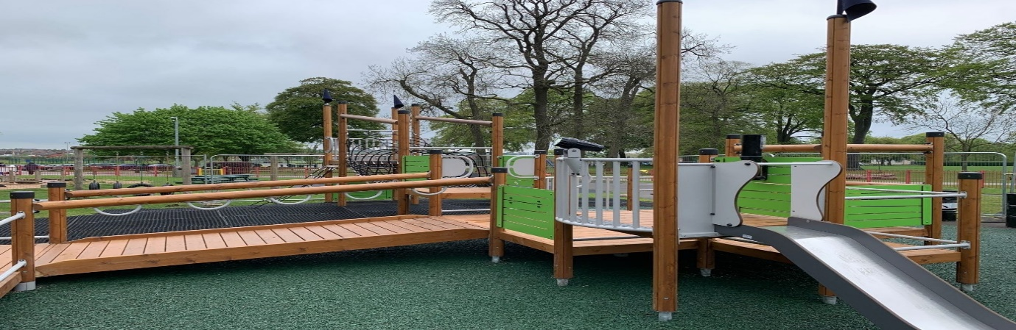
In considering this topic members of the Committee reviewed the actions set out in Ashfield District Council’s Public Open Space Strategy 2016-2026, a strategy adopted by Ashfield District Council in 2016 setting out the catchment areas for play areas, including an assessment of the quality of each play area which has been used to prioritise projects across the District. and the Play Strategy, a plan of action to continue to improve play facilities across the District over a four-year period, with an additional funding stream. The strategy provides £120k per year for four years to one area per year.
Further research has also been undertaken regarding the national context of inclusive play areas that provide a safe environment where all children and young people have the freedom – time, space, permission, and opportunity – to play throughout their childhood and teenage years.
In hearing firsthand evidence, Committee Members have become better informed on some of the challenges faced by children with disabilities or any additional needs.
Inclusive play is not solely about physically accessing an environment, but also intensely focused on what happens once an individual gets there. By equipping children of all abilities with inclusive environments and the skills to play together more independently, children will feel nurtured, encouraged, respected, and active during play both physically and emotionally thereby creating a sense of community among all children.
Members acknowledged that the Council is already committed to making its parks and playgrounds accessible and discussed the work already undertaken to improve accessibility for across the district.
The Panel is due to present its findings to Cabinet in September 2021

Crime & Disorder Scrutiny
Under the Police and Justice Act 2006, Overview & Scrutiny has the right to consider crime and disorder issues and, to review the performance of the Ashfield Community Partnership or focus on areas of concern. The Partnership is responsible for drawing-up and implementing the District’s Crime and Disorder Reduction Strategy. It is made up of public sector bodies, such as the Council and Nottinghamshire Police, as well as representatives from the business community and voluntary groups.
Councillors have carried out numerous crime and disorder Scrutiny exercises including CCTV, the Community Protection Service (both detailed in this report) and extraordinary meetings with stakeholders from the Partnership

The extraordinary meeting focussed on anti-social behaviour in Ashfield and included representation from Nottinghamshire Police, the Council’s Community Safety and Housing Teams, as well as a charitable organisation providing support to adults, children, young people, and families.
Members considered the following issues:
n. Anti-social behaviour issues in Ashfield
o. Anti-social behaviour issues nationally
p. Action taken against anti-social behaviour in Ashfield
On conclusion of the meeting, the collaborative work undertaken by the Police and the Council’s Community Protection Team (and contributing partners) and the continued work to tackle problems associated with anti-social behaviour through a variety of initiatives, integrated support and working practices was acknowledged.
Recommendation(s):
Consider the possibility of engaging a dedicated Mental Health Worker within the
Complex Case Team should any additional funding become available
Having acknowledged the benefits of restorative justice, to consider its application on a wider basis and to focus on the rehabilitation of anti-social behaviour offenders through reconciliation with victims and local communities
The Community Safety Team be requested to endeavour to capture additional anecdotal evidence from professionals and regular visitors to the courts to enable any ASB issues to be addressed more efficiently
All recommendations presented to Cabinet as part of the final report were unanimously accepted.

Additional Overview & Scrutiny Activity
In addition to carrying out bespoke reviews, the Overview and Scrutiny Committee also have the responsibility for consideration of performance, Budget, Call-ins and Petitions.

Performance
Members of the Overview and Scrutiny Committee consider the Corporate Performance Scorecard on a quarterly basis. This provides Members with an insight into how well each service area is performing, trend and best practice information and highlights any problems or issues as they are arising.

During consideration of performance information various methods are utilised to assess how well the Council was performing including delivery of the Corporate Plan, outcomes from the service review programme, feedback from the LGA Peer Challenge, the Place/Star Surveys and performance scorecards.
Members have the opportunity to discuss any issues with officers and the relevant Portfolio Holder and also make suggestions / recommendations for improvement. Issues raised through consideration of performance are also used to help inform the Scrutiny Workplan.

Budget Scrutiny
Budget Scrutiny is carried out at least annually by the Overview & Scrutiny Committee. The Panels role is to consider the annual budget and the Medium-Term Financial Strategy (MTFS).

During consideration of the budget, Members reviewed the General Fund corporate, service related, and other savings made or being made to endeavor to close the funding gap and balance the budgets accordingly.
Members also considered the Council’s property investment portfolio and acknowledged that the rental being achieved was a key income stream that supported services being delivered to residents.
Resolved:
a. Thank you be extended to the Corporate Finance Manager and Finance Team for the production of an excellent budget and the associated medium term planning strategy
b. Concerns raised regarding the levels of fraud surrounding ‘Single Person Council Tax Discount’ with acknowledgement that a countywide group has been established to tackle the problem
c. A desire to raise awareness and more fully advertise the commercial services offered by the Council’s (i.e., pest control) through the Council’s media platforms
d. A further review should be undertaken to consider further savings around printing requirements including the use of paper copy committee agendas
e. The importance of the Council recognising the impact (i.e. wellbeing and work/life balance) on existing staff being required to cover gaps in staffing as part of the ‘vacancy factor’

Petitions
The Overview and Scrutiny Committee consider any petitions that are submitted with between 750 and 1499 signatures. In considering such petitions, the most relevant officer will be invited to the Overview and Scrutiny Committee to give evidence about the issues and the petition organiser will have up to 15 minutes to ask 3 questions of them. The committee may then refer the matter to a future meeting of the Cabinet.

In accordance with the procedure set out in the Council’s Petition Scheme, the Overview and Scrutiny Committee have considered 2 petitions over the last 2 years. These are:
- Section 106 Agreement Local Infrastructure Funding
- Lettings Policy

Covid-19 Response and Recovery Scrutiny Committee
The Covid-19 Response and Recovery Scrutiny Panel was established in June 2020 following the outbreak of the global pandemic. Its remit, as agreed by Council is to
review the Council’s response to the COVID-19 pandemic and take an active role in respect of the Council’s recovery plans.

This includes:
a) reviewing the Council’s response to COVID 19, and identifying any short-term actions arising, which improve operational and corporate resilience.
b) Policy development in respect of the Council’s recovery from COVID-19, including preparedness for future waves of COVID-19.
c) Policy development in respect of the Council’s approach to the renewal of the local economy.
d) Policy development in respect of the renewal and reform of local government services, including the future structure of local government in Nottinghamshire.
The Panel also reports any recommendations or considerations to Cabinet in respect of the responsibilities outlined above.
The Panel held its first meeting in July 2020 and has subsequently held 7 meetings over the last 12 months. From the outset, Members of the Panel were clear in their objectives to consider and make deliverable, tangible recommendations to Cabinet. The Committee also agreed a robust timetable and workplan, setting out areas of interest and key partners who could contribute to the work of the Committee.
In addition to the formal recommendations made to Cabinet, Members of the Panel also worked directly with Council officers to provide both reactive and proactive solutions to problems as and when they arose.

Key Stakeholders Providing Evidence to the Panel
Key to the work of the Covid-19 Scrutiny Panel was the contributions from Senior Officers and key stakeholders in the District. This provided Members with expert witnesses, trend data in real time and first-hand accounts on the impacts at a local level of the Covid-19 Pandemic.
Attendees and contributors at meetings of the Panel include:
- Chief Executive of Sherwood Forest Hospitals NHS Foundation Trust
- Chairman of Discover Ashfield Board
- Inspector Nottinghamshire Police
- Chief Executive Ashfield District Ashfield
- All Service Directors Ashfield District Council
- Operational Officers across the Council
- Local Businesses from across the District including local hairdressers, Nail bar and gym amongst others

The Panel also utilized social media to take questions and concerns from the public in real time, allowing the community access to key community leaders across both the public and private sector.
Not only does the Covid-19 Scrutiny Panel provide residents, communities and local businesses a forum to challenge, question and gain the latest up-to-date information from community leaders, but it also provides a forum to share good practice between local service providers such as NHS, Local Council, the Police and Discover Ashfield.
Findings, comments, and recommendations of the Covid-19 Scrutiny Panel are reported verbally to each subsequent Cabinet meeting.
Considerations and Recommendations of the COVID-19 Recovery Scrutiny Panel Presented to Cabinet:
the draft Economic Recovery Plan be approved with the proviso that the Plan is updated accordingly as circumstances change;
work be undertaken to consider establishing a scheme to recognise local businesses that have excelled at adapting to guidelines and providing a COVID-secure environment for customers, in conjunction with key partners such as Discover Ashfield;
the Council continues working toward the establishment of a Key Workers Memorial, including consultation with Ashfield residents and key partners;
the Council’s established Business Support Hub offers support for those looking to set up new businesses or reinvent existing businesses as a result of the pandemic;
Cabinet be commended for the decision to implement 2 hour free parking in all town centre car parks to aid the longer-term recovery of Ashfield’s local economy;
congratulations be extended to the Planning and Economic Development Team, the Environmental Health Team, and the Discover Ashfield Board for their continued efforts to ensure that local businesses sufficiently adapt to COVID-19 measures and survive the ongoing economic difficulties brought about by the pandemic;
the Council looks at all options to use all of the ‘ring-fenced ‘reopening High Streets’ Fund, innovatively.
concerns for the ongoing viability and survival of sole traders and small businesses should lockdowns continue;
to avoid undue worry and to allow local businesses to react proactively to the current climate, a request for additional communication regarding the latest Government guidelines to be sent out to business communities in a swift and timely manner;
to make all businesses aware of existing local business forums like Discover Ashfield Board and our Town Centre Trader Groups and encourage their participation and if needed, to establish new forums where existing provisions are not suitable;
to continue work around the establishment of a shop recognition scheme for businesses that have provided exemplary Covid-secure environments for customers;
Options for how the Council and local businesses can continue to support local foodbanks and health and wellbeing organisations during the pandemic;
appreciation to Cabinet for the imminent provision of hand sanitiser stations at car parking ticket machine location;
concerns around the extensive, ongoing, cost of providing PPE to protect employees and a hope to see a tax relief of reimbursement scheme from Government in the near future.

SCRUTINY PANEL A

Scrutiny Review: Unauthorised Encampment Protocol
This topic was added to the scrutiny work programme as Members wished to consider the detail and potential impact of the draft Unauthorised Encampment Protocol, in line with the responsibility of scrutiny to assist with the Council’s policy development.
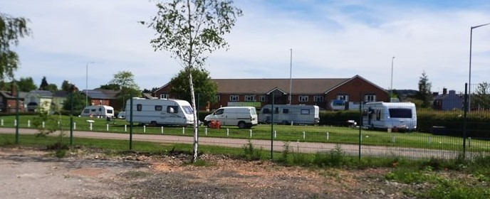
Members were assisted by the Service Manager for Strategic Housing and Lettings and representatives from the Council’s Private Sector Enforcement Team throughout the review. In reviewing the Unauthorised Encampment Protocol, Members focused on gaining an understanding of the national context regarding unauthorised encampments, including legislation in place, issues commonly caused by unauthorised encampments, and the powers granted by Government to local authorities to take enforcement action.
Members were also presented with detailed information on unauthorised encampments in Ashfield, including statistics on the number of reported incidents on both council owned land and private land in recent years. Alongside enforcement action, Members were further informed of the obligations of the Council to conduct welfare checks and to respond to any issues such as facility checks, nuisance assessments, and personnel checks. Typical costs associated with managing an encampment were also reported to Members.
At a meeting of the Panel, Members were joined by a representative from Rural Community Action Nottinghamshire who discussed the need for the Council to have robust enforcement procedures in place, but also advocated for emphasising a negotiated response to dealing with unauthorised encampments.
Members were concerned with the focus on a singular, enforcement-based process as detailed in the draft Unauthorised Encampment Protocol and favoured a more tailored approach to dealing with unauthorised encampments. Members also wished to extend the decision making around which approach would be most appropriate to the front-line Officers tasked with responding to incidents in Ashfield. The value of working and developing stronger relationships with external delivery partners was also discussed by the Panel, with Members keen to ensure the Council seeks collaboration with relevant third parties, especially so with the North Nottinghamshire Travellers Group. Finally, Members acknowledged the vital work of involved Officers in developing a robust protocol to deal with unauthorised encampments, and due to the importance of the policy, wished to have an opportunity to review the protocol again after a year of operation.
At the conclusion of the review, a set of recommendations were agreed by Scrutiny Panel A and presented to a meeting of cabinet.
Recommendation(s):
a. The Unauthorised Encampment Protocol be amended to include two potential processes for dealing with unauthorised encampments; the primary approach focusing on negotiation, and the secondary approach focusing on enforcement action
b. Officers be given the appropriate delegation to use their professional judgement and expertise, along with established criteria, to assess which process to utilise on a case-by-case basis
c. Consideration be given to the possibility of utilising the services of external delivery partners such as Rural Community Action Nottinghamshire via Service Level Agreements in supporting the actions of the Council to negotiate with the occupiers of unauthorised encampments
d. Officers continue to enhance work with North Nottinghamshire Travellers Group to ensure effective and constructive collaboration between the member Councils in identifying further sites within the County
e. The Unauthorised Encampment Protocol be reviewed after one year of operation
f. Officers be thanked for their work in drafting the revised Unauthorised Encampment Protocol
At the time of consideration of these recommendations, Cabinet only felt able to receive and note recommendations a, b, c, and d as an enforcement-based approach was favoured. Recommendations e and f were approved by Cabinet. Cabinet acknowledged that the review had generated constructive debate and spotlighted an important issue for the Council to focus on.

Scrutiny Review: Veterans and Service Personnel
This topic was added to the scrutiny work programme as Members looked to understand measures the Council had in place to support the armed forces community in Ashfield, and to identify any areas of improvement that the Council could act upon.
Members worked closely with the Council’s Senior Community Engagement Officer during the review, who assisted Members in building a knowledge base of the support measures offered to the armed forces community by the Council, as well as details of developing policies.
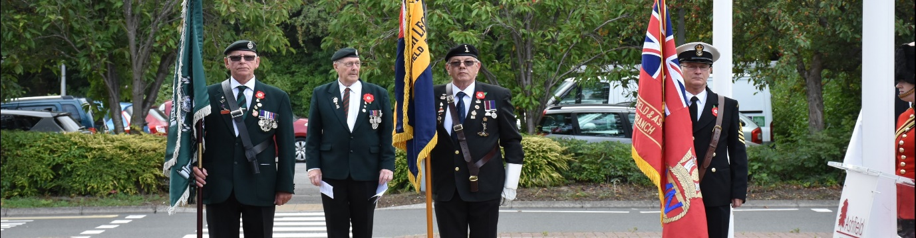
Members also learned of the Council’s extensive work to achieve the criteria set out within the MoD Defence Employee Recognition Scheme. At the start of the review, Members had learned that the Council had achieved the Silver Recognition Award through the scheme and were working towards achieving the Gold Award.
To gain a deeper understanding of the challenges faced by the armed forces community, a member of the community joined the Panel at several meetings to share their experiences and offer insight into how the Council could adapt services to provide more tailored support.
Members were made aware of several e-learning opportunities that could be made available to Council Officers and agreed that further training is vital to ensure staff can provide support to the armed forces community. These training opportunities could also be provided to Members in their roles. Members also discussed the potential for the Council to designate armed forces representatives across the Council, providing a network to ensure the Council has a unified approach to information sharing and service delivery.
Members recognised the importance of the MoD Employer Recognition Scheme and wished to see the Council achieve the Gold Award, and as part of this criteria, development of a robust Reservist Policy would be essential. To further embed the importance the Council places on supporting the armed forces community, Members discussed how the Corporate Plan should include reference to this commitment. Through evidence gathering during the review process, Members examined several information packs produced by other authorities aimed at the armed forces community including key information and agreed that the Council should work to develop a similar pack.
Recommendation(s):
a. Further explore the possibility of expanding the e-training modules regarding the Armed Forces Covenant, Housing and Homelessness for frontline staff, across all sections of the Council.
b. Commend the work undertaken by the Council’s Senior Community Engagement Officer in supporting the Ashfield Armed Forces community.
c. Explore the potential to designate an Armed Forces representative in each section of the Council.
d. Support and continue to commit to achieving the MoD Gold Employer Recognition Award through the Defence Employee Recognition Scheme.
e. Continue to develop a robust and purposeful Reservist Policy to assist and support employees as required.
f. Commit to increasing awareness across the Council and embedding ongoing support for the local Armed Forces Community within the Council’s Corporate Plan.
g. Develop an Armed Forces Welcome Pack designed to support the Armed Forces Community with the transition to civilian life in Ashfield.
Cabinet unanimously approved all recommendations submitted as part of the Scrutiny Review: Veterans and Service Personnel. Ashfield District Council has since been honoured with the Gold Employer Recognition Scheme Award, a further testament to the commitment the Council has in providing support to the armed forces community.

Scrutiny Review: Bus Provision in Ashfield
This topic was added to the scrutiny work programme with the agreed remit to focus on bus provision in Ashfield, how elderly isolation and loneliness can be impacted by limited bus routes, and the impact of bus provision on local businesses and communities.
Members considered the national context of bus services, including how legislation altered the way in which bus services were operated and funded in the country. Members also examined regional context, discussing the role of Nottinghamshire County Council as the responsible authority for setting the objectives and direction of the County’s public transport networks. Key policies regarding bus provision, including the County Council’s Nottinghamshire Local Transport Plan, were reviewed by the Panel as part of wider evidence gathering exercises.

Further consideration was given to the impact of bus services on social inclusion, isolation, and loneliness. Members agreed that improved bus services can contribute greatly to improving accessibility of jobs and services to people experiencing social exclusion. It was also acknowledged that bus services can often be a lifeline for elderly communities.
Members also considered community and voluntary transport schemes that offer services for people who have difficulty or are unable to use public transport services.
Representatives from Our Centre, a local transport company in Ashfield, attended a Panel meeting to discuss issues the service face and how the Council could work with similar organisations.
At the request of Members, the Director of Commercial Services at Trent Barton attended a Panel meeting and offered a commercial operator perspective, and the criteria Trent Barton used to select routes in Ashfield. The representative from Trent Barton also offered insight into funding opportunities made available by the County Council, as well as the most common challenges facing bus provision in Ashfield, including congestion and the impact of Brexit.
Unfortunately, the work of Scrutiny Panel A reviewing this topic was halted due to the outbreak of the COVID-19 pandemic. The Scrutiny Review: Ashfield Bus Provision will recommence at a more appropriate time.

Scrutiny Review: Community Engagement
Community engagement was added as a topic for review to the Scrutiny Workplan in 2020. Members of the Panel agreed that the primary purpose of investigating community engagement was to ensure that an effective mechanism for members of the public to help influence and shape Ashfield in a proactive and meaningful way was provided.

Scrutiny Panel A Members carried out their review over a number of information gathering meetings with the assistance of the Director of Place and Communities and the Health and Wellbeing Manager. Throughout the review, Members of the Panel considered a number of key areas including:
- Different methods of engagement
- Creative ways of engagement with appropriate groups;
- Targeted liaison to support the inclusion of underrepresented and hard to reach groups
- The importance of avoiding a tokenistic approach to consultation
- Impact of Digital and Service Transformation in engagement
- Measuring the effectiveness of engagement
- Aims and objectives of a Community Engagement Strategy.
At the time of the review, Members were informed that Ashfield District Council were already in the early stages of the development of a Community Engagement Strategy, which would outline values, objectives, and priorities for all types of community engagement. Scrutiny could add value to this by working with officers and helping to establish priority areas and key actions.
The views and direction provided during the review helped to shape some of the priorities and objectives identified in the Community Engagement Strategy, which was presented to Cabinet in 2020 and accepted in full.

SCRUTINY PANEL B

Scrutiny Review: CCTV
This topic was added to the scrutiny work programme as Members wished to gain an understanding of Ashfield District Council’s CCTV provision. Furthermore, Members wanted to give significant consideration to the impact CCTV has in communities in Ashfield, and how the service contributes to the Council’s established corporate priorities.
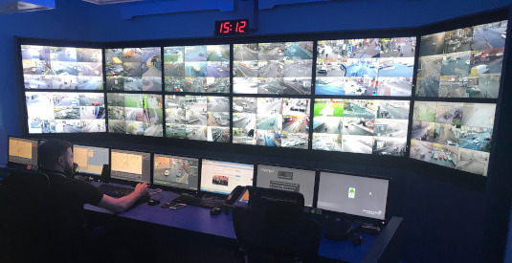
Throughout the review process, Members were assisted by the Service Manager, Community Safety and Community Protection Team Leader. Members examined a wide variety of evidence relating to the Council’s CCTV provision, including the reasons Ashfield introduced a CCTV provision, the established Shared Service Agreement, detailed CCTV statistics, and the national context around local authority use of CCTV, with guidance from the Surveillance Commissioners Code of Practice.
Members also undertook two separate site visits to the CCTV Control Room located at Sherwood Lodge, Nottinghamshire Police Headquarters. These visits were invaluable in providing Members with a fuller understanding of how CCTV is utilised in Ashfield, how the equipment is monitored, how the Control Room is staffed, the quality of the equipment in use, and how the Control Room communicated with the Council’s Community Safety Team and Nottinghamshire Police.
Additionally, Members held an informal working group with representatives from Planning, Licensing, Communications, Community Safety, Commercial Development, and Nottinghamshire Police in attendance.
Following a comprehensive review of the Council’s CCTV provision, Members identified several areas of concern. At the site visits, Members noted the poor image quality of cameras located at the Council’s parks and open spaces, moreover, Members understood the need for Control Room Operatives to spend less time dealing with calls directed to the Control Room from the Council. Through examining per camera incident statistics, Members identified three of the Council’s cameras had been identified as underperforming and in need of relocation. Public perception and awareness of the Council’s CCTV provision was a major point of discussion throughout the review, with Members keen to see existing resources utilised further to address this. Improved collaboration with the Police regarding the use of CCTV was also a primary concern of Members.
At the conclusion of the review, a set of recommendations were agreed by Scrutiny Panel B and presented to a meeting of Cabinet.
Recommendation(s):
a. Investigate the cost and benefits of cameras located on the Council’s parks and open spaces to incorporate HD/infra-red capabilities, and to continue exploring advances in CCTV technology (both mobile and fixed)
b. An evaluation exercise to consider the relocation of three cameras identified within the report as being underperforming be undertaken without delay
c. Public awareness of the Council’s CCTV provision be enhanced through all available platforms including social media, the Council’s website, and press releases
d. Secure an ongoing commitment towards increasing collaboration with the Police focused on gaining more analytical support
e. Explore the feasibility and benefits of installing a call filtering system at the Sherwood Lodge Control Room to facilitate more time monitoring cameras and responding to relevant issues rather than answering a diverse range of non-urgent out-of-hours calls
f. Further work be undertaken to enhance the Community Protection Officer work tasking programme based on real-time CCTV evidence as reported
g. The outcomes of these recommendations be reported back to Scrutiny Panel B

All recommendations presented to Cabinet as part of the final report were unanimously accepted. The Cabinet reiterated the Council’s commitment towards the ongoing delivery of an effective and responsive CCTV provision throughout Ashfield.

Scrutiny Review: War Memorials
This topic was added to the scrutiny work programme as Members were concerned that appropriate steps were not being taken to ensure the war memorials in Ashfield were being maintained through professional cleaning and restoration methods.
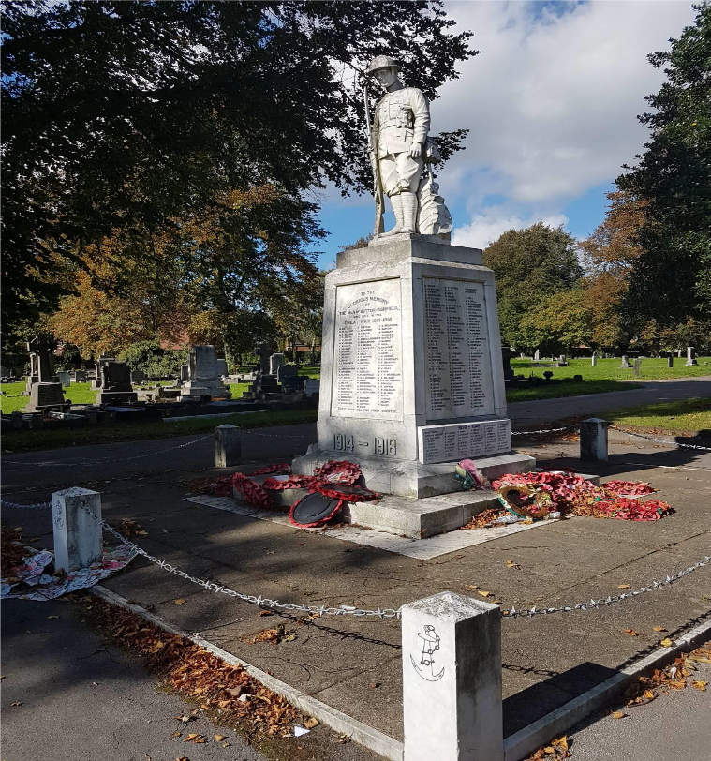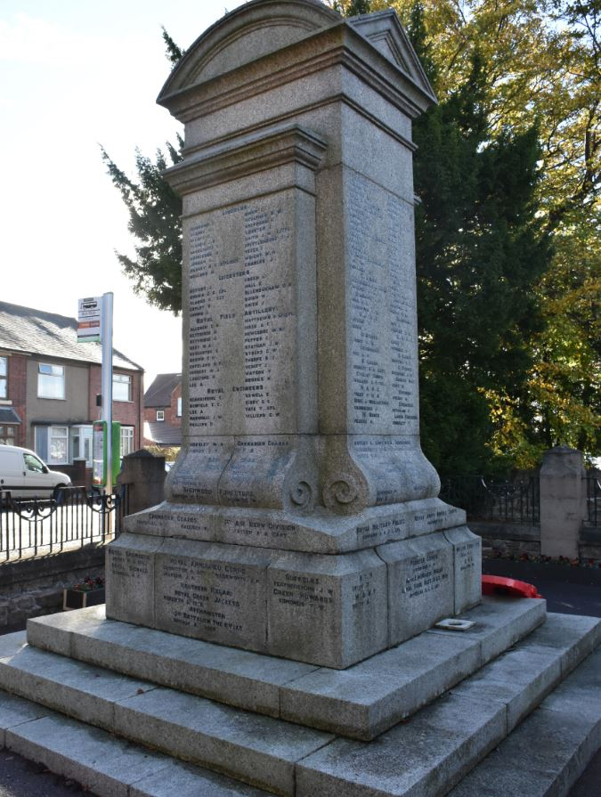
Throughout the review, Scrutiny Panel B welcomed involvement from the Director for Place and Communities, Assistant Director for Planning and Regulatory Services, Conservation Officer, and the Cemeteries and Allotments Team. At the first formal meeting of Scrutiny Panel B reviewing this topic, attention was focused on the cleaning and restoration work required on four priority war memorials located in Kirkby, Sutton, Hucknall, and Huthwaite. These four memorials were identified as priority due to the scale of maintenance and restorative work required.
Guidance from the War Memorials Trust on maintaining memorials alongside other help sheets were used by the Panel while discussing plans for a War Memorial Management Plan. The review was carried out with urgency as Members were keen to ensure any recommendations could be implemented ahead of remembrance events later in the year.
The condition of war memorials in Ashfield was of primary concern during the review process, with Members taking the time to learn the extent of work needed on each memorial, including what type of wax would be used, how cracks would be repaired, and how lettering would be reinstated. Members understood that memorials falling into disrepair could have significant detrimental impact to communities, and that any restorative work should be undertaken at the earliest possible opportunity.
The Panel was pleased to be informed that grant funding was being sought to pay for any such repair work and were happy to endorse the lengthy and stringent process. It was also believed to be important for the Council to identify funds to carry out the repair work should the application to the War Memorials Trust be unsuccessful. Due to the significance of Ashfield’s war memorials to many communities, it was vital for the Council to ensure the public is fully informed of any planned works regarding the memorials, as well as any planned events. Aligning with this, expansion of the information on the Council’s website regarding memorials was also identified as an area of improvement.
Finally, Members agreed that a protocol should be developed to ensure Ashfield’s war memorials are maintained in future, with the Council’s key principles regarding maintenance, engagement, and partnership working set out within.
Scrutiny Panel B submitted two sets of recommendations to Cabinet through the course of the Scrutiny Review: War Memorials. An interim set of recommendations was agreed by Members due to the time sensitive nature of the recommendations.
Recommendation(s):
a. Ensure the four priority war memorials identified are professionally cleaned and restored in readiness for remembrance events
b. Continue with the submission of a grant application to the War Memorials Trust, to secure funding for the professional cleaning and restoration work required
c. Immediately identify sufficient Council funding for the professional cleaning and restoration work required should the grant application to the War Memorials Trust prove unsuccessful
d. Develop a communications plan ensuring the public is fully informed of the proposed cleaning and restoration works, and any other events or plans relating to Ashfield’s war memorials
Some additional final recommendations were also agreed by Scrutiny Panel B and presented to a meeting of Cabinet.
a. The development of a protocol focusing on the four priority war memorials previously identified, setting out the Council’s key principles regarding maintenance, engagement, and partnership working
b. Enhancement of existing web pages on the Council’s website to provide further information on maintenance work, events, and community guidance relating to war memorials

Scrutiny Review: Community Protection Service
This topic was added to the scrutiny work programme as Members wished to consider the objectives and remit of the Community Protection Service, as one of the Council’s largest discretionary services. Understanding partnership working and ensuring the service remains fit for purpose and provides value for money were key considerations throughout the review.
At the outset of the review, the Panel agreed terms of reference detailing the rationale, objectives, indicators of success, review methodology, key witnesses and information required. Ensuring the service continued to both meet wider established objectives and adapt to differing social challenges was a primary focus of the review.
The review was conducted with Members considering a wide range of varying information. Members first looked back on the previous review carried out on the Ashfield.
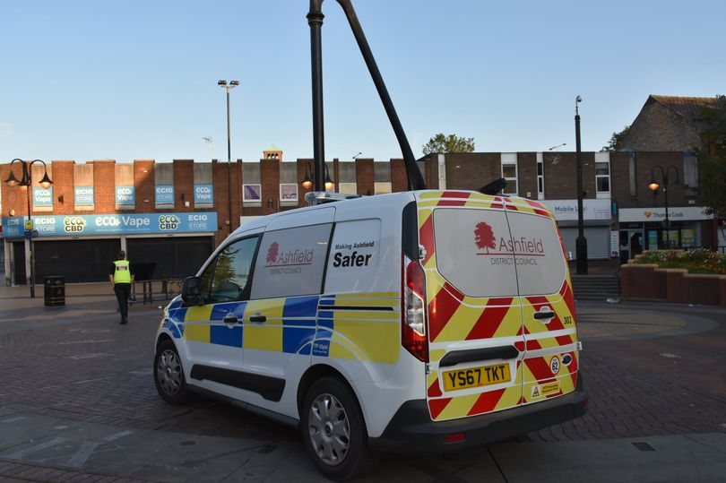
Neighbourhood Warden Service to understand if any issues or any areas of improvement in that review remained relevant during this review.
The Panel examined in detail the role of a Community Protection Officer, including the key tasks and responsibilities carried out such as:
- High visibility foot, bicycle, and vehicle patrols across Ashfield
- Dealing with anti-social behaviour complaints
- Supporting victims of anti-social behaviour
- Gathering evidence and preparing statements to proceed with legal action
- Problem solving approach to persistent anti-social behaviour
- Targeted approach to specific areas and locations
- Recognising issues relating to safeguarding children and vulnerable adults
Members also learned how the Community Protection Service operates within the Integrated Services Hub alongside organisations such as Nottinghamshire Police, Nottinghamshire Fire and Rescue, Women’s Aid Integrated Service, Reducing Re-offending Partnership, Department for Work and Pensions, Nottinghamshire Victim Care, Framework, and Change Grow Live. In gaining an understanding of a Community Protection Officer’s role, Members considered patrol plans, hotspot identification, operational tasking, case referrals, mobility, area-based work, and the Community Safety Triage Service.
Senior Officers assisting Scrutiny Panel B with the review also detailed a wider ongoing review/restructure of Community Safety. Members were assured that the discussions had as part of the review would be used to inform the wider restructure of the service, ensuring increased flexibility and improved strategic management. Members were also kept up to date with recruitment exercises undertaken by the Council.
Numerous Community Protection Officers were interviewed by the Panel who discussed the challenges facing the service, resourcing of the service and the impact of airwave radios and body-worn cameras, the value of providing a visible presence in the District, and performance targets. Furthermore, a breakdown of the latest crime figures in Ashfield was provided to the Panel to assist Members in gaining an understanding of the most common types of crime recorded in the area, and the challenges faced by the Community Protection Service.
The importance of ensuring Community Protection Officers were both protected and had the capacity to efficiently log cases and referrals was a key concern raised through the review. Members agreed that the service would benefit from reviewing the effectiveness of current equipment with a view to upgrade as appropriate.
Ascertaining and then managing public perceptions and expectations of the Community Protection Service, as a key discretionary service, was identified as a further conclusion of the review. Members agreed this could be achieved through undertaking a public consultation exercise involving residents and businesses in Ashfield as part of a wider engagement exercise as Community Safety works more closely with the Community Engagement Team.
A further concern raised by the Panel was ensuring that Community Protection Officers are utilising all accredited powers, and that options for optimising the use of these powers should be fully explored in conjunction with any changes to legislation.
The importance of the Integrated Hub in strengthening collaborative working was acknowledged by the Panel. Members were encouraged by the benefits that the Hub had provided so far, such as the Police providing training for CPOs, and considered the Hub a key factor in ensuring the Community Protection Service could effectively work towards core priorities.
At the conclusion of the review, a set of recommendations were approved by Scrutiny Panel B and presented to a meeting of Cabinet.
Recommendation(s):
a. Scrutiny Panel B note the importance of and endorse the ongoing restructure and recruitment exercise within Community Safety, ensuring the Community Protection Service is fully resourced
b. Full consideration is given to the equipment needs of Community Protection Officers to ensure that the on-street presence and back-office support maximises efficiency in both reporting and monitoring casework
c. The Community Protection Service focuses on four core priorities of:
Providing a visible presence
Dealing with anti-social behaviour issues
Working collaboratively with key partners
Ensuring public safety in Ashfield District Council
whilst maintaining a flexible approach to holistic issues
d. As part of a wider engagement initiative, a managed consultation exercise is undertaken to understand public perception of the Community Protection Service. This would also allow the Council opportunity to raise awareness of the service and its priorities
e. Delegate the power to the Director of Place and Communities, in consultation with the Portfolio Holder for Community Safety, to ensure all options are explored regarding the use of powers accredited to Community Protection Officers
f. the Police and other key stakeholders, including training opportunities and intelligence sharing, to ensure a more integrated approach to community safety in Ashfield
g. Following the review and restructure of Community Safety, the Community Protection Service topic be referred to Scrutiny Panel B as appropriate in 2021
All recommendations submitted to Cabinet were unanimously approved.

Scrutiny Review: Town Centre Regeneration
This topic was added to the scrutiny work programme as Members wished to explore funding opportunities available to the Council, key partners the Council works with regarding economic growth, and wider regeneration ambitions for Ashfield. Scrutiny involvement with this topic was further endorsed at a State of Ashfield Debate.
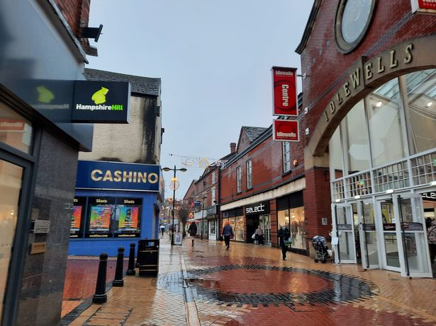
Scrutiny Panel B held one meeting on this topic, joined by the Director for Place and Communities who explained to Members the opportunities available through the Towns Fund and Future High Streets Fund. The Towns Fund was designed to support initiatives such as regenerating town centres, improving travel links and public transport, digital infrastructure, further education, and cultural and social infrastructure. At the time of the review, the Council was awaiting the publication of a Towns Fund prospectus providing guidance on the process and eligibility criteria.
The Future High Streets Fund was set up to support the renewal and reshaping of high streets and town centres. Serving two purposes, the fund would support local areas to prepare long-term strategies for high streets and town centres and provide expertise and hands-on support to local areas.
Additionally, Members also learned of the partnership working opportunities the Council utilised while proceeding with funding applications, business case development, and project plans. The Council worked in partnership with organisations such as Midlands Engine, East Midlands Councils, and the Local Enterprise Partnership.
As a result of this review, the Chairman of Scrutiny Panel B was formally appointed as a Council representative on the Discover Ashfield Board to take an active in role in discussions regarding town centre regeneration

