

Ashfield District Council Workforce Report January 2016

Human Resources

Contents Page
Executive Summary 3
Part 1 – Introduction 3
Background, Data Collection and Definitions 4
Part 2 – Workforce Profile 5
Overall Workforce Profile 5
  - Gender 6
  - Gender reassignment 6
  - Ethnicity 7
  - Age 7
Young People and Careers in Local Government 8
Ambitious in Mansfield and Ashfield 9
Pathways to work 10
Vision Apprentices 10
Sector Based Work Academy 11
  - Disability 11
Life Opportunities Survey 13
  - Religion 13
  - Sexual Orientation 14
  - Employees on Maternity leave 15
  - Adoption policy 16
Part 3 – Recruitment and Retention 16
  - Top 5% of Earners 16
  - Recruitment 17
  - Turnover 19
Part 4 – Equal Pay 19
Part 5 – Employment Casework 20
  - Disciplinary proceedings 20
Part 6 - Support for Employees 21
  - Workplace Health Awards 21
  - Coaching 21
  - Pam Assist 21
  - Flexible working 22
  - Employee Survey 23
Part 7 – Training 23
Part 8 – Positive Actions for 2015 24
My View 24
Part 9 – Goals for 2016 24
Part 10 – Home Locations 24

Executive Summary
This is the sixth year that Ashfield District Council has produced an Annual Workforce report. This report provides an analysis of the size and makeup of the workforce as well as recruitment, retention and learning and development in relation to age, disability, ethnic origin, gender, religion or belief and sexual orientation where data is available.

The Authority continues to challenge itself to achieve a wider representation within the workforce against the local labour market profile. Analysis of the data identifies trends and the areas that are underrepresented to develop strategies for reducing these gaps and achieving a workforce that is representative of the district.

Priority areas that have emerged through these reports are as follows:

- Low representation of black and minority ethnic (BME) employees within the organisation
- An ageing workforce
To address these areas we will review the impact of our policies that underpin our work in relation to recruitment and retention and learning and development to ensure that they are fair, accessible and promote opportunity to develop a diverse workforce.

There have been a number of significant interventions over the last 12 month period which, include:
- Staff Survey
- Young People and Careers in Local Government Report
- Achievement of the Bronze Award in the Workplace Health Award Scheme
- Success of Pam Assist the confidential support service for employees
- Introduction of My View. A system that enables employees to view their pay documents, training records and absence history. It also enables them to view and update certain aspects of your personal details.

Part 1 - Introduction
Welcome to Ashfield District Council’s Annual Workforce Information Report for the period up to 31st January 2016.

The purpose of this report is to provide an annual summary of the profile of the workforce. All public sector employers, including local authorities, have a statutory duty under the Equality Act 2010 to publish equality information on an annual basis. This information is available to members, employees and members of the public.

The report shows how the profile has changed over the last few years and we are keen to make sure that our workforce truly represents the people that we serve so that we can be as responsive as possible. To do this we regularly monitor our workforce data to help us identify where we need to focus efforts in attracting people to work for us for example within our recruitment and retention practices. It represents the continuation of the People Strategy to ensure that the Organisation has the right people with the right skills in place at the right time to deliver efficient and effective services across the District.
We will continue to work on these areas to develop a workforce that represents the Local Labour market profile and that is truly representative of the local community that it serves.
It is essential for the organisation to have accurate information on its existing workforce as this is used to develop other policies and functions including:

- Supporting the development of the Corporate Workforce Strategy
- Informing effective business planning
- Providing dates required to enable workforce planning across the Authority
- Providing the necessary information for effective Equality Impact Assessments to be undertaken
- Monitor and provide information on the Authority’s position in meeting the statutory obligations detailed below
- Continue to adopt employment practices that as far as possible ensure that the workforce is representative of the whole community of Ashfield District Council
- Identify areas for continuous improvement
This data also underpins the Authority’s commitment to ensure that its employment practices and services are free from discrimination and prejudice while fulfilling the statutory duty placed on all public sector employees, including local authorities, to:

- Monitor the profile of the workforce
- Analyse how this is reflected in the recruitment and development of employees
- Publish the relevant data on a regular basis
- Take any necessary action to address any negative trends or issues

Data Collections and Definitions

Topic | Definitions | Notes
Time Frame | As at 31st December 2015 | Workforce Profile Other data sets
Who is included | Permanent and temporary employees | Based on headcount
Who is not included | Casual and agency staff
Diversity measures used in the analysis | Gender Ethnic Group Age  Disabled Status Maternity/Pregnancy Religion  Sexual Orientation | Data utilised from application forms and employee personal details annual check in 2013
Community | Aged over 16 in Ashfield area | 2011 census

PART 2 – Workforce Profile

Overall Workforce Profile
As at 31st December 2015 there were 464 people employed by Ashfield District Council.

ADC workforce profile 2009 – 2015 (page 25)

Following a significant reduction in numbers of employees between 2009 and 2013 the trend over the last 3 years has been for the number of employees to remain constant at around 460-470.

The above data in relation to the number of employees is broken down and compared to that of the community in the following ‘protected characteristics’ under the Equality Act 2010 which are:

- Gender
- Ethnicity
- Age
- Disability
- Sexual Orientation/Transgender
- Religion/Belief
- Pregnancy and Maternity
The analysis of Applicants to the Authority will be extended to report against all the protected characteristics in the 2016 Workforce report moving forward.

Gender Profile of the Ashfield District Council workforce, Ashfield Community following the 2011 Census and the Local Labour Market Profile
ADC gender profile 2012 - 2015 (page 26)
The percentage of male employees has increased slightly from 2014 to 2015 with corresponding slight decrease in percentage of females.

The Census and Local Labour Market Profile (LLM) both show a differential in the gender split with The LLM stating a higher percentage of males and the Census, a marginal higher percentage of females Our workforce closely mirrors the LLM profile. A substantial proportion of work carried out the by the Authority is historically male orientated and the Authority has been looking to change the culture of what is deemed for male/female positions both internally and externally to attract a greater gender split to all positions within the Authority.

There are a number of women undertaking roles within the Authority that would typically be male dominated this is positive recognition that roles are no longer defined by gender. There are 14 females working as Community Protection Officers this has increased over the last few years and is now an equal match to the number of males.

Salary | At 31/12/14 | At 31/12/15
Average Male Salary | £23,482 | £24,442
Average Female Salary | £23,040 | £24,153
Above figures based on FTE salary for all posts

Full time/Part time split | 31/12/14 |  | 31/12/15
 | Full time | Part time | Full Time | Part Time
Male | 234 | 15 | 240 | 16
Female | 128 | 94 | 118 | 90

Gender Reassignment

In line with the conventions in the presentation of data used elsewhere, we do not collect data that allows individuals to be identified. For this reason we do not monitor gender identity within the workforce to ensure that the employees feel confident that their personal information is protected.

A report by the Gender Identity Research and Education Society 2009 gave an indication of geographic distribution on transgender people. This came from a sample size of 1,196 people and the data enabled an estimation of the implied prevalence of people who have presented with Gender Dysphoria in each area. It appeared high in Nottinghamshire, for which the prevalence per 100,000 aged 16 and over appeared to be 43 compared to the national average of 20

Ethnicity Profile of the Community and Ashfield District Council Workforce

ADC ethnicity profile 2012 - 2015 (Page 27)

The Local Labour Market figure is distorted in relation to comparability as it is includes the city of Nottingham as well as the rest of Nottinghamshire.

The latest figure for the Ashfield community and the Local Labour Market – Nottinghamshire are those shown for 2011.

The number of BME employees has increased by 1 employee with corresponding percentage increase from 2014 to 2015. Exit interviews are offered to all employees who have chosen to leave the Authority.
Since 2009 the Authority has monitored the ethnic profile of the organisation through performance indicators and has explored new initiatives in relation to recruitment to address the imbalance. Assistance is offered to all applicants in relation to the completing of application forms. The recruitment process is continually reviewed and updated/amended where required, interviews can be re-arranged to suitable days and times and Skype has also been utilised.
Managers have also undertaken interview training to ensure that there is a fair and consistent approach to the interview process and actively promoting opportunities to a wider community.

Age Profile of the Ashfield District, Local Labour Market and Ashfield District Council Workforce

ADC age groups profile 2012 – 2015 (Page 28)

The data compares the age profile of the organisation against the Local Labour Market (LLM) for Ashfield District. There is underrepresentation within the under 30 age range and especially so within the 16-24 age group.

The 60+ age group has remained very similar showing only a slight increase even with the removal of the default retirement age by Government in October 2011, whereby employees are no longer allowed to give notice of retirement to employees.

“Our research shows that an estimated 100,000 workers were forced to retire in 2009 alone. The harm this causes to those who wish to work beyond retirement age, both financially and in terms of the impact on the person’s self determination, should not be underestimated”.

Source: Age UK, Default Retirement Age.

There is a positive increase in the 16-24 age group which hopefully will continue with the ongoing actions in place to reach this age group and engage them to consider careers within local government. This age group is still however underrepresented against the Local labour Market, although many in this group are in education or training but there is more to understand here.
In particular there is opportunity to target entry level roles at this group and to review our selection criteria in order to support this group.

The Authority recognised the need to attract more youngsters into the organisation and engaged two graduate placements to undertake research and analysis of the recruitment process to determine the potential barriers to attracting young people into local government.

Young People and Careers in Local Government.
The objective of the report entitled ‘Young People and Careers in Local Government’, was to acquire a higher percentage of young people within the workforce at Ashfield District Council (ADC) and Mansfield District Council (MDC). In order to reach this aim, this report analysed all aspects of recruitment, from advertisement, through to the application process and to the appointment of the desired candidate.
The findings are outlined in a report which offers recommendations to increase the career opportunities for young people aged 16-25. In summary these findings were focussed on the following areas for improvement:

- Wording of vacancies
- Briefing to departments on social media
- Building a community on social media
- Use of YouTube
- Young people tab on the website
- Separate website for careers
- Review of the selection criteria
- Circulation of case studies
- Development of feedback to applicants
- 1-2-1 scheme briefing volunteers working with young people
- Development of a recruitment portal
The Authority continues to develop its commitment towards working with young people to help them raise their aspirations, gain valuable experience and improve their chances of finding permanent work.

Ambitious in Ashfield and Mansfield
Ambitious in Ashfield and Mansfield is a joint initiative between The Brunts Academy, Ideas4Careers(uk) Ltd and both Mansfield and Ashfield Councils. The Brunts Academy hosted an event in November 2015. The day included guest speakers on interviewing skills, apprenticeships and team work and problem solving.

The objectives for the project are to:
- Excite, inspire and inform young people about the world of work
- Give insight into potential career opportunities
- Help young people become more employable providing them with the skills and confidence to present themselves to an employer
- Help them recognise their personal qualities and strengths to make informed career choices
- Raise aspiration and self-belief

- Benefit from business mentors as role models
Also included was a session called ‘What’s my Line’ based on a speed dating theme where employees form different organisations were asked a number of questions about their job role by a team of students who then attempted to guess what job they did.

Further similar events are scheduled into July 2016 with other schools and further education providers including Holgate , Sutton Centre, Quarrydale School, Kirkby College, All Saints School, National Church of England School, Meden School, Ashfield School, Manor School and Selston High School.

Pathways to Work

Pathways to Work is a programme of work that has been approved by Council and is aimed at encouraging young people with high level skills to consider careers in local government. Many of the young people participating in the scheme have gone on to secure permanent job outcomes.

The Scheme started in the summer of 2015 and 2 undergraduate placements were appointed, one in Community Protection and one in Human Resources. Graduate placements were successful in Local Community Empowerments that led to a 6 month temporary post with Corporate Improvement. Another graduate position was found with New Cross Pilot Scheme and the placement was extended for one month.

Vision apprentices

The Authority is keen to promote apprenticeships, as they are seen as an essential way of supporting young people, helping them to build their employability skills, qualification levels and providing them with local work opportunities. Apprentices are employed by Vision Apprentices (a company set up by Vision West Nottinghamshire College). There has been 1 Apprentice recruited during 2015, 2 trainees (directly employed by ADC) and 9 work experience placements. These positions will be with various departments within the Council.

Recruitment data is detailed later in this report and it can be seen that 16 to 24 year olds make up 15.99% of all applications to the Authority. Applicants from this age band are now being attracted to the Authority which is positive However, this is not necessarily being translated into long term employment.

Ashfield and Mansfield District Councils are working together to offer high value apprenticeship and work opportunities across both authorities in the future to improve job prospects for this group. The new Apprenticeship Levy will underpin a refreshed and positive commitment to increasing the annual number of apprenticeships.

Sector Based Work Academy

Partnership working between the Waste and Environment Services, Department for Work and Pensions and Academy Transformation Trust Further Education to support young people in applying for and achieving work with the Authority. The scheme is currently running throughout February 2016 will focus on the basic skills that young people need to succeed in gaining employment including:
- Confidence building
- Personal hygiene
- Form filling
- Preparing for interviews
- Problem solving
- Independent thinking
- Presentation skills
- Mock interviews
- Customer service

Disability

ADC disability profile 2012 - 2015 (Page 29)

The data represents individuals who consider themselves to be disabled under the definition of the Disability Discrimination Act (DDA) 2005 and subsequently the Equality Act 2010, which is the test applied in law to disability discrimination.

The Ashfield Community figures will include all disabled residents. There would be a high percentage of these residents that would be unable to work due to their disability.
The figure for the Local Labour Market is taken from the Annual Population Survey from NOMIS for Sept 2012 and included only those residents who are DDA only disabled and not the work-limiting disabled. This is the latest information available from NOMIS for this dataset as the Annual Population Survey has adapted new standardised questions for individuals with regard to health and this has led to a discontinuity in the series of information.

Disability Employment Gap

Conservative Party Manifesto for 2015 indicates that there are 78% economically active 16 – 64 year olds. By comparison the figure for disabled people is 48%. This is a 30% Disability Employment Gap.

A number of positive initiatives have been put in place to support disabled employees for example:
    - The Authority was successful in gaining reassessment of the ‘Two ticks positive about disabled people’ in 2013
    - Disability related sickness absence is considered within the Attendance Management Policy
    - There are ongoing, reasonable adjustments in place to support employees including; adjustments to working hours, adjusted shift patterns, adaptations to workstations, equipment and car parking arrangements
    - A number of employees from across the organisation have completed a Mental Health Awareness course
    - Work with ‘Access to Work’ a joint scheme that provides physical, financial and sometimes emotional support for employees.
    - Disability awareness training for managers
    - PAM assist is an employee assistance programme that offers confidential support for employees dealing with illness

The Authority has signed up to the Mindful Employer Charter run by Workways, a service of Devon Partnership NHS trust. Mindful Employer provides businesses and organisations with easier access to information and support in relation to staff who, experience stress, anxiety, depression and other mental health conditions.

The Charter is for employers who are positive about supporting both employees and job applicants who are experiencing mental ill health. It promotes a positive attitude to supporting individuals in the workplace and also in the recruitment process by ensuring that staff involved in the recruitment process, are trained and able to offer a positive and enabling attitude to interviewees.

Life Opportunities Survey

The Life Opportunities Survey (LOS) is a large scale longitudinal survey of disability in Great Britain. It is the first major social survey to explore disability in terms of the social barriers to participation that disabled people experience.

The survey was funded by the Department for Work and Pensions (DWP) and was carried out by The Office for National Statistics (ONS). The ONS ran the survey throughout the year across Great Britain. It interviewed a random sample of households, with sectors of society chosen to reflect the general population. The survey followed respondents over a time period from June 2009 to September 2014 and collected information regarding their changing situations.

The survey found the following:
    - Working age adults without impairments were twice as likely to be employed than working age adults without impairments 66% compared to 33%
    - Working age adults with impairment were less likely to have a degree level qualification and more likely to have no formal qualifications than those without impairment. This was true for both employed and inactive adults

    - Working age adults with impairment were more likely to work in semi- routine and routine occupations than those without impairment and were less likely to work in higher, managerial and administrative and professional occupations
    - For employed adults, those with impairment were more likely to have caring responsibilities than those without impairment

Source: Office for National Statistics LOS – An executive summary

Religion/belief

ADC religious Identity profile 2012 – 2015 (Page 30)

The Authority conducts annual personal details check of all employees.

Included within the Leave policy all employees are entitled to one celebration or faith day per annual leave year, taken as part of their annual leave entitlement, or accrued time in lieu, where the employee’s religion requires their moral obligation to attend this day.

Sexual Orientation

ADC sexual orientation profile 2012 - 2015 (Page 31)

These are the latest results in terms of religion and sexual orientation for the total workforce for the 2015 period. It is a positive development that more employees are willing to declare their sexual orientation.

Monitoring this information will help to asses if the Authority is becoming more diverse and will determine if people feel assured that they can declare their sexual orientation to develop the Authority and the people working within it towards an all-inclusive organisation. Verification of personal details for employees are updated every 2 years. Employees are made aware of how the information will be used but that disclosing this information is optional.
These figures will be compared with available district statistics to identify any gaps and trends. According to the household survey 1.5% of adults in the UK identified themselves as Gay, Lesbian or Bisexual. The percentage of employees representative of these groups is currently 1.01%.
In 2012, 1.5 per cent of adults in the UK identified themselves as Gay, Lesbian or Bisexual.
Adults aged 16 to 24 were more likely to identify themselves as Gay, Lesbian or Bisexual (2.6 per cent) compared with adults aged 65 and over (0.4 per cent).
Source: ONS Key Findings Integrated Household Survey Jan – Dec 2012

In 2013, the ONS asked around 180,000 UK adults about their self-perceived sexual identity as part of the Integrated Household Survey.

1.6% of UK adults aged 16+ gave their identity as lesbian, gay or bisexual in 21013.

This compares with 1.5% of adults who identified in 2012 representing a small increase.

Males were twice as likely as females to consider themselves gay or lesbian

Adults aged 16 to 24 were more likely to identify themselves as Gay, Lesbian or bisexual (2.6%) compared to adults aged 65 and over (0.4%)

Source: ONS Key Findings Integrated Household Survey Jan – Dec 2012

Employees on Maternity Leave
For the 12 month period up to 1st January 2015 to 31st December 2015, 13 employees utilised the maternity policy. 9 employees started their leave in 2015 and 4 returned from maternity leave during the same period.

The current maternity policy for leave offers the statutory minimum plus 12 weeks at half pay for employees with more than 12 months service, if they return to work for a period of at least 3 months after maternity leave.

The Authority currently offers all employees access to the right to request flexible working going beyond the legislative requirements. Options available to employees to request include, term–time working, part time working and in addition to this employees may request to work job share under the Job Sharing Agreement.
The Authority offers employees the opportunity to join the Childcare Vouchers Scheme through a Salary Sacrifice Scheme to assist with childcare costs.
The Maternity, Paternity, Shared Parental, Paternity and Adoption Leave were reviewed in 2015 to include the following changes:

Maternity Leave
- Increase in SMP rate
Adoption Leave
- Removal of continuous service eligibility criteria
- Introduction of the right for a primary adopter to take reasonable paid time off to attend up to five adoption appointments.
- Introduction of the right for a secondary adopter to take reasonable paid time off to attend up to two adoption appointments.
Paternity Leave
- Removal of additional paternity leave, (replaced by shared parental leave).
Parental Leave
- Entitlement increased from 13 to 18 weeks unpaid parental leave to be taken before the child’s 18th birthday.

In addition to the rights contained in the above policies, both MDC and ADC offer Maternity Support Leave

Adoption Policy

The Authority has an Adoption Policy that sets out the rights of employees to adopt a child from within the UK or overseas. Adoption leave is for both men and women and employees who quality for this leave will also qualify for statutory adoption pay, (dependent upon their earnings). The Authority also offers keeping in touch days up to 10 days work during adoption leave.
The policy has been revised recently to consider the time needed for adoption matching as part of the pre adoption process. There are also keeping in touch days to support the process.

PART 3 – Recruitment and Retention

Top 5% Earners

ADC gender profile of top 5% of earners 2012 - 2015 (Page 32)
ADC ethnicity profile of top 5% of earners 2012 - 2015 (Page 33)
ADC disability profile of top 5% of earners 2012 – 2015page (Page 34)

    - There has been a slight reduction in earners that are female
    - There has been a positive increase of 4.16% in earners that are from an ethnic minority
    - There has been a substantial increase in earners that have declared a disability

Recruitment
The number of applications received by the Authority shown as a breakdown in relation to protected characteristics is as follows. The total number of applications received is 577 for 66 vacancies.

ADC gender profile of applicants & appointees 2012 - 2015 (Page 35) ADC ethnicity profile of applicants & appointees 2012 - 2015 (Page 36) ADC age groups profile of applicants & appointees 2012 - 2015 (Page 37) ADC disability profile of applicants & appointees 2012 - 2015 (Page 38)

Headlines from the recruitment table:
    - Of the 577 applicants 518 completed their ethnicity as White British which is 89.7%
    - Of the 518 completing as White British 57 were successful at the interview which is 11%
    - Of the 577 applicants 46 completed their ethnicity as BME which is 7.98%
    - Of the 46 completing as BME 1 was appointed which is 2.17%
    - However further investigation shows that there were 3 candidates of the 46 that reached the interview stage and one was successful. So at the interview stage of the candidates reporting as BME the success rate was 33.33%
In future years we will be able to compare similar information at the interview stage for both White British and BME candidates.

Future Workforce Profiles will report on a wider range of protected characteristics under the Equality Act 2010. The recording of Sexual Orientation and Religion, will be extended to the applicants to the Authority moving forward.

Recruitment 01/01/15 to 31/12/15
TABLE 1  Appointments made: | 61
Recruitment Campaigns: | 66
Description | No. Applied |  | % Applied |  | No.  Appointed | %  Appointed
Male | 329 |  | 57.02% |  | 43 | 70.49%
Female | 248 |  | 42.98% |  | 18 | 29.51%
White - British English | 471 |  | 81.21% |  | 57 | 93.44%
- British Scottish | 0 |  | 0.00% |  | 0 | 0.00%
- British Welsh | 0 |  | 0.00% |  | 0 | 0.00%
- Irish | 0 |  | 0.00% |  | 0 | 0.00%
- Gypsy or Irish Traveller | 1 |  | 0.17% |  | 0 | 0.00%
- European | 5 |  | 0.86% |  | 0 | 0.00%
- Any Other | 8 |  | 1.38% |  | 0 | 0.00%
Mixed - White & Black Caribbean 4 | 4 |  | 0.69% |  | 0 | 0.00%
- White & Black African | 0 |  | 0.00% |  | 0 | 0.00%
- White & Asian | 0 |  | 0.00% |  | 0 | 0.00%
- Any Other | 1 |  | 0.17% |  | 0 | 0.00%
Asian, Asian British, Asian English, Asian Scottish, or Asian Welsh:
- Indian | 7 |  | 1.21% |  | 1 | 1.64%
- Pakistani | 7 |  | 1.21% |  | 0 | 0.00%
- Bangladeshi | 1 |  | 0.17% |  | 0 | 0.00%
- Any Other | 0 |  | 0.00% |  | 0 | 0.00%
Black, Black British, Black English, Black Scottish, or Black Welsh:
- Caribbean | 5 |  | 0.86% |  | 0 | 0.00%
- African | 6 |  | 1.03% |  | 0 | 0.00%
- Any Other | 1 |  | 0.17% |  | 0 | 0.00%
Chinese, Chinese British, Chinese English, Chinese Scottish, Chinese Welsh or Other Ethnic Group
- Chinese | 1 | 0.17% |  | 0 |  | 0.00%
- Any Other Chinese | 0 | 0.00% |  | 0 |  | 0.00%
- Any Other Ethnic Group | 0 | 0.00% |  | 0 |  | 0.00%
Disabled | 19 | 3.29% |  | 1 |  | 1.63%
16-24 | 96 | 16.55% |  | 8 |  | 13.11%
25-29 | 97 | 16.72% |  | 9 |  | 14.75%
30-44 | 188 | 32.41% |  | 29 |  | 47.54%
45-59 | 180 | 31.03% |  | 15 |  | 24.595
60-64 | 10 | 1.72% |  | 0 |  | 0.00%
65+ | 2 | 0.34% |  | 0 |  | 0.00%

Ashfield District Council is committed to ensuring equal opportunities to all applicants applying for vacancies. The Authority ensures alternative arrangements for interviews are offered where possible to ensure accessibility to all applicants, this includes re-arranging interviews to suitable days and times and also conducting interviews by Skype.

Turnover
Turnover is calculated using the following calculation:

Number of leavers

(Headcount at period start +headcount at period end)/2 %

Year | Turnover (%)
2011 | 9.86
2012 | 20.37*  Without TUPE transfer – 10.09
2013 | 16.53%*  Without TUPE transfer – 13.67
2014 | 6.68%
2015 | 8.97%
The number of leavers during this period was 41 employees.

ADC gender profile of leavers (Page 39) ADC ethnicity profile of leavers (Page 40) ADC disablity profile of leavers (Page 41)

Part 4 – Equal Pay
Following the implementation of the Single Status Agreement in October 2014 all new posts and amendments to existing posts are evaluated under the national joint council local government scheme which has been devised to be free from gender bias and discrimination on the grounds of race, sexuality, religious belief, age and disability.

Any changes to terms and conditions are subject to Equality Impact Assessments. Corporate arrangements are in place to ensure any future changes to pay, terms and conditions take account any potential equality impacts.

Under the Equality Act 2010 all public authorities are required to monitor the impact of internal procedures by racial group, gender, disability and age.

Ashfield District Council currently monitors the following issues in line with the Equality Act –
- Disciplinary
- Grievance
- Bullying and Harassment
- Attendance Management
- Performance Capability
- Redundancy
- Re-deployment
- Home Working
- Flexible Working
Training delivered to all managers and team leaders in early 2015 on the revised grievance and disciplinary policies

Part 5 – Employment Casework
Following the implementation of the Single Status Agreement in October 2014 all new posts and amendments to existing posts are evaluated under the national joint council local government scheme which has been devised to be free from gender bias and discrimination on the grounds of race, sexuality, religious belief, age and disability.

Any changes to terms and conditions are subject to Equality Impact Assessments. Corporate arrangements are in place to ensure any future changes to pay, terms and conditions take account any potential equality impacts.

Under the Equality Act 2010 all public authorities are required to monitor the impact of internal procedures by racial group, gender, disability and age.

Ashfield District Council currently monitors the following issues in line with the Equality Act –
- Disciplinary
- Grievance
- Bullying and Harassment
- Attendance Management
- Performance Capability
- Redundancy
- Re-deployment
- Home Working
- Flexible Working
Training delivered to all managers and team leaders in early 2015 on the revised grievance and disciplinary policies

5.1 Grievance

5 females were involved in grievance proceedings compared to 6 men.

Disciplinary proceedings

Gender profile of ADC disciplinary cases (Page 42) Ethnicity profile of ADC disciplinary cases (Page 43)
12 employees in total subject were subject to disciplinary proceedings.
Should this data collected identify any trends in relation to the protected characteristics then this would be investigated further to ensure that practices are fair and non-discriminatory. To ascertain if there are differences in the way differing groups of employees are treated or any underlying reasons that may lead to potential discrimination or unfair disadvantage and that these cases are dealt with accordingly.

The Authority reviewed the Attendance management policy. This policy includes more guidance and support for employees with disabilities.
Employees also have access to request Disability Leave for any appointments or treatment related to their disability.

The HR Team continue to hold regular case review meetings to ensure consistency across employment related casework.

There has been 1 case of Bullying and Harassment for the period January 2015 to December 2015.

Part 6 - Support for Employees

Workplace Health Award
The Authority in 2015 achieved Bronze Standard of the Nottinghamshire Wellbeing at Work – Workplace Health Award Scheme which demonstrates that the Council is committed to its work and wellbeing agenda. The scheme focusses on promoting five key themes:
    - Substance use/misuse: Smoking. Alcohol, and drugs/substances
    - Emotional mental wellbeing: stress, anxiety, depression, spiritual and emotional wellbeing
    - Healthy weight: healthy eating, physical activity, sport and weight management
    - Protecting health: cancer, sexual health, health checks, domestic abuse and immunisations
    - Safety at work: Health and safety in the workplace
The Authority is now aiming to achieve the Silver Standard in 2016 which involves an enhanced focus on working with and supporting suppliers and businesses to adopt workplace health initiatives.

There are a number employees undertaking roles of health Champions for the Authority. These Champions have completed The Royal Society for Public Health Level 2 Award in Understanding health Improvement. These champions are able to support individuals and signpost them on to access information and support. Many have also achieved the NCFE Level 2 in Mental Health Awareness.

Coaching
There are 4 employees completing the ILM Level 5 in Coaching and Mentoring award. These employees not only gain personal development from achieving this award but are able to support colleagues both within the organisation and other Authorities signed up to the East Midlands Coaching Network.

Occupational Health

Sessions For period March to December 2015 | Male | Female
Counselling sessions
Consultation report | 6
Health Surveillance | 5
Occupational Health Doctors appointment | 40 | 11
Occupational Health Nurse Appointment | 5
Pre employment Paperscreen | 14 | 8
Workplace assessment | 2 | 6
HAVS |  | 5
Wellbeing appointment
Physiotherapy treatment | 3 | 2

Pam Assist

Pam Assist is the current provider for the Authorities Employee Assistance Programme. The Authority changed to this provider in In the Autumn of 2014. Pam Assist provide confidential support 24 hours a day 365 days a year through trained advisors who are able to offer support on most matters from life crises to everyday matters including:
    - Debt advice
    - Positive life changes
    - Getting married
    - Healthy choices
    - Returning to work
    - Illness
    - Personal crises
    - Family crises
    - Retirement
    - Moving house
    - Having a family

Employees can access the service online, or over the telephone. Further support is then available when required through face to face counselling services.

There is a whole person approach to well-being now with the involvement of Occupational Health through wellbeing clinics.

Each quarter the Authority receives a breakdown of usage, for the period November 2014 to July 2015 the figures show the following:
    - 114 employees accesses the service
    - 4 people received face to face counselling some going on to further sessions
    - 10 people received telephone counselling
    - The main reason for employees accessing the telephone counselling was for relationship advice
    - By far the highest number of employees accessing the service via the web was for mental health advice
Feedback from employees accessing the service has been very positive and in some cases making a real difference to their work life.

Flexible Working

The Authority currently offers all employees’ access to the right to request flexible working. Options available to employees to request include, term–time working, part time working and in addition to this employees may request to work job share under the Job Sharing Agreement.
    - Flexible retirement
    - Counselling
    - Leisure Centre concessions
    - Health and Wellbeing initiatives (health eating, exercise)
    - Cycle to Work Scheme
    - Childcare Voucher Scheme
    - PAM Assist (Employee Assistance Programme)
    - Wellbeing clinics
    - Workplace Choir

Employee Survey

The Employee Survey was conducted in 2015. The response to completing the survey was positive at 60% with a total of 282 employee taking part. To address the issues emerging from the survey employees from across the organisation have been invited to take part in themed groups to identify what needs to be done and putting it into practice.

Part 7 – Training

Gender profile of ADC training courses (Page 44) Ethnicity profile of ADC training courses (Page 45)

Age groups profile of ADC training courses (Page 46)

Member training for Equality and Diversity took place in 2015 and was well attended and supported by members. Invited guests from Disability Nottinghamshire attended the sessions to give a personal insight to disability issues and share their experiences. Feedback was very positive from those attending. Further sessions are planned for those members who were unable to attend and there have been 121 briefing sessions on Equality for individual members.

Bespoke training sessions have been delivered through a representative from MIND. These were specifically focussed on front line services through their own recognition that they would benefit from training and awareness around Mental Health. Furthers sessions are scheduled for 2016 that will reach all front line services.

As well as these e-learning courses, ACAS delivered tailored equality training to meet the needs of specific areas. This included Diversity and Dignity in the workplace and unconscious Bias training for front line operatives. This was well attended and positively received by the team of 12 employees and feedback has identified improvements on both a personal and professional level within the team.

Local Authority Challenge event was a joint exercise between Mansfield District Council and Ashfield District Council managers. An external training provider supported the running and evaluation of the event and provided feedback to managers. Managers were split into teams representing fictional local authorities to challenge their understanding of what it takes to transform the way the authority works to develop their ability to be flexible and manage change. This project identified areas for development within both organisations and this will be used to develop the future Leadership Development Programme.

Preparing for Retirement courses are provided by an external Associate. These courses are for all ages to provide guidance and knowledge of current pension and retirement options.

Continued development of the management development programme with a number of employees from across the organisation completing the ILM Level 3 and ILM Level 5 qualifications.

Job skills workshops are open to all employees through the Learning Together Programme to assist employees in developing their skills in areas such as CV writing and completing application forms. Information is also available to all employees through the Learning Together programme on Ela where there are booklets available to print off and use as reference.
In 2015 a major programme of development commenced within the Environmental services section in 2015. Each individual employee has developed their own individual learning plan that meets their needs and what

is expected of them within their roles. A comprehensive programme of training has been developed to meet these needs currently and also plan for future development.

The Authority is also commenced in 2015 the Prevent training to all members of staff under the Home Office instruction. This will continue into 2016.

The Authority is also part of the Aspire Foundation programme which is a partnership programme that aims to mentor and support women who are working in areas of work that are challenging. The Aspire Foundation virtual mentoring program partners the expertise and experience of women and men in the business and corporate world with ‘MAD’- 'Making A Difference' women in charities and social enterprises that are impacting women and girls. The Authority is also working with the Foundation to develop leadership, entrepreneurial, strategic and sustainability skills for women.

New starters to the Authority complete an e-learning ‘Introduction to Equality’ course, must be completed prior to their face to face meet and greet session.

Hate Crime awareness training is available to all employees on a rolling programme.

IOSH programme in place across the Authority for managers and supervisors within all services. The training focusses on managing health and safety of the staff within their own teams.

NVQ Level 2 in Mental Health Awareness
- 16 employees from across the organisation have completed the NVQ Level 2 in Mental Health Awareness. This course not only raises awareness but enables the candidates to understand more and support their colleagues and family and friends when experiencing mental ill health.

Diversity, Dignity and Unconscious Bias
- 7 managers attended
- 21 front line employees attended

Dealing with Difficult People
- 58 people attended from across the organisation attended

Royal Society for Public Health Award Level 2 in Understanding Health Improvement
- 2 employees have volunteered to complete this course and become Workplace Health Champions for the Authority.

The Authority continues to work with the Union Learning Partnership to deliver a varied learning at work programme across the Authority

Part 8 Positive actions in 2015

8.1 My View

My View is an information management system that enables employees to view their pay documents, training records and absence history. It also enables them to view and update certain aspects of your personal details.

Part 9 Goals for 2016
Continued work with local schools to develop employability skills and raise awareness of the career opportunities within Local Government.

Raising awareness of how to apply for jobs in the public sector, potential use of You Tube video demonstrating how to complete applications forms

Reconsideration of essential criteria for entry level jobs and to consider alternative strengths that candidates demonstrate.
To support employees in returning to work through the following:
- Improved working with GP’s to make adjustments to support the individual employee returning to work
- Promoting the physiotherapy service provided through Occupational Health

Part 10 Home Location
Home Location Profile of ADC Workforce (Page 47)
Gender Profile of ADC Workforce and Home Location (page 48) Age group Profile of ADC Workforce and Home Location (Page 49)

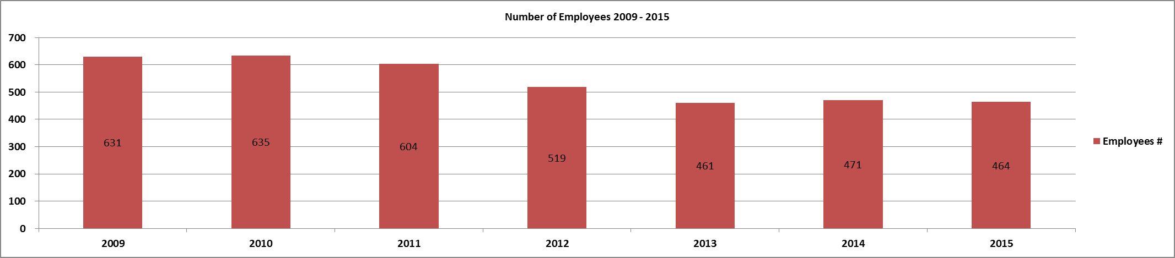

Year | Employees #
2009 | 631
2010 | 635
2011 | 604
2012 | 519
2013 | 461
2014 | 471
2015 | 464
Return

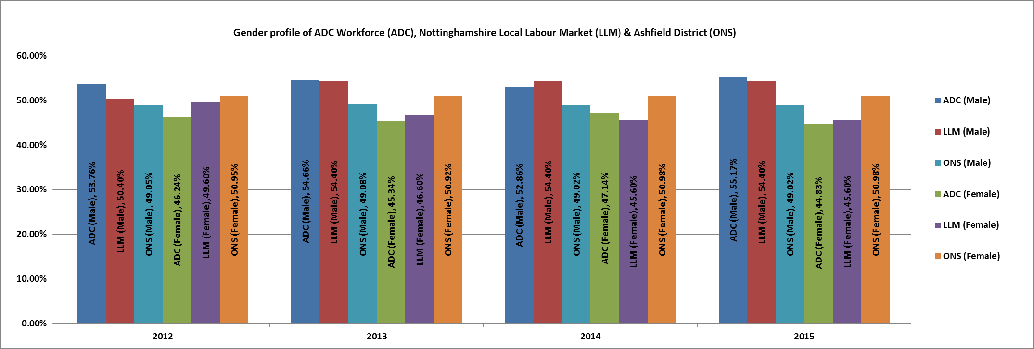

Year | ADC (Male) | LLM (Male) | ADC (Female) | LLM (Female) | ONS (Male) | ONS (Female)
2012 | 53.76% | 50.40% | 46.24% | 49.60% | 49.05% | 50.95%
2013 | 54.66% | 54.40% | 45.34% | 46.60% | 49.08% | 50.92%
2014 | 52.86% | 54.40% | 47.14% | 45.60% | 49.02% | 50.98%
2015 | 55.17% | 54.40% | 44.83% | 45.60% | 49.02% | 50.98%
Return

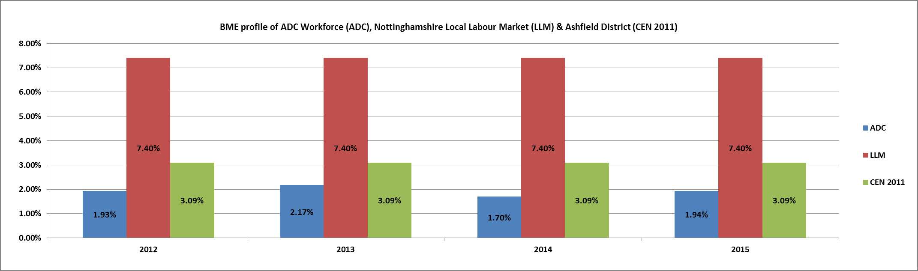

Year | ADC | LLM | CEN 2011
2012 | 1.93% | 7.40% | 3.09%
2013 | 2.17% | 7.40% | 3.09%
2014 | 1.70% | 7.40% | 3.09%
2015 | 1.94% | 7.40% | 3.09%
Return

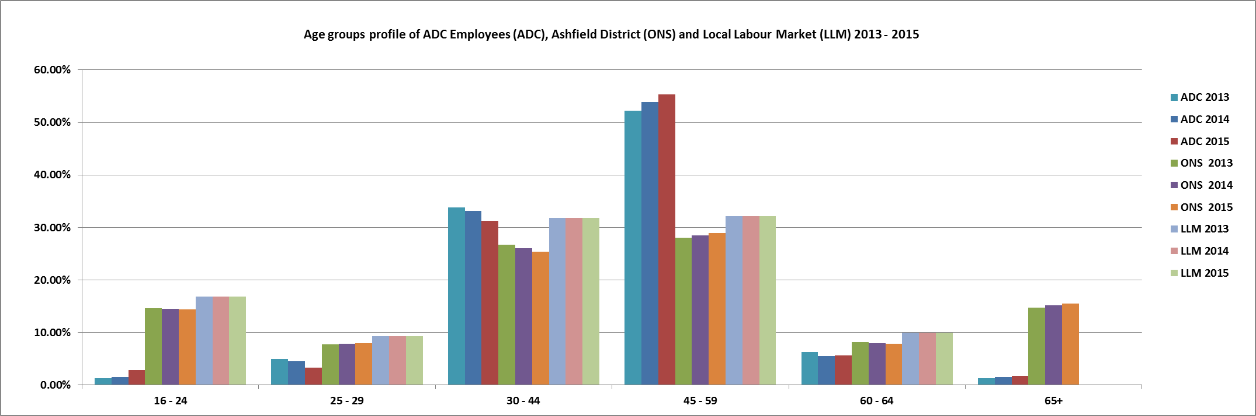

Age Group | 16 - 24 | 25 - 29 | 30 - 44 | 45 - 59 | 60 - 64 | 65+ | Total
ADC 2013 | 1.30% | 4.99% | 33.84% | 52.28% | 6.29% | 1.30% | 100.00%
ADC 2014 | 1.49% | 4.46% | 33.12% | 53.93% | 5.52% | 1.49% | 100.00%
ADC 2015 | 2.80% | 3.23% | 31.25% | 55.39% | 5.60% | 1.72% | 100.00%
ONS 2013 | 14.59% | 7.66% | 26.74% | 28.08% | 8.19% | 14.74% | 100.00%
ONS 2014 | 14.52% | 7.86% | 26.07% | 28.43% | 7.96% | 15.17% | 100.00%
ONS 2015 | 14.35% | 7.94% | 25.41% | 28.95% | 7.88% | 15.47% | 100.00%
LLM 2013 | 16.83% | 9.29% | 31.85% | 32.12% | 9.91% | 0.00% | 100.00%
LLM 2014 | 16.83% | 9.29% | 31.85% | 32.12% | 9.91% | 0.00% | 100.00%
LLM 2015 | 16.83% | 9.29% | 31.85% | 32.12% | 9.91% | 0.00% | 100.00%

Return

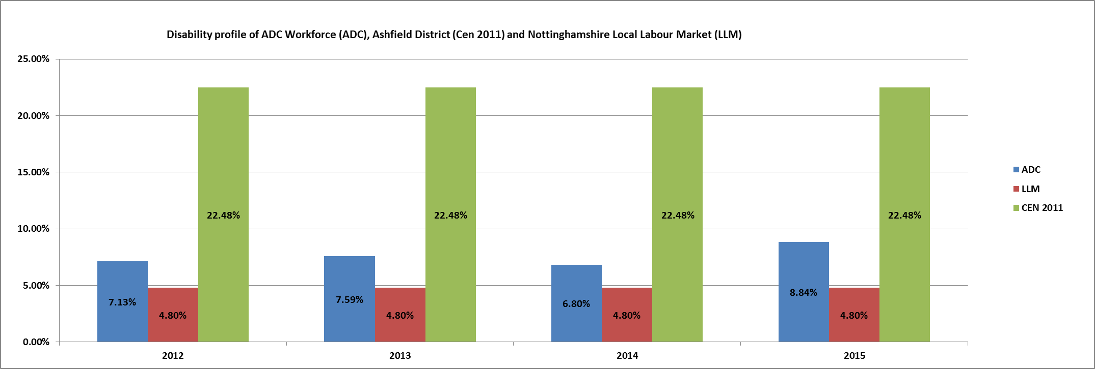

Year | ADC | LLM | CEN 2011
2012 | 7.13% | 4.80% | 22.48%
2013 | 7.59% | 4.80% | 22.48%
2014 | 6.80% | 4.80% | 22.48%
2015 | 8.84% | 4.80% | 22.48%
Return

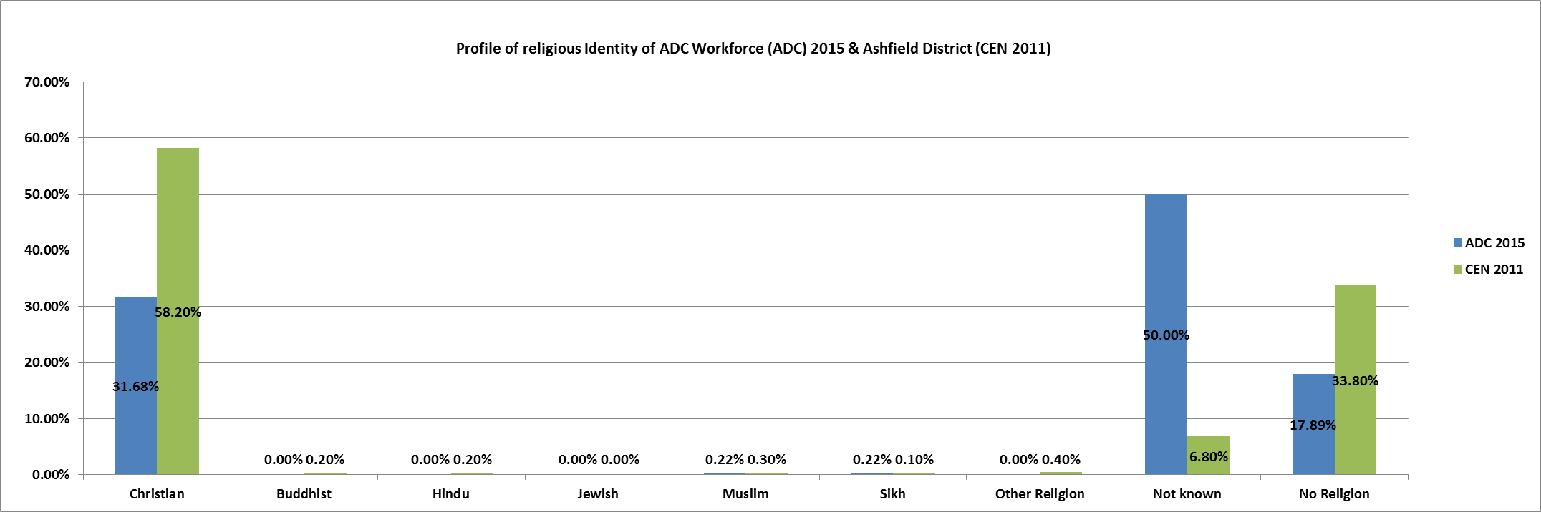

Religion | Christian | Buddhist | Hindu | Jewish | Muslim | Sikh | Other  Religion | Not known | No  Religion | Total
ADC 2015 | 31.68% | 0.00% | 0.00% | 0.00% | 0.22% | 0.22% | 0.00% | 50.00% | 17.89% | 100.00%
CEN 2011 | 58.20% | 0.20% | 0.20% | 0.00% | 0.30% | 0.10% | 0.40% | 6.80% | 33.80% | 100.00%
Return

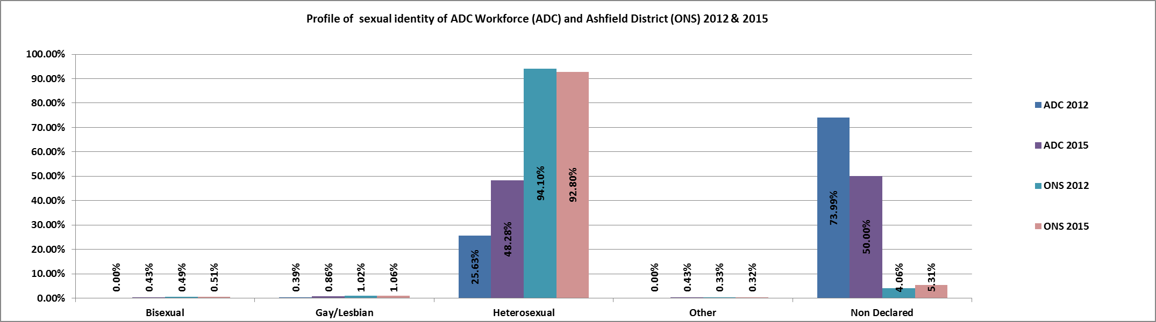

Year | Bisexual | Gay/Lesbian | Heterosexual | Other | Non Declared | Total
ADC 2012 | 0.00% | 0.39% | 25.63% | 0.00% | 73.99% | 100.00%
ADC 2015 | 0.43% | 0.86% | 48.28% | 0.43% | 50.00% | 100.00%
ONS 2012 | 0.49% | 1.02% | 94.10% | 0.33% | 4.06% | 100.00%
ONS 2015 | 0.51% | 1.06% | 92.80% | 0.32% | 5.31% | 100.00%
Return

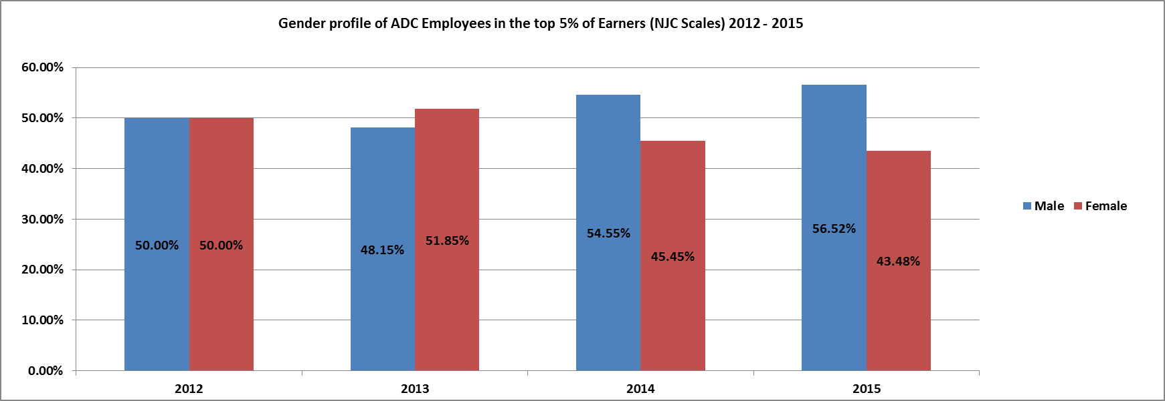

Year | Male | Female | Total %
2012 | 50.00% | 50.00% | 100.00%
2013 | 48.15% | 51.85% | 100.00%
2014 | 54.55% | 45.45% | 100.00%
2015 | 56.52% | 43.48% | 100.00%
Return

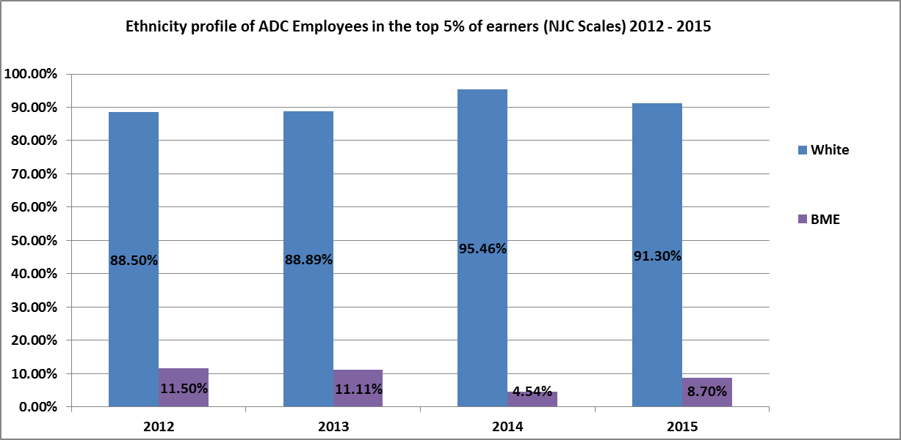

Year | White | BME | Total
2012 | 88.50% | 11.50% | 100.00%
2013 | 88.89% | 11.11% | 100.00%
2014 | 95.46% | 4.54% | 100.00%
2015 | 91.30% | 8.70% | 100.00%
Return

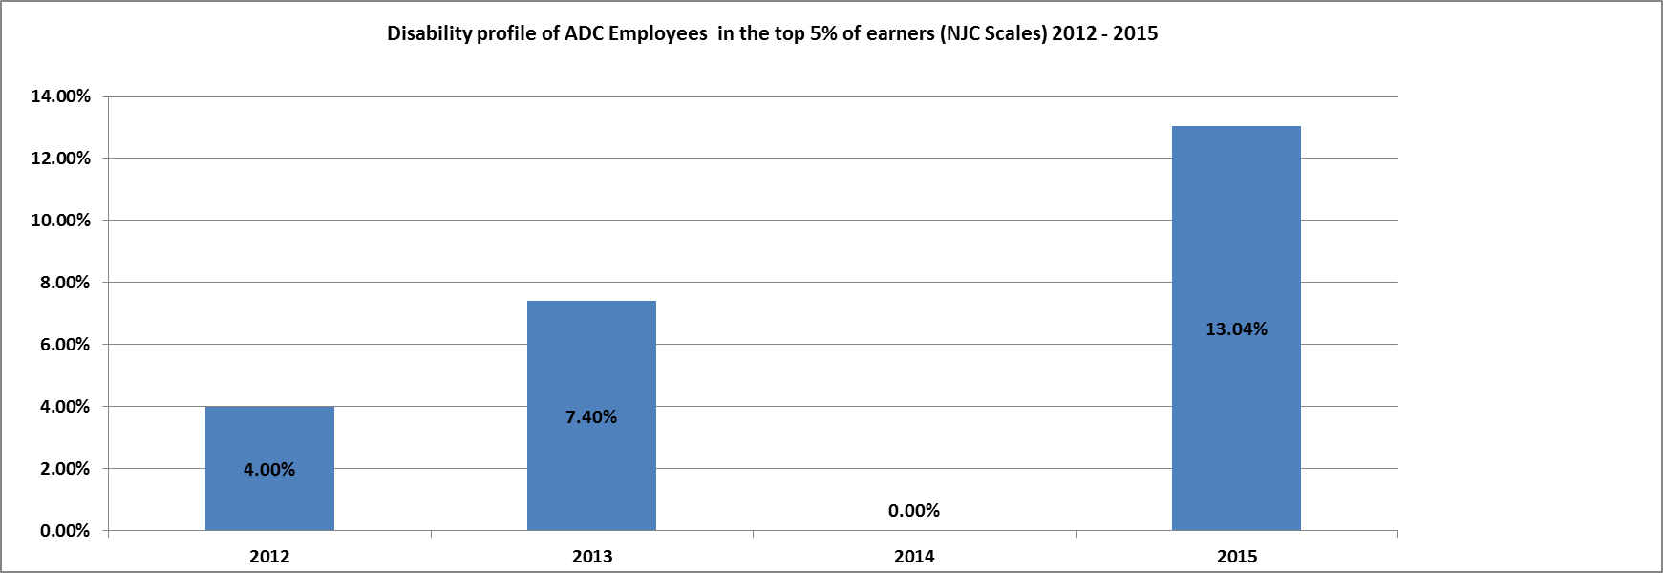

Year | Disabled
2012 | 4.00%
2013 | 7.40%
2014 | No information
2015 | 13.04%
Return

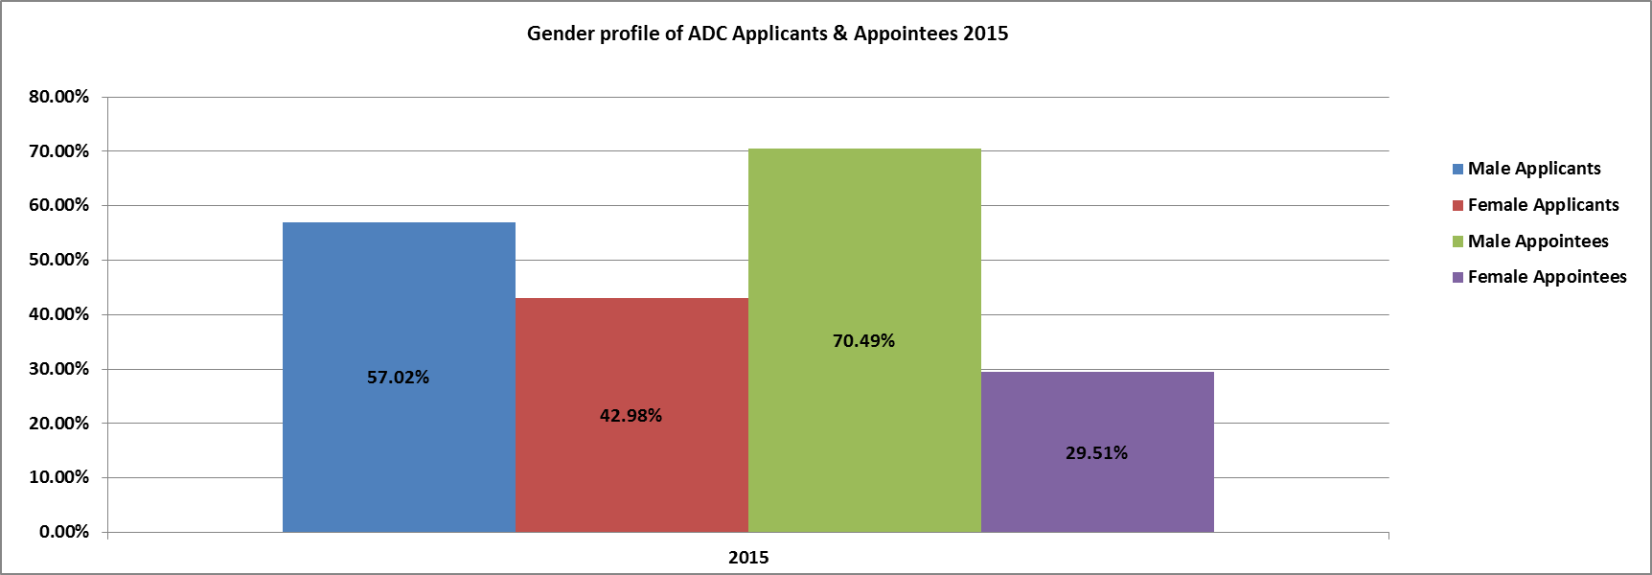

Year | Male Applicants | Female Applicants | Total % | Total #
2015 | 57.02% | 42.98% | 100.00% | 577
Year | Male Appointees | Female Appointees | Total % | Total #
2015 | 70.49% | 29.51% | 100.00% | 61
Return

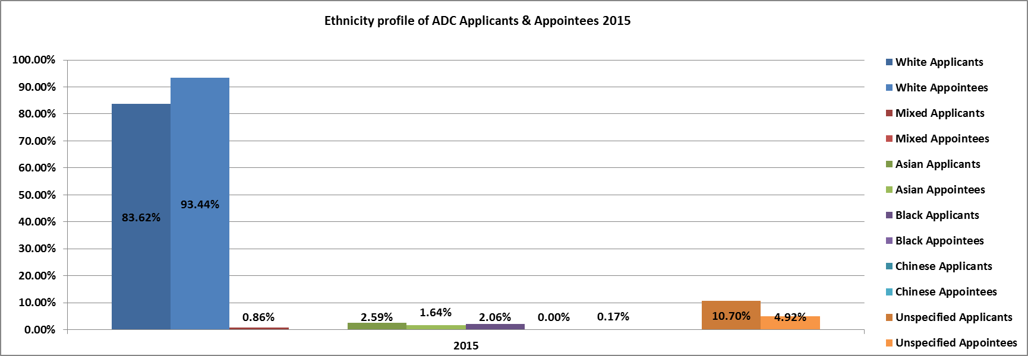

Year | White Applicants | Mixed Applicants | Asian Applicants | Black Applicants | Chinese Applicants | Unspecified Applicants | Total % | Total # Specified | Total # Unspecified | Total #
2015 | 83.62% | 0.86% | 2.59% | 2.06% | 0.17% | 10.70% | 100.00% | 514 | 63 | 577
Year | White Appointees | Mixed Appointees | Asian Appointees | Black Appointees | Chinese Appointees | Unspecified Appointees | Total % | Total # Specified | Total # Unspecified | Total #
2015 | 93.44% | 0.00% | 1.64% | 0.00% | 0.00% | 4.92% | 100.00% | 58 | 3 | 61
Return

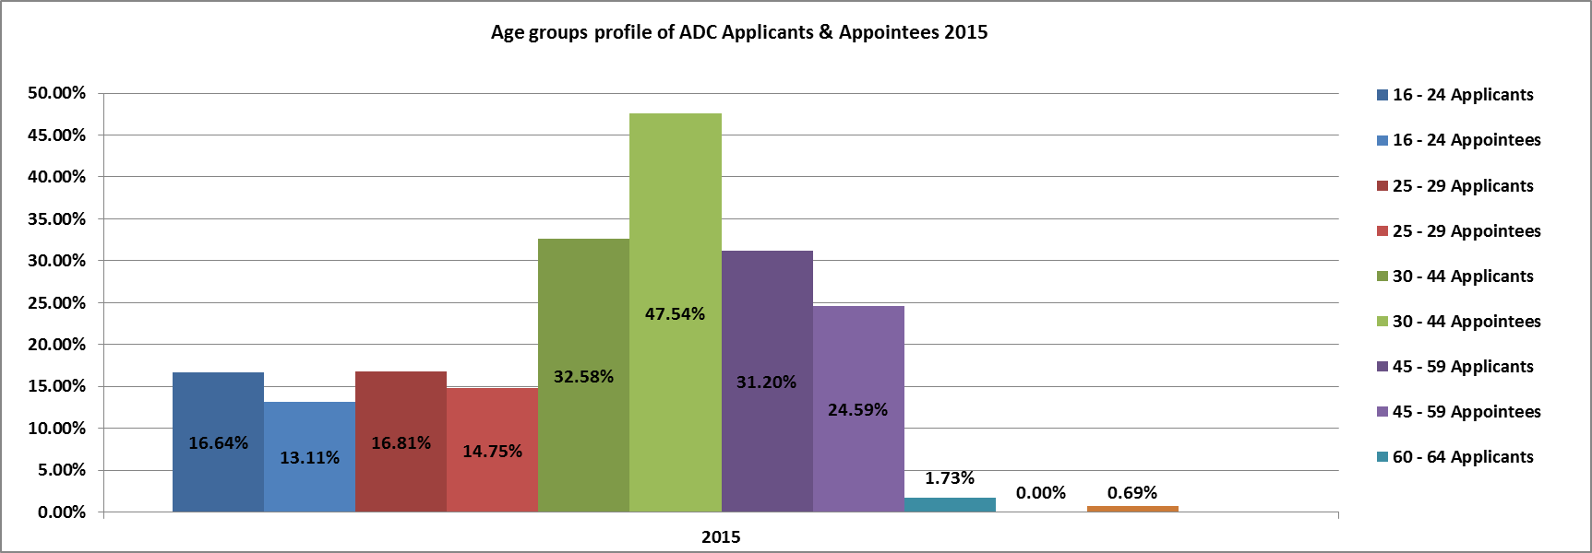

Year | 16 - 24  Applicants | 25 - 29  Applicants | 30 - 44  Applicants | 45 - 59  Applicants | 60 - 64  Applicants | 65+ Applicants | Unspecified Applicants
2015 | 16.64% | 16.81% | 32.58% | 31.20% | 1.73% | 0.35% | 0.69%
Year | 16 - 24  Appointees | 25 - 29  Appointees | 30 - 44  Appointees | 45 - 59  Appointees | 60 - 64  Appointees | 65+ Appointees | Unspecified Appointees
2015 | 13.11% | 14.75% | 47.54% | 24.59% | 0.00% | 0.00% | 0.00%
Return

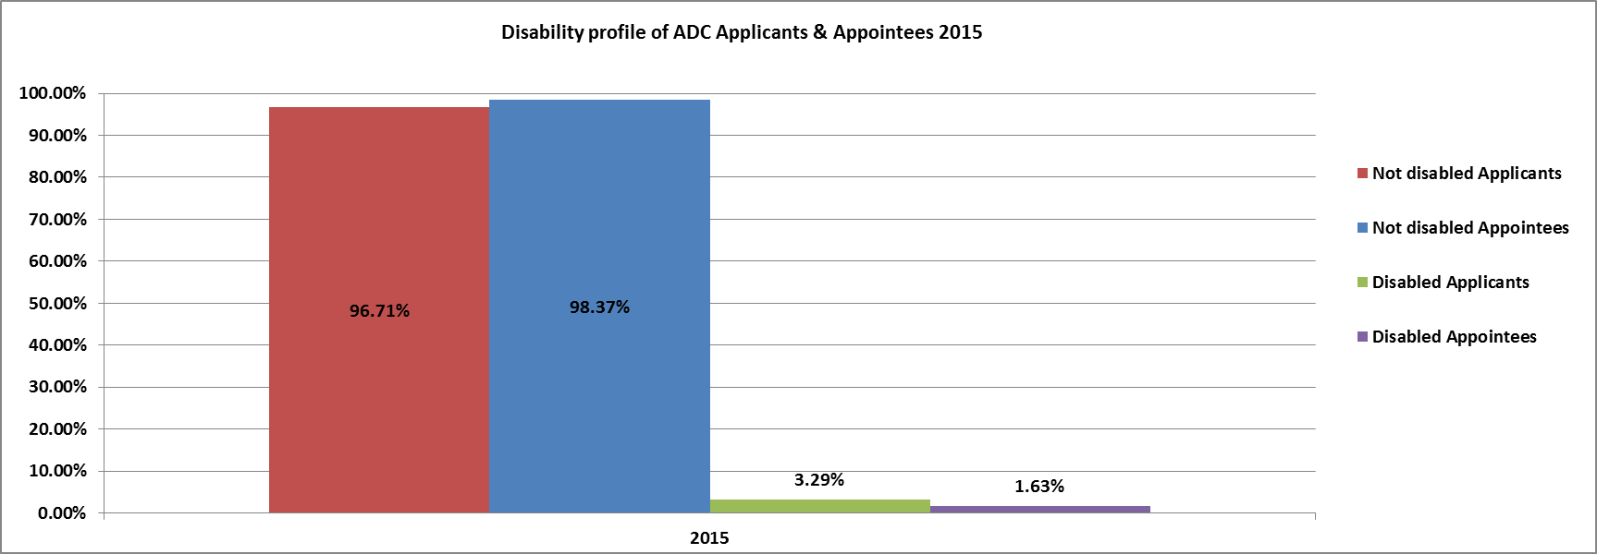

Year | Not disabled Applicants | Disabled Applicants | Total %
2015 | 96.71% | 3.29% | 100.00%
Year | Not disabled Appointees | Disabled Appointees | Total %
2015 | 98.37% | 1.63% | 100.00%
Return

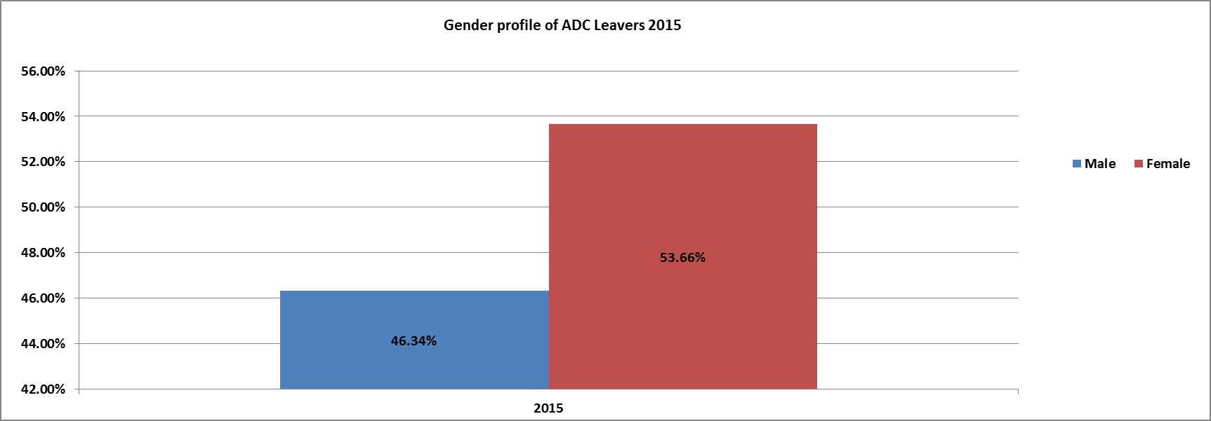

Year | Male | Female | Total % | Total #
2015 | 46.34% | 53.66% | 100.00% | 41
Return

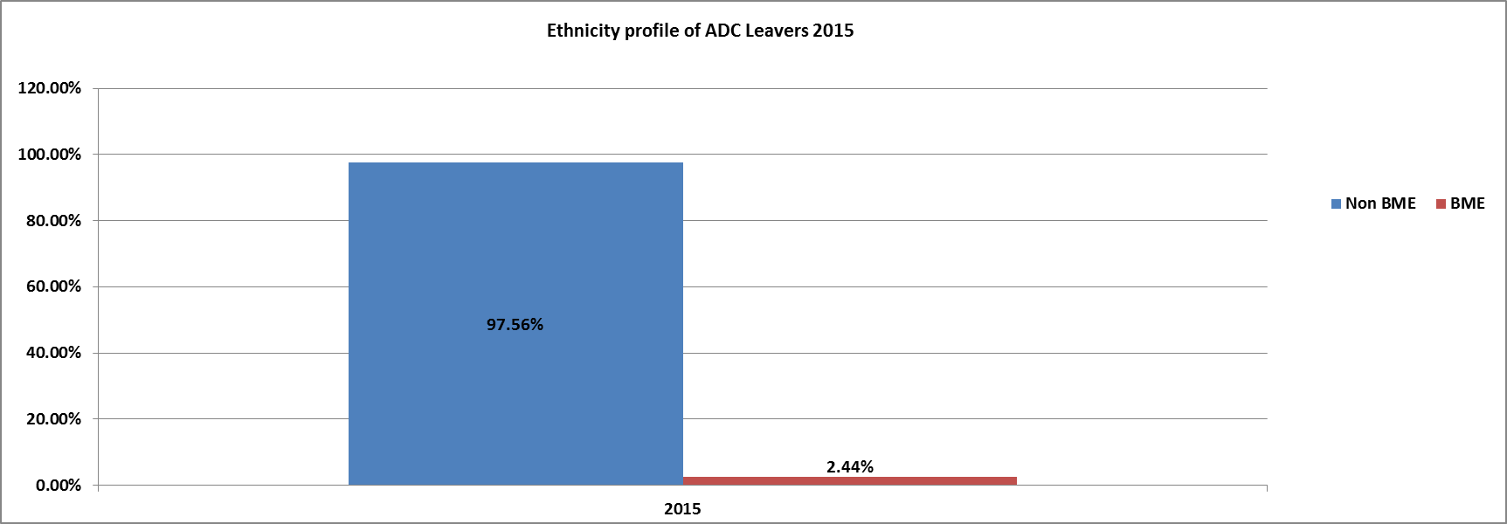

Year | Non BME | BME | Total % | Total #
2015 | 97.56% | 2.44% | 100.00% | 41
Return

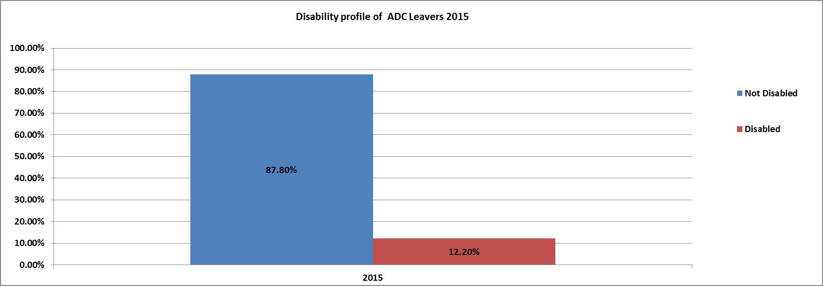

Year | Not Disabled | Disabled | Total % | Total #
2015 | 87.80% | 12.20% | 100.00% | 41
Return

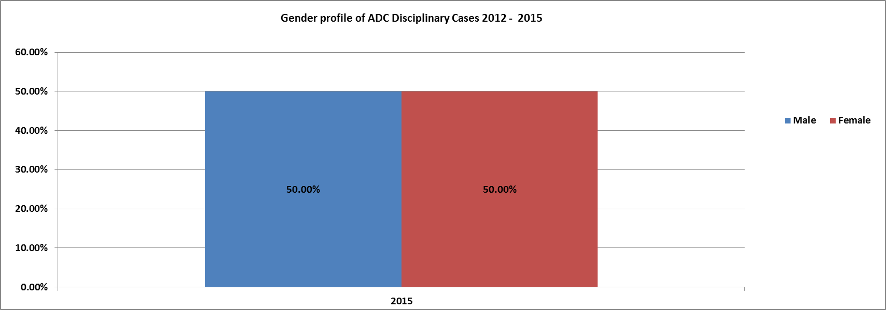

Year | Male | Female | Total %
2015 | 50.00% | 50.00% | 100.00%
Return

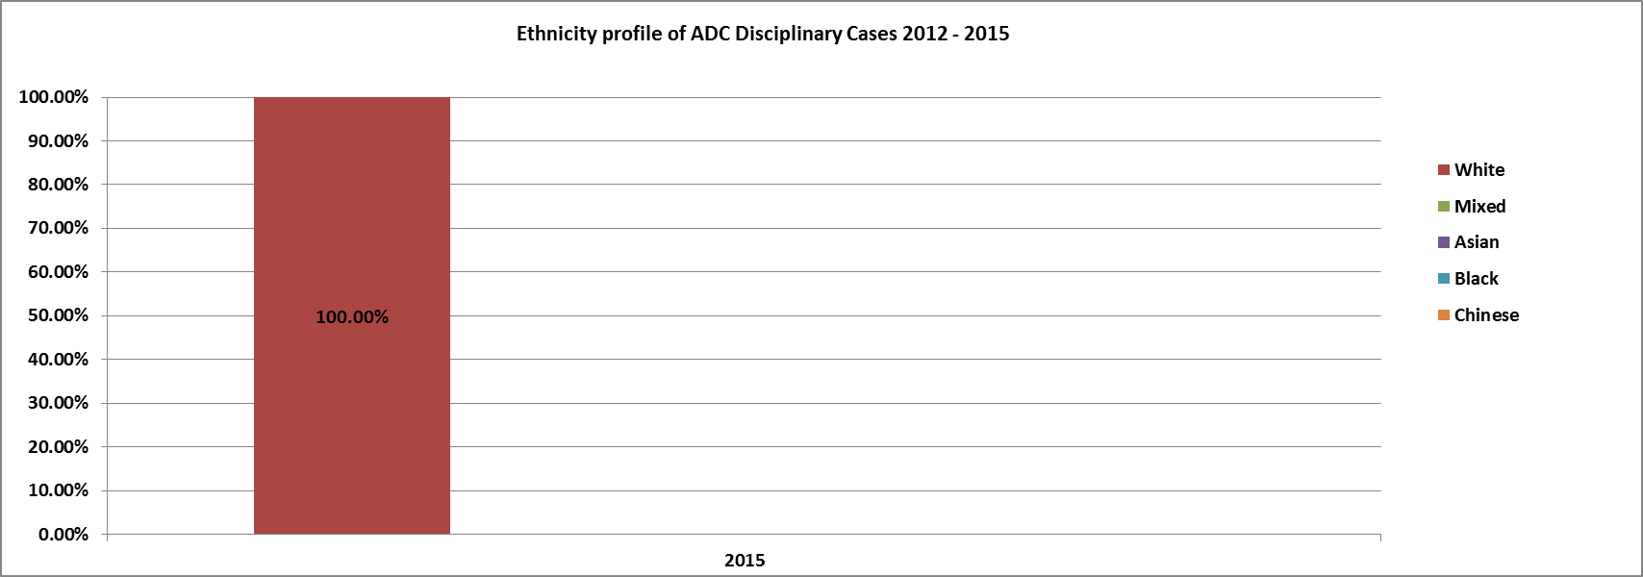

Year | White | Mixed | Asian | Black | Chinese | Total %
2015 | 100.00% | 0.00% | 0.00% | 0.00% | 0.00% | 100.00%
Return

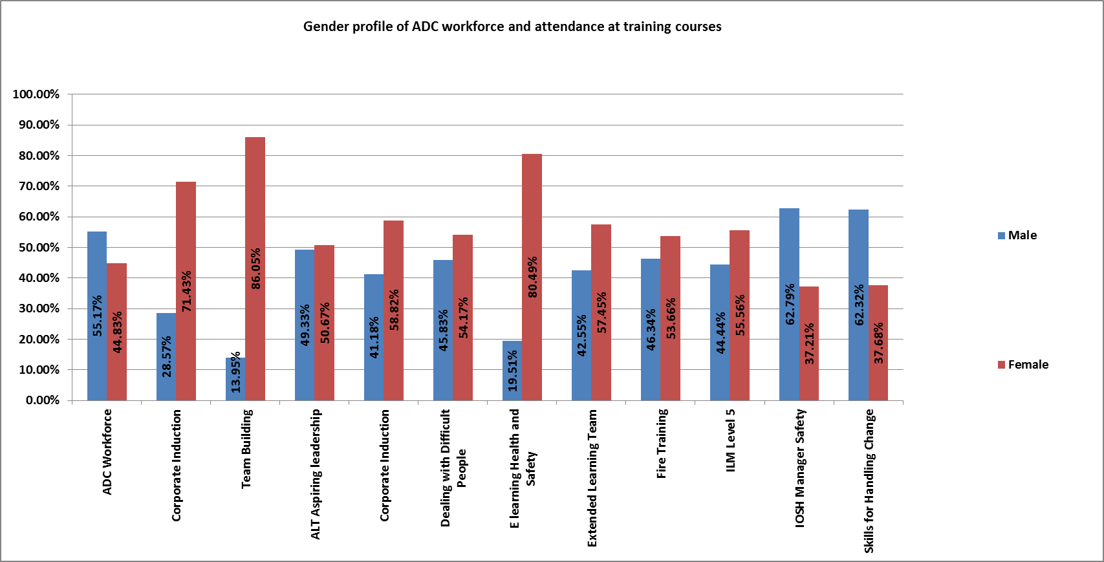

Gender | ADC  Workforce | Corporate Induction | Team Building | ALT  Aspiring leadership | Corporate Induction | Dealing with Difficult People | E  learning Health and  Safety | Extended Learning Team | Fire Training | ILM  Level 5 | IOSH  Manager Safety | Skills for Handling Change
Male | 55.17% | 28.57% | 13.95% | 49.33% | 41.18% | 45.83% | 19.51% | 42.55% | 46.34% | 44.44% | 62.79% | 62.32%
Female | 44.83% | 71.43% | 86.05% | 50.67% | 58.82% | 54.17% | 80.49% | 57.45% | 53.66% | 55.56% | 37.21% | 37.68%
Return

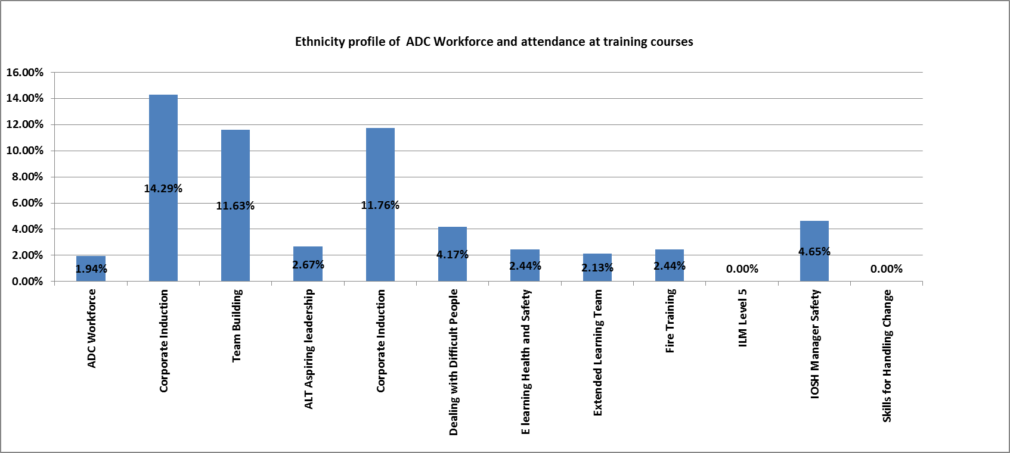

ADC  Workforce | Corporate Induction | Team Building | ALT Aspiring leadership | Corporate Induction | Dealing with Difficult People | E learning Health and Safety | Extended Learning Team | Fire Training | ILM  Level 5 | IOSH  Manager Safety | Skills for Handling Change
1.94% | 14.29% | 11.63% | 2.67% | 11.76% | 4.17% | 2.44% | 2.13% | 2.44% | 0.00% | 4.65% | 0.00%
Return

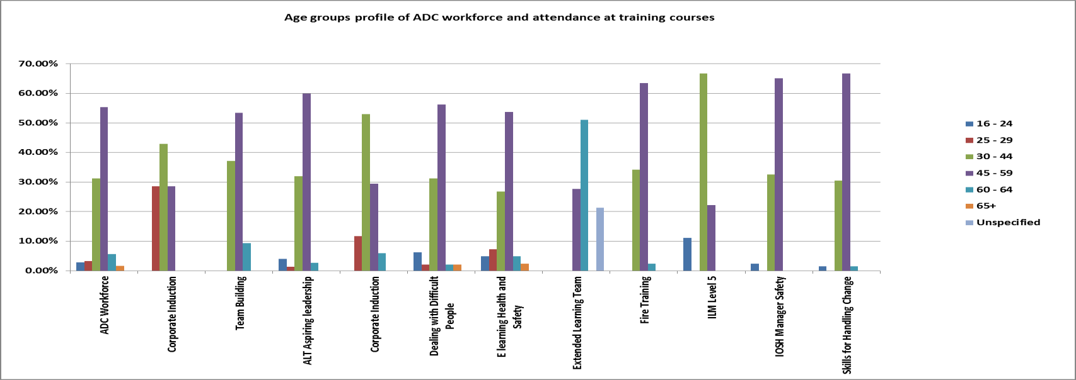

Course | 16 - 24 | 25 - 29 | 30 - 44 | 45 - 59 | 60 - 64 | 65+ | Unspecified
ADC Workforce | 2.80% | 3.23% | 31.25% | 55.39% | 5.60% | 1.72% | 0.00%
Corporate Induction | 0.00% | 28.57% | 42.86% | 28.57% | 0.00% | 0.00% | 0.00%
Team Building | 0.00% | 0.00% | 37.21% | 53.49% | 9.30% | 0.00% | 0.00%
ALT Aspiring leadership | 4.00% | 1.33% | 32.00% | 60.00% | 2.67% | 0.00% | 0.00%
Corporate Induction | 0.00% | 11.76% | 52.94% | 29.41% | 5.88% | 0.00% | 0.00%
Dealing with Difficult People | 6.25% | 2.08% | 31.25% | 56.25% | 2.08% | 2.08% | 0.00%
E learning Health and Safety | 4.88% | 7.32% | 26.83% | 53.66% | 4.88% | 2.44% | 0.00%
Extended Learning Team | 0.00% | 0.00% | 0.00% | 27.66% | 51.06% | 0.00% | 21.28%
Fire Training | 0.00% | 0.00% | 34.15% | 63.41% | 2.44% | 0.00% | 0.00%
ILM Level 5 | 11.11% | 0.00% | 66.67% | 22.22% | 0.00% | 0.00% | 0.00%
IOSH Manager Safety | 2.33% | 0.00% | 32.56% | 65.12% | 0.00% | 0.00% | 0.00%
Skills for Handling Change | 1.45% | 0.00% | 30.43% | 66.67% | 1.45% | 0.00% | 0.00%

Return

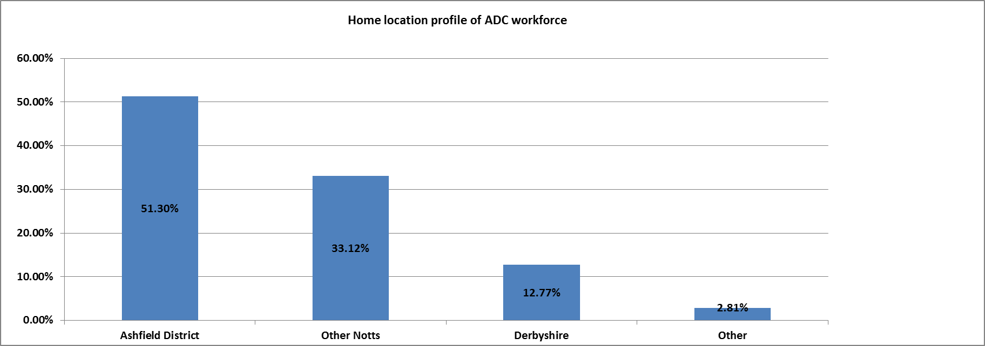

Area | % of Workforce
Ashfield District | 51.30%
Other Notts | 33.12%
Derbyshire | 12.77%
Other | 2.81%
Total | 100.00%
Return

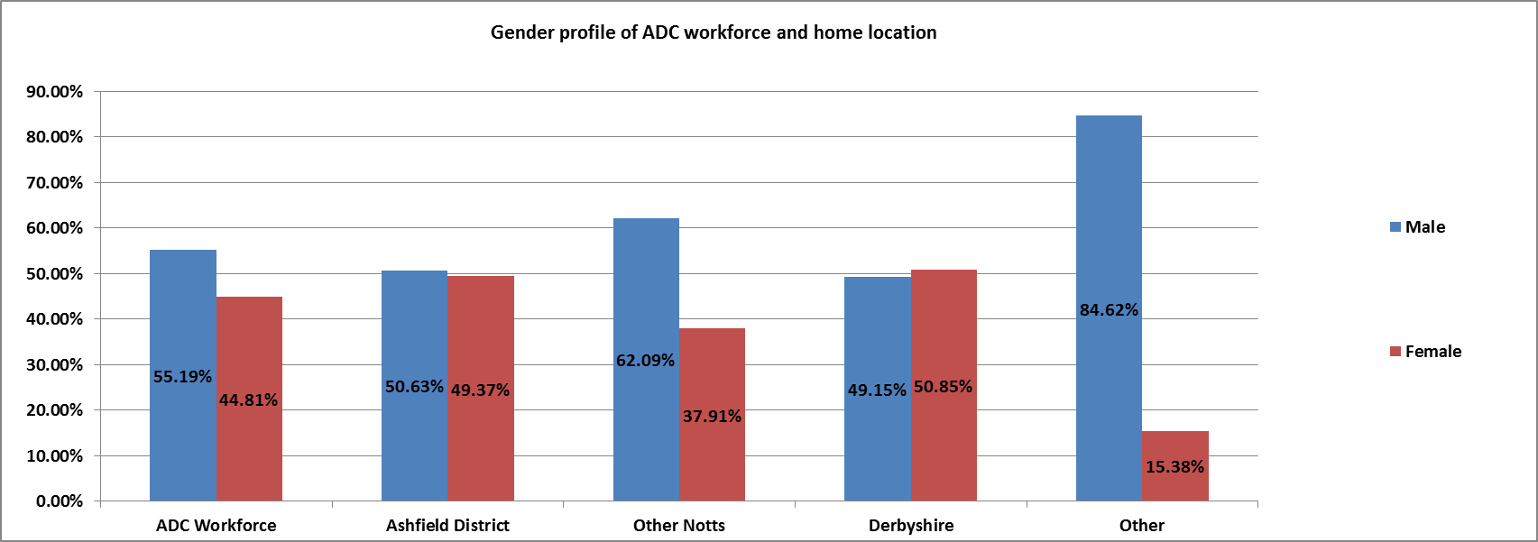

Area | Male | Female
ADC Workforce | 55.19% | 44.81%
Ashfield District | 50.63% | 49.37%
Other Notts | 62.09% | 37.91%
Derbyshire | 49.15% | 50.85%
Other | 84.62% | 15.38%
Return

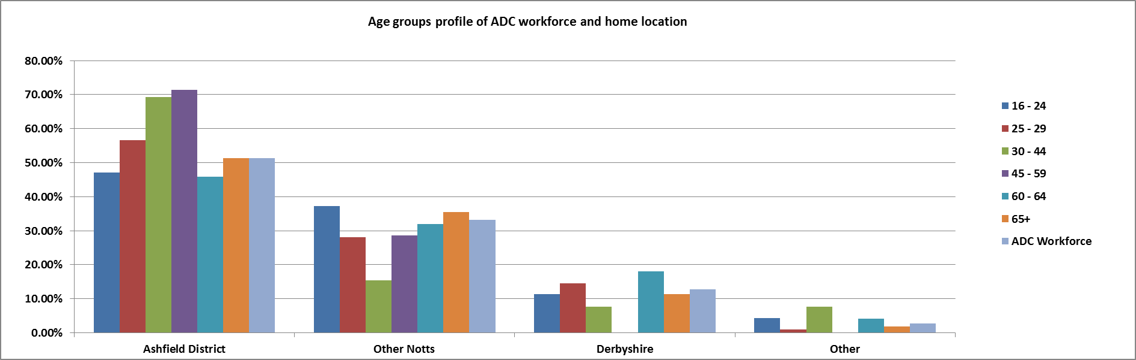

Area | 16 - 24 | 25 - 29 | 30 - 44 | 45 - 59 | 60 - 64 | 65+ | ADC Workforce
Ashfield District | 47.06% | 56.52% | 69.23% | 71.43% | 45.83% | 51.36% | 51.30%
Other Notts | 37.25% | 28.02% | 15.38% | 28.57% | 31.94% | 35.41% | 33.12%
Derbyshire | 11.37% | 14.49% | 7.69% | 0.00% | 18.06% | 11.28% | 12.77%
Other | 4.31% | 0.97% | 7.69% | 0.00% | 4.17% | 1.95% | 2.81%
Return

