

DISCLAIMER

This document or some parts of it may not be accessible when using adaptive technology.

If you require assistance with accessing the content of the document, please contact us and quote the document name and the web page you found it on:

- email: Regeneration – place@ashfield.gov.uk

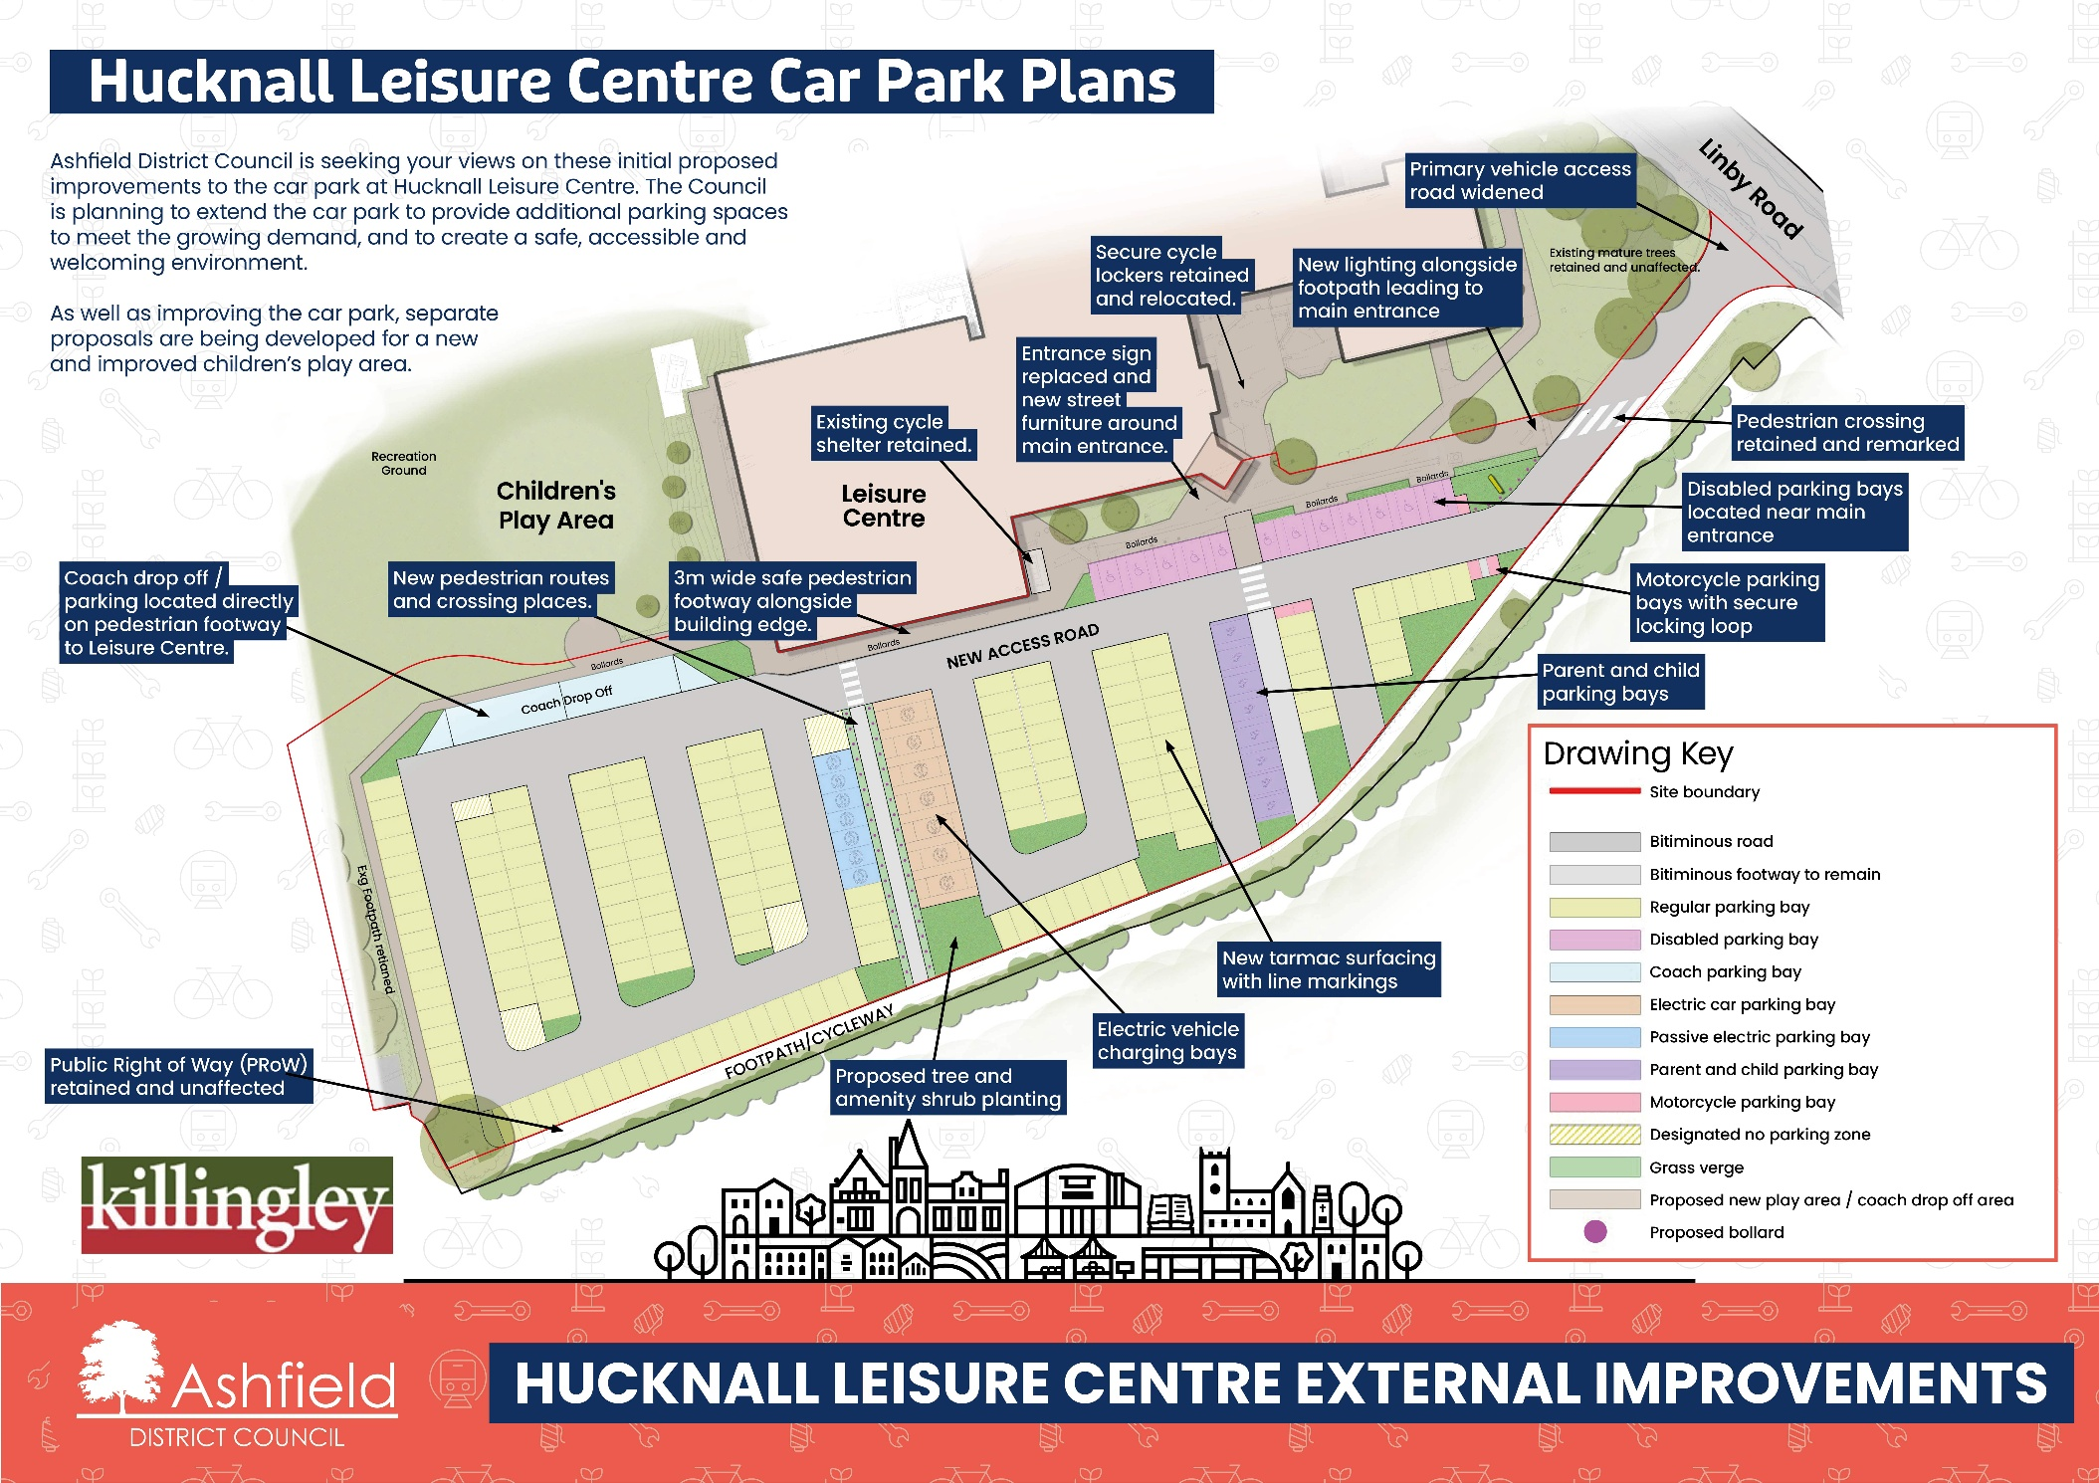
Hucknall Leisure Centre car park plans
Ashfield District Council is seeking your views on these initial proposed improvements to the car park at Hucknall Leisure Centre. The Council is planning to extend the car park to provide additional parking spaces to meet the growing demand, and to create a safe, accessible and welcoming environment.
The improvements include:
- New pedestrian routes and crossing places
- Removal of 7 streetlights and replaced with 21 LED streetlights
- 3m wide safe pedestrian footway alongside building edge
- Entrance sign replaced and new street furniture around main entrance
Bollards
Bollards
Sign
- Secure cycle lockers retained and relocated
- Motorcycle parking bays with secure locking hoop
- New lighting along footpath leading to main entrance
- Primary vehicle access of Linby Road widened
- Pedestrian crossing retained and remarked
- Disabled parking bays located near main entrance
- Parent & child parking bays.
- New tarmac surfacing with line markings
- Electric Vehicle Charging Bays
Bollards
- Proposed tree and amenity shrub planting
- Public Right of Way retained and unaffected
- Existing cycle shelter retained
- Coach drop off / parking located directly on pedestrian footway to Leisure Centre

The existing car park includes 128 standard bays (2.4 x 4.8m) and 9 Disabled bays, as well as 2 coach parking spots and 19 cycle parking spaces.
The new plans will include 172 large standard bays (2.5 x 5m), 12 Disabled bays, 2 coach parking spots, 19 cycle parking spaces and will introduce 8 parent and child bays, 7 electric vehicle charging bays, and 5 motorcycle/moped bays.

