

DISCLAIMER

This document or some parts of it may not be accessible when using adaptive technology.

If you require assistance with accessing the content of the document, please contact us and quote the document name and the web page you found it on:

- email: Regeneration – place@ashfield.gov.uk

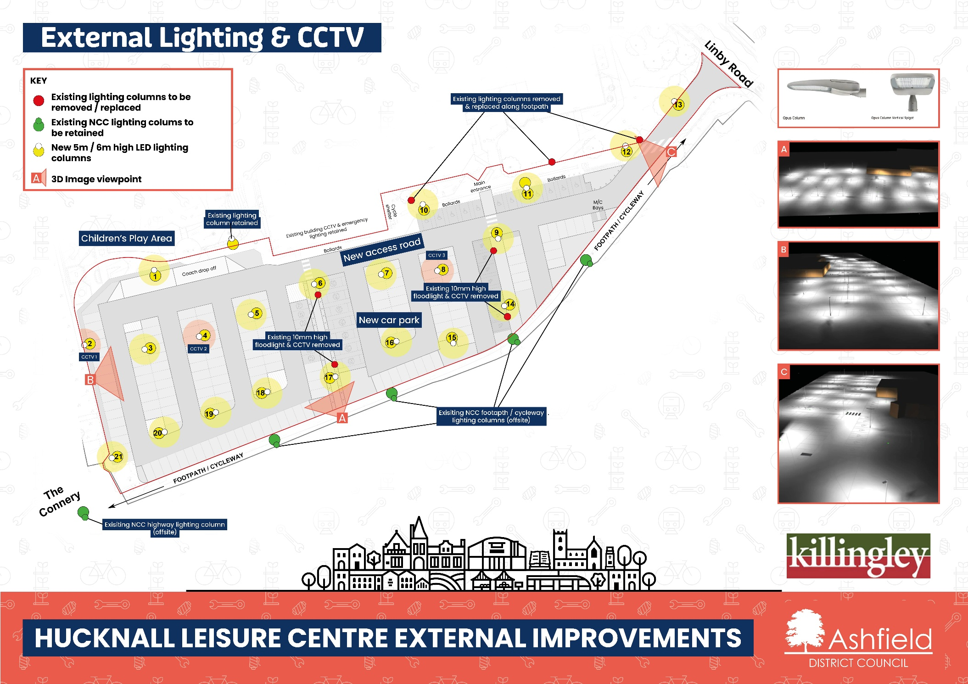

Hucknall Leisure Centre car park External Lighting and CCTV
The plan shows the external lighting and CCTV plan for the proposed car park. The are twenty-one new 5/6m high LED light columns. Five Nottingham County Council (NCC) existing lighting columns to be retained. Seven existing light columns to be removed and replaced. Existing CCTV will be removed and replaced with three new CCTV cameras.
The plans show:
- Children’s play area
- Existing light column retained
- Existing building CCTV & emergency lighting retained
- New car park
- New access road
- Coach drop off
- Linby Road
- Footpath/cycleway
- Existing 10m high floodlights & CCTV removed
- Existing NCC footpath / cycleway lighting columns (Off Site)
- Existing NCC Highway lighting column (Off Site)
- Crossing place
- Cycle Shelter
- Opus column
- Opus column Vertical Spigot
- Bollards
- Sign
- View A
- View B
- View C
- Main Entrance
- Existing Lighting Columns to be removed / replaced
- Existing NCC Lighting Columns to be retained
- New 5 / 6m high LED Lighting Columns
- 3D Image viewpoint

