

Tenant Engagement Strategy

2025 - 2027

CONTENTS PAGE NUMBER
Summary 2
Tenant profile information 3
Housing Stock 4
Vision and Objectives 5
Leaseholder Engagement 5
Training and Development 6
Tenant Involvement Mechanisms and Engagement Channels 6
Tenant Engagement Activities and Roles 6
Special Interest Groups 9
Monitoring and Evaluation 9
Evidence Base of Engagement Outcomes 10
What Does Success Look Like? 10
Regulatory Framework 11
Engagement Structure in Ashfield District 11

SUMMARY
Ashfield District Council’s Tenant Engagement Strategy aims to enhance communication and collaboration between tenants, leaseholders, and the local authority around the services we provide as their landlord. This strategy also ensures compliance with regulatory requirements while empowering tenants and leaseholders to participate in the decision-making process that affects their housing, to help ensure services are relevant to the needs of our tenants and leaseholders.
Ashfield District Council recognise that involving tenants and leaseholders is an essential part of our decision-making/continuous development process and we are committed to:
- ensuring opportunities for tenants and leaseholders to participate in the design and delivery of our Housing Services
- designing policies and processes that are transparent and fair
- promoting meaningful involvement in the district
- offering a range of opportunities for tenants and leaseholders to participate in the management of their housing service
- improvement of levels of customer satisfaction in the future.
Tenant Engagement is a priority area within council’s Ashfield Council Corporate Plan and aligns with our corporate values:
- People Focussed - Putting people at the heart of what we do.
- Honest - Being honest with people in an open and transparent way.
- Proud - Being proud that Ashfield is a positive place to work, live and visit.
- Ambitious - We are ambitious about Ashfield’s future.
This Tenant Engagement Strategy replaces our Tenant’s Charter and sets out how we will collaborate with tenants and leaseholders to ensure we meet our obligations set out in the Regulator of Social Housing’s Consumer Standards, which focus on the following key areas:
- Safety and Quality
- Tenancy Standard
- Neighbourhood and Community
- Transparency, Influence and Accountability
This strategy sets out how we aim to achieve our current statutory regulatory requirements in relation to tenant engagement/voice, including timescales for how we will achieve this.
Ashfield District Council priorities are based on knowledge and understanding of the needs of people living in Ashfield.
The full corporate plan 2023 to 2027 is on our website:
Corporate plan
Ashfield District Council plans to achieve its Homes and Housing target in key areas of:
- Housing Development
- Tackling Disrepair and poor housing conditions
- Suitable and appropriate Housing
- Reduce and prevent homelessness.
- Compliance with Social Housing (Regulation) Act 2023
- Customer Focus
And Innovate and Improve in key ambitions of:
- Positive and proactive communications
- Customer Experience
- Customer Focus
- Digital and Service Transformation
- Financial Sustainability
- People and Partnerships
- Performance, Data and Change Management

TENANT PROFILE INFORMATION
Ashfield is one of seven district borough councils within Nottinghamshire and is ranked:
- 68th most deprived out of 317 lower tier authorities in the country.
- Seventy-three out of 317 districts on income deprivation.
Large parts of Sutton, Kirkby and Hucknall are ranked in the top 20% of the most deprived wards in the country.
The median gross weekly wage for Ashfield is far lower than England average and lower than Nottinghamshire average.
We regularly review, update and analyse the data we hold on the profile of our tenants, and use the information to align service delivery based on tenant need.

HOUSING STOCK INFORMATION
Ashfield council owns and manages a stock of social housing properties throughout the district, let to applicants on the housing waiting list based on housing need. The housing stock breakdown as of January 2025 is:
Area | Number of properties | % of stock
Hucknall | 1629 | 25.0%
Kirkby in Ashfield | 1593 | 24%
Sutton in Ashfield | 2905 | 44.0%
Rurals | 483 | 7.0%
Total | 6610 | 100%
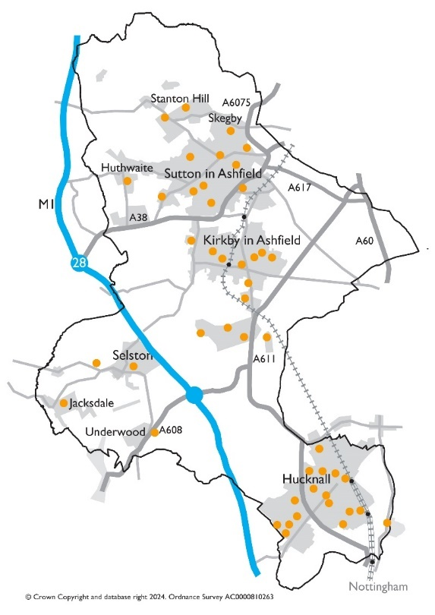

VISIONS AND OBJECTIVES
To create an inclusive, responsive, and transparent relationship between the Council and tenants by:
- providing a wide range of opportunities for tenants to be central to decision making, future plans, and play a critical role in helping us to achieve excellent housing services.
- ensuring that housing services are delivered in a transparent way and tenants have access to sufficient information/data to hold us to account.
- actively promoting opportunities for tenants to be involved and ensuring all tenants can participate at a level that suits them.
- effectively using tenant feedback to improve service delivery to meet customer needs.
- ensuring housing services are continually monitored for the benefit of all tenants.
- meeting all statutory and regulatory requirements.
- removing barriers that tenants may experience in participating with engagement opportunities.
- increasing the number of tenants involved and promoting tenant led activities across the district.
Our Housing Board, Tenant Gateway, Scrutiny Panel and other involved tenant groups track, challenge and monitor outcomes.

Leaseholder Engagement
Ashfield District Council has approximately 200 Leaseholders across the district. Leaseholders are welcome to be involved in any of the Engagement activities offered by the council relevant to their tenure. In addition, we commit to:
- Starting conversations about significant change before decisions finalised to ensure maximising any leaseholder influence.
- Use a variety of methods to communicate by asking leaseholders what methods they prefer, including face-to-face, phone, and online forums.
- Building relationships and community knowledge.
- Respond to leaseholders’ views and concerns.
- Send any information well in advance of any changes that affect leaseholders.

Training and development
We will provide training and development opportunities for involved tenants including:
- access to TPAS conferences, training, webinars, and resources
- Housing Ombudsman training and information
- bespoke training and development
- dedicated officer support/point of contact

Tenant Involvement Mechanisms
To support and encourage tenant participation there are a range of resources and mechanisms to engage which tenant groups and individuals can access including:
- a wide range of involvement methods to suit all lifestyles to ensure that individuals and groups have equal opportunity to engage with us
- Arranging meeting times and locations most accessible to tenants
- Training for tenants who are committed to engagement
- Dedicated staff resource and time

Engagement Channels
- Face-to-Face Meetings: at community centres/communal rooms and council offices.
- Online Webinars and Virtual Meetings.
- Hybrid meetings incorporating in person and digital sessions.
- Newsletters and Social Media.
- COIN (Customer Opinion and Influencing Network) – Link https://www.ashfield.gov.uk/housing/tenant-involvement/

Tenant Engagement Activities and Roles
Group name | Activities and responsibility
Housing Board Quarterly | Up to four tenant representatives from existing involved tenant groups  - to highlight barriers, challenges and to shape future tenant engagement.  - Along with tenants, the Housing Board group includes Executive Director, Assistant Directors, and Elected Members to highlight barriers, challenges and to shape future tenant engagement.
Tenant Gateway Panel | Up to sixteen tenants meet in person every two months to:  - review performance and offer feedback on proposed changes to policies, repairs, or improvements.  - review housing policy, procedural change, housing performance, annual report, and tenant satisfaction feedback  - track recommendations and outcomes from engagement activities to support achieving requirements of regulatory requirements.  - publish annual report detailing tenant engagement activities, outcomes, and progress against objectives.  - monitor results of Tenant Satisfaction Measures feedback  - Sign off, monitor, and track completion of the engagement plan
Tenant Scrutiny Group | Up to nine trained tenants meets online and in person to:  - review housing services performance against processes and procedures.  - scrutinise housing processes across all directorates  - Scrutiny topics are agreed in collaboration between tenants and business areas
Customer Opinion and Influencing Network (COIN) | - Network of tenants who share their views on the services received from the Council as their landlord.  - Members can provide feedback at any time, and as frequently as they wish via a range of methods including phone, in person or online consultations
Tenant satisfaction Surveys and Consultation | - Tenant Satisfaction Measures (TSMs)  - Satisfaction Surveys on repairs, maintenance, Anti-Social behaviour and complaints  - Bespoke surveys and consultation
Engaged Tenant forum | - Quarterly online forum (with facility to be in person for those without access to online facilities)  - Open to any involved tenant that has been involved in the previous 12 months  - Topics to be agreed with tenants.
Special interest groups | - Task and finish focus groups on key areas led by tenant priorities and the regulatory requirements  - Specific consultations with tenants who have lived experience of the particular business area  - See section below for overarching topics
Tenants and Residents Groups / Community Associations | - Community groups acting in the interest of tenants and residents, in particular areas in the district.  - Tenant led to discuss any issues that affect people living in their area and invite relevant organisations to help address their concerns which are not restricted to housing matters and many groups will also arrange social events for their residents.  - The Council may provide funding and support to Tenants and Residents Associations, subject to their constitution and the make-up of their membership.  - The frequency and duration are set by the group, meetings are normally held in person in the locality of the area the group represents.
Online | - Tenant Portal, tenant magazines and newsletters
Housing Surgeries | - In person visits by Housing Officers to meet with tenants at sheltered schemes
Annual Estate Inspections | - In person visits by Housing Officers to check neighbourhoods and estates for any issues across the district  - All tenants are welcome to attend these inspections
Local Tenant Champions | - Points of contact and advocates for communities

Special interest groups | Bespoke groups and consultations on different special interest areas identified by tenants including the topics below. Method of engagement agreed with tenants
Safety and quality | - Stock quality  - Decent Homes Standard  - Health and safety  - Repairs, Maintenance and Planned works  - Adaptations  - Damp and Mould
Tenancy standard | - New build properties  - Allocations and Lettings  - Tenancy Sustainment and Evictions  - Tenancy Management  - Mutual Exchange
Neighbourhood and Community Standard | - Safety of Shared Spaces  - Local Cooperation  - Anti-Social Behaviour and Hate Incidents  - Domestic Abuse Procedures, Guidelines and Support available  - Local neighbourhood and Community plans
Transparency, Influence and Accountability Standard | - Fairness and Respect  - Provision of feedback of day-to-day services and complaints  - Scrutiny of Service Delivery  - Demographic information and fair access to services  - Communication

Monitoring and Evaluation
The tenant engagement strategy is a working document subject to continuous review to ensure it is meeting objectives and achieving targets.
We have a separate 3-year action plan produced with involved tenants which details how we will achieve this strategy.
This strategy and action plan are monitored and evaluated six monthly by officers, members and tenants.
Progress on the action plan and outcomes from engagement activities will be available annually and reported to Tenant’s Gateway

Evidence base of Engagement Outcomes
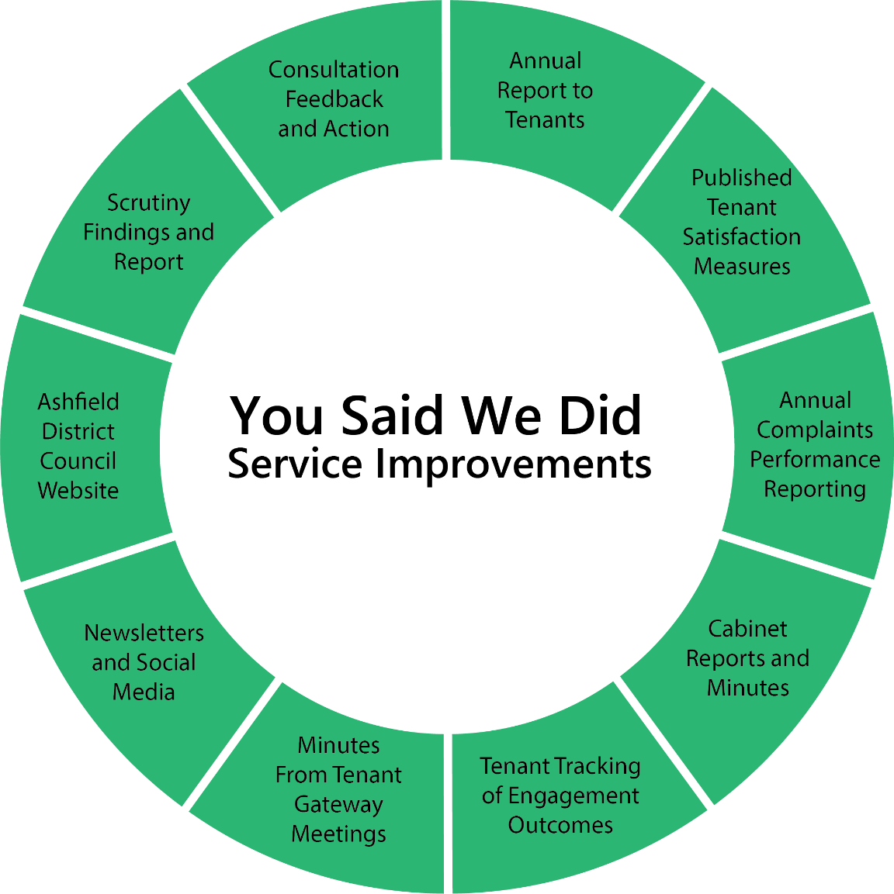

What does success look like?
- Engagement Activities held in line with Engagement plan.
- Increasing numbers of engaged tenants
- Evidence of service improvements from tenant engagement activities
- Improved or consistent TSM scores –TP01 and TP06- Proportion of respondents who report that they are satisfied with the overall service from their landlord.

Regulatory Framework
This strategy complies with:
- Consumer Standards Regulatory Framework: Regulatory Standards for Landlords
- Housing Ombudsman Guidance: Housing Ombudsman Complaint Handling Code
- Local Government and Social Care Ombudsman Guidance: Guidance on Complaint Handling and Good Administrative Practice
- The Building Safety Act 2022 (Although there are no tall buildings in the district there are twelve sheltered courts for over 55’s, and some lower-level blocks to review in terms of on general block safety, fire safety, personal evacuation plans and what to do in an emergency.
- TPAS guidance and Tpas Engagement Standards 2024
- Three-year Action Plan (see separate document on our website for details)

Engagement Structure in Ashfield District
