Feeding Ashfield

Action Plan

2026 - 2035

Be Healthy Be Happy
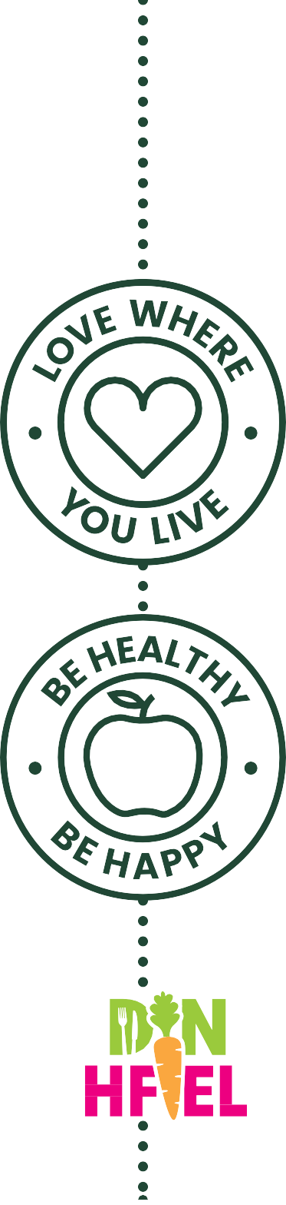

Map of Ashfield

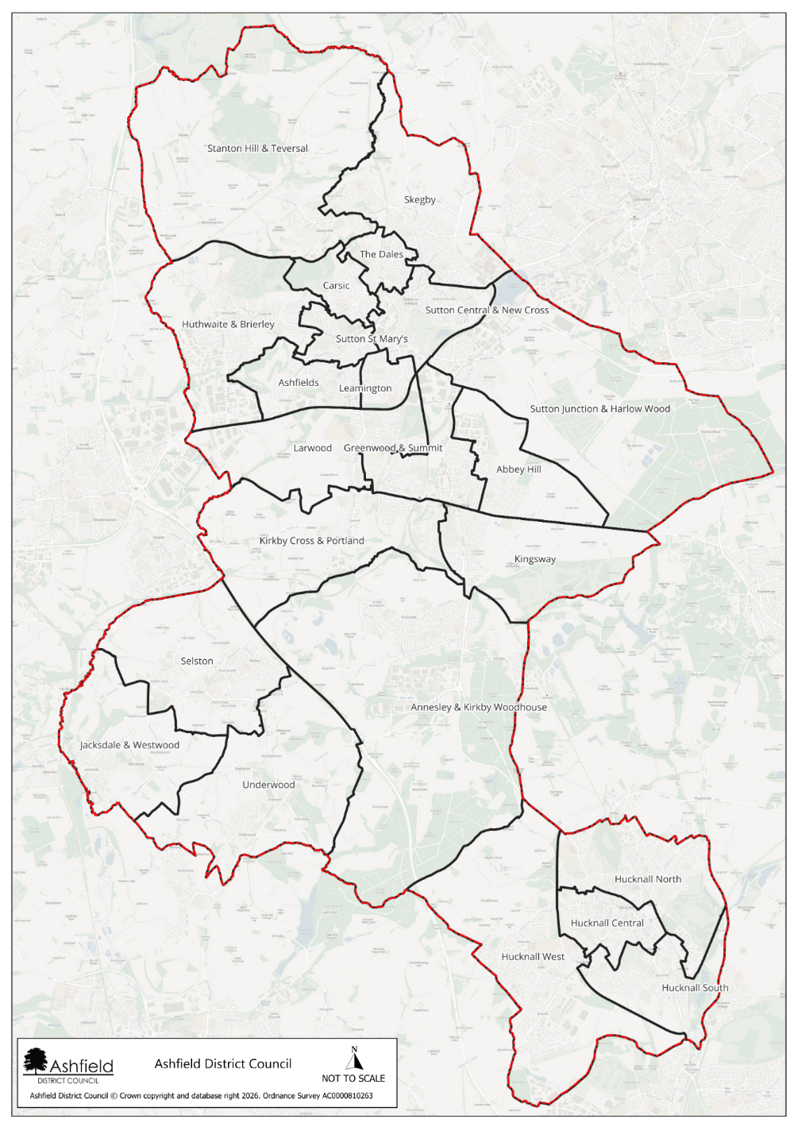

Introduction and background
Ashfield is a district within the county of Nottinghamshire. Ashfield is home to just under 130,000 residents, with a population that has grown steadily since 2011. The district has a relatively balanced age structure, though it is ageing, with one in five residents now over 65. Levels of disability are significant, affecting more than 27,000 people, including nearly one in five children. Many households’ face vulnerability, reflected in high proportions of single-person households, lone parent families, and a large share of homes in Council Tax Band A. Digital exclusion is above the national average, and access to green space is limited for most households.
Children and young people in Ashfield experience some of the most notable inequalities. Over 40% live in income deprived families, childhood obesity rates exceed national levels, and participation in higher education is considerably lower than the England average, with nearly a quarter of adults having no qualifications. Older people also experience notable health challenges, with high numbers of lone pensioner households and continued demand for support to age well. The district also faces higher than average fuel poverty and ranks as a high-risk area for food insecurity due to pressures such as low incomes, limited retail diversity, and rising living costs. Together, these factors create a community with pronounced economic challenges and health inequalities, shaping clear priorities for targeted support and investment.
Despite these challenges, Ashfield is a resilient community with a strong sense of identity and clear opportunities for improvement. While some communities experience greater pressures, there is significant potential for targeted investment to deliver meaningful change—particularly in strengthening health, financial security, and opportunities for residents. Many people in Ashfield demonstrate remarkable adaptability and tenacity, and with the right support, the district is well positioned to build on its existing strengths to improve quality of life and reduce inequalities.
Food insecurity presents a powerful opportunity to strengthen community wellbeing in Ashfield by expanding access to affordable, nutritious food and building on the district’s strong networks of support. By enhancing local food partnerships, increasing community growing initiatives, and improving access to healthy options, Ashfield can turn this challenge into a catalyst for stronger resilience, improved health, and greater community connection.

Map showing locations of food provision across Ashfield 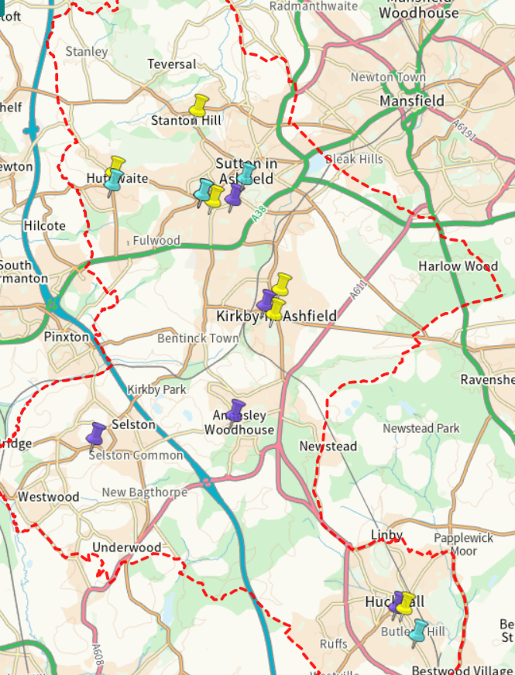

Data and Insight

Population

Area | Total population | 0 – 14 years | 15 – 64 years | 65 or over years | Female | Male
Ashfield | 129,572 | 18.5% | 61.5% | 20.1% | 51.1% | 48.9%
Nottinghamshire | 857,013 | 18.0% | 61.0% | 22.0% | 51.0% | 49.0%

Health

Area | Self reported poor health | Children overweight or obese (Reception) | Children overweight or obese (Year 6)
Ashfield | 7.1% | 25.6% | 40.4%
Nottinghamshire | 5.8% | 25.5% | 37.4%

Economy
Area | Provide 50 hours of unpaid care per week | Economically inactive | Out of work Benefits claimant count | Universal credit claimants  16 to 65 years old | People in Universal Credit  3 years plus | No qualifications  16 years plus | Children under 16 in families with absolute low income
Ashfield | 3.8% | 41.6% | 4.0% | 22.8% | 9.9% | 23.6% | 24.5%
Nottinghamshire | 3.1% | 22.0% | 3.0% | 18.3% | 7.9% | 19.4% | 18.8%

Housing

Area | Council rented | Owned outright | Household in fuel poverty | No cars or vans within household
Ashfield | 14.90% | 35.7% | 12.3% | 20.6%
Nottinghamshire | 8.4% | 38.2% | 11.4% | 23.4%

Ashfield has similar population demographics to Nottinghamshire as a whole, with higher levels of self-reported poor health and children overweight or obese in year 6 reported in Ashfield. There is a significantly higher percentage of economically inactive individuals within Ashfield, with 24.5% of children under 16 in families with absolute low income compared to 18.8% reported within Nottinghamshire. Fewer homes are owned outright in Ashfield than Nottinghamshire, however a higher percentage have access to cars and vans within Ashfield than within Nottinghamshire as a whole.
Within The Broken Plate Report 2025, The Food Foundation reported that, to be able to afford the government recommended healthy diet, the most deprived fifth of the country’s population would need to spend 45% of their disposable. This number rises to 70% for households with children.

Disease prevalence
Data table: Disease - percentage prevalence within the population area
Area | Severe Multiple Disadvantage | Diabetes Type 1 | Diabetes  Type 2 | Stroke | Coronary Heart Disease | Heart Failure | Hypertension | Chronic Obstructive Pulmonary Disease | Cancer | Serious Mental Illness | Substance Misuse
Ashfield | 0.6% | 0.7% | 6.9% | 1.5% | 3.6% | 1.6% | 17.4% | 2.7% | 5.1% | 0.7% | 2.2%
Nottinghamshire (including Nottingham City) | 0.7% | 0.6% | 5.9% | 1.4% | 3.0% | 1.2% | 15.6% | 2.2% | 4.5% | 0.7% | 1.9%
Disease prevalence within Ashfield is similar to that within Nottinghamshire with a notably higher prevalence of Type 2 Diabetes and Hypertension within Ashfield.

Foodbanks spend a lot of money at supermarkets to top up food parcels.
Many residents that would benefit from support do not access the food provision available. This is often due to not believing they qualify to access the support or because of the stigma associated with attending a foodbank.
There is a good understanding between the organisations offering food provision and those offering wider wraparound support regarding who can offer what service, when and how to access it.
There are not many opportunities for residents to learn how to cook. This sometimes limits what people are happy to take from foodbanks and clubs.
People are often pleasantly surprised by what is included in food parcels.
All sorts of people access food support within Ashfield. This is not limited to certain demographics.
School staff are reporting lower number of families claiming Free School Meals compared to the amount that qualify for them.
Relying on public transport can be a barrier to accessing food provision.

Key messages from partners and residents

In school, lunch is often the only hot meal many students eat that day.

Culturally appropriate foods can be hard to access through food provision.

The Feeding Ashfield Network
The Feeding Ashfield Network was established in 2021. The Partnership forms part of a network set up in Ashfield to deliver the vision of:
‘Healthy, happy lives for all who live in Ashfield’
The partnership is made up of a wide range of organisations, including but not limited to foodbanks, food clubs, health and educational providers, who work together to achieve this vision, aligned to a set of core values, that underpin a collaborative, action and person centre-focussed approach. The Feeding Ashfield Network also forms part of the wider Nottinghamshire Sustainable Food and Feeding Britain Networks.
The partnership has achieved several key successes since its inception.

Successes to date

Growth of the Network
The Feeding Ashfield Network continues to grow, taking a holistic approach to tackle food insecurities and other related issues by providing improved access to food and educational opportunities. Network meetings are well attended with members collaborating to support residents and each other as well as to share insights and resources. The work of the Feeding Ashfield Network is also regularly fed into wider food systems, including as the Nottinghamshire Sustainable Food Network which achieved the Bronze Award for Sustainable Food Places 2024 and Feeding Britain who a representative from the Feeding Ashfield Network joined at their Summer 2024 parliamentary reception at the House of Lords.
The Feeding Ashfield Network have also created a webpage for professionals and residents to use as a tool to find information regarding food provision and regular updates, training and funding opportunities are shared with community partners through an online newsletter.

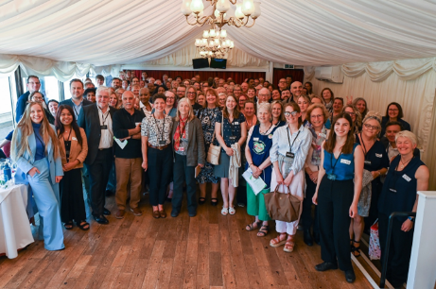
Feeding Britain parliamentary reception
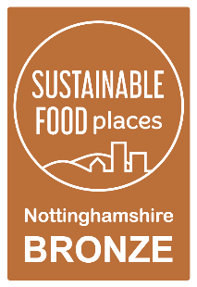
Bronze Sustainable Food Place award
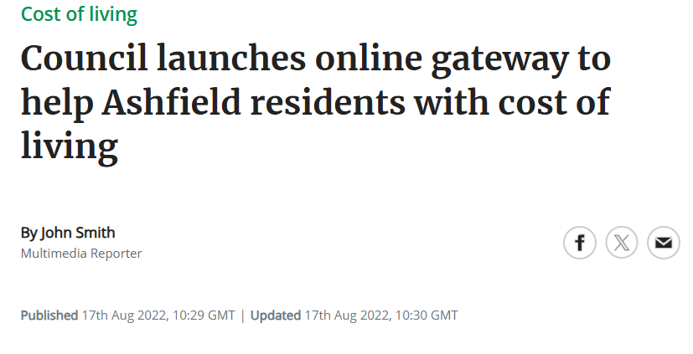Screenshot of press coverage of Feeding Ashfield web page launch

Improving access to wraparound support
Networking has enabled partners to improve their understanding of the different services available to residents and how they might be able to work with other partners to improve access to wraparound support. For example, the Feeding Ashfield Network has been able to build relationships with fuel poverty charities including National Energy Action, Nottingham Energy Partnership and Better Housing Better Health who have been able to offer support and energy saving advice to those accessing food provision and the wider Ashfield Community. Mental Health services, educational providers and Citizens Advice have also been able to improve their links with food hubs either through sharing information of their offer with volunteers or through having a presence at the food hubs during opening hours.

Encouraging community growing projects
In October 2022, the Feeding Ashfield Network highlighted an opportunity to encourage the community to get involved in community growing projects. Since then, multiple actions have been taken towards achieving this goal including;
- Ashfield District Council Environments team were supported to deliver and plant planters to 16 schools across the district. Planters have also been installed within priority places within Ashfield.
- St Mary Magdalene C of E school contacted ADC to see if it was possible to bring a group of pupils to visit an allotment site and learn about the work involved in growing fruit & veg. Allotment holders from Sutton met with the group to give a tour of the allotment and share their knowledge on the work involved in keeping an allotment.
- UKSPF Funds have been utilised to provide community groups with grants to enable them to set up and improve their community growing offer as well as providing family growing packs to residents during 2024 and 2025.
Photos showing community growing activity supported through the Feeding Ashfield Network
Photos showing community growing activity supported through the Feeding Ashfield Network

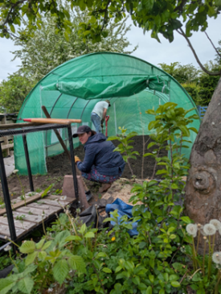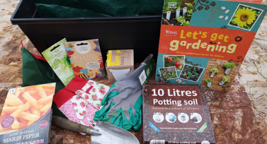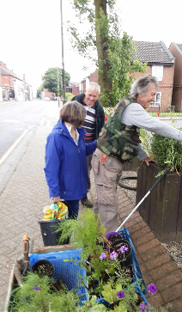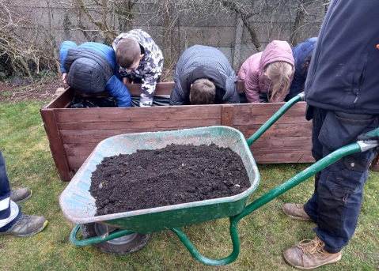

Creating welcoming spaces in the community
Many partners within the Feeding Ashfield Network have been successful in creating welcoming spaces within the community. There is often stigma attached to accessing food support, so to be able to create a friendly and welcoming environment for residents is a huge success. The Network regularly receives feedback from partners and residents on how they had felt anxious to access certain places but were then welcomed in a friendly and unjudgmental manner by the volunteers within the food hubs.
Photos of social eating events provided by FoodCycle and Bowls of Blessings 1

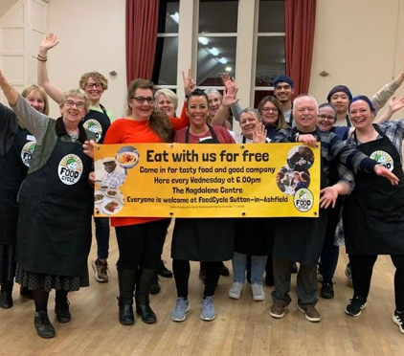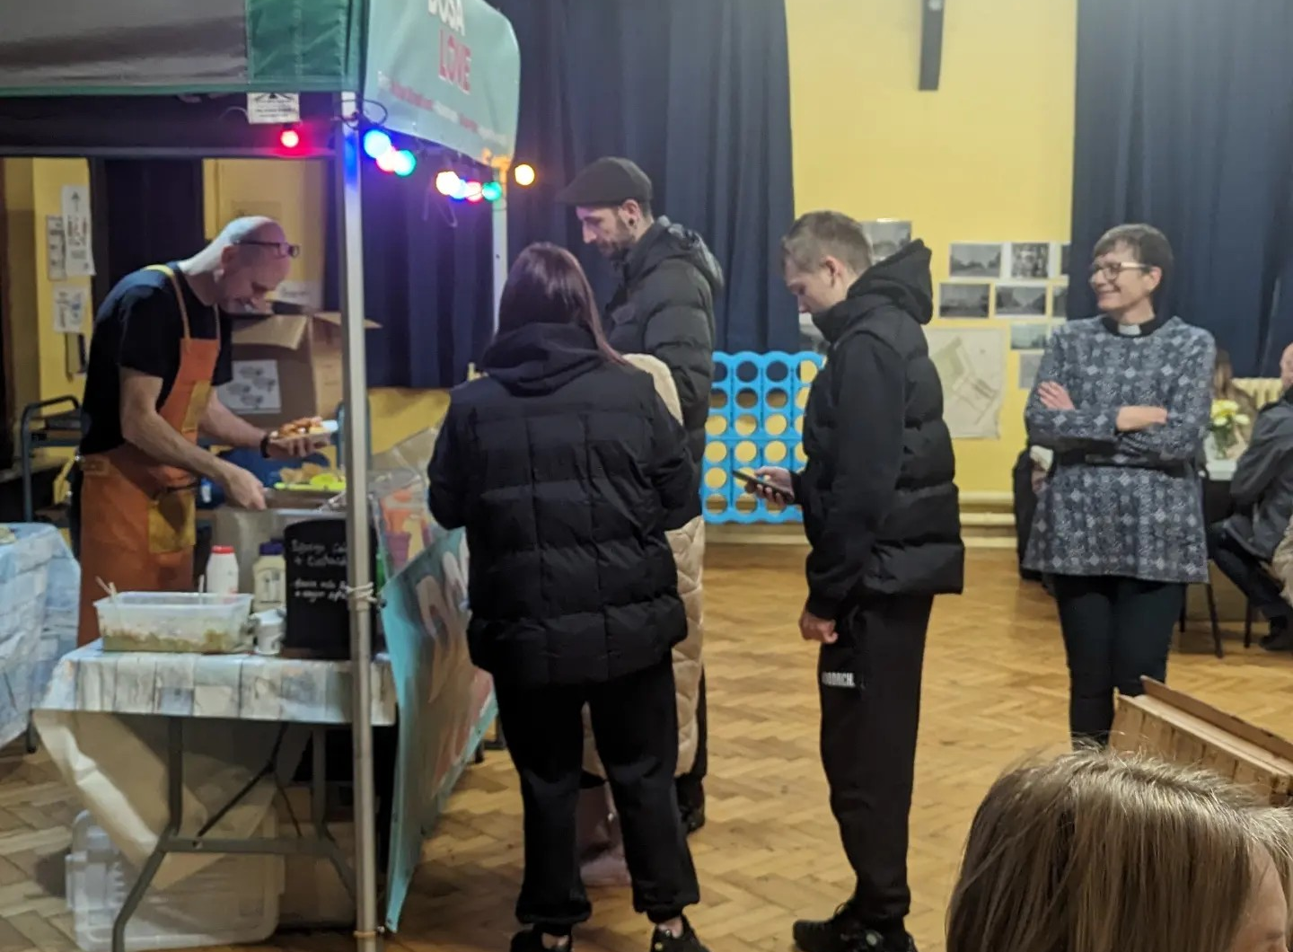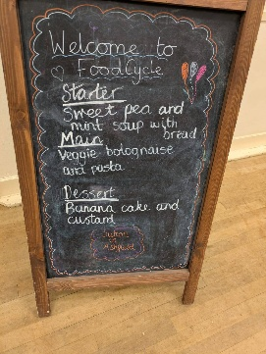

Feeding Ashfield Action Plan 2026 - 2035

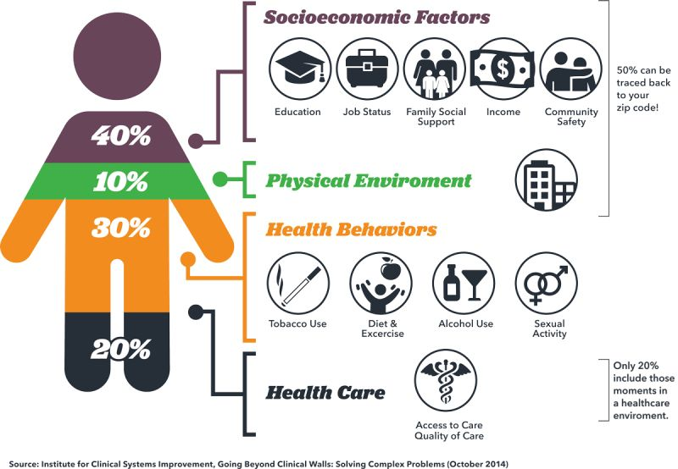
This action plan has been developed by the Feeding Ashfield Network following a series of workshops held throughout 2025. These sessions shaped the objectives, actions, and expected outcomes, all of which are organised using the Building Blocks of Health framework.

A wide range of factors influence people’s wellbeing.

These include:
- Socioeconomic factors such as education, employment, income, family support, and community safety.
- The physical environment, including access to green spaces and exposure to pollution.
- Health behaviours like diet, physical activity, smoking, alcohol use, and other lifestyle choices.
- Access to and the quality of health care services.

THE HEALTH FOUNDATION - WHAT BUILDS GOOD HEALTH?
The Health Foundation developed the Building Blocks of Health to help communities understand how these factors interact and what needs to be addressed to reduce inequalities and support thriving, healthy neighbourhoods.
In Ashfield, ‘system development’ has been added as a 9th building block, recognising the importance of collaborative working between organisations and communities.
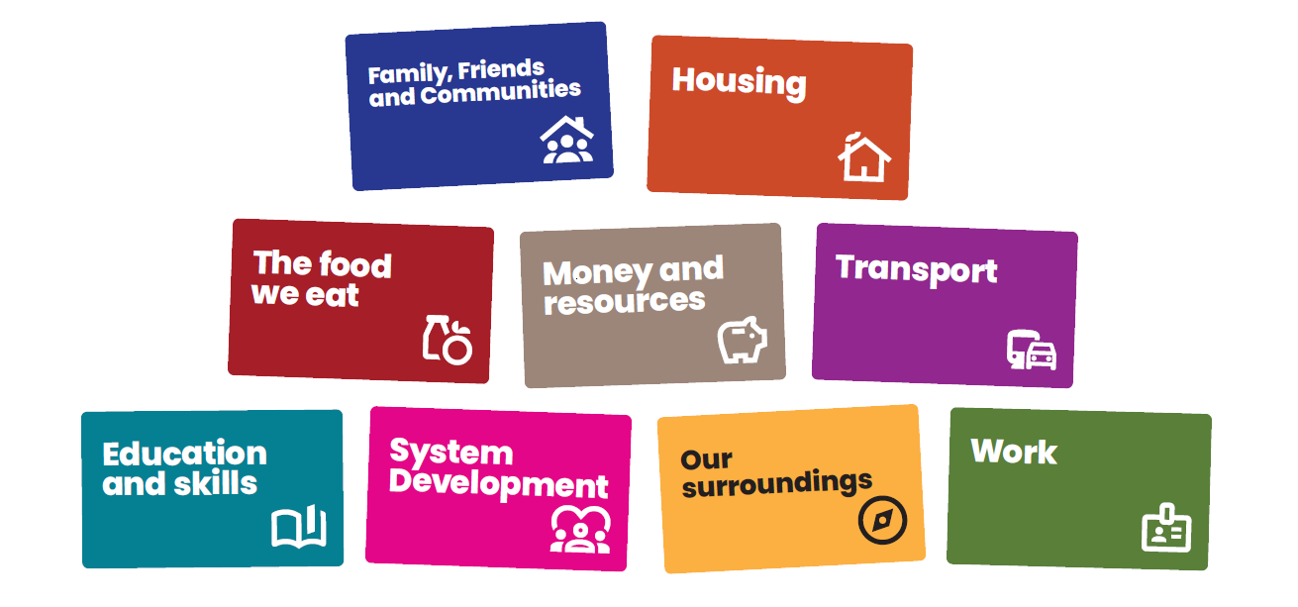
Link: What builds good heath – The Health Foundation
Education
and skills
Housing
Transport
The food
we eat
Work
System
Development
Family, Friends
and Communities

Our values

INCLUSIVE

AND

RESPECTFUL
We want everyone to feel that they are involved and that their views are heard.
We will acknowledge and embrace difference, encouraging different perspectives.

In doing this we will seek to understand, not challenge, and use this as a strength to build a shared understanding. We will use data and lived experience to help identify where to focus our energies and work with residents to enable inclusivity.

AMBITIOUS

AND

COMMITTED
We are ambitious in our desire to create a culture of collaboration across all sectors and communities where we work towards shared goals and learn together.
We will be brave and committed to working in this way, shifting our individual and collective behaviours to enable this way of working to happen.

COLLABORATION
Individuals and organisations are connected, and relationships are important. We will develop shared goals and an understanding of the work we want to do together.

PERSON

CENTRED
We will put people at the centre of everything we do, recognising that everyone and every community is different and what matters to them is what matters to us.
We will spend time understanding and reaching those who do not usually have a voice and have ongoing authentic conversations to understand what is important to them.

INNOVATION
We will be led by insight to focus our energies and think creatively as to how we engage with residents to understand what is important to them.
We will encourage ‘trying new’ and testing different approaches to help us understand what creates change, what doesn’t and most importantly, why.
We will create a culture of learning where to celebrate innovation, encouraging people to be creative and test ideas, by putting them into practice so that we can learn from them to inform what needs to happen next.

Feeding Ashfield Action Plans

Family, Friends and Communities

10-year vision:
To foster strong, connected, and resilient communities where residents can access support early, feel confident seeking help, and build meaningful relationships across generations. By strengthening volunteer skills, expanding wraparound support within food hubs, and creating community led and intergenerational activities, residents will experience improved wellbeing, reduced crisis situations, and a stronger sense of belonging and collective responsibility.

Focus areas and themes:
Strengthening community connections by expanding wraparound support, empowering volunteers, and creating inclusive intergenerational activities that build resilience, confidence, and a stronger sense of belonging across Ashfield.
Objective | 1-year actions | 3-year actions | Expected Outcomes | Lead
Enable those accessing food provision to access a variety of wraparound support when needed. | Provide wraparound support such as mental health and money advice at food hubs. | Develop community-led food support models to reduce reliance on foodbanks. | Residents receive holistic support alongside food provision, leading to improved wellbeing and reduced long-term dependency on emergency food services. | Ashfield District Council (ADC), Food Providers, Community Partners
Empower volunteers to signpost residents to support services where appropriate. | Train volunteers within Food Hubs to confidently signpost residents to support services. | Ensure volunteers are kept updated with signposting advice, have access to peer support, and improved links with wider community services. | Residents are more effectively connected to the right support at the right time, reducing crisis situations and improving outcomes. | Citizens Advice, Community Partners.
Improve intergenerational relationships within communities. | Launch a pilot intergenerational cooking and growing programme. | Expand intergenerational food activities across the district, embedding them in schools, community hubs, and local neighbourhood projects. | Stronger intergenerational relationships, increased food confidence, and more connected communities. | Community Partners, Schools

The food we eat

10-year vision:
Ashfield will have a sustainable, inclusive food system where residents can easily access healthy, affordable, and culturally appropriate food through strong local partnerships, thriving Food Clubs, and improved school holiday provision—reducing stigma, waste, and inequalities across the district.

Focus areas and themes:
Creating a sustainable, inclusive food system that offers healthy, affordable, and culturally appropriate food through strong partnerships, thriving Food Clubs, and improved school holiday provision.
Objective | 1-year actions | 3-year actions | Expected Outcomes | Lead
Improve the quality and variety of food available for school holiday provision. | Promote the Holiday activities and food (HAF) scheme to more local businesses and provide information of how to sign up to be a food provider. | Work alongside the Nottinghamshire County Council (NCC) HAF team to improve variety of food provided within Ashfield as needed. | Increased variety of healthy food available to school holiday activity providers. | NCC HAF team
Promote the use of Food Clubs to reduce stigma to residents accessing food provision and lower the amount of food that goes to waste. | Social media campaign to highlight what Food Clubs are and who can access them.  Launch a “Try Before You Buy” healthy food initiative across the district. | Develop a district-wide Food Club engagement programme—including community cooking demos and family food discovery events to normalise membership and strengthen community ownership. | More residents will feel comfortable accessing affordable food provision and amount of food waste reduced. | ADC & Affordable food providers
Improve access to inclusive and culturally appropriate food provision across all food hubs. | Gain insight into the cultural demographics and dietary requirements within the different areas of Ashfield and what types of foods would be beneficial to have available within each food provision. | Build relationships with businesses providing culturally appropriate food and explore opportunities to access donations of these foods. | Increased variety of foods available within food hubs – Saving foodbank costs when providing for different dietary requirements. | Food Providers
Improve access to more affordable healthy food across the district. | Create a district-wide directory of local producers willing to donate or sell surplus produce at low cost and share it with all food hubs. | Build stronger relationships with local producers including farmers and allotments for sustainable sourcing. | Allotment/farm surplus to be made available to food hubs – increasing access to fruit and veg whilst lowering costs and food waste. | Fareshare  Supermarket Community Leads

Work
10-year vision:
Over the next decade, Ashfield will create a skilled, confident, and well-connected local workforce, where residents have clear pathways into secure, good quality employment. Volunteering within Food Hubs and community projects will act as a stepping stone into meaningful work, supported by strong partnerships with employers, training providers, and community organisations. Through research, advocacy, and collaborative action, the district will reduce reliance on Universal Credit and insecure contracts, enabling more residents to access stable careers that support long-term wellbeing and financial resilience.
Focus areas and themes:
Strengthening volunteering pathways, expanding access to food sector training and careers, building strong employer partnerships, and advocating for secure, fair wage employment across Ashfield.
Objective | 1-year actions | 3-year actions | Expected Outcomes | Lead
Promote work and volunteering opportunities across the district including opportunities within Food Hubs. | Run a district-wide volunteering awareness campaign, highlighting roles within Food Hubs and community projects | Support volunteers to access training and progression routes that link to food related career pathways and long-term opportunities. | Increased number of active volunteers supporting food provision; improved local skills, confidence, and pathways into employment. | Standguide Ltd
Support Feeding Britain research and lobbying to reduce reliance on Universal Credit and zero-hour contracts. | Gather insight from residents, employers, and community organisations about barriers to secure employment, and share findings with local partners to inform advocacy. | Work with regional partners, training providers and employers to influence policy and promote secure, fair wage employment models that reduce dependency on Universal Credit and unstable work. | Increased understanding of local employment barriers; strengthened advocacy for fair, stable employment; improved access to secure work opportunities for residents. | ADC, Standguide Ltd, Local Employment Partners

Transport

10-year vision:
Ashfield will have accessible, reliable and inclusive transport options that enable all residents to reach food hubs and community food spaces with ease. Through partnerships with community transport providers, improved active travel routes, and coordinated travel support, residents will face fewer transport barriers, helping reduce isolation and ensuring everyone can access affordable, healthy food and local wellbeing opportunities.

Focus areas and themes:
Improving access to food by strengthening community transport partnerships, promoting active travel, and creating movement focused initiatives that help residents reach food hubs more easily
Objective | 1-year actions | 3-year actions | Expected Outcomes | Lead
Improve access to transport that supports residents in reaching food provision. | Share public and community transport timetables and group travel options at food hubs. | Partner with Community Transport services to coordinate regular routes, group travel schemes, and supported transport options that help residents reach food hubs more easily. | Residents experience fewer transport barriers when accessing food provision, increasing uptake and reducing isolation. | ADC, Food Hubs, Community Transport
Explore opportunities to link movement and food. | Promote walking and wheeling routes to food provision sites. | Launch a “Food Around the World” virtual walking and tasting trail, linking physical activity with food discovery and encouraging residents to explore local food hubs. | Increased physical activity, stronger engagement with food hubs, and improved awareness of local healthy food options. | Active Notts

Our Surroundings

10-year vision:
Ashfield will create welcoming, connected community spaces where residents can come together to eat, socialise, and access support. By strengthening social eating opportunities, improving awareness of local hubs, and fostering intergenerational activities, neighbourhoods will become more inclusive, resilient, and supportive. Food related community spaces will be widely recognised, easily accessible, and embedded within wider wellbeing, cultural, and social initiatives—helping residents build stronger relationships and feel more connected to where they live.

Focus areas and themes:
Strengthening community food spaces by improving awareness, promoting social eating, and creating inclusive, intergenerational activities that help residents connect with each other and their local area
Objective | 1-year actions | 3-year actions | Expected Outcomes | Lead
Identify, highlight, and increase awareness of the places in Ashfield where people can come together to eat, connect, and access support. | Map and promote community hubs and social eating spaces. | Develop intergenerational food projects to build resilience and respect. | Increased awareness of local food spaces; stronger intergenerational relationships and more inclusive community food activities. | ADC, Community Partners
Increase awareness of food provision available within the district and how to access it. | Share food provision information in a variety of spaces including within GP waiting rooms, community noticeboards and online. | Integrate food projects with wider community initiatives and campaigns, including wellbeing, social prescribing, and local events. | Improved access to information; more residents connected to local food support and community projects. | Primary Care Networks (PCN), Social Prescribers

Housing

10-year vision:
Through stronger partnerships with housing services, community organisations, and environmental partners, residents will have improved access to fuel bill support, better living conditions, and practical guidance on food recycling and reducing waste. By addressing the link between housing, financial strain, and food insecurity, the district will create healthier home environments where families can thrive and make sustainable, affordable food choices.

Focus areas and themes:
Improving living conditions, reducing financial strain, and supporting sustainable food practices by strengthening housing partnerships, promoting fuel bill support, and expanding food recycling education across the district
Objective | 1-year actions | 3-year actions | Expected Outcomes | Lead
Promote fuel bill support schemes and housing advice through food hubs to help residents manage living costs and improve home environments. | Promote fuel bill support schemes and housing advice through food hubs to help residents manage living costs and improve home environments. | Build partnerships with housing services to address poor living conditions and evaluate how housing affects food access and health outcomes across the district. | Residents experience improved living conditions, reduced financial strain, and better ability to store, prepare, and access healthy food. | Fuel Poverty Charities, Housing Services, Community Partners
Promote food recycling and encourage the reduction of food waste. | Support rollout of food recycling education in homes. | Deliver simple food recycling guidance through food hubs, community groups, and social media, including tips on reducing waste and correct food recycling practices. | Increased household knowledge and participation in food recycling; reduced food waste; improved environmental sustainability across the district. | ADC, Housing Services, Environmental Partners

Money and Resources

10-year vision:
Ashfield will ensure that residents can confidently access the financial support, advice, and resources they need to afford healthy food and reduce financial pressures. By improving uptake of key schemes, strengthening funding for food hubs, and introducing community-based incentives, the district will build a fairer, more resilient support system that helps families manage costs, reduce hardship, and improve long-term wellbeing.

Focus areas and themes:
Improving access to financial support, strengthening sustainable funding for food hubs, and introducing community incentives that help residents manage costs, reduce hardship, and access affordable healthy food.
Objective | 1-year actions | 3-year actions | Expected Outcomes | Lead
Support residents and families to understand and access financial and food support schemes available to them. | Promote schemes such as Healthy Start, Free School Meals, and Holiday Activity and Food provision along with food provision and wrap around support available through schools and networks. | Expand coordinated signposting and automatic enrolment support across schools, early years settings, and community partners to increase uptake of financial and food related support schemes. | Increased uptake of financial and food support schemes; improved access to healthy food for families most in need. | Schools & Family Support Services
Understand trends and track changing demand on Food Hubs. | Collect baseline data on Food Hub usage and needs. | Support organisations to secure sustainable funding models for food hubs and transport initiatives. | Clear understanding of service demand; improved long-term financial sustainability for food hubs and transport solutions. | ADC, Food Hubs,
Introduce a community discount/loyalty card for volunteers and residents. | Explore the viability of a loyalty/discount scheme to reward volunteers and support residents accessing food provision. | Develop a pilot loyalty/discount scheme to reward volunteers and support residents accessing food provision. | Increased volunteer retention, reduced stigma, and improved access to affordable food options for residents. | ADC, Affordable Food Providers, Local Businesses

Education and Skills

10-year vision:
Ashfield will empower residents of all ages with the skills, confidence, and knowledge needed to access, prepare, and enjoy healthy, affordable food. Through expanded digital inclusion, lifelong learning, practical cooking education, and widespread food growing opportunities, communities will develop stronger food resilience and healthier habits. Schools, early years settings, and community partners will work together to embed nutrition, sustainability, and food skills into everyday learning, ensuring future generations grow up confident, capable, and connected to the local food system.

Focus areas and themes:
Promoting digital and cooking skills, expanding food growing opportunities, sharing sustainable food knowledge, and embedding healthy eating education across schools and early years settings to build long-term food confidence and resilience
Objective | 1-year actions | 3-year actions | Expected Outcomes | Lead
Promote digital and cooking skills through community learning providers. | Deliver beginner level digital and cooking workshops through community learning providers. | Expand digital inclusion and cooking programmes, including supporting access to accredited short courses and progression pathways. | Increased resident confidence in essential digital and cooking skills; improved ability to plan, prepare, and access healthy food. | Community Learning Providers
Share recipes and food sustainability tips via social media. | Share simple, low-cost recipes and food sustainability tips through social media, newsletters, and community networks. | Develop a digital content plan that includes seasonal recipes, food waste reduction advice, and community generated content. | Improved awareness of healthy cooking ideas and sustainable food practices across the district. | ADC, Community Partners
Encourage participation in food growing activity across the district. | Pilot food growing workshops with schools, community hubs, and allotments. | Development of community food growing education programme. | Increased community participation in food growing; improved understanding of sustainable food practices; stronger local food resilience. | Schools, Allotment & Growing Groups
Embed healthy eating education in schools and early years settings. | Work with schools and early years providers to share healthy eating resources with children and families. | Embed healthy eating education in schools and early years settings supported by partnerships with community partners. | Children and families develop healthier eating habits, improved food confidence, and sustained understanding of good nutrition. | Schools, Early Years Providers, Public Health

System development

10-year vision:
Over the next decade, Ashfield will build a strong, coordinated, and insight driven food system, where partners share data, learning, and best practice to improve access to food and strengthen community wellbeing. Through collaborative planning, co-located services, and long-term research partnerships, the district will create a connected, efficient, and evidence-based network that delivers consistent, high-quality support and drives continual improvement across all elements of food provision.

Focus areas and themes:
Strengthening collaboration, shared learning, and data driven decision making by improving insight collection, coordinating best practice, co-locating services, and building long term research partnerships across the Feeding Ashfield Network
Objective | 1-year actions | 3-year actions | Expected Outcomes | Lead
Encourage partnership working. | Share best practices and data through the Feeding Ashfield Network. | Establish a coordinated learning and insight framework that supports joint planning, skills development, and continuous improvement across partners. | Stronger collaboration, consistent standards, and improved efficiency across food provision partners. | Feeding Ashfield Network
Co-locate health services (e.g. BP checks, stop smoking support) with food provision. | Pilot co-location of simple health services (e.g. blood pressure checks, healthy living advice) at a selected food hub. | Embed regular co-located health and wellbeing services within food hubs across the district where possible. | Increased access to preventative health support; improved community health outcomes. | Public Health, PCNs, Food Hubs
Participate in research opportunities where able. | Partner with universities to support local and national research into local food systems. | Develop long term research partnerships to evaluate impact, test innovative models, and inform strategic decision making. | Strong evidence base for future planning; increased credibility and influence of the Feeding Ashfield Network. | Universities, Feeding Ashfield Network

Measuring success
Each year, the Feeding Ashfield Network will produce a detailed annual review that clearly sets out the work undertaken, the successes achieved, and the challenges faced over the previous 12 months. This review will be grounded in the same data sources that informed the original priorities, enabling partners to assess what has changed and why.
Alongside this, project level information—such as participation numbers, reflections, observations, and case studies—will be gathered to ensure every action is evidenced and accountable
The review will also assess the insight gained throughout the year, how learning has been shared across partners, the
stories that demonstrate impact, and the new or strengthened connections that have developed. Crucially, it will outline how each action has made a measurable difference, making clear where progress has been strong and where further improvement is required
The completed annual review will be presented to the Be Healthy, Be Happy Management Group. Each lead organisation is directly accountable for the actions they committed to, including delivering progress, monitoring outcomes, and providing timely and accurate contributions to the review


Call to action

Achieving our vision of a healthier and happier Ashfield requires everyone—residents, organisations, businesses, and community groups—to play their part. Here are six key actions you can take:

COLLABORATE

FOR CHANGE
Work together—whether you’re a resident, business, or organisation.

Pool resources, share expertise, and commit to joint action to tackle inequalities and create lasting impact. Align strategies, plans and policies to the priorities within
this strategy and share insight, ideas, solutions and challenges.

PROMOTE

HEALTH

AND

LIFESTYLE
Promote healthy lifestyles by sharing local wellbeing opportunities, encouraging others to join, and taking part yourself. Raise awareness of healthy habits, support proactive health management and foster movement and balance at work.

STRENGTHEN

RESIDENT

VOICE
Enable and support residents to create the change, they wish to see. Join or create local resident groups. Share your ideas, co-design solutions, and influence decisions that shape each community.

SHARE

INFORMATION

AND

RESOURCES
Help improve communication by sharing updates about services, events, and support. Use noticeboards, social media, and word of mouth to keep each community informed

.
CHAMPION

COMMUNITY

ASSETS
Support and use local hubs,
community centres, and green spaces. Encourage others to get involved and help make these spaces vibrant, inclusive, and sustainable.

VOLUNTEER

AND LEAD
Become a Community Champion or volunteer for local projects. Your time and skills can make a real difference in reducing inequalities and building stronger network.

