

Evaluation Report

Selective licensing of private rented properties in Sutton Central (New Cross) and Stanton Hill

Nov 2021

# Contents

|  |  |  |
| --- | --- | --- |
| **Sec** |  | **Page** |
| **1** | **Introduction** | **3** |
| **2** | **Designated areas** | **4** |
| **3** | **Licensing process** | **6** |
| **4** | **Objectives of the Selective Licensing Schemes** | **7** |
| **5** | **Licence application and enforcement process** | **12** |
| **6** | **Impact of selective licensing** | **13** |
| **7** | **Case studies** | **28** |
| **8** | **Scheme costs and administration** | **29** |
| **9** | **Benefits of selective licensing** | **30** |
| **10** | **Drawbacks & criticisms of selective licensing** | **31** |
| **11** | **Learning outcomes** | **32** |
| **12** | **Stakeholder feedback** | **33** |
| **13** | **Impact of Covid-19** | **34** |
| **14** | **Conclusions and recommendations** | **35** |

## 1.Introduction

Every person has the right to live in a home that is warm, safe and secure. Substandard housing affects lives and can have a long-term damaging effect on the physical and mental health of its occupants. Those on a low income, the elderly and those with underlying medical conditions are disproportionately affected due to their lack of housing choices.

The English Stock Condition Survey 2019/20 identified 23% of homes nationally as failing to meet decent homes standard, with the cost of correcting this put at £18.6bn. Within Ashfield, an estimated 31% of homes are said to fall below the decent homes standard.

Through its Corporate Plan the Council is committed to ensuring Ashfield residents live in homes that are warm, safe and affordable. The Council acknowledges that good housing underpins so much within society, from ensuring children can reach their potential in school to having an active workforce and to improving the health of the elderly.

There is a stated desire to work pro-actively with private landlords, providing advice and support to improve housing standards, this activity goes on . The Council also acknowledges that additional steps may need to be taken to address localised problems or long-standing issues that advice and support alone will not solve.

Selective licensing of private rented properties is one such additional step. Included within the Housing Act 2004, selective licensing can be considered in areas where issues such as poor housing standards, low demand and anti-social behaviour persist. Under the terms of a selective licensing scheme landlords of all properties in the designated area have to apply for a licence and they are expected to comply with conditions relating to the maintenance and management of their property.

In February 2017 the Council introduced its first selective licensing schemes in parts of Sutton Central (New Cross) and Stanton Hill. In both areas the number of disrepair issues reported to the Council and the number of management practice problems reported to the Council was high. Both areas also suffered in respect of crime rates, levels of anti-social behaviour, nuisance and fly tipping.

The schemes ran for an initial 5 year period, with the expectation being that a review would be conducted before a decision made on their cessation or continuation. The review findings and recommendations are included within this Evaluation Report.

The report considers the aims and objectives of the original schemes, it looks at whether these have been met and also considers new, emerging issues. In addition, the report includes feedback from residents, landlords and 3rd party agencies directly affected by the schemes. Finally, the report concludes with recommendations for the future.

It is important to highlight the impact of the Coronavirus pandemic on the selective licensing schemes. The schemes focus on pro-active engagement; in particular visits and inspections to improve housing conditions and management practices. For the last 18 months these have been either stopped or severely restricted in response to the pandemic.

## 2. Designated Areas

### Sutton Central (New Cross), Sutton in Ashfield

The Sutton Central (New Cross) scheme, as outlined in blue overleaf, is focused on the terrace streets either side of Outram Street. There are circa 650 properties within the designated area of which the majority, circa 500 are privately rented and needed to be licenced.

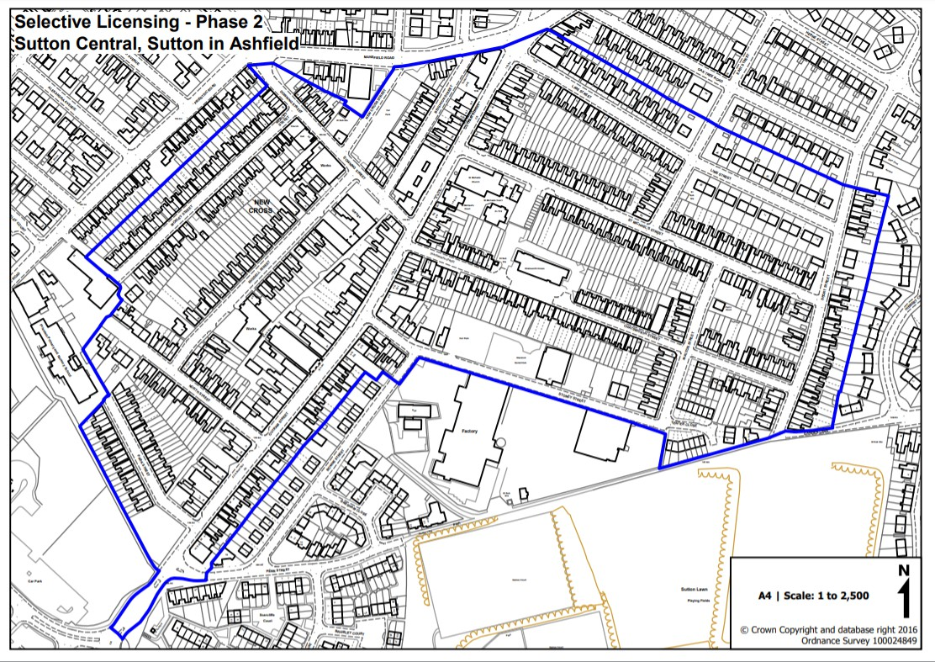

### Street names

|  |  |
| --- | --- |
| Park Street Sutton in Ashfield | Short Street (partial) Sutton in Ashfield |
| North Street Sutton in Ashfield | Walton Street Sutton in Ashfield |
| Russell Street Sutton in Ashfield | Stoney Street Sutton in Ashfield |
| Morley Street Sutton in Ashfield | St Michaels Street Sutton in Ashfield |
| Downing Street Sutton in Ashfield | East Street (partial) Sutton in Ashfield |
| Beighton Street Sutton in Ashfield | Tenter Close Sutton in Ashfield |
| Chatsworth Street Sutton in Ashfield | Outram Street (partial) Sutton in Ashfield |
| Lime Street Sutton in Ashfield |  |

### Stanton Hill, Sutton in Ashfield

By contrast, the Stanton Hill scheme is smaller, with circa 230 properties of which 125 are privately rented and needing to be licenced. The scheme itself is focused on the streets of terrace homes located off High Street.

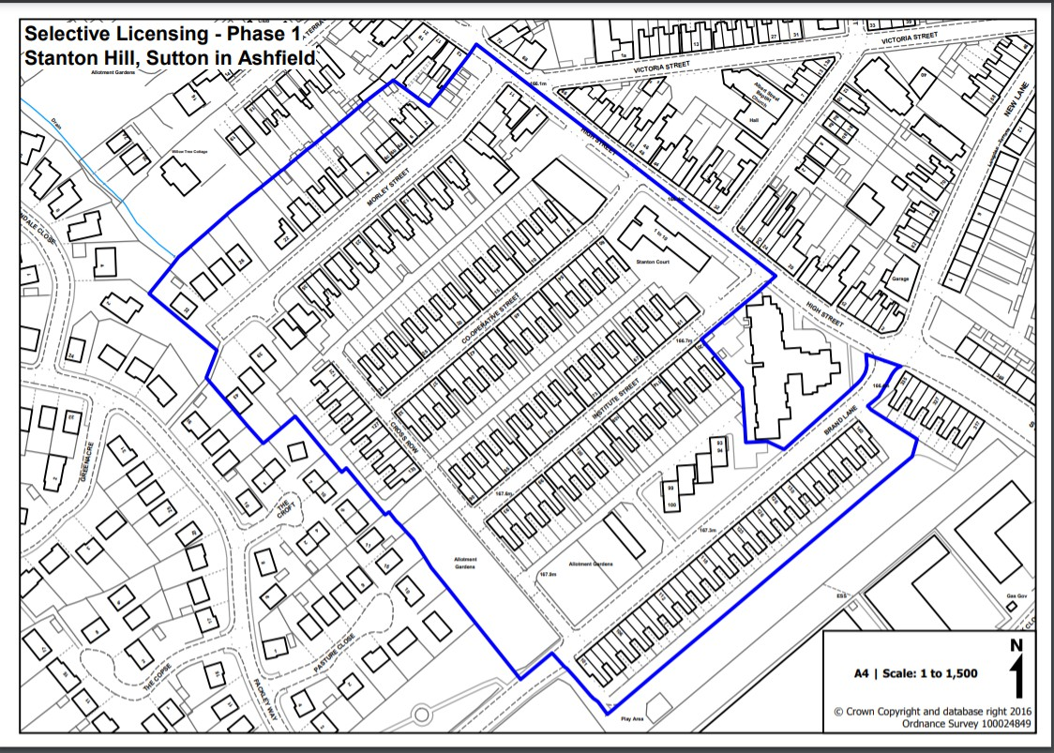

### Street names

|  |  |
| --- | --- |
| High Street (partial) Stanton Hill | Cooperative Street Stanton Hill |
| Brand Lane (partial) Stanton Hill | Institute Street Stanton Hill |
| Morley Street Stanton Hill | Cross Row Stanton Hill |

## 3.Licensing process

In the designated areas all private landlords (owners or agents) must apply for a licence if they want to rent out their property.

The licence holder is assessed to ensure that they are a “fit or proper person” and can comply with the licence conditions concerning the management and upkeep of the property including essential safety measures such as adequate smoke detection.

Following receipt of the application an initial property inspection was conducted to see if there were any obvious hazards or other worries regarding property condition. Where

issues were identified a full property inspection was conducted in accordance with the Housing, Health and Safety Rating System (HHSRS). The HHSRS inspection focuses on hazards within the home, the aim being to identify and deal with any category one, high risk hazards and to provide advice and assistance to ensure lower risk, category two hazards are addressed.

A licence is not issued until all category one hazards are dealt with. Advice and guidance is given in respect of lower priority, category 2 hazards, to ensure they are actioned as soon as possible.

Through selective licensing, Local Authorities have the power to enter a property (and then proceed to take enforcement action) without providing 24 hours’ notice under section 239 of the Housing Act 2004. This power of entry is different to the notice requirements associated with Part 1 of the Housing Act (the enforcement of housing standards, i.e. the provision of 24 hours’ notice to landlords and tenants which can result in a lack of cooperation from the tenant and landlord and can also contribute to retaliatory eviction).

## 4. Objectives of the Selective Licensing schemes

Selective Licensing was introduced to try and tackle a number of long standing and increasingly problematic issues in the private rented sector in the designated areas. Traditional methods of engaging with landlords and responding to residents’ enquiries and complaints on a reactive basis was ineffective, hence the need for a different, more proactive approach to tackling the problems.

The reasons for selective licensing and the corresponding objectives of the schemes can be summarised as follows;

|  |  |
| --- | --- |
| **Issue** | **Objective** |
| 1. High level of reported disrepair | 1. Improve property standards |
| 2. High level of reported poor management  practices, related to a failure to comply with tenancy agreement responsibilities | 2. Improve management practices |
| 3. Hot spot for empty properties within the  District. | 3. Improve levels of demand for housing  and reduce the number of empty homes |

|  |  |
| --- | --- |
| 4. Levels of crime and anti-social behaviour including fly tipping, domestic nuisance and waste on land. | 4. Contribute towards effective partnership working to improve wider community issues including crime, ASB and domestic  nuisance |

## Objective 1: Improve housing standards

Prior to the introduction of selective licensing, in 2016/17 the Environmental Health (Residential) team received a record 907 complaints from private sector residents regarding disrepair. Of these, 73% of complaints were from properties in the designated areas. There are over 55,000 properties in the Ashfield District, less than 2% of these are in the selective licensing areas, thus highlighting the high concentration of disrepair issues in those areas.

Excess cold, damp and mould were the stand-out issues, these are inextricably linked to fuel poverty and wider socio-economic issues that we know prevail in the designated areas.

The aim of Selective Licensing was to reduce the incidence of disrepair, in particular those category one hazards that are detrimental to the resident’s safety, their health and well- being. The intention was to do this in a positive, pro-active way, raising awareness amongst residents and working to advise and support landlords to resolve any issues that were identified.

## Objective 2: Improve management practices

An aim of Selective Licensing was to ensure landlords operated in a professional way and met their obligations under the tenancy agreement. Hand in hand with this was a need to raise awareness amongst residents of their tenancy rights and their obligations and responsibilities towards the landlord and the property. It is very much a 2-way relationship and both parties needed to be on-board and playing by the rules if it was going to be a success.

The hope was that improvements in practices would lead to fewer reported issues and where there were issues landlords would be willing to seek advice and assistance at an earlier stage, thereby reducing the need for any form of enforcement action and

safeguarding the tenancy. A reduction in the number of attempted illegal evictions and an increase in the number of landlords making enquiries with the Team would be good indicators of success.

A good relationship between landlord and tenant should lead to tenants being happier in their home, wanting to stay for longer and landlords wanting them to remain. Reduced turnover and a greater degree of continuity will be of benefit to the local area as residents become invested and have more than a passing interest in the health of the community.

There was a concern that a focus on how tenancies were being managed could result in some landlords in the area leaving the sector or moving their investment to areas where there is less of a focus, this in turn would reduce the availability of much needed private rented accommodation in the area.

### Objective 3: Improve levels of demand for housing and reduce the number of empty homes

The map below, from the original (2016) Selective Licensing report, shows the two designated areas (blue boundary) and clearly identifies them as ‘hotspots’ when compared to the rest of the District.

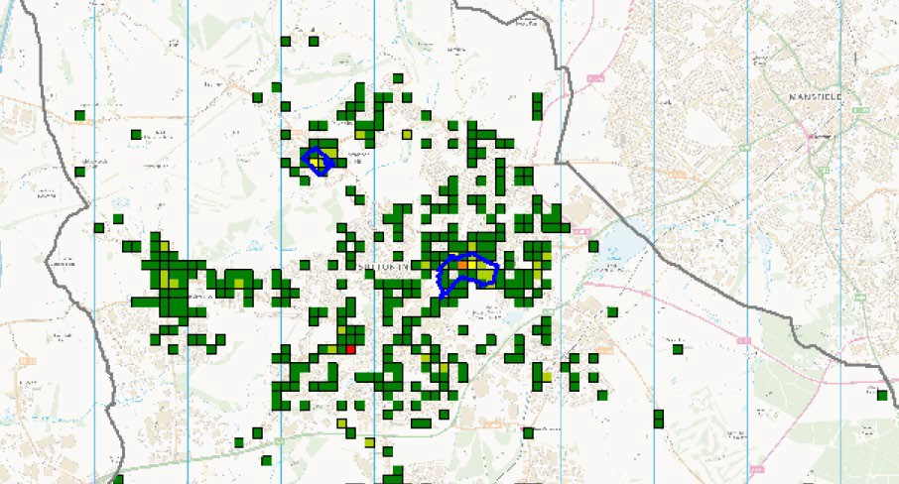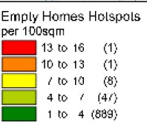

Reducing the number of empty homes has been an intrinsic part of the Council’s wider Housing Strategy for a number of years. The Council is aware of the high level of demand

for housing and the negative impact vacant properties can have on a local area when they become a focus for vandalism, damage and neglect.

An objective of Selective Licensing was to target empty homes and to work with the owner to ensure everything possible was being done to bring them back into use. Other improvements being brought about by Selective Licensing should give owners confidence in the local area and to invest in their homes.

## Objective 4: Contribute towards effective partnership working to improve wider community issues including crime, ASB and domestic nuisance

The table below, from immediately prior to the implementation of Selective Licensing (2016) shows that of the 74 so-called Lower Super Output Areas (LSOA) that make up the Ashfield District the New Cross area is ranked in position 1 for crimes relating to domestic violence, position 2 for Anti-Social Behaviour (ASB) and Hate Crime and position 6 for crimes relating to drugs and alcohol.

By comparison Stanton Hill fared better but remained a standout area in comparison to the other LSOAs.

|  |  |  |  |  |
| --- | --- | --- | --- | --- |
| Lower Super Output area | ASB | Domestic Violence | Hate Crime | Drugs and Alcohol |
| New Cross | 2nd | 1st | 2nd | 6th |
| Stanton Hill | 4th | 20th | 6th | 21st |

The Crime and Disorder Act (1998) defines ASB as activities or behaviours which “cause or is likely to cause harassment, alarm or distress to one or more persons not of the same household". Not all ASB directly constitutes criminal offences but may still be unpleasant and affect quality of life within an area.

The following activities and offences are typically described as ASB:

|  |  |
| --- | --- |
| Arson | Alcohol and drugs related offences |
| Criminal damage | Graffiti and fly posting |
| Noise nuisance | Fly tipping and litter |
| Harassment and intimidation | Verbal abuse |

The table below summarises where reports of crime and ASB originated from and demonstrates that those in private rented accommodation were having to deal with issues far beyond the condition of their home.

|  |  |  |  |  |
| --- | --- | --- | --- | --- |
| Tenure | Stanton Hill | New Cross | Total | % |
| Business | 9 | 54 | 63 | 12.2% |
| Council Owned | 18 | 1 | 19 | 3.6% |
| Not Listed | 4 | 8 | 12 | 2.3% |
| Owner Occupier | 6 | 20 | 26 | 5% |
| **Private Rented** | **61** | **190** | **251** | **48.6%** |
| Road Only | 1 | 64 | 65 | 12.5% |
| RSL | 11 | 42 | 53 | 10.2% |
| Void | 4 | 23 | 27 | 5.2% |
| Total | 114 | 402 | 516 |  |

Similarly, in respect of incidents reported to the Council, both areas saw a higher than average incidence of fly tipping, domestic nuisance and waste on land.

It was hoped that through Selective Licensing we will have a greater level of intelligence, knowledge and leverage with landlords regarding tenants who may be involved with localised ASB. Working in partnership with the Police and Council colleagues on a ‘problem solving’ approach, there was an opportunity engage with residents and have in place an expectation that landlords would take action against those tenants guilty of ASB.

Improvements to the local area, brought about through objectives 1, 2, 3 and 4, should also help ensure there is sufficient demand in place for properties that do become available and that the landlord can choose suitable new tenants following a robust vetting process.

## 5. Licence applications & Enforcement Action

Circa 650 Properties within the two selective licence areas required a licence. A total of 623 licence applications were received and processed. Of these 620 full licences were issued, with 3 being rejected because the licence holder failed the ‘fit and proper’ test and new licence holders had to be appointed.

Despite repeated requests, landlords of 27 properties failed to apply for a licence. Of these, 20 cases were submitted to our Legal Team to review failure to licence offences. Civil Penalty fines totally £35,000 have already been paid from landlords failing to licence with a potential further £60,000 due if the remaining offences are upheld.

In addition, 3 landlords have been prosecuted for breaching licensing conditions, this has included poor management and failure to carry out essential repairs to a property.

As will be discussed later in this report, the requirement to apply for a licence, to manage and maintain the property in accordance with licence conditions, has forced out those landlords who were not minded to operate in this way. Crucially, these landlords have been replaced by those who are willing to commit, the properties have not been lost from the private rented stock.

## 6. Impact of selective licensing

## Objective 1: Improve housing standards

As part of the licensing application process an initial inspection was conducted. The purpose of the inspection was to check on the general condition and to determine if there were any obvious hazards that would warrant a full property inspection in accordance with the Housing Health and Safety Rating System (HHSRS).

The principle behind the HHSRS is that: A dwelling, including the structure, the means of access, any associated outbuildings and garden, yard and/or other amenity space, should provide a safe and healthy environment for the occupants and any visitors. To satisfy this principle a dwelling should be free from unnecessary and avoidable hazards; and where

hazards are necessary or unavoidable, they should be made as safe as reasonably possible.

The majority of properties, 561 in total were identified as needing a full HHSRS inspection. As part of the inspection officers considered the following hazards and work to reduce their associated risks.

|  |  |
| --- | --- |
| Hazard | Works required to reduce risks |
| Damp and Mould | Repairs to roofs, Improved ventilation Improvement of insulation  Improvements and repairs to guttering and drainage.  Repairs to leaking pipes |
| Excess cold | Renewal/replacement of heating systems Improvement to windows and doors.  Installation of insulation/draft proofing. |
| Excess heat | Improved ventilation  Improved heating |
| Carbon monoxide/ uncombusted fuel gases | Requirement for Gas Safety checks and removal of obsolete or dangerous items.  Checks of solid fuel units  Ensuring carbon monoxide detectors are in place. |
| Entry by Intruders | Replacement of doors and window. Improved lighting  Replacements of fences and gates. |
| Domestic hygiene including pests and refuse | Service of PDPA notices  replacement of floor and wall coverings requirements for adequate waste provisions. |
| Food safety | Improvement of amenities.  Improvement to design and layout of kitchens and storage. |
| Personal Hygiene, sanitation and drainage | Improvement to bathrooms Consistence of hot water supply  Flushing toilets |

|  |  |
| --- | --- |
| Falling on level surfaces | Relaying paving  Fixing damaged flooring |
| Falling on the stairs | Improvement of lighting Replacing floor coverings Improving treads on stairs Provision of handrails  Provision of balustrades |
| Falling between levels | Installation of safety latches on doors  Balustrades to staircases and windows |
| Electrical Hazards | EICR required for all properties and all code 1 and 2 to be addressed. |
| Fire | Requirement for hardwired interlinked fire detection.  Provision of protected and adequate means of escape. Reduction of obstructions. |
| Structural collapse and falling elements | Replacement of joists Replacement of supporting walls Fixing of long-term leaks  Repairs to chimneys and roofs. |

Of the 561 properties inspected 157 met the HHSRS standard and needed no further works. A total of 97 of the 404 remaining properties had at least one high risk, category one hazard, that needed urgent repair and 307 properties had Category two hazards that required attention.

Of the 97 properties with high risk hazards none of these had been reported to the Council by the tenant prior to the inspection. When asked tenants offered up the following explanations for this;

* Rent is cheap so I thought this was acceptable
* I wasn’t aware that the issues were dangerous
* I don’t know who to contact (not reported to agent or landlord)
* I didn’t know there was anything the council could do
* I am worried my landlord will evict me
* It doesn’t affect me

There was a combination of tenants not knowing how to raise concerns or who to raise them with and a fear that raising complaints about the property condition could lead to the landlord taking action to recover possession of their home. Selective licensing has gone some towards helping to address this and giving tenants the confidence to raise issues.

Officers supported landlords to ensure all Category one hazards were dealt with without delay and that there was a monitored plan in place for dealing with Category two hazards.

As a result of the inspections and interventions the following actions were taken;

* Works to 338 properties to improve and make safe electrical installations
* Improvements to 195 properties to reduce damp and cold by
  + 83 installing new boilers,
  + 4 installing new windows,
  + 123 have had new roofs roof repairs and/or insulation.
* All properties have improved fire safety measures including
  + Early alerts (hard wired interlinked detection as a minimum)
  + Clear guidance with support from the fire service on means of escape and fire prevention from tenants.
* Around 40 properties have installed emergency escape windows or ensured that alternative escape routes were unobstructed.
* 12 properties external lighting was improved for security.
* 10 Properties external staircases were repaired or replaced to reduce risks associated with falls on stairs.
* 8 properties with Solid fuel heating have installed Carbon monoxide detectors as well as a majority of all other licenced properties.

Section 6 looks in more detail at case studies highlighting typical findings from an inspection.

The table overleaf captures the total number of disrepair enquiries and complaints made to the Council during the selective licensing period. Whilst the total number of complaints has increased the percentage of those from residents in the selective licensing areas has fallen significantly, indicating an improvement in property conditions. There is an argument for thinking the number of complaints from residents in the Selective Licensing areas could

have increased as those residents who pre-licensing were unaware of how to report a repair or were frightened to do so had new found knowledge and confidence.

|  |  |  |
| --- | --- | --- |
| Period. | Number of Complaints relating to disrepair. | Percentage in Selective Licence area. |
| 2016-2017 | 907 | 73% |
| 2017-2018 | 931 | 65% |
| 2018-2019 | 793 | 52% |
| 2019-2020 | 1040 | 31% |
| 2020-2021 | 1139 | 26% |

The Environmental Health (Residential) Team have encouraged landlords to attend Landlord Forum Meetings where all aspect of property management including property condition are discussed.

## Objective 2 : Improve management practices

As part of the licensing process landlords were required to sign up to a number of licence conditions, including the following;

* Ensure a suitable person is in place to manage the property;
* Make sure landlords have written tenancy agreements with their tenants;
* Ensure references are requested and vetting checks conducted;
* Ensure there are working smoke alarms;
* Provide contact details for the licence holder to the tenants;
* Ensure landlord takes reasonable and practicable steps to tackle anti-social behaviour caused by their tenants.

During the property inspection and subsequently tenants were advised of the licence conditions and how to report possible breaches.

As part of the licensing checks tenants were also asked questions relating to the management of their home, specifically;

* Have they received a gas test certificate?
* Have they received a tenancy agreement?
* Is there an ASB condition in the tenancy agreement?
* Are they aware of the arrangement for the collection of refuse and bulky goods?
* Are alleyway gates fitted? Does the tenant have a key / know how to obtain a key?
* Have they been provided with a detailed inventory?
* Was a deposit taken for the property?
* Do they know if the deposit was protected (with a relevant Tenancy Deposit Scheme)?
* Does the landlord or managing agent undertake property inspections?
* Have they been provided with;
  + Name and address of the Licence Holder or managing agent if different
  + A copy of the licence
  + A contact daytime telephone number and
  + An emergency contact telephone number.

Documentation was checked during the property inspection visit. Where there was evidence to suggest information was lacking, incomplete or that appropriate action, such as to protect the deposit, had not been taken the landlord was asked to provide the relevant documentation. In total 486 requests for additional documentation (over and above that obtained during visits) were made, typically these were gas safety certificates and tenancy agreements.

Additionally, where issues of ASB were identified relating to a private rented property the landlord was asked to provide extra information, such as proof of referencing and vetting checks conducted.

Selective Licensing raised the bar in respect of the documentation a landlord was expected to provide and the steps they were expected to take in managing their tenancy. The requirements were backed up by checks conducted with both the tenant and the landlord.

The table below illustrate what a difference the schemes have made. The first shows that the number of attempted illegal evictions in the selective licensing areas has fallen over the lifetime of the scheme. The second shows the number of advice enquiries the

Environmental Health (Residential) team received from landlords. These were enquiries that were not related to selective licensing. The figures in the second table show a continued increase, suggesting that landlords increasingly know where to come for advice and are willing to seek it.

### Selective licensing areas – Record of alleged attempts to illegal evict

|  |  |
| --- | --- |
| 2017/2018 | 12 |
| 2018/2019 | 6 |
| 2019/2020 | 3 |
| 2020/2021 | 2 |

### Selective licensing areas – landlord request for advice (none SL related)

|  |  |
| --- | --- |
| 2017/2018 | 4 |
| 2018/2019 | 28 |
| 2019/2020 | 91 |
| 2020/2021 | 146 |

## Objective 3: Improve the levels of demand for housing and reduce the number of empty homes

The selective licensing areas were a hotspot for empty homes. Following implementation of the schemes officers actively sought to identify vacant properties, this was through door knocking, liaising with Estate Agents and speaking to other departments such as Council Tax.

Owners were traced, contacted and supported to bring their homes back to use as quickly as possible. In some cases officers provided advice on the works that were needed and recommended possible contractors, other cases were more complex, often being linked to issues of probate.

With very few exceptions the home-owners were keen to bring their homes back into use and were working towards this. Officer involvement provided a bit of a push and impetus to ensure it happened as quickly as possible. It was evident that the buoyant housing market and the potential financial returns were encouragement enough for property owners.

In total officers have been involved in 50 empty properties in the selective licensing area over the duration of the scheme. At the time of writing this report 6 properties remain vacant but only 2 are active cases as the others are being renovated or sold.

In respect of levels of demand, officers haven’t focused ostensibly on this because action to improve property conditions and management practices along with the buoyant housing market was sufficient stimulus to ensure there was a good level of demand for properties in the area. The feedback from landlords in section 12 of this report indicates demand levels of healthy and that landlords can choose from a pool of potentially good quality tenants.

## Objective 4: Contribute towards effective partnership working to improve wider community issues including crime, ASB and domestic nuisance

The selective licensing areas were a hotspot for crime, ASB and nuisance and remain so. New Cross for example currently makes up over 11% of all reported crime despite it being home to less than 2% of properties.

Similarly, as the table below shows, in respect of the number of incidents reported to the Council’s Community Safety Team (CST) relating to waste on land, domestic nuisance and ASB there has been no reduction and in the case of Stanton Hill, the figures have increased significantly. This may be down to improved awareness and easier reporting processes but nevertheless the figures are not what we had hoped for. Whilst the schemes have brought about improvements in the condition of homes and how those homes are managed the areas still struggle in respect of these wider social issues.

### Number of reported incidents to Ashfield DC for waste on land, domestic nuisance and ASB.

|  |  |  |  |  |
| --- | --- | --- | --- | --- |
|  | **2017-2018** | **2018-2019** | **2019-2020** | **2020-2021** |
| **New Cross** | **292** | **286** | **214** | **291** |
| **Stanton Hill** | **72** | **67** | **92** | **103** |

During the selective licensing period officers have regularly shared intelligence and undertaken joint operations with the Police, the Council’s CST and other agencies. As a result closure orders have been obtained, large homes in multiple occupation closed and there has been a general disruptive influence to what was the unacceptable norm.

Attitudes have changed and what selective licensing has helped bring about is a sense of unity between partner agencies and a perception that action can and will happen to address the issues.

Whilst the impact on levels of crime and anti-social behaviour has been limited the Schemes were only ever going to support the role and action taken by other agencies. The award of £550,000 Safer Streets Funding in August 2021 to help tackle crime and anti- social behaviour in the New Cross area demonstrates the complexity of the problem and maybe it was too much to expect Selective Licensing to make a significant dent in issues.

Despite the limited success the Police and the Council’s Community Safety Team have been very clear in their support for Selective Licensing and the difference it has made;

### Inspector Mark Dickson, Nottinghamshire Police

I have reviewed the scheme’s impact in relation to crime and ASB and how we have being able to work together to make Ashfield safer. The New Cross and Sutton Central area account for 11.4% of all crime in Ashfield. Given the relatively small area this is concerning. To try to reduce crime in the area Nottinghamshire police are carrying out a range of actions in the area including additional targeted high visibility patrols, joint ASB reduction patrols, the area is targeted for pro-activities operations such as stop searches of persons and vehicles for drugs and weapons. These actions have being successful in managing crime, but have not yielded a reduction.

To support each other, Nottinghamshire Police and Ashfield District Council have worked together in a range of capacities, with the Selective Licensing being one of them. Through the use of Selective Licensing we have being able to obtain closure orders, close HMO’s causing issues, support people living in unsafe premises, and disrupt crime and anti-social behaviour. Nottinghamshire Police are committed to working closely with ADC and have worked on various projects together, and this relationship is continuing to grow further.

It is my observation that the Selective Licensing scheme is extremely successful and a great asset to keeping Ashfield safe. Whilst the success is hard to quantify through figures, local residents are happy, vulnerability has being reduced and the areas becoming more positive. Further plans are in place to work closely on the Police ran Vulnerable Adult Safeguarding and Support scheme, which supports Ashfields most vulnerable adults, which will have a positive effect both on those effected but also local residents. Plans are also in place for more community based events to raise the profile of both the scheme and the joint agency approach to encourage the public to report their local issues. Whilst this will create demand for services for all partners, it will no doubt vastly improve the area.

### Antonio Taylor – Ashfield DC Community Safety Manager

Tackling anti-social behaviour and environmental crime are key priorities for the Council, extending the Council’s Selective Licensing scheme for a further 5 years will contribute to these priorities enabling additional powers for the Council to tackle localised problems in areas of New Cross and Stanton Hill, Sutton-In-Ashfield. Following consultation at a number of community events, the scheme is largely seen by members of the public as an effective approach to improving housing standards and supporting place enhancement through regulation, education and prevention, and will continue to contribute to the Council’s safer and stronger priorities.

## 7. Case Studies

The following 3 case studies provide an insight into how the schemes operated and the difference they made to tenants, landlords and partnership working.

### Property A – Disrepair and support for the tenant

A selective licence application was submitted, and arrangements made to inspect.

No complaints had been received by the Council relating to the property, either in respect of disrepair or antisocial behaviour.

Upon inspection it was identified that the tenant was previously homeless and based upon her previous experience she was fearful to complain about disrepair issues in case she was evicted.

The tenant advised that she felt that the property was her only option due to her low income and the fact she could not afford a deposit. The rent for the property was £450 pcm.

# A full HHSRS inspection was conducted that identified 4 Category 1 hazards, including those related to damp and mould and fire safety. Additional category 2 hazards were found.

Due to the serious nature of the hazards and lack of response from the owner an Improvement Notice under the Housing Act 2004 was served.

A revisit to the property identified that no works had been carried out to the property and that the property had further deteriorated.

Despite continued attempts to engage with the landlord they failed to comply with the terms of the Improvement Notice leaving the Council with no option but to take further enforcement action and prosecute the landlord. In the Magistrates court the landlord was found guilty of the offences and fined £10,000 plus costs.

Officers made every attempt to work with the landlord to resolve the issues identified. Officers were also able to advise and educate the tenant in respect of their rights and responsibilities, explaining what was acceptable in relation to a good landlord and a safe property.

The Tenant made application for rent repayment, to allow her and her family to find alternative housing.

***A Rent Repayment Order requires repayment, of rent or housing benefit or housing* costs element of universal credit paid in respect of a tenancy or licence, by a landlord/agent who has committed a particular offence, which includes a breach of**

***an Improvement Notice. A Rent Repayment Order can require the repayment of a sum of up to a maximum of 12 months’ rent.***

The tenant was also able to make a claim from the landlord as their deposit was not secured.

***A Landlord or agent must protect a tenant’s deposit with an authorised scheme if* they have an assured shorthold tenancy. Most private renters have this type of agreement. Where a landlord has failed to do this within 30 days a tenant has a right to make a claim against the landlord for up to 3 times the amount of their deposit.**

Officers made referrals to partner agencies to provide ongoing help and support to the tenant, these extended beyond the resident’s housing need and included help with her health and well-being.

The property was subsequently sold by the landlord. It has been purchased by a new landlord and has now been relet.

When summing up the case the District Judge made the following comment:

Tenants are stuck between a rock and a hard place and unscrupulous landlord know this. In this day and age people should not be living in the conditions presented today.

Had Selective Licensing not been in place it is clear that this tenant would not have complained about the conditions her and her family were living in for fear of repercussions and becoming homeless.

Some landlords target the most vulnerable people in our society for their own gains. It appears particularly of benefit to this tenant that Selective Licensing was introduced and will help to differentiate between good and poor landlords in the long term.

### Property B - Supporting Landlords

A Landlord applied for a Selective licence, however, was worried about not being able to access his property even though he was aware he was legally required to carry out repairs/safety checks.

**23 |** P a ge

The property had been occupied by the same tenant for over 15 years. The tenant was known to struggle with their mental and physical health and additionally was a hoarder.

The landlord knew he was not meeting his obligations in respect of the following;

* No Gas certificate
* No EPC
* No Electrical certification
* No Fire detection
* No heating or hot water

The team were able to identify the needs of the tenant and were able to involve support agencies so the tenant felt in a position to engage and could also face up to their problematic living arrangements.

The landlord was given advice on how to access his home and the Council helped facilitate access through the support agencies. Officers provider the landlord with details of registered and competent contractors and the landlord arranged for essential health and safety works to be undertaken.

It was important that the hard work and effort was not shortlived. Crucially officers were able to help establish positive dialogue between the 2 parties that continues today.

### Property C - Partnership Working

The Council’s Community Safety Team (CPT) raised concerns with officers regarding drug use, accumulations of waste and noise being emitted from a property within the selective licensing area.

Officers were able to identify the landlord and tenants and working with the CPT contact was made. Tenants were warned about their behaviour and the landlord advised about the ongoing problems and their duty to act should problems persist.

Complaints relating relating to the property continued and officers conducted a joint unannounced visit.

With the property being in a licensing area officers had pwners of immediate entry and also accelerated enforcement powers. Officers were not required to give the usual 24 hours notice of an inspection and follow the standard enforcement pathway.

Officers found the property to be over occupied and in a poor condition, The electric meter had been bypassed and the smoke detection had been removed by the tenants. The landlord had not visited the property in over 12 months and claimed to not be aware the condition of the property.

A Prohibition Order was served on the property to ensure the safety of the occupants and those in neighbouring properties and the landlord’s licence was revoked as he was in breach of licensing conditions. The landlord subsequently sought to sell the property and it has now been full renovated and reoccupied.

## 8. Scheme costs and administration

Landlords were charged a flat licence fee of £350 per property. With 620 licences issues the scheme income was circa £210,000. The income was used to cover costs associated with administering schemes over the 5 year period fee and for providing support to tenants and landlords, it was not used for any other purpose.

The Council recruited dedicated Selective Licensing Officers to operate all aspects of the scheme. These officers were supported by Environmental Health colleagues when inspecting sub-standard homes or when liaising with landlords.

A significant amount of time and resource was dedicated to the application process itself. All applications made during the first 4 years were made on a paper application form. The form itself was relatively long and despite guidance being provided, not easy to complete. Officer focus on the application process was to the detriment of pro-active engagement with tenants and landlords. As part of the scheme the intention was to be a visible presence in the community, being available to advise and educate, however, the complexity of the process inhibited this.

In 2020, year 4 of the scheme, a fully online application form was launched. In addition to landlords being able to apply online they could also submit all of the necessary documentation in this way and cases could be managed electronically.

Looking ahead, if a decision is made to renew Selective Licensing the online changes will ensure the a application process as a whole is more streamlined and less resource intense. It will enable Officers to focus more on engaging with tenants and landlords and with working in partnership with support agencies to make a real difference within the community.

## 9. Benefits of Selective Licensing

Selective licensing has achieved some of its objectives but not all. The following summarises some of the benefits the scheme has delivered.

# It was a new, pro-active way of working and delivered results

Whilst officers have always strived to be as proactive as possible, service delivery has long been based on reacting to issues as and when they occur. Selective licensing has given officers the opportunity to change focus, to actively engage and seek out problems and issues. Doing so has ensured early intervention and reduced the need for crisis management and enforcement action.

# Housing standards have improved

The focus on property condition has undoubtably improved the standard of housing in the selective licensing areas, in particular in respect of fire and electrical safety. Some of these issues would have been picked up through the reactive service but not all and not in such a short period of time.

* + **Hidden issues relating to property condition have come to the fore**. There was very clearly a proportion of tenants who knew their home was in disrepair but who were too scared to raise matters because of the fear of them

losing their home. Most of these concerns would have been unfounded as landlords routinely undertake repairs when needed and would not consider ending a tenancy on this basis. On these occasions it was officers who identified and reported issues, meaning the tenant was not put in this uncomfortable position and giving them confidence to report future problems.

# Vulnerable tenants have been assisted

This is not simply with their housing needs but in dealing with underlying issues that affect their ability to cope within their home and remain within their tenancy. The number of tenants lacking essential help and support was surprising and referrals were made to the Safeguarding Hub and to health, social care and complex case for assistance. It highlighted the fact that property condition cannot be dealt with in isolation of broader underlying issues and problems.

# There is an awareness amongst tenants and landlords of the standards expected.

The information from pre selective licensing indicated that a small number of tenants and landlords didn’t feel the rules applied to them. Through the inspection and spot check regime, plus enforcement action when licence conditions are wilfully breached there is an understanding of what is expected by all parties and that rules must be adhered to.

# Better relationship with support agencies.

The relationship with the Police, with the Community Safety Team and other agencies working in the selective licensing areas is much stronger. There is a growing understanding that to make a difference we need to work together and the relationship will only grow and prosper in future.

# Incoming landlords

A number of landlords who did not want to work with the Council or apply by the licensing conditions sold their homes. By and large these homes were purchased by a landlord with a different take on what was expected of them, the properties were not lost from the private rented stock.

## 10. Drawbacks and criticisms of Selective Licensing

Selective licensing is not without its critics, some of the issues raised at fair and reasonable. Criticisms of the scheme have included the following;

# It penalises all landlords for the failings of the few.

The expectation is that all landlords, however compliant their activities, will licence their homes thus incurring a degree of inconvenience and expense. There is an argument to say that activity should be focused on those landlords who persistently fail in their duties, leaving alone those who are fully compliant.

In response, there is an acceptance that for all landlords there is inconvenience and expense. However, for those landlords who are complaint there should be no further work or action needed and the focus of enforcement activity is very much on those who wilfully fail in their duties and obligations. The schemes highlighted the fact that there are often things even the most complaint landlord miss, as evidence through the high number of category one and two identified during the property inspections.

* + **It will increase rents making properties unaffordable for those in most need**. The expectation was that landlords would need to recoup the licence fee and the cost of any subsequent works from the tenant through higher rents. There is no conclusive evidence to substantiate this. Yes, average rents in the selective licensing areas are higher now compared to 5 years ago but the % increase is in line with other parts of the District. The buoyancy of the market and the demand or private rented accommodation will be a much bigger driver in raising rents than recovering costs associated with selective licensing.

New Cross and Stanton Hill remain entry level areas, their average rents remain at the lower end of the market and selective licensing hasn’t changed this.

# Selective licensing would lead to landlords leaving the sector and reduce the number of private rented properties available:

Very few landlords have sold their properties in the selective licensing areas as a direct result of the scheme and the expectations placed upon them. It is important to stress that the vast majority of landlords deliver an excellent service and so there was no reason for them to leave. We have seen a small number of landlords either sell and leave the sector or sell and move elsewhere. However this has been the exception and in most cases those landlords who have left because they do not want to work with the council on licensing have been replaced by ones that do. The housing stock in the selective licensing areas remains a good, affordable investment and the private rented sector remains buoyant.

* + **Landlords should not be held responsible for ASB from bad tenants:** Landlords have criticised the anti-social behaviour conditions attached to licensing, arguing that they have no way of dealing with their tenants’ anti-social behaviour

and often suffer economic loss themselves due to their tenant’s behaviour. In many respects this is true but some ASB is caused by poor property management, in particular overcrowding of properties which can lead to a knock on effect relating to increase in rubbish, domestic incidents due to lack of amenities, privacy and recreational space

## 11. Learning outcomes

When it was introduced in 2017 Selective Licensing was a relatively new phenomenon. Officers developed and introduced what they thought was the most appropriate schemes for the areas. Upon reflection there are things we could have done differently and that we need to learn from moving forward, these include the following;

# The lack of an online application and case management process was a real hindrance to positive engagement.

The scheme relied on processing paper based forms and in view of the information requested and the complexity of some of the issues this took up a disproportionate amount of officer time, thus impacting on positive engagement with tenants and landlords.

# Better ongoing publicity of the schemes is needed to retain impetus

Raising awareness at the implementation stage was effective but tenants and landlords would have benefitted from ongoing publicity regarding the scheme and the hep and assistance that was available to them during the latter years of the scheme. This is especially true for tenants given the fact they often do move on over time.

* + **Help and assistance from other advice agencies is essential in meeting needs** Housing needs are often symptomatic of other underlying issues, such as mental health, substance misuse, domestic abuse or financial worries. Addressing these is essential in helping the tenant remain safe and secure in their home. Selective Licensing Officers must have access to support agencies at the earliest opportunity in order to ensure the tenant receives the help they need.

# Speedier enforcement is needed to ensure issues are dealt with when they occur.

During the first 12-18 months of the schemes the sole focus was on processing licence applications, including conducting property inspections and gathering all of the supporting documents. There wasn’t the opportunity to focus on those landlords who at that very early stage were unwilling to apply for a licence. In hindsight it would have been beneficial to consider enforcement against these landlords alongside the ongoing application and assessment process. There may have been an argument for staggering the implementation of teams to ensure that resources were available for this purpose.

## 12. Stakeholder Feedback

As part of the evaluation process, landlords (licence holders) and tenants have been asked to complete an online questionnaire regarding their experience of selective licensing and their support for any future scheme.

### Tenants

On the whole tenants were complimentary about the scheme and the improvements it had delivered.

* + Over 90% of respondents were aware that their home was licensed
  + 43% of respondents felt that private landlords in the area were quick to deal with issues of ASB. The same % figure felt they weren’t.
  + Zero respondents saw neglected, run down properties as a significant problem, 40% considered it a minor problem and 60% said it was not an issue.
  + Asked about how problems and issues had changed since the tenant moved into their home, 30% said there had been significant or slight improvements.
  + 75% of respondents stated they felt safe in the area they live.
  + 56% of respondents felt landlords in the area acted responsibility in letting, managing and maintaining properties. 35% felt they were not acting responsibly.
  + 42% of respondents said they had seen a significant improvement in their local area in the last 5 years whereas 28% had stated a slight improvement.
  + 85% of respondents supported the renewal of selective licensing in their area.

### Landlords/Licence Holders

Key findings and comments from landlords include the following;

* + When asked specifically about properties they owned in the selective licensing areas
    - 25% of landlords stated they have difficulty of sorts obtaining references for prospective tenants
    - 25% of landlords said that ASB by tenants was a significant problem.
    - 30% of landlords stated that poor property condition was not an issue albeit not a significant one
    - 50% of landlords stated they had problems of some sort with neighbouring properties,
  + When asked to think about issues and problems and how the current situation compares to 5 years ago
    - Over 50% of landlords stated there had been an improvement in levels of noise nuisance
    - 75% of landlords stated there had been improvements in the number of neglected and run down properties.
    - 50% of landlords stated there had been a reduction in nuisance neighbour issues in the area, a further 20% said there was no change and the remainder said problems had worsened.
    - Close to 65% of landlords stated some improvement or significant improvement in residents treating each other with consideration.
    - Almost 40% of landlords stated that littering and fly-tipping in the area had worsened.
  + When asked for their views on the option of renewing the selective licensing schemes a range of comments were received, those of note included;

*I feel it is a money-making scheme and I don’t feel anything has improved. I don’t feel it gives any benefit whatsoever to be honest.*

*Reject as we do not feel this adds benefit to either the tenant or the landlord. If the landlord cares about the property they will act responsibly anyway, with the same applying to the tenant.*

*It affected the sale of my property, but I did get a better price for it.*

*I haven’t observed the scheme making any significant improvement, however, if it has stopped decline in the area I feel it is worth continuing…*

*Can’t see why not, all properties should be licenced, £350 is a good price*

*Happy for the scheme to be renewed, it helps ensure landlords keep their properties in a good state of repair…*

### Councillors

Discussions have been held with the Council’s Scrutiny Committee as part of their ongoing review of tenancy sustainment services.

Councillors were very keen to understand the help that was offered to tenants and landlords and consider what a difference the scheme has made to residents’ homes and the wider community.

Councillors were also conscious of the burden the scheme placed on landlords and the need to ensure it delivered value for money for them. Concern was raised about the licence fee and this being passed on to tenants through higher rents, thereby squeezing lower income tenants out of this part of the market and severely limiting their housing choices. The evidence suggests that rents in the selective licensing areas have increased but only in line with increases elsewhere in the district. Rent rises have been driven more by the buoyant market than landlords passing on licensing costs. Rents in the selective licensing areas remain lower in comparison to other parts of the District.

Councillors on the Scrutiny Committee are keen to be involved in further discussions regarding the future of the selective licensing schemes.

## 13. Impact of Covid-19

It would be amiss of us to conclude the evaluation report without mentioning the pandemic and the impact that has had on the schemes.

Following the implementation of lockdown rules in March 2020 all but emergency visits stopped, ending property inspections and investigations into reported issues. Officers liaised with tenants and landlords by telephone and email but a crucial part of the service, being out on site, was curtailed. Inevitably this has impacted on our ability to meet the scheme objectives.

The Environmental Health Team were tasked with advised tenants and landlords throughout the District on their obligations under covid and the intelligence gained through selective licensing made identifying landlords and tenants and getting key messages to them easier.

## 14. Conclusions and recommendations

Selective licensing was introduced to help tackle long standing problems that standard interventions and ways of working were failing to address. The schemes have met some of their objectives, in particular relating to property conditions and management practices, but not all.

A significant number of tenants in need have been assisted and are now living in safe, warm homes. Thanks for this must be given to local landlords, the majority of whom have worked with the Council in a very positive way.

The selective licensing areas remain a priority for the Council and are an increasing priority for partners such as the Police and Community Safety Team, as evidenced through the recent Safer Streets funding.

Housing standards in the area have improved but they are far from perfect and there is concern that ending selective licensing will be a backward step, causing standards to fall and losing the progress that has been made in recent years. As a Council, community and district we don’t wish to lose what we have gained nor return back to high levels of disrepair, inconsistent management practices and escalating social issues.

It is on this basis that a recommendation is being made, subject to consultation and approval, to renew the existing selective licensing schemes for a further 5 year period, with a review of the scheme terms and conditions and geographical boundaries. The recommendation is being supported by the Police and the Community Safety Team.