

Ashfield District Local Plan Examination

Employment Land Allocations Current Position Advice Note

December 2025
Overview
This paper provides an update on the current planning status of the employment site allocations as set out in Policy EM2: Employment Land Allocations, Ashfield Local Plan 2023 to 2040: Regulation 19 Presubmission Draft ( SD.01).

Current Planning Status – Employment Site Allocations
Appendix: Site Allocation Maps

Current Planning Status – Employment Site Allocations

Site Reference | Site Address | Permission Type | Permission Date | Floorspace (sqm) | Uses Permitted | Status
Strategic Policy S6(a) | Land to the north-east of Junction 27, Annesley | Outline | 02/10/2024 | Up to 65,000 sqm | B8 | Planning permission has been granted (reference V/2022/0360).  A pre-application enquiry has been submitted for reserved matters.
Strategic Policy S6(b) | Land to the south-east of Junction 27, Annesley | Hybrid | 13/03/2025 | Phase 1 (full): single unit with a gross external area of 30,866 sqm  Phase 2 (outline): 4 units up to the following:  Building 1: 30,192.5 sqm  Building 2: 11,148 sqm  Building 3: 10,219.33sqm  Building 4: 9,290 sqm | B2/B8 | Planning permission has been granted (ref V/2022/0246).  The HS2 safeguarded land has been lifted. In discussions with the developer about bringing Phase 2 forward alongside Phase 1. Will be subject to a future planning application.
EM2 S1 | Unit 9, Farmwell Lane, Castlewood Business Park, Sutton in Ashfield | Full | 06/08/2021 | 15,281 sqm floorspace and 1,114 sqm ancillary office space | B8 | Fully built and operational.
EM2 S2 | Fulwood Road North, Sutton in Ashfield | Full | 31/10/2024 | 823.28 sqm for storage unit | B8 | Storage unit to west of site built in 2023 and granted planning permission retrospectively in 2024.
EM2 S3 | Hamilton Road, Sutton in Ashfield | None | N/A | N/A | None | No planning applications on record.  Two parcels submitted to SHELAA (east parcel SA030 – E & west parcel SA054 – E).
EM2 S4 | West of Fulwood, Export Drive, Sutton in Ashfield | Full | 07/06/2022 | One industrial unit with total floor space of 17,707 sqm | B8 | Built and operational in 2024.
EM2 K1 | Kings Mill Road East, Kirkby in Ashfield | None | N/A | N/A | None | The site was granted planning permission in 2008 for warehouse/ industrial units (reference V/2008/0227). Not implemented.  Officers have been working recently with developers to submit a viable application for the development of this site. The submission of a further application is currently awaited.
EM2 K2 | Park Lane Business Park, Kirkby in Ashfield | Full  (south part only) | 26/10/2022 | No floorspace permitted | B8 | Includes a northern and southern parcel.  North parcel – granted permission in 2007 for a garage and workshop (reference V/2007/0120). Not implemented.  South site - granted planning permission as part of a County Matters application to create areas of hardstanding, waste storage and car parking (ref V/2022/0747). In use / under construction as of 15/10/2025.
EM2 K3 | Portland Industrial Park, Kirkby in Ashfield | None | N/A | N/A | None | Principle of development established through previous planning applications.  Outline permission for reclamation of colliery site and development of industrial estate and open storage 09/04/2013 (ref V/2013/0006). Permission has lapsed.
EM2 K4 | Land to the east of Lowmoor Road, Kirkby in Ashfield | Full (on part of site) | 31/07/2024 | Automated distribution and manufacturing centre (ADMC) with gross internal area of 2,806 sqm. | B2/B8 | Granted planning permission, work commenced as of October 2025.  The remainder of the site is being promoted by the Council as a technology park with proximity to the nearby railway station and higher education providers.
EM2 H1 | Land off Aerial Way, Hucknall | None | N/A | N/A | N/A | Application ref V/2016/0515 approved 07/04/2017 included the construction of a football ground including 3 commercial units on part of the allocated site. However, these have not been built.
EM2 H2 | Baker Brook Close, Butlers Hill, Hucknall | Full (two permissions) | West parcel: 11/04/2023  East parcel: 16/12/2024 | West parcel includes 3 industrial units with total floor area of 840 sqm.  East parcel includes single industrial unit with internal gross floor area of 936 sqm | B2 | West parcel has had land cleared in 2024, but building work has not commenced.  East parcel has been built and is operational.
EM2 H3 | Harrier Park, Dorey Way, Hucknall | Full | 26/08/2025 | 6 units comprising a total of 47,706 sqm. | B2/B8 | Not commenced.  Site allocation includes an existing employment unit built in 2020.

Appendix: Site Allocation Maps

- Land north east of J27 of the M1 (Policy S6a)
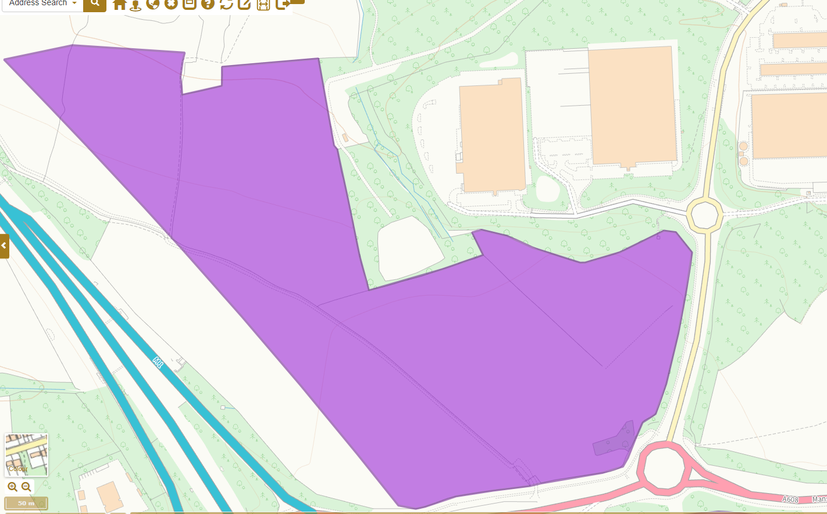

- Land south east of J27 of the M1 (Policy S6b)
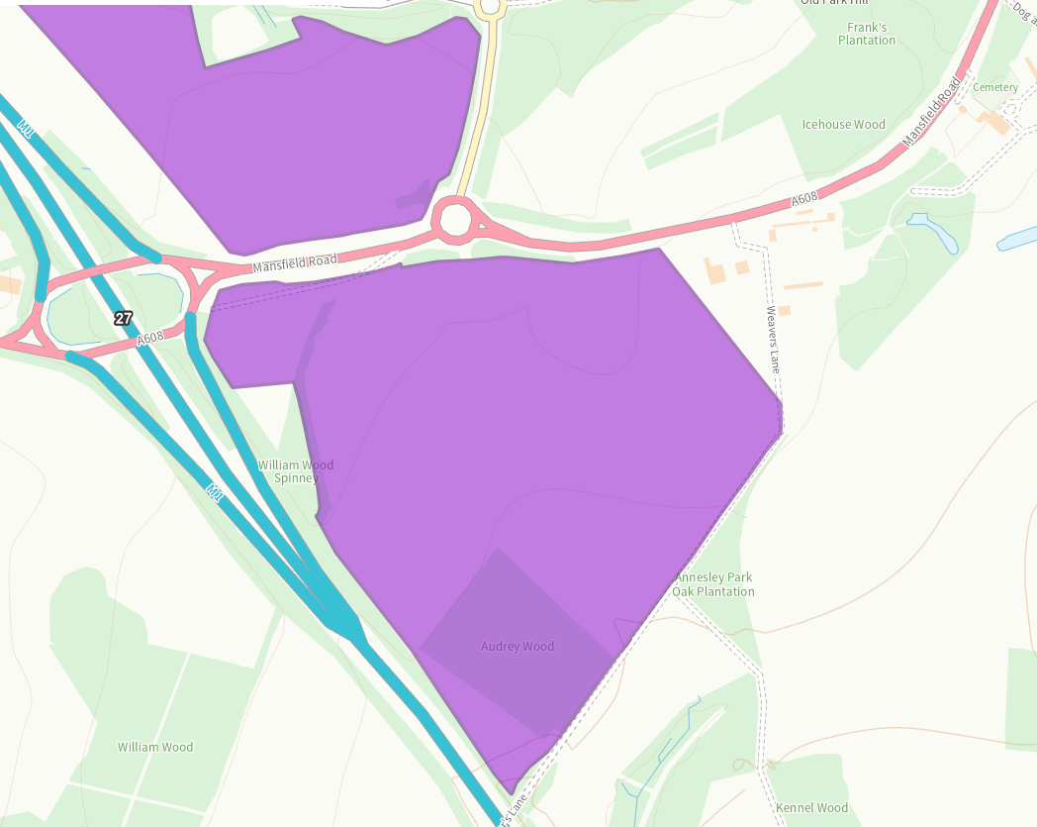

- EM2 S1 – Castlewood Business Park, Sutton in Ashfield
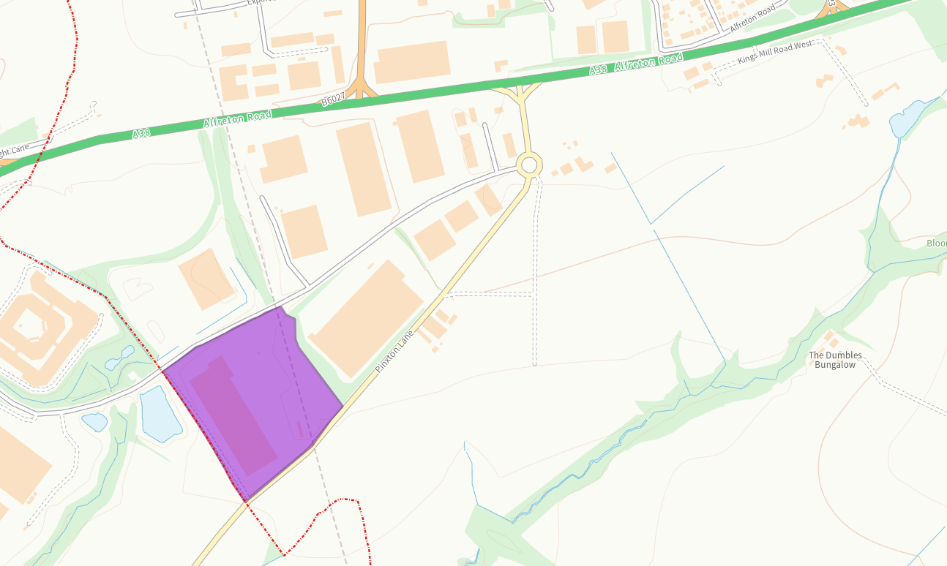

- EM2 S2 – Fulwood Road North, Sutton in Ashfield
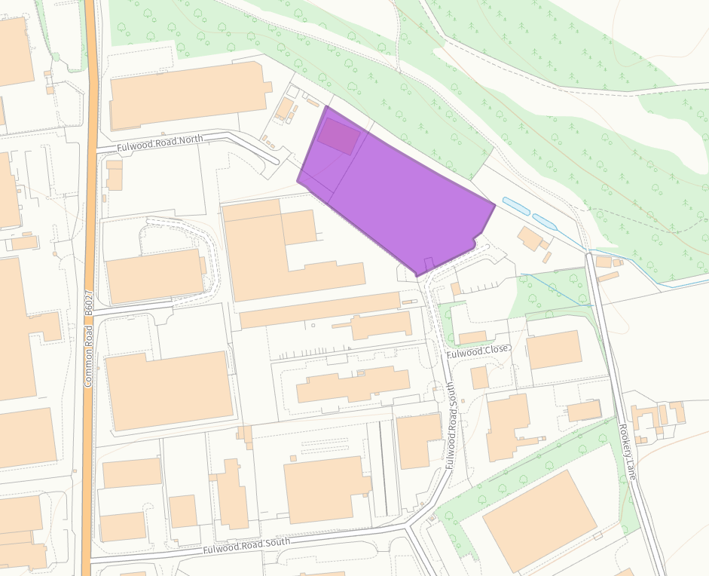

- EM2 S3 – Hamilton Road, Sutton in Ashfield
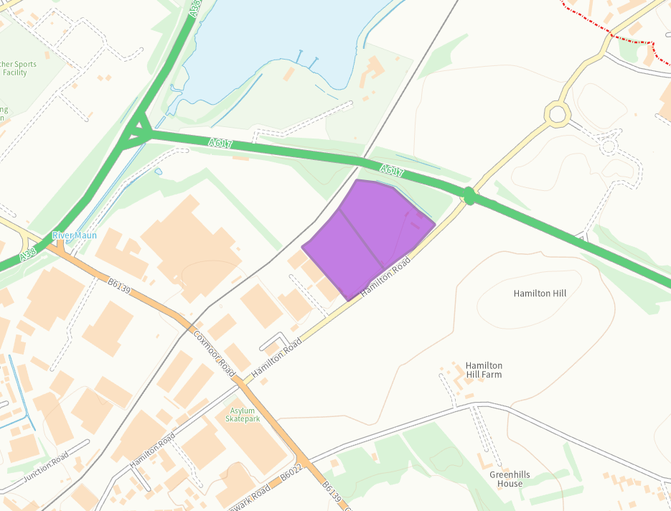

- EM2 S4 – West of Fulwood, Export Drive, Sutton in Ashfield
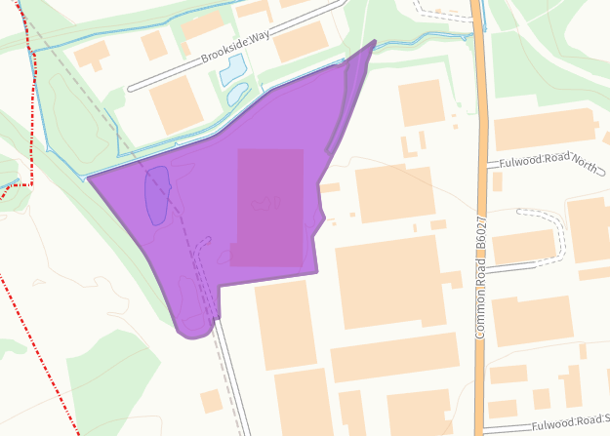

- EM2 K1 – Kings Mill Road, Kirkby in Ashfield
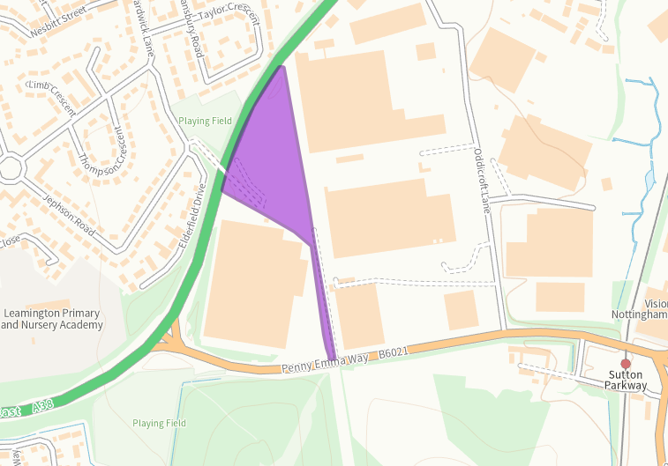

- EM2 K2 – Park Lane, Kirkby in Ashfield
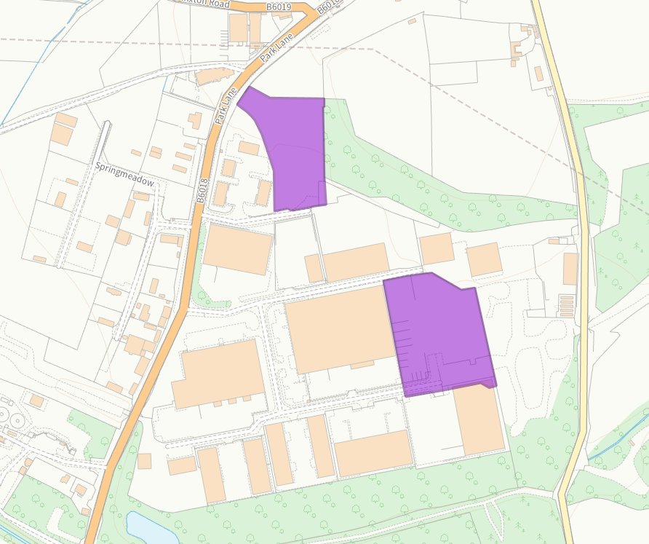

- EM2 K3 – Portland Industrial Park, Kirkby in Ashfield
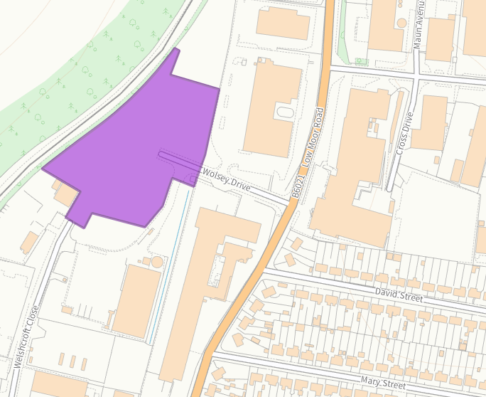

- EM2 K4 – Land to the East Lowmoor Road, Kirkby in Ashfield
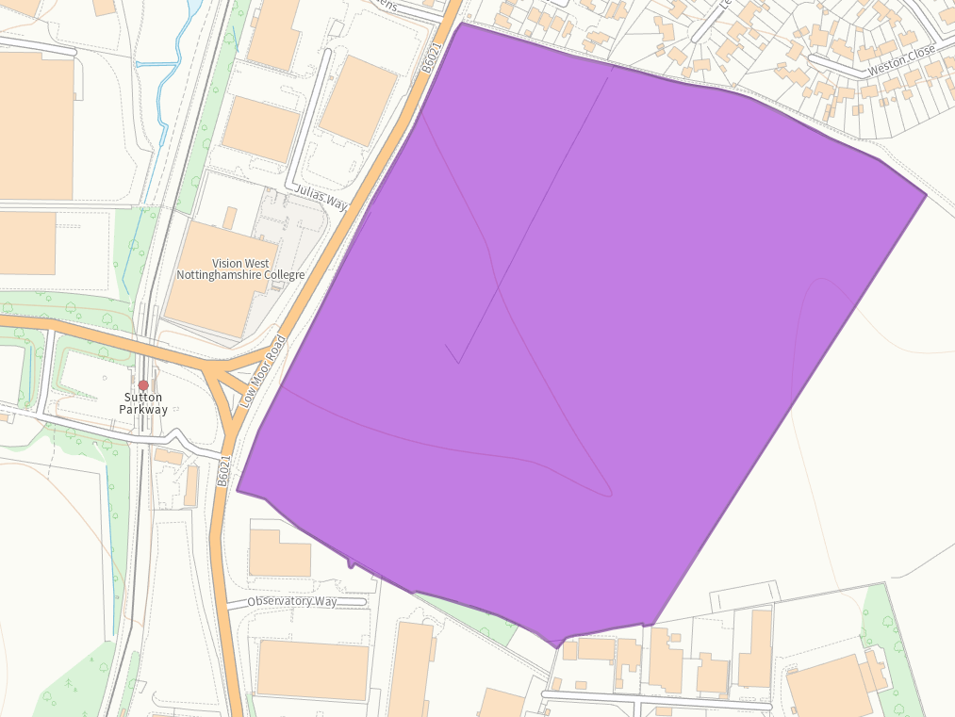

- EM2 H1 – Aerial Way, Hucknall
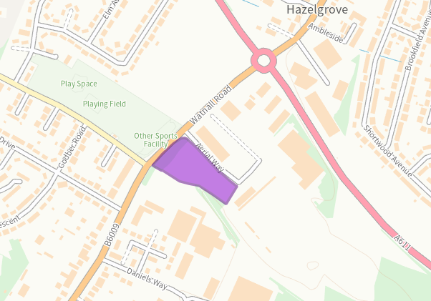

- EM2 H2 – Butlers Hill, Hucknall
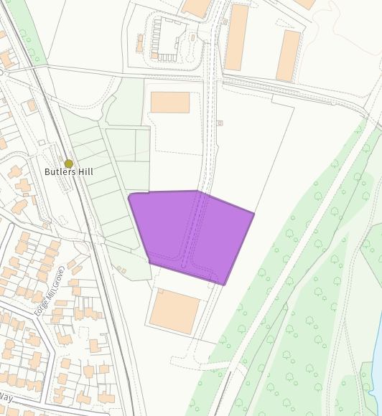
- EM2 H3 – Harrier Park, Hucknall
