Make your business better
Hucknall High Street

Shop Front Improvement Grant Scheme

Grant Information and Design Guidance

Contents Page

Hucknall High Street Shop Front Improvement Grant Scheme

- Introduction 1

- What is the Grant Scheme? 1

- Am I eligible to apply for a grant? 1

- What can I use the grant for? 2

- What can’t I use the grant for? 2

- How much grant could I receive? 3

- How do I apply? 3

- Due diligence checks 4

- How is the grant paid to applicants? 5

- Important Notes 5

- Next Steps 5
Shopfront Design Guidance

- Purpose of the Design Guidance 6

- Why Improve Shop Fronts? 7

- What is the Character of Hucknall High Street? 8

- Hucknall Town Centre Conservation Area 9

- Principles of Good Shop Front Design 11

- Details of Good Shop Front Design 13

- Security Measures on Shop Fronts 20
Hucknall High Street
Shop Front Improvement Grant Scheme
1. Introduction
The Council is committed to improving Hucknall’s town centre and restoring some of the built heritage that is so important to the town and its people. Well-designed, well-maintained, quality shop fronts project an image of quality and confidence, helping businesses to thrive and succeed.
2. What is the Grant Scheme?
As part of Ashfield’s allocation of the UK Shared Prosperity Fund (UKSPF), the Council has created a Shop Front Improvement Scheme. This will provide grant funding to eligible businesses and landlords with premises on Hucknall High Street (between the Bus Interchange and the Byron Cinema) to improve their property frontage (including doorway, display window, frame and signs).
3. Am I eligible to apply for a grant?
The grant is available to existing independent businesses or a chain of 5 or fewer UK locations, and landlords who would like to improve, replace, or carry out repairs to their shop front / business premises. Premises must be located in the area shown on the map below.
Premises must have a ground floor and street facing frontage.
Premises can be occupied or unoccupied.
If you are a tenant applying for the grant, you must obtain written permission from the property owner prior to making your application. You will also need to notify the property owner if you receive a grant offer from the Council.
Certain businesses are excluded from applying for this grant - these include pawn brokers, adult/private shops, betting shops, national and international chain stores, and residential properties.
4. What can I use the grant for?
The grant can contribute towards expenditure including the following:
- Reinstatement of traditionally style shop front
- Repairs to stonework/render/brickwork as part of wider shop front work
- Restoration/repair/repainting of acceptable or traditional shop fronts, including upper floors (where deemed appropriate)
- Removal of unsightly signs with new and appropriate signs
- Replacement shop front, windows, and doors (where appropriate)
- Double glazing as part of wider shop front works
- Appropriate lighting, for example for window a display
- Appropriate external artwork
- Installation of traditional and retractable shop blinds and canopies
- Replacement guttering and downpipes.
- Internal open mesh security grilles
- Disabled access improvements that meet the requirements of the Equalities Act, as part of wider shop front work
- Professional fees, such as architects, planning applications and building regulations.

Important:
The Council has a strong preference for the use of local suppliers and businesses to be utilised in any grant funded work, for the benefit of the local economy. Applicants should use suppliers located within a 45min travel area of applicant premises address wherever possible.

5. What can’t use the grant for?
The grant will NOT fund the following:
- Works already started or completed.
- Temporary window dressing (e.g. Christmas decorations)
- Routine repair work
- New roofing or repairs to chimneys, flashing etc.
- Installation of external and solid security shutters
- A-board signs
- Burglar alarms and CCTV equipment
- Costs associated with changes to branding.
6. How much grant could I receive?
Grants will pay for up to 80% of the eligible project cost (up to a maximum grant payment of £9,600, excluding VAT).
For example, to obtain the maximum grant of £9,600 applicants will need to spend at least £2,400 (excluding VAT). Maximum eligible total expenditure for the 80% grant would be £12,000. Any spend above this value must be borne by the applicant.
7. How do I apply?
Step 1: If you meet the initial eligibility criteria as outlined on pages 1 and 2, please contact the Forward Planning Team by emailing localplan@ashfield.gov.uk or by calling 01623 457383 to discuss your proposals. A site visit will then be arranged for one of our team to visit you at the premises for which you are applying for the grant. This meeting will help us to evaluate the suitability of this grant for your needs and to offer you design advice. Only items and work recommended by the Council will be eligible for grant payment to contribute towards shop front improvements.
Step 2: Applicants will need to provide the following documents and submit these via an online portal at https://www.ashfield.gov.uk/hucknall-high-street-shop-front-improvement-grant-scheme/
- A completed grant application form;
- Three written quotes for any single item costing over £3,000 (excluding VAT);
- Images/drawings of any new signs or alterations to the shop front, including details of materials, colours (RAL no.’s) etc;
- A copy of your latest business accounts; and
- Confirmation of any necessary approvals, if required, e.g. planning permission and building regulations. Applicants will need to evidence that all required permissions have been obtained or produce written confirmation from the Council that no permissions are required before a grant can be paid.
In all cases, applicants need to apply for the grant and obtain written approval of the application before any work is undertaken. The grant will not be paid towards the cost of transactions that have occurred before the date of the approval.
If you need additional support completing your online application form, please contact localplan@ashfield.gov.uk and ask to make an appointment to complete your application at our offices in Kirkby in Ashfield. One of our team will assist you to complete the application (We are not allowed to complete the application for you.)
Planning application advice is available by contacting the Duty Planner at Ashfield District Council on 01623 457388 or email dutyplanner@ashfield.gov.uk Further information is available at Ashfield District Council planning permission advice
For building control advice, please email buildingcontrol@erewash.gov.uk or telephone: 0115 907 2244. Please note that Erewash Borough Council handles applications and payments for us. Further information is available at: Ashfield District Council building control regulations advice
All applications will be subject to an assessment by a Panel and the amount offered will be at the discretion of the Panel and only whilst funds are available. The Panel’s decision is final and there is no right of appeal.
8. Due diligence checks
Ashfield District Council will undertake due diligence checks and will hold the following information on all applicants:
- Name of business
- Business Trading Address including postcode.
- Unique identifier (preferably Company Reference Number (CRN)) if applicable. If not applicable, VAT Registration Number, Self-Assessment Partnership Number, National Insurance Number, Unique Taxpayer Reference (UTR), Registered Charity Number are acceptable.
- Nature of Business
- Date business established.
- Number of employees
- Business rate account number (if applicable)
- Cumulative total of previous funding received under all grant schemes.
- Any outstanding debt to the Council
9. How is the grant paid to applicants?
As the grant is paid in arrears, applicants will need to pay for the total project before receiving the grant funding.
If the grant application is approved, applicants will have up to four months to submit copies of relevant invoices and business bank statements showing that eligible expenditure has been made. Failure to produce the relevant information with this timeframe may result in your grant being delayed or withdrawn.
- All invoices and bank statements must be dated after the grant approval date. Items purchased using cash will not be eligible for grant payment.
- To draw down the maximum grant of £9,600 applicants will need to provide evidence of expenditure on the agreed items of at least £12,000 (excluding VAT).
- The grant payment will be made directly into the applicant’s business bank account via BACS. A business bank account is a trading commercial account in the name of the applying business. All purchases must be made via the business account and all claim payments will be made to the same business account. Personal or current accounts are NOT eligible.
10. Important notes
The amount of funding a business can apply for is restricted to £9,600 in a 12-month period. This can be made from multiple eligible grants, available from the Council.
Any applicant who is offered and claims up to the scheme’s maximum amount (in this case £9,600 will not be eligible to apply to the same scheme again. even after a 12-month period has passed.
Applications submitted by Agents or Consultants will not be accepted. All applications must be submitted by the applicant.
This grant scheme will end on 31st March 2025. The closing date for applications is 31st October 2024.
11. Next steps
If you believe you have a project that meets the criteria of the grant scheme and would like to apply, then please request a meeting with a member of the Forward Planning Team by emailing localplan@ashfield.gov.uk or telephoning 01623 457383.
Please be advised that a meeting is required before you can access our online portal to complete an application form and make a submission.
Shop Front Design Guidance
12. Purpose of the Design Guidance
The Council is committed to improving Hucknall’s town centre and restoring some of the built heritage that is so important to the town and its people.
The purpose of this document is:
- To provide information on why it is so important to have a well-designed shop front.
- To provide information on the Hucknall Conservation and what implications this may have for any grant application submitted.
- To provide guidance on the design of new shop fronts, as well as for alterations and restoration of existing traditional shop fronts.
The Guide’s principles therefore apply to any property wanting to improve their shop front, including other commercial or community use as well as retail units. Shop fronts are a major contributor to an area’s distinctive identity and character.
An opportunity to:
‘MAKE YOUR BUSINESS BETTER!’

13. Why Improve Shop Fronts?
A shop front serves a number of purposes – to provide an attractive frame for the goods displayed, to advertise the presence of the shop, and to project an image for the business inside – a poorly kept shop front suggests that the goods and services offered will be poor. The same is true collectively for the town as a whole, with well-designed, well-maintained shop fronts projecting an image of quality for the town.
Shop fronts also play an important feature in defining the character and appearance of the centre of a historic town such as Hucknall. Improving Hucknall’s town centre shops will help nurture a quality retail environment that will help attract shoppers, visitors, and new businesses while providing a better experience for residents.
The benefits of improving the shop fronts include:
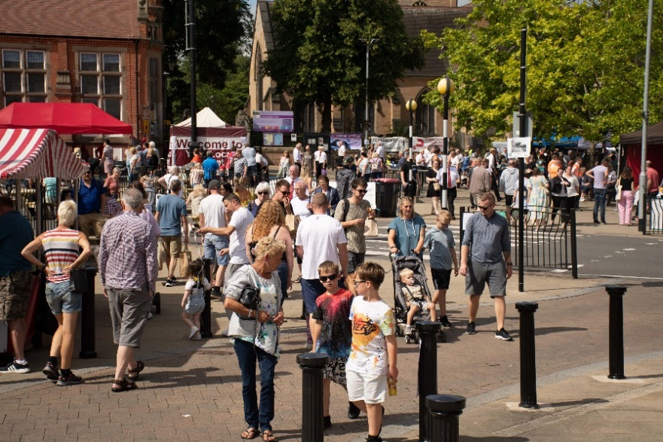 |  | Create a bustling town centre that people want to visit, linger, meet friends, and go shopping.  Increase footfall on the High Street, leading to new opportunities for businesses and the potential to create jobs.
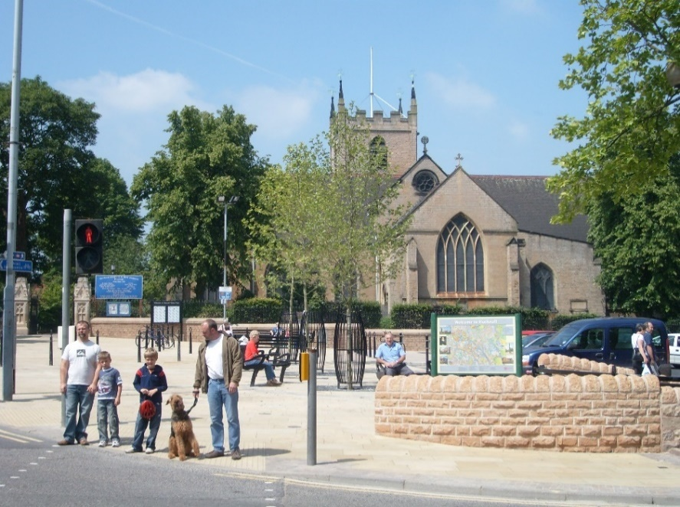 | Create a high-quality environment to enhance the historic character of Hucknall’s town centre.  Make the street more attractive.

14. What is the Character of Hucknall’s High Street
The buildings along High Street were mostly built in late 19th century replacing earlier buildings. Buildings are generally 3 storeys, brick, although a few of the earlier buildings are stone, with slate roofs. Elevations are decorated with the use of stone banding and decorative brick and terracotta detailing often seen as bands between stone window cills, lintels or forming cornices at eaves levels.
Many of the traditional sash windows have been lost but the window openings together with chimney stacks create rhythm in the street elevations at 2nd and 3rd floor.
Ground floors are mostly retail units, elements of traditional 19th century shop fronts survive in parts, although much has been lost. A number of buildings have canted or curved corners making them notable in the street scene.

High Street contains many buildings that contribute positively to the character and appearance of the conservation area. They include buildings that reflect the main architectural style of the area, or are of a particular architect, or have a landmark quality, or are associated with a particular event or person. These are buildings that the Council will seek their retention of, or sensitive alteration, where planning permission is required.
Some of the positive buildings along High Street:
Byron Cinema, built in the Art Deco style | Chequers PH (now residential)
Plough and Harrow PH | Important Curved Corner Building

15. Hucknall Town Centre Conservation Area
Hucknall High Street is part of the Hucknall Conservation Area, which was designated by Ashfield District Council in 2018, to preserve and enhance what is of architectural or historic interest in the area.
Conservation Areas are defined as:
“areas of special architectural or historic interest the character or appearance of which it is desirable to preserve or enhance” (section 69 (1) of the Planning (Listed Buildings and Conservation Areas) Act 1990.
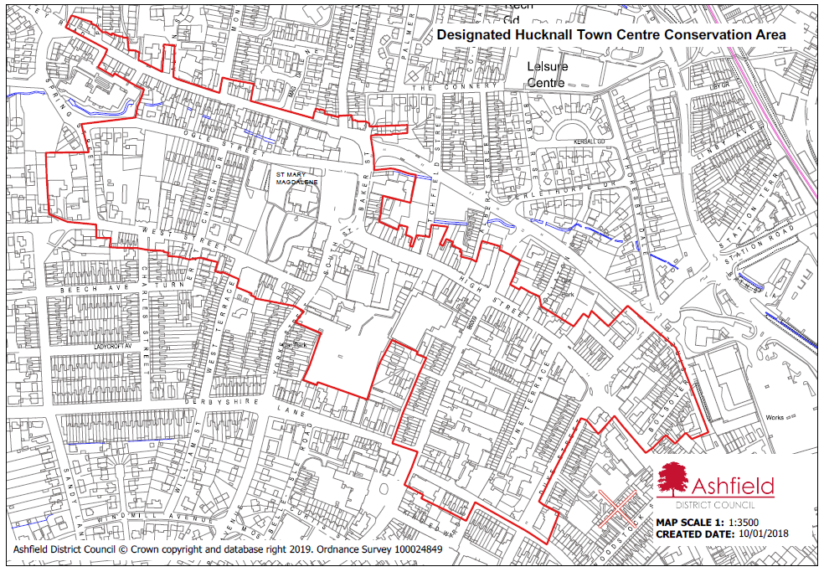
The emphasis within conservation areas is on ensuring local character is strengthened, not diminished, by change. Sensitive management of change is essential rather than no change at all. This is reflected in some extra planning controls and considerations being in place within conservation areas.
Changes to the external appearance of a building in a conservation area may require planning permission from the Council that is not required elsewhere, as some Permitted Development Rights are curtailed.
(Permitted Development Rights are a national grant of planning permission which allow certain building works and changes of use to be carried out without having to make a planning application but are subject to conditions and limitations to control impact and to protect local amenity.)
16. Principles of Good Shop Front Design
Traditional Shop Front
Traditional shop fronts are designed like picture frames; to set out the goods on display and distinguish each shop from its neighbours. This principle is a valuable basis for designing shop fronts of all types.
Good quality traditional shop fronts are the supported approach for proposals:
- In conservation areas.
- In street scenes with a prevalence of traditional shop fronts.
- Where the host building has a strong traditional character

The diagram below shows the typical elements of a Traditional Shop Front.
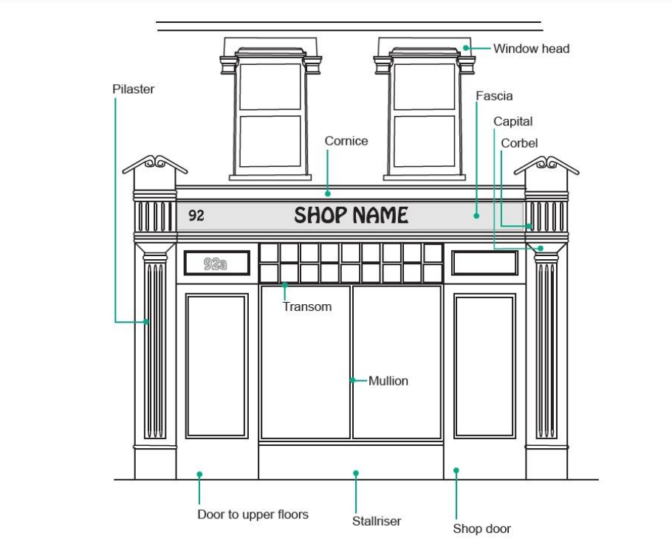

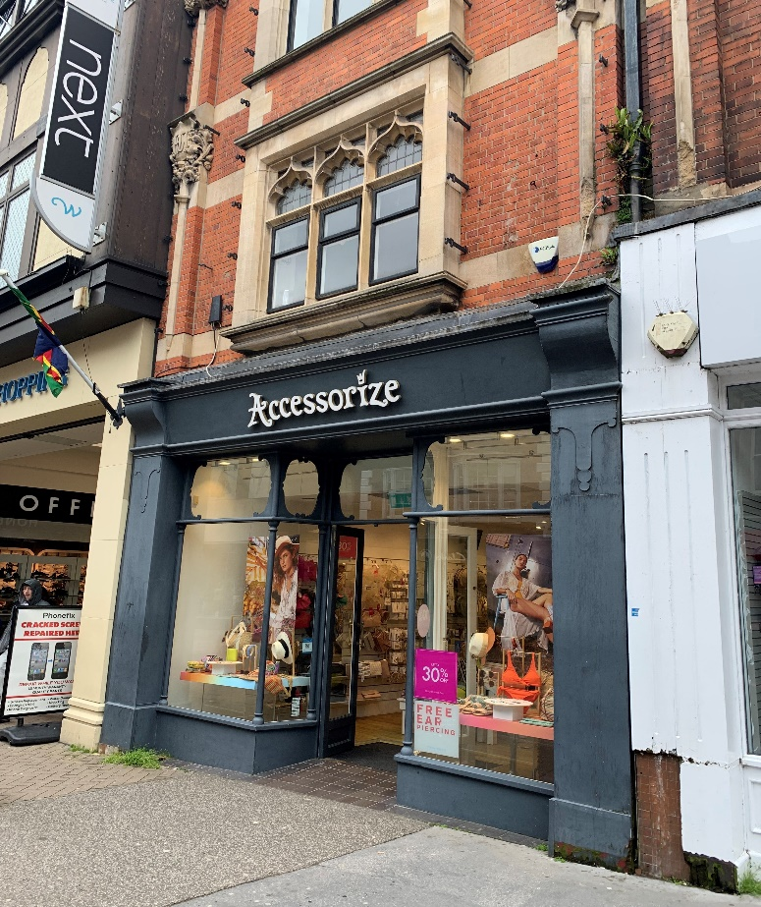 | Traditional shop front design as shown in the image opposite, incorporates elements such as transom windows, decorative pilasters, and corbels.  Features such as these give traditional shop fronts a strong sense of character as a result of these being more decorative and detailed than modern approaches.

Modern Interpretation of a Traditional Shop Front
In many instances, the character of the host building or the street will provide opportunities to provide a more modern interpretation of the traditional shop front. This approach is typically appropriate where there is a difference between the character of the host building and the wider street.
Modern interpretations of traditional shop fronts generally have less ornamental detailing than traditional shop fronts, but they still create a ‘frame’ to the shop front. In order that these modern interpretations enhance the character and appearance of retail areas these should include well-proportioned components which also exhibit a level of depth and detailing to these.
The diagram below shows a Modern Interpretation of a Traditional Shop Front.
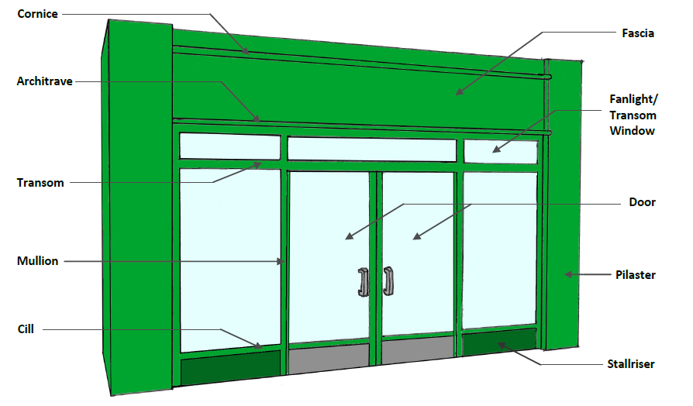
Modern interpretation shop front design as shown in the image opposite is typically less decorative than traditional designs but still incorporates the same elements albeit in a in a simpler, more contemporary manner. | 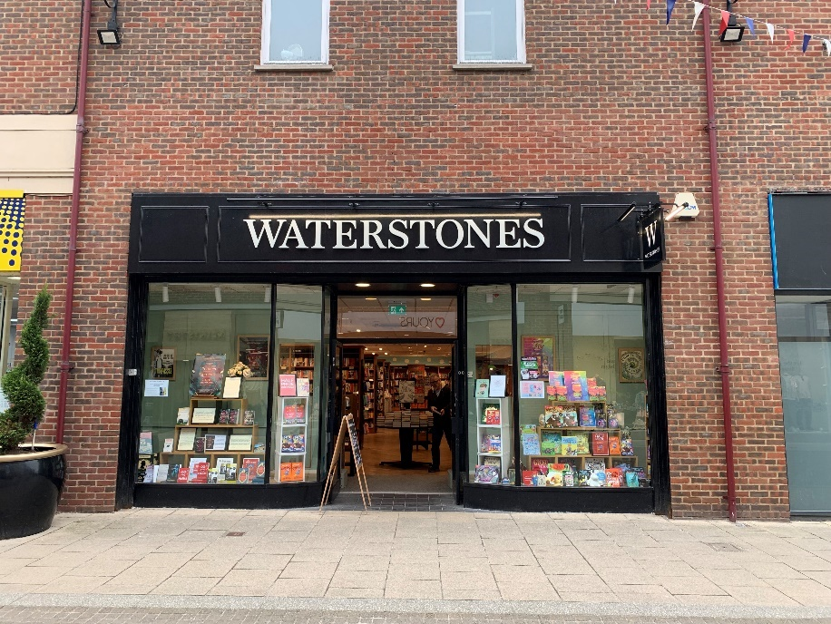
17. Details of Good Shop Front Design:
- Fascia
This is perhaps the most important element of a shop front. The fascia is the uppermost, and most visually prominent element of the shop front’s frame and provides the hoarding upon which the name of the shop is generally displayed. In traditional shop fronts, the fascia itself should be made of timber, with hand-painted lettering.
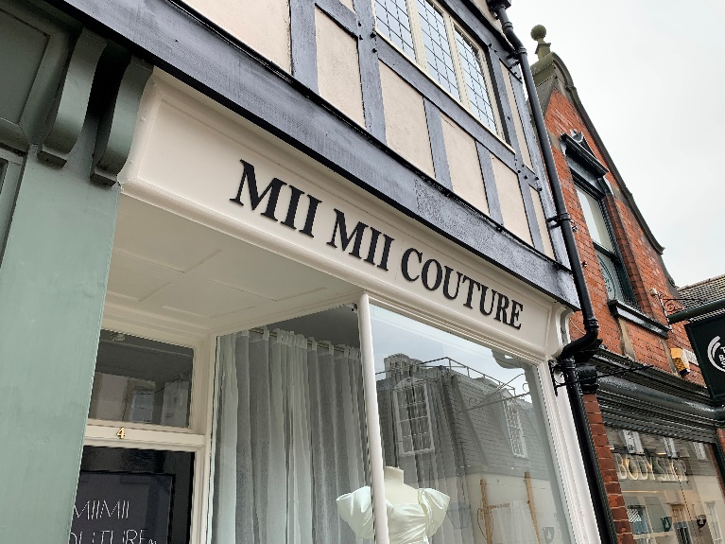 | 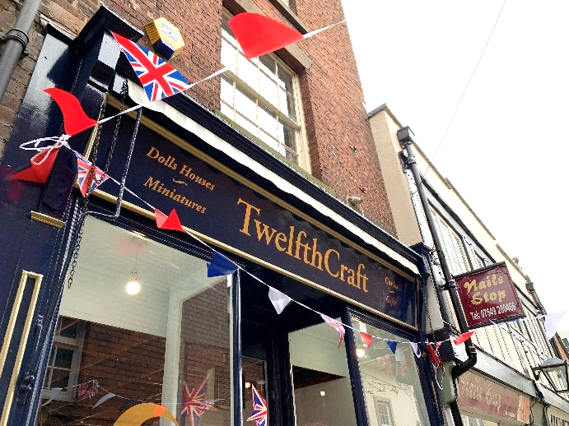

The depth of the fascia is crucial and should be in proportion both to the other elements of the frame (including the stallriser and pilasters) and to the elevation as a whole. It should not be excessively deep (no taller than 600mm, though traditionally they were closer to 400mm), as not only are deep fascias not locally traditional, but they can be unduly visually dominant, leading to the shop front having a top-heavy appearance.
The fascia should be kept well below first-floor window cill level, sit below the cornice and between the pillasters. It may be aligned with the wall planeor may occasionally be canted forwards in order to make it more legible to shoppers.
Many original fascias have been either covered up with new pvc signs or have been lost. Surviving fascia boards should be retained and re-used. Internally illuminated box fascias are not appropriate in a Conservation Area.
- Stallriser
The stallriser is the built-up area between the pavement and the window of a shop.  It reduces the risk of damage to the glazing and provides a solid base for window displays. Surviving stallrisers should be retained and restored. If lost or altered, they should be reinstated to the original height (typically between 450mm and 750mm) and using appropriate materials, for example, brick, render, tiles stone or hardwood panels. | 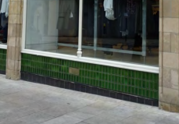
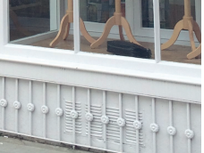 | 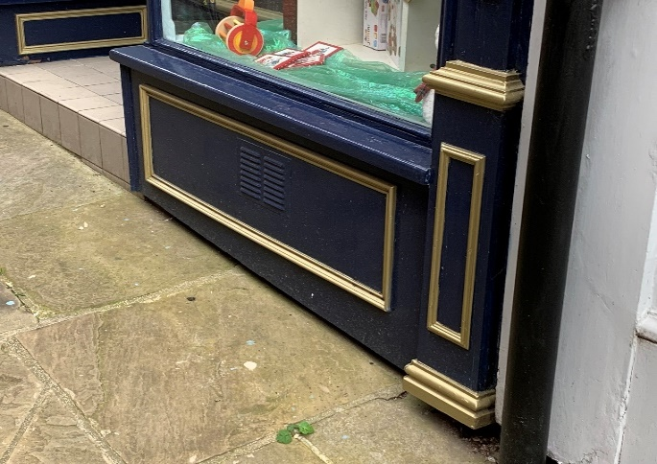
- Pilasters
Pilasters are non-structural shallow columns (typically between 100mm and 300mm) that project out of the wall and often provides a vertical separation between shops. Along with the cornice and corbel brackets, they form a ‘frame’, which the rest of the shop front is contained within. Often over time original pilasters are covered up but remain in place, hidden by more modern additions. Any remaining pilasters, including their details, should be uncovered, retained, and restored or, if lost, replaced in a style in keeping with the building.
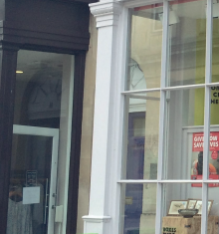 | 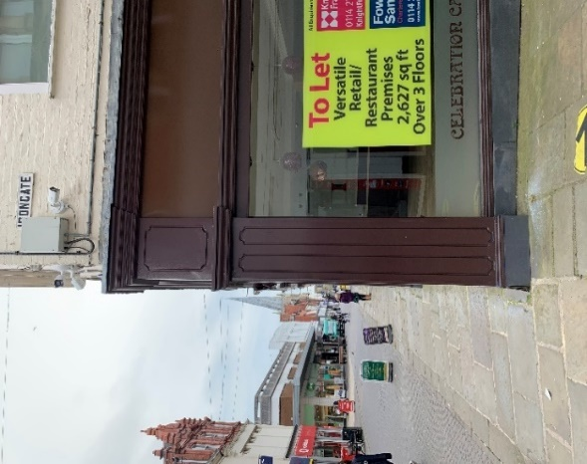 | 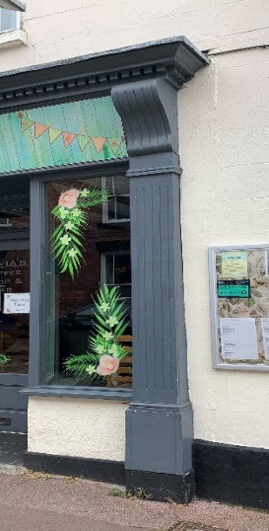 | 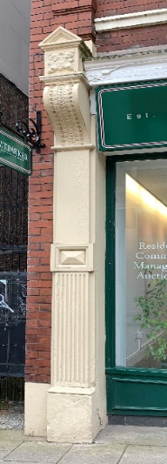
- Cornice
A cornice (Italian for a ledge) provides an attractive horizontal division between the shop front and the floors above.
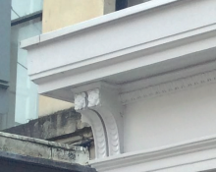 | Originally its purpose was to draw away water from the building to prevent damaging the fabric of the building. It is usually constructed of stone or timber with a lead flashing.
Surviving cornices should be retained and restored or reinstated if missing. | 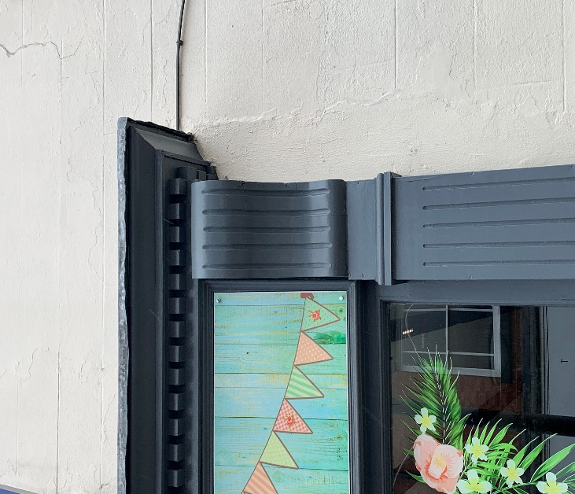
- Corbels and Capitals
Corbel brackets provide support to the cornice and are usually located, though not always, at the top of pilasters. Original corbel brackets should be retained or restored. Where capitals are present, these typically ‘support’ the fascia.
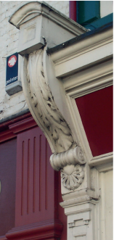 | 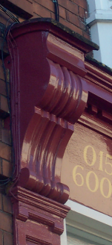 | 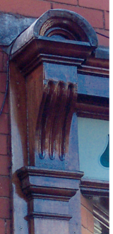 | 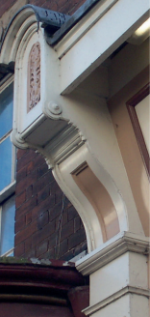
Corbels are often very decorative and add character to a shopfront.
- Transoms and Mullions
Transoms and mullions form the principle vertical and horizontal members (beam, bar, or crosspiece) of the shop window. They were always profiled and not simply square or rectangular as seen often in modern shopfronts.
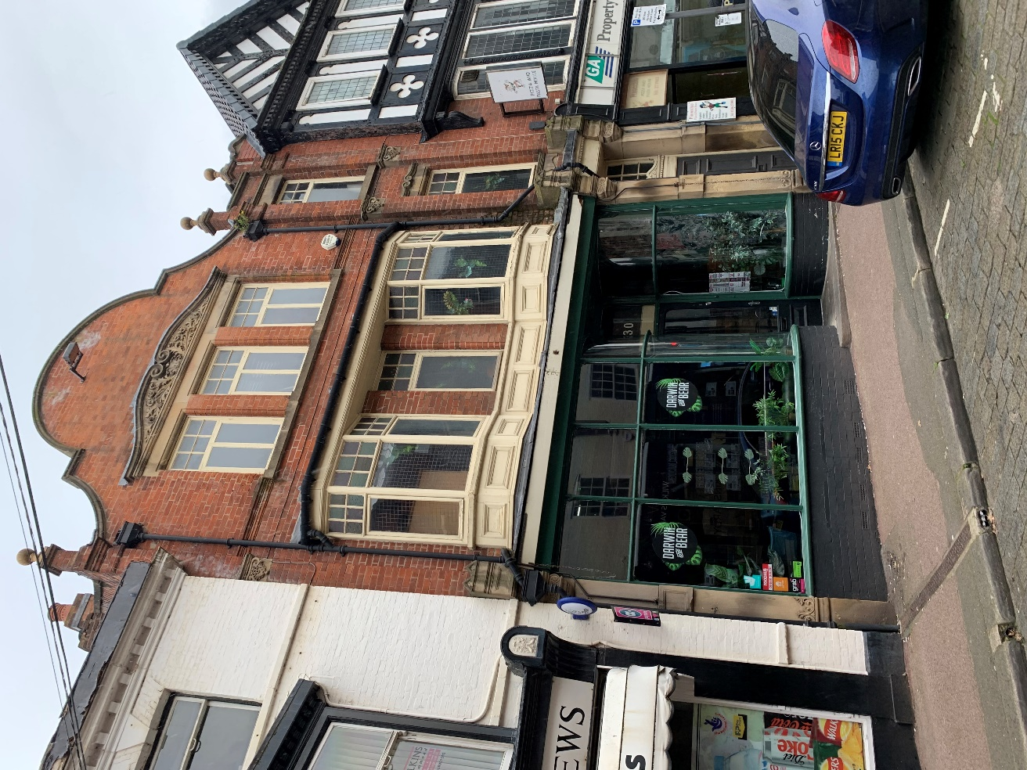 | 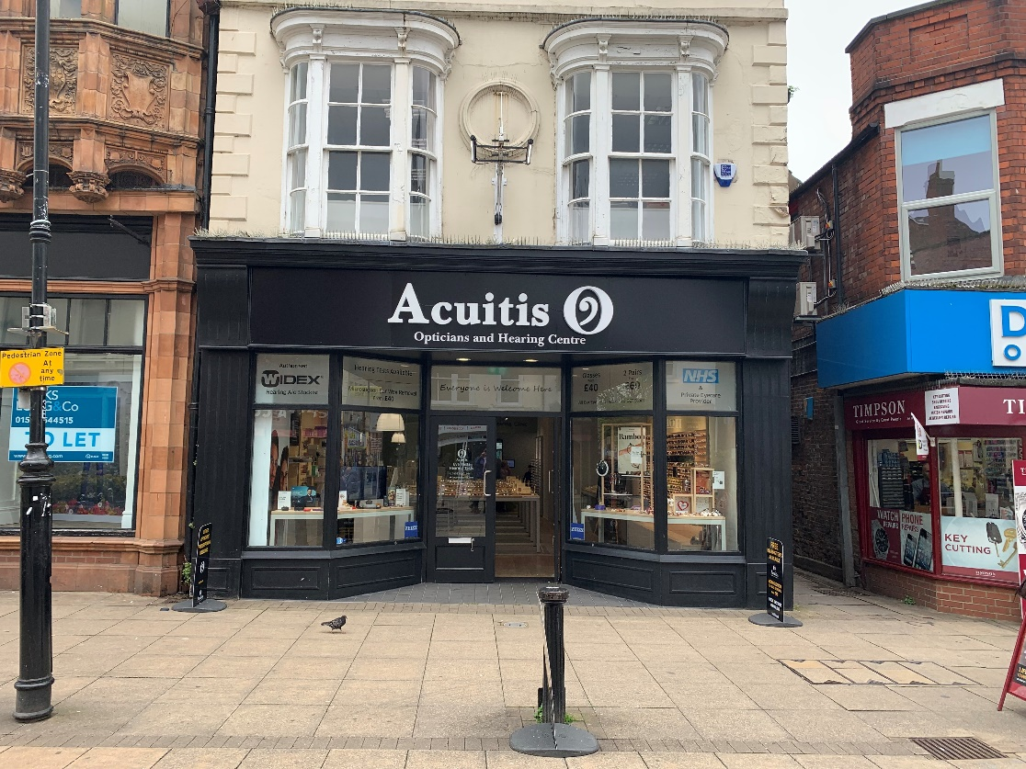
- Entrance Door
The design of the entrance door must be integral with the design and layout of the whole shopfront. Painted timber, part-glazed doors are recommended for shop entrances: the material used and the finish should match that of the main shopfront frame. A solid panel at the base of a glazed door should be used and this should coincide with the line of the stallriser.
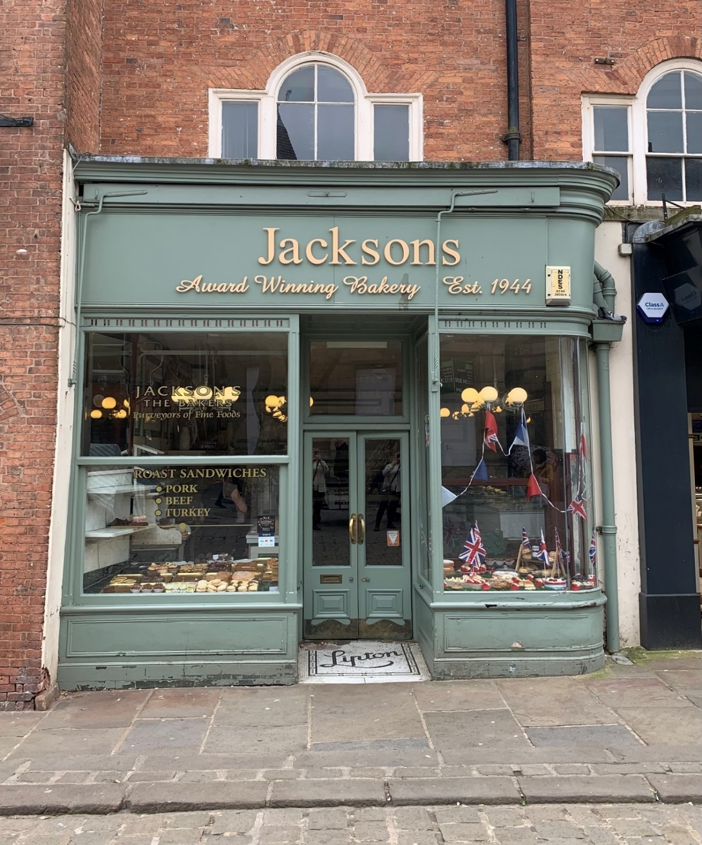 | 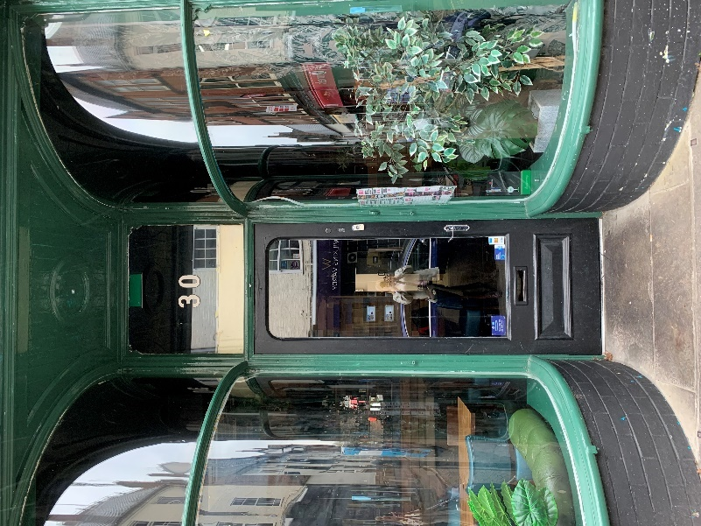
All new designs should conform to the Equalities Act 2010 in allowing all members of the public access to the premises. The only exception to this is where the loss of historic fabric would be more harmful than the public benefit of the adaptation.
- Window Display
An interesting window display should showcase the goods for sale in the shop, which attracts customers and enlivens the street. Windows should be used to display goods for sale, not for advertising signs.
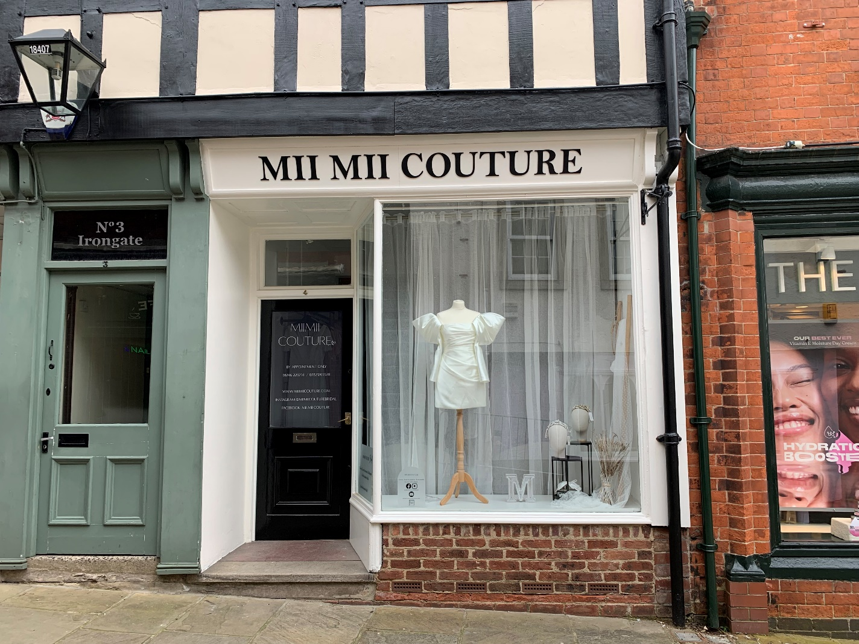
As the majority of a shop fronts will comprise a window display, the treatment of this aspect of its design is also important, both for the appearance and success of the shop itself, and for that of the street and wider area. Clarity and an absence of visual clutter are generally key ingredients in a successful window display: a few carefully chosen, and well displayed items are likely to result in a more eye-catching and enticing display than one crammed haphazardly with goods.
- Materials & Colour
Painted timber (hardwood or softwood) is the traditional material for shop fronts. It is versatile, durable, relatively cost effective and simple to maintain and refurbish. If choosing softwood, a slow growing softwood will be preferred. Accoya is a FSC certified, high-performance alternative to hardwood, offering a more sustainable and environmentally friendly approach. Materials such as aluminium and plastic (uPVC, acrylic or Perspex) are not generally appropriate for shop fronts in historical contexts, being conspicuously modern materials that tend to look out of place on historic buildings.

There is no standard formula for shop front paint schemes. However, restrained, dark colours often work well, as they can act as a strong frame for window displays. Lighter colours tend to appear more intrusive, look dirty or faded more quickly and need more frequent maintenance.
While traditional paint colours are encouraged, there is also scope for more modern and contemporary colour palettes to be introduced where appropriate.
- Signs
The purpose of shop front signs is primarily to inform shoppers of the name and nature of the business. It is important that shop signs are well designed in their own right and relate meaningfully to the design of the shop front as a whole, and to the elevation / building more widely.
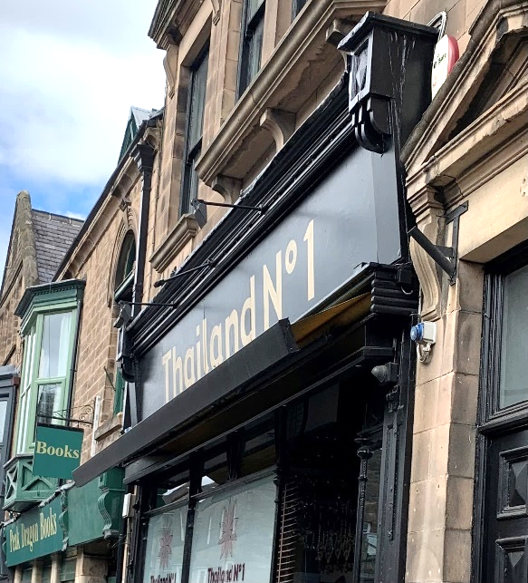 | 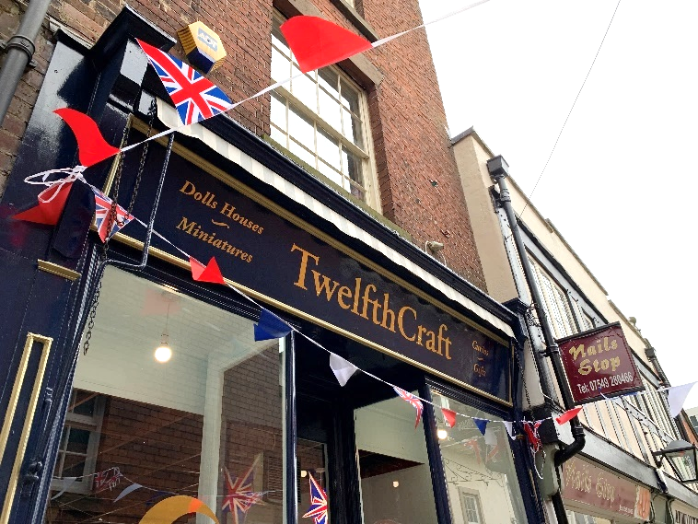
Lettering and text in particular should be carefully considered in terms of their design, colour, and size of typography. Lettering on principal signs should be sign-painted on timber wherever possible. The use of individual wood, metal or porcelain letters may also be appropriate.
On principal signs (fascia) the name and nature of the business is generally sufficient. Other information, including opening times and contact details can be displayed on much smaller secondary signs, on entrance doors or within windows. Excessive signs (including excessive text upon signs) can lead not only to a visually cluttered shop front, but also to a dilution of the message and branding being the character of the elevation/ building.
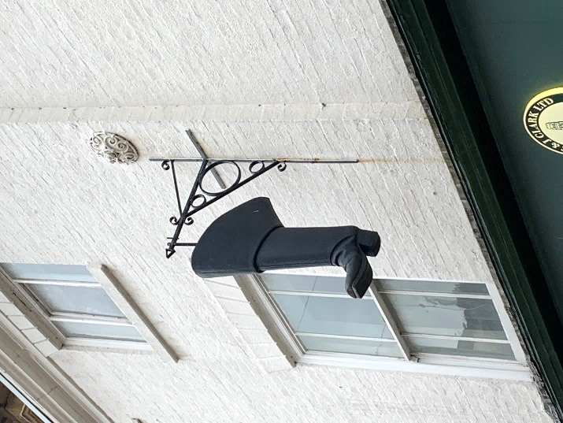 | 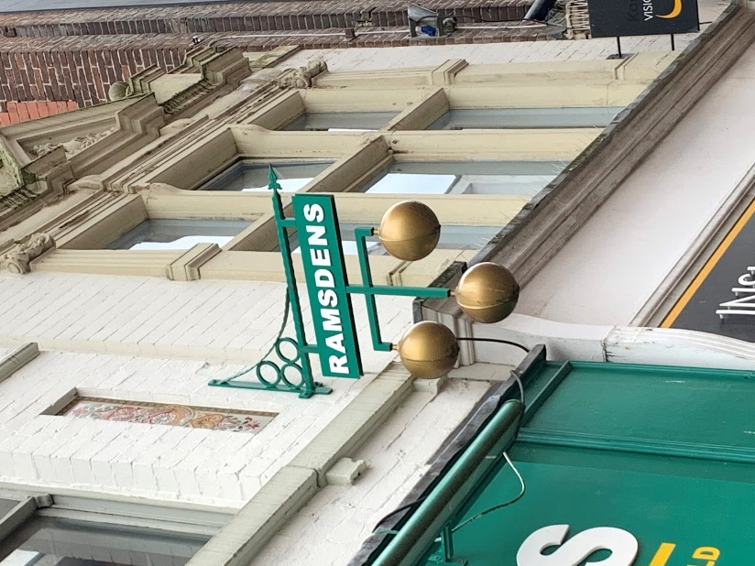
Hanging signs can be particularly attractive when their shape reflects the goods and services offered.
- Illumination and Lighting
To protect visual amenity, vehicular and pedestrian safety and to reduce and minimise light pollution and energy consumption, unnecessary illumination of signs and projecting box signs will not be permitted. Some down lighting or concealed lighting may be agreeable in justifiable cases.
Late-night venues such as bars and public houses will require some lighting. Where lighting is necessary, it should be minimal in nature and used sparingly. Lighting should also be low energy.
- Other Elements
 | Decorative Elements - such as tiling, mosaics, or trade emblems like barber’s poles should be retained.

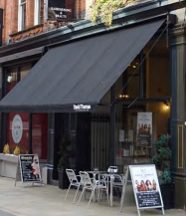 | Blinds and Canopies - Retractable blinds and Canopies were part of the historic streetscape of Hucknall and many high-streets in England. Where blind boxes still exist it is usually possible to restore the blind to working use by renovating the mechanism and installing new blind cloth.

External Alarm Boxes - act as a visual deterrent but can also detract from the shopfront. They should be sited inconspicuously and painted to match the frontage.

Ironmongery - Traditional ironmongery such as door handles, letterboxes and window fittings are often overlooked, however, these contribute to the character of a shop front and should be retained and refurbished.

Glazing – Where original windows in shopfronts survive, these should be retained. Where replacement windows are necessary, double or triple glazed units in timber frames will enhance the thermal properties of a building and help reduce carbon emissions. Units should be high quality, slim in profile and of a appropriate design in context with the host building.
18. Security Measures on Shop Fronts
Security considerations are an integral part of re-designing the shop front.
Over recent years many businesses have installed rolling shutters, which while understandably providing security are unsightly when closed, inappropriate to historic buildings, and add to the unwelcome feeling of a town centre which can contribute to the town centre’s decline.
Shutters are not normally integrated in to the historic building and alongside inappropriate signs contribute to distorting proportions.  Shutters obscure the display within the window and contribute to the feeling that a high street is unsafe and /or unwelcoming. | 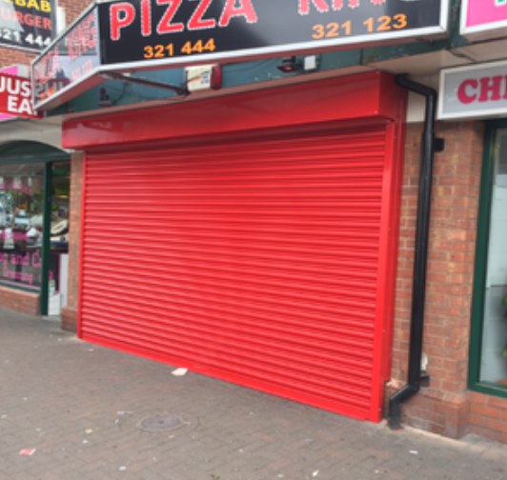

Alternative Solutions
There are other, more appropriate, security solutions to rolling shutters that will enhance the appearance of the shop and its displays, adding to the quality of the High Street and contributing to building a thriving Hucknall town centre. Examples include, removable external metal grills, internal open grid grills, improved CCTV, security safety glass, or a combination of all these.
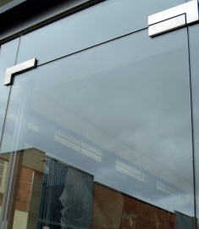 | 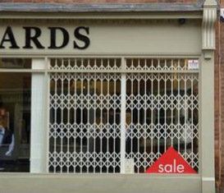
Security Safety Glass | Internal Open Grills

