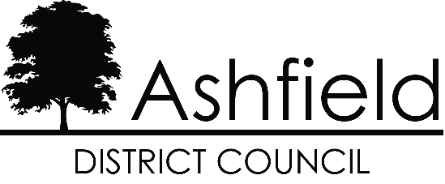

Full Equality Impact Assessment (EIA)
Impact assessment should be considered in the full range of functions, activities and decisions that the organisation is responsible for. Their purpose is to analyse policies and practices to ensure that they do not discriminate or disadvantage people. They must be relevant and proportionate to the level of changes and impact and where potential for disadvantage is identified they should demonstrate plans to eliminate.
Complete a full equality impact assessment where there is a potential risk of disadvantage to groups or individuals representative of the protected characteristics.

Which Function/policy are you assessing?

Damp and Mould Policy

2. Who is responsible for this Function/policy? (Manager and Section)

Chris Clipstone, Assistant Director – Housing Operations

3. What changes are you proposing to this service?

Policy reviewed to include reference to Awaab’s Law

4. What potential impact will these changes have on each equality strand?

Equality Strand | Positive  (Please provide evidence) | Negative  (Please provide evidence) | Unmet Need  (please provide evidence)
Age | Emphasis within the new legislation on recognising the adverse effects Damp and Mould can have on young children and acting quickly to reduce harm | N/A | N/A
Disability | Emphasis within the new legislation on recognising the adverse effects Damp and Mould can have on various vulnerabilities and acting quickly to reduce harm | N/A | N/A
Gender | N/A | N/A | N/A
Race | N/A | N/A | N/A
Religion or Belief | N/A | N/A | N/A
Sexual Orientation | N/A | N/A | N/A
Socio Economic (Deprivation) | Emphasis within the new legislation on recognising socio economic issues and supporting tenants to improve their housing situation. | There is a requirement for tenants to use the heating within the property. Tenants on low incomes may not use this. Lack of heating causes cold surfaces, leading to condensation which fuels damp and black mould growth.

What evidence or data do you have that supports your assessment?

For example usage, customer feedback, consultation, comparative information etc.#

Consultation with tenants
Awaab’s Law / Damp and Mould – Special Interest Group
Tenants completed the Housing Ombudsman Service’s ‘Spotlight on Damp and Mould’ eLearning. They then developed reality-check questions for tenants with recent damp and mould cases and met with management colleagues across the Housing Operations Directorate to gather information.

Learning
Tenants completed Housing Ombudsman Service Centre for learning eLearning and reviewed the two Housing Ombudsman Service Spotlight reports:
- Spotlight report on damp and mould – it’s not a lifestyle
- Follow up: Spotlight on damp and mould – it’s not lifestyle
- Reviewing the spotlight reports and completing the learning enabled tenants to understand national failings and learning from cases, the Ombudsman’s expectations, and how Awaab’s Law changes landlord responsibilities.

Meetings with Staff
Tenants met with managers responsible for damp and mould on 11 June 2025 and 31 October 2025. Following these meetings, tenants are confident that:
- The council’s Damp and Mould Policy reflect Awaab’s Law timescales.
- All housing and repairs staff complete mandatory annual learning.
- All damp and mould reports are triaged at first contact, ensuring cases are prioritised correctly.
- A decant policy is in place for severe cases.
- Systems have been updated to monitor compliance against Awaab’s Law.
- Tenant vulnerabilities are identified via Capita the Capita Housing system.

Reality Checks
Between November 2024 and May 2025 Ashfield Council received 317 reports of Damp and Mould. The group contacted 178 tenants with email addresses. Fifteen responded (8% response rate).
Key findings:
- Tenants experienced damp and mould in kitchens, hallways, landings, bathrooms and bedrooms.
- 47% said their issue was resolved to their satisfaction; 53% said it was not.
- 60% felt well-informed throughout their case.
- 47% felt the council takes damp and mould reports seriously.
- 40% said damp and mould had returned in the same areas

Tenant Profiling

Summary of Indices of Deprivation 2025
Ashfield District Council has 77 Lower Super Output Areas (LSOA’s) in the district and 9 of them are in the most deprived 10% in the Country a further 12 are in the most deprived 20% of LSOA’s in the Country.
Ashfield is more deprived in the Overall IMD than 75% of all local authority districts in Nottinghamshire.
Pink dots represent Ashfield, and grey dots represent other Districts in Nottinghamshire. 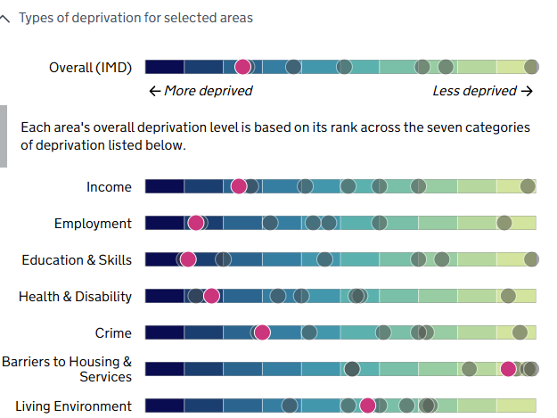
The most deprived LSOA’s are concentrated in Ashfield and Ashfield has 2 LSOAs which are in the 10% most deprived in England.
- Kirkby: Coniston Road area
- Sutton: Leamington Estate
Large parts of Sutton, Kirkby and Hucknall are ranked in the top 20% of the most deprived wards in the country.
The following issues have been highlighted in Ashfield by Census 2021:
- 20% of population are under 18 and 20% are over 65 years old.
- Ashfield ranked average among local authority areas in England for health in 2021.
- Worse than median 16-64 years with a level 3 or above qualification.
- Life expectancy is lower in male and females in Ashfield compared to
Nottinghamshire and England overall.
- The median gross weekly wage for Ashfield is far lower than England average and lower than Nottinghamshire average.
- Taken from ONS around 2,600 people aged 16 and over in Ashfield are unemployed at year end December 2023 rate of 4.9%.
From the research and analysis that we have undertaken, we can see that amongst our tenant base:
- 61.6% of tenants are female.
- 84.0% of tenants are White British
- 40% are between 50-70 years, while 22% are 70 plus

Age of all tenants

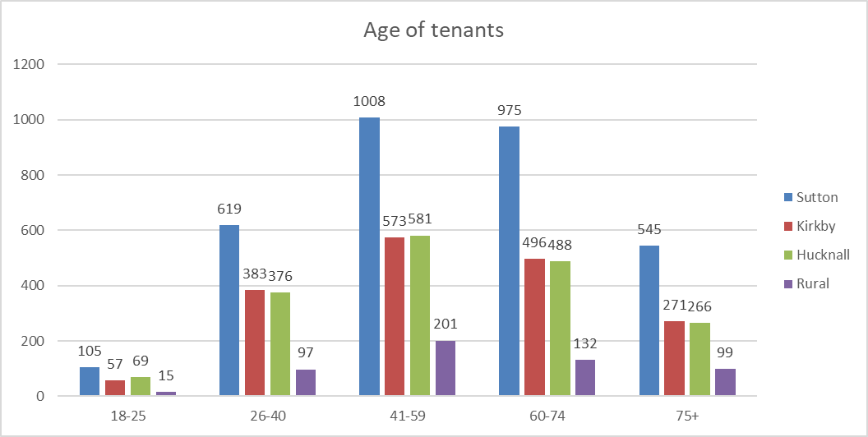
The table shows the breakdown of tenants based on age bands.
The lowest number of tenants in all areas was in 18-25 age group followed by 75+. The highest proportion of tenants fall in the 41-59 category but 60-74 are still increasing from previous profiles.
Age band | Percentage of residents (End of 2024 - 2025) | Change from end of 2024 - 2025
18-25 | 3.34% (3.43%) | Down 0.09%
26-40 | 20.05% (20.46%) | Down 0.41%
41-59 | 32.12% (32.73%) | Down 0.61%
60-74 | 28.43% (28.13%) | Up 0.30%
75+ | 16.05% (15.85%) | Up 0.20%
Total | 100.00%

Vulnerabilities
Area | Autism | Blind | Cancer | Care Leaver | Deaf | Dementia | Dependency  issues | Disabled -  prefer not  to say | Disabled -  other | Learning  disability | Literacy | Mental  Health | Mobility | Respiratory | Survivor  of DV | Wheelchair  user
Hucknall | 19 | 21 | 7 | 4 | 44 | 2 | 10 | 4 | 46 | 51 | 20 | 226 | 215 | 18 | 10 | 26
Kirkby in Ashfield | 32 | 35 | 10 | 3 | 51 | 6 | 4 | 0 | 56 | 55 | 11 | 1051 | 326 | 15 | 21 | 27
Rural | 7 | 9 | 5 | 0 | 12 | 1 | 1 | 2 | 15 | 18 | 7 | 273 | 87 | 6 | 7 | 3
Sutton in Ashfield | 54 | 47 | 12 | 12 | 86 | 14 | 8 | 1 | 93 | 178 | 6 | 1315 | 679 | 36 | 18 | 40
Total | 112 | 112 | 34 | 19 | 193 | 23 | 23 | 7 | 210 | 302 | 44 | 3469 | 1307 | 75 | 56 | 96
Percentage | 0.77% | 0.77% | 0.23% | 0.13% | 1.33% | 0.16% | 0.16% | 0.05% | 1.45% | 2.08% | 0.30% | 23.87% | 8.99% | 0.52% | 0.39% | 0.66%
The vulnerability categories have been updated, and some have been pre-populated from old categories.
The tenancy audit is now underway, so the above information will be refreshed in future reports. Currently the vulnerability in which the highest number of tenants have disclosed is mental health followed by mobility.

Action plan

5. If you have found a negative impact, what are the concerns?

6. What action do you plan to take to mitigate this impact? This could involve consultation with those affected.

7. What is the target date for these actions?

8. Who is responsible?

5. Concern | 6. Action | 7. Target Date | 8. Responsible
Tenants on low incomes may not use their heating. Lack of heating causes cold surfaces, leading to condensation which fuels damp and black mould growth. | Money Management Advice and support can be provided to tenants to enable them to manage their money, maximise their income and access support. This includes budgeting support, assistance with maximising income, accessing utility funds and any grants available e.g. NCC’s Household Support Fund (fuel vouchers). Advice can also be provided on utility tariffs and how to swap to these. | Ongoing | Money Management Advisors in the Housing Management Department

9. Explain how you have included these actions to mitigate within your service plan

N/A

Date: | 16 February 2026
Signed - Chris Barley | Chris Barley

