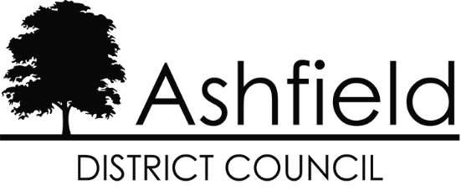

Ashfield District Local Plan Examination

Housing Allocation Permission Status:

Update from 3rd December 2025

ADC.22

8th January 2026

The following table provides an update of changes to the planning status of proposed allocations between 3rd December 2025 and 8th January 2026 and serves as an addendum to the schedule of sites set out in ADC.20a in the Examination Library.

Site Allocation Ref. | Planning Application Ref | Address | Yield | Planning Status
H1Km | V/2023/0312 | Abbey Road, Kirkby. | 38 | Outline Permission granted 16th Dec 2025.
H1Kq | V/2024/0422 V/2025/0433 | Former Wyvern Club site, Lane End, Kirkby. | 12 | Full PP for demolition. Resolution to grant Full subject to a Unilateral Undertaking (Draft UU published 10th December 2025).
H1Ss | V/2023/0679 | Land to the east of A6075 Beck Lane, Skegby. | 230 | Outline Permission granted 23rd Dec 2025.  Note that Nexus assumes delivery in 2027 at 40 dpa if consented in 2025 (see HS10.12).
H1Vc | V/2022/0653 | Land adj. Bull & Butcher PH, Selston | 149 | Resolved to grant O/L PP subject to s106 for 149 dwgs plus commercial at 10th Dec Committee. Will be referred to SoS due to current Green Belt designation.

