

DISCLAIMER

This document or some parts of it may not be accessible when using adaptive technology.

If you require assistance with accessing the content of the document, please contact us and quote the document name and the web page you found it on:

- email: Regeneration – place@ashfield.gov.uk

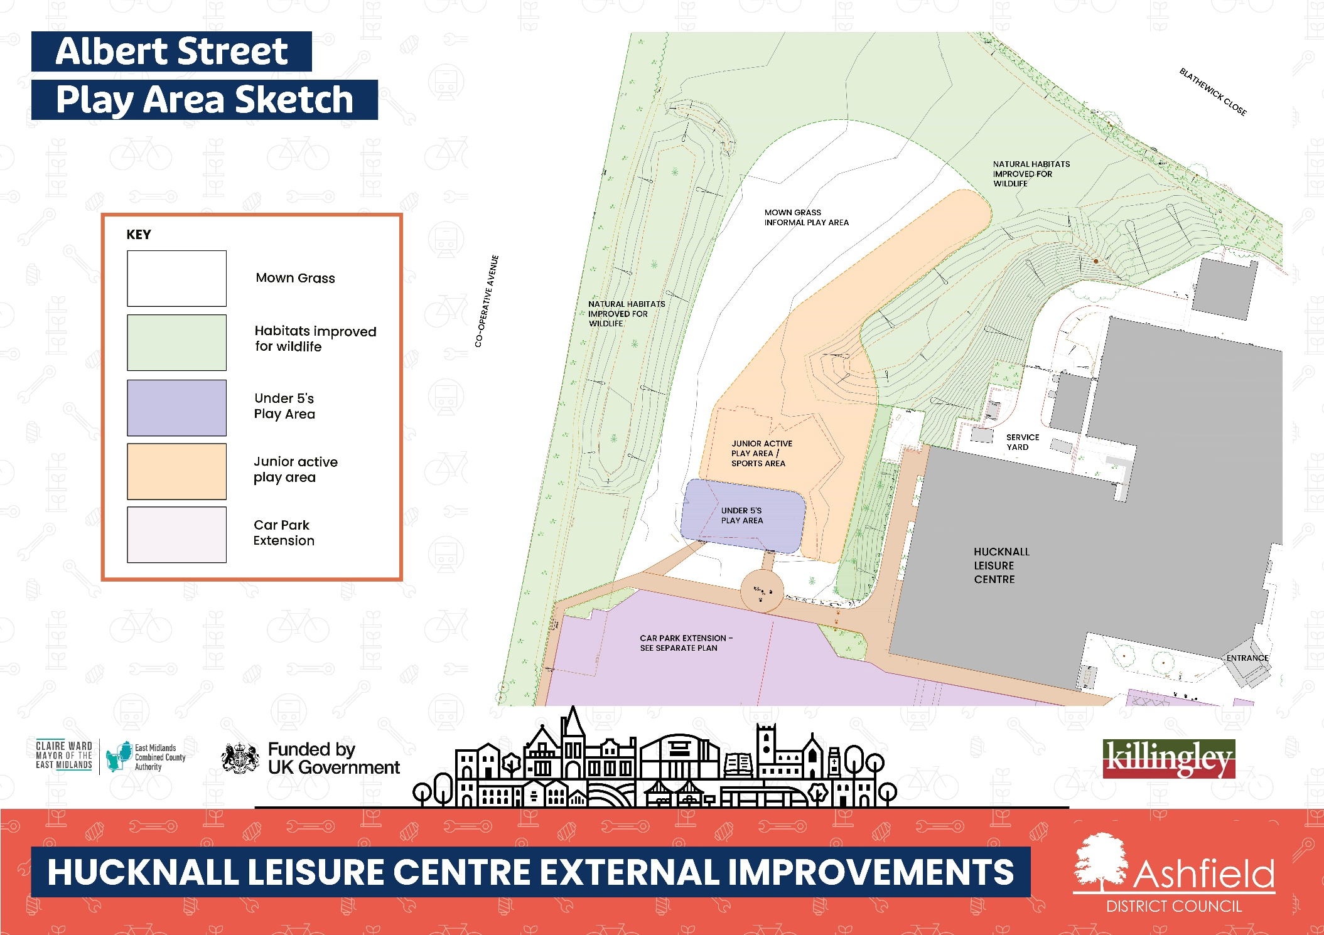

Albert Street Play Area Site Location Design
The plan shows the location of the proposed play area which will be relocated to the green space/ recreation ground to make space for the car park improvements. It shows the location of:
- BLATHEWICK CLOSE
- CO-OPERATIVE AVENUE
- NATURAL HABITATS IMPROVED FOR WILDLIFE
- MOWN GRASS
- INFORMAL PLAY AREA
- JUNIOR ACTIVE PLAY AREA / SPORTS AREA
- UNDER 5'S PLAY AREA
- SERVICE YARD
- HUCKNALL LEISURE CENTRE
- CAR PARK EXTENSION - SEE SEPARATE PLAN

