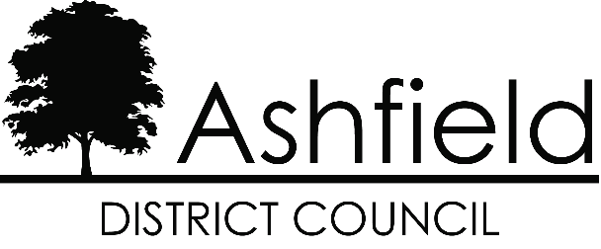

Ashfield Workforce Report 2026


Table of Contents
Page

Executive Summary 1
Actions for 2026 2
Workforce Profile 2025 3
- Ashfield Workforce 3
- Workforce Diversity 4
- Maternity/Paternity 6
- Pay 7
- Training 7
- Recruitment 8
Gender Pay Gap 2025 11
The Equality Act 2010 and the Public Sector Equality Duty requires all public authorities to publish equality information on their workforce to demonstrate that they are compliant and transparent in their practices. This report builds on the previous year’s reporting and forms part of the information that we collate, monitor, and publish to help us ensure that equality considerations are embedded within our employment policies and practices, and they meet our responsibilities under the duty.

Executive Summary
Ashfield District Council workforce has increased over the past year, in January 2026 there were 637 employees at the council, an increase from 619 in 2025. In January 2024 there were 582.
The proportion of males and females working for the council has remained static with 54.3% of the workforce is male and 45.7% female, a small decreas in the male workforce.
There has been a significant increase in part time workers from 98 to 204, over 90% of part time employees are female.
The proportion of the workforce within the age range 45 – 59 has risen slightly to 41.9%, wilst those aged 30-44 have fallen to 27.8%.
There has been a continued increase in the number of over 65’s to 5.2% and a small increase in those aged 16-24 to 5.0%.
The proportion of the workforce who consider themselves disabled has continued to decrease. Disabled employees are now 1.4% of the workforce, in 2023 those with a disablity made up nearly 10% of employees.
Those identifying as Christian has risen slightly to 38.2%. Religion continues to fall, and no religion has increased to 42.4%.
The BME proportion of the council’s workforce is 3.7%, an increase of 1.1% from the previous year. Ashfield workforce is now more representative of the local population which Census 2021 shows as becoming increasingly diverse. The Council is aware that the recruitment process should continue to encourage and enable employees from minority ethnic and religious belief groups to join the workforce.

Actions for 2026
Following the completion of a comprehensive independent audit and review of the Councils Recruitment and Retention strategy in 2022; implement a revised action plan that seeks to increase applications and appointments across all demographics.
Continue to brand and promote the Council as an attractive employer of choice especially for young people.
Fundamentally review the methodology and approach to recruitment to advertise vacancies as widely as possible so that they are accessible to all possible candidates.
To further strengthen the improvements within 2026 to encourage a more diverse workforce within the organisation and ensure BME representation across all levels of the organisation.

Ashfield Workforce
In January 2026 there were 637 employees at the council, in 2025 there were 619 employees, an increase of 2.8%.
The proportion of males working for the council has declined slightly to 54.3% with females correspondingly rising to 45.7%.
The proportion of female part-time employees has increased since 2025 from 15% of the workforce to 29%. Male part-time working has fallen to 2.9%.

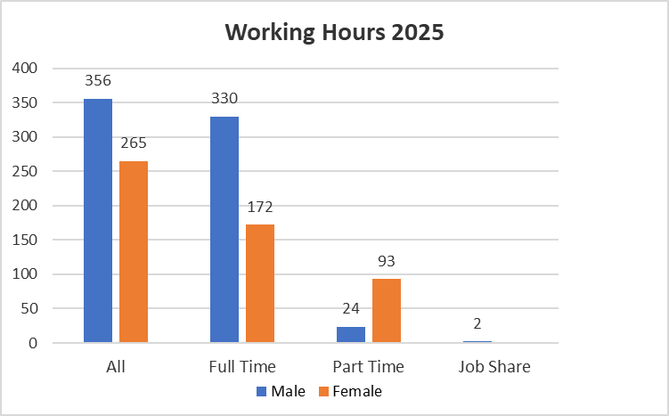

Whilst most people working for the council continue fall within the 45 – 59 age range there has been an increase in the number of those aged 16-24 working for the council.

Workforce Diversity

The proportion of the Council workforce with a disability has risen by 0.6% in 2026, considerably less than the high of 9.8% in 2023.

Ethnicity | % of Workforce  2025 | % of Workforce  2024 | % of Workforce  2023 | Ethnicity all ages Census 2021
White | 94.9% | 96.6% | 96.1% | 95.1%
Asian | 0.8% | 0.3% | 0.3% | 1.3%
Black | 1.1% | 0.9% | 1.2% | 1.2%
Mixed | 1.8% | 1.4% | 1.4% | 1.6%
Chinese | 0% | 0% | 0.2% | 0.03%

Ashfield’s population is predominately White British. The BME working age population of the district from the Census 2021 was 4.4%. The BME proportion of the council’s workforce is 3.7%, an increase of 1.1% from the previous year.
This will continue to be a key action; encourage applications from minority ethnic groups.

The proportion of employees who do not state their religions has declined slightly in the past years with a continued increase in ‘No Religion’ and a slight increase in ‘Christian’.
The results for all beliefs in the district from the Census 2021 can be seen in the table below.
Religion - Census 2021 - Ashfield District
No Religion | Christian | Buddhist | Hindu | Jewish | Muslim | Sikh | Other religion | Not answered
50.3% | 42.0% | 0.2% | 0.3% | 0.0% | 0.6% | 0.2% | 0.5% | 5.8%

A new question regarding sexual orientation was asked in the Census 2021
Census 2021 - Sexual Orientation in Ashfield District
Straight or Heterosexual | Gay or Lesbian | Bisexual | All other sexual orientations | Not answered
90.7% | 1.4% | 1.0% | 0.2% | 6.8%

Maternity/Paternity
In 2025, five employees took maternity leave and three employees took paternity leave.

Pay

The top 5% of earners at the council have become less male and white over the past year, with women now representing slightly more than a quarter of the total. The proportion of disabled represented in the top 5% has declined.
The above figures of the top 5% of earners excludes CEO, Directors, and Assistant Directors, they are NJC posts only. For JNC posts including CEO, Directors, and Assistant Directors; 34% are female, a decrease from 45% in 2024.

Training
The council have delivered the following statutory compliance training to employees:-
- Health and Safety
- Fire Safety
- Safeguarding
- Equality, Diversity, and Inclusion
- Cyber Security
- Data Protection
- Vulnerability
- Domestic Abuse
- Climate Change

Recruitment
The Authority is committed to creating a diverse workforce that is fair and free from discrimination. Reasonable adjustments are made to support disabled people throughout the recruitment process and continue into their role if they are successful. The Authority is accredited to the Disability Confident Scheme, the Mindful Employer Charter, has signed the Armed Forces Covenant and achieved the Employer Recognition Scheme Gold Award.
Turnover of staff across the year was 4.7% a significant decrease from the 8.6% from the previous year.

In 2025 Ashfield appointed more female than male applicants than in 2024 although more applicants were male. A higher proportion of younger applicants were appointed, 19.5% in 2025 although the dominant age range remains those aged 30-59. No people over the age of 65 were appointed to post and few applied.

Applications and appointments of people with a disability were higher in 2025, 7.2% of appointees were disabled in 2025, 3.6%in 2024.

Recruitment within the White British cohort applications has remained stable whilst the percentage of those appointed has risen (80% – 86.6%%), the proportion of other ethnicities has fallen, with non-white appointments at 11% of compared to 13% last year. The most marked change is with those who did not state their ethnicity, those appointed decreasing from 25.5%in 2023 to 1.2% in 2025.

Disciplinary and Grievance
There were 9 disciplinary actions in 2025, 8 male and 1 female. There were 6 grievances, 4 male and 2 female.
Whilst we would monitor and address any concerns with grievances that were related to the protected characteristics, we will not report on these cases as the small number may identify individual employees and same for disciplinary cases.

Ashfield District Council - Gender Pay Gap Information – 2025
Introduction
Under the Equality Act 2010 (Gender Pay Gap Information) Regulations 2017 the Council is required by law to publish an annual gender pay gap report. The information contained within this report is for the snapshot date of 31 March 2025.
2.0 Summary of data
- The mean gender pay gap is -1.71%
- The median gender pay gap is -5.35%

Table 1. Comparison to Female and Male in each salary range quartile
Quartile | Females | Males | Salary range
Lower | 40.91% | 59.09% | £24,404 - £27,269
Lower Middle | 39.35% | 60.65% | £27,269 - £30,060
Upper Middle | 47.74% | 52.26% | £30,060 - £37,035
Upper | 43.51% | 56.49% | £37,035 and above

Table 2. Breakdown splits of Female to Male across the Authority
Quartile | Females | Males | Salary range
Lower | 23.77% | 25.78% | £24,404 - £27,269
Lower Middle | 23.02 % | 26.63% | £27,269 - £30,060
Upper Middle | 27.92% | 22.95% | £30,060 - £37,035
Upper | 25.28% | 24.65% | £37,035 and above
Total | 100% | 100%

The mean is defined as the average of the figures and is calculated by adding up all the figures and diving by the number there are. The median is defined as the salary that lies at the midpoint and is calculated by ordering all salaries from highest to lowest and the median is the central figure. The quartile information is calculated by listing all salaries from highest to lowest and the splitting that information into four equal quarters to determine the percentage of male / female employees in each quartile.
All the figures set out above have been calculated using the standard methodologies used in the Equality Act 2010 (Gender Pay Gap Information) Regulations 2017. Although reporting of the salary ranges for the quartiles is not required, this has been provided for additional information.
- Analysis of data
Although the mean pay gap has increased from the previous year, the mean pay gap still suggests that ranges of pay are spread fairly and equally across the organisation but that the average pat for women is higher. In comparison to last year, this figure has changed from -1.43% to -1.71% suggesting that salaries are fairly equivalent. The mean gender pay gap is likely due to a change in the organisation profile as there has been changes to the female/male split in all quartiles.
Further analysis of the data indicates that the lower quartiles have the higher percentage of males in these roles, one of the key reasons for this is that is contains a high proportion of frontline workers. This would suggest that the disparity is due to posts that traditionally attract specific genders. The Council recognises that although actions are in place to try to address this, it will take time change these historical and social norms.
The quartile data also outlines the percentage of males in the lower quartile has stayed consistent from last year. Traditionally roles in this quartile attract female applicants due to the flexibility and ability to fit in around caring responsibilities. Widely these responsibilities are generally undertaken by women but there has been a slight increase in males in this quartile over the last couple of years.
The Council remains committed to the principle of equal opportunities and equal treatment for all employees and has a clear procedure to ensure employees are paid equally for the same or equivalent work, regardless of their sex or any other protected characteristic. In 2014 the Council implemented job evaluation and undertook a comprehensive review of pay and allowances to address a number of factors which significantly improved the gender pay gap position. As part of that scheme the Council also evaluates job roles as necessary to ensure a fair structure. In 2016 the Council brought the ALMO back into the Council which included the transfer of a large number of craftworkers. The vast majority of employees that have been TUPE transferred are now on ADC terms and conditions however there is a very small number remaining which are not likely to influence any major changes in the gender pay gap.
4.0 Action to be undertaken to address the gender pay gap
Although the gender pay gap is not significant enough to be a cause for concern the organisation will continue to implement actions as detailed below to address the disparities.

- Continue to use on line adverts and jobs boards to advertise vacancies as widely as possible so that they are accessible to all possible candidates and therefore not advertise via routes that could attract traditional genders.
- The Council is still involved in initiatives to promote flexible working, including hybrid working in all posts that are viable and continues to build on the work of this initiative to ensure that all vacancies are advertised as flexible and hybrid where possible and encourage applicants to approach managers to discuss flexible working requirements at appointment stage.
- Policies associated with hybrid and flexible working are currently being reviewed to ensure they are fit for purpose
- Review of the level policy has been undertaken to reflect Carers Legislation.
- Officers from the Council attend career fairs to promote all careers within public sector.

