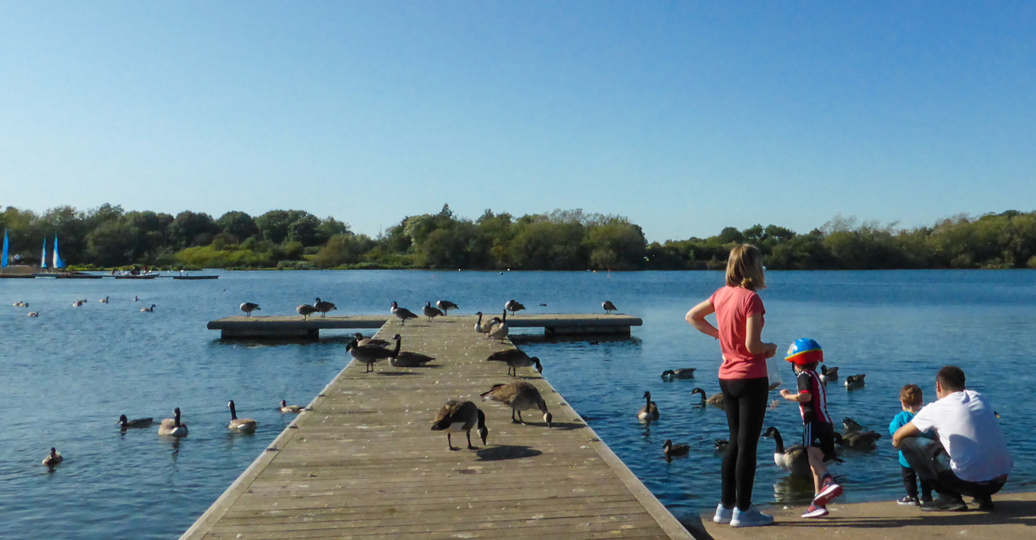

KINGS MILL RESERVOIR

MANAGEMENT PLAN

January 2023 - December 2028

Ashfield District Council

Urban Road, Kirkby-in-Ashfield, Nottinghamshire. NG17 8DA 1623 450000 Website: www.ashfield.gov.uk

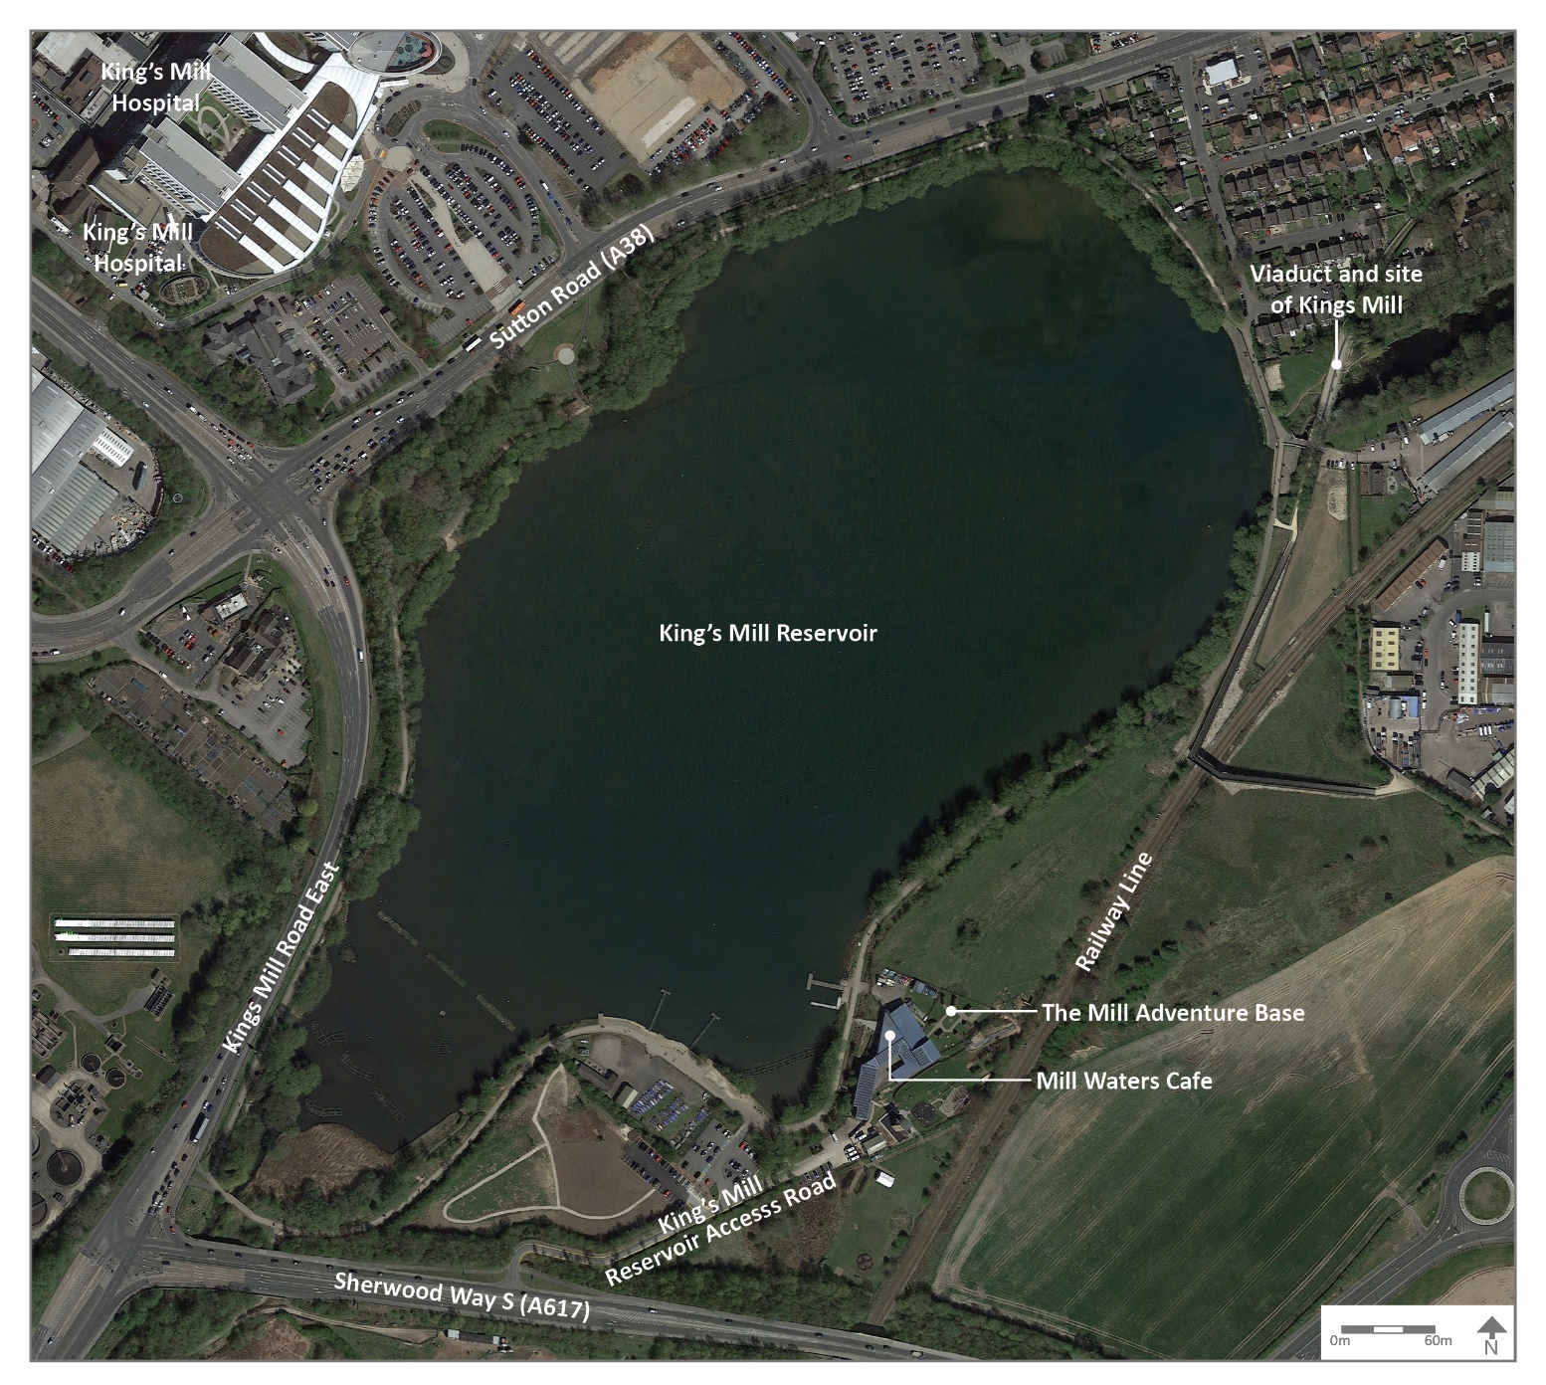

Aerial Plan illustrating extent of site (© Google maps 2022).
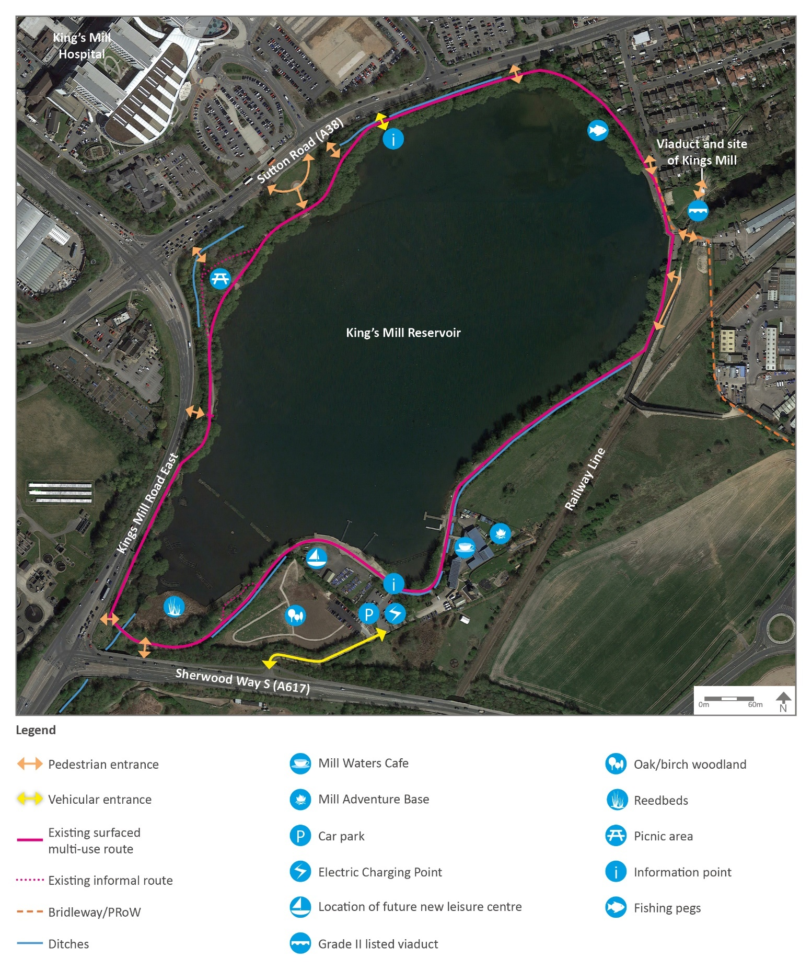

Layout Plan and facilities (© Google maps 2022).

CONTENTS Page

OVERVIEW
  - Introduction 4
  - Reservoir facilities 6
  - Investment 7
  - Heritage 7
  - Community Involvement 11
  - Landscape and Ecology 13
  - Green Flag criteria 17
- DELIVERY/ IMPLEMENTATION
  - Action Plan 24
- MONITORING/ REVIEW
  - Monitoring and Review 34
  - Contacts 35

OVERVIEW

Introduction

This management plan has been developed by Ashfield District Council in partnership with the groups and organisations that use the reservoir. The plan will support the development and management of the site. Details of the Council’s policies and procedures for green space management are contained within the document: ‘Management Plan Overview and Supporting Information.’ This should be read in conjunction with this management plan).

Kings Mill Reservoir is located off the A617 Sherwood Way South and the A38 Mansfield Road, opposite Kings Mill Hospital, in Sutton-in-Ashfield. It is within the Natural England Southern Magnesian Limestone National Character Area. In terms of the Nottinghamshire Regional Character Areas, it is within the Coxmoor Wooded Farmlands landscape type of the Sherwood Policy Zone (Nottinghamshire County Council, 2009).

The Kings Mill Reservoir site covers an area of 31.8ha, including the reservoir and adjacent marshy and grassland fringes. A dam forms the north-eastern edge of the reservoir with a spillway for the River Maun.

The reservoir provides recreation facilities including an adventure base, angling, walking/ running, a picnic area, bird watching and cycling, and a café and visitor centre which offers refreshments and information for visitors.

The site provides a programme of community events and opportunities for local people with events organised and managed on site by a project ranger. Events include regular litter picking, tree planting, water vole surveying training, nature-based arts and map reading for children. These ongoing events provide opportunities for local residents and encourage ongoing volunteering and engagement.

A circular recreational route is provided around the reservoir with a series of links to the wider network of footpath and cycleways adjacent to the site. Links are possible to ‘The Lower Linear Route’ (one of Nottinghamshire County Council’s Multi-User Routes), as well as links to the National Cycle Network Route 6, which extends as far as Lincoln through NCN Route 64.

The reservoir forms part of Greenwood, the community forest covering the Nottinghamshire area and the reservoir links to Vicar Water Country Park as part of the Timberland Trail and the Maun Valley Trail in Mansfield.

The site is located to the immediate south of King’s Mill Hospital with good links and access points into the site from the hospital off the A38.

Ashfield District Council owns the site, freehold, including some land under the jurisdiction of Mansfield District Council and is responsible for the management of the site. The reservoir has a Water Bailiff, employed by Nottinghamshire Anglers Association. This management plan refers to land in the ownership of Ashfield District Council. The reservoir comes under the terms of the Reservoir Act 1975 and is inspected on a regular basis by an independent inspecting engineer.

The historic context of the site demonstrates that the reservoir was excavated at the order of the then landowner, the Duke of Portland, to provide a sufficient head of water for the mills along the Maun Valley. What had been a smaller pond became the great Portland reservoir in 1839, flooding the ancient Sutton Mill. A new water driven flour mill was built, remaining in use until 1963, when it was destroyed by fire. It is unclear as to when the current name of the reservoir was adopted.

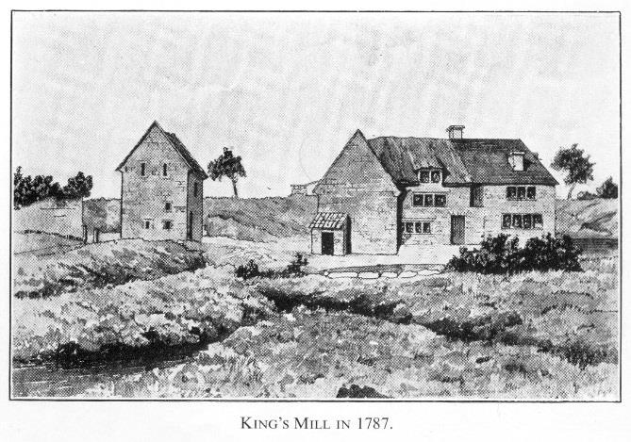
The reservoir was created from farmland in 1837 by the 4th Duke of Portland. 72 acres were cleared of topsoil using manpower, horses and carts. The dam was constructed using thousands of tons of limestone and clay in a cut and fill operation. The works took two years to complete.

Kings Mill Reservoir is designated as a Local Nature Reserve and contains a number of wildlife habitats. The majority of these are located around the reservoir and comprise reed bed and swamp made up of bulrush, sweet read grass and pond sedge. Surrounding the reservoir are areas of wet woodland dominated by Crack Willow (Salix fragilis) and a series of native mixed hedgerows can also be found across the site.

The reservoir is locally important for a range of wildfowl and wetland birds including kingfisher, grey heron, grebes and migrants such as sedge and reed warblers.

A series of ditches are found around the edges of the side which feed into the reservoir and have historically been home to a small population of water vole. The reservoir is also home to a diverse range of invertebrate, as well as fish and amphibians.

Reservoir facilities Users

The Mill Adventure Base | The Mill Adventure Base is operated by Nottinghamshire County Council under a lease agreement for the land with Ashfield District Council.  The building is owned by Nottinghamshire County Council.  The Mill Adventure Base has an outdoor conservation area available for school study
Mill Water Café and Visitor Centre | Mill Water Café and visitor centre providing hot and cold meals, toilet facilities and visitor centre  The base is a hub for community events and volunteering
Car park | Open access off the A617.  Tarmac car park with disabled parking available (car park fees apply).  Electric Car Charging Point
Leisure Facilities | Previous site of sailing club is identified for new leisure facilities to be completed in 2023-2034, with changing rooms, events space toilets, restaurant and bar area.
Fishing pegs | Fishing pegs are available around the reservoir
Picnic area and viewing platform | Open access. 6 picnic tables and viewing platform over the reservoir.  Numerous benches and litter bins around the site
Pedestrian / cycling route | Open access on circular route around the reservoir.
Bridleway | Open access. Horse dismount steps near  A617 bridge
Interpretation and signage | Interpretation panels (x2) and finger post signage at key locations around the reservoir
Bird feeding station (x5) | Open access

Investment

The Mill Adventure Base opened in 2006 and was funded by a Big Lottery Grant. The facility is owned and operated by Nottinghamshire County Council under a 25-year lease agreement (from 2004) for the land with Ashfield District Council. The café within the Adventure Base is managed by an organisation offering supported work opportunities and is popular with visitors. The Mill Adventure Base has recently invested in the creation of an outdoor conservation study area for schools (ecology field).

Heritage Lottery Fund
There has been substantial investment in the site through a Heritage Lottery Funded scheme, with funding of £871k secured in 2021 to deliver comprehensive improvements across the project area which covers the reservoir site and Sutton Lawn. This included:

- De-silting of the reservoir and Island creation

- Mill Waters Café and Visitor Centre Refurbishment

- Signage and interpretation

- Project ranger who runs a series of community events and engagement activities across the site. The ranger post is being extended until March 2025 funded through HLF and UK Shared Prosperity Fund.

- Restoration of Grade II listed Viaduct

- Construction of new and upgraded footpaths and access points.

- Construction of a larger car park

New Leisure Building
A new leisure building is due to be constructed in 2023-2024 on the site of the previous sailing club which will include changing facilities and new Changing Places room, club / events and conference space and an 80-seater restaurant and bar area. The scheme is being funded with a grant of £2.541 million from the Towns Fund and £900k of Council funding. The new facilities will provide space for the Sea cadets and other community led groups to lead and access water sports activities.

Mill Adventure Base
The Mill Adventure Base will be expanding its’ facilities and accommodation onto land to the north-east of the side of the existing site to further increase the opportunities and facilities which will be accessible to the public to use.

The £1.5 million investment will provide an aerial high ropes recreational course and amenity building and low-level adventure activities.

An easement and funding agreement is in place between the Sherwood Forest Hospitals NHS Foundation Trust and Ashfield District Council for the installation in the reservoir of a geothermal heating system. The equipment consists of seven groups of 20 Slim Jim geo lake plates and associated pipework which serves the nearby King’s Mill Hospital.

Phases of footpath surfacing improvements have been undertaken in recent years across the site with the works funded by developer contributions from Section 106 agreements.

Management works relating to the ecological, arboricultural and wetland areas are supported by Ashfield District Council’s Neighbourhoods and Environment team’s maintenance budget.

Site Heritage/ History

The first mention of a Sutton mill was in 1359 to a Richard de la Vache, knight, who was granted the title of Lord of Mansfield. In 1596, Queen Elizabeth I granted by charter to Edwards Longford, 31 years lease of a “water mill called Sutton Mill” with ponds of the same, within the forest of Sherwood, on payment of an annual rent of 51s, 5d. After 1737, the name ‘Kings Mill’ appeared when the Mansfield born playwright and publisher Robert Dodsley wrote his stage play “The King and Miller”.

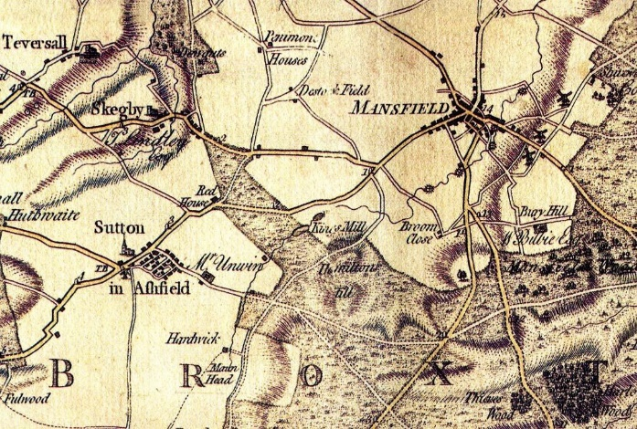
Map Chapman 1774

In 1817 Portland Bridge was built and the River Maun flowed through its centre arch. The water was regulated by control sluices situated on top of the dam.
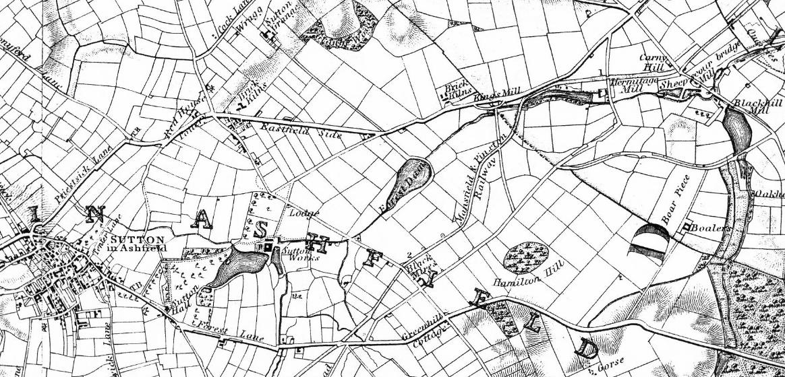
Sanderson Map 1835

In 1837 the 4th Duke of Portland conceded to his mill lessees and other water powered mill owners on the River Maun in Mansfield, that a large regulated head of water was required to ensure continuity of supply all year round to avoid disruption to the businesses. In order to make the project viable, the Duke flooded 72 acres of farmland he was obliged to acquire from the Unwin family.

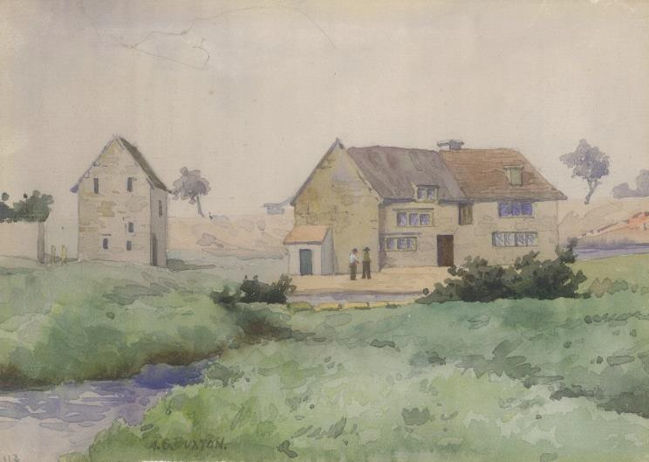
Kingsmill by Buxton
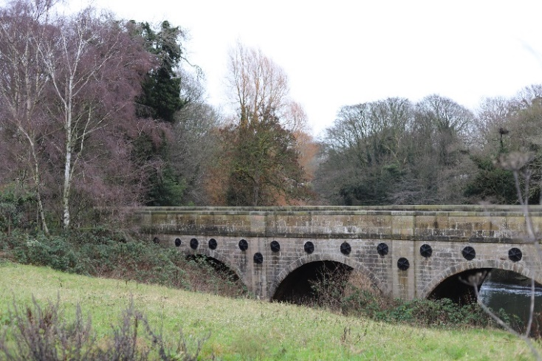

An overflow was constructed following a severe flood soon after the reservoir was constructed. It was built to take the surplus water into a dyke behind to the River Maun.
9

The overflow is now spanned by a bridge. The Grade II Listed railway viaduct was built from locally extracted limestone. The railway
The land was cleared of topsoil using manpower, horses and carts. The dam was constructed using thousands of tons of limestone and clay in a cut and fill operation. The works took two years to complete. The watermill worked as a flour mill until it was destroyed by fire while operating as an animal feed processing mill in the early 1900s. It remained derelict for many years before being cleared for housing development in the 1970s.

engineer was Josiah Jessop. The bridge carried the Mansfield and Pinxton Railway over the River Maun and became redundant in 1971.

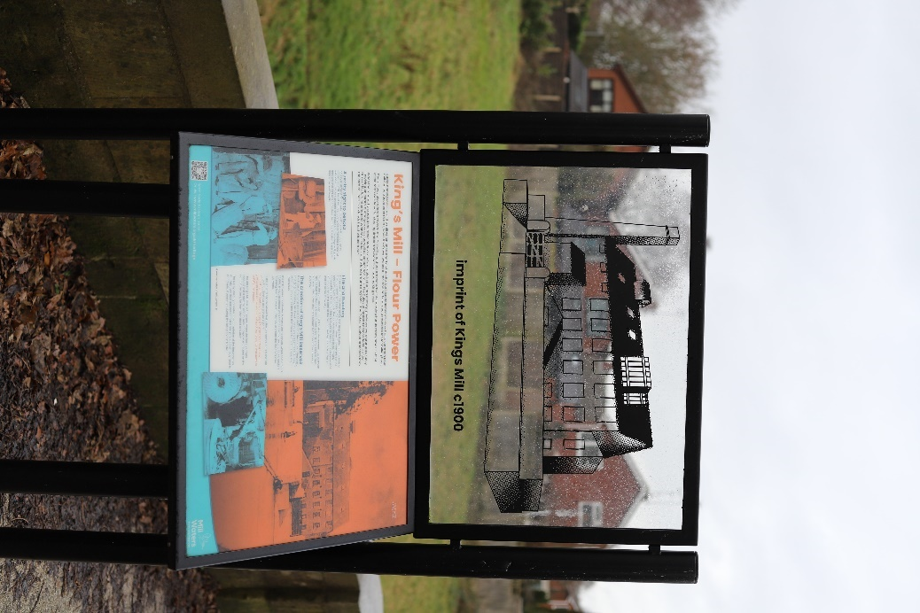
Interpretation board near site of Kings Mill Artwork and interpretation in the Mill Waters Cafe

More recently the heritage features of the site have been a focus for interpretation and learning with a series of information boards within the café and at the site of the Kings Mill interpretation panels exploring the heritage of the site.
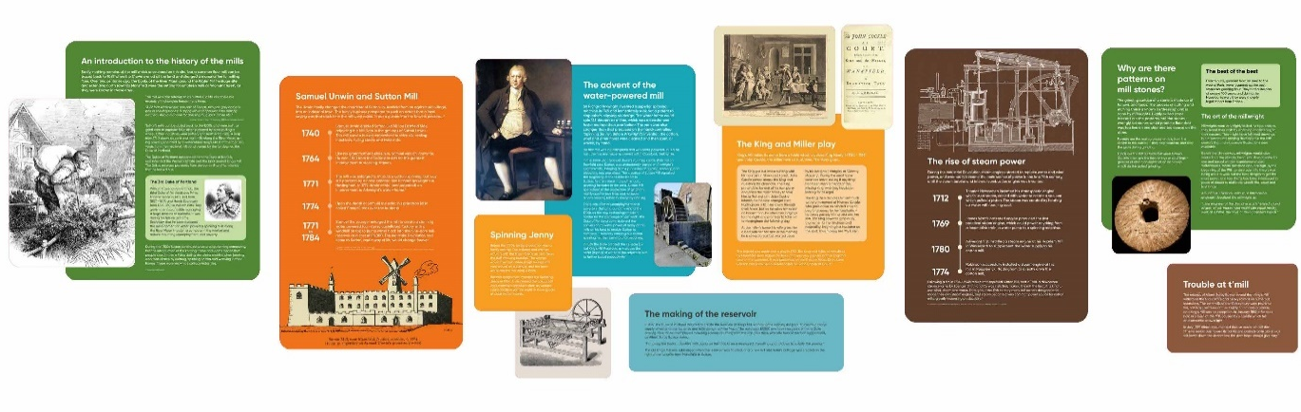
Interpretation and information in the Mill Waters Café

Community Involvement

Mill Waters Café and Visitor Centre

The café and visitor centre provides a base for visitors offering homemade cakes, vegetarian, vegan and gluten free options. The café is open from 9am, seven days a week with a dedicated staff presence, inside and outside seating and toilet facilities. The café is leased by Nottingham County Council to a commercial operator.

Community Engagement and Events

The Mill Waters Visitor Centre, which forms part of the café is the base from which a number of community and volunteer engagements are run. A dedicated project ranger is based on site, whose post was initially funded through Heritage Lottery Funding.

Events are advertised through the café, a dedicated website (www.millwaters.org.uk) and associated social media pages. Events provide local people opportunities to engage in activities around the reservoir and at the centre.

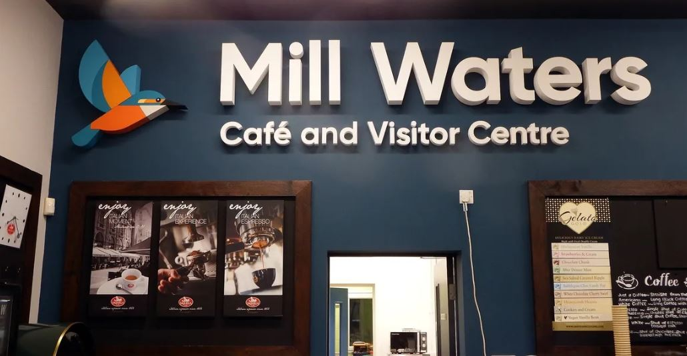

Events are focused on conservation, heritage, arts and health and wellbeing. A sample list of events can be found in Appendix 1.

The Mill Adventure Base

The Mill Adventure Base provides a sailing and canoeing centre, an adventure base with climbing facilities, camping pods, wildlife conservation area and rooms with educational facilities available for use by schools and organized group sessions.

The adventure base is used by local schools and groups. The manager of the adventure base attends the Council’s quarterly reservoir partnership meetings. The County Council has the right to use the launch ramp to launch sail boats and canoes into the water and to utilise the waters of the reservoir for sailing and canoeing.

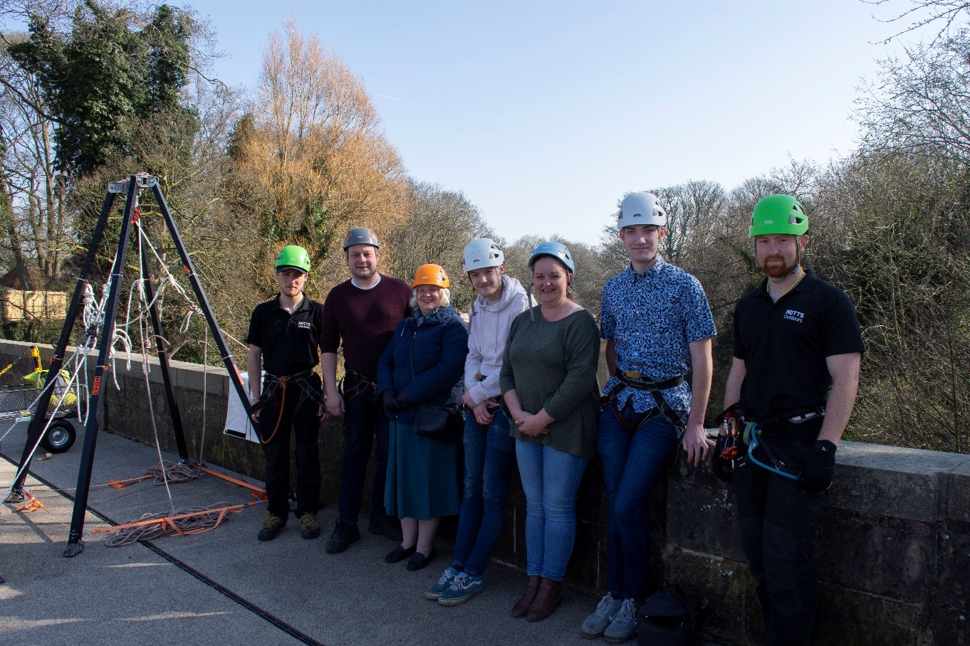
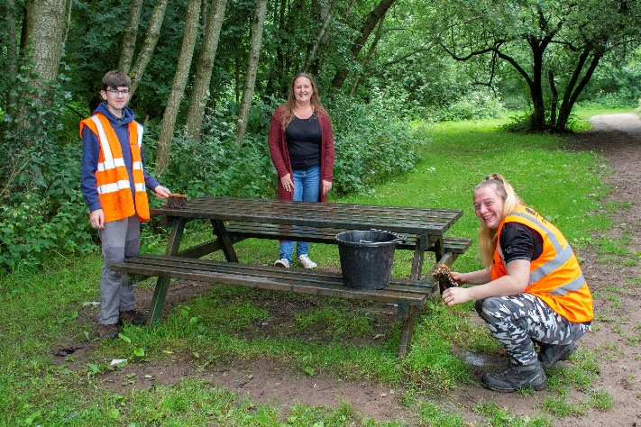

JD Fishery Management

Ashfield District Council is currently in negotiation with JD Fishery Management to administer the fishing rights on the reservoir. This is currently completed on an ad hoc basis, with fishing permitted on four fishing pegs on the western banks of the reservoir only, and a water bailiff in place to administer the fishing rights. Negotiations are currently ongoing to develop options for night fishing.

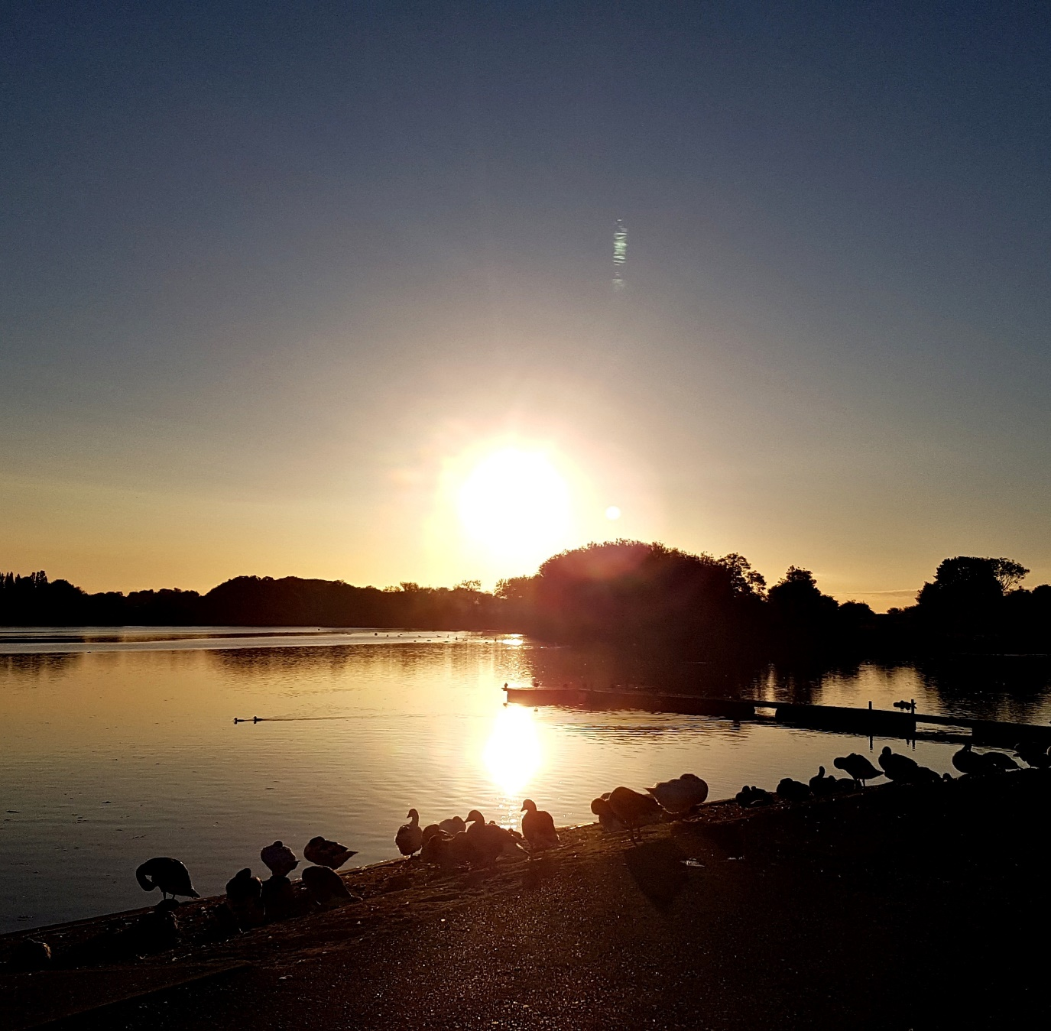

Landscape and Ecology

Kingsmill Reservoir has a range of habitats which are indicated on the Extended Phase 1 Habitat Plan (AMA Ecology) and found in Appendix 2 and shown below.

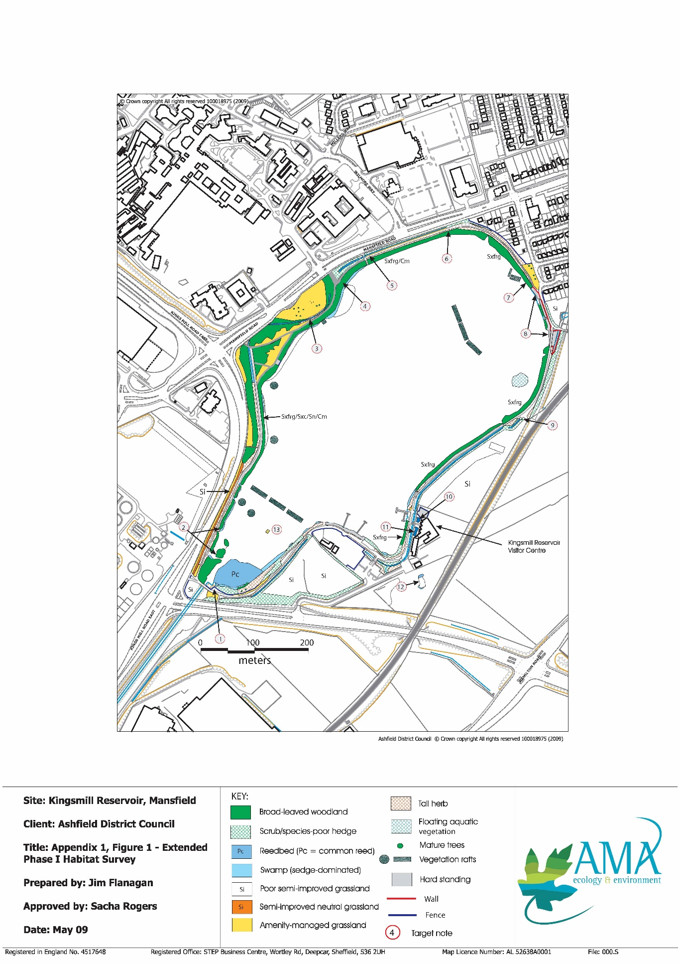

One of the main features of the site is the presence of an area of reed bed near the inflow of the River Maun which is considered to be of local significance. There are many areas of marginal aquatic habitat around the reservoir, comprising mainly of bulrush, sweet reed grass and pond sedge. Most of the habitats around the reservoir are linear in character and include mature crack willow with large multi-stemmed specimens.

Local Nature Reserve Status (LNR)

Kings Mill Reservoir was designated as a Local Nature Reserve (LNR) in 2013. LNR status applies to land of at least local wildlife interest and allows the local authority to protect that interest through the creation of special bye-laws. LNRs are usually close to or within urban areas and provide considerable opportunities for introducing large numbers of people to sustainable enjoyment of the countryside.

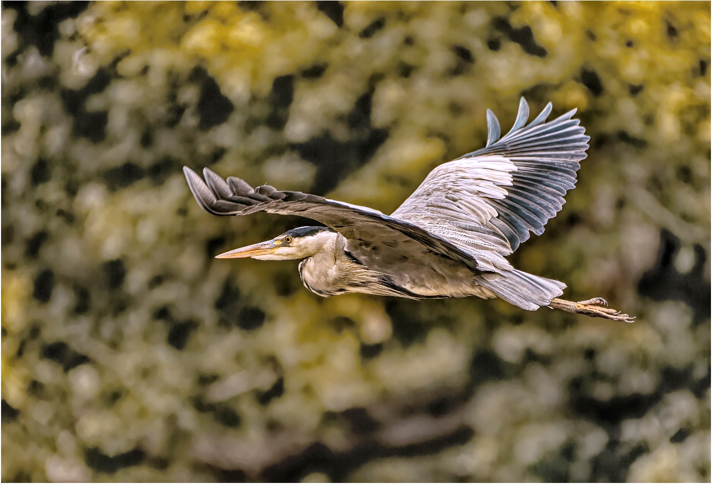

Scrub and Woodland

Scrub is widespread along the paths, alongside some ditches and within parts of the willow woodland and other broad-leaved woodland to the north and west. It comprises mainly hawthorn and elder. Hedgerows and hedgerow bottoms are mainly species poor but provide good breeding habitat for a range of birds. Along a section of the northern reservoir shore is an area of wet willow Carr type habitat with an abundant field layer dominated by sedge over damp and waterlogged ground. Tree species include white willow, goat willow and planted Italian alder.

Broad-leaved secondary woodland comprising poplar, ash and willow occurs in the northwest and western part of the site. Several mature trees of note within the site and small amounts of standing and horizontal deadwood in the marginal willow woodland areas.

Reed bed

The reed bed is located next to the River Maun inlet and comprises common reed. It also includes marginal swamp with sedge, bulrush and area of willow scrub. Next to the reed beds are two heavily vegetated islands dominated by willow and tall herbs.

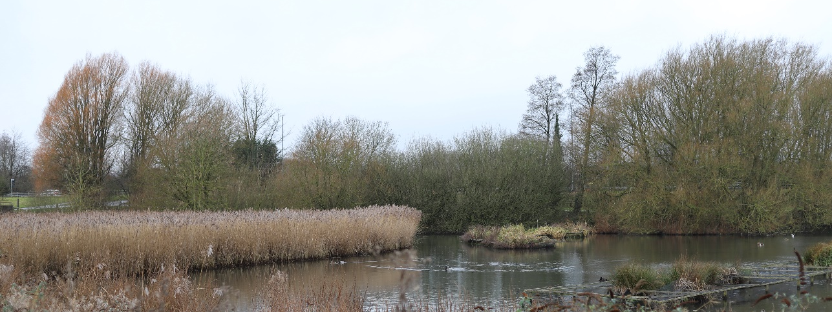

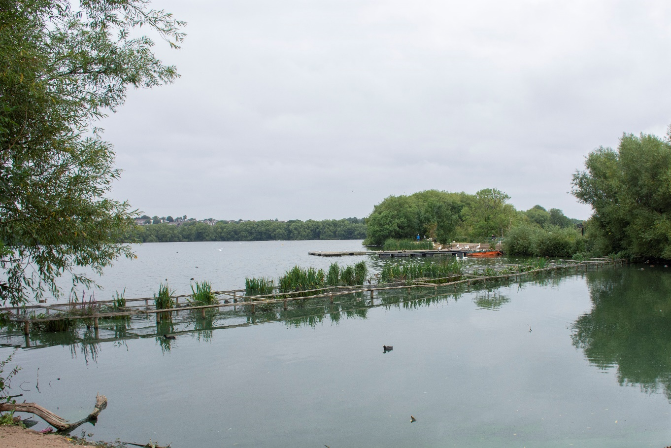

Tall herb and ditch habitat

Tall herb occurs along the woodland margins close to the paths and margins of some ditches. The ditches themselves are often heavily shaded and in places overgrown and silted up. Sections of the ditches near to the adventure base café have a more varied species composition consisting of a range of emergent / submerging and floating aquatic plants. These include water cress, water starwort and rushes.

Floating aquatic vegetation

Floating aquatic vegetation (amphibious bistort) is present in one area on the reservoir. A variety of wet vegetation (mainly sedge, marsh marigold and purple loosestrife) is supported on rafts which have been installed as part of the mechanism to manage the presence of blue green algae Aphanizomen.

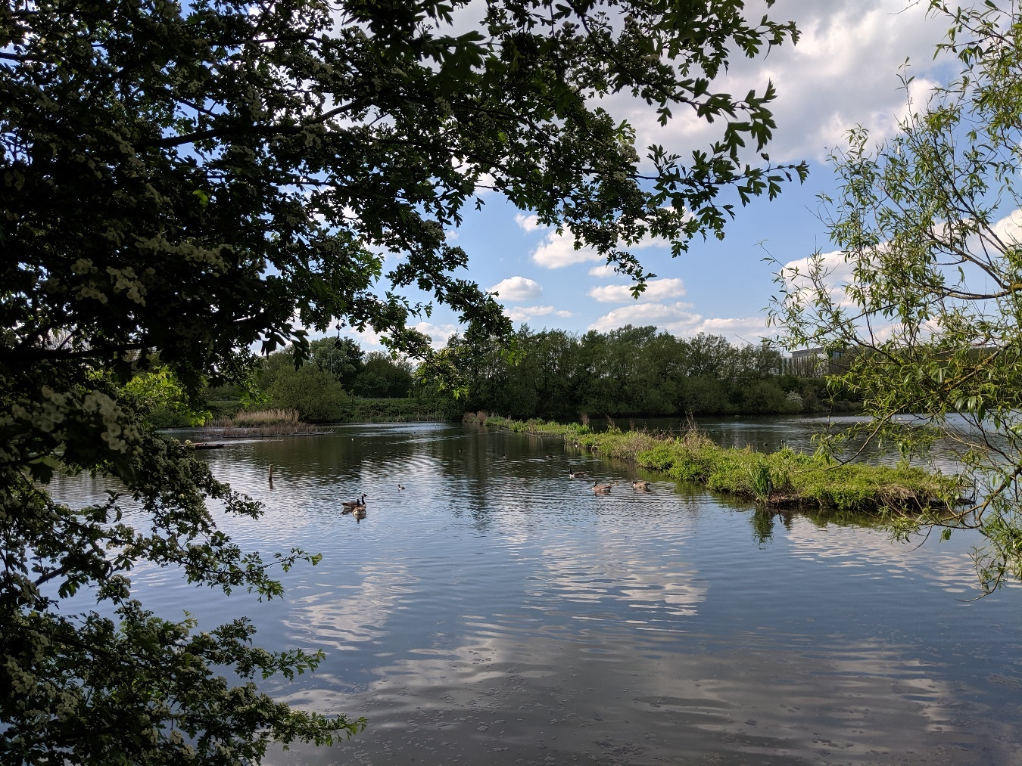

Grassland

Grassland within the reservoir site boundaries is limited and consists mainly of amenity managed areas although there are some patches of unimproved and semi improved neutral grassland. Species include lady’s bedstraw, ox eye daisy, meadow cranesbill and common sorrel.

Oak/birch woodland
More recently the area to the rear of the car park has been planted with a new oak and birch woodland to increase tree cover and form a small woodland walk.

Fauna

The site is locally important for a range of wildfowl and other birds of wetland habitats. These include kingfisher, grey heron, grebes and migrants such as sedge and reed warblers.

Historically a small population of water vole was found on the site, along with squirrels and up to six species of bats. Amphibians such as frogs and toads, as well as invertebrates such as dragonflies and water beetles are also present.

Birds
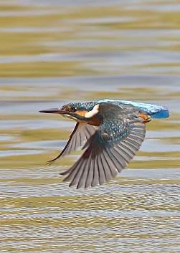
A total of 43 species were recorded through survey, of the total, three were red listed species of conservation concern (song thrush, house sparrow and starling). Bird species thought to breed within the site include dunnock, robin, wren black bird and robin.

Kingfishers and water rails have been observed, along with willow tit. The reservoir has records for a range of wildfowl including mallard, coot, moorhen, little grebe and mute swan, that breed on a regular basis. Lapwings and gulls are noted.

Photo: Kind permission of P. Millns

Invertebrates

Amphibians such as frogs and toads are found. Invertebrates include dragonflies, water beetles and water bugs. Alder flies and a range of crane flies are present. Three species of butterflies including brimstone, green veined white and orange tip have been recorded.
Migrant hawker and adult caddisflies have been recorded.

Fish

The fish population in the reservoir consists of carp, bream, roach, tench and pike. Sticklebacks have also been recorded.

Local Biodiversity Action Plan (LBAP)

The Local Biodiversity Action Plan for Nottinghamshire (Nottinghamshire Biodiversity Action Group, 1998) lists species and habitats of conservation concern in the county, based on national and local criteria. 28 habitats are listed, and these have targeted action plans for maintenance and restoration. In addition, action plans for eight flagship species or species groups have been produced, such as those for barn owl and water vole.

The following habitat action plans are relevant to the reservoir, Unimproved Neutral Grassland, Fen and Marsh, Eutrophic and Mesotrophic Waters, Ditches, Reed bed, Wet woodland, and Rivers and Streams. The species action plans for Water Vole and Bats apply.

Green Flag criteria
The Green Flag Award is the benchmark national standard for parks and green spaces in the UK. In order to achieve the award green spaces need to meet eight key criteria. The table below shows how the park meets the criteria.

1. A welcoming place
Good and safe access | There are numerous points of level access into the site for pedestrians at various points of the circular route.  There is a bridle route access point off Kings Mill Lane, and a vehicular access off the  A617 which provides access to a pay and display visitor car park with disabled parking available.  An electric car charging point is also available within the car park.  Cars are separated from pedestrian routes by vehicular barriers  Access into the site opposite the King’s Mill hospital provides a clear and safe route into the site with a wide and well surfaced route and sightlines.
Good signage to and in the park/green space | There are welcome signs off the main vehicular entrance at the A617 Sherwood Way South.  Numerous finger post signs are located at key points within the site which were installed as part of the HLF funding.  The onsite café has a noticeboard advertising various events, displaying the café menu and providing emergency contact details.  Main health and safety entrance signs are located at all the reservoir pedestrian entrances. Two new interpretation boards are being installed 2023 to aid navigation of the site and set out the key features.
Equal access for all members of the community | There are a number of level access points onto the site and access around the reservoir is generally good on stone or tarmac surfaced paths. Some routes are unsurfaced and more informal in nature,  The main car park off A617 Sherwood Way South has bays marked specifically for disabled users.  The site has a range of busier and quieter places with focused areas around visitor centre/café and quieter pedestrian routes around the reservoir offering a range of experiences for all members of the community.  Most of the pedestrian route is wide enough to allow pedestrians to walk in groups of at least two people, and easily pass others doing the same.  The café and visitor centre are accessible and on one level, with disabled toilet facilities.

2. Healthy, safe and secure
Equipment and facilities must be safe to use | Regular testing of the reservoir water quality and algal levels is undertaken by the water activity delivery partners, with an agreed action plan in place.  The facilities provided within the café and visitor centre are accessible, regularly cleaned and safe to use.
Dog fouling must be adequately addressed | Dog control orders are in place and notices displayed on site instructing users to behave responsibly. Litter bins are provided around the site which can be used to dispose of dog waste.
Health and safety policies should be in place, in practice and regularly  reviewed | The Council has up to date policies which are regularly reviewed, further information is within the  Management Overview.
Toilets, drinking water, first aid, public telephones and emergency equipment where relevant (e.g. life belts by water) should be available in or near the park/green space, and be clearly signposted | Toilet facilities are provided within the café and accessible during opening hours.  The adventure base has a phone for emergency use.  Signage with location details and emergency contact numbers is located at each of the main reservoir entrances.  Two new interpretation boards with the 3D site map will be located at key locations within the site early 2023.  First aid facilities are provided at the Mill Café and Visitor Centre.  Ashfield District Council as a partnership member of the Nottinghamshire County Council Water Safety Group (NWSG) follow the Nottingham Water Safety Policy April 2022, through its commitments in relation to Public Education, Edge Protection, Water Safety Signs and Public Rescue Equipment. The Risk & Emergency Planning Unit assess all water-based reservoirs, rivers, springs, and ponds, within its boundaries, by means of water safety risk assessments, which presently was updated September 2022

3. Clean and well maintained
Litter and other waste management | The site is generally clean with numerous bins located around the site which are in good order.  The Adventure Base & Mill Waters Café have 2 x 770 litre general waste bins that are emptied weekly and 2 x 770 litre recycling bins that are emptied fortnightly.  The Environment Team empty the waste bins and collect litter, which is then sent to the Veolia collection point for incineration.  Waste generated from vegetation works is managed by Ashfield DC and processed centrally at the depot.  Regular litter picking events are run through the visitor centre via the Mill Waters project.
The maintenance of grounds, buildings, equipment and other features | General maintenance and horticultural/landscape maintenance of the various landscape elements including hedgerows, grass, aquatic vegetation and trees is undertaken by the Council’s Neighbourhoods and Environment team.  The site of the previous sailing club is closed and identified for redevelopment as part of the new leisure facilities.  Policy information on asset management is provided within the Management Plan Overview.
A policy on litter, vandalism and maintenance should be in place, in practice and regularly reviewed | Policy information on asset management is provided within the Management Plan Overview.

4. Sustainability
An environmental policy or charter and management strategy in place, which is in practice and regularly reviewed | The Council has a policy in place (within the Management Plan Overview).
Minimise and justify pesticide use | Pesticides are not used on the site
Eliminate horticultural peat use | Horticultural peat is not used on the site
Recycle waste plant material | Waste plant material is processed by Ashfield District Council at the main depot, where composting and recycling is centralised.  Waste generated from tree works is reused on site, either at the adventure centre for bushcraft activities or to create deadwood / habitat piles across the site.
Demonstrate high horticultural and arboricultural standards | The reservoir is maintained to the Council’s  standards, details are provided within the Management Plan Overview.
Have energy conservation, pollution reduction, waste recycling, and resource conservation measures | The Mill Adventure Base includes PV panels on the roof to create a sustainable source of energy to supply the building.  Two electric car charging points are available within the car park.  Reed bed system is used to reduce environmental impacts through reducing sediment and suspended solids within the water to minimise water pollution.  There is a 10 year programme in place to displace sediment from the reservoir to create islands and create improvements to aquatic margin.

5. Conservation and heritage
Particular attention should be paid to the conservation and appropriate management of:  Natural features, wildlife and fauna | The management of the ecological habitats across the site are detailed within the enhanced Ecological Management Plan with specific compartments identified for ongoing management.  This includes the woodland, hedgerows, wetlands and grass areas which are managed in line with the prescriptions of the plan. Specific advice is also available for the ongoing management of water vole habitats to increase the watervole population across the site.  The reservoir is managed with advice from ecologists and the Environment Agency as required. Specific advice is gained from the EA on matters relating to water quality.  Bird boxes are provided around the reservoir.  Water levels are monitored annually, works to undertake necessary repairs of the emergency outfall have recently been carried out.
Landscapes | The main heritage feature of the site is the reservoir itself, with the Grade II listed viaduct and previous site of Kings Mill found to the north east of the site.  Gaps in the scrub and trees along the reservoir are regularly cleared to retain vistas of these features.  There are good links to other accessible green spaces and the site forms part of a wider network of green infrastructure.
Buildings and structural features | The buildings adjacent the reservoir are the adventure base and café. The structural features on the reservoir are the dam, spillway and spillway bridge.  External repairs to the adventure base and café are the responsibility of Nottinghamshire County Council.  Repairs to the car park, reservoir dam, spillway bridge, seating, picnic tables and signage are the responsibility of the Council’s Neighbourhoods and Environment Team, who carry out regular inspections.  Repairs to Kings Mill Viaduct is the responsibility of Mansfield District Council who own and maintain the asset.  The geothermal heating system within the reservoir is the responsibility of Skanska on behalf of the  Sherwood Forest Hospitals NHS Foundation Trust.  The café provides heritage information on the history of the site with interpretation, notices and information boards.

6. Community involvement
The park/green space management should actively pursue the involvement of members of the community who represent as many park/green space user groups as possible. | A number of engagement activities are provided through the project ranger who is based on site at the Mill Water Café and Visitor Centre.  These events are run regularly across the year for a range of users and enable the local community to be involved and engaged in the site.  The local community have opportunities to participate in regular events such as conservation work, litter picking, walking, bird watching, art groups and heritage events.
Knowledge of user community and levels and patterns of use | Questionnaires for visitor feedback are available  in the café and the results are fed back at the quarterly reservoir partnership meetings.  Visitor numbers for the site are collected through Place Informatics The annual number of visitors for the year to November 2022 was 546,307
Evidence of community involvement in management and/or developments and results achieved | Community engagement is implemented through the HLF project partnership which includes Ashfield District Council, Nottinghamshire County Council and Mansfield District Council.  The project ranger appointed through the HLF project coordinates engagement with local groups and stakeholders through the delivery of the activity plan.
Appropriate levels of provision of recreational facilities for all sectors of the community | There are opportunities for a wide range of activities around the reservoir – visiting the cafe, adventure activities, bird watching, walking, cycling, horse riding, angling, picnicking and bird  feeding.  Footpath routes through the site are accessible and surfaced allowing for a range of users and sectors of the community to access the site. In addition, the facilities at the Mill Waters Café are accessible.  The completion of the new leisure facilities will enhance recreational provision further and expand sports and recreational activities for the community.  The expansion of the adventure centre facilities increased opportunities for schools and young people to use the site.

7. Marketing
A marketing strategy should be in place, which is in practice and regularly reviewed | Marketing for the site is coordinated by Ashfield District Council communications team and includes publishing opportunities through the ranger led delivery programme to publicity of improvements and achievements across the site. Information on the site is hosted across the platforms listed below.  http://www.ashfield.gov.uk  http://www.millwaters.org.uk/  http://discoverashfield.co.uk/Kingsmill-Reservoir  Through investment from Towns Fund and the Heritage Lottery the Council is developing a new web and mobile app platform which will create a new destination management system (DMS) which will include the Mill Waters site.  General details of the marketing strategy are provided within the Management Plan Overview.
There should be good provision of information to users, e.g. about management strategies, activities, features, ways to get involved | Information is available with ways to get involved with events across the site through the Mill Waters website: www.millwaters.com, the Council and Adventure Base websites.  Site leaflets are produced for events.  QR codes are provided which link to relevant websites/topics in particular relating to the heritage of the site. Activities and events are promoted via the Council’s Facebook page.
The park/green space should be promoted as a community resource | Information is available on the Council’s website as well as through The Mill Waters Café and Visitor Centre website, which provide details of the community resource.

8. Management
A management plan or strategy should be in place | The management plan was updated in early 2023 and is reviewed every two years
The plan must be actively implemented and regularly reviewed | The management plan is reviewed every two years
A financially sound management of the park/green space must also be  demonstrated | The park is managed as part of the Council’s green space provision and does not have separate budgets

KEY:
PW: Place & Wellbeing team
ET: Neighbourhoods & Environment Team
EH: Environmental Health
MAB: Mill Adventure Base

S106: Developer contributions
TR6: Transport Developer contributions
- Completed ● to be completed ○ Ongoing

2.1 Kings Mill Reservoir Action Plan

The action plan should be read in conjunction with the action plan map and management compartment plan (page 33) 1-13 and compartments 1-19 (page 34)

Objectives | Action | Delivery |  |  |  |  | Resources | Lead
Create a Welcoming Place |  | 23 | 24 | 25 | 26 | 27
Digital Connectivity | Create a new website and mobile app platform to form a destination management system (DMS) to aid the visitor experience and site promotion. | ● |  |  |  |  | Grant funding | PW
Paths and park entrances | Carry out phases of path and entrance improvements and monitor condition of routes as necessary. Surfacing works to improve inclusive access throughout.  Provide surfaced routes to waters edge at existing informal footpath routes allowing all users to gain access to the water | ● | ● | ● | ● |  | S106 / TR6  Grant funding | PW
Update interpretation boards | Install new interpretation panels at entrance near car park and by A38 access point  (3) | ● |  |  |  |  | HLF (in place) | PW
Update entrance signage | Provide additional welcome signage off the A38  (3) |  | ● | ● |  |  | S106/grant funding  opportunities | PW
Entrance and gateway to Mill Waters | Create welcoming entrance and improve interface between site and Mill Waters Café with vegetation clearance and landscaping work.  (2)  Compartment 3 |  |  | ● | ● |  | S106/grant funding  opportunities | PW/ET
Improve signage for recreational activities and links to bridleway | Improve signage for recreation activities including running routes and trails and links to bridleway (work with Nottinghamshire County Council) |  | ● | ● | ● |  | Revenue budget and NCC | PW
Update/rationalise signage and site furniture | Rationalise existing site signage and remove redundant items of street furniture and fencing |  | ● | ● | ● |  | S106/grant  funding opportunities | PW
Remove redundant access points off A38 | Rationalise access points off A38 to improve access (4) |  |  | ● | ● |  | Grant Funding  / Revenue budget | PW / ET
Improvements to access at Sherwood Way South | Remove graffiti from bridge and create new welcome feature/artwork at gateway to the site to enhance entrance  (4) |  |  | ● | ● |  | S106/grant  funding opportunities | PW
 | New lighting at bridge under Sherwood Way South to increase safety and access into the site  (4) |  |  | ● | ● |  | S106/grant  funding opportunities | PW
Car park landscaping | Ongoing enhancements and general maintenance to landscaping at car park to create welcoming feature into the site  (2) | ● | ● | ● | ● |  | Revenue budget and NCC | PW
New picnic area | Creation of new picnic area on eastern part of the site closer to café, toilet and car parking area.  (11) |  |  | ● | ● |  | S106/grant  funding opportunities | PW
Sustainable transport links | Provide information for users for sustainable travel options through ongoing marketing and provision of QR codes within car park and at key pedestrian access points to encourage walking/cycling and public transport | ● | ● | ● | ● |  | Revenue budget and NCC | PW / ET
Ongoing monitoring of fly tipping/litter picking | Maintain regular clearance of fly tipping and litter across the site, with a particular focus on ditches and access points | ● | ● | ● | ● |  | Grant Funding  / Revenue budget | PW / ET
Health and Safety | Rationalise health and safety across the site with clear emergency contact details, instructions on access to first aid, water safety | ● | ● | ● | ● |  | Grant Funding  / Revenue budget | PW / ET

Objectives | Action | Delivery |  |  |  |  | Resources | Lead
Conservation and Heritage |  | 23 | 24 | 25 | 26 | 27
Vistas and views of heritage features | Continue to maintain heritage features and views across reservoir through tree lines and scrub by selective clearance works to open up vistas across reservoir  Particular focus to retain views of dam wall, and views at key pedestrian entrances. | ● | ● | ● | ● | ● | S106/grant funding  opportunities | PW
Maintain and enhance established natural habitats:
Reservoir water body | Review angling with JD Fishery Management/Water Bailiff, to ensure a sustainable managed resource and that a license is in place. Explore formal opportunities for night-time fishing  (12) | ● | ● | ● | ● | ● | Revenue budget | ET
 | Replace fishing platforms as required  (12) | ● | ● | ● | ● | ● | S106/grant funding opportunities | PW
 | Carry out regular inspections of the reservoir dam | ● | ● | ● | ● | ● | Revenue budget | ET
 | Carry out defined desilting works to maintain reservoir capacity |  | ● | ● | ● |  | S106/grant funding  opportunities | PW
 | Continue to manage aquatic habitats in line with aquatic management plan and controlled areas for the following:  - Oxygenating plant development  - Reed beds development  - Sailing and water sports activities  - Fishing  - Site specific habitat |  | ● | ● | ● | ● | Revenue budget | PW/ET
Algal management | Review the condition of plants in the floating reed beds and plant up as advised by ecological consultants | ● | ● | ● | ● | ● | Revenue budget | ET
 | Continue to develop oxygenating plant management areas and implementation plan |  | ● | ● | ● | ● | S106/grant funding opportunities | PW
 | Monitor the occurrence of algal blooms and take action as per agreed protocol where there is a  potential risk of harm to visitors and users of the reservoir | ● | ● | ● | ● | ● | Revenue budget | ET /EH / MAB
Reed bed | Maintain and enhance the reed bed habitat. Remove scrub (November to mid-March)  (10) Compartment 8 | ● | ● | ● | ● | ● | Revenue budget | ET
 | Record extent of willow and other scrub encroachment as a basis for informing informal  scrub removal | ● | ● | ● | ● | ● | Revenue budget | ET
Ditch habitat | Maintain and enhance the quality of the ditch habitat and support invertebrate communities and watervole habitats  (5)  Remove scrub and overhanging vegetation.  Compartments 1, 2, 6,11,13,15 and 19. (November to mid-March) | ● | ● | ● | ● | ● | Revenue budget | ET
Hedgerows | Maintain and improve hedgerow condition to include hedge laying and gapping up of existing hedgerows to enhance condition and provide breeding opportunities for birds.  (7) | ● | ● | ● | ● | ● | Revenue budget | ET
Trees - general | Undertake ongoing survey work of mature trees across the site to review quality, condition and value of existing tree stock. Systematic management with a focus on unsafe and poor quality trees | ● | ● | ● | ● | ● | Revenue budget | PW
Scattered trees | Provision of new tree planting along boundary of A38  (8)  Compartment 9 | ● | ● | ● | ● | ● | Revenue budget | PW/ET
Willow trees | Undertake tree management for the Willow tit by identifying no more than 10 trees for pollarding a year and no more than two in the same compartment to create standing deadwood  Compartments 4,10a,10b,13, and 18 (November -mid march) |  | ● |  | ● |  | Revenue budget | ET
 | Continue pollarding of White and Crack willow.  Fell stems with potential collapse on the path side and position on the reservoir margin for invertebrates. (November to mid-March).  Compartments 10a, 10b and 18. | ● | ● | ● | ● | ● | Revenue budget | ET
 | Willows pollarded during the period 2020 -2022 to be re pollarded from 2027 |  |  |  |  | ● | Revenue budget | ET
Wet willow woodland | Allow grey, goat and crack willow to extend their area and allow a field layer of species such as sedge to colonise in compartments 10a and 10b to support invertebrate conservation. | ● | ● | ● | ● | ● | Revenue budget | ET
Woodland Areas | Progressive thinning of broad-leaved woodland to favor native species and invertebrate communities.  Undertake a gradual thinning of non-native poplar, alder and sycamore in wooded areas in favour of native willow and alder.  Fell and remove young saplings and treat stumps (November to mid-March)  Compartments 11 and 13 | ● |  | ● |  | ● | Revenue budget | ET
Species conservation | Put up bird boxes filled with woodchip on willows to encourage willow tit breeding  Compartments 4,10a,10b,13 and 18 (Sept – mid March) | ● |  |  | ● |  | S016 funding | PW
Species conservation | Put up 12 bird boxes  Compartments 10a,10b,13,15 and 18 (Sept to mid-March) | ● |  |  | ● |  | S016 funding | PW
 | Put up 12 bat boxes  Compartments 10a,10b,13,15 and 18 (Sept to mid-March) | ● |  |  |  |  | S016 funding / Towns Funding | PW
 | Collect bird data in all compartments throughout the year. | ● | ● | ● | ● | ● |  | Ranger
 | Investigate mapping for bats to comply with LBAP species action plans. |  |  | ● |  |  |  | PW
 | Comply with LBAP species action plan for Water vole | ● | ● | ● | ● | ● | Revenue funding | ET
 | Create public bird feeding stations around the reservoir to control the spread of bird food and  assist vermin control and provide an education programme with visitors through events at visitor centre on responsible bird feeding practices. |  | ● |  |  |  | S016 funding | PW
Non-native plants | Ongoing eradication of Himalayan balsam. Remove by physical hand pulling before seeding in autumn.  Compartments 10a (September to mid-March) | ● | ● | ● | ● | ● | S106/grant  funding opportunities | ET
 | Monitor and remove any non-invasive aquatic plants from reeds and ditches. | ● | ● | ● | ● | ● | Revenue budget | ET
Seating | Accommodate the installation of additional seating in appropriate locations around the reservoir | ● | ● | ● | ● | ● | S106/grant  funding opportunities | ET / PW
Maintain views | Remove selected scrub areas to open up identified vistas across the reservoir | ● | ● | ● | ● | ● | Revenue budget | ET

Objectives | Action | Delivery |  |  |  |  | Resources | Lead
Community Involvement |  | 23 | 24 | 25 | 26 | 27
Support the Reservoir user groups | Organise reservoir partnership meetings for exchange of information and reservoir development | ● | ● | ● | ● | ● | Revenue budget | PW
 | Provide a questionnaire in the café for visitor feedback both electronically and hard copy. | ● |  |  |  |  | Revenue budget | PW / MAB / Ranger
Support the Reservoir user groups | Continue to run the ongoing volunteer engagement/events through site ranger from the base at The Mill Waters.  (2) | ● | ● | ● | ● | ● | Revenue budget | PW / MAB / Ranger
 | Seek to engage with user groups at King’s Mill Hospital through Mill Waters Centre to enhance connections and increase opportunities to use site for health and wellbeing events  (9) | ● | ● | ● | ● | ● | Revenue budget | PW / MAB / Ranger
 | Seek to increase links with local schools to access the the site and engage in education and learning | ● | ● | ● | ● | ● | Revenue budget | PW / MAB / Ranger
 | Seek to engage members of the community to establish a sense of ownership and pride in the site through ongoing championing of volunteering | ● | ● | ● | ● | ● | Revenue budget | PW /MAB / Ranger
 | Increase conservation-based management events on the site with volunteer programme | ● | ● | ● | ● | ● | Revenue budget | PW / MAB / Ranger
New community facilities:
Leisure Facilities | Provide new leisure facilities at site of previous sailing club (6)  Compartment 5 | ● | ● |  |  |  | Towns Fund | PW
Adventure Base Facilities | Expansion of adventure base facilities (Public Offer)  (1) | ● | ● |  |  |  | NCC | NCC

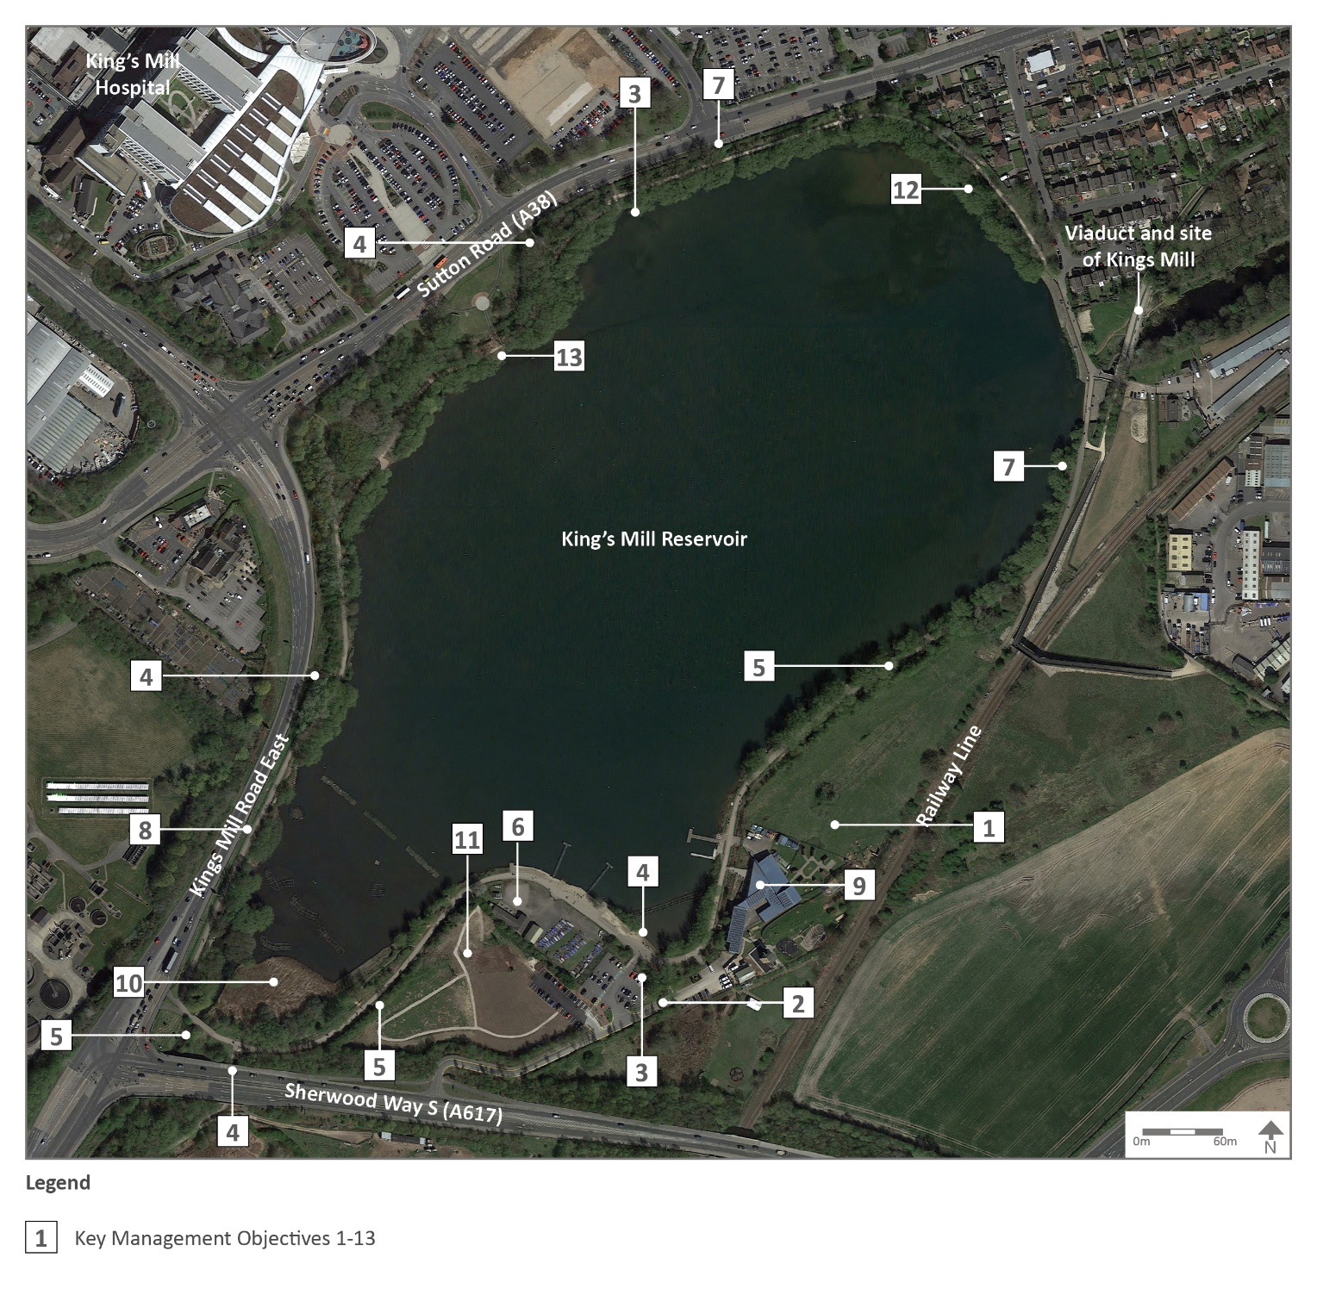

Key Management Plan Objectives
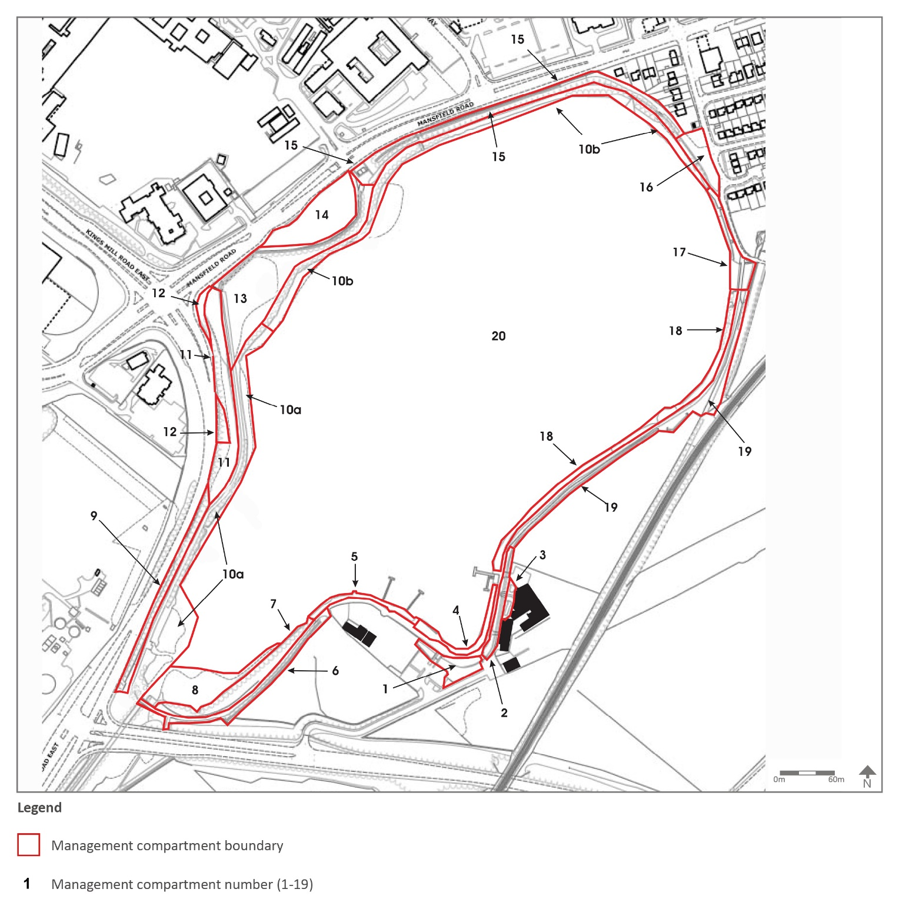

Management Plan Compartments

MONITORING/ REVIEW

Monitoring and Review

The management plan will be reviewed every two years with a review of the action plan carried out annually to monitor progress. This process will be carried out in September to feed into the Council’s business plan cycle. The results of the process will give the opportunity to assess the overall success of the management plan and whether additional funding and resources are required.

A site inspection will be carried out during August / September to check whether any additional works are required, which will then be added to the work programme/ Action plan, as appropriate.

3.2
Contacts
Kings Mill Reservoir
off the A617 Sherwood Way South and the A38 Mansfield Road Nottinghamshire
NG17 4PA

Grid reference SK 516596

Email: environment@ashfield.gov.uk 0800 183 8484 / 01623 457 857

www.ashfield.gov.uk
Clubs and Community Groups

The Mill Adventure Base Kingsmill Reservoir Sherwood Way South Sutton in Ashfield
NG17 4PA

Tel: 01623 556110
www.nottinghamshire.gov.uk/themill

The Mill Waters Ranger
Emma Hancock

The Mill Adventure Base
Kings Mill Reservoir
Sherwood Way South
Sutton in Ashfield
NG17 4PA

Tel: 01623 556110 ext 211
M: 07815 016278

www.millwaters.org.uk

The Mill Waters Café
Kings Mill Reservoir Sherwood Way South
Sutton in Ashfield
NG17 4PA

Tel: 01623 556110

www.millwatercafe.com

JD Fishery
Tel: 07515427562
07947318183

https://www.jdfisherymanagement.co.uk/

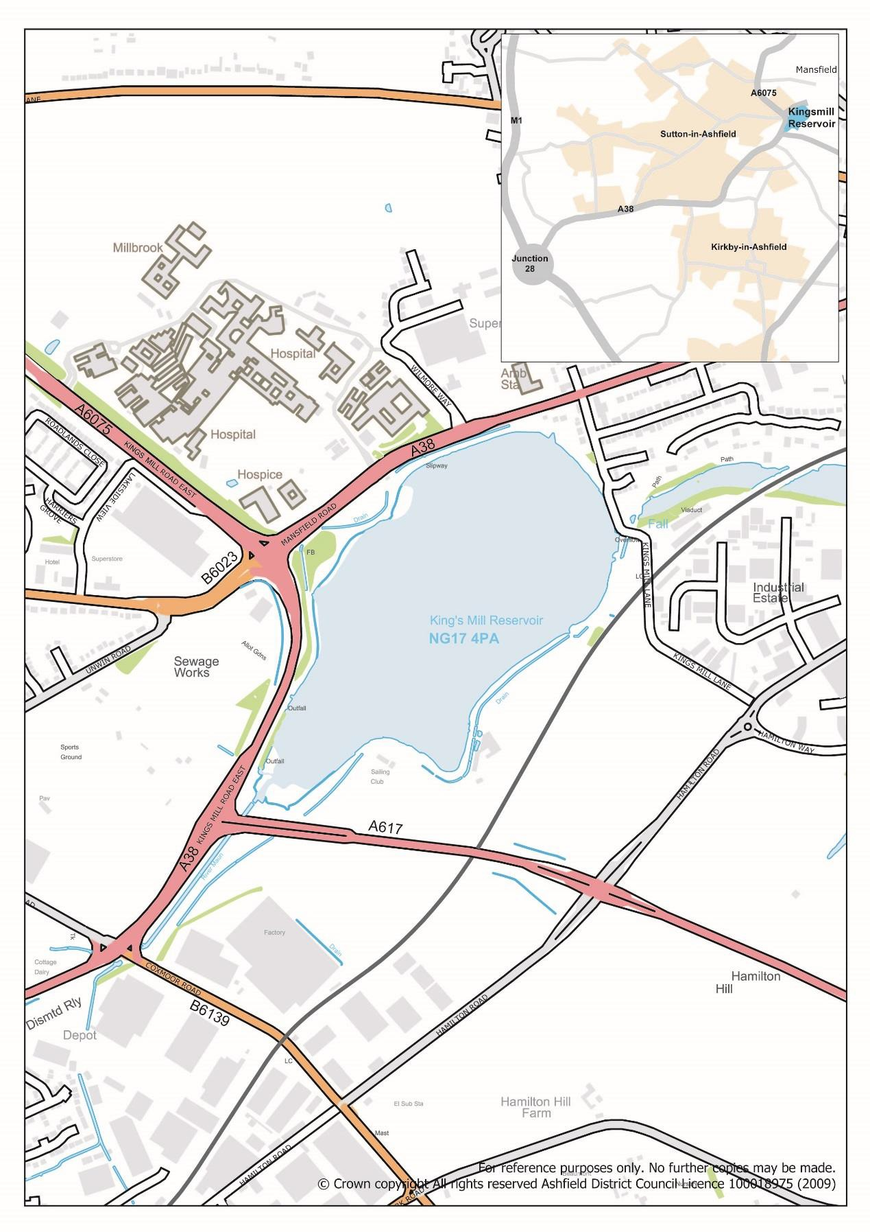

Ashfield District Council
Urban Road, Kirkby-in-Ashfield. Nottinghamshire. NG17 8DA Tel: 01623 450000 Fax: 01623 457585 Website: www.ashfield.gov.uk

