

Disclaimer

This document or some parts of it may not be accessible when using adaptive technology.
If you require assistance with accessing the content of the document, please contact Us and quote the document name, website and web page you found it on:

- email: asbduty@ashfield.gov.uk
- telephone: 01623 450000

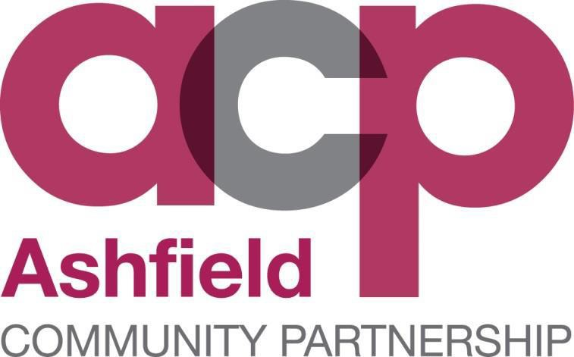

STRATEGIC ASSESSMENT 2019-2022



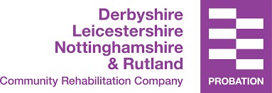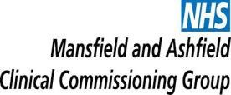

This page is intentionally blank.

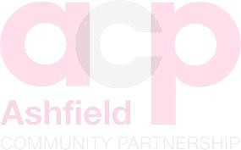

CONTENTS:

Executive summary | Page 4
Introduction | Page 6
Ashfield Community Safety Partnership | Page 6
Purpose | Page 6
Methodology | Page 6
Economic | Page 8
Growth and deficit reduction | Page 8
Employment levels | Page 9
Economic activity | Page 9
Social | Page 10
Detailed population figures 2017 | Page 11
Population by ethnic group | Page 13
Life expectancy | Page 14
Participation in sport and physical activity | Page 16
Adult and childhood obesity | Page 17
Children in poverty | Page 18
Housing | Page 19
Welfare changes | Page 21
Homelessness | Page 21
Crime and disorder | Page 23
Review of current CSP priorities | Page 32
Recommendations | Page 39
PRIORITY: Anti-social behaviour | Page 40
PRIORITY: Protecting vulnerable people | Page 41
PRIORITY: Domestic abuse | Page 42
PRIORITY: Violence | Page 43

Executive Summary
Between 1st October 2017 and 30th September 2018, total recorded crime in the Ashfield District was 11354 offences, which was a rise of 17.51% (1692 offences) on the previous year. There were only three areas that showed a reduction; burglary (5.46%), other theft (11.55%) and drug offences (1.67%).

The community consultation was conducted from 20.07.2018 to 30.09.2018.

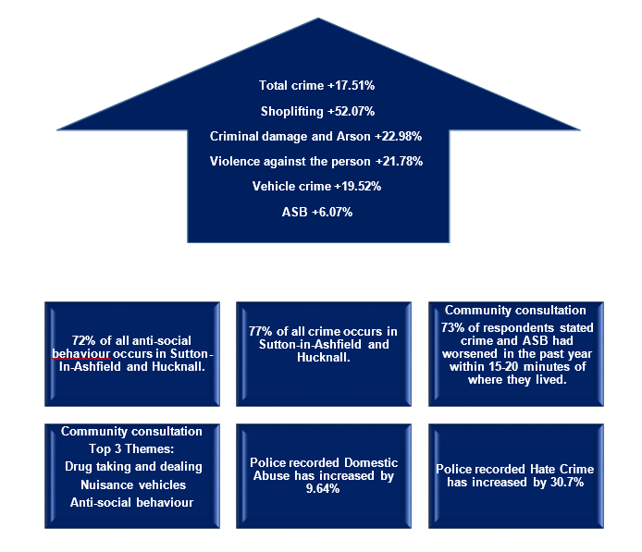

Priorities:

What are we going to do?

Anti-Social Behaviour
- Increased identification and active targeting of offenders and hot spot locations
- Improved provision and promotion of support to victims and witnesses.
- Increased community empowerment to tackle ASB.
- Increased positive diversionary activity for those at risk from becoming involved in ASB.
- Improved management of perceptions and reassurance.
- Ensure people know how to report ASB.

Protecting Vulnerable People
- Increased identification and support for vulnerable residents and victims.
- Improved early help support mechanisms.
- Improved multi-agency awareness and prevention programs.
- Increased proactive response to emerging and high-risk vulnerability concerns as they occur.
- Improved early intervention and community based assistance to tackle root causes of children and family vulnerabilities.
- Enhanced awareness of violent extremism and hate crime.

Domestic Abuse
  - Improved challenge of underlying attitudes and behaviours.
  - Develop early identification and intervention support.
  - Increased support and risk reduction for high-risk victims of domestic abuse.
  - Improved partnership working to ensure appropriate actions around perpetrators.
  - Improved work with other partners to obtain the best outcomes for those affected by domestic abuse and their families.

Violence
    - Increased proactive response to violence associated with night-time economy disorder
    - Increase identification and support for young people involved with (or at risk of being involved with) violent crime.
    - Increased identification and active targeting of offenders who are exploiting vulnerable groups
    - Enhance awareness of violent extremism and hate crime
    - Improved support for victims of violent crime
    - Improved targeting of prolific and repeat violent crime offenders

      - To further develop and improve partnership working across the Ashfield District.

Integrated Working

Introduction

Ashfield Community Safety Partnership

Ashfield Community Safety Partnership (ACP) is a joint partnership between Ashfield District Council, Nottinghamshire Police, Nottinghamshire Fire and Rescue Service, the Probation Service, and Mansfield and Ashfield Clinical Commissioning Group who work together to tackle crime and anti-social behaviour that affect our communities.

These agencies have a duty to come together and work with other groups, organisations and agencies to prevent crime and disorder.

The CSP was formed in response to the Crime and Disorder Act 1998 as a statutory requirement.

The quality of life for those who live, work or visit the Ashfield District depends on many organisations: the Council, Police, Fire and Rescue and healthcare organisations, as well as businesses, voluntary organisations, tenants and residents associations, community, race and faith groups, individual residents, workers and visitors. Tens of thousands of people have an impact on what it feels like to live and work in Ashfield District.

Purpose

This crime and disorder Strategic Assessment is prepared on behalf of the Ashfield Community Safety Partnership to inform strategic planning and commissioning processes, to ensure that community safety considerations form an integral part of the delivery of statutory services within the CSP. Full statutory requirements can be found in Section 17 Crime and Disorder Act (Formulation and Implementation of Strategy) Regulations (2007)2.

The crime and disorder strategic assessment is part of an intelligence process that is used to help tackle crime and disorder and to improve community safety. It is produced annually by the Community Safety and Strategic Partnerships Officer within the Ashfield District Council Community Safety Team, with contributions from across the partnership. It has detailed analysis that explores key and emerging problems and consultations with community groups.

The aim of the crime and disorder strategic assessment is to identify key crime, disorder and anti-social behaviour issues that affect the Ashfield District. It considers what needs to be achieved to help improve community safety, including how the community can feel assured and confident that their concerns and fears are being addressed.

Methodology

The previous priorities were set under the strategic plan for the years 2016/2017.

These priorities have been reviewed and are not reflective of the current climate in respect of the partnership and social and economic factors. Therefore, the new Ashfield Community Safety Partnership Plan will contain new priorities that will look forward from 2019 to 2022.

A period of public consultation took place over the period from 20.07.2018 to 30.09.2018.

Whilst the co-ordination of the consultation took place within the District’s Community Safety Team, the delivery of the survey took place over a number of partnership communication channels and public events.

An online version of the survey was made available via the District’s website and promoted through social media channels. Key partners provided similar opportunities, through the face-to-face completion and social media accounts.

The consultation was delivered at a number of locations and public events over the period. The times and places of these events were coordinated to encourage engagement will all sections of the community. All Ward Councillors were aware of the consultation and details of the survey were promoted through a number of political party sites.

Data from a wide range of sources was analysed to show how the CSP compares with other areas for the priority crime types and how volumes and rates have changed over time. Information from research was used to describe any notable risk factors and victim and offender characteristics as well as approaches to partnership working.

This approach ensures the most effective use of partnership resources and prevents the collation of data and information that is irrelevant to the development of the document. It allows focus to be placed on the issues that are most significant. The use of this approach does not mean that those issues which our communities face on a daily basis will not be dealt with. The process identifies the demands that will receive an elevated level of service while others are dealt with as usual business processes of the CSP.

Economic

Growth & Deficit Reduction

The Office for Budget Responsibility forecasts published in October 2018 provides an economic outlook over the next several years with forecast GDP growth of 1.3% in 2018, 1.6% in 2019 and 1.4% in 2020.

Consumer spending is being supported by low interest rates and was boosted in summer 2018 by the football World Cup and a prolonged period of good weather.

The Bank of England raised the base interest rate from 0.5% to 0.75% in August 2018 and this was only the second rise in over a decade. This rise may place pressure on some households, particularly those that are highly indebted and have little flexibility to respond to higher debt service levels.

Whilst the Chancellor, Phillip Hammond, stated in his October 2018 Budget that the “era of austerity is finally coming to an end”, the effects will continue to be felt over the coming years.

It is unlikely that the reductions in central government funding to partner agencies will end. Pressure will continue on partners to do more with less and to make hard choices about services they will continue to support. The effect being:

- Any new initiatives will have to be delivered within existing budget and resources.

- A key element of successful partnership ventures will support the delivery of crime and disorder reductions and an acknowledgement of each parties own performance objectives.

Employment Levels
For the years April 2017 to March 2018 the average unemployment in Ashfield was 4.3%, a 0.4% fall in unemployment on the previous year. However, the July 2018 figure shows a rise to 4.6%.

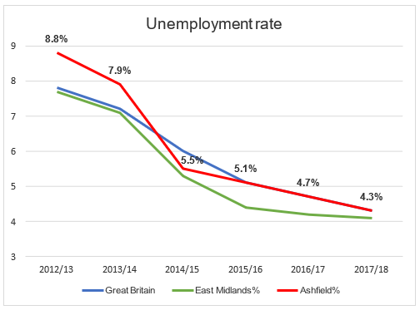

Economic Activity

Jul 17 - Jun 18 | Nottinghamshire | Ashfield | Bolsover | Erewash | Mansfield | Cannock Chase | Nuneaton and Bedworth
Economic activity rate males - aged 16-64 | 83.9 | 77.3 | 81.5 | 92.2 | 77.8 | 89.3 | 81.8
Economic activity rate females - aged 16-64 | 72.9 | 64.5 | 69.7 | 70.3 | 70.3 | 72.7 | 81.3

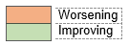

Social
Ashfield District covers an area of 10,956 hectares and is located on the western side of Nottinghamshire in the East Midlands Region. It adjoins seven districts within the county including Nottingham City to the south and Mansfield to the north and east, as well as part of the western boundary with Derbyshire.
There are three main urban areas in the District where housing, jobs and services are generally concentrated. The southernmost is Hucknall which lies immediately north of Nottingham. Kirkby in Ashfield and Sutton in Ashfield are to the north of the District and include the adjoining settlements of Annesley Woodhouse/ Annesley, Huthwaite, Stanton Hill and Skegby areas respectively.
Sutton in Ashfield, the largest of the three town centres, has been identified as a centre of Sub-Regional importance, with Hucknall being identified as a ‘Major District centre’ and Kirkby in Ashfield is the smallest of the three town centres, defined as a ‘District centre’ by the Ashfield Retail Study 2016. Three villages of Jacksdale, Selston and Underwood also contain significant residential areas, but lack the concentration of employment opportunities and services found in the main centres.
The remainder of the District is primarily countryside but contains a number of smaller settlements such as Teversal and Fackley.
There are two parish councils within the District, Annesley and Felley Parish Council and Selston Parish Council.
The District comprises of 23 wards as of 2015 and has its administrative centre in Kirkby-in-Ashfield.

The District has excellent road links to much of the country due to its location beside the M1 motorway. Junction 26 of the M1, which is outside the District, provides a good link to Hucknall now that new routes around Bulwell are complete. Junction 27 of the M1 lies within the District and provides a major link to Ashfield’s three towns and Junction 28 can be easily accessed via the A38 and other major routes including the A617; Mansfield-Ashfield Regeneration Route (MARR).
The 2017 mid-year population estimate shows the District to have a population of 126,164, with 61,931 males 64,233 females, the imbalance being due to the aging population. Population is increasing in Hucknall, Sutton in Ashfield and Kirkby in Ashfield but declining in the Rural Areas.

 | Census 2001 | Census 2011 | 2017
Working Age Population (16 – 64) | 70,809 | 78,100 | 79,862
Pension Age Population (65+) | 17,468 | 20,200 | 23,896
Households | 46,600 | 50,900 | -
Average people per household | 2.39 | 2.35 | -
Population density (people per sq km) | 1017 | 1091 | 1152

Detailed Population Figures 2017
Ashfield has 23 wards.

 | Total resident population
 | 2015 | 2016 | 2017
Abbey Hill | 3,458 | 3,450 | 3,601
Annesley & Kirkby Woodhouse | 7,086 | 7,273 | 7,578
Ashfields | 3,990 | 4,000 | 4,097
Carsic | 3937 | 3,919 | 4,027
Central & New Cross | 7,843 | 7,948 | 8,166
Hucknall Central | 6,711 | 6,714 | 7,034
Hucknall North | 10,203 | 10,335 | 10,570
Hucknall South | 7,451 | 7,534 | 7,600
Hucknall West | 9,387 | 9,393 | 9,643
Huthwaite & Brierley | 7,320 | 7,378 | 7,515
Jacksdale | 3,412 | 3,413 | 3,410
Kingsway | 3,160 | 3,128 | 3,185
Kirkby Cross & Portland | 4,130 | 4,288 | 4,220
Larwood | 3,294 | 3,283 | 3,394
Leamington | 4,258 | 4,264 | 4,209
Selston | 6,573 | 6,581 | 6,392
Skegby | 6,749 | 6,796 | 6,791
St Mary's | 4,048 | 4,053 | 4,017
Stanton Hill & Teversal | 3,166 | 3,287 | 3,322
Summit | 7,351 | 7,406 | 7,358
Sutton Junction & Harlow Wood | 3,800 | 3,813 | 3,809
The Dales | 3,149 | 3,134 | 3,070
Underwood | 3,098 | 3,092 | 3,156
Ashfield | 123,574 | 124,482 | 126,164
Hucknall | 33,752 | 33,976 | 34,847
Sutton in Ashfield | 48,260 | 48,592 | 49,023
Kirkby in Ashfield | 28,479 | 28,828 | 29,336
Selston, Jacksdale & Underwood | 13,083 | 13,086 | 12,958

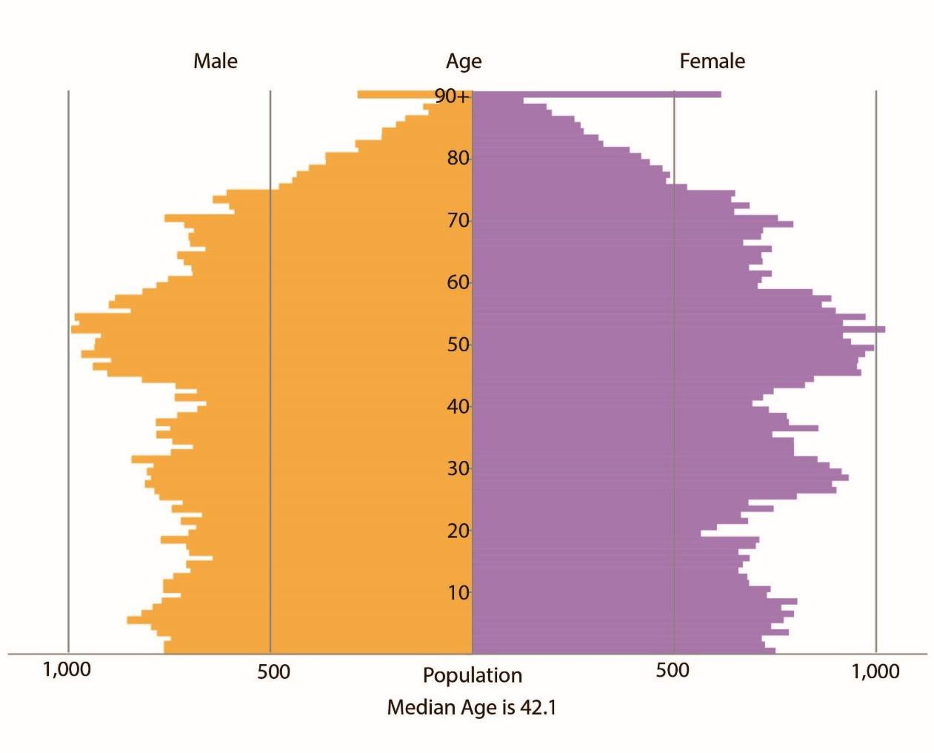

Ashfield has a history of industrialised wealth from coal mining and textile industries. Both declined in the 1980’s creating high unemployment and widespread deprivation throughout the District. Since this time, the District has benefited from new employment opportunities and improvements to transport links including re- established railway links to Nottingham and the tram system in Hucknall. Recent regeneration projects are transforming Ashfield and the District is fast becoming a more desirable place to work and live with a wide range of visitor attractions.
The proportion of foreign nationals has increased following national increases in international migration. Sutton in Ashfield has the largest concentration of migrants with an increasing number of eastern Europeans settling in the New Cross area.
An Office for National Statistics study in 2014 showed that 3% of the population of Ashfield were not born in the United Kingdom.

The majority of migrants come to the district for employment. There is clearly a benefit for the local economy, but this also places additional demands on public services.

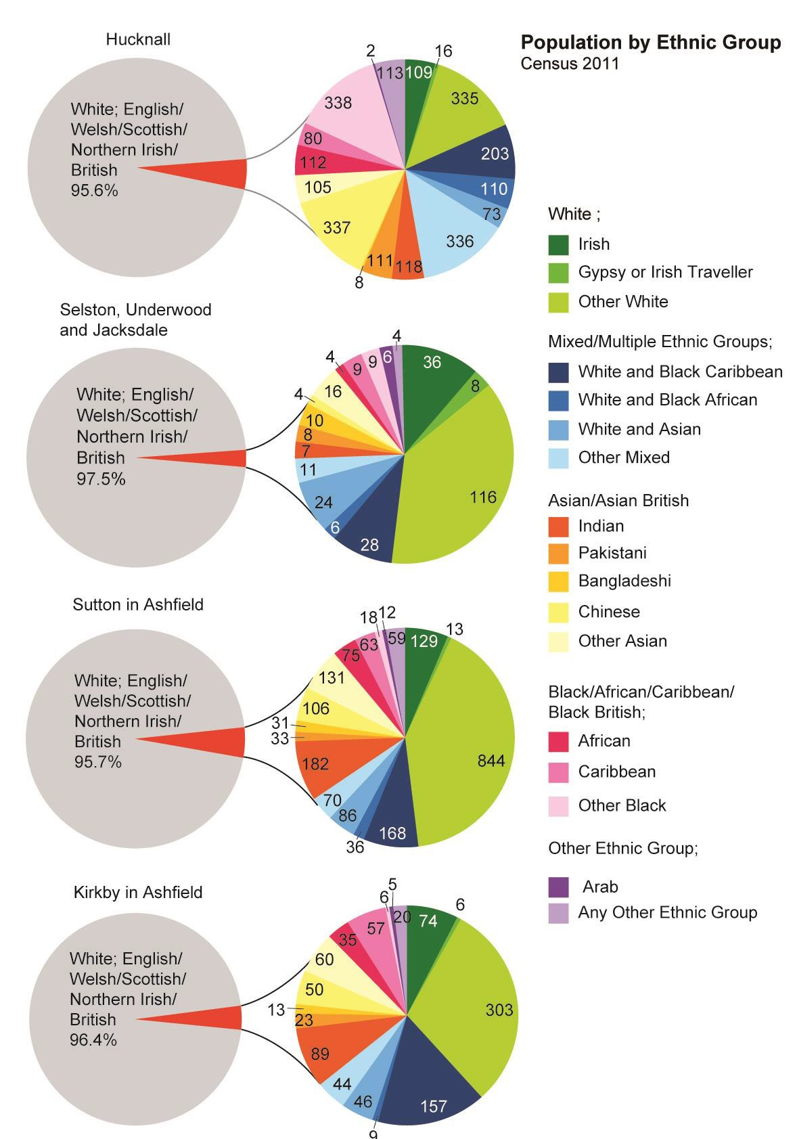

Health and Wellbeing
The health of people in Ashfield is generally worse than the England average. This can be seen in a number of areas:
- There are less people over the age of 18 diagnosed with diabetes than the England average;
- Obesity in children aged 4-5 is lower than the England average but obesity amongst 10-11 years is above average
- Excess weight in adults at 74% is higher than the England average (61.3%). The Regional average is 63.3%.
- There are health inequalities within Ashfield by level of deprivation. The difference in life expectancy between the most and the least deprived areas of Ashfield is 9 years for men and 6.9 years for women (based on death rates from 2011-2013). The difference in healthy life expectancy is 18.3 years for men and 18.9 years for women;
- Over the last ten years, life expectancy has increased for men and women in Ashfield; 1 year for men and 1.5 years for women, the improvement is in line The health of people in Ashfield is generally worse than the England average. This can be seen in a number of areas:
  - The health of people in Ashfield is generally worse than the England average.
  - There are less people over the age of 18 diagnosed with diabetes than the England average;
  - Obesity in children aged 4-5 is lower than the England average but obesity amongst 10-11 years is above average
  - Excess weight in adults at 74% is higher than the England average (61.3%). The Regional average is 63.3%.
  - There are health inequalities within Ashfield by level of deprivation. The difference in life expectancy between the most and the least deprived areas of Ashfield is 9 years for men and 6.9 years for women (based on death rates from 2011-2013). The difference in healthy life expectancy is 18.3 years for men and 18.9 years for women;
  - Over the last ten years life expectancy has increased for men and women in Ashfield; 1 year for men and 1.5 years for women, the improvement is in line with the England average rates although they remain below average for England. Over the most recent period, life expectancy for both men and women has fallen slightly;
  - There has been another decline in the number of adult smokers;
  - Lifestyle indicators are generally worse than the average for England.

 | Life Expectancy at Birth |  |  |  | Life Expectancy at Age 65
 | Male |  | Female |  | Male |  | Female
 | 2013-15 | 2012-14 | 2013-15 | 2012-14 | 2013-15 | 2012-14 | 2013-15 | 2012-14
Bolsover | 77.4 | 77.6 | 81.4 | 81.7 | 17 | 17 | 19.5 | 19.5
Erewash | 79.6 | 79.7 | 82.9 | 83.1 | 18.3 | 18.4 | 20.7 | 21
Ashfield | 78.1 | 77.9 | 81.7 | 82 | 17.7 | 17.8 | 19.7 | 20.1
Mansfield | 78 | 78.1 | 81.6 | 81.7 | 18 | 18.1 | 20 | 20
Cannock Chase | 78.9 | 79.1 | 82.9 | 82.5 | 18.1 | 18.2 | 20.6 | 20.6
Nuneaton and Bedworth | 78.1 | 78.4 | 82.1 | 82.7 | 17.9 | 17.8 | 20.3 | 20.5
Nottinghamshire | 79.4 | 79.4 | 82.8 | 82.9 | 18.5 | 18.5 | 20.7 | 20.8

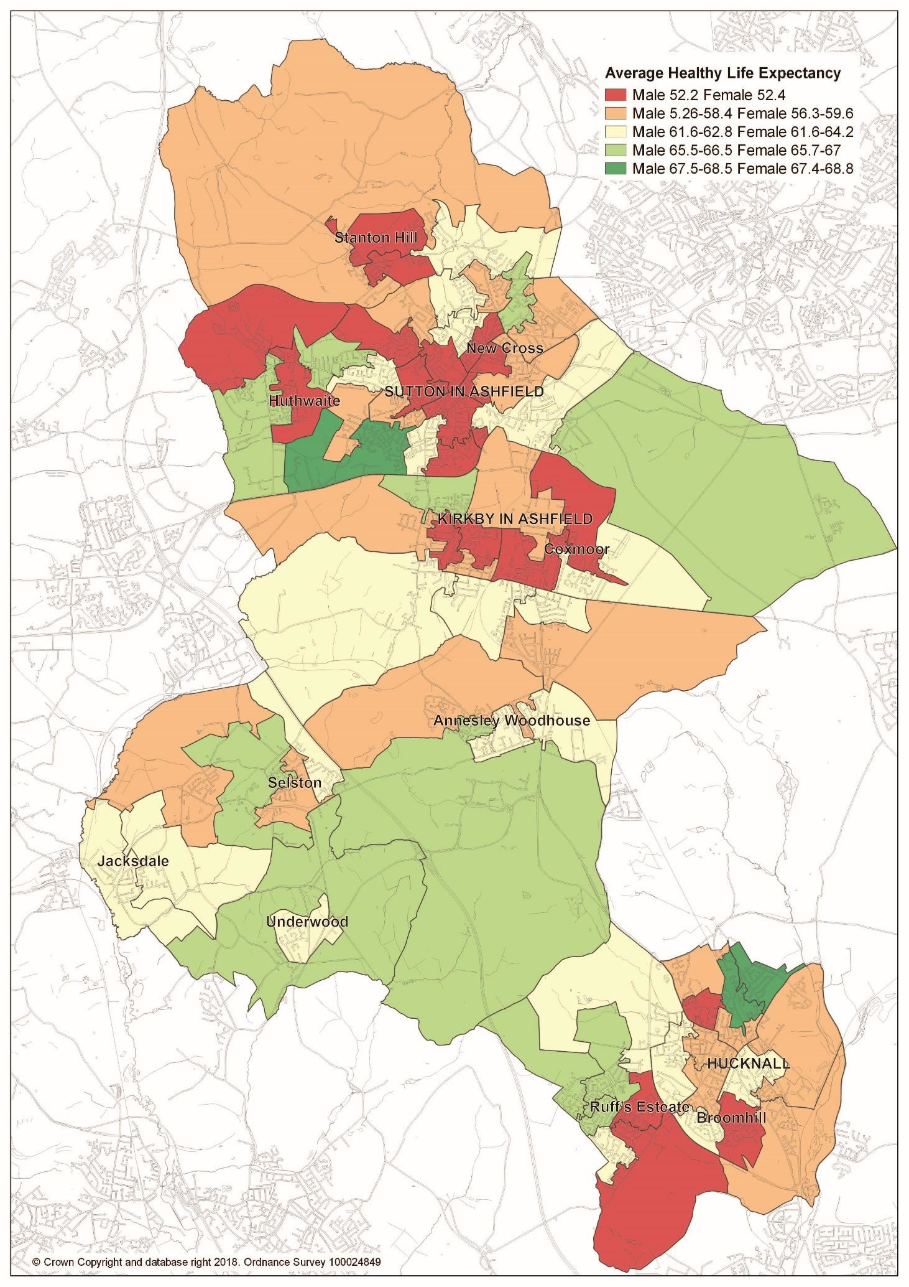

Participation in Sport and Physical Activity

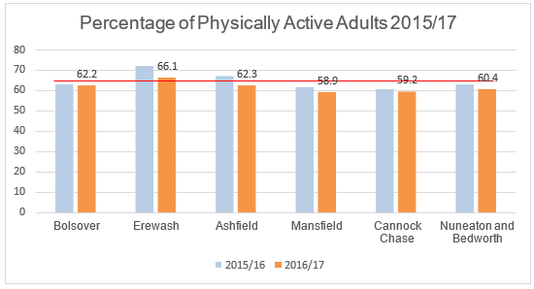

The East Midlands average was 64.4% in 2016/17
The physical activity of adults over the age of 19 has fallen in the district and is now below the average for the East Midlands.
The activity is 150 or more moderate intensity active minutes per week

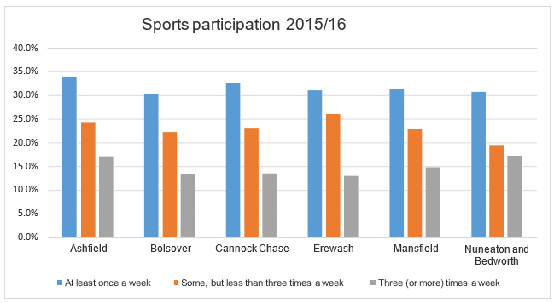

Adult obesity

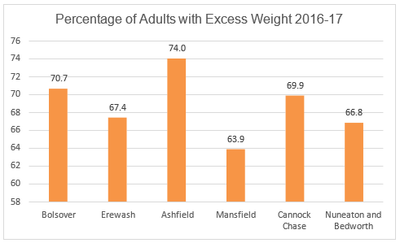
The East Midlands average was 63.3% over the same period
Adult excess weight is now measured from age 18, previously it was from age 16. However, in the previous reporting period, adult excess weight in Ashfield was above the Nottinghamshire average.

Childhood obesity
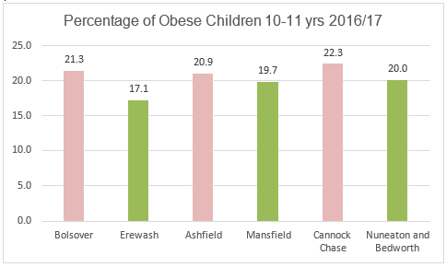

 | Improved since 2015 /20216 |  | Worsened since 2015/2016

The Nottinghamshire average is 17.4% over the same period.

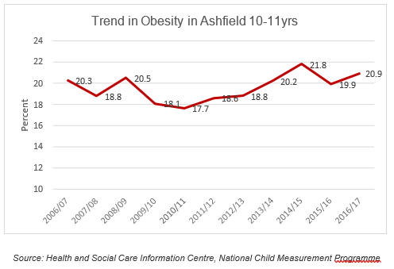
%

Children In Poverty
Latest data.
Children Living in Low Income Families 2015
25
20.9
19.9
20
19.4
15

10

5

0
Bolsover Erewash
Ashfield Mansfield Cannock Nuneaton
Chase and Bedworth
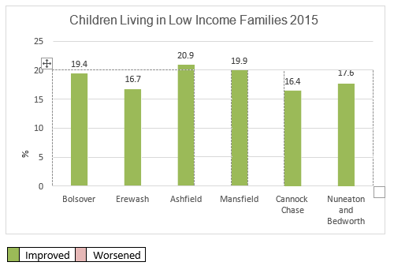

There has been an improvement in this category shown by the latest available data. The number of children in low income families has fallen to the lowest level since 2006.

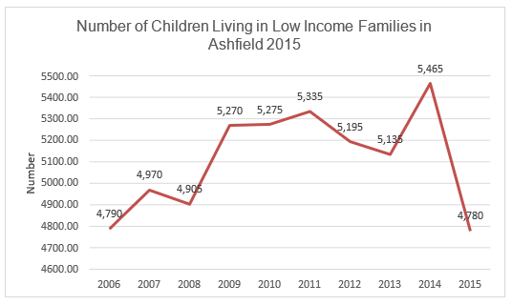

Source: HM Revenue and Customs (Personal Tax Credits: Related Statistics - Child Poverty Statistics)

Housing
Ashfield lies within the Nottingham Outer Housing Market Area (HMA) Area that comprises Newark & Sherwood, Mansfield and Ashfield Districts. The housing needs assessment undertaken across the HMA has highlight the following key characteristics of households and housing within Ashfield, based on Census 2011 data.
Across the Housing Market Area Ashfield has the highest population of the three authorities, with the population rising by 4.1% to 124,482 between
2011-2016. Of this there is an above national average of people between the ages of 40 and 65. Ashfield also has the highest percentage of households with dependent children in the HMA, but has also seen a significant growth in single person households. The population of the district is due to rise by around 11% to 136,350 by 2033.
House prices are still amongst the lowest in the region although house prices have continued to rise in recent years with the average price now £138,425

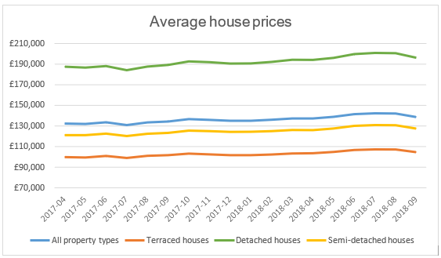
Land Registry

Within the District of Ashfield there are 6790 (December 2018) council owned properties, down from 6866 in 2015 and a further 2182 owned by other Registered Housing Providers (at March 2017).
The number of long term vacant properties fell to 543 in October 2017, this number has fallen continuously since 2004 when it was 815.
The private rented sector makes up around 15% of all stock with over 8000 homes across the district whilst the majority of homes are owner occupied. Rents in the private sector are comparatively low with mean monthly rents of around £502 (compared to £548 in the County, £601 regionally and £829 at national level: Shelter, Q1 2018).
Actions by local government to improve transport links between Ashfield, Nottingham and Mansfield appear to have had an effect on both local and wider housing markets, both increasing house prices along the NET Tram Route and levelling out prices around the Mansfield to Ashfield Regeneration Route (A617).
Migration to and from the District is largely contained within the HMA and the Nottingham Core HMA, with the majority of moves between Ashfield and Mansfield, and from Nottingham and Broxtowe into Ashfield. Ashfield shows a net inflow of people, with significant inflows to Ashfield from Nottingham and Broxtowe. Migration from Nottingham has a significant impact, particularly in Hucknall.
Existing policy and housing strategy documents distinguish three main housing market areas within Ashfield – North (Sutton-in-Ashfield, Kirkby-in-Ashfield and surrounding settlements); South (Hucknall) and Rural (Selston, Jacksdale, Underwood, Bagthorpe and Brinsley areas – Selston Parish).

Welfare Changes
Universal Credit

Universal Credit (UC), is a new benefit administered by the Department for Work and Pensions (DWP) through a local Jobcentre Plus. The next phase of Universal Credit has been fully introduced in Ashfield. This means that Ashfield is now a “UC Full Service” area therefore any working age claimant who would like to make a new claim for help with their income and to help pay their rent must now apply for Universal Credit. Housing Benefit is no longer available for most new working age claimants.

Universal Credit replaces a range of existing benefits including Job Seekers Allowance, Income Support and Housing Benefit. Universal Credit is paid directly to a nominated householder; people not experienced in budgeting may mismanage their UC and get into debt. There have already been reports of increasing rent arrears in pilot areas and the full effects will not be known for some time.

Homelessness
Each local housing authority is required to consider housing needs within its area, including the needs of homeless households, to whom local authorities have a statutory duty to provide assistance.

The Housing Act 1977, Housing Act 1996, and the Homelessness Act 2002, placed statutory duties on local housing authorities to ensure that advice and assistance to households who are homeless or threatened with homelessness is available free of charge. All households that apply for assistance under the Housing and Homelessness Acts are referred to as ‘decisions’. However, these do not include households found to be ineligible for assistance (some persons from abroad are ineligible for assistance).

A ‘main homelessness duty’ is owed where the authority is satisfied that the applicant is eligible for assistance, unintentionally homeless and falls within a specified priority need group.

In the past year this issue has received significant publicity due to the high visibility of people perceived as being homeless within Sutton-In-Ashfield. The number of homeless in the district is supplemented by those individuals who have accommodation but choose to live on the street.

Homelessness has a number of layers with Rough Sleepers very tightly defined as ‘in/on bedding in the open air’ and does not include those residing in shelters or simply could not be found when the count took place.
Within the homeless population of the Ashfield District there are challenges around alcohol & substance abuse, mental health, and the various individual difficulties which led to someone sleeping on the street. The challenge for the partnership will be to minimise the impact of those individuals upon the settled community whilst

working alongside agencies supporting these individuals into a more positive lifestyle.

Accepted as being homeless and in priority need

 | Ashfield |  | Bolsover |  | Cannock Chase |  | Erewash |  | Mansfield |  | Nuneaton and Bedworth
 | Number | Per 1000  hseholds | Number | Per 1000  hseholds | Number | Per 1000  hseholds | Number | Per 1000  hseholds | Number | Per 1000  hseholds | Number | Per 1000  hseholds
2017-18 | 123 | 2.28 | 29 | 0.85 | 57 | 1.34 | 17 | 0.33 | 189 | 4.04 | 180 | 3.3
2016-17 | 98 | 1.87 | 29 | 0.85 | 38 | 0.9 | 39 | 0.77 | 169 | 3.63 | 128 | 2.36
2015-16 | 93 | 1.77 | 46 | 1.36 | 19 | 0.45 | 22 | 0.44 | 114 | 2.48 | 137 | 2.52
2014-15 | 87 | 1.67 | 40 | 1.19 | 34 | 0.82 | 32 | 0.64 | 137 | 3 | 191 | 3.54
2013-14 | 85 | 1.64 | 30 | 0.9 | 42 | 1.01 | 26 | 0.53 | 150 | 3.3 | 172 | 3.22
2012-13 | 26 | 0.51 | 50 | 1.52 | 27 | 0.66 | 45 | 0.92 | 180 | 4 | 180 | 3.4
2011-12 | 16 | 0.33 | 54 | 1.69 | 41 | 1.05 | 36 | 0.75 | 128 | 2.98 | 139 | 2.73
Department for Communities and Local Government

Prevention of Homelessness

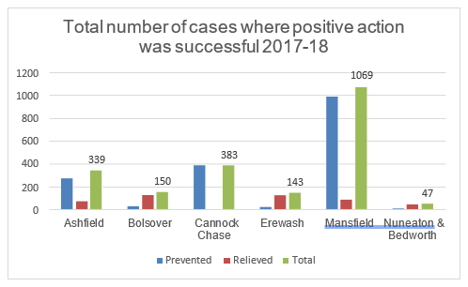

All DCLG homelessness statistics can be found at: https://www.gov.uk/government/collections/homelessness-statistics

Crime and Disorder
In the 12 months (October 2017 – September 2018), Nottinghamshire Police recorded 11354 offences in the Ashfield District. This is an increase of 17.51% (1692 offences) on the previous year.

 | Current:  Oct 2017- Sept  2018 | Previous:  Oct 2016-Sept 2017 | Volume Change | %Change | Target
Total recorded crime | 11354 | 9662 | 1692 | 17.51% | Reduce
Victim based crime | 10181 | 8649 | 1532 | 17.71% | Reduce
Violence against the person | 3439 | 2824 | 615 | 21.78% | Reduce
Sexual offences | 381 | 373 | 8 | 2.14% | Reduce
Robbery | 128 | 57 | 71 | 124.56% | Reduce
Burglary | 952 | 1007 | -55 | -5.46% | Monitor
Vehicle offences | 1102 | 922 | 180 | 19.52% | Reduce
Theft from person | 53 | 28 | 25 | 89.29% | Reduce
Bicycle theft | 142 | 100 | 42 | 42.00% | Reduce
Shoplifting | 1320 | 868 | 452 | 52.07% | Reduce
Other theft | 957 | 1082 | -125 | -11.55% | Monitor
Criminal damage and arson | 1707 | 1388 | 303 | 22.98% | Reduce
Other crimes against society | 1173 | 1013 | 160 | 15.79% | Reduce
Drug offences | 177 | 180 | -3 | -1.67% | Monitor
Possession of weapons | 84 | 67 | 17 | 25.37% | Reduce
Public order offences | 654 | 592 | 62 | 10.47% | Reduce
Miscellaneous crimes against society | 258 | 174 | 84 | 48.28% | Reduce
Anti-Social Behaviour | 3582 | 3377 | 205 | 6.07% | Reduce

There is an increase in recorded crime of 17.51% (1692 offences) which can partly be attributed to a change in Police crime recording practices particularly around Violence Against the Person – 21.78% ( 615 offences).

Significant increases can be seen in the following:
- Robbery – 124.56% (71 offences),
- Theft from Person – 89.29% (25 offences),
- Shoplifting – 52.07% (452 offences)
- Miscellaneous Crimes Against Society – 48.28% (84 offences)
- Criminal Damage and Arson – 22.98% (303 offences)
- Vehicle offences – 19.52% (180 offences)
Only three reporting areas show a reduction:
- Other Theft -11.55% (125 offences)
- Burglary 5.46% (55 offences)
- Drug Offences – 1.67% (3 offences)

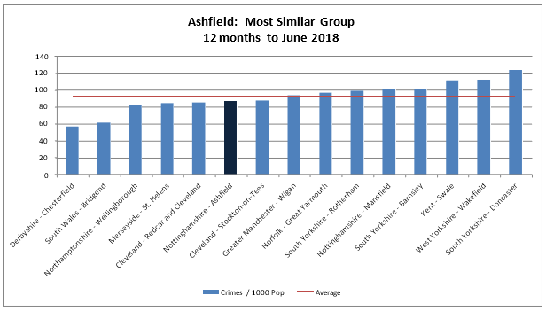

Ashfield compares favourably when measured against similar areas. Crimes per thousand population are below the average.

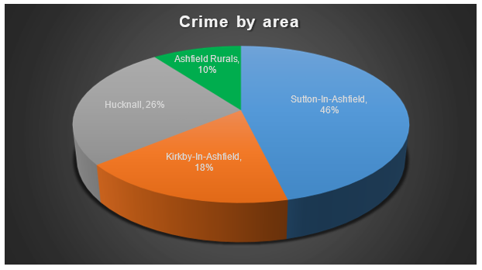

Crime percentages loosely mirror the population figures for each main area. Sutton- In-Ashfield and Hucknall combined account for 72% of all crime.

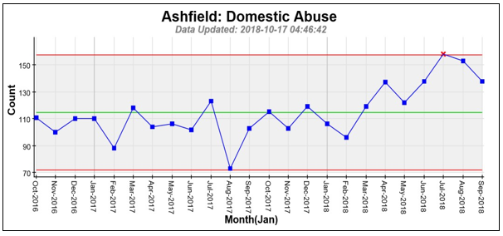

 | Current: Oct 2017-  Sept 2018 | Previous: Oct 2016-  Sept 2017 | Volume Change | %Change | Target
Domestic Abuse | 1456 | 1328 | 128 | 9.64% | Reduce

Domestic abuse reporting has continued to rise over the past two years with a 9.64% (128 offences) rise between October 2017 and September 2018. This is encouraging as it demonstrates a potential improved confidence in the ability of organisations to support victims and deal positively with perpetrators.

Women’s Aid Integrated Services (WAIS) deliver the following services in the Ashfield area:

- Serenity Dispersed Refuge Accommodation. External funding has supported refuge accomodation for women & children fleeing domestic abuse in Ashfield. There are six properties across Ashfield – 3 flats and 3 houses with 37 bed spaces.
Serenity can house:

  - Women with larger families
  - Women with older boy children
  - Women for whom communal refuge accommodation isn’t suitable
- Indigo Team – Offer support to women and children who are medium and standard risk. Support includes one to one support, drop-ins and healthy relationship programs. The teams are based with partners within the Ashfield Hub and with the Social Care Assessment Team.
- DAR’S (Domestic Abuse Referral Service) - The service takes referrals directly from GP’s and other health professionals.

- CAT Team (Children & Teen Team) – One to one support to children who have experienced domestic abuse in their home, one to one support to teenagers who have experienced abuse in their own relationship, group work in schools and throughout the school holidays.

- Pets Project – The Pets project offers support to women to flee domestic abuse by arranging fostering for their pets.

- Helpline – a 24-hour helpline for women and agencies offering information, advice and signposting.

- Independent Domestic Violence Advisors (IDVA), Court IDVAs and Integrated Offender Management (IOM) – Women assessed as high risk via the Multi-agency Risk Assessment Conference (MARAC) process and court receive support IDVAs.

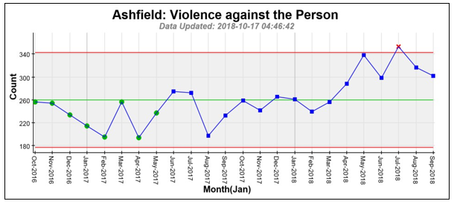

Violence against the person has shown a rise of 21.78%. Whilst a proportion of this rise can be attributed to revisions Police recording practices, it is an area that will be addressed in the CSP plan moving forwards.

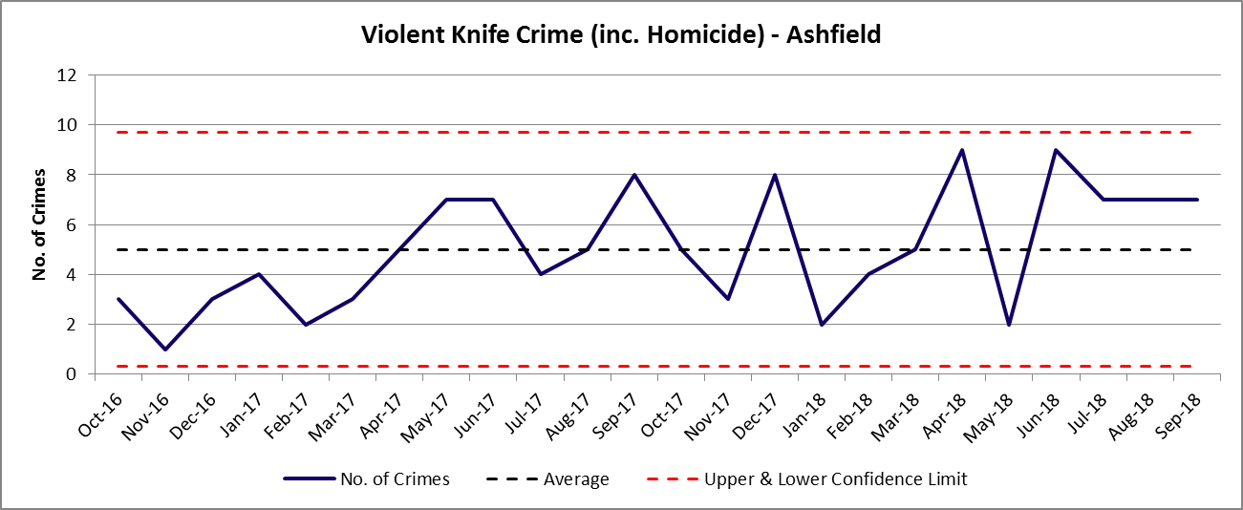

Knife crime in the United Kingdom continues to receive significant media attention. This in turn contributes to an increase in reporting.

The Nottinghamshire Police and Crime Commissioner has published Nottinghamshire’s Knife Crime Strategy 2018.

The Knife Crime Strategy 2018 is a pan-agency agreement that will see partners working together with the voluntary sector to tackle every aspect of knife violence with a strong emphasis on education, early intervention and youth engagement.

Backed by Nottingham City Council and Safer Nottinghamshire Board, voluntary and community sector and criminal justice partners the strategy sets out four key areas of work:

- Identification and management of risk: Identifying those at risk of becoming perpetrators or victims of knife crime and managing these risks with diversion and enforcement.
- Developing resilient spaces: Making it harder for offenders to carry and use knives in public spaces by robust enforcement, particularly in the night-time economy.
- Communication and behaviour change: Ensuring clear messages are delivered and promoting alternative lifestyle options.
- Communities and the third sector: Working with the community and wider partners to build resilient neighbourhoods and tackle both the immediate and long-term impact of knife crime.
A recent Nottinghamshire ‘Knife Amnesty’ resulted in 31 knives being recovered in Ashfield as part of a countywide total of 418.



Anti-Social Behaviour

Levels of reporting of Anti-Social Behaviour rose slightly by 6.07% (205 offences) and reductions seen in two of the key areas; Environmental -13.69% (33 offences) and Personal -1.16% (7 offences). The only rise being in Nuisance -9.67% (245 offences).

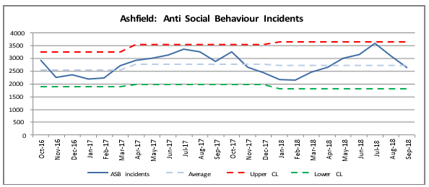

Sutton-In-Ashfield and Hucknall account for 77% of all reported antisocial behaviour.

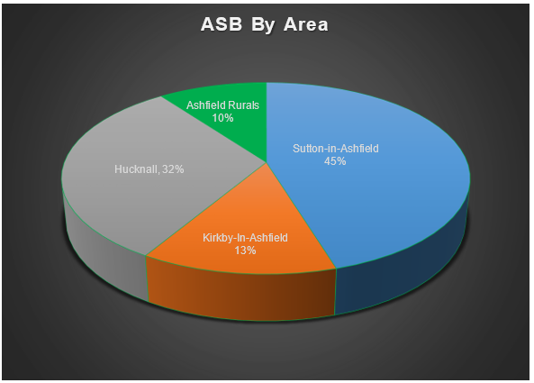

Hate Crime

A hate incident is any incident that is perceived by the victim, or any other person, to be motivated by hate, hostility or prejudice.
Data is collected under five strands:
- Race
- Disability
- Faith or religion
- Sexual orientation
- Gender identity
Nottinghamshire Police also collect data for:
- Misogyny
- Alternative subcultures

 | Current:  Oct 2017-  Sept 2018 | Previous:  Oct 2016-  Sept 2017 | Volume Change | %Change | Target
Hate Crime | 115 | 88 | 27 | 30.7% | Reduce

Hate crime reporting has increased significantly in the period between October 2017 and September 2018. This is against the background of BREXIT which has seen a national rise in reported hate crime in the United Kingdom.

It can be seen that the Ashfield District has shown a rise of 30.7% (27 offences) which could also be attributed in greater victim confidence in reporting instances of hate crime.

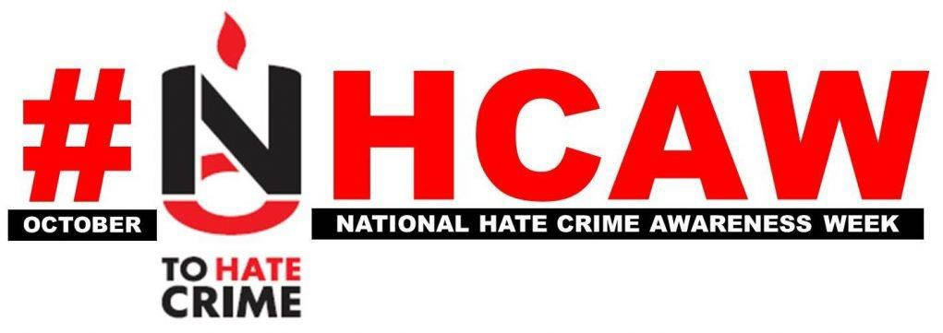

Community Consultation 2018.

A recent Community Consultation in the Ashfield District showed that the largest proportion of residents, 73%, identified that crime and anti-social behaviour in the District had become worse over the past twelve months. 19% identified that it had remained the same and only 6% identified that it had improved.
It is important to note that this consultation was completed at a time that the local media was dominated by issues connected to the controlled substance known as ‘Mamba’ and the associated anti-social behaviour.

“Thinking about your local area, 15-20 minutes’ walk from where you live, how have levels of crime and anti-social behaviour changed over the past year?”

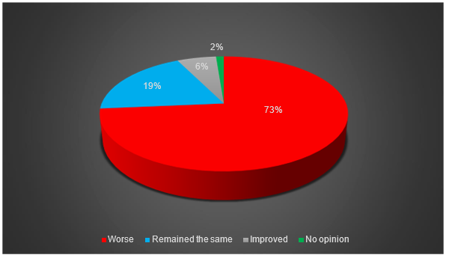

When asked, “What makes your area a safe place?” the most common responses related to community and agencies. 20.2% mentioned a visible authority within the community and a further 17.6% talked about good neighbours.

When asked, “What makes your area an unsafe place?” there were two overwhelming categories: drug issues – 19.87% and a lack of Police – 18.57%.

It is important the partnership recognises community concern alongside more readily available datasets for recorded crime and disorder.

The fear or perception of crime is just as likely to have an impact on a community as a change in recorded incidents.

The consultation has gathered a significant amount of information about the communities’ opinions, awareness and concerns of community safety issues.

Headlines;

- Levels of crime and anti-social behaviour are perceived as becoming worse
over the past year.
- Respondents identified that a well-established community, good neighbours and visible authority in the community are the key factors in making their area safe.
- Respondents stated that drug issues and a lack of Police are the key factors in making their area an unsafe place.
- Respondents perception is that substance misuse and youth issues are the main contributors to levels of crime and anti-social behaviour.
- Respondents claim to have a good understanding of cybercrime, hate crime and child sexual exploitation, but less so about modern day slavery and preventing radicalisation.
- Respondents are most concerned about drug taking and dealing, nuisance vehicles and rowdy/inconsiderate behaviour.

The details of the consultation will be used to inform the development of a new CSP plan, which will set out the strategic aims of the partnership over the next three years.

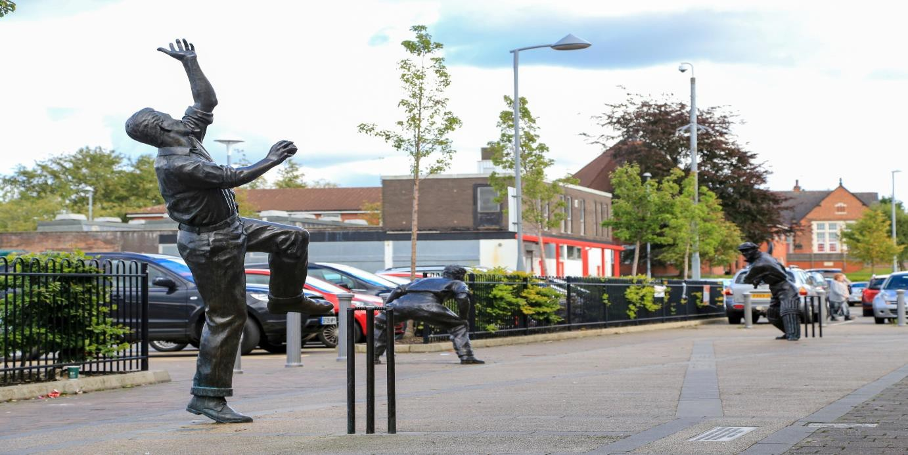

Review of Current CSP Priorities

Note: Due to financial restrictions and limited resources, there has been a period of two years since the last assessment which was prepared for 2016/2017. As such this section of the report will relate to the priorities which were set within that assessment.

The previous plan can be found at:
https://democracy.ashfield-dc.gov.uk/documents/s4828/ACP%20-%20Enc.pdf

Priority 1: Improving quality of life for residents of Ashfield

- Reducing vulnerabilities

Support continuation of medium risk Domestic Abuse Support

This is completed as part of daily business by the Nottinghamshire Police Safer Neighbourhood Team following a comprehensive risk assessment. It remains restricted by the lack of consent from some survivors.

Forging stronger links with Nottingham City Assurance and Learning Group for Domestic Homicides.

Partners attend the above and good practice is shared and adopted in respect of Domestic Homicide Reviews.

Mainstreaming emergency accommodation for survivors of Domestic Violence in collaboration with Women’s Aid Integrated Services.

Serenity Dispersed Refuge Accommodation is fully established in the Ashfield District.

This is currently funded until 2020.

Continue to roll out ECINS (Empowering Communities Inclusion and Neighbourhood Management System) to help partners share information.
ECINS empowers multi-agency partnerships by providing a secure, encrypted, cloud-based central hub to manage, collaborate, share, task and audit evidence.

Ashfield District Council has embedded ECINS as the primary recording system for incidents of anti-social behaviour. Nottinghamshire Police and Nottinghamshire Fires and Rescue are utilising the system. It is utilised positively in the management of the Ashfield Complex Persons Panel.

Continue multi-agency partnership working through the Vulnerable Person’s Panel to resolve problems / support victims.

This is now known as the Complex Person’s Panel and is embedded as a referral and problem-solving tool within the partnership. Currently (December 2018) there are 5 active cases.

Continue building upon integrated working & the success of the New Cross and Broomhill support teams by expanding the learning to the wider hub teams

The New Cross and Broomhill Support Teams have now been embedded within the Community Safety Team at Ashfield District Council as the Complex Case Team.
They now help vulnerable and hard to reach people across the district. Their ‘triangle of need’ ethos is embedded within the Community Safety team as the accepted working methodology. This was the subject of an independent evaluation by Nottingham Trent University that was shared with partner agencies.

Establishing a policy direction within ADC that requires all services to place a particular emphasis on key places and key people.

A review of services was completed in 2016/2017 which established a ‘Systems Thinking’ approach across the Community Safety Department. This focused on establishing the underlying causes of repeat demands upon services and ensuring that those demands were reduced through targeted positive interventions.
This ethos is now embedded within the service and is at the heart of case management.

- Reducing enviro-crime

Continue to work with residents to tackle issues such as dog fouling, littering.
Dog bags are available at various outlets throughout the district at a reduced cost. A meeting of the full Council authorised an extension and variation to an existing
Public Spaces Protection Order (PSPO) on 26th July 2018 for a period of three years commencing 01/10/2018 and this includes:
- Dog fouling in specified areas.
- Failing to produce device or other means or removing dog faeces on demand.
- Dogs specified maximum amount
- Dog exclusion in specified areas
- Dogs on leads in specified areas.

Community litter-picks are a regular event often led by elected representatives and litter picking is offered as an alternative to prosecution in respect of littering offences.

- To significantly reduce the crime and anti-social behaviour occurring in vulnerable families
- Reduce overall ASB

Focus on those individual and families that cause the most demand to public organisations. Targeted partnership working with the Family Service.

Caseworkers refer cases into the Family Service and work alongside them to assist those families that cause the most demand to public organisations. The Complex Case Team (ADC) work to identify ‘troubled families’ in the area and assign a key worker to act as a single point of contact.

Partners to ensure that suitable accommodation is made available to avoid vulnerable young people with mental health concerns being detained in custody and develop an appropriate place of safety.

Custody officers will not book a young person with mental health vulnerabilities into custody unless it is a last resort.

In the event the young person has committed a crime then the necessity for arrest is rigidly scrutinised and alternative options such as voluntary attendance interviews are explored. There should also be a safeguarding referral made if they are under
18. When detention is necessary then there is engagement between the custody officer and Emergency Duty Team at Social Care and the young person will be linked into the mental health workers who are based within the custody suites. The Police occasionally seek to remand young people overnight, but always refer them to Social Care who should seek an alternative provision via the relevant local authority.

If young people are brought to the custody suite for mental health issues only they are then either linked into the mental health triage team or diverted to a suitable place of safety such as a hospital.

Use of new Anti-social behaviour Tools and Powers.
The use of these powers is firmly embedded within the Ashfield District Council and Nottinghamshire Police. Community Protection Warnings and Notices have been effectively used to address issues of anti-social behaviour across the district. They were successfully used to restrict both the sale and usage of the controlled substance known as ‘Mamba’ within Sutton-in-Ashfield town centre.

Supporting development of Street Pastors in all of our town centres.

The Street Pastors are active and highly visible in Hucknall town centre. They voluntarily patrol the streets at night, helping and caring for people in practical ways. They hand out space blankets outside nightclubs, and flip-flops to clubbers unable to walk home in their high-heeled footwear; giving out water, chocolate for energy, personal alarms, carrying bus timetables; and ensuring the safety of vulnerable persons. Street pastors remove bottles and other potential weapons from the streets, in order to discourage violence and vandalism

- Reducing violent crime (including that related to the night-time economy)

Further development and Integration of the Community Alcohol Partnership (CAP.)
The Sutton-in-Ashfield/Huthwaite CAP is embedded within the community and meetings take place every six to eight weeks. In the past twelve months they have conducted the following:
  - Proactive stencil campaign on pavements adjacent to licensed premises.
  - CAP branded point of sale materials distributed to all licenced premises.
  - Test purchase operation. Two individuals prosecuted and referred to Ashfield District Council Licensing Department for re-education into their responsibilities.
  - Week of action completed during Alcohol Awareness Week.
  - Continued promotion and support of the ‘Challenge 25’ initiative.
  - Expanded membership following engagement from the Forge Café youth project.
The Selston CAP has been established and meets on a monthly basis.

Priority 2: Increased Community Involvement in decisions that affect them.

- Engagement with communities to ensure there is greater understanding of what is going on in specific areas.

Encourage greater uptake on Neighbourhood Alert.

Neighbourhood Alert provides an advanced community messaging system for Nottinghamshire Police.

Currently Neighbourhood Alert is managed effectively by Police volunteers based at Hucknall Police Station and has a weekly circulation of over two thousand recipients in the Hucknall and rurals area. The weekly ‘Alert’ highlights all crimes reported in the area and provides a valuable communication to residents.

Development of better connectivity and relationships between providers and the community.
It has been impossible to assess this as there is no recorded baseline for measurement.

Dragons Den style project.

The 2018 Dragons Den Project focused on promoting “Community Resilience, Community Cohesion, Diversity In order to promote Community Safety & Prevent Crime”

In the preparation, they worked with expert input from Young Minds and working alongside young artists from Emerge. The theme this year was to use Shakespeare and the concept of “festival” as a creative lens.

The competing schools were Holgate Academy, Quarrydale Academy and Kirkby College.

They were also tasked to design a creative exhibit for the Emerge Festival 2018. They all pitch their festival exhibit to a panel of Dragon’s Den Style Judges and compete for prize funding to develop their exhibit further for their school and local community.

Together We Are Better- project that identify people that live alone and would benefit from friendships from likeminded individuals – tackles loneliness.

This initiative was managed by ‘Jigsaw’ and allowed partner agencies to refer suitable candidates.

Priority 3: Improved Integrated Working at Local Level on priorities specific to each community
- Creation of more effective ‘citizen-shaped’ services.
- Redesigning the way mainstream services are delivered at a neighbourhood level

Continuing to support improvement in our Priority areas, coordinating activities from the various Partners to add value to the existing mainstream provision.
The focus on so called ‘Priority Areas’ has now shifted to a more dynamic approach to problem solving based on an intelligence and need led approach.

The five areas were:
- Broomhill
- New Cross
- Leamington
- Stanton Hill
- Coxmoor

Broomhill and New Cross had dedicated teams with offices on the relevant areas. These teams dealt with those individuals in crisis and had significant success as well as delivering considerable savings across the partnership.

These teams have now been mainstreamed as the ‘Complex Case Team’ and are now working with clients with complex needs across the District.

Process reengineering project to assess the ASB approach by Council and Police

A review of services was completed in 2016/2017, which established a ‘Systems Thinking’ approach across the Community Safety Department. This focussed on establishing the underlying causes of repeat demands upon services and ensuring that those demands were reduced through targeted positive interventions.
This ethos is now embedded within the service and is at the heart of case management.

The right level of representation and involvement by partners (internal and external).

The integrated HUB is now thriving with representation and involvement from Ashfield District Council, Nottinghamshire Police, Nottinghamshire Fire and Rescue, Women’s Aid Integrated Services, Probation Services, Family Services, Catch 22 and Victim Care. Problem solving is conducted on a multi-agency basis with excellent results being achieved on the Sutton Town centre ‘Mamba’ issue and the ongoing anti-social behaviour issues on the Coxmoor estate at Kirkby-In-Ashfield.

Work with partners to better understand, prevent and reduce demand and take steps to bolster community volunteering

Working in partnership has allowed all organisations to understand their demand and work towards preventing and reducing it. Volunteers are a key element to this as they provide additionality and free key staff to complete other duties.
Ashfield District Council and Nottinghamshire Police both have well-advertised volunteer schemes.
The Ashfield District Council scheme has 16 schools signed up to the Green Buddy Scheme, over 350 people have taken part in environmental initiatives and 103 people registered as Environmental Volunteers.

To volunteer at Ashfield District Council individuals can contact Community Action on 01623 457092 or email: volunteering@ashfield.gov.uk

To volunteer at Nottinghamshire Police individuals can contact the volunteer co- ordinator on 101 ext. 8106922 or email volunteers@nottinghamshire.pnn.police.uk.

Taking lessons from the pilot in New Cross* and developing them across the area.

As has been previously stated the ‘systems thinking’ approach and working practices of the pilot are now embedded as the accepted method of working within Ashfield District Council’s Community Safety Department.

Ensure there is practical information sharing agreements in place to support multi-agency and locality working.

This is ongoing and constantly evolving.

Increasing connectivity with the County Council’s new Family Support unit.

Partner agencies can and do refer into the unit, but again there is no baseline for the measurement of outcomes.

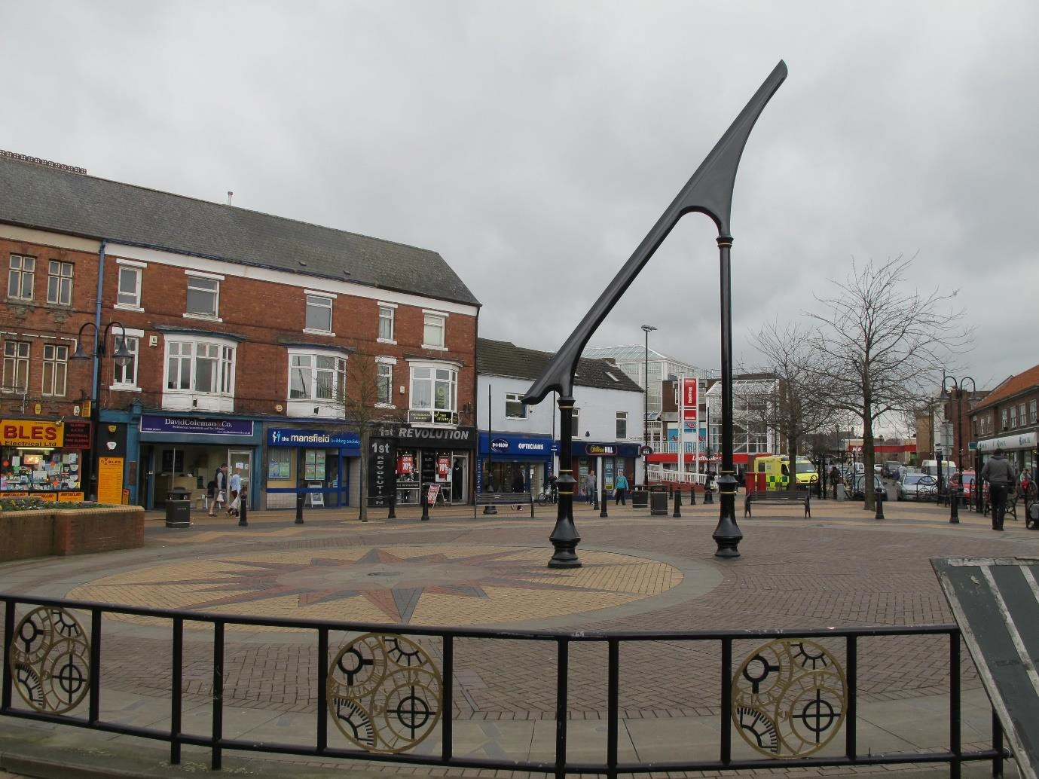

Recommendations:

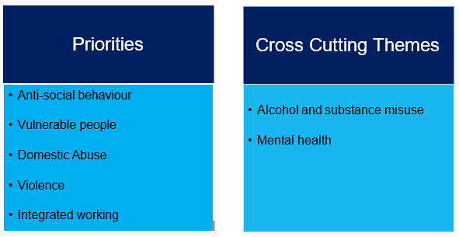
How will we address these priorities?

It should be accepted that the above priorities will very often be linked and there will be an ongoing necessity for them to be addressed in a flexible manner. The completed Ashfield Community Safety Partnership Plan will therefore be a dynamic document.

All partners have committed to sharing information and identifying means to gather relevant information and making best use of technology to inform tactical plans around priority issues.

Real-time data and intelligence will be utilised to address those issues that affect our communities.

Problem solving is to be completed in partnership with specific focus groups being formed to address both emerging and long-standing issues.

Activities will be effective, deliver value for money and any new services or projects will be commissioned in areas of greatest need.

The Community Safety Partnership will target its resources to improve public confidence in services, address those issues that have the greatest impact and protect the communities that they serve.

The Mansfield and Ashfield Community Safety Partnership Delivery Group will be responsible for monitoring emerging issues and delivering the plan. They will then report outcomes to the Mansfield and Ashfield Community Safety Partnership Strategic Group to ensure that the plan is being effectively delivered.

The plan will be reviewed and updated on a yearly basis.

PRIORITY: ANTI-SOCIAL BEHAVIOUR

Aims:

- Increased identification and active targeting of offenders and hot spot locations
- Improved provision and promotion of support to victims and witnesses.
- Increased community empowerment to tackle ASB.
- Increased positive diversionary activity for those at risk from becoming involved in ASB.
- Improved management of perceptions and reassurance.
- Ensure people know how to report ASB.

What will we do?

- Provide consistent multi-agency approach to the identification and support of vulnerable and repeat victims of ASB.
- Take a partnership approach to the use of appropriate enforcement powers
- Support and develop partnership targeted seasonal education and awareness campaigns; i.e. Bonfire Night, Halloween, end of school year.
- Continue to support primary and secondary school education initiatives locally and countywide.
- Engage fully in countywide strategies, policies and working groups enabling better outcomes for the communities of Ashfield.
- Expansion of the Community Alcohol Partnership to Kirkby-in-Ashfield and Hucknall.
- Increased public visibility from all partners in those areas experiencing high levels of ASB. This is to be dynamic and data driven.
- Support and engage with the Nottinghamshire Police Schools and Early Intervention Officer to tackle school absence and associated ASB.
- Continue to engage proactively with those misusing both drugs and alcohol within the communities of Ashfield.
- Conduct inter-agency research to better understand the results of our public consultation. (72%)
What does success looks like?
- In the twelve months to the end of September 2018, there were 3,582 incidents of ASB reported to the police in Ashfield District, which was a six per cent increase on the previous year.

Indicators of success:-
- A downward trend in incidents.
- Communities and people are safer and feel safer. (Measured via the
- Improved public perception of ASB and connected issues as measured in the annual CSP Public Consultation.
- Reduce the number of repeat victims year on year in respect of ASB.

PRIORITY: PROTECTING VULNERABLE PEOPLE

Aims.

- Increased identification and support for vulnerable residents and victims.
- Improved early help support mechanisms.
- Improved multi-agency awareness and prevention programs.
- Increased proactive response to emerging and high-risk vulnerability concerns as they occur.
- Improved early intervention and community based assistance to tackle root causes of children and family vulnerabilities.
- Enhanced awareness of violent extremism and hate crime.

What will we do?

- Use a partnership approach to ensure vulnerable children, families and adults are identified through the ongoing development of the Ashfield Complex Persons Panel.
- Actively promote knowledge of and the referral process for, the Ashfield Complex Persons Panel.
- Support and develop a partnership approach to countywide and national strategies around vulnerable people (to include PREVENT, Modern Day Slavery, CSE and Hate Crime) and organised crime groups (County Lines).
- Raise awareness of vulnerability concerns through targeted campaigns and events.
- Support and assist voluntary and other community groups to identify commissioning and funding opportunities.
- Engage fully in countywide strategies, policies and working groups enabling better outcomes.
- Support and promote engagement through appropriate mediums to ensure residents are aware what is happening in their area.
- Support and promote the National Property Register, ‘Immobilise’, to safeguard resident’s valuable items.
- Promote, both internally and externally, the use of the National Referral Mechanism for reporting suspected cases of modern day slavery.
- Work with Public Health and Education agencies to find ways in which key (age-appropriate) sexual educational messages for children can be communicated and reinforced; particularly around issues of consent, personal boundaries and appropriate behaviour.
- Reinforce messages for children and young people in respect of the safe use of the internet. This will also include providing guidance for parents; both in terms of technical solutions (e.g. parental controls) and support to assist them in identifying possible issues.
What does success looks like?

- Communities and people are safer and feel safer.
- Increased perception and understanding of Cybercrime, Preventing Radicalisation, Child Sexual Exploitation, Modern Day Slavery and Hate Crime as measured in the annual CSP Public Consultation.
- Increased confidence in agencies to encourage reporting of hate crime.
- Hate crime recording to correlate with ONS data.

PRIORITY: DOMESTIC ABUSE

Aims.

- Improved challenge of underlying attitudes and behaviours.
- Develop early identification and intervention support.
- Increased support and risk reduction for high-risk victims of domestic abuse.
- Improved partnership working to ensure appropriate actions around perpetrators.
Improved work with other partners to obtain the best outcomes for those affected by domestic abuse and their families.

What will we do?

- Support and develop partnership targeted education and awareness campaigns; i.e. White Ribbon.
- Support voluntary and other groups through identified commissioning and funding opportunities.
- Take a proportionate partnership approach to the use of appropriate enforcement powers.
- Support and develop the MARAC process to reduce risk for victims and families.
- Continue to support primary and secondary school education initiatives locally and countywide around healthy relationships.
- Engage fully in countywide strategies, policies and working groups enabling better outcomes for the communities of Ashfield.
- Support the countywide commissioning for Domestic Abuse Services. i.e The Serenity Project.
- Sustain early intervention processes.
- Work towards accreditation with the Domestic Abuse Housing Alliance (DAHA). DAHA is a partnership between three agencies who are leaders in innovation to address domestic abuse within housing;
Standing Together Against Domestic Violence (STADV), Peabody and Gentoo.
Domestic Homicide Reviews will be conducted in line with Home Office Guidance. All agencies involved will identify what lessons there are to learn about the way local professionals and organisations work individually and together to safeguard victims.

What does success looks like?

- Reduce the number of repeat victims year on year in respect of domestic abuse.
Increased confidence in agencies to encourage reporting of domestic abuse.
PRIORITY: VIOLENCE

Aims.

- Increased proactive response to violence associated with night-time economy disorder
- Increase identification and support for young people involved with (or at risk of being involved with) violent crime.
- Increased identification and active targeting of offenders who are exploiting vulnerable groups
- Enhance awareness of violent extremism and hate crime
- Improved support for victims of violent crime
Improved targeting of prolific and repeat violent crime offenders

What will we do?

- Promote and engage communities to report crime issues of concern via all appropriate channels (to include online reporting via the Nottinghamshire Police website and CRIMESTOPPERS)
- Support and develop partnership targeted education, awareness and crime reduction campaigns.
- Provide consistent multi-agency approach to the identification of repeat and high risk offenders for crime and ASB.
- Engage fully in countywide strategies, policies and working groups enabling better outcomes for the communities of Ashfield.
- Support voluntary and other groups through identified commissioning and funding opportunities for the reduction of re-offending.
- Reduced placement of vulnerable people into sensitive locations through development of the Ashfield Complex Persons Panel and liaison with Ashfield District Council Housing Services.
Support and implement Nottinghamshire’s Knife Crime Strategy 2018. (OPCC)

What does success looks like?
- In the twelve months to the end of September 2018, there were 3439 violent crimes reported to the police in Ashfield. This was a rise of 21.78%.

Success:-
- A downward trend in incidents (excluding harassment and stalking).
Communities and people are safer and feel safer.
PRIORITY: INTEGRATED WORKING

Aims.

To further develop and improve partnership working across the Ashfield District.

What will we do?

- Have mutual respect within partner organisations.
- Actively listen to each other to improve outcomes for residents.
- Work from shared values.
- Better understand the priorities and limitations of partner organisations.
- Honesty with each other.
- Be customer and solution focused.
- Acknowledge each other’s’ views.
- Be inclusive.
- Have open communication and information sharing.
- Take an evidence based approach to the setting of shared priorities.
Problem solving to be completed using approved methodology (OSARA).

What does success looks like?

- An expanded and more inclusive partnership HUB.
Increase public satisfaction in agencies across the Ashfield District. (Measured via the public consultation.)

