Ashfield Local Plan 2023 to 2040
Regulation 19 Pre-Submission Draft

Background Paper 2:

Housing

October 2023

THIS PAGE IS INTENTIONALLY BLANK

Contents

Section |  | Page
1 | Introduction | 1
2 | Policy Background | 1
 | - Map 1: Extent of Green Belt in Ashfield | 2
3 | Housing Market Area | 4
 | Map 2: Nottingham Outer Housing Market Area | 4
4 | The Need for Homes in Ashfield | 5
 | Standard Method for assessing Local Housing Need (LHN) | 5
5 | Supply of Housing Land | 7
 | Sources of Housing Supply | 7
 | Strategic Housing and Economic Land Availability Assessment | 8
 | Approach to Windfall Sites | 8
 | Approach to non-implementation of Planning Permissions | 11
6 | Housing Site Delivery Assumptions | 13
 | - Lead-in Timescale | 13
 | - Annual Delivery Rate | 14
 | - Density | 16
7 | Supply of Housing Land to meet Need in Ashfield | 18
8 | Housing Mix | 20
9 | Gypsy, Traveller and Travelling Showpeople’s Accommodation | 23
Appendix 1 | Delivery Rates on Large Sites 2013-2016 | 25

THIS PAGE IS INTENTIONALLY BLANK

Introduction

  - This Background Paper provides the context for the housing provision and supply in the Draft Ashfield Local Plan 2023-2040, together with the context and reasoning behind the housing mix, delivery assumptions and Gypsy and Traveling Showpeople policies. It summarises the broad approach to housing, drawing on evidence and signposting to where further information can be found.

Policy Background

  - The National Planning Policy Framework (NPPF) sets out the Government’s approach to significantly boosting the supply of homes. It confirms that the standard methodology for assessing Local Housing Need (LHN) should be the source for determining the minimum number of homes required, unless exceptional circumstances justify an alternative approach which also reflects current and future demographic trends and market signals.

  - The Council recognises the expectation that the standard method should be used to determine housing provision in the Local Plan. However, it is also acknowledged that government are in the process of reforming the approach to assessing housing need, and has consulted on proposed amendments to the NPPF including that local plans will only be required to meet an area’s objectively assessed housing needs “so far as possible”. The Government has also proposed that it will issue more explicit guidance to outline the ‘exceptional circumstances’ which may justify using an alternative approach to the standard method to calculate housing need. In this respect, the level of housing need and supply will be kept under review.

  - Ashfield District is a Green Belt authority with approximately half of the land outside of the urban areas forming part of the Nottingham-Derby Green Belt. Essentially this is the area in the southern half of the District, surrounding the town of Hucknall and the larger villages of Selston, Jacksdale and Underwood, alongside smaller settlements of Annesley/Newstead, Brinsley and Bestwood (see Map 1). Any significant increase in housing land supply in these areas is therefore dependent on a review of the Green Belt through the Local Plan process.

  - The NPPF states that altering Green Belt boundaries through a Local Plan can only be justified by exceptional circumstances. Such exceptional circumstances may include any unmet quantitative need for housing that cannot be accommodated within the built-up area. It has been determined that Ashfield District will aim to meet its own need for housing, but this will necessarily require a review of the Green Belt boundaries to address the Council’s strategy for growth, as set out in Background Paper 1: Spatial Strategy and Location of Development and Chapter 3 of the draft Ashfield Local Plan.

Map 1: Extent of Green Belt in Ashfield District
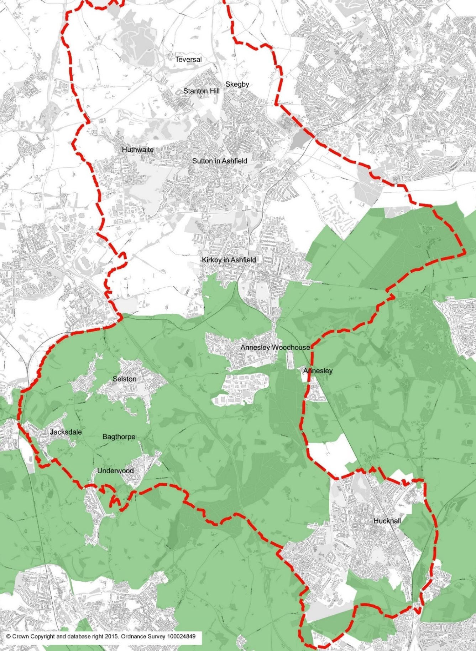

  - The NPPF also requires the size, type and tenure of housing needed for different groups in the community to be assessed and reflected in planning policies. To this end, Ashfield and the Greater Nottingham councils jointly commissioned the Greater Nottingham & Ashfield Housing Needs Assessment, 2020 (HNA) and the Greater Nottingham and Ashfield District Council Gypsy and Traveller Accommodation Assessment, 2021 (GTAA).

  - The HNA considers the size type and tenure of housing required, addressing the needs of groups as set out in the NPPF (i.e. including, but not limited to, those who require affordable housing, families with children, older people, students, people with disabilities, service families, travellers, people who rent their homes and people wishing to commission or build their own homes), with the exception of Gypsies and Travellers, whose accommodation needs, together with those of boat dwellers, are considered in the GTAA, and people wishing to commission or build their own homes, which are considered via the joint Self and Custom Build Registers for Ashfield, Newark and Sherwood, and Mansfield districts.

Housing Market Area

  - Ashfield falls within the Nottingham Outer Housing Market Area (Map 2), which also includes the districts of Mansfield and Newark and Sherwood. An economic relationship also exists with Mansfield District Council, and to a lesser extent with Newark and Sherwood. However, all three local authorities are at different stages in their Local Plan preparation and as such there are no proposals for a joint plan covering these areas.

  - From a strategic perspective, Ashfield District Council forms part of a wider Housing and Functional Economic Market Area. The location of Hucknall and its proximity to Nottingham City has also led to a close working relationship with other local authorities forming part of the Greater Nottingham Joint Planning Partnership. Further information on the duty to co- operate and the Housing and Functional Economic Market areas can be found in the Spatial Strategy background paper.

Map 2: Nottingham Outer Housing Market Area
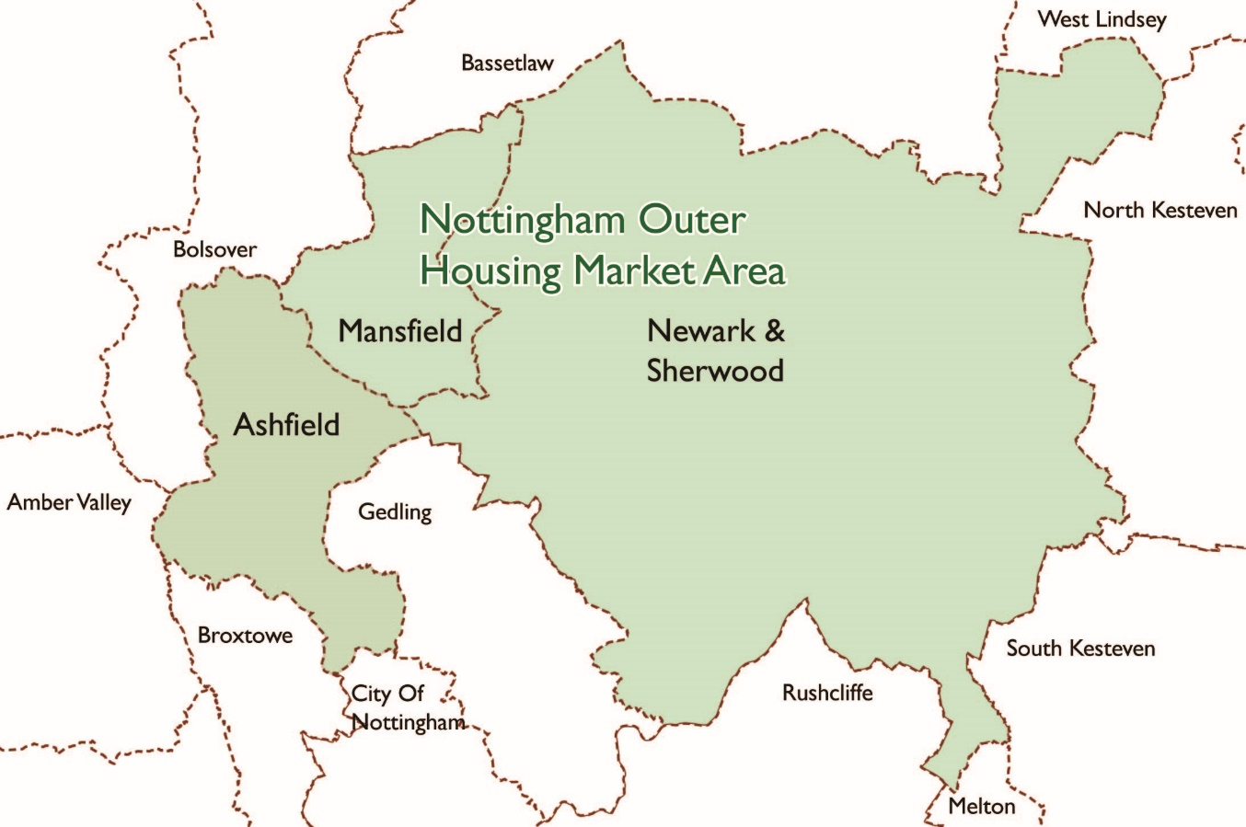

The Need for Homes in Ashfield

Standard Method for assessing Local Housing Need (LHN)

  - Planning practice guidance sets out the standard methodology for assessing the minimum number of homes expected to be planned for in a local planning authority area. Essentially the process is as follows:-

Calculate the average annual household growth over a 10 year period, based on 2014 household growth data. This should be 10 consecutive years, with the current year being used as the starting point from which to calculate growth over that period.
Ashfield household growth 2023 to 2033 = 4023 (402 dpa)

Adjust the annual figure used on the affordability of the area. This uses a ‘median workplace based affordability ratio’ as published by the ONS (Table 5c). The ratio for Ashfield is 5.73 (2022 ratio published March 2023).
Adjustment factor = (5.73 - 4) x 0.25
4

= 1.73 x 0.25
4

= 0.4325 x 0.25

= 0.108125

Total minimum annual LHN at March 2023 is calculated as follows:
1 + adjustment factor x projected household growth =

1.108125 x 402.3 = 445.8
446 dwellings per annum (dpa)

Supply of Housing Land

Sources of Housing Supply

Source of supply | Notes
1. Past completions | This category provides the net number of homes (including new build, converted homes and changes of use and losses) completed from the start of the plan period for the Ashfield Local Plan from 2020.
2. Sites with planning permission | This category includes all sites with current planning permission unless there are clear indications that the site will not come forward for development. Sites may be under construction, or not yet implemented.
3. Proposed Local Plan allocations not in the above category | This category includes sites that are “developable” using the approach set out in the SHELAA methodology report and have been selected as preferred sites to meet the need for future housing and Council’s strategic approach for growth.
4. Other developable sites | This category includes sites that are not included in above categories and may include:-  - Non-allocated sites awaiting s106 sign off.  - Sites without planning permission to be delivered by local authority or partners.  - Sites with lapsed permission and new application pending determination.
6. Windfall allowance | The Council includes a windfall allowance for small sites which may come forward from year 5 onwards. This has a basis in historic rates and is set out in more detail in paragraph 5.5 onwards

Strategic Housing and Economic Land Availability Assessment

  - The Strategic Housing Land Availability Assessment (SHELAA) is an ongoing assessment of sites undertaken by councils to identify sites that have may potential for residential development. It helps the council to understand where and when housing could be built in the future.

  - The SHELAA methodology was updated in 2021 and the individual SHELAA site reports have also been published on the Council’s website. The SHELAA methodology report focusses on the following:-

- The identification of sites/broad locations;
- Assessment of each site/broad location to consider:-
- Establishing whether a site can be considered for future allocation based on:-
- Suitability
- Availability
- Achievability
- Whether identified site constraints can be overcome
- Estimating the development potential based on:-
- Density.
- Developable area
- Responding to site constraints
- Lead in times and build out rates

  - The site assessments enable sustainable site selection from a pool of achievable sites to meet the assessed needs.

  - An assessment for potential supply from ‘Windfall’ sites, and also an assessment of non-implementation rates is considered separately in this report.

Approach to Windfall Sites

  - Paragraph 69 of the NPPF emphasises the importance of small and medium sites in meeting an areas housing requirement. It sets out that local planning authorities should support the development of windfall sites through policies and decisions – giving great weight to the benefits of using suitable sites within existing settlements for homes.

  - NPPF paragraph 71 goes on to provides that where an allowance is to be made for windfall sites as part of anticipated supply, there should be compelling evidence that they will provide a reliable source of supply. Any allowance should be realistic having regard to the strategic housing land availability assessment, historic windfall delivery rates and expected future trends. Resisting inappropriate development in residential gardens where development would cause harm to the local area is also encouraged.

  - The NPPF defines Windfall sites as sites which have not been specifically identified as available in the development plan. It is assumed therefore that the term ‘windfall’ can refer to sites of all sizes.

Large Site Windfalls

  - For the purposes of the Local Plan and supporting information, ‘large sites’ refer to those of 10 dwellings and above (in accordance with the NPPF definition of ‘Major’ development). The Council do not consider that there is currently any justification to make an allowance for large windfall sites as part of the future housing supply.

  - The Draft Local Plan includes proposed sites allocated under Policy H1 towards future supply. Those considered to be developable the period 2023 to 2040 have been counted towards the overall supply, whilst only those deliverable 2025 to 2030 have been counted towards the Local Plan post adoption 5 year supply calculations. Where available, the anticipated rates of delivery are as provided by the agent/ developer/ landowner. Where delivery information has not been provided, assumptions have been used (see paragraph 6.14).

  - At present there is no justification to include any additional large site windfall allowance in the Draft Local Plan since all appropriate large sites which are not contrary to emerging policy are anticipated to have been picked up through the site selection process. This approach avoids the risk of over-estimating future supply from large sites. It is reasonable to expect large windfall sites may come forward in future and these will be monitored and count towards supply at that time.

Small Site Windfalls

  - For the purposes of the Local Plan and supporting information, ‘small sites’ refer to those with a yield below 10 dwellings and will generally be considered as windfalls since the Local Plan does not allocate sites below this threshold. Although the SHELAA does not have a site size threshold, few small sites have been submitted for assessment and those deemed deliverable are negligible – these have not been counted as contributing towards future supply. It is therefore considered appropriate to project forward past trends in small site delivery to help establish a windfall rate. This approach ensures that no ‘double counting‘ will occur.

Estimating a Future Windfall Allowance for Small Sites

  - For the purposes of projecting forward past trends in housing delivery it is appropriate to look back over a longer period in order to take account of the peaks and troughs of the housing market cycle. Between the years 2011 to 2021 a total of 727 dwellings were delivered on small sites, including new build, conversions and change of use. This equates to an average rate of 73 dwellings per annum (dpa).

Table 1: Small Housing Site completions 2011-2021

Year (1st April - 31st March) | New Build | Net Additions through Conversion/ Change of Use | Net additions through Permitted Development | Total Dwellings
2011 - 2012 | 43 | 15 | n/a | 58
2012 - 2013 | 37 | 13 | n/a | 50
2013 - 2014 | 34 | 17 | n/a | 51
2014 - 2015 | 41 | 19 | n/a | 60
2015 - 2016 | 103 | 23 | n/a | 126
2016 - 2017 | 57 | 34 | n/a | 91
2017 - 2018 | 35 | 48 | 4 | 87
2018 - 2019 | 63 | 28 | 5 | 96
2019 - 2020 | 39 | 9 | 2 | 50
2020 - 2021 | 27 | 23 | 8 | 58
2011 to 2021 | 479 | 229 | 19 | 727
Average per year | 47.9 | 22.9 | 1.9 | 72.7

  - As set out in paragraph 71, the NPPF specifically refers to resisting inappropriate development in residential gardens and is less restrictive than the previous iteration of the NPPF in this respect (which excluded residential gardens). Gardens were re-classified as ‘Greenfield’ from ‘Previously Developed Land’ (PDL/Brownfield) for planning purposes as of 9th June 2010 through a revised version of PPS3 and development on garden land has therefore been monitored from this date. Data for the period 2011 to 2021 shows that a total of 132, or an average of 13.2 per annum dwellings were completed on small sites on garden land.

  - Taking a cautious approach to future provision from this source, it is considered reasonable to subtract the number of homes developed on residential land (albeit accepting there may be appropriate schemes of this nature which come forward in any event). This would give an annual average of 60 dwellings per annum (dpa) from small site windfalls.

  - The Draft Local Plan includes a future supply from small site planning permissions which amount to some 262 dwellings as of 1st April 2023, after the deduction of a non-implementation rate. These are included in the 5 year housing land supply. As a comparison, projecting forward the reduced historic rate of 60 dpa would provide around 300 dwellings over 5 years. Although the estimated delivery from small site permissions is marginally lower than the projected historic delivery figure, this is to be expected due to the 3 year lifespan of planning approvals.

  - The Council taken the decision not to include any additional small site windfall allowance in the first 5 years supply at this time, in order to acknowledge pipeline projects and avoid double-counting. It is considered appropriate, however, to include an allowance beyond 5 years, since small unallocated sites have consistently formed part of past supply and there is no justification to assume this source will cease in future. Projecting forward the 60 dpa will give an additional supply of 720 towards meeting the overall housing requirement for the period 2028 to 2040.

Approach to Non-implementation of Existing Planning Permissions

  - The HLMR sets out the supply of housing sites deliverable without policy change against the Local Housing Need (LHN) and demonstrates how the District performs with regard to the 5 year supply requirement at April 2023. Appendix 2 of the Draft Ashfield Local Plan 2023-2040 sets out the 5 year Housing Land Supply (post adoption) including new site allocations.

  - The calculations include all residential planning permissions towards future supply, offset by proposals for losses and demolitions. Whilst there is no reason to believe that any specific permission may not be implemented, it is accepted that there will be a number which may never be developed.

  - In order to determine a rate for discounting the potential supply from this source, a comparison has been drawn with the number of dwellings on permissions granted against those lapsing over a 10 year period. The assessment has been undertaken separately for small and large sites (see Table 2).

TABLE 2: Historical Lapse Rate for Large and Small Residential Permissions
Site size | Permissions Granted  2006-2016 (Dwellings) | Lapsed Permissions  2006-2016 (Dwellings) | Lapse Rate  %
Large | 6535 | 421 | 6.4%
Small | 1011 | 272 | 26.9%

  - The percentage rates for lapsed permissions have been applied to large site planning permissions where development has not yet commenced since once a site has started it becomes ‘extant’ and can no longer lapse. In contrast, all of the outstanding permissions on small sites have been discounted. The effect of applying a non-implementation rate is illustrated in Table 3 and amounts to 159 dwellings based on historic trends.

TABLE 3: Effect of lapsed rate on unimplemented Planning Permissions deliverable over the Plan Period

Area/Site size | Outstanding permissions* | Lapse rate applicable | Discounted permissions | Dwellings deducted over plan period
Hucknall Large | 0 | 6.4% | 0 | 0
Hucknall Small | 113 | 26.9% | 83 | 30
Rurals Large | 0 | 6.4% | 0 | 0
Rurals Small | 38 | 26.9% | 28 | 10
Kirkby Large | 54 | 6.4% | 51 | 3
Kirkby Small | 48 | 26.9% | 35 | 13
Sutton Large | 500 | 6.4% | 468 | 32
Sutton Small | 131 | 26.9% | 96 | 35
Total Large | 554 | 6.4% | 519 | 35
Total Small | 330 | 26.9% | 241 | 89
TOTAL ALL SITES | 884 | n/a | 760 | 124
*Small sites = all dwellings. Large sites = dwellings on sites not under construction

Housing Site Delivery Assumptions

  - In order to ensure that the Council maintains a sufficient supply of housing to meet the Local Housing Need it has been necessary to undertake a review of housing delivery in Ashfield District over recent years. This analysis has contributed towards the assumptions made in relation to the timescale of housing delivery and the annual build rates included in Ashfield District’s Housing Trajectory.

  - In addition, the Council has liaised with landowners, agents and developers of sites submitted for consideration as housing allocations in the emerging Local Plan. Studies undertaken by the HBF, Nathaniel Lichfield and Partners, and Savills have also informed the approach taken. This process has enabled the Council to developed a realistic timetable of future housing delivery, justified through the assessment of past delivery rates, literature review and ongoing dialogue with developers and landowners of potential housing sites.

Lead-in Timescales

  - For the purposes of estimating future delivery in the trajectory, the Council have adopted a cautious approach to assumptions on lead-in times. For sites with full or reserved matters planning permission, the Council assumes that it will take 9 months for the discharging of conditions and a further 15 months from the granting of planning permission to the commencement of development. Taking this into consideration, the Council has assumed that development will commence in Year 3 of the Local Plan. For small sites with outline planning permission, development is assumed to commence in Year 4 of the Local Plan to take account of the Reserved Matters planning process. Unless site specific information has been submitted by landowners or developers, lead in times for Large sites with Outline planning permission, sites with Permission in Principle, and allocated sites without planning permission are assumed to be beyond 5 years, consistent with the NPPF definition of ‘deliverable’.

  - The Council has assumed the following lead in periods in the absence of site-specific information which would indicate otherwise. Where there is clear evidence of progress on a site, delivery may be brought forward.

TABLE 4: Standard Lead in Period Assumptions

Planning Status | Commencement Year
Full/detailed planning permission - where development has commenced | Current Year
Full/detailed planning permission - not started | Year 3
Outline permission – Small site (less than 10 dwellings) | Year 4
Outline permission – Large/major site (10 or more dwellings) | Year 6
Sites with Permission in Principle (PIP) | Year 6
Allocated sites without planning permission | Year 6

Annual Delivery Rate

Historic Annual Delivery in Ashfield

  - An analysis of large site (sites over 10 dwellings) with full or reserved matters planning permission has been undertaken which looks at annual build rates over recent years (Appendix 1). Results demonstrate that, on average, large sites have delivered between 39 dwellings per annum (dpa) in 2013/14 and 44 dpa in 2015/16 which reflects the gradual recovery in the local housing market. Over the three year period, this averages out at 42 dpa. Delivery rates have varied from 25 dwellings per annum up to 66 dwellings on individual sites (looking at full years only).

  - However, these figures are skewed by 2 sites at Brook Street and Portland road of 25 and 30 dwellings respectively. In both cases the whole site has been completed within 1 year, but delivery has clearly been limited by the total site capacity. If these are excluded from the calculations, delivery rates increase to between 41 and 46 dpa, averaging out at 44 dpa.

  - It is notable that the larger site at Papplewick Lane (799 dwellings) has delivered between 57 and 129 dpa over the past 3 years. This averages a substantial 87 dpa across the site. However, 2 developers/sales outlets were active on site at the time, consequently resulting in an average of 44 dpa per developer being achieved on the larger site.

Literature Review

  - A survey undertaken by the HBF in February/March 2016 on ‘large sites’ over 350 dwellings, indicated that on average 70 dwellings per annum were delivered. Nathaniel Lichfield and Partners’ (NLP) study “Start to Finish - How quickly do large-scale housing sites deliver? (November 2016)” also indicates that, on average, sites with a capacity of between 500 and 999 dwellings deliver approximately 70 dwellings per annum. This study also implies that sites of 1000-1499 dwellings average out at a delivery of approximately 105 dwellings per annum. These are similar findings to the Council’s own conclusions on the delivery of development on urban extensions over 500 dwellings which shows that 81 dwellings per annum have typically been delivered.

  - NLP published a study “Stock and Flow: Planning Permissions and Housing Output, January 2017” which sets out that each sales outlet typically generates 30 to 40 sales per annum.

Future Annual Delivery Assumptions

  - Large sites (allocations and permissions): The Council has taken a cautious approach in setting the delivery rates in the housing trajectory to ensure that the Draft Local Plan provides for sufficient land to meet the LHN. Consequently, sites between 10 and 500 dwellings are assumed to be capable of delivering 35 dwellings per annum (per developer) based on past delivery rates. This is lower than the average build rates experienced locally in Ashfield but is consistent with the findings of HBF and NLP national studies.

  - The NLP findings, together with typical large site delivery in Ashfield, support the Council’s approach to the delivery of development on larger sites which assumes that sites of 500 or more dwellings will deliver 80 dwellings per annum (based on an assumption of 2 developers/sales outlets). The HBF’s report “Responding to demand; Understanding private housing supply (August 2015)’ also indicates that larger sites are likely to have more sales units on site. Indeed it is often the case that landowners will seek to realise their return sooner and request that large sites are built out in partnership.

  - Small Site Permissions: Sites below 10 dwellings are not allocated in the submitted Ashfield Local Plan but do count towards overall supply as commitments. The anticipated delivery of housing from this source is summarised in the Housing Trajectory in Appendix 2 of the Local Plan.

  - Assumptions applied in respect of annual delivery were initially drawn up with input from the development industry and historic evidence. Developments consisting entirely of flats are assumed to have a quicker build out rate due to the nature of construction.

  - Table 5 illustrates Ashfield’s approach to annual delivery rates. These are applied in the absence of any alternative site specific information being made available to the Council.

TABLE 5: Standard Assumptions Annual Delivery Rates

Site size/house types | Dwellings per Year (per developer)
1 - 4 houses | 2
1 - 4 flats | 4
5 - 9 houses | 5
5 - 10 flats | 10
10 – 499 houses | 35
>10 flats | 50
>500 dwellings | 40

Density

  - Sites with Full or Reserved Matters planning permissions are based on the approved details. For Outline permissions and allocated sites without planning consent, the approach to densities is as follows, and is reflected in the Draft Local Plan policy H7.

  - Development on sites of 0.4 hectares or greater, within distances indicated below from district shopping centres and major public transport nodes are subject to the following minimum densities:

- Within 400m - 40 dwellings per hectare
- Within 1Km - 34 dwellings per hectare
- Over 1km - 30 dwellings per hectare

  - Where sites have masterplans or are subject to a pending planning application, these have helped to inform potential site delivery.

  - A conservative approach to site densities has been applied in order to avoid over estimating delivery and to ensure enough development to meet the needs of the district. In instances where sites have significant constraints which restrict the developable area, this is taken into account when estimating potential yield. Furthermore, it is important that densities are applied to a net developable area, rather than the total site area in order to acknowledge the need for essential infrastructure. Consequently, the following density multipliers have been applied to allocated sites without planning permission to establish the net developable area. Exceptions to this include sites where comments from the owner/developer have justified a different capacity.

TABLE 6: Standard Assumptions to Identify Net Developable Area
Site size (Ha) | Multiplier | Comments
Sites below 0.4 ha | 100% | No reduction – Gross site area used to calculate yield.
Sites between  0.4 ha – 2.0 ha | 90% | On sites with an area between 0.4 and 2 hectares, a 10% reduction is applied for potential infrastructure requirements.
Sites between  2.0 ha – 10.0 ha | 75% | Where sites exceed 2 hectares, 10% of the site size is deducted to accommodate open space requirements (in accordance with Policy H5 of the Draft Ashfield Local Plan 2020-2038). A further 15% is to take account of additional necessary infrastructure.
Sites over 10 ha | 60% | On large sites over 10 Hectares a 40% reduction is applied to take account of larger scale infrastructure e.g., the potential need for a new primary school, local shopping centre or medical centre, etc.

Supply of Housing Land to meet Need in Ashfield

  - Table 7 illustrates how housing land allocations in the Draft Ashfield Local Plan 2023-2040 will meet future requirements alongside existing residential commitments from planning permissions and permitted development (where known). This takes account of the assumptions set out in Sections 5 and 6 of this paper with respect to potential non-implementation, windfalls, lead-in periods and build out rates.

  - Residential Institutions have also been included towards the supply of homes for Ashfield. National Planning Practice Guidance provides that housing for older people, including residential institutions in use class C2 should be counted towards their housing requirement. The Housing Delivery Test Measurement Rule Book published in July 2018 sets out that the number of net homes delivered should be adjusted to include a figure for student accommodation and other communal accommodation (calculated by applying nationally set ratios to the bedroom data of 2.5 and 1.8 respectively). Ashfield does not currently have any student accommodation which falls into this category.

  - As Table 7 identifies, the Plan currently provides for 6700 dwellings against a need of 7582 to the year 2040, amounting to approximately 13 years supply post adoption (to year 2038/39). It is considered to be consistent with NPPF paragraph 68 which requires policies to identify a sufficient supply and mix of sites, (taking into account their availability, suitability and likely economic viability), with specific, deliverable sites for years one to five of the plan period, and specific, developable sites or broad locations for growth, for years 6-10 and, where possible, for years 11-15 of the plan. This is discussed in greater detail in Background Paper 1: Spatial Approach and Site Selection.

  - Housing trajectories illustrating the anticipated delivery of individual sites on an annual basis are included in Appendix 2 of the Draft Local Plan, along with the 5 year Supply of deliverable housing sites. These elements are updated annually in the Housing Land Monitoring Report.

Table 7: Dwelling Requirement and Provision 2023-2040

Housing Requirement | Dwellings
Annual Local Housing Need based on Standard Methodology at April 2023 | 446
Houses needed to meet requirement, 1/4/2023 to 31/4/2040 | 7,582

Future Supply Source | Dwellings
Houses deliverable on small sites, 1/4/2023 to 31/3/2040
- With planning permission (including new build, net conversions and change of use) at 1st April 2023 | 338
- Known permitted development/prior notification schemes not yet implemented at 1st April 2023 | 14
- Demolitions and other losses with planning permission at 1/4/23 | -1
- Deduction to account for potential lapsed permissions | -89
- Windfall allowance beyond 5 years (60 dpa) - 1/4/2028 to 1/4/2040 | 720
Houses deliverable on large sites 1/4/2023 to 31/3/2040
- With planning permission at 1st April 2023 | 1950
- Demolitions and other losses with planning permission at 1/4/23 | 0
- Deduction to account for potential lapsed permissions | -35
- Delivery from H1 allocated sites without planning permission | 3757
Provision from C2 residential institutions (dwelling equivalent) | 46
Total housing supply 1/4/2023 to 31/3/2040 | 6,700

Net Provision | Dwellings
Provision against Local Housing Need 2023 to 2040 | -882

Quantum of Housing to be delivered on sites of less than 1 Hectare

  - NPPF paragraph 69 recognises that small and medium sized sites can make an important contribution to meeting the housing requirement of an area and are often built-out relatively quickly. As such local planning authorities are required to identify land to accommodate at least 10% of their housing requirement on sites no larger than one hectare.

  - For Ashfield, if we look at the entire 17 year requirement, this means at least 758 dwellings need to be delivered on such sites. The supply as proposed in Table 7 would more than meet this requirement with a potential for 1,243 dwellings on sites of less than 1 hectare (comprised of a net total of 982 on ‘small’ sites plus 261 from larger allocated sites).

Housing Mix

  - Paragraph 62 of the NPPF requires planning policies to take account of the housing needs of different groups in respect of size, type and tenure. The specific groups named under this paragraph are “those who require affordable housing, families with children, older people, students, people with disabilities, people who rent their homes and people wishing to commission or build their own homes”.

  - Paragraph 63 of the NPPF states that where a need for affordable housing is identified, planning policies should specify the type of affordable housing required. The NPPF breaks this down into defined types including affordable housing for rent, starter homes, discounted market sales housing and other affordable routes to home ownership. (included in the NPPF glossary definition).

  - The government’s preferred form of discounted market sale housing is First Homes. First Homes are a specific kind of discounted market sale housing which are discounted by a minimum of 30% against the market value, sold to a person or persons meeting the eligibility criteria set out in the Planning Practice Guidance and cost no more than £250,000. This discount (30%) will apply to any subsequent sales of the property. Under national planning guidance, councils will be required to ensure that at least 25% of all affordable homes delivered through developer contributions will be First Homes. However, the NPPF in paragraph 65 identifies that at least 10% of all homes delivered on major development sites should be “available for affordable home ownership, unless this would exceed the level of affordable housing required in the area, or significantly prejudice the ability to meet the identified affordable housing needs of specific groups.”

  - The Planning Practice Guidance on housing needs assessments states that authorities will need to consider how the needs of individual groups can be addressed within the overall need established. The need for particular sizes, types and tenures of homes as well as the housing needs of particular groups should be considered separately. There is also specific PPG on Self Build and Custom Housebuilding; Build to Rent and Housing for Older and Disabled People.

  - The Greater Nottingham and Ashfield Housing Needs Assessment Report, October 2020 (HNA) prepared by ICENI consultants was commissioned to address the requirements of the NPPF in respect of paragraphs 62 and 63. The study was commissioned jointly with the Greater Nottingham authorities of Broxtowe, Gedling, Erewash, Nottingham City and Rushcliffe councils. As this was commissioned and published prior to the government’s First Homes policy, the study did not take account of First Homes, but did consider the need for affordable home ownership by individual authority.

  - A subsequent First Homes Assessment to build on the HNA was prepared for the partner authorities in September 2022. This reiterated the findings of the original HNA in respect of First Homes as an affordable home ownership product and considered that the evidence of need and for different types of affordable housing (specifically rented versus affordable home ownership (AHO) means that the 10% of all housing as affordable home ownership is not appropriate across the study area.

  - The key recommendations from the HNA and the policy response to these are summarised in the Table 8. Draft ALP policies H3, H4 and H6 together with their associated supporting text set out the Council’s approach to delivering a mix of housing types to meet need

Table 8: Key findings of the Housing Needs Assessment

Key finding / recommendation | Policy response
Housing sub-market areas: The report identifies 44 housing sub-market areas across the plan area. The methodology for identification is based on analysis of data on sales transactions by type, house price patterns by type, commuting flows, self-containment and urban form/ morphology. | The housing sub-market areas will be used in any subsequent viability work. Due to the varying levels of viability across authority areas it is considered appropriate to set different levels of affordable housing and tenure requirements based on sub-market area.
Housing mix: Housing mix recommendations at an authority level and housing sub-market area (in terms of bedroom sizes) | As currently drafted, the justification text to policy H6 includes the housing mix recommendations (by tenure). The policy requires these to be used as a starting point for negotiations on house size mix on application sites.
Rented affordable housing need: A need for 237 dwellings per annum is identified for Ashfield. The report does not break this need down into social rent and affordable rent, although it is indicated that social rents will be affordable to a greater proportion of households than affordable rents | The identified level of need identified in the report provides a starting point in developing an affordable housing target. Draft policy H3 is informed by the approach taken in the Whole Plan Viability Assessment 2023 which tested a range of different affordable housing levels and tenures. This will need to be updated and the policy amended accordingly if required.
Affordable home ownership need: A negative need for –195 dwellings per annum is identified for Ashfield. Although the analysis shows there are a number of households able to afford to rent privately but who cannot afford to buy because of the initial outlay/ deposit/securing a mortgage, there was considered to be enough potential supply within existing stock to make a contribution to this need with a reasonable proportion of properties available at lower quartile prices.  If the Council seeks to provide affordable home ownership, then Shared ownership is recommended as the most appropriate type product due to the lower deposit requirements and lower overall costs (given that the rent would also be subsidised). | Policy H3 includes the requirement for 25% of any affordable housing requirement to be delivered through shared ownership. Given the circumstances, the Council considers that the provision First Homes would significantly prejudice the ability of local people to meet their housing needs and an emphasis is placed on share ownership rather than First Homes.
Accessible and adaptable homes: A need for around 3,203 wheelchair accessible dwellings for wheelchair users across the study area (including Erewash and Ashfield) has been identified, equivalent to 5% of the total housing need identified through the standard method. | Draft policy H6 requires that 10% of dwellings on sites with a capacity of 10 or more dwellings will be accessible or easily adaptable.
Specialist residential accommodation:  For Ashfield District, the analysis in this report points to a need for 1,037 units of housing with support to 2038, and 507 units of housing with care. The report also identifies a need for 1,252 additional bed spaces (C2 Use class). | Draft policy H6 has does not include any specific targets in relation to specialist accommodation for older people. However, the requirement for 10% adaptable dwellings on large sites will contribute towards future needs for specialist housing. The Council will also encourage proposals which include supported/ specialist accommodation and residential institutions, where they are in suitable locations.

Gypsy, Traveller and Travelling Showpeople’s Accommodation

  - The Government’s Planning Policy for Traveller Sites (2015) states that local planning authorities should set pitch targets for Gypsies and Travellers and plot targets for Travelling Showpeople which address the likely permanent and transit site accommodation needs of travellers in their area. Where there is no identified need, criteria-based policies should be included to provide a basis for decisions in case applications nevertheless come forward.

  - In line with the requirement to review Traveller accommodation need, the Greater Nottingham and Ashfield District Gypsy and Traveller Accommodation Assessment (GTAA) was commissioned in 2020 and completed by RRR consultancy in 2021. It assessed the accommodation needs of Gypsies, Travellers, Travelling Showpeople and boat dwellers, including:
- A review of national and local planning policies, recently undertaken GTAAs, and an analysis of secondary data.
- An online survey, and extensive face-to-face and telephone surveys of Gypsies, Travellers and Travelling Showpeople, covering a range of issues related to accommodation and service needs. RRR achieved a 90% survey rate.

  - The study used 3 different approaches to establishing need. First, one based on the ethnic identity definition; second, based on the needs of families who have not permanently ceased to travel (i.e., based on the PPTS 2015 definition); and third, based on the ‘travel to work’ interpretation of PPTS 2015. PPTS requires travellers to demonstrate that they have not ceased to travel in order to be defined as such. The study recommended that the local authorities’ Local Plans seek to meet the PPTS need (as required) with ‘ethnic’ need (potential need) covered by a criteria-based policy.

  - The GTAA sets out the level of future need for the District for the period 2020 to 2038 as illustrated in Table 9. In respect of Gypsy/Traveller pitches, the PPTS requires travellers to demonstrate that they have not ceased to travel in order to be defined as such. However, due to the ‘ambiguity’ around demonstrating this and various court challenges to it, the Council have taken the decision to use the higher level of assessed need based on the ‘ethnic definition’, as opposed to the Traveller definition set out in national policy Planning Policy for Traveller Sites.

  - It is acknowledged that there is a slight mismatch in the evidence base timeframe, i.e., for the period 2020-2038, rather than the Local Plan period of 2023-2040. However, since the quantum of assessed need is minimal it is considered appropriate that any additional need will be addressed using criteria-based policy H2 alongside site allocations within policy H2a.

  - The provision of Traveller sites will be monitored in future Housing Land Monitoring Reports on an annual basis.

Table 9: Ashfield Future Pitch/Plot Requirements 2020 to 2038

Period | Gypsy/Traveller Pitches  (Ethnic definition) | Gypsy/Traveller Pitches  (PPTS 2015 definition) | Gypsy/Traveller Pitches  (Work definition) | Showpeople’s Plots/Yards
2020 to 2025 | 1 | 0 | 0 | 9
2025 to 2030 | 1 | 1 | 1 | 2
2030 to 2035 | 1 | 1 | 1 | 2
2035 to 2038 | 1 | 1 | 1 | 1
Total 2020 to 2038 | 4 | 3 | 3 | 14

APPENDIX 1 – Delivery Rates on Large Sites 1st April 2013 to 31st March 2016

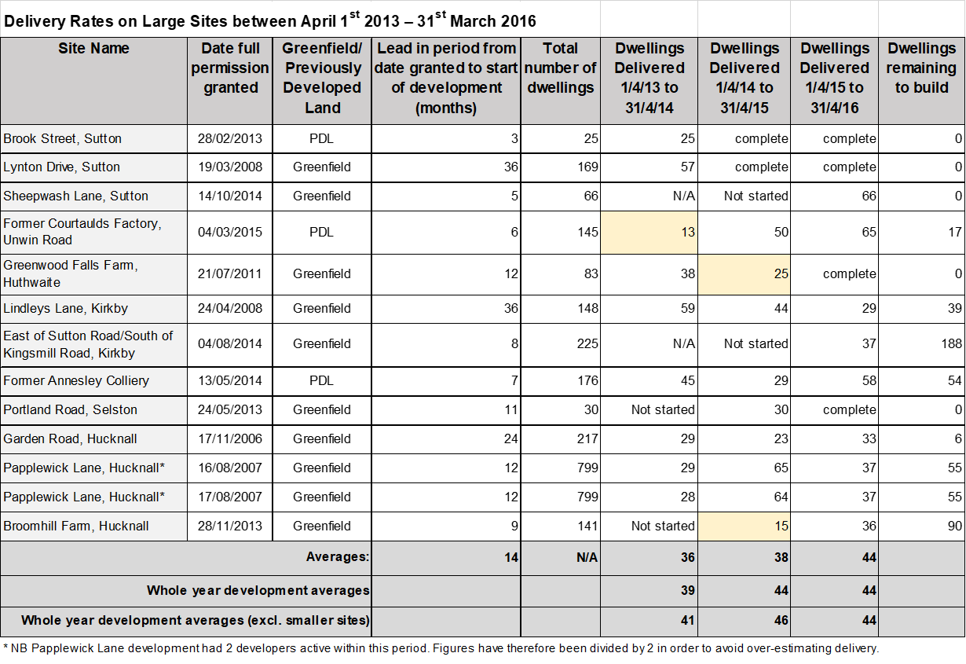

https://www.ashfield.gov.uk/media/8d890976f713e6c/2020-11-10-greater-nottingham-and-ashfield_housing-needs-assessment_final.pdf
Add link when published.
https://www.gov.uk/government/publications/housing-delivery-test-measurement-rule-book
Note: Supply from planning permissions is subject to a non-implementation rate.
Further information on site selection can be found in the Background Paper No. 1
Included in Appendix 2 of Draft Ashfield Local Plan (2023-2040)
HBF Policy Conference, 22nd March 2016 – Speaker: John Stewart, Director Economic Affairs http://www.house-builder.co.uk/UserFiles/File/JohnStewart-Policy16.pdf
http://nlpplanning.com/nlp-insight/start-to-finish-how-quickly-do-large-scale-housing-sites-deliver
http://www.savills.co.uk/research_articles/141285/209239-0 Spotlight New Build Homes 2016/17
https://assets.publishing.service.gov.uk/government/uploads/system/uploads/attachment_data/file/1005759/NPPF_July_2021.pdf
HBF Policy Conference, 22nd March 2016 – Speaker: John Stewart, Director Economic Affairs http://www.house-builder.co.uk/UserFiles/File/JohnStewart-Policy16.pdf
http://lichfields.uk/media/2517/stock-and-flow-planning-permissions-and-housing-output.pdf
Town & Country Planning (Use Classes) Order 1987, as amended
https://www.ashfield.gov.uk/planning-building-control/development-management-documents/

