Graph 3 – Stage one complaint volumes over the last 3 financial years 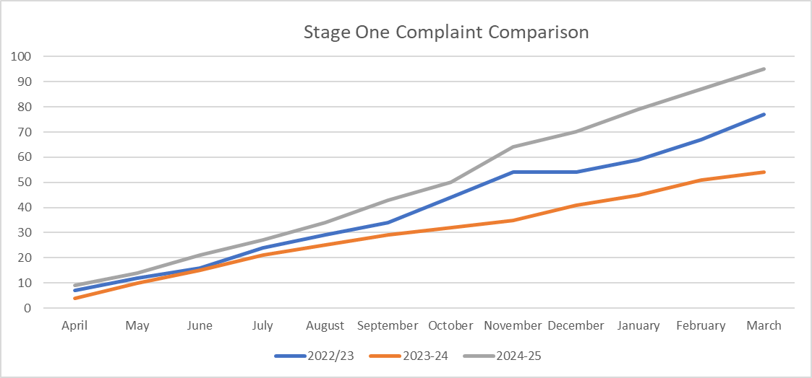

52.6 precent of the stage one complaints received in 2024 to 2025 were found to be upheld or partially upheld (0.07 precent more than 2023 to 2024).

In 2024 to 2025, stage one complaints took an average of 12.4 working days (1.7 days higher than 2023 to 2024), which is lower than the overall target of 15 working days.