AP12

Proposed Gypsy/Traveller Site Allocation H2a(c), Park Lane, Kirkby: Background Information

Planning History
- V/2009/0625 (granted 20/03/2012)
Full permission for 8 gypsy pitches (red edge boundary below).
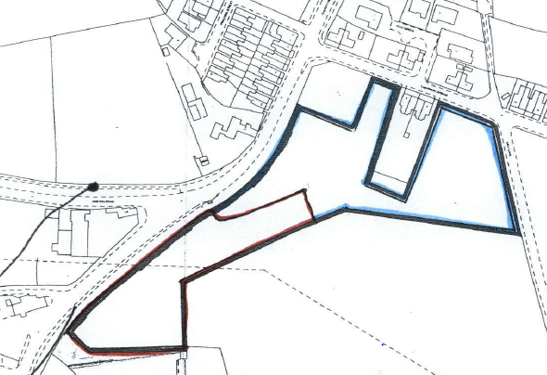
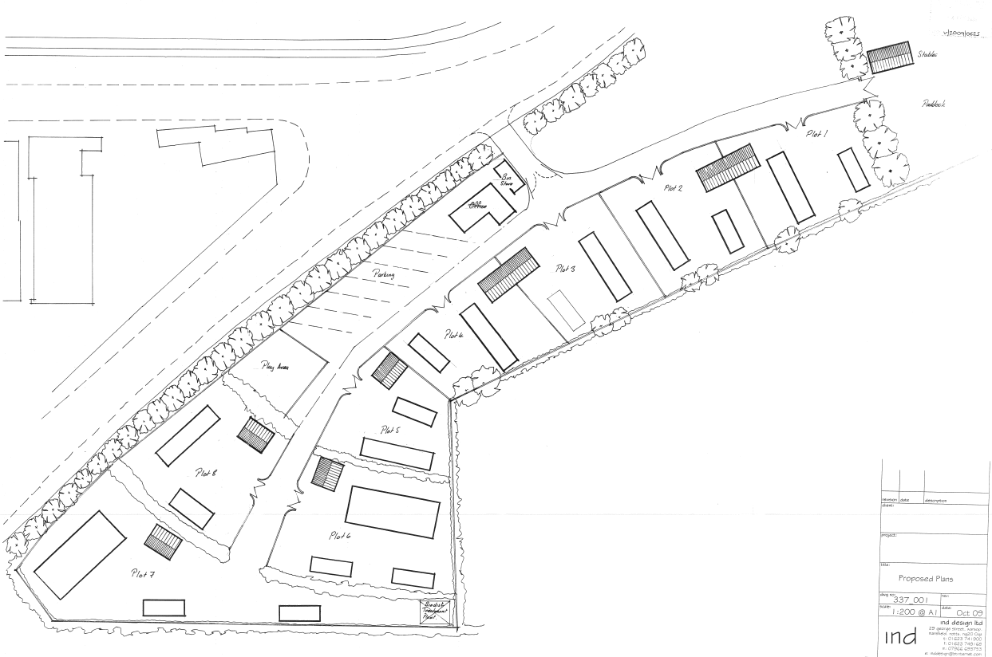
A formal access was created off Park Lane prior to the permission lapse date which implemented the approval and resulted in the permission being deemed extant. However, the site was never fully developed or occupied.
The site changed ownership in 2019, and the new landowners had no intention to develop it for a traveller site at that time. Consequently, it was not included for future supply in GTAA 2021 as it could not be deemed to be genuinely available. Neither was the site included in the Reg 18 version of the Local plan for the same reason (consultation Oct-Nov 2021).

- V/2020/0627 (granted 6/8/2024)
A more recent Full PP has since been secured at a wider site Laburnum Avenue for an affordable housing development of 38 homes. In a revision to the submitted planned layout, Planning Officers successfully negotiated the retention of the southern part of the site for gypsy/traveller pitches (shown as ‘Site area to be preserved for existing consent – Gypsy Pitches’ on the plan below).
Planning Committee on 26th July 2023 resolved to grant this permission subject to the signing of a s106 agreement. This was subsequently agreed and a decision notice issued on 6th August 2024 which referred to permission in accordance with 23 plans, including those illustrated below.
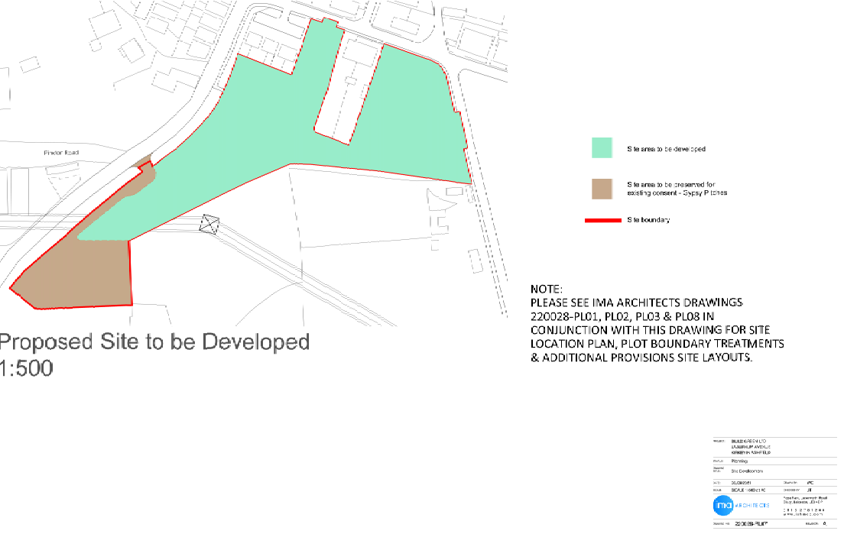
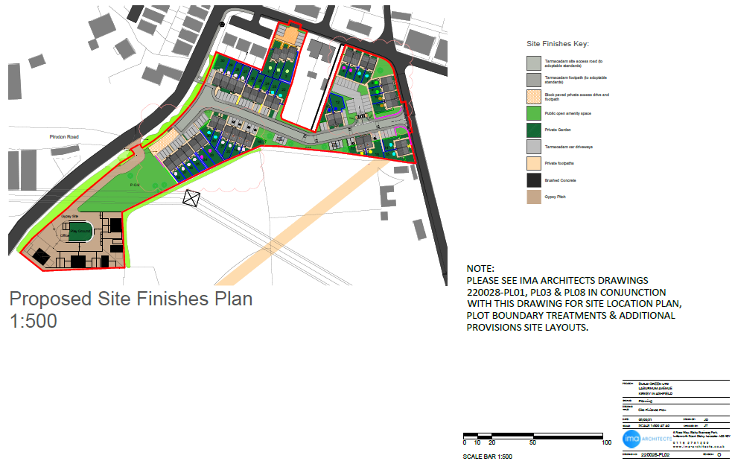
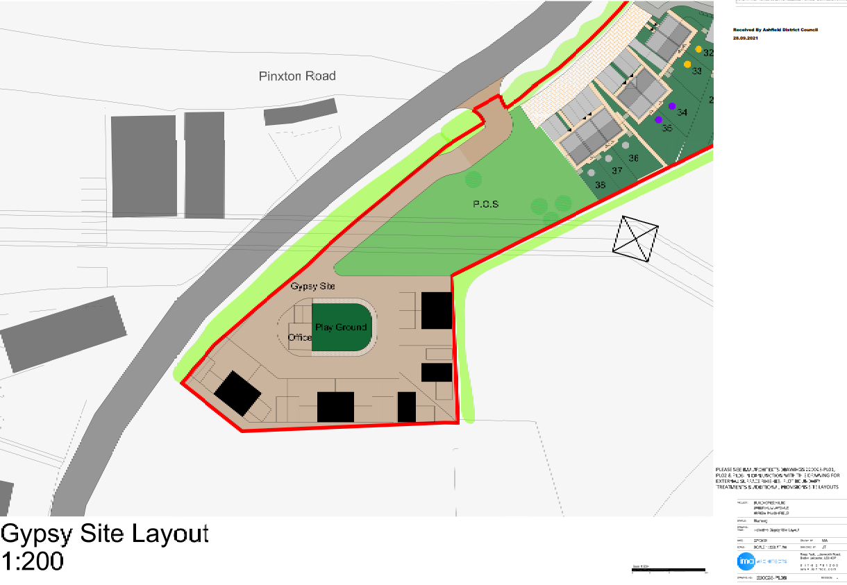
The indicative layout illustrates the provision of 8 pitches on a smaller site than the original Traveller site permitted under V/2009/0625.
A copy of the decision notice is included at Appendix 1.

Summary of Proposed Site Allocation Status
The use of the southern part of the extant permission for a traveller site has been preserved within the housing proposal for 38 dwellings which is now under construction. Groundworks had commenced at April 2025, and several conditions were discharged on 22/7/2025 (V/2025/0008).
Given the greater certainty provided by the most recent permitted scheme, and the availability of this site, the Council took the decision to propose allocation H2a(c) in the subsequent Reg 19 Local Plan. In taking account of the original layout which provided for significantly larger pitches, it was considered prudent to assume a lower potential yield of 4 pitches in order to avoid over reliance of supply from this site. This does not limit the number of pitches which may come forward as part of a future proposal but provides a more cautious approach to estimating future provision.
N.B. The Section 106 agreement is not directly relevant to the provision of traveller pitches and relates to affordable housing and contributions towards a bus stop and public open space.

Appendix 1

