Graph 4 – Stage 2 complaint volumes over the last 3 financial years

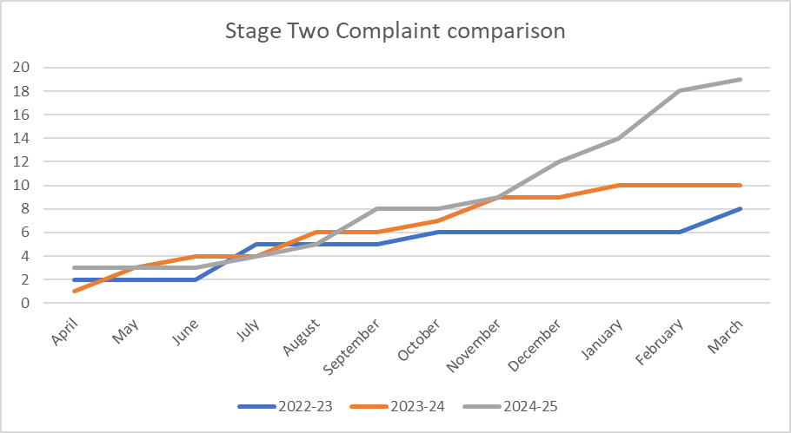

Stage two complaints have increased by 90 percent, compared to the previous financial year, which can be expected, with increasing stage one complaint volumes. However, the proportion of complaints escalating to stage two remains relatively low at 20.0 percent.

The proportion of stage two complaints that have been upheld or partially upheld is 47.4 percent.

Stage two complaints took an average of 26.6 working days, from receipt to response, against a overall target of 25 working days.