

DISCLAIMER

This document or some parts of it may not be accessible when using adaptive technology.

If you require assistance with accessing the content of the document, please contact us and quote the document name and the web page you found it on:
- email: Forward planning – localplan@ashfield.gov.uk

- telephone: 01623 457381







Ashfield District Council
Sustainability Appraisal

Sustainability Appraisal of Ashfield Local Plan Appendix D
- Baseline

Wood Environment & Infrastructure Solutions UK Limited – September 2021

Report for
Neil Oxby Planning Policy
Ashfield District Council Kirkby-in-Ashfield

Main contributors
Pete Davis Rob East
Ryan Llewellyn Andrew Williamson

Issued by

.................................................................................
Andrew Williamson

Approved by

.................................................................................
Pete Davis

Wood
The Renaissance Centre 601 Faraday Street Birchwood Park Warrington WA3 6GN United Kingdom
Tel +44 (0)1925 675000

Doc Ref. 42521 document1

Copyright and non-disclosure notice
The contents and layout of this report are subject to copyright owned by Wood (© Wood Environment & Infrastructure Solutions UK Limited 2021) save to the extent that copyright has been legally assigned by us to another party or is used by Wood under licence. To the extent that we own the copyright in this report, it may not be copied or used without our prior written agreement for any purpose other than the purpose indicated in this report. The methodology (if any) contained in this report is provided to you in confidence and must not be disclosed or copied to third parties without the prior written agreement of Wood. Disclosure of that information may constitute an actionable breach of confidence or may otherwise prejudice our commercial interests. Any third party who obtains access to this report by any means will, in any event, be subject to the Third Party Disclaimer set out below.

Third party disclaimer
Any disclosure of this report to a third party is subject to this disclaimer. The report was prepared by Wood at the instruction of, and for use by, our client named on the front of the report. It does not in any way constitute advice to any third party who is able to access it by any means. Wood excludes to the fullest extent lawfully permitted all liability whatsoever for any loss or damage howsoever arising from reliance on the contents of this report. We do not however exclude our liability (if any) for personal injury or death resulting from our negligence, for fraud or any other matter in relation to which we cannot legally exclude liability.

Management systems
This document has been produced by Wood Environment & Infrastructure Solutions UK Limited in full compliance with our management systems, which have been certified to ISO 9001, ISO 14001 and ISO 45001 by Lloyd's Register.

Document revisions
No. Details Date

Contents

- Baseline analysis 6
  - Introduction 6
  - Ashfield District: An overview 6
  - Population 8
Population 8
Migration Flows 10
Likely evolution without the Local Plan 11
Key sustainability Issues 12
  - Housing 12
Housing need 12
Housing affordability 14
Likely evolution without the Local Plan 16
Key sustainability Issues 16
  - Economy 17
Employment 17
Employment land 18
Likely evolution without the Local Plan 22
Key sustainability Issues 22
  - Town centres 23
Overview of town centres 23
Likely evolution without the Local Plan 26
Key sustainability Issues 26
  - Healthy and safe communities 27
Health 27
Deprivation 28
Open space 29
Crime 30
Likely evolution without the Local Plan 31
Key sustainability Issues 31
  - Transport 32
Road links 32
Rail links 32
Local Transport Plan 32
Likely evolution without the Local Plan 33
Key sustainability Issues 33
  - Effective use of land and achieving well designed places 34
Land use 34
Brownfield land 35
Housing density 37
Design 37
Likely evolution without the Local Plan 37
Key sustainability Issues 38
  - Climate change and flooding 38
Climate Change 38
Water resource and quality 39
Flood risk 40
Likely evolution without the Local Plan 42
Key sustainability Issues 42
  - Conserving and enhancing the natural environment and Green Belt 43
Biodiversity and geological significance 43
Agricultural Land 48
Landscape 49
Air Quality 50
Green Belt 50
Likely evolution without the Local Plan 51
Key sustainability Issues 52
  - Conserving and enhancing the historic environment 53
Likely evolution without the Local Plan 57
Key sustainability Issues 57
  - Minerals and waste 57
Likely evolution without the Local Plan 57
Key sustainability Issues 58
  - Key sustainability issues 58

Table 1.1 | Ashfield 2018 Mid-year population estimate (percentage by age) | 8
Table 1.2 | Housing Completion Rates 1st April 2011 to 31st March 2020 | 13
Table 1.3 | Ashfield Affordable Housing Completions 2010 to 2020 | 14
Table 1.4 | Recommended housing mix by size and type | 15
Table 1.5 | Ashfield Employment Land Requirements 2011-2033 | 19
Table 1.6 | Ashfield Public Open Space Strategy (2016-2026) requirements | 30
Table 1.7 | Employment Land Losses to residential development 1st April 2001 to 31st March 2020. | 36
Table 1.8 | Sites of Special Scientific Interest within Ashfield | 43
Table 1.9 | Local Nature Reserves within Ashfield | 44
Table 1.10 | Key Sustainability Issues | 59

Figure 1.1 | Ashfield District Council and surrounding context | 7
Figure 1.2 | Ashfield 2018 mid-year estimate population split by area | 8
Figure 1.3 | Ashfield Population breakdown | 9
Figure 1.4 | Commuting data and commuting flows (2011) | 10
Figure 1.5 | Major Gross Migration Flows (2011) | 11
Figure 1.6 | Average house prices | 12
Figure 1.7 | Housing trajectory for 2020-2037 | 12
Figure 1.8 | Viability assessment of the District | 15
Figure 1.9 | Ashfield Significant Employment Areas (Use Classes B1, B2 and B8). | 20
Figure 1.10 | Hucknall Town Centre Composition in 2006, 2011 and 2016 | 24
Figure 1.11 | Sutton Town Centre Composition in 2006, 2011 and 2016 | 25
Figure 1.12 | Kirkby-in-Ashfield Town Centre Composition in 2006, 2011 and 2016 | 25
Figure 1.13 | Ashfield District Council impact on the social determinants of health and wellbeing | 27
Figure 1.14 | Ashfield life expectancy | 28
Figure 1.15 | Ashfield Index of Deprivation 2019 | 29
Figure 1.16 | Recorded Crime Incidents | 30
Figure 1.17 | Ashfield Broad Land Uses | 34
Figure 1.18 | Ashfield Flood risk Zones 2 and 3 | 41
Figure 1.19 | Designated Natural Assets in Ashfield but including the ppSpecial Protection Area for Sherwood Forest. | 45
Figure 1.20 | Local Designated Biodiversity Sites in Ashfield | 47
Figure 1.21 | Agricultural Land Classification Grade 2 approximate location | 48
Figure 1.22 | Best Agricultural Land based on Agricultural Land Classification (ALC) Grades - Post 1988 Survey. | 49
Figure 1.23 | Green Belt Ashfield & surrounding districts | 51
Figure 1.24 | Designated Heritage Assets in Ashfield | 55
Figure 1.25 | Ashfield Local Heritage Assets. | 56

Baseline analysis

Introduction
1.1.1 The SA requires the collection of baseline information to describe the social, economic and environmental characteristics of Ashfield. This provides the basis for predicting and monitoring effects of the policies within the Local Plan. The baseline information will also help to identify sustainability issues, potential alternatives and if necessary, mitigation measures.
1.1.2 Understanding geographical differences and constraints across the District assists in developing alternatives related to the needs, character and roles of different areas, and in preparing strategies that are spatially specific in the distribution of development and the management of change. To consider alternatives there is a requirement to understand the environment, community and economy of the different areas within the District, the interconnection between them and their interaction with the wider area.
1.1.3 Not all information is currently available, but the data will continue to be refined and updated as work on the SA report proceeds.

Ashfield District: An overview
1.2.1 Ashfield District covers an area of 10,956 hectares with an estimated population of 128,337 (2020 mid-year estimate)1. It is located on the western side of Nottinghamshire, adjoins five districts within the county including Nottingham City to the south and Mansfield to the north east. The western and northern boundary of the District forms part of the County boundary line with Derbyshire (Amber Valley Borough Council and Bolsover District Council) (see Figure 1.1).
1.2.2 The Rural-Urban Classification of Local Authority2 sets out Ashfield as “Urban with City and Town”. This identifies that the majority of the resident population living in urban settlements (the classification is not based on land area).
1.2.3 There are three Main Urban Areas in the District where housing, jobs and services are concentrated. The southernmost is Hucknall which lies immediately north of Nottingham. Kirkby-in- Ashfield and Sutton in Ashfield are to the north of the District and include the adjoining settlements of Annesley Woodhouse/ Annesley, Huthwaite, Stanton Hill and Skegby areas respectively. Three villages of Jacksdale, Selston and Underwood also contain significant residential areas, but lack the concentration of employment opportunities and services found in the three towns. The remainder of the District is primarily countryside but contains a number of smaller settlements including Bagthorpe, Teversal, Fackley. and New Annesley together with smaller hamlets.
1.2.4 The area to the west of the District has a number of closely linked villages which form part of the Parish of Selston. The population of the Parish is approximately 13,066 people based on Mid 2018 Population estimates comprising Selston 6,511 people, Jacksdale 3,389 Underwood 3,166.
1.2.5 The settlements contain significant residential areas but lack the concentration of employment opportunities and services found in the three towns. However, Selston in particular is located relatively close to Kirkby-in-Ashfield and to Pinxton and South Normanton (Junction 28 of the M1)

1 ONS data via: ONS population estimates
2 2011 Rural-Urban Classification of Local Authority Districts and Similar Geographic Units in England: DEFRA & ONS.

and the employment opportunities these areas. The major employment centre of Sherwood Park, off Junction 27 of the M1, is located in close vicinity to Selston and Underwood.
1.2.6 The villages of Selston, Jacksdale and Underwood do not have the range of services reflected in the three towns in the District. However, they are served by public transport with a regular bus service during peak periods. They are connected through green Infrastructure routes and the road network. Selston, the largest of the three villages, has a number of facilities, which include a secondary school, leisure centre, medical centre, primary schools, community facilities, convenience stores and public houses. However, Selston lacks a central retail centre. There is a wider range of small shops at Jacksdale, which is identified in the Ashfield Local Plan Review 2002 as a local centre. At Underwood the retail facilities are limited.

Figure 1.1 Ashfield District Council and surrounding context
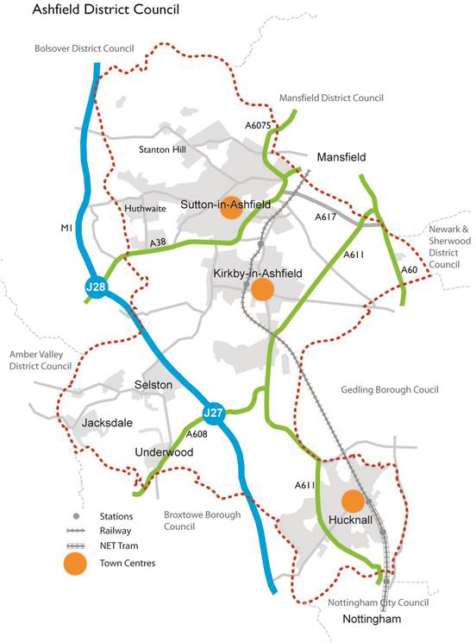
Source: Ashfield District Council
1.2.7 There are two parish councils within the District, Annesley and Felley Parish Council and Selston Parish Council. The Teversal, Stanton Hill and Skegby Neighbourhood Forum has been designated. Two neighbourhood plans have been ‘made’:
1.2.8 There are two Neighbourhood Plans which form part of the development plan for the District:

- Jacksdale, Underwood Selston Tomorrow (JUSt) Neighbourhood Plans3 brought forward by Selston Parish Council and covering a substantial part of the Parish of Selston.
- Teversal, Stanton Hill and Skegby Neighbourhood Plan4 brought forward by the Neighbourhood Forum. The Plan covers Stanton Hill, Skegby and the rural area to the north of Sutton in Ashfield (including Teversal, Fackley and Stanley).
1.2.9 Additional information on the neighbourhood areas is set out in the respective neighbourhood plans.

Population

Population
1.3.1 Ashfield has a very similar population profile by age to the East Midlands region (See Table 1.1). The population of Ashfield is anticipated to continue to increase into the future with an increasingly older population. The population split by area of the district is set out in Figure 1.2 (using data from 2018).

Table 1.1 Ashfield 2020 Mid-year population estimate (percentage by age)

Age Ashfield East midlands

0-15 | 18.9% | 18.5%
16-64 | 61.7% | 61.8%
65+ | 19.4% | 19.6%

Source: ONS Mid-Year Population Estimates, UK, June 2020

Figure 1.2 Ashfield 2018 mid-year estimate population split by area
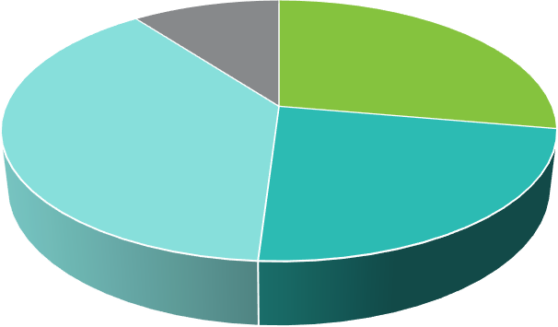
Ashfield population split by area
13,066
35,277

49,243
29,565

Hucknall Kirkby-in-Ashfield Sutton in Rural
Source: data taken from Ashfield Annual Monitoring Report 2018-2019

3 See: Neighbourhood Plan webpage
4 See: Neighbourhood Plan webpage

Figure 1.3 Ashfield Population breakdown
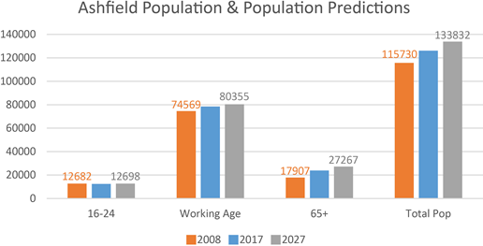
Source: Ashfield District Council/ONS

1.3.2 The population rose by 6.1% to 127,151 between 2011-2018. Of this, there is an above national average of people between the ages of 40 and 65. Ashfield also has the highest percentage of households with dependent children in the HMA but has also seen a significant growth in single person households. The population of the District is projected to rise due to 146,797 by 2038 based on 2018 population projections.5
1.3.3 Evidence from the 2015 Nottingham Outer Strategic Housing Market Assessment (SHMA)6 and the 2015 Employment Land Forecasting Study7 identified that Ashfield has a modest level of workforce containment with strong links to Nottingham, which is a large employment centre. In 2019, Ashfield had a jobs density of 0.768.

5 Office for National Statistics (2020) population Projections. Available via: https://www.ons.gov.uk/peoplepopulationandcommunity/populationandmigration/populationprojections/datasets/locala uthoritiesinenglandtable2 [accessed July 2020]
6 Nottingham Outer Strategic Housing Market Assessment 2015, Para 2.52 and Table 11.
7 Employment Land Forecasting Study 2015 Nathaniel Litchfield & Partners (page 30).
8 NOMIS official labour market statistics – Ashfield local authority profile September 2021.

Figure 1.4 Commuting data and commuting flows (2011)
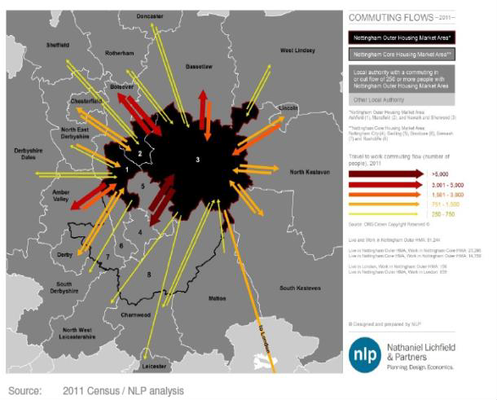
Source: Employment Land Forecasting Study (2015) Nathaniel Litchfield & Partners

Migration Flows
1.3.4 In terms of migration, based on the Census of 2011, Ashfield has a net inflow into the District with a strong relationship between Ashfield and Mansfield and Ashfield and Nottingham9,

9 Nottingham Outer 2015 Strategic Housing Market Assessment 2015 Paragraphs 2.25 to 2.43

Figure 1.5 Major Gross Migration Flows (2011)
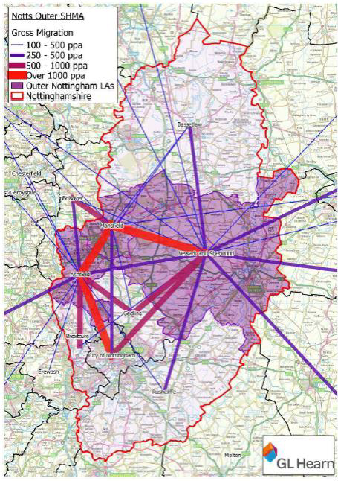
Source: Nottingham Outer 2015 Strategic Housing Market Assessment 2015/ONS2011

Likely evolution without the Local Plan
- Relevant policies in the Ashfield Local Plan 2002, saved policies will continue. However, they will become increasing dated and inconsistent with changes in national planning policy.
- Decisions would increasing reflect material considerations set out in national planning policy with a lack of any vision or framework for the future development of Ashfield.
- Population growth would continue with ad hoc housing developments.
- Requirements for services would increase but with the potential lack of infrastructure provision through S106 contributions/CIL contributed identified through an adopted planning framework.

Key sustainability Issues
- Population growth will increase the demand for housing and services and put additional requirements on local infrastructure.
- An increasing percentage of the population is anticipated to be over 65, this will have implications for service provision.

Housing

Housing need
1.4.1 In Ashfield, house prices are still amongst the lowest in the region although prices have continued to rise in recent years with the average price in 2019 of £138,425.

Figure 1.6 Average house prices
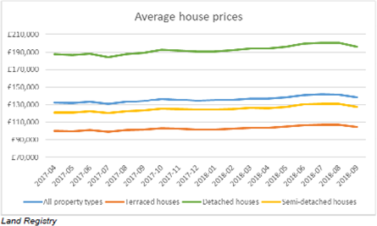
Source: Land Registry
1.4.2 There are 6,790 (December 2018) council owned properties, down from 6,866 in 2015 and a further 2,182 owned by other Registered Housing Providers (at March 2017).
1.4.3 Under the NPPF’s standard method, the Greater Nottingham and Ashfield Housing Needs Assessment (2020)10 identified that the minimum housing need for Ashfield for 2020 to 2030 was 481 dwellings per annum. Following the latest update on the affordability part of the Standard Method equation the housing need for Ashfield in 2021 has been calculated as 457 dwellings per annum. The NPPF11 also requires that the Council should identify and update annual a supply of specific deliverable sites sufficient to provide a minimum of five years’ worth of housing against their housing requirement. Figure 1.7 sets out the position for the period from 2019 to 2037.

Figure 1.7 Housing trajectory for 2020-2037

10 Iceni Projects Limited on behalf of the Greater Nottingham Planning Partnership (2020) Greater Nottingham and Ashfield Housing Needs Assessment
11 National Planning Policy Framework, Paragraph 74

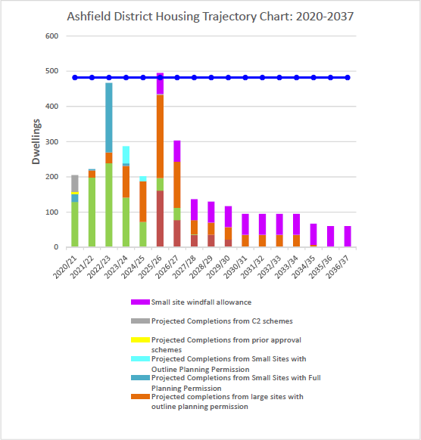

Source: Ashfield DC Housing Land Monitoring Report August 2020
1.4.4 The Ashfield District Housing Land Monitoring Report12 identifies that completion rates for new build have been falling in recent years.

Table 1.2 Housing Completion Rates 1st April 2011 to 31st March 2020

12 Ashfield District Council (2020) Housing Land Monitoring Report. Available via: https://www.ashfield.gov.uk/media/8d85a56dbe9fec9/housing-land-monitoring-report-2020.pdf

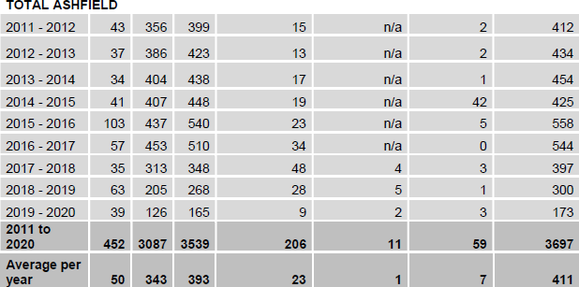

Source: Ashfield Housing Land Monitoring Report (2020)

Housing affordability
1.4.5 The estimated average (median) household income for Ashfield in 2019 was £29,400 with a mean household income of £38,600. Using a 26% affordability threshold just under half of households with a current need are estimated to be likely to have insufficient income to afford market housing.13

Table 1.3 Ashfield Affordable Housing Completions 2010 to 2020
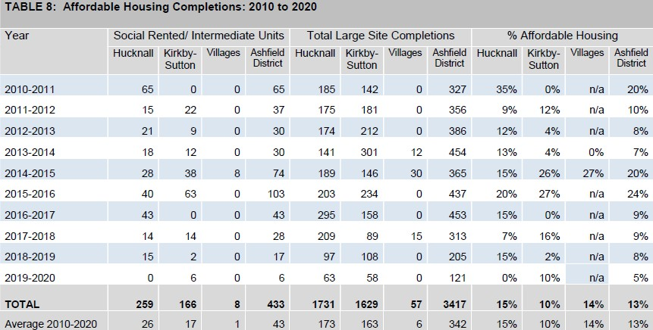

13 Iceni Projects Limited on behalf of the Greater Nottingham Planning Partnership (2020) Greater Nottingham and Ashfield Housing Needs Assessment

Source: Ashfield Housing Land Monitoring Report (2020)
1.4.6 The Housing Needs Assessment (2020)14 indicates there is a need for more 2 and 3 bed dwellings to cater for the predicted increase in smaller family units and older people in the Nottingham Outer HMA. There is less need for larger (4+) houses across all housing types. See Table 1.4.

Table 1.4 Recommended housing mix by size and type

Indicative Property Size Guide | Market Sector Housing % | Affordable home ownership % | Affordable rented %
1 bedroom | 4% | 23% | 35%
2 bedrooms | 27% | 38% | 37%
3 bedrooms | 45% | 24% | 25%
4+ bedrooms | 24% | 15% | 3%
Total | 100% | 100% | 100%
Source: Iceni Projects Limited on behalf of the Greater Nottingham Planning Partnership (2020) Greater Nottingham and Ashfield Housing Needs Assessment
1.4.7 Both Neighbourhood Plans place an emphasis on smaller market dwellings15.
1.4.1 The Ashfield Whole Plan & Community Infrastructure Levy Viability Assessment, July 2016, concluded that in terms of viability there were two submarkets Low Value (Yellow) corresponding to Hucknall and the Villages and Medium Value (Green) Kirkby-in-Ashfield and Sutton in Ashfield. See Figure 1.8.

Figure 1.8 Viability assessment of the District
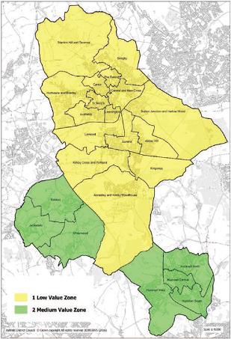

14 Iceni Projects Limited on behalf of the Greater Nottingham Planning Partnership (2020) Greater Nottingham and Ashfield Housing Needs Assessment
15 JUS-T Neighbourhood Plan Policy NP4; Housing Type. Teversl, Stanton Hill & Skegby Neighbourhood Plan NP3; Housing Types.

Likely evolution without the Local Plan
- Relevant policies in the Ashfield Local Plan 2002, saved policies will continue. However, they will become increasing dated and inconsistent with changes in national planning policy.
- Decisions would increasing reflect material considerations set out in national planning policy with a lack of any vision or framework for the future development of Ashfield
- The Council has a limited supply of land for housing. This will reduce over time until there are very limited allocated sites to meet housing need. While sites will come forward through individual planning applications this may be insufficient to meet a 5 year housing supply and is less efficient and cost effective.
- Fewer opportunities to take a strategic joined up approach to the provision of housing and infrastructure across the district.
- Housing would come forward through ad hoc planning applications within the countryside as the allocations within the Ashfield Local Plan Review 2002 have been substantial developed.
- The supply of housing through ad hoc development would be unlikely to meet the identified housing needs, including affordable housing. Changes to the population structure with an aging population is likely to create specific needs for housing and services which are unlikely to be met without allocation of sites to meet housing and community needs and specific local policy considerations in the Local Plan.
- The housing mix may well not reflect current and future needs due to the lack of local policy on this aspect unless it is located with the Neighbourhood Plan areas.
- Population will increase as new homes through planning applications are delivered.
- Without a coordinated approach to infrastructure provision, it is likely that S106 planning contributions will not meet the requirement of the Section 122 of The Community Infrastructure Levy Regulations 2010, as amended.
- Provision of affordable housing is unlikely to be maximised given the lack of an up to date Local Plan policy reflecting viability and the ad hoc development of housing sites do not meet the anticipated housing need.
- There is likely to be continued pressure for housing development on green open spaces rather than brownfield sites.
- Potential for house prices to rise relative to earnings given the lack of supply.
- Inability to bring forward rural exceptions sites, particularly in the Green Belt as there is no policy basis for this in the Ashfield Local Plan Review 2002.
- No specific provision to meet any demand for self-build or custom build properties in the District.

Key sustainability Issues
- Understand the level of housing required in Ashfield and the interaction between different areas of the District and the relationship with the Greater Nottingham Area.
- To provide sufficient housing of a type and tenure to meet specific needs.
- Housing in terms of new build has declined in recent years and is not meeting the housing need identified by the NPPF Standard Method.

- While the District is perceived as an area of affordable housing, when income levels in Ashfield are taken into account, housing affordability is an issue in the District.
- Changing demographic structure, including an aging population, will impact future household characteristics and will have implications for the provision of housing requirements, employment opportunities and services.
- Given that substantial parts of the District are in Green Belt, there are issues in balancing the housing needs of specific areas against the impact on the Green Belt and the countryside.
- A substantial number of brownfield sites have been developed in Ashfield. The consequence is that limited brownfield sites are available necessitating the utilisation of greenfield sites to meet housing needs.
- Reduce the potential impacts on the environment and social infrastructure of Ashfield whilst allocating land to provide for housing requirements.
- Improving the quality of the existing housing stock.

Economy

Employment
1.5.1 Ashfield has a much greater percentage of jobs in the manufacturing sector (18.9% in 2019) compared the East Midlands and (12.9%) and Great Britain as a whole (8.0%)16. Ashfield faces a number of issues as:
    - The unemployment rate in Ashfield is in line with the national average although there are local high concentrations at a ward level within Hucknall, Kirkby in Ashfield and Sutton in Ashfield.
    - A disproportionate number of people in the District work in semi-skilled and unskilled occupations and furthermore, the District has a low educational base. There is a need to increase the skills and education in the labour market as low level skills creates a barrier to higher tech and higher value business locating in the area.
    - The economic activity rate (ages 16-64) is lower in Ashfield than when compared to the England average.
    - The socio-economic profile of the District is weighted towards skilled and unskilled manual trades such as manufacturing and construction (evolving as a natural progression of a post coalmining community). As a result of historical, cultural and socio-economic factors some areas of Ashfield demonstrate income levels that are significantly lower than average compared to neighbouring areas or regional figures.
    - The District’s working age population has grown over the period 2001 to 2020. However, whilst the working population is growing, it is also becoming older. Consequently, over time there needs to be a greater focus on retaining older workers in the labour market to ensure that a shortfall in the supply of workers does not prevent the District from realising its economic potential.
    - With regard to education, levels of GCSE achievement in Ashfield are lower than the national average. The District also has a higher proportion of residents with no qualifications than the national average. In terms of the ‘very well qualified’, those qualified to NVQ level 4 or above. There are issues in retaining graduates in Ashfield. The concern is that too many residents

16Office for National Statistics NOMIS – Labour Market Profile Ashfield (2021)

currently lack skills at the right level to respond to these labour market changes and will thus struggle to compete effectively.
1.5.2 Further information on these aspects is available from Ashfield Annual Monitoring Report 2017/18 and the State of Ashfield Report 2019.

Employment land
1.5.3 The Employment Land Forecasting Study 2015 anticipated that under Scenario 2: Job Growth reflecting D2N2 LEP Policy On requirements for Ashfield will result in 10,724 new jobs in all sectors between 2011 and 2033. Of these jobs, 2,099 are anticipated to be in offices, factories and distribution this requires 59 hectares of employment land17. Figure 1.9 sets out significant employment estates.
1.5.4 The Nottingham Core and Outer Housing Market Area Employment Land Needs Study 2021 (ELNS) prepared by Lichfields18 provides updated evidence on the quantity of employment land to be planned for over the plan period to 2018-2038. The study reconfirms that Hucknall has a strong relationship with the Nottingham Core HMA. Both Kirkby-in-Ashfield and Sutton in Ashfield link in with the Mansfield area and in practice. The study identifies a range of potential employment land requirements based on various methodologies. The Regeneration and Standard Method (481 dpa) give similar results of around 46 to 54ha and 53 to 57ha of employment land respectively. Past take up rates identify a larger figure of 118.90 ha for industrial land to 2038.
1.5.5 The employment land requirements and the current supply of land is set out in detail in the most recent Ashfield Employment Land Monitoring Report (compared to the 2015 Employment Land Forecasting Study). Table 1.5 sets out the current position.

17 Employment land is considered to be land falling with Class B1, B2 or B8 of the previous Town and Country Planning (Use Classes) Order. Please note that class B1 was revoked on September 2020 and is replaced by class E(g) but has been retained here as reference to B1 for consistency with recent monitoring. The Ashfield Local Plan Review 2002 identifies that sui generis employment outside these categories may also be appropriate, subject to normal site planning considerations.
18 http://www.gnplan.org.uk/media/3332934/employment-land-needs-study-may-21.pdf

Table 1.5 Ashfield Employment Land Requirements 2011-2033
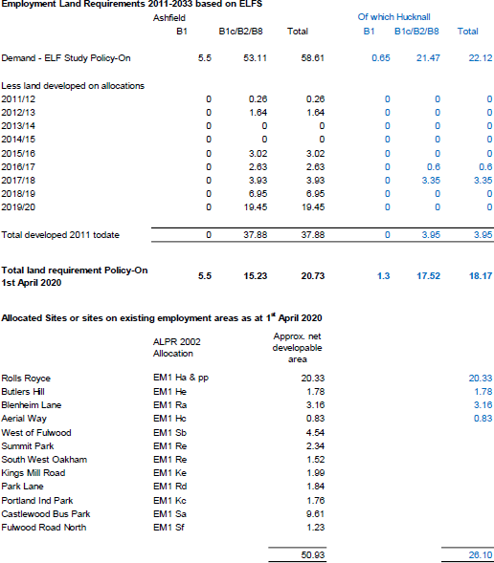

Source: Ashfield District Council/Employment Land Forecasting Study 2015 Nathaniel Litchfield & Partners and Ashfield Employment Land Monitoring Report 2020

Figure 1.9 Ashfield Significant Employment Areas (Use Classes B1, B2 and B8).

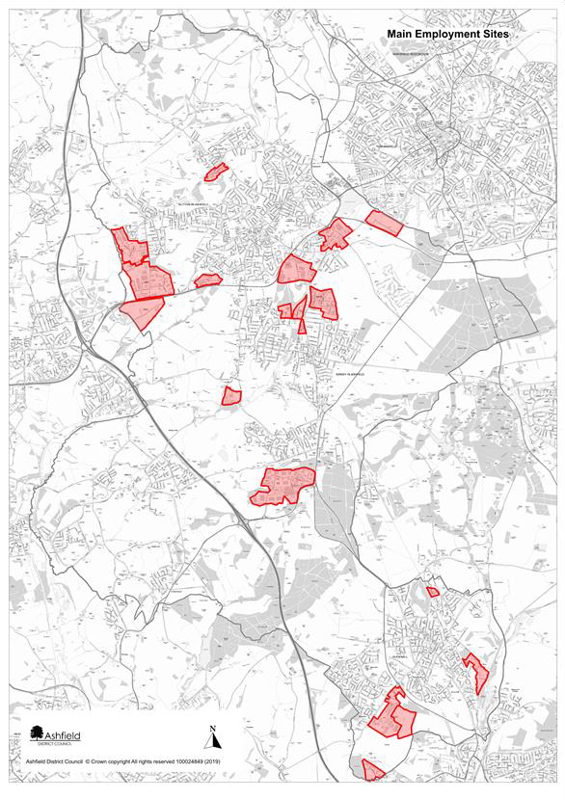
Source: Ashfield District Council

Likely evolution without the Local Plan
- Relevant policies in the Ashfield Local Plan 2002, saved policies will continue. However, they will become increasing dated and inconsistent with changes in national planning policy.
- Decisions would increasing reflect material considerations set out in national planning policy with a lack of any vision or framework for the future development of Ashfield.
- In continuing the Ashfield Local Plan Review 2002, employment land allocation may meet short term demand for sites. However, there are likely to be future issues on the requirement of growing sectors, such as logistics.
- An increase in the population is likely to increase the demands for jobs in the District but there may not be sufficient land to meet these needs leading to additional out commuting from Ashfield. These has potential implications for congestion on roads as well as air quality is greater traffic is generated.
- Out-commuting from the District is likely to continue give the geographic location of Nottingham and its function as a major source of employment.
- Some new schools such as at the Royce Royce development Hucknall have been brought forward. This reflects the size of the proposed development. However, ad hoc applications are more likely to be of a more limited number of dwellings. (1,000 dwellings generates a requirement for a new single form primary school1). This raises issues of how new schools and particularly land for new schools will come forward.

Key sustainability Issues
- Meeting the needs of all current and future populations in terms of business and job opportunities.
- Overreliance on the manufacturing sector where employment levels have declined over time.
- Accommodating any employment land and other development opportunities as far as possible within an urban area so as to minimise the impact on greenfield sites.
- Facilitate digital infrastructure to maximise growth opportunities.
- Providing the necessary infrastructure to accommodate current and future development needs in terms of physical green and social infrastructure.
- The need to encourage and accommodate both indigenous and inward investment particularly in relation to identified sectors, which have the potential for growth.
- Creating an environment that is attractive to future growth sectors to improve performance in comparison with other locations.
- Identifying opportunities for heritage led regeneration.
- There are pockets of deprivation particularly within the urban area. Economic regeneration is particularly important in these areas of the towns to help alleviate poverty.
- To increase incomes and skill levels, particularly in those communities suffering high levels of deprivation.
- The concern is that too many residents currently lack skills at the right level to respond to these labour market changes and will thus struggle to compete effectively.

- With the predicted increase in households there is likely to be a need to expand schools or provide new schools as a significant number of schools in Hucknall, Kirkby-in-Ashfield and Sutton in Ashfield are currently at or near capacity.
- To supporting the provision of appropriate sized schools/colleges and other skill learning facilities at a local level to help improve skills and opportunities.
- Potentially, using planning to improving employment prospects and training for local residents.
- The District’s working population has grown over the period 2001 to 2011 but is now showing
signs of declining as the population ages.
- Responding to future trends in employment and supporting the growth of self-employment.

Town centres

Overview of town centres
1.6.1 The Ashfield Retail & Leisure Study 2016 identifies that the Javelin Venue score’s index ranks 2,711 retail venues within the UK. The three centres in Ashfield remain relatively low in the rankings compared to traditionally competing regional and sub-regional centres with Nottingham being located approximately six miles from the Ashfield District boundary by road. Nevertheless, the Retail Study 2016 concluded that the majority of the centres are fulfilling their designated roles and functions as expected for their position the District retail hierarchy. Of note, each of the key town centres (Sutton, Hucknall and Kirkby) has a large format multi-channel supermarket either in, or in close proximity to, the core of the centre.

Hucknall
1.6.2 The Hucknall Town Centre Masterplan19 was formally adopted by the Council in November 2009 following public consultation. The Masterplan sets out a vision and strategy for the future development of Hucknall Town Centre based on five themes:
    - to discover the roots of Hucknall as a market town;
    - to create a range of uses and activities where people can work, rest and play as well as shop, by encouraging leisure uses, civic functions, cultural uses and community uses;
    - to extend the visits of those seeking Lord Byron’s grave to stay longer and spend more money
in the town;
    - to create a bustling High Street by strengthening the traditional retail offer of the town centre;
    - to transform the environment of the town, particularly on the edges of the centre and when arriving from the station.
1.6.3 The Masterplan develops these themes by identifying three main areas for change:
    - the Piggins Croft area;
    - the new relief road and associated potential development land;
    - the land around the station and the NET car park.

19 URBED with Gordon Hood Regeneration & Simon Fenton Partnership (2009) Hucknall Town Centre Masterplan

1.6.4 The relief road and pedestrianisation of the High Street has been undertaken and improved the shopping environment.
1.6.5 The current vacancy rate in Hucknall is much higher than it has been in the past (13.1%). However, the significant amount of rebuilding and redevelopment within the town centre is attributable for a number of these vacancies. Figure 1.10 sets out the changes in Hucknall’s town centre since 2006.

Figure 1.10 Hucknall Town Centre Composition in 2006, 2011 and 2016
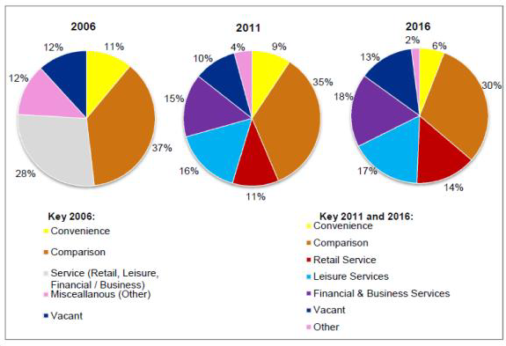
Source: GVA Grimley 2006 Ashfield Retail Study, WYG 2011 Ashfield Retail Study and Nexus Retail Survey January 2016
*The 2006 GVA Grimley Study does not breakdown service retail units by type – leisure, retail service, or financial / business service.

Sutton in Ashfield
1.6.6 The Sutton Town Centre spatial Master Plan 2019 sets out a vision and key opportunities for the town centre. It includes a concept plan identifying key gateways, primary and secondary streets and civic space. Opportunities for eight different areas of the town centre are set out being delivered by a mix of private, sector, public sector and partnership delivery.
1.6.7 The retail and Leisure Study, 201620 identified that generally a healthy town centre, key multiple retailers are present in proportion to the centre’s size, with Asda serving as the key retailer within the centre. The Idlewells Centre was covered in 1994 to provide a substantially improved shopping environment and along with the pedestrianised Low Street it forms the anchor shopping area. The town is performing moderately well, with the number of vacant units being slightly below the UK average figure – 10.8% compared to 11.3%. The amount of vacant floorspace is aligned with the national average – 9.1% compared to 9.2%.
1.6.8 Ease of access and parking are key factors in influencing visitation rates. The town centre has car parking situated at various points around the centre, including Asda, Priestsic Road, The Idlewells

20 Ashfield District Retail & Leisure Study May 2016 Nexus Planning.

multi-storey and the Market Place. The bus station on Devonshire Square links closely with the Town Centre Core retail area.

Figure 1.11 Sutton Town Centre Composition in 2006, 2011 and 2016
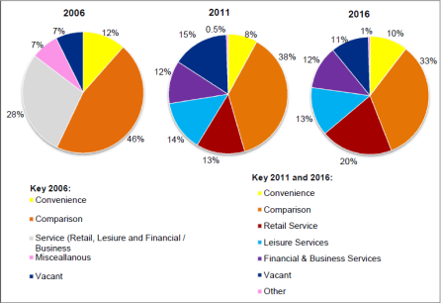
Sources: GVA Grimley 2006 Ashfield Retail Study, WYG 2011 Ashfield Retail Study and Nexus Retail Survey January 2016
*The 2006 GVA Grimley Study does not breakdown service retail units by type – leisure, retail service, or financial / business service.

Kirkby-in-Ashfield
1.6.9 Kirkby-in-Ashfield is identified as the smallest of the three main settlements in Ashfield District, and is designated as a ‘District Centre’ in the Retail & Leisure Study 2016. Morrisons supermarket, which has its frontage and car park facing onto Lowmoor Road, provides a strong anchor store within the centre. Lowmoor Road is pedestrianised and the redevelopment of the new Civic Square in 2014 has enhanced the overall shopping environment.
1.6.10 Kirkby-in-Ashfield has experienced a significant reduction in the number of vacant units in the past ten years aided by the Morrisons development. (The 2006 Retail Study identified a vacancy rate of 22.6%). Since the recession the vacancy rate has continued to decrease and now sits below the UK average of 11.3%, at 9.6%. The attraction of the new large format Morrisons is evident when reviewing the Retail Study results, as 10.2% of total respondents and 10.2% of Zone 2 respondents said their main reasons for visiting Kirkby is the strength of the supermarket.
1.6.11 Figure 1.12 sets out the changes in Kirkby in Ashfield town centre since 2006.
1.6.12 The town centre provides an important central hub for social, leisure and transport facilities in the area. People are drawn into the town centre by a number of leisure, community and health facilities including the Ashfield Community Hospital, Post Office, doctors and dentists, a library, the Festival Hall Leisure Centre and community facilities.

Figure 1.12 Kirkby-in-Ashfield Town Centre Composition in 2006, 2011 and 2016

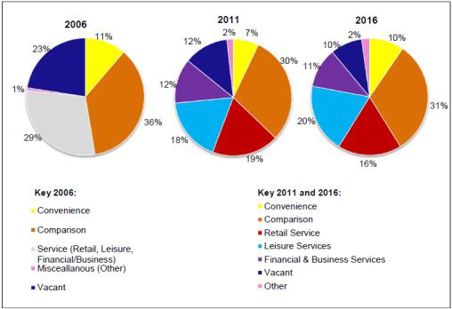

Likely evolution without the Local Plan
- Relevant policies in the Ashfield Local Plan 2002, saved policies will continue. However, they will become increasing dated and inconsistent with changes in national planning policy.
- Decisions would increasing reflect material considerations set out in national planning policy with a lack of any vision or framework for the future development of Ashfield.
- Lack of Section 106/CIL support for town centre improvements and opportunities.
- Lack of up-to-date policy town centre policies for the spatial masterplans for the town centre.
- Lack of an up-to-date Plan may impact on bidding for funding opportunities.

Key sustainability Issues
- The District has three shopping centres that need to be supported in order to keep them vital and viable.
- Bring forward key opportunities identified in the town centre masterplans within an appropriate timescale.
- Meeting the needs of all current and future populations in terms of business and job opportunities within town centres.
- Providing the necessary infrastructure to accommodate current and future development.
- Creating an environment that is attractive to future growth sectors to improve performance in comparison with other centres.
- Identifying opportunities for heritage led regeneration.

Healthy and safe communities

Health
1.7.1 Figure 1.13 sets out the potential influence the Council can have in relation to the social aspects of health and wellbeing.

Figure 1.13 Ashfield District Council impact on the social determinants of health and wellbeing
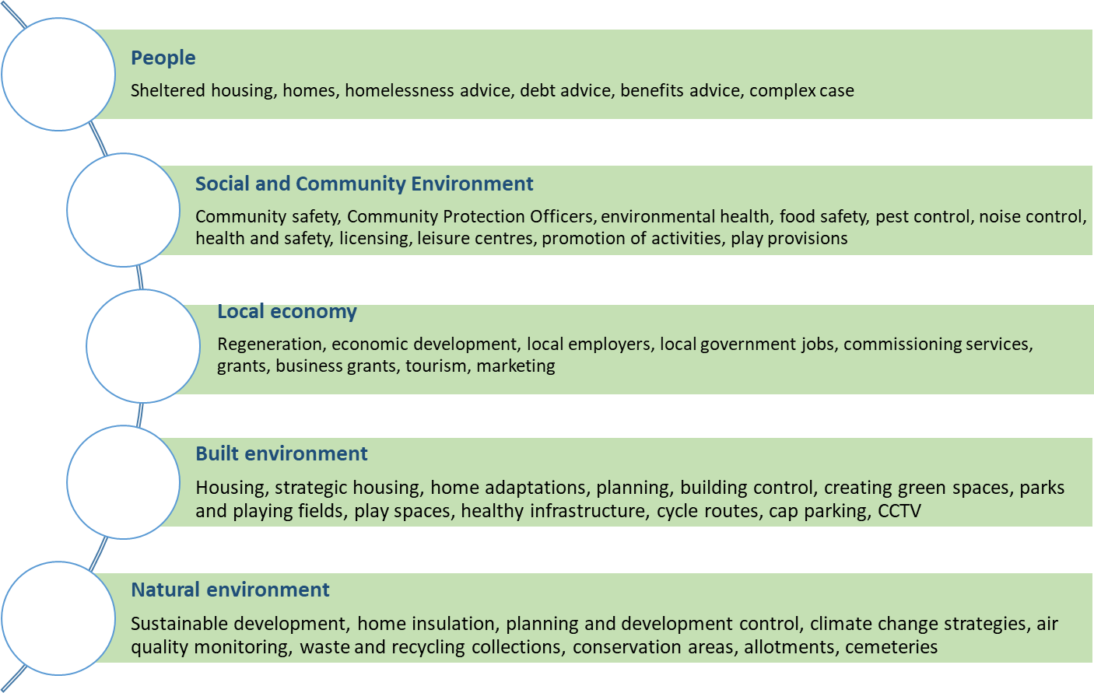

Source: Ashfield District Council
1.7.2 The health of people in Ashfield is generally worse than the England average. This can be seen in a number of areas:
    - Life expectancy is lower in Ashfield that the English average with the difference in life expectancy between the most and the least deprived areas of Ashfield is 10.4 years for men and
8.3 years for women (based on death rates from 2014-2016).
    - Over the last ten years life expectancy has increased for men and women in Ashfield; 1 year for men and 1.5 years for women, the improvement is in line with the England average rates although they remain below average for England. Over the most recent period, life expectancy for both men and women has fallen slightly.
    - There are less people over the age of 18 diagnosed with diabetes than the England average.
    - Obesity in children aged 4-5 is lower than the England average but obesity amongst 10-11 years is above average.
    - Excess weight in adults at 74% is higher than the England average (61.3%). The Regional average is 63.3%.
1.7.3 The average life expectancy in Ashfield for men and women is set out in Figure 1.14 below.

Figure 1.14 Ashfield life expectancy
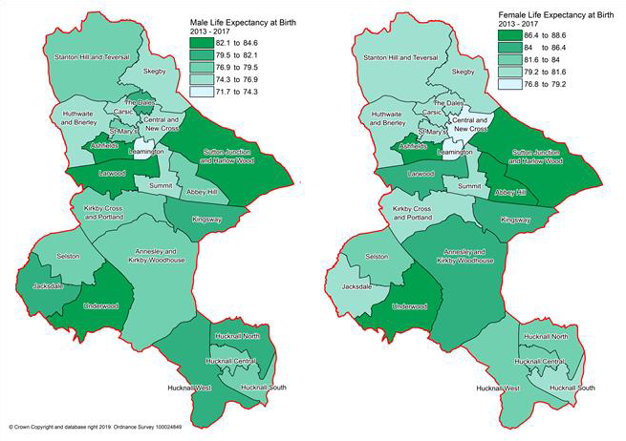
1.7.4 The physical activity of adults over the age of 19 has fallen in the District and is now below the average for the East Midlands. (Activity is 150 or more moderate intensity active minutes per week21). Priority areas for directing resources to achieve improvements are identified in the Lifestyle Strategy Active Ashfield 2017-2021. These include:
    - Leamington Estate, Sutton in Ashfield;
    - Stanton Hill (brand Lane, Wharf Road, Fackley Road, Victoria Street);
    - Broomhill, Hucknall,
    - Coxmoor Estate and Southwell Lane, Kirkby-in-Ashfield;
    - New Cross and surrounding area, Sutton in Ashfield.

Deprivation
1.7.5 The English Indices of Deprivation measure relative levels of deprivation in 32,844 small areas or neighbourhoods, called Lower-layer Super Output Areas (LSOA). It is the official measure of relative deprivation in England and is part of a suite of outputs that form the Indices of Deprivation (IoD). The level of deprivation in Ashfield is relatively high as set out on the indicators below. In 2015 Ashfield was ranked as the 70th most deprived district out of 326 according to the IMD. In 2019 Ashfield ranking was 63 out of 317 districts. The two LSOA below are in the 2% most deprived in England:
    - E01027974 Leamington Rank of IMP score (1 most deprived) 438
    - E01027951 Coxmoor Rank of IMP score (1 most deprived) 985

21 Ashfield Annual Monitoring Report 2017/18

Figure 1.15 Ashfield Index of Deprivation 2019
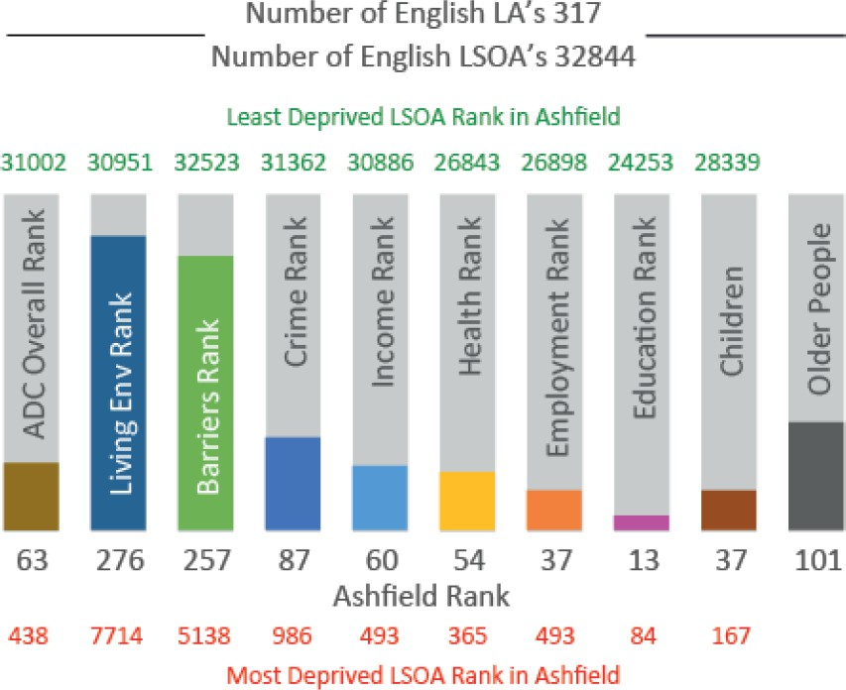

Source: Ashfield Annual Monitoring Report 2018/19

Open space
1.7.6 Green infrastructure has a multi-functional role including improvement to health and wellbeing, improved flood risk management, enhancing biodiversity and adaption to climate change.
1.7.7 The local approach to green infrastructure and biodiversity is set out in the Council’s Green Infrastructure and Biodiversity Technical Paper 2013. This examines the connectivity of green spaces at a local level and identifies green infrastructure network opportunities and ensures that the Green Infrastructure network is protected and enhanced. The Technical Paper includes a number of maps which set out various aspects including Key Habitat Linkages; Accessibility; Community facilities; Green Infrastructure Networks.
1.7.8 Ashfield’s Green Space Strategy provides evidence on the existing green space network and its recreational values. It provides a basis for improving the quality and potential uses of green spaces to cater for increasing future demand arising from growth and the changing needs of the community. The Strategy sets out locally-derived standards for the provision of green spaces and identifies deficiencies in the quantity, quality or accessibility of green spaces.

Table 1.6 Ashfield Public Open Space Strategy (2016-2026) requirements
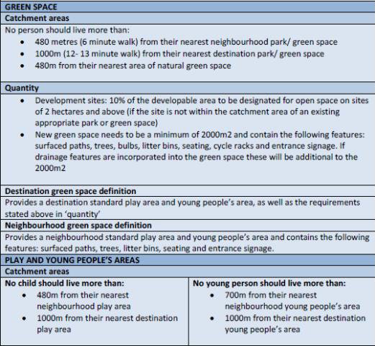
Source: Ashfield District Council
1.7.9 The Ashfield Playing Pitch Strategy 2017-2020 includes provisions for new facilities through the development process. It sets out anticipated requirements for various sport on an area basis up to 2026. (Part 3 Supply & Demand).

Crime
1.7.10 Recorded crime has increased in Ashfield in 2019 for only a couple of categories but for the majority there has been a slight decrease from 2018 (see Figure 1.16).

Figure 1.16 Recorded Crime Incidents
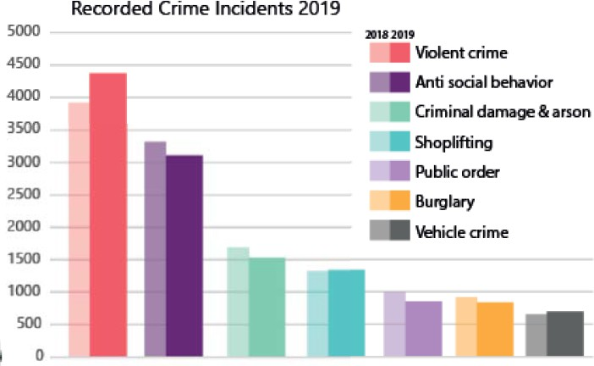
Source: Ashfield District Annual Monitoring Report 2018-2019

Likely evolution without the Local Plan
- Relevant policies in the Ashfield Local Plan 2002, saved policies will continue. However, they will become increasing dated and inconsistent with changes in national planning policy.
- Decisions would increasing reflect material considerations set out in national planning policy with a lack of any vision or framework for the future development of Ashfield.
- There are national, regional and countywide initiatives to consideration and improve healthy lifestyles, however, it is likely to result in fewer opportunities for systematic improvements in health service provision.
- Without relevant policies inappropriate housing mixes to meet future needs are unlikely to come forward as part of ad hoc development.
- Health issues identified in the issues and problems are likely to continue into the future without the opportunity to maximise the opportunities to tackle these issues.
- A lack of strategic planning through the Ashfield Local Plan to meet the housing needs means that new housing will not be required to be accessible or adaptable for future occupation by the elderly or people with disabilities.
- Ad hoc housing development could put increased pressure on Ashfield’s green spaces, with a risk of degradation from increased use if no additional spaces are created, or even the possible loss of some green areas to development.
- The NPPF requires good design that creates safe places (paragraph 91) but without a more detailed local policy there is more limited opportunity to influence the best outcome.
- Opportunities for the improvement of community facilities are likely to be more opportunistic. Sites may be progressed that are acceptable in policy terms but not the best possible option in light of all the evidence available.

Key sustainability Issues
- Residents of Ashfield have a shorter life expectancy than on average for England.
- To improve health and wellbeing, and to prevent ill health (e.g. through healthy eating and exercise).
- Health inequalities exist between the most and least deprived areas of the District.
- To provision health services and facilities in relation to the demands arising from new development.
- The Health and Wellbeing Board has identified priority areas which they believe will have the biggest impact to help improve health and wellbeing. This includes including ‘losing the gap in educational attainment.’
- Lifestyle indicators are generally worse than the average for England.
- Ashfield performs poorly in the Indices of Multiple Deprivation and is ranked at 63rd out of 317 local authority areas (IMD, 2019).
- New health, sporting, leisure and recreational facilities should be provided encouraging walking, cycling and more active lifestyles.
- The development of a high quality multifunctional green infrastructure network should be promoted identifying any opportunities for links with and enhancement of cultural heritage.

- Potential issue in meeting the needs of an aging population.
- The development of accessible cycle networks to facilitate alternative modes of transport.
- The development of quality green infrastructure should be promoted as part of development, linking to a green infrastructure network.
- Adult participation in sport has decreased in Ashfield in recent years.
- New health, sporting, leisure and recreational facilities should be provided and should encourage walking, cycling and more active lifestyles.
- Recent evidence indicates that crime rates are increasing in the District.
- To improve safety and security for people and property (e.g. through design intervention) and to reduce fear of crime.

Transport

Road links
1.8.1 The District has excellent road links to much of the country due to its location beside the M1 motorway. Junction 26 of the M1, which is outside the District, provides a good link to Hucknall. Junction 27 of the M1 lies within the District and provides a major link to Ashfield’s three towns and Junction 28 can be easily accessed via the A38. Other major routes include the A617, Mansfield-Ashfield Regeneration Route (MARR) and A611 between Mansfield and Nottingham via Hucknall.
A’ roads in the District are the A38, A611, A6617, A60, A6075 and A608.
1.8.2 The County Council is considering the case for seeking additional funding to improve junctions on the A611 between Mansfield and the M1, Junction 27 and the widening of the A617 from the A38 to the Rainworth Bypass. It is also understood that Highways England are examining the possibilities of improving Junction 27 of the M1.

Rail links
1.8.3 The Robin Hood railway line (which runs from Nottingham to Worksop) has stations at Hucknall, Kirkby-in- Ashfield and Sutton Parkway. Trains runs from Ashfield to Nottingham, typically twice every hour during the day. On an average week day there are 58 trains travelling from these stations to Nottingham.
1.8.4 Hucknall is a terminus for the Nottingham Express Transport (NET) tram route to Nottingham. A peak times trams run every 7 minutes with a tram every 15 minutes early in the morning and late at night.

Local Transport Plan
1.8.5 The Nottinghamshire Local Transport Plan sets out the transport strategy for the whole of Nottinghamshire (LTP3) to 2016. It is anticipated that the Local Plan will be closely linked to the objectives of LTP3 in seeking to promote smarter choices of transport. A third implementation plan covers the period from 2018 to 2021. Nottinghamshire County Council, identifies that 99% of residents in Ashfield are less than a 10 minute walk from a bus stop with an hourly service.

1.8.6 Information on traffic flows and the potential impact on junctions of development in Ashfield and neighbouring authorities is set out in the Ashfield Transport Study 201622. The evidence identifies that there is congestion between Mansfield, Ashfield and Nottingham resulting in slower vehicular speeds, particularly during the AM and PM peak periods.

Likely evolution without the Local Plan
- Relevant policies in the Ashfield Local Plan 2002, saved policies will continue. However, they will become increasing dated and inconsistent with changes in national planning policy.
- Decisions would increasing reflect material considerations set out in national planning policy with a lack of any vision or framework for the future development of Ashfield.
- Traffic flows are likely to increase with the increased population unless there is less reliance on the car as a means of transport.
- The implementation of the Nottinghamshire Local Transport Plan will lead to improvements in sustainable transport in the area encouraging alternative modes of transport from the car.
- Potential improvements to the A611 and A617 and the M1 Junction 27 if taken forward will offset congestion. However, it is possible that these improvements may need some financial support from development.
- Housing development will come forward on an ad hoc basis through planning applications, which means it is substantially more difficult to plan for improvements to the wider highway network.
- Existing patterns of transport are likely to be reinforced, with high levels of car dependency and less opportunities to tackle social exclusion and resolve strategic matters.
- Poorly located development would result in a lack of travel choice and high levels of dependency on the car.

Key sustainability Issues
- Embed accessibility into locational requirements for development and decision making and the access to services (such as health, education and leisure).
- The need to improve the quality and range of services available within communities.
- Ensure that new development has good access to facilities and alternative means of travel.
- Reducing the dependency on the private car.
- Traffic congestion is an issue in Ashfield reflecting the new development proposed.
- Improvements will be required to specific junctions as part of development as otherwise there will be an adverse impact on congestion and journey times.
- Development close to the M1 motorway at Junction 27 has the potential to encourage car use and increase congestion, particularly around Sherwood Business Park.
- To facilitate alternative forms of transport including encouraging more people to walk and cycle.

22 Ashfield Transport Study Final Report 2016. Systra

- Significant new development will need to facilitate bus services to gives choice of transport mode.
- To work with partners to provide an integrated and efficient transport system including public transport, walking and cycling network in Ashfield.
- Ensure that new development has good access to facilities and alternative means of travel, reducing the dependency on the private car.
- To facilitate alternative forms of transport including encouraging more people to walk and cycle.
- A new Transport Study will be required to identify the implications of development.
- The implications that over the life of the Plan combustion engines are likely to be increasingly phased out and replaced by ultra-low emission and electric vehicles.

Effective use of land and achieving well designed places

Land use
1.9.1 Land use involves decisions on crosscutting and multi-layered issues that affect a wider variety of aspects including brownfield land, recreation, biodiversity, flooding, an, density of housing development. It is anticipated that these aspects are covered in the various other section of the baseline.
1.9.2 Similarly design potential has an impact on all aspects of place making. and cross into the issues and problems identified in the other sections of the baseline.
1.9.3 Figure 1.17 sets out in broad terms the existing Land Use in Ashfield. The District covers an area of 10,956 hectares and the percentage figures are based against this total area.

Figure 1.17 Ashfield Broad Land Uses
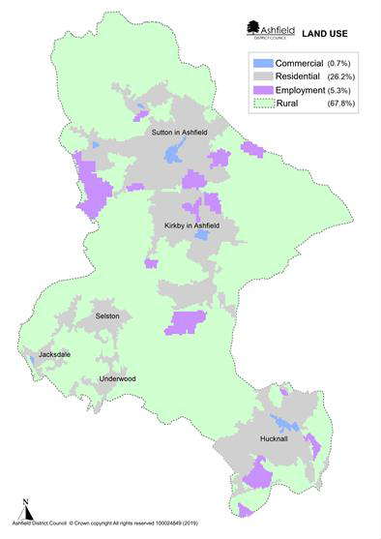Source: Ashfield District Council

Brownfield land
1.9.4 Brownfield' (previously developed) land is defined in Annex 2 of the NPPF (2021) as: land which is or was occupied by a permanent structure, including the curtilage of the developed land (although it should not be assumed that the whole of the curtilage should be developed) and any associated fixed surface infrastructure. This excludes:
- land that is or was last occupied by agricultural or forestry buildings;
- land that has been developed for minerals extraction or waste disposal by landfill, where provision for restoration has been made through development management procedures;
- land in built-up areas such as residential gardens, parks, recreation grounds and allotments; and land that was previously developed but where the remains of the
- permanent structure or fixed surface structure have blended into the landscape.
1.9.5 However, this is a very broad definition and (apart from the exclusions) covers all land in England where there are or have been buildings or other development. Much of this land is already in productive use and would not be suitable for new housing.
1.9.6 Government Land Use Change Statistics in England 2017-1823 identify that nationally for 2017-18
- 53 per cent of new residential addresses were created on previously developed land.
- The average density of residential addresses surrounding a newly created residential address was 31, a decrease from 32 in 2016-17.
1.9.7 However, the proportion of new address on previously development land can vary significantly, between authorities. To a substantial degree this will dependent on the nature of the authority. For example, a city would be anticipated to have a substantial degree of development on brownfield land. Ashfield District falls within the 21% to 40% category for the period from 2013 -2018.
1.9.8 For a brownfield site to be allocated it must be deliverable. This will be a site not in current use, or a site in use (though not for housing) or under utilised where the local authority has evidence that the owner would be willing to make the land or buildings available for new housing, provided planning permission can be obtained. The site also needs to be free of constraints. In this context:
- It will not be suitable for housing if any land has severe physical, environmental or policy constraints, unless the constraints can realistically be mitigated while retaining the viability of redevelopment.
- Contaminated land should also be excluded if there is clear evidence that the cost of remediation would be out of proportion to its potential value, making re-development unviable.
- Land in the Green Belt is subject to a national policy to keep land permanently open. Consequently exceptional circumstances will be necessary to justify changes to the Green Belt.
1.9.9 The Ashfield Employment Land Monitoring Report 2020, identifies that substantial areas of former employment land has been developed for none employment purposes between 2001 and 2020 (Table 1.7) with the majority of that land being developed for housing. Former coal mines and

23 MHCLG (2018) Government Land Use Change Statistics in England 2017-18. Available via: https://assets.publishing.service.gov.uk/government/uploads/system/uploads/attachment_data/file/805435/Land_Use_Change_Statistics_ England_2017-18.pdf [accessed July 2020]

textiles factory sites have been redeveloped or greened over. Consequently, it is not anticipated that substantial brownfield land will be available for future development.

Table 1.7 Employment Land Losses to residential development 1st April 2001 to 31st March 2020.
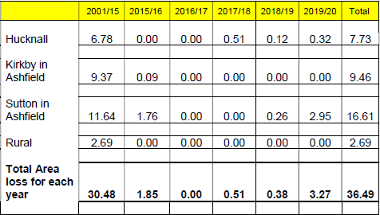

Source: Ashfield District Council Employment land Monitoring Report 2020
1.9.10 Wherever possible, the opportunity should be taken to take forward brownfield sites within urban areas. However, for Ashfield this needs to be seen in the context that:
- A large number of brownfield sites, typically used for coal production or textile manufacturing, have already been developed for housing or employment or have been green over as part of
the District’s green infrastructure. For example, the former site and spoil heap to Silverhill
Colliery.
- An industrial building or warehouse and the associated land will only be put forward by landowners for redevelopment when the building reaches the end of its economic life. The timing of redevelopment will depend on the relationship between:
 The capital value of the existing use (the value of the existing use plus the cleared value of the site in its existing use);
 The capital value of the best alternative use;
 The cost of rebuilding.
A building will continue in its existing use until the value of the cleared site for the new development (housing) exceeds the value of the site and building in its existing use (industrial or warehouse).
- For Ashfield there are no significant areas identified of derelict land within the urban areas that is available for housing.
- There are a limited number of small sites identified on the Council’s Brownfield Register.
1.9.11 Given these circumstances and reflecting that sites must be based on their potentially suitability and deliverability, it is not anticipated that there is a significant supply of brownfield site available for housing in Ashfield.

Housing density
1.9.12 The residential address statistics can be used to create an estimate of the density of new residential development. This is derived by calculating the density of all residences in the hectare surrounding a newly created residential address. In 2017-18, the average density of residential addresses surrounding a newly created residential address was 31 addresses per hectare.24
1.9.13 The Ashfield Local Plan Review 2002 saved policies sets out a policy requirement25 for Ashfield, on sites of 0.4 ha or more within walking distances of district shopping centres, Robin Hood Line Stations or Nottingham Express Transit rail stops of
- 40 dwellings per ha within 400 m.
- 34 dwellings per ha within 1 km.
- 30 dwellings per ha elsewhere.
1.9.14 Planning application within the District have been considered against these requirements. However, it is stressed these are minimum net requirements and individual housing developments will excess these requirements. Information is set out in the Council’s Housing Monitoring Repot 202026 identifies that for large sites (10 dwellings or more) between 2010 to 2019:
- 17.91% of completions fell below 30 dwellings per ha,
- 73.09% of completions fell between 30 -50 dwellings per ha, and
- 9.00% of completions fell above 50 dwellings per ha.
1.9.15 This information is broken down in the Monitoring Report into the three areas of Hucknall, Kirkby-in-Ashfield/Sutton in Ashfield and Villages (Selston Parish).

Design
1.9.16 National planning policy puts a substantial emphasis on achieving well design places both in the NPPF and in Planning Practice Guidance. This has been supported at a national level by National Design Guidance.
1.9.17 At a local level the Ashfield Local Plan Review 2002, saved policies set out broad design principles in various policies including: Policy ST1, HG5 new residential development, HG7 residential extensions, HG8 residential care homes, houses in multiple occupation, bedsit, flats and hostels, SH8 commercial/retail development, Policy SH9, hot food shops. It is supported by supplementary planning documents on residential design and residential extensions.

Likely evolution without the Local Plan
- Relevant policies in the Ashfield Local Plan 2002, saved policies will continue. However, they will become increasing dated and inconsistent with changes in national planning policy.
- Decisions would increasing reflect material considerations set out in national planning policy with a lack of any vision or framework for the future development of Ashfield.

24 MHCLG (2018) Government Land Use Change Statistics in England 2017-18. Available via: https://assets.publishing.service.gov.uk/government/uploads/system/uploads/attachment_data/file/805435/Land_Use_Ch ange_Statistics_England_2017-18.pdf [accessed July 2020]
25 Ashfield Local Plan Review 2002, Saved Policies – Policy HG3.
26 Ashfield Housing Land Monitoring Report 2020,

- Brownfield land has to be seen in the context of a limited supply. However, greenfield sites are more likely to be priorities by developers as the Ashfield Local Plan Review 2002, saved policies does not reflect a brownfield first approach.
- Minimum densities will reflect the relevant policy in the Ashfield Local plan Review 2002, saved policies.
- There would be a reliance on national design guidance rather than local guidance, although this could be off set by local supplementary planning documents on design under the more dated design policies in the current local plan.
- Design policies will not reflect latest national planning policy & guidance.

Key sustainability Issues
- While there are extensive employment sites in Ashfield these are largely currently occupied.
- The traditional factory sites related to textiles and the coal industry have been redeveloped or green over as part of country parks. Sites that have not been developed, such as North Street, already have planning permission for re-development. Consequently, there is likely to be a very limited supply of brownfield sites of the nature in the future.
- There are extensive ‘modern’ industrial estates but buildings have not reached the end of their economic life. Consequently, they are no suitable or deliverable in terms of national planning policy.
- There is limited brownfield land available for development in Ashfield with the consequence that development is likely to be predominantly on greenfield sites.
- Minimum densities are set out by the Ashfield Local Plan Review, saved policies but these do not fully reflect national policy.
- Well-designed places can be achieved by taking a proactive and collaborative approach at all stages of the planning process, from policy and plan formulation to development but Local Plan design and density policies are increasing out of date in relation to national guidance.

Climate change and flooding

Climate Change
1.10.1 Climate change is the greatest environmental challenge facing the world today. Rising global temperatures will bring changes in weather patterns, rising sea levels and increased frequency and intensity of extreme weather events, the effects will be felt here in the UK and internationally. Current projections indicate that the Midlands will experience hotter, drier summers and warmer, wetter winters. Potentially, this could result in more frequent drought and flood events.
1.10.2 It is emphasised that in relation to climate change there are a number of cross overs with different sections of the SA Report. The local plan has a role in tackling climate change through a range of measures including the location and layout of development, reuse of waste materials, a move towards zero carbon, multi-functional green infrastructure, protecting and enhancing habitats that provide carbon sinks reduce and reduce demand on water resources.

1.10.3 The Low Carbon Energy Opportunities and Heat Mapping for Local Planning Areas Across the East Midlands’ Study27 sets out an evidence base of the technical potential for renewable and low carbon energy technologies within the East Midlands. The results indicate that Ashfield has considerable potential for microgeneration; in particular, heat pumps, solar thermal and solar photo voltaics and these uses are particularly encouraged. The study also highlighted that, whilst Ashfield District has good average wind speeds, the potential for commercial scale wind energy developments is limited by constraints relating to the presence of existing infrastructure, properties and bird sensitivity issues.

Water resource and quality
1.10.4 Severn Trent Water forecasts a shortfall of water supply against demand if no interventions are made. Their Water Resources Management Plan 2019 identifies various demand management and supply side measures together with additional investment to ensure water resources are maintained. Supply and demand forecasts are made for the next 25 years to enable Severn Trent Water to determine whether they have enough water to meet customer requirements. The plan takes into account various aspects including climate change scenarios, demand scenarios for population changes and protecting the environment in the long-term by not putting at risk the future ecological status of the water bodies. Severn Trent identifies that this should not constrain growth but there may be time implications for developments in upgrading water infrastructure. The Plan emphasises that the plan protects the environment in the long-term by not putting at risk the future ecological status of the water bodies in our region (as defined by the Water Framework Directive).
1.10.5 The Watercycle Study for Greater Nottingham and Ashfield28 indicates that the water resource situation in the East Midlands is significantly constrained with little opportunity to develop new
water resource schemes. The Environment Agency’s Catchment Abstraction Management Strategies (CAMS) identifies that water is either not available for extraction or is restricted dependent on the CAMS area.
1.10.6 Foul water service provision is provided through a number of Wastewater Treatment Works. In the past issues have been identified at Huthwaite but there has been an increase in hydraulic limit so
that immediate capacity issues have been alleviated. The ‘no deterioration’ policy of the Water
Framework Directive29 requires that current environmental conditions are maintained or improved
1.10.7 The proactive protection of groundwater resources is key to providing improvements to the aquatic environment and protecting water resources for future use. Under the Water Framework Directive, the environmental objectives for groundwater and surface water bodies are:
- To prevent deterioration in the status of water bodies, improve their ecological and chemical status and prevent further pollution.
- Aim to achieve good quantitative and good groundwater chemical status by 2015 in all water bodies. For a groundwater water body to be in overall 'good' status, both its quantitative and chemical status must be 'good'
- Implement actions to reverse any significant and sustained upward trends in pollutant concentrations in groundwater
- Comply with the objectives and standards for protected areas where relevant.

27 Low Carbon Energy Opportunities and Heat Mapping for Local Planning Areas Across the East Midlands’ study Land
Use Consultants, Centre for Sustainable Energy and SQW on behalf of East Midlands Councils in 2011
28 Entec (2010) Greater Nottingham and Ashfield Outline Water Cycle Study
29 Directive 2000/60/EC of the European Parliament and of the Council of 23 October 2000

- Hazardous substances must be prevented from entry into groundwater and the entry into groundwater of all other pollutants must be limited to prevent pollution.
1.10.8 This approach is important for Ashfield as the District is situated on principal and secondary aquifers. These are layers of rock or drift deposits that provide a high level of water storage. They may support water supply and/or river base flow on a strategic scale. Secondary aquifers are permeable layers capable of supporting water supplies at a local rather than strategic scale, and in some cases forming an important source of base flow to rivers.

Flood risk
1.10.9 Ashfield is located upstream of the Trent Valley with a number of the River Trent’s tributaries rising in the District. Figure 1.18 identifies Flood Zone 2 and 3 in Ashfield. The Strategic Flood Risk Assessment 200930 identifies that while the risk of flooding from watercourses is relatively low compared with some neighbouring authorities, properties at Hucknall and Jacksdale are particularly at risk from watercourses. Additional water into the River Leen raises potentially significant flood issues in Nottingham. The impact of climate change and the topography is anticipated to result in an increasing risk from surface water flooding in the District.

30 Strategic Flood Risk Assessment 2009 Ashfield District Council

Figure 1.18 Ashfield Flood risk Zones 2 and 3
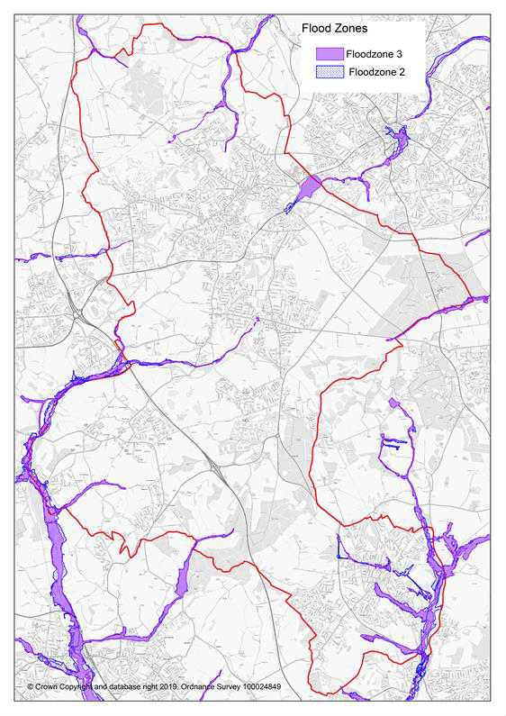
Source: Environment Agency Flood Maps for Planning

Likely evolution without the Local Plan
- Relevant policies in the Ashfield Local Plan 2002, saved policies will continue. However, they will become increasing dated and inconsistent with changes in national planning policy.
- Decisions would increasing reflect material considerations set out in national planning policy with a lack of any vision or framework for the future development of Ashfield.
- Baseline trends relevant to climate change will continue.
- Emissions from road transport and households are likely to continue to be the two largest inputs to greenhouse gas emissions. Road traffic use in and around the District is likely to increase may with population increases.
- New developments is anticipated to include some features which will help to facilitate resilience to the effects of climate change, such as sustainable drainage systems. However, lack of policy up-to-date policy provision is likely to mean that the Council has a more limited response to these aspects.
- Population growth will increase water demand for the area placing increasing pressure on water resources. Severn Trent Water has planned for increases for a period of 25 years from 2020. The Water Management Plan places an emphasis on saving water, however, without a Local Plan and relevant policies there are more limited opportunity to reduce water consumption below Part G of the Building Regulations.
- No policies were saved relating to flood in the Ashfield Local Plan Review 2002. Nevertheless, the NPPF would provide a material consideration to reduce the possibility of housing development within Flood Zones 2 or 3. It is also anticipated that surface water risk would still need to be mitigated through Sustainable Urban Drainage Schemes. However, the absence of up-to-date Local Plan Policies means that these scheme may not maximise the biodiversity benefits and there is less flexibility to incorporate this with a blue and green infrastructure network.

Key sustainability Issues
- Planning for the adaptation of and long-term resilience of Ashfield in relation to all aspects of climate change.
- The Local Plan policies provide opportunities to support adaptation to climate change through appropriate design and layout and incorporation of features to facilitate resilience to the effects of climate change.
- Improving energy efficiency and increasing use of low-carbon and renewable energy.
- Balancing the potential amenity and landscape impacts and the need for alternative sources of energy.
- Ensure that new development has good access to facilities and alternative means of travel.
- Reducing the dependency on the private car.
- To facilitate alternative forms of transport including encouraging more people to walk and cycle.
- To take account of the impact of development on water in relation to water quality and flood risk.
- To avoid development within Flood Zones 2 and 3 unless exceptional reasons arise.

- While the risk of flooding from watercourses is relatively low there is a risk from flooding is specific area, in particular, Hucknall and Jacksdale.
- The River Leen flows into the City from Ashfield and is identified as responding rapidly in the urban area to rainfall, giving less time for community response. Additional water into the River Leen raises significant flood issues in Nottingham. It is important that neighbouring authorities work in partnership to ensure that activities upstream do not increase flood risk within the City of Nottingham.
- To the south and west of Nottinghamshire there are relatively steep areas, including heavily urbanised areas, such as Sutton-in-Ashfield and Mansfield.
- Water supply will need to be considered and consideration should be given to reducing water consumption below Part G of Building Regulations which specifies that new homes must consume no more than 125 litres of water per person per day.
- Waste water will need to be effectively managed through development and infrastructure planning.

Conserving and enhancing the natural environment and Green Belt

Biodiversity and geological significance
1.11.1 Ashfield is recognised as one of the most biodiverse areas in Nottinghamshire, due largely to its varied geological context of magnesian limestone, triassic sandstone (to the east) and coal measures (to the west). The District supports a broad range of habitats, including heathland, ancient woodland dumbles, calcareous grasslands (often on post-industrial sites) and fields rich in wild flowers. The east is characterised by small fields and streams, while the west and south contains large blocks of tree planting. The rivers and streams within the District provide habitat for significant populations of water vole and native crayfish.
1.11.2 Ashfield has nine Sites of Special Scientific Interest (SSSI), representing some of the County’s richest
habitats, see Table 1.8 below.

Table 1.8 Sites of Special Scientific Interest within Ashfield

Ashfield - SSSIs | Area ha | Interest
Annesley Woodhouse Quarries | 34.6031 | Biological
Bagthorpe Meadows | 6.3072 | Biological
Bogs Farm Quarry | 4.8971 | Biological
Bulwell Wood, Hucknall | 16.8741 | Biological
Dovedale Wood | 13.4252 | Biological
Friezeland Grassland | 3.6781 | Biological
Kirkby Grives | 22.0184 | Biological
Teversal Pastures | 17.9162 | Biological
Teversal – Pleasely Railway | 5.0122 | Biological

1.11.3 Ancient Woodland have been identified by Natural England within Ashfield at:
- Healds Wood, Stanton Hill/Skegby;
- Bloomer Wood, Kirkby-in-Ashfield;
- Bulwell Wood, Hucknall;
- Dawgates Wood, Skegby;
- Dawgates Wood 1, Skegby
- Dovedale Wood, Stanley
- High Park Wood, Underwood.
- Little Oak Plantation, Annesley;
- Millington Springs, Underwood;
- Normanshill/Thieves Wood; Sutton in Ashfield
- The Dumbles. Kirkby-in-Ashfield.
1.11.4 In addition, Starth Wood, Elhole Wood and Watnall Coppice are on the western district boundary of Ashfield, close to the urban edge of Hucknall.
1.11.5 Sherwood Forest possible potential Special Protection Area (ppSPA) – Natural England has confirmed that Sherwood Forest satisfies Stage 1 of the RSPA Selection Guidelines for breeding nightjar and woodlark. Natural England therefore advocates that further consideration of Sherwood Forest against Stage 2 of the SPA Selection Guidelines at the appropriate stage during the UK SPA Review process. Accordingly, Natural England advocates that a risk-based approach or similar be adopted until such a time that the full SPA Review process has been completed31, Plan 13.
1.11.6 Local Wildlife Sites (formerly “Sites of Importance for Nature Conservation’) are locally designated wildlife sites incorporated into the planning system for protection. They represent sites that are of at least County-wide importance, and form a crucial framework of ‘stepping stones’ for the migration and dispersal of species. These sites are identified and surveyed by the local Biological and Geological Records Centre, based on criteria set by the Nottinghamshire SINC panel, and are subject to regular review. Local Nature Reserves (LNR) are sites mainly under the control of the local authority, designated in consultation with Natural England to encourage public access and enjoyment of the natural environment. Ashfield currently has four LNR identified below in Table 1.9.

Table 1.9 Local Nature Reserves within Ashfield

Ashfield – Local Nature Reserves | Area ha | LNR Type
Brierley Forest Park, Sutton in Ashfield | 80.6 | Urban
Kingsmill Reservoir, Sutton in Ashfield
Portland Park, Kirkby | 9.43 | Urban
Teversal to Pleasley Railway | 21.49 | Urban

31 Advice Note to Local Planning Authorities regarding the consideration of the likely effects on the breeding population of nightjar and woodlark in the Sherwood Forest Region, Natural England, March 2014.

Figure 1.19 Designated Natural Assets in Ashfield but including the ppSpecial Protection Area for Sherwood Forest.
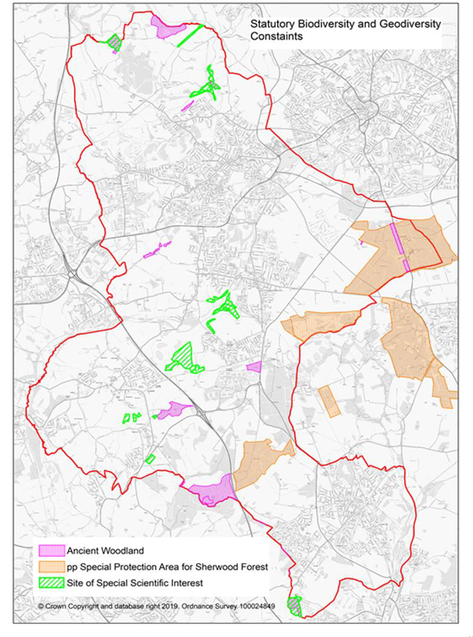
Source: Natural England & Natural England Advice Note to Local Planning Authorities regarding the consideration of the likely effects on the breeding population of nightjar and woodlark in the Sherwood Forest Region, Natural England, March 2014.

1.11.7 The evidence base for the Local Plan and planning applications includes The Nottingham Biodiversity Opportunity Mapping Project for Ashfield 201632. The NPPF stresses the need to

32 The Nottingham Biodiversity Opportunity Mapping Project Ashfield District Final Report, November 2016. Chris Jackson Nottingham Biodiversity Action Group

enhance biodiversity33 these maps identify opportunities for improving habitat condition and connectivity across Ashfield. The maps identify the following:
- Woodland Biodiversity Opportunities with associated Table;
- Heathland & Acid Grassland Biodiversity Opportunities with associated Table;
- Grassland Biodiversity Opportunities with associated Table;
- Wetland Opportunities with associated Table.
1.11.8 The Sherwood Biodiversity Opportunities Mapping Report includes parts of Ashfield and mapping has also been undertaken for Broxtowe. The maps and Tables in these and any future Biodiversity Opportunities for neighbouring districts to Ashfield will need to be considered as part of the Local Plan and planning applications. They link to biodiversity opportunities beyond Ashfield District boundary but which may be crucial for enhancing biodiversity and the natural environment. Further information is available on Nottinghamshire Biodiversity Action Group website.
1.11.9 The whole of Ashfield lies within the Greenwood Community Forest. The Greenwood Partnership works with communities to create, improve and enjoy woodlands and other high quality accessible green spaces in a sustainable way that benefits the environment, landscape and the local economy. The Council has carried out numerous schemes contributing to the Greenwood Community Forest including Brierley Forest Park, a major public open space between Sutton-in-Ashfield, Huthwaite and Stanton Hill. This parkland includes extensive areas of tree planting, wetlands and wildflower meadow together with a large trail network and visitor centre. The Government’s independent
‘Landscape Review’ of National Parks an AONBS34 recommends that Sherwood Forest is given the status as a national forest. If taken forward this will give increased emphasis on tree planting and improvements to biodiversity.
1.11.10 As well as facilitating nature and biodiversity, there are nature based solutions to address the adverse impact of climate change. The Government and other organisations such as the National Trust have put a substantial emphasis on tree planting as part of carbon sequestration. The Agricultural Bill also places an emphasis on future agriculture schemes being orientated farmers
being paid for ‘public goods’. It is proposed under the Bill that farmers will be paid for creation of new and expanded habitats for wildlife and public access.
1.11.11 UK BAP priority habitats cover a wide range of semi-natural habitat types, identified as being the most threatened and requiring conservation action under the UK Biodiversity Action Plan (UK BAP). As a result of devolution, and new country-level and international drivers and requirements, much of the work previously carried out by the UK BAP is now focused at a country-level rather than a
UK-level, and the UK BAP was succeeded by the 'UK Post-2010 Biodiversity Framework' in July 2012.

33 National Planning Policy Framework 2021 Paragraph 174.
34 Landscapes Review 2008 Department for Environment, Food& Rural AffairsPage 122 New National Status for Sherwood Forest.

Figure 1.20 Local Designated Biodiversity Sites in Ashfield
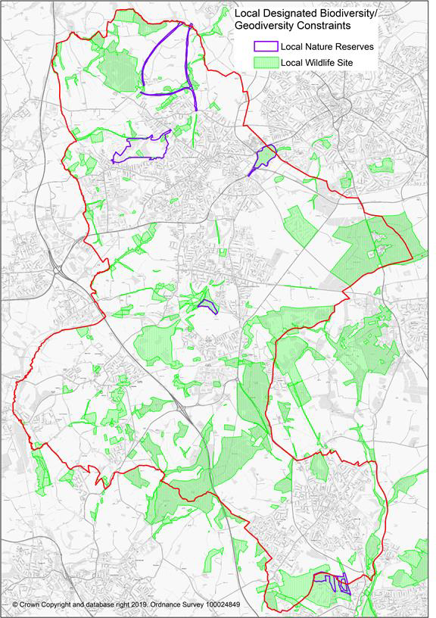

Source: Ashfield District Council & Nottinghamshire Biological and Geological Records Centre

Agricultural Land
1.11.12 Table 14 sets out the grades of agricultural land. The NPPF identifies ‘Best and most versatile agricultural land’ as land in grades 1, 2, and 3a of the Agricultural Land Classification35. There is no Grade 1 land in Ashfield. Plans 15 and 16 set out locations of Grade 2 and 3a land in
1.11.13 The Town and Country Planning (Development Management Procedure) (England) Order 2015 require local planning authorities to consult Natural England on development which is not for agricultural purposes and is not in accordance with the provisions of a development land where there is the loss of not less than 20 hectares of grades 1, 2 and 3a agricultural land36

Figure 1.21 Agricultural Land Classification Grade 2 approximate location
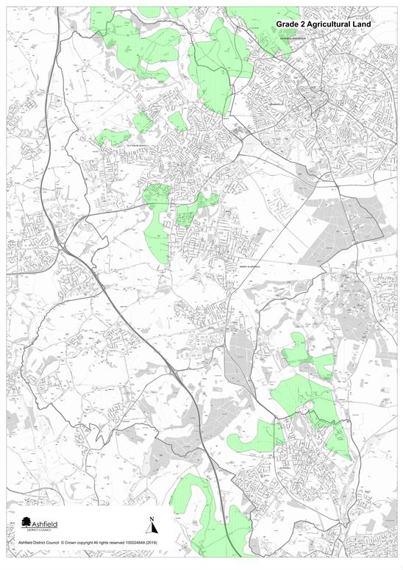
Source: Natural England – Agricultural Land Classifications Provisional (England)

35 National Planning Policy Framework, Annex 2: Glossary, page 65
36 Schedule 4 Consultations before the grant of permission, Articles18,19 and 20

Figure 1.22 Best Agricultural Land based on Agricultural Land Classification (ALC) Grades - Post 1988 Survey.
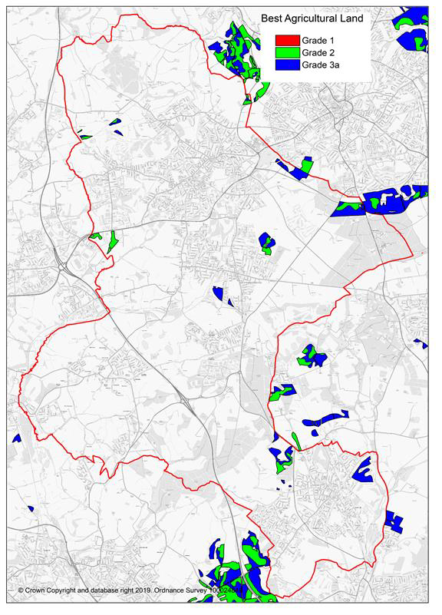
Source: Natural England (magic map). Reflects scanned original paper maps and survey reports for individual sites surveyed in detail between 1989 and 1999 by the Ministry of Agriculture Fisheries and Food.

Landscape
1.11.14 The Landscape Character Assessment for Ashfield (2009) sets out three landscape character areas which broadly influence the scale and form of development across the District. These are:
- Magnesium Limestone Ridge,
- Nottinghamshire Coalfields and

- Sherwood.
1.11.15 Each of these areas has been further sub-divided into component landscape character areas know as Draft Policy Zones (DPZ). Each DPZ identifies and lists the key features which make it special and provides a judgement on the condition of the landscape and its strength of character.
1.11.16 There are no national designated landscapes in Ashfield

Air Quality
1.11.17 The area no Air Quality Management Areas in Ashfield District Council. The Local Air Quality Update identifies that a review of air quality measurement during 2014 has demonstrated that all the air quality objectives continue to be achieved across Ashfield.

Green Belt
1.11.18 Approximately 41% of Ashfield is within the Nottingham - Derby Green Belt. This including land around Hucknall, land to the south and east of Kirkby-in-Ashfield and land surrounding the rural villages of Selston, Jacksdale, Underwood and part of Brinsley. Bagthorpe is ‘wash over’ by the Green Belt.

Figure 1.23 Green Belt Ashfield and surrounding districts
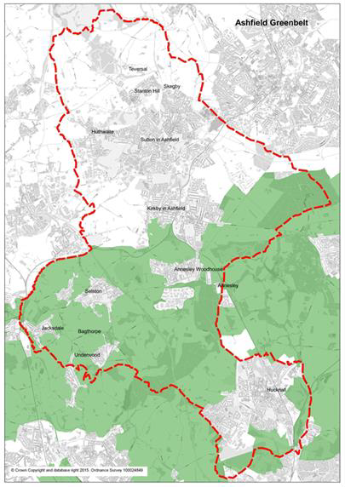
Source: Ashfield District Council

Likely evolution without the Local Plan
- Relevant policies in the Ashfield Local Plan 2002, saved policies will continue. However, they will become increasing dated and inconsistent with changes in national planning policy.
- Decisions would increasing reflect material considerations set out in national planning policy with a lack of any vision or framework for the future development of Ashfield.
- Biodiversity and geodiversity will still be protected under the Ashfield Local Plan Review 2002. However, the lack of up-to-date Local Plan policies and a lack of a 5 year housing supply for Ashfield means that local designated sites are more vulnerable to development. This reflects

that locally designated sites are not identified within protected areas or assets set out in NPPF paragraph 11 and the supporting footnote.
- Without an up-to-date Local Plan with housing allocations and infrastructure provision, housing pressure will put countryside area at risk from unmanaged development. It could result in the loss of locally valued landscapes and possible coalescence of settlements. In addition, there may be the loss of high quality agricultural land and soil resources.
- A fragmented, piecemeal approach reflected in individual planning application is likely to result in a lack of protection of the best landscapes.
- Without a strategic approach to housing and employment requirements this could result in piece meal development in areas sensitive to noise and air pollution and potentially exacerbate these factors.

Key sustainability Issues
- The protection and enhancement of biodiversity, particularly statutory and non statutory sites of nature conservation interest in Ashfield.
- Ensuring that the plan proposals have no adverse effect upon the South Pennines Special Area of Conservation (SAC), the Birklands & Bilhaugh SPC and the Sherwood Forest possible potential Special Protection Area.
- Safeguarding nationally and locally valued species/habitats.
- Enhancing biodiversity and the natural environment potentially through Biodiversity Opportunity Mapping.
- Identifying opportunities for tree planting facilitating Green wood Community Forest and facilitating zero carbon targets.
- Uncontrolled development could harm local landscape and settlement character.
- Protect and enhance landscapes that contribute to the distinctive local character of areas within the District;
- Maximise the benefits from the landscape character assessment by using landscape character to make choices about the locations for development and the design of proposals.
- Improving the public realm and promoting high standards of design where regeneration is required.
- Potential effects on landscape quality from poor design and layout of new development areas.
- Balancing the needs for protecting better quality agriculture land and development requirements.
- Providing a framework within which to manage protection of existing habitats and creation of new ones.
- The need to safeguard and improve soil resources.
- Addressing contamination issues relating to previous land uses.
- Past development of brownfield sites means that currently there are limited stocks of vacant brownfield land. By implication, this means that there will be a loss of greenfield sites and agricultural land.

- Maintaining and improving air quality in accordance with National Air Quality Standards and best practice.
- Seeking to secure a reduction in emissions from sources which contribute to poor air quality.
- A substantial part of the District of Ashfield is identified as being within the Green Belt where exception circumstances are require to justify changes to the Green Belt boundaries.

Conserving and enhancing the historic environment
1.12.1 The Council is committed to protecting, conserving and where opportunities arise, enhancing the historic environment of the District. The historic environment is all aspects of the environment which have resulted from the interaction between people and places through time, including all surviving physical remains of past human activity, whether visible, buried or submerged, and landscaped planted or managed flora. Those elements of the historic environment that hold significance are called heritage assets.
1.12.2 Ashfield benefits from a variety of formally designated historic assets including:
    - 6 Conservation Areas;
    - 80 Listed Buildings;
    - 9 Scheduled Ancient Monuments;
    - 2 Registered Historic Parks and Gardens
1.12.3 Ashfield’s six designated Conservation Areas are Kirkby Cross, Lower Bagthorpe, Teversal, New
Annesley, Sutton in Ashfield Church and Market Place and Hucknall Town Centre.
1.12.4 Listed Buildings are buildings that appear on the Secretary of State's 'List of Buildings of Special Architectural or Historic Interest', prepared by the Department of Culture, Media and Sport. Listed buildings are graded to show their relative architectural or historic interest, as follows
    - Grade I buildings are of exceptional interest (there are two in Ashfield);
    - Grade II* buildings are particularly important buildings of more than special interest (four in Ashfield);
    - Grade II buildings are of special interest, warranting every effort to preserve them.
1.12.5 Harwick Hall, a Grade 1 listed building and Old Hall, a Grade1 listed building and Schedule Monument is located just over the district boundary with Bolsover District Council to the north of the District. The two Hall are located on the edge of an elevated scarp and are prominent in the landscape. The National Trust has commission a Hardwick Setting Study37, which sets out detailed information on the setting of these buildings. It sets out a characterisation of the Landscape around Hardwick into 14 areas.
1.12.6 Three historic assets are identified on the Heritage at Risk Register (August 2020): Annesley Hall, Annesley, Wansley Hall manorial site, Selston, and Sutton in Ashfield Church Market Place Conservation Area.
1.12.7 Ashfield has a limited stock of statutorily listed buildings. This puts an increased emphasis on non-designated heritage assets. The Council has introduced a scheme by which historic assets of local

37 Hardwick Setting Study 2016, Atkins for National Trust.

importance are identified, using local selection criteria. In addition, there is a locally protected Historic Park and Gardens at Skegby Hall Gardens.
1.12.8 Archaeological remains are important for their historical and educational interest and may also be important features in the landscape. The Nottinghamshire Historic Environment Records (HERs) is maintained and updated by the County Council and contains details of all known sites, structures, landscapes or other areas of archaeological interest in Ashfield. Nine sites within the District are currently scheduled as Ancient Monuments under the Ancient Monuments and Archaeological Areas Act, 1979.
1.12.9 Registered Historic Parks and Gardens are important in historical and landscape terms and may also be of wildlife and recreational value. Ashfield has two designed landscapes on the Historic England Heritage Register of Parks and Gardens of Special Historic Interest, including Hardwick Hall Grounds (that part within Ashfield) which is Grade I of international importance and Annesley Hall which is Grade II* of exceptional interest.
1.12.10 Plans of the constraints are set out in Figures 1.24 and 1.25.

Figure 1.24 Designated Heritage Assets in Ashfield
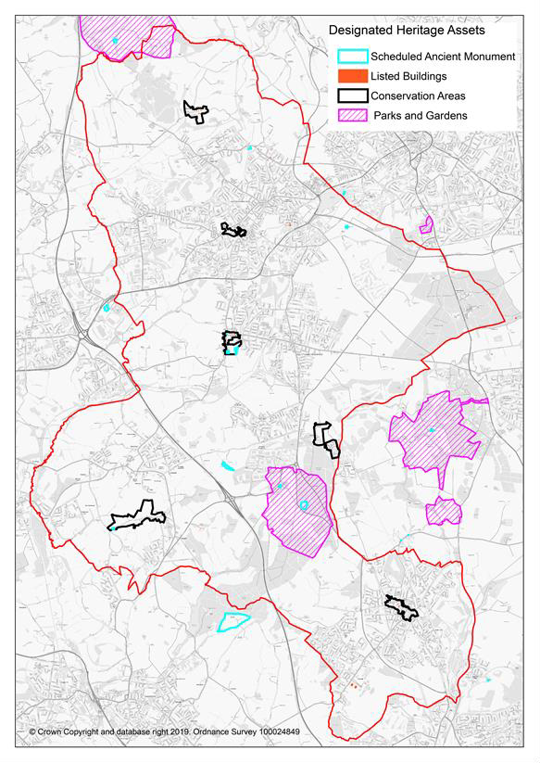
Source: Historic England

Figure 1.25 Ashfield Local Heritage Assets.
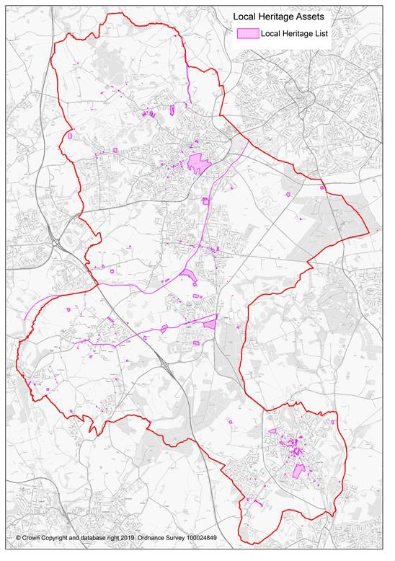
Source: Ashfield District Council

Likely evolution without the Local Plan
- Relevant policies in the Ashfield Local Plan 2002, saved policies will continue. However, they will become increasing dated and inconsistent with changes in national planning policy.
- Decisions would increasing reflect material considerations set out in national planning policy with a lack of any vision or framework for the future development of Ashfield so there would be no opportunity to identify possibilities to enhance the historic environment, heritage assets or their setting.
- National policy emphasises the importance of designated heritage assets which are irreplaceable. However, opportunities to plan across the district in terms of protecting and enhancing the historic environment will be reduced as development would come forward on an ad hoc basis.
- Potential for harm to heritage assets and setting as a result of development coming forward outside the Local Plan. Local historic assets are particularly at risk given Ashfield’s lack of a five year housing supply and the likely application of NPPF paragraph 11 on a planning application for housing development.

Key sustainability Issues
- The conservation and enhancement of Ashfield’s historical and archaeological assets and their setting.
- Three heritage assets are identified on the Heritage at Risk Register (August 2020).
- The protection of non-designated heritage assets within Ashfield.
- There is a need to actively promote the character and distinctiveness of the Conservation Areas.
- Promote the conservation and enhance of the heritage assets within the District town centres to support the local economy.
- Using the Conservation Area appraisals, to inform choices about development and the design of proposals within and adjacent to those areas.

Minerals and waste
1.13.1 Minerals and Waste Local Plans are brought forward by Nottinghamshire County Council.
Nevertheless, there are some implications for Ashfield’s Local Plan.
1.13.2 The Waste Core Strategy by Nottinghamshire County Council sets out the importance of the Waste Hierarchy. It identifies that existing landfill sites have only a limited life and stresses the importance of waste prevention, re-use, recycling and recovery to minimise what goes to landfill.
1.13.3 The NPPF stresses the importance of safeguarding mineral resources by defining Minerals Safeguarding Areas so that specific minerals are not sterilised by non-mineral development where this should be avoided38 .

Likely evolution without the Local Plan
    - Relevant policies in the Ashfield Local Plan 2002, saved policies will continue. However, they will become increasing dated and inconsistent with changes in national planning policy.

38 National Planning Policy Framework, 2019, paragraph 204 c).

    - Decisions would increasing reflect material considerations set out in national planning policy with a lack of any vision or framework for the future development of Ashfield.
    - The requirements of the latest Nottinghamshire County Council produced Mineral and Waste plans would become increasingly difficult to achieve.
    - More waste to be generated and less waste potentially recycled.

Key sustainability Issues
    - To follow the ‘waste hierarchy’ and in particular to reduce the growth in waste and increase the
amount of waste which is re-used and recycled.
    - New development needs to include provision for waste recycling facilities.
    - Existing landfill sites have only a limited life (Nottinghamshire Waste Core Strategy).
    - The Waste Core Strategy identifies a 70% recycling target for all wastes by 2025.
    - Avoiding development on safeguarded mineral resources where this needlessly sterilises the minerals resource.

Key sustainability issues
1.14.1 A summary of the key sustainability issues identified above is included in Table 1.10.

Overreliance on the manufacturing sector where employment levels have declined over time.

Table 1.10 Key Sustainability Issues
An increasing percentage of the population is anticipated to be over 65, this will have implications for service provision.

Topic | Key Sustainability Issues
Population • Population growth will increase the demand for housing and services and put additional requirements on local infrastructure.
•
Housing | - Content Understand the level of housing required in Ashfield and the interaction between different areas of the District and the relationship with the Greater Nottingham Area.  - To provide sufficient housing of a type and tenure to meet specific needs.  - Housing in terms of new build has declined in recent years and is not meeting the housing need identified by the NPPF Standard Method.  - While the District is perceived as an area of affordable housing, when income levels in Ashfield are taken into account, housing affordability is an issue in the District.  - Changing demographic structure, including an aging population, will impact future household characteristics and will have implications for the provision of housing requirements, employment opportunities and services.  - Given that substantial parts of the District are in Green Belt, there are issues in balancing the housing needs of specific areas against the impact on the Green Belt and the countryside.  - A substantial number of brownfield sites have been developed in Ashfield. The consequence is that limited brownfield sites are available necessitating the utilisation of greenfield sites to meet housing needs.  - Reduce the potential impacts on the environment and social infrastructure of Ashfield whilst allocating land to provide for housing requirements.  - Improving the quality of the existing housing stock.
Economy | - Meeting the needs of all current and future populations in terms of business and job opportunities.  - Accommodating any employment land and other development opportunities as far as possible within an urban area so as to minimise the impact on greenfield sites.  - Facilitate digital infrastructure to maximise growth opportunities.  - Providing the necessary infrastructure to accommodate current and future development needs in terms of physical green and social infrastructure.  - The need to encourage and accommodate both indigenous and inward investment particularly in relation to identified sectors, which have the potential for growth.  - Creating an environment that is attractive to future growth sectors to improve performance in comparison with other locations.  - Identifying opportunities for heritage led regeneration.  - There are pockets of deprivation particularly within the urban area. Economic regeneration is particularly important in these areas of the towns to help alleviate poverty.  - To increase incomes and skill levels, particularly in those communities suffering high levels of deprivation.  - The concern is that too many residents currently lack skills at the right level to respond to these labour market changes and will thus struggle to compete effectively.  - With the predicted increase in households there is likely to be a need to expand schools or provide new schools as a significant number of schools in Hucknall, Kirkby-in-Ashfield and Sutton in Ashfield are currently at or near capacity.  - To supporting the provision of appropriate sized schools/colleges and other skill learning facilities at a local level to help improve skills and opportunities.  - Potentially, using planning to improving employment prospects and training for local residents.  - The District’s working population has grown over the period 2001 to 2011 but is now showing signs of declining as the population ages.  - Responding to future trends in employment and supporting the growth of self-employment.

●

Topic Key Sustainability Issues

Town  The District has three shopping centres that need to be supported in order to keep them vital and viable.
Centres  Bring forward key opportunities identified in the town centre masterplans within an appropriate timescale.
- Meeting the needs of all current and future populations in terms of business and job opportunities within town centres.
- Providing the necessary infrastructure to accommodate current and future development.
- Creating an environment that is attractive to future growth sectors to improve performance in comparison with other centres.
- Identifying opportunities for heritage led regeneration.
Healthy and  Residents of Ashfield have a shorter life expectancy than on average for England.
safe  To improve health and wellbeing, and to prevent ill health (e.g. through healthy eating and exercise).
communities  Health inequalities exist between the most and least deprived areas of the District.
- To provision health services and facilities in relation to the demands arising from new development.
- The Health and Wellbeing Board has identified priority areas which they believe will have the biggest impact to help improve health and wellbeing. This includes including ‘losing the gap in educational attainment.’
- Lifestyle indicators are generally worse than the average for England.
- Ashfield performs poorly in the Indices of Multiple Deprivation and is ranked at 63rd out of 317 local authority areas (IMD, 2019).
- New health, sporting, leisure and recreational facilities should be provided encouraging walking, cycling and more active lifestyles.
- The development of a high quality multifunctional green infrastructure network should be promoted identifying any opportunities for links with and enhancement of cultural heritage.
- Potential issue in meeting the needs of an aging population.
- The development of accessible cycle networks to facilitate alternative modes of transport.
The development of quality green infrastructure should be promoted as part of development, linking to a green infrastructure network.
- Adult participation in sport has decreased in Ashfield in recent years.
- New health, sporting, leisure and recreational facilities should be provided and should encourage walking, cycling and more active lifestyles.
- Recent evidence indicates that crime rates are increasing in the District.
- To improve safety and security for people and property (e.g. through design intervention) and to reduce fear of crime.
Transport  Embed accessibility into locational requirements for development and decision making and the access to services (such as health, education and leisure).
- The need to improve the quality and range of services available within communities.
- Ensure that new development has good access to facilities and alternative means of travel.
- Reducing the dependency on the private car.
- Traffic congestion is an issue in Ashfield reflecting the new development proposed.
- Improvements will be required to specific junctions as part of development as otherwise there will be an adverse impact on congestion and journey times.
- Development close to the M1 motorway at Junction 27 has the potential to encourage car use and increase congestion, particularly around Sherwood Business Park.
- To facilitate alternative forms of transport including encouraging more people to walk and cycle.
- Significant new development will need to facilitate bus services to gives choice of transport mode.
- To work with partners to provide an integrated and efficient transport system including public transport, walking and cycling network in Ashfield.
- Ensure that new development has good access to facilities and alternative means of travel, reducing the dependency on the private car.

Topic | Key Sustainability Issues
- To facilitate alternative forms of transport including encouraging more people to walk and cycle.
- A new Transport Study will be required to identify the implications of development.
- The implications that over the life of the Plan combustion engines are likely to be increasingly phased out and replaced by ultra-low emission and electric vehicles.
Effective use of land and achieving well designed places | - While there are extensive employment sites in Ashfield these are largely currently occupied.  - The traditional factory sites related to textiles and the coal industry have been redeveloped or green over as part of country parks. Sites that have not been developed, such as North Street, already have planning permission for re-development. Consequently, there is likely to be a very limited supply of brownfield sites of the nature in the future.  - There are extensive ‘modern’ industrial estates but buildings have not reached the end of their economic life. Consequently, they are no suitable or deliverable in terms of national planning policy.  - There is limited brownfield land available for development in Ashfield with the consequence that development is likely to be predominantly on greenfield sites.  - Minimum densities are set out by the Ashfield Local Plan Review, saved policies but these do not fully reflect national policy.  - Well-designed places can be achieved by taking a proactive and collaborative approach at all stages of the planning process, from policy and plan formulation to development but Local Plan design and density policies are increasing out of date in relation to national guidance.
Climate change and flooding | - Planning for the adaptation of and long-term resilience of Ashfield in relation to all aspects of climate change.  - The Local Plan policies provide opportunities to support adaptation to climate change through appropriate design and layout and incorporation of features to facilitate resilience to the effects of climate change.  - Improving energy efficiency and increasing use of low-carbon and renewable energy.  - Balancing the potential amenity and landscape impacts and the need for alternative sources of energy.  - Ensure that new development has good access to facilities and alternative means of travel.  - Reducing the dependency on the private car.  - To facilitate alternative forms of transport including encouraging more people to walk and cycle.  - To take account of the impact of development on water in relation to water quality and flood risk.  - To avoid development within Flood Zones 2 and 3 unless exceptional reasons arise.  - While the risk of flooding from watercourses is relatively low there is a risk from flooding is specific area, in particular, Hucknall and Jacksdale.  - The River Leen flows into the City from Ashfield and is identified as responding rapidly in the urban area to rainfall, giving less time for community response. Additional water into the River Leen raises significant flood issues in Nottingham. It is important that neighbouring authorities work in partnership to ensure that activities upstream do not increase flood risk within the City of Nottingham.  - To the south and west of Nottinghamshire there are relatively steep areas, including heavily urbanised areas, such as Sutton-in-Ashfield and Mansfield.  - Water supply will need to be considered and consideration should be given to reducing water consumption below Part G of Building Regulations which specifies that new homes must consume no more than 125 litres of water per person per day.  - Waste water will need to be effectively managed through development and infrastructure planning.
Conserving and | - The protection and enhancement of biodiversity, particularly statutory and non statutory sites of nature conservation interest in Ashfield.

Topic | Key Sustainability Issues
enhancing the natural environment and Green Belt | - Ensuring that the plan proposals have no adverse effect upon the South Pennines Special Area of Conservation (SAC), the Birklands & Bilhaugh SPC and the Sherwood Forest possible potential Special Protection Area.  - Safeguarding nationally and locally valued species/habitats.  - Enhancing biodiversity and the natural environment potentially through Biodiversity Opportunity Mapping.  - Identifying opportunities for tree planting facilitating Green wood Community Forest and facilitating zero carbon targets.  - Uncontrolled development could harm local landscape and settlement character.  - Protect and enhance landscapes that contribute to the distinctive local character of areas within the District;  - Maximise the benefits from the landscape character assessment by using landscape character to make choices about the locations for development and the design of proposals.  - Improving the public realm and promoting high standards of design where regeneration is required.  - Potential effects on landscape quality from poor design and layout of new development areas.  - Balancing the needs for protecting better quality agriculture land and development requirements.  - Providing a framework within which to manage protection of existing habitats and creation of new ones.  - The need to safeguard and improve soil resources.  - Addressing contamination issues relating to previous land uses.  - Past development of brownfield sites means that currently there are limited stocks of vacant brownfield land. By implication, this means that there will be a loss of greenfield sites and agricultural land.  - Maintaining and improving air quality in accordance with National Air Quality Standards and best practice.  - Seeking to secure a reduction in emissions from sources which contribute to poor air quality.  - A substantial part of the District of Ashfield is identified as being within the Green Belt where exception circumstances are require to justify changes to the Green Belt boundaries.
Conserving and enhancing the historic environment | - The conservation and enhancement of Ashfield’s historical and archaeological assets and their setting.  - Three heritage assets are identified on the Heritage at Risk Register (August 2020).  - The protection of non-designated heritage assets within Ashfield.  - There is a need to actively promote the character and distinctiveness of the Conservation Areas.  - Promote the conservation and enhance of the heritage assets within the District town centres to support the local economy.  - Using the Conservation Area appraisals, to inform choices about development and the design of proposals within and adjacent to those areas.
Minerals and waste | - To follow the ‘waste hierarchy’ and in particular to reduce the growth in waste and increase the amount of waste which is re-used and recycled.  - New development needs to include provision for waste recycling facilities.  - Existing landfill sites have only a limited life (Nottinghamshire Waste Core Strategy).  - The Waste Core Strategy identifies a 70% recycling target for all wastes by 2025.  - Avoiding development on safeguarded mineral resources where this needlessly sterilises the minerals resource.



