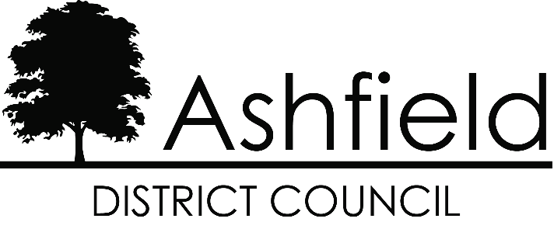

STRATEGIC

DIRECTION

2022 – 2027

Our Purpose

The Council exists to serve the communities and residents of Ashfield.
Our priority is to understand the needs and desires of Ashfield residents, communities and businesses. The Council has a unique role, leading and enabling delivery of improvements for Ashfield as a place. We are committed to engaging more effectively with our communities and working more closely together to deliver the changes we all want to see in Ashfield.

We will provide good quality, value for money services.
We want to deliver good quality Council services, consistently and reliably, putting the customer at the heart of everything we do. We are focussed on delivering an improved customer experience, simplifying and standardising basic transactional processes. Enabled by digital technology we will transform the way we do things, encouraging people who can access services online to do so. This will create capacity for us to better support in person the people who need us the most.

We will act strategically and plan for the future, working with others to bring about sustainable improvements in people’s lives.
Whether it’s making our communities safe, our town centres more vibrant or our environment cleaner we need strong and effective partnership working to achieve our goals. We recognise that, with fewer resources, the Council, along with other public sector organisations, cannot work in isolation to effectively deliver what matters for Ashfield.

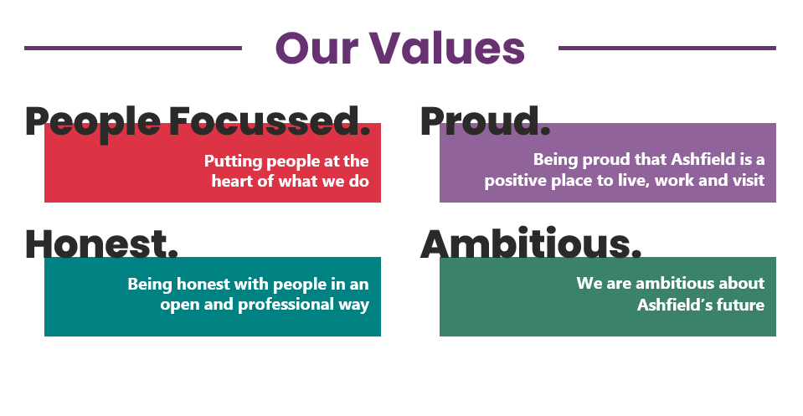

SIZE AND SCOPE
- The Council will retain its purpose as set out in this document.
- The assumption is that in five years we will still be an independent sovereign Council. However with greater levels of integration with other public sector services.
- The Council will be smaller in terms of its employee numbers, spending power and will likely offer fewer services to residents.
- The Council will be better placed to engage with and work alongside local communities and businesses to support them in delivering local improvements.
- The Council will have greater influence with external partners.
- The Council will re-shape and re-align its service areas.
- The Council will actively engage with Devolution Agenda influencing opportunities for improvements and addressing inequalities across the District e.g. skills, health.

CUSTOMERS
  - The Council will treat customers with courtesy and respect, have a better understanding of its different customers needs and preferences and be transparent and open in its decision-making.
  - The Council will have a greater knowledge of its customers and offer a more personalised service, pursuing improved data driven decision making.
  - Customers will have access to a customer account where they can get information on their dealings with the Council including payments.
  - The Council will improve access to information.
  - Continuing to build on success, the Council will significantly increase the digital service opportunities for people to self-service their request via online and digital methods but remain accessible to those who have difficulty operating technology.
- The Council will seek to reduce demand through solving customer’s problems without the need for multiple referrals and signposting.
- After an interaction with the Council, customers will be satisfied.
- The Council will consider the impact of its decisions on individual customers, other Council services and partners, including consideration of environmental and social value impact.

MONEY (FINANCES)
  - The Council will aim to be self-financing, setting a robust deliverable budget within the funding available.
  - The Councils finances will still depend largely on national and regional government policy.
  - As all Council house rents received are put back into maintaining the properties,
providing services for residents and acquiring additional houses - significant efficiencies will be required to balance the Housing Revenue Account.
- Resources will be aligned to achieve future priorities underpinning the Council’s evolving Corporate Plan.

CLIMATE AND ASSETS
  - Our assets will be well maintained and aligned to our future corporate ambitions, including value for money and climate change.
  - The Council will continue with a process of rationalising and sharing its office space.
  - The Council will continue with its commitment to increasing its social housing, building and acquiring properties.
  - The Council will have reviewed its depot and maximise the potential for the site.
  - The Council will need to rationalise other assets, and this could include community and parks buildings. These buildings may remain in community use but perhaps not delivered by the Council.
- The Council will seek to respond to climate change by ensuring buildings, vehicles and other assets are 100% environmentally friendly.
- The Council will maintain Decent Homes standard and maximise its return from Housing Revenue Assets.
- Deliver direct actions to support the national target of net zero carbon emissions by 2050.

OUR PEOPLE
  - The organisational culture will be focused on innovation, creativity, engagement, empowerment, trust, accountability, customer first and transformational change.
  - There is likely to be fewer people directly employed by the Council.
  - There is likely to be a move towards more generic jobs although specialisms and technical specialists will still be required in many services.
  - The Council will employ and retain, talented, proactive and highly engaged people ‘living and breathing’ the values and competency behaviours.
  - The future workforce will be recruited and developed based on our competencies.
  - Our People will be more adept at working in partnership and across departmental and organisational boundaries to solve customers’ problems and provide improved services.
  - The Council aims to have a workforce more representative of communities we serve e.g. young people, disabled.
  - The Council will further embed agile and hybrid working.
  - The Council will be a competitive and desirable ‘employer of choice’ through an attractive package of pay, personal development, lifestyle rewards, flexible working and wellbeing support.

DEMOCRACY
    - The Council will make open and transparent decisions, underpinned by good governance and democratic processes.
    - Councillors will be provided with the skills, knowledge and information to carry out their roles effectively and will be accountable for their decisions.
  - Councillors will be effective community leaders, leading by example, demonstrating appropriate behaviours and upholding the Seven Principles of Public Life. https://goo.gl/2InvTX

TECHNOLOGY
The Council will continue to focus on
- the use of technology enabling effective engagement and communications with customers, residents, businesses, employees, and Members
    - The Council will continue to introduce new technology and systems producing leaner, joined up, user-friendly access to services, 24/7.
    - Employees will be ‘digital savvy’ increasing their productivity through full use of technology in their work environment, including digital skills enhancement.
  - Single entry data input and the use of digital analytics will be used to measure performance including digital skills enhancement.
  - There is likely to be enhanced electronic data transfer between partners further supporting integrated services and collaborate working.

HOW WILL WE CHANGE?
The existing action plans that underpin the following strategies will be periodically reviewed and updated to deliver the above principles:
    - Corporate Plan
    - Medium Term Financial Strategy
    - People Strategy
    - Technology Strategy
    - Commercial Enterprise Strategy

