

## DISCLAIMER

This document or some parts of it may not be accessible when using adaptive technology.

If you require assistance with accessing the content of the document, please contact us and quote the document name and the web page you found it on:

* Email: Forward planning – [localplan@ashfield.gov.uk](mailto:localplan@ashfield.gov.uk) .

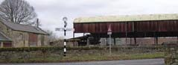

**Conservation Area Appraisal and**



**Management Plan**

**2012**

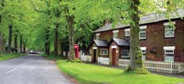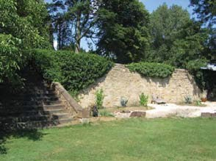Teversal

### Executive Summary

* 1. Teversal Conservation Area Appraisal and Management Plan, which includes amendments to the Conservation Area boundary, was adopted by the Council on 5th January 2012
  2. The District Council formally adopted the Ashfield Local Plan Review on the 22nd November 2002.This will be replaced by the Ashfield Development Framework in the near future.This Conservation Area Appraisal has been undertaken in response to the supporting text to Policy EV10 (Conservation Areas) within Paragraph 3.63 of the Local Plan Review.The text highlights the District Councils intentions to review Ashfields four Conservation Areas.

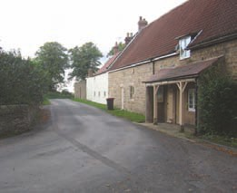

* 1. This Conservation Area Appraisal has reviewed the designation of Teversal as a conservation area of historical and architectural value.This is in accordance with Section 69(2) of the Planning Listed Buildings and Conservation Areas Act which specifies that It shall be the duty of a local planning authority from time to time to review the past exercise of functions under this section and to determine whether any parts or any further parts of their area should be designated as conservation areas; and, if they so determine, they shall designate those parts accordingly.
  2. The overall aim of this Appraisal is to guide the preservation and enhancement of Teversal Conservation Area. It outlines the

setting, character and important features and aspects of the village, and sets out a Management Plan to sustain them.

* 1. 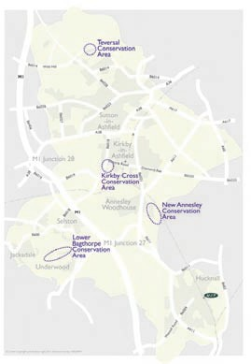In terms of its setting, the landscape surrounding the conservation area plays a significant role in the character of Teversal. The village is surrounded by an undulating, agricultural landscape which is practically unblemished due to the lack of man-made vertical structures.This helps to emphasise the old English rural character of Teversal.
  2. The rural character of Teversal Conservation Area is further enhanced by the retention of hedgerows, stone walls, a combination of stone and brick built properties dating back to the Twelfth Century, and traces of the villages aristocratic and agricultural past in the form of Teversal Manor and nearby farm buildings.
  3. Teversal currently has three distinct areas within the conservation boundary (Page 19).
  4. Area one is the main entrance into the village from Sutton in Ashfield and is the busiest in terms of vehicular activity. It contains a mix of properties dating from the

Eighteenth to the Twentieth Century.This area retains many elements from the villages

**The Appraisal, in simple terms:**

* Highlights historic factors that have shaped Teversal village into its current form.
* Reviews current Conservation Area policy and any other policy that has a relevance to Teversal.
* Contains a thorough and comprehensive physical appraisal of the Conservation Area and immediate surroundings.

**The Management Plan:**

* Identifies a series of actions which will help to preserve and enhance the character of the Conservation Area.

agricultural past.

* 1. Area two, the oldest section of the village, is a quiet, tree-lined area which contains some of the oldest properties in Teversal. St. Katherines church, a Grade I Listed Building dating back to the Twelfth Century, is located towards the centre of area three. Teversal Manor is also located in area three; the combination of buildings and surrounding foliage in this area creates a quiet, leafy, rural character.
  2. Area three, Manor Close, is the most recent addition to Teversal in terms of development.This area, which is the most modern in character, is quietly tucked away from the main thoroughfare on Pleasley Road (area one).
  3. This Appraisal also proposes to amend the conservation area boundary to include features currently not in the conservation area as these are deemed important to the maintenance of Teversal as an traditional English village.

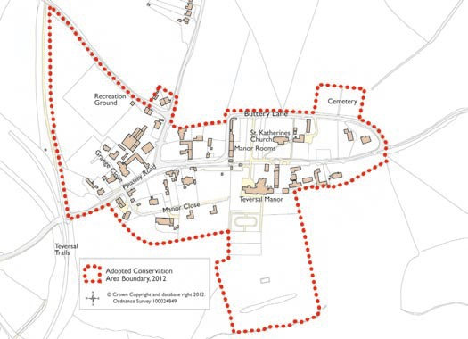

**Teversal Conservation Area**

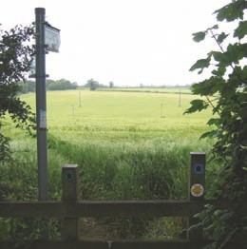

**Contents**

1

2

3

4

6

7

Executive Summary Introduction

Planning Policy Context

Distinctiveness of Teversal Conservation Area

Historical Development and Archaeology

Location and Setting

Proposed Extensions to the Conservation Area

Spatial Analysis Character Analysis

1

3

6

8

5

10

12

8

9

1. Changes Affecting Teversal
2. Physical Record of Teversal
3. Problems, Issues and Capacity For Change
4. SWOT analysis
5. Management Plan
6. Glossary

Appendix 1

Public Consultation Responses

13

15

16

26

27

43

44

48

53

55

Countryside surrounding Teversal

### Introduction

* 1. This Conservation Area Appraisal has reviewed the designation of Teversal as a conservation area of historical and architectural value.This is in accordance with Section 69(2) of the Planning Listed Buildings and Conservation Areas Act which specifies that it shall be the duty of a local planning authority from time to time to review the past exercise of functions under this section and to determine whether any parts or any further parts of their area should be designated as conservation areas; and, if they so determine, they shall designate those parts accordingly.
  2. Located within Ashfield District in north Nottinghamshire,Teversal Conservation Area was designated in 1970 and encompasses almost the entire built up area of Teversal village. Figure 1 (page 5) illustrates the scope of the current Conservation Area and its local context.
  3. The conservation area is influenced by a wide range of national, regional and local policies as set out in section 3 (page 8).
  4. The designation of a Conservation Area introduces special controls, including the requirement of consent from the Council to demolish any building or part of a building or to carry out works on unprotected trees. These special restrictions aim to ensure that the special architectural or historic character of an area is retained for future generations and that the overall environmental quality of the area is maintained to a high standard for the benefit of residents, local businesses and visitors alike.
  5. The Council has a limited built heritage resource which places a much greater importance in local terms on the Conservation Areas, Listed Buildings and Ancient Monuments that it has. As such, the review of the Conservation Areas and opportunities to conserve and enhance those areas are considered to be a very significant part of the Council?s objectives regarding the environment.

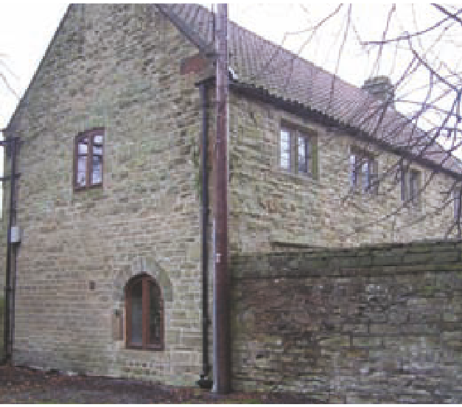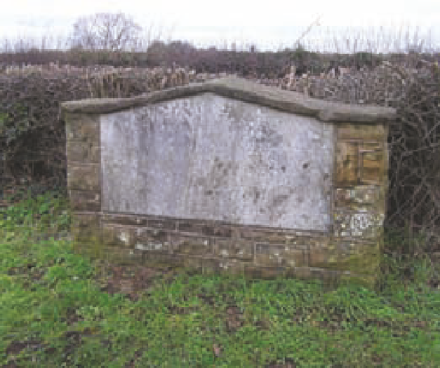

**Contacts and Further Information**

If you would like any further information or clarification on any issues raised within this appraisal, please do not hestitate to contact us;

Planning Policy Team Ashfield District Council Council Offices

Urban Road Kirkby-in-Ashfield Nottinghamshire NG17 8DA

Tel: 01623 457 382

Fax: 01623 457 590

Email: <mailto:localplan@ashfield.gov.uk> Website: <http://www.ashfield.gov.uk>

The Gate House

Plaque on Teversal Recreation ground

* 1. **The appraisal, in simple terms:**
* Highlights historic factors that have shaped Teversal village into its current form;
* Defines the special architectural and historic interests of the Conservation Area;
* Reviews Local, Regional and National guidance regarding Conservation Area policies including Ashfield Local Plan Review 2002;
* Includes a comprehensive physical appraisal of the Conservation Area and immediate surroundings to clearly identify what is worthy of preservation;
* Identifies a series of actions arising from the appraisal to help preserve and enhance the character of the Conservation Area;
* Reviews and amends the current Conservation Area boundary to ensure it reflects what is considered to be of special interest;
* Provides a draft management framework for guiding future development and assisting in the determination of planning applications, as well as forming a basis for consultation with local residents and other interested parties.

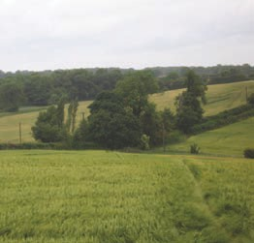

Countryside

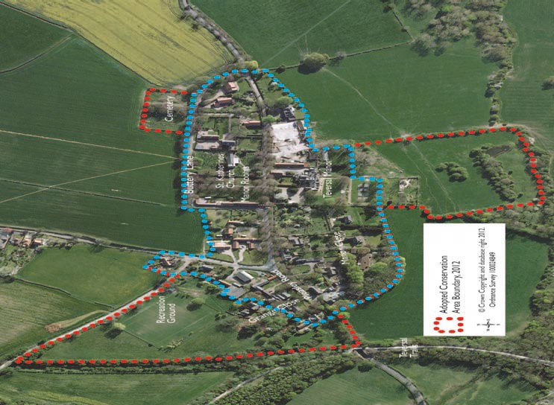

Figure 1 Teversal Conservation Area boundary

### Planning Policy

*Local Development Frameworks (LDF) should set out a positive, proactive strategy for the conservation and enjoyment of the historic environment in their area, taking into account the variations in type and distribution of heritage asset, as well as the contribution made by the historic environment*

PPS5: Planning for the Historic Environment (2010)

**Context**

* 1. **National Policy Context**
     1. The legislation for planning control in Conservation Areas is mainly contained within the Planning (Listed Buildings and Conservation Areas) Act 1990.

*Areas of special architectural or historic interest, the character or appearance of which it is desirable to preserve or enhance.*

Section 69 of the Listed Buildings and Conservation Areas Act 1990

* + 1. Planning Policy Statement 5: Planning for the Historic Environment (PPS5) is national guidance which sets out general criteria for the historic environment; it sets out a range of policies which relate to development affecting/impacting on historical assets (including conservation areas).The Government are currently in the process of replacing all National Planning Policy Statements (including PPS5) with one streamlined policy document known as the National Planning Policy Framework (NPPF). Public consultation was undertaken on the draft document from July 2011 until October 2011. Full details of PPS5 and the NPPF can be found at: www.communities.gov.uk.
  1. 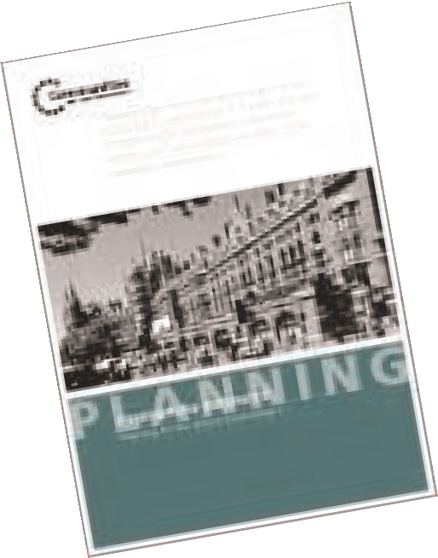**Regional Policy Context**
     1. The East Midlands Regional Plan is currently in the process of being revoked by the Government as part of the Localism Act (2011). However, policies within the East Midlands Regional Plan will still be a material consideration for all development affecting historic assets until it has been officially revoked. It is anticipated that this will take place in Spring 2012.

#### Local Policy Context

* + 1. Local conservation planning policies are contained within the Ashfield Local Plan Review, adopted in November 2002, and are drafted to take into account current national, regional and county policy and guidance. Ashfield’s policies recognise the requirement to manage new development, while at the same time preserving important buildings and spaces, in order to preserve and enhance the character and appearance of the Conservation Areas and Historic Environments.
    2. Ashfield contains four Conservation Areas, these being at Lower Bagthorpe, Kirkby Cross, New Annesley and Teversal.

**Policy EV10: Conservation Areas** of the Ashfield Local Plan Review 2002 states that development will only be permitted where:

* It preserves or enhances the character or appearance of the area, or its setting;
* In the case of demolition or partial demolition it can be demonstrated that the building is beyond economic repair, viable alternative uses cannot be found or redevelopment would produce substantial benefits for the community that would outweigh the buildings loss;
* Redevelopment following demolition is undertaken within an agreed timescale as secured by condition.
  + 1. Other planning policies which relate to Teversal Conservation Area and the surrounding countryside include;

**EV2** – Countryside;

**EV4** - Mature Landscape Area;

**EV5** - Sites of Special Scientific Interest (SSSI);

**EV6** - Local nature reserves and sites of importance for nature conservation and geological significance;

**EV8** – Trees and Woodlands;

**EV10** – Conservation Areas;

**EV11** – Ancient monuments and archaeological sites.

* + 1. Other policies will apply to development in general. For more information about these policies, refer to the Local Plan Review 2002.

#### Local Development Framework

* + 1. Ashfield Local Plan will be superseded by the emerging Local Development Framework when it is adopted.
    2. The Local Development Framework (LDF) is a statutory suite of documents which every Local Authority is required to produce.The LDF include a Core Strategy, Area Action Plans, Annual Monitoring Report and other development plan documents.
    3. 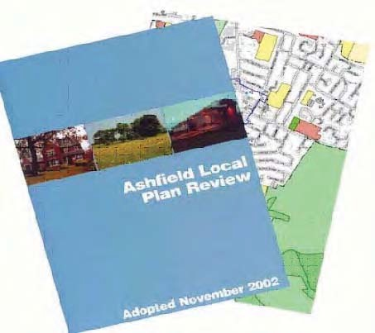The aim of the LDF is to cover all aspects of development within the district and as such, it is anticipated that conservation areas will still be protected through these documents.

### Distinctiveness of the Conservation Area

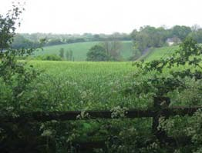

|  |
| --- |
| Countryside surrounding Teversal |
|  |
| Hillcroft Farm |

* 1. Teversal is a well contained village of rural character situated in the countryside.The settlement, which is located in a wooded enclave on the crest of a hill, has retained its historic street layout, including narrow highways and wide, grassed and tree lined verges without kerbs, with sandstone walls and hedgerows fronting the highway in many places.
  2. Such character is enhanced by traditional items of streetscape including original and replica Victorian street lamps, traditional finger signposts and characteristically rural gravel driveways.

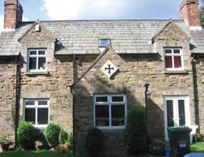

* 1. Also, traditional street furniture has been retained to further maintain the image of a typically old English village, e.g. the telephone box and wooden benches.

|  |  |
| --- | --- |
| Traditional Gas Lamp | Buttery Lane |

|  |  |
| --- | --- |
| Dovecote Barn |  |
|  |
| Sash windows in The Firs |
|  |
| Stone wall boundaries |
|  |
| Stone archways and gate piers | Coped gable with kneelers |

* 1. The area has retained remnants of its aristocratic and agricultural past in the form of Teversal Manor and a number of converted farm buildings.

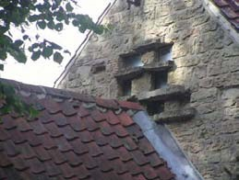

* 1. It is the group value of the buildings and the setting in which they are located which accounts for the designation of Teversal Conservation Area.Teversal contains multiple Listed Buildings, including a Grade I listed 12th Century church and a Grade II listed walled garden with steps and gate piers. Further more the area includes a number of buildings of townscape merit, including a mix of 16th, 17th and 18th Century buildings, many of which exemplify local traditional building characteristics.

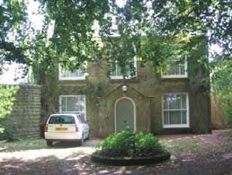

* 1. Characteristic features include:
* Coped gables with kneelers;
* Ashlar Dressings;
* Yorkshire sliding sash windows;
* Construction in coursed and square rubble;
* Stone lintels/reveals (framing windows);

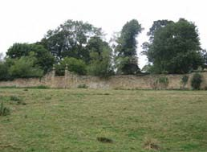

* Welsh slate and red clay pan-tile roofing;
* Stone slab verges on some roofs;
* Red brick chimney stacks;
* Stone archways and gate piers;
* Stone walls adjoining the highway; and
* Hedgerows adjoining the highway.

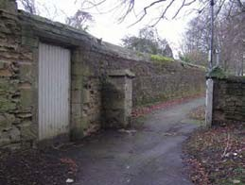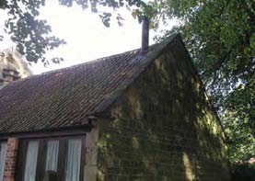

Year 1000

**Pre 1086**

The settlement of Teversal was first recognised at the time of the Domesday Book when it was recorded as ‘Tevershalt. It is believed that the village took its name from the Old Saxon word ‘sal’ which translates as meaning a seat, dwelling, mansion, palace or hall, indicating that an early landowner possessed a residence there. However it has since been acknowledged by some authors that the name could actually date from the Celtic era as the name ‘Teversal’ roughly translates as ‘boundary stronghold’ which can be authenticated by the village’s military and geographical position. It has since been recorded as Tyversholtee (1337), Teversale (1349) and Tevershall (1562).

**16th Century**

Francis Molyneux was a major landowner and colliery owner in the area from 1562 and the Molyneux family cross is borne by the gates to Teversal Manor.This site has been home to a manor building since the late 12th Century although the current building has its roots in the 16th Century.

**St Katherine’s Church**

St Katherine’s church, at the centre of Teversal village has origins dating from the Norman period.This is evidenced by the very narrow north arcade, the internal porch and the tower built partly over the nave arcade.

**18th and 19th Centuries**

The 18th and 19th Centuries were key periods of development in the village which saw the construction of many buildings still in use today.Teversal’s Manor Room was constructed in stages from the mid 18th Century to the mid 19th Century but was not officially known as this until 1906. Originally constructed as a Corn Barn, 5 bays in length, it was owned by the Manor and leased out to others.The village school had originally been in a building adjacent to the barn (School House Cottage) which by 1880 had outgrown this small property.The Manor Rooms were closed in 2001 due to Health and Safety standards, but in 2006 were refurbished and reopened to the public.

**Post World War Two**

The post war period from 1945-1970 saw a number of new properties built around the two cul-de-sacs of Manor Close and Grange Close.The past two decades (1986-2006), have seen few changes to the village and it remains predominantly a rural community with a visually attractive and peaceful character.

Extracts of historical maps are included in Appendix 1 while Map 4 illustrates the growth of Teversal Village to the present day.

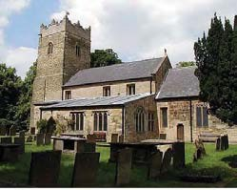

**5 Historical Development**

St. Katherines Church

Year 2012

**Interesting Fact…**

Teversal is firmly believed to be the setting of D.H. Lawrence’s novel “Lady Chatterley’s Lover” with Teversal Manor being the fictional home of Lady Chatterley.

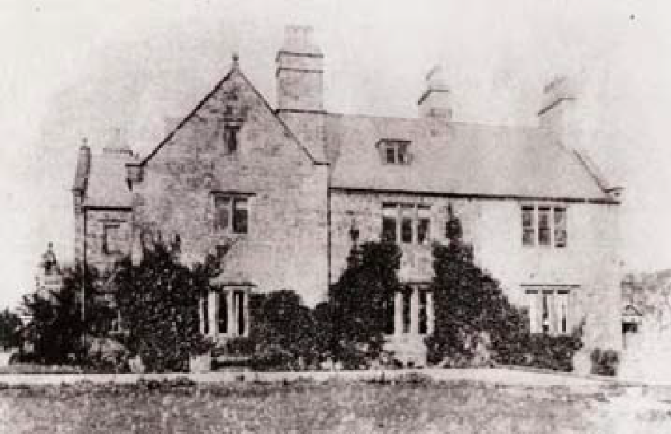

**Manor House c1870**

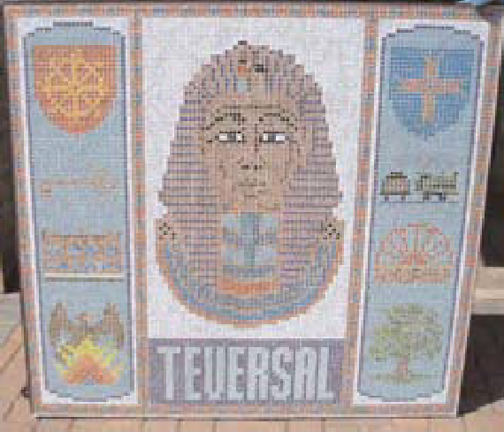

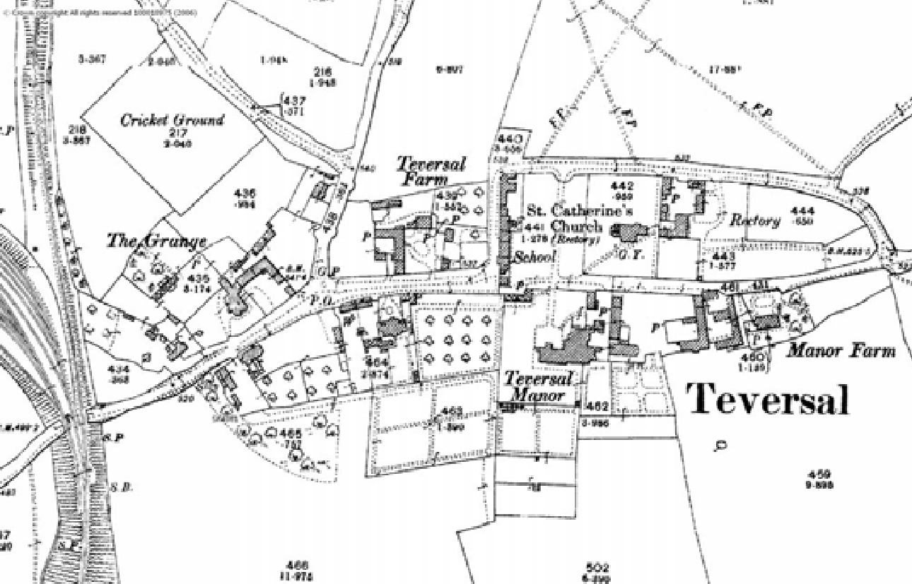

**1899**

**Interesting Fact…**

The third Lord Carnarvon, owner of the village, was the financier of the expedition that found the tomb of Tutankhamen. Many believe that Lord Carnarvon’s death, just months after the finding of Tutankhamen, was as a result of the curse relating to disturbing the tomb.

### Location,Setting and Character

#### Location and General Character

* + 1. Part of Ashfield District,Teversal Village is located within the North Ward of Sutton-in- Ashfield, itself located in North Nottinghamshire.The village lies five miles west of Mansfield and seventeen miles

north-west of Nottingham City Centre and is centred on the unclassified minor road of Buttery Lane, which links the village to nearby Skegby to the south.

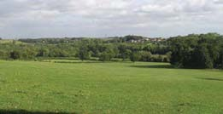

Countryside surrounding Teversal

* + 1. Teversal village is a rural settlement which has formed around St Katherine’s Church and Teversal Manor and the junction between Pleasley Road and Buttery Lane. The village has largely retained its historic street pattern including the ‘dog leg’ in Buttery Lane which forms a physical divide between the dominant ‘zones’ of Teversal.

#### Geology and Landscape Setting

* + 1. Teversal is elevated some 20 metres above the surrounding countryside, atop a 160 metre ridge of Lower Magnesium Limestone.The village is situated on a spur of this ridge, affording pleasant views over the surrounding undulating landscape. Surrounding the ridge of Lower Magnesium Limestone is a ring of Lower Permeable Marl and to the south and east of the village, a large area of undivided material. The village lies within the North Nottinghamshire coalfield, concealing extensive coal measures up to 900 metres (3000 feet thick) which are interlined with shales and further layers of limestone.
    2. The Greater Nottingham Landscape Character Assessment 2009 (NGLCA) which covers the whole of Ashfield, classifies the landscape into distinctive areas and monitors the interaction between topography, geology, land use, vegetation pattern and human influence to ensure changes to the land are not detrimental to the character.
    3. The NGLCA deems the landscape condition at Teversal as good and the character of landscape area as strong. As a result, it is suggested the overall landscape strategy is to conserve.

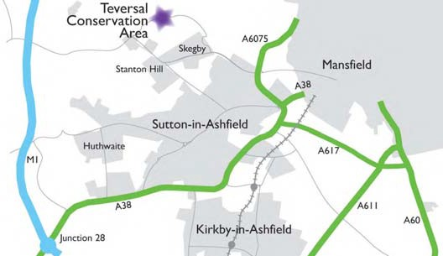

© Crown Copyright and database right 2012. Ordnance Survey 100024849

### Extensions to the existing Conservation Area

* 1. A substantial amount of land to the west of the Teversal Village lies outside the Conservation Area boundary. It includes a number of farm buildings, a few residential properties, the village recreation ground, a wooded area/open land, and the entrance to Teversal from Fackley. This area (especially the recreation ground) is both physically and visually part of Teversal village.Therefore, the conservation area boundary has been extended to include the area marked as **A** on the plan (page 16).
  2. To the south of the Conservation Area the bottom two tiers of the listed walled Manor garden are currently not included within the conservation area boundary. In addition to this the historic field pattern to the south is estimated to be around 150 years old and includes a historic Victorian bath which was formerly used by the occupants of the Manor.This would have originally been reached by a gate in the walled garden. Although the gate has since been removed, the gate piers remain and views of them and walls are particularly impressive when viewed from the field and site of the bath. The conservation area boundary is extended to include the area marked as **B** on the plan (page 16).

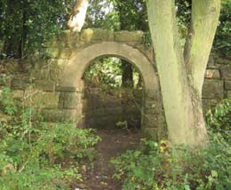

Stone arched entrance in Teversal

* 1. The cemetery to the north of Buttery Lane would form a natural inclusion into the Conservation Area and is therefore also an extension to the conservation area marked as **C** on the plan (page 16).

#### Archaeology

* + 1. To date there have been no archaeological excavations at Teversal. However the widely held belief that there has been a settlement on the village site since Celtic times ensures that there is a possibility that future excavations may unearth evidence from various centuries. On the basis of comparison with similar settlements, archaeological deposits and features can be expected to be found within the Teversal Conservation Area, particularly around the church and Manor, which are the two oldest buildings in the village.

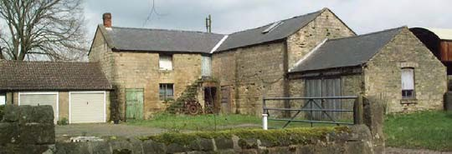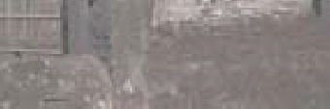

Agricultural buildings in Teversal

### Figure 2  Additions to Teversal Conservation Area Boundary

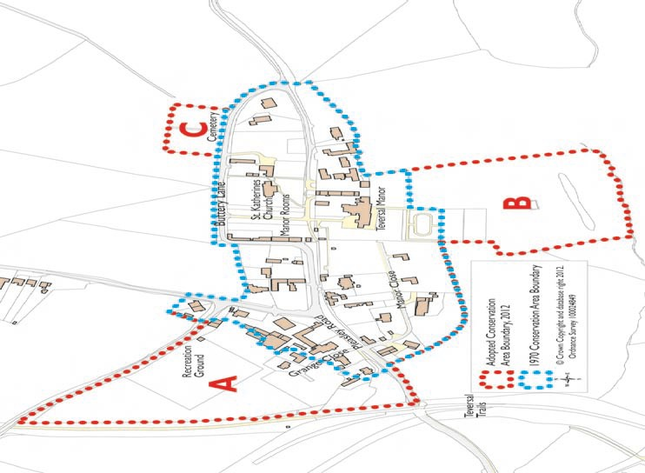

1. **Spatial Analysis**
   1. Character and Inter-Relationship of spaces within the Area:
      1. Teversal Village is a relatively low density settlement, with buildings that are generally detached and widely spaced.This creates a feeling of spaciousness within the village.
      2. The quiet and narrow country roads of Pleasley Road and Buttery Lane form the routes around which the village is arranged. Buttery Lane is lined with wide grass verges and rows of Lime and Oak trees, lending the road a feeling of informality and affinity with the countryside. Adjacent to the Manor Room, Buttery Lane turns 90 degrees, with the wide verges replaced with stone walls that closely line both sides of the

road. The resulting environment is far more enclosed although this quickly changes again, with another 90 degree turn to the right. Here it becomes more open and the road is once again lined with Lime trees.This part of Buttery Lane forms a strong boundary to the Northern and Eastern edges of the Conservation Area, only broken by the siting of the Cemetery to the left hand side of the road.

Road out of Teversal

Tree lined roads - Buttery Lane

90° turns Buttery Lane

Countryside surrounding Teversal

Teversal Manor wall & gate piers-

The cemetery

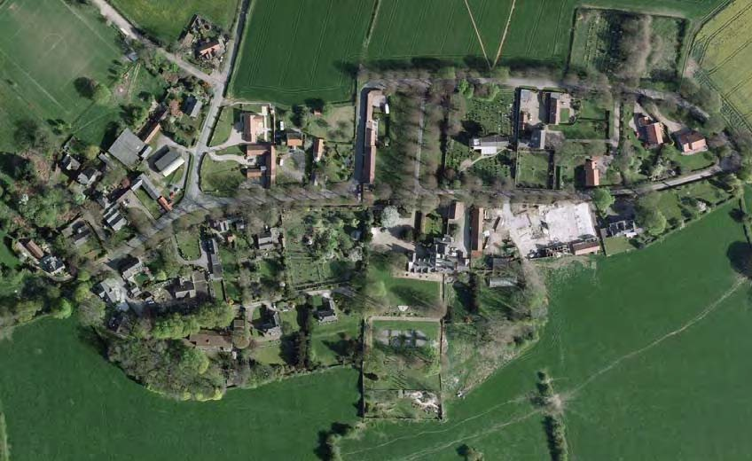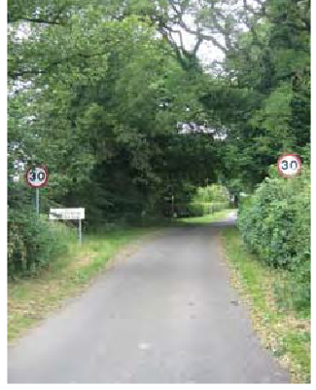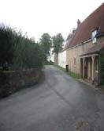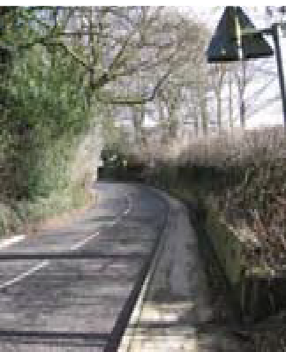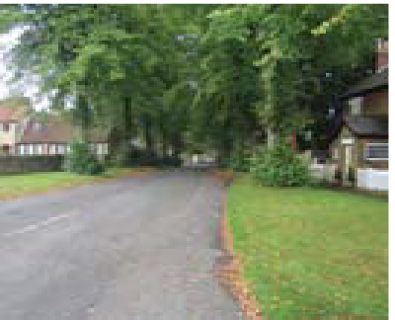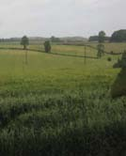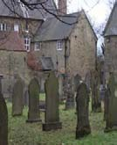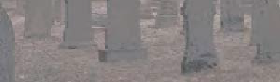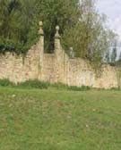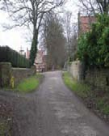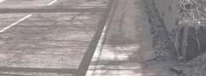

Hedge lined road intoTeversal

Teversal Conservation Area Appraisal 2012

15

### Character Analysis

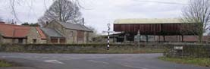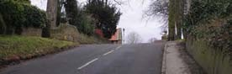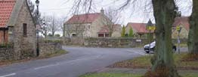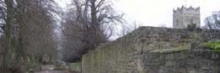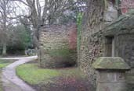

#### Definition of ‘character areas’

The Conservation Area can be divided into three distinctive character areas or ‘zones’ as identified in the plan below.These do not have precise boundaries and there is a certain amount of overlap between them. However their purpose is to identify how parts of the Conservation Area are viewed differently in terms of architectural characteristics, spatial composition, land use and level of activity.

### Area 1

Entering the village under the railway bridges on Pleasley Road; the road climbs up towards the centre of the village. The buildings in this area are loosely arranged in an irregular pattern. They are now all used as private dwellings although around one hundred years ago this section would have formed the small commercial core of the village. Additionally, the area previously encompassed many of the former village farms and agricultural buildings, many of which have now been converted. The buildings generally date from the 18th to the 20th Century and encompass a wide variety of architectural styles. Originally many of the older properties would have been red brick but are now rendered. The atmosphere mostly is peaceful and quiet, with relatively low levels of traffic, although it should be acknowledged that Pleasley Road can be occasionally busy during peak periods, as it provides an alternative route to the M1 motorway between Sutton and Chesterfield.

### Area 2

To the east of the settlement are the oldest buildings in the Conservation Area including St Katherine’s Church and Teversal Manor, and it is here that the most historical and architecturally interesting buildings in the village are found. The buildings at the core of this area date from the 12th to the 18th Century with almost all using sandstone block laid in traditional ashlar or coursed forms. There is also some modern development which has been constructed with a degree of historical and architectural awareness. The stone walls lining the road and surrounding many of the properties provides a real sense of enclosure in the central part of the village and this is further enhanced by the many trees and mature green spaces in locations such as the Manor Gardens and driveway. The lime tree avenues planted in a clearly formal alignment appear in both the manorial and church sites and alongside the road, providing a formal parkland character. The hedgerows on the entrance to the village from Buttery Lane, and those which align the driveway at Teversal Manor, create a very distinctive rural character.

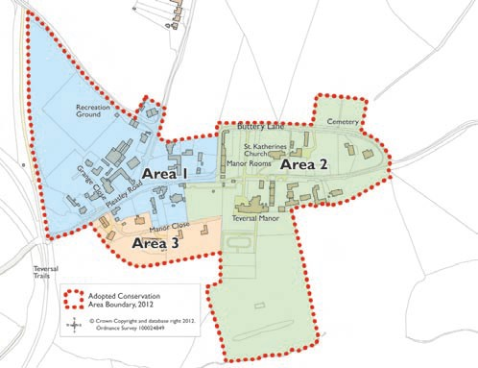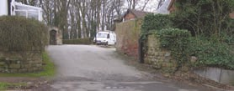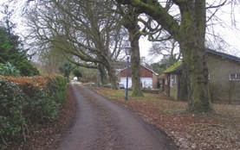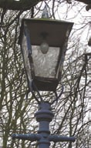

**Area 3**

This part of the village encompasses almost the whole length of Manor Close. The dwellings in this area are larger than an average sized property and all have been constructed during the past 60 years. Most possess very different designs to those seen in other parts of the Conservation Area which lends this area a certain sense of enclosure away from the rest of the village. The entrance to Manor Close is a formal environment with a tarmac road and all existing space covered with cultivated material. Further along the Close the layout becomes more informal with verges to the left hand side of the road. Items of historic interest here are few although the wall enclosing the Manor orchard is a Grade II listed structure.

The wall is intermittently covered in plants and ivy and enhances the character of this part of Manor Close. The replica Victorian street lamps also contribute positively to the streetscape.

### Figure 3  Character areas of Teversal Conservation Area

#### Architectural and Historic Qualities of Buildings

Teversal Conservation Area contains eight listed buildings plus a listed walled garden. Together these represent the largest concentration of listed structures in Ashfield District and accordingly they make a very significant contribution to the historic interest of the Conservation Area.The area additionally contains a small number of buildings which are unlisted but of local, historical or architectural interest.

The group of listed buildings encompass elements of a multitude of local and national styles. All are constructed using vernacular materials and craftskills, some incoporating the grander architectural ‘polite’ features of the time, alongside the more humble local traditional details. These traditional buildings date from the 12th century and continued to be built into the late 19th and

early 20th Centuries. Many of these buildings retain historical details such as red pan-tiled roofs, sandstone ashlar/coursed rubble and clamp-fired (handmade) brick walls,Yorkshire sliding sash windows, decorative doorcases and carved stone surrounds and decorative chimney stacks, all of which contribute greatly to the quality of the townscape.The variety of traditional features, architecture and materials used in Teversal Conservation Area makes a significant contribution to the interest of the townscape.

#### Prevailing and Traditional Building and Surfacing Materials

**Walls**

The majority of pre 18th Century buildings in the Conservation Area are constructed from sandstone, which is mostly coursed and squared rubble. The many stone walls in the village are constructed from similar materials and were originally constructed using lime mortar with a coarse sand aggregate and have a solid rubble core. Recent fashion of ribbon pointing (using modern cement finished proud from the surrounding stone

|  |
| --- |
| Teversal Farm |
|  |
| The Old Bakery |
|  |
| The Old Rectory |

face) in some walls has caused damage to these sandstone walls. Smooth render is a common form of wall covering and has affected a small number of stone built buildings, it is both aesthetically erosive and highly damaging to the sandstone fabric beneath.

From the 19th Century red brick became more common due to cheaper forms of transportation and most buildings of this period are built of this material. Many properties have since been covered in render.

**Roofs**

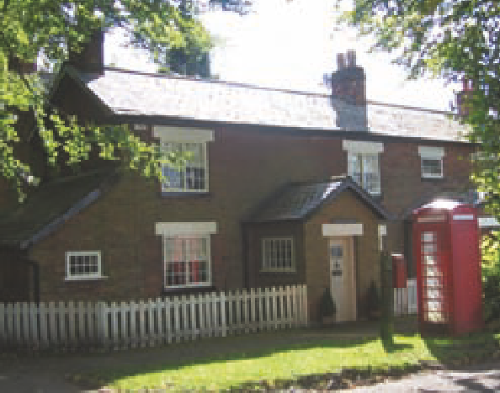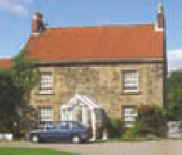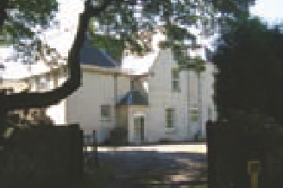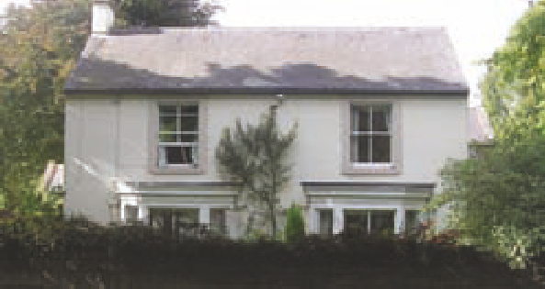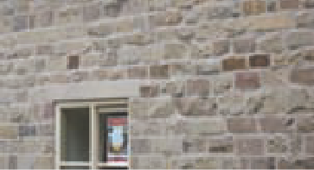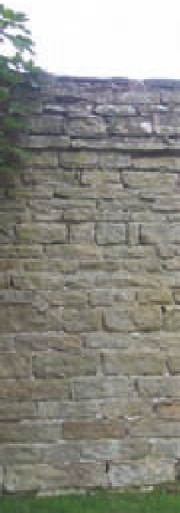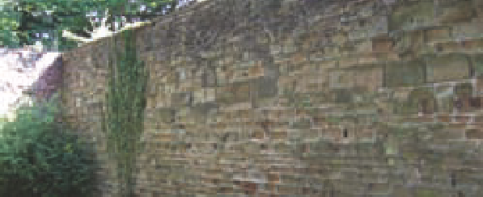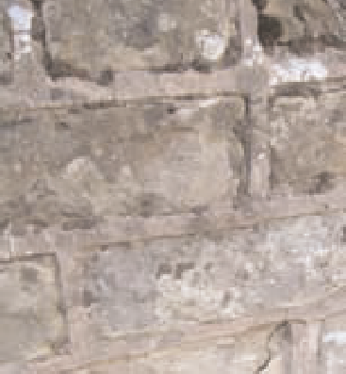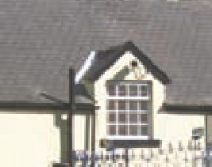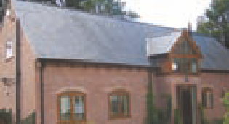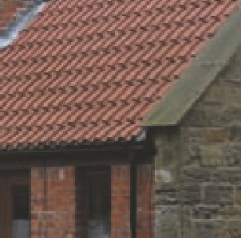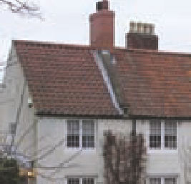

Red brick, stone built and rendered buildings in Teversal.

The most common roofing material is the red pan-tile which is a common feature on properties in the east central counties of England. A small number of generally more recent properties utilise slate.

Almost all of the historic properties in the Conservation Area incorporate chimneys as a skyline feature, another important characteristic of the area. The earlier buildings in the village pre-date the use of pantiles and would most likely have had stone flag roofs of local limestone (very dissimilar to more recent Welsh slate).The steeper pitch of the roofs of older properties and the very substantial hand- crafted oak pegged roof structures are a clear indication of the earlier history of the buildings, such as the Manor House and Gatehouse.

Examples of sandstone walls and ribbon pointing in Teversal.The bottom left picture shows a modern build with the traditional style of limestone walls in keeping with the character of the area.

These pictures show common roof styles in Teversal. Red pan-tile and slate are prevalent materials in the conservation area.

#### Doors and Windows

Timber is the traditional material for doors and windows on historic buildings within the Conservation Area. Other materials, include the non traditional UPVC replacements on many dwellings, which have adversely affected the architectural qualities of those properties. The glazing style of the windows is very much dependant on the age of the building and varies from side hung casements to vertical sliding sashes. Most of the more humble historic buildings had, and some retain, timber horizontal ‘Yorkshire’ sliding sash windows. Along with their slightly grander vertical sliding sashes these are of paramount significance and impact on the character of the historic buildings and village conservation area.

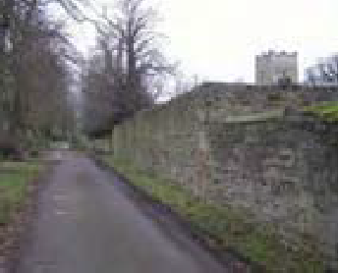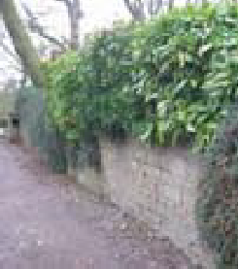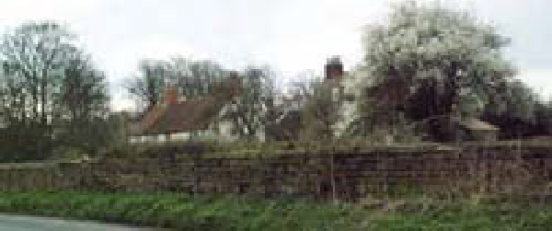

Walled Boundaries particularly prevalent in Area 2

#### Boundary Treatments

There are a number of different boundary treatments in the Conservation Area which range from traditional high and low sandstone walls to hedges of Holly. Wooden five-bar gates are used to enclose most properties and in many cases these positively contribute to the character of the Conservation Area by providing reminders of the area’s agricultural past. A small number of metal gates contribute a more suburban feel and, as such, should be discouraged where possible. Close boarded wooden gates painted or stained are generally suburban in character and equally out of place.

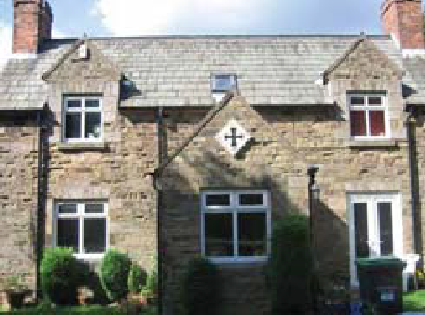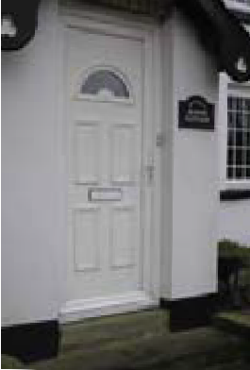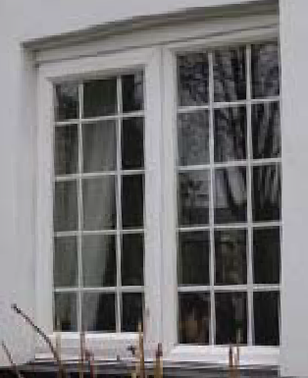

UPVC windows and doors in character properties.This should be discouraged in preference to traditional wooden framed windows and doors.

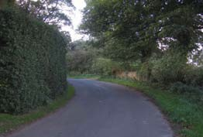

Hedgerow Boundary in Teversal

area is one of the proposed additions to the conservation area (Page 14, marked **A**) and as such could become protected.

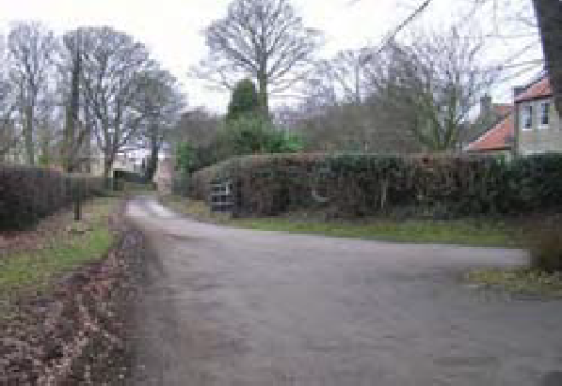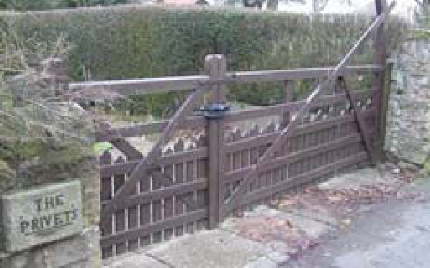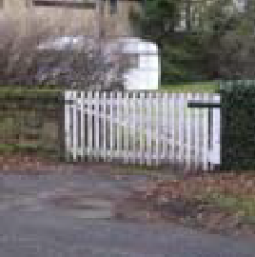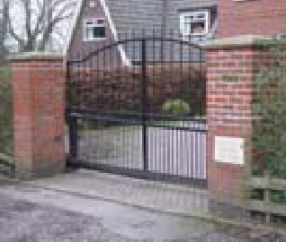

Above: Hedgerow boundary in Teversal. Below: Use of traditional wooden gates is preferable to surburban metal gates.

* + - 1. Trees are vitally important in enhancing the natural beauty of the area and additionally form a key element of the Conservation Area’s unique character. There are many varieties including Ash, Beech, Horse Chestnut, Lime, Oak and Sycamore.These are protected under guidelines contained in PPS5: Planning for the Historic Environment.

#### Contribution made by trees, hedges, green spaces and stone walls

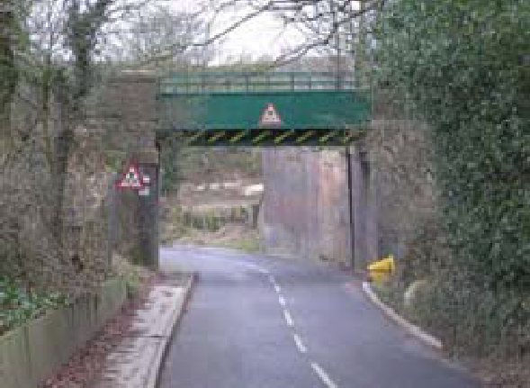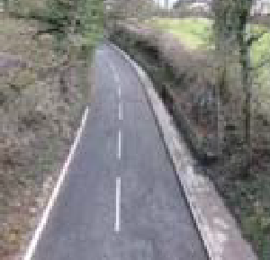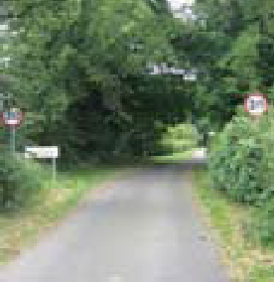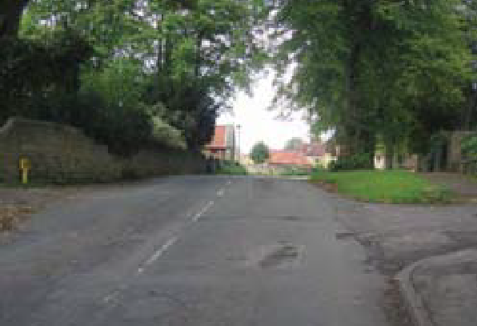

The entrance into Teversal through the proposed addition to the conservation area (**A**).The road has a rural feel as it is enclosed by trees and hedges.

The main entry point to the Conservation Area, up a steep hill and under three closely located railway bridges, provides a natural entrance and lends a sense of enclosure to the village. This is further enhanced by the tightly kept gardens with a wide variety of plants and shrubbery, in addition to the trees lining the main road.

This key entrance to the area is currently not included within the Conservation Area and, as such, remains unprotected by Conservation Area policies. However, this

sandstone. The symmetry that this affords contributes greatly to the sense of local heritage and the overall character of the Conservation Area. Many of these walls are of a substantial height, ensuring a sense of privacy for the dwellings and providing only brief glimpses of properties for passers by. The tall section of estate wall bounding Buttery Lane is a distinct reminder of the status of the

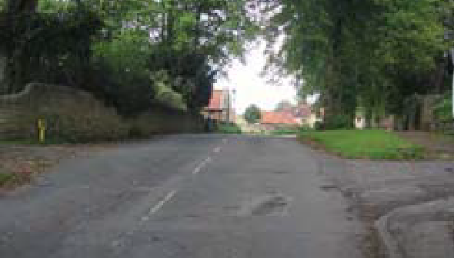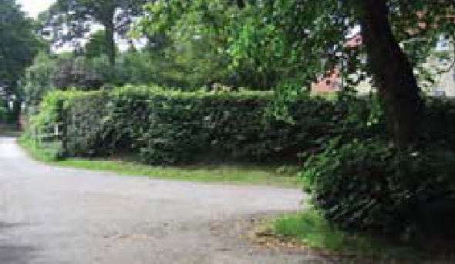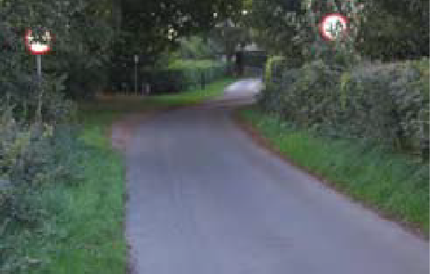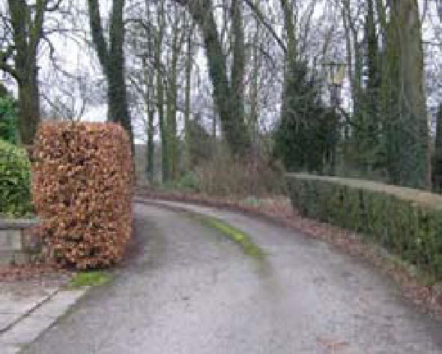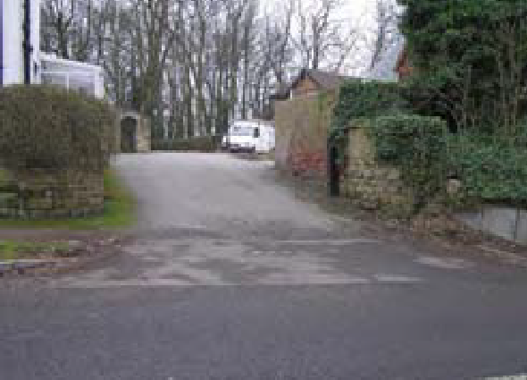

Hedgerows line the roads into Teversal, and help to form a strong, locally distinctive rural character

group of Manor buildings within.

* + - 1. In addition to this, four of the trees to the east of the village are subject to Tree Preservation Orders (TPOs) which offer additional protection.

Entrance to Manor Close

* + - 1. There are a number of historic stone walls within the Conservation Area, many of which demarcate the boundary between residential gardens and the grass verge. It is not known when these walls were constructed although it is possible that they date from around the time of some of the earlier properties, an example being the wall opposite the Manor Rooms which is constructed in the same type of
      2. In many places stone walls are substituted for natural hedgerows.The entrance into the conservation area on Buttery Lane is particularly rural in character due to the hedges which align the roadside. This creates a soft green landscape in this area during the spring and summer months. Hedges are a significant feature, which help to form a strong, locally distinct, rural character whilst also serving as a natural habitat for wildlife and helping to promote biodiversity within the Conservation Area. The loss of such features should be strongly resisted by the Council unless there are very special circumstances which outweigh the harm that would be caused by the removal of a hedgerow.
      3. The contrast between the streetscape of minor roads in the village is noticeable when comparing Manor Close and Grange Close (Manor Close and Grange Close are private drives). The entrance to Manor Close gives the impression of a formal environment. Further along the Close the layout becomes more informal with verges to the left hand side of the road and plants covering the wall which divides Manor Close from the Manor orchard.
      4. Opposite the entrance to Manor Close, Grange Close is quite different.

The pair of gate piers was formerly linked by an arch, lending a strong air of authority to this part of the village.

Although there are no longer gates

on these piers their memory is preserved by the large hinges which remain intact.

* + - 1. The layout of Grange Close is informal with soft landscaping including grass and in some places wild flowers and general foliage lining the sides of the road. A small and fragile strip of grass lines the centre of the road here. These features provide an important reminder of the villages agricultural past and should therefore be preserved.
      2. In some areas of the village, stone walls and building frontages are covered by a thick covering of foliage including holly and ivy. This includes most of the south face of the Manor. Although this does not contribute to the heritage of the Conservation Area it does contribute a certain amount of natural beauty particularly during the summer and autumn months. These features are complemented by the many private gardens in the village, most of which are well cared for by their owners.

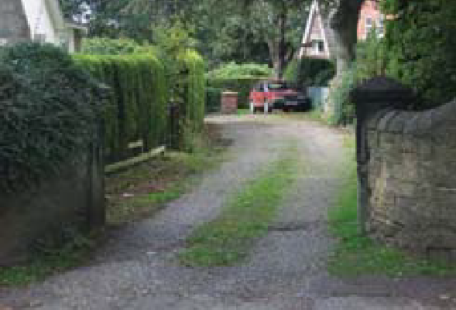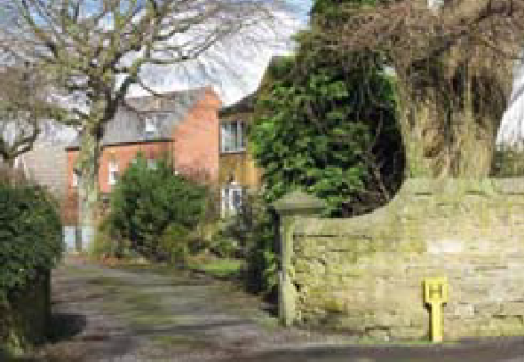

Entrance to Grange Close

Holly and ivy have created a thick coverage
on a number of walls in Teversal, including most of the south face of the Manor.


Holly and ivy have created a thick coverage
on a number of walls in Teversal, including most of the south face of the Manor.


#### Roadscape and Public Realm

The roadscape around the village consists of soft grass verges without kerbs, with a footpath only along the first section of Buttery Lane, from the junction with Pleasley Road to the Manor Rooms.

There are comparatively few examples of modern signage, with the exception of the speed limit restrictors at each entry point to the village and around the junction of Pleasley Road and Buttery Lane. The fingerpost sign at the junction, which is a replacement of the old post, is in-keeping with the character of Teversal. Other

modern road signs in the village add nothing to the character of the settlement and should be discouraged where possible, in favour of more traditionally styled items of street furniture.

The bright red telephone box in Buttery Lane, just off Pleasley Road, provides a colour contrast with the building materials and natural features of the rest of the village. In recent years this has become the most photographed location in Teversal and, despite the telephone box being one of the more recent additions to the village, it provides a positive contribution to the conservation area.

|  |
| --- |
|  |

There is no formal structure for public parking in the village, causing problems during events at the church and the newly refurbished Manor Rooms.This has proved damaging to the many grass verges and some trees, which are regarded as a characteristic feature of the village street scene. As such the issue of providing a sensitively located and designed public car park, located to serve the Conservation Area, is an option that needs to be seriously considered.

Holly and ivy have created a thick coverage

on a number of walls in Teversal, including most of the south face of the Manor.

#### Public Footpaths

There are three public footpaths within the Conservation Area. Two of these lead to and from St Katherine’s Church to the north and the other from the south east of the village which links the Conservation Area with the nearby settlement of Stanton Hill. The footpaths provide a range of different views into the Conservation Area, those from the south being the most impressive and form an important network of walking trails throughout the area.

#### Historic Landscape Character

The land surrounding Teversal village was, in Saxon times, thickly wooded and the Conservation Area itself has retained many of its trees. The area surrounding the village has been almost completely deforested and has always been used for agricultural purposes. The National Monument Programme of mapping aerial photographs does record evidence of the

Examination of historical maps compared with the present day suggests that many field boundaries have been joined to create larger areas of land. This is as a result of modern farming practices and machinery.

|  |  |  |
| --- | --- | --- |
|  | tell tale ‘ridge and furrow’ field patterns  on a small parcel of land south of the historic parkland of the Manor, but there are no other recorded signs of the Medieval open field system of strip farming in the immediate vicinity of the village.  It is worth noting that the Nottinghamshire village of Laxton to the east of Teversal is unique in the country for the continued use of open field farming. |  |
|  | Surrounding countryside |  |
|  | The red telephone box adds character to the streetscape. Although the telephone box is not functioning, it was retained and put under the care of the community. |  |
|  | The red telephone box adds character to the streetscape. Although the telephone box is not  functioning, it was retained and put under the care of the community. |  |

### Changes affecting Teversal Conservation Area

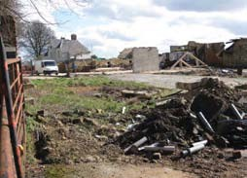

|  |
| --- |
| Before -Former farmyard at Manor Farm |

In recent years there have been a number of planning applications for new residential development within Teversal conservation area. Elements of Teversal’s agricultural past are gradually disappearing; the farmyard at Manor Farm has recently been transformed into a small residential housing development and a number of other farm outbuildings have been converted into residential properties.There is a danger that there will be a loss of all traces of Teversal’s agricultural past if this is not managed appropriately.

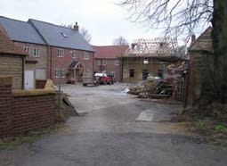

|  |
| --- |
| New development at Manor Farm |

#### Negative Impacts

10.2.1 As mentioned previously, remnants of Teversal’s agricultural past are slowly being erased from the village and this is having an effect on the rural character of the conservation area. In order to ensure that this does not continue, planning applications involving the loss of agricultural buildings and farmyards should be handled sensitively in terms of the design and layout of new development in order to retain as much of the original rural character as possible. Avoiding overtly suburban characteristics of detailing is also necessary. Retaining and creating the agricultural appearance of driveways will necessitate not using block paving and Tarmac for entrance ways off the key roads. This should be a priority alongside choosing appropriately sensitive types of use for redundant farm buildings and designing new additions very carefully so that they can demonstrate their sensitivity to the character of the conservation area.

### Physical Record of Teversal

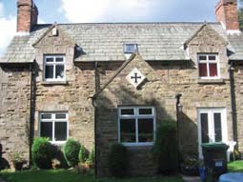

|  |
| --- |
| Hillcroft Farm |

#### Pleasley Road

11.1.1 Entering the village by Pleasley Road from the West, the road climbs up a moderate incline underneath three disused railway bridges.Tree and foliage cover is thick and many buildings are well enclosed and obscured from view. One such building is **Hillcroft Farm**.This stone built dwelling with its Westmorland slate roof has long since ceased being a working farm.

11.1.2 Despite its relatively modern appearance, Hillcroft Farm actually dates from 1889, which is confirmed by an indicatory stone on the property. In addition to this is the mark of the Carnarvon Cross indicating that it is possible that the Carnarvon family at one time possessed an interest in the farm.There are several outbuildings which enhance the buildings character and appearance.To the rear is a former barn which contributes positively to the character of the property and Conservation Area.The building is enclosed, surrounded by stone walls, trees and a variety of plants and foliage.

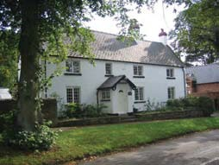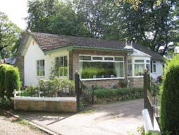

|  |
| --- |
| Manor Cottage |

|  |
| --- |
| Grange Bungalow |

11.1.3 The first building seen on the right hand side is that of **Manor Cottage**.This is a large L shaped rendered cottage with slate roofs.The original windows have been replaced with UPVC units which have eroded the character of the property.The date of 1752 features on the front of the property. A modern porch/conservatory has been added onto the side of the property.

11.1.4 Adjacent to Hillcroft Farm is a large rendered property which is known as **Grange Bungalow**.The large stone chimney stack to the front of the property is the most distinctive feature of the building and although the dwelling is not particularly unattractive, the character is unsympathetic to that of the Conservation Area.

11.1.5 Opposite Manor Close is **Grange Close**. The first building on the right upon entering the road is that of **The Grange** itself.

11.1.6 The Grange is an impressive rendered building set back from the main road and is a building of many eras.Viewed from Grange Close the centre part of the building dates from the 17th- 18th Century and possesses deep set windows from the early Queen Anne/ Georgian period.These include stone reveals.The rear of the property dates from the late 19th Century along with the section which lines Pleasley Road. In this section of the property, the windows are sash on the first floor, surrounded by yellow brick and on the ground floor are splayed bay. All possess white casements. Sections of the building have been affected by infill in the 20th Century.; the chimney to the side of the property dates from the 1960s.

surrounded by a variety of foliage which enhances its character.

* + 1. There are two properties adjacent to The Grange, **Pear Tree House** and **Melda.** Pear Tree House, which was built in the 2000s, is a well proportioned three storey red brick property. Melda is a two storey brick built 1960s/1970s chalet style property.
    2. Adjacent to Manor Cottage is a large rendered property, **The Chantry**, which was probably constructed during the Victorian period of red brick and later rendered. Much of the buildings architectural interest has been lost by the installation of the render and ornate metal gates at the front of the property and on the porch. In addition to these features similar railings on the roof of the porch which lend the property a suburban feel which is of a different character to most of the rest of the Conservation Area.The historic boundary wall along the front of the property remains one of the most interesting features.

11.1.7 Much of this development however is not immediately noticeable from many angles. Originally the property was used as one complete dwelling but now encompasses a number of apartments.The building was notable in its early years for its connections with the aristocracy, and indeed in its early years Lady Carnarvon resided here, during the refurbishment of the Manor.The property was later sold to the owners of the Silverhill Colliery. Unfortunately, during this period the interior of the property lost many of its original features.The entire building is

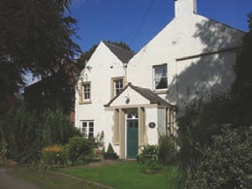

The Grange

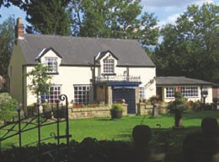

|  |
| --- |
| The Chantry |

* + 1. Opposite Manor Cottage and adjoining The Grange are a collection of **former outbuildings** which contain historical and architectural interest.The one storey building immediately adjoining The Grange is now utilised as a set of private garages. However the aesthetic appeal of the building is undermined by the modern garage doors.

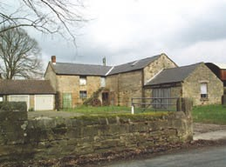

|  |
| --- |
| Outbuildings at Grange Farm |

* + 1. The central stone building adjoining the garage is a two storey slate roofed property with an exterior staircase.The building to the south of this barn has been renovated to create a one storey cottage. Some other outbuildings and their surroundings in this area are less attractive although do also provide genuine reminder of the villages agricultural past including the corrugated iron barn and disused agricultural equipment which surrounds it.

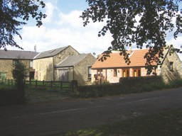

|  |
| --- |
| Redeveloped outbuilding at Grange Farm |

* + 1. Adjoining the farm buildings which are mentioned above is **Grange Farm** itself. This attractive two storey mid 19th Century building is mostly constructed from red brick. One side of the building has been rendered.The property is well enclosed, with a thick hedge separating the building from the road.The white gates, black drainpipe, guttering and eaves in addition to the wide variety of foliage in the gardens contribute further to the aesthetic appeal of the property and this area of the village. However, the modern windows detract from the character of this property.

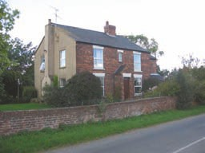

|  |
| --- |
| Grange Farm |

* + 1. Adjacent to Grange Farm is the building of **Old School House**.As its name suggests this residential dwelling was formerly the village school, from the time of its construction in 1906 (when it replaced the previous School in the Manor Room) up until 1957 when it was transferred to nearby Stanton Hill. Records show that in its prime, the school played host to 65-78 scholars.
    2. The building has been converted into two properties. It retains few of the characteristics from when it was a school, the original windows and doors have been replaced with modern units. However, the original iron school railings still run around the property boundary although these are obscured in places.The building itself takes on more of a residential form than a school property. It is rendered with some elements of red brick retained and distinctive red brick chimneys. Despite the dwellings age of over 100 years the building takes on something of a more modern appearance due to its UPVC windows. However its character is enhanced somewhat by the fact that a large part of the front façade is covered by a variety of plants.

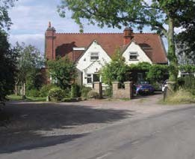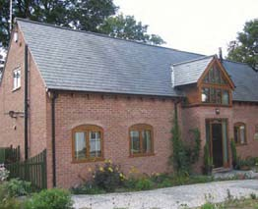

Hill House

|  |
| --- |
| Old School House |

#### Manor Close

11.2.1 It is possible that Manor Close was originally one of the access points to the Manor House and is made up of several individual properties of varying merit in terms of architectural and historic interest. On the side of Manor Cottage and in Manor Close is one of the most recently constructed properties in the village, **Hill House**.This red brick house is built in the style of a barn or stable with wooden eaves and a slate roof.The central glass and wooden dormer in the subsidiary gable is the focal point of the building and despite the modern appearance of this feature, the building can be considered to be at ease in its setting and provides a good example of how modern development can contribute to the Conservation Area’s character.

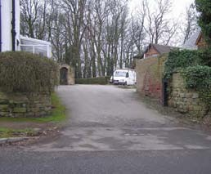

|  |
| --- |
| Manor Close |

11.2.2 Adjacent to Hill House is a slightly larger residential property which dates from the 1970’s. **Windrush** consists of a single storey building with a second floor constructed under eaves. Its distinctiveness results from its tall chimney stack and flat-roofed ground floor extension although it is regarded as contributing little to the Conservation Area’s character.

11.2.3 **Traumerei** is a single storey red brick bungalow which is located on the opposite side of Manor Close from Windrush.This dwelling was constructed in the last half century and possesses a grey slate roof, UPVC windows and a recent UPVC conservatory extension. Although not of a style that contributes to the character of the Conservation Area, Traumerei is set back, within a large and well kept garden that enhances the natural beauty of this section of the village.

11.2.4 From the driveway leading to Traumerei, the Close turns a corner and the trees become denser. Set back from these trees on the right hand side of the road is **The Spinney** (see picture on next page).This exceptionally large bungalow was constructed in the 1960s before the designation of the Conservation Area and is constructed from stone and brick that has since weathered.The dwelling possesses a slate roof, a large prominent stone chimney and casement windows, matching with the white eaves which run around the entire property.The trees which surround it protect the views into the development from the open fields to the south and should be considered for enhanced protection measures such as TPOs.

11.2.5 Continuing along the Close, there is a high stone wall to the left hand side which encloses the Manor gardens.This is intermittently covered in ivy and adds to the character of this part of Manor Close.

11.2.6 The property adjacent to The Spinney possesses a large front garden and is setback from the road. **Manor House** is a large L shaped property dating from the 1950s, rendered with distinctive black drainpipes.The render has been applied in an unusual fashion and has been weathered by nearby trees. It has faded somewhat but the slate roof has been well preserved along with the exceptionally tall chimney stack.The tall, metal-framed rectangular windows with light blue casements are somewhat out of character

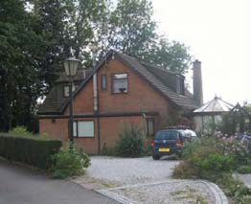

Windrush

|  |
| --- |
| Traumerei |

The Spinney

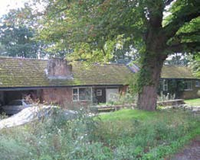

with the large central staircase window exhibiting a semi circular head.The glass porch which was a later addition does not adversely affect the character of the building.

11.2.7 Adjacent to Manor House is an unnamed but architecturally similar property.This dwelling is also rendered and possesses a slate roof. However it differs in that the most northerly part of the building is single storey, the house windows have been replaced by UPVC fittings and the central staircase window has been replaced with stained glass. Few windows of this property face to the north, reflecting the lack of sunshine that this side of the building receives.The major changes have not adversely affected the facades of the properties and both properties maintain a pleasant appearance,

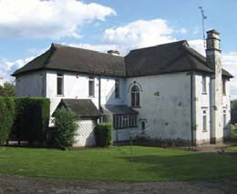

Manor House

although do not add any great architectural or historical value to the Conservation Area.

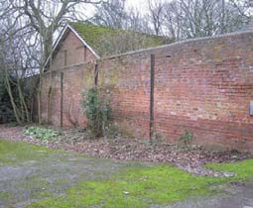

|  |
| --- |
| Walls along Manor Close |

Both Manor House and the similar property next door stand within large well kept grounds which possess pleasant views out, to the south over the gently rolling countryside.

#### Buttery Lane

11.3.1 Leaving Pleasley Road and entering Buttery Lane yields many of the most architecturally important buildings in the Conservation Area, seven of which are listed.The road itself is notable for its peace tranquillity, and comparative lack of traffic, in addition to the general lack of noise and relative ease of pedestrian movement.The character is further enhanced by the stone walls, many of them over 1.5 metres tall, and the lime trees which line the road.

11.3.2 The first building on the right hand side consists of two separate dwellings now named **One Ash** and **Ashfield Cottage**. Dating from around the early to mid 19th century these traditional dark red bricked properties with Welsh slate roofs formerly served as the village provision store and post office respectively. Originally these properties would have been symmetrical.

11.3.3 Ashfield Cottage has retained its original Yorkshire sliding sash windows with stone lintels which further enhance its appearance and character.This section of building is constructed from clamp fired Georgian brick which compares favourably when compared to the more modern brick which has been used in One Ash Cottage.The modern extension to the side and rear of this dwelling coupled with the replacement of original windows with modern UPVC units further does not accord with the historic nature of the property.The garden to the rear of One Ash Cottage may at one time have been an extension of the Manor’s orchard, which is situated on the other side of the 3 metre high wall.

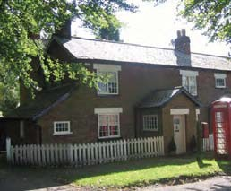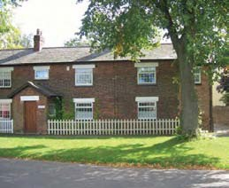

|  |
| --- |
| Ashfield Cottage |

|  |
| --- |
| One Ash |

11.3.4 The bright red telephone box and lime trees directly to the front of the dwellings complement the general architecture of this part of the village and ensure that this is widely the most photographed location within the Conservation Area.

11.3.5 Ashfield Cottage has a white painted door with a 1970’s ‘bullseye’ cut glass feature which were popular during this period. However this does not distract from the overall character of the building.

11.3.6 This is in contrast to the adjacent One Ash Cottage which has a timber door which is coated in varnish.The contrast between these properties reinforces the importance of preserving the historic and architectural environment of the village and appropriate measures should be taken to ensure that historic features are not lost from Ashfield Cottage.

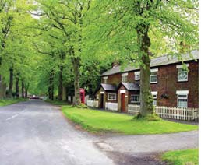

|  |
| --- |
| Ashfield Cottage and One Ash |

11.3.7 Adjacent to One Ash and Ashfield Cottage stands **The Firs**.This large stone built house is set back from the road, providing a contrast with the adjacent cottages. It is further enhanced by the grand scale of the Yorkshire sliding sash windows and Lime trees in front of the property.

11.3.8 Opposite The Firs stands a residential property by the name of **Dovecote Barn**.This dwelling was formerly a farm building for Teversal Farm, which has now been converted into a separate private dwelling.The original farmhouse still stands behind Dovecote Barn and despite the extensive renovations to the style in which it has been refurbished it can be considered to be at ease with the rest of the village.This is mainly due to the retention of original features such as the exterior staircase up to the first floor and timber frame posts. Overall the building demonstrates a good example of how modern conversions can conserve historic buildings.

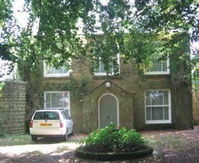

The Firs

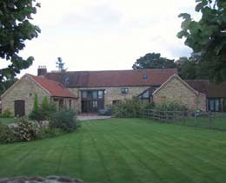

Dovecote Barn

11.3.9 Adjacent to Dovecote Barn is **Teversal Farm**. Once a working farm it is now a residential property and is Grade II listed. The two storey building dates from the late 18th Century and is constructed of coursed and squared rubble with a bright red pan tiled roof and stone slab verges. These features are reflective of an authentic style used in the construction of properties in west Nottinghamshire.

11.3.10 The windows are mainly 19th Century casements and glazing bar sashes with projecting architraves.To the west of the building is a two storey service wing with a casement which is difficult to view due to a medium sized apple tree which covers the façade.To the front of the building is a late 19th century porch which is gabled and glazed and although it provides an alternative style to the rest of the building, does not unduly affect its character or heritage. A small outbuilding with Welsh slate roof and used currently as a garage provides an authentic reminder of the agricultural past of the settlement which is enhanced by the short gravel/ grass driveway.

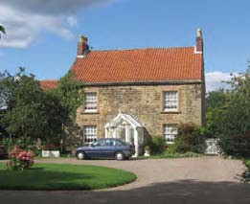

Teversal Farm

11.3.11 Adjacent to Teversal Farm is an 18th Century Grade II Listed cottage by the name of **The Privets**.The cottage is rendered with dark red, gabled and lean to pan-tile roofs and ashlar stone dressings. The windows, which are Georgian in style and in-keeping with the character of the property, have recently been installed.The most recent addition to the property is a modern conservatory, fitted to the left hand side of the building. Despite this the cottage retains all the charm of a traditional country residence and makes a positive contribution to the historic streetscape of the Conservation Area.To the south is an orchard which provides many different varieties of tree and contributes to the significant natural beauty of this part of the village.

11.3.12 Directly opposite The Privets is the **Manor Room**. Originally the property may have been a tithe barn, with a thatch or stone roof. In the 19th century it was converted to a school, with additions in the mid and late 19th Century.The building was affected during the past 50 years due to mining subsistence although this has been rectified by the recent refurbishment programme which was completed in 2006.

11.3.13 The building is directly on Buttery Lane and is dressed in stone, partly rendered with a steep pan tiled roof which is also a feature of the adjacent School House Cottage. It is single storey with attics throughout its length with the exception of the most northerly section of the Manor Room which are two storeys.The Yorkshire sliding sash windows are housed in 19th and 20th Century casements and the property is widely regarded as one of the most aesthetically pleasing buildings within the Conservation Area and now also one of the most important for the community since the refurbishment of

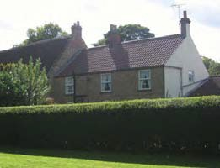

|  |
| --- |
| Lime Tree |

the Manor Room has ensured that community events can once again take place.The building is a prime example of

how dwellings in the historic environment can be successfully preserved and converted.

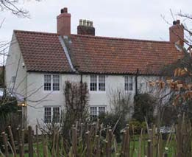

The Privets

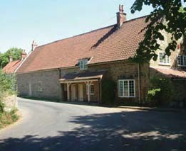

The Manor Room

11.3.14 Adjoining the Manor Room to the south is a small

cottage.As its name suggests, **School House Cottage** was a former school building which is Georgian in style. Like the adjacent Manor Room, of which School House Cottage is effectively one building, the property dates from the mid 18th Century.This Grade II listed

building’s character and heritage is threatened by a number of different factors, for example the use of ‘ribbon pointing’ to patch up casings in the stone work.This can be damaging to the original lime material underneath.This cement work easily comes loose and causes damage to the property. It is therefore regarded that use of such material should be discouraged within historic buildings in the Conservation Area.

11.3.15 Adjacent to the Manor Room stands **Lime Tree Cottage**. Originally this property would have been of similar appearance to the Manor Rooms. However this L plan stone building is now partly rendered.The building dates from the early 19th Century and is enclosed by high stone walls which ensure that many views of the property are extremely limited.The rear elevation has a 20th Century fenestration.

11.3.16 The building has changed greatly since its inception, for example on the 1840 Tithe map Lime Tree Cottage is much smaller and does not extend into the corner. Originally a listed building, this former village shop with red pan tiled roof was de-listed in the 1990s due to extensions and renovation work, most of which had occurred during the 1970s. Although the building still retains a certain amount of charm, there is no doubt that most of its historical and architectural interest has been eroded.

11.3.17 From the Manor Room the road turns sharply to the right.The vehicle entrance to Lime Tree Cottage is here. Just beyond this, also on the right hand side, lies the Lime Tree lined driveway which leads up to **Teversal Manor**. Separating the

driveway from Buttery Lane is a stone wall with impressive gate piers.The wooden gates on this wall contribute to this part of the village’s agricultural heritage and although in need of repair should be replaced or renovated where possible.The formal green area lining the Manor driveway has matured over the past 150 years and provides a hint of the impression to come from the Manor itself and its gardens.

|  |
| --- |
| School House Cottage |

11.3.18 The Grade II listed Manor is itself not particularly visible from this area due to the long driveway and high interior walls which guard the building creating a strong sense of enclosure.The wooden gates bear the Molyneux family cross.The main building is constructed from coursed and dressed rubble stone with ashlar dressing. The roofs are constructed from welsh slate with ashlar coped gables and kneelers with ball finials.The tall chimney shafts are synonymous with stone buildings constructed in the 18th Century. The entrance to the north side of the building contains a projecting 2 storey porch with a large four-centred archway containing double panel doors in a glazed surround, and a hood mould with stops. Above this are 3 light cross mullion windows which are with a flat hood. Above, in the gable, a small square plaque containing a shield and the date 1764 gives the indication that this is one

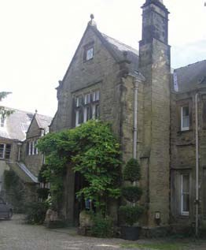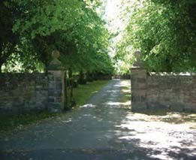

Teversal Manor Driveway

|  |
| --- |
| Teversal Manor |

of the oldest sections of the building. From the south section of the building which looks over the expansive and now remodelled gardens are seven irregular bays.

11.3.19 Most of this part of the Manor is covered with thick Virginia creeper which lends a green or red façade to the building depending on the season.The western section of the building dates from 1896 and includes 5 bays with 2 central sets of double glazed doors within chamfered surrounds.These are flanked by single 4 light and beyond single 2 light cross mullion windows.The eastern wing of the house is the oldest in the Manor and consists of the kitchen and from an architectural point of view, a single 17th Century 3 light mullion window on the upper floor.

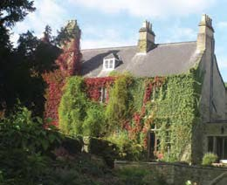

|  |
| --- |
| Teversal Manor |

11.3.20 The Manor can be considered to be the centrepiece of the village and indeed the Conservation Area. It is of great architectural and historical interest, due to its exterior, interior and grounds in addition to the connection of the well known families who have inhabited it.

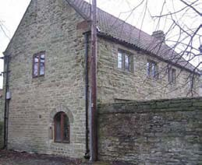

|  |
| --- |
| Gate House |

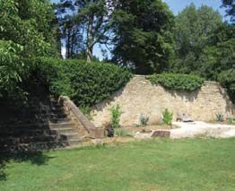11.3.21 A Grade II Listed Building (Garages to the North East of Teversal Manor), known locally as the Gate House, is situated to the side of Teversal Manor.This building has been sensitively restored and converted into a dwelling. It retains some original features including windows with stone mullions. Other aspects have been tastefully restored, in particular the roof, which contains reclaimed red pan-tiles.

|  |
| --- |
| Teversal Manor walled gardens |

11.3.22 A short distance to the north east of Teversal Manor is a collection of red brick outbuildings which are currently being used as garages and for storage.The buildings, which previously belonged to Manor Farm, have retained their red pan- tiled roofs.The outbuildings enhance the historical and architectural character of the village.

11.3.23 To the south of the main Manor building are the **Teversal Manor gardens** which have recently been restored and redesigned. Protected by two metre high walls and terraces they enclose a wide variety of plants as well as ornamental ponds and sculptures. Although this area dates from the late 17th Century, most of what can be seen dates from the present day.Three sets of steps (one at each end of the garden and one in the centre), lead down to the lower terraces.

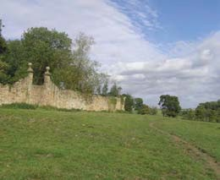

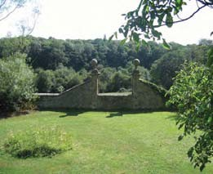11.3.24 Particularly impressive in the first sector is the rose garden, in which a collection of Molyneux roses have been shaped into the Molyneux family coat of arms.The central section of steps on the two lowest tiers

|  |
| --- |
|  |
|  |
| Teversal Manor walled garden |

of the garden, although listed currently lie outside the Conservation Area.The garden furthest from the house is guarded by a set of square **gate piers** with moulded caps and ball finials supported on ogee bases. In the past, this path led from the Manor and through the gardens to a Victorian swimming bath, located to the south of the Manor.This was fed by natural underground springs.

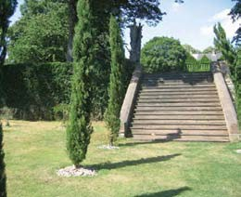

11.3.25 Between the Manor building and Buttery Lane is the Manor orchard which holds a variety of trees, a water feature and glasshouse. Some of the trees located in this part of the grounds are not native to the UK including an Italian olive tree.The main feature of this part of the Manor grounds is the sense of enclosure since the orchard is surrounded by high walls on all four sides.The preservation of this listed feature is an important issue within the Conservation Area but is not a simple task due to the regular and expensive maintenance that a structure such as this needs.The recent restoration and redesign of all parts of the gardens in 2005 has established the Manor as a local tourist attraction and undoubtedly has further enhanced the building and Conservation Area.

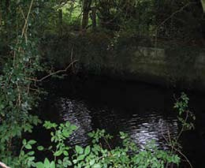

Victorian swimming bath

11.3.26 In 2010 however Teversal Manor closed to the public due to the owners’ retirement.

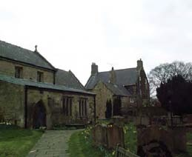11.3.27 Adjacent to the Manor driveway is the oldest building in Teversal village, St Katherine’s Church. Originally a wooden structure, the current structure is the only Grade I listed building in the settlement and originally dates from the 12th and 13th Centuries although it was fenestrated and refitted around 1684.The original structure of the building is constructed of coursed and squared rubble with lead and slate lean-to and gabled roofs.This is supplemented with Ashlar dressings, coved eaves, and coped gables with kneelers and crosses.

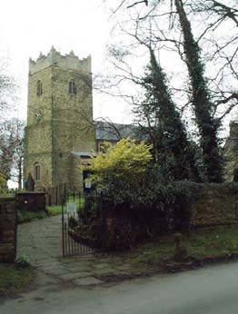

|  |
| --- |
| St Katherine’s Church today |

11.3.28 There have been further alterations to the church over the past two centuries including the addition of a vestry and double purlin roof with arch braces in the 19th Century, but despite this the character of the building has been well preserved.To the casual observer it is impossible to notice the later additions to the building from the exterior.The visual setting of this building is extremely important with views out over the open countryside to the north of the settlement. Similarly the two footpaths to the village which join in the field to the north of the church (on the opposite side of Buttery Lane) provide views in to the settlement during the winter months.This location is outside the Conservation Area and is designated as countryside in the Ashfield Local Plan Review (2002).

11.3.29 Adjacent to the church and further along the lane are two Grade II Listed properties: **The Old Rectory and The Coach House Stable (known locally as The Old Bakery)**. Although they share the same large courtyard these two properties are extremely different.

11.3.30 Both **The Old Rectory** and the high garden wall which adjoins it are Grade II listed and date from around the late 17th Century, the entry possessing an impressive set of tall gate piers.The property was refenestrated and additions to the building were added in the mid 19th Century. A relatively humble property, it lacks the more extravagant details of some other buildings in the village such as the Manor. However despite this, it possesses its own unique character and contributes significantly to the historical interest of the Conservation Area, having served as the vicarage for many years. In more recent years it has served as a residential property when the rector moved to the parsonage, which is outside the Conservation Area. The building is constructed of coursed and squared rubble, partly rendered, with slate roofs and possesses mainly 19th Century sash windows with cornices.The 20th Century porch to the right of the building (when viewed from the front) is obscured from this angle by foliage and so the overall architecture and character of the building is comparatively well preserved.

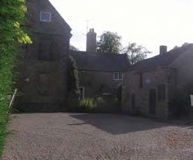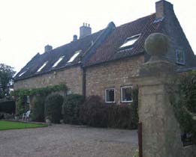

|  |
| --- |
| The Old Rectory (left) and The Old Bakery(right) |

|  |
| --- |
| The Old Coach House |

11.3.31 The **Old Bakery** is also Grade II listed but is very different architecturally from the Rectory. Despite this the building retains much of its original charm and character.The single range but now two storey property dates from the late 17th Century and mid 19th Century and like many properties in the eastern area of the village is constructed of coursed and squared rubble with red pan-tile roof.The windows are mainly late 19th Century casements.The dwellings appeal is heightened by the variety of foliage in the garden and the ivy covered wall and gate piers. Despite the creation of skylights in the roof the building contributes to the historic and architectural character of the conservation area.

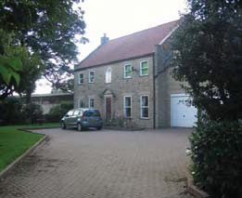

Benjarong House

11.3.32 Adjacent to the Old Rectory is the **Old Coach House**.This property once belonged to the Old Rectory. The dwelling is constructed of coursed and square Rubble and contains modern casement windows and skylights.

11.3.33 Beyond the buildings listed above,There are three properties built in traditional style at the end of the 20th Century. At the end of a long driveway is a large stone built house with red pan tiled roof. **Benjarong House** has been constructed in a style which has tried to be in keeping with this section of the Conservation Area. Due to its secluded location, it is well shielded, by trees from the northern section of Buttery Lane and by high stone wall from the south.

11.3.34 The similar properties of **Monsal House** and **Sycamore House** have been designed to be in keeping with the character of Teversal.The properties are larger than average, taking into account the character of this part of the Conservation Area, which was formerly a paddock. However the centuries old stone walls surrounding the properties have been retained along with much original foliage and trees.The result of this is that the properties are relatively at ease in the fabric of the village.

11.3.35 A short distance from Sycamore House the road divides. A turn to the right leads down a narrow road lined with Lime and Oak trees with an historic wall on the right hand side.This wall possesses examples of ribbon pointing which should be discouraged on historic walls/ buildings due to the damage which can be caused. The road here at one time may have only been a simple farm track and still possesses a comparatively informal layout with soft verges and glimpses of the villages agricultural past.The grass verges are important, not only from an aesthetic point of view, but also because they provide natural protection for the historic wall. All efforts should therefore be made

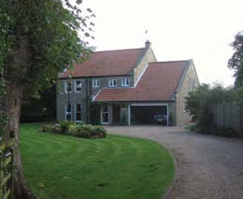

Sycamore House

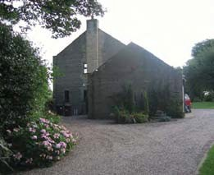

Monsal House

|  |
| --- |
| Manor Farm |

to protect this important feature in this and other locations of the Conservation Area.

11.3.36 **Manor Farm** is located on the left hand side of the track and is no longer a working farm.This well proportioned rendered property with slate roofs has retained a Carnarvon crest which contains the initials HC.The majority of farm buildings within the farmyard to the side of Manor Farm have recently been demolished and there is now a small residential development on the site. Some of the outbuildings have been retained and are incorporated into the development. A barn has been converted into a dwelling and a brick built storage shed/garage has also been retained There are five properties in total (including four new dwellings), each individual in design. Materials are generally in-keeping with the character of the conservation area, with a mix of red brick and stone built properties with red pan-tiled and slate roofs.

### Problems, Issues and Capacity for Change

The inclusion of a Strengths,Weaknesses, Opportunity and Threats (S.W.O.T) analysis within this appraisal summarises the positive and negative aspects of Teversal Conservation Area in a concise manner, providing a useful basis to produce a management plan for the area.

The S.W.O.T analysis has been produced from the findings of the physical appraisal, supported by information gathered from other sources. In addition to the identification of positive and negative aspects, the analysis will consider what opportunities are available to address identified weaknesses. It will also consider if there are any future threats to the character and appearance of the Conservation Area.

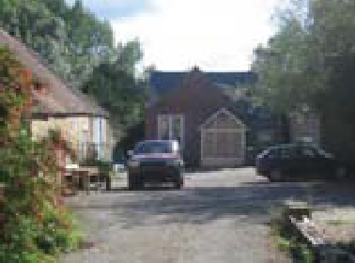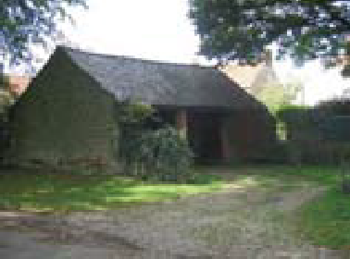

**S** SWOT Analysis

**TRENGTHS:**

**S1** – Seven listed buildings and one listed walled garden exist within the Conservation Area.

**S2** – Few buildings in the Conservation Area can be considered unsightly.

**S3** – No major through route in the village ensures a relatively peaceful and tranquil environment.

**S4** – Teversal possesses many character elements worth conserving and which are not listed buildings or ancient monuments, including; historic buildings,

stone boundary walls, open spaces, outbuildings, agricultural buildings and settings (eg. farmyards).

**S5** – An impressive selection of views out over the surrounding countryside and inwards from the adjacent areas.

**S6** – The Conservation Area boundary is easily demarcated by countryside on three sides.

**S7** – The Manor Rooms have been fully refurbished and provide a valuable facility for the community as well as a focal historical point of interest.

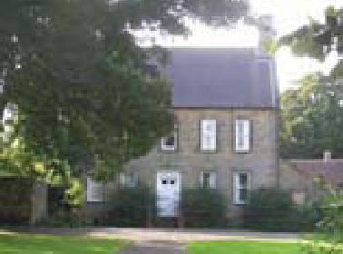**S8** – A large variety of plants, trees and flowers flourish on both private and public land which positively enhances the character of the village.

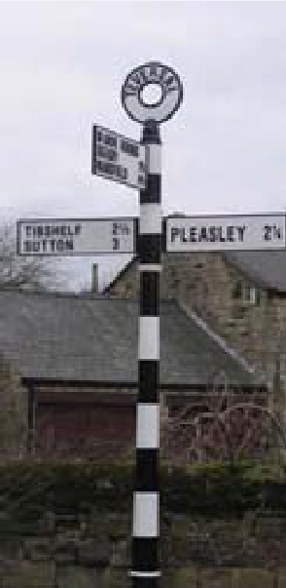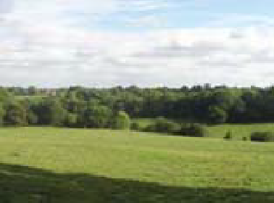

SWOT Analysis

**W**

# EAKNESSES

**W1** – Maintenance issues on pavements and roads.

**W2** – Use of render/ unsuitable extensions to historic buildings

**W3** - Lack of information for visitors to the Conservation Area regarding its historic importance and value.

**W4** – Loss of traditionally styled windows/ doors on properties.

**W5** – Severely limited parking for visitors to the area is causing damage to grass verges during busy periods.

**W6** – There are a few buildings within the Conservation Area which have no historical or architectural interest.

**W7** – High volumes of traffic on Pleasley Road during peak hours.

**W8** - Intrusive road signs.

**W9** – Maintenance issues surrounding tree pruning and grass verge maintenance.

**W10** – Lack of guidance on what modifications are acceptable leading to enforcement measures being taken.

**W11** – Loss of rural character in terms of the diminishing number of agricultural features e.g. farmyards.

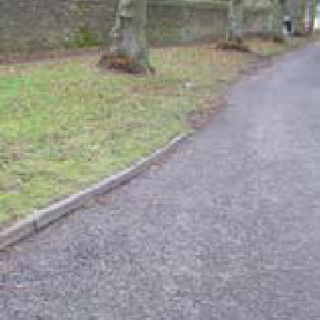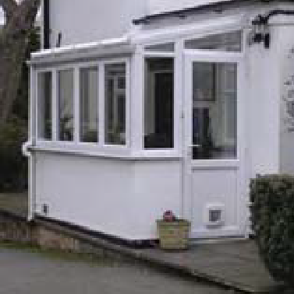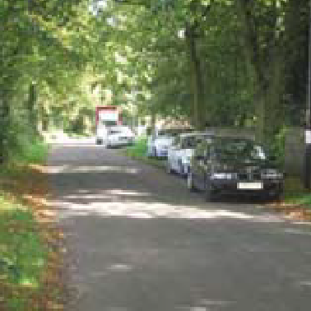

SWOT Analysis

**O**

## PPORTUNITIES

**O1** - Publish literature informing residents of the implications and responsibilities of living in a conservation area, particularly residents living in listed buildings.

**O2** - Amend the Conservation Area boundary to take into account of any additional areas of interest (page 14).

**O3** – To consider strengthening and tightening policy at a local level relating to permitted development, preventing further losses.

**O4** – The sensitive conversion of previous farm buildings to residential dwellings.

**O5** – Formulation of new policies through the LDF to protect agricultural elements of the conservation area e.g. farmyards, architectural features on agricultural buildings and outbuildings.

**O6** – The creation of a sensitively designed car park in an appropriate location which is in-keeping with the traditional character of the area.

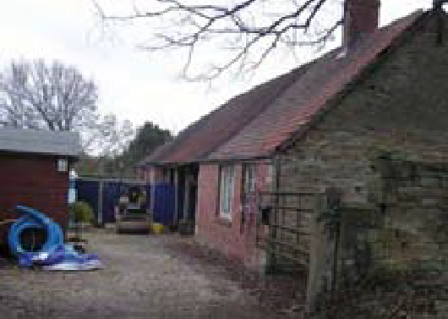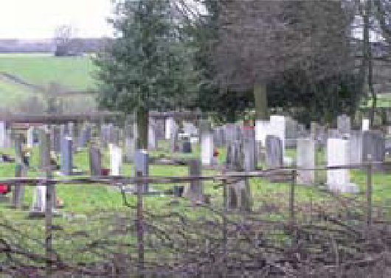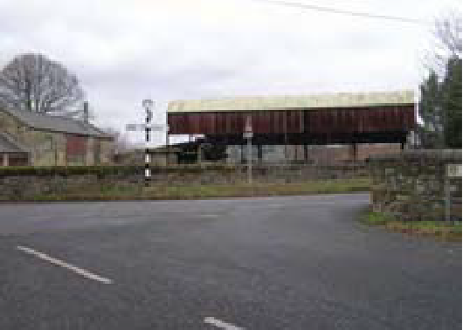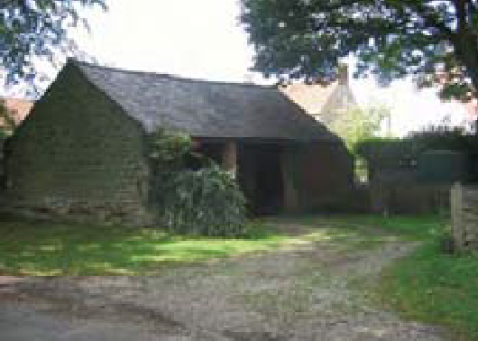

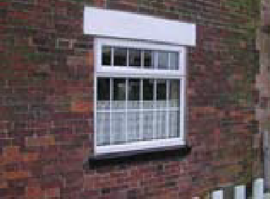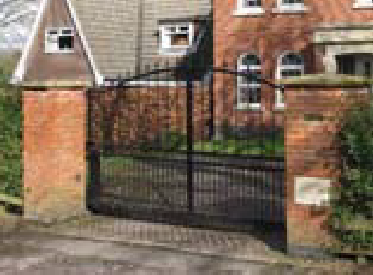

SWOT Analysis

**T**

# HREATS

**T1** - Potential to develop in areas surrounding Conservation Area – for example the north section of Grange Close.This could impact on the setting of the conservation area.

**T2** - Further decline of the general street environment due to poor quality road surfaces and pavements, and the addition of modern road signs not in keeping with traditional character.

**T3** - Cars parking and damaging grass verges and trees.

**T4** – Increasing use of Pleasley Road for through traffic.

**T5** – The possibility of infill development between buildings, leading to loss of spatial character and views out of the conservation area.

**T6** – Modern additions to historic properties such as conservatories, UPVC and varnished windows and doors, and metal gates.

**T7** – ‘Ribbon pointing’ on stone walls.

**T8** – Total loss of rural character brought about by the loss of significant architectural features on agricultural buildings and the loss of farmyards.

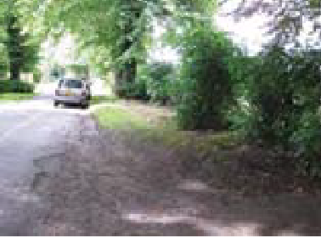**T9** – loss of hedgerows, particularly at the eastern entry into the Conservation Area

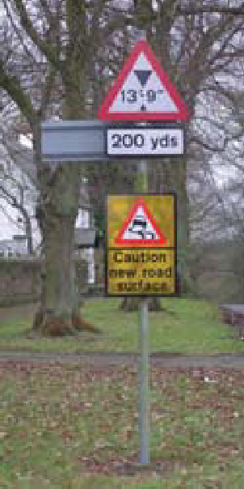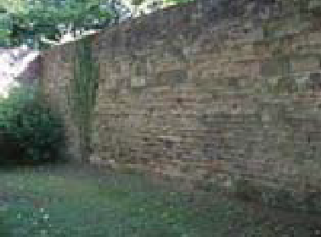

### Management Plan

Issues and recommendations arising from the Appraisal

From the S.W.O.T analysis, several key issues have risen from the analysis of Teversal Conservation Area, which are listed below:-

**A** The need for adequate protection to ensure that changes to buildings and structures are undertaken appropriately

**B** There is potential for the publication of design guidance

**C** There are a number of ways the environment of the village could be improved

**D** Parking issues during usage of St Katherine’s Church and the Manor Room

1. Pressures of development and modern lifestyle
2. Boundary changes

**G** Local generic planning guidance

## A CHANGES TO BUILDINGS AND STRUCTURES

Threats and weaknesses: The appraisal has highlighted some aspects of Teversal village that have been altered. Although the Conservation Area has still retained much of its character, certain elements have been eroded.

13.2.1 Replacement Modern Materials: The main threat to the character and appearance of the Conservation Area are the use of modern replacement windows and doors on both listed and unlisted historic buildings. These materials are becoming more prevalent and erode the character and appearance of the Conservation Area, particularly when they are inserted in one building where the others still retain their original windows and doors. A number of modern style timber doors and windows,

most of which are varnished have been installed which are out of character with their setting.

13.2.2 Historic Stone Walls: Traditional sandstone walls are integral to the historic and architectural quality and character of the Conservation Area. It is acknowledged that sandstone is a fragile material that needs the right conditions to survive. The use of ‘ribbon pointing’ on many walls in the Conservation Area prevents the lime from ‘breathing’ and can cause extensive damage. It is important to inform the community on issues such as these to prevent the character of the Conservation Area being eroded and to ensure that walls do not become unnecessarily unsafe. The threat to walls in the Conservation Area is considerable and since walls are so integral to the character of the area it is proposed that an Article 4/2 (Definition in Glossary) direction is placed on all of these features.

13.2.3 Rendering: Many of the facades of buildings have been covered by render which has covered the existing brick or stonework. Although it is not considered advisable to remove render from existing properties, consideration should be given to policies which prevent the rendering of red brick and stone built properties that have not yet been rendered.Therefore it is proposed that an Article 4/2 direction is placed on all of these features as well.

13.2.4 Loss of Agricultural Buildings and Farmyards: The loss of agricultural buildings and farmyards needs to be carefully managed in order to ensure that the character of the conservation area is not affected.The conversion of agricultural buildings should be done as sensitively as possible, ensuring that key architectural features are retained.The loss of

farmyards should be resisted as they help to reinforce the rural, open character of Teversal conservation Area. Farmyards can also be utilised for parking, where possible, during busy periods.

## 13.2.5 ACTIONS TO ADDRESS THE THREAT/WEAKNESS

13.2.6 Article 4 Directions: An Article 4 Direction can be used in certain circumstances to protect vulnerable features in Conservation Areas.This will restrict the normal ‘permitted development rights’ enjoyed by householders. Certain alterations can be made to properties without having to apply for planning permission; this is called ‘permitted development’. For example windows and doors, in normal circumstances, can be replaced without having to apply for permission. An Article 4 direction can remove these permitted development rights which means that planning permission is then needed for minor alterations and extensions to residential properties. It may be necessary to put an Article 4 Direction on certain features within Teversal Conservation Area in

order to stop the erosion of its character.

13.2.7 Adequacy of Current Local Planning Policy: After undertaking a thorough physical appraisal of the Conservation Area, a review of the adequacy of current policy controls can be undertaken and this will inform the emerging Local Development Framework.

## B ADVICE AND DESIGN GUIDANCE

Threats and weaknesses: An issue that has risen from the consultation for the appraisal is the need for information and advice for local residents in and around Teversal Conservation Area.

13.3.1 It is important to raise awareness of the consequences of living in such an area and to inform residents of their obligations, with regard to proposals for planning permission and conservation consent. Also, by increasing awareness of conservation issues it is hoped that residents will be better informed, and as a consequence minimise the potential harm that could occur to the character of the area.

13.3.2 This appraisal document provides much useful information on the most valuable aspects of the Conservation Area for all relevant parties, which will help to guide future development within Teversal village. However additional advice and literature would benefit residents and in turn the council in terms of specific policies relating to the Conservation Area. For example,

if an Article 4 (2) direction was placed on any feature within the Conservation Area, separate literature would provide in depth information. This is equally true for design guidance although this would not be enforceable on existing households.

## C ENVIRONMENTAL IMPROVEMENTS

Threats and weaknesses In recent times, modern additions have been added to the streetscape of Teversal, which has had a detrimental impact on its character.There are a number of ways the environment of the village could be improved.

13.4.1 General Appearance: The area generally is maintained in a very good condition, with the general fabric in fair condition. However, the installation of satellite dishes, television aerials and security lights on the exterior of buildings has in some cases created a cluttered appearance and are regarded as unsightly. Enforcement action will be taken on any property which has installed such a device without obtaining planning permission.

13.4.2 Road Signs: Road signs in the village are mainly limited to the entry points and the junction of Pleasley Road and Buttery Lane. If some of these signs were repositioned their negative impact would be greatly reduced whilst the village also contains some obsolete signposts, such as at the entrance to Buttery Lane, which should be removed as they clutter the historic streetscape. Additionally, the design of the existing signage can be regarded as not in-keeping with the

historic environment and consequently should be replaced with new signage mounted on black poles.These would be far less intrusive in appearance than the existing grey poles. The finger post at the centre of the village should be replaced with a traditional example as soon as funds allow.

13.4.3 Tree/ Grass Verge Maintenance: The maintenance of most trees and grass verges in the Conservation Area is the responsibility of Nottinghamshire County Council. Ashfield District Council will continue to monitor the state of these valuable aspects of streetscape and inform the County Council when pruning or maintenance is needed.

## D TRAFFIC AND PARKING ISSUES

Threats and weaknesses: The level of traffic passing through the village continues to increase during peak hours from Monday to Friday.

13.5.1 There is very little that can be done to counter this problem although there may, in the future be possibilities to introduce traffic calming measures on Pleasley Road to reduce traffic speeds. Council Officers in the Highways and Planning sections must work together to ensure that future highways projects do not harm the character of the Conservation Area.

12.5.2 There are no formally designated parking spaces within the Conservation Area boundary at Teversal.The Council will continue to work with Nottingham County Council Highways, Landscape Architects and to try to resolve parking issues in Teversal.

## E PRESSURES OF DEVELOPMENT AND MODERN LIVESTYLE

Threats and weaknesses: A pressure throughout the district and the East Midlands in general is the need for new housing.

13.6.1 The possibility of development in Teversal Conservation Area is mainly limited to conversion of former farm buildings and infill between properties. Where these sites do exist, new housing has the potential to significantly alter the character of the Conservation Area and needs to be carefully considered and planned. Open spaces between dwellings assist in the retention of the open, rural character of the village. Infill development would create a more urbanised character which would negatively impact on this rural village.

13.6.2 Satellite Dishes, Other Antennae and External Alarm Boxes: The widespread erection of satellite dishes and other telecommunication equipment can have a detrimental effect on the character of the Conservation Area. In Conservation Areas, planning permission is required to fix satellite dishes and other antennae onto any walls, roofs or chimneys of buildings or other structures that face onto and are visible from a road. In assessing such applications consideration will be given to the visual impact on the property and the Conservation Area as a whole, but there will be a presumption that, other than exceptional circumstances, antennae will not be allowed in prominent locations where they are visible from the road.

## F BOUNDARY CHANGES 13.8 G LOCAL GENERIC

13.7.1 The extensions to the Conservation Area

## PLANNING GUIDANCE

will help the Council to further protect **FOR CONSERVATION**

and enhance the special, distinctive **AREAS**

character of Teversal through the

development management process.

.1 Topography and Setting: It is important that the significant views both within and out of the Conservation Area are maintained and, where possible enhanced. Any new development in the village should respect the nature of these views and positively contribute to them. Similarly, any new development in the wider area should take account of its impact on the views from the Conservation Area.

* + 1. Architecture and Building Details: There should be a strong presumption towards the retention of all historic buildings that make a positive contribution to the character and appearance of the Conservation Area. The Council’s presumption against the demolition of buildings in Conservation Areas has been set out.There should also be a presumption in favour of the retention of historic attributes such as traditional doors, windows, architectural features (e.g. kneelers) and railings (all items set out in the ‘Special Interest’ section) as these add a great deal of interest and value to the townscape. When historic features need replacing a like for like approach should be taken wherever possible. The reinstatement of tradition features will be actively encouraged; however it should always be based on a sound understanding of the original structure and if possible, historical evidence.
    2. Traditional Building Materials: The use of traditional materials will be encouraged in new buildings and when repairs and extensions are made to existing buildings. Modern materials such as UPVC, varnish and aluminium should be avoided as these are out of character with the area and erode the quality of the street scene.
    3. Trees and Open Spaces: It is important to maintain the trees and open grassed areas that are an integral part of the character of the Conservation Area. The Council has stated in the Ashfield Local Plan Review (2002) that development which adversely affects trees worthy of retention will not be permitted (policy EV8). Seven trees in the Conservation Area are subject to Tree Preservation Orders which offer extra protection.
    4. Hedges: The loss of hedges within the conservation area should be strongly resisted. Hedges help to maintain the rural character of the Conservation Area, particularly on the eastern entrance into the village on Buttery Lane.
    5. Environmental Quality: It is important that the overall quality of the environment is maintained to a high standard. Road signs should not have an adverse impact on the streetscape and unnecessary signs and signposts should be kept to a minimum.

It is the Council’s policy to ensure that public utility companies and Nottinghamshire County Council consider the character of Conservation Areas when carrying out works in them. Street furniture should enhance the environment and be in character with the Conservation Area in terms of design and materials.

* + 1. New Development: It is acknowledged that new development should sometimes be permitted in a Conservation Area and that new additions can sometimes enhance the fabric, if sympathetic to their surrounding and of a high quality. In general any new development should preserve or enhance the character and appearance of the area or its setting and respect adjoining buildings in term of scale, density, massing, style and materials.
    2. Community involvement has been an integral part of this process. As part of this Appraisal process, the Council invited residents and members of local heritage groups to an exhibition of the Appraisal and Management Plan held in Teversal Manor Room. The exhibition was subsequently displayed in St. Katherine’s Church for the remainder of the consultation period. Copies of the document were also available to view in Sutton Library; Skegby Library, Huthwaite Library, at the main Council offices in Kirkby in Ashfield and on the Council’s website.

The consultation provided an opportunity for the Council to take on board the views of community members in relation to their aspirations for the historic environment.

This was taken into account in defining the special interest of the Conservation Area and formulating strategies for its future management.

The Council would like to acknowledge the role played by the Heritage Department at Nottinghamshire County Council in several matters relating to the historic built environment.These include:

* + - * Providing expert advice on matters affecting the Conservation Area; and
      * Working in conjunction with Ashfield District Council to highlight potential enhancement schemes for the area.
    1. Thanks go to all those involved throughout the Appraisal process.

### Glossary

**Agriculture** – Land that is used, or is ancillary to farming, including fields, barns and walls. A further description can be found in Ashfield Local Plan Review 2002.

**Appraisal** – An appraisal is a document which summarises and discusses methods for development. In this case, the appraisal outlines why Teversal is a conservation area, and sets out a management plan to maintain the status.The document will be referred to during the writing of policies and decision of applications to ensure changes to, and additions to the area are in keeping with the character.

**Article 4 Direction** – A local authority can restrict the permitted development rights of property owners to carry out certain categories of development that would other wise be automatically allowed under Article 3 of the Town and Country Planning (General Permitted Development Order 2008.

**Article 4 (2) Direction** –This direction restricts the carrying out of certain development in relation to dwellinghouses that front onto highways, waterways or open spaces in conservation areas.This includes;

* + - * The enlargement, improvement or other alteration of a dwellinghouse
      * Any addition or alteration to its roof
      * The construction of a porch
      * The provision within its curtilage of a building, enclosure or swimming pool
      * The provision of a hard surface
      * The installation of a chimney, flue or soil and vent pipe
      * The installation of a microwave antennae
      * The erection, construction, maintenance, improvement or alteration of a gate, fence, wall or other means of enclosure
      * The painting of the exterior of any part of a dwellinghouse, building or enclosure
      * The demolition of all or part of a gate, fence, wall or other means of enclosure.

**Ashlar Dressings** - A square-cut building stone used on the exterior of houses, often cut with each block the same size.

**Conservation Area** – An area designated by a Local Planning Authority under Section 69 of the Planning Act 1990, regarded as being an area of special architectural or historic interest, the character or appearance of which is desirable to preserve or enhance. A further description can be found in Ashfield Local Plan Review 2002.

**Countryside** – The rural parts of the District lying outside the defined Main Urban Areas and Named Settlements. For the purpose of this appraisal and the Local Plan, this excludes land designated as Greenbelt. A further description can be found in Ashfield Local Plan Review 2002.

**Coved Eaves** – Concave under the eave of a roof

**Gables** – A wall closing the end of a pitched roof, usually bounded by two sloped walls forming the roof shape.

**Kneelers** – Stone slabs lay on the edge of roofs to hold the tiles in position. See page 9.

**Lime Pointing** – A limestone based mortar used to re-point decayed or worn walls and buildings. It is extremely hardwearing, and as a result often erodes at a slower rate to the stone it is surrounding (see page 9).

**Listed Buildings** – A building or structure of special architectural or historic interest included on a list prepared by the Secretary of State for Culture, Media and Sport under Section 1 of the Planning Act 1990. Consent is normally required for its demolition in whole or part, and for any works of alteration or extension which would affect its special interest.

**Local nature Reserve** – Established by a local authority under the powers of the National Parks and Access to the Countryside Act, 1949.

**Mullion Windows** – Traditional style of windows, with stone frames and surroundings in an arched shape.These windows are used in Teversal Manor.

**Ogee** - Decorative moulding with S-shaped section; an ogee arch consists of a pointed arch with ogee curve on either side.

**Ribbon Pointing** – Process, material or completed finish of mortar-joints in brickwork or masonry.

**Sash Windows** – Fixed or opening frame fitted with one or more panes of glass forming a window, set in a larger frame placed in the whole window opening or aperture. opening sashs can be vertical or horizontal in grooves or hinges.

**SSSI** – Site of Special Scientific Interest.The designation under Section 28 of the Wildlife and Countryside Act 1981, of an area of land of special interest by reason of any of its flora, fauna, geological or physiographical features. A further description can be found in Ashfield Local Plan Review 2002.

**SINC** – Site of Importance for Nature Conservation. Site of local importance for nature conservation or geology as identified by the Nottinghamshire Wildlife Audit Steering Group. A further description can be found in Ashfield Local Plan Review 2002.

**Streetscape** - All that we see in the street.This includes buildings, the quality of the pavement surfaces, the odd pieces of street furniture as well as the official traffic related street equipment.The streetscape in a conservation area is often highly influential in terms of creating character.

**Tithe Barn** - A tithe barn was a type of barn used for storing the tithes - a tenth of the farm's produce which had to be given to the church.

**Tree Preservation Order** - A tree preservation order is an order made by a local planning authority in respect of trees or woodlands.The principal effect of a TPO is to prohibit the cutting down, uprooting, topping, lopping, wilful damage, or wilful destruction of trees without prior consent. For more information, please visit the CLG website.

**UPVC** – or unplasticised polyvinyl chloride, is often used in window frames and doors due to cost competitiveness and easy handling as an alternative, although it is not preferable, to wood or metal.

**Appendix 1: Public Consultation Officer Response**

**Responses** An application for 5 wind farms was submitted in early 2010 but was later withdrawn (SO/2010/0002).There are no further applications for wind turbines at this time. Each application sent to the Council is assessed on its individual merits, and as such we are unable to comment on prospective future applications.

In February 2011, the Council held an exhibition of Teversal CA Appraisal as part of the consultation process. Approximately 35 people visited the exhibition on Tuesday and Saturday (8th and 12th February 2011), with generally positive feedback.

Following the consultation the Council received 7 official responses. Below are the comments made by local residents and interested parties regarding the Draft Conservation Area Appraisal, and officer responses to the feedback by the Council.

#### Increased development as a result of boundary change?

##### Public Feedback

*The change to the proposed conservation area boundary was misinterpreted as a change to the settlement boundary, and concerns were*

#### New development off Manor Lane on the former Manor Farm farmyard

##### Public Feedback

*The design and materials of the new development were thought to be out of character with the conservation area in terms of*

* 1. *compactness;*
  2. *height of the properties;*
  3. *materials – too modern in appearance and no use of reclaimed materials;*
  4. *increase in vehicular activity/ number of vehicles per property;*
  5. *impact on setting of a listed building.*

#### Officer Response

The recommendations set out in the appraisal should ensure that proposals for new development must be designed sensitively so as not to impact on the open spaces between properties.

#### Former Wind Farm Proposal .

##### Public Feedback

*The impact on character of the conservation area and size and proximity of turbines to the village and Teversal trails would be unacceptable in terms of visual appearance and noise.*

*raised about further development off Grange Close – residents were opposed to this.*

#### Officer Response

The change to the Conservation Area boundary does not impact on the settlement boundary, and therefore it should not result in further development within or around Teversal. It is important to note that Teversal is surrounded by designated Countryside in accordance with the Ashfield Local Plan Review 2002 which gives increase protection from inappropriate development.

#### Highway Signage

##### Public Feedback

*Many residents were critical of the increase in modern signage, including the modern ”Buttery Lane” sign, and the new housing signpost for the new development (both located on the Buttery Lane/ Pleasley Road junction).They felt replica traditional signs would be much more appropriate.*

#### Officer Response

Discussions are ongoing with the Highways Department as to whether the signage issues in Teversal can be overcome.

#### Infill Development

##### Public Feedback

*Concerns over further infill development as it*

*was felt this would ruin the dispersed and spacious character of Teversal.*

#### Officer Response

The appraisal has identified issues relating to density and existing spaces within the Conservation Area.There are only limited opportunities for new development within the Conservation Area.The recommendations set out in the appraisal should ensure that proposals for new development must be designed sensitively so as not to impact on the open spaces between properties.

#### Car Parking

##### Public Feedback

*There was a mixed response to the topic of car parking in the village; some residents thought it wouldn’t be used and would be unsightly, others were generally in favour. Near the church was the preferred location, as this tends to be where there is the greatest build up of vehicles.*

#### Officer Response

The Council will continue to work with local residents and the highways department on this issue.The Council does not have funding for a car park at the present time and it is unlikely that this will change for some time.There are also issues relating to land ownership; the land within and surrounding Teversal is in private ownership. Consequently, the land owner/s would have to take the lead on such a project.

#### Expense of living in a conservation area

##### Public Feedback

*A few comments were made regarding the expense of maintaining a property in a conservation area, e.g. the installation of traditional wooden windows (as opposed to UPVC).*

#### Officer Response

It is important to preserve, and where possible enhance, conservation areas in order to ensure that the character of each

area is retained for future generations.The slow erosion of character of a conservation area could eventually lead to a total loss of character and may result in the withdrawal of the designation.

#### Original gate archway

##### Public Feedback

*The owners of Grange Farm still have the original gate arch to join the gate piers at the entrance to Grange Close.They would like to reinstate this (or a replica of the archway) at some point.*

#### Officer Response

Although the Council are in favour in principle, the resident was advised to discuss this issue with a DC officer prior to submitting a planning application.

#### Terracotta pan-tiled roofs

##### Public Feedback

*It was observed this type of roof tile (as used on numerous properties in the village) did not weather very easily in order to blend with the surroundings, and as a result it may be beneficial to use reclaiming roofing materials instead in future.*

#### Officer Response

The recommendations set out in the appraisal should ensure that proposals for new development must be designed sensitively so as not to impact negatively on the Conservation Area.The Council are also producing a Design Supplementary Planning Document which gives policy guidance to applicants on such issues.

#### Speeding Traffic

##### Public Feedback

*A number of residents raised concerns over the speed of traffic through the village, and asked if any measures could be taken to slow the traffic, such as speed bumps.This concern is not within the capacity of the conservation area appraisal and is a matter to be taken up with Highways.*

#### Officer Response

Traffic calming measures (e.g. road humps) would need signage so this could erode the character of the Conservation Area further.There are other methods which would be more suitable (e.g. carriageway narrowing and gateways just outside the CA boundary).The Council will continue to work with the Highways Department on highway safety issues.

#### Enforcing Former Changes

##### Public Feedback

*One resident asked if non traditional features would be enforced against if they were put in prior to Teversal becoming a Conservation Area. It is suggested this is added to the appraisal for clarification*

#### Officer Response

Only non-permitted development in a Conservation Area which began after the designation would be liable to enforcement.The document will be amended to incorporate this information for future reference.

#### Restricted Development in Conservation Areas

##### Public Feedback

*Confusion over restricted development in conservation areas was raised, in particular in relation to the new development along Manor Lane. One resident suggested a conservation area status doesn’t seem to restrict the amount or type of development.*

#### Officer Response

The conservation area status restricts development within the boundary in order to maintain and conserve the area to a high standard; the designation is not designed as a way of stopping development altogether. The restrictions imposed by the designation of a Conservation Area can be found in the Ashfield Local Plan Review (2002) policy EV10 Conservation Areas.

The policy states development in Conservation Areas will only be permitted where:-

* 1. It preserves or enhances the character

or appearance of the area, or its setting.

* 1. In the case of demolition or partial demolition it can also be demonstrated that the building is beyond economic repair, viable alternative uses cannot be found, or redevelopment would produce substantial benefits for the community that would outweigh the building’s loss.
  2. Redevelopment following demolition is undertaken within an agreed timescale.

#### Name of the village

##### Public Feedback

*Some of the residents voiced their confusion over the change in name of the village from “Old Teversal” to “Teversal”, and stated a preference in the original name to maintain the traditional village feel.*

#### Officer Response

This is not a matter which can be dealt with by the Planning Department. If you would like to pursue this matter further we would suggest contacting your local Councillor.

#### Proposed boundary change

##### Public Feedback

*Residents queried why the boundary had been changed at Area B (Manor Gardens) but were generally happy with the changes. A few residents suggested including the land between Area A and B as this would protect the view of the village from Teversal trails.*

#### Officer Response

Support has been noted.With regard to extending the boundary further, the Council has considered this as an option but decided against it.This area is protected because it is countryside and that is not likely to change for years to come.The area is considered to form part of the setting of the CA along with other areas of countryside surrounding the village.

<http://www.ashfield.gov.uk>

Ashfield District Council Urban Road, Kirkby-in-Ashfield, Nottingham,

East Midlands, NG16 8DA Tel: (01623) 457383 Fax: (01623) 457474