ANTI-SOCIAL BEHAVIOUR, CRIME AND POLICING ACT 2014 (the “Act”)

The Public Spaces Protection Order

– Ashfield District Council 2026 (the “Order”)
Ashfield District Council (“the Authority”), being satisfied that:

- activities as described in article 1 below which are carried on in a public place within the Authority’s area have had a detrimental effect on the quality of life of those in the locality; or

- it is likely that activities will be carried on in a public place within that area and that they will have such an effect.

And that the effect, or likely effect, of the activities:

- is, or is likely to be, of a persistent or continuing nature,

- is, or is likely to be, such as to make the activities unreasonable, and

- justifies the restrictions imposed by this Order.

And that the prohibitions described in article 1 below are reasonable to impose in order—
- to prevent the detrimental effect referred to above from continuing, occurring or recurring, or

- to reduce that detrimental effect or to reduce the risk of its continuance, occurrence or recurrence.

And pursuant to section 60 of the Act, the Authority wishes to extend the period for which The Public Spaces Protection Order – Ashfield District Council 2023 has effect being satisfied on reasonable grounds that doing so is necessary to prevent—

(a) occurrence or recurrence after that time of the activities identified in the order, or

(b) an increase in the frequency or seriousness of those activities after that time.

And pursuant to section 72 of the Act the Authority:

- having had particular regard to the rights of freedom of expression and freedom of assembly set out in articles 10 and 11 of the European Convention on Human Rights and

- having carried out the necessary consultation, notification and publicity

HEREBY MAKES THE FOLLOWING ORDER as follows:

- The land described in the Schedule to this order (“the Restricted Areas”) being land in the area of the Authority to which the Act applies is land protected by this Order.

- This Order may be cited as The Public Spaces Protection Order – Ashfield District Council 2026 (the “Order”) and shall come into force on 1st March 2026 and remains in place for a period of 3 years.

Definitions
In this Order:

“Authorised Officer” means an employee of the Authority who is authorised in writing by the Authority for the purpose of this Order

“Authorised Person” includes an Authorised Officer and a Police Community Support Officer (PCSO)

‘Public Place’ means any place to which the public or any section of the public has access, on payment or otherwise, as of right or by virtue of express or implied permission

Offences
1. Restricting Access
1.1 This Article applies to land specified in Schedule 1 of this Order (“the Restricted Access Highways”).
1.2 A person commits an offence if at any time he uses the public right of way on land to which this article applies unless he has a reasonable excuse for doing so.
1.3 A barrier or barriers may be installed, operated and maintained at each of the respective ends of the Restricted Access Highway. Ashfield District Council is responsible for maintaining and operating the barrier or barriers.
1.4 In accordance with section 67 of the Act a person who is guilty of an offence under article 1 shall be liable on summary conviction to a fine not exceeding level 3 on the standard scale.

Fixed Penalties
A constable or an Authorised Person may issue a fixed penalty notice to anyone he or she has reason to believe has committed an offence under section 67 of the Act in relation to a public spaces protection order.

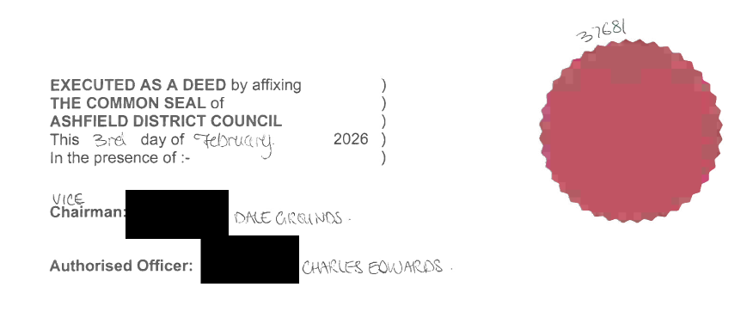

The Public Spaces Protection Order

– Ashfield District Council 2026

Schedule 1 (Restricting Access – Prohibition 1)
The highways described in the following Schedule and shown edged by bold red lines on the plans attached, being Public Places in the Authority's area to which the Act applies

Land Designated Specifically (“the Restricted Access Highways”):
The strips of land:
- Between Spruce Grove and Beacon Drive, Kirkby-in-Ashfield, Nottinghamshire
- Between Bentinck Street and Bramley Court, Sutton-in-Ashfield, Nottinghamshire
- Between Downing Street and North Street, Sutton-in-Ashfield, Nottinghamshire
- Rear of 34-37 Rockwood Walk, Hucknall, Nottinghamshire
- Adjacent 40 Rosewood Drive, Kirkby-in-Ashfield, Nottinghamshire
- Between Spruce Grove and Poplar Avenue, Kirkby-in-Ashfield, Nottinghamshire
- Between Welbeck Street and Portland Close, Sutton-in-Ashfield, Nottinghamshire
- Between Bramley Court and Sutton Lawn, Sutton-in-Ashfield, Nottinghamshire

