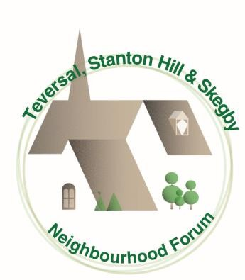Teversal, Stanton Hill & Skegby Neighbourhood Forum

[*www.tssneighbourhoodplan.org*](http://www.tssneighbourhoodplan.org/)

Manor Cottage, Manor Close, Teversal Village, Sutton-in-Ashfield,

Notts.,

NG17 3JN.

11th September 2024

Melanie Wheelwright

Forward Planning & Economic Growth, Ashfield District Council,

Urban Road, Kirkby in Ashfield, Nottingham, NG17 8DA.

Dear Melanie,

# Application for re-designation of the Teversal, Stanton Hill and Skegby Neighbourhood Forum

The Neighbourhood Planning (General) Regulations 2012 state that, where an organisation or body submits a neighbourhood forum application to the local planning authority, it must include:

1. The name of the proposed neighbourhood forum
2. A copy of the written constitution of the proposed neighbourhood forum
3. The name of the neighbourhood area to which the application relates and a map which identifies the area
4. Contact details of at least one member of the proposed neighbourhood forum to be made public under regulations 9 and 10
5. A statement setting out how the proposed neighbourhood forum meets the conditions contained in section 61F(5) of the 1990 Act.

For the avoidance of doubt, the following information and the paragraph references below relate to the information required in the order they are listed above.

1. **The name of the forum** is Teversal, Stanton Hill and Skegby Neighbourhood Forum
2. **Teversal, Stanton Hill and Skegby Neighbourhood Forum** written constitution is enclosed herewith.

# Teversal Stanton Hill and Skegby Neighbourhood Area

The Teversal, Stanton Hill and Skegby Neighbourhood Area, the subject of this application, is identified on the map submitted with this application and is similarly identified in the Forum Constitution.

No changes or amendments to the Neighbourhood Area have occurred since the Forum was originally designated or are proposed so it is considered unnecessary to set out further details of the extent of and justification for the area.

# Teversal, Stanton Hill and Skegby Neighbourhood Forum contact details:

Geoff Snare, Manor Cottage, Manor Close, Teversal Village, Sutton in Ashfield,

NG17 3JN Tel: 07970 125709

# How the Neighbourhood Forum accords with section 61 (F) 1990 Act.

The Forum has been established to promote or improve the social, economic and environmental well-being of the area. It consists of more than 21 members and its membership is open to people living in the area, people working in the area and to county councillors and district councillors for the area. This is reflected in the Forum’s constitution submitted with the application. A list of 21 members

extracted from the Forum’s membership (which is now considerable) is enclosed to meet the requirements and includes individuals from all of Teversal, Stanton Hill and Skegby. Meetings of the Forum are advertised by various means including posters, its website and Facebook pages (including Facebook pages of its constituent groups).

The Forum now has four groups of Forum members working on different challenges affecting the Neighbourhood Area. These are the Planning and Environment Group, the Friends of Stanton Hill, the Heritage Group and the Climate Change Action group. With the change in government policy relating to HS2 that group has been disbanded. Improvements to public transport now falls within the remit of the Climate Change Action group as it is part of the strategy to reduce carbon emissions throughout the Neighbourhood Area. A brief outline of the objectives of each of these groups appears on the Forum website. The formation of each of these groups was prompted by concerns raised by residents, businesses and Forum members and by perceived challenges to the well-being of residents and businesses.

The Planning and Environment Group is tasked, in addition to responding to planning and development issues affecting the Neighbourhood Area, with the maintenance, monitoring and amendment of the Neighbourhood Plan if considered necessary.

County and District Councillors are notified of and invited to attend Forum meetings and are encouraged to actively engage with Forum members and Forum initiatives. The Forum works with Ashfield District Council officers and officials on partnership projects of benefit to residents and businesses within the Neighbourhood Area.

Yours sincerely

Geoff Snare on behalf of

Teversal, Stanton Hill and Skegby Neighbourhood Forum