

DISCLAIMER

This document or some parts of it may not be accessible when using adaptive technology.

If you require assistance with accessing the content of the document, please contact us and quote the document name and the web page you found it on:
- Email: Forward planning – localplan@ashfield.gov.uk .

Kirkby Cross

Conservation Area Appraisal

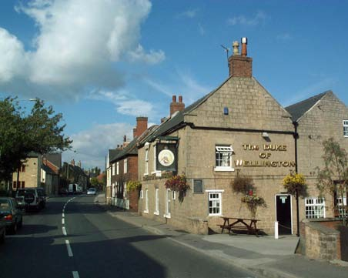
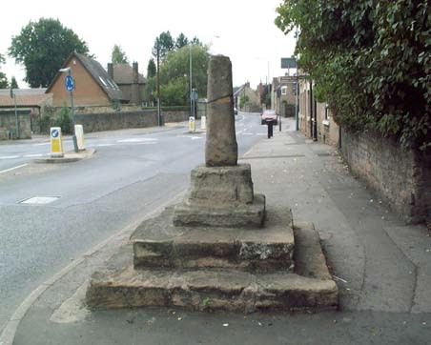
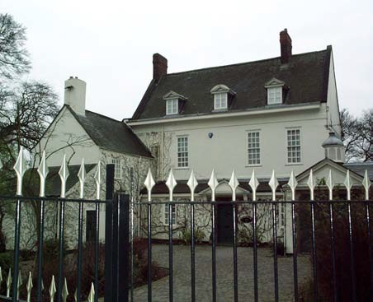
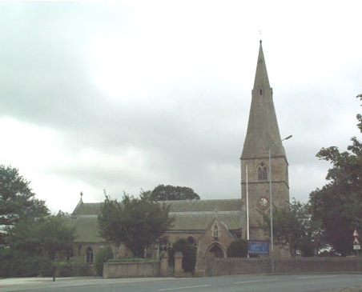


Ashfield District Council Adopted September 2004

INDEX Page
Table of Figures iii
Foreword v
- Introduction 1
- Conservation Policy and Designations 5
  - National Policy Context 5
  - Regional Policy Context 5
  - Structure Plan Context 6
  - Local Policy Context 7
  - Other Policy Context 9
- Historical Development 11
- Detailed Character Appraisal 15
  - Introduction 15
  - Old Chapel Close to Kirkby House Drive 18
  - Kirkby House Drive to Titchfield Park 24
  - Titchfield Park to Hockley Place 29
  - Hockley Place to Castle Hill earthworks 36
- Current Issues and Pressures 41
  - S.W.O.T Analysis 41
  - Strengths, Weaknesses, Opportunities, Threats – (S.W.O.T Analysis) 41
- Issues and Recommendations Arising from the Appraisal 43
  - Introduction 43
  - Amendments to the Conservation Area boundary 43

  - Buildings of Architectural/Historic Value 50
  - Potential Environmental Improvement Schemes 51
  - Adequacy of Current Policy Provisions 53
  - Information and Advice 56
  - Partnership working 57
Appendices 59
Appendix 1(a) 59
Appendix 1(b) 60
Appendix 2 63
Appendix 3(a) 69
Appendix 3(b) 70
Appendix 4(a) 71
Appendix 4(b) 72
Appendix 5 74
Appendix 6 75

Table of Figures

Figure 1- New Boundary of Kirkby Cross Conservation Area. 2
Figure 2 - Original Conservation Area boundary in 1975 3
Figure 3 – The Areas of the physical appraisal 17
Figure 4 – Land immediately north of Cow Pasture Lane 44
Figure 5 – Land to the east of St Wilfrids Church 45
Figure 6 - Land to the east of Old Chapel Close/west of Orchard Road 46
Figure 7 – Land at St Wilfrids Drive 47
Figure 8 – Land immediately north of St. Wilfrids Parish Hall 48
Figure 9 - Land to the rear of 12-16 Chapel Street 49

Foreword
The District Council formally adopted the Ashfield Local Plan Review on the 22nd November 2002. This replaces the Ashfield Local Plan which had been in effect since 1995. This Conservation Area Appraisal is being undertaken in response to the supporting text to Policy EV10 (Conservation Areas) within Paragraph 3.63 of the Local Plan Review. The text highlights the District Council’s intentions to review Ashfield’s four Conservation Areas during the near future. The reviews will be carried out as part of a ‘rolling programme’ commencing with the Kirkby Cross Conservation Area.
The Council has a limited built heritage resource which places a much greater importance in local terms on the Conservation Areas, Listed Buildings and Ancient Monuments that it has. As such, the review of the conservation areas and opportunities to improve those areas are considered to be a very significant part of the Council’s objectives regarding the environment.
This report draws upon the knowledge of a variety of people and groups from the local area and this has been achieved by consultation with the residents of Kirkby Cross and the Kirkby & District Conservation Society (KDCS), the preservation group for the Kirkby area. The KDCS have been a helpful source of valuable knowledge and assistance with historical data and of current pressures and issues to be found in the Conservation Area. Also of help and assistance has been the Nottinghamshire County Council Heritage Team who have supplied useful information and data in relation to the Conservation Area.

The appraisal in simple terms aims to:

- Highlight historic factors that have shaped the Kirkby Cross settlement into its current form.
- Review current conservation area policy and boundaries.
- Complete a thorough and comprehensive physical appraisal of the Conservation Area and immediate surroundings.
- Identify a series of actions arising from the appraisal to help preserve and enhance the character of the Conservation Area.
- Consult with the local community and other relevant bodies.

Several periods of consultation were undertaken with the aim of giving local residents, organisations and other interested parties a chance to make comments about the contents of the Conservation Area Appraisal. The first of these took place at St. Wilfrids Church Hall in December 2003 where local residents examined the proposed measures outlined in the Consultation Draft and were invited to comment on them. After all comments were received, the appraisal was amended where appropriate and a Revised Consultation Draft was created in March 2004. A Council Cabinet Report dated 1st July 2004 obtained authorisation to embark upon a further period of consultation requesting views on two substantive re-alignments to the Conservation Area boundary. After
further comments from the public on the two proposals, the Cabinet Report dated 16th September 2004 fully adopted the Kirkby Cross Conservation Area Appraisal as a Council document.

Introduction

  - Kirkby Cross is situated within the District of Ashfield, which is located within North Nottinghamshire. Kirkby Cross forms part of the urban settlement of Kirkby-In-Ashfield (population 19,585 – 2001 Census data) and is located five miles south-west of Mansfield, eleven miles north-west of Nottingham.

  - The newly-adopted boundary of the Kirkby Cross Conservation Area as of September 2004 is shown overleaf on Figure 1. The original Conservation Area boundary as designated in 1975 can be found on the next page as Figure 2. The Conservation Area predominately comprises residential buildings based around three main roads; Chapel Street from the east, Church Street from the south and Sutton Road to the north.

  - Kirkby Cross is elevated above the surrounding countryside to the east, west and the south, affording pleasant views of St Wilfrids Church and the adjacent Rectory, both buildings of significant importance within the Conservation Area. The settlement of Kirkby Cross is located at the head of the valley of a small stream which flows into the River Erewash. It is situated on a ridge of Lower Magnesian Limestone (Cadeby Formation) which slopes away to the east and is one of only three known areas in the world where the formation rises to just below ground level.
  - An essential element of a conservation area appraisal is to highlight the policy context that currently influences planning issues in Kirkby Cross. A review of national planning guidance has been undertaken which then filters down into a review of regional planning guidance, county level, and finally, planning guidance concerning conservation issues at a local (district) level.

  - A key stage in compiling this appraisal has been to analyse the history of the area. This is a logical first step in understanding the extent to which Kirkby has evolved from its early beginnings. This stage required the collation of available historical records and data. Such data has included historical newspaper articles, photographs and various plans of Kirkby through different periods of its past.
  - The main body of the report is the physical appraisal of Kirkby Cross Conservation Area. This appraises the current physical form of the area and with the aid of photographic data to be seen later in the report, a thorough survey of individual buildings and their surroundings within Kirkby Cross has been carried out.

  - By appraising the physical form of Kirkby Cross, main issues have been identified which will provide an opportunity for enhancing and preserving the character of the Conservation Area. The recommendations stemming from this appraisal have focussed on five key issues that can be seen within the foreword on the previous page.

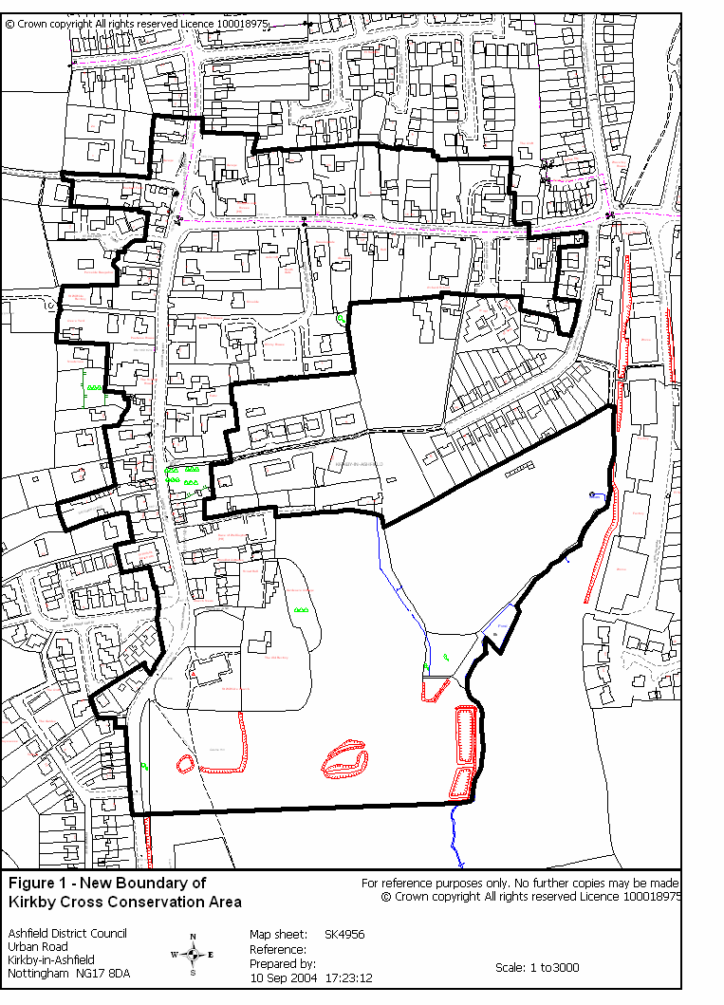

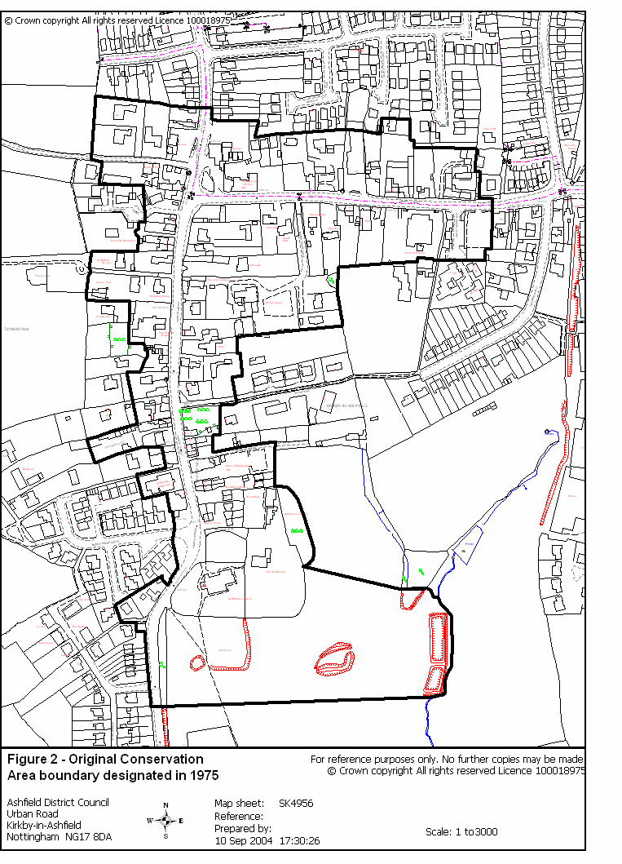
Figure 2

Conservation Policy and Designations
  - National Policy Context

    - The legislation for planning control in conservation areas is mainly contained within the Planning (Listed Buildings and Conservation Areas) Act 1990. Section 69 of the Act places a duty upon Local Authorities to designate
‘areas of special architectural or historic interest, the character or appearance
of which it is desirable to preserve or enhance.’
    - Section 71 of the Act states that once a Local Authority designates a conservation area, it is then,
‘the duty of the local planning authority to review the past exercise of
functions under this section and to determine whether any parts or any further parts of their area should be designated as conservation areas; and, if they so determine, they shall designate those parts accordingly.’

    - Planning Policy Guidance Note 15, ‘Planning and the Historic Environment (1994)’ provides the basis for helping to shape and guide policy regarding conservation areas at County (Structure Plan) and District (Local Plan) levels. Planning Policy Guidance Note 15 stresses the need and importance for the integration of conservation policies with policies for other aspects of the local area such as shopping, housing provision and traffic management. A review of conservation area designations is identified as important to maintaining the credibility of such areas.

  - Regional Policy Context

    - Conservation policy at regional level is addressed within the East Midlands Regional Planning Guidance Note (2002). Regional Planning Guidance provides a regional interpretation of national policy, and aims to set out a spatial development strategy that amongst other things, encompasses proposals for the “conservation and enhancement of the natural and cultural environment for the benefit of all the region’s citizens.”
    - Policy 29 of the Regional Planning Guidance emphasises the importance of the region’s environment and preserving regional and local distinctiveness throughout the East Midlands. Policy 29 reads as follows: -

Policy 29 – Protecting and Enhancing Natural and Cultural Assets.

To protect and where possible enhance the East Midlands environment, development plans should reflect the following environmental principles in respect of both natural and cultural assets, taking account of the economic costs involved:
      - Important aspects of the environment, including individual features, special sites and landscapes should be protected;

      - Regional and local distinctiveness and variety should be recognised, based on a thorough assessment of local character any local, national or international designations;
      - A more broadly based concern for, and awareness of, biodiversity and other environmental issues should be integrated into site-based approaches.
      - Damaged environmental features should be restored whenever
possible;
    - The new Draft Revision of Regional Planning Guidance for the East Midlands (2003) maintains the same approach towards the region’s environment in line with current national planning guidance. There are several slight amendments in policy, but the overall aim of preserving regional and local distinctiveness remains broadly the same.
  - Structure Plan Context

    - The Nottinghamshire County Structure Plan provides the strategic planning framework for the development and use of land in the area and for the protection and enhancement of the environment.
Policy 3 / 4 of the Structure Plan recognises the County’s historic heritage as an important asset which the Plan seeks to preserve and manage.

Policy 3 / 4 – Protection of Ancient Monuments and Archaeological Sites

Proposals affecting areas of archaeological interest will not be permitted where:

- Development would result in any disturbance to a scheduled Ancient Monument and/or its setting.
- Development on other sites of archaeological importance would involve significant alteration or cause damage, or would have a major impact on the setting of the archaeological remains
    - Policy 3 / 17 relates to the protection that settlements of historic and architectural character should receive. This can be done through the mechanism of listing for individual buildings or where a collection of buildings is considered worthy of protection; a conservation area may be designated.

Policy 3 / 17 – Historic Buildings and Areas
The historic and architectural character of the County will be protected and enhanced by:

- The protection and maintenance of buildings listed as of special architectural, historic or landscape importance:
- The designation, enhancement or preservation of conservation areas:

- Provision for environmental improvement schemes in conservation areas and other appropriate areas:
- Provision for appropriate alternative uses for, and the restoration of,
listed or other buildings worthy of retention.
  - Local Policy Context

    - The designation of Kirkby Cross by Ashfield District Council as a Conservation Area occurred in 1975. The area (as seen in Appendix 1(a)) is home to a number of listed buildings in addition to two ancient monuments which contribute to the historic character of Kirkby Cross. Together with a well-preserved townscape, these elements justified the original designation of Kirkby Cross as a conservation area.

    - Conservation planning policies within the Ashfield Local Plan Review are drafted to take into account current national, regional and county policy and guidance. Such planning policies are integrated within the Ashfield Local Plan Review adopted in November 2002.
    - The Ashfield Local Plan Review policies acknowledge the role that conservation within Ashfield currently has. Ashfield contains four conservation areas, these being at Kirkby Cross, Bagthorpe, Teversal and Annesley Village. Ashfield’s policies recognises the requirement to accommodate change through new development, but at the same time, preserve buildings and spaces, the loss of which would have a negative impact upon the character and appearance of the area.

    - Policy EV10 of the Ashfield Local Plan relates directly to development within conservation areas. The designation of a Conservation Area does not prohibit development from occurring, but it does place tighter control on what development can or can not take place. In the case of Permitted Development rights, building demolition and works to trees, all are subject to additional legislative requirements within an conservation area. The policy reads as follows: -

Policy EV10 – Development in conservation areas will only be permitted where: -

- It preserves or enhances the character or appearance of the area, or its setting.
- In the case of demolition or partial demolition it can also be demonstrated that the building is beyond economic repair, viable alternative uses cannot be found or redevelopment would produce substantial benefits for the community that would outweigh the building’s loss.
- Redevelopment following demolition is undertaken within an agreed timescale secured by condition.

    - Policy EV11 relates to Ancient Monuments. There are two Ancient Monuments within the Conservation Area. The first is the 13th Century Market Cross, whilst the second is the remains of a 14th Century fortified Manor House within the field

immediately south of St.Wilfrids Church. Both monuments were scheduled in 1995. The Fishponds to the east of St. Wilfrids Church are also a recognised Ancient Monument (listed recently in 2001) but are not fully located within the boundary of the Kirkby Cross Conservation Area. This may have implications for a possible re-alignment of the existing Conservation Area boundary which will be investigated later in the Appraisal. The policy places emphasis on the importance of the preservation of such scarce irreplaceable resources, which help to inform a community about its history.
Policy EV11 – Development affecting ancient monuments or other sites of archaeological interest will only be permitted where: -
In the case of an Ancient Monument

- It would preserve a scheduled ancient monument or other nationally important monument and/or its setting.

In the case of other sites of archaeological interest:

- In-situ preservation is merited, it would not involve significant alteration or cause damage or would have a major adverse impact on its setting, or
- In-situ preservation is not possible and the need for the development outweighs the importance of the remains and arrangements are in place for the site to be surveyed, excavated and recorded prior to the development.
    - Policy EV12 relates to Listed Buildings within Ashfield. There are 16 Grade II Listed Buildings within the Kirkby Cross Conservation Area, which have been recognised as being of special architectural or historic interest (these are shown in Appendix 1(a)). The policy indicates that development involving a Listed Building must ensure that the appearance and character of the building is preserved. In addition to this, any development must take into account the setting of the Listed Building in relation to its immediate surroundings. Any alteration or extension must respect the building’s character and scale, so care is needed to prevent damage occurring to important features. If the building can no longer function in the way in which it was intended, careful consideration will be given to alternative uses that will secure the Listed Building’s future. Any alternative use will however, have to respect the composition and appearance of the Building with as little external and internal alteration as possible.

Policy EV12 – Development involving the alteration, extension or re-use of a listed building will only be permitted where:-

- It preserves the character of the Listed Building and its setting,
- It respects the scale, design, and materials of the existing building,
- Redevelopment following demolition is undertaken within an agreed timetable.

In the case of demolition or partial demolition it can be demonstrated that the building is beyond economic repair, viable alternative uses cannot be found or redevelopment would produce substantial planning benefits for the community that would far outweigh the building’s loss.
    - Policy EV13 relates to external effects from development that might impact on the setting of a Listed Building. The setting plays a key role in the character and appearance of a Listed Building and will be protected where development is likely to have a significant adverse affect. Such development may well be sited some distance away from a Listed Building, but may harm and impede views essential to its appearance and character.

Policy EV13 – Development will only be permitted where through its siting, scale or design, it preserves the setting of a Listed Building.
  - Other Policy Context
    - There is no other planning policy context constraints currently in place which directly affect development within the Kirkby Cross Conservation Area. However, the Council’s Community Strategy and Cultural Strategy recognises the role of the historic environment in Ashfield and the importance of preserving and enhancing this resource.
    - A corporate policy not uncommon to other conservation areas throughout the country is an Article (4) Direction. This directive falls within the 1988 Town & Country General Permitted Development Order. The Directive is a tool that gives local authorities the power to remove either part or all of the General Permitted Development Order in a particular area such as a conservation area in this particular case. An Article Four Direction requires the owner or occupier of a building to submit a planning application for development which is no longer considered as permitted. Examples of this are the replacement of traditional doors, windows and rendering of the property’s exterior. The Article Four Direction may be one option that is considered as a result of the Conservation Area appraisal. Applying an Article 4 Direction may help preserve the Conservation Area from piecemeal alterations that could be viewed to be gradually eroding the character felt within Kirkby Cross.

    - The County Council has commenced work on identifying a ‘Local List of Important Buildings’. Survey work for Kirkby Cross did not include the Conservation Area itself. The limited work that was carried out directly to the east of the Conservation Area has been incorporated into this appraisal and the buildings identified by the County Council have been annotated as ‘Other Buildings Contributing to the Historic Townscape’.

  - Historical Development
  - The history of the settlement at Kirkby Cross can be traced back as far as the 8th Century, when the first Lord of Ashfield requested the construction of a castle, later to be known as Kirkby Castle, which had distant and important views to the south and the west. The settlement took its name from the Danes who occupied the area; Kirkby when translated simply meaning ‘village with a church’. In this section of the appraisal, ‘Kirkby’ refers to the settlement immediately surrounding the Kirkby Cross Monument, which extends southwards to St. Wilfrids Church. ‘East Kirkby’ refers to the settlement which developed two miles east of Kirkby, centred around the junction of Kingsway and Diamond Avenue.

  - Mention is made of Kirkby within the Doomsday Book of 1086 with particular reference made towards Kirkby as having ‘a church, a priest and two mills’.
  - Doubt is raised as to the exact date of when the Market Cross was constructed, as Henry III granted the area a market sometime between 1216 and 1272, although the official listing dates the Cross as 14th Century. The monument came to symbolise the early settlement, becoming the focal point for local people as well as the centre of early commercial and social activity. Even today, the steps and the shaft of the cross can be found preserved to a reasonable state adjacent to the crossroads of Church Street and Chapel Street. Its original location was thought to have been located in the centre of the junction between the two main roads.

  - In 1261, Kirkby was granted a weekly market and a fair by Henry III. This resulted in the role of Kirkby being enhanced along with the growth of commerce in the area.

  - By the turn of the 14th Century Kirkby was growing supported by the relative safety of Kirkby Castle, which had been constructed in the style of a fortified Manor House. However, by 1310, King Edward I had his valuers assess the value of all castles throughout the country. Kirkby Castle was deemed to be ‘worthless’ and steadily degenerated until the structure was left in ruin as the 15th Century approached.

  - Throughout the 16th and 17th Centuries, farming increased in prominence up until the iron industry arrived in Kirkby in 1666. The Lord of Kirkby at the time, the Duke of Newcastle, granted Humphrey Jennens “all the wood and underwood now standing or growing within the bounds and lands of Kirkby Wood.” Large swathes of surrounding forest were felled to feed the furnace (constructed in 1671) and properties were erected for the workmen and servants. However, by 1680 the iron industry had ceased to operate in Kirkby after timber reserves from the surrounding forests had been exhausted.

  - By the start of the 18th Century, Framework Knitting had been introduced to Kirkby. The population of the village in 1743 as counted by one of the Rectors sent by the Archbishop of York was “around” 600 people. By the end of the 18th Century, the population, as counted by Lowe, had risen to 891 people. The Framework Knitting industry continued to grow in status throughout the 19th Century, with a survey carried

out in 1844 showing there to be a total of 155 masters’ shops (with 474 frames in active use) in Kirkby and Kirkby Woodhouse. During this period, tradesmen in Kirkby included a grocer, shoemaker, blacksmith, wheelwright, maltster, butcher, baker and limeburner.
This shows how diverse commercial activity was in Kirkby during the early 19th Century.
  - The spatial growth of Old Kirkby from the 1830’s onwards can be seen from the maps shown within the text (Appendix 5). The first plan from 1878 shows Kirkby as a settlement surrounded by agricultural land located along the roads that are now known as Chapel Street and Church Street. Important buildings at the very heart of Kirkby were The Manor House, The Rectory and the Church of St Wilfrids. The remaining dwellings comprised farm-related and residential buildings and helped form a link between the three structures mentioned above, and the ancient monument of Kirkby Cross in the north of the Conservation Area.

  - The plans of 1878, 1900 and 1917 show very little change in what stood within Kirkby, although there were very significant changes taking place just outside what would later become the Conservation Area boundary. The latter years of the 19th Century and the early years of the 20th Century saw a substantial shift in employment sectors in the local area. Agricultural practices slowly faded to be replaced by the heavy industrial methods of coal mining that located to the south and north-east of Kirkby (Bentinck and Summit collieries respectively). These influenced the development of the surrounding area, with significant new housing being constructed to the east of Kirkby to meet the housing needs of coal workers.

  - The development surrounding Kirkby prompted associated problems that were to have a bearing on the settlement. First, the need to house the miners and their families led to the development of a separate settlement a mile east of Kirkby. This area became known as East Kirkby and quickly developed westwards until 1938, by this time the new housing developments had reached the edge of Kirkby. Kirkby was no longer a self-standing settlement with rural surroundings and had become joined to East Kirkby with its new development and modern architectural styles. During this period, the area known as Kirkby began to be referred to locally as Kirkby Cross. Levels of traffic passing through Kirkby Cross increased. Heavy trucks and lorries carrying coal were increasing noise levels and the activity seen on the local roads.

  - Change within Kirkby Cross from 1938 to the modern day has predominately come about through the demolition of dwellings. Many of the farm-related dwellings that lined the yards off Church Street have gradually disappeared during the last 75 years. This is perhaps the most noticeable feature found when comparing the present-day Kirkby Cross (see appendix plan 1(a)) to a plan of the area 100 years ago. Several yards, enclosed areas off the main road that were lined by terraced housing, have disappeared over time. Such yards include Davison’s Yard, Heath’s Yard, Shardley’s Yard, Bradley’s Yard and Brunt’s Yard, all names to be found in the ancient parish registers that commenced in 1620. Where these yards once stood, new private housing developments, generally large detached properties away from the street frontage have been erected. This has somewhat diluted and altered the original character within certain parts of the Conservation Area. Unfortunately, local landmarks have been lost along the way and an example of this is the loss of Kirkby Manor House in the early

1950’s. This prompted the creation of the Kirkby and District Conservation Society, a local Preservation Society to aid with the conservation of remaining examples of architectural merit in the Kirkby area. Today, the Manor House Court Estate stands on the site of the old Manor House.

  - Detailed Character Appraisal
  - Introduction
Each conservation area has a special character. This is a result of several factors, such as individual (or collections of) buildings or spaces, their settings and surroundings, street patterns, the nature of the landscape (vistas) and land-use and activity found within the area. These will all differ from area to area.

    - Kirkby Cross was designated a conservation area by Nottinghamshire County Council in 1975. It is an historical section of Kirkby-In-Ashfield that still shows traces of the agricultural settlement that Kirkby Cross once used to be. Despite the gradual, but total loss of agricultural activity in farms, stables and barns, several farm buildings have been carefully conserved however, and contribute to the character of the area.
    - Kirkby Cross has evolved from a small farming-based settlement into a predominantly residential area. The majority of buildings within the Conservation Area are now of residential use with a limited, but diverse range of commercial properties found within the boundary of Kirkby Cross. Contributing to the commercial activities in the area are a Petrol Filing Station, a Car Showroom, a Furniture Sales Outlet, a Potato Merchant, two Public Houses (both present in the settlement throughout the last several centuries), a Billiards Hall and a Gas Installation Company. This commercial core of use adds little to the architectural value of the area as a whole. However, they do add to the economic activity in Kirkby Cross, and are a modern day reminder of the earlier market basis of the area.

    - Whilst the historical core of Kirkby Cross has witnessed limited changes to its shape and character, the wider Kirkby-in-Ashfield area to the east and north of the Conservation Area has seen expansion through the introduction of heavy industry and mass housing since the turn of the 20th Century. The shape of the Conservation Area today is virtually identical to the shape of the settlement of Kirkby Cross in 1830. It is the immediate surrounds of the area that contribute to the distinct difference in character felt inside and outside Kirkby Cross. An example of this is the northern section of Conservation Area boundary that now divides several traditional 18th Century farm buildings from late 20th Century private housing development.

    - What helps to create the historical character within Kirkby Cross is the near-continuous street boundaries made up of either buildings (predominately of dressed stone build) or dressed stone walls. Where these physical features sit closely against the roadside, a sense of enclosure is evident in the streetscape. Over the last few decades though, this characteristic has been eroded slightly by the loss of buildings positioned immediately at the roadside. These properties have been replaced by buildings located further back in their plots of land lessening the sense of enclosure and widening the general streetscape.

    - One way to gain the full appreciation of the character within Kirkby Cross is to assess the various elements of the Conservation Area by travelling through it along the main thoroughfares from one end of the area to the other. The elements described

above, when pieced together help create a sense of character, which can be described in some detail.
    - The appraisal at this point divides the Conservation Area into four areas for the purpose of the physical appraisal. The four areas that collectively comprise the Kirkby Cross Conservation Area are:

      - Old Chapel Close to Kirkby House Drive.
      - Kirkby House Drive to Titchfield Park.
      - Titchfield Park to Hockley Place.
      - Hockley Place to Castle Hill Earthworks.

The above areas are shown overleaf in Figure 3. The physical appraisal commences where the current Conservation Area boundary crosses Chapel Street near to the Sherwood House Inn, and concludes at the Castle Hill Earthworks to the south of St Wilfrids Church.

    - Appraising the physical form highlights several aspects which appear within the appendices of the Conservation Area appraisal. The appraisal highlights important aspects such as:

      - Listed Buildings
      - Other Buildings contributing to the historic townscape
      - Scheduled Ancient Monuments
      - Open spaces of significance
      - Significant trees and landscape
      - Important Views
      - Important stone boundary walls

All of which individually, and combined as a whole, help to characterise the historic area of Kirkby Cross.

Figure 3
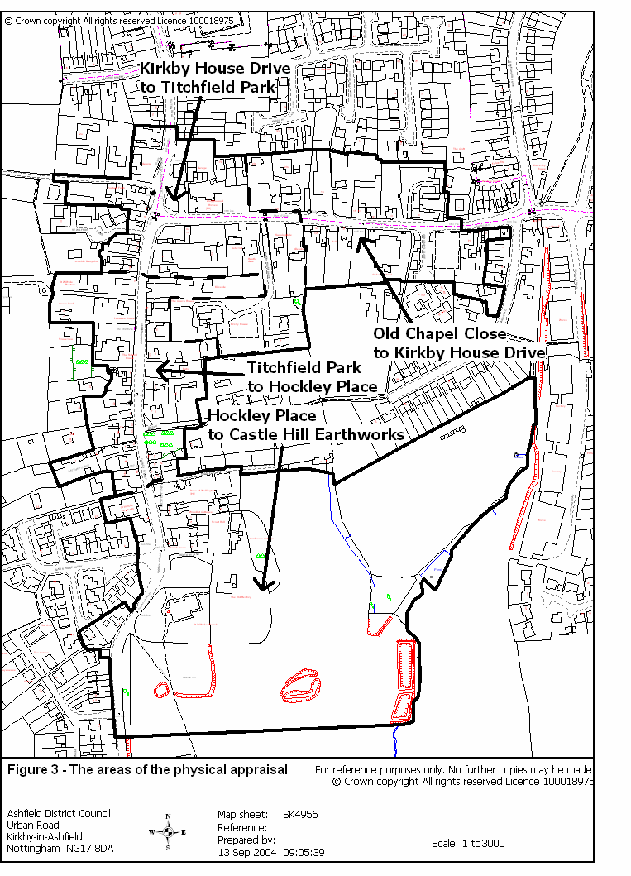

  - Old Chapel Close to Kirkby House Drive
    - This section forms the main link between Kirkby Cross and the more recent urban settlement of Kirkby-In-Ashfield (formerly East Kirkby) to the east. The frontages of properties facing onto Chapel Street have undergone only minimal change during the last several decades. However, there have been some alterations, the most notable being the recent construction of a commercial property on the north side of Chapel Street. This section of the Conservation Area has seen recent housing developments within some of the large plots of land on the north side of Chapel Street. Many properties have survived from the 19th Century until the present day, only their usage changing, and particularly several farmhouses on the north side of the road that have seen only minimal alterations to their appearance.
    - The retention of many agricultural buildings from the late 18th, 19th and early 20th Centuries gives this part of Kirkby Cross a traditional feel. This is enhanced due to the close proximity of the older buildings on Chapel Street and the closeness of the buildings to the road, with narrow pavements, helping to form a sense of enclosure along the streetscape. With Chapel Street being so straight in its appearance, there is an impressive view through the spine of this area, towards the crossroads with Church Street and Sutton Road.
    - When approaching the Conservation Area from the east, the first noticeable feature is a collection of brick buildings on the south side of Chapel Street which all lie just outside the existing Conservation Area. 1, 3, 5 and 7 Chapel Street contribute collectively to the entrance view along Chapel Street from the east.

    - 1 Chapel Street is a detached, single-storied property which has a grey slate roof. It stands on the corner of Chapel Street and Orchard Road. At present, the property lies vacant and is in need of renovation work. The building helps to define the corner plot on entrance into the ‘old village’. Between 1 and 3 Chapel Street, elevated above the streetscape behind a stone retaining wall, is a small car park that takes its access from Orchard Road.
    - 3 and 5 Chapel Street are a pair of semi-detached, three-storied properties set behind a small stone wall. The building has a grey slate roof. To either side of the central passageway that provides access to the buildings is a single bay window with render applied to the surrounding brickwork. At first floor level are three timber sash windows with painted lintels and sills. On the second floor there are three timber sash windows, again, with painted lintels and sills, albeit slightly smaller than the ones on the level below. Immediately above is a timber-panelled section of the north-facing gable.

    - 7 Chapel Street is the Sherwood House Inn public house. This detached, three-storied property has a grey slate roof and is constructed from brick. The form of the building is loosely based on a rectangular form with gable-ends looking to the north and the west, with the frontage of the building looking out into Chapel Street.
On the first floor to the left of the front door is a single casement window with a segmental arch; whilst to the right of the door are two top-hung timber casement windows, also with segmental arches. At the first-floor level looking from east to west, is

a single casement window with segmental arch. To the east is a painted white datestone that reads ‘1898’. Further to the east are two top-hung timber casement windows, both with segmental arches. The second floor of the building can be divided into two sections. One section of the building’s frontage is incorporated into its gable-end with two timber sash windows, whilst the other component of the second floor is incorporated into the roof with two dormer windows. Each of the above buildings is of a slightly differing design, but are mostly in keeping with their immediate neighbours.
Numbers 3 and 5 as well as the Public House are all three-storied, and this starkly contrasts in scale with Number 1, which is single storey, small and isolated in nature. When viewed alongside Orchard School, this group of buildings form a group of late Victorian buildings which are worthy of note.
    - To the rear of this collection of properties are the properties of 12 and 14 Orchard Road. A late-18th century south-facing property now subdivided into two dwellings. The building is two-storied and is positioned at right angles to the road. Located to the rear is an imposing stone wall, with an attractive landscaped garden located to the front and sides of the property. The building has been constructed from square-cut regular coursed stone and has a grey slate roof with two stone gable-end stacks to either side of the property. To the eastern end of 12 Orchard Road is a mid-20th Century two-storey extension that is slightly lower in height, with a roof line set lower than that of the original property’s roof. The frontage of the property sees to the left of the central door with lintel, a single stone mullion window on both floors consisting of three UPVC lights, with surrounding stone architrave. This is replicated to the right of the central door. Directly above the central door on the first floor is a near-identical mullion window, this one only containing two lights. To the right is the extended wing, and at ground floor level is a large recess spanning the width of the wing comprising timber walling which has several window lights incorporated into it. Upon the frontage in both of the upper corners of the building, is a single modern satellite dish. The architectural features of these properties combined with its attractive landscaped grounds and sense of tranquillity help to make a positive contribution to the historic townscape of the Conservation Area.
    - When entering the Conservation Area from the east, the first noticeable feature is the public house car park on the south side of Chapel Street. This space is noticeable, as it is not in keeping with surrounding land-uses. Just beyond the car park lies Old Chapel Close, which provides access to a recent housing development (1990) of low-rise residential flats and apartments located just beyond the boundary of the conservation area.

    - Immediately on the opposite side of the road is 6 Chapel Street. This comprises two separate buildings, one being two-storied and the other single storey clustered around a courtyard. The larger building is constructed from dressed stone in courses with a slate roof. The building has three stacks, a gable stack at both ends and a ridge stack in the centre. The seven windows on the frontage of the property are all modern casement windows. Overall, this building contributes to the historic townscape seen within Kirkby Cross.

    - Immediately to the west is 10 Chapel Street. The building is instantly recognisable from the vivid whitewash used on the façade of the building. The vivid whitewash combined with the architectural merits of the building ensures that this property contributes to the historic townscape seen within the area. A small section of the west-facing gable remains free from whitewash, showing the property to be constructed from coursed dressed stone. This two-storey property has a blue slate roof with a gabled stack at either end. Flanking the porch on the ground floor are two top-hung wooden casement windows, above on the first floor are four wooden casement windows. On the west-facing gable are fixed casement windows on the upper and lower floors. The frames of all windows are painted black creating a striking contrast with the surrounding whitewash used on the property.
    - Immediately opposite 10 Chapel Street is the Orchard Nursery and Infants School which was constructed in 1900 following the designs of Lawrence Bright. The school is set behind a wall that is divided into three sections to allow for pedestrian and vehicular access to the school. The wall is constructed from stone coursed rubble with the first section to the east standing eight feet tall, which falls to four feet for the central section (topped by four feet high metal railings) and then reverting back to eight feet in height for the final section to the west.

    - The school building is single storey and constructed from red brick with a blue slate roof. It forms a ‘T’-shaped plan with gabled ends facing north and south, and gabled ends facing east and west, all of which have parapets. A porch has been erected to the front of the building extending it towards the main road.

    - The windows on the east and west-facing gables as well as those at the southern end of the building are mullioned and have stone piers that rise to meet decorative windows on the upper half of the gable. On the frontage of the school are two round-headed dormer windows above seven modern sash windows on the porch of the building. To the rear of the school, but just beyond the Conservation Area boundary is a recently constructed single story classroom of little architectural merit. The main school building helps to contribute to the historic townscape of the Conservation Area.

    - Bordering the east of the school site is a footpath that leads to Orchard Walk. Ultimately the footpath leads onto Church Street further south within the Conservation Area.
    - Opposite the Orchard School are the properties of 12-16 Chapel Street (No. 1 in Appendix 1(a)), a Grade II listed group of buildings (Photo 1 – Appendix 2). This collection of properties includes a farmhouse, farmyard, stables and a barn. The farmhouse, which is late 18th Century along with the adjoining cottage rebuilt in the 20th Century, is constructed from dressed stone and brick with a slate roof. The farmhouse that incorporates property numbers 12, 14 and 16, collectively has an ‘L’ shaped form with a gable-end facing out onto Chapel Street. To the left of the door on the south front of the building is a single sash window with two sash windows to the right. On the first floor are three sash windows. The west-end of the farmhouse has a two-storey rear wing with a door flanked by a single casement window. To the right of this is a casement window with three casement windows above. The south gable has a re-

bricked opening, whilst above is a casement window with a segmental head. The ground floor of the eastern side of the farmhouse has two modern casement windows with three casement windows above, all having segmental heads.
    - The adjoining stables and barn (No. 2 in Appendix 1(a)), also Grade II listed, can be dated to the late 18th Century and are constructed from dressed stone and brick with pantile roofs. Both the stables and barn have recently been subject to conversion into several residential properties. There are several casement windows that alternate with doors on the frontage of the converted stables, as well as a single garage door on the east wall. The west gable of the barn has an external stone staircase to an above door. The south-facing frontage has four doors at ground-floor level and three casements above. On the north-facing rear of the barn-conversion are several modern timber side-hung casements on each of the two stories. Each property in the converted barn has its own enclosed private garden.

    - The farmyard and boundary walls (No. 3 in Appendix 1(a)) of 12-16 Chapel Street are Grade II listed for their group value. Dating from the late 18th and early 19th Century, the walls, which are 30 metres long, are coursed and constructed from squared rubble with half-rounded coping.

    - To the rear of 12-16 Chapel Street, the Conservation Area boundary currently incorporates the property of 9 Castle Hill Close. This property forms part of a late-1990’s housing development of no particular architectural merit, which is predominantly positioned outside the current Conservation Area. The positioning of the property in relation to 12-16 Chapel Street ensures that visibility of it from Chapel Street is all but obscured contributing to the isolated nature of the property. Proposals to re-align the Conservation Area boundary to remove this property can be seen in section 6.2 later in the appraisal.

    - Adjoining 12-16 Chapel Street is a modern furniture showroom warehouse set well back from the road behind a large parking area. Should redevelopment be proposed on this site in the future, careful consideration will need to be given to the possible enhancement of this part of the Conservation Area which currently contributes little to its appearance.

    - Immediately opposite the furniture showroom is the old Methodist Chapel that is flanked by a single property to either side. The building was constructed in 1834 when Chapel Street was known as Town Street. As the building pre-dates the reign of Queen Victoria, the County Council has grounds for designating this building as one of Local Interest. It has since been converted into a Snooker and Billiards Hall. A two-storey brick extension to the west of the original structure has been added during the mid 20th Century. The building is raised slightly above street level. It is two-storied and constructed from coursed dressed stone. The building is north facing and its frontage has four top-hung casement windows (one on the mid-20th Century extension) on the first floor and two casement windows flanking a painted stone archway of which the entrance to the building is within. The Chapel makes a positive contribution to the townscape of the Conservation Area (see Appendix 1(a)).

    - To the east of the Old Methodist Chapel is 21 Chapel Street. The brickwork on the frontage of this detached two-storied property has been heavily rendered leaving only the windows and door exposed.
    - To the west of the Old Methodist Chapel are 23 and 25 Chapel Street. This pair of cottages have been constructed from coursed dressed stone and have a blue slate roof. The property is west facing and sits at a 90-degree angle to the main road with the north facing gable fronting onto Chapel Street. On the ground floor of the west-facing wall are two adjoining central porchways. To the left of the entrance porch is a top-hung timber casement window with an identical window above and this is replicated to the right of the twin central porch-ways. On the east-facing side at ground level are four side-hung casement windows with four identical windows above. All windows on the east elevation of the property have distinct black painted lintels. Overall, this pair of cottages make a positive contribution to the townscape of Kirkby Cross (see Appendix 1(a)).

4.2.2325 metres west, located on the north side of the road is 20 Chapel Street (No. 4 in Appendix 1(a)), a two-storied Grade II listed building (Photo 2 – Appendix 2). This property, a renovated farmhouse, is immediately noticeable for its almost-complete ivy coverage on the frontage and the south-facing gable of the building. A coursed rubble wall separates the yard of the property from the pavement. The property dates from the late 18th Century and is constructed from dressed stone. The roof is blue slate and has a single ridge and a single gable-end corniced stone stack. The east-facing frontage has three glazing-bar sash windows on each floor.

    - To the north-east of the farmhouse is a stable (No. 6 in Appendix 1(a)) which is Grade II listed for its group value (Photo 3 - Appendix 2). The stable dates from the late 18th Century with modifications carried out in the mid-19th Century. It is constructed from dressed stone and brick and has a steeply pitched pantile roof. The stable is two-storied and on the south side of the building is a stable door.

    - West of the farmhouse is a garden boundary wall (No. 5 in Appendix 1 (a)) constructed from coursed and squared rubble dating from the late 18th Century. This is also Grade II listed for its group value.

    - To the east of the yard is a single storey stable range (No. 7 in Appendix 1(a)), now in use as private garages. It is Grade II listed for its group value. The building dates from the late 18th Century and is constructed from dressed stone and brick. It has a pantile roof with a single external gable stack. The west elevation of the stables has a stable door flanked by a single casement window. Moving to the right, there is a stable door and a more recent 20th Century garage door. The garage door is flanked by a single casement window. Further to the right is another stable door.

    - Within the grounds of the property is a Grade II listed (for its group value) K6 Telephone Kiosk (No. 8 in Appendix 1(a)) that dates from 1935. The Kiosk is constructed from cast iron and has a wooden door.

    - To the rear of 20 Chapel Street are the properties of 20a and 20b Chapel Street. 20b is a late 20th Century two-storied detached property of no architectural value to the Conservation Area. The property of 20a again, contributes little architecturally to the Conservation Area and is barely visible from the main road due to its location to the rear of 20 Chapel Street.

  - Kirkby House Drive to Titchfield Park
    - This area is where the busy highways of Church Street, Chapel Street and Sutton Road meet at the heart of the Kirkby Cross Conservation Area. The areas most important facet is undoubtedly the Kirkby Cross monument, an ancient monument dating back to the 13th Century. Despite the presence of one of the oldest features of Kirkby Cross, the area has also been home to new development over the last four decades.

    - There are only a small number of properties remaining in this area that were constructed prior to the 20th Century. The area has become home to a variety of architecture of mixed quality and appearance.

    - Carrying on from the junction between Kirkby House Drive and Chapel Street, the first noticeable feature is the car park on the north side of the road that serves the Waggon & Horses public house and a small landscaped area to the road frontage in need of improvement. Behind the car park and just within the confines of the conservation area boundary are three detached dwellings that form part of a small housing estate on Meadow Farm View. The houses contribute little to the architectural value of the area. These properties are partially screened by a brick boundary wall that divides them from the car park. This reduces visibility of the houses from the main road.

    - On the south side of Chapel Street lie four large, early 20th Century detached houses. The properties of Glendore, Sunningdale, Heathgate and Ashcroft are all set in spacious plots of land well back from the main road. Between the properties of Sunningdale and Heath Gate is the access drive leading to Kirkby House. A protective shield of varying types of deciduous trees give the properties on the south side of Chapel Street a sense of privacy from the passing pedestrians and traffic. These properties fill most of the space immediately south-east of the mini-roundabout and around onto Church Street, where some of the properties have their access from the main road.

    - To the rear of these properties set in a large plot of land is Kirkby House. This large detached stone-built property dates back to Victorian times. The building has a grey slate roof with four stacks (two gable-end stacks and two ridge stacks). The House has an east-facing frontage with a slightly projecting central section containing a door and above, a sash window. To either side of the door are bay windows, each containing three sash windows. Above the bay windows to either side is a single sash window. Projecting from the roof is a long box dormer containing three casement windows. On both corners of the frontage are decorative stone quoins. The north elevation of the building has in total, fourteen windows distributed evenly over the ground and first floor of the property and these comprise a mixture of modern casement and timber sash windows. A large single storey ‘L’ plan extension is of little architectural merit and has been added to the south side of the building in the late 20th Century. Added to the west elevation of the building is a flight of stairs within an extension. Again, this extension is of no architectural value. Overall, the House and its immediate setting make a positive contribution to the historic townscape of the Conservation Area (see Appendix 1(a)). To the east of Kirkby House is an area of significant open space, bounded on its northern

side by a row of beech trees and partitioned from a much larger piece of open space to the south (which is outside the Conservation Area), by a concrete fence. The central area of the space is grassed with hardstanding surrounding the grassed area on all four sides. This area of open space helps contribute to the setting of Kirkby Hall.
    - The main means of access to the building is by Kirkby House Drive. The Driveway continues southwards from Chapel Street and then turns at right angles to the west arriving at the House. The Drive is lined on its east and the north sides by a dense collection of mature Beech trees that follow the road around to the House. Access to Kirkby House is also available from Church Street through a small driveway, and noticeable on this is a set of large decorative iron gates with the name of the building incorporated into the design.

    - To the east of Kirkby House are two late 20th Century two-storied detached houses, 1 and 3 Kirkby House Drive, that are of little architectural value.

    - On the north side of Chapel Street is the Waggon & Horses public house. The public house dates from the mid-17th Century and was one of three Inns known to have existed in Kirkby in 1675. The pub, which makes a positive contribution to the townscape of the Conservation Area (see Appendix 1(a)), can be clearly divided into two distinct sections. The west section dates from the 19th Century, whilst an eastern wing has been added during the latter half of the 20th Century. The ground floor of the west section has been rendered leaving only two glazing-bar sash windows exposed. Above, spanning this section of the public house’s frontage, is the ‘Wagon and Horses’ hoarding. The first floor of the frontage as well as the east-facing gable and two chimneystacks on the older structure have had whitewash applied. The east-wing of the public house was added during the mid-20th Century and is constructed from coursed redbrick. To the right of the door is a top-hung glazing bar casement window. To the left of the door are two sash windows divided by a small fixed casement window, filling a space where a larger window looked to have once been present.
    - Facing the mini-roundabout on the north side of Chapel Street is a small paved area. The centrepiece of the raised area of paving is two tall trees that are themselves raised slightly above the paved space. There are several benches around the perimeter of the space for the public’s usage. This area is currently in a state of deterioration. Due to the proximity of the paved space to the mini-roundabout, this site is clearly visible to passing pedestrians and motorists, so consideration should be given to carrying out environmental improvements that would enhance this space.

    - Immediately north of the paved section on Sutton Road is a Petrol Filling Station. The Filling Station is a simple functional building that adds very little to the architectural quality found within the Conservation Area. Within the Filling Station’s boundary is land to the north and east of the main building that is used as a car sales dealership. If proposals to redevelop this site were forthcoming, thought would need to be given to the potential physical enhancements that would benefit this section of the Conservation Area.

    - Further along from the Petrol Filling Station on Sutton Road on the west side of the road is the most northerly point of the conservation area. Just before the Conservation Area boundary is an early 20th Century detached and semi-detached house. 7 Sutton Road is an early 20th Century late-Victorian two-storied property constructed from stone. 9 Sutton Road also dates back from the late-Victorian period, and is a two storied property constructed from brick. The south-facing side of the building has been extensively rendered with pebbledash.
    - Immediately south of 7 Sutton Road is a Car Sales Dealership. The offices are set well back from the main road behind a large sales forecourt. Flanking the forecourt to the east (Sutton Road) and the south (Cow Pasture Lane) are stone walls which contribute to the historic character of the area. Similarly to the opposite Petrol Filing Station, if proposals to redevelop the site behind the stone walls were forthcoming, thought would need to be given to the potential physical enhancements that would benefit this section of the Conservation Area.

    - To the rear of the Car Sales Showroom are three newly constructed detached bungalows that take their access from Cow Pasture Lane, a narrow lane that leaves Sutton Road eventually petering out into a footpath. A protective screen of conifer trees obscures visibility of the bungalows. Immediately south of Cow Pasture Lane, are several small brick outbuildings which form part of Pasture Farm. The bungalows are of no architectural or historical significance and a proposal to re-align the Conservation Area boundary to exclude this area can be seen in section 6.2.

    - By leaving Sutton Road on Cow Pasture Lane, Pasture Farm is immediately to the left-hand side of the road. The farmhouse is two-storied and has a 20th Century pantile roof with a gable-end stack at the north and south ends of the building. The farmhouse has been heavily pebble dashed leaving several modern casements and a door on the east and west-facing elevations exposed.
    - Immediately south of Cow Pasture Lane is the ancient monument/listed building of Kirkby Cross (No. 11 in Appendix 1(a)). Doubt is raised as to the exact date of when the monument was constructed, as Henry III granted the area a market sometime between 1216 and 1272, although the official listing dates the Cross as 14th Century. The monument is constructed from dressed stone and has a square base of three steps with a tapered square shaft and shaped top on a restored square plinth (Photo 4 – Appendix 2). This monument forms the focal point of the settlement’s historic development. The location of the monument at present has limited historic significance (it was relocated from the centre of the Church and Chapel Street junction during the last century). The monument in its current location suffers from a lack of visual prominence aided by the ever-evolving surroundings that Kirkby Cross finds itself in. A key contributing factor to the lack of visual prominence in particular is the busy adjoining roundabout that diverts attention away from the monument. This detracts from the historical significance that Kirkby Cross over centuries had grown to have when the Market Cross was the centrepiece and focal point of the early settlement.

    - Heading back along Cow Pasture Lane and turning right onto Sutton Road brings us to 2 and 6 Church Street (No.10 in Appendix 1(a)). The houses, formerly a single

farmhouse, are Grade II listed and two storied (Photo 5 – Appendix 2). The original dwelling dates from 1775 whilst several extensions were added during the late 19th Century. The houses are constructed in coursed and squared rubble and brick with 20th Century tile gabled and hipped roofs. The property has two ridge and single gable-end stacks. Around the base of the property is a stone plinth. The windows on the frontage are an assortment of 20th Century casement and 19th Century sash windows. The stable to the rear of 2 Church Street dates from the late 19th Century and has a door and slatted casement window on its frontage.
    - South of this is a small housing estate consisting of five late 20th Century bungalows of no historic interest. This estate, centred on St Wilfrids Drive was developed during the middle part of the 1985’s on a spacious plot of land that formerly housed two detached properties. The drafting of the Conservation Area boundary initially took into account the plot boundary and ran along its western-most boundary. After the housing development, the Conservation Area boundary runs roughly in a line from north to south and divides the estate in half with two properties inside the boundary and the rest of the bungalows situated outside. A recommendation arising from the appraisal will be to re-align the boundary to exclude the recent housing development on St Wilfrids Drive as the bungalows are of no architectural value to the Conservation Area (see section 6.2).

    - Immediately to the south-east of the Chapel Street and Church Street mini-roundabout are 27 and 29 Chapel Street. To the front of the building is a two metre tall dressed stone wall. The building is two-storied with a blue slate roof and a ridge-stack; all the windows on the frontage of the building are timber casements. Extending westwards from the building is a long rectangular single storied building (formally stables) constructed from coursed dressed stone and is made up of several bays. The building is now used as a private garage. The buildings architectural merits and setting ensures that this building makes a positive contribution to the historic townscape within Kirkby Cross.

    - To the south are 1, 1a and 3a Church Street. 1 Church Street is a late-20th Century, brick-built dormer bungalow with three skylight windows incorporated into a blue slate roof. 1a Church Street is a small bungalow in an ‘L’ shaped plan set back behind 1 Church Street which partially blocks visibility of the property. 3a Church Street is a detached two-storey house with a red slate roof. The windows are modern top-hung casement windows with the two windows to the north of the front door on both floors being bow windows. The buildings are of minimal architectural value and contribute little to the Conservation Area.

    - Immediately west are the semi-detached properties of 8a and 8 Church Street. The houses have a blue-slate roof with a gabled stack to each end. 8a Church Street has been rendered and has two modern PVC casement windows with a modern PVC door. Slightly to the north of the building is a detached garage serving the property. The property of 8 Church Street is also rendered. The ground floor has a door and a large display window with an above advertising hoarding. On the first floor is a timber casement window and to the south, a freestanding bay window.

The frontages of these properties are in a poor state of repair and frontage improvements could significantly enhance the appearance of the Conservation Area.
    - Further to the south are 9a and 10a Church Street. These are redbrick, two-storied semi-detached properties set back from the main road contributing little to the architectural stock seen elsewhere within the Conservation Area.

  - Titchfield Park to Hockley Place
    - This section of the Conservation Area covers the northern part of Church Street and contains three Grade II listed buildings, The Post Office building (no longer in use as a Post Office), 13 The Croft and the Well Head slightly to the east of this property.

    - On the east of the main road in this section are a group of properties immediately north of the Duke of Wellington public house. The proximity of these properties firstly to each other and secondly, to the main road help give this section of Church Street a historical character. Historical photographs of Kirkby Cross show many buildings fronting directly out onto the main roads along this stretch of Church Street, forming a near-continuous street boundary of houses. These properties through their closeness to Church Street and architectural styles have helped retain the historic character of the area.

    - Many of the houses in this area date from the early to mid-19th Century and have been well preserved. The high level of building preservation has enabled this section to retain its traditional character. Also preserved here is Bateman’s Yard, the last in existence of the several yard structures that existed during the late 19th and early 20th Centuries.

    - Immediately inside the northern boundary of this appraisal is 10 Church Street. The cottage is two-storied and constructed from coursed dressed stone. The property is positioned at 90 degrees to the road with a gable-end facing east, fronting out onto Church Street. Due to the positioning of the property, the frontage of the cottage is south facing. The building’s eastern gable has a small north-projecting wing that gives the building its L-shaped plan. The cottage has a pantile roof with a ridge stack and a gable-end stack on the west-facing gable. The eastern gable has a central fixed-light casement window with a side-hung casement window above. To the north is a fixed-light casement window with a painted lintel. The south elevation of the cottage has a porch with pantile roof. To the east of the porch are two modern casement windows with a single casement window above. The quality of the architectural facets ensures that the building makes a positive contribution to the historic townscape of Kirkby Cross.

    - Further south is the path that links Church Street to the open space of Titchfield Park, located just to the west of the Conservation Area boundary. St Wilfrid’s Rectory is to the north of the path. This is a mid-20th Century brick two-storey detached property of little architectural value to the Conservation Area.

    - Rejoining the main road, the next collection of properties are those clustered around Crees Yard. On entering Crees Yard, the property of Pastures House is immediately north. This property dates from the late 20th Century. It has been constructed from dressed coursed stone that is sympathetic with older, traditional properties found elsewhere within the Conservation Area.

    - The properties of 7 and 8 Crees Yard are further to the west. These two semi-detached properties are two-storied and have a grey slate roof. Both properties have

been extensively rendered. They are of little architectural interest and value to the Conservation Area.
    - To the east of Church Street opposite Crees Yard is the property of Kirkside. This bungalow is positioned well back from the roadside and is of little architectural interest. To the front of the property is a large pine tree protected by a Tree Preservation Order.

    - Immediately south is 5 Church Street. The property consists of a house fronting onto the main road, known as the Gardeners Cottage and a separate building known as the Coach House to the rear that sits at 90 degrees to the cottage. Both of these buildings historically served Kirkby House (see para. 4.3.5) which is located immediately to the east of the two buildings. The two-storied 19th Century building is constructed from coursed dressed stone and has a 20th Century pantile roof with a stone gable-end stack at the north and south end. The frontage of the house has to the left of a central door, a modern casement window on each floor. Above the door is a single fixed-light modern casement window. To the right of the door is a modern casement on each floor. Further to the right is a single storey wing projecting from the north-facing gable. The wing has a brick frontage and a single side-hung modern casement window. The north-facing gable of the wing is in coursed dressed stone and has a single modern top-hung casement window. The building to the rear of the house is constructed from brick and is in two bays; one being single-storey and the other two-storey. Along the north elevation of the building are several timber sash windows, all with stone lintels. The architectural features of the property combined with its good condition helps make a positive contribution to the historic townscape of the Conservation Area.
    - Further to the south is 5a Church Street. This mid-20th Century bungalow is set back from the roadside behind an eight-feet tall dressed stone wall. The height of the wall partially obscures visibility of the property from the main road. The bungalow is of very little architectural value to the Conservation Area.

    - Immediately opposite on the west side of the road is the Old School House. This large building which has been classed as fulfilling the criteria needed to be of Local Interest originally dates from 1826 with notable extensions to the building occurring in 1854 and 1875. The building was originally single storey, but after alteration work is now two-storied. It is constructed from brick and has a grey slate roof. The frontage of the building is east facing. The majority of the numerous windows around the property have painted stone transoms and mullions with rendered lintels and sills. A pattern that is replicated around the building sees a large middle transomed and mullioned window flanked by an identical smaller window to either side. To the north and west of the property is a large yard with a brick outbuilding to the west of the yard. The building with its architectural qualities and good condition mean that The School House makes a positive contribution to the historic character of Kirkby Cross.

    - On the east side of the main road is 11 Church Street. This 20th Century detached property is constructed from brick and has a blue-slate roof. The building contributes very little to the architectural value to the Conservation Area.

    - Further east is 9 Church Street. This mid-20th Century brick bungalow is again, of no particular architectural value to the Conservation Area.
    - To the south-west is the bungalow Ewtor. The bungalow, dating from the early 20th Century, has a loose ‘T’ shaped form. The property, which is set well back from the roadside, has a pantile roof and an external gable-end stone stack flanked by single fixed-light casement windows on the west-facing gable. Whitewash has been applied to the exterior of the bungalow. The positioning of the building away from the main road lessen its visibility.

    - To the south are the properties of 15 and 17 Church Street. This pair of cottages sit at 90 degrees to the main road and are located behind a coursed stone wall with round coping. The gable ends of the cottages face east and west. The cottages are constructed from coursed stone. 15 Church Street has a grey slate roof, whilst 17 Church Street has a red slate roof. There are two gable-end stacks and a ridge stack. On the south-facing frontage of Number 15, to the west of a lean-to porch extension is a single window. Above are two bottom-hung casement windows. All windows are surrounded by painted-white architrave. The frontage of Number 17 sees, to the east of a lean-to porch extension, a single Lancashire Cast window. Above are two Lancashire Cast windows, all with painted-black sills. The north (rear) elevation of Number 15 has a single storey stone coursed lean-to wing that rises to two-storeys with an addition of a brick extension. On the ground floor are three modern casement windows with a single modern casement window above. Both properties make a positive contribution to the historic townscape seen within Kirkby Cross.

    - To the east is 13 Church Street (No. 13 in Appendix 1(a)), a Grade II Listed Building (Photo 6 – Appendix 2). This two-storied cottage originally dates from the 16th Century although the property was rebuilt in the 18th Century and altered again during the mid-20th Century. The property is extensively rendered and has a pantile roof with two stacks, a single twisted ridge stack and an external brick gable-end stack. The west-facing frontage has a centrally positioned door, flanked by single casement windows. Above are three sash windows. The rear of the building has to the left, two casement windows and to the right, a lean-to porch. Above to the left is a single sash window. To the right are two casement windows. The north gable has a casement window on each floor. To the west is a single storey lean-to outbuilding with door. Further to the west is a late 20th Century bungalow.
    - Immediately east of 13 Church Street is a Grade II Listed (for its group value) Well Head (No. 14 in Appendix 1(a)). The Well Head dates from the late 18th Century and has a slab base with a round hole covered by a grill (Photo 7 – Appendix 2). It is flanked on three sides by small rectangular slabs and has a slab top.

    - To the south-west is 19 Church Street. This is a mid-20th Century brick-built bungalow that has undergone a loft conversion to create a large dormer window looking southwards. The bungalow is of little architectural value to the Conservation Area.

    - To the south is Orchard Walk. This path heads eastwards from Church Street leaving the Conservation Area. The path divides further along Orchard Walk and

eventually returns to the Conservation Area immediately to the east of the Orchard School as it finishes at Chapel Street.
    - To the west of the main road are the properties of 16 and 18 Church Street. This two-storied building is constructed from dressed stone in courses and has a blue slate roof. On the roof are a ridge stack and a gable-end stack as well as a garret skylight serving 16 Church Street. The cottages are east facing, fronting onto the main road.

    - The frontage of 16 Church Street sees to the north of the front door, a modern casement window with a painted sill on both the lower and upper floors. This is repeated to the south of the door. The frontage of 18 Church Street sees to the north of the front door, a timber casement window on the lower and upper floors. This is repeated to the south of the front door. All the windows on the frontage of the property have vivid white-painted lintels and sills. The south-facing gable of the cottage has near complete ivy coverage. Left exposed is a single timber casement window at first-floor level. A 20th Century brick extension has been added to the west elevation of the property. To the south bordering the pavement is a coursed stone outbuilding that serves the property. Both properties through their architecture and condition make positive contributions to the historic townscape of Kirkby Cross.

    - To the south, set back from the main road is 22 Church Street. This bungalow has undergone a loft conversion to transform it into a two-storied property. Immediately noticeable is the application of render to the property. There are two modern top-hung casement windows on the ground floor of the east-facing gable with one modern fixed casement above. The location of the property away from the street frontage lessens the visibility of the bungalow from the main road.

    - To the south is 26 Church Street, currently in use as a commercial property. The building is constructed in brick and has a grey slate roof. The frontage of the property at ground level includes to the south of the entrance, a large single-paned display window that is replicated to the north as well. The brickwork at ground-floor level on the frontage has had pebbledash applied. Above this is a large display hoarding spanning the entirety of the shop frontage. At first floor level is a mock-Tudor frontage that surrounds a large rectangular square latticed window.

    - To the south are the semi-detached properties of 32 and 34 Church Street. The properties are two-storied and have a blue slate roof with two ridge stacks and a gable-end stack on the south-facing gable. Both of the buildings are constructed from coursed dressed stone, although the frontage and south-facing gable of 34 Church Street has been subject to rendering work. The frontage of 32 Church Street includes to the north of the front door a single top-hung timber casement window. To the south of the door is a single top-hung casement window on the ground and first floor of the property. The frontage of 34 Church Street has either side of the front door, a single timber top-hung casement window on both the ground and first floor. To the rear of the property is a late 20th Century two-storey brick extension.

    - To the west are the properties of 28 and 30 Church Street. These are two 20th Century semi-detached properties that sit back from the roadside to the rear of 32 and 34 Church Street. As a result of this, visibility of the properties is heavily obscured. The two-storey, brick-built houses contribute little to the architectural value of the Conservation Area.
    - To the south-east is 36 Church Street (No. 9 in Appendix 1(a)), a Grade II Listed Building (Photo 8 – Appendix 2). Formerly a Post Office and still known locally as the Post Office Building, the property originally dates back to 1738 with alterations carried out during the mid-19th Century. More recently, the building underwent restoration work which was rewarded with the Harry Johnson award in 2002 for the Best Restored House in Nottinghamshire. The building is an excellent example of careful and sympathetic restoration work and should be highlighted as good practice in relation to the restoration of historic buildings. It is constructed from squared and coursed rubble and has a steep pitched slate roof with three gable end stone stacks. The east-facing gable has been subject to render creating a contrast with the exposed stone seen on the south elevation of the building. The south facing elevation has to the left, a two-storey wing with a single sash window. To the right is a door with a date stone reading ‘1738’ above, flanked to the left by a single casement window, and to the right by two casement windows with stone architraves. Above are three casement windows and to the right, a sign with the road name of Bateman’s Yard upon it. Flanking the door on the east-facing gable are single sash windows. Above are two sash windows with stone lintels and sills free from render. Above are two identical, but smaller sash windows set into the garret of the building.

    - Further to the west, flanking what is left of Bateman’s Yard on the north side are the properties 2,3,4,5,6 and 7 Bateman’s Yard. Dating from the late 19th Century, each house in this row of properties has render applied to the frontage of the building to cover the original building material of brick. The two-storied properties all have grey-slate roofs, with each house having modern casement windows. The layout of these properties is a modern-day reminder of the historic network of yard patterns that were in evidence throughout Kirkby Cross over 50 years ago. Collectively, the form and layout of the properties helps contribute positively to the historic townscape of the area.
    - South of Bateman’s Yard is 38 Church Street. This late 20th Century brick-built bungalow sits slightly away from the main road behind two conifer trees. The conifers lessen visibility of the property. The bungalow is of little architectural value.
    - To the south is 58 Church Street. This is a two-storied semi-detached cottage dating from the early 18th Century which sits at 90 degrees to the main road and is considered to be of Local Interest. The cottage is constructed from coursed dressed stone and has a Single Roman tiled roof with a single brick stack at the east and the west ends. The south-facing frontage has, to the west of the ground-floor door, two central-opening casement windows, whilst to the east of the door is a single central-opening casement window. All windows as well as the door have lintels that have been painted white which contrast with the surrounding stonework. On the first-floor level are two central-opening casement windows. The Conservation Area boundary at this point cuts through the building and divides the eastern and western parts of the cottage. To

the west of the existing boundary is a single-storey building constructed in dressed stone which adjoins the two-storied cottage with an attached modern garage further to the west. A proposal to re-align the Conservation Area boundary to include the single-storey stone building and its grounds immediately to the south will be examined in more detail later in the appraisal in section 6.2. Overall, the cottage makes a positive contribution to the historic townscape of the Conservation Area (see Appendix 1(a))
    - On the east of the main road are the properties of 21, 23, 25, 27 and 27a Church Street. The proximity of these properties firstly to each other and secondly, to the main road help give this section of Church Street a historic character, contributing positively to the historic townscape of the Conservation Area. Historic photographs of Kirkby Cross show many buildings fronting directly out onto the main roads along this stretch of Church Street, forming a near-continuous street boundary of houses.

4.4.3121 Chapel Street, a two-storied house, is constructed from both coursed-dressed stone and brick and has a blue slate roof. The property sits at 90 degrees to the main road. The west-facing gable faces onto the main road, with render and whitewash applied to the building at first-floor level. On the ground floor of the west-facing gable are two multi-paned timber windows; whilst on the first floor of the building is a single modern top-hung casement window. The property’s south elevation has a section of brickwork continuing above the dressed stone that rises to the roof. There is a small adjoining out-building to the north of the property constructed from coursed dressed stone that has a red-slate roof.

    - Immediately south are 23 and 27 Church Street. These two-storied semi-detached properties are constructed from coursed dressed stone and have a grey slate roof. The frontage of 23 Church Street has to either side of a front door, single timber top-hung casement windows. Render and whitewash have been applied to the stonework at first floor level and this surrounds two timber casement windows. 27 Church Street is located immediately east of 23 Church Street. Due to the close proximity of this group of properties to each other, visibility of the property is severely restricted from the main road.

    - Further south are the properties of 25 and 27a Church Street. Both of these semi-detached buildings front directly onto the pavement at the side of the main road. The buildings are constructed from coursed brick and have a grey slate roof. Both properties share a large rendered plinth spanning the length of the frontage. The frontage of 25 Church Street has to the north of a door, a single casement window that is replicated above. To the south is a small oval shaped window surrounded by render with a single casement window above.

    - Immediately south is Hockley Place, a narrow track which heads east, eventually leaving the Conservation Area, arriving at 1 and 2 Hockley Valley at the bottom of a short but steep decline. These cottages date from the mid-18th Century and sit at the head of a valley containing ancient fishponds at its bottom. A narrow stream runs down from the cottages into the ancient fishponds at the bottom of the valley, although the channel has been dry for several decades. The properties are two-storied and constructed of stone; however the stonework has been subjected to render and

whitewash ensuring a vivid external appearance. The windows on the property are predominately timber casements, and these have all been painted black to create great contrast alongside the applied whitewash. The roof comprises red clay tiles, and has had several modern skylights inserted into it, whilst the chimney is positioned mid-stack and has also been subject to render and whitewash. A proposal to re-align the Conservation Area boundary to include a section of the open fields to the east of the Old Rectory will be examined in more detail later in the appraisal in section 6.2.

  - Hockley Place to Castle Hill earthworks
    - This is the final section of the Kirkby Cross Conservation Area. The most prominent structure within this section is the Church of St Wilfrids that stands at the beginning of the ridge upon which Kirkby Cross is built, thus enabling the church to be seen from as far away as Shoulder of Mutton Hill, Annesley Woodhouse and the M1 motorway. St Wilfrids and The Old Rectory are key buildings within this section of the Conservation Area with both being of Grade II listed status.

    - Modern housing has been constructed to the east and the west of the main road and gives this section of the Conservation Area a modern appearance despite the presence of two important historic buildings. The housing to the west of the main road, just beyond the existing Conservation Area boundary, is predominately from the 1960’s in an estate comprising mainly bungalows of no particular architectural value. The 1998 housing development to the east of the main road, is of a smaller scale and is more in keeping with its immediate surroundings as more sympathetic construction materials have been used (stone). The construction of new housing set back from the main road does not have a sense of enclosure that is found further north along Church Street.

    - The first building of note within this particular section is St Wilfrids Parish Hall on the western side of Church Street. The plan of the building is loosely based on a rectangular design. To the front of the Hall is a random stone coursed wall with an iron gate providing access to the building. The building is constructed in coursed brick and has a grey slate roof. The façade of the hall is heavily rendered. The main entrance to the Hall has been extended towards the main road. The entrance bay contains modern PVC windows flanking a PVC door. Either side of the entrance bay are two large top-hung casement windows whilst at both ends of the façade are single fixed casement windows. On the south-facing wall are two large coloured-glass windows.

    - Immediately south of the Parish Hall is 46 Church Street. This two-storied property has been subject to extensive rendering in addition to the application of whitewash. It has a red-slate roof with a single ridge stack. The building is in an ‘L’ shaped form. Extending southwards from the property is an eight-feet tall whitewashed and rendered wall that divides a small courtyard from the road. The house is south facing with gabled ends to the west and the south. The east elevation of the building faces out onto the main road and has two casement windows on each floor. The south-facing elevation has a single casement window on each floor to the north of a door. The architectural merits and good condition of the building ensure that it makes a positive contribution to the historic townscape of Kirkby Cross.

    - Opposite the Parish Hall is the Duke of Wellington public house. This public house is constructed in two distinct sections. The western section at the side of Church Street and a mid 20th Century brick extension to the east. The western section is constructed from dressed stone in courses and the west-facing frontage has three modern PVC windows on the ground and first floor levels. The building has a grey slate roof and has two gabled stacks at both the north facing and south facing gables. The southern front has on the ground floor, two modern PVC top-hung casements with one similar casement above. The 20th Century one-storey extension to the public house is

constructed from coursed brick. To the south and the west of the building is a large car park serving the Duke of Wellington public house that takes its access from Church Street. The public house makes a positive contribution to the historic townscape of the Conservation Area (see Appendix 1(a)).
    - Immediately south of the car park are eleven recently constructed houses that are clustered around two newly created and separate yards. Six properties comprising four semi-detached and two detached houses surround the two yards. The two semi-detached houses closest to the main road, 33 and 35 Church Street which date from 1996 are constructed from coursed stone with decorative quoins and have a rustic pantile roof. To the east are four properties in two groups of two collectively known as Woodlot Cottages. The first two properties are semi-detached and constructed from regular coursed redbrick with a blue slate roof. Both properties, which date from 1998, have modern casement windows as well as a small central front porch on each house. Immediately north-east, bordering the Duke of Wellington car park are the second pair of properties which date from 2000. These are two detached, two-storied houses. Both houses are constructed from red brick and have a grey slate roof. The windows on both properties are modern side-hung casement windows. Immediately to the west is a two-bay red brick garage serving the houses. To the south-west are 2, 3 and 4 Church Mews. These three two-storied, semi-detached properties are constructed from red brick and have rustic pantile roofs. The properties, which were constructed in 1996, all have west-facing frontages. On the frontages of the houses are several casement windows along with pantile-roofed porches to Number 2 and 3 Church Mews. Number 4 Church Mews has a partial decorative timber frontage that surrounds an upstairs casement window.
    - To the east of these houses is a row of buildings of varying ages. At the southern end of the row is a two-storied property, dating from the early 20th Century, constructed from random stone rubble that has a grey slate roof with two gable-end stacks. Extending southwards from the building is a single-storey extension, also with a grey slate roof that has a weathercock at its southern-most point. Connected to the previous property by a random stone rubble wall is a two-storey semi-detached building constructed at around the same time as the previously mentioned building. This property is constructed from coursed stone with a flat-pitched slate roof. The west-facing frontage of the building has to the south of a door, a partially blocked window, with a side-hung modern casement above. The use of a tradition building material (stone) ensures that the two buildings described above contribute to the historic character of the Conservation Area. A 20th Century addition to the above building is the Scout Hall, a late-20th Century brick two-storied property with a flat-pitched slate roof which runs in line with the two buildings immediately to the south. The Scout Building is of little architectural merit. Between the Scout Hall and the new housing development on Church Street is spacious plot of grassed open space which helps contribute to the setting of all of the buildings mentioned within this paragraph (see Appendix 1(a)).

    - To the west of Church Street is the Manor House Court estate on the site of the Old Manor House that was demolished in 1964. The estate was constructed during the late 1960’s and comprises a mixture of bungalows and two-storied detached housing. Although this estate is not within the Conservation Area boundary, it is clearly

visible from the main road. However, the road access into the housing estate lies within the confines of the Conservation Area and has two large paved public areas that are currently in a poor condition. This site is clearly visible to passing pedestrians and motorists, so consideration should be given to carrying out improvements that would enhance this space.
    - On the east side of Church Street is a car park separated from its surroundings by an irregularly coursed stone wall. The car park serves St. Wilfrids Church. The eastern section of wall is the highest section and stands two metres in height. This wall divides the car park from the Old Rectory. The height of this section of wall helps to obscure a large proportion of the building when viewed from the main road.

    - The Old Rectory building (No. 12 in Appendix 1(a)) is a Grade II listed building (Photo 9 – Appendix 2), with access to it through a stonewall-lined access road from Church Street. The rectory (now a house) was originally constructed in 1717 although alterations were made during the late 19th and mid 20th Centuries. The building is two-storied, constructed from brick with partial rendering, as well as coursed and squared rubble and has a slate roof. On the roof are six dormer windows, three south facing and three north-facing with a gable-end stack and a single ridge stack. The south front has a central door within a porch flanked by two sash windows. To the right is a mid-20th Century flat-roofed extension. Above are five sash windows, and above those are three pedimented dormers. The rear of the Rectory has a full width lean-to extension with a central door that is flanked by single sash windows. Above these are three sash windows, and above these are three dormer windows. The east elevation of the Rectory has to the left, an extension that has a single sash and two casement windows. On the east gable there is a sash window on each floor. There is a 17th Century two-storey extension that has three modern casement windows on the ground floor and two casement windows above. This property makes a very positive contribution to the historic character of the Conservation Area.
    - To the south-west of the Old Rectory building is the Church of St. Wilfrids (No. 16 in Appendix 1(a)), a Grade II listed building (Photo’s 10 and 11 – Appendix 2). The church dates from the 12th Century with modifications carried out during the 15th Century. Sadly, an extensive fire in 1907 destroyed all 12th Century remains of the church and brought about a widespread reconstruction of St Wilfrids during 1908. Today’s church was designed from Romanesque and 13th Century styles. The Church is constructed from dressed stone and has slate roofs with coped gables. The west tower has three distinct sections divided by two stringcourses. The tower also has a deep moulded plinth and two corner buttresses. The church’s broach spire dates from 1863 and has a single tier of lucarnes (a small gable on a church spire) as well as a weathercock. The first section of the tower has a doublet lancet window to the west. The second section has a stair light, and to the north, a clock and a small lancet window. The third and highest section has four double lancet windows. St Wilfrids Church along with the neighbouring Rectory are dominant features on the landscape when viewed from the lower ground to the west, south-west, south, south-east and east.

    - To the south of St Wilfrids Church is an open field that slopes away gently to the south. The open space is considered to be of important value to the Conservation Area as it contributes to the rural character that is found in the south and adds to the prominence of the Old Rectory and St Wilfrids Church. This field is divided by the Conservation Area’s southern-most boundary with St. Wilfrids Cemetery slightly further south. Located within this field is a distinct circular mound in the surface of the land. The mound, known locally as Castle Hill, is a scheduled Ancient Monument and is the most prominent remaining earthwork of the ancient Kirkby Castle, a fortified Manor House (for more information, see section 4.0). Additionally, a mound in the plan of an inverted ‘L’ runs along a ridgeline in the field. From this location there are excellent views out to the south, south-east and east from the Conservation Area into the surrounding countryside. Within this field is a mixture of Beech, Sycamore, Lime and Chestnut trees with Tree Preservation Order status. A full list of Tree Preservation Orders within the Kirkby Cross Conservation Area can be found in Appendix 3(a) and
(b). These trees, along with the green, open space that surround them, help to contribute to the more rural and open character found within this part of the Conservation Area, setting the context for St Wilfrids Church. The boundary of the Conservation Area also includes land to the east at St Wilfrids Fishponds.
4.5.13220 yards to the east of St Wilfrids Church at the bottom of a gradually sloping piece of open land are several ancient fishponds that are Scheduled Ancient Monuments which were designated in 1997 (see Appendix 1(a)). These fishponds lie in the bottom of a small ‘V’ shaped valley at the confluence of two small streams and are for the most part currently inside the Conservation Area boundary. The southernmost pond is approximately 20metres long by 15metres wide with a small earth bank at its western bank. Immediately north is the longest of the series of ponds, measuring 50metres in length and 15metres in width. It is segregated from the southernmost dam by a small stone dam. At the northern end of the pond is a recently constructed track that provides access between the fields immediately to the east and the west. Both ponds are flanked on their eastern side by a large bank which segregates the ponds from a deep grassed channel. The ponds are lined by dense vegetation and are populated by heavy reed growth. To the north, positioned on both sides of the present Conservation Area boundary is a third fishpond in the shape of an inverted triangle. Most of this pond has been colonised by reed type vegetation taking advantage of the wet ground conditions. The course of the stream runs through the pond, carrying on running in a north-easterly direction for 5 metres before joining with a small triangular-shaped pond. This pond also has a dense coverage of reed growth within its banks. To the north-west and north-east of the fishponds are open fields which rise gently up to the backs of properties on the south side of Orchard Road and also the properties just outside the Conservation Area at the end of Hockley Place, described in 4.4.34. A proposal to include the whole fishponds network and adjoining historic fields within the Conservation Area can be seen within section 6.0(i).

    - To the east of St Wilfrids on the west side of the main road is 4 Church Street. This 20th Century bungalow is set away from the roadside and this significantly impedes vision of the property. To the front of the bungalow is a large wall constructed from coursed irregular stone. This wall sweeps along the roadside to 2 Church Street. This is a two-storied property which has had render applied to all four walls. The frontage of

the building faces out onto Church Street and to the left of the door is a single sash window with another sash window above. This is replicated to the right of the door along with a decorative multi-coloured single paned window. The building has a blue slate roof and there are gabled ends to the north and south with gable stacks at both ends of the property. There is a separate structure within the boundary of the property that acts as a garage. The building is single storey with a pantile roof that has had a skylight window installed. It is constructed from random stone in courses and has a barn-style door on the frontage with a glazing-bar sash window immediately to the left. The architectural merits of the building help make a positive contribution to the historic townscape within the Conservation Area.
    - South of this is the Pinfold (No.15 in Appendix 1(a)), a Grade II Listed Building (Photo 12 – Appendix 2). The Pinfold dates from 1740 and is constructed from coursed and squared rubble with dressed stone. The Pinfold has a four-sided plan, with its walls having gabled coping. To the east is a late 20th Century wooden gate. By following a prominent and imposing tall stonewall on both sides of the road for 70 metres to the south of the Pinfold the most southern point of the Conservation Area boundary is reached. At this point, the boundary of the Conservation Area continues eastwards in a straight-line over open fields towards the Ancient Fishponds following no defined boundary on the ground.

Weaknesses
W1 - The past removal of important components of the Conservation Area that have resulted in the dilution of the character.
W2 - Two buildings within the Conservation Area (8 and 8a Church Street) have fallen into a particularly poor state of disrepair.
W3 – A small number of developments significantly undermine the historic character. These developments include the Petrol Filling Station, the Car Sales Showroom with forecourt and Carpet Showroom.
W4 - The issue of traffic problems through the Conservation Area. Larger lorries damaging pavements and kerbs.
W5 - The amount of road signage that is currently evident throughout the Conservation Area.
W6 – Maintenance issues on public open spaces and pavements.
W7 - The lack of knowledge amongst the residents of Kirkby Cross about the implications of living in a conservation area, and in particular the implications of living in a listed building.
W8 – Lack of information for visitors to the Conservation Area regarding its historic importance and value.

  - Current Issues and Pressures
  - S.W.O.T Analysis
The inclusion of S.W.O.T analysis within this Appraisal will help to focus attention on particular aspects of Kirkby Cross that are contributing positively or negatively to the Conservation Area. The S.W.O.T analysis has been produced from the findings of the comprehensive physical appraisal and other known information. Where aspects of Kirkby Cross are felt to be having a negative impact on the Conservation Area, S.W.O.T analysis can assist in highlighting possible ways to rectifying problems in order to preserve and enhance the character of the Conservation Area. S.W.O.T analysis comprises:
    - Strengths – What are the positive aspects and components of the Conservation Area?
    - Weaknesses – What at present is considered to be detracting from the
character and appearance of Kirkby Cross Conservation Area?
    - Opportunities – What opportunities are currently available, that through appropriate action, will help to improve and enhance the identified weaknesses of the Conservation Area?
    - Threats – What issues can be considered as being of a potential future threat to the character and appearance of the Conservation Area if remedial measures concerning the identified weaknesses were not forthcoming.

  - Strengths, Weaknesses, Opportunities, Threats – (S.W.O.T Analysis)
Strengths
S1 - Sixteen Listed Buildings and three Ancient Monuments exist within the Conservation Area. This constitutes 20% of the Listed Building stock that exists within Ashfield District.
S2 - The designation of sixteen Listed Buildings and three Ancient Monuments has ensured a good standard of architecture remains amongst the nucleus of important buildings in Kirkby Cross.
S3 - There are still many elements of historic character in Kirkby Cross that are not either Listed Buildings or Ancient Monuments. Examples of this are the Buildings which contribute to the historic townscape, open spaces within Kirkby Cross and of particular note, the abundance of stone boundary walls, all of which are worth conserving.
S4 – Strong support is provided for conservation at Kirkby Cross through the Kirkby and District Conservation Society (KDCS).

Opportunities
O1 - The possibility of publishing literature informing residents of the implications of living in a conservation area, particularly residents living in listed buildings.
O2 - To investigate the possibility of reducing and consolidating the number of signs throughout Kirkby Cross.
O3 – To investigate the possibility of implementing environmental improvement schemes on open spaces and neglected buildings to help enhance the area.
O4 - To consider strengthening and tightening policy at a local level relating to permitted development preventing further losses.
O5 – To consider erecting bollards at relevant points within Kirkby Cross to discourage large vehicles from turning in the road.
O6 – Improved partnership working with the KDCS and Nottinghamshire County Council.
O7 – To consider publishing a tourism-based leaflet highlighting the historic value of Kirkby Cross.
O8 – To amend the Conservation Area boundary to take into account any modern development and areas of interest.
O9 – The production of basic design guidance for new developments.
O10 – To seek out opportunities to provide funding to help reinforce the character of the area to undo insensitive erosion.
Threats
T1 - Residents continue to be unaware of the obligations of living in a conservation area and the benefits of maintaining the area’s character.
T2 - Further signage is erected in Kirkby Cross which may undermine the setting of the streetscape and buildings of importance.
T3 - The state of 8 and 8a Church Street are allowed to worsen becoming an increasing blight to the Conservation Area’s physical appearance/condition.
T4 - The failure to implement appropriate planning policy could result in further deterioration of the Conservation Area and in particular, the loss of key features such as stone boundary walls.
T5 - Further decline of the general street environment due to lack of ongoing improvement.
T6 – Continual increase in heavy traffic.

  - Issues and Recommendations Arising from the Appraisal
  - Introduction

    - Several key issues have emerged following the physical appraisal and subsequent S.W.O.T analysis of the Kirkby Cross Conservation Area.

      - Potential amendments to the Conservation Area Boundary
      - Buildings of Architectural/Historic Value
      - Potential Environmental Improvement Schemes
      - Adequacy of current policy controls
      - Publishing of literature to provide information about Kirkby Cross

The following section considers each of these issues in turn and subsequently makes recommendations on future action.
  - Amendments to the Conservation Area boundary
    - The Conservation Area boundary was established in 1975 when the area was designated as a conservation area. The positioning of the boundary took into account the physical form and understanding of Kirkby Cross at the time of the designation. Due to development in and adjacent to the Conservation Area since 1975, the physical form of Kirkby Cross has evolved and this has implications on possible amendments to the current Conservation Area boundary. Selected development that has taken place since designation has produced anomalies seen within the original drafting of the boundary. Consequently, the boundary fails to take into account any of the changes to the physical form of Kirkby Cross since 1975 and a review of the Conservation Area boundary can rectify these anomalies. Furthermore, a better understanding of the historic value not recognised in 1975 is possible and amendment to the Conservation Area boundary can address this issue.

    - The appraisal has highlighted six possible amendments to the present Conservation Area boundary to take into account specific considerations in these areas.

Figure 4 Land immediately north of Cow Pasture Lane
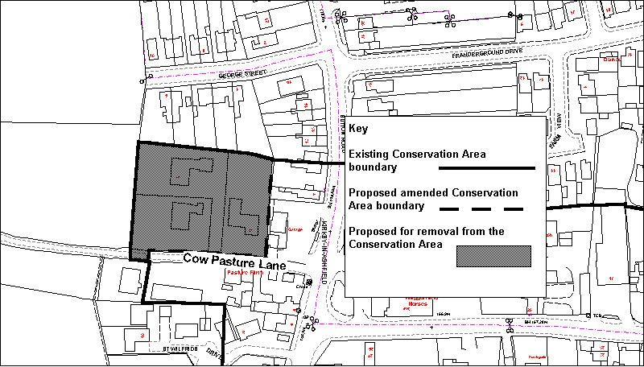
© Crown copyright All rights reserved Licence LA07702X
    - This area of land incorporates the properties of 2, 2a and 4 Cow Pasture Lane. The land remained undeveloped until 1978 when it was sub-divided into three plots, each with a single bungalow constructed upon the plot. A line of conifer trees obscures views of the bungalows from the main road. The bungalows, described further in paragraph 4.49, are isolated from the immediate streetscape of Sutton Road due to their lack of height, distance from the main road and location of trees and hedgerow to the front of the properties. The bungalows are of no architectural or historical value to the Conservation Area. Any value the land had as an agricultural field parcel has of course been lost.

    - The settlement of Kirkby Cross has evolved over centuries and has been categorised into varying components by the Kirkby Extensive Urban Survey, 2001. The Conservation Area encompasses for the most part the components that have been found to be medieval and post-medieval. This part of the Conservation Area however, was not found in the survey to be either a medieval or post-medieval component and has no historic or architectural basis in this respect for being included within the Conservation Area.

    - Therefore, considering the above information, it is recommended that this part of Kirkby Cross be removed from the Conservation Area as indicated in the plan above.

Figure 5 Land to the east of St. Wilfrids Church
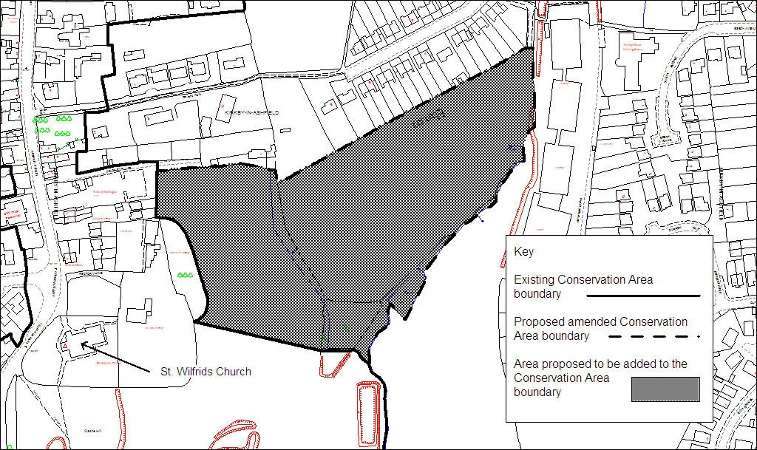
© Crown copyright All rights reserved Licence LA07702X
    - This area of land is home to part of a series of ancient fishponds listed as a Scheduled Ancient Monument (designated in 2001) and open fields. A description of the Fishponds can be found earlier within the physical appraisal of the Conservation Area in paragraph 4.5.13. The ponds are segregated at present by the Conservation Area boundary that separates the two southernmost ponds (which are included within the existing Conservation Area) from the two northernmost ponds (which are outside the boundary of the Conservation Area). The ponds are several centuries old and are thought to have been associated with the 14th Century fortified manor house that once stood at Castle Hill.
    - The fields to the north of the Ancient Fishponds and the properties of 1 and 2 Hockley Valley have historic connections to the Fishponds, and are described in paragraphs 4.4.34 (1 and 2 Hockley Valley) and 4.5.13 (open fields)

    - Following designation of the whole of the pond site as a Scheduled Ancient Monument and in recognition of its collective contribution to the Conservation Area, it is logical to extend the Conservation Area boundary to encompass all of the ancient fishponds.
    - Therefore, considering the above information, it is recommended that the area shown on the plan above be added to the Conservation Area as indicated by the plan above.

Figure 6 Land to the east of Old Chapel Close/west of Orchard Road
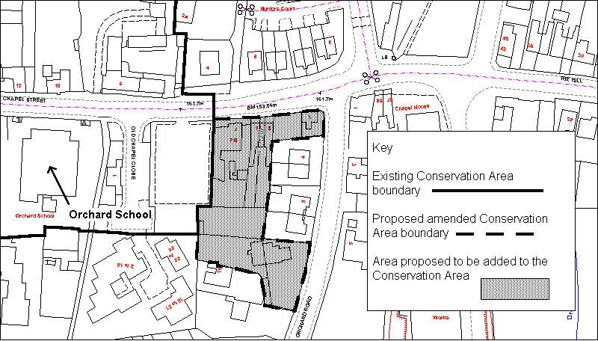
© Crown copyright All rights reserved Licence LA07702X
    - This area of land adjoins the eastern boundary of the current Conservation Area, incorporating the properties 1,3,5 and 7 Chapel Street and 12 & 14 Orchard Road. These buildings have been referred to earlier within the physical appraisal (see paragraphs 4.2.3, 4.2.5 and 4.2.6) in terms of their appearance. The buildings on Chapel Street collectively, form an interesting group of late Victorian, early 20th Century brick-built properties, whilst the properties of 12 & 14 Orchard Road are an attractive 18th Century stone building situated within attractive grounds (see paragraph 4.2.7).

    - The buildings have significant merit in terms of their contribution to the historic townscape of the Conservation Area. The inclusion of the first group of properties would help to safeguard the view into the Conservation Area from the east, looking along Chapel Street. Incorporating this collection of buildings into the Kirkby Cross Conservation Area would be a logical step to bringing them within the added statutory protection afforded by conservation area designation.

    - Therefore, considering the above information, it is recommended that this part of Kirkby Cross be added to the Conservation Area as indicated by the plan above.

Figure 7 Land at St Wilfrids Drive
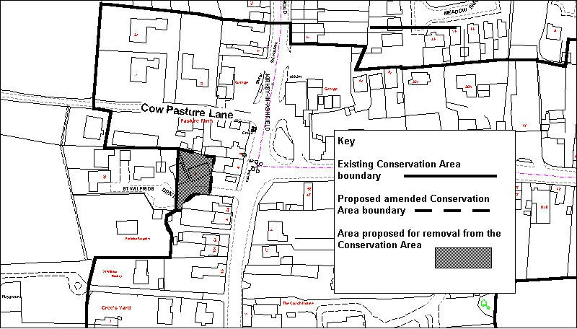
© Crown copyright All rights reserved Licence LA07702X
    - This area of land incorporates two properties to the north of St Wilfrids Drive. These bungalows were constructed in the mid-1980’s and formed part of a site occupied by two former detached properties. A more detailed description of these modern bungalows and their immediate setting can be found in paragraph 4.3.17. One of the buildings is dissected by the Conservation Area boundary. Retention of the boundary through a building is clearly not logical.

    - As the two bungalows are of no architectural value to the Conservation Area, it is proposed that the area of land that the bungalows occupy be withdrawn from the Conservation Area. The amended Conservation Area boundary will consequently exclude this part of the small housing development and be amended eastwards towards the junction of Church Street and St Wilfrids Drive.

    - Therefore, considering the above information, it is recommended that this part of Kirkby Cross be removed from the Conservation Area as indicated by the plan above.

Figure 8 Land immediately north of St. Wilfrids Parish Hall
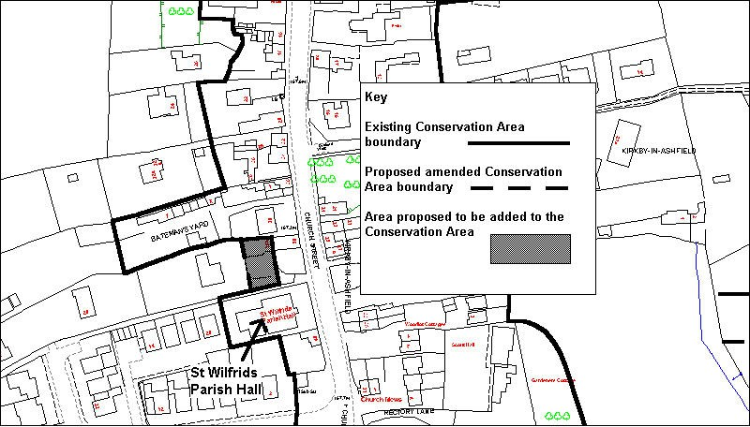
© Crown copyright All rights reserved Licence LA07702X
    - This area of land is located immediately west of Church Street and is just outside the current Conservation Area boundary. The area in question contains 58 Church Street, a two-storey cottage which is within the Conservation Area presently, and adjoining single-storey building currently outside the Conservation Area. Both are constructed from coursed dressed stone. Spacious grounds lie immediately to the building’s south (for further description of property – see paragraph 4.4.29).

    - After appraising this particular part of the Conservation Area, 58 Church Street has been identified as a Building Contributing to the Historic Townscape (see Appendix 1(a)). It would therefore, be a logical step to re-align the Conservation Area boundary to include both the cottage and the adjoining stone building along with the open setting immediately south of the building. In visual terms, these elements can be read as one unit.
    - Therefore, considering the above information, it is recommended that this part of Kirkby Cross be included within the Conservation Area as indicated by the plan above.

Figure 9 Land to the rear of 12-16 Chapel Street
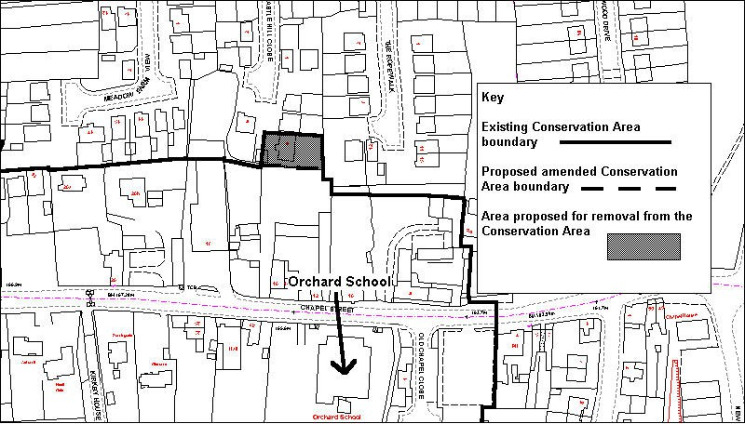
© Crown copyright All rights reserved Licence LA07702X
    - This area of land incorporates a single property (9 Castle Hill Close) to the north of 12-16 Chapel Street The house along with adjacent garage forms part of a modern housing development on Castle Hill Close which dates from the late 1990’s. A more detailed description of this area can be found in paragraph 4.2.13.

    - The property is of no architectural value to the Conservation Area following the more recent development, and due to its positioning to the rear of 12-16 Chapel Street and the Carpet Sales Warehouse, visibility of the property is all but totally obscured. It is proposed that this area be removed from the Conservation Area with the amended boundary running along the south side of the property/north boundary of 12-16 Chapel Street.

    - Therefore, considering the above information, it is recommended that this part of Kirkby Cross be removed from the Conservation Area as indicated by the plan above.

  - Buildings of Architectural/Historic Value
    - This appraisal reviews the general condition and architectural/historic value of all buildings, whether Listed or non-Listed, within Kirkby Cross. From the appraisal it is clear that the current condition of the sixteen Listed Buildings is such that they all warrant continued protection.

    - Listed Building Consent has and will continue to be a vital tool in the preservation of Listed Buildings, being effective in preserving the character and appearance of several important buildings in Kirkby Cross, as well as their immediate surroundings and setting.
    - After appraising all of the non-Listed buildings within the Conservation Area and consulting with the Nottinghamshire County Council Heritage team, it is felt that there are no other buildings worthy of designation for Listed Building status.
    - Therefore, considering the above information, it is recommended that no buildings should either be put forward for Listing or removed from the Conservation Area’s stock of Listed Buildings.

    - The appraisal also identifies buildings that do not have Listed Building status, but make a significant positive contribution to the historic character and townscape of the Conservation Area. For the purposes of the appraisal, such buildings have been identified as ‘Other buildings contributing to the historic townscape’. The identification of these buildings and their key architectural features will assist the council in its decision making process when dealing with new proposals for development requiring planning permission.

  - Potential Environmental Improvement Schemes
    - After appraising the physical form of the Conservation Area, specific elements in the public realm are considered to detract from the general appearance and character of Kirkby Cross, and more specifically on the exterior of properties including the replacement of doors, windows (by way of UPVC) and unsympathetic rendering. The detracting elements should, where possible, form the basis for future Conservation Area Improvement Schemes or improved maintenance to preserve and enhance the Conservation Area. These areas have been annotated on a plan in Appendix 6 – Potential Schemes, and include:

      - Environmental improvement to the seating area immediately north-east of the mini-roundabout between Chapel Street, Church Street and Sutton Road. (No.1 – Appendix 6)
      - Improvement to the frontage of the vacant commercial property at 8 Church
Street. (No.2 – Appendix 6)
      - Addressing the over-use of render and pebbledash to the exterior of several houses within the Conservation Area, which conceal the original type of building material. An example of this problem being rectified is the restoration work undertaken at 1 Bateman’s Yard to remove render, once again exposing the original stonework. Heritage funding may well be available for restoration work to be undertaken at other similar properties in Kirkby Cross. (Conservation Area-wide scheme)
      - Installation of more sympathetic and traditional street furniture throughout Kirkby Cross which would contribute to the enhancement of the Conservation Area. This may include signage, lighting columns, litter-bins/seats etc. (Conservation Area-wide scheme)
      - Improved paving and maintenance of land on the north and south side of the junction between Manor House Court and Church Street. (No.3 – Appendix 6)
      - The consolidation and improvement of highway signage in conjunction with Nottinghamshire County Council. This is in response to examples seen within the Conservation Area where several individual signs have been positioned on lighting columns. (Conservation Area-wide scheme)
      - Environmental Improvements to the frontage of the Waggon and Horses public house car park. (No.5 – Appendix 6)

    - The appraisal has also identified a specific highway-related issue that relates to large lorries turning in the road at the junction of Manor House Court and Church Street. The problem concerns lorries mounting the kerb on the east-side of Church Street causing damage to the kerbstones and pavement on this side of the road. Additionally, this is putting pedestrians at risk from the turning traffic. The installation of bollards would prevent lorries from having the road space to manoeuvre (No.4 – Appendix 6).

    - The installation of several bollards outside the car park on the St Wilfrids side of Church Street to prevent large vehicles from mounting the pavement in order to turn around. Better signage at the Chapel Street/Sutton Road junction may prevent some large vehicles from travelling in the wrong direction. (No.5 – Appendix 6)

    - The implementation of the above schemes will of course require funding to be identified and in some cases will need co-operation from private landowners. The council will work together with Nottinghamshire County Council to secure resources and attract grant funding where available.

  - Adequacy of Current Policy Provisions
    - After undertaking a thorough appraisal of the physical form seen within Kirkby Cross, a review of the adequacy of current policy controls can be undertaken.

    - Appraising the Conservation Area has highlighted many aspects where key elements of the streetscape have been altered since 1975, either through permitted development or development requiring planning permission. Whilst the Conservation Area retains a considerable amount of its character, certain elements have been eroded. Whole buildings and specific historic elements such as original timber frames (usually lost to the rising use of U-PVC windows), stone walls and pantile roofs on buildings have gradually disappeared over time. By analysing historical photographs and maps, the urban form of the area has changed considerably with many buildings over the course of the last century disappearing to make way for newer development that has been less sympathetic with the traditional character of the area in terms of building location, design and materials. However, recent development in Kirkby Cross has been more sympathetic to the character of the Conservation Area. This is shown through the use of local stone in the construction of several modern houses situated just north of St Wilfrids Church.

    - It is vital through the use of relevant policies, to preserve and enhance the remaining elements of Kirkby Cross, which contribute to the historic character of the area.

    - The policy context outlined in Section 2 of the appraisal provides a raft of controls for development proposals in Kirkby Cross, both in terms of specific buildings (Listed Buildings and Scheduled Ancient Monuments) and across the area as a whole (Conservation Area Control). Conservation Area designation also provides stricter control than would be found elsewhere over what is deemed to be Permitted Development.
    - The policies highlighted earlier that are contained within the Ashfield Local Plan Review relating to the protection of Listed Buildings and Ancient Monuments and their setting and conservation areas are considered to be soundly based having been adopted recently (November 2002), as part of the Local Plan. These policies have been tested through the review process including at a Public Inquiry. Consequently there are no proposals to amend these policies at this stage.

    - Listed Building, Scheduled Ancient Monument, Conservation Area and permitted development controls can only provide certain restrictions over development. These are established through the relevant Statutory Frameworks and Local Plan policies principally and are considered to provide as much protection as can be expected given the powers available under the relevant acts. Further restrictions on development can however be applied, if considered appropriate, through an Article 4 direction and this is described earlier in the appraisal within section 2.0. An Article 4 direction can be used to preserve individual elements that are considered to be worthy of protection such as windows, doors, boundary walls etc.

    - The use of Article 4 directions is however generally limited in a practical sense to instances where there is a sufficient amount/number of the facet that it is desirable to provide additional protection to. Otherwise, the Council’s ability to monitor and enforce any breaches in the Direction would not be achievable and this would subsequently undermine the credibility of the Direction.
    - Through the appraisal, it is considered that there is one key feature found to be particularly significant and extensive throughout Kirkby Cross and not protected through other policy controls, this is the presence of numerous stone walls. These have been described earlier in this appraisal as being an integral component of the Conservation Area’s character. The stone walls are prominent due to being located immediately at the roadside, notably on approach to Kirkby Cross up Church Hill. The heights of the walls form an imposing streetscape.
    - To enable the preservation of these stone walls, planning policy needs to ensure that they receive the necessary protection from unnecessary demolition. Government Circular 14/97 - Planning and the Historic Environment - Notification and Directions by the Secretary of State grants consent for minor demolition works in conservation areas including….
“Gates, walls and fences etc less than one metre high where abutting a highway, waterway or open space or less than two metres high in other cases”
    - To establish the extent of the existing stone walls and whether or not these are potentially at risk from lawful demolition, a survey has been undertaken (Appendix 4) to discover the heights and total (in metres) of the stone walls abutting a highway in the Conservation Area. The findings from the survey illustrate an approximate total of 1276 metres of stone wall. Of this total, 18.2% (269.75 metres) of stone walls are of a height (under 1 metre) where they could lawfully be demolished without the need for seeking planning consent. The remaining 81.8% of stone walls in Kirkby Cross (1212.25 metres) are above 1 metre in height and adjoin a highway and therefore have statutory protection from demolition.

    - These results illustrate that a vast majority of remaining stone wall in Kirkby Cross does have statutory protection and any proposals to demolish any of it would need planning consent from the local planning authority. Concern is however expressed at the current lack of control over the remaining walling under one metre.

    - From these findings, two clear policy options are available to the Local Planning Authority. The first option is to introduce an Article 4 Direction to withdraw permitted development rights for the demolition of stone walls abutting roads in the Conservation Area. As there is so little stone wall under 1 metre in height, the additional work required to enforce the Article 4 Direction would not be overly problematic for the District Council to achieve. This would add additional statutory protection to the stone walls to help safeguard this element that characterises Kirkby Cross.

    - It is recommended that the application of an Article 4 Direction by the Council is an appropriate measure to preserve the remaining lengths of stone

wall under 1 metre in height. Further action to preserve aspects such as doors and windows has been considered unworthy of Article 4 protection due to the large-scale loss and replacement of the aforementioned elements. Publication of guidance/advice (see part v of this section) would highlight the importance of the stone walls and publicise the existence of additional statutory protection for the walls from demolition.

  - Information and Advice
    - An issue that has arisen from this appraisal is the need for information and advice relating to the Conservation Area that would benefit both residents and visitors to Kirkby Cross. It is important to raise awareness amongst residents living within the Conservation Area as to the value and importance of the Conservation Area and what their obligations are particularly with regard to proposals requiring planning permission and/or conservation area consent. By raising awareness amongst local residents, it is hoped that residents will be better informed, and as a consequence minimise the potential harm that may occur to the character of the area.

    - The appraisal document itself will of course be available for all relevant parties and provides useful information on what is of value in a statutory and non-statutory sense. This will help inform the owners of land and buildings, potential developers and the council.

    - Additional information/advice will also be of benefit to residents/developers and the Council in terms of guidance specifically for Kirkby Cross which will identify key considerations in respect of location, design and materials for any new proposed development in the Conservation Area. This will hopefully produce a high quality of architecture in new development within Kirkby Cross that can help to enhance the character and appearance of the Conservation Area.

    - The appraisal has also identified the need for a publicity leaflet promoting the leisure and tourism aspects of the Conservation Area. This will provide information that will help residents and people visiting the area to familiarise themselves with the key aspects of the Conservation Area such as the Listed Buildings, Scheduled Ancient Monuments and Other buildings and structures of interest. In addition to information about the present, any such leaflet will be able to present important historic information on how the settlement of Kirkby Cross has evolved through the last several centuries.

  - Partnership working
    - This appraisal has benefited from the Council’s close relationship with the Kirkby and District Conservation Society (KDCS). The close relationship has ensured that important local information has been readily available to the Council which has helped with the production of the appraisal. An example of the close relationship was the meeting with members of the Society at a very early stage of the appraisal’s life to discuss with them what a conservation area appraisal entailed and what should be included. This gave the members an opportunity to highlight issues prominent within Kirkby Cross, which were of concern to them. In addition to this, two ‘walkabout’ mornings were organised in conjunction with the Society where members were invited to join a Council employee in walking around the Conservation Area. This gave Society members a chance to a) point out specific problems/opportunities evident within Kirkby Cross, and b) to impart their local knowledge of the area which has been beneficial to the physical appraisal of the Conservation Area.

    - It is also appropriate to acknowledge the role played by English Heritage and Nottinghamshire County Council in several matters relating to the historic built environment. These matters include:

      - Providing expert advice on matters affecting listed buildings.
      - Providing advice to owners on appropriate repair techniques for their historic buildings.
      - Commenting on proposals affecting the character of the Conservation Area.
      - Working in conjunction with the District Council to highlight potential enhancement schemes for the area.

    - Further partnership working with the Society will be of importance after the appraisal has been finalised. The implementation of schemes, highlighted from both the physical survey and the Society’s local awareness and knowledge, will help to enhance the character of the Conservation Area.

    - In addition to the partnership work conducted with KDCS, the Council recognises the importance of close consultation with the general public in and around Kirkby Cross. The public’s participation in a consultation exercise is key as the Council places great importance on listening to the thoughts and views of local residents in order to achieve a comprehensive appraisal of which everyone is satisfied. Public consultation will prove to be helpful should the Council, for whatever reason, overlook any detail that local residents feel is necessary for inclusion within the appraisal.

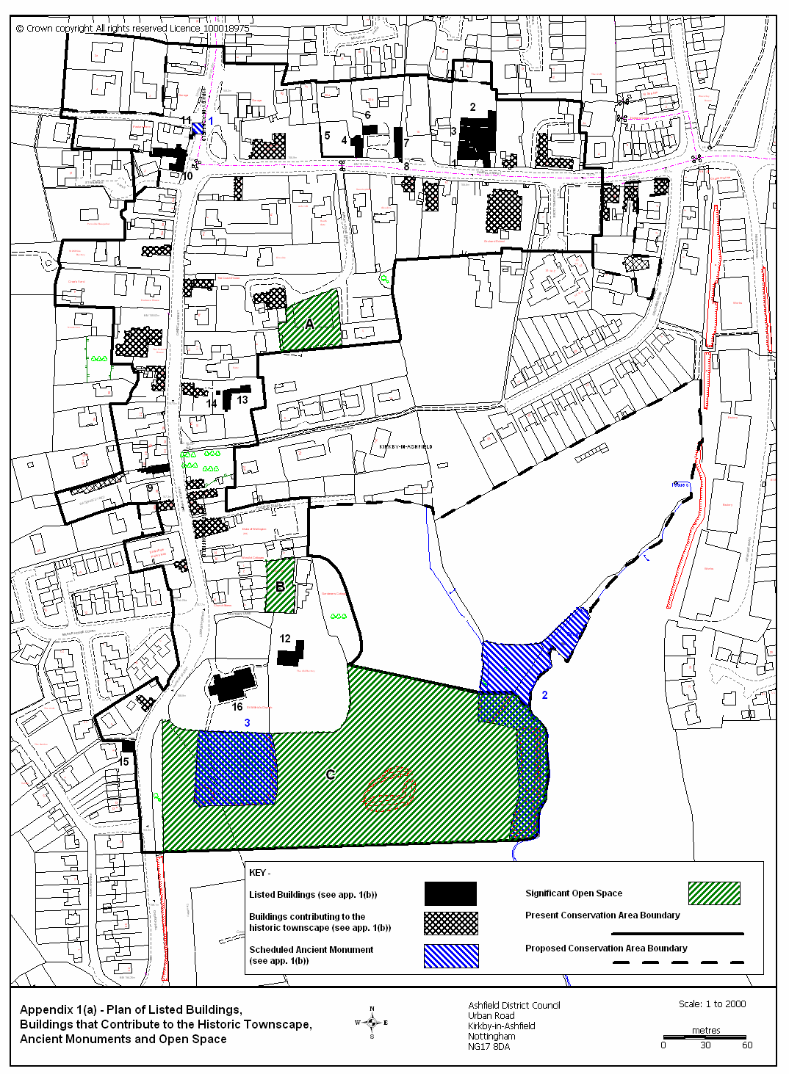

Appendices Appendix 1(a)

Appendix 1(b)
Listed Buildings in Kirkby Cross (Numbers are used in conjunction with Appendix 1(a))

- Numbers 12-16 (even) Chapel Street, Farmhouse and adjoining Cottage

- Barn and Stables at nos. 12-16 (even) Chapel Street

- Farmyard and Garden Walls at nos. 12-16 (even) Chapel Street

- Number 20 Chapel Street

- Garden Boundary Wall to the west of Number 20 Chapel Street

- Stable adjoining Number 20 Chapel Street to the north-east

- Stable Range 20m. east of Number 20 Chapel Street.

- K6 Telephone Kiosk adjacent to Stable Range mentioned above.

- The Old Post Office at the junction of Batemans Yard and Church Street.

- Numbers 2 and 6 and adjoining Stable, Church Street.

- Kirkby Market Cross, Church Street.

- The Old Rectory, Church Street.

- Number 13 (The Croft) Church Street.

- Well Head, 7m. east of Number 13 Church Street.

- Pinfold, Church Hill.

- Church of St. Wilfrid, Church Hill.

Scheduled Ancient Monuments (Numbers used in conjunction with Appendix 1(a))

- Kirkby Market Cross, Church Street

- Fishponds 220m. east of St. Wilfrids Church.

- Castle Hill Fortified Manor

Appendix 2
Listed Buildings – Photographs
12,14 and 16 Chapel Street Kirkby Cross Monument
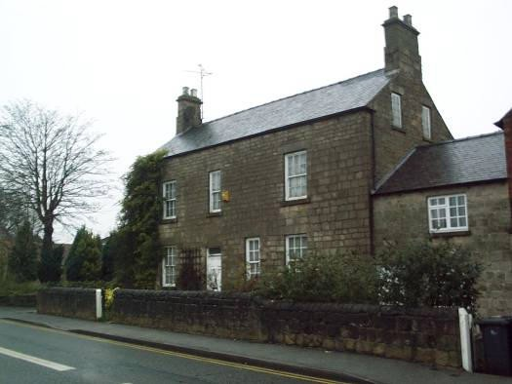
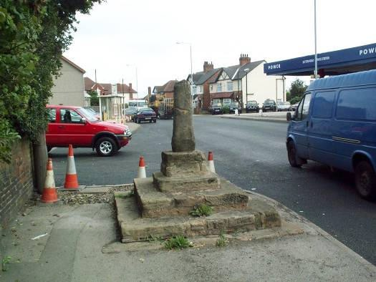
20 Chapel Street (Farmhouse) 2 and 6 Church Street
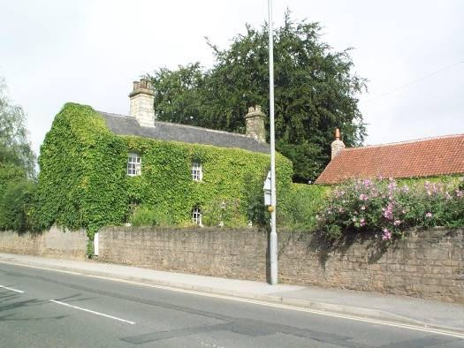
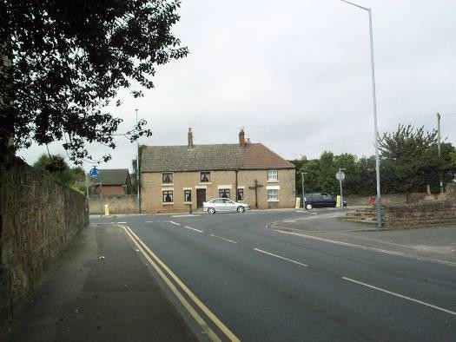
20 Chapel Street (Stables) 13 Church Street (The Croft)
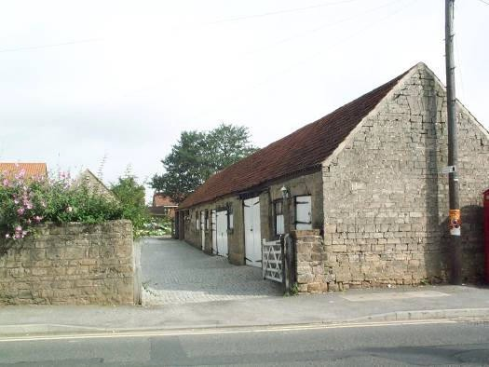
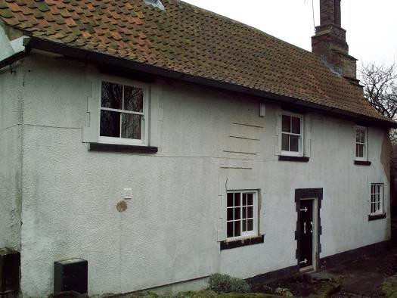

Listed Buildings – (Continued)
Well to west of 13 Church St. St Wilfrids Church (South)
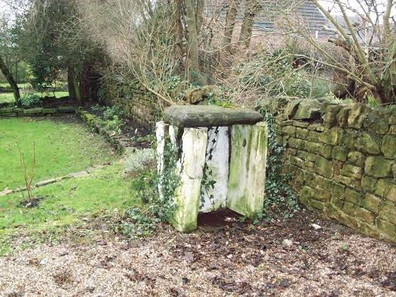
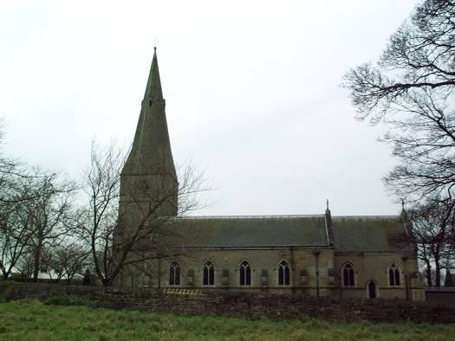
1 Bateman’s Yard St Wilfrids Church (North)
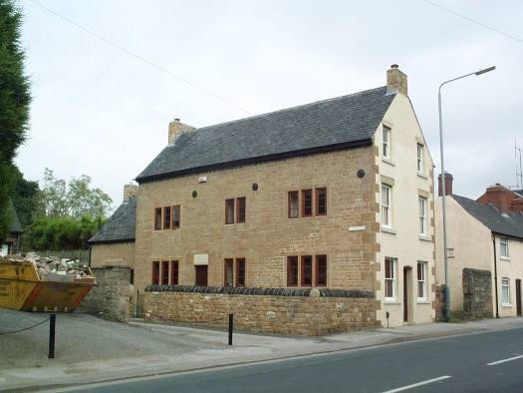
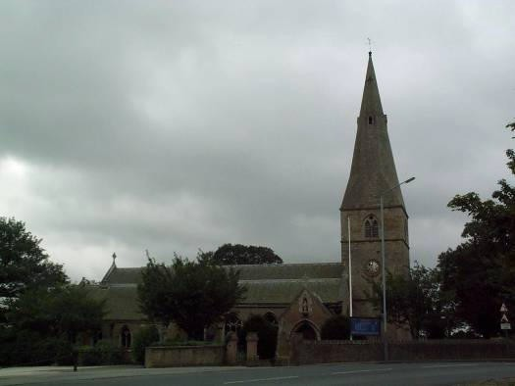
The Old Rectory The Pinfold
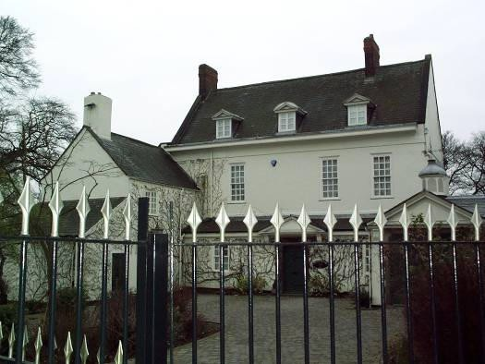
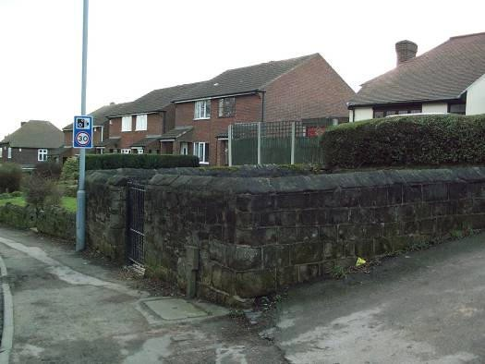

Other buildings contributing to the historic townscape
Orchard School The Coach House
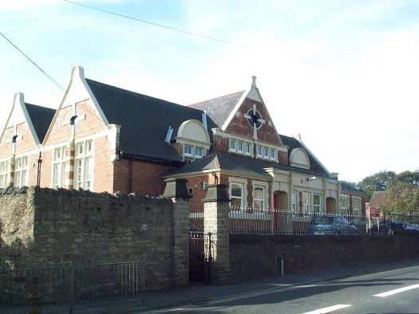
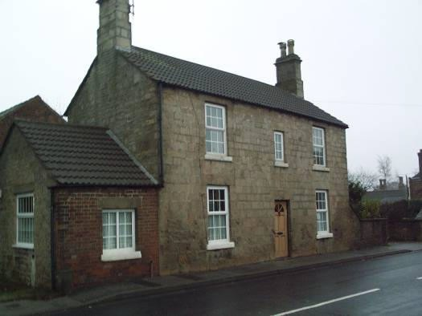
Kirkby House 16 and 18 Church Street
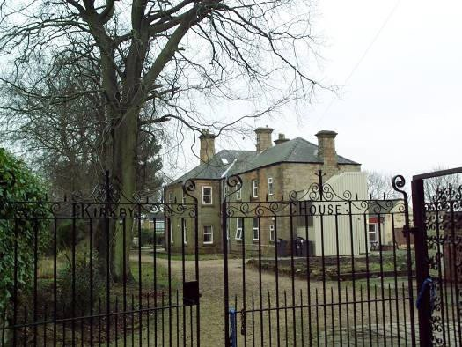
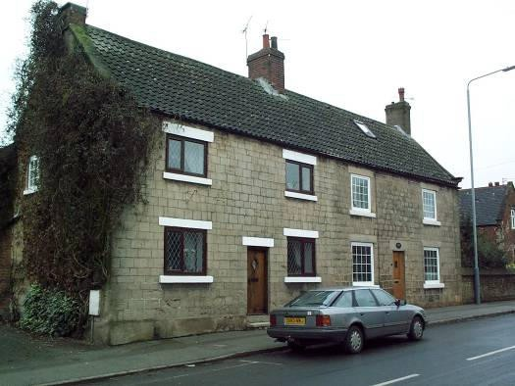
10 Church Street 15 and 17 Church Street
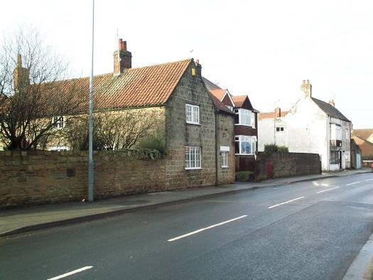
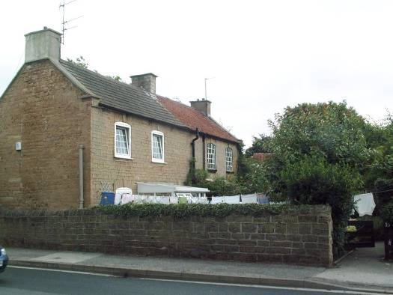

Other buildings contributing to the historic townscape (continued)
10 Chapel Street 6 Chapel Street
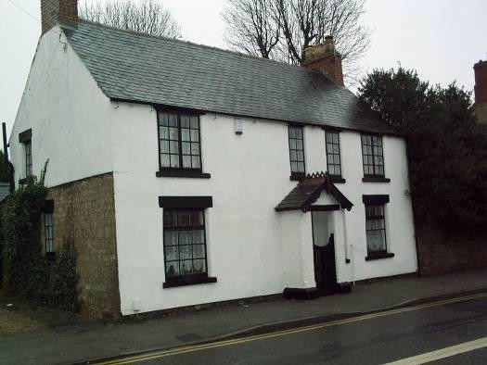
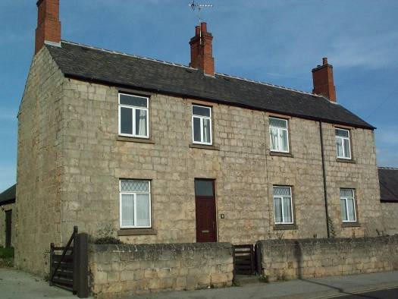
Old Methodist Chapel 27 and 29 Chapel Street
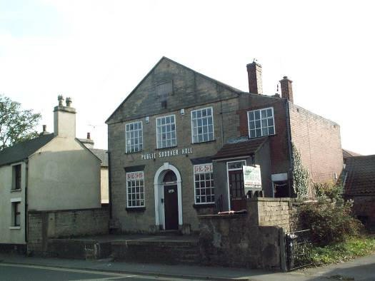
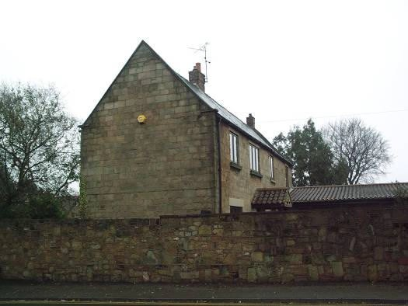
23 and 25 Chapel Street The School House
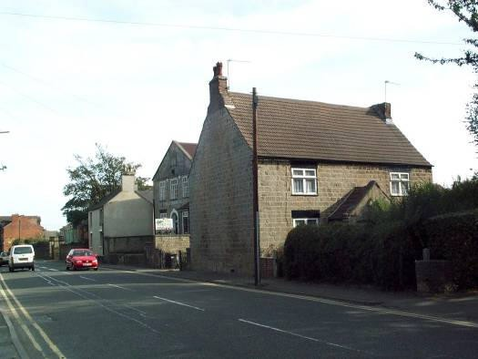
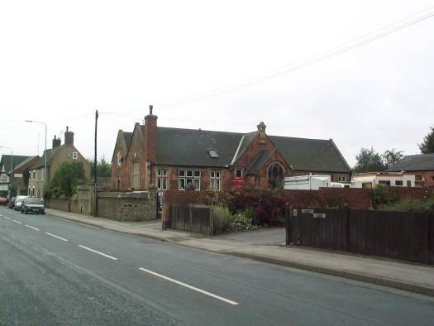

Other buildings contributing to the historic townscape (continued)
21 and 23 Church Street 3 & 5 Chapel Street
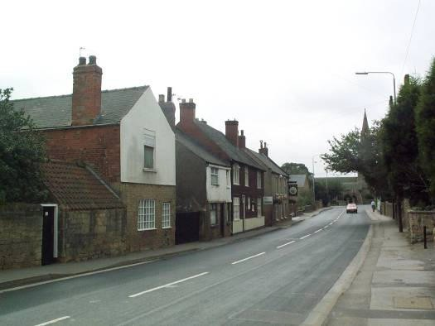
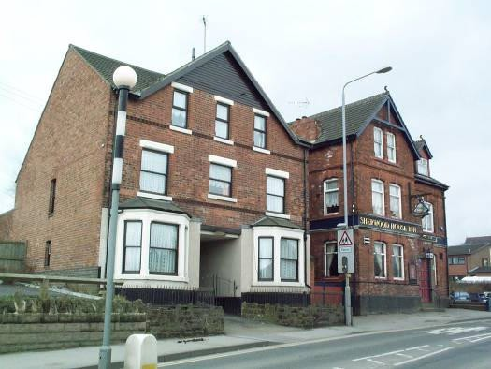
58 Church Street 7 Chapel Street
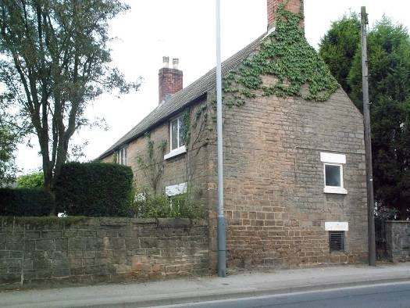
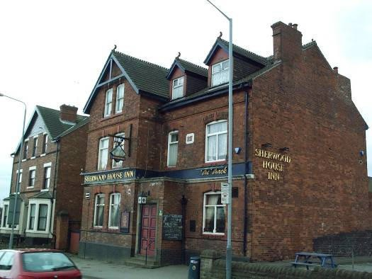
1 Chapel Street Bateman’s Yard
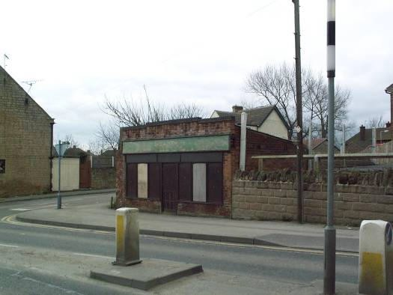
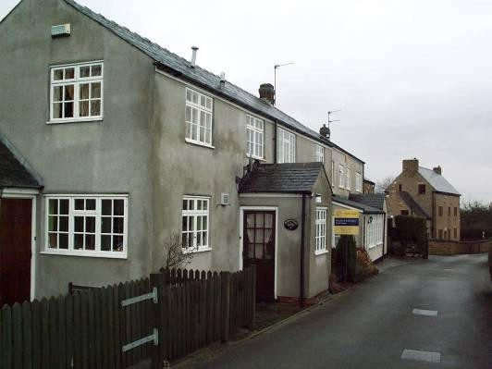

Other buildings contributing to the historic townscape (continued)
Duke of Wellington 2 Church Hill
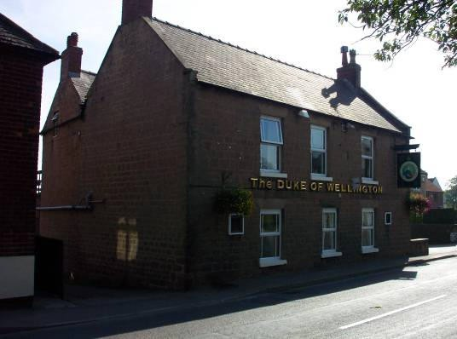
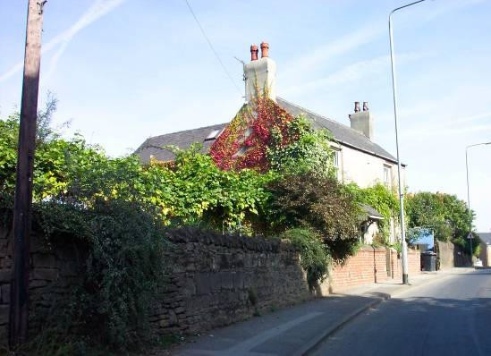
46 Church Street
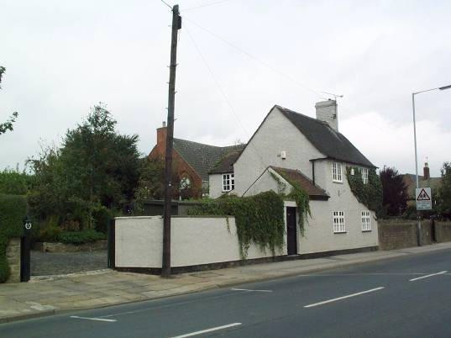
Waggon and Horses
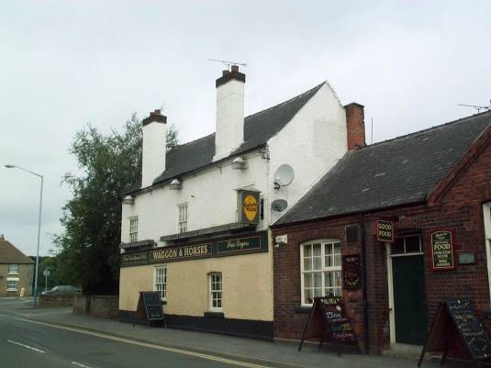

Appendix 3(a)
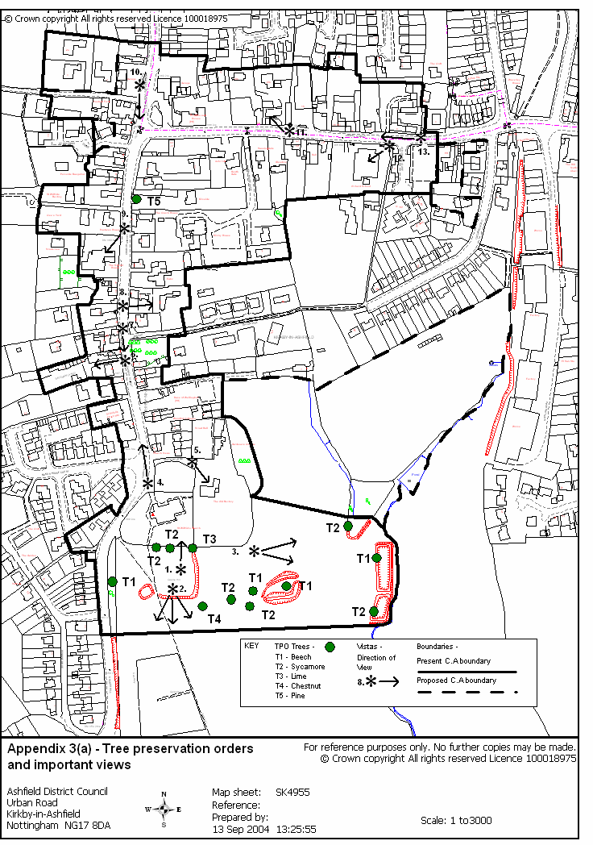

Appendix 3(b)
Significant Views within the Conservation Area (Numbers to be used in conjunction with Appendix 3(a))

- St. Wilfrids Church (south elevation) and The Old Rectory alongside each other.

- Long distance view into countryside towards Annesley and beyond.

- Ancient Fishponds amongst a dense collection of trees at the bottom of the valley.

- Looking along the spine of Church Street.

- The Old Rectory behind decorative iron gates.

- View looking along Batemans Yard with a row of early 20th Century terraced houses to the right.

- Looking southwards towards St. Wilfrids Church with an interesting collection of brick-built properties on the left-hand side lining the road.
- View over gardens of 13 Church Street, a Listed 16th Century cottage.

- The School House sitting at 90 degrees to the main road.

- The Ancient Monument of Kirkby Cross in the foreground, with the enclosed streetscape of Church Street to the rear.
- 20 Chapel Street, a stone built 16th Century farmhouse with other outbuildings around a cobbled yard.

- Orchard School elevated above ground level overlooking Chapel Street.

- View along the spine of Chapel Street.

Appendix 4(a)
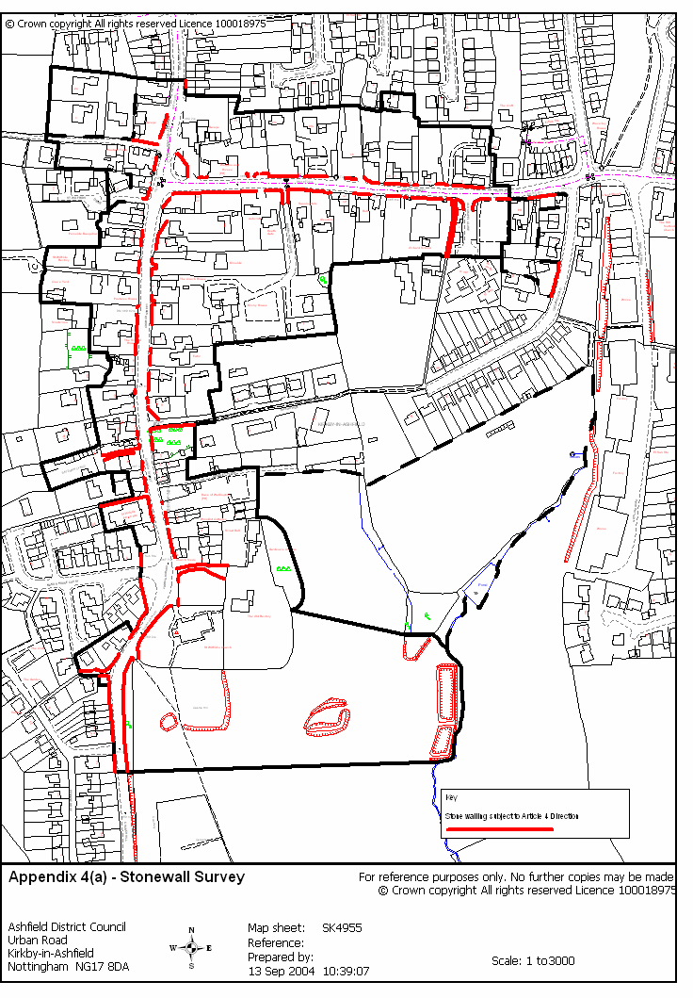

Appendix 4(b) –

Examples of Stonewalls in Kirkby Cross under 1 metre in height.

- Sherwood House Inn and adjoining car park.
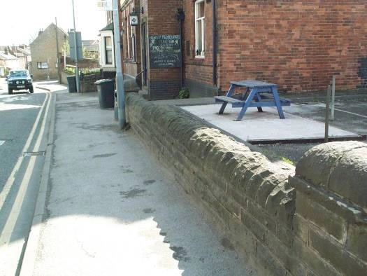

- Wall to the front of Ewtor, Church Street.
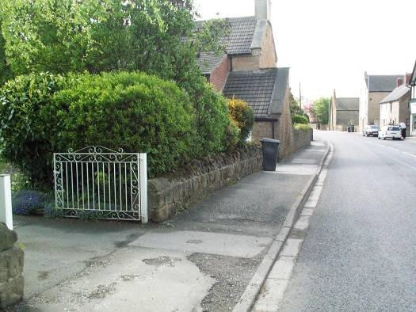

- Wall to the front of the Waggon and Horses car park.
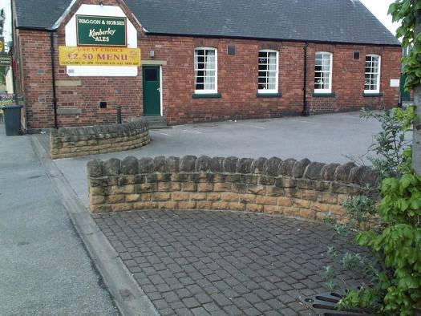

Appendix 4(b) –

Examples of Stonewalls in Kirkby Cross over 1 metre in height.
- Stonewall in the immediate surrounds of the roundabout.

- Stonewall to the front of 20 Chapel Street

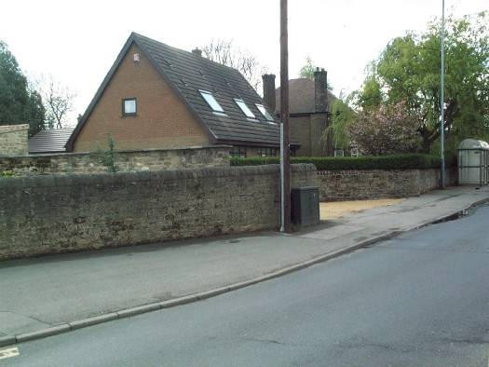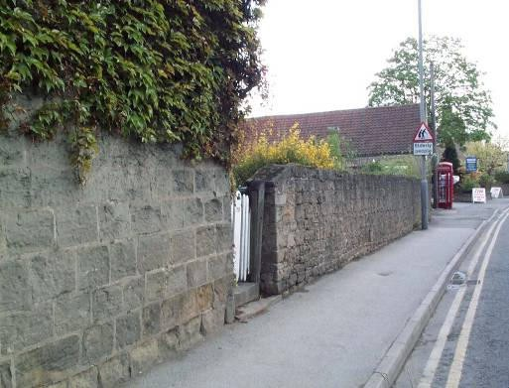
- Stonewall fronting onto the north side of Chapel Street.
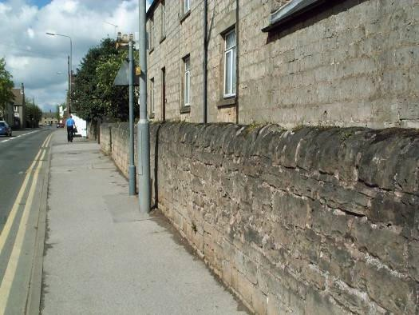

- Path leading to the Old Rectory from Church Street.
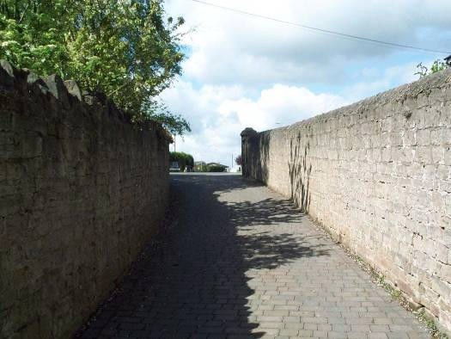

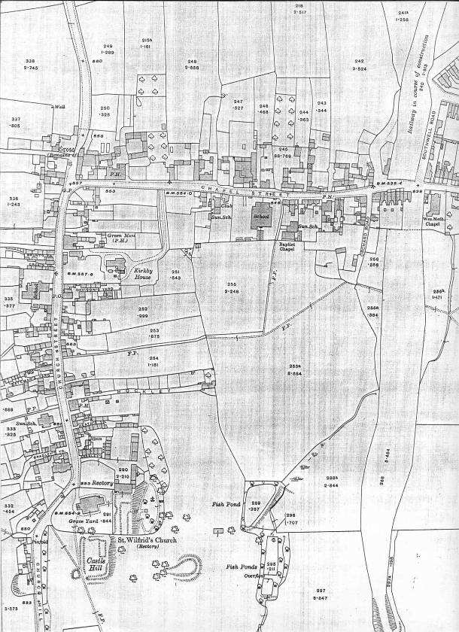
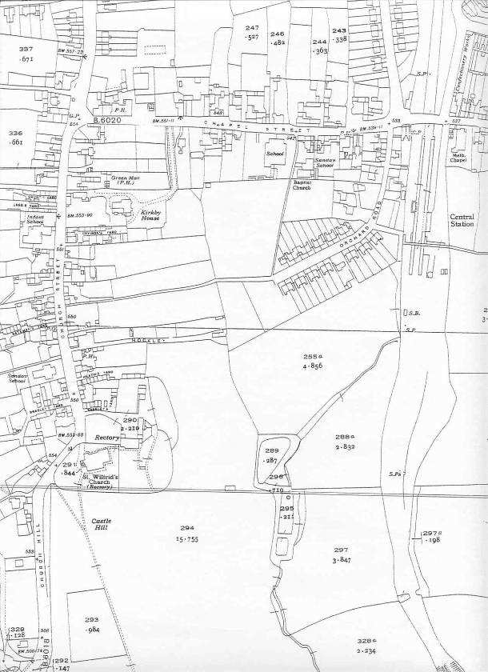
1938
1917
The Growth of Kirkby Cross (1878 – 1938)
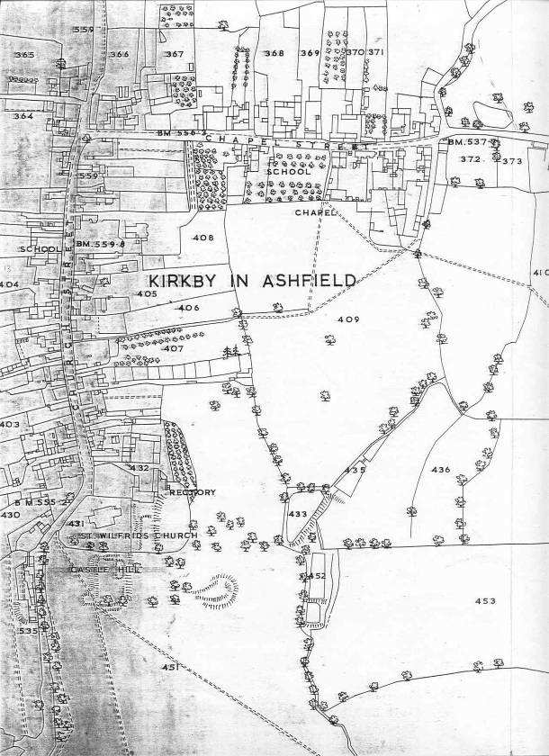
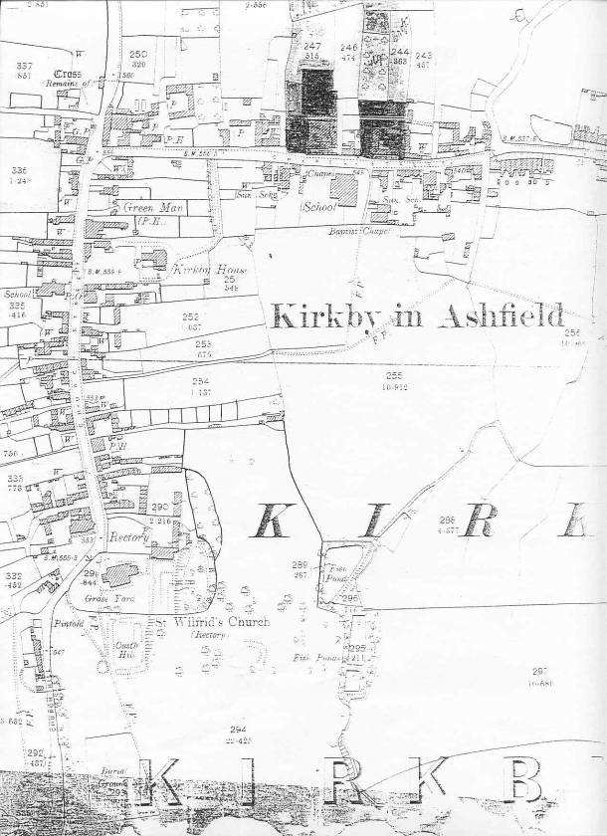
1878
1900

Appendix 6
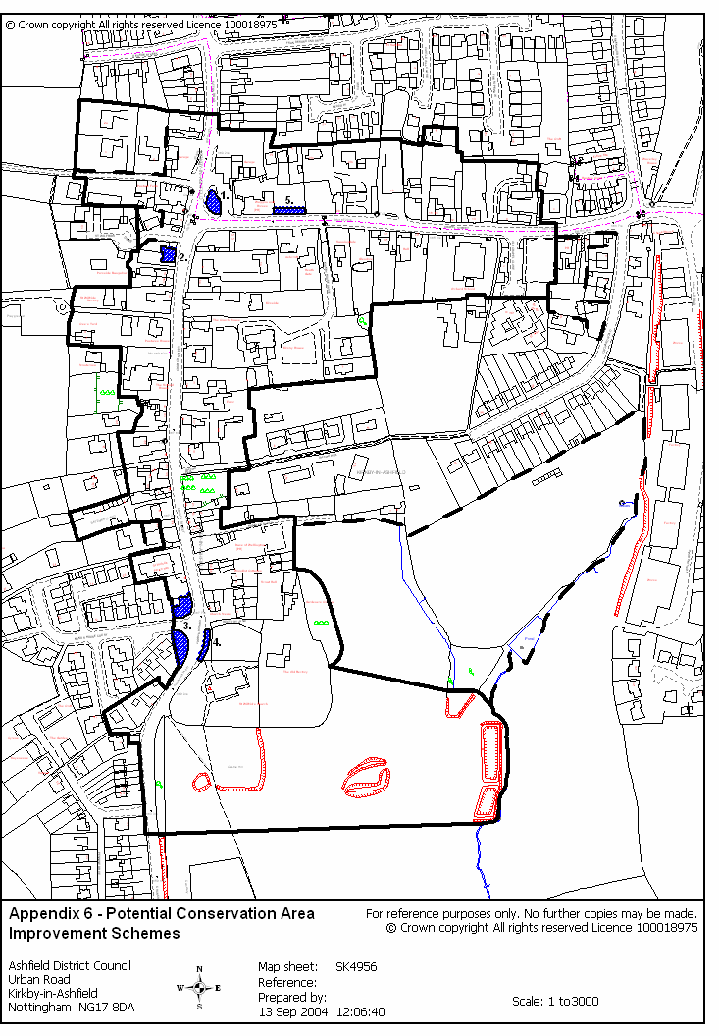



Ashfield District Council, Planning Policy & Projects, Council Offices, Urban Road, Kirkby-in-Ashfield, Nottingham, East Midlands Region,
NG15 8DA
Tel. 01623 450000 Fax. 01623 457332

